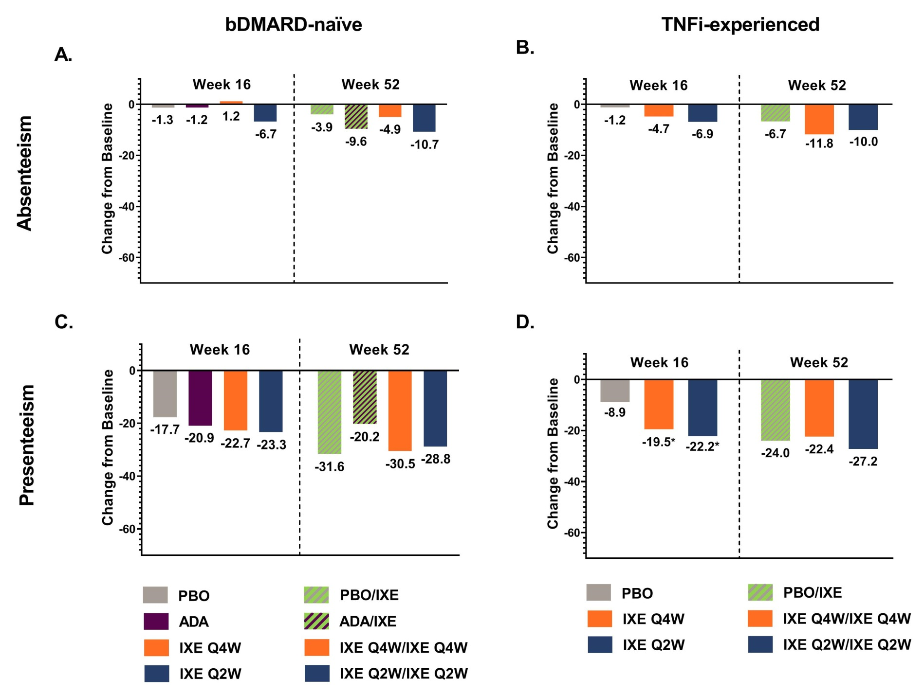
Figure S1. Changes from baseline in Absenteeism and Presenteeism at Weeks 16 and 52. Absenteeism in A) bDMARD-naïve and B) TNFi-experienced patients and Presenteeism in C) bDMARD-naïve and D) TNFi-experienced patients.

For Week 16, values are LSM (SE) from ANCOVA with missing data imputed via mBOCF. For Week 52, values are mean (SD) with missing data imputed via mBOCF.
At Week 16, patients receiving placebo (COAST-V, bDMARD-naïve; COAST-W, TNFi-experienced) or adalimumab (COAST-V, bDMARD-naïve) were switched to ixekizumab Q4W or Q2W. Data for IXE Q4W and IXE Q2W were combined for the PBO/IXE and ADA/IXE groups.
Absenteeism and presenteeism were measured in patients reporting part- or full-time paid work.
The sample sizes for randomized patients (intent-to-treat population) were:
- Figure 1A and 1C, COAST-V (bDMARD-naïve) treatment groups: PBO (N=87) PBO/IXE (N=86); ADA (N=90) ADA/IXE (N=86); IXE Q4W (N=81) IXE Q4W/IXE Q4W (N=78); and IXE Q2W (N=83) IXE Q2W/IXE Q2W (N=79).
  - Number of patients eligible for analysis of absenteeism: PBO (Nx=50) PBO/IXE (Nx=49); ADA (Nx=65) ADA/IXE (Nx=63); IXE Q4W (Nx=57) IXE Q4W/IXE Q4W (Nx=58); and IXE Q2W (Nx=49) IXE Q2W/IXE Q2W (Nx=52).
  - Number of patients eligible for analysis of presenteeism: PBO (Nx=50) PBO/IXE (Nx=49); ADA (Nx=60) ADA/IXE (Nx=59); IXE Q4W (Nx=55) IXE Q4W/IXE Q4W (Nx=57); and IXE Q2W (Nx=47) IXE Q2W/IXE Q2W (Nx=49).
- Figure 1B and 1D, COAST-W (TNFi-experienced) treatment groups: PBO (N=104) PBO/IXE (N=93); IXE Q4W (N=114) IXE Q4W/IXE Q4W (N=98); and IXE Q2W (N=98) IXE Q2W/IXE Q2W (N=90).
  - Number of patients eligible for analysis of absenteeism: PBO (Nx=57) PBO/IXE (Nx=49); IXE Q4W (Nx=47) IXE Q4W/IXE Q4W (Nx=45); and IXE Q2W (Nx=46) IXE Q2W/IXE Q2W (Nx=46).
  - Number of patients eligible for analysis of presenteeism: PBO (Nx=54) PBO/IXE (Nx=47); IXE Q4W (Nx=44) IXE Q4W/IXE Q4W (Nx=42); and IXE Q2W (Nx=43) IXE Q2W/IXE Q2W (Nx=43).
P-values were from ANCOVA (treatment vs. placebo) for Weeks 0–16. *=p<0.05, ‡=p<0.01, †=p< 0.001.
ADA=40 mg adalimumab every 2 weeks; bDMARD=biological disease-modifying anti-rheumatic drug; IXE Q2W=80 mg ixekizumab every 2 weeks; IXE Q4W=80 mg ixekizumab every 4 weeks; IXE Q4W=80 mg ixekizumab every 2 weeks; LSM=least squares mean; mBOCF=modified baseline observation carried forward; N=number of patients in the treatment group; Nx=number of patients eligible for analysis; PBO=placebo; SD=standard deviation; SE=standard error

