Supplementary material

Supplement to: Repository Corticotropin Injection for Persistently Active Systemic Lupus Erythematosus: Results From a Phase 4, Multicenter, Randomized, Double-blind, Placebo-Controlled Trial

List of independent ethics committees (IECs) and institutional review boards (IRBs) that provided approval for the study at centers that screened or enrolled subjects.
Country | Center Number | IEC/IRB Address
USA | 1028 | Columbia University Medical Center IRB  154 Haven Avenue, 1st Floor  New York, NY 10032  615 West 131st St, 3rd Floor  New York, NY 10027
USA | 1002, 1004, 1005, 1007, 1010, 1012, 1013, 1014, 1015, 1017, 1018, 1020, 1021, 1022, 1023, 1024, 1026, 1027, 1029, 1032, 1033, 1036 | Western IRB Copernicus Group  5000 CentreGreen Way, Suite 200  Cary, NC 27513
Argentina | 5001, 5004, 5005, 5006, 5008, 5009 | Comité Independiente de Ética para Ensayos en Farmacología Clinica  Fundación de Estudios Farmacológicos y de Medicamentos  Presidente J. E. Uriburu 1st Floor  Ciudad Autónoma de Buenos Aires  Buenos Aires PC C1027AAP
Chile | 7001, 7002, 7004 | Comité de Ética Cientifico del Servicio de Salud Metropolitano Oriente  Av Salvador # 364  Providencia Santiago Chile
Mexico | 3001 | Comité de Ética en Investigación del Hospital Hispano, S.A. de C.V.  Pedro Moreno no. 934  Col. Centro  Guadalajara, Jalisco, C.P. 44100
Mexico | 3002 | Comité de Ética en Investigación de Clinica Baijo CLINBA, S.C.  Valenciana No. 7  Col. Paxtitlan  Guanajuato, Guanajuato C.P. 36090
Mexico | 3003 | Comité de Ética en Investigación de Clinica Borda, S.A. de C.V.  Avenida Alvaro Obregon no. 107  Col. Centro  Cuernavaca, Morelos C.P. 62000
Mexico | 3004 | Comité de Ética en Investigación del Centro de Especialidades Médicas del Sureste  Calle 60 No, 329B  Col. Centro  Merida, Yucatan C.P. 97000
Mexico | 3005 | Comité de Ética en Investigación de Pharmet, S.A. de C.V.  Av. De las Granjas No. 972, local 08A  Col. Santa Barbara  Del. Axcapotzalco, Ciudad de Mexico C.P. 02230
Mexico | 3008, 3010, 3011 | Comité de Ética en Investigación del Hospital Hispano  Pedro Moreno no. 934  Col. Centro  Guadalajara, Jalisco, C.P. 44100
Mexico | 3009 | Comité de Ética en Investigación del Sanatorio Alcocer Pozo  Reforma No. 23  Col. Centro  Santiago de Queretaro, Queretaro C.P. 76000
Mexico | 3012 | Comité de Ética en Investigación de Accelerium  Modesto Arreola numero 917 Oriente, Colonia centro, CP 64000, Monterrey Nueva Leon
Mexico | 3013, 3014, 3018 | Comité de Ética en Investigación de Investigación Biomedica para el Desarrollo de Fármacos  Av. Sebastian Bach No. 5257  Col. La Estancia  Zapopán, Jalisco C. P. 45030
Mexico | 3015 | Comité de Ética en Investigación del Hospital Arista  Calle Arista número 1525, colonia Artesanos CP 44200 Guadalajara, Jalisco
Peru | 4001 | Comité Institutional de Ética en Investigación del Hospital Cayetano Heredia  Avenida Honorario n° 262  Urb. Ingenieria  San Martin de Porres, Lima 31 (15102)
Peru | 4002, 4003, 4004, 4005, 4006 | Comité Institucional de Ética en Investigación de la Asociacion Benefica Prisma  Calle Carlos Gonzales n° 251  Urb. Maranga  San Miguel, Lima 32 (15088)

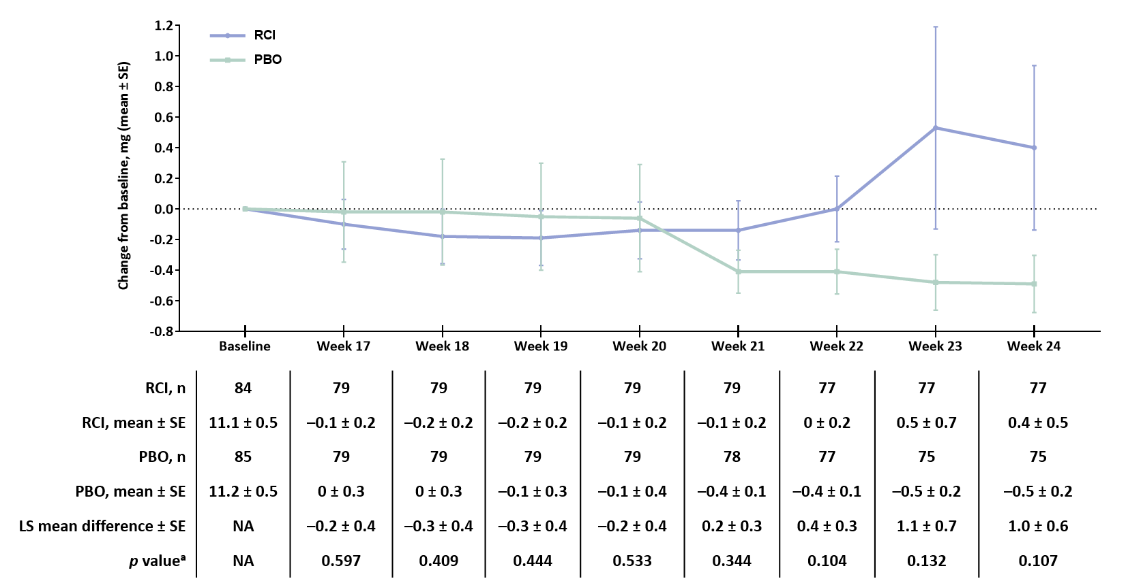
Figure S1. Change from baseline in daily prednisone equivalent dose during the optional taper period in the mITT population

ªThe p values were assessed for the LS mean difference using ANCOVA models with the change from baseline as the dependent variable, treatment as the factor, and baseline value of the corresponding endpoint as the covariate, with stratification for location (US and outside the US) and baseline glucocorticoid dose (≤20 and >20 mg per day).
ANCOVA=analysis of covariance. LS=least square. mITT=modified intention-to-treat. NA=not applicable. PBO=placebo. RCI=repository corticotropin injection. SE=standard error.

Table S1: Exploratory endpoints in the mITT population
 | RCI (N=84) | Placebo (N=85) | OR (95% CI)ª | p value^{b}
Proportion of patients with a decrease in prednisone equivalent dose to <7.5 mg per day at Week 24, no. (%) | 4 (4.8) | 6 (7.1) | 0.7 (0.2 to 2.4) | 0.4858
Proportion of patients with a decrease in prednisone equivalent dose by >50% compared with baseline at Week 24, no. (%) | 0 (0) | 1 (1.2) | NA | 0.3173
Proportion of SRI-4 responders at Week 16 that maintained SRI-4 response through Week 24, n/N (%) | 32/40 (80.0) | 30/37 (81.1) | 0.9 (0.3 to 2.9) | 0.7204
Proportion of patients with ≥4-point reduction in SLEDAI-2K at Week 24, n/N (%) | 44 (52.4) | 46 (54.1) | 0.9 (0.5 to 1.7) | 0.7996
ªThe 95% CI is asymptotic Wald confidence limits. ^{b}The p value was assessed using a CMH test stratified for location (US and outside the US) and baseline glucocorticoid dose (≤20 and >20 mg per day). CMH=Cochran-Mantel-Haenszel. mITT=modified intention-to-treat. NA=not applicable. OR=odds ratio. RCI=repository corticotropin injection. SLEDAI-2K=Systemic Lupus Erythematosus Disease Activity Index-2000. SRI-4=Systemic Lupus Erythematosus Responder Index-4.

Table S2: Exploratory endpoints for levels of cytokines, circulating leukocytes, and bone turnover markers in the mITT population
 | Baseline |  | Change from baseline at Week 24 |  | LS mean difference  (95% CI) | p value^{b}
 | RCI  (N=84) | Placebo  (N=85) | RCI  (N=84) | Placebo  (N=85) | LS mean difference  (95% CI) | p value^{b}
Circulating lymphocyte profile: CD19⁺ B cells, cells/µL
Naive B cells  (IgD⁺CD27⁻) | n=77  122.8 (112.9) | n=82  132.4 (131.2) | n=70  –14.7 (76.6) | n=70  2.9 (101.2) | –16.2 (–46.8 to 14.3) | 0.2953
Unswitched memory cells (IgD⁺CD27⁺) | n=77  14.4 (13.9) | n=82  12.8 (10.0) | n=70  2.6 (13.0) | n=70  0.6 (10.3) | 3.2 (–0.3 to 6.7) | 0.0763
Switched memory cells  (IgD⁻CD27⁺) | n=77  42.3 (45.5) | n=82  37.3 (27.2) | n=70  2.2 (36.1) | n=70  1.5 (20.9) | 3.4 (–5.0 to 11.9) | 0.4236
Double-negative memory cells (IgD⁻CD27⁻) | n=77  20.0 (17.2) | n=82  22.4 (29.3) | n=70  3.2 (22.0) | n=70  8.7 (39.8) | –4.9 (–15.7 to 5.9) | 0.3682
Atypical activated memory cells (IgD⁻CD27⁻CD95⁺) | n=77  6.1 (6.0) | n=82  6.7 (12.9) | n=70  0.8 (5.0) | n=70  2.0 (11.4) | –1.0 (–3.9 to 1.9) | 0.4993
Circulating lymphocyte profile: CD3⁺ total T cells, cells/µL
Helper T cells  (CD4⁺CD8⁻) | n=77  697.1 (411.6) | n=82  702.6 (420.9) | n=70  –9.2 (373.1) | n=70  –29.7 (248.2) | 42.0 (–48.5 to 132.6) | 0.3600
Cytotoxic T cells  (CD4⁻CD8⁺) | n=77  418.4 (234.6) | n=82  452.6 (268.5) | n=70  18.8 (180.5) | n=70  –11.5 (176.4) | 26.9 (–29.3 to 83.2) | 0.3450
Double-negative T cells  (CD4⁻CD8⁻) | n=77  29.5 (38.7) | n=82  38.2 (49.6) | n=70  7.5 (29.9) | n=70  6.8 (33.4) | –1.5 (–11.4 to 8.5) | 0.7720
Double-positive T cells (CD4⁺CD8⁺) | n=77  12.7 (11.3) | n=82  12.6 (15.5) | n=70  14.4 (118.5) | n=70  -0.6 (8.4) | 15.1 (–13.4 to 43.7) | 0.2963
Circulating lymphocyte profile: CD4⁺ total Treg cells, cells/µL
Naive Treg cells  (CD25⁺ -FoxP3^{low}- CD45RA⁺) | n=68  80.8 (248.3) | n=68  45.3 (85.2) | n=57  –56.4 (273.8) | n=54  37.4 (222.2) | –48.4 (–105.5 to 8.7) | 0.0955
Effector Treg cells  (CD25⁺ -FoxP3^{high}- CD45RA⁻) | n=68  64.3 (118.3) | n=68  53.0 (94.3) | n=57  –29.5 (124.3) | n=54  12.7 (138.9) | –19.9 (–55.9 to 16.1) | 0.2762
Nonsuppressive cells  (CD25⁺ -FoxP3^{low}- CD45RA⁻) | n=68  312.0 (603.7) | n=68  195.0 (367.5) | n=57  –145.6 (629.4) | n=54  81.9 (720.1) | –113.1 (–289.5 to 63.3) | 0.2066
Cytokines
IL-6, pg/mL | n=75  6.2 (11.0) | n=76  9.7 (19.8) | n=61  –0.5 (6.2) | n=60  0.8 (21.5) | –3.7 (–8.7 to 1.4) | 0.1542
IL-10, pg/mL | n=65  1.1 (1.2) | n=70  0.9 (0.9) | n=45  0.1 (1.0) | n=48  –0.1 (0.8) | 0.2 (–0.2 to 0.6) | 0.3214
IL-17, pg/mL | n=76  0.2 (0.3) | n=75  0.2 (0.2) | n=65  0.0 (0.2) | n=56  –0.03 (0.2) | 0.0 (–0.1 to 0.0) | 0.3921
Type I IFN-α, pg/mL | n=78  13.9 (7.4) | n=79  13.5 (5.1) | n=69  –1.3 (6.7) | n=65  –0.9 (5.3) | 0.1 (–0.3 to 0.4) | 0.6659
sVCAM-1, ng/mL | n=79  1047.6 (443.1) | n=78  960.3 (395.3) | n=71  –2.0 (250.9) | n=64  53.3 (228.3) | –38.0 (–119.5 to 43.5) | 0.3584
Bone turnover markers
PINP, µg/mL | n=80  44.6 (24.7) | n=80  47.0 (24.6) | n=73  2.4 (19.4) | n=67  –0.7 (15.3) | 2.7 (–2.7 to 8.2) | 0.3162
CTX-I, µg/L | n=80  0.4 (0.2) | n=80  0.4 (0.2) | n=73  0.0 (0.2) | n=66  0.0 (0.2) | 0.0 (0.0 to 0.1) | 0.0823
ªThe p values were assessed using ANCOVA models with the change from baseline as the dependent variable, treatment as the factor, and baseline value of the corresponding endpoints as the covariate, with stratification for location (US and outside the US) and baseline glucocorticoid dose (≤20 and >20 mg per day).
Data are in mean (SD). ANCOVA=analysis of covariance. CD=cluster of differentiation. CTX-I=C-terminal crosslinking telopeptide of type I collagen. FOXP3=forkhead box protein 3. IFN=interferon. Ig=immunoglobulin. IL=interleukin. LS=least square. mITT=modified intention-to-treat. PINP=N-terminal propeptide of type I collagen. RCI=repository corticotropin injection. SD=standard deviation. sVCAM=soluble vascular cell adhesion molecule. Treg=regulatory T.

