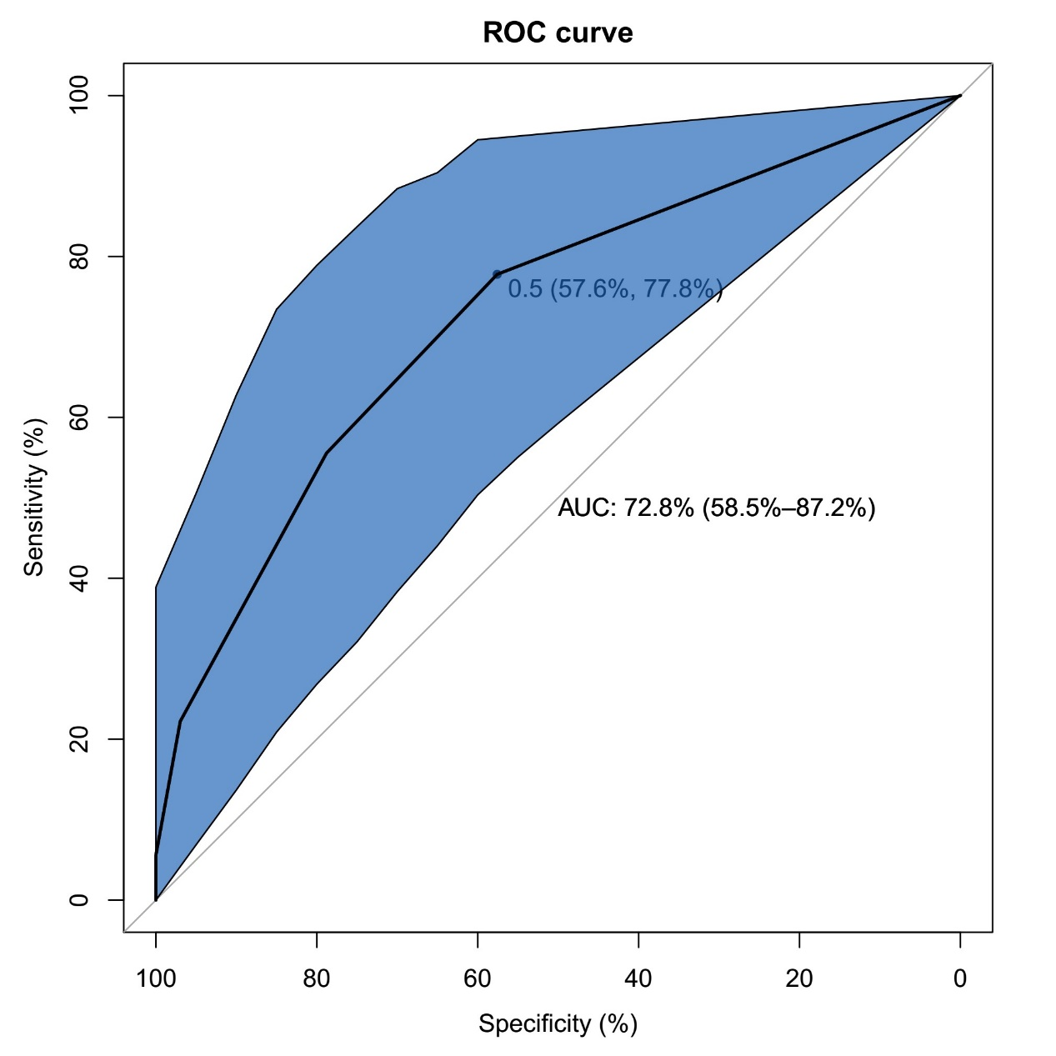
Supplementary Fig 1
ROC curve analysis revealed an area under curve of 0.728 and a cutoff value of 0.5.

