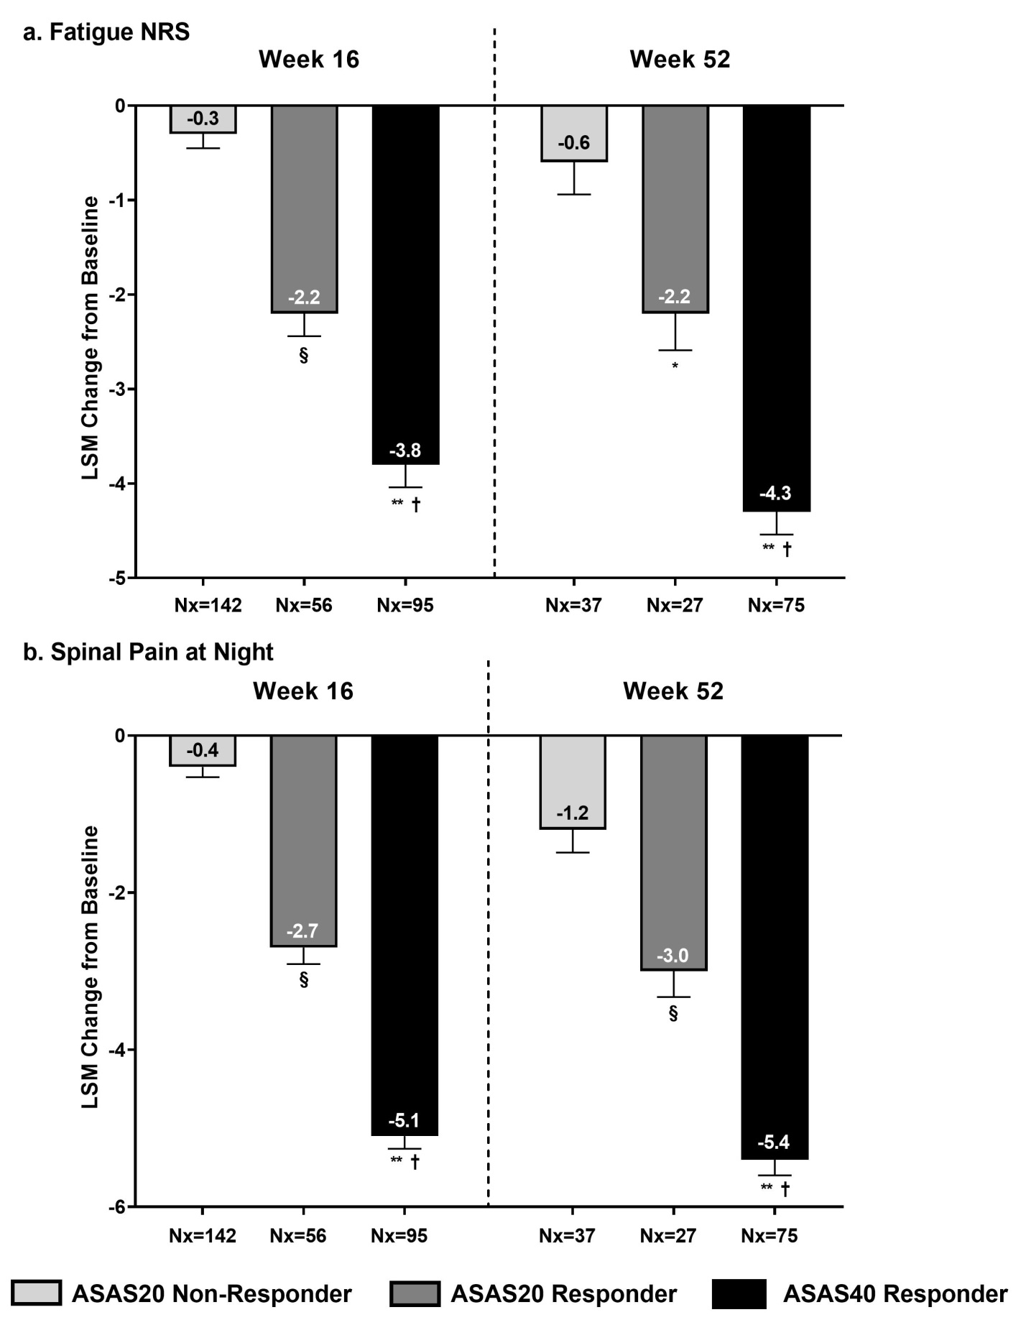
Supplemental Figure S1. Association between ASAS response and changes from baseline in a) fatigue (Fatigue NRS) and b) spinal pain at night.
Values are LSM (SE) from ANCOVA. Missing data was imputed by mBOCF.
p values were from ANCOVA after correcting for baseline value, age, gender, and ASAS response category. §=p<0.001, ASAS20 responder vs. ASAS20 non-responder; *=p<0.01, ASAS20 responder vs. ASAS20 non-responder; **=p<0.001, ASAS40 responder vs. ASAS20 non-responder; †=p<0.001, ASAS40 responder vs. ASAS20 responder.
ANCOVA=analysis of covariance; ASAS=Assessment of Spondyloarthritis International Society; LSM=least-squares mean; mBOCF=modified baseline observation carried forward; Nx=number of non-missing observations; NRS=numeric rating scale; SE=standard error.

