Supplementary Methods

Exclusion criteria
Patients were excluded from the long-term extension (LTE) study if they had taken any of the following agents between the end of study RAJ1 and the start of the extension study: biologic disease-modifying antirheumatic drugs (DMARDs) (etanercept, adalimumab, golimumab, infliximab, tocilizumab, abatacept, rituximab), nonbiologic DMARDs (methotrexate [MTX], salazosulfapyridine, gold, D-penicillamine, leflunomide, lobenzarit, actarit, tacrolimus, mizoribine, bucillamine, iguratimod, tofacitinib), or other RA drugs (e.g., cyclosporine, cyclophosphamide, azathioprine, minomycin). Patients were also excluded if they received prohibited concomitant medication or therapy (see below) between the end of studies RAJ3 or RAJ4 and the start of the extension study.

Concomitant medications
The following concomitant medications (new administration and dose adjustments) were permitted at the discretion of the investigator: nonsteroidal anti-inflammatory drugs (NSAIDs), oral morphine (≤30 mg/day or equivalent of other opioid analgesics), and acetaminophen. If concurrent MTX was administered, the concomitant use of folic acid (maximum 10 mg/week) was considered, where possible.
Concomitant use of the following drugs was prohibited during the extension study treatment period: biologic DMARDs (etanercept, anakinra, adalimumab, golimumab, infliximab, tocilizumab, abatacept, rituximab, certolizumab pegol, denosumab, sarilumab) and nonbiologic DMARDs according to preceding study (RAJ1: MTX, salazosulfapyridine, gold, D-penicillamine, leflunomide, lobenzarit, actarit, tacrolimus, mizoribine, bucillamine, iguratimod, tofacitinib, baricitinib; RAJ3: all except those used concomitantly during RAJ3; RAJ4: salazosulfapyridine, gold, D-penicisllamine, leflunomide, lobenzarit, actarit, tacrolimus, mizoribine, bucillamine, iguratimod, tofacitinib, baricitinib).
The daily dose (prednisolone equivalent) of any oral corticosteroid was prohibited from exceeding the amount used at the initiation of studies RAJ1, RAJ3, or RAJ4.

Outcomes
The American College of Rheumatology (ACR) core set included tender joint count at 68 joints [TJC68], swollen joint count at 66 joints [SJC66], Subject’s Global Assessment of Pain [SGAP], Subject’s Global Assessment of Disease Activity [SGA], Physician’s Global Assessment of Disease Activity [PGA], and Health Assessment Questionnaire – Disability Index [HAQ-DI]).

Supplementary results

Case histories of patients who died

Death due to malignant lymphoma during the study
A 65-year-old man from Japan enrolled in the RAJ4 study and started placebo treatment on April 09, 2015. He switched to peficitinib 100 mg/day at Week 12 on July 02, 2015. On April 07, 2016 (Day 1), the patient provided informed consent for the RAJ2 study and started treatment with peficitinib 100 mg/day. The patient had a medical history of diabetes, hyperuricemia, hyperlipidemia, right kidney cyst, constipation, colon polyp, colon diverticulosis, trichophytosis unguium and pulmonary emphysema. He was also receiving concomitant MTX (oral, 12 mg/week). Other concomitant medications at the time of the first dose of peficitinib in the extension study included prednisolone, teprenone, loxoprofen sodium, magnesium oxide, folic acid, risedronate sodium, ketoprofen, alogliptin benzoate, febuxostat, glimepiride, metformin hydrochloride, atorvastatin calcium, omega-3-acid ethyl ester, adenosine triphosphate, disodium salt and betahistine mesilate.
On June 17, 2016 (Day 72), the patient began to experience thoracoabdominal pain, appetite impairment, excessive sweating and malaise. On June 21, 2016 (Day 76), the patient was admitted to hospital with pyrexia, elevated C-reactive protein (CRP) (9.55 mg/dL) and elevated lactate dehydrogenase (LDH; 3365 U/L). Thoracoabdominal computerized tomography (CT) examination showed multiple hepatic and splenic masses, with a suspected diagnosis of malignant lymphoma. Treatment with peficitinib and MTX were suspended on June 21, 2016. On June 24, 2016, bone marrow aspiration confirmed the diagnosis of malignant lymphoma and the investigator discontinued the study. Disseminated intravascular coagulation (DIC) developed, associated with the malignant lymphoma.
On June 25, 2016 (Day 80), chemotherapy with intravenous etoposide, intravenous vincristine sulfate and intravenous doxorubicin hydrochloride was initiated, but was interrupted later the same day following observation of pupillary inequality and a depressed level of consciousness. CT examination revealed a subdural hematoma, which was evacuated by craniotomy. On June 26, 2016 (Day 81), post-operative pupillary inequality improved after artificial respiration control, transfusion and DIC treatment were administered. On June 27, 2016 (Day 82), hemorrhage was observed in the left subdural space. Chemotherapy was resumed on June 29, 2016 (Day 84), and convulsions began to occur on the same day. On June 30, 2016 (Day 85), SpO₂ decreased to 80–90%, and further convulsions, pupillary inequality and loss of light reflex in the right pupil were observed. CT and MRI examinations showed a midline shift and brain infarction. Chemotherapy was terminated on July 03, 2016 (Day 88). On July 04, 2016 (Day 89), aspiration was performed, SpO₂ and heart rate decreased, and dilated pupils and loss of brainstem reflex were observed. During the morning of July 06, 2016 (Day 91), the patient’s respiratory status was unstable, and cyanosis and cold feeling were noted. On July 07, 2016 (Day 92), the patient was diagnosed with advanced neutropenia associated with chemotherapy, left atelectasis due to sputum retention, hepatic shock and renal failure. Blood culture showed Gram-negative rods. On July 08, 2016 (Day 93), heart rate decreased to 40–50 bpm and intermittent convulsion developed. The patient died on July 09, 2016 (Day 94).
The investigator considered the malignant diffuse large B-cell lymphoma probably related to the study drug as the event developed after initiation of peficitinib, although the event could also be due to the underlying disease after long-term MTX treatment.

Death due to pneumonia during the study
A 58-year-old man from Taiwan enrolled in the RAJ3 study and started peficitinib 150 mg treatment on February 17, 2016. On February 15, 2017 (Day 1) the patient provided informed consent for the RAJ2 study and started treatment with peficitinib 100 mg/day. On April 03, 2018 (Day 413), the peficitinib dose was increased to 150 mg/day. The patient had a medical history of diabetes, hypertension, hyperlipidemia, and left ventricular hypertrophy. He was also receiving concomitant MTX (oral, 10 mg/week), sulfasalazine (oral, 2000 mg/day) and hydroxychloroquine (oral, 400 mg/day). Other concomitant medications at the time of the first dose of peficitinib in the extension study included amlodipine, metformin, folic acid and etoricoxib.
On March 29, 2019 (Day 773) the patient was admitted to hospital with shortness of breath, accompanying productive cough with purulent sputum, but no fever. Chest X-ray examination showed multifocal alveolar infiltrates over the bilateral lung fields. Physical examination showed body temperature 37.1°C, pulse rate 112 bpm, respiratory rate 40 bpm and blood pressure 104/64 mmHg. The patient had respiratory distress with SpO₂ 78% and clear consciousness. Decreased and coarse breath sounds were heard over the bilateral lower lung fields. No abdominal tenderness or pitting edema were found. The patient wore a non-rebreathing mask in the emergency room. Thereafter, the patient started to receive empiric treatment with ciprofloxacin (intravenous) and cefepime (intravenous) for suspected infection; however, the patient still presented desaturation without respiratory distress under a non-rebreather face mask. The patient began intubation and ventilator support and was transferred to the intensive care unit. On March 29, 2019 (Day 773) the patient received levofloxacin (intravenous), hydrocortisone sodium succinate (intravenous, 100 mg/day), ipratropium bromide/salbutamol sulfate (respiratory [inhalation]), cefuroxime axetil (intravenous) and piperacillin/tazobactam (intravenous). Treatment with peficitinib was interrupted and the last dose was taken on March 29, 2019 (Day 773).
On March 30, 2019 (Day 774), the patient still presented desaturation despite full ventilator use for infection. Chest X-ray examination revealed acute respiratory distress syndrome with pulmonary edema. The patient began trimethoprim–sulfamethoxazole (intravenous) treatment due to a suspected Pneumocystis jirovecii infection. As O₂ desaturation was not reversed after a combination of diuretic and albumin supply, and arterial gas revealed decreased PaO₂, veno-venous extracorporeal membrane oxygenation (ECMO) was initiated for acute respiratory distress syndrome. On April 01, 2019 (Day 776), blood gas examination still showed low PaO₂, and after adjusting the ECMO flow rate, blood PaO₂ had gradually improved. Chest X-ray examination showed bilateral lung white-out, and a left side pig tail was inserted for pleural effusion drainage. Empyema was suspected due to elevated LDH (1725 U/L; normal range: 95 to 213 U/L) and sputum culture was positive for yeast. Voriconazole was prescribed, treatment with trimethoprim–sulfamethoxazole continued, and the dose of hydrocortisone was gradually reduced. Treatment with ciprofloxacin and cefepime was ongoing. On April 03, 2019 (Day 778) ciprofloxacin treatment was terminated, and on April 08, 2019 (Day 783) cefepime treatment was terminated. After a positive galactomannan test and sputum culture showed presence of Aspergillosis species, voriconazole was prescribed for invasive fungal infection. Furthermore, bilateral pleural effusion drainage was performed. Since elevated LDH was found in the pleural fluid and emphysema was less likely, treatment with voriconazole and meropenem was ongoing. Despite elevation of ECMO flow rate, a blood gas test showed low PaO₂ and the ventilator was adjusted to FiO₂ of 100. A chest X-ray showed no obvious improvement. Continuous veno-venous hemodialysis was initiated owing to exacerbation of the patient’s renal function, which was likely related to sepsis. During hemodialysis, blood pressure dropped and hemodialysis was interrupted. The patient died on April 12, 2019 (Day 787).
While the patient’s concurrent diabetes made him susceptible to infection, the investigator considered the multifocal pneumonia possibly related to study drug due to the immunosuppressive properties of peficitinib with a long period of exposure, although concomitant MTX would have also contributed to pneumonia due to its immunosuppressive properties.

Death due to uterine sarcoma after discontinuation from the study
A 65-year-old woman from Japan who was enrolled in the RAJ1 study received her first dose of peficitinib 150 mg/day on May 11, 2012. She had a medical history of hyperlipidemia, osteoporosis, urine occult blood reaction and hypertension. Concomitant medications at the time of first dose of peficitinib in the extension study included atorvastatin calcium, risedronate sodium, amlodipine besilate, methylprednisolone, nabumetone and rebamipide. Following enrolment in the RAJ2 study, the patient started to receive peficitinib 50 mg/day on August 31, 2012 (Day 1).
On April 12, 2013 (Day 225), mild elevation of CRP and leukocyte count were noted, although there were no signs of infection; the study drug was discontinued from June 07, 2013, following further increases in CRP and leukocyte count. On July 20, 2013 (Day 324), positron emission tomography (PET)/CT showed a suspected uterine cancer. Further examination on July 26, 2013 (Day 330) revealed a suspected myoma (size 4.9 cm) and endometritis. On August 12, 2012 (Day 347), a transvaginal scan revealed a 9.9 cm-sized tumor. Further assessments on September 30, 2013 (Day 396) and October 11, 2013 (Day 407) indicated gastrointestinal perforation, symptoms of ileus and adherence of the uterine tumors to the bladder and rectum. Uterine sarcoma or cancer was diagnosed. As the patient was unable to take meals, she experienced malnutrition and dehydration. She was discharged from hospital care on October 23, 2013 (Day 419).
In December 2013, the patient presented with edema, vomiting, and abdominal pain; there were also signs of hematuria. On December 13, 2013 (Day 470), the patient began to receive drip infusion treatment with high-calorie infusion, prochlorperazine maleate, oxycodone hydrochloride, octreotide acetate, rebamipide, acetaminophen and fentanyl citrate. Ascites were also drained. An oxygen tube and ureteral catheter were placed. From December 23, 2013 (Day 483), the patient responded poorly to verbal stimulation, and all oral drugs were discontinued. She became dependent on drip infusion for nutritional support from December 26, 2013 (Day 483) and died on December 28, 2013 (Day 485).
Other adverse events experienced by the patient during the study included chronic gastritis and sliding hiatal hernia. The investigator considered the elevation of CRP and leukocytes possibly related to peficitinib, and the suspected uterine sarcoma possibly related to peficitinib, as the tumor may have developed after initiation of study drug.

Study sites
A list of study sites has been published previously [19].

Supplementary Tables

Table S1 Institutional Review Board or Independent Ethics Committee at each study site
Country | Site number | Independent Review Board or Ethics Committee name
Japan | 001 | Yokohama Minoru Clinic Institutional Review Board
 | 002 | Sone clinic Institutional Review Board
 | 003 | Sapporo City General Hospital Institutional Review Board
 | 004 | Sendai Institutional Review Board
 | 005 | Sendai Institutional Review Board
 | 006 | Niigata University Medical and Dental Hospital Institutional Review Board
 | 007 | Yokohama Minoru Clinic Institutional Review Board
 | 008 | Yokohama Minoru Clinic Institutional Review Board
 | 009 | Sone clinic Institutional Review Board
 | 010 | Sone clinic Institutional Review Board
 | 011 | Sone clinic Institutional Review Board
 | 012 | Sone clinic Institutional Review Board
 | 013 | Hiroshima Red Cross Hospital & Atomic-Bomb Survivors Hospital Institutional Review Board
 | 014 | Sone clinic Institutional Review Board
 | 015 | Sone clinic Institutional Review Board
 | 016 | Sone clinic Institutional Review Board
 | 017 | Sone clinic Institutional Review Board
 | 018 | Sone clinic Institutional Review Board
 | 019 | Kumamoto Saishun Medical Center Institutional Review Board
 | 020 | Kyushu Medical Center Institutional Review Board
 | 021 | Sone clinic Institutional Review Board
 | 022 | Kumamoto Orthopaedic Hospital Institutional Review Board
 | 023 | Sendai Institutional Review Board
 | 024 | Tokyo Medical and Dental University Hospital Institutional Review Board
 | 025 | Nagaoka Red Cross Hospital Institutional Review Board
 | 026 | Toyooka Chuo Hospital Institutional Review Board
 | 027 | Sendai Institutional Review Board
 | 028 | Sendai Institutional Review Board
 | 029 | Niigata University Medical and Dental Hospital Institutional Review Board
 | 030 | Taga General Hospital Institutional Review Board
 | 031 | Hokkaido University Hospital Institutional Review Board
 | 032 | Tokyo Women's Medical University Institutional Review Board
 | 033 | Inoue Hospital Institutional Review Board
 | 034 | Sendai Institutional Review Board
 | 035 | Ono Hospital Institutional Review Board
 | 036 | Yokohama Minoru Clinic Institutional Review Board
 | 037 | Nagoya University Hospital Institutional Review Board
 | 038 | Hokkaido Medical Center for Rheumatic Diseases Institutional Review Board
 | 039 | University of Tsukuba Hospital Institutional Review Board
 | 040 | University of Occupational and Environmental Health Hospital Institutional Review Board
 | 041 | Matsubara Mayflower Hospital Institutional Review Board
 | 042 | Matsubara Mayflower Hospital Institutional Review Board
 | 043 | The University of Tokyo Hospital Institutional Review Board
 | 044 | Sone clinic Institutional Review Board
 | 045 | Sone clinic Institutional Review Board
 | 046 | Sone clinic Institutional Review Board
 | 047 | Sone clinic Institutional Review Board
 | 048 | Kawasaki Municipal Hospital Institutional Review Board
 | 049 | Sendai Institutional Review Board
 | 050 | Yokohama Minoru Clinic Institutional Review Board
 | 051 | Sone clinic Institutional Review Board
 | 052 | Sone clinic Institutional Review Board
 | 053 | Yokohama Minoru Clinic Institutional Review Board
 | 054 | Sone clinic Institutional Review Board
 | 055 | Sendai Institutional Review Board
 | 056 | Sone clinic Institutional Review Board
 | 057 | Yokohama Minoru Clinic Institutional Review Board
 | 058 | Yokohama Minoru Clinic Institutional Review Board
 | 059 | Kyushu Medical Center Institutional Review Board
 | 060 | Clinical Research Hospital Tokyo Institutional Review Board
 | 061 | Osaka Toneyama Medical Center Institutional Review Board
 | 062 | Adachi Kyosai Hospital Institutional Review Board
 | 063 | Yokohama Minoru Clinic Institutional Review Board
 | 064 | Beppu Medical Center Institutional Review Board
 | 065 | Kyushu Central Hospital Institutional Review Board
 | 066 | Yokohama Minoru Clinic Institutional Review Board
 | 067 | Fukuoka Hospital Institutional Review Board
 | 068 | Koseiren Hospital Central Institutional Review Board
 | 069 | Himeji Medical Center Institutional Review Board
 | 070 | Saiseikai Suita Hospital Institutional Review Board
 | 071 | St. Mary's Hospital Institutional Review Board
 | 072 | Tokyo Medical Center Institutional Review Board
 | 073 | Review Board of Human Rights and Ethics for Clinical Studies Institutional Review Board
 | 074 | Kagoshima Red Cross Hospital Institutional Review Board
 | 075 | Ureshino Medical Center Institutional Review Board
 | 076 | Kyushu Central Hospital Institutional Review Board
 | 077 | Koseiren Hospital Central Institutional Review Board
 | 078 | Osaka Minami Medical Center Institutional Review Board
 | 080 | Nagano Municipal Hospital Institutional Review Board
 | 081 | Japanese Red Cross Medical Center Institutional Review Board
 | 083 | Toho University Ohashi Medical Center Institutional Review Board
 | 084 | Tokai University Hospital Institutional Review Board
 | 085 | University Hospital Kyoto Prefectural University of Medicine Institutional Review Board
 | 086 | Osaka University Hospital Institutional Review Board
 | 088 | Kagawa University Hospital Institutional Review Board
 | 089 | Sendai Institutional Review Board
 | 090 | Hakodate Goryoukaku Hospital Institutional Review Board
 | 092 | Kobe University Hospital Institutional Review Board
 | 093 | Clinical Research Hospital Tokyo Institutional Review Board
 | 094 | Hanna Hospital Institutional Review Board
 | 095 | Mitsui Memorial Hospital Institutional Review Board
 | 096 | Yokohama City Minato Red Cross Hospital Institutional Review Board
 | 098 | Nihonbashi Sakura Clinic Institutional Review Board
 | 099 | Review Board of Human Rights and Ethics for Clinical Studies Institutional Review Board
 | 100 | Hanna Hospital Institutional Review Board
 | 101 | Nagasaki Medical Center Institutional Review Board
 | 102 | Tokushukai Group Institutional Review Board
 | 103 | Nihonbashi Sakura Clinic Institutional Review Board
 | 104 | Hoshikuma Hihuka Allergy Clinic Institutional Review Board
 | 105 | Yukaria Institutional Review Board
 | 106 | Hoshikuma Hihuka Allergy Clinic Institutional Review Board
 | 107 | Review Board of Human Rights and Ethics for Clinical Studies Institutional Review Board
 | 108 | Toyohashi Medical Center Institutional Review Board
 | 109 | Nagoya Medical Center Institutional Review Board
 | 112 | The Japanese Red Cross Nagasaki Genbaku Hospital Institutional Review Board
 | 114 | Tonan Hospital Institutional Review Board
 | 115 | Chibaken Saiseikai Narashino Hospital Institutional Review Board
 | 117 | Hyogo College of Medicine College Hospital Institutional Review Board
 | 118 | Japanese Red Cross Okayama Hospital Institutional Review Board
 | 119 | Shinkokura Hospital Institutional Review Board
 | 120 | Iizuka Hospital Institutional Review Board
 | 122 | Shimin-No-Mori Hospital Institutional Review Board
 | 123 | Japanese Red Cross Kyoto Daiichi Hospital Institutional Review Board
 | 124 | Oki Medical Clinic Institutional Review Board
 | 125 | Kushiro Red Cross Hospital Institutional Review Board
 | 126 | Clinical Research Hospital Tokyo Institutional Review Board
 | 129 | Review Board of Human Rights and Ethics for Clinical Studies Institutional Review Board
 | 130 | Chubu Rosai Hospital Institutional Review Board
 | 131 | Hamanomachi Hospital Institutional Review Board
 | 133 | Hamamatsu University Hospital Institutional Review Board
 | 134 | Higashiosaka City Medical Center Institutional Review Board
 | 135 | Japanese Red Cross Shizuoka Hospital Institutional Review Board
 | 136 | Kinki Central Hospital Institutional Review Board
 | 137 | Kindai University Hospital Institutional Review Board
 | 138 | Shimoshizu National Hospital Institutional Review Board
 | 139 | Toyama University Hospital Institutional Review Board
 | 140 | Fujita Health University Hospital Institutional Review Board
 | 141 | Sagamihara Hospital Institutional Review Board
 | 142 | St. Luke's International Hospital Institutional Review Board
 | 143 | The University of Tokyo Hospital Institutional Review Board
 | 144 | Niigata Rheumatic Center Institutional Review Board
 | 145 | Jichi Medical University Hospital Institutional Review Board
 | 146 | Osaka University Hospital Institutional Review Board
 | 147 | Nagasaki University Hospital Institutional Review Board
 | 148 | Toho University Omori Medical Center Institutional Review Board
 | 149 | Juntendo University Hospital Institutional Review Board
 | 150 | Osaka City University Hospital Institutional Review Board
 | 151 | Tohoku University Hospital Institutional Review Board
 | 152 | Nippon Medical School Hospital Institutional Review Board
 | 153 | Sasebo Chuo Hospital Institutional Review Board
 | 154 | Kobe University Hospital Institutional Review Board
 | 155 | Nihonbashi Sakura Clinic Institutional Review Board
 | 156 | Koseiren Hospital Central Institutional Review Board
 | 157 | Osaka Medical Association Institutional Review Board
 | 158 | Sone clinic Institutional Review Board
 | 159 | Kyoto University Hospital Institutional Review Board
 | 161 | Saitama Medical Center Institutional Review Board
 | 162 | Isahaya General Hospital Institutional Review Board
 | 163 | Higashihiroshima Memorial Hospital Institutional Review Board
 | 164 | Kyushu University Hospital Institutional Review Board
 | 165 | Fukushima Daiichi Hospital Institutional Review Board
 | 166 | Funabashi Municipal Medical Center Institutional Review Board
 | 167 | Hoshikuma Hihuka Allergy Clinic Institutional Review Board
 | 168 | Yokkaichi Hazu Medical Center Institutional Review Board
 | 169 | Osaki Citizen Hospital Institutional Review Board
 | 170 | Toyohashi Municipal Hospital Institutional Review Board
 | 171 | Shinko Hospital Institutional Review Board
 | 172 | Japanese Red Cross Kitami Hospital Institutional Review Board
 | 174 | Nagano Red Cross Hospital Institutional Review Board
 | 175 | Daido Medicine Institutional Review Board
 | 176 | Sendai Institutional Review Board
 | 178 | Tomisaka Clinic Institutional Review Board
 | 179 | Fukui General Hospital Institutional Review Board
 | 180 | Review Board of Human Rights and Ethics for Clinical Studies Institutional Review Board
 | 181 | Review Board of Human Rights and Ethics for Clinical Studies Institutional Review Board
Korea | 501 | Seoul National University Hospital Institutional Review Board
 | 502 | Hanyang Univsersity Seoul Hospital Institutional Review Board
 | 504 | Daegu Catholic University Medical Center Institutional Review Board
 | 505 | Chonnam National University Hospital Institutional Review Board
 | 506 | Inha University Hospital Institutional Review Board
 | 507 | Ajou University Hospital Institutional Review Board
 | 508 | Chonbuk National University Hospital Institutional Review Board
 | 509 | Konkuk University Medical Center Institutional Review Board
 | 511 | KyungHee University Hospital Institutional Review Board
Taiwan | 701 | National Taiwan University Hospital Research Ethics Committee
 | 702 | Institutional Review Board of the Taipei Veterans General Hospital
 | 703 | Chang Gung Medical Foundation Institutional Review Board
 | 704 | Institutional Review Board of the Taichung Veterans General Hospital
 | 705 | China Medical University and Hospital Research Ethics Committee
 | 709 | Institutional Review Board of the Kaohsiung Veterans General Hospital
 | 710 | Chung Shan Medical University Hospital Institutional Review Board
 | 711 | Cathay General Hospital Institutional Review Board
 | 712 | National Cheng Kung University Hospital Institutional Review Board

Table S2 Patient demographics and characteristics by preceding study, and overall, at the extension study baseline (SAF)
 | RAJ1  (N=201) | RAJ3  (N=225) | RAJ4  (N=417) | Total  (N=843)
Age, years | 52.7 (11.3) | 55.3 (12.7) | 57.3 (11.4) | 55.7 (11.9)
Female, n (%) | 158 (78.6) | 164 (72.9) | 297 (71.2) | 619 (73.4)
Study region, n (%)  Japan  Korea  Taiwan | 201 (100.0)  0  0 | 188 (83.6)  19 (8.4)  18 (8.0) | 417 (100.0)  0  0 | 806 (95.6)  19 (2.3)  18 (2.1)
RA duration at baseline of preceding study, years¹ | 7.3 (6.1) | 8.7 (7.2) | 4.3 (3.0) | 6.2 (5.6)
Patients in prednisolone dose category, n (%)  None  0–5 mg/day  >5 mg/day | 87 (43.3)  91 (45.3)  23 (11.4) | 129 (57.3)  83 (36.9)  13 (5.8) | 213 (51.1)  169 (40.5)  35 (8.4) | 429 (50.9)  343 (40.7)  71 (8.4)
Prior non-biologic DMARD use² | 143 (71.1) | 182 (80.9) | 238 (57.1) | 563 (66.8)
Prior biologic DMARD-IR³ | 18 (9.0) | 16 (7.1) | 1 (0.2) | 35 (4.2)
Patients receiving concomitant DMARD, n (%)  None  MTX  DMARD except for MTX | 201 (100)  0  0 | 29 (12.9)  136 (60.4)  60 (26.7) | 4 (1.0)  413 (99.0)  0 | 234 (27.8)  549 (65.1)  60 (7.1)
Maximum MTX dose category, n (%)  None  0–≤8 mg/week  8–≤12 mg/week  >12 mg/week | 0  0  0  0 | 90 (40.0)  43 (19.1)  59 (26.2)  33 (14.7) | 1 (0.2)  207 (49.6)  162 (38.8)  47 (11.3) | 91 (14.2)  250 (38.9)  221 (34.4)  80 (12.5)
Tender joint count at 68 joints⁴ | 10.8 (9.6) | 3.2 (5.1) | 3.4 (6.0) | 5.1 (7.5)
Swollen joint count at 66 joints⁴ | 8.2 (6.8) | 2.8 (4.2) | 2.6 (3.6) | 4.0 (5.3)
HAQ-DI score⁵ | 0.86 (0.62) | 0.50 (0.52) | 0.51 (0.55) | 0.59 (0.58)
CRP, mg/dL⁶ | 1.89 (2.28) | 0.58 (1.02) | 0.54 (0.96) | 0.87 (1.51)
ESR, mm/h⁶ | 42.3 (24.3) | 24.3 (20.4) | 24.0 (20.1) | 28.4 (22.6)
DAS28-CRP⁴ | 4.53 (1.42) | 2.62 (1.08) | 2.53 (1.14) | 3.03 (1.46)
DAS28-ESR⁴ | 5.20 (1.44) | 3.19 (1.24) | 3.11 (1.28) | 3.63 (1.58)
CDAI score⁴ | 23.44 (14.37) | 8.18 (7.57) | 7.75 (8.04) | 11.59 (11.83)
SDAI score⁴ | 25.33 (15.46) | 8.75 (8.01) | 8.31 (8.48) | 12.47 (12.69)
Data are expressed as mean (SD) unless otherwise stated
¹Duration of RA was calculated as (date of screening visit of preceding study – onset date of RA + 1)/365.25
²Except for MTX use, at baseline of preceding study
³At baseline of preceding study
⁴Higher scores indicate greater levels of disease activity
⁵Possible HAQ-DI scores range 0–3, with higher scores indicating greater disability
⁶Higher CRP and ESR values indicate greater inflammation
CDAI Clinical Disease Activity Index, CRP C-reactive protein, DAS Disease Activity Score, DMARD disease-modifying antirheumatic drug, ESR erythrocyte sedimentation rate, HAQ-DI Health Assessment Questionnaire – Disability Index, IR inadequate response, MTX methotrexate, RA rheumatoid arthritis, SAF safety analysis set, SDAI Simplified Disease Activity Index

Table S3 Peficitinib treatment exposure and changes in peficitinib dose during the overall period, by preceding study (SAF)
 | RAJ1  (N=201) | RAJ3  (N=225) | RAJ4  (N=417)
Duration of peficitinib exposure, months¹  Mean (SD)  Minimum  Median  Maximum | 47.1 (30.1)  0.5  51.1  85.2 | 28.1 (11.3)  0.9  30.3  46.9 | 26.9 (11.2)  0.1  27.4  46.9
Duration of initial peficitinib dose, months²  Mean (SD)  Minimum  Maximum | 11.0 (20.0)  0.5  83.6 | 19.7 (14.2)  0.9  46.9 | 19.5 (13.8)  0.1  46.9
Treatment compliance rate (%)³  Mean (SD) | 98.9 (1.9) | 97.7 (4.8) | 98.3 (2.6)
Patients with dose increase, n (%)  No  Yes  1 dose increase  2 dose increases  ≥3 dose increases | 36 (17.9)  165 (82.1)  103 (51.2)  57 (28.4)  5 (2.5) | 147 (65.3)  78 (34.7)  73 (32.4)  5 (2.2)  0 | 278 (66.7)  139 (33.3)  133 (31.9)  4 (1.0)  2 (0.5)
Patients with dose decrease, n (%)  No  Yes  1 dose decrease  2 dose decreases  ≥3 dose decreases | 190 (94.5)  11 (5.5)  8 (4.0)  3 (1.5)  0 | 208 (92.4)  17 (7.6)  15 (6.7)  2 (0.9)  0 | 398 (95.4)  19 (4.6)  18 (4.3)  1 (0.2)  0
Maximum peficitinib dose, n (%)  50 mg/day  100 mg/day  150 mg/day | 36 (17.9)  105 (52.2)  60 (29.9) | 0  153 (68.0)  72 (32.0) | 0  285 (68.3)  132 (31.7)
¹Duration of exposure for overall period (days) was calculated as: date of the last dose of study drug – date of initial dose of study drug + 1
²Duration from first peficitinib taken (50 mg/day for patients from RAJ1, 100 mg/day for patients from RAJ3 and RAJ4) up to first dose change was calculated
³Treatment compliance for overall period (%) was calculated as: 100 × (total number of tablets actually received in the overall period / total number of tablets planned to receive in the overall period)
SAF safety analysis set, SD standard deviation

Table S4 Overview of treatment-emergent adverse events in the overall period, by preceding study (SAF)
 | RAJ1 (N=201)  n (%) | RAJ3 (N=225)  n (%) | RAJ4 (N=417)  n (%)
All TEAEs | 193 (96.0) | 208 (92.4) | 395 (94.7)
Drug-related¹ TEAEs | 175 (87.1) | 160 (71.1) | 321 (77.0)
≥Grade 3 TEAE² | 75 (37.3) | 73 (32.4) | 118 (28.3)
All SAEs | 59 (29.4) | 56 (24.9) | 84 (20.1)
Drug-related¹ SAEs | 22 (10.9) | 37 (16.4) | 54 (12.9)
TEAEs leading to permanent discontinuation of study drug
All | 50 (24.9) | 34 (15.1) | 56 (13.4)
Drug-related¹ | 30 (14.9) | 18 (8.0) | 44 (10.6)
SAEs | 23 (11.4) | 20 (8.9) | 32 (7.7)
Drug-related SAEs | 11 (5.5) | 12 (5.3) | 27 (6.5)
Deaths³ | 0 | 1 (0.4) | 1 (0.2)
Treatment-emergent adverse events were defined as any AE that started or worsened in severity after initial dose of study drug in the extension study until the end of the final observation
¹Possible or probable, as assessed by the investigator or records where relationship was missing
²National Cancer Institute Common Terminology Criteria for Adverse Events (NCI-CTCAE): grade 3, severe or medically significant; grade 4, life-threatening; grade 5, death related to AE
³One death during the study due to diffuse large B-cell lymphoma was considered probably related to study drug. One death during the study due to pneumonia and one death after the end of the study due to uterine sarcoma were considered possibly related to study drug
SAF safety analysis set (all patients who received at least one dose of study drug), AE adverse event, SAE serious adverse event, TEAE treatment-emergent adverse event

Table S5 Serious herpes zoster-related disease in the overall period, by maximum dose of study drug and preceding study (SAF)
Preceding study | Treatment | Patient ID | Age, sex | Adverse event¹ | Onset day, end day | Severity | Action taken with study drug | Outcome | Relationship to study drug
RAJ1 | Peficitinib 100 mg | S03312 | 54 years, female | Herpes zoster | Day 258, Day 323 | Grade 2 (moderate) | Not applicable | Resolved | Probable
RAJ3 | Peficitinib 100 mg | A09602 | 66 years, male | Herpes zoster | Day 96, Day 148 | Grade 2 (moderate) | Suspension/ interruption | Resolved | Possible
RAJ3 | Peficitinib 100 mg | A10102 | 59 years, female | Herpes zoster | Day 749, Day 771 | Grade 3 (severe) | Suspension/ interruption | Resolved | Probable
RAJ3 | Peficitinib 150 mg | A05002 | 70 years, female | Herpes zoster | Day 313, Day 337 | Grade 3 (severe) | Suspension/ interruption | Resolved | Possible
RAJ3 | Peficitinib 150 mg | A07501 | 59 years, female | Herpes zoster | Day 1034/- | Grade 3 (severe) | Suspension/ interruption | Resolving | Probable
RAJ4 | Peficitinib 100 mg | B00204 | 69 years, female | Herpes zoster oticus | Day 85/- | Grade 3 (severe) | Permanent Discontinuation | Resolving | Probable
RAJ4 | Peficitinib 100 mg | B00302 | 78 years, female | Herpes zoster | Day 499, Day 530 | Grade 3 (severe) | Permanent Discontinuation | Resolved | Possible
RAJ4 | Peficitinib 100 mg | B01806 | 59 years, female | Herpes zoster | Day 1078/- | Grade 3 (severe) | Suspension/ interruption | Resolving | Probable
RAJ4 | Peficitinib 100 mg | B04102 | 54 years, female | Herpes zoster | Day 648, Day 680 | Grade 3 (severe) | Suspension/ interruption | Resolved | Probable
RAJ4 | Peficitinib 100 mg | B05801 | 57 years, female | Herpes zoster disseminated | Day 629, Day 652 | Grade 3 (severe) | Suspension/ interruption | Resolved | Possible
RAJ4 | Peficitinib 150 mg | B04106 | 52 years, female | Herpes zoster | Day 263, Day 292 | Grade 3 (severe) | Suspension/ interruption | Resolved | Probable
RAJ4 | Peficitinib 150 mg | B07401 | 63 years, female | Herpes zoster | Day 1225, Day 1279 | Grade 3 (severe) | Suspension/ interruption | Resolved | Probable
RAJ4 | Peficitinib 150 mg | B08102 | 58 years, female | Herpes zoster | Day 292, Day 311 | Grade 3 (severe) | Suspension/ interruption | Resolved | Probable
RAJ4 | Peficitinib 150 mg | B09303 | 66 years, female | Herpes zoster | Day 395, Day 428 | Grade 3 (severe) | Suspension/ interruption | Resolved | Probable
RAJ4 | Peficitinib 150 mg | B13601 | 62 years, male | Herpes zoster | Day 692/- | Grade 2 (moderate) | Suspension/ interruption | Resolving | Possible
 |  |  |  | Keratitis herpetic | Day 697/- | Grade 3 (severe) | Suspension/ interruption | Resolving | Possible
RAJ4 | Peficitinib 150 mg | B15609 | 68 years, male | Herpes zoster | Day 627, Day 639 | Grade 3 (severe) | Suspension/ interruption | Resolved | Possible
Treatment-emergent adverse events were defined as any AE that started or worsened in severity after initial dose of study drug in the extension study until the end of the final observation
¹Reported according to MedDRA (v11.1) Preferred Term
LTE long-term extension

Supplementary Figures
Fig. S1 Design of the long-term extension study. DMARD-IR patients with an inadequate response to disease-modifying antirheumatic drugs, MTX-IR patients with an inadequate response to methotrexate, W weeks
Reproduced under the terms of the Creative Commons Attribution 4.0 International License (http://creativecommons.org/licenses/by/4.0/) from: Takeuchi T, Tanaka Y, Tanaka S, Kawakami A, Song Y-W, Chen Y-H, et al. Safety and effectiveness of peficitinib (ASP015K) in patients with rheumatoid arthritis: interim data (22.7 months mean peficitinib treatment) from a long-term, open-label extension study in Japan, Korea, and Taiwan. Arthritis Res Ther. 2020;22:47. https://doi.org/10.1186/s13075-020-2125-2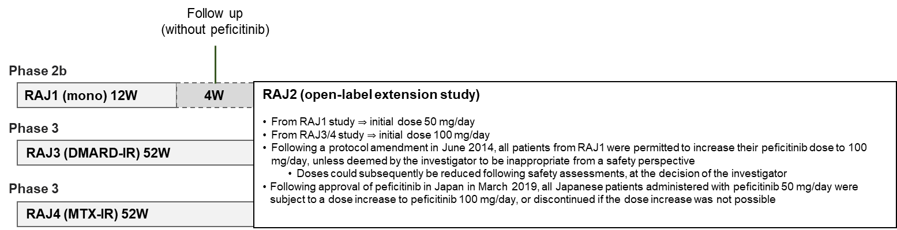

Fig. S2 Patient flow through the study, by preceding study

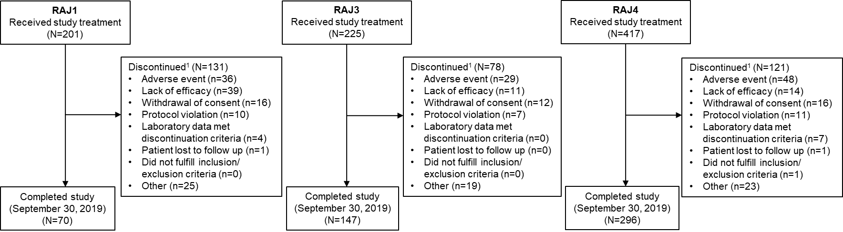
Fig. S3 Response rates by preceding study: (a) ACR20; (b) ACR50; (c) ACR70 over time (FAS). *Includes LOCF. ACR American College of Rheumatology, EOT end of treatment, FAS full analysis set, LOCF last observation carried forward
(a)
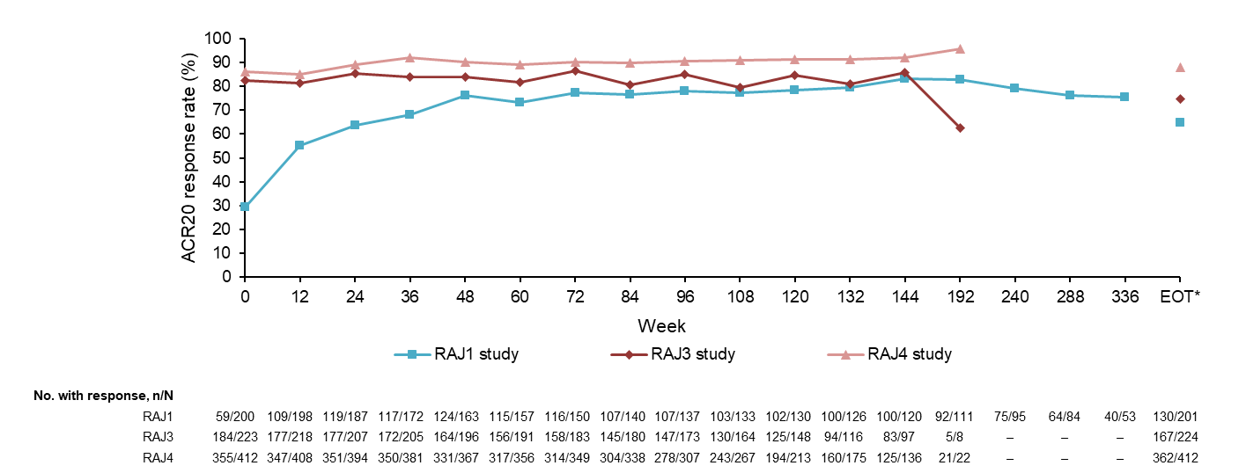
(b)
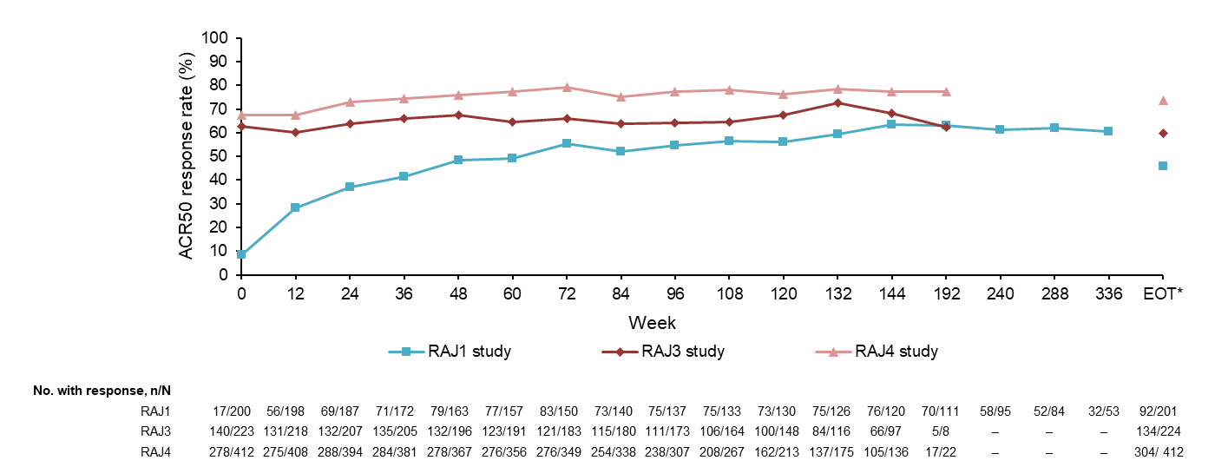
(c)
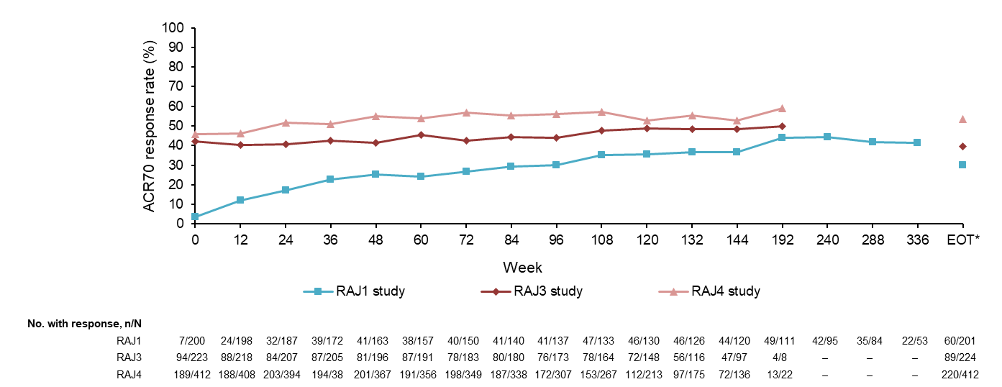

Fig. S4 Mean changes from the baselines of the preceding studies in (a) DAS28-CRP (<2.6), (b) CDAI, (c) SDAI, (d) TJC68, (e) SJC66, (f) SGAP (100 mm VAS), (g) SGA (100 mm VAS), (h) PGA (100 mm VAS), and (i) HAQ-DI (FAS). *Includes LOCF. CDAI Clinical Disease Activity Index, DAS28-CRP Disease Activity Score in 28 joints based on C-reactive protein, EOT end of treatment, FAS full analysis set, HAQ-DI Health Assessment Questionnaire – Disability Index, LOCF last observation carried forward, PGA Physician’s Global Assessment of Disease Activity, SDAI Simplified Disease Activity Index, SGA Subject’s Global Assessment of Disease Activity, SGAP Subject’s Global Assessment of Pain, SJC66 swollen joint count at 66 joints, TJC68 tender joint count at 68 joints

(a)
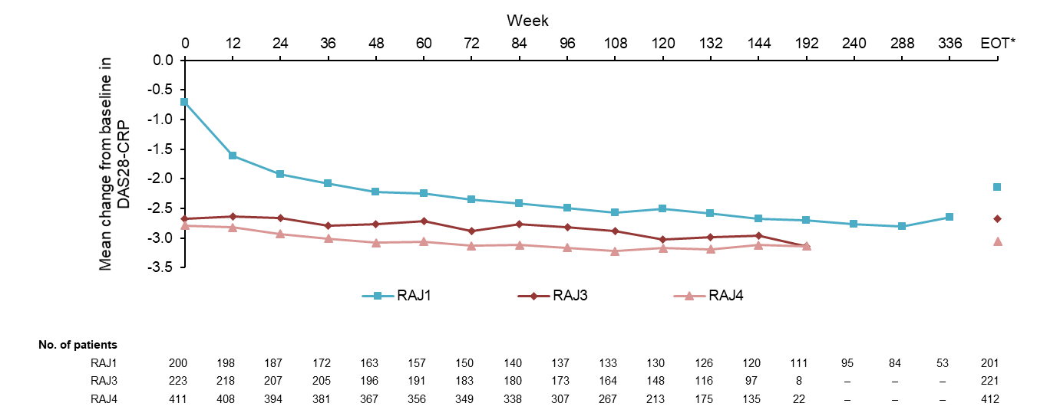
(b)
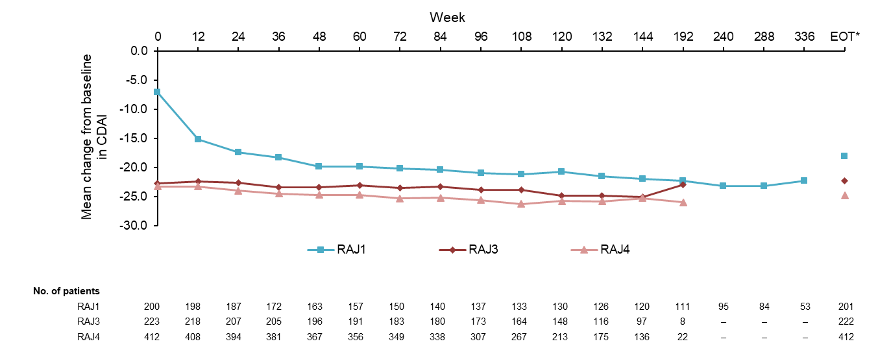
(c)
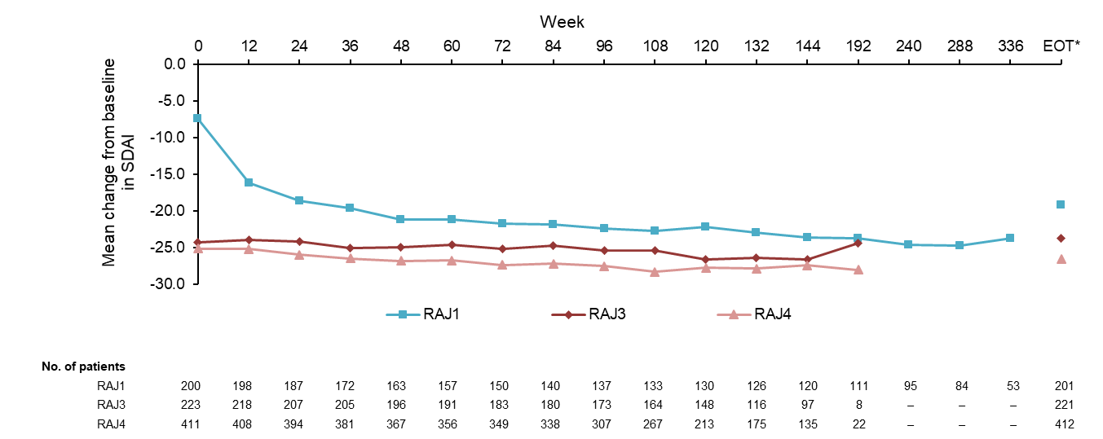

(d)
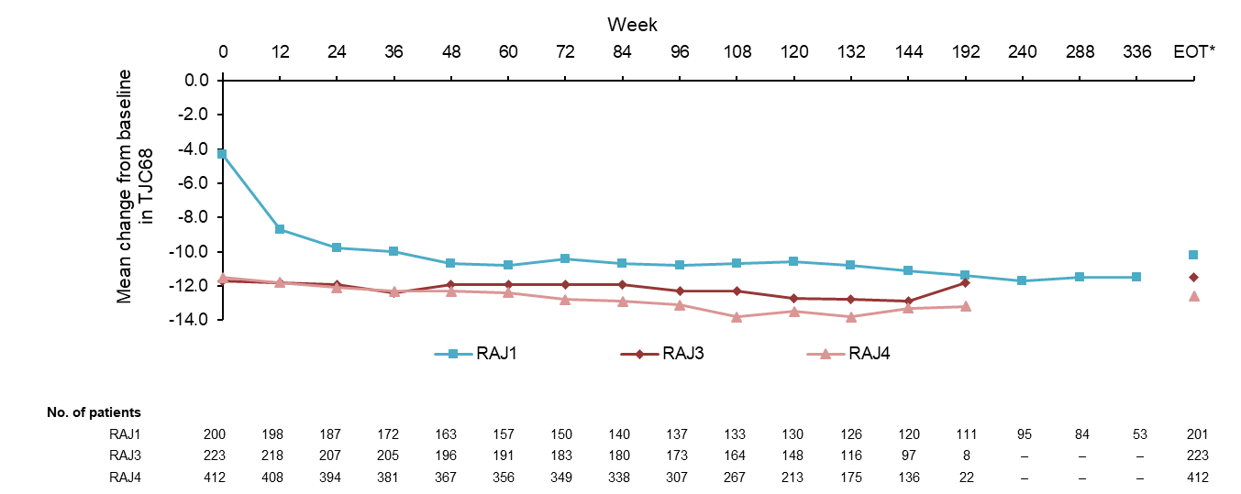
(e)
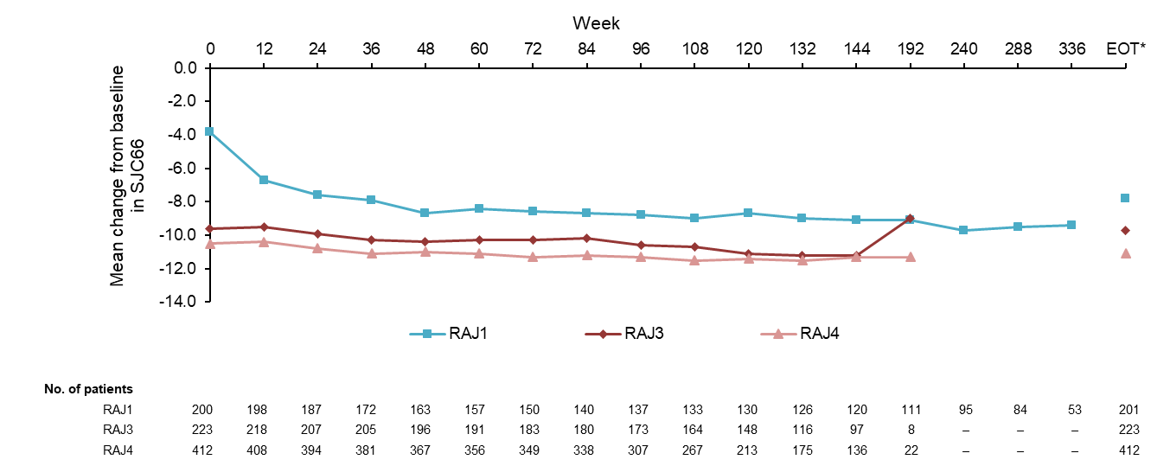

(f)
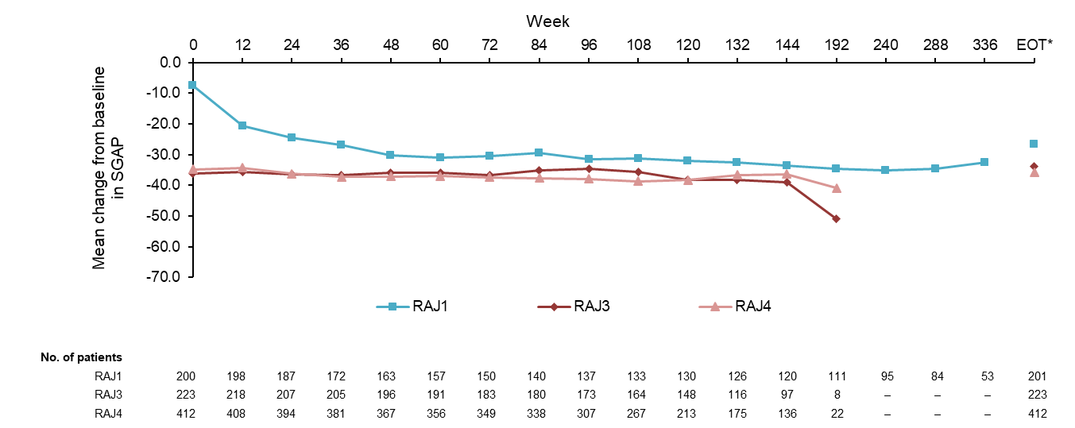
(g)

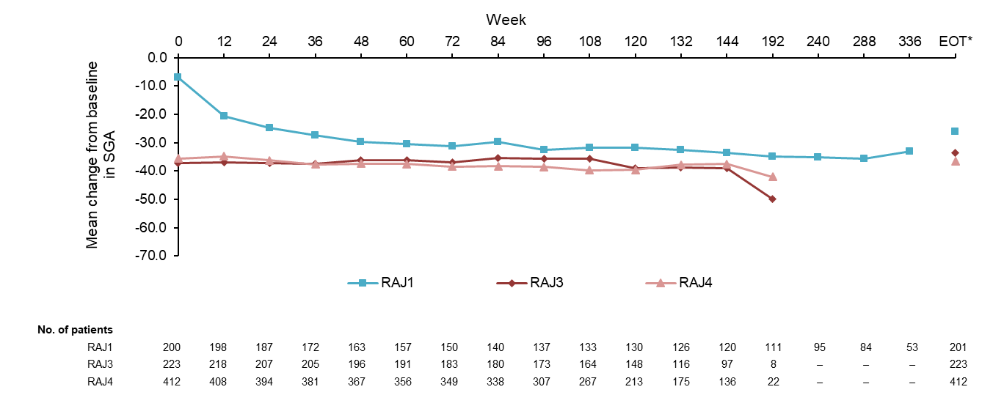
(h)
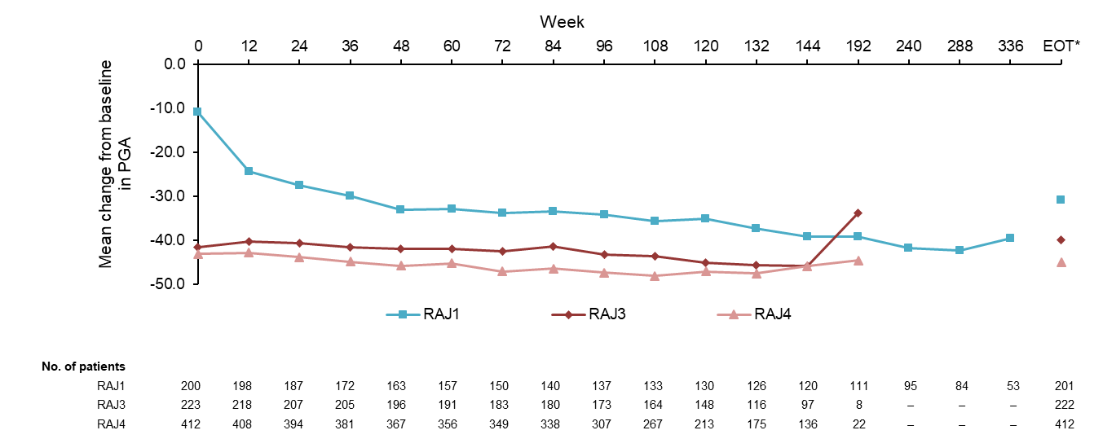
(i)
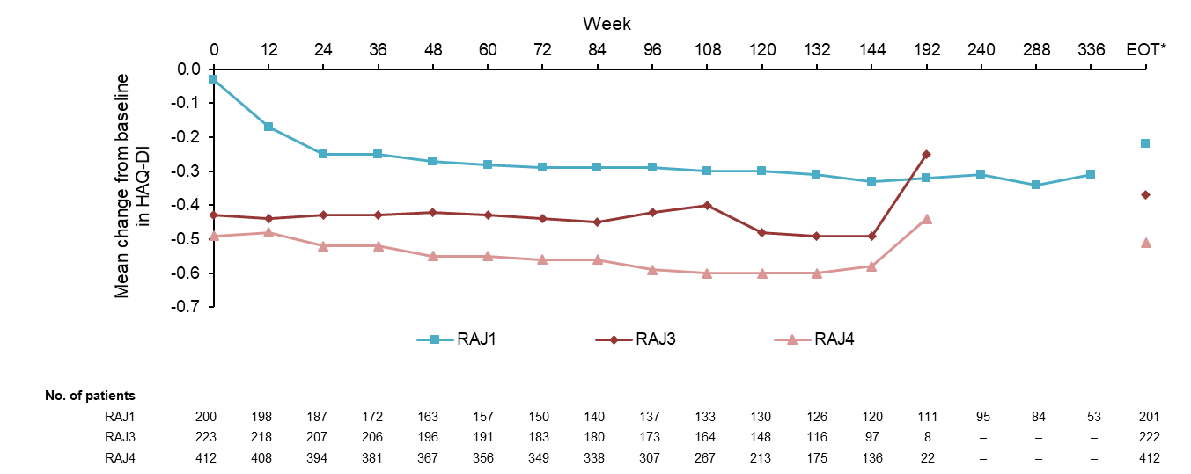

Fig S5. The proportion of patients achieving remission or LDA, by preceding study, in relation to (a) DAS28-CRP <2.6, (b) DAS28-CRP ≤3.2, (c) CDAI ≤2.8, (d) SDAI ≤3.3, and (e) ACR/EULAR Boolean-based definition of remission (FAS). *Includes LOCF. ACR American College of Rheumatology, CDAI Clinical Disease Activity Index, DAS28-CRP Disease Activity Score in 28 joints based on C-reactive protein, EOT end of treatment, EULAR European League Against Rheumatism, FAS full analysis set, LDA low disease activity, LOCF last observation carried forward, SDAI Simplified Disease Activity Index
(a)
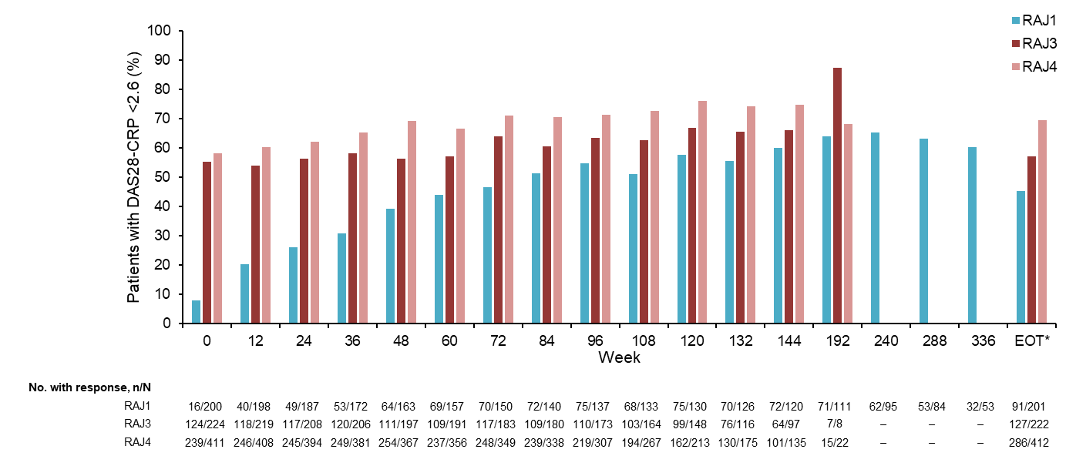
(b)
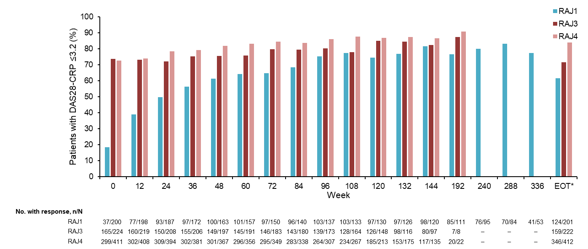

(c)
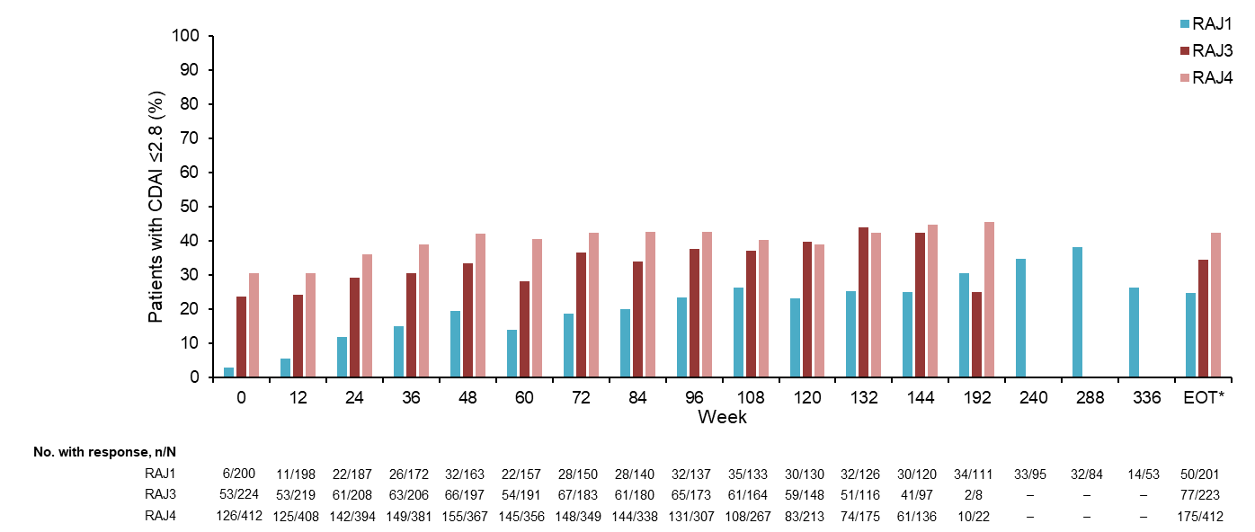
(d)
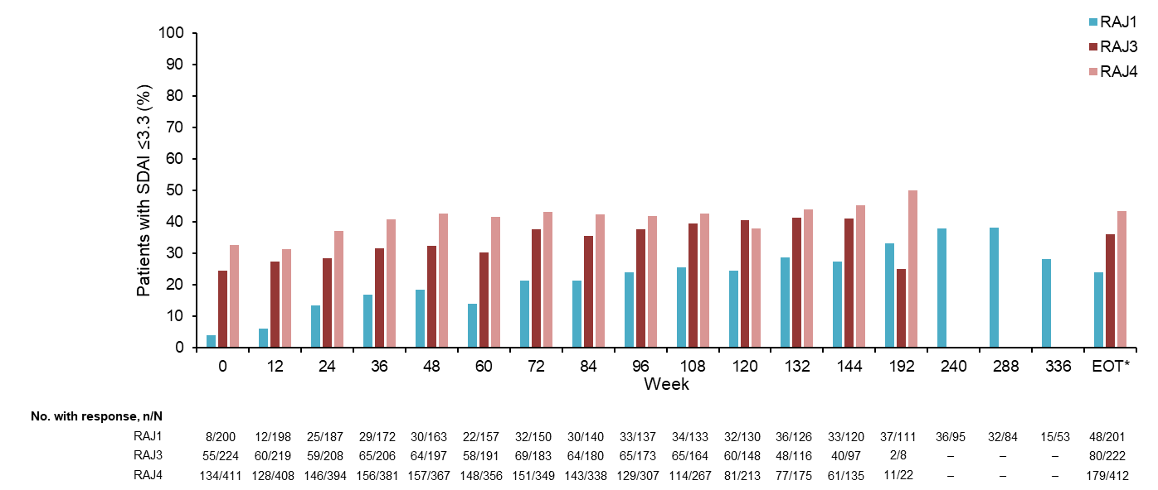

(e)
