Supplementary Table 1: ICD-9 and ICD-10 codes used in the study
 | ICD-9-CM/ICD-PCS | ICD-10-AM/ACHI
Pyogenic arthritis | 711.00- 711.99 | M00.00- M00.99
Prosthetic joint (infection) | 99.60, 996.66, 996.67, E878.1 | T84.5-T84.7, Y83.1, Y83.8
Osteomyelitis | 003.24, 730.00-730.30 | M46.2, M46.3, M86.00- M87.0
Immune arthritis | 446.0-447, 714.0-715, 696 | M03-M09
Connective tissue disease | 710.0-711, 446.0-447 | M30 -M36
Osteoarthrosis | 715.0-716 | M15.0-M20
Arthrocentesis | 81.9, 83.9 | 50124
Charlson comorbidity index | Am J Epidemiol 2011; 173:676-82 (ref 20)
Serious infections | J. Rheumatology, 2020; 47:424-30 (ref 22)
ICD: International Classifications of Diseases
CM: Clinical Modification
PCS: Procedure code system
AM: Australian Modification
ACHI: Australian Classification Health Interventions

Suppl Figure 1. Annual incidence of pyogenic arthritis by gender per 100,000 population under the age of 16 years in Western Australia over period 1990-2010

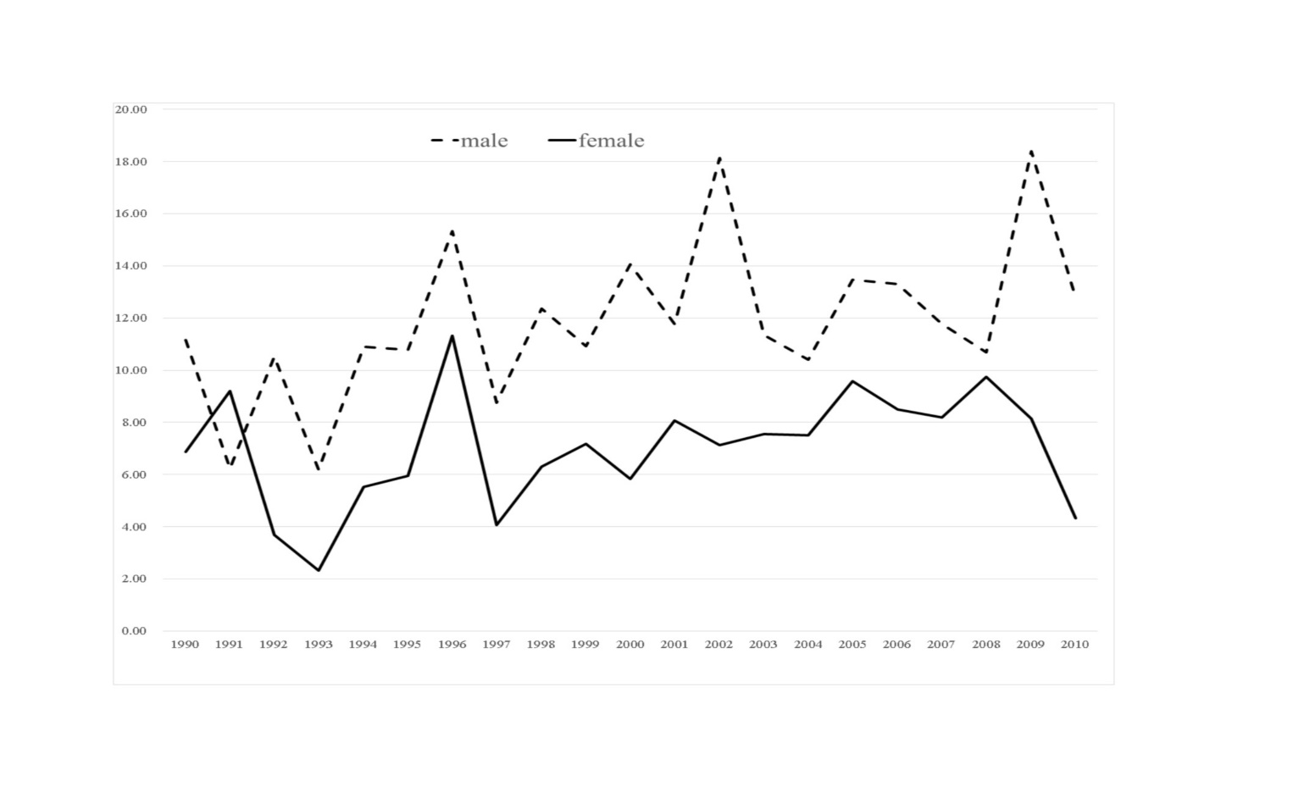

Suppl Figure 2. Seasonal occurence of septic artritis in patients <16 years in Western Australia in period 1990-2010

