Patient-reported nausea and fatigue related to methotrexate: A prospective, self-controlled study in the ArthritisPower® Registry
ONLINE SUPPLEMENTARY MATERIAL

Phase 1 Survey Questions
- What is your age?
- What is your current country of residence?
- What is the highest level of education you have completed?
- Less than high school
- High school/GED
- Some college (no degree)
- Associate’s degree
- Trade school
- Undergraduate degree (Bachelor’s)
- Post-graduate degree (Master’s, Doctoral)
- Have you been diagnosed with rheumatoid arthritis (RA) by a physician?
- Yes
- No
- Have you been diagnosed with psoriatic arthritis (PsA) by a physician?
- Yes
- No
- What is the name of your current rheumatologist or other physician treating your RA/PsA?
- What are the prescription medications that you currently take for your RA/PsA? Please select all that apply.
- A biologic medication given by injection (for example, adalimumab/Humira®, golimumab/Simponi®, etanercept/Enbrel®, certolizumab pegol/Cimzia®, sarilumab/
Kevzara®, tocilizumab/Actemra®, anakinra/Kineret®, and abatacept/Orencia®)
- A biologic medication given by infusion (for example, infliximab/Remicade®, tocilizumab/Actemra® infusion, infliximab-dyyb/Inflectra®, infliximab-abda/Renflexis®, rituximab/Rituxan®, abatacept/Orencia® infusion, and golimumab/Simponi Aria®)
- A conventional synthetic DMARD (for example, methotrexate, hydroxychloroquine/
Plaquenil®, sulfasalazine/Azulfidine®, leflunomide/Arava®, azathioprine/Imuran®)
- A targeted synthetic DMARD (for example, tofacitinib citrate/Xeljanz®/Xeljanz XR® and baricitinib/Olumiant®)
- A steroid medication (for example, prednisone, betamethasone, budesonide, hydrocortisone, prednisolone, prednisone, triamcinolone)
- A prescription NSAID (for example, ibuprofen, naproxen, celecoxib/Celebrex®, meloxicam/Mobic®, and diclofenac/Voltaren®)
- Opioid pain medications (for example, Percocet®, morphine, and oxycodone)
- Other prescription pain medications (for example, tramadol and gabapentin)
- Prescription sleep medications (for example, zolpidem/Ambien®)
- Other prescription medication
- Which conventional synthetic DMARD do you currently take for your RA/PsA? Please select all that apply.
- Methotrexate
- Hydroxychloroquine/Plaquenil®
- Sulfasalazine/Azulfidine®
- Leflunomide/Arava®
- Azathioprine/Imuran®
- How do you currently take your methotrexate dose?
- By an oral pill
- By an injection
- Do you take folic acid?
- Yes
- No
- I don’t know
- What are the prescription medications that you ever have previously taken for your RA/PsA but are no longer taking? Please select all that apply.
- A biologic medication given by injection (for example, adalimumab/Humira®, golimumab/Simponi®, etanercept/Enbrel®, certolizumab pegol/Cimzia®, sarilumab/
Kevzara®, tocilizumab/Actemra®, anakinra/Kineret®, and abatacept/Orencia®)
- A biologic medication given by infusion (for example, infliximab/Remicade®, tocilizumab/Actemra infusion, infliximab-dyyb/Inflectra®, infliximab-abda/Renflexis®, rituximab/Rituxan®, abatacept/Orencia® infusion, and golimumab/Simponi Aria®)
- A conventional synthetic DMARD (for example, methotrexate, hydroxychloroquine/
Plaquenil®, sulfasalazine/Azulfidine®, leflunomide/Arava®, azathioprine/Imuran®)
- A targeted synthetic DMARD (for example, tofacitinib citrate/Xeljanz®/Xeljanz XR® and baricitinib/Olumiant®)
- A steroid medication (for example, prednisone, betamethasone, budesonide, hydrocortisone, prednisolone, prednisone, triamcinolone)
- A prescription NSAID (for example, ibuprofen, naproxen, celecoxib/Celebrex®, meloxicam/Mobic®, and diclofenac/Voltaren®)
- Opioid pain medications (for example, Percocet®, morphine, and oxycodone)
- Other prescription pain medications (for example, tramadol and gabapentin)
- Prescription sleep medications (for example, zolpidem/Ambien®)
- Other prescription medication
- Which conventional synthetic DMARD have you ever previously taken for your RA/PsA? Please select all that apply.
- Methotrexate
- Hydroxychloroquine/Plaquenil®
- Sulfasalazine/Azulfidine®
- Leflunomide/Arava®
- Azathioprine/Imuran®
- How did you previously take your methotrexate dose?
- By an oral pill
- By an injection
- When you took methotrexate previously, did you stop taking it because of unwanted side effects that you think were related to taking your methotrexate?
- Yes
- No
- How often do you take your methotrexate?
- Once every week
- Multiple days every week
- When did you start taking this medication?
- If you were to add up the total number of years that you have been taking methotrexate on a weekly basis, about how many years would that be? (Subtracting the time that you stopped or were not taking methotrexate.)
***Questions 18 to 22 have the responses: strongly agree, agree, neither agree nor disagree, disagree, or strongly disagree***
- My life would be impossible without my methotrexate
- Without my methotrexate, I would be very sick
- My health, at present, depends on my methotrexate
- My methotrexate protects me from becoming worse
- My health in the future will depend on my methotrexate
- Do you have any unwanted side effects that you think are related to taking your methotrexate?
- Yes
- No
- Which of the following have you experienced in relation to methotrexate? (Select all that apply)
- Hair thinning
- Hair loss
- Nausea
- Abdominal pain
- Loss of appetite
- Diarrhea
- Fatigue/tiredness
- Brain fog
- Flu-like feeling
- Mouth sores or ulcers
- Difficulty sleeping
- None
- Others
- Do you commonly feel fatigue within a day of taking methotrexate compared with other times?
- Yes
- No
- Do you commonly have gastrointestinal symptoms, like nausea or vomiting, within a day of taking methotrexate compared with other times?
- Yes
- No
- Indicate your level of agreement with the following statement: “If my RA/PsA was well-controlled and my doctor said it was okay to stop taking methotrexate, I would stop taking it.”
- Strongly agree
- Agree
- Neither agree nor disagree
- Disagree
- Strongly disagree

Supplementary Table 1. Phase 2 assessments: electronic patient-reported outcome measures.
Health domain | PRO instrument*
Physical health | - Global Health Physical v2.1 (PROMIS) (2-item measure)†  - PROMIS CAT Bank v1.0 – Sleep Disturbance†  - PROMIS – Fatigue (1-day recall period, fixed-item)  - PROMIS Gastrointestinal Nausea and Vomiting (custom instrument, adapted from the 4-item Short Form v1.0, and excluding question #4)  - PROMIS short form Bank v1.2 – Physical Function  - PROMIS short form Bank v1.1 – Pain Interference  - Pain Intensity – Numeric Rating Scale
Mental health | - PROMIS CAT Bank v1.0 – Depression†  - PROMIS short form Bank v1.0 – Anxiety  - PROMIS short form Bank v1.0 – Applied Cognition Abilities (“brain fog”)
Social health | - PROMIS short form v2.0 – Ability to Participate in Social Roles & Activities (8 items, with time referent of “today” in the question stem)
Methotrexate tolerance and satisfaction | - Treatment Satisfaction Questionnaire for Medication (TSQM)†  - Methotrexate Intolerance Severity Score (MISS) questionnaire
*All PROMIS short form stems “In the past 7 days…” were changed to “In the past 24 hours…” or “Since you woke up…”. †Baseline only. CAT: computer-adaptive testing; PROMIS: Patient Reported Outcomes Measurement Information System.

Supplementary Figure 1. Participant workflow for study in the ArthritisPower Registry mobile app.
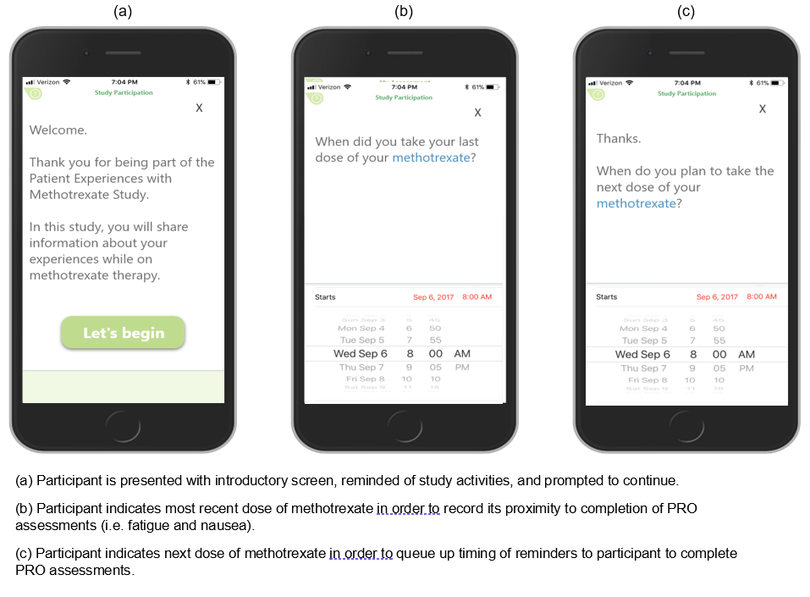

Supplementary Figure 2. Distribution of change in PROMIS nausea (A) and fatigue (B) score between risk and control windows (6‒36 hours and 96‒144 hours after weekly MTX dosing) in participants with baseline nausea (N = 43 pairs) and baseline fatigue (N = 62 pairs), respectively
A
B

Supplementary Figure 3. Scatter plots representing the change in PROMIS fatigue and nausea scores from baseline in patients with and without fatigue (A) and nausea (B)
A
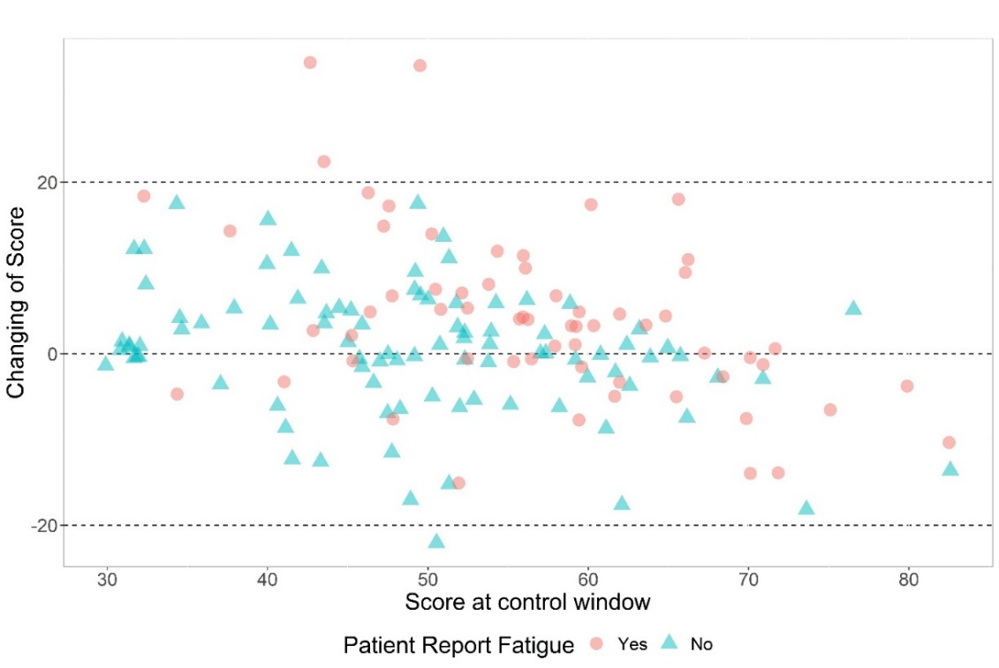
B
