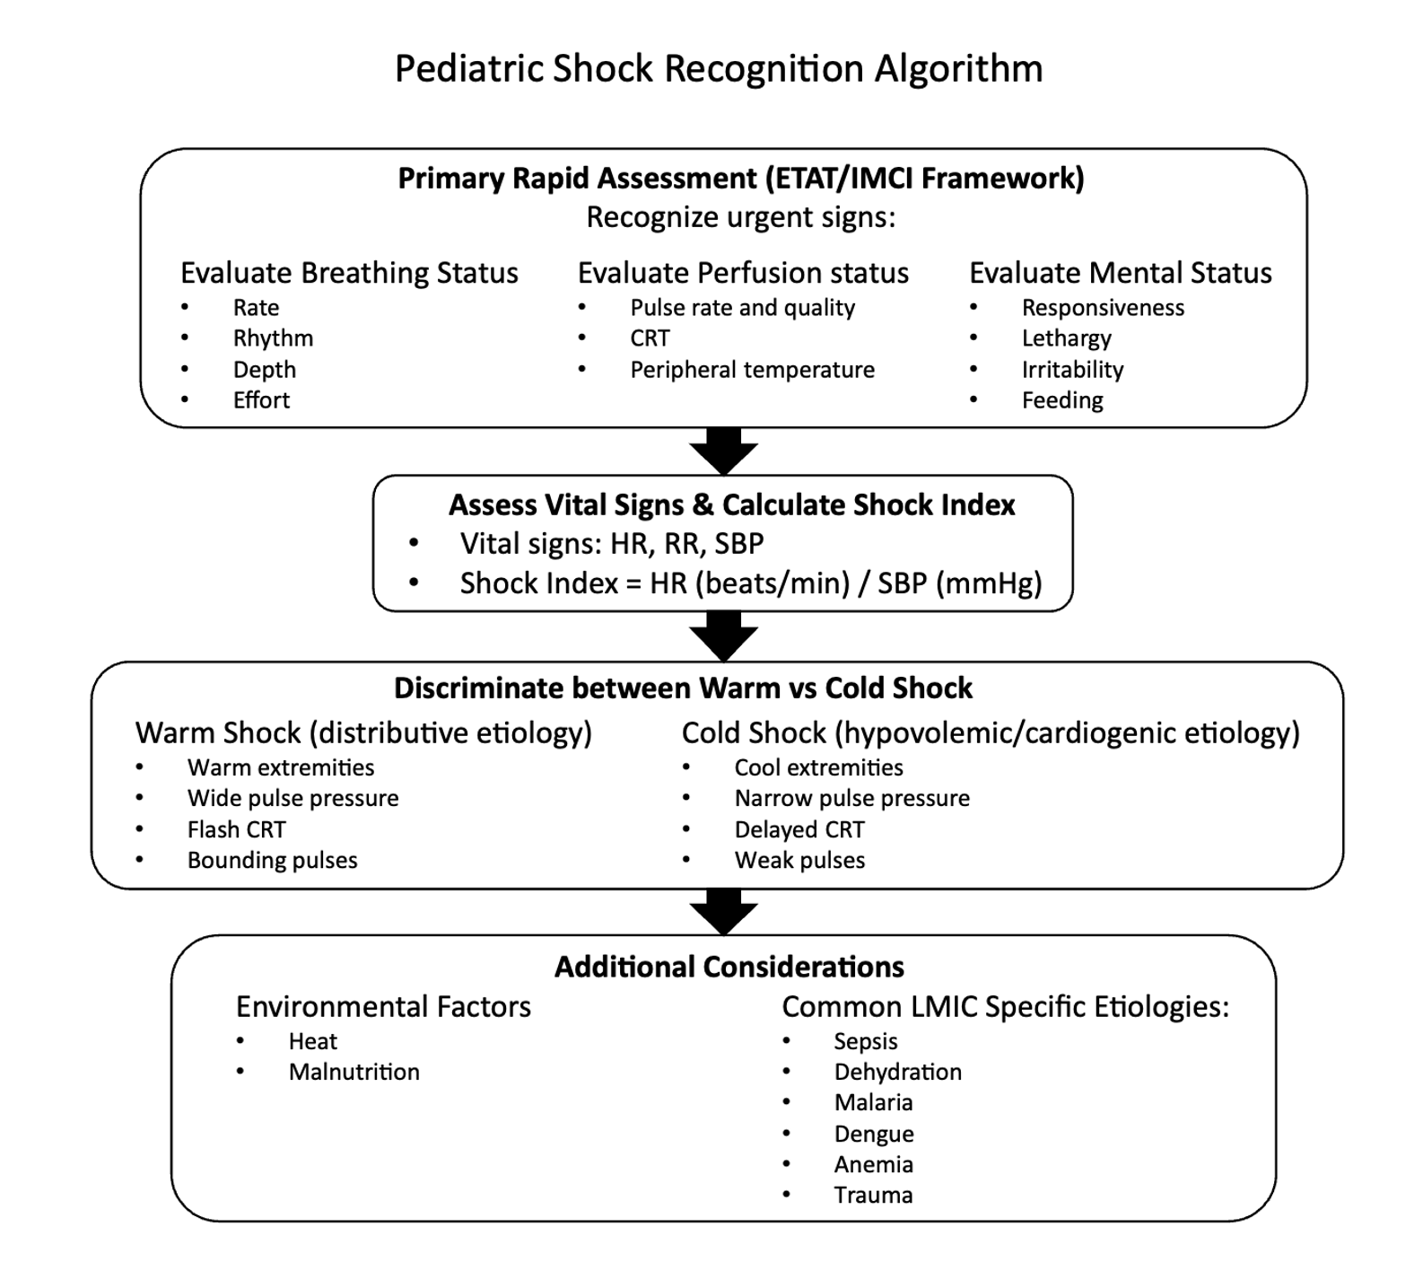

Figure 1: Timeline and stepwise fluid resuscitation strategy post-FEAST

Figure 2: Innovations supporting pediatric shock management in low-resource settings.

Figure 3: Stepwise interventions in pediatric hemorrhagic shock in resource-limited settings

Figure 4: Blood transfusion barriers and adaptations for pediatric hemorrhagic shock in low-resource settings.

