Supplementary File for the Paper “Multiobjective Integrated Scheduling of Disassembly and Reprocessing Operations Considering Product Structures and Stochastic Processing Time using an Reinforcement Learning-Based Evolutionary Algorithm”

This supplementary file contains eight sections. Section S1 introduces the solution encoding methods, and Section S2 describes the methods used to repair infeasible solutions. Section S3 describes the PPX methods. Section S4 introduces the stochastic simulation methods. Section S5 gives the definitions of the performance metrics. Section S6 lists the results of the Taguchi experiments conducted to set the parameters of RLMEA. Section S7 presents comparison results for RLMEA and its peers.
Section S1. Solution representation
An example of two products is given in Fig. S1, where (a) and (b) are diagrams of the two products’ structures, and (c) illustrates a solution. Products 1 and 2 are dismantled following their relative sequence at the disassembly shop. Disassembly operations 2, 4, and 5 of product 1 and 1, 3, 8, and 6 of product 2 are conducted in accordance with the given sequence.
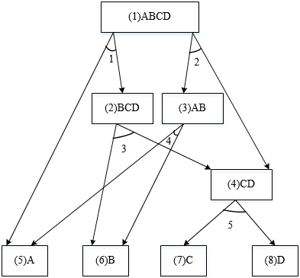
(a) AND/OR graph of Product 1.

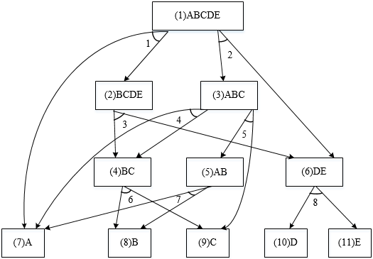
(b) AND/OR graph of Product 2.

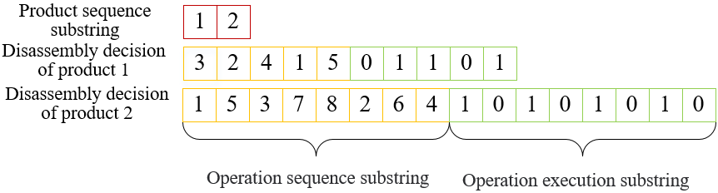
(c) Diagram of an individual.
Fig. S1. An example of an illustrated solution representation.
Section S2. Repair methods for infeasible solutions
Notably, it might be possible for a generated individual to violate the precedence and conflict constraints of disassembly operations. Hence, we devise a heuristic method to modify infeasible operation sequence and operation implementation substrings. Let $η=\left(η_{0},\left(η_{1}^{'},η_{1}^{''}\right),\left(η_{2}^{'},η_{2}^{''}\right),⋯,\left(η_{P}^{'},η_{P}^{''}\right)\right)$ be an infeasible solution, where the disassembly decision of product $p$ is infeasible. Then, the heuristic rule is given as follows.
1) The operation implementation substring is adjusted in accordance with the precedence matrix of product $p$ as follows. a) The first implemented disassembly operation is identified, and its conflict operations are identified. In the case that the associated elements of conflict operations in $η_{p}^{''}$ are 1, they are modified to 0 and the other elements in $η_{p}^{''}$ are modified to 1. b) The first operation corresponding to 1 in $η_{p}^{''}$ is obtained again, and we change the succeeding elements of its conflict operations in $η_{p}^{''}$ to 0. By repeating b), we check all the disassembly operations until they do not conflict each other.
2) The operation sequence substring is modified based on the succession matrix as follows. a) All the implemented operations are removed from $η_{p}^{'}$. b) For each implementation operation, we determine the immediate precedence operations performed. Then, we construct a precedence operation list for each implemented operation. c) The operation without immediate precedence operations is inserted into the first vacant position in $η_{p}^{'}$, and then it is deleted from the lists of the other implemented operations. By iterating c), we can form an operation sequence obeying precedence relationships.
Section S3. Evaluation of individuals’ objective values
Significantly, this research formulates an expected value model to define the investigated problem since the products’ disassembly time and components’ reprocessing time are random. Consequently, the expected objective values of individuals cannot be directly evaluated. In recent years, stochastic simulation approaches have often been used to calculate the expected objective values. This work devises a stochastic simulation method that averages a great quantity of samples. Each sample includes all the disassembly times of the products and reprocessing times of the components, which are sampled according to their own stochastic distributions. On the condition that the number of samples is approximately infinite, this approach is capable of acquiring the true values. However, computational resources are often finite in reality, and we have to use limited resources to conduct such work. Let $η$ be an assessed individual and $ϖ$ be the number of samples equal to 50. The primary procedure is described below.
Step 1: Set $F_{M}\left(η\right):=0$, $T\left(η\right)≔0$, and $ϖ≔50$.
Step 2: Create $ϖ$ samples, and each one is recorded as $κ_{λ}$, $λ=1,2,⋯,ϖ$.
Step 3: Assess $F_{M}^{'}\left(κ_{λ}\right)$ and $T^{'}\left(κ_{λ}\right)$ of $κ_{λ}$, in which $F_{M}^{'}\left(κ_{λ}\right)$ and $T^{'}\left(κ_{λ}\right)$, respectively denote the MCT and TT of $η$ associated with $κ_{λ}$, $λ=1,2,⋯,ϖ.$
Step 4: Calculate the average values $F_{M}\left(η\right)$ and $T\left(η\right)$ of all samples as:
$${ F}_{M}\left(η\right):=\frac{\sum_{λ=1}^{φ}{F_{M}^{'}\left(κ_{λ}\right)}}{ϖ},T\left(η\right):=\frac{\sum_{λ=1}^{φ}{T^{'}\left(κ_{λ}\right)}}{ϖ}. (S1)$$
Step 5: Return $F_{M}\left(η\right)$ and $T\left(η\right)$ as approximations of the expected MCT and TT of $η$.
Section S4. Crossover methods of PPX
The PPX crossover methods are given as follows. A binary string having the same length as the quantity of disassembly operations is produced at random. If a number in this string equals 0, the element in the operation sequence substring $η_{p}^{'}$ at the corresponding position is from one parent individual; otherwise, it is from the other parent individual. Then, this element is deleted from two parent individuals.
For the operation implementation substring, the elements corresponding to 1 in the binary string are sequentially chosen from a parent individual, and the rest are successively chosen from the other parent individuals. Fig. S2 gives an example to explain the PPX crossover methods.
Fig. S2. Illustration of the PPX approach.
Section S5. Performance metrics
The metrics C, IGD and HV are defined as follows.
1) The C-metric focuses on calculating the domination percentage of two solution sets. Assume that $U$ and $V$ are two solution sets. $C(U,V)$ is the percentage of solutions in $V$ that are dominated by at least one solution in $U$. Eq. (22) is used to calculate $C(U,V)$ as follows:
$$C(U,V)=\frac{\left|\left\{v∈V|∃u∈U:u≺v\right\}\right|}{\left|V\right|}. (S2)$$
where $\left|V\right|$ is the quantity of solutions in $V$. Obviously, a larger $C(U,V)$ implies a better performance of $U$.
2) The IGD metric calculates the average distance from an optimal solution set $V^{*}$ to an approximated solution set $V$. Hence, both the convergence and diversification of a solution set can be assessed. Eq. (23) shows the calculation method of $IGD\left(V,V^{*}\right)$ as follows:
$$IGD\left(V,V^{*}\right)=\frac{1}{\left|V^{*}\right|}\sum_{v∈V^{*}}{dist\left(v,V\right).} (S3)$$
where $dist\left(v,V\right)$ is the Euclidean distance from a solution $v$ in $V^{*}$ to its nearest solution in $V$. In real life, it is difficult to attain $V^{*}$ for an industrial application problem, as in this study. Hence, the nondominated solutions found via RLMEA and its rivals are taken as $V^{*}$, and all objective values are normalized to [0, 1]. Afterwards, $IGD\left(V,V^{*}\right)$ is calculated using Eq. (23). Clearly, a smaller $IGD\left(V,V^{*}\right)$ implies a better performance of $V$.
3) The hypervolume metric is used to evaluate both the convergence and diversification of a solution set $V$. Assume that $v^{*}=\left(v_{1}^{*},v_{2}^{*}\right)$ is a reference point in the objective domain, and all optimal solutions can dominate it. Then, the volume of a region in which all solutions are dominated by $V$ and dominate $v^{*}$ is taken as the hypervolume value of $V$. $v^{*}$ is set to $(1,1)$, and the objective values of the evaluated solutions are normalized to $[0, 1]$, subsequently, we calculate the hypervolume of $V$. Evidently, a larger hypervolume signifies a better performance of $V$.
Section S6. Parameter setting
To dissect the impact of user parameters on RLMEA, we perform Taguchi experiments by using an instance with four products. RLMEA contains four key parameters, i.e., population size $ξ$, mutation probability $ς$, percentage of local search $ζ$ and number of iterations of local search $χ$. Each of them has four levels, i.e., $ξ∈\left\{40,60,80,100\right\}$, $ς∈\left\{0.1,0.2,0.3,0.4\right\}$, $ζ∈\left\{0.1,0.4,0.7,1.0\right\}$ and $χ∈\left\{1,4,7,10\right\}$. This research forms an orthogonal array $L_{16}\left(4^{4}\right)$ with 16 combinations, as listed in Table S1. RLMEA with each of them addresses the used instance 20 times by taking the running time equalling $10∙P∙H$ seconds as stopping conditions, where $P$ signifies the number of products, and $H$ represents the maximum number of operations among $P$ products. In addition, all elements in the Q-table are initially set to 0, and $ε$ is set to 0.2.
The IGD values of the obtained solutions are calculated as the average response variable (ARV). All the acquired nondominated solutions are regarded as an optimal solution set, and then the IGD values are computed. The ARVs are reported in Table S1, and the responses and ranks of the parameters are given in Table S2. Fig. S3 shows the influence trends of the parameters. $ξ$ and $ς$ play the most important roles in RLMEA, followed by $ζ$ and $χ$. By dissecting the results, we find that RLMEA can achieve better results when $ξ=80$, $ς=0.2$, $ζ=0.4$ and $χ=7$. These parameters are used in the following comparison experiments.
Table S1. Orthogonal table and ARV values for RLMEA.
No. | $$ξ$$ | $$ς$$ | $$ζ$$ | $$χ$$ | ARV
1 | 40 | 0.1 | 0.1 | 1 | 0.6598
2 | 40 | 0.2 | 0.4 | 4 | 0.2821
3 | 40 | 0.3 | 0.7 | 7 | 0.3307
4 | 40 | 0.4 | 1.0 | 10 | 0.2520
5 | 60 | 0.1 | 0.4 | 7 | 0.4400
6 | 60 | 0.2 | 0.1 | 10 | 0.2365
7 | 60 | 0.3 | 1.0 | 1 | 0.2208
8 | 60 | 0.4 | 0.7 | 4 | 0.2988
9 | 80 | 0.1 | 0.7 | 10 | 0.5572
10 | 80 | 0.2 | 1.0 | 7 | 0.2101
11 | 80 | 0.3 | 0.1 | 4 | 0.2004
12 | 80 | 0.4 | 0.4 | 1 | 0.2034
13 | 100 | 0.1 | 1.0 | 4 | 0.5780
14 | 100 | 0.2 | 0.7 | 1 | 0.2004
15 | 100 | 0.3 | 0.4 | 10 | 0.2129
16 | 100 | 0.4 | 0.1 | 7 | 0.2513

Table S2. Response and rank of parameters regarding RLMEA.
Level | $$ξ$$ | $$ς$$ | $$ζ$$ | $$χ$$
1 | 0.3812 | 0.5587 | 0.3370 | 0.3211
2 | 0.2990 | 0.2323 | 0.2846 | 0.3398
3 | 0.2928 | 0.2412 | 0.3468 | 0.3080
4 | 0.3106 | 0.2514 | 0.3152 | 0.3147
Delta | 0.0884 | 0.3265 | 0.0622 | 0.0318
Rank | 2 | 1 | 3 | 4

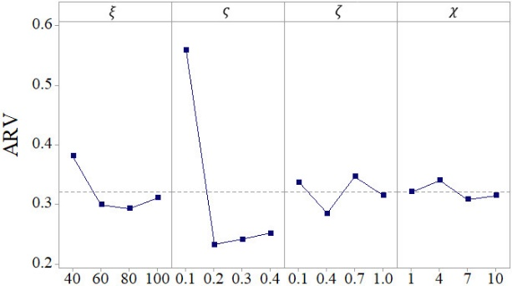
Fig. S3. Influence trends of parameters in RLMEA.
To make impartial comparisons, the parameters in the competitive methods are also determined by employing Taguchi experiments, which are the same as those in RLMEA. The experimental results are reported below.
There are three vital user parameters in NSGA-II, i.e., population size $ξ_{N}$, crossover probability $ς_{N}$ and mutation probability $ζ_{N}$. Each parameter has three levels, $ξ_{N}∈\left\{20,40,60,80\right\}$, $ς_{N}∈\left\{0.60,0.70,0.80,0.90\right\}$ and $ζ_{N}∈\left\{0.05,0.10,0.15,0.20\right\}$. We form an orthogonal array $L_{16}\left(4^{3}\right)$ with 16 parameter combinations, as given in Table S3. By performing the experiments in RLMEA, we obtain the ARVs of the parameter combinations and the responses and ranks of the parameters, which are shown in Tables S3 and S4, respectively. The influence trend of the parameters is shown in Fig. S4. NSGA-II can achieve better results when $ξ_{N}=60$, $ς_{N}=0.80$ and $ζ_{N}=0.20$. NSGA-II uses them in subsequent experiments.

Table S3. Orthogonal table and ARV values for NSGA-II.
No. | $$ξ_{N}$$ | $$ς_{N}$$ | $$ζ_{N}$$ | ARV
1 | 20 | 0.60 | 0.05 | 0.5475
2 | 20 | 0.70 | 0.10 | 0.5192
3 | 20 | 0.80 | 0.15 | 0.4228
4 | 20 | 0.90 | 0.20 | 0.4146
5 | 40 | 0.60 | 0.10 | 0.7341
6 | 40 | 0.70 | 0.05 | 0.4566
7 | 40 | 0.80 | 0.20 | 0.3135
8 | 40 | 0.90 | 0.15 | 0.3182
9 | 60 | 0.60 | 0.15 | 0.6087
10 | 60 | 0.70 | 0.20 | 0.2433
11 | 60 | 0.80 | 0.05 | 0.2667
12 | 60 | 0.90 | 0.10 | 0.3023
13 | 80 | 0.60 | 0.20 | 0.5732
14 | 80 | 0.70 | 0.15 | 0.2945
15 | 80 | 0.80 | 0.10 | 0.3028
16 | 80 | 0.90 | 0.05 | 0.2985

Table S4. Response and rank of parameters regarding NSGA-II.
Level | $$ξ_{N}$$ | $$ς_{N}$$ | $$ζ_{N}$$
1 | 0.4760 | 0.6159 | 0.3923
2 | 0.4556 | 0.3784 | 0.4646
3 | 0.3553 | 0.3264 | 0.4110
4 | 0.3673 | 0.3334 | 0.3861
Delta | 0.1208 | 0.2894 | 0.0784
Rank | 2 | 1 | 3

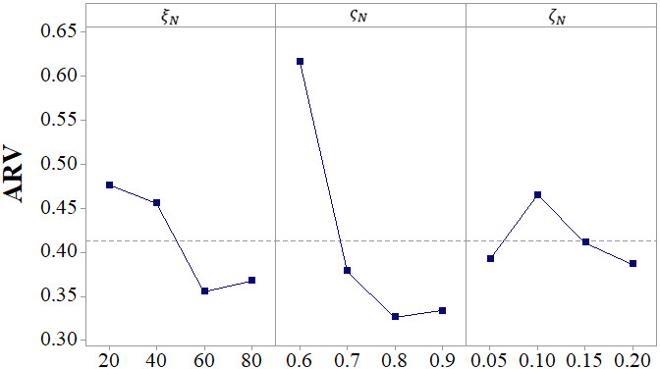
Fig. S4. Influence trends of parameters in NSGA-II.
MOEA/D has three parameters including population size $ξ_{E}$, mutation probability $ς_{E}$ and neighbourhood size $ζ_{E}$. Each parameter has four levels, i.e., $ξ_{E}∈\left\{20,40,60,80\right\}$, $ς_{E}∈\left\{0.05,0.10,0.15,0.20\right\}$ and $ζ_{E}∈\left\{10,20,30,40\right\}$. An orthogonal array $L_{16}\left(4^{3}\right)$ having 16 parameter combinations is shown in Table S5. After performing the experiments as RLMEA, we report the ARV values in Table S5, and the response and rank of parameters are given in Table S6. Fig. S5 shows the influence trend of parameters. By making analysis on the experimental results, we provide a suggested parameter combination as: $ξ_{E}=80$, $ς_{E}=0.20$ and $ζ_{E}=10$. MOEA/D uses it in the following experiments.
Table S5. Orthogonal table and ARV values regarding MOEA/D.
No. | $$ξ_{E}$$ | $$ς_{E}$$ | $$ζ_{E}$$ | ARV
1 | 20 | 0.05 | 10 | 0.7632
2 | 20 | 0.10 | 20 | 0.7480
3 | 20 | 0.15 | 30 | 0.7631
4 | 20 | 0.20 | 40 | 0.6645
5 | 40 | 0.05 | 20 | 1.3233
6 | 40 | 0.10 | 10 | 0.6902
7 | 40 | 0.15 | 40 | 0.6423
8 | 40 | 0.20 | 30 | 0.6719
9 | 60 | 0.05 | 30 | 1.2417
10 | 60 | 0.10 | 40 | 0.6644
11 | 60 | 0.15 | 10 | 0.6335
12 | 60 | 0.20 | 20 | 0.5658
13 | 80 | 0.05 | 40 | 1.0810
14 | 80 | 0.10 | 30 | 0.5209
15 | 80 | 0.15 | 20 | 0.5041
16 | 80 | 0.20 | 10 | 0.5051

Table S6. Response and rank of parameters regarding MOEA/D.
Level | $$ξ_{E}$$ | $$ς_{E}$$ | $$ζ_{E}$$
1 | 0.7347 | 1.1023 | 0.6480
2 | 0.8319 | 0.6559 | 0.7853
3 | 0.7763 | 0.6358 | 0.7994
4 | 0.6528 | 0.6018 | 0.7631
Delta | 0.1792 | 0.5005 | 0.1514
Rank | 2 | 1 | 3
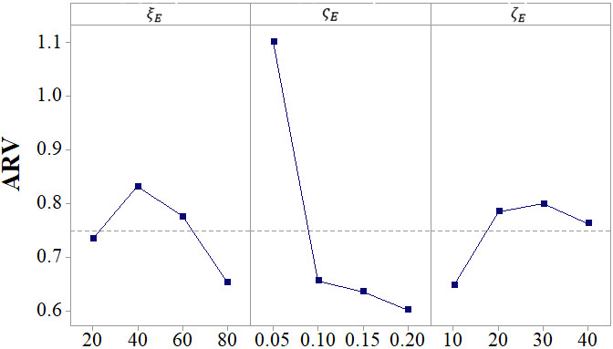
Fig. S5. Influence trends of parameters in MOEA/D.
There are two important parameters in MOABC, i.e., population size $ξ_{A}$ and maximum limitations with no improvement $ς_{A}$. Each of them owns four levels, $ξ_{A}∈\left\{50,100,150,200\right\}$ and $ς_{A}∈\left\{10,20,30,40\right\}$. There exist 16 combinations as shown in Table S7 along with their ARV values. The response and rank of parameters are given in Table S8, and the corresponding influence trend is provided in Fig. S6. It is seen that MOABC can achieve a better result when $ξ_{A}=50$ and $ς_{A}=30$. They will be employed in the subsequent experiments.
Table S7. Orthogonal table and ARV values regarding MOABC.
No. | $$ξ_{A}$$ | $$ς_{A}$$ | ARV
1 | 50 | 10 | 0.2878
2 | 50 | 20 | 0.3334
3 | 50 | 30 | 0.2923
4 | 50 | 40 | 0.3921
5 | 100 | 10 | 0.7113
6 | 100 | 20 | 0.2865
7 | 100 | 30 | 0.2807
8 | 100 | 40 | 0.4712
9 | 150 | 10 | 0.8099
10 | 150 | 20 | 0.3379
11 | 150 | 30 | 0.3806
12 | 150 | 40 | 0.4399
13 | 200 | 10 | 0.7501
14 | 200 | 20 | 0.4960
15 | 200 | 30 | 0.4913
16 | 200 | 40 | 0.4304

Table S8. Response and rank of parameters regarding MOABC.
Level | $$ξ_{A}$$ | $$ς_{A}$$
1 | 0.3264 | 0.6398
2 | 0.4374 | 0.3634
3 | 0.4921 | 0.3612
4 | 0.5420 | 0.4334
Delta | 0.2156 | 0.2785
Rank | 2 | 1

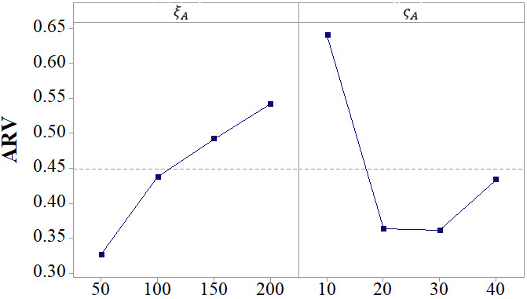
Fig. S6. Influence trend of parameters in MOABC.
Section S7. Comparison results for RLMEA and its rivals
To clearly analyze the results, we further use the Friedman test, Nemenyi post hoc test and Wilcoxon signed-rank test methods to rank the overall performance of RLMEA and its peers. The test results are reported as follows.
1) To perform the Friedman test, we sort RLMEA and its peers in ascending order in accordance with the mean values of the metric IGD and in descending order based on the mean values of the metric HV. Then, we assign the order values 1, 2, 3, and 4 to them. Subsequently, we calculate their average order values over all instances, which are provided in Tables 6 and 7. The average order values of RLMEA, NSGA-II, MOEA/D and MOABC regarding the metric IGD are 1.1250, 2.2500, 4.0000 and 2.6250, respectively. In addition, the average order values of RLMEA, NSGA-II, MOEA/D and MOABC with respect to the metric HV are 1.1250, 2.1250, 4.0000 and 2.7500, respectively. Fig. S8 illustrates the Friedman test of the attained results with respect to the IGD and HV metrics. It is seen that RLMEA achieves better rank values than the peers. Therefore, we can conclude that RLMEA has obvious advantages over its rivals in dealing with the considered problem since its rank values are smaller than those of its competitors.
2) To further analyse the difference between RLMEA and its rivals, the Nemenyi post hoc test at a significance level of 0.05 is employed to calculate a critical range value of the difference with respect to their average order values. The results are given in Tables 6 and 7. The differences in the average order values of the RLMEA, MOEA/D and MOABC for the IGD metric are 2.8750 and 1.5000, respectively, which are greater than the critical range of 1.1720. The difference between RLMEA and NSGA-II in terms of the IGD metric is 1.1250 (smaller than 1.1720). In addition, their difference in the HV metric is 1.0000, signifying that their capacities are statistically equivalent. Additionally, the differences between RLMEA, MOEA/D and MOABC in terms of the average order of HV are 2.8750 and 1.6250, respectively. This indicates that RLMEA is significantly better than MOEA/D and MOABC.
3) The results of the Wilcoxon signed-rank test are analysed as follows. The symbols “$w^{+}$”, “$w^{-}$” and “$w^{∼}$” denote that RLMEA is superior to, inferior to and equivalent to its competitors, respectively. “$R_{s}^{+}$” indicates the sum of ranks for which the first algorithm outperforms the second, and “$R_{s}^{-}$” is calculated for the opposite. It is observed that RLMEA exhibits better performance than its rivals with respect to the IGD and HV metrics. The statistical results verify that RLMEA achieves better performance than its peers in coping with the proposed problem.

