Supplemental Information for
Coal Ash Resources and Potential for Rare Earth Element Production in the United States
Robert C. Reedy, Bridget R. Scanlon, Davin A. Bagdonas, Sandy Ebersole, James C. Hower, Dennis James, J. Richard Kyle, and Kristine Uhlman

Contents:
1 Discussion
11 Figures
8 Pages
Section S1. FERC and EIA data for coal and associated ash delivery to power plants
Monthly data on coal and related ash for the period 1972 – 2007 for this analysis were reported on Federal Energy Regulatory Commission (FERC) Form 423 and Energy Information Agency (EIA) Form 423. Data include the coal source state, amounts and grades of coal delivered, and the ash contents on a weight basis. The source state data from FERC 423 prior to 1990 are not reliable and include many states that have never produced any coal. However, the source basin data are reliable. During 1972 – 2001, data were exclusively reported to FERC. Data during 2002 – 2007 were reported to both FERC and EIA and reporting requirements by each agency varied during the overlap period. During the overlap, EIA Form 423 included fuel receipts data for nonutility power plants and for plants with a fossil-fuel nameplate generating capacity of ≥50 MW while the remaining utility plant fuel receipts were reported on FERC Form 423. For this analysis, the data from both sources were combined during the overlap period. Data reported on EIA Form 923 during 2008 – 2021 were comprehensive of the power sector.
Comparison of the total amount of coal consumed by the power sector with total coal deliveries reported by FERC and EIA indicate that the data are not comprehensive of the entire electric power sector due to underreporting during certain periods (Fig. S1). During much of the period, the reported amount of coal delivered to power plants was close to 100% of total consumption by the power sector and small deviations can generally be explained as differences between consumption vs deliveries to maintain stock piles. However, during 1972, 1979 – 1982, and 2000 – 2002 coal deliveries were notably less than consumption. However, the reported total amount of coal delivered to power plants (34.5 Gt) during 1972 – 2021 (50 years) accounts for 92% of total consumption by the power sector (37.4 Gt). Excluding the noted periods of under-reporting, the reported total amount of coal delivered represents 98% of total consumption by power plants.

Fig. S1. Percentage of power sector coal use reported on FERC Form 423 and EIA Form 423. Data are provided in Table S5.

Fig. S2. Comparison between total US coal production and consumption, with differences accounted for by varying ratios of imports to exports. Data are provided in Table S2.

Fig. S3. US annual electric power generation by energy source shown as a) total net generation and b) percent of total net generation. Data are provided in Table S4a.

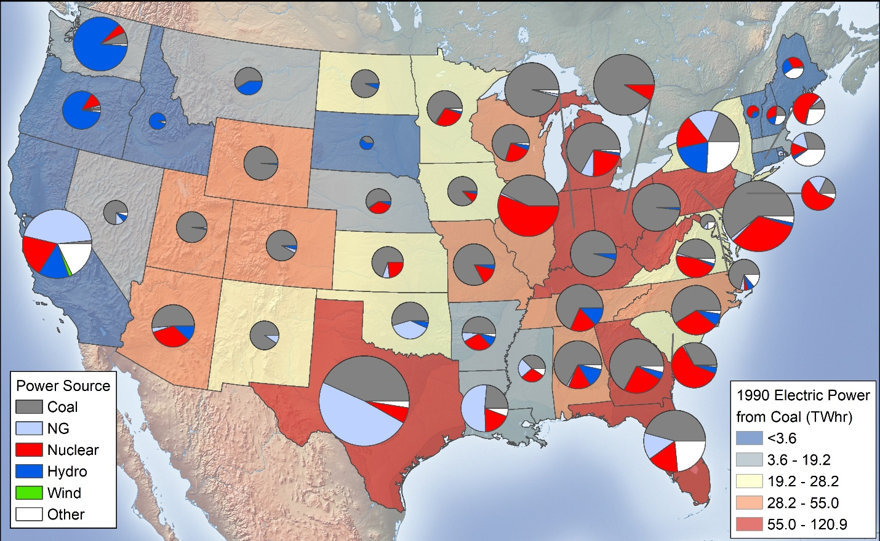
Fig. S4. US 1990 distribution of electric power generation (TWHr) by fuel source (pie charts) and by coal (color shading). The sizes of the pie charts are proportional to total electrical generation in each state. The states are color-shaded based on quintiles of US total electrical power from coal for 1990. Data are provided in Table S4b.

Fig. S5. Total coal and associated ash a) delivered to power plants by producing basin and coal rank during 1972 – 2021 (Table S6a) and b) the inter-annual mean and standard deviation of associated ash content (Table S6b). Data are from FERC Form 423 (1972-2007), EIA form 423 (2002-2007), and EIA Form 923 (2008-2021). The Powder River Basin was not reported separately prior to 1990 and was aggregated with other Western basin subbituminous basins. Data shown in for both of these basins are based on 1990 – 2021 data. BIT: bituminous, SUB: subbituminous, LIG: lignite.

Fig. S6. a) Total coal and associated ash delivered to power plants by producing state during 1990 – 2021 (Table S7a) and b) mean ash content and inter-annual standard deviation of associated ash content by producing state (Table S7b). Data are from FERC Form 423 (1990-2007), EIA form 423 (2002-2007), and EIA Form 923 (2008-2021).

Fig. S7. Total annual coal ash generated by electric generation power plants in the US. Data for 2006 – 2007 were not collected and are interpolated here. Data are provided in Table S8.

Fig. S8. Disposition of ash generated at US electrical generation power plants, including a) potentially accessible and b) inaccessible categories. Data are provided in Table S8.

Fig. S9. Amounts of potentially accessible ash generated by state during 1985 – 2021, excluding 2006 – 2007. Data are provided in Table S9.

Fig. S10. Historical coal use by the electric power industry and CCB amounts based on data from the American Coal Ash Association (ACAA). The ACAA data are represented during 1974 – 2021. A value of 14% CCB content was applied to coal production prior to 1974. Data are provided in Table S10.

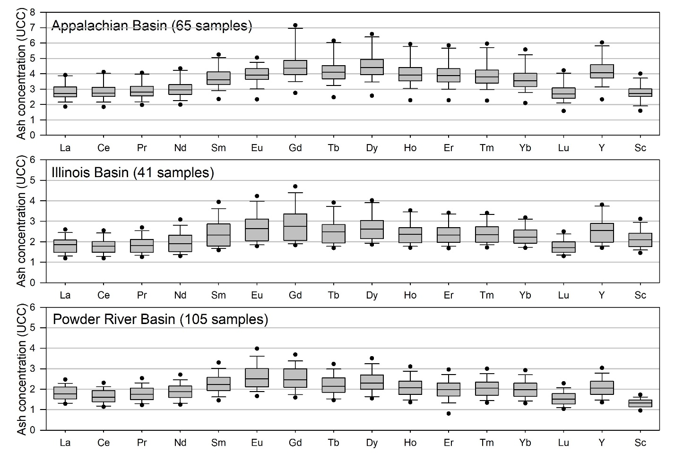
Fig. S11. Distribution of REEYSc in ash derived from the Appalachian, Illinois, and Powder River basins expressed as concentration ratios relative to mean Upper Continental Crust (UCC) values. Data are provided in Table S12c.

