Supporting Information for

Rare Earth Element Potential in Coal and Coal Ash in the U.S. Gulf Coast

Bridget R. Scanlon¹, Robert C. Reedy¹, Brent A. Elliott¹, James C. Hower², J. Richard Kyle¹, Marek Locmelis¹, Nolan Theaker³, and Peter D. Warwick⁴
¹Bureau of Economic Geology, Jackson School of Geosciences, University of Texas at Austin, Austin, TX, USA
²University of Kentucky, Center for Applied Energy Research, Lexington, KY, USA
³University of North Dakota, Institute of Energy Studies, Grand Forks, ND, USA
⁴U.S. Geological Survey, Geology, Energy & Minerals Science Center, Reston, VA, USA

Section 1. Sample Processing
Samples for analysis of critical minerals (CMs) including rare earth elements (REEs) were obtained primarily from archived samples at the U.S. Geological Survey (USGS) at Reston, Virginia (n=63 samples) and supplemented with additional samples collected during this study from San Miguel mine (n=12) and from outcrops in Alabama (n=12) and Arkansas (N-4). Samples from the coal mines were collected primarily by channeling exposed high walls of active opencast pits (Warwick et al., 1996, 1997)^{1,2}.
All samples were air dried and ground (0.25 to 0.47 mm particle diameter). Methods of sampling the coals at the mines are described in Warwick et al. (1996, 1997)^{1,2}. All samples were run through a riffle splitter to obtain ~ 50 g of sample for CM and REE analysis. Samples were analyzed at Standard Laboratories, Inc. (Freeburg, Illinois). Prior to analysis, remnant moisture was measured.
Analysis of REEs and CMs followed ASTM (2021) D6357³ using Method B for Inductively Coupled Plasma Mass Spectrometry (ICP-MS) determination. In accordance with the method, samples were increased to 500 ºC in a muffle furnace and maintained at that temperature for ≥ 2 h. The ash was then digested to dryness using nitric, hydrochloric, and hydrofluoric acids in a perfluoroalkoxy (PFA)/Teflon digestion vessel. A Perkin Elmer NexION 300× Inductively Coupled Plasma Mass Spectrometer (ICP-MS) was used to analyze the samples. A total of 11 standard reference materials (SRMs) were analyzed to verify the analytical technique; five National Institute of Standards and Technology (NIST, 5) SRMs (1632D, 1633b, 1633c, 2702, and 2711, 5), South African Reference Material (SARM, 2) standards (18 and 19), and USGS standards (AGV-2, BHVO-1, MAG-1, and SGR-1, 4) (written communication, 2023, Tim Hutchison, Laboratory Manager Standard Laboratories, Inc.). Concentrations of CMs and REEs are reported on a dry coal basis and on an ash basis by dividing by the ash content.
Although the International Union of Pure and Applied Chemistry includes lanthanide elements, Y, and Sc as REEs (Connelly et al., 2005)⁴, in this study REEs are used to refer to elements only in the lanthanides, and REY is used to refer to REE + Y, and REYSc for REY + Sc.

Section 2. Extractability
Extractability of REEs was quantified using a sequential solvent extraction method in solutions of water, 1 molar ammonium acetate, and 0.5 molar hydrochloric acid. Samples were ground to ~ 75 μm (200 mesh) to ensure no REEs were encapsulated in minerals. A 100 g ground sample was then vacuum dried and the coal was stirred with 200 mL of deionized water to extract water-soluble minerals, including sodium chloride and sodium sulfate. The solution was stirred for 24 h at room temperature and then filtered. The filtered coal was dried and a portion was tested using ICP-MS to quantify the REE concentrations. The residues were then mixed with 200 mL of 1 molar ammonium acetate (NH₄OAc) and stirred at 70 ºC for 24 h to extract ion-exchangeable cations. The ammonium acetate extractions were repeated two times to ensure complete removal of ion-exchangeable cations. A portion was dried and analyzed using ICP-MS. The remaining residue after the ammonium acetate extraction was then mixed with 0.5 molar hydrochloric acid (HCl) at 70 ºC for 24 h to extract chelated elements within the organic coal structure, in addition to acid soluble minerals such as carbonates, some oxides, and sulfates. The residue was then analyzed using ICP-MS.
Any use of trade, firm, or product names is for descriptive purposes only and does not imply endorsement by the U.S. Government.

Section 3. References
- Warwick, P. D., Crowley, S. S., Ruppert, L. F. & Pontolillo, J. Petrography and geochemistry of the San Miguel lignite, Jackson Group (Eocene), south Texas. Organic Geochemistry 24, 197-217, doi: https://doi.org/10.1016/0146-6380(96)00018-6 (1996).
- Warwick, P. D., Crowley, S. S., Ruppert, L. F. & Pontolillo, J. Petrography and geochemistry of selected lignite beds in the Gibbons Creek mine (Manning Formation, Jackson Group, Paleocene) of east-central Texas. International Journal of Coal Geology 34, 307-326, doi: https://doi.org/10.1016/s0166-5162(97)00028-1 (1997).
- ASTM D6357-21b, Standard Test Methods for Determination of Trace Elements in Coal, Coke, and Combustion Residues from Coal Utilization Processes by Inductively Coupled Plasma Atomic Emission Spectrometry, Inductively Coupled Plasma Mass Spectrometry, and Graphite Furnace Atomic Absorption Spectrometry. ASTM International, West Conshohoken, PA, 16 pp. (2021).
- Connelly, N. G., Hartshorn, R. M., Damhus, T. & Hutton, A. T. Nomenclature of inorganic chemistry: IUPAC recommendations 2005. Royal Society of Chemistry (2005).
- Warwick, P. D., SanFilipo, J. R., Crowley, S. S., Thomas, R. E., & Freid, J., Digital Compliation by Tully, J. K. Map showing outcrop of the coal-bearing units and land use in the Gulf Coast Region. U. S. Geological Survey Open File Report 97-172 (1997).
- Seredin, V. V. & Dai, S. Coal deposits as potential alternative sources for lanthanides and yttrium. International Journal of Coal Geology 94, 67-93, doi: https://doi.org/10.1016/j.coal.2011.11.001 (2012).
- Rudnick, R. L. & Gao, S. The Composition of the Continental Crust, In: Holland, H. D. and Turekian, K. K., Eds., Treatise on Geochemistry, Vol. 3, The Crust, Elsevier-Pergamon, Oxford, 1-64, doi: http://dx.doi.org/10.1016/b0-08-043751-6/03016-4 (2003).
- U.S. Geological Survey. 2022 Final List of Critical Minerals. Federal Register, vol. 87, FR 10381 - 10382, Doc. No. 2022-04027, https://www.govinfo.gov/content/pkg/FR-2022-02-24/pdf/2022-04 027.pdf (2022a).
- U.S. Geological Survey. U.S. Geological Survey Releases 2022 List of Critical Minerals. U.S. Geological Survey National News Release. https://www.usgs.gov/news/national-news-release/us-geological-survey-releases-2022-list-critical-minerals (2022b).
- Zygarlicke, C. J. et al. Rare-earth elements (REES) in U.S. coal-based resources: Sampling, characterization, and round-robin interlaboratory study. 247 pp. https://edx.netl.doe.gov/dataset/rare-earth-elements-in-u-s-coal-basedresources, rfp-10982-fe0029007-final-report-RRIS-UND.pdf (accessed 27 June 2023) (2019).
- Hackley, P. C., Willett, J. C., Warwick, P. D., Law, S. J. & Nichols D. J. A review of the lignite resources of Arkansas. In P. D. Warwick, A. K. Karlsen, M. Merrill, and B. J. Valentine, eds., Geologic assessment of coal in the Gulf of Mexico coastal plain, U.S.A.: AAPG Discovery Series No. 14/ AAPG Studies in Geology No. 62, 313 – 325 (2011).
- U.S. Geological Survey (USGS) Energy Resources Program. Geochemistry Database. U.S. Geological Survey (USGS) Energy Resources Program Website. https://certmapper.cr.usgs.gov/data/apps/geochem-db/ (2014).
- Warwick, P. D., Crowley, S. S., Ruppert, L. F. & Pontolillo. J. Petrography and geochemistry of selected lignite beds in the Gibbons Creek mine (Manning Formation, Jackson Group, Paleocene) of east-central Texas. International Journal of Coal Geology, 34(3-4), 307-326, doi: https://doi.org/10.1016/S0166-5162(97)00028-1 (1997).
- Hower, J. C., Warwick, P. D., Scanlon, B. R., Reedy, R. C. & Childress, T. M. Distribution of rare earth and other critical elements in lignites from the Eocene Jackson Group, Texas. International Journal of Coal Geology 275, 104302, doi: https://doi.org/10.1016/j.coal.2023.104302. (2023).
- Ruppert, L. F., Warwick, P. D., Crowley, S. S. & Pontolillo, J. Tonsteins and clay-rich layers in coal-bearing intervals of the Eocene Manning Formation, east-central Texas, Gulf Coast Assoc. Geol. Soc. Trans., 44, 649-656. (1994).
- Warwick, P. D., Crowley, S. S., Ruppert, L. F. & Pontolillo, J. Petrography and geochemistry of the San Miguel lignite, Jackson Group (Eocene), south Texas, Organic Geochemistry, 24(2), 197-217, doi: https://doi.org/10.1016/0146-6380(96)00018-6 (1996).
- Warwick, P. D. & Hook, R. W. Petrography, geochemistry, and depositional setting of the San Pedro and Santo Tomas coal zones: anomalous algae-rich coals in the middle part of the Claiborne Group (Eocene) of Webb County, Texas. International Journal of Coal Geology, 28, 303-342, doi: https://doi.org/10.1016/0166-5162(95)00022-4 (1995).
- USGS Energy Resources Program, Geochemistry Database. U.S. Geological Survey (USGS) Energy Resources Program Website. https://certmapper.cr.usgs.gov/data/apps/geochem-db/ (2014).
- Groves, S. J., Rozinek, T. R. & DeVera, C. A., Energy Geochemistry Database: U.S. Geological Survey data release, https://doi.org/10.5066/P1WNUHWO (2025).
- Crowley, S. S., Warwick, P. D., Ruppert, L. F. & Pontolillo, J. The origin and distribution of HAPs elements in relation to maceral composition of the A1 lignite bed ( Paleocene, Calvert Bluff Formation, Wilcox Group), Calvert mine area, east-central Texas. International Journal of Coal Geology 34, 327-343, doi: 10.1016/S0166-5162(97)00029-3 (1997).
- Seredin, V. V. & Dai, S. Coal deposits as potential alternative sources for lanthanides and yttrium. International Journal of Coal Geology 94, 67-93, doi: https://doi.org/10.1016/j.coal.2011.11.001 (2012).
- U.S. Energy Information Administration. Coal explained, coal prices and outlook. U.S. Energy Information Administration website https://www.eia.gov/energyexplained/coal/prices-and-outlook.php (2024).
- U.S. Geological Survey. Rare earths statistics and information. U.S. Geological Survey Minerals Yearbook. https://www.usgs.gov/centers/national-minerals-information-center/rare-earths-statistics-and-information (2024).
- Shanghai Metals Market. Latest Update in the SMM Rare Earth Oxides Market. https://www.metal.com/Rare-Earth-Oxides (2024).
- Statista. Praseodymium oxide price worldwide from 2009 to 2020 with a forecast from 2021 to 2030. Statista website: https://www.statista.com/statistics/450148/global-reo-praseodymium-oxide-price-forecast/ (2024).
- Statista. Samarium oxide price worldwide from 2009 to 2020, with a forecast for 2021 to 2030. Statista website: https://www.statista.com/statistics/450155/global-reo-samarium-oxide-price-forecast/ (2024).
- Statista. Holmium oxide price worldwide from 2011 to 2020 with a forecast for 2021 to 2030. Statista website: https://www.statista.com/statistics/1116371/global-reo-holmium-oxide-price-forecast/ (2024).
- Statista. Erbium oxide price worldwide from 2011 to 2020 with a forecast for 2021 to 2030. Statista website: https://www.statista.com/statistics/450172/global-reo-erbium-oxide-price-forecast/ (2024).
- Statista. Ytterbium oxide price worldwide from 2010 to 2025. tatista website: Statista website: https://www.statista.com/statistics/450173/global-reo-ytterbium-oxide-price-forecast/ (2024)
- Statista. Lutetium oxide price worldwide from 2011 to 2020 with a forecast for 2021 to 2030. Statista website: https://www.statista.com/statistics/1116376/global-reo-lutetium-oxide-price/ (2024).
- Bagdonas, D. A. et al. Rare earth element resource evaluation of coal byproducts: A case study from the Powder River Basin, Wyoming. Renewable and Sustainable Energy Reviews 158, 112148, doi: https://doi.org/10.1016/j.rser.2022.112148 (2022).
- U.S. Energy Informaiton Administration. Coal data. U.S. Energy Informaiton Administration website: https://www.eia.gov/coal/data.php (2024).
- Railroad Commission of Texas. Surface Mining and Reclamation. Railroad Commission of Texas website: https://www.rrc.texas.gov/surface-mining/ (2024).
- Reedy, R. C., Scanlon, B. R., Bagdonas, D. A., Hower, J. C., James, D., Kyle, J. R. & Uhlman, K. Coal ash resources and potential for rare earth element production in the United States. International Journal of Coal Science & Technology, 11(1), 74, doi: https://doi.org/10.1007/s40789-024-00710-z (2024).
- Esri (Environmental Systems Research Institute, Inc.). Globus3_WTL1. avialble online at https://www.arcgis.com/home/item.html?id=bc25c56c907a4e1aac39d35613af0c55 (2023).

Section 4. Figures

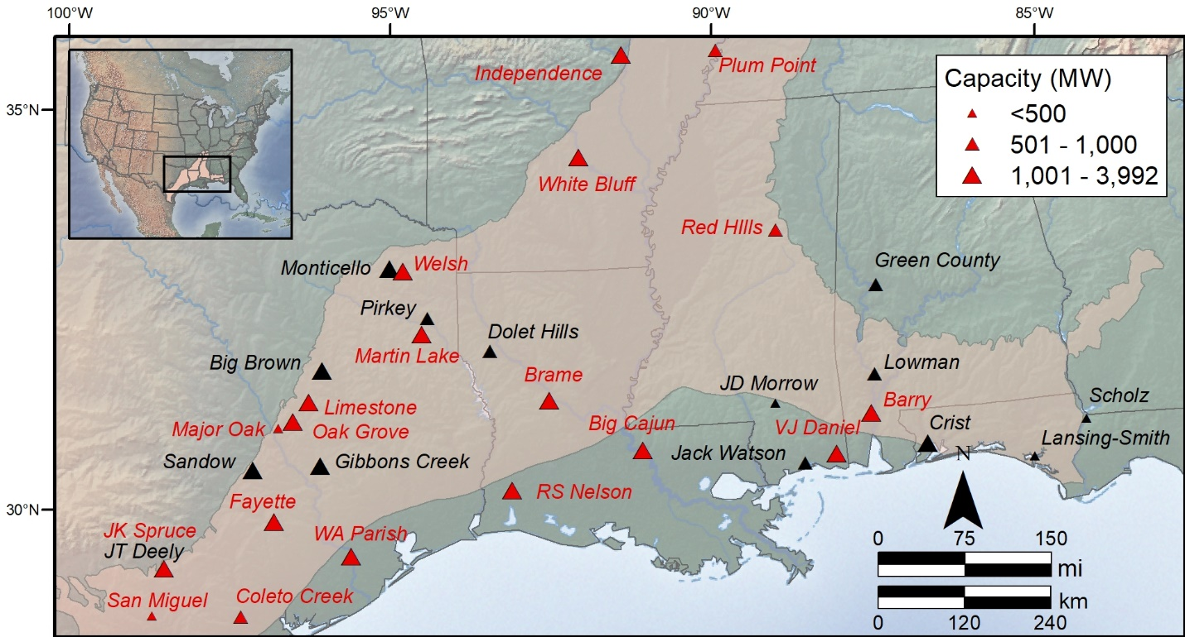
Figure S1. Locations and names of coal power plants in the Gulf Coastal Plain coal-bearing region (highlighted area, adapted from Warwick et al., 1997⁵). Active plants are shown in red and retired plants are shown in black. The location data are provided in Table S15. Base map from Esri³⁵.

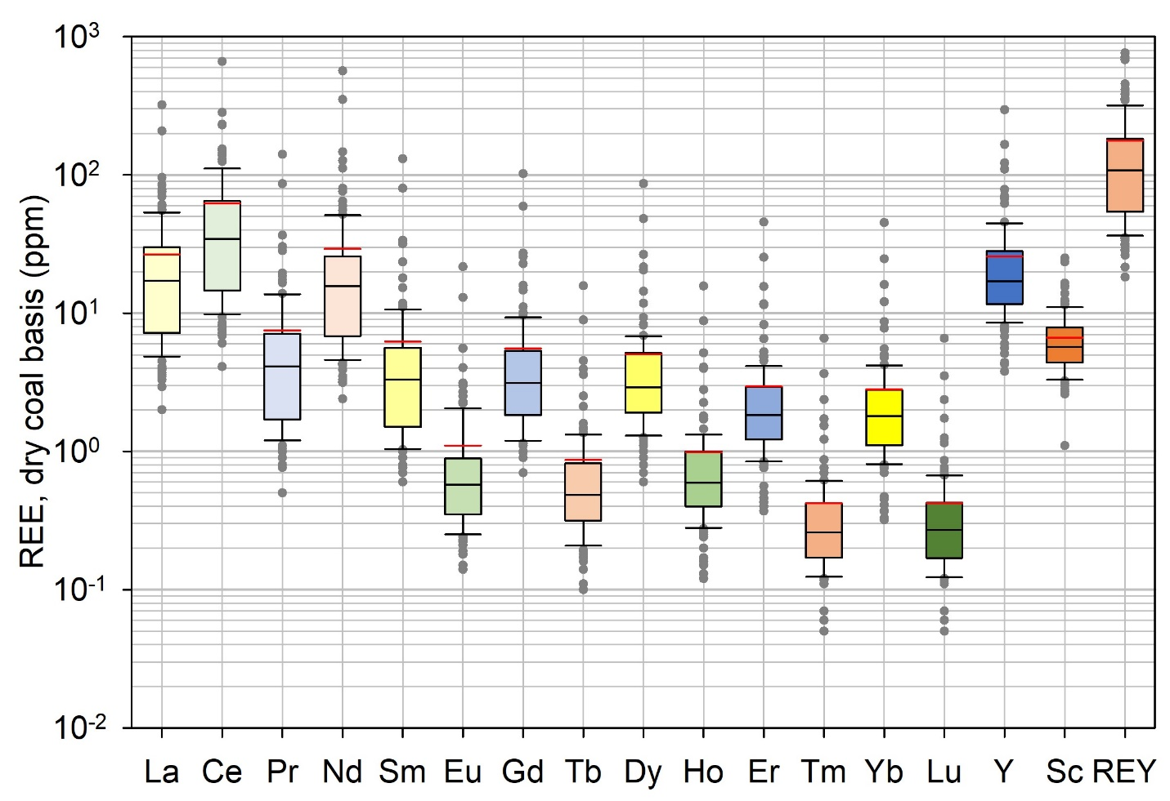
Figure S2. Box plots of rare earth element (REE) concentrations, showing median (black bar), mean (red bar), 25th and 75th percentile (box), and 5th and 95th percentile (lower and upper bars) values with all sample points totaling 118. These data show that elements with even atomic numbers have higher concentrations than those with odd atomic numbers according to the Oddo-Harkins Rule. Data are provided in Table S3a.
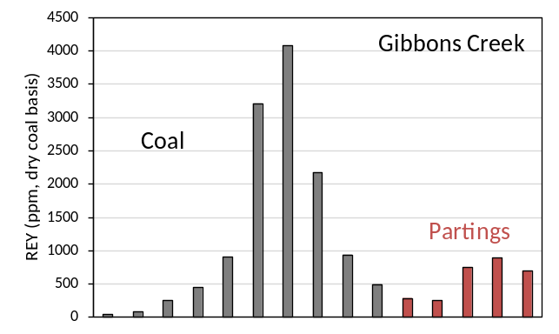
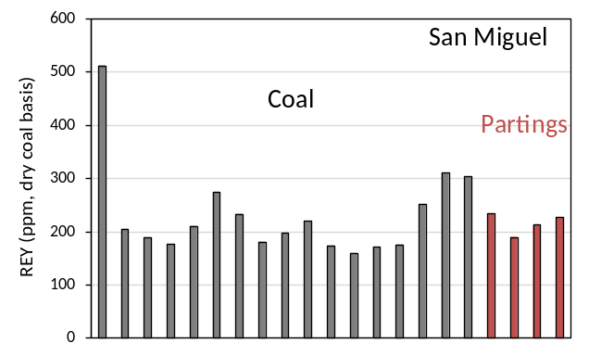
Figure S3. Distribution of rare earth element + Y (REY) concentrations in coal (gray bars) versus coal partings (red bars) in samples from the San Miguel mine and Gibbons Creek mine. Data are provided in Table S8.

Figure S4. Rare earth element + Y (REY) concentrations relative to ash percentages in coal samples (n=118). Data are provided in Table S3.

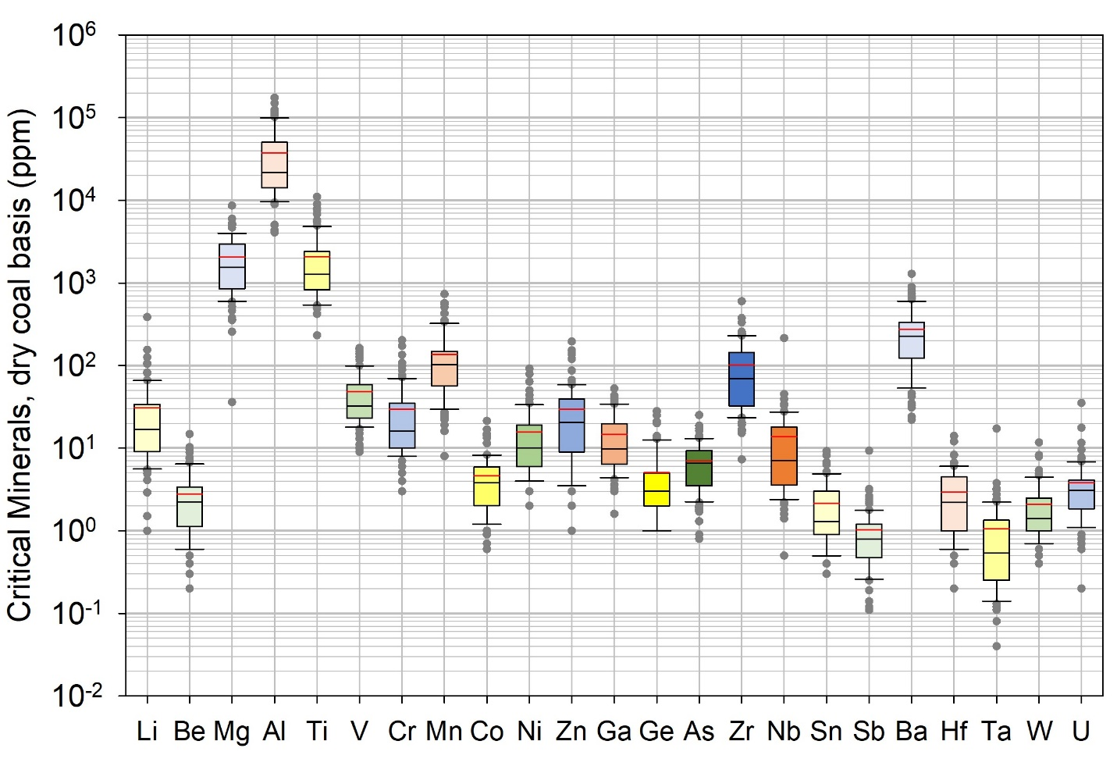
Figure S5. Box plots of critical minerals, excluding rare earth elements, showing median (black bar), mean (red bar), 25th and 75th percentile (box), and 5th and 95th percentile (lower and upper bars) values and all sample points totaling 118. Data are provided in Table S3b.

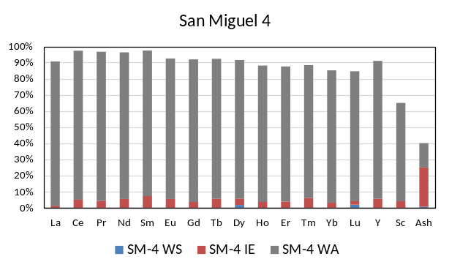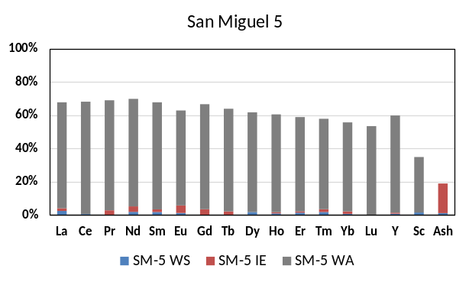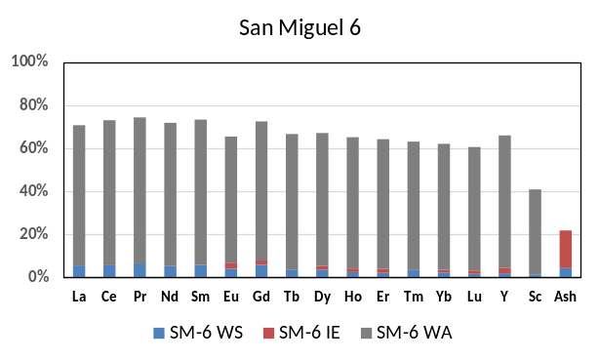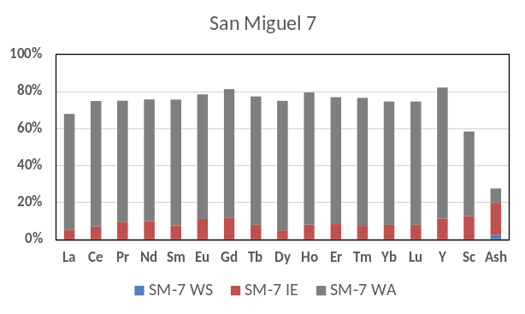
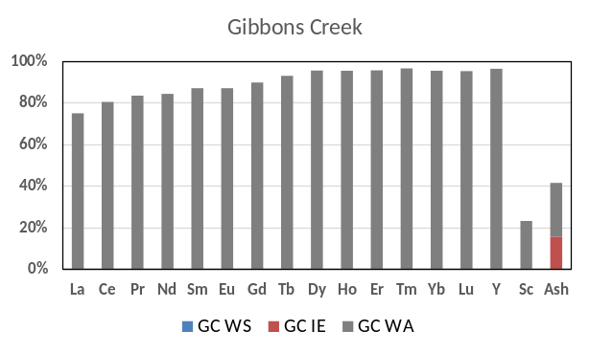
Figure S6. Results of sequential extraction of coal samples from Gibbons Creek (GC) and four samples from the San Miguel (SM) mine, including water soluble (WS, blue), ion exchangeable (IE, red), and weak acid (0.5 M HCl, gray). The vertical axis on each plot is percent extraction for the elements or coal ash listed on the horizontal axis. Data are provided in Table S9.

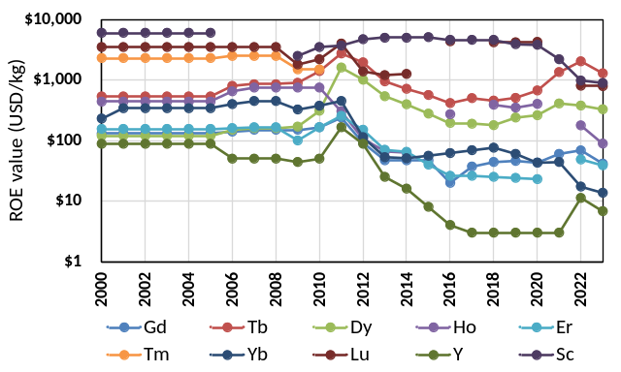
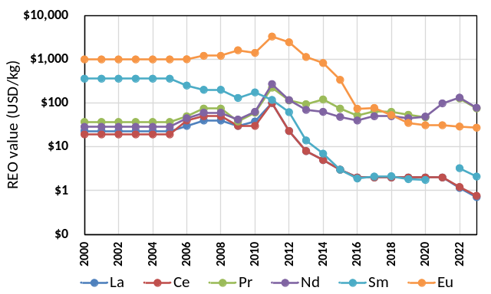
Figure S7. Prices of rare earth oxides (REO) per kg. Data and sources are listed in Table S10.

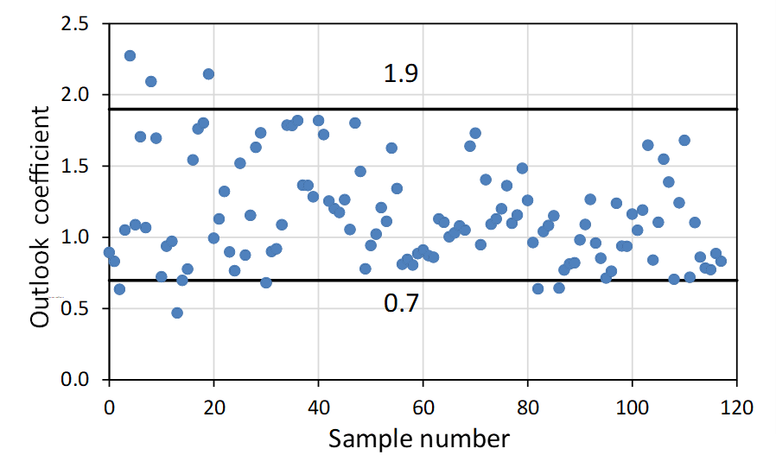
Figure S8. Outlook coefficient based on Seredin and Dai (2012)⁶ for 118 samples. Outlook coefficients between 0.7 and 1.9 are considered promising. Data are provided in Table S3a.

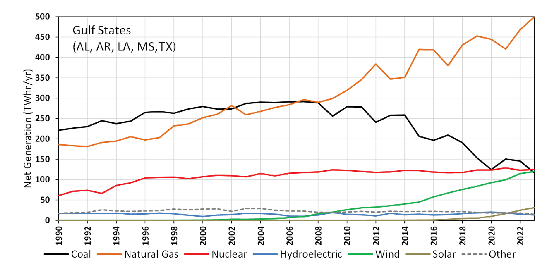
Figure S9. Power generation based on fuel source for Gulf Coast states (AL, AR, LA, MS, and TX). Electricity generation from coal has been decreasing since ~ 2000 and replaced by natural gas and renewables (wind and solar). Data are provided in Table S16.

Section 5. Tables
List of Tables
Table S1a. | Concentrations of some minerals and rare earth elements (REEs) in the upper continental crust (UCC).
Table S1b. | List of critical minerals, including rare earth elements (REEs), published by the U.S. Geological Survey in 2022.
Table S2 | Details of samples analyzed for critical minerals, including rare earth elements (REEs), in this study.
Table S3a. | Concentrations of rare earth elements (REEs) on a dry coal basis.
Table S3b. | Concentrations of critical minerals on a dry coal basis.
Table S3c. | Laboratory number; field number; and available as received moisture, dry ash, sulfur, and calorific value (CV) for samples analyzed in this study.
Table S4a. | Ratios of rare earth elements (REEs) (dry coal basis) relative to concentrations in upper continental crust (UCC).
Table S4b. | Ratios of critical minerals (dry coal basis) relative to concentrations in upper continental crust (UCC).
Table S5. | Correlation matrix of critical minerals, including rare earth elements (REEs), on dry coal basis.
Table S6a. | Concentrations of rare earth elements (REEs) on an ash basis.
Table S6b. | Concentrations of critical minerals on an ash basis.
Table S7a. | Ratios of rare earth elements (REEs) (ash basis) relative to concentrations in upper continental crust (UCC).
Table S7b. | Ratios of critical minerals (ash basis) relative to concentrations in upper continental crust (UCC).
Table S8. | Concentrations of rare earth elements (REEs) in coal and partings (ppm on dry coal basis) in samples from the Gibbons Creek and San Miguel mines.
Table S9. | Extractability of rare earth elements (REEs) using water, ammonium acetate, and weak hydrochloric acid in samples from the Gibbons Creek and San Miguel mines.
Table S10. | Rare earth oxides (REOs) mean annual prices, USD/kg, 2000 - 2024.
Table S11a. | Rare earth oxide (REO) concentrations on a dry coal basis.
Table S11b. | Value of rare earth oxides (REOs) per tonne using prices in Table S10 for 2024.
Table S12a. | Rare earth oxide (REO) concentrations on an ash basis.
Table S12b. | Value of rare earth oxides (REOs) on an ash basis using prices in Table S10 for 2024.
Table S13. | Coal production from mines in the Gulf Coast region during 1983 - 2022.
Table S14. | Status of coal mines in Texas.
Table S15a. | Source of coal for power plants (lignite [LIG], subbituminous [SUB], and bituminous [BIT]) from Appalachia, Powder River Basin [PRB], Western U.S. Basins, Gulf Coast, and Imported.
Table S15b. | Disposition of coal combustion byproducts (CCBs) for Gulf Coast power plants during 1985 - 2021.
Table S16. | Electricity generation by fuel source in Gulf Coast States (AL, AR, LA, MS, and TX).

