APPENDIX A

Table A.1. Comparison of the balance sheet data
before the policy intervention for untreated, treated and drop-out firms
Before
Untreated | Mean | SD
Maturity | 17.888 | 14.387
Debts | 2,348.147 | 6,078.151
Assets | 1,129.557 | 4,205.085
Production | 3,350.018 | 8,806.721
Revenues | 3,249.617 | 8,671.196
ROE | 8.614 | 20.292
Employees | 17.150 | 58.548
Value Added | 47,439.890 | 29,855.560
ABITDA | 250.961 | 845.050
Treated
Maturity | 20.416 | 15.053
Debts | 2,971.112 | 12,517.830
Assets | 1,421.427 | 3,285.523
Production | 4,279.658 | 10,081.120
Revenues | 4,160.243 | 9,871.803
ROE | 9.037 | 17.147
Employees | 17.675 | 20.626
Value Added | 54,357.950 | 32,890.520
EBITDA | 329.798 | 619.587
Drop-out
Maturity | 15.727 | 13.11
Debts | 3,142.360 | 16,633.580
Assets | 1,029.587 | 3,186.610
Production | 3,847.061 | 13,190.610
Revenues | 3,675.812 | 12,242.800
ROE | 7.968 | 21.973
Employees | 19.482 | 50.002
Value Added | 45,521.990 | 29,314.040
EBITDA | 276.134 | 1,051.108

Table A.2. Comparison of the balance sheet data
after the policy intervention for untreated, treated and drop-out firms
After
Not assigned | Mean | SD
Maturity | 17.888 | 14.387
Debts | 2,623.548 | 7,402.622
Assets | 1,346.607 | 5,195.403
Production | 3,973.213 | 13,291.300
Revenues | 3,834.102 | 13,094.13
ROE | 9.035 | 19.116
Employees | 18.209 | 33.366
Value Added | 52,180.070 | 33,722.980
EBITDA | 315.779 | 1,009.499
Assigned
Maturity | 20.417 | 15.053
Debts | 3,116.239 | 8,093.336
Assets | 1,741.034 | 4,057.304
Production | 4,934.206 | 9,303.179
Revenues | 4,743.951 | 8,904.172
ROE | 11.370 | 18.331
Employees | 19.630 | 22.664
Value Added | 60,248.880 | 34,835.600
EBITDA | 444.731 | 1,033.520
Drop-out
Maturity | 15.727 | 13.114
Debts | 3,267.017 | 13,067.100
Assets | 1,330.922 | 5,322.211
Production | 4,459.459 | 14,717.910
Revenues | 4,228.070 | 12,899.840
ROE | 9.755 | 17.918
Employees | 23.373 | 105.646
Value Added | 51,812.620 | 36,647.770
EBITDA | 360.479 | 1,372.77

Table A.3. Descriptive statistics (number and percentage) relative to
the stratification and dichotomous variables
Variables | Untreated |  | Treated |  | Drop-out
 | Obs. | Percentage | Obs. | Percentage | Obs. | Percentage
Ateco
Manufacturing | 2,857 | 43.6 | 594 | 51.4 | 379 | 37.5
Construction | 1,683 | 25.7 | 240 | 22.5 | 305 | 30.2
Other | 1,881 | 28.7 | 264 | 24.7 | 314 | 31.1
Unknown | 137 | 2.1 | 16 | 1.5 | 12 | 1.2
Company type
Srl | 5,927 | 90.4 | 954 | 89.2 | 902 | 89.3
Spa | 317 | 4.8 | 84 | 7.9 | 57 | 5.6
Cooperative and Corsortia | 286 | 4.4 | 25 | 2.3 | 45 | 4.5
Other | 28 | 0.4 | 6 | 0.6 | 6 | 0.6
Macro region
North | 3,148 | 48.0 | 633 | 59.2 | 295 | 29.2
Centre | 1,294 | 19.7 | 270 | 25.3 | 290 | 28.7
South | 2,116 | 32.3 | 166 | 15.5 | 425 | 42.1
Technology
High | 3,877 | 59.1 | 591 | 55.3 | 648 | 64.2
Low | 2,681 | 40.9 | 478 | 44.7 | 362 | 35.8

Table A.4. Comparison of logarithm and ranked variables describing the balance sheet data
before policy intervention for untreated, treated and drop-out firms
Before
Untreated | Obs. | Mean | SD
(ln)Debts | 6,388 | 6.808 | 1.364
(Ranked)Assets | 6,558 | 42.543 | 24.916
(Ranked)Production | 6,558 | 42.339 | 24.995
(ln)Revenues | 6,328 | 7.143 | 1.403
(Ranked)ROE | 6,558 | 43.021 | 25.120
(ln)Employees | 6,327 | 2.389 | 0.916
(Ranked) Value Added | 6,558 | 42.509 | 25.059
(Ranked)EBITDA | 6,558 | 42.339 | 24.945
Treated
(ln)Debts | 1,025 | 7.103 | 1.103
(Ranked)Assets | 1,069 | 11.488 | 5.773
(Ranked)Production | 1,069 | 11.381 | 5.718
(ln)Revenues | 1,013 | 7.562 | 1.233
(Ranked)ROE | 1,069 | 10.490 | 5.911
(ln)Employees | 1,013 | 2.555 | 0.851
(Ranked) Value Added | 1,069 | 11.605 | 5.622
(Ranked)EBITDA | 1,069 | 11.432 | 5.787
Drop-out
(ln)Debts | 984 | 6.883 | 1.428
(Ranked)Assets | 1,010 | 40.413 | 25.135
(Ranked)Production | 1,010 | 41.522 | 25.229
(ln)Revenues | 977 | 7.099 | 1.473
(Ranked)ROE | 1,010 | 43.305 | 24.755
(ln)Employees | 977 | 2.441 | 0.951
(Ranked)Value Added | 1,010 | 40.078 | 25.114
(Ranked)EBITDA | 1,010 | 41.326 | 25.062

Table A.5. Comparison of logarithm and ranked variables describing the balance sheet data
after policy intervention for untreated, treated and drop-out firms
After
Untreated | Obs. | Mean | SD
(ln)Debts | 6,475 | 6.918 | 1.344
(Ranked)Assets | 6,558 | 42.285 | 24.943
(Ranked)Production | 6,558 | 42.205 | 25.002
(ln)Revenues | 6,390 | 7.212 | 1.505
(Ranked)ROE | 6,558 | 42.768 | 25.107
(ln)Employees | 6,385 | 2.426 | 0.971
(Ranked)Value Added | 6,558 | 42.355 | 25.090
(Ranked)EBITDA | 6,558 | 41.982 | 24.936
Treated
(ln)Debts | 1,064 | 7.226 | 1.239
(Ranked)Assets | 1,069 | 11.329 | 5.676
(Ranked)Production | 1,069 | 11.149 | 5.551
(ln)Revenues | 1,061 | 7.690 | 1.282
(Ranked)ROE | 1,069 | 10.487 | 5.772
(ln)Employees | 1,061 | 2.641 | 0.872
(Ranked)Value Added | 1,069 | 11.192 | 5.511
(Ranked)EBITDA | 1,069 | 11.250 | 5.596
Drop-out
(ln)Debts | 976 | 7.049 | 1.354
(Ranked)Assets | 1,010 | 41.897 | 25.595
(Ranked)Production | 1,010 | 42.870 | 26.033
(ln)Revenues | 961 | 7.204 | 1.509
(Ranked)ROE | 1,010 | 44.113 | 25.333
(ln)Employees | 960 | 2.485 | 1.012
(Ranked)Value Added | 1,010 | 42.246 | 25.924
(Ranked)EBITDA | 1,010 | 43.092 | 25.942

APPENDIX B
As discussed extensively in the estimation methodology section (Section 5), the Click Day procedure simulates a randomized assignment to treatment. As Bryson et al. (2002) highlight, random assignment ensures that treated and untreated populations are comparable in terms of both observable and unobservable characteristics. However, the operational features of the administrative procedure may introduce evaluation challenges that need to be addressed when assessing the initiative's impact. In the case of the 2013 Inail ISI call, the benefits of random assignment may be partially offset in practice due to the administrative filters applied to eligible firms (e.g., drop-outs).
To address this concern, it is essential to test whether, after excluding drop-out firms from the assignment group, the covariates exhibit predictive power for the treatment variable. To this end, we estimate a logistic regression model, using the treatment variable (receipt of funds) as the dependent variable and the full set of covariates as independent variables (Table B.1).

Table B.1. Multivariate test of the non-ability of the control variables to predict treatment
Variables | Logistic Model  (Dependent Variable: treatment)
Debts | 0.915*  (0.049)
Assets | 1.003  (0.002)
Production | 1.002  (0.006)
Revenues | 1.164  (0.120)
ROE | 1.000  (0.002)
Employees | 0.873*  (0.070)
Value Added | 1.003  (0.002)
EBITDA | 1.004  (0.003)
Construction | 1.090  (0.344)
Other | 1.085  (0.340)
Unknown | 0.987  (0.309)
Spa | 1.164  (0.168)
Cooperative and Consortia | 0.710  (0.158)
Other | 1.681  (0.779)
Centre | 0.828  (0.070)
South | 0.420***  (0.046)
Technology low | 1.044  (0.088)
Intercept | 0.095***  (0.055)
Observations | 7,339
$$LR χ^{2}$$ | 201.260
Pseudo $R^{2}$ | 0.0342

Robust standard errors in parentheses: *** p<0.01, ** p<0.05, * p<0.1

As illustrated in Table B.1, the continuous variables Debts and Employees demonstrate some predictive power for treatment status. Among the categorical and stratification variables, firms located in the South exhibit a lower odds ratio compared to those in the Center, indicating a significant predictive relationship with treatment status. To evaluate the model's performance, we calculate the Area Under the Receiver Operating Characteristic Curve (AUC) and plot the corresponding ROC curve (Figure B.1).
Figure B.1 ROC curve to asses the performance of logistic model about imbalanced datasets
(Dependent variable: treatment)
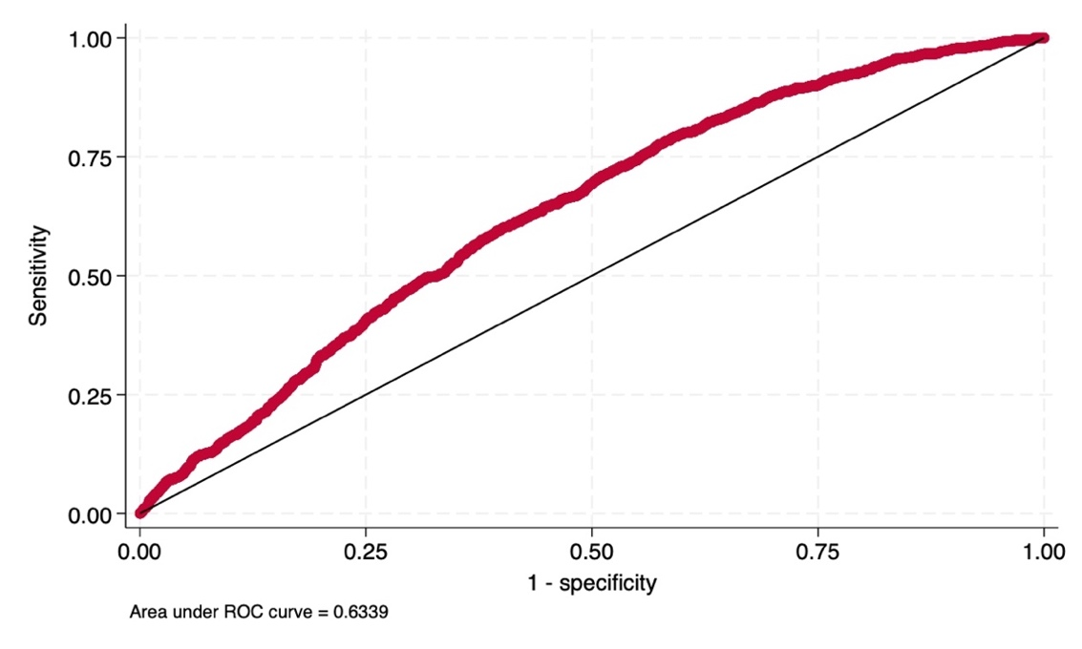
The Area Under the ROC Curve (AUC) for the model with "treatment" as the dependent variable is 0.63, which is higher than the AUC obtained when "assignment" is used as the dependent variable. This finding suggests that the removal of drop-outs from the sample of assigned firms has reduced the comparability between the units being compared. Consequently, a direct comparison between treated and untreated units without employing matching techniques would likely yield biased estimates.

APPENDIX C
The estimates of the Average Treatment Effect (ATE) using 1:2 and 1:4 Nearest Neighbour matching are presented in Table C.1 and Table C.2, respectively.
Table C.1. ATE estimated after 1:2 Nearest Neighbour matching
Bankrupt | Coefficient | AI Robust std. err. | z | P>|z| | [95% conf. interval]
ATE  treated  (1 vs 0) | -0.044 | 0.009 | -4.71 | 0.000 | -0.063 | -0.026

Table C.2. ATE estimated after 1:4 Nearest Neighbour matching
Bankrupt | Coefficient | AI Robust std. err. | z | P>|z| | [95% conf. interval]
ATE  treated  (1 vs 0) | -0.043 | 0.009 | -4.71 | 0.000 | -0.060 | -0.025

Tables C.1 and C.2 validate the previous ATE estimate obtained using 1:1 Nearest Neighbour matching (Table 11). While the magnitude of the effect slightly decreases, it retains its negative sign and remains statistically significant at the 1% level.

APPENDIX D
The estimate of the Average Treatment Effect on the Treated (ATT) is provided in Table D.1.

Table D.1. ATT estimate based on NN Matching
Bankrupt | Coefficient | AI Robust std. Err. | Z | P>|z| | [95% conf. Interval]
ATT  (1 vs 0) | -0.021 | 0.011 | -2.84 | 0.0062 | -0.043 | -0.010

The standardized mean differences are subsequently calculated to assess the balance of covariates (based on the pre-treatment values of the variables) between the treated and untreated groups, both before and after matching.
Table D.2. Standardized mean differences of the pre-treatment value of the covariates
between treated and untreated group before (Raw) and after (Matched) PS matching
Variables | Standardized differences
 | Raw | Matched
Maturity | 0.169 | -0.029
Debts | 0.218 | 0.020
Assets | 0.285 | -0.001
Production | 0.314 | 0.014
Revenues | 0.318 | 0.013
ROE | 0.015 | -0.032
Employees | 0.188 | -0.004
Value Added | 0.323 | 0.017
EBITDA | 0.319 | -0.144
Construction | 0.158 | 0.002
Other | -0.086 | -0.005
Unknown | -0.076 | 0.002
Spa | 0.133 | 0
Cooperative and Consortia | -0.115 | 0
Other | -0.023 | 0
Centre | 0.214 | -0.008
South | -0.392 | -0.003
Technology low | 0.082 | 0.004
As presented in Table D.2, the NN matching procedure ensures that the standardized differences for all variables fall below the 0.1 threshold, indicating negligible imbalance. Additionally, Table D.3 provides the ATT estimate based on PS matching.
Table D.3. ATT estimate based on PS Matching
Bankrupt | Coefficient | AI Robust std. Err. | Z | P>|z| | [95% conf. Interval]
ATT  (1 vs 0) | -0.023 | 0.012 | -1.98 | 0.048 | -0.047 | -0.0002

The estimates show a negative (decreased bankruptcy) Average Treatment Effect on the Treated, significant at the 5% level.
Regarding the ATE estimate based on PSM, we assess whether the assumptions of unconfoundedness (Table D.4), balance (Table D.5), and overlap (Figure D.1) hold, ensuring an unbiased estimate.
Table D.4. Mantel-Haenszel Test
Gamma | $$Q_{MH}^{+}$$ | $$Q_{MH}^{-}$$ | $$p_{MH}^{+}$$ | $$p_{MH}^{-}$$
1 | 2.33318 | 2.33318 | 0.009819 | 0.009819
1.05 | 2.59772 | 2.071 | 0.004692 | 0.019179
1.1 | 2.85055 | 1.82139 | 0.002182 | 0.034274
1.15 | 3.09332 | 1.58362 | 0.00099 | 0.05664
1.2 | 3.32694 | 1.35658 | 0.000439 | 0.087457
1.25 | 3.55219 | 1.13929 | 0.000191 | 0.127292
1.3 | 3.76975 | 0.930882 | 0.000082 | 0.175957
1.35 | 3.98024 | 0.730621 | 0.000034 | 0.232505
1.4 | 4.1842 | 0.537846 | 0.000014 | 0.295342
1.45 | 4.38208 | 0.351976 | 5.9e-06 | 0.362428
1.5 | 4.57433 | 0.172493 | 2.4e-06 | 0.431525
1.55 | 4.76133 | -0.001065 | 9.6e-07 | 0.500425
1.6 | 4.94341 | -0.020211 | 3.8e-07 | 0.508063
1.65 | 5.12089 | 0.142285 | 1.5e-07 | 0.443428
1.7 | 5.29405 | 0.299955 | 6.0e-08 | 0.382106
1.75 | 5.46315 | 0.453108 | 2.3e-08 | 0.325235
1.8 | 5.62842 | 0.602022 | 9.1e-09 | 0.27358
1.85 | 5.79007 | 0.74695 | 3.5e-09 | 0.227547
1.9 | 5.94831 | 0.888125 | 1.4e-09 | 0.187237
1.95 | 6.10331 | 1.02576 | 5.2e-10 | 0.152502
2 | 6.25523 | 1.16005 | 2.0e-10 | 0.123015

Table D.5. Standardized mean differences of the pre-treatment value of the covariates
between treated and untreated group before (Raw) and after (Matched) PS matching
Variables | Standardized differences
 | Raw | Matched
Maturity | 0.169 | -0.014
Debts | 0.218 | 0.051
Assets | 0.285 | 0.009
Production | 0.314 | 0.043
Revenues | 0.318 | 0.038
ROE | 0.015 | -0.007
Employees | 0.188 | 0.041
Value Added | 0.323 | 0.003
EBITDA | 0.319 | 0.015
Construction | 0.158 | 0.014
Other | -0.086 | -0.024
Unknown | -0.076 | 0.007
Spa | 0.133 | 0.037
Cooperative and Consortia | -0.085 | 0.020
Other | -0.023 | 0
Centre | 0.214 | 0.004
South | -0.392 | 0
Technology low | 0.082 | 0.005

Figure D.1. Overlap between treated and untreated firms after PS matching
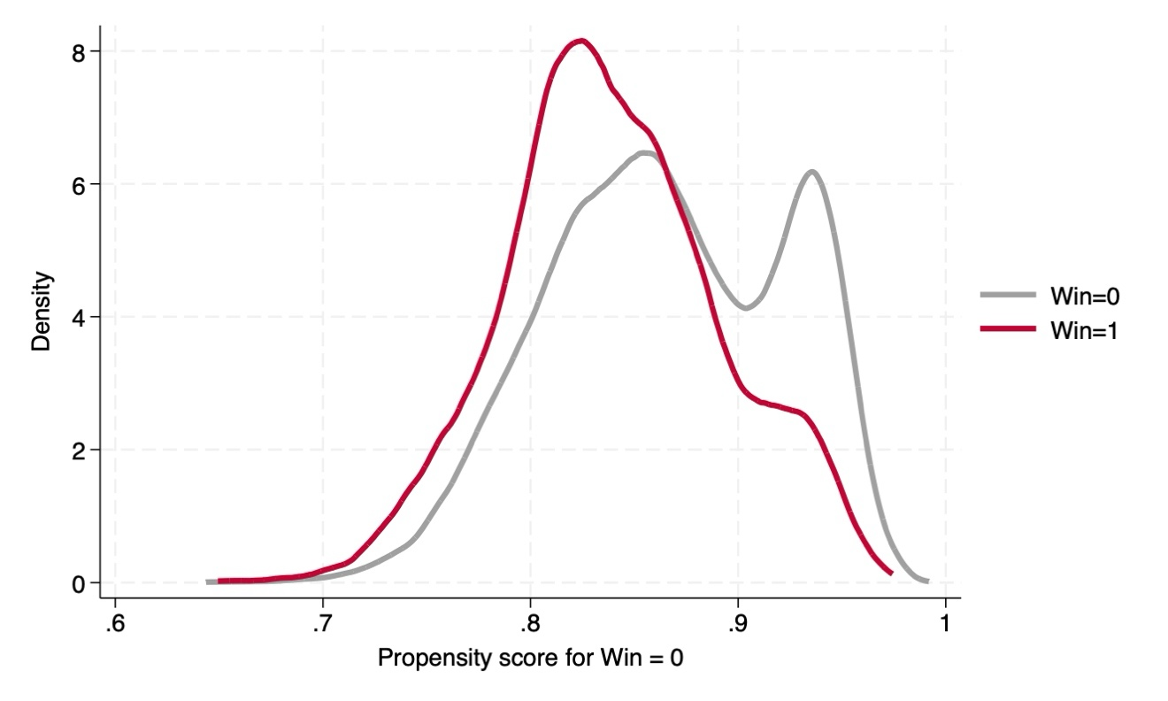
The results obtained (Table D.4, Table D.5, and Figure D.1) provide evidence consistent with the previous findings for the baseline ATE estimate (see Section 6). Thus, we can conclude that the tests do not indicate any bias in the ATT estimates post-PSM.
In both the NN and PS estimates, the ATT estimates are lower than the ATE estimates, regardless of the method used. Since, in general, when individuals with the lowest expected gains participate, the ATE will be higher than the ATT (Bryson et al., 2002), it can be inferred that the 2013 Inail policy targeted firms with the least need in terms of survival.

APPENDIX E
A t-test for equality of means between the two samples is conducted both before and after the PS matching. Additionally, the standardized percentage bias is computed. The standardized percentage bias is presented both before and after matching, along with the percentage reduction in bias achieved.
The standardized percentage bias represents the percentage difference between the sample means in the treated and non-treated (unmatched or matched) sub-samples, expressed as a percentage of the square root of the average of the sample variances in the treated and non-treated groups (Rosenbaum and Rubin, 1985).

Table E.1. t-tests and standardised percentage bias before and after PS mathcing
Variable | Unmatched (U)  Matched (M) | Mean |  | %bias | % reduct |bias| | t-test |  | $$\frac{V(T)}{V(C)}$$
Variable | Unmatched (U)  Matched (M) | Treated | Control | %bias | % reduct |bias| | $$t$$ | $$p>|t|$$ | $$\frac{V(T)}{V(C)}$$
Maturity | U | 20.24 | 17.751 | 16.9 |  | 5.08 | 0.000 | 1.09
Maturity | M | 20.24 | 20.447 | -1.4 | 91.7 | -0.31 | 0.758 | 0.97
Debts | U | 7.1028 | 6.8151 | 21.8 |  | 6.31 | 0.000 | 0.88*
Debts | M | 7.1028 | 7.0365 | 5.0 | 77.0 | 1.15 | 0.252 | 0.93
Assets | U | 48.241 | 41.47 | 28.5 |  | 8.29 | 0.000 | 0.91
Assets | M | 48.241 | 48.03 | 0.9 | 96.9 | 0.20 | 0.838 | 1.00
Production | U | 48.075 | 40.796 | 31.4 |  | 9.03 | 0.000 | 0.86*
Production | M | 48.075 | 47.097 | 4.2 | 86.6 | 0.96 | 0.335 | 0.91
Revenues | U | 7.5621 | 7.143 | 31.8 |  | 8.98 | 0.000 | 0.77*
Revenues | M | 7.5621 | 7.5134 | 3.7 | 88.4 | 0.86 | 0.390 | 0.88*
ROE | U | 41.883 | 41.516 | 1.6 |  | 0.45 | 0.652 | 0.87*
ROE | M | 41.883 | 42.052 | -0.7 | 53.8 | -0.17 | 0.869 | 0.92
Employees | U | 2.5553 | 2.3889 | 18.8 |  | 5.42 | 0.000 | 0.86*
Employees | M | 2.5553 | 2.5191 | 4.1 | 78.2 | 0.93 | 0.351 | 0.90
Value Added | U | 48.421 | 40.976 | 32.4 |  | 9.22 | 0.000 | 0.81*
Value Added | M | 48.421 | 48.349 | 0.3 | 99.0 | 0.07 | 0.942 | 0.91
EBITDA | U | 48.265 | 40.793 | 31.9 |  | 9.26 | 0.000 | 0.90
EBITDA | M | 48.265 | 47.931 | 1.4 | 95.5 | 0.33 | 0.743 | 0.97
Construction | U | 0.51333 | 0.4346 | 15.8 |  | 4.96 | 0.000 | NA
Construction | M | 0.51333 | 0.50642 | 1.4 | 91.2 | 0.31 | 0.756 | NA
Other | U | 0.22113 | 0.25763 | -8.6 |  | -2.48 | 0.013 | NA
Other | M | 0.22113 | 0.231 | -2.3 | 73.0 | -0.53 | 0.596 | NA
Unknown | U | 0.25271 | 0.28657 | -7.6 |  | -2.22 | 0.026 | NA
Unknown | M | 0.25271 | 0.24975 | 0.7 | 91.3 | 0.15 | 0.878 | NA
Spa | U | 0.08292 | 0.04998 | 13.3 |  | 4.29 | 0.000 | NA
Spa | M | 0.08292 | 0.07305 | 4.0 | 70.0 | 0.83 | 0.408 | NA
Cooperative and Consortia | U | 0.02369 | 0.0446 | -11.5 |  | -3.09 | 0.002 | NA
Cooperative and Consortia | M | 0.02369 | 0.02073 | 1.6 | 85.8 | 0.45 | 0.651 | NA
Other | U | 0.00592 | 0.00427 | 2.3 |  | 0.73 | 0.466 | NA
Other | M | 0.00592 | 0.00592 | 0.0 | 100.0 | -0.00 | 1.000 | NA
Centre | U | 0.5844 | 0.4781 | 21.4 |  | 6.30 | 0.000 | NA
Centre | M | 0.5844 | 0.5844 | 0.0 | 100.0 | 0.00 | 1.000 | NA
South | U | 0.15893 | 0.32342 | -39.2 |  | -10.68 | 0.000 | NA
South | M | 0.15893 | 0.15696 | 0.5 | 98.8 | 0.12 | 0.903 | NA
Technology low | U | 0.44719 | 0.40645 | 8.2 |  | 2.45 | 0.014 | NA
Technology low | M | 0.44719 | 0.44423 | 0.6 | 92.7 | 0.13 | 0.893 | NA
* if variance ratio outside [0.88; 1.13] for U and [0.88; 1.13] for M
Sample | $$Pseudo R^{2}$$ | $$LR χ^{2}$$ | $$P>χ^{2}$$ | MeanBias | MedBias | B | R | %Var
Unmatched | 0.036 | 209.19 | 0.000 | 19.1 | 17.9 | 50.9* | 0.63 | 67
Matched | 0.001 | 3.98 | 1.000 | 1.8 | 1.4 | 8.9 | 1.08 | 11
* if $B>25\%$, R outside $[0.5; 2]$

Morever, (Figure E.1) provides a graphical depict of the propensity score by treatment status (treated and untreated).

Figure E.1. Graph of the propensity score histogram by treatment status
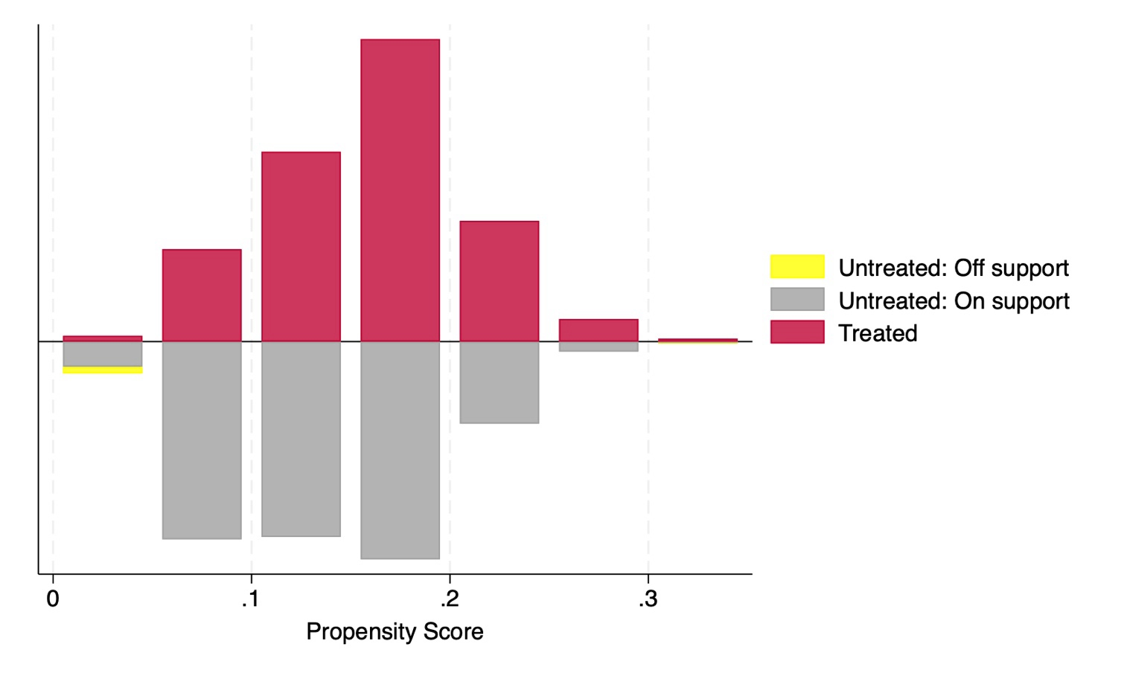

References

Bryson, A., Dorsett, R., & Purdon, S. (2002). The use of propensity score matching in the evaluation of active labour market policies.
Rosenbaum, P. R., & Rubin, D. B. (1985). Constructing a control group using multivariate matched sampling methods that incorporate the propensity score. The American Statistician, 39(1), 33-38.

APPENDIX F
In this appendix, we extend the analysis by focusing on the regions with the highest participation rates, specifically the top two regions from each macro-geographical area. We estimate the Average Treatment Effect (ATE) using 1:2 Nearest Neighbor (NN) Matching across six regions, which were selected due to the limited number of units of observation available for conducting our analysis. Table F.1. below presents the frequencies of participants and the participation rate per region, with the two most participated regions highlighted, which are considered in the ATE estimates. Table F.2. presents the ATE estimates for the specific regions selected.
Table F.1. Participants per region (frequencies and percentages)
Region | Freq. | Percent | Cum.
PIEMONTE | 575 | 6.66 | 6.66
VALLE D’AOSTA | 8 | 0.09 | 6.75
LOMBARDIA | 1,722 | 19.94 | 26.69
TRENTINO ALTO ADIGE | 77 | 0.89 | 27.58
VENETO | 701 | 8.12 | 35.70
FRIULI VENEZIA GIULIA | 172 | 1.99 | 37.69
LIGURIA | 108 | 1.25 | 38.94
EMILIA ROMAGNA | 723 | 8.37 | 47.31
TOSCANA | 656 | 7.60 | 54.90
UMBRIA | 188 | 2.18 | 57.08
MARCHE | 374 | 4.33 | 61.41
LAZIO | 672 | 7.78 | 69.19
ABRUZZO | 253 | 2.93 | 72.12
MOLISE | 69 | 0.80 | 72.92
CAMPANIA | 752 | 8.71 | 81.63
PUGLIA | 311 | 3.60 | 85.23
BASILICATA | 155 | 1.79 | 87.02
CALABRIA | 283 | 3.28 | 90.30
SICILIA | 690 | 7.99 | 98.29
SARDEGNA | 148 | 1.71 | 100.00
 | 8,637 | 100.00

Table F.2. ATE estimate based on 1:2 NN-Matching (regions)
Regions | Coefficient | Robust std. error | Z | P>|z| | [95% conf. interval]
Lombardia | -0.028 | 0.015 | -1.91 | 0.056 | -0.057 | 0.001
Emilia Romagna | -0.044 | 0.026 | -1.71 | 0.087 | -0.094 | 0.006
Toscana | -0.064 | 0.019 | -3.45 | 0.001 | -0.100 | -0.028
Lazio | -0.089 | 0.036 | -2.47 | 0.014 | -0.159 | -0.018
Campania | -0.082 | 0.023 | -3.60 | 0.000 | -0.127 | -0.038
Sicilia | 0.031 | 0.056 | 0.54 | 0.587 | -0.079 | 0.141

APPENDIX G
To complement the main analysis on firm survival, we implement a difference-in-differences (DID) specification using EBITDA as a continuous outcome variable. This extension aims to investigate the potential economic channels through which the policy may have influenced firm dynamics beyond the binary survival margin. In particular, EBITDA (Earnings Before Interest, Taxes, Depreciation, and Amortization) serves as a key proxy for a firm’s core operating profitability and internal cash flow generation capacity, independent of capital structure and accounting choices. As such, changes in EBITDA can reflect improvements in operational efficiency, revenue growth, or cost optimization—factors that are often critical to a firm’s ability to withstand economic shocks and remain viable in the long run.
By focusing on EBITDA, this analysis allows us to assess whether the treatment had an impact on firms’ economic fundamentals, which may in turn help explain the observed effects on survival. If assgined firms display higher EBITDA following the intervention, this suggests that the policy not only affected firm status in a binary sense (exit or survival) but also enhanced the financial conditions underpinning longer-term sustainability. This type of performance improvement can act as a transmission mechanism: for example, higher EBITDA may improve access to credit, support reinvestment, or reduce the likelihood of financial distress, all of which reduce the probability of firm failure.
The Diff-In-Diff model includes standard firm-level controls (e.g., balance sheet indicators), as well as fixed effects for geographic region, sector (Ateco classification), company type, and technological orientation. Results are reported in Table G.1.

Table G.1. DID estimation with EBITDA as dependent variable
Variables | Dependent variable: EBITDA
DID (assigned*post) | 0.894**  (0.450)
Assigned_group | 0.524  (0.331)
Post | -1.047***  (0.222)
Balance Sheet Controls | Yes
Region Controls | Yes
Ateco Control | Yes
Company Type Control | Yes
Technology Control | Yes
Intercept | -99.44***  (4.277)
F-stat | 1707.55***
$R^{2}$ | 0.733
Obs. | 16,412
Robust standard errors in parentheses: *** p<0.01, ** p<0.05, * p<0.1

The coefficient on the assigned group indicator (0.524, not statistically significant) suggests that, prior to the policy intervention, assigned firms had slightly higher EBITDA levels than untreated firms. Crucially, this lack of statistical significance is consistent with the identifying assumption of the Difference-in-Differences framework, namely that—absent the treatment—the assigned and control groups would have followed similar trends. In other words, the absence of systematic pre-treatment differences supports the credibility of the parallel trends assumption.
The negative and highly significant coefficient on the post-policy indicator (-1.047, p < 0.01) indicates that, on average, all firms experienced a decline in EBITDA in the post-treatment period. This likely reflects macroeconomic factors or common shocks affecting firms across the board.
The interaction term between treatment status and the post-policy period is positive and statistically significant at the 5% level, with an estimated coefficient of 0.894. This suggests that assigned firms experienced an increase in EBITDA relative to untreated firms after the policy was implemented. These findings reinforce the hypothesis that the intervention may have supported firm survival by improving underlying economic performance.

APPENDIX H
In this appendix, we implement the two-stage least squares (2SLS) approach to estimate the Local Average Treatment Effect (LATE) or the Average Treatment Effect (ATE) in the presence of imperfect compliance, using the initial random assignment as an instrument. This approach effectively rescales the Intent-to-Treat (ITT) estimate by the first-stage compliance rate.
We have included the 2SLS estimates as a robustness check in this appendix. This additional analysis serves to demonstrate the consistency of our results across different estimation strategies and further addresses concerns regarding the validity of our causal inference.
The corresponding 2SLS estimates are reported in Table H.1.
Table H.1. 2SLS (Dependent variable: Bankrupt; Instrumental variable: Assigned)
Variables | 2SLS
Treatment | -.0204*  (.0115)
Balance sheet controls | Yes
Ateco control | Yes
Company type control | Yes
Macro region control | Yes
Technology control | Yes
Intercept | -.212***  (.048)
F-stat | 32.15
Uncentered $R^{2}$ | 0.21
F-Stat. (1, 8373) - First Stage | 2352.14***
Observations | 8,393
Robust standard errors in parentheses: *** p<0.01, ** p<0.05, * p<0.1

Along with the Kleibergen-Paap rk Wald F statistic, which validates the relevance of our instruments, we assess the strength and validity of the instruments using two key statistical tests. First, we examine the extent of the relationship between the additional instruments and the endogenous variable. If the F statistic for the excluded instrument in the first stage is not statistically significant (i.e., the p-value exceeds 10%), it suggests that the additional instruments do not provide sufficient explanatory power (i.e., weak instruments) for the endogenous variable, even after accounting for the influence of other potential confounders. However, Hall, Rudebusch, and Wilcox (1996), using a Monte Carlo simulation, demonstrate that an F statistic on the excluded instrument that is significant at the usual 5% or 10% levels is inadequate. For this reason, we adhere to the approach of Stock, Wright, and Yogo (2002) and evaluate whether, in the case of a single endogenous regressor, the F statistic surpasses the critical threshold of 10 to ensure the reliability of the 2SLS estimator.

