SUPPLEMENTAL MATERIAL

Anti-epileptic medication exposure influences functional status in New Zealand stroke patients: a retrospective population level study

Ailsa L. McGregor*, PhD,
School of Pharmacy, University of Otago, Dunedin, New Zealand

Md. Rashedul Hoque, MSc,
Faculty of Health Sciences, Simon Fraser University
Arthritis Research Canada

Sophia Nickel, BPharm
School of Pharmacy, University of Otago, Dunedin, New Zealand

Alesha J. Smith, PhD,
School of Pharmacy, University of Otago, Dunedin, New Zealand,

Mohammad Atiquzzaman, PhD
School of Pharmacy, University of Otago, Dunedin, New Zealand

*Corresponding Author:
Dr Ailsa McGregor,
School of Pharmacy, Division of Health Sciences,
University of Otago,
PO Box 56, Dunedin 9054, New Zealand
Ph: +64 3 479 4235
Email: ailsa.mcgregor@otago.ac.nz
Twitter: @McGregor_lab

Supplementary Figures 3
Supplementary Tables 2
Word Count 1266

Table I: List of medicines in AED and co-variable medication categories-
AEDs
Carbamazepine
Clobazam
Clonazepam
Ethosuximide
Gabapentin
Lamotrigine
Levetiracetam
Phenobarbital
Primidone
Phenytoin
Sodium Valproate
Topiramate

NSAID
Aspirin
Celecoxib
Diclofenac
Ibuprofen
Ketoprofen
Naproxen
Sulindac
Tenoxicam

Paracetamol
Paracetamol

Pain medication
Codeine
Dihydrocodeine
Fentanyl
Methadone
Morphine
Oxycodone
Paracetamol with codeine
Pethidine
Tramadol
Nefopam

Anti-depressants
Amitriptyline
Clomipramine
Dosulepin
Doxepin
Imipramine
Mianserin
Nortriptyline
Citalopram
Escitalopram
Fluoxetine
Paroxetine
Sertraline
Mirtazapine
Venlafaxine
Bupropion
Maprotiline
Moclobemide
Tranylcypromine

Anti-psychotics
Chlorpromazine
Flupenthixol
Fluphenazine
Haloperidol
Levomepromazine
Pericyazine
Prochlorperazine
Trifluoperazine
Zuclopenthixol
Amisulpride
Aripiprazole
Clozapine
Olanzapine
Paliperidone
Quetiapine
Risperidone
Lithium carbonate
Clonidine
Methylphenidate

Hypnotics
Alprazolam
Diazepam
Lorazepam
Lormetazepam
Midazolam
Nitrazepam
Oxazepam
Temazepam
Triazolam
Buspirone
Zopiclone

Anti-muscarinic agents
Benzatropine
Hyoscine
Procyclidine

Anti-nausea
Metoclopramide
Metoclopramide with paracetamol
Ondansetron
Cyclizine

Migraine medication
Pizotifen
Ergotamine with caffeine
Rizatriptan
Sumatriptan

Smoking cessation medications
Nicotine
Varenicline

Parkinson’s disease (PD) and Huntington’s disease* (HD)
Amantadine
Levodopa with benserazide
Levodopa with carbidopa
Pramipexole
Ropinirole
Tolcapone
Selegiline
*Tetrabenazine

Anti-cancer drugs
Aprepitant

Cholinesterase inhibitors
Donepezil
Rivastigmine

Supplementary Methods

Beta Regression Model
As a generalized linear model (GLM), beta regression models the association of covariates with changes in mean and precision of the outcome at the same time, in addition to modeling possible non-constant changes in variance. We considered ‘logit’ and strictly non-negative ‘natural log’ link function as the mean and precision link functions in our beta regression models. A unit change in any covariate in the mean model therefore explained a difference in log-odds of observing the outcome. Following exponentiation, the mean regression parameters can be interpreted as an odds ratio.

On the other hand, a unit change in any covariate in the precision model explained a logarithmic unit change in the precision of the outcome. In the precision model, negative and positive parameter estimates indicate a decrease and increase in precision and subsequent increase and decrease in variance, respectively. In both the mean and precision models, error and other covariates are accounted for though we have the flexibility to choose our covariates separately for each model.

A percentage was calculated from the ratio of ADL-Score to the total possible score 60 for each stroke patient; this percentage ADL-Score has the range [0,1] and used as the outcome in our Beta regression models (1). For perfect scores 0 and 60, we could have a percentage 0 or 1; those boundary values will be ignored in the Beta models. We have done a transformation according to Swearingen to scale the percentages into the range (0,1) by letting $Z=[Y^{'}\left(N-1\right)+0.5]/N$ where $Y^{'}=\left[Y-minimum \left(Y\right)\right]/(maximum \left(Y\right)- minimum \left(Y\right))$. Here $Z$ is the transformed percentage, $Y^{'}$ is the observed percentage value, N is the number of total observations, and Y is the original scale measurement for the outcome (2). This transformation shifts any observed percentage exactly equal to 0 or 1 slightly away from 0 or 1.

Supplementary Results

The distribution of total ADL score was examined prior to modeling (Figure S1). Both the distributions of total ADL score and its logarithmic transformations showed a skewed pattern supporting the use of beta regression models on transformed ADL-Score percentage.
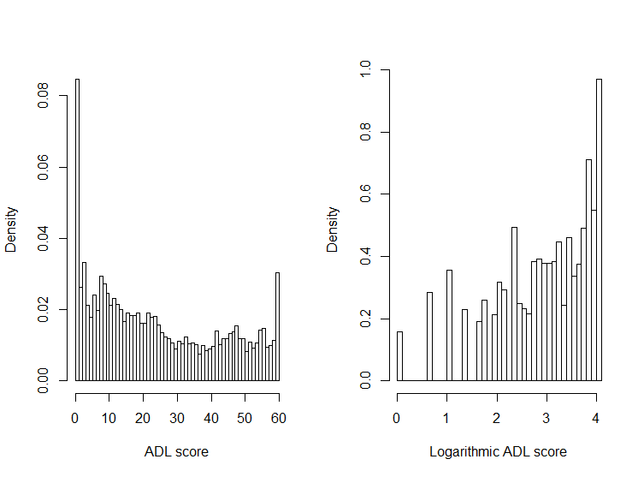
Figure I: ADL-Score and its natural logarithmic transformation

Both the distribution of ADL score in the study population, and its natural logarithmic transformation show a skewed distribution.

AED exposed patients were further subdivided into AED exposure ‘after’ and ‘before and after’ stroke categories. The distribution of time to assessment for three AED exposure categories is presented in Figure II. Both AED exposed categories had comparable median values, whereas unexposed had a higher median.
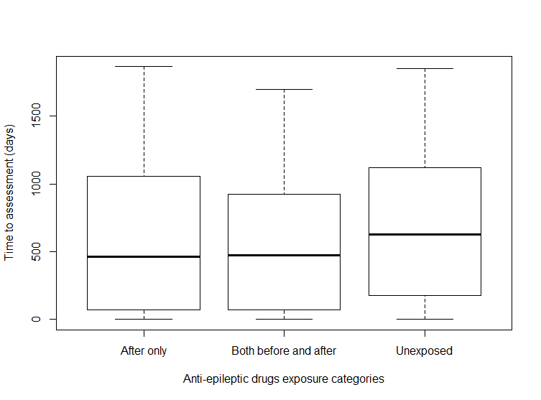
Figure II: Distribution of time to assessment for different AED exposure categories
The median time to interRAI™ assessment after stroke was higher in unexposed patients that in those exposed to AED medication only after and both before and after stroke.

Also, the distribution of total length of hospital stay (LoS) for the three AED exposure categories is shown in Figure III. After only AED exposed patients had the highest median LoS (suggesting a more severe initial stroke), whereas patients exposed both before and after stroke had the lowest median LoS.

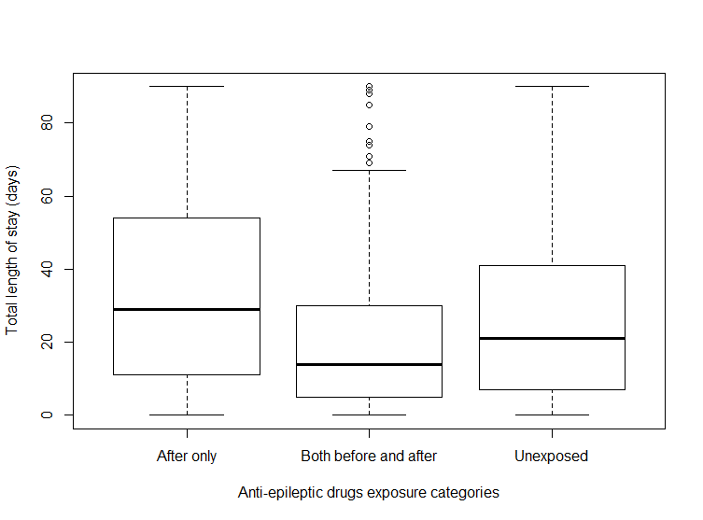
Figure III: Length of hospital stay for different AED exposure categories
Distribution of length of hospital stay (LoS) related to stroke admission for different AED exposure categories. The median LoS was highest in patients exposed to AED medication only after stroke. Unexposed patients had a higher median LoS than patients exposed to AED, both before and after stroke. Taking LoS as a surrogate marker for stroke this suggests patients who develop post stroke epilepsy have more severe initial strokes.

Table II: Modelling mean and precision – Beta regression model with binary AED exposure

 | Mean model |  | Precision model
Variables | OR estimate  (95% CI) | P-value | Effect estimate  (95% CI) | P-value
AED exposure
Unexposed | Ref
Exposed | 1.29 (1.15– 1.45) | <0.001 | -0.15 (-0.26 - -0.05) | 0.004
Age categories
16-64 | Ref
65-74 | 1.00 (0.81 – 1.24) | 0.985 | -0.06 (-0.14 - 0.25) | 0.538
75-84 | 1.16 (0.94 – 1.43) | 0.169 | -0.12 (-0.08 – 0.30) | 0.220
85 and above | 1.43 (1.15 – 1.77) | 0.001 | -0.29 (0.08 – 0.47) | 0.004
Sex
Male | Ref
Female | 0.93 (0.86 – 1.01) | 0.104 | -0.03 (-0.11 – 0.05) | 0.471
Ethnic categories
European | Ref
Maori | 1.46 (1.20 – 1.77) | <0.001 | - 0.19 (-0.36 - -0.02) | 0.034
Pacific people | 2.04 (1.60 – 2.59) | <0.001 | -0.29 (-0.50 - -0.09) | 0.006
Asian | 1.64 (1.31 – 2.06) | <0.001 | 0.08 (-0.13 – 0.30) | 0.441
Other ethnicity | 1.27 (0.94 – 1.71) | 0.120 | -0.07 (-0.35 – 0.21) | 0.608
BMI categories
Underweight | Ref
Normal | 0.74 (0.64 – 0.87) | <0.001 | 0.10 (-0.04 – 0.24) | 0.174
Overweight | 0.61 (0.52 -0.72) | <0.001 | 0.19 (0.04 – 0.34) | 0.014
Obese | 0.57 (0.48-0.69) | <0.001 | 0.32 (0.16 – 0.49) | <0.001
Length of stay | 1.01 (1.00 – 1.02) | <0.001 | 0.005 (0.004 – 0.007) | <0.001
Time to assessment | 1.00 (0.99 – 1.00) | 0.135 | -0.0001 (-0.0002 – -0.0001) | 0.014
NSAIDs
No | Ref
Yes | 1.05 (0.93 – 1.19) | 0.404 | -0.15 (-0.26 – -0.04) | 0.009
Paracetamol
No | Ref
Yes | 1.24 (1.12 – 1.38) | <0.001
Other pain medications
No | Ref
Yes | 1.12 (1.03 – 1.22) | 0.008
Anti-depressants
No | Ref
Yes | 1.09 (1.01 – 1.19) | 0.038
Anti-psychotics
No | Ref
Yes | 1.30 (1.16 – 1.44) | <0.001 | -0.12 (-0.22 - -0.03) | 0.012
Hypnotics
No | Ref
Yes | 0.98 (0.90 – 1.07) | 0.671
Anti-muscarinic
No | Ref
Yes | 1.25 (0.74 – 2.10) | 0.395
Anti-nausea
No | Ref
Yes | 1.29 (1.12 – 1.47) | <0.001 | -0. 26 (-0.38 - -0.14) | <0.001
Migraine medication
No | Ref
Yes | 0.79 (0.47 – 1.32) | 0.363
Smoking cessation medications
No | Ref
Yes | 0.90 (0.73 – 1.11) | 0.324
Abbreviations: AED, anti-epileptic drug; OR, odds ratio; CI, confidence interval.
*The mean and precision components of the Beta regression model were adjusted for demographic variables (age, sex, and ethnicity), BMI status, length of stay during hospitalization, time to assessment, and other medications that may affect post-stroke functional status. All centrally acting medications were considered in the mean model, whereas the precision model utilized NSAIDs, anti-psychotics, and anti-nausea medications.

References
1. Smithson M, Verkuilen J. A better lemon squeezer? Maximum-likelihood regression with beta-distributed dependent variables. Psychol Methods. 2006;11(1):54-71.

2. Swearingen CJ, Tilley BC, Adams RJ, Rumboldt Z, Nicholas JS, Bandyopadhyay D, et al. Application of beta regression to analyze ischemic stroke volume in NINDS rt-PA clinical trials. Neuroepidemiology. 2011;37(2):73-82.

