Supplementary information

[Article title]
Treatment patterns of biologic disease-modifying antirheumatic drugs and Janus kinase inhibitors in patients with rheumatoid arthritis in Japan: a claims-based cohort study

[Journal name]
Drugs - Real World Outcomes

[Author Names and affiliation]
Masahiko Miyashiro¹, Teita Asano¹*, Yutaka Ishii¹, Celine Miyazaki², Hirohito Shimizu³, Junya Masuda¹

¹Immunology & Infectious Diseases Department, Medical Affairs Division, Janssen Pharmaceutical K.K., Nishi Kanda 3-5-2, Chiyoda-Ku, Tokyo, 101-0065, Japan.
²Value, Evidence & Access Department, Janssen Pharmaceutical K.K., Nishi Kanda 3-5-2, Chiyoda-Ku, Tokyo, 101-0065, Japan.
³Medical Excellence Department, Medical Affairs Division, Janssen Pharmaceutical K.K., Nishi Kanda 3-5-2, Chiyoda-Ku, Tokyo, 101-0065, Japan.
*Address correspondence to Teita Asano; e-mail: tasano8@its.jnj.com

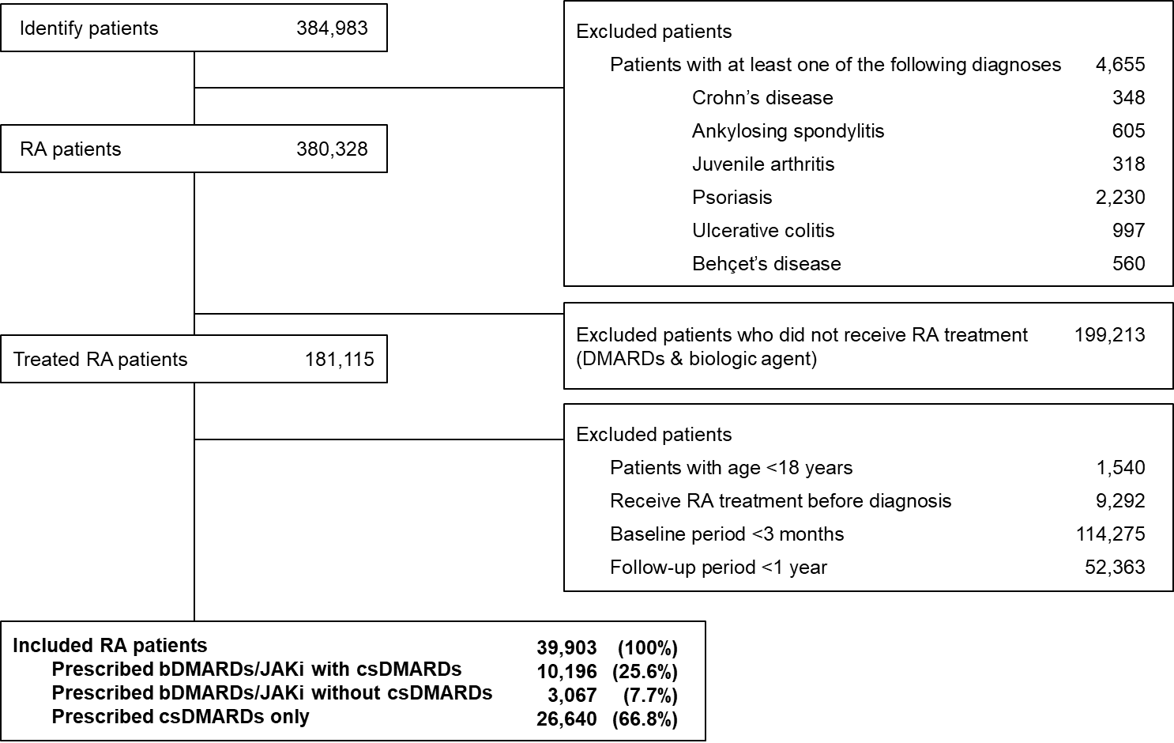
Supplementary figure 1 Flow chart for cohort selection

Supplementary table 1 Change in bDMARDs/JAKi therapy
Change in therapy, n (%) | bDMARDs/JAKi with csDMARDs  N=10,196 | bDMARDs/JAKi without csDMARDs  N=3,067
Switching | 3,150 (30.9) | 849 (27.7)
1 agent | 2,106 (20.7) | 573 (18.7)
2 agents | 732 (7.2) | 191 (6.2)
≥3 agents | 312 (3.1) | 85 (2.8)
Non- switching | 7,046 (69.1) | 2,218 (72.3)
Temporary discontinuation | 1,379 (13.5) | 513 (16.7)
Discontinuation | 2,025 (19.9) | 833 (27.2)

Supplementary table 2 (A) Switching of the first bDMARDs/JAKi to another one (with csDMARDs)
1st bDMARD/JAKi | (n) | 2nd | (n) | 3rd | (n)
TNFi | 6116 | TNFi | 872 | TNFi | 120
 |  |  |  | IL-6i | 125
 |  |  |  | CTLA4-Ig | 44
 |  |  |  | JAKi | 31
 |  | IL-6i | 775 | TNFi | 98
 |  |  |  | IL-6i | 17
 |  |  |  | CTLA4-Ig | 60
 |  |  |  | JAKi | 52
 |  | CTLA4-Ig | 379 | TNFi | 41
 |  |  |  | IL-6i | 56
 |  |  |  | CTLA4-Ig | -
 |  |  |  | JAKi | 24
 |  | JAKi | 197 | TNFi | 8
 |  |  |  | IL-6i | 10
 |  |  |  | CTLA4-Ig | 1
 |  |  |  | JAKi | 18
IL-6i | 1725 | TNFi | 141 | TNFi | 24
 |  |  |  | IL-6i | 28
 |  |  |  | CTLA4-Ig | 9
 |  |  |  | JAKi | 18
 |  | IL-6i | 30 | TNFi | 1
 |  |  |  | IL-6i | 3
 |  |  |  | CTLA4-Ig | 2
 |  |  |  | JAKi | 1
 |  | CTLA4-Ig | 114 | TNFi | 12
 |  |  |  | IL-6i | 11
 |  |  |  | CTLA4-Ig | -
 |  |  |  | JAKi | 5
 |  | JAKi | 70 | TNFi | 6
 |  |  |  | IL-6i | 5
 |  |  |  | CTLA4-Ig | 2
 |  |  |  | JAKi | 5
CTLA4-Ig | 1997 | TNFi | 240 | TNFi | 26
 |  |  |  | IL-6i | 47
 |  |  |  | CTLA4-Ig | 16
 |  |  |  | JAKi | 14
 |  | IL-6i | 197 | TNFi | 20
 |  |  |  | IL-6i | 6
 |  |  |  | CTLA4-Ig | 11
 |  |  |  | JAKi | 20
 |  | CTLA4-Ig | - | TNFi | -
 |  |  |  | IL-6i | -
 |  |  |  | CTLA4-Ig | -
 |  |  |  | JAKi | -
 |  | JAKi | 69 | TNFi | 5
 |  |  |  | IL-6i | 6
 |  |  |  | CTLA4-Ig | 5
 |  |  |  | JAKi | 4
JAKi | 358 | TNFi | 19 | TNFi | 2
 |  |  |  | IL-6i | 2
 |  |  |  | CTLA4-Ig | 0
 |  |  |  | JAKi | 2
 |  | IL-6i | 17 | TNFi | 0
 |  |  |  | IL-6i | 0
 |  |  |  | CTLA4-Ig | 1
 |  |  |  | JAKi | 2
 |  | CTLA4-Ig | 8 | TNFi | 0
 |  |  |  | IL-6i | 2
 |  |  |  | CTLA4-Ig | -
 |  |  |  | JAKi | 0
 |  | JAKi | 22 | TNFi | 1
 |  |  |  | IL-6i | 1
 |  |  |  | CTLA4-Ig | 0
 |  |  |  | JAKi | 2

(B) Switching of the first bDMARDs/JAKi to another one (without csDMARDs)
1st bDMARD/JAKi | (n) | 2nd | (n) | 3rd | (n)
TNFi | 1395 | TNFi | 170 | TNFi | 14
 |  |  |  | IL-6i | 19
 |  |  |  | CTLA4-Ig | 11
 |  |  |  | JAKi | 5
 |  | IL-6i | 172 | TNFi | 7
 |  |  |  | IL-6i | 3
 |  |  |  | CTLA4-Ig | 17
 |  |  |  | JAKi | 11
 |  | CTLA4-Ig | 105 | TNFi | 8
 |  |  |  | IL-6i | 16
 |  |  |  | CTLA4-Ig | -
 |  |  |  | JAKi | 3
 |  | JAKi | 47 | TNFi | 3
 |  |  |  | IL-6i | 3
 |  |  |  | CTLA4-Ig | 1
 |  |  |  | JAKi | 0
IL-6i | 856 | TNFi | 65 | TNFi | 14
 |  |  |  | IL-6i | 9
 |  |  |  | CTLA4-Ig | 5
 |  |  |  | JAKi | 3
 |  | IL-6i | 19 | TNFi | 0
 |  |  |  | IL-6i | 0
 |  |  |  | CTLA4-Ig | 1
 |  |  |  | JAKi | 3
 |  | CTLA4-Ig | 49 | TNFi | 8
 |  |  |  | IL-6i | 8
 |  |  |  | CTLA4-Ig | -
 |  |  |  | JAKi | 4
 |  | JAKi | 24 | TNFi | 3
 |  |  |  | IL-6i | 3
 |  |  |  | CTLA4-Ig | 1
 |  |  |  | JAKi | 0
CTLA4-Ig | 689 | TNFi | 71 | TNFi | 14
 |  |  |  | IL-6i | 14
 |  |  |  | CTLA4-Ig | 4
 |  |  |  | JAKi | 1
 |  | IL-6i | 74 | TNFi | 11
 |  |  |  | IL-6i | 1
 |  |  |  | CTLA4-Ig | 7
 |  |  |  | JAKi | 9
 |  | CTLA4-Ig | - | TNFi | -
 |  |  |  | IL-6i | -
 |  |  |  | CTLA4-Ig | -
 |  |  |  | JAKi | -
 |  | JAKi | 23 | TNFi | 0
 |  |  |  | IL-6i | 3
 |  |  |  | CTLA4-Ig | 1
 |  |  |  | JAKi | 1
JAKi | 127 | TNFi | 4 | TNFi | 0
 |  |  |  | IL-6i | 1
 |  |  |  | CTLA4-Ig | 0
 |  |  |  | JAKi | 0
 |  | IL-6i | 6 | TNFi | 0
 |  |  |  | IL-6i | 0
 |  |  |  | CTLA4-Ig | 1
 |  |  |  | JAKi | 0
 |  | CTLA4-Ig | 3 | TNFi | 0
 |  |  |  | IL-6i | 2
 |  |  |  | CTLA4-Ig | -
 |  |  |  | JAKi | 0
 |  | JAKi | 7 | TNFi | 0
 |  |  |  | IL-6i | 0
 |  |  |  | CTLA4-Ig | 0
 |  |  |  | JAKi | 1

Supplementary table 3 Multivariate analysis of the factors affecting the temporary discontinuation of bDMARDs/JAKi
 | TNFi |  |  | IL-6i |  |  | CTLA4-Ig |  |  | JAKi
 | n | Odds ratio  (95%CI) | p-value | n | Odds ratio  (95%CI) | p-value | n | Odds ratio  (95%CI) | p-value | n | Odds ratio  (95%CI) | p-value
Total | 1,084 |  |  | 403 |  |  | 370 |  |  | 35
Age
≤60 | 502 | Reference |  | 182 | Reference |  | 76 | Reference |  | 11 | Reference
61–75 | 413 | 0.72 (0.62-0.83) | <0.001 | 167 | 0.83 (0.66-1.05) | 0.125 | 176 | 0.84 (0.63-1.13) | 0.251 | 17 | 0.74 (0.33-1.66) | 0.463
>75 | 169 | 0.66 (0.54-0.80) | <0.001 | 54 | 0.64 (0.46-0.89) | 0.009 | 118 | 0.74 (0.54-1.01) | 0.056 | 7 | 0.60 (0.20-1.75) | 0.350
Gender
Male | 216 | Reference |  | 86 | Reference |  | 83 | Reference |  | 13 | Reference
Female | 868 | 1.03 (0.87-1.21) | 0.753 | 317 | 1.19 (0.91-1.54) | 0.198 | 287 | 0.99 (0.76-1.30) | 0.959 | 22 | 0.57 (0.27-1.19) | 0.132
CCI score
≤2 | 833 | Reference |  | 286 | Reference |  | 222 | Reference |  | 21 | Reference
3–5 | 227 | 1.04 (0.88-1.22) | 0.639 | 95 | 0.81 (0.62-1.04) | 0.098 | 126 | 1.16 (0.91-1.47) | 0.235 | 9 | 1.25 (0.54-2.89) | 0.596
>5 | 24 | 0.73 (0.47-1.12) | 0.147 | 22 | 0.98 (0.61-1.58) | 0.936 | 22 | 0.91 (0.57-1.46) | 0.688 | 5 | 4.09 (1.29-12.99) | 0.017
Combination therapy of csDMARDs
With | 818 | Reference |  | 261 | Reference |  | 278 | Reference |  | 22 | Reference
Without | 266 | 1.57 (1.34-1.83) | <0.001 | 142 | 1.18 (0.94-1.48) | 0.161 | 92 | 0.96 (0.74-1.24) | 0.757 | 13 | 1.70 (0.81-3.60) | 0.163

Supplementary table 4 Multivariate analysis of the factors affecting the discontinuation of bDMARDs/JAKi
 | TNFi |  |  | IL-6i |  |  | CTLA4-Ig |  |  | JAKi
 | n | Odds ratio  (95%CI) | p-value | n | Odds ratio  (95%CI) | p-value | n | Odds ratio  (95%CI) | p-value | n | Odds ratio  (95%CI) | p-value
Total | 1,659 |  |  | 527 |  |  | 579 |  |  | 93
Age
≤60 | 563 | Reference |  | 176 | Reference |  | 97 | Reference |  | 24 | Reference
61–75 | 729 | 1.20 (1.06-1.36) | 0.004 | 224 | 1.17 (0.94-1.46) | 0.172 | 249 | 0.95 (0.73-1.24) | 0.704 | 41 | 0.96 (0.55-1.67) | 0.875
>75 | 367 | 1.43 (1.22-1.67) | <0.001 | 127 | 1.79 (1.37-2.35) | <0.001 | 233 | 1.24 (0.95-1.63) | 0.114 | 28 | 1.83 (0.96-3.49) | 0.068
Gender
Male | 401 | Reference |  | 138 | Reference |  | 133 | Reference |  | 25 | Reference
Female | 1,258 | 0.79 (0.69-0.90) | <0.001 | 389 | 0.91(0.73-1.13) | 0.384 | 446 | 0.98 (0.78-1.22) | 0.842 | 68 | 0.95 (0.56-1.61) | 0.853
CCI score
≤2 | 1,203 | Reference |  | 330 | Reference |  | 346 | Reference |  | 63 | Reference
3–5 | 403 | 1.16 (1.01-1.33) | 0.030 | 162 | 1.14 (0.92-1.42) | 0.226 | 183 | 1.00 (0.82-1.23) | 0.971 | 23 | 0.98 (0.56-1.69) | 0.933
>5 | 53 | 0.96 (0.70-1.32) | 0.795 | 35 | 1.20 (0.80-1.80) | 0.384 | 50 | 1.32 (0.93-1.88) | 0.118 | 7 | 1.48 (0.56-3.92) | 0.424
Combination therapy of csDMARDs
With | 1,231 | Reference |  | 337 | Reference |  | 396 | Reference |  | 61 | Reference
Without | 428 | 1.71 (1.50-1.95) | <0.001 | 190 | 1.09 (0.89-1.34) | 0.400 | 183 | 1.43 (1.16-1.75) | <0.001 | 32 | 1.48 (0.90-2.45) | 0.122

