Relational aggression and lifetime offspring

Supplementary materials

Figure S1
Scatter plot for the correlation between peer-directed relational aggression and (age-controlled) fertility (dzieci_m2)
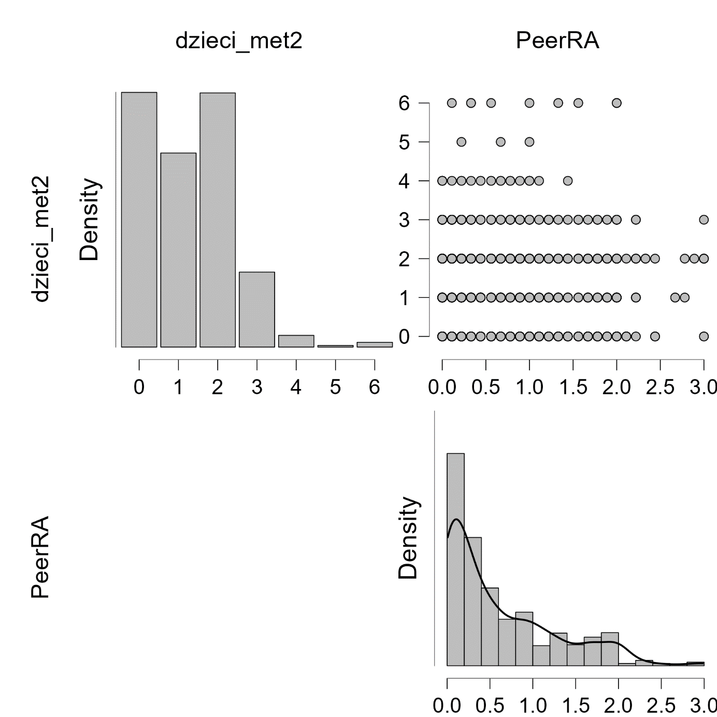

Figure S2
Scatter plot for the correlation between peer-directed relational aggression and (age-controlled) fertility (dzieci_m2) among romantically involved participants

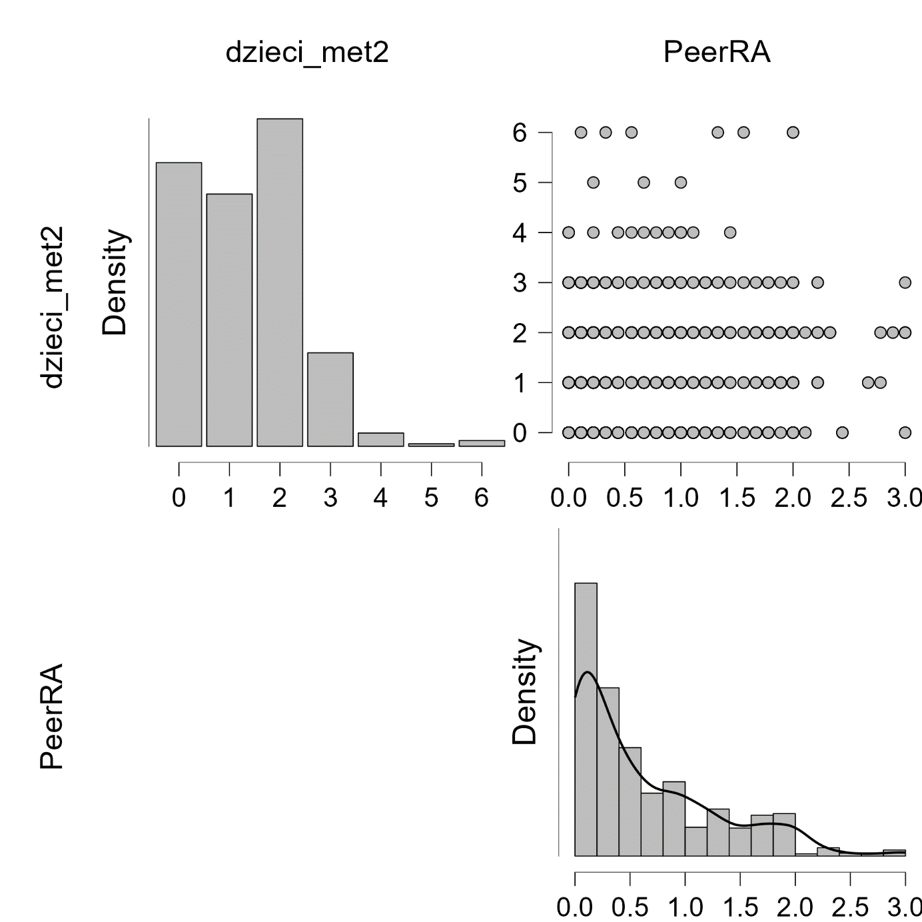

Figure S3
Scatter plot for the correlation between romantic partner-directed relational aggression and (age-controlled) fertility (dzieci_met2) among romantically involved participants

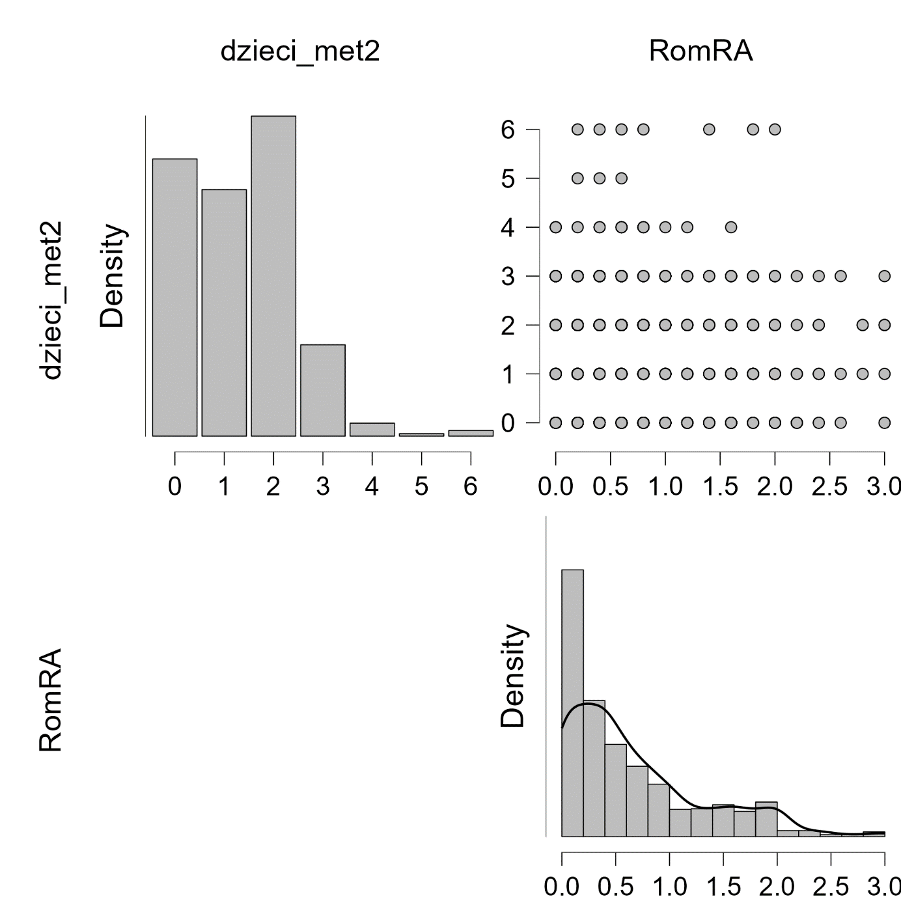

Figure S4
Outlier diagnostics in Poisson model 1
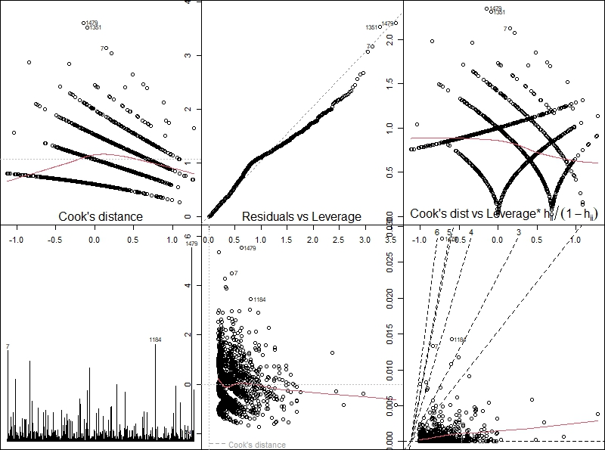

Table S1
Poisson regression model 1 after removing outliers (cases 1479, 1184, 7)
Predictors | Model 1
 | B (SE)
Intercept | –1.08 (0.18)***
Sex (1 – women; 2 – men) | –0.07 (0.05)
Age | 0.03 (0.002)***
Involvement in a romantic relationship | –0.32 (0.06)***
Socioeconomic status | 0.09 (0.05)
Peer-directed relational aggression | 0.11 (0.04)**
Romantic relational aggression | –
Negelkerke’s R² | .29

Deviance = 1418.7; df = 1488; p = .90, AIC = 3936.1

Figure S5
Outlier diagnostics in Poisson model 2
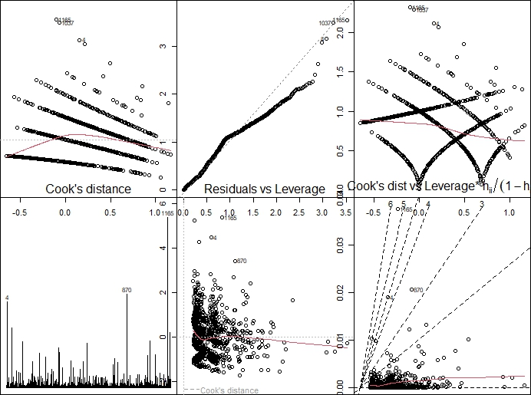

Table S2
Poisson regression model 2 after removing outliers (cases 4, 870, 1165)
Predictors | Model 2
 | B (SE)
Intercept | –1.26 (0.17)***
Sex (1 – women; 2 – men) | –0.05 (0.05)
Age | 0.03 (0.002)***
Involvement in a romantic relationship | –
Socioeconomic status | 0.07 (0.05)
Peer-directed relational aggression | –
Romantic relational aggression | 0.10 (0.04)*
Negelkerke’s R² | .29

Deviance = 1075.3; df = 1175; p = .98, AIC = 3145.7

Table S3
Poisson regression model 2 after including peer-directed relational aggression
Predictors | Model 2 | Model 2a (after removing outliers: cases 4, 870, 1165)
 | B (SE) | B (SE)
Intercept | –1.21 (0.17)*** | –1.25 (0.17)***
Sex (1 – women; 2 – men) | –0.05 (0.05) | –0.06 (0.05)
Age | 0.03 (0.002)*** | 0.03 (0.002)***
Involvement in a romantic relationship | – | –
Socioeconomic status | 0.05 (0.06) | 0.07 (0.06)
Peer-directed relational aggression | 0.11 (0.04)** | 0.10 (0.04)*
Romantic relational aggression | – | –
Negelkerke’s R² | .29 | .29

Model 2: Deviance = 1103.9; df = 1178; p = .94, AIC = 3185.3
Model 2a: Deviance = 1074.5; df = 1175; p = .98, SIC = 3144.9

