Appendix

Supplementary methods

1 MUSLE

Williams and Berndt (1977) proposed the MUSLE, which replaces the rainfall factor with a runoff factor. The MUSLE increases the accuracy of sediment yield prediction by incorporating flows. Williams (1975) used 778 storm-runoff events collected from 18 small watersheds (in the USA), with areas varying from 15 ha to 1 500 ha, slopes from 0.9% to 5.9% and slope lengths of 78.64 m to 173.74 m (Williams and Berndt, 1977) to generate the Modified USLE (MUSLE) in the following general form:

$Sy=α×{\left(Q×qp\right)}^{b}×K×L×S×C×P$ (Equation A1)

where Sy is sediment yield (in tonnes) on a storm basis for the entire catchment, Q is the volume of runoff (in m³), qp is the peak flow rate (in m³ s⁻¹) and K, L, S, C and P are the soil erodibility (in t ha h MJ⁻¹ mm⁻¹), slope length, slope steepness, crop management and soil erosion control practice factors, respectively, similar to the USLE, and a and b are location coefficients. For the area (Oklahoma and Texas) where the equation was developed, the a and b coefficients were 11.8 and 0.56, respectively (Williams and Berndt, 1977).

1.1 Flow (Q and qp) estimation

The model algorithms described here are similar to the description presented in Gwapedza et al. (2020).The WQSED model assumes that runoff is related to slope gradient, with higher slopes producing higher flow and more significant erosion. Consequently, zones with higher slopes/flow are assumed to produce more erosion and sediment delivery relative to zones of lower slope and flow (Pimentel and Burgess, 2013); however, this also depends on the amount of sediment held in storage within a slope zone and other MUSLE inputs. Equations A2–A10 govern the flow (Q and qp) estimation within the model.
The catchment surface runoff depth (Depth) is calculated from the input surface flow data (Flow_{s}) in m³ s⁻¹:
$Depth={Flow}_{s} × 3.6 ×24/Area$ (Equation A2)
where Area is the sub-basin area (km²).
The storm duration associated with the surface flow on each day is calculated using:
$D={Vsf}^{Dpow}+ D_{con}$, (Equation A3)
where D is the duration (hours) and D_{pow} and D_{con} are power and constant parameters, respectively. Vsf is the surface flow depth in mm d⁻¹. All three runoff zones are assumed to have the same duration of runoff. The duration is used to calculate peak runoff, which is an input for the calculation of the MUSLE R-factor.
The runoff depths for each slope zone are calculated with the assumption that the high runoff zone generates 75% more runoff than the moderate runoff zone, which in turn is assumed to generate 75% more than the low runoff zone (Bryson 2015):
${Depth}_{H}=\frac{Depth}{H+\left(\frac{M}{1.75}\right)+\left(\frac{L}{3.0625}\right)}$, (Equation A4)
${Depth}_{M}= {Depth}_{H}/1.75$, (Equation A5)
${Depth}_{L}= {Depth}_{H}/3.0625,$ (Equation A6)
where Depth is the runoff depth for the entire catchment (mm d⁻¹), H, M and L are the proportions of the catchment area that fall within the high, medium and low runoff zones, respectively, and Depth_{H}, Depth_{M,} and Depth_{L} are the runoff depths (mm d⁻¹) for the high, medium and low runoff zones, respectively.
The peak runoff depth for each runoff zone is calculated assuming a simple symmetrical triangle:
${QP}_{H}=\frac{{Depth}_{H}}{0.5 × D }$, (Equation A7)
${QP}_{M}=\frac{{Depth}_{M}}{0.5 × D }$, (Equation A8)
${QP}_{L}=\frac{{Depth}_{L}}{0.5 × D }$, (Equation A9)
where QP_{H}, QP_{M}, and QP_{L} are the peak runoff depths for the high, medium and low runoff zones, respectively (in mm d⁻¹).
The MUSLE equation used within the model is an alternative form of Equation 1 and estimates sediment yield (Sy) in t ha⁻¹ (Williams and Berndt, 1977), using values of total runoff depth (QD) in mm and peak runoff (qdp) in mm h⁻¹ in Equation 4.9. The equation can be derived by substituting α×(Q×qp) ^{b} for Q and qdp × Area × 10/3,600 for qp in Equation 1, with the result dividing by Area to obtain a result in t ha⁻¹ instead of in tonnes:
R = 1.586× (QD.qdp)^{0.56}× (Area)^{0.12} (Equation A10)
where Area is the total catchment area in ha.
Equation A10 is therefore applied to each slope zone using the Depth_{H, M, L} values for QD and QP_{H, M, L} for qdp. The parameters in Table 4.1 are required as input for the MUSLE component of the model.
Number | Parameter/information
1 | Topographic (LS) factor
2 | Vegetation (C) factor
3 | Soil erodibility (K) factor
4 | Management practice (P) factor
5 | Surface runoff (Q)
6 | Catchment area and proportion of HML zones
7 | Duration parameters (D_{pow} and D_{con})
Table 1 A list of parameters for the Modified Universal Soil Loss Equation of the erosion and sediment transport (WQSED) model.

1.2 LS, K, C and P estimation

1.2.1 Topography (LS) factor
Several LS estimation methods exist, including ground-based, flow path and cumulative cell length (FCL), and the LS-TOOL method (Zhang et al., 2013). The current study uses the unit contributing area (UCA) (Moore and Wilson, 1992) approach because of its ease of use within GIS and because it has been shown to calculate LS with good accuracy compared to field data (Oliveira et al., 2015), similar to the LS-TOOL method (Zhang et al., 2013).
The precision with which the LS factor can be estimated depends on the resolution of the DEM used. Comprehensive GIS-based methods for calculating the LS factor are presented in Zhang et al. (2013). The LS factor map was generated in ArcGIS using the Raster Calculator (Jain et al., 2010) by using the LS equation given by Moore and Wilson (1992):
$LS={\left({FA × cellsize}/{22.13}\right)}^{0.4}×{\left({\sin\left(α\right)0.01745}/{0.0896}\right)}^{1.3}$ (Equation A11)
where FA is flow accumulation, cell size is the DEM grid resolution and$α$ is slope. Figure 4.6 illustrates the calculation procedure.
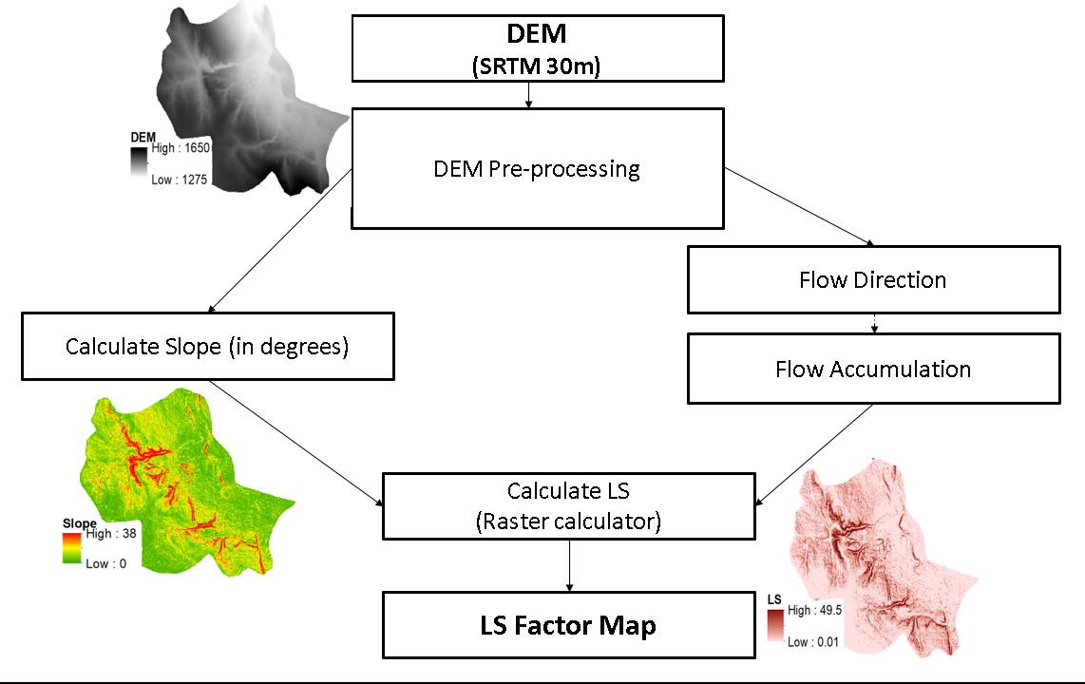
Fig. 1 Flowchart illustrating the process of determining the Modified Universal Soil Loss Equation (MUSLE) topography (LS) factor. Abbreviations: DEM-digital elevation model; SRTM-Shuttle Radar Topographic Mission.

1.2.2 Vegetation cover (C) factor

The cover factor was determined for each land cover type using guidelines published by Wischmeier and Smith (1978); the guidelines consist of lookup tables showing the C factor values that can be used for different land cover classes. C values assigned in previous studies e.g. Ayalew et al. (2015), Jang et al. (2015), Ranzi et al. (2012), and Shinde et al. (2011), were used to verify the derived C factor classes. Table 4.6 shows the C factor values assigned for Zimbabwean land cover types. The C values for the USA (and associated territories) were accessed from the SWAT crop database (Neitsch et al., 2005).
Land cover data for the USA was accessed from ArcGIS Online (https://www.arcgis.com/index.html, last accessed 20 August 2020), and the national land cover data for Zimbabwe was physically accessed from Dabane Water Workshops. HML zone cover properties were extracted by using the Clip tool in ArcMap to extract data from the maps using HML zone proportions.
The attribute table containing land cover categories was exported to Microsoft Excel 2016, where C values were assigned to respective land cover classes. Land cover categories with the same C value were lumped together. Assigned C values were weighted according to the proportion of the HML zone covered by particular land cover classes.
Table 2 Cover factor (C) for Zimbabwean land cover/use categories.
Land cover type | C
Forest, bush, thicket | 0.009
Grasslands | 0.12
Cultivated lands | 0.37
Low shrub | 0.013
Open bush | 0.012
Bare/degraded land | 1
Plantations / Woodlots | 0.012
Waterbodies | 0.01
Wetlands | 0.038
Settlements | 0.1

1.2.3 Soil erodibility (K) factor
Generally, K factor computations are based on the USLE method (Wischmeier & Smith, 1978). Since empirical observations are generally not possible for catchment-scale studies, soil erodibility calculations are typically based on readily available soil data. Example calculation approaches can be found in the literature for the USLE (Wischmeier & Smith, 1978) and RUSLE (Renard et al., 1997). The data for Zimbabwean catchments was calculated using Equation A12 from soils data accessed from Dabane Water Workshops GIS database.
K values were calculated for the application of the MUSLE model and were taken directly from RUSLE K (Renard et al., 1997) calculations for global soils with limited available soils information.
$K=7.594(0.0034+0.0405exp⁡(-1/2{(\log\left(Dg\right)+1.659/0.7101)}^{2}))$, (Equation A12)
where
$Dg(mm)=exp\left(0.01\sum{f_{i}{\ln{m_{i}}}}\right)⁡$ (Equation A13)
Dg is the mean particle size diameter, f_{i} is the primary particle size fraction in percent, and m_{i} is the arithmetic mean of the particle size limits of that size.
For the USA catchments, the soil erodibility factor was accessed from ArcGIS Online (https://www.arcgis.com/index.html, last accessed 20 August 2020). The method used to calculate soil erodibility is contained in the USA National Soil Survey Handbook (https://www.nrcs.usda.gov/wps/portal/nrcs/detail/soils/ref/?cid=nrcs142p2_054242) and is generally similar to the method of Renard et al. (1997).

1.2.4 Management practice (P) factor

The P factor relates to soil conservation methods, implemented mostly in agriculture, to reduce the rate of soil loss (Ayalew, 2015). These practices include contour and strip farming. The P factor has a value between 0 and 1, where 1 (indicating no practice) is assigned as the P factor for non-agricultural lands (Ayalew, 2015; Jang et al., 2015; Luo et al., 2016). Most studies using the USLE, Revised Universal Soil Loss Equation (RUSLE) and MUSLE usually set the P factor to the default of 1, indicating that no conservation practice is implemented (Sadeghi et al., 2013). This may be partly attributed to the P factor being too complex to quantify or due to study areas not having significant agricultural activity.
The catchment P factor is derived by using an STRM 30m DEM to calculate catchment slope categories (Section 4.1.2) overlaid with a map of cultivation (Jang et al., 2015) extracted from land use/land cover maps. A layer specifying the percentage of cultivated land in each slope category is derived, following which the Wischmeier and Smith (1978) tables for estimating P factor for various slope classes are used to assign the P factor values for cultivated land in each slope category. The resulting P factor (for each HML zone) is weighted against the total area of that zone to derive the mean P factor that is input into the MUSLE.

2 The Storage module

The simple storage option operates according to principles similar to the storage component reported in Section 4.3, with the exception that the multiple storage components are eliminated; instead, a single storage is used. This storage model description presented here has been previously described in Gwapedza et al. (2021). When applying the storage, the first step is to estimate the proportion of the daily MUSLE sediment output (MS_{i}) that contributes directly to sediment delivery at the catchment outlet (SD_{i}) on the same day (i). This is based on a power function (parameter SPOW1) of the average of the available sediment at the start and end of the day relative to a maximum possible storage parameter (SS_{Max}). The initial estimate of the available sediment at the end of the day (TS_{i}) is given by:
${TS}_{i}={MS}_{i}+{SS}_{i}$ (Equation A14)
The direct estimate of sediment delivery is given by:
${SDD}_{i}= {MS}_{i}×{\left({\left({TS}_{i}+{SS}_{i}\right)}/{2×{SS}_{max}}\right)}^{SPOW1}$ (Equation A15)
The updated total sediment in storage after direct delivery is then given by:
${TS}_{i}={MS}_{i}+{SS}_{i}-{SDD}_{i}$ (Equation A16)
A second component of the storage model assumes that sediment can be removed from storage during higher stream flows. These estimates are based on power functions of relative streamflow discharge and relative sediment storage. The discharge power function is:

${Qfact}_{i}={\left(Qi/\left(Q_{max}×1.2\right)\right)}^{QPOW}$ (Equation A17)

where Qfact_{i} is the streamflow factor, Qi is the current day streamflow (m³ s⁻¹), $Q_{max}$is the maximum daily streamflow in the input data, and QPOW is a power parameter. The 1.2 multiplier is included on the assumption that the input data do not represent the highest possible flows and could be considered a parameter, even though it was fixed in this study. The total flow is used to drive the movement of sediment through the storages of the storage model, whereas only surface runoff is used to drive the MUSLE as the sub-surface flow is unlikely to impact on slope erosion.
The sediment storage factor (SSfact_{i}) is given by a relationship similar to that defined in Equation A15 using an additional power parameter (SPOW2):

${SSfact}_{i}= {\left({\left({SS}_{i}+{TS}_{i}\right)}/{\left(2×{SS}_{max}\right)}\right)}^{SPOW2}$ (Equation A18)

The final downstream output from storage (SSD_{i}) is given by Equation A19 after which the storage is updated (Equation A20) for the following day, and the total sediment delivery becomes the sum of SSD_{i} and SD_{i}

${SSD}_{i}={TS}_{i}×{Qfact}_{i}×{SSfact}_{i}$ (Equation A19)
${SS}_{i+1}={SS}_{i}+{MS}_{i}-{SD}_{i}-{SDD}_{i}$ (Equation A20)

The main objective of using average sediment storage values in Equations A15 and A19 is to smooth the effect of very large sediment inputs from the MUSLE during any one day. Parameters for the simple storage option are presented in Table 3.
Table 3 A list of parameters for the simple storage option of the erosion and sediment transport (WQSED) model.
Number | Parameter/information
1 | Maximum catchment storage (SS_{max})
2 | Initial storage (TS_{i})
3 | Sediment storage power (QPOW )
4 | Threshold flow for sediment delivery
5 | Peak flow scaling
6 | Maximum daily total flow ($Q_{max}$)

References
Ayalew G (2015) A Geographic Information System Based Soil Loss and Sediment Estimation in Zingin Watershed for Conservation Planning, Highlands of Ethiopia. International Journal of Science, Technology and Society, 3(1), 28. http://doi.org/10.11648/j.ijsts.20150301.14
Bryson L (2015) An erosion and sediment delivery model for semi-arid catchments. Master’s Thesis:http://vital.seals.ac.za:8080/vital/access/manager/Repository/vital:6056?site_name=GlobalView&exact=sm_creator%3A%22Bryson%2C+Louise+Kay%22&sort=sort_ss_title%2F.Grahamstown: Rhodes University.
GwapedzaD, Nyamela N, Hughes DA, Slaughter AR, Mantel S, van der Waal B (2020b) Prediction of sediment yield of the Inxu River catchment (South Africa) using the MUSLE. Int. Soil Water Conserv. Res. 9, 37–48. https://doi.org/10.1016/j.iswcr.2020.10.003
Jain SK, Tyagi J, Singh (2010) Simulation of runoff and sediment yield for a Himalayan watershed using SWAT model. J Water Resource Protection. 2:267–281.
Jan C, ShinY, Kum D, Kim R, Yang JE, Kim SC, Jung Y (2015) Assessment of soil loss in South Korea based on land-cover type. Stoch Environ Res Risk Assess 29, 2127–2141. https://doi.org/101007/s00477-015-1027-3
Luo Y, Yang S, Liu X, Liu C, Zhang Y, Zhou Q, Don G (2016) Suitability of revision to MUSLE for estimating sediment yield in the Loess Plateau of China. Stoch Environ Res Risk Assess 30, 379–394. https://doi.org/101007/s00477-015-1131-4
Moore ID, Wilson JP (1992) Length-slope factors for the revised universal soil loss equation: simplified method of estimation. J Soil Water Conserv 47 (5), 423–428
Neitsch SL, Arnold JG, Kiniry JR, Williams JR (2005) Soil and Water Assessment Tool Theoretical Documentation. Agricultural Research Service. Temple, Texas, USA
Oliveir JA, Dominguez JML, Nearing MA, Oliveira PTS (2015) A GIS-Based procedure for automatically calculating soil loss from the universal soil loss Equation: GISus-M. Appl Eng Agric 31, 907–917. https://doi.org/1013031/aea3111093
Pimentel D, Burgess M (2013) Soil Erosion Threatens Food Production. Agriculture 3, 443–463. https://doi.org/103390/agriculture3030443
Ranzi R, Le T H, Rulli M C (2012) A RUSLE approach to model suspended sediment load in the Lo river (Vietnam): Effects of reservoirs and land use changes. Journal of Hydrology 422–423(February), 17–29. http://doi.org/101016/jjhydrol201112009
Renard K, Foster G, Weesies G, McCool D, Yoder D (1997) Predicting soil erosion by water: a guide to conservation planning with the Revised Universal Soil Loss Equation (RUSLE). Agricultural Handbook No 703. http://doi.org/DC0-16-048938-5 65–100
Sadeghi SHR, Gholami L, Khaledi Darvishan A, Saeidi P (2013) A review of the application of the MUSLE model worldwide. Hydrol Sci J 00, 1–11. https://doi.org/101080/026266672013866239
Shinde V, Sharma A, Tiwari K N, Singh M (2011) Quantitative Determination of Soil Erosion and Prioritization of Micro-Watersheds Using Remote Sensing and GIS. Journal of the Indian Society of Remote Sensing 39(2), 181–192. http://doi.org/101007/s12524-011-0064-8
Williams J R (1975) Sediment yield prediction with universal equation using runoff energy factor In: Present and Prospective Technology for Predicting Sediment Yield and Sources. 40: 244-254 Washington DC: USDA-ARS
Williams J R, Berndt H D 1977 Sediment yield based on watershed hydrology. Transactions of the Society of Agricultural Engineers 20: 1100-1104
Wischmeier WH, Smith DD 1978 Predicting rainfall erosion losses. Agric Handb no 537 285–291. https://doi.org/101029/TR039i002p00285
Zhang H, Yang Q, Li R, Liu Q, Moore D, He P, Geissen V (2013) Extension of a GIS procedure for calculating the RUSLE equation LS factor. Comput Geosci 52. https://doi.org/101016/jcageo201209027

