A SWAT model depicts the impact of land use change on hydrology, nutrient, and sediment loads in a Lake Michigan watershed.

Table 1 SM: Review of some studies investigating the impact of different land use on watershed hydrology in the U.S. Midwest
Authors | Study areas | State | Methods | Responses
Tong and Chen (2002) | East Fork Little Miami watershed | Ohio | Better Assessment Science Integrating  Point and Nonpoint Sources (BASINS) | Phosphorus and nitrogen
Zhang and Schilling (2006) | Mississippi River basin | Minnesota, Wisconsin, Iowa, Illinois, Missouri, Kentucky, and Tennessee | Trend analysis | Streamflow and baseflow
Tong and Naramngam (2007) | Little Miami River watershed | Ohio | SWAT and BASINS | Streamflow, sediment, ammonia, and phosphorus
Choi and Deal (2008) | Kishwaukee River basin | Illinois | Hydrological Simulation Program—Fortran (HSPF) | Streamflow (runoff and baseflow)
Mbonimpa et al. (2012) | Upper Rock River watershed | Wisconsin | SWAT | Runoff, sediments and phosphorous
Maalim et al. (2013) | Minnesota River Basin | Minnesota | Water Erosion Prediction Project (WEPP) | Runoff and sediment yield
Xu et al. (2013) | 50 different basins | Iowa, Illinois, Indiana and Ohio | Statistical and trend analysis | Streamflow and baseflow
Cibin et al. (2016) | Wildcat Creek watershed and St Joseph River watershed | Indiana and Ohio | SWAT | Flow, sediment, nitrogen and phosphorus
Wang et al. (2016) | Tennessee River Basin | Tennessee | SWAT | Streamflow, nitrogen and phosphorus
Aboelnour et al. (2019) | Little Eagle Creek | Indiana | SWAT | Streamflow and baseflow
Hubbart et al. (2019) | Hinkson Creek Watershed | Missouri | Nested-scale experimental watershed study design | Hydrology regime and nutrient yield
Aboelnour et al. (2020) | Upper West Branch DuPage River | Illinois | SWAT | Streamflow and baseflow
Vera Mercado and Engel (2021) | Wabash River basin | Indiana and Ohio | Statistical analysis (linear and mixed models) | Nitrogen, phosphorous, sediment, and oxygen
Ren et al. (2022) | St Joseph River watershed | Indiana and Ohio | SWAT | Streamflow, evapotranspiration, leaf area index, sediment, nitrogen, and phosphorous
Trentman et al. (2022) | Shatto Ditch Watershed | Indiana | Field observations | Dissolved oxygen
Table 2 SM: Land management operations in the SJRB
Crop |  | Date | Operation
Corn-soybean rotation
Year 1 | Corn | May 5 | Harvest and kill
Year 1 | Corn | May 6 | Tillage implementation (conventional till)
Year 1 | Corn | May 10 | Fertilizer application: 33-00-00 220 kg/ha (72.6 kg N/ha)
Year 1 | Corn | May 10 | Planting corn
Year 1 | Corn | June 1 | Fertilizer application: ANH-NH3 220 kg/ha (180.4 kg N/ha)
Year 1 | Corn | October 20 | Harvest corn and kill
Year 2 | Soybean
Year 2 | Soybean | May 6 | Tillage implementation (conventional till)
Year 2 | Soybean | May 10 | Planting soybean
Year 2 | Soybean | October 20 | Harvest soybean and kill

Niles subwatershed | Paw Paw subwatershed
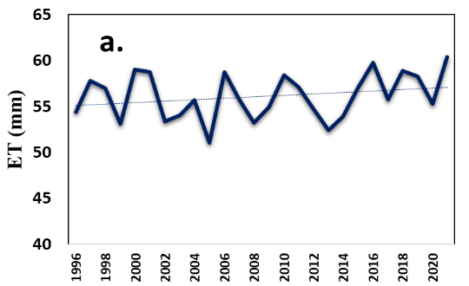 | 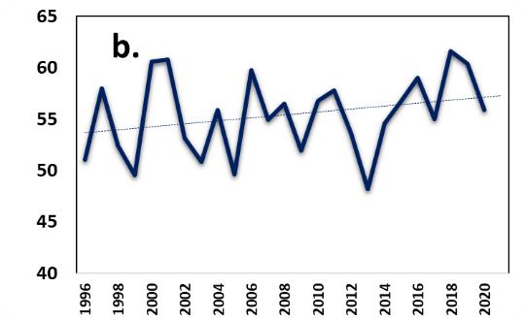
Fig. 1 SM: Interannual variation in the simulated evapotranspiration (ET) in the SJRB; (linear line indicating the significant trend)

1992 | 2019 | Δ 2019 - 1992
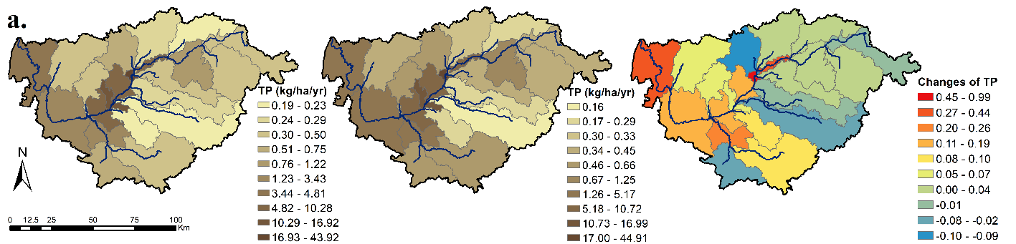
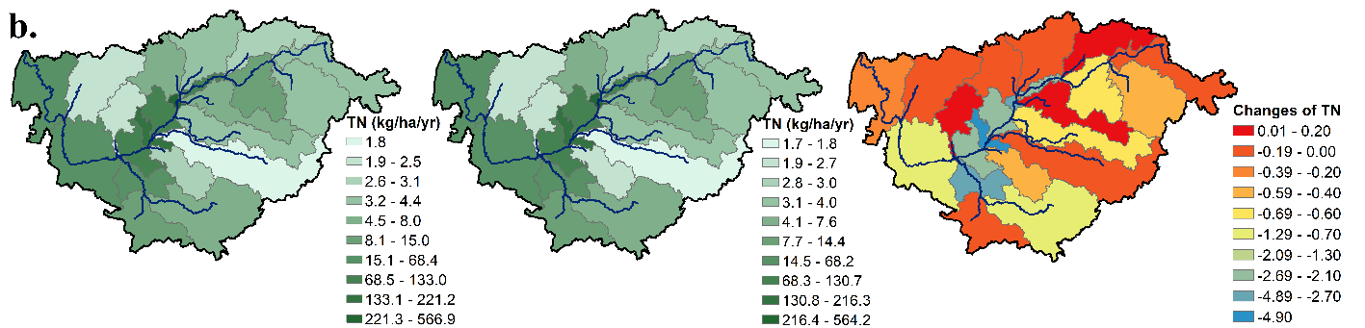
Fig. 2 SM: Spatial distribution of Niles subwatershed responsive variables in 1992, 2019 and relative changes from 1992 to 2019 at subbasin scale. Total phosphorus (a); and total nitrogen (b). Note: each figure has its own legend

1992 | 2019 | Δ 2019 - 1992
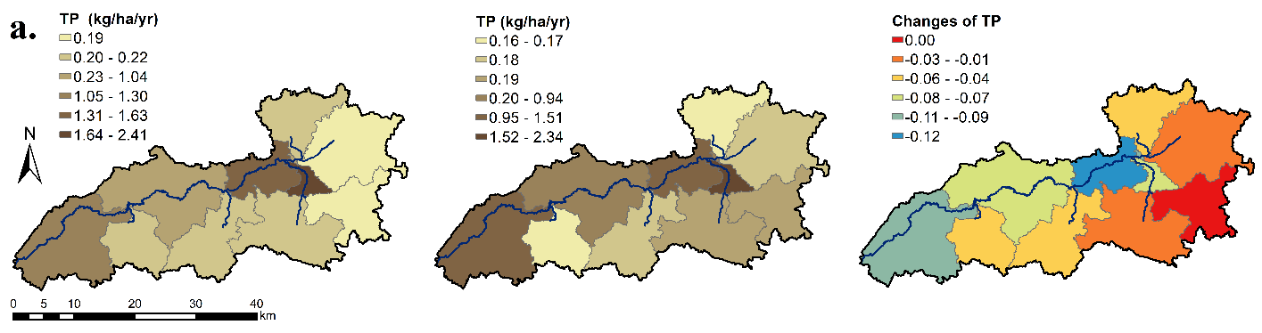
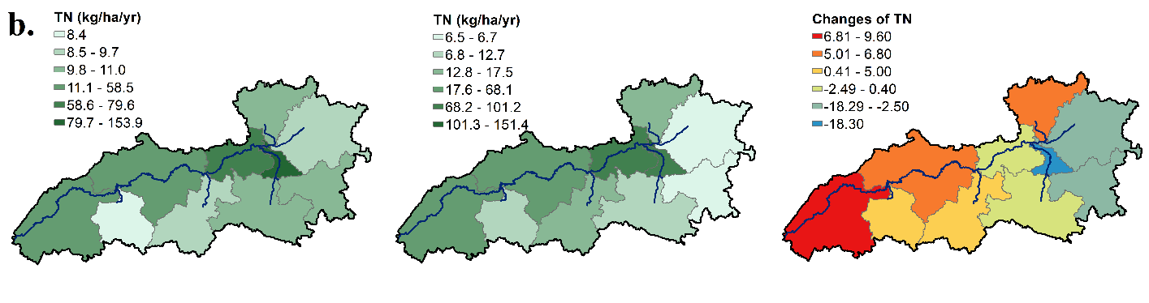
Fig. 3 SM: Spatial distribution of Paw Paw subwatershed responsive variables in 1992, 2019 and relative changes from 1992 to 2019 at subbasin scale. Total phosphorus (a); and total nitrogen (b). Note: each figure has its own legend

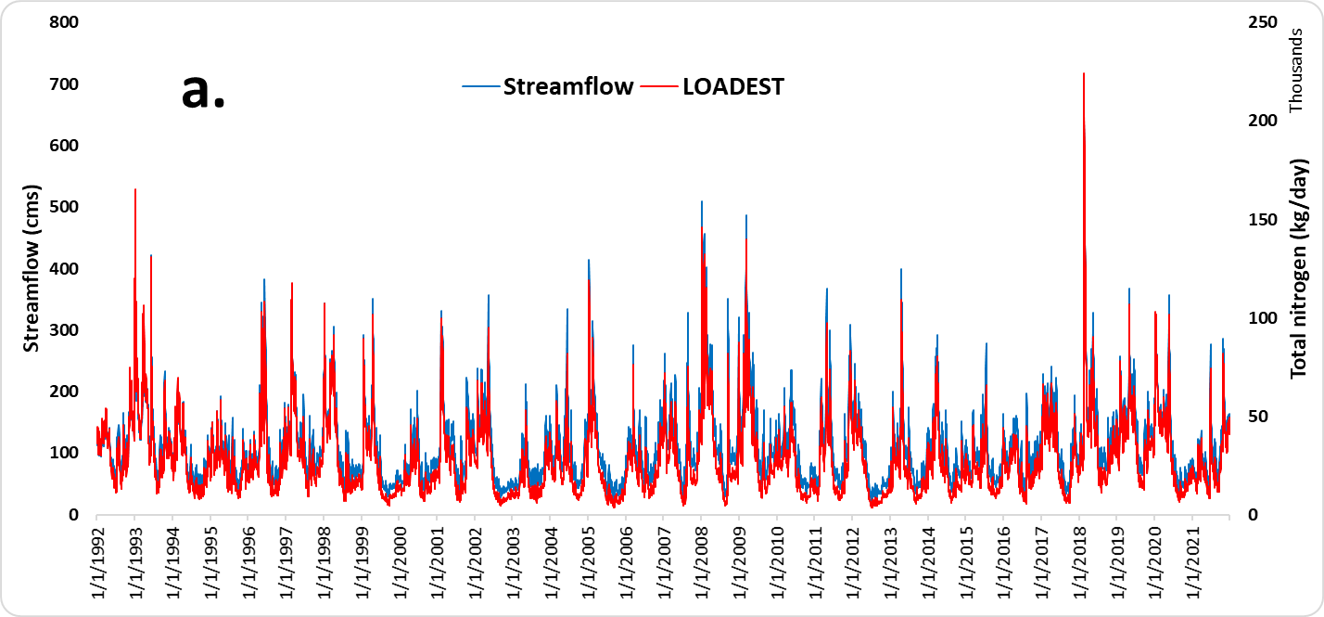
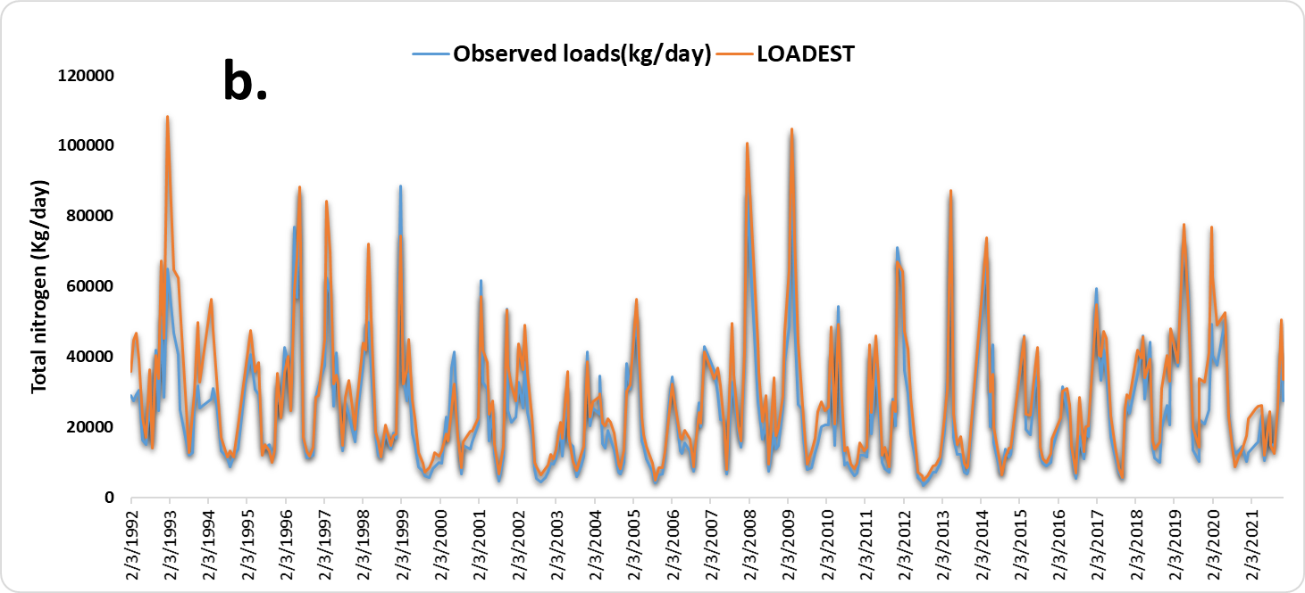
Fig. 4 SM: Time series of daily TN loads generated by LOADEST for the Niles subwatershed (a); comparison of observed TN loads with LOADEST-generated TN loads (b).

