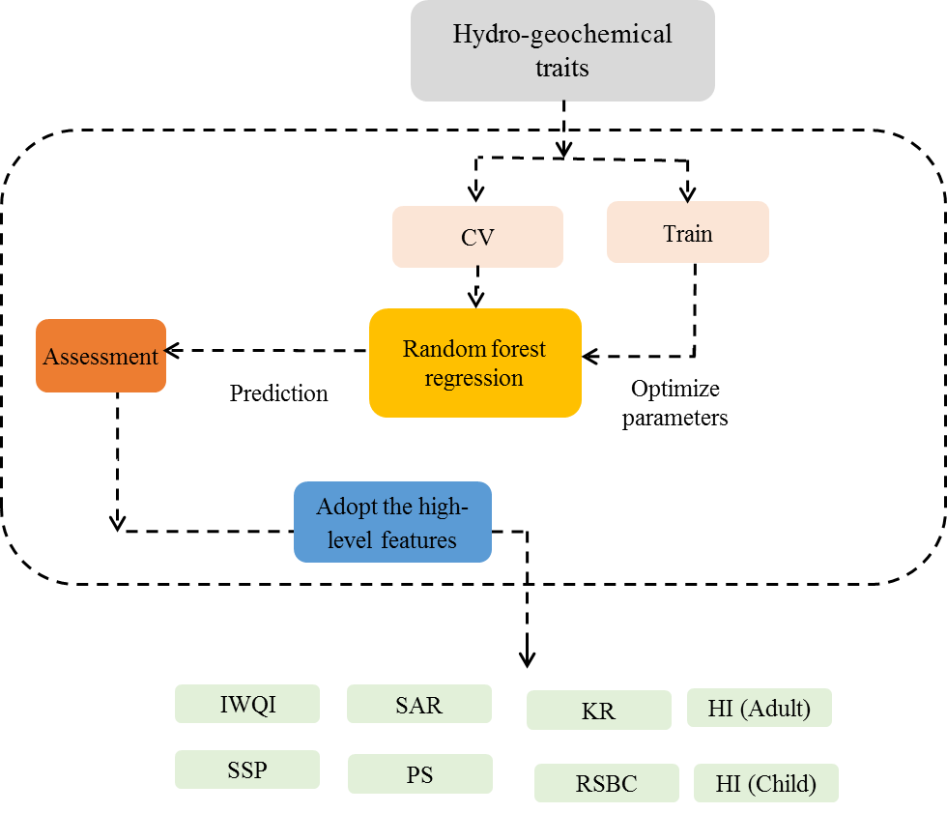

Fig. 1S Diagram illustrating the proposed method
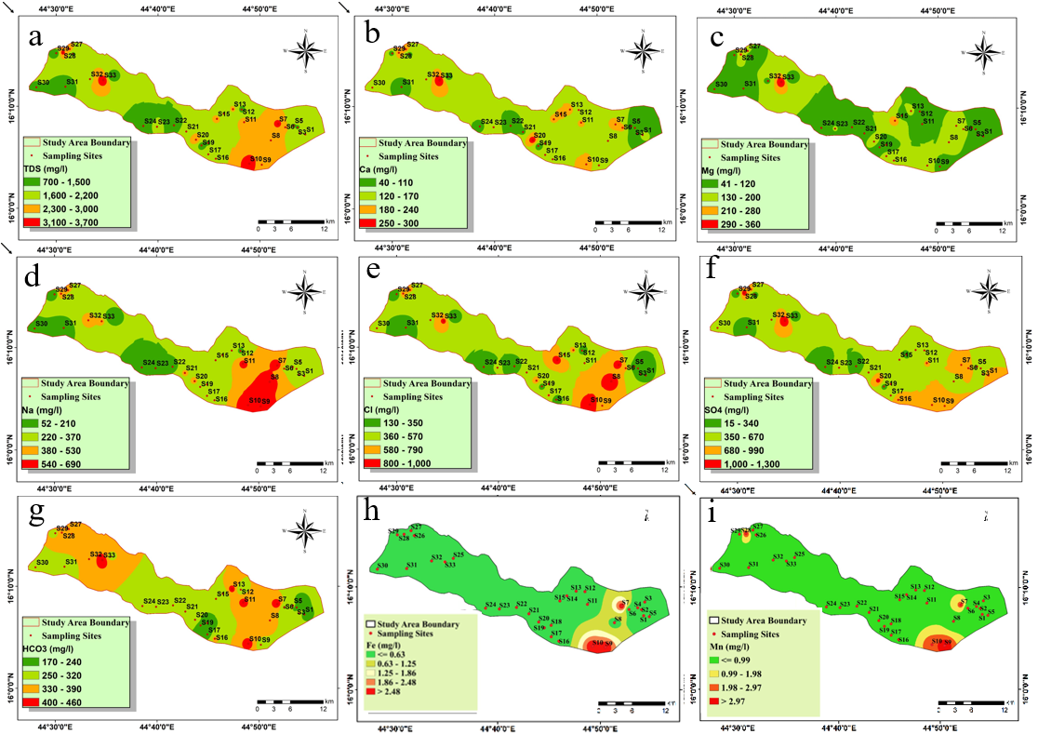 Fig. 2S Distribution map of the physicochemical parameters: (a) TDS, (b) Ca²⁺, (c) Mg²⁺, (d) Na⁺, (e) Cl⁻, (f) SO₄²⁻, (g) HCO₃⁻, (h) Fe, and (i) Mn

Fig. 3S Plots of PCA scores for F2 vs. F1 (left) and F3 vs. F1 (right).
Table 1S. The sampling number, location and well depth.
Sampling | Sea elevation m | Districts | Well type | Water level | Depth | Source Type
S1 | 1114 | Alhazm | GW | 100 | 120 | Deep borehole
S2 | 1093 | Alhazm | GW | 90 | 150 | Deep borehole
S3 | 1093 | Alhazm | GW | 93 | 125 | Deep borehole
S4 | 1086 | Alhazm | GW | 80 | 120 | Deep borehole
S5 | 1086 | Alhazm | GW | 80 | 120 | Deep borehole
S6 | 1118 | Alhazm | GW | 70 | 120 | Deep borehole
S7 | 1102 | Alhazm | GW | 60 | 110 | Deep borehole
S8 | 1103 | Alhazm | GW | 60 | 110 | Deep borehole
S9 | 1106 | Alhazm | GW | 45 | 130 | Deep borehole
S10 | 1100 | Alhazm | GW | 60 | 120 | Deep borehole
S11 | 1095 | Alhazm | GW | 80 | 111 | Deep borehole
S12 | 1136 | Alhazm | GW | 15 | 90 | Deep borehole
S13 | 1125 | Alhazm | GW | 30 | 100 | Deep borehole
S14 | 1121 | Alhazm | GW | 30 | 115 | Deep borehole
S15 | 1143 | Alhazm | GW | 35 | 70 | Deep borehole
S16 | 1105 | Alkhaleq | GW | 48 | 100 | Deep borehole
S17 | 1115 | Alkhaleq | GW | 31 | 102 | Deep borehole
S18 | 1109 | Alkhaleq | GW | 25 | 120 | Deep borehole
S19 | 1107 | Alkhaleq | GW | 25 | 120 | Deep borehole
S20 | 1116 | Alkhaleq | GW | 10 | 116 | Deep borehole
S21 | 1157 | Alghail | GW | 60 | 135 | Deep borehole
S22 | 1156 | Alghail | GW | 40 | 165 | Deep borehole
S23 | 1157 | Alghail | GW | 60 | 125 | Deep borehole
S24 | 1160 | Alghail | GW | 15 | 70 | Deep borehole
S25 | 1157 | Almasloob | GW | 60 | 102 | Deep borehole
S26 | 1144 | Almasloob | GW | 30 | 70 | Deep borehole
S27 | 1144 | Almasloob | GW | 30 | 60 | Deep borehole
S28 | 1139 | Almasloob | GW | 35 | 100 | Deep borehole
S29 | 1240 | Almatamah | GW | 35 | 60 | Deep borehole
S30 | 1238 | Almatamah | GW | 27 | 30 | Shallow well
S31 | 1229 | Almatamah | GW | 20 | 50 | shallow borehole
S32 | 1259 | Almatamah | GW | 7 | 10 | Shallow well
S33 | 1157 | Almotoon | GW | 20 | 90 | Deep borehole

Table 2S The parameters utilized in the water quality evaluation (Q_{i}) including its upper and lower parameters

Q_{i} | SAR | EC (µs/cm) | Na⁺ (emp) | HCO₃²⁻ (epm) | Cl⁻ (emp)
85 -100 | 2 ≤ SAR < 3 | 200 ≤ EC < 750 | 2 ≤ Na < 3 | 1 ≤ HCO₃ < 1.5 | 1 ≤ Cl < 4
60 -85 | 3 ≤ SAR < 6 | 750 ≤ EC < 1500 | 3 ≤ Na < 6 | 1.5 ≤ HCO₃ < 4.5 | 4 ≤ Cl < 7
35 -60 | 6 ≤ SAR < 12 | 1500 ≤ EC < 3000 | 6 ≤ Na < 9 | 4.5 ≤ HCO₃ < 8.5 | 7 ≤ Cl < 10
0 -35 | SAR > 2 or SAR ≥ 12 | EC < 200 or EC ≥ 3000 | Na < 2 or SAR ≥ 9 | HCO₃ < 1 or HCO₃ ≥ 8.5 | Cl < 1 or Cl ≥ 10

Table 3S Factors used for calculation of chronic daily intake and health indices.
Factors | Fe | Mn | References
EF | 350 days/year |  | USEPA, 2004
ED(Adult) | 30 years |  | USEPA, 2004
ED(Child) | 6 years |  | USEPA, 2004
BW(Adult) | 52 kg |  | Giri and Singh, 2015
BW(Child) | 15 kg |  | Giri and Singh, 2015
AT(Adult) | 10,950 days |  | Saha et al., 2017
AT(Child) | 2190 day |  | Saha et al., 2017
SA(Adult) | 1.8 m² |  | USEPA, 2011
SA(Child) | 0.66 m² |  | USEPA, 2011
AF | 0.07 |  | USEPA, 2011
ABS_{d} | 0.03 |  | USEPA, 2011
ET | 0.58 h/ day |  | Wu et al., 2009
CF | 10⁻² kg/mg |  | USEPA, 2002
RFD (dermal) | 0.14 | 96 × 10−5 | USEPA, 2010

Table 4s Health risk indices and percentage of the risk in the collected water samples
Health risk Parameters | Type | Min | Max | Mean | Range | Category | Number of Samples (%)
CDI Dermal (Fe) | Adult | 1.4E-06 | 0.0004 | 6.2E-05 | <1 | Low risk | 33 (100%)
 |  |  |  |  | >1 | High risk | 0 (0%)
CDI Dermal (Fe) | Child | 4.2E-06 | 0.001 | 0.0002 | <1 | Low risk | 33 (100%)
 |  |  |  |  | >1 | High risk | 0 (0%)
CDI Dermal (Mn) | Adult | 1.4E-07 | 0.0006 | 6.4E-05 | <1 | Low risk | 33 (100%)
 |  |  |  |  | >1 | High risk | 0 (0%)
CDI Dermal (Mn) | Child | 4.2E-07 | 0.002 | 0.0002 | <1 | Low risk | 33 (100%)
 |  |  |  |  | >1 | High risk | 0 (0%)
HQ (Fe)  Dermal | Adult | 1.02E-05 | 0.003 | 0.0004 | <1 | Low risk | 33 (100%)
 |  |  |  |  | >1 | High risk | 0 (0%)
HQ (Fe)  Dermal | Child | 3.01E-05 | 0.009 | 0.001 | <1 | Low risk | 33 (100%)
 |  |  |  |  | >1 | High risk | 0 (0%)
HQ (Mn)  Dermal | Adult | 0.0001 | 0.60 | 0.07 | <1 | Low risk | 33 (100%)
 |  |  |  |  | >1 | High risk | 0 (0%)
HQ (Mn)  Dermal | Child | 0.0004 | 1.76 | 0.20 | <1 | Low risk | 30 (90.9%)
 |  |  |  |  | >1 | High risk | 3 (9.09%)
HI dermal | Adult | 0.0002 | 0.60 | 0.07 | <1 | Low risk | 33 (100%)
 |  |  |  |  | >1 | High risk | 0 (0%)
HI dermal | Child | 0.0005 | 1.77 | 0.20 | <1 | Low risk | 30 (90.9%)
 |  |  |  |  | >1 | High risk | 3 (9.09%)

