Supplementary materials
Mapping spatial zones of climate vulnerability and adaptive potential for major crops in the Texas High Plains
Ahmed Attia^{a⁎}, Prem Woliª, Charles R. Longª, Francis M. Rouquette Jr.ª, Gerald R. Smithª,
Amir M.H. Ibrahim^{b}

ª Texas A&M AgriLife Research and Extension Center, Overton, TX 75684, USA
^{b} Department of Soil and Crop Sciences, Texas A&M University, College Station, TX 77843, USA

⁎Corresponding author
Email: ahmed.attia@ag.tamu.edu, ahmed.attia3@outlook.com
https://orcid.org/0000-0002-6751-6584

Model calibration and validation
The DSSAT model was calibrated using previously validated cultivar-specific parameters for sorghum, cotton, maize, and wheat to ensure accurate representation of crop growth in the Texas High Plains. The CERES-Sorghum module was calibrated based on field data from cotton-sorghum rotation experiments conducted at Halfway, Texas, between 2006 and 2014 (Kothari et al., 2019b). The calibration involved adjusting thermal time requirements, photoperiod sensitivity, and radiation use efficiency to match observed crop growth stages and yield under varying irrigation levels. The model demonstrated an average percent error of 1.3% for grain sorghum during calibration and -2.2% during validation, confirming its reliability in simulating sorghum yield and water use efficiency. Cultivar coefficients are listed in Table S1.
For cotton, the DSSAT CSM-CROPGRO-Cotton model was calibrated using field data from irrigation management experiments conducted at the Texas A&M AgriLife Research Center at Halfway, Texas, from 2010 to 2013 (Adhikari et al., 2016). Key parameters related to cotton growth stages, including time to flowering, seed filling duration, and physiological maturity, were optimized to ensure accurate simulation of crop development under varying irrigation regimes. Adjustments were made to photosynthetic parameters such as maximum leaf photosynthesis rate and radiation use efficiency to improve biomass accumulation predictions (Table S1). The model demonstrated strong agreement with observed data, achieving an average percentage error of 0.1% during calibration and 6.5% during validation.
The DSSAT-CERES-Maize model was calibrated using field data from multi-year irrigation experiments conducted at the USDA-ARS Conservation and Production Research Laboratory in Bushland, Texas, and the Texas A&M AgriLife North Plains Research Field in Etter, Texas (Marek et al., 2017). These experiments included several years of maize experiments grown under full and deficit irrigation regimes with detailed agronomic measurements. The calibration process refined genetic coefficients governing phenology, growth, and yield formation, ensuring accurate simulations of crop development under local environmental conditions. Parameters such as thermal time requirements for different growth stages, kernel number per plant, and kernel filling rate were iteratively adjusted using fully irrigated treatments as reference conditions (Table S1). Model validation indicated good agreement between observed and simulated values under full irrigation, though limited irrigation treatments tended to overestimate leaf area index (LAI) and yield due to model limitations in water stress response simulations. Field measurements were obtained through destructive sampling and canopy sensors, and irrigation amounts were precisely monitored using soil moisture sensors and weather-based scheduling, providing a robust dataset for model calibration and evaluation.
For winter wheat, the CERES-Wheat model was calibrated using field data from winter wheat experiments conducted at Bushland, Texas, over multiple growing seasons (Kothari et al., 2019a). Calibration was performed using observed phenological data, biomass accumulation, LAI, grain yield, and seasonal evapotranspiration (ET_{c}) under different irrigation levels. Genetic coefficients governing crop development stages, thermal time requirements, and kernel number were refined iteratively to improve alignment between simulated and observed values (Table S1). Crop growth parameters, including radiation use efficiency and specific leaf area, were optimized to ensure accurate simulation of LAI and biomass accumulation. The model was evaluated using independent field data, achieving a percent error of less than 4.7% for grain yield and less than 7.1% for biomass, indicating reliable performance in simulating winter wheat growth under different climate and irrigation scenarios.
The calibrated cultivar parameters from Kothari et al. (2019b) for sorghum, Adhikari et al. (2016) for cotton, Marek et al. (2017) for maize, and Kothari et al. (2019a) for wheat were adopted in this study to maintain consistency in model application and ensure accurate simulations of crop production in the Texas High Plains.

Table S1. Calibrated values of winter wheat, cotton, sorghum, and maize used in the simulation.
Crop | Abbreviation | Description | Calibrated value
Winter wheat
Winter wheat | P1V | Days, optimum vernalizing temperature, required for vernalization | 21
Winter wheat | P1D | Photoperiod response (% reduction in rate/10 h drop in pp) | 70
Winter wheat | P5 | Grain filling (excluding lag) phase duration (oC.d) | 500
Winter wheat | G1 | Kernel number per unit canopy weight at anthesis (#/g) | 16
Winter wheat | G2 | Standard kernel size under optimum conditions (mg) | 30
Winter wheat | G3 | Standard, non-stressed mature tiller wt (incl grain) (g dwt) | 2.8
Winter wheat | PHINT | Interval between successive leaf tip appearances (oC.d) | 100
Winter wheat | P1 | Duration of phase end juvenile to terminal spikelet (PVTU) | 350
Winter wheat | P2 | Duration of phase terminal spikelet to end leaf growth (TU) | 250
Winter wheat | P3 | Duration of phase end leaf growth to end spike growth (TU) | 180
Winter wheat | P4 | Duration of phase end spike growth to end grain fill lag (TU) | 450
Winter wheat | PARUE | PAR conversion to dm ratio, before last leaf stage (g/MJ) | 2.4
Winter wheat | PARU2 | PAR conversion to dm ratio, after last leaf (g/MJ) | 2.0
Winter wheat | LAIS | Area of standard first leaf (cm2) | 2.6
Winter wheat | LAFV | Increase in potential area of leaves, vegetative phase (fr/leaf) | 0.15
Winter wheat | LAFR | Increase in potential area of leaves, reproductive phase (fr/leaf) | 0.30
Winter wheat | SLAS | Specific leaf area, standard first leaf (cm2/g) | 400
Winter wheat | LSPHS | Final leaf senescence starts (GrowhStage) | 4.2
Winter wheat | LSPHE | Final leaf senescence ends (GrowhStage) | 5.5
Cotton | EM-FL | Time between plant emergence and flower appearance (photothermal days) | 42
 | FL-SH | Time between first flower and first pod (photothermal days) | 6
 | FL-SD | Time between first flower and first seed (photothermal days) | 12
 | SD-PM | Time between first seed and physiological maturity (photothermal days) | 42
 | FL-LF | Time between first flower and end of leaf expansion (photothermal days) | 55
 | LFMAX | Maximum leaf photosynthesis rate at 30 ◦C, 350 ppm CO₂, and high light (mg CO₂ m⁻² s⁻¹) | 1.1
 | SLAVR | Specific leaf area of cultivar under standard growth conditions (cm² g⁻¹) | 170
 | SIZLF | Maximum size of full leaf (three leaflets) (cm2) | 300
 | XFRT | Maximum fraction of daily growth that is partitioned to seed + shell | 0.8
 | SFDUR | Seed filling duration for pod cohort at standard growth conditions (photothermal days) | 35
 | PODUR | Time required for cultivar to reach final pod load under optimal conditions (photothermal days) | 12
 | THRSH | Threshing percentage. The maximum ratio of (seed/(seed + shell)) at maturity | 70
 | PL-EM | Time between planting and emergence (thermal days) | 4
 | EM-V1 | Time required from emergence to first true leaf, thermal days | 4
 | RWDTH | Relative width of the ecotype in comparison to the standard width per node | 1
 | RHGHT | Relative height of the ecotype in comparison to the standard height per node | 0.9
 | FL-VS | per node 0.8–0.95 0.9  FL-VS T | 40
Sorghum | P1 | Thermal time from seedling emergence to the end of the juvenile phase (expressed in degree days above TBASE, i.e., 8 °C) | 334
 | P2 | Thermal time from the end of the juvenile stage to tassel initiation under short days (degree days above TBASE) | 102
 | P2O | Critical photoperiod or the longest day length (in hours) at which development occurs at a maximum rate | 15.2
 | P2R | Extent to which phasic development leading to panicle initiation (expressed in degree days) is delayed for each hour increase in  photoperiod above P2O | 40
 | PANTH | Thermal time from the end of tassel initiation to anthesis (degree days above TBASE) | 617.5
 | P3 | Thermal time from to end of flag leaf expansion to anthesis (degree days above TBASE) | 152.5
 | P4 | Thermal time from anthesis to beginning grain filling (degree days above TBASE) | 81.5
 | P5 | Thermal time from beginning of grain filling to physiological maturity (degree days above TBASE) | 575
 | PHINT | Phylochron interval; the interval in thermal time between successive leaf tip appearances (degree days) | 49
 | G1 | Scaler for relative leaf size | 3.5
 | G2 | Scaler for partitioning of assimilates to the panicle (head) | 7
Maize | P1 | Thermal time from seedling emergence to the end of the juvenile phase during  which the plant is not responsive to changes in photoperiod. | 320
 | P2 | Extent to which development is delayed for each hour increase in photoperiod  above the longest photoperiod at which development proceeds at a maximum  rate, which is considered to be 12.5 h. | 0.530
 | P5 | Thermal time from silking to physiological maturity. | 800.0
 | G2 | Maximum possible number of kernels per plant. | 760
 | G3 | Kernel filling rate during linear grain filling under optimum conditions. | 10.50
 | PHINT | Phylochron interval; the thermal time between successive leaf tip appearances. | 50.0

Table S2. Design of the suggested improved 4-year crop rotation with cover crops in the Texas High Plains.
Crop | Plant Date | Harvest Date | Synthetic N (kg/ha) | Organic N (kg/ha) | Total N (kg/ha) | Application Dates
Sorghum | June 25, 1990 | Nov 15, 1990 | 55 + 55 | 40 | 150 | July 20 (10d planting) + Aug 20 (tillering stage)
Winter Legume CC (Austrian Pea) | Nov 20, 1990 | April 20, 1991 | 0 | 0 | Fixes ~50 kg N/ha | No synthetic or organic N applied
Maize | April 25, 1991 | September 15, 1991 | 50 + 50† | 50 | 150 | April 25 (10d planting) + June 25 (V6 stage)
Winter Legume CC (Austrian Pea) | October 10, 1991 | April 20, 1992 | 0 | 0 | Fixes ~50 kg N/ha | No synthetic or organic N applied
Cotton | May 1, 1992 | October 15, 1992 | 50 + 50 | 0 | 100 | May 10 (10d planting) + June 20 (midseason)
Winter Wheat | October 20, 1992 | June 20, 1993 | 30 + 30 +  30 | 50 | 140 | October 30 (10d planting) + March 1 (tillering stage)

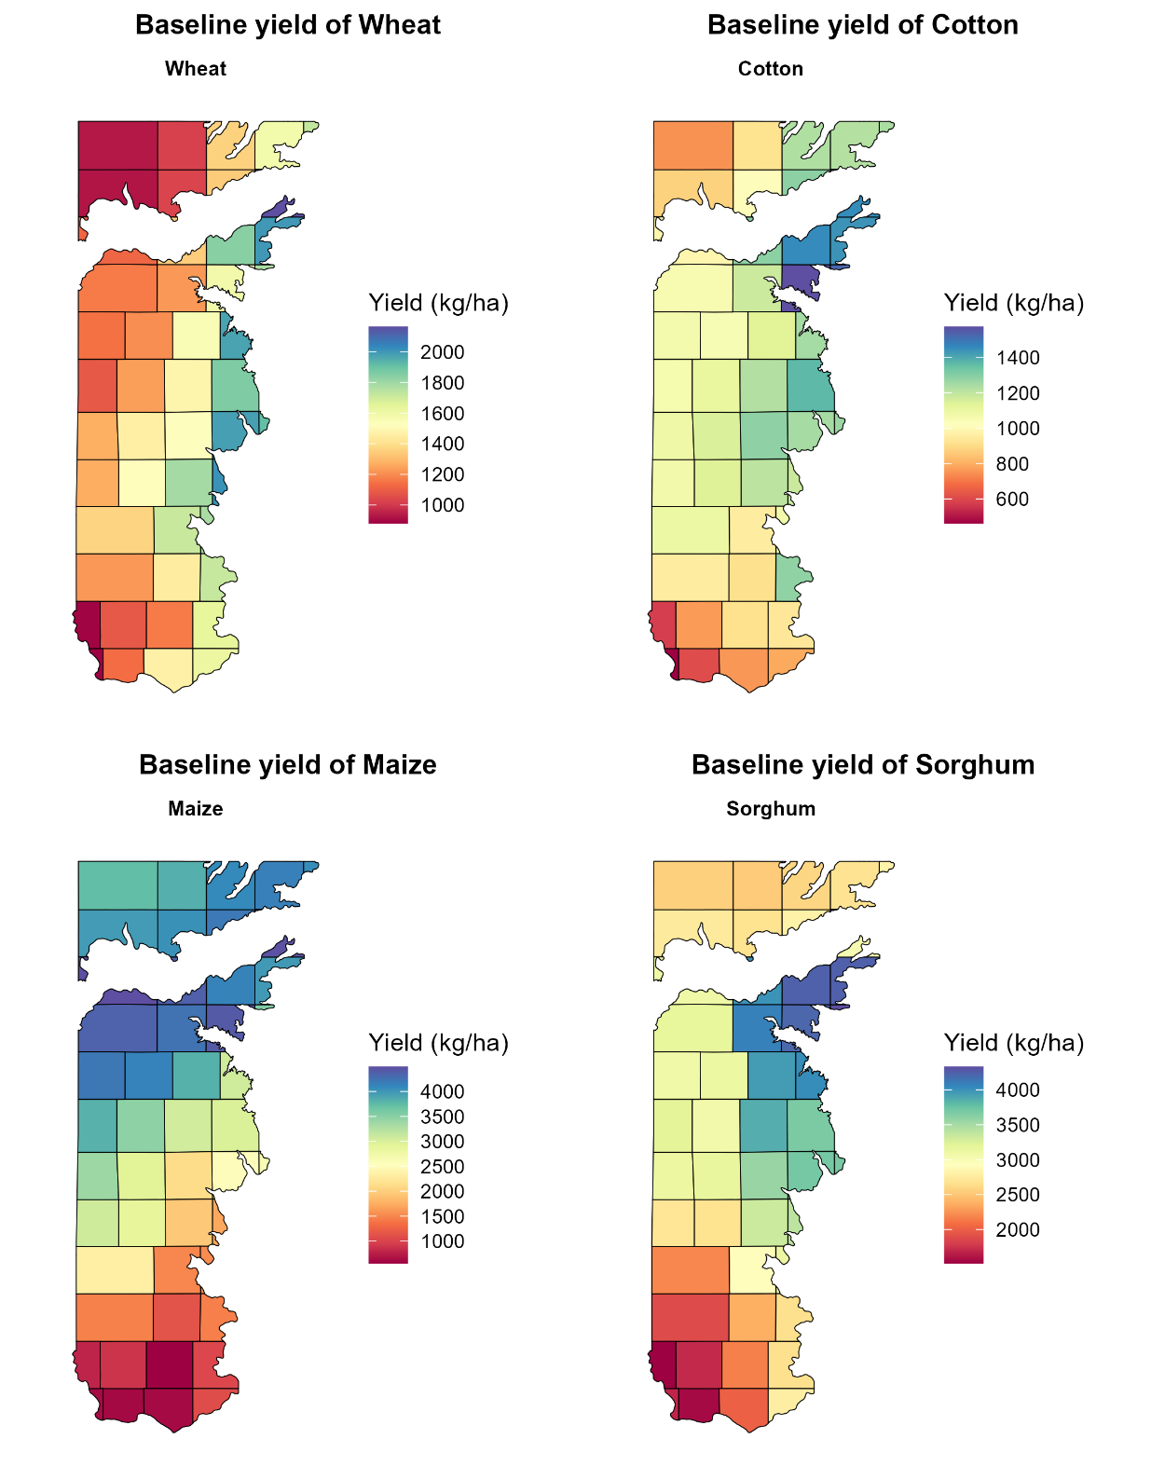
Fig. S1. County level baseline (1991-2020) simulated yield for wheat, cotton, maize, and sorghum in Texas High Plains.

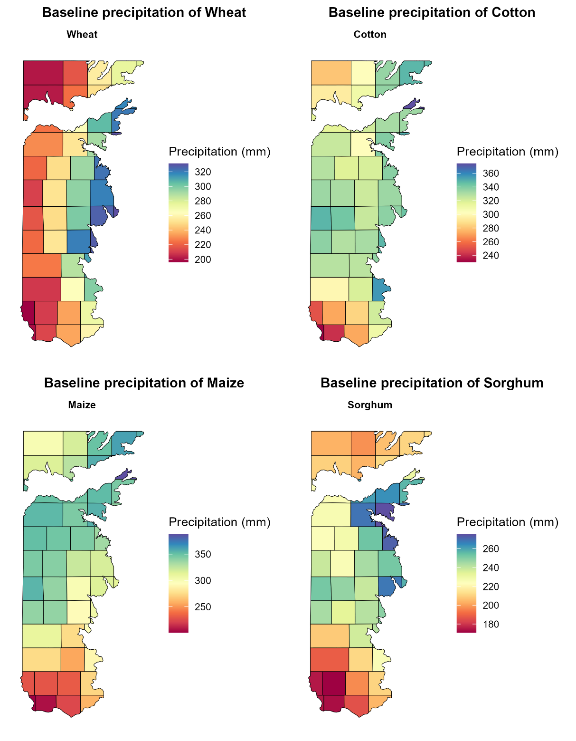

Fig. S2. County-level average baseline precipitation (1991–2020) during the growing season for wheat, cotton, maize, and sorghum across the Texas High Plains. Precipitation values are crop-specific and reflect the period from planting to harvest for each crop, based on typical management practices simulated in the study.

References
Adhikari P, Ale S, Bordovsky JP, Thorp KR, Modala NR, et al. (2016). Simulating future climate change impacts on seed cotton yield in the Texas High Plains using the CSM-CROPGRO-Cotton model. Agric. Water Manag., 164, 317-330.
Kothari K, Ale S, Attia A, Rajan N, Xue Q, et al. (2019a). Potential climate change adaptation strategies for winter wheat production in the Texas High Plains. Agric. Water Manag., 225, 105764.
Kothari K, Ale S, Bordovsky JP, Thorp KR, Porter DO, et al. (2019b). Simulation of efficient irrigation management strategies for grain sorghum production over different climate variability classes. Agric. Syst., 170, 49-62.
Marek GW, Marek TH, Xue Q, Gowda PH, Evett SR, et al. (2017). Simulating evapotranspiration and yield response of selected corn varieties under full and limited irrigation in the Texas High Plains using DSSAT-CERES-Maize. Trans. ASABE, 60(3), 837-846.

