A novel artificial neuron-like gas sensor constructed from CuS quantum dots/Bi₂S₃ nanosheets

Xinwei Chen¹, Tao Wang¹, Jia Shi¹, Shuyue Zheng², Wen Lv¹, Yutong Han¹, Min Zeng¹, Jianhua Yang¹, Nantao Hu¹, Yanjie Su¹, Hao Wei¹, Zhihua Zhou¹, Zhi Yang¹*, Yafei Zhang¹*

¹ Key Laboratory of Thin Film and Microfabrication (Ministry of Education), Department of Micro/Nano Electronics, Institute of Marine Equipment, School of Electronic Information and Electrical Engineering, Shanghai Jiao Tong University, Shanghai 200240, P. R. China.

² Department of Breast Surgery, Fudan University Shanghai Cancer Center, Shanghai 200032, P. R. China.

*Corresponding authors. E-mail address: zhiyang@sjtu.edu.cn and yfzhang@sjtu.edu.cn.

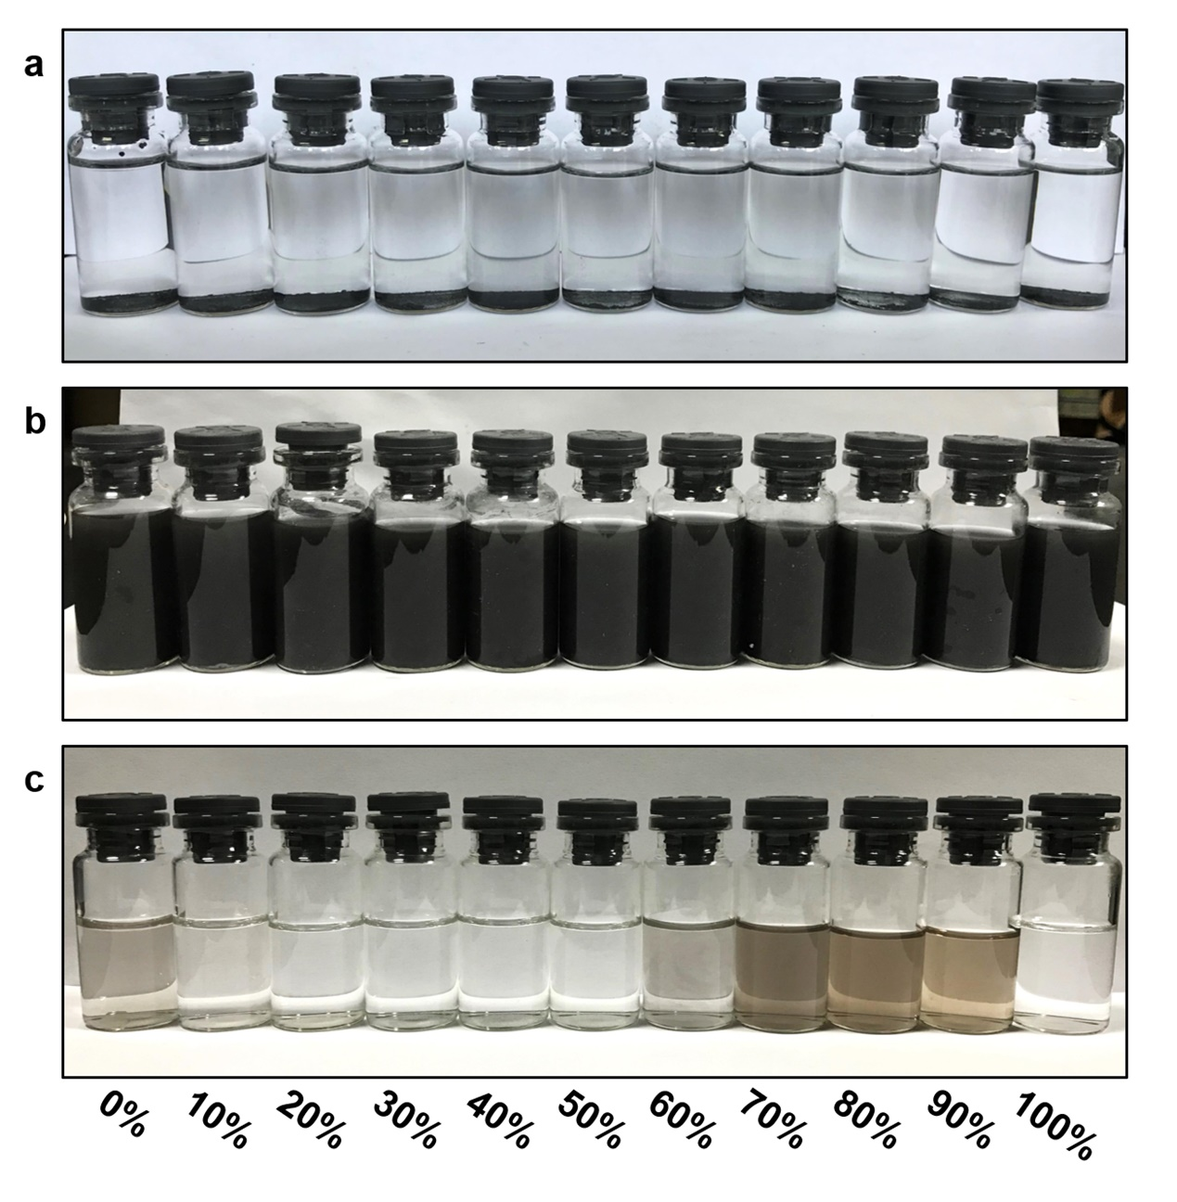
Fig. S1 Photographs of Bi₂S₃ dispersions in various ethanol/water mixtures: a Before and b after ultrasonication treatment for 8 h. c Supernatant collection by centrifugation at 3000 rpm.

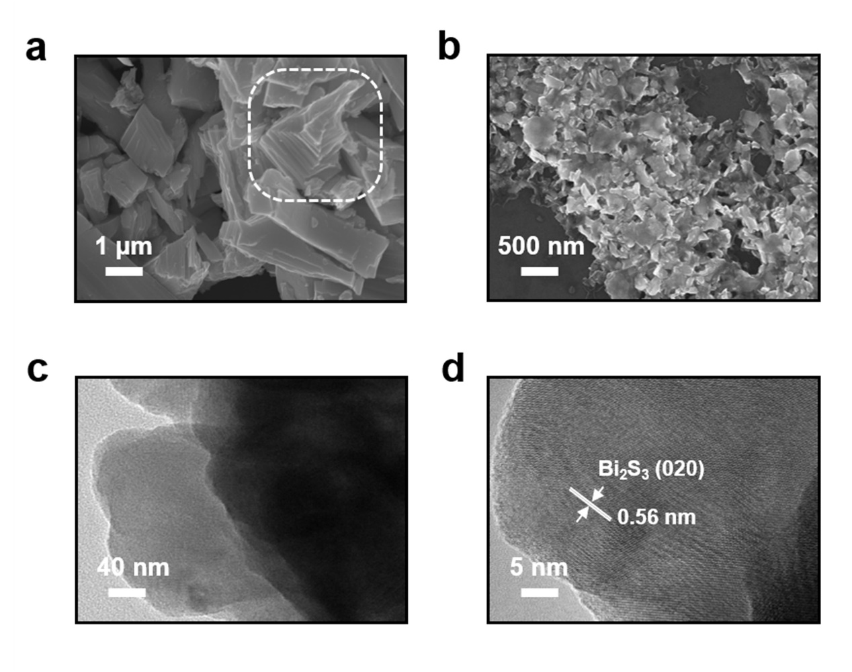
Fig. S2 SEM image of Bi₂S₃ samples before a and after b Liquid phase stripping. c and d TEM and HR-TEM images of Bi₂S₃ NSs.

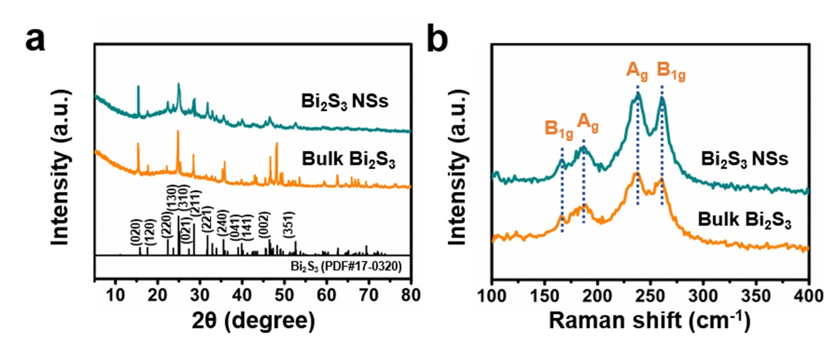
Fig. S3 XRD patterns a and Raman spectra b of bulk Bi₂S₃ and Bi₂S₃ NSs.

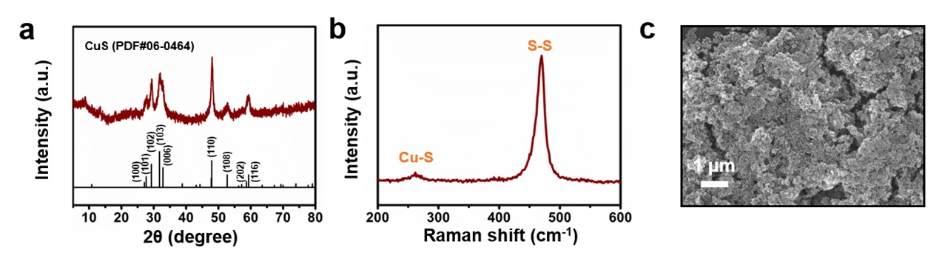
Fig. S4 a XRD pattern b Raman spectra and c SEM image of CuS sample.

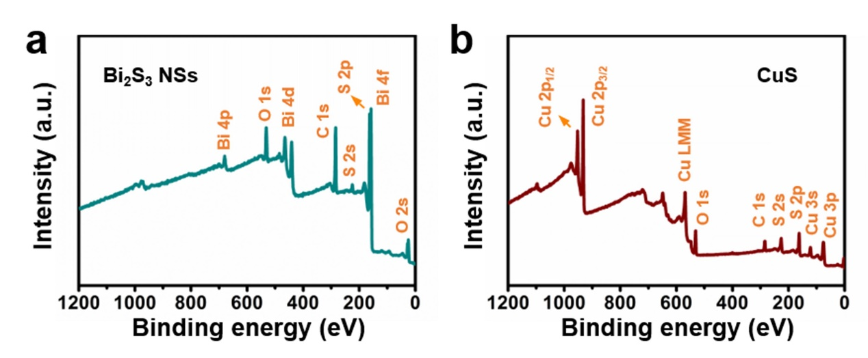
Fig. S5 Full XPS survey spectrums of a Bi₂S₃ NSs and b CuS.

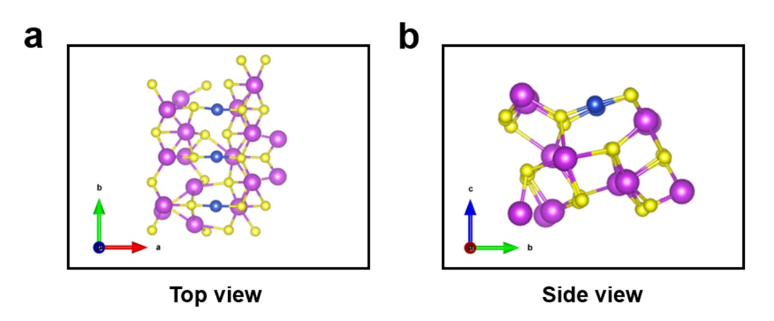
Fig. S6 The atomic structure of CuS-Bi₂S₃.

Fig. S7 UPS spectra of a Bi₂S₃ and b CuS: the secondary electron cut-off energy region (left) and low binding energy region (right) of each.

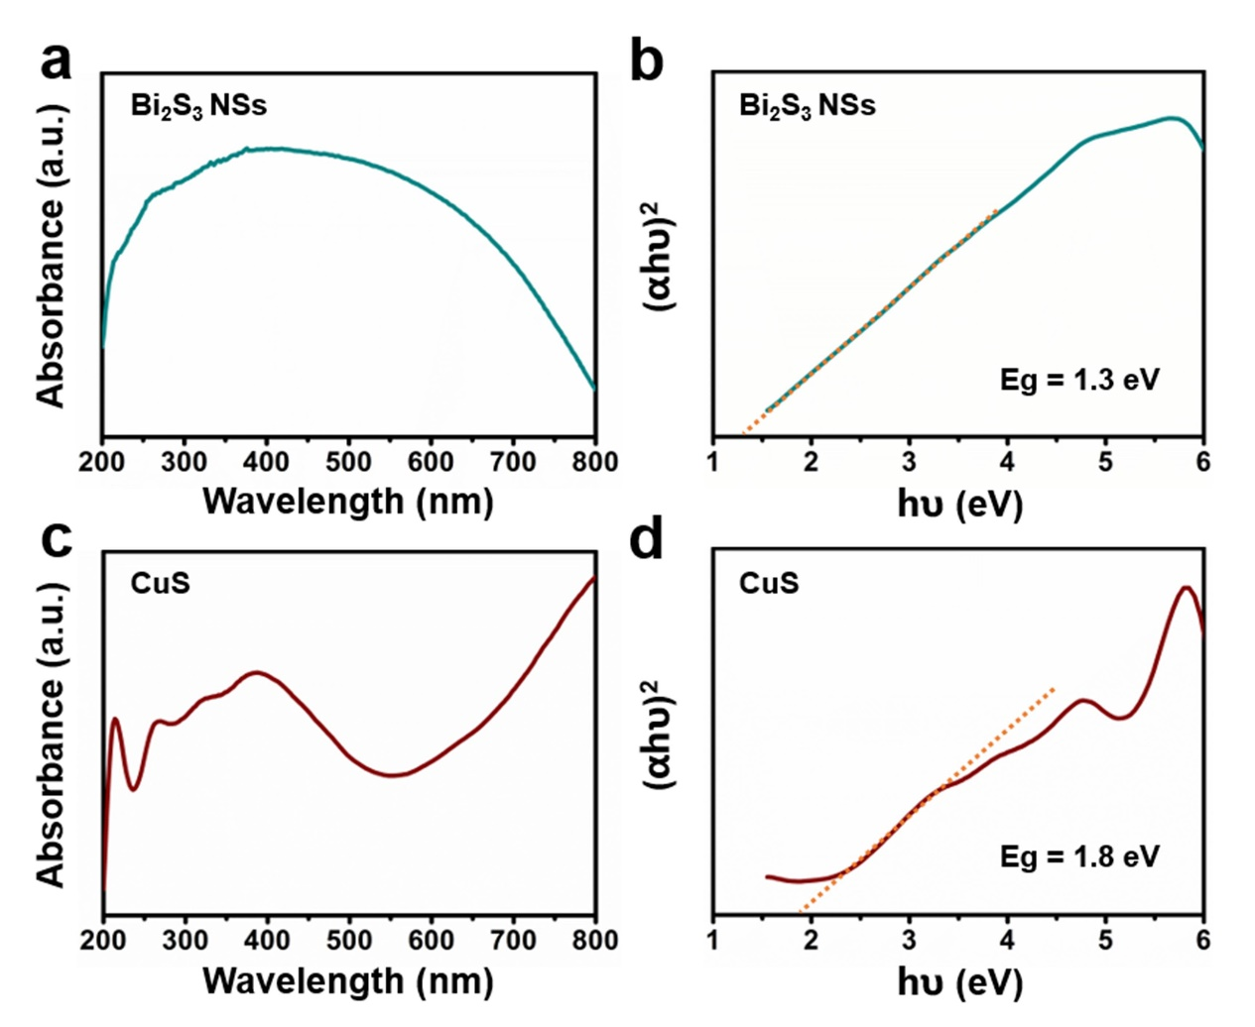
Fig. S8 UV−vis diffuse reflectance spectra of a Bi₂S₃ NSs and c CuS. (αhν)² v.s. hν curve of b Bi₂S₃ NSs and d CuS.

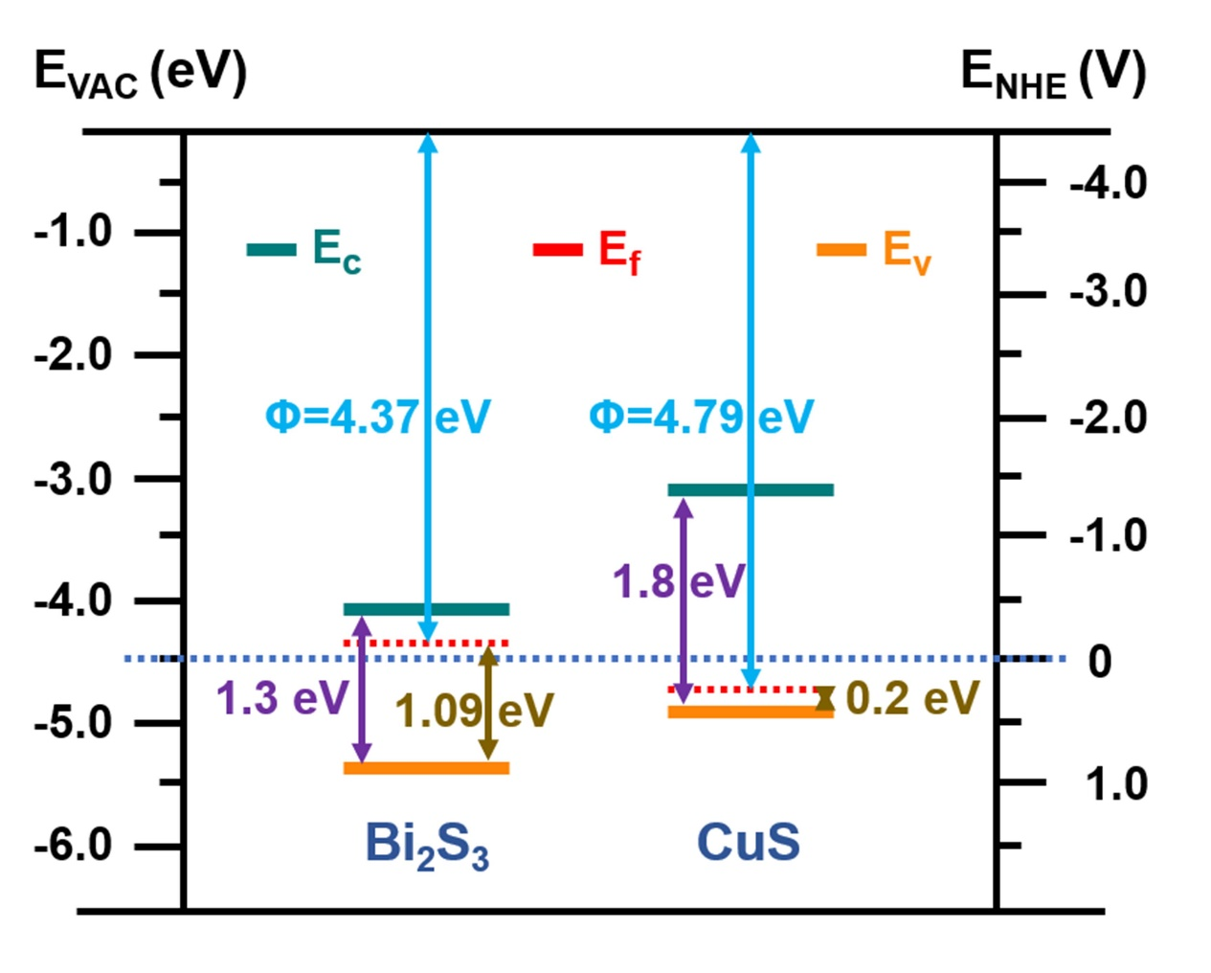
Fig. S9 Energy level diagram between interfacial materials CuS and Bi₂S₃ and schematic diagram of the charge transfer process.

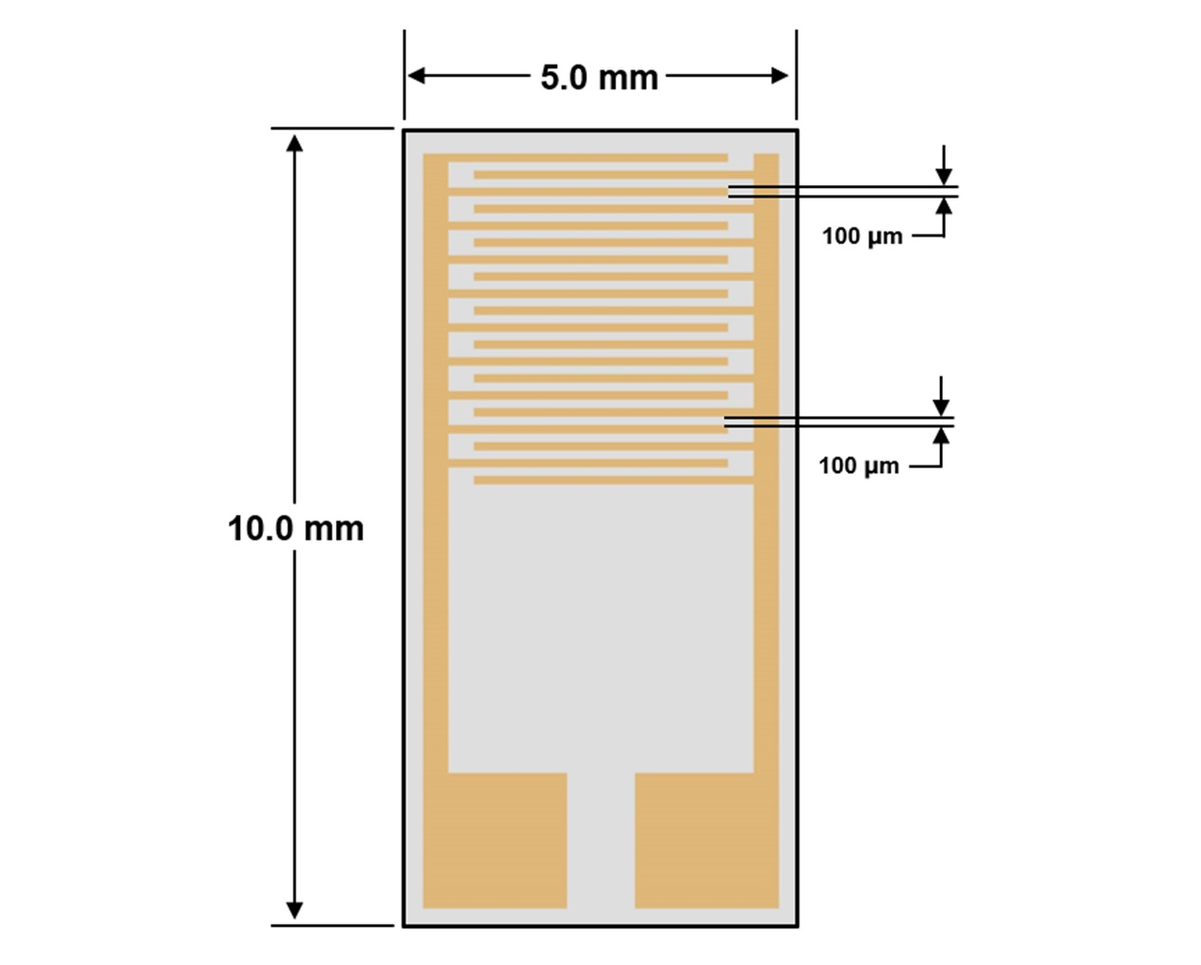
Fig. S10 Structure diagram of the flexible interdigital electrode.

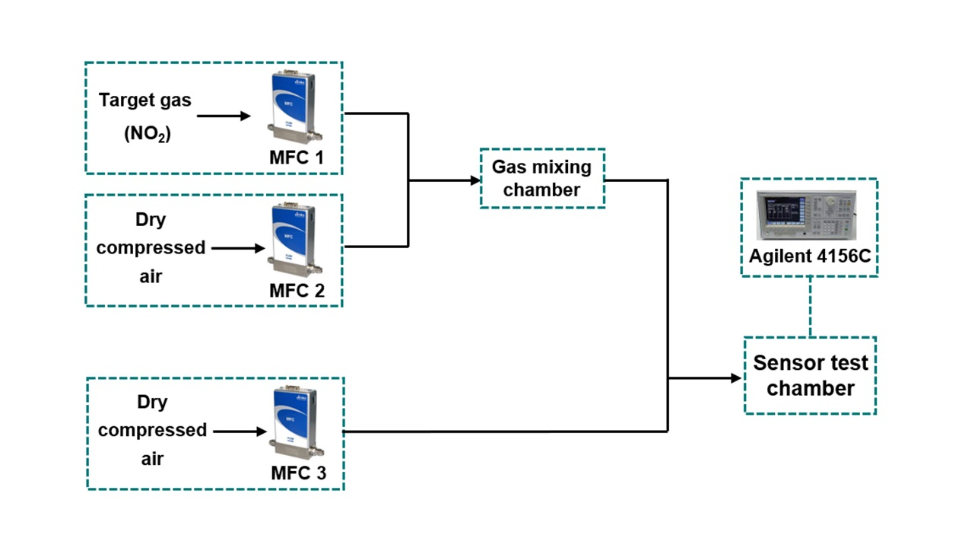
Fig. S11 Schematic diagram of the homemade gas-control system.

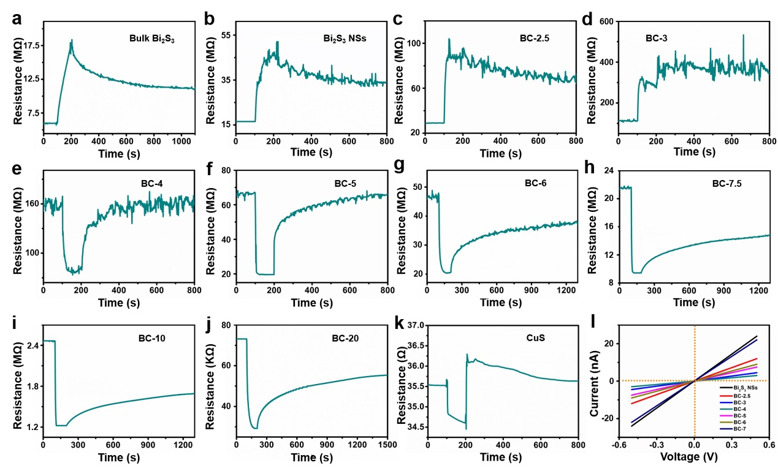
Fig. S12 a-k Sensitive response at a concentration to 10 ppm NO₂ through a dynamic gas-sensing room temperature testing for bulk pure Bi₂S₃, Bi₂S₃ NSs, BC-2.5, BC-3, BC-4, BC-5, BC-6, BC-7.5, BC-10, BC-20, and pure CuS. l I-V curves of Bi₂S₃, different content of CuS QDs/Bi₂S₃ NSs and CuS-based gas sensors.

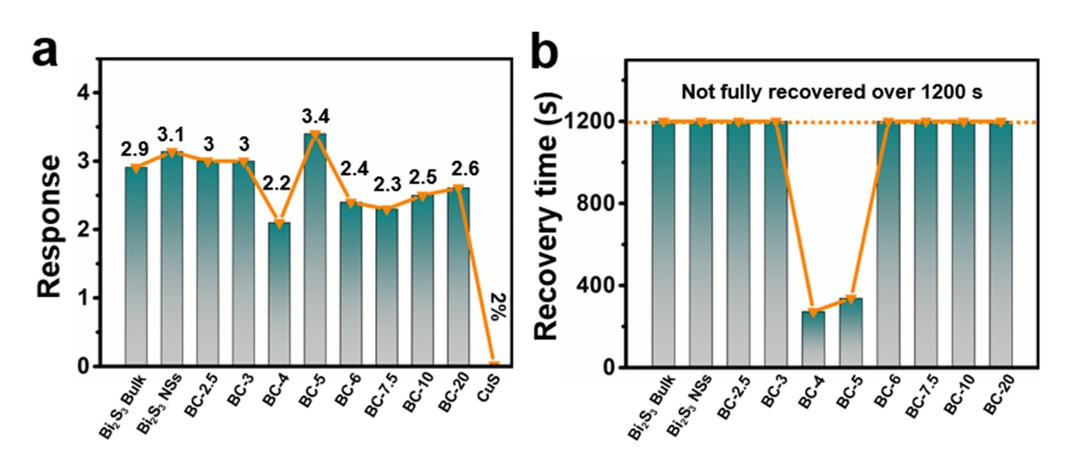
Fig. S13 a Response and b recovery performances of Bi₂S₃, different content of CuS QDs/Bi₂S₃ NSs, and CuS-based gas sensors to 10 ppm NO₂.

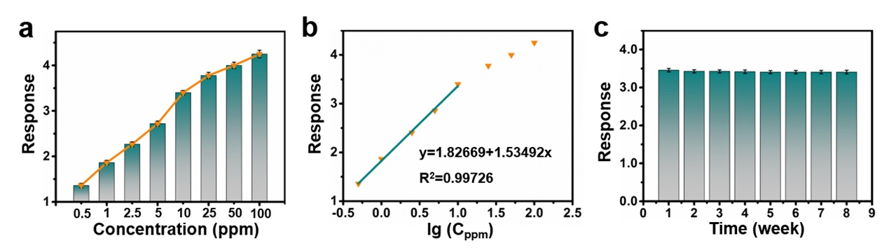
Fig. S14 a The response value of BC-5 sensor to different concentrations of NO₂ and its error bars. b The response of BC-5-based sensor as a function of the logarithm of the NO₂ concentration. c Long-term stability of BC-5-based sensor.

Fig. S15 The selectivity of the BC-5-based sensor to 10 ppm different target gases of a H₂S, b NH₃, c SO₂, d H₂ and e NO.

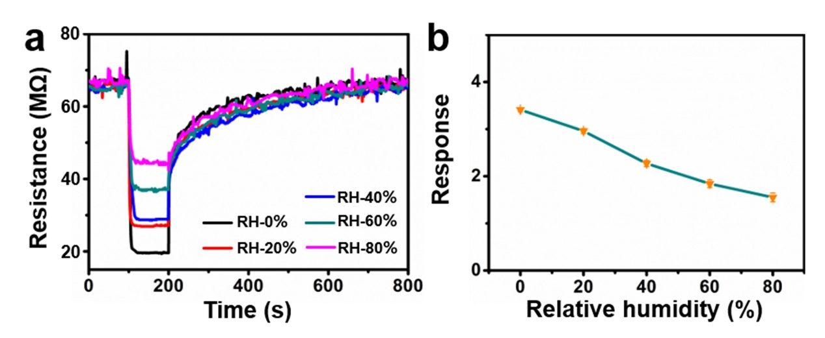
Fig. S16 Sensing characteristics of the sensor to 10 ppm NO₂ at different humidity levels.

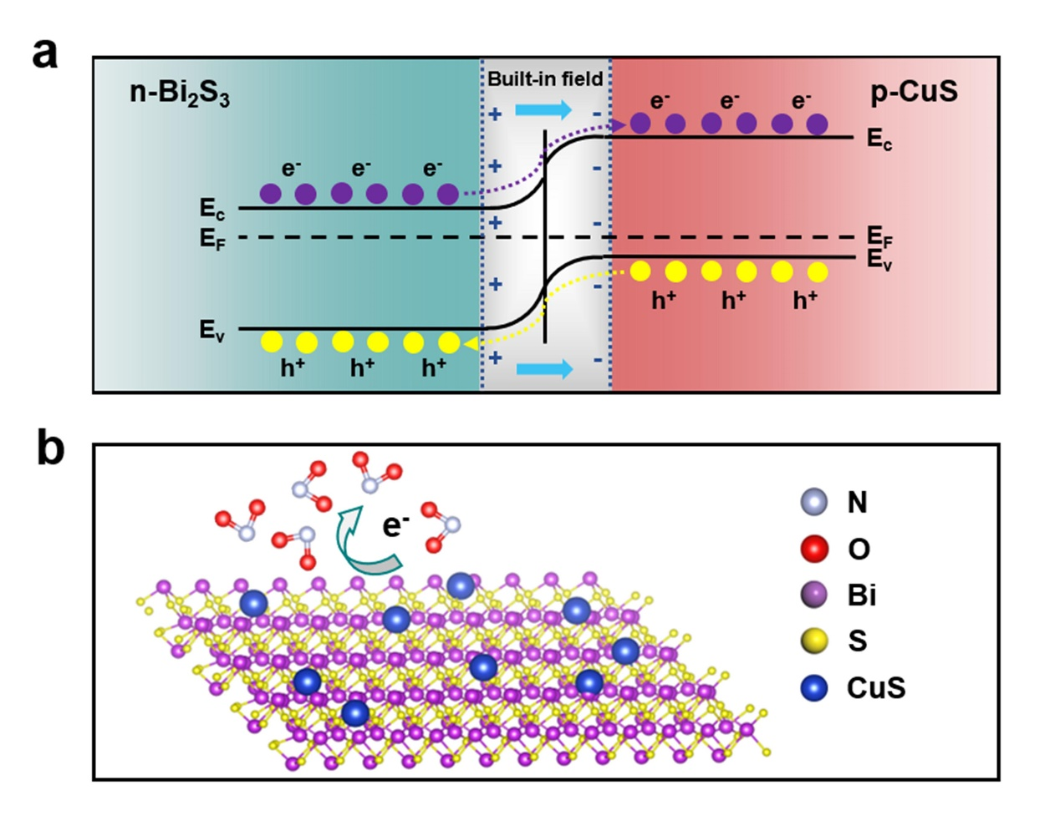
Fig. S17 a Energy band structures of CuS QDs/Bi₂S₃ NSs heterostructure in air. b the proposed sensing mechanism of the heterostructure.

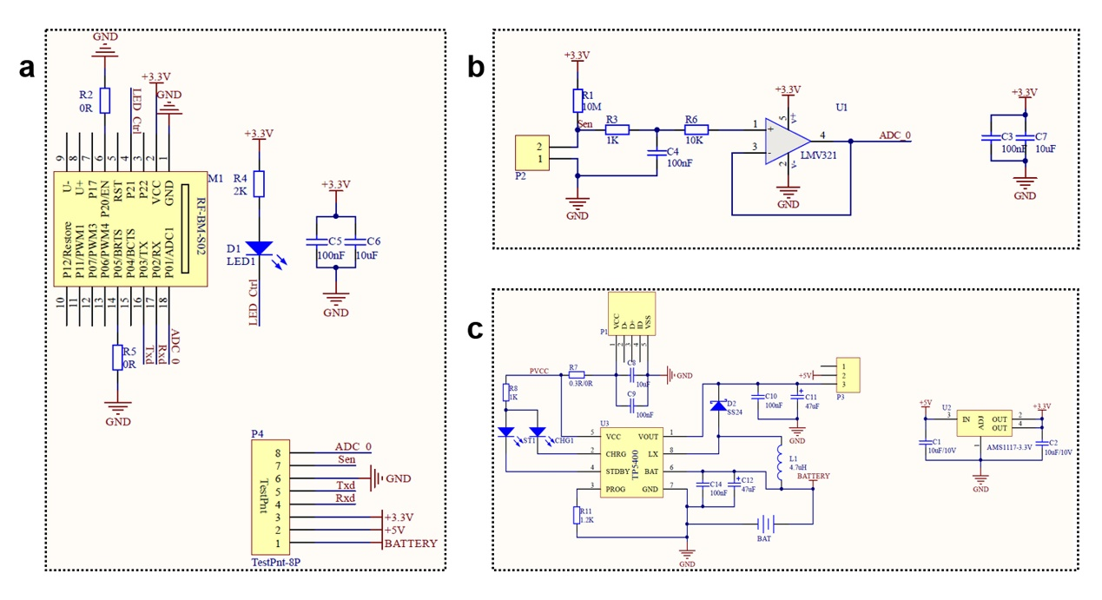
Fig. S18 The schematic circuit diagram of the flexible printed circuit board: a Data acquisition and communication circuit. b Sensor front-end circuit. c USB/Wireless charging circuit.

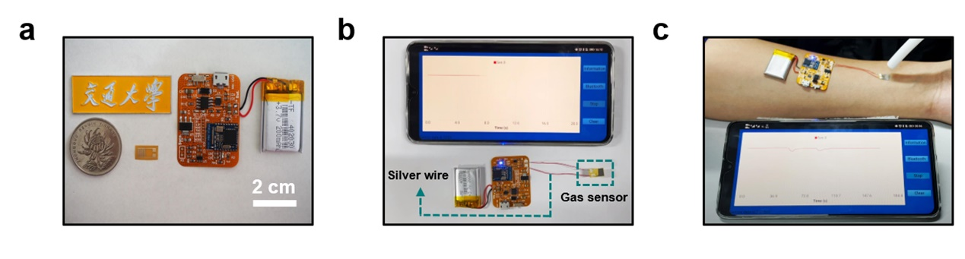
Fig. S19 a Photograph of the flexible circuit and electrode used in the current work (placed next to a school logo and 1 RMB coin for comparison). b Photographs of Bluetooth signal connection of wearable sensor device. c Photographs of wireless sensor signal acquisition process of the wearable sensor device.

Table S1 The bond length of M-O on NO₂-CuS-Bi₂S₃ structure.

Binding structure | Atoms | Bond | Length (Å)
n1 | N (from NO₂) | Cu-N | 1.978
n1 | Cu (CuS-Bi₂S₃) | Cu-N | 1.978
n2 | O (from NO₂) | Bi-O | 2.025
n2 | Bi (CuS-Bi₂S₃) | Bi-O | 2.018
n3 | O (from NO₂) | Cu-O | 2.396
n3 | Bi/Cu (CuS-Bi₂S₃) | Bi-O | 2.557
n4 | O (from NO₂) | Cu-O | 2.555
n4 | Cu (CuS-Bi₂S₃) | Cu-O | 2.567

Table S2 The charge and charge transfer of NO₂ correlated to Fig. 5.

Binding structure | Atoms | Charge | Charge transfer
n2 | N | 4.4197582 | -0.5802418
n2 | O | 6.5942103 | 0.5942103
n2 | O | 6.6273451 | 0.6273451
n2 | Total-NO₂ |  | 0.6413136
n4 | N | 4.4885298 | -0.5114702
n4 | O | 6.598587 | 0.598587
n4 | O | 6.6327922 | 0.6327922
n4 | Total-NO₂ |  | 0.719909

Table S3 The charge and charge transfer of CuS correlated to Fig. 3d.
Binding structure | Atoms | Charge (e) | Charge transfer (e)
CuS-Bi₂S₃ | Cu1 | 10.59286 | -0.40714
CuS-Bi₂S₃ | Cu2 | 10.59062 | -0.40938
CuS-Bi₂S₃ | Cu3 | 10.58872 | -0.41128
CuS-Bi₂S₃ | S1 | 6.800926 | 0.800926
CuS-Bi₂S₃ | S2 | 6.751016 | 0.751016
CuS-Bi₂S₃ | S3 | 6.768011 | 0.768011
CuS-Bi₂S₃ | S4 | 6.763804 | 0.763804
CuS-Bi₂S₃ | S5 | 6.771819 | 0.771819
CuS-Bi₂S₃ | S6 | 6.74335 | 0.74335
CuS-Bi₂S₃ | Total-CuS |  | 3.371122

Table S4 Resistance values of bulk Bi₂S₃, Bi₂S₃ NSs, CuS, and different complex amounts of CuS QDs/Bi₂S₃ heterostructures.
 | R |  |  | R
Bulk Bi₂S₃ | 6.4 MΩ |  | BC-6 | 48 MΩ
Bi₂S₃ NSs | 17 MΩ |  | BC-7.5 | 21.5 MΩ
BC-2.5 | 30 MΩ |  | BC-10 | 2.5 MΩ
BC-3 | 110 MΩ |  | BC-20 | 73 KΩ
BC-4 | 160 MΩ |  | CuS | 35.5 Ω
BC-5 | 66 MΩ

Table S5 The room-temperature sensing performance comparison of NO₂ flexible gas sensors with different sensing materials.
Materials | Conc. (ppm) | Response | τ_{res.} (s) | τ_{rec.} (s) | LOD (ppb) | Ref.
MoSe₂ | 10 | 4 ª | 250 | 150 | 10 | 1
VA-2D MoS₂ | 5 | 380%^{b} | 500 | Can’t recover | - | 2
SnS₂/S-rGO | 1 | 75% ^{c} | 600 | 1200 | 0.7 | 3
RGO/Mesoporous ZnO NSs | 15 | 44% ^{c} | 140 | 630 | 43.5 | 4
3D SnS₂-rGO | 5 | 32.1% ^{d} | 300 | Can’t recover | 2.8 | 5
CuS QDs/Bi₂S₃ | 10 | 3.4 e | 18 | 338 | 78 | This work

Conc.: Gas concentration; Temp.: Operating temperature; τ_{rec.}: Recovery time; RT: Room temperature.
ª I_{g}/I_{a}.
^{b} ΔI/I₀
^{c} ΔR/R_{a}.
^{d} ΔG/G.
^{e} R_{g}/R_{a}.

References
[1] S. Guo, D. Yang, S. Zhang, Q. Dong, B. Li, N. Tran, Z. Li, Y. Xiong, M.E. Zaghloul, Development of a cloud-based epidermal MoSe₂ device for hazardous gas sensing. Adv. Funct. Mater. 29, 1900138 (2019). https://doi.org/10.1002/adfm.201900138
[2] M.A. Islam, H. Li, S. Moon, S.S. Han, H.-S. Chung, J. Ma, C. Yoo, T.-J. Ko, K.H. Oh, Y.J. Jung, Y.W. Jung, Vertically aligned 2D MoS₂ layers with strain-engineered serpentine patterns for high-performance stretchable gas sensors: experimental and theoretical demonstration. ACS Appl. Mater. Interfaces 12(47), 53174−53183 (2020). https://doi.org/10.1021/acsami.0c17540
[3] Y. Huang, W. Jiao, Z. Chu, S. Wang, L. Chen, X. Nie, R. Wang, X. He, High sensitivity, humidity-independent, flexible NO₂ and NH₃ gas sensors based on SnS₂ hybrid functional graphene ink. ACS Appl. Mater. Interfaces 12(1), 997−1004 (2020). https://doi.org/10.1021/acsami.9b14952
[4] W. Li, R. Chen, W. Qi, L. Cai, Y. Sun, M. Sun, C. Li, X. Yang, L. Xiang, D. Xie, T. Ren, Reduced graphene oxide/mesoporous ZnO NSs hybrid fibers for flexible, stretchable, twisted, and wearable NO₂ e‑textile gas sensor. ACS Sens. 4(10), 2809−2818 (2019). https://doi.org/10.1021/acssensors.9b01509
[5] J. Wu, Z. Wu, H. Ding, Y. Wei, W. Huang, X. Yang, Z. Li, L. Qiu, X. Wang, Three-dimensional graphene hydrogel decorated with SnO₂ for high-performance NO₂ sensing with enhanced immunity to humidity. ACS Appl. Mater. Interfaces 12(2), 2634−2643 (2020). https://doi.org/10.1021/acsami.9b18098

