Supporting Information for

Carbon-Coated Three-Dimensional MXene/Iron Selenide Ball with Core-Shell Structure for High-Performance Potassium-Ion Batteries

Su Hyun Yang¹, Yun Jae Lee², Heemin Kang¹, Seung-Keun Park^{2,}*, and Yun Chan Kang^{1,}*

¹Department of Materials Science and Engineering, Korea University, Anam-Dong, Seongbuk-Gu, Seoul 136-713, Republic of Korea

²Department of Advanced Materials Engineering, Chung-Ang University, 4726 Seodong-daero, Daedeok-myeon, Anseong-si, Gyeonggi-do, 17546, Republic of Korea

*Corresponding authors E-mail: yckang@korea.ac.kr (Prof. Y.C. Kang) and skpark09@cau.ac.kr (Prof. S.-K. Park)

Supplementary Characterizations of Materials

The morphologies of the prepared FeSe_{x}@C/MB, FeSe_{x}/MB, FeSe₂-Fe₂O₃ microspheres, and MBs were examined using microscopic characterization techniques, including scanning electron microscopy (SEM, VEGA3 SBH) and field-emission transmission electron microscopy (FE-TEM, JEM-2100 F). X-ray photoelectron spectroscopy (XPS, Thermo Scientific K-Alpha) was conducted to confirm the chemical nature of FeSe_{x}@C/MB. The crystal phases of the prepared samples were characterized by powder X-ray diffraction (XRD, X’Pert PRO) with Cu-Kα radiation (λ = 1.5418 Å), at the Korea Basic Science Institute (Daegu Center). Their surface areas and pore sizes were investigated using the Brunauer–Emmett–Teller (BET) method, with pure N₂ as the adsorbate gas. Thermogravimetric analysis (TGA) was performed using a Pyris 1 TGA (Perkin Elmer) in the 30–700 °C range, at a ramp rate of 10 °C·min⁻¹ in air, to confirm the carbon content of the composites. Raman spectroscopy (Jobin Yvon LabRamHR800, excited by a 632.8-nm-wavelength He/Ne laser) was performed, for analyzing the structure of the carbon and Se bonding of FeSe_{x} in FeSe_{x}@C/MB and FeSe_{x}/MB.

Supplementary Electrochemical Measurements

The electrochemical properties of FeSe_{x}@C/MB, FeSe_{x}/MB, FeSe₂-Fe₂O₃ microspheres, and MBs were evaluated using a standard 2032-type coin cell. The anodes were prepared by mixing active material (70 wt%), Super P (20 wt%), and sodium carboxymethyl cellulose (CMC, 10 wt%) in DI water, which were then applied to a copper foil using a doctor blade. A coin cell was fabricated in an argon-filled glove box and consisted of metallic potassium as the counter-electrode, porous polypropylene as the separator, and potassium bis(fluorosulfonyl) imide (KFSI, 1 M) dissolved in a mixture of ethylene carbonate/diethyl carbonate (EC/DEC, volumetric ratio of 1:1). The diameter of the electrode was 1.4 cm, and the mass loading of the electrode was 1.4 mg·cm⁻². Galvanostatic charge/discharge and cyclic voltammetry (CV) measurements were carried out using a battery analyzer (WonATech, WBCS-3000s cycler) over the 0.001–3.0 V range of potentials, at various current densities. In-situ and ex-situ electrochemical impedance spectroscopy (EIS) measurements of the samples were performed, and the results were analyzed for frequencies ranging from 0.01 Hz to 100 kHz. During the in situ EIS analysis, the cell was cycled at a current density of 0.05 A g⁻¹, and the samples’ Nyquist plots were obtained at preselected potentials.

Supplementary Figures and Table

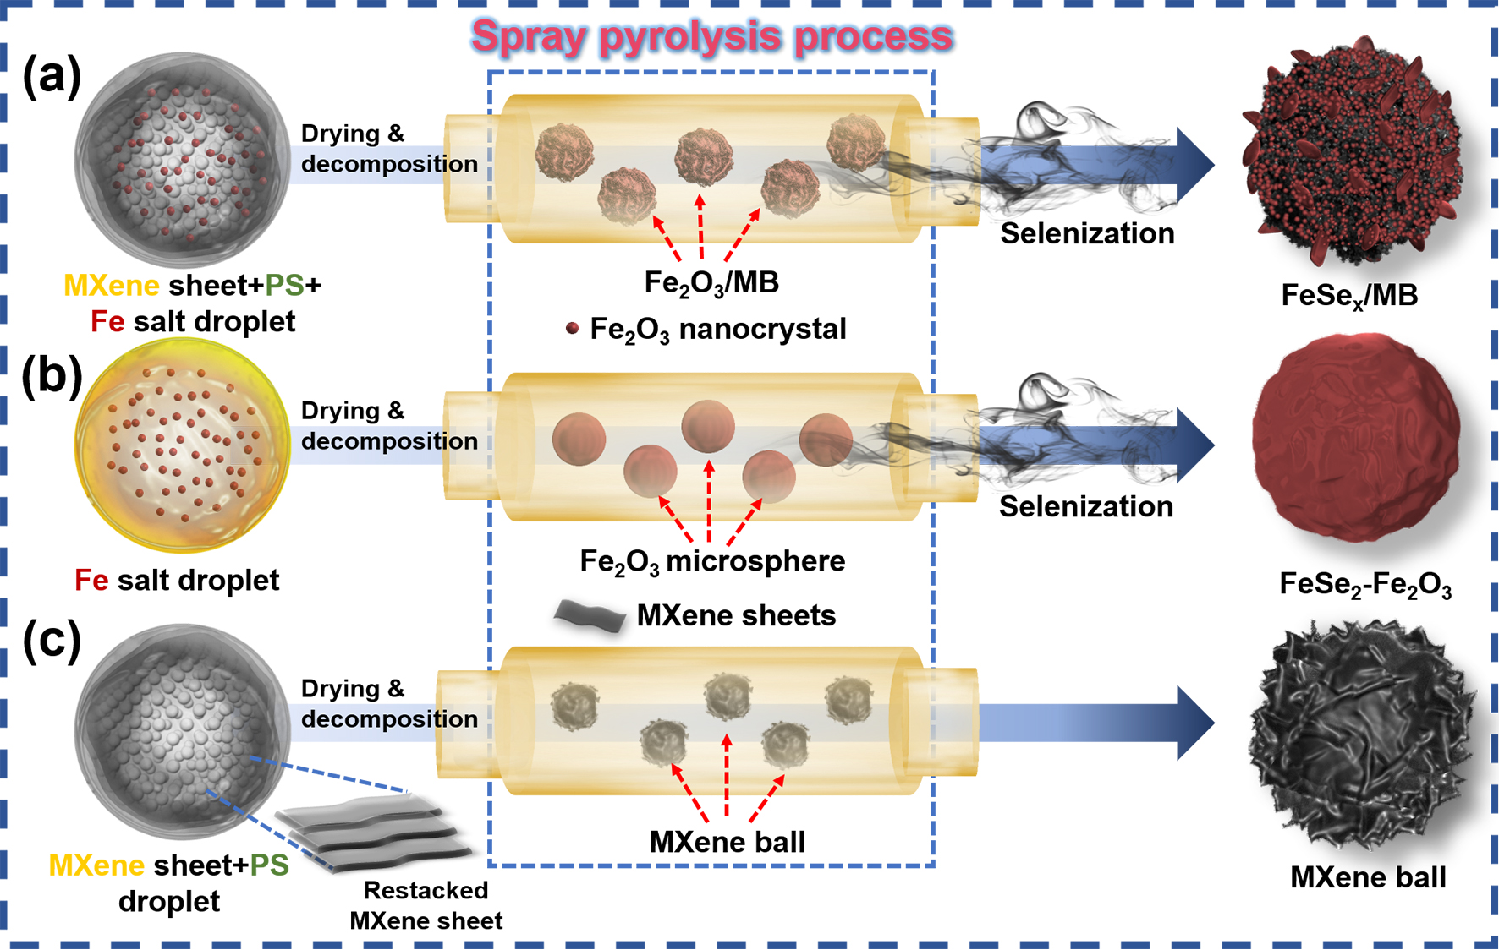
Fig. S1 The formation mechanism of FeSe_{x}/MB, bare FeSe₂-Fe₂O₃, and MB

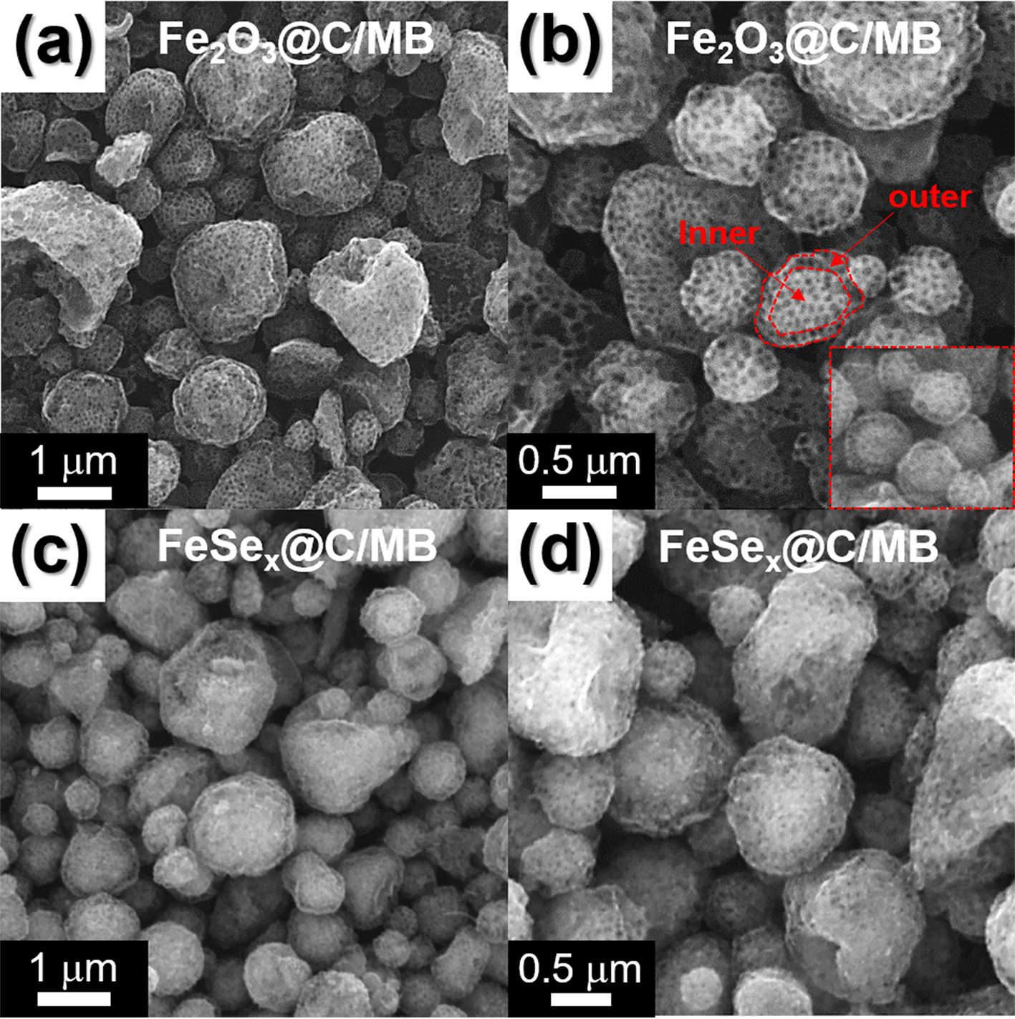
Fig. S2 SEM images: a, b Fe₂O₃@C/MB, and c, d FeSe_{x}@C/MB

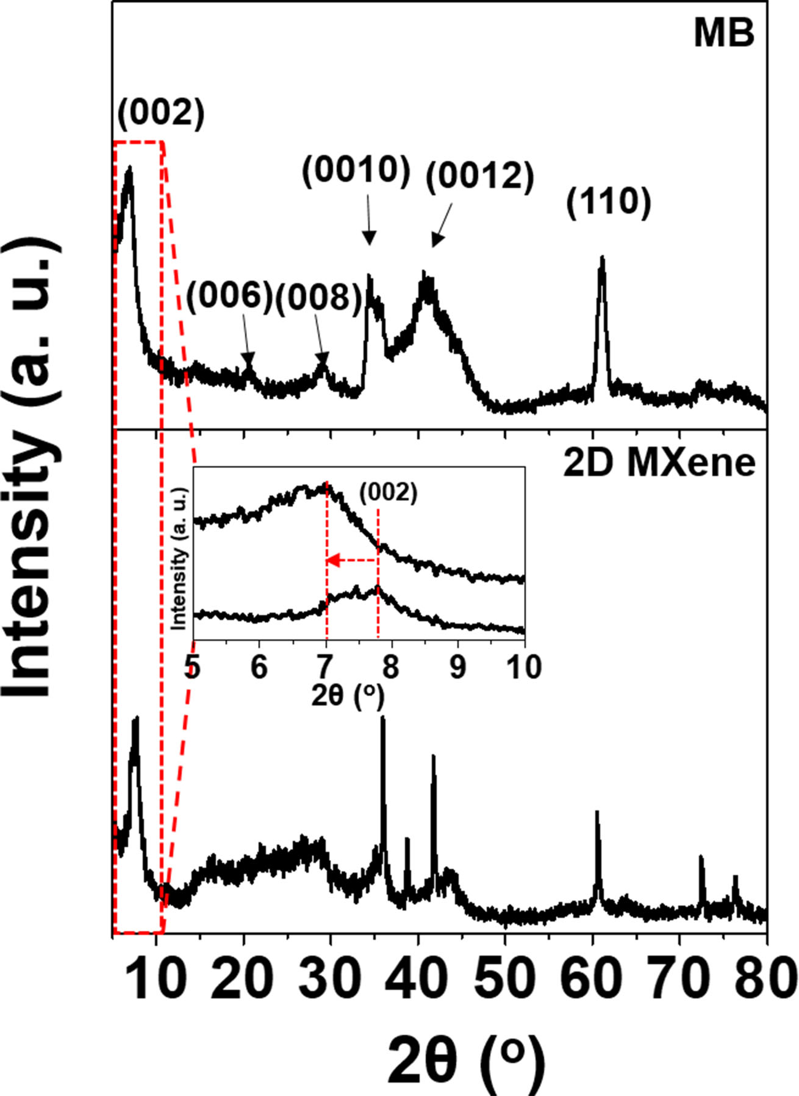
Fig. S3 XRD patterns of MB and 2D MXene

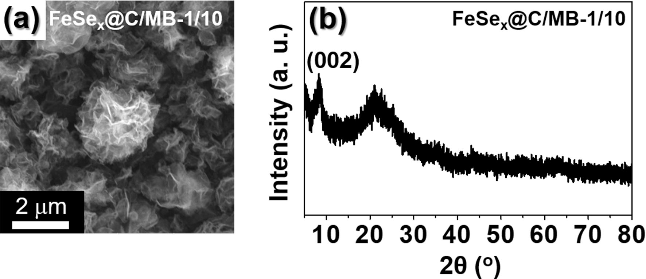
Fig. S4 a SEM image and b XRD data of 1/10 FeSe_{x}@C/MB

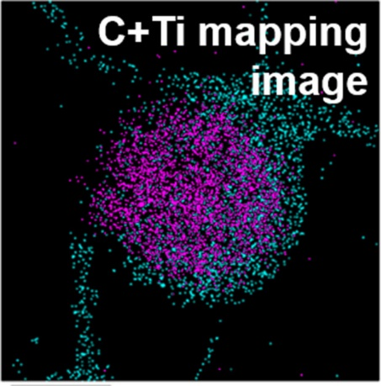
Fig. S5 The distribution of C (blue color) and Ti (pink color) elements in FeSe_{x}@C/MB

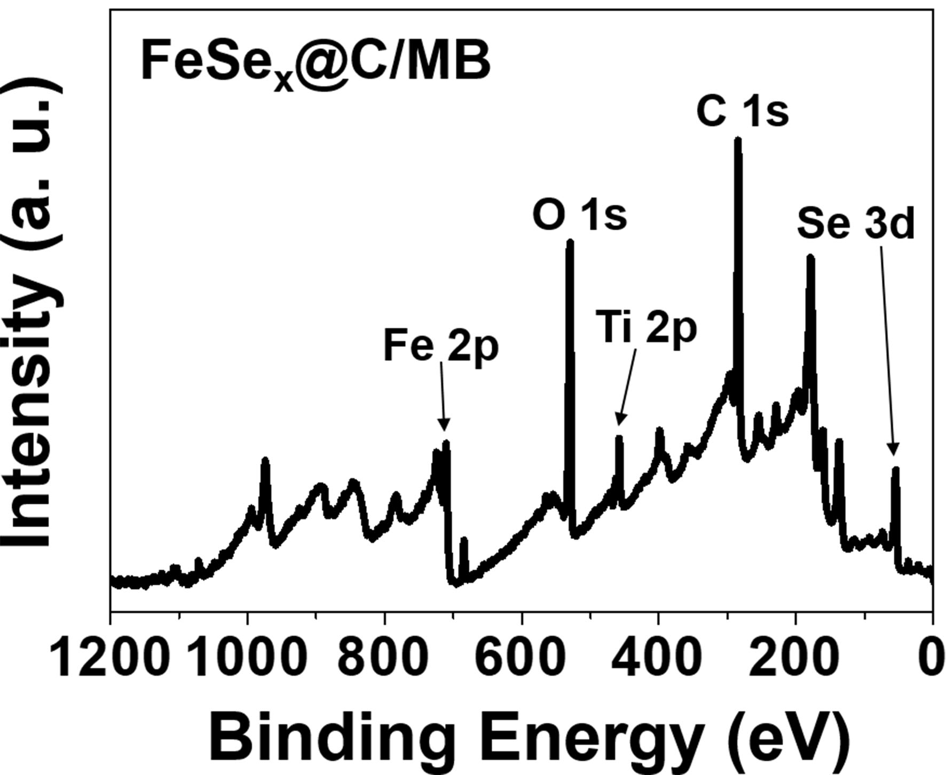
Fig. S6 XPS survey scan for FeSe_{x}@C/MB

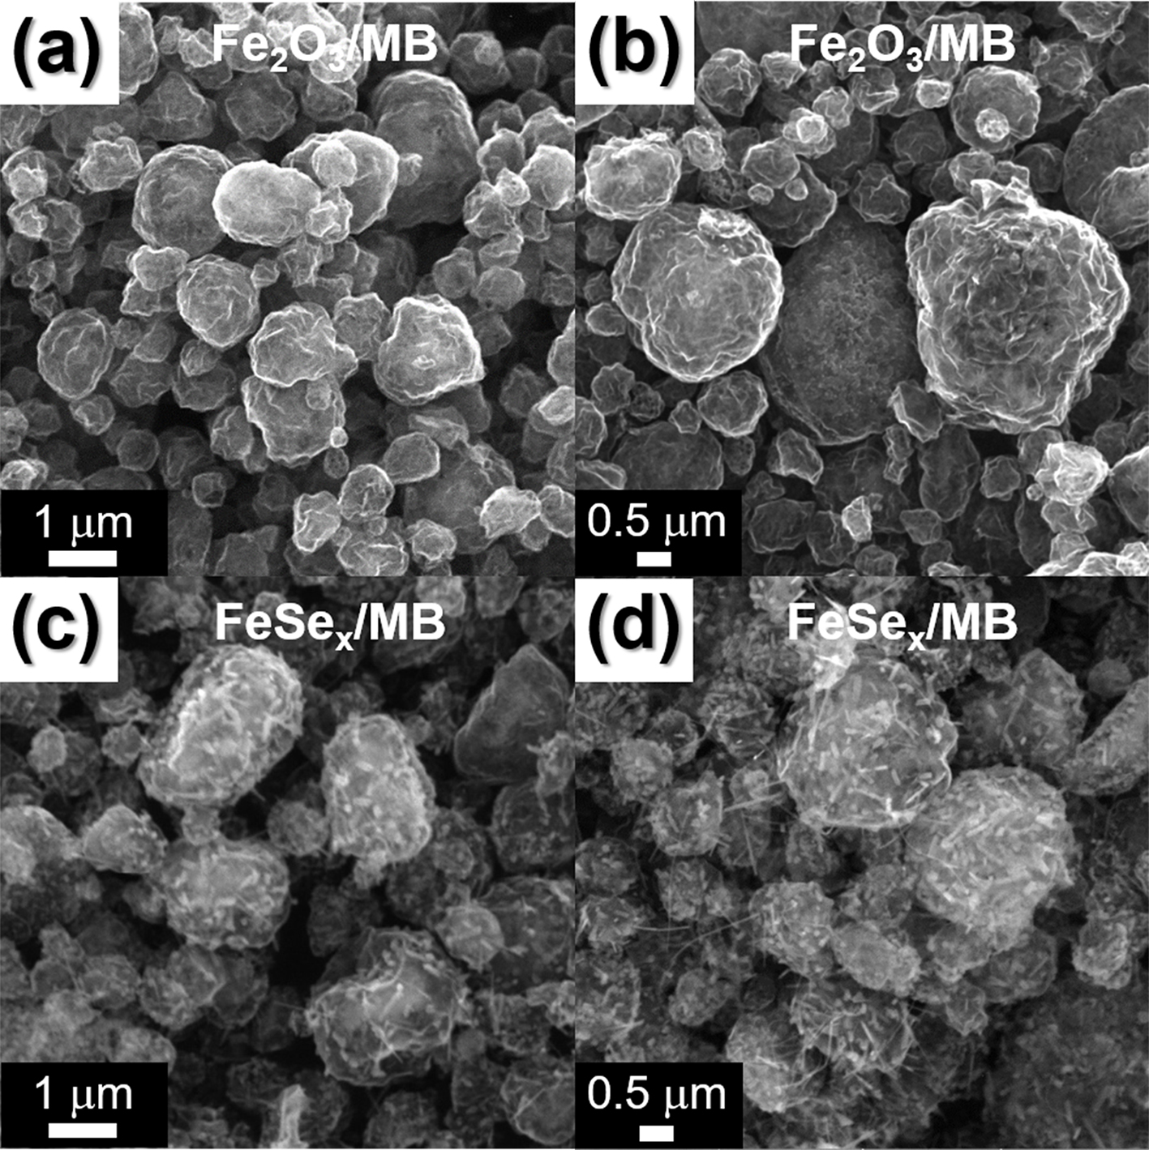
Fig. S7 SEM images: a, b Fe₂O₃/MB, and c, d FeSe_{x}/MB

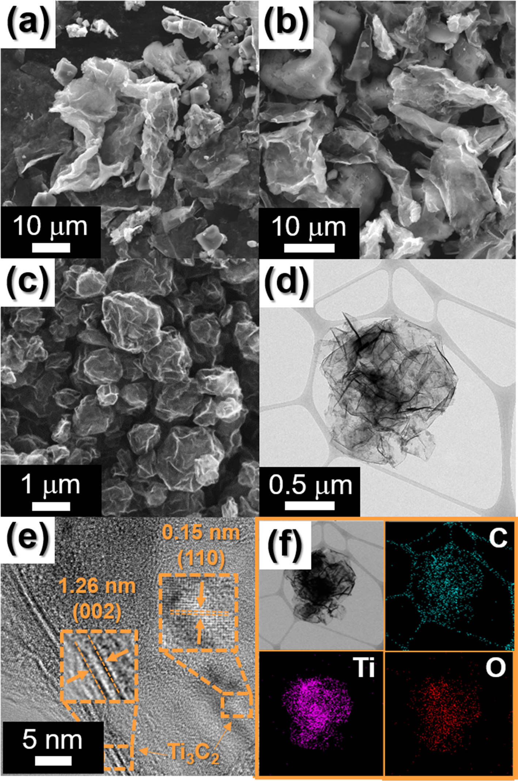
Fig. S8 Morphologies, SAED, and elemental mapping images: a, b SEM images of 2D MXene nanosheets, c SEM image, d TEM image, e HR-TEM image, and f elemental mapping images of MB

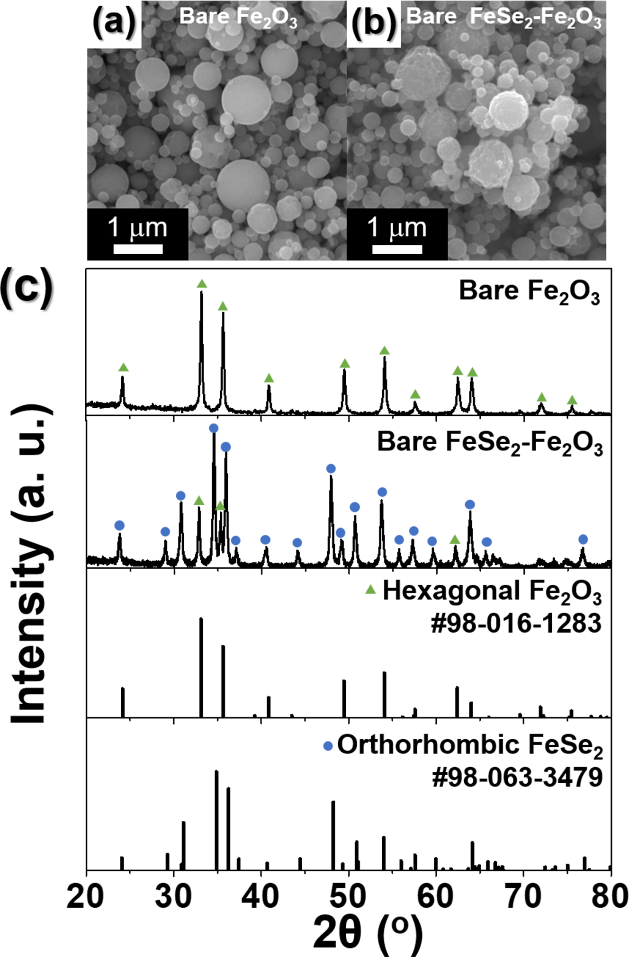
Fig. S9 a, b SEM images and c XRD data of bare Fe₂O₃ and FeSe₂-Fe₂O₃
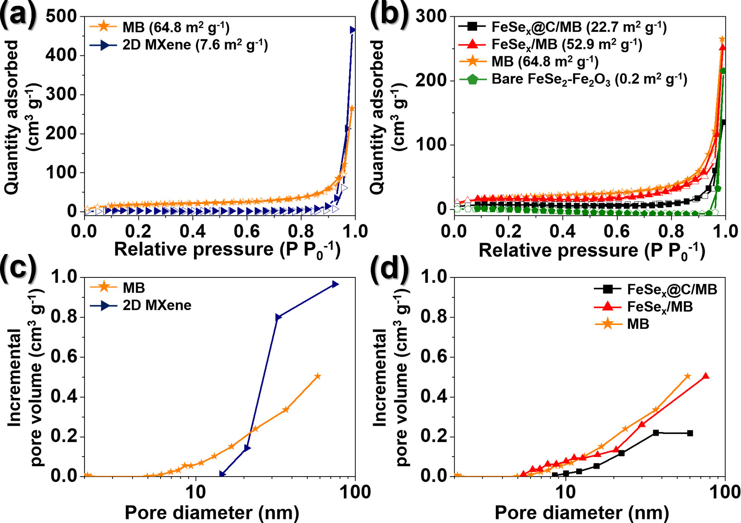
Fig. S10 a, b N₂ gas adsorption and desorption isotherms, and c, d BJH pore size distributions of MB, 2D MXene, FeSe_{x}@C/MB, FeSe_{x}/MB, and bare FeSe₂-Fe₂O₃

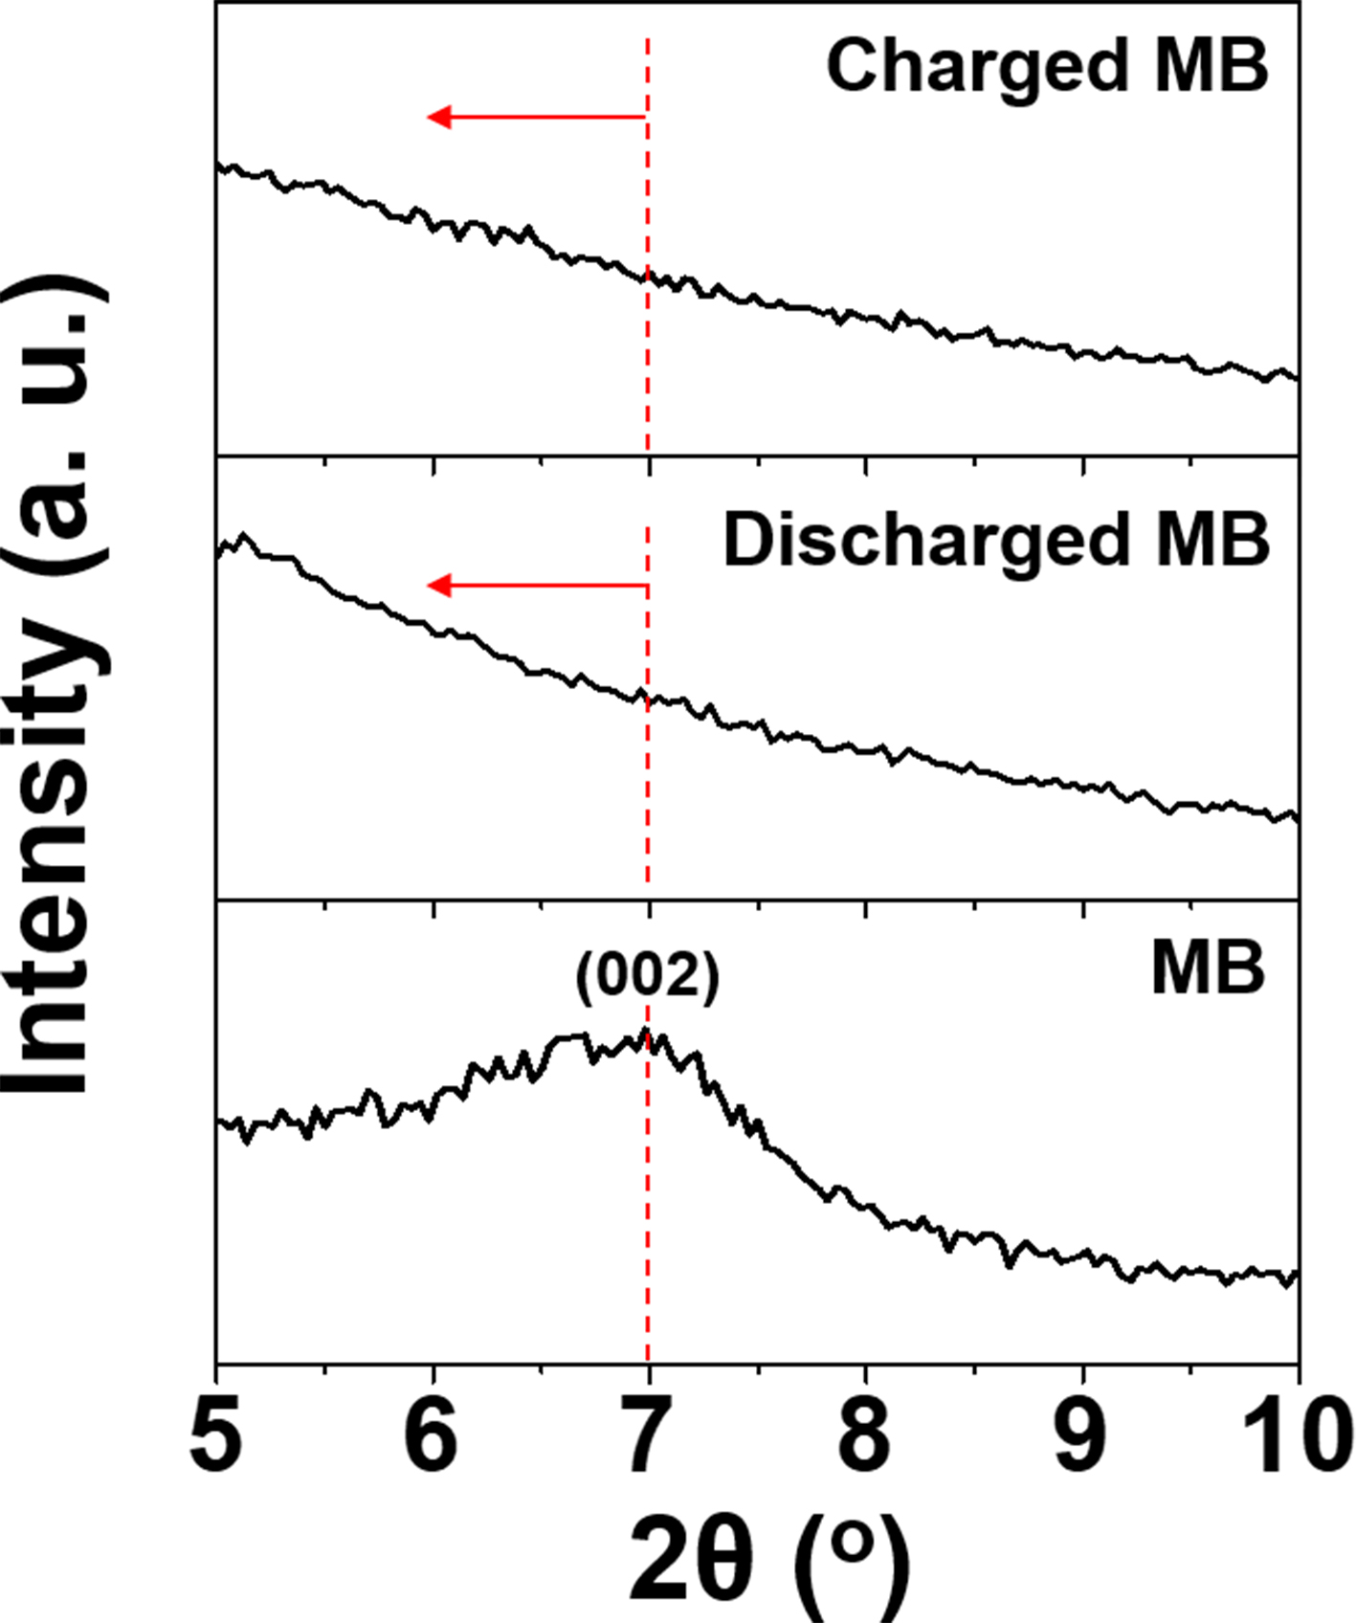
Fig. S11 Ex-situ XRD pattern of MB after the first discharge, and charge state

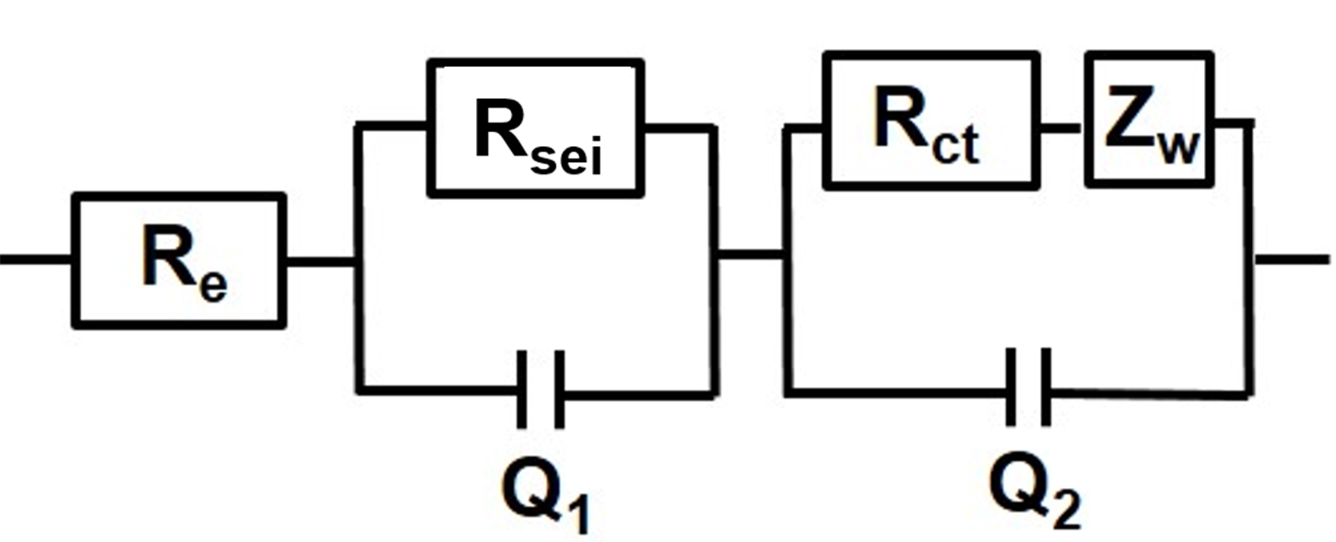
Fig. S12 Randle-type equivalent circuit model used for EIS fitting
R_{e}: Electrolyte resistance, corresponding to the intercept of high frequency semicircle at Z_{re} axis
R_{sei}: SEI layer resistance corresponding to the high-frequency semicircle
Q₁: Dielectric relaxation capacitance corresponding to the high-frequency semicircle
R_{ct}: Charge transfer resistance related to the middle-frequency semicircle
Q₂: Associated double-layer capacitance related to the middle-frequency semicircle
Z_{w}: K-ion diffusion resistance
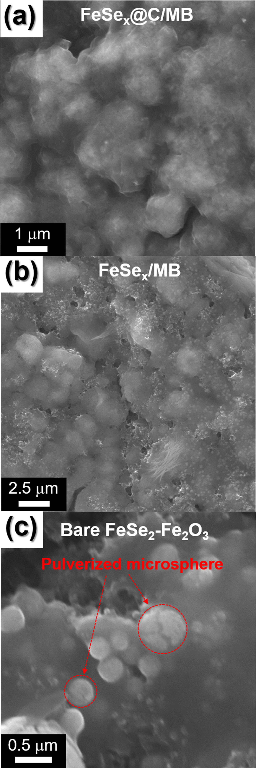
Fig. S13 SEM images of a FeSe_{x}@C/MB, b FeSe_{x}/MB, and c bare FeSe₂-Fe₂O₃ after 200 cycles.

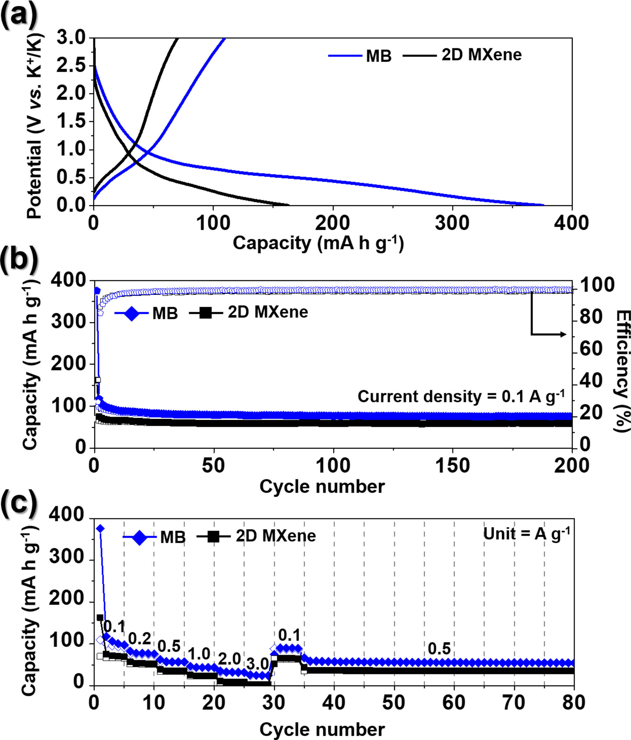
Fig. S14 Electrochemical properties of MB and 2D MXene: a initial charge-discharge curves, b cycle performances at a current density 0.1 A g⁻¹, and c rate performances at various current densities

Table S1 Electrochemical properties of various nanostructured iron selenide anode materials applied as potassium-ion batteries reported in the previous literatures.
Materials | Voltage range (V) | Current rate | Discharge capacity  [mA h g⁻¹] and (cycle number) | Rate capacity  [mA h g⁻¹]  (current rate) | Ref
FeSe_{x}@C/MB | 0.001-3.0 | 0.1 | 410  (200) | 169  (5.0 A g⁻¹) | This work
FeSe₂/NC | 0.01-3.0 | 0.1 | 434  (70) | 341  (1.0 A g⁻¹) | [S1]
FeSe@C | 0.01-3.0 | 0.5 | 298  (200) | 297  (1.0 A g⁻¹) | [S2]
Fe-Mo selenide@N-doped C | 0.01-2.5 | 0.2 | 272  (100) | 227  (1.0 A g⁻¹) | [S3]
FeSe₂@C | 0.005-3.0 | 0.1 | 182  (100) | 61  (1.6 A g⁻¹) | [S4]
FeSe₂@C NBs | 0.7-3.0 | 0.1 | 221  (700) | 128  (1.0 A g⁻¹) | [S5]
Mn-Fe-Se/CNTs | 0.0-3.0 | 0.05 | 141  (70) | 83  (0.8 A g⁻¹) | [S6]
FeSe₂@C-3 MCs | ~0.0-2.8 | 0.1 | 228  (100) | 142  (2.0 A g⁻¹) | [S7]
Fe₃Se₄@CF | 0.01-2.0 | 0.05 | 357~  (50) | 77  (4.0 A g⁻¹) | [S8]

References
[S1] Y. Liu, C. Yang, Y. Li, F. Zheng, Y. Li, Q. Deng, W. Zhong, G. Wang, T. Liu. FeSe₂/nitrogen-doped carbon as anode material for potassium-ion batteries. Chem. Eng. J. 393, 124590 (2020). https://doi.org/10.1016/j.cej.2020.124590

[S2] J. Deng, X. Huang, W. Gao, H. Liu, M. Xu. 3D carbon framework-supported FeSe for high-performance potassium ion batteries. Sustain. Energy Fuels 4, 4807-4813 (2020). https://doi.org/10.1039/D0SE00146E

[S3] J. Chu, Q. Yu, D. Yang, L. Xing, C.-Y. Lao, M. Wang, K. Han, Z. Liu, L. Zhang, W. Du, K. Xi, Y. Bao, W. Wang. Thickness-control of ultrathin bimetallic Fe–Mo selenide@N-doped carbon core/shell “nano-crisps” for high-performance potassium-ion batteries. Appl. Mater. Today 13, 344-351 (2018). https://doi.org/10.1016/j.apmt.2018.10.004

[S4] T. Wang, W. Guo, G. Wang, H. Wang, J. Bai, B. Wang. Highly dispersed FeSe₂ nanoparticles in porous carbon nanofibers as advanced anodes for sodium and potassium ion batteries. J. Alloys. Compd. 834, 155265 (2020). https://doi.org/10.1016/j.jallcom.2020.155265

[S5] C. Liu, Y. Li, Y. Feng, S. Zhang, D. Lu, B. Huang, T. Peng, W. Sun. Engineering of yolk-shelled FeSe₂@nitrogen-doped carbon as advanced cathode for potassium-ion batteries. Chin. Chem. Lett. (2021). https://doi.org/10.1016/j.cclet.2021.04.002

[S6] J. Wang, B. Wang, X. Liu, J. Bai, H. Wang, G. Wang. Prussian blue analogs (PBA) derived porous bimetal (Mn, Fe) selenide with carbon nanotubes as anode materials for sodium and potassium ion batteries. Chem. Eng. J. 382, 123050 (2020). https://doi.org/10.1016/j.cej.2019.123050

[S7] S. Lu, H. Wu, S. Xu, Y. Wang, J. Zhao, Y. Li, A. M. Abdelkader, J. Li, W. Wang, K. Xi, Y. Guo, S. Ding, G. Gao, R. V. Kumar. Iron selenide microcapsules as universal conversion-typed anodes for alkali metal-ion batteries. Small 17(8), 2005745 (2021). https://doi.org/10.1002/smll.202005745

[S8] A. Mahmood, Z. Ali, H. Tabassum, A. Akram, W. Aftab, R. Ali, M. W. Khan, S. Loomba, A. Alluqmani, M. Adil Riaz, M. Yousaf, N. Mahmood. Carbon fibers embedded with iron selenide (Fe₃Se₄) as anode for high-performance sodium and potassium ion batteries. Front. Chem. 8, 408 (2020). https://doi.org/10.3389/fchem.2020.00408

