Supporting Information

Enhancing Hydrophilicity of Thick Electrodes for High Energy Density Aqueous Batteries

Jungeun Lee¹, Hyeonsoo Lee¹, Cheol Bak², Youngsun Hong¹, Daeha Joung³, Jeong Beom Ko¹, Yong Min Lee^{2,}* and Chanhoon Kim^{1,}*

¹Sustainable Technology and Wellness R&D Group, Korea Institute of Industrial Technology (KITECH), 102 Jejudaehak-ro, Jeju-si, Jeju-do 63243, Republic of Korea
²Department of Energy Science and Engineering, Daegu Gyeongbuk Institute of Science and Technology (DGIST), Daegu 42988, Republic of Korea
³Department of Physics, Virginia Commonwealth University, Richmond, VA 23284, USA

*E-mail: ckim8608@kitech.re.kr

Keywords: thick electrodes, hydrophilic binder, sulfonation, aqueous zinc-ion batteries, high areal capacity

Fig. S1 A scheme to synthesize sulfornated PVdF (S-PVdF) from PVdF through simple chemical reaction.
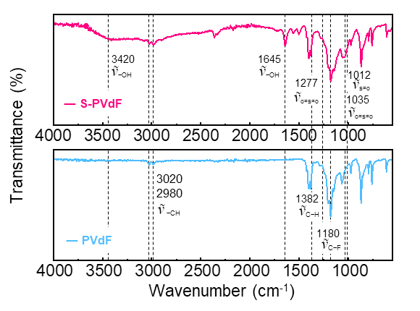
Fig. S2 FT-IR spectra of S-PVdF and PVdF binders.
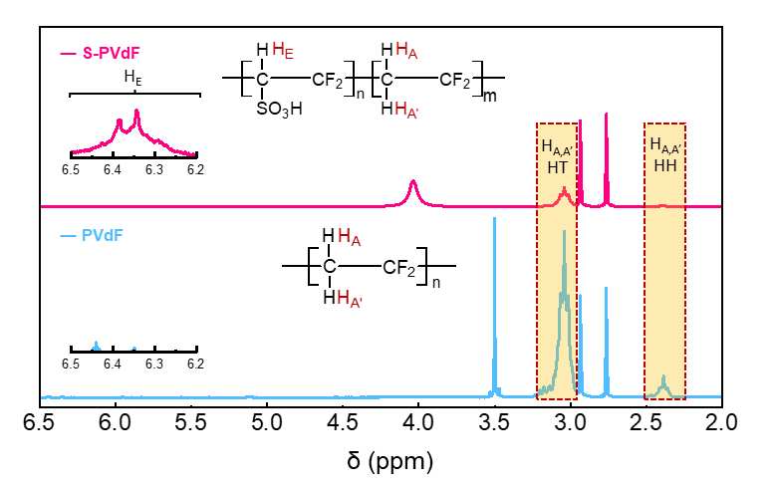
Fig. S3 ¹H NMR spectra of S-PVdF and PVdF binders.

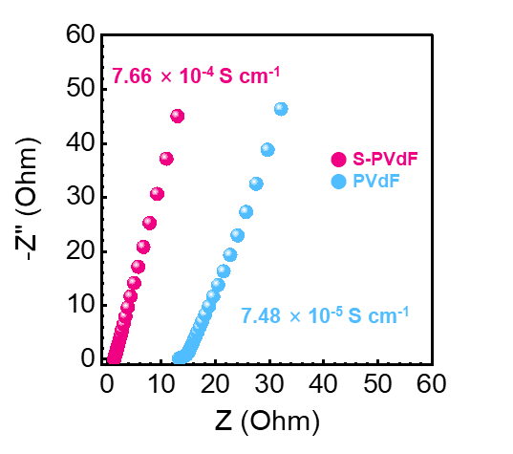
Fig. S4 Nyquist plots of S-PVdF and PVdF binders and their ionic conductivities.

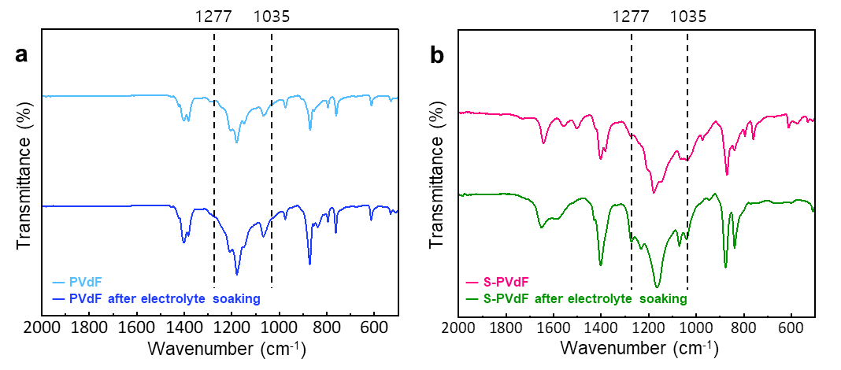
Fig. S5 FTIR spectra of binder before and after electrolyte soaking. a PVdF binders before and after electrolyte soaking. b S-PVdF binders before and after electrolyte soaking.

We have confirmed that the sulfonate groups in S-PVdF binders can provide abundant coordination sites with Zn²⁺ by Fourier transformation infrared spectrum (FTIR). After soaking in electrolyte for 24 h, the 1277 cm⁻¹ symmetric O=S=O peak shifts to a wave number (1271 cm⁻¹) in S-PVdF binders, which suggests that the Zn²⁺ ions interact with sulfonate groups [1].

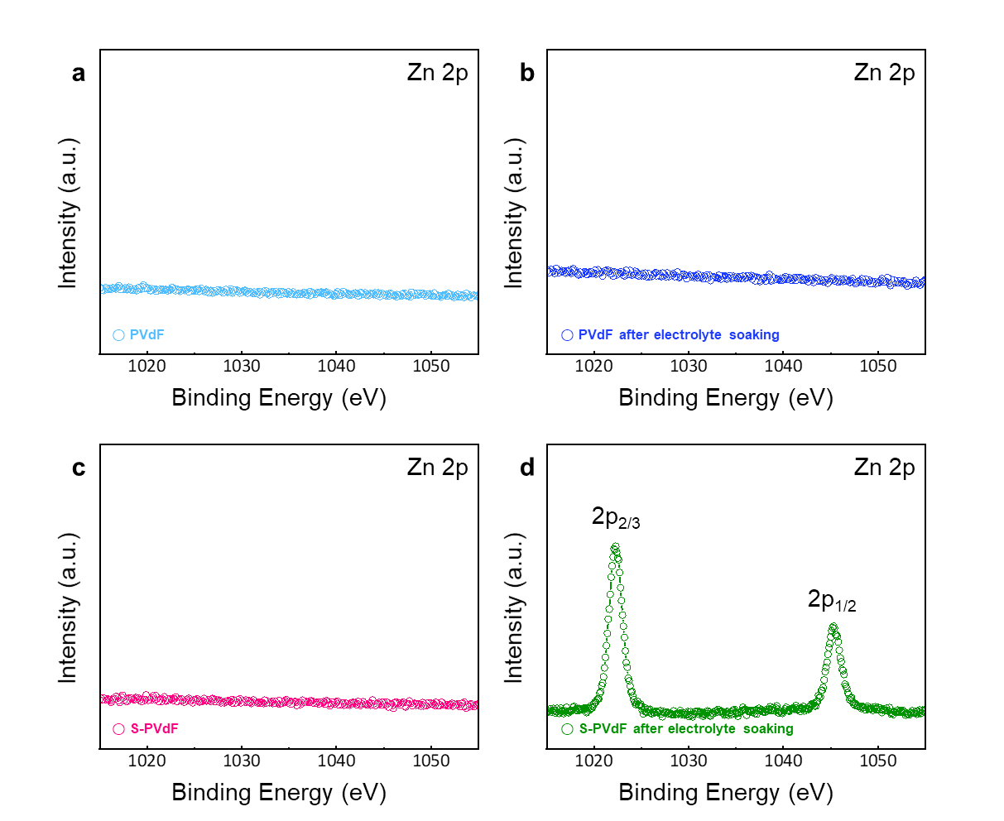
Fig. S6 XPS spectrum of Zn 2p in PVdF binders a before and b after electrolyte soaking. XPS spectrum of Zn 2p in S-PVdF binders c before and d after electrolyte soaking.

We also measured the binding energy of PVDF and S-PVDF to zinc ions via X-ray photoelectron spectroscopy (XPS). As can be seen in Fig. S6, XPS analysis exhibits the characteristic binding energies of Zn 2p_{3/2} and Zn 2p_{1/2} of 1022.3 and 1045.4 eV in S-PVdF [2].

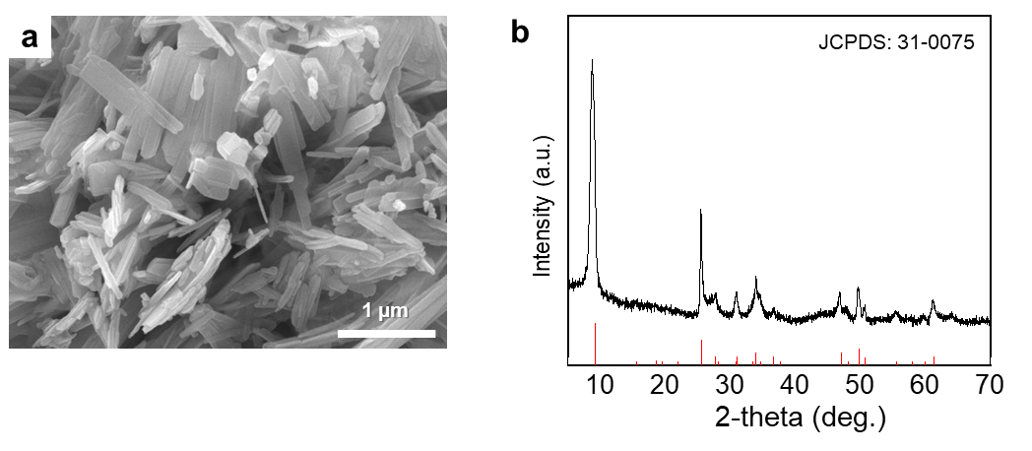
Fig. S7 a SEM image and b XRD pattern of NH₄V₄O₁₀ (NHVO).

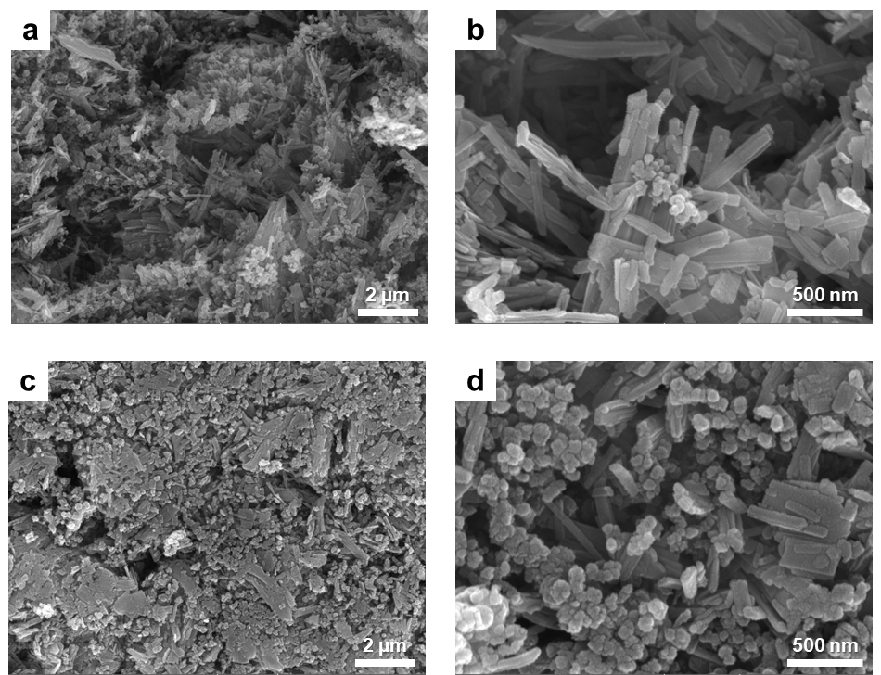

Fig. S8 Cross-sectional SEM image of a cathode with a S-PVdF binders and b its magnification. Cross-sectional SEM image of a cathode with c S-PVdF binders and d its magnification after the calendering process.

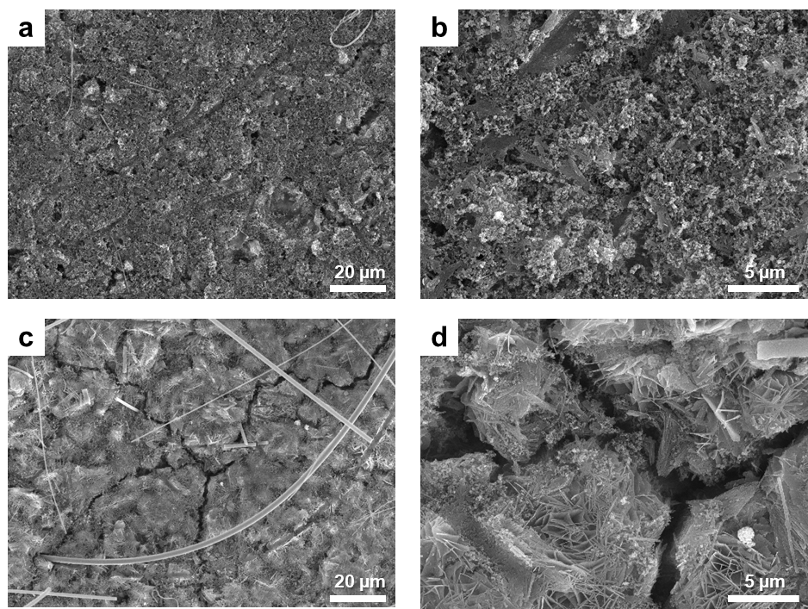
Fig. S9 a SEM images of cathodes with S-PVdF binders and b its magnification. SEM images of cathodes with c PVdF binders and d its magnification.

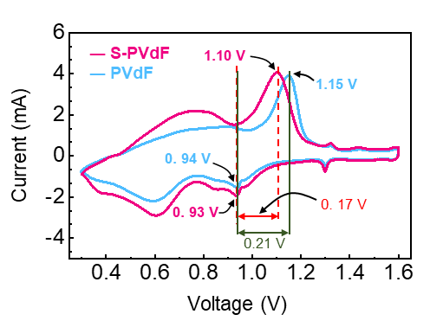
Fig. S10 CV profiles of full cells with S-PVdF and PVdF binders at 0.2 mV s⁻¹.

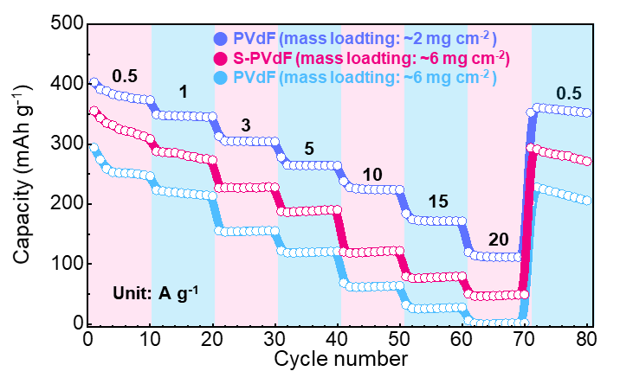
Fig. S11 Rate capability of cathodes with different binders.

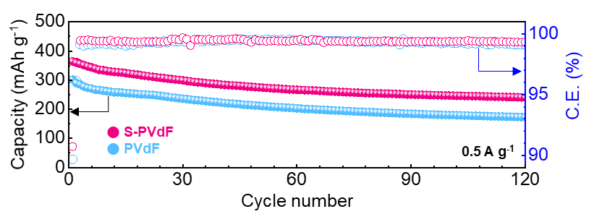
Fig. S12 Cycling performances of full cells with different binders at a low current density of 0.5 A g⁻¹ (~0.1 C).

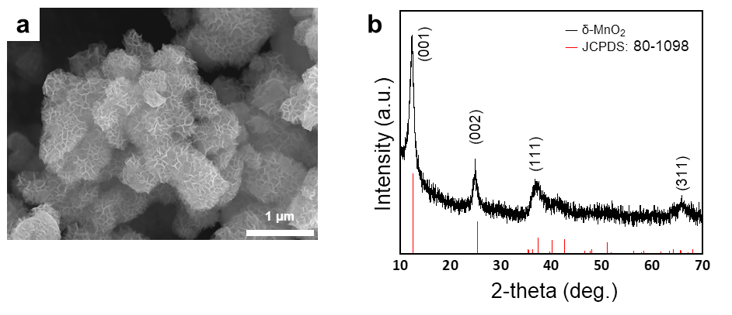
Fig. S13 a SEM image and b XRD pattern of δ-MnO₂.

To prove the universality of the binder, δ-MnO₂ was prepared. First, 1.2g of KMnO₄ and 0.215 g of MnSO₄ were dissolved in 130 ml DIW. Then, the solution was put into a Teflon-contained autoclave and heated at 160 °C for 12 h. After cooling and centrifugation, the product was rinsed with DIW several times. Finally, δ-MnO₂ was obtained after drying in a convection oven at 80 °C for 12 h. Next, the δ-MnO₂ was cast on stainless (SUS) foil and composed of three components: active material, conductive materials, and binders in the weight ratio of 7:2:1. Denka black was selected as the conductive material. Slurries containing the three components in N-methyl-2-pyrrolidone (NMP) were cast onto SUS foil (20 µm thick) via the doctor blading method, followed by a drying step at 80 °C for 12 h under vacuum. The active mass loadings for the cathode materials were ~ 3 mg cm⁻². The full cell with S-PVdF binders showed a higher reversible capacity (282 mAh g⁻¹) than those with PVdF binders (237 mAh g⁻¹) at the same mass loading of 3 mg cm⁻²) at a current density of 0.2 A g⁻¹. Moreover, the full cell with S-PVdF showed higher reversible capacities in the cycle test. More importantly, it retained a highly improved capacity of ~ 185 mAh g⁻¹ with a durable capacity retention of 66% after 200 cycles at 0.2 A g⁻¹. On the other hand, only a 20% capacity (49 mAh g⁻¹) was obtained in the full cell with PVdF binders after the cycle test.
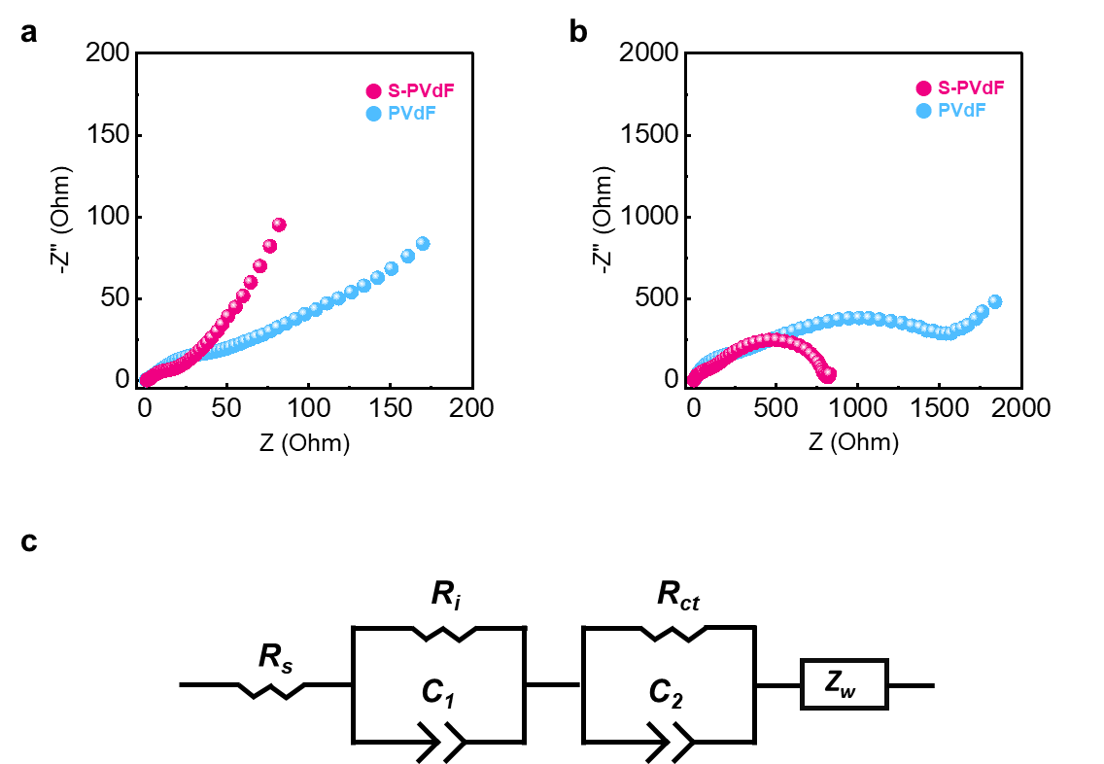
Fig. S14 EIS spectra of a before and b after long-term cycling (3000 cycles at 10 A g⁻¹). c Corresponding equivalent circuit. R_{i} and R_{s} are the ohmic resistance of solution and electrodes. R_{ct} is the charge-transfer resistance. C₁ and C₂ are the constant phase element of the double-layer capacitance, respectively. Zw is the Warburg impedance.

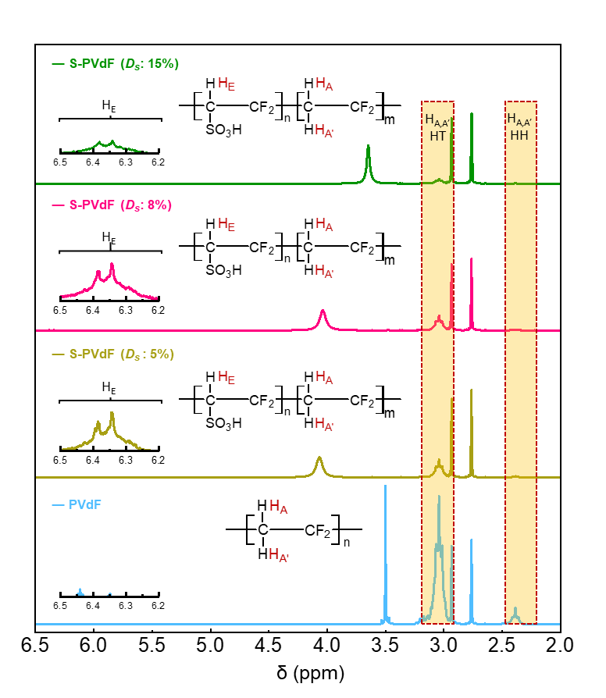
Fig. S15 ¹H NMR spectra of binders with different sulfonation degrees.

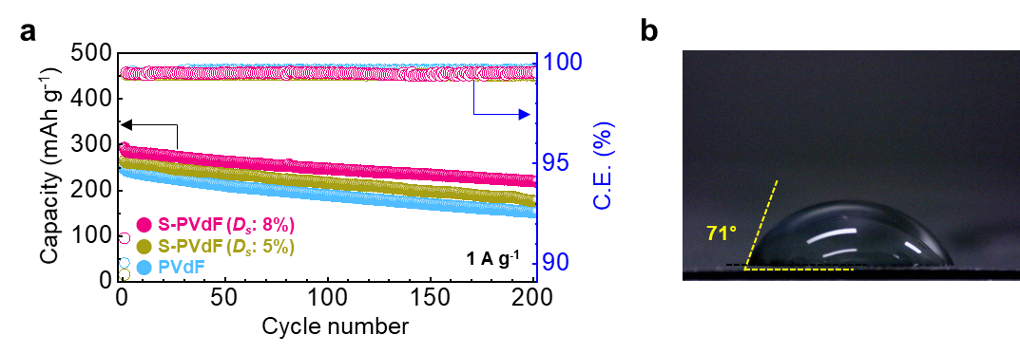
Fig. S16 a Galvanostatic cycling performances of cathodes with different binders at a current density of 1 A g⁻¹. b Contact angle of the cathode with S-PVdF binder (low sulfonation degree of 5%).

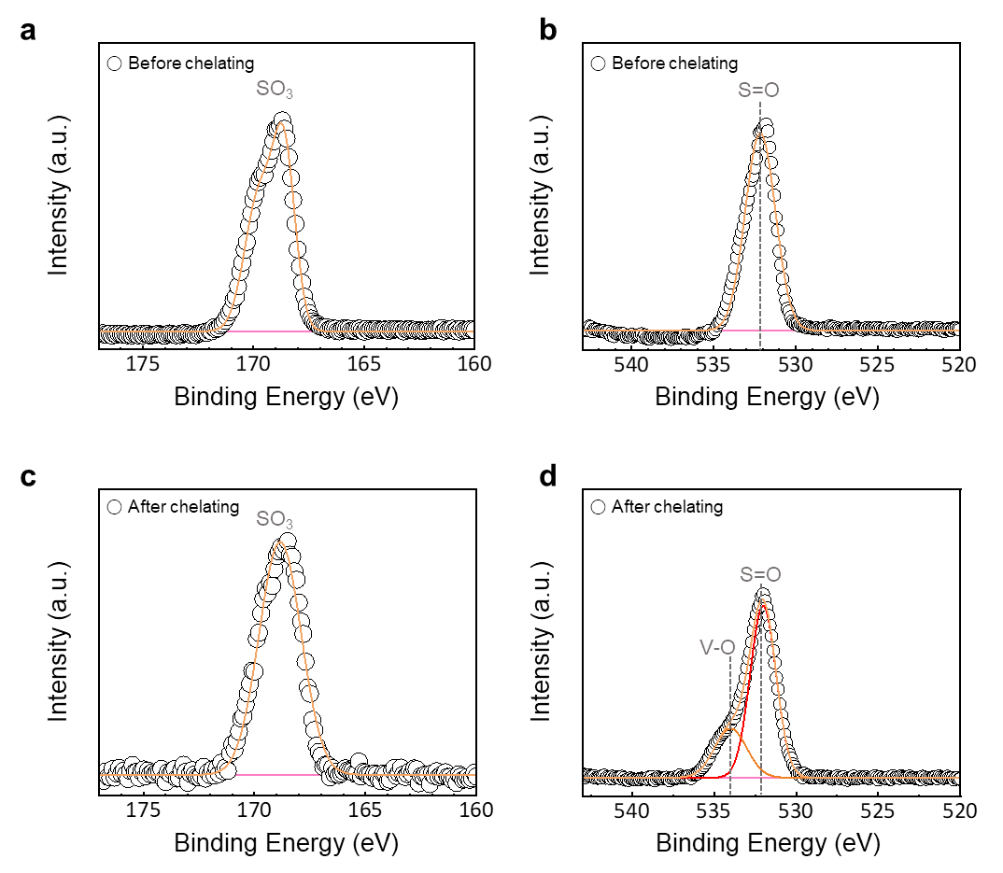
Fig. S17 High-resolution XPS spectra of S-PVdF films before and after being immersed into cathode-dissolved electrolytes. a S2p and b O1s spectra peaks of immersed S-PVdF film before being immersed into cathode-dissolved electrolytes. c S2p and d O1s spectra peaks S-PVdF film after being into cathode-dissolved electrolytes.

To clarify the suppression of vanadium dissolution of vanadium-based active materials, we prepared cathode-dissolved electrolyte. First, 0.1 g of the vanadium-based active materials (NH₄V₄O₁₀) were immersed into 10 ml of 2 M ZnSO₄ aqueous electrolytes. Then, the solution was kept in an oven for 24 h at 70 °C and puriﬁed via ﬁltration by 0.45 µm syringe ﬁlter. S-PVdF films for measuring ionic conductivities were also used here. The films were immersed into the yellowish cathode-dissolved electrolyte for 24 h at room temperature. Then, the films were rinsed with DIW and ethanol several times. Finally, the films were dried in a convection oven at 80 °C for 12 h.

Supplementary References
[S1] H. Fan, M. Wang, Y. Yin, Q. Liu, B. Tang, et al., Tailoring interfacial Zn²⁺ coordination via a robust cation conductive film enables high performance zinc metal battery. Energy Storage Materials. 49(380-389 (2022).
https://doi.org/https://doi.org/10.1016/j.ensm.2022.04.031
[S2] Y. Yang, C. Liu, Z. Lv, H. Yang, Y. Zhang, et al., Synergistic manipulation of Zn2+ ion flux and desolvation effect enabled by anodic growth of a 3d ZnF2 matrix for long-lifespan and dendrite-free zn metal anodes. Advanced Materials. 33(11), 2007388 (2021).
https://doi.org/https://doi.org/10.1002/adma.202007388

