Supporting Information for

Surface Patterning of Metal Zinc Electrode with an In-Region Zincophilic Interface for High-Rate and Long-Cycle-Life Zinc Metal Anode
Tian Wang¹, Qiao Xi², Kai Yao³, Yuhang Liu², Hao Fu⁴, Venkata Siva Kavarthapu¹, Jun Kyu Lee¹, Shaocong Tang¹, Dina Fattakhova-Rohlfing³, Wei Ai^{2,} *, Jae Su Yu^{1,} *
¹ Department of Electronics and Information Convergence Engineering, Institute for Wearable Convergence Electronics, Kyung Hee University, Yongin-si, Gyeonggi-do 17104, Republic of Korea
² Frontiers Science Center for Flexible Electronics (FSCFE) and Shaanxi Institute of Flexible Electronics (SIFE), Northwestern Polytechnical University (NPU), 127 West Youyi Road, Xi'an 710072, People’s Republic of China
³ Institute of Energy and Climate Research: Materials Synthesis and Processing (IEK-1), Forschungszentrum Jülich GmbH, 52425 Jülich, Germany
⁴ School of Chemical Engineering, Sungkyunkwan University, 2066 Seobu-ro, Jangan-gu, Suwon-si, Gyeonggi-do, Republic of Korea
*Corresponding author. E-mail: iamwai@nwpu.edu.cn (W. Ai), jsyu@khu.ac.kr (J. S. Yu)
Supplementary Figures and Table

Fig. S1 SEM images of the a, b stainless steel meshes and c In powder. d XRD patterns of the In powder
Fig. S2 Optical microscopic images of a the Zn electrodes after the rolling process and b the pristine ZnIn electrode
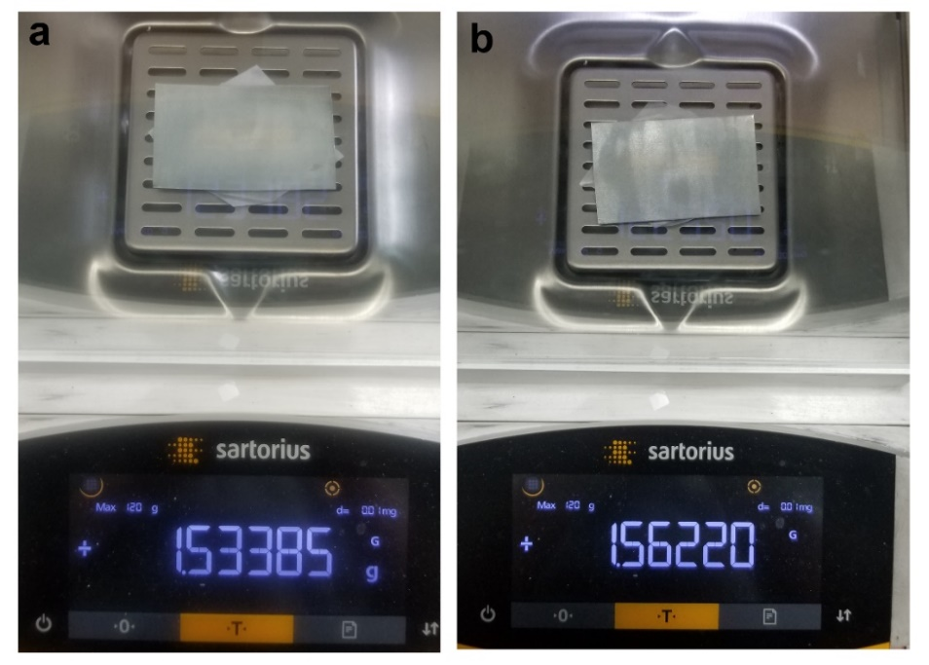
Fig. S3 Optical photographic images of the P-Zn electrode a before and b after In powder modification
Fig. S4 Optical microscopic images of the Zn deposits on the ZnIn electrode with the areal capacities of a 0 mAh cm⁻², b 3.0 mAh cm⁻², c 5.0 mAh cm⁻², and d 10.0 mAh cm⁻²

Fig. S5 In situ optical microscopic images of the Zn deposition on the P-Zn electrode. Scale bar: 100 μm

Fig. S6 a SEM image and b optical microscopic image of the Zn deposits on the ZnIn electrode with the areal capacity of 15.0 mAh cm⁻²

Fig. S7 a, b SEM images of Zn deposits on the pristine Zn electrode with the current density of 1.0 mA cm⁻² for 5 h
Fig. S8 a XPS full survey scan spectra and high-resolution core-level spectra of b Zn 2p and c In 3d for the pristine ZnIn electrode and the ZnIn electrode after Zn metal deposition

Fig. S9 Contact angles of the a pristine Zn, b P-Zn and c P-Zn electrode with the capacities of 3.0 mAh cm⁻², and d pristine ZnIn electrodes and the ZnIn electrode with the capacities of e 3.0 and f 5.0 mAh cm⁻²

Fig. S10 Simulation results of a the current density and b the Zn ion concentration distribution on the pristine Zn electrode surface
Fig. S11 2D view of the evolution process of a-c the current density and d-f the Zn ion concentration distribution on the ZnIn electrode surface

Fig. S12 a 3D view of the evolution process of the current density on the ZnIn electrode surface and b its corresponding 2D view

Fig. S13 a 3D view of the evolution process of the Zn ion concentration on the ZnIn electrode surface and b its corresponding 2D view
Fig. S14 Slice of the electron density difference map of the Zn atom on the In (002) and Zn (002) planes, respectively

Fig. S15 Nyquist plots of the a Zn and b ZnIn symmetric batteries before and after polarization test and the corresponding current-time curves of the c Zn and d ZnIn symmetric cells under the constant voltage polarization of 5 mV.

The Zn ions transference number was obtained by the Evans’ method [S1, S2]:
$$t_{{Zn}^{2+}}=\frac{I_{S}\left(∆V-I_{0}R_{0}\right)}{I_{0}(∆V-I_{S}R_{S})}$$
where I₀ and I_{s} are the currents of the initial and steady state, respectively and R_{s} and R_{s} represent the corresponding resistances, respectively. The ΔV means the applied voltage polarization.

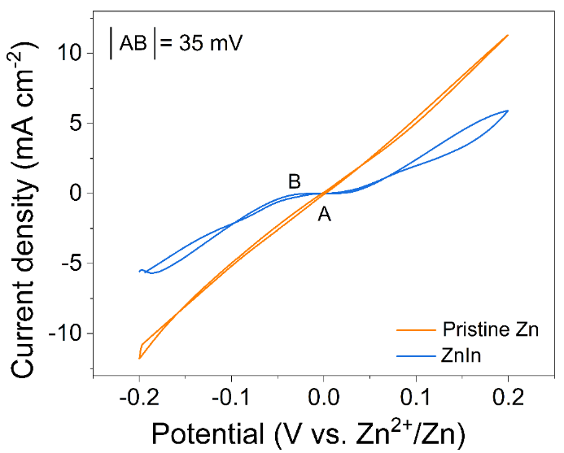
Fig. S16 CV curves of Zn plating/stripping on pristine Zn and ZnIn electrodes

Fig. S17 EIS curves of the a pristine Zn and b ZnIn electrodes at different temperatures. c Corresponding desolvation activation energy values of the differnet electrodes

Fig. S18 Optical microscopic images of the a pristine Zn and b P-Zn, and c, d ZnIn electrodes after cycling 100 h at the current density of 1.0 mA cm⁻² with the area capacity of 1.0 mA cm⁻²

Fig. S19 Band contrast image and its corresponding EBSD mapping of the ZnIn electrode a, b before and c, d after cycling 100 h

Fig. S20 Mulliken charge distributions of the Zn atom on the a In (002), b In (110), c Zn (002), and d Zn (100) planes, respectively

Fig. S21 Voltage profiles of Zn deposition on the pristine Zn and ZnIn electrodes at a 0.5 mA cm⁻², b 1.0 mA cm⁻², and c 2.0 mA cm⁻²
Fig. S22 Voltage profiles of pristine Zn, P-Zn, and ZnIn symmetric cells with plating/strapping conditions of a 1.0 mA cm⁻² and 1.0 mAh cm⁻² and c 2.0 mA cm⁻² and 2.0 mAh cm⁻². b, d Their corresponding magnified curves at specific time in a, c, respectively

Fig. S23 Voltage profiles of the pristine Zn and P-Zn symmetric cells with plating/strapping conditions of 10.0 mA cm⁻² and 1.0 mAh cm⁻²
Fig. S24 Coulombic efficiency of the Zn plating/stripping on Ti foil at a 1.0 mA cm⁻² and 1.0 mAh cm⁻² and b 10.0 mA cm⁻² and 1.0 mAh cm⁻². c-e Plating and stripping voltage profiles of Zn//Ti cell at 10.0 mA cm⁻² and 1.0 mAh cm⁻²

Fig. S25 Voltammetry of the pristine Zn and ZnIn symmetric cells at a scan rate of 1.0 mV s⁻¹

Fig. S26 a Voltage profiles of the pristine Zn and ZnIn symmetric cells with plating/strapping conditions of 40.0 mA cm⁻² and 1.0 mAh cm⁻² and b, c magnified voltage-time curves at different times

Fig. S27 Magnified voltage-time curves at different times in Fig. 4c

Fig. S28 a Voltage profiles of the pristine Zn and ZnIn symmetric cells with plating/strapping conditions of 2.0 mA cm⁻² and 10.0 mAh cm⁻² and b, c magnified voltage-time curves at different times
Fig. S29 a Voltage profiles of the pristine Zn and ZnIn symmetric cells with plating/strapping conditions of 10.0 mA cm⁻² and 10.0 mAh cm⁻² and b, c magnified voltage-time curves at different times
Fig. S30 Comparison of a the voltage polarization from rate performance and b the cumulative capacity of the pristine Zn and ZnIn symmetric cells at various working conditions

Table S1 Performance comparison of different modification strategies for Zn anode.
Materials | Method/Mechanism | Current density  (mA cm⁻²) | Areal  capacity  (mAh cm⁻²) | Time (h) | Refs.
Hydroxyl-rich  silica ion sieve | Separator modification | 1.0 | 1.0 | 3400 | [S3]
Hydroxyl-rich  silica ion sieve | Separator modification | 10.0 | 1.0 | 2550 | [S3]
TiN | Protective  coating layer | 0.5 | 0.5 | 2800 | [S4]
TiN | Protective  coating layer | 1.0 | 1.0 | 2300 | [S4]
TiN | Protective  coating layer | 2.0 | 2.0 | 1050 | [S4]
3D porous Ti | Nanoporous host | 1.0 | 1.0 | 2000 | [S5]
3D porous Ti | Nanoporous host | 10.0 | 0.5 | 500 | [S5]
3D intertwined  bacterial cellulose | In situ  self-assembly | 0.5 | 0.25 | 3000 | [S6]
3D intertwined  bacterial cellulose | In situ  self-assembly | 5.0 | 2.5 | 570 | [S6]
3D intertwined  bacterial cellulose | In situ  self-assembly | 5.0 | 5.0 | 300 | [S6]
Zinc phosphate | Hydrothermal reaction | 1.0 | 1.0 | 469 | [S7]
Zinc phosphate | Hydrothermal reaction | 5.0 | 1.0 | 1976 | [S7]
Zinc phosphate | Hydrothermal reaction | 10.0 | 1.0 | 500 | [S7]
Sulfonate-rich | Ion-exchange layer | 1.0 | 1.0 | 600 | [S8]
Sulfonate-rich | Ion-exchange layer | 2.0 | 2.0 | 230 | [S8]
Cross-linked  gelatin | Artificial interface layer | 1.0 | 1.0 | 4000 | [S9]
Cross-linked  gelatin | Artificial interface layer | 2.0 | 2.0 | 200 | [S9]
Betaine | Electrolyte additive | 0.5 | 0.5 | 4200 | [S10]
Betaine | Electrolyte additive | 2.0 | 2.0 | 830 | [S10]
Carbonyl-containing  Layer | Ion redistributor  and functional protective interphase | 1.0 | 0.25 | 5000 | [S11]
Carbonyl-containing  Layer | Ion redistributor  and functional protective interphase | 4.0 | 1.0 | 2100 | [S11]
Carbonyl-containing  Layer | Ion redistributor  and functional protective interphase | 10.0 | 2.5 | 820 | [S11]
ZnO/C  nanoparticles | Host | 10.0 | 1.0 | 400 | [S12]
ZnO/C  nanoparticles | Host | 20.0 | 1.0 | 150 | [S12]
Bi | Termodynamics inertia and kinetics zincophilia | 2.0 | 1.0 | 1700 | [S13]
Bi | Termodynamics inertia and kinetics zincophilia | 5.0 | 2.0 | 1500 | [S13]
Bi | Termodynamics inertia and kinetics zincophilia | 10.0 | 1.0 | 2000 | [S13]
Bi | Termodynamics inertia and kinetics zincophilia | 10.0 | 5.0 | 310 | [S13]
C/Cu nanocomposite decoration layer | Functional ultrathin separators | 1.0 | 0.5 | 2000 | [S14]
C/Cu nanocomposite decoration layer | Functional ultrathin separators | 5.0 | 2.5 | 650 | [S14]
C/Cu nanocomposite decoration layer | Functional ultrathin separators | 10.0 | 2.0 | 600 | [S14]
Zn(NO₃)₂ 6H₂O and (NH₄)₂HPO₄ | Conversion  coating | 5.0 | 1.25 | 2000 | [S15]
Zn(NO₃)₂ 6H₂O and (NH₄)₂HPO₄ | Conversion  coating | 20.0 | 5.0 | 470 | [S15]
Graphdiyne | Atomic electrode | 10.0 | 1.0 | 3200 | [S16]
Graphdiyne | Atomic electrode | 30.0 | 1.0 | 250 | [S16]
Metal-organic  complex interphase | In situ complexing of metal-phytic acid | 0.5 | 0.25 | 2000 | [S17]
Metal-organic  complex interphase | In situ complexing of metal-phytic acid | 5.0 | 2.5 | 1750 | [S17]
Lanthanum nitrate | Electrolyte additive | 1.0 | 1.0 | 1200 | [S18]
Lanthanum nitrate | Electrolyte additive | 10.0 | 5.93 | 160 | [S18]
Zn anode with 0.3 mAh cm⁻² perdeposited layer | Stable zinc metal electrode surface morphologies | 5.0 | 1.0 | 1000 | [S19]
Zn anode with 0.3 mAh cm⁻² perdeposited layer | Stable zinc metal electrode surface morphologies | 7.5 | 1.0 | 700 | [S19]
Zn anode with 0.3 mAh cm⁻² perdeposited layer | Stable zinc metal electrode surface morphologies | 10.0 | 1.0 | 500 | [S19]
Poled ferroelectric coating layer | Deconcentrate and  self-accelerate ion migration | 1.0 | 1.0 | 4000 | [S20]
Poled ferroelectric coating layer | Deconcentrate and  self-accelerate ion migration | 10..0 | 2.0 | 1250 | [S20]
Poled ferroelectric coating layer | Deconcentrate and  self-accelerate ion migration | 20.0 | 2.0 | 625 | [S20]
Poled ferroelectric coating layer | Deconcentrate and  self-accelerate ion migration | 40.0 | 2.0 | 225 | [S20]
Hexamethylenetetramine | Electrolyte additive | 5.0 | 1.0 | 4000 | [S21]
Hexamethylenetetramine | Electrolyte additive | 5.0 | 5.0 | 590 | [S21]
Yolk-shell  microspheres film | Artificial interface layer | 1.0 | 0.5 | 3800 | [S22]
Yolk-shell  microspheres film | Artificial interface layer | 10.0 | 1.0 | 4000
ZnIn anode | Surface patterning and zincphilic interface design | 1.0 | 1.0 | 1020 | This work
ZnIn anode | Surface patterning and zincphilic interface design | 2.0 | 2.0 | 1200 | This work
ZnIn anode | Surface patterning and zincphilic interface design | 10.0 | 1.0 | 5050 | This work
ZnIn anode | Surface patterning and zincphilic interface design | 20.0 | 1.0 | 2700 | This work
ZnIn anode | Surface patterning and zincphilic interface design | 20.0 | 5.0 | 850 | This work
ZnIn anode | Surface patterning and zincphilic interface design | 40.0 | 1.0 | 400 | This work

Fig. S31 Photographic images of the obtained CFs host at a folding, b bending, and c twisting states. d SEM and e, f TEM images of the CFs

Fig. S32 a Cross-sectional SEM image of the CFs. b TEM image and the corresponding EDS mapping images of the I₂-CFs electrode

Fig. S33 a Charge/discharge profiles of the Zn//I₂-CFs full cell at the current density of 0.5 C and b their corresponding dQ/dV curves

Fig. S34 Charge/discharge profiles of a the Zn//I₂-CFs and b ZnIn//I₂-CFs full cells at the current density of 5.0 C

Fig. S35 a Open circuit voltage, b two cells connected in series, and c, d flexibility testing of the quasi-solid-state ZnIn//I₂-CFs pouch cell

Fig. S36 Optical photographic images of the quasi-solid state ZnIn//I₂-CFs pouch cell powering a LED under different temperature conditions

Supplementary References
[S1] Evans, J., Vincent, C. A. & Bruce, P. G. Electrochemical measurement of transference numbers in polymer electrolytes. Polymer 28, 2324-2328 (1987). https://doi.org/10.1016/0032-3861(87)90394-6
[S2] X. Yang, W. Li, Z. Chen, M. Tian, J. Peng et al., Synchronous dual electrolyte additive sustains Zn metal anode with 5600 h lifespan. Angew. Chem. Int. Ed. 135, 202218454 (2023). https://doi.org/10.1002/ange.202218454
[S3] H. Gan, J. Wu, F. Zhang, R. Li, H. Liu, Uniform Zn2+ distribution and deposition regulated by ultrathin hydroxyl-rich silica ion sieve in zinc metal anodes. Energy Stor. Mater. 55, 264-271 (2023). https://doi.org/10.1016/j.ensm.2022.11.044
[S4] J. Zheng, Z. Cao, F. Ming, H. Liang, Z. Qi et al., Preferred orientation of TiN coatings enables stable zinc anodes. ACS Energy Lett. 7, 197-203 (2021). https://doi.org/10.1021/acsenergylett.1c02299
[S5] Y. An, Y. Tian, S. Xiong, J. Feng, Y. Qian, Scalable and controllable synthesis of interface-engineered nanoporous host for dendrite-free and high rate zinc metal batteries. ACS Nano 15, 11828-11842 (2021). https://doi.org/10.1021/acsnano.1c02928
[S6] S. Jiao, J. Fu, M. Wu, T. Hua, H. Hu, Tailoring Zn²⁺ desolvation kinetics and flux toward dendrite-free metallic zinc anodes. ACS Nano 16, 1013-1024 (2021). https://doi.org/10.1021/acsnano.1c08638
[S7] S. Zhang, M. Ye, Y. Zhang, Y. Tang, X. Liu et al., Regulation of ionic distribution and desolvation activation energy enabled by in situ zinc phosphate protective layer toward highly reversible zinc metal anodes. Adv. Funct. Mater. 33, 2208230 (2023). https://doi.org/10.1002/adfm.202208230
[S8] L. Zhang, J. Huang, H. Guo, L. Ge, Z. Tian et al., Tuning ion transport at the anode-electrolyte interface via a sulfonate-rich ion-exchange layer for durable zinc-iodine batteries. Adv. Energy Mater. 13, 2203790 (2023). https://doi.org/10.1002/aenm.202203790
[S9] J. Shin, J. Lee, Y. Kim, Y. Park, M. Kim et al., Grain-directed zinc deposition in aqueous zinc ion batteries. Adv. Energy Mater. 11, 2100676 (2021). https://doi.org/10.1002/aenm.202100676
[S10] H. Ren, S. Li, B. Wang, Y. Zhang, T. Wang et al., Molecular-crowding effect mimicking cold-resistant plants to stabilize the zinc anode with wider service temperature range. Adv. Mater. 35, 2208237 (2023). https://doi.org/10.1002/adma.202208237
[S11] P. Wang, S. Liang, C. Chen, X. Xie, J. Chen et al., Spontaneous construction of nucleophilic carbonyl-containing interphase towards ultra-stable zinc metal anodes. Adv. Mater. 34, 2202733 (2022). https://doi.org/10.1002/adma.202202733
[S12] P. Xue, C. Guo, L. Li, H. Li, D. Luo et al., A MOF-derivative decorated hierarchical porous host enabling ultrahigh rates and superior long-term cycling of dendrite-free Zn metal anodes. Adv. Mater. 34, 2110047 (2022). https://doi.org/10.1002/adma.202110047
[S13] R. Zhao, X. Dong, P. Liang, H. Li, T. Zhang et al., Prioritizing hetero-metallic interfaces via thermodynamics inertia and kinetics zincophilia metrics for tough Zn-based aqueous batteries. Adv. Mater. 35, 2209288 (2023). https://doi.org/10.1002/adma.202209288
[S14] Y. Li, X. Peng, X. Li, H. Duan, S. Xie et al., Functional ultrathin separators proactively stabilizing zinc anodes for zinc-based energy storage. Adv. Mater. 35, 2300019 (2023). https://doi.org/10.1002/adma.202300019
[S15] Z. Xing, Y. Sun, X. Xie, Y. Tang, G. Xu et al., Zincophilic electrode interphase with appended proton reservoir ability stabilizes Zn metal anodes. Angew. Chem. Int. Ed. 135, 202215324 (2023). https://doi.org/10.1002/anie.202215324
[S16] X. Luan, L. Qi, Z. Zheng, Y. Gao, Y. Xue et al., Step by step induced growth of zinc-metal interface on graphdiyne for aqueous zinc-ion batteries. Angew. Chem., Int. Ed. 2023, 62, 202215968 (2023). https://doi.org/10.1002/anie.202215968
[S17] H. Liu, J. Wang, W. Hua, L. Ren, H. Sun et al., Navigating fast and uniform zinc deposition via a versatile metal-organic complex interphase. Energy Environ. Sci. 15, 1872-1881 (2022). https://doi.org/10.1039/d2ee00209d
[S18] R. Zhao, H. Wang, H. Du, Y. Yang, Z. Gao et al., Lanthanum nitrate as aqueous electrolyte additive for favourable zinc metal electrodeposition. Nat. Commun. 13, 3252 (2022). https://doi.org/10.1038/s41467-022-30939-8
[S19] Q. Li, A. Chen, D. Wang, Y. Zhao, X. Wang et al., Tailoring the metal electrode morphology via electrochemical protocol optimization for long-lasting aqueous zinc batteries. Nat. Commun. 13, 3699 (2022). https://doi.org/10.1038/s41467-022-31461-7
[S20] P. Zou, R. Zhang, L. Yao, J. Qin, K. Kisslinger, et al., Ultrahigh-rate and long-life zinc-metal anodes enabled by self-accelerated cation migration. Adv. Energy Mater. 11, 2100982 (2021). https://doi.org/10.1002/aenm.202100982
[S21] H. Yu, D. Chen, Q. Li, C. Yan, Z. Jiang et al., In situ construction of anode-molecule interface via lone-pair electrons in trace organic molecules additives to achieve stable zinc metal anodes. Adv. Energy Mater. 13, 20300550 (2023). https://doi.org/10.1002/aenm.202300550
[S22] Q. Hu, J. Hou, Y. Liu, L. Li, Q. Ran et al., Modulating zinc metal reversibility by confined antifluctuator film for durable and dendrite-free zinc ion batteries. Adv. Mater. 35, 2303336 (2023). https://doi.org/10.1002/adma.202303336

