Supporting Information for
Diamond-Like Carbon Depositing on the Surface of Polylactide Membrane for Prevention of Adhesion Formation during Tendon Repair
Yao Xiao^{1, #}, Zaijin Tao^{1, #}, Yufeng Ju^{2, #}, Xiaolu Huang³, Xinshu Zhang¹, Xiaonan Liu¹, Pavel А. Volotovski⁴, Chao Huang⁵, Hongqi Chen^{6,} *, Yaozhong Zhang^{7,} * and Shen Liu^{1,} *
¹Department of Orthopaedics, Shanghai Jiao Tong University School of Medicine Affiliated Sixth People’s Hospital, 600 Yishan Rd, Shanghai, 200233, P. R. China
² Shanghai Tongji Hospital, 389 Xincun Rd, Shanghai, 200065, P. R. China
³Key Laboratory for Thin Film and Microfabrication of Ministry of Education, Research Institute of Micro/Nano Science and Technology, Shanghai Jiao Tong University, Shanghai, 200240, P. R. China
⁴Orthopedic Trauma Department, Belarus Republic Scientific and Practical Center for Traumatology and Orthopedics, Kizhevatova str., 60/4, Minsk, 220024, Belarus
⁵Shanghai Haohai Biological Technology Limited Liability Company, 1386 Hongqiao Rd, Shanghai, 200336, P. R. China
⁶Department of General Surgery, Shanghai Jiao Tong University School of Medicine Affiliated Sixth People’s Hospital, 600 Yishan Rd, Shanghai, 200233, P. R. China
⁷Shanghai Key Laboratory for High Temperature Materials and Precision Forming, School of Materials Science and Engineering, Shanghai Jiao Tong University, Shanghai, 200240, P. R. China.
# Yao Xiao, Zaijin Tao, and Yufeng Ju contributed equally to this work.
*Corresponding authors. E-mail: liushensjtu@sjtu.edu.cn (Shen Liu); zhangragnar@sjtu.edu.cn (Yaozhong Zhang); hqchen08@163.com (Hongqi Chen)
Supplementary Figures and Table
Fig. S1 The scanning electron microscope image of PLA and PLA/DLC membrane. Content of MDA (a), 3-NT (b), and 8-OHdG (c) in H₂O₂-induced NIN/3T3 cells was examined by assay kit respectively
Fig. S2 The western bolt analysis of peritendinous tissues follow membrane implant for 7 days after tendon injury
Fig. S3 Live/dead staining of fibroblasts cultured on different membranes for 1 and 3 days
Fig. S4 Phalloidin staining for adhesion analysis of fibroblasts cultured on different membranes at days 1 and 3

Fig. S5 Flow cytometry results of macrophage M1 polarization
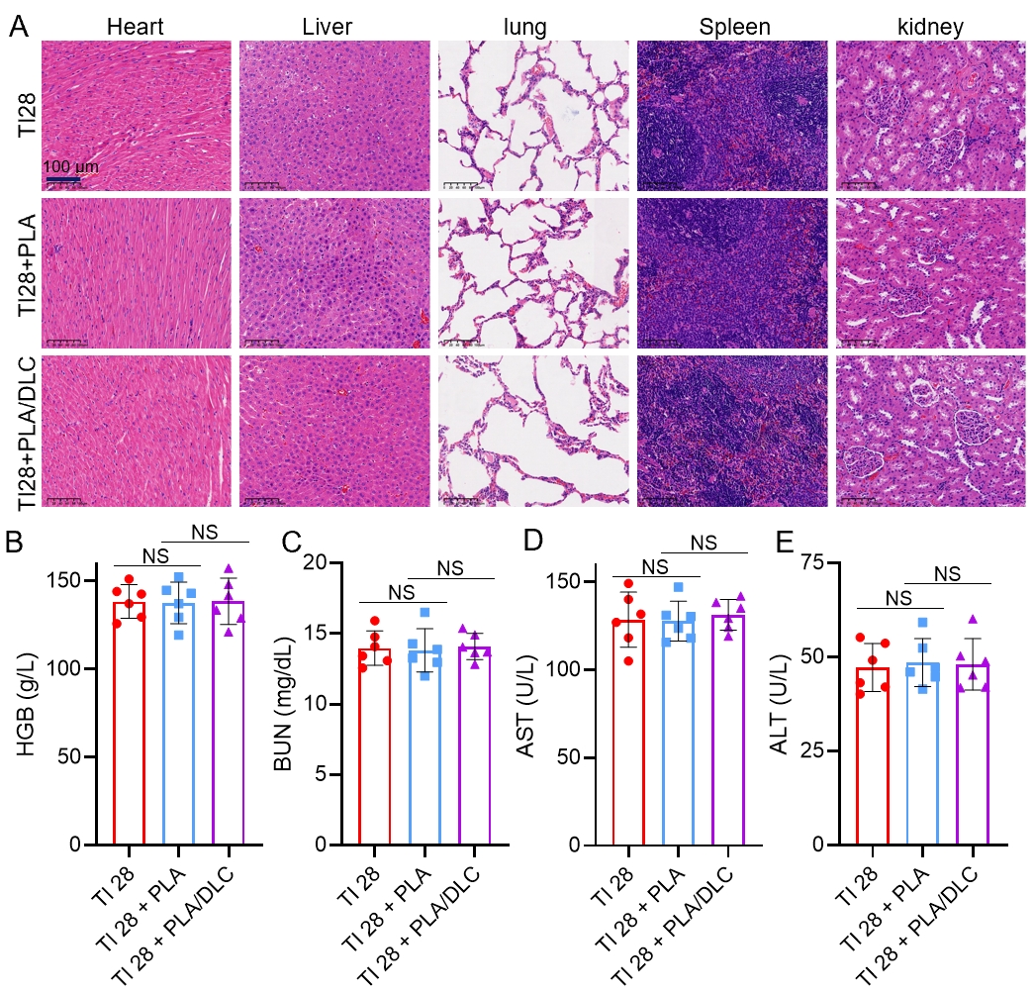
Fig. S6 Biocompatibility and biosafety evaluation. (a) H&E staining and (b-e) blood routine and biochemical analysis. Data represent independent experiments, and all data are presented as mean ± SD; NS: non-significant. HGB: haemoglobin. BUN: blood urea nitrogen. AST: aspartate aminotransferase. ALT: alanine aminotransferase

Fig. S7 The western bolt analysis of peritendinous tissues follow membrane implant for 14 days
Fig. S8 The lactic acid content in the peritendinous adhesion tissues following membrane implant for 14 days after tendon injury
Fig. S9 The TGF-β1 content in the peritendinous adhesion tissues following membrane implant for 14 days after tendon injury
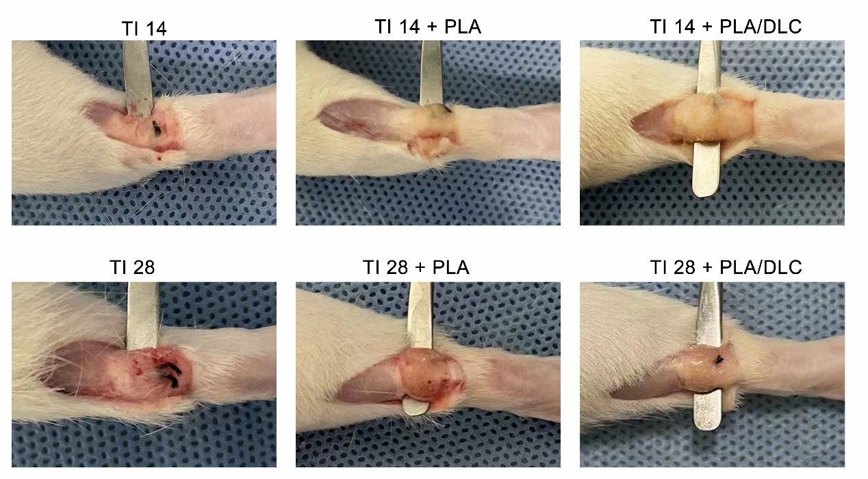
Fig. S10 The Gross observation of peritendinous tissues after tendon injury and membrane implantation for 14 and 28 days
Fig. S11 The gross evaluation standards for peritendinous adhesion. The adhesion scoring was classified into 5 grades: 1, no obvious adhesion at surgical site; 2, a little of adhesion tissue but can be bluntly separated; 3, less than 50% of the adhesion tissue that needed sharp separation; 4, about 51% - 97.5% of the adhesion tissue which needed sharp separation; 5, more than 97.5% severe adhesion tissue that required sharp separation
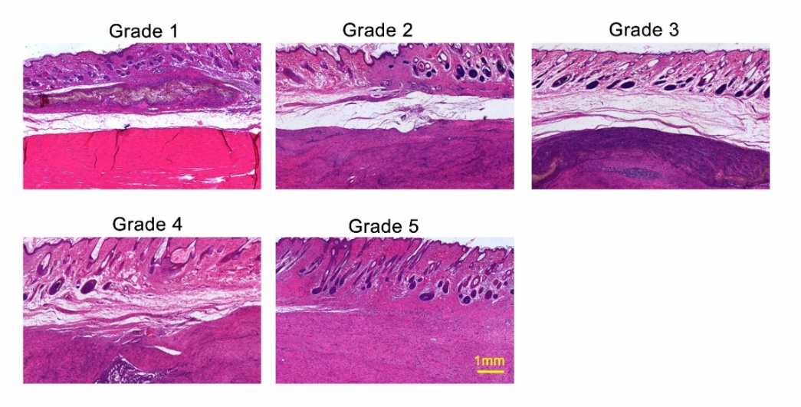
Fig. S12 The histological evaluation standards for peritendinous adhesion. Grade 1, no adhesions in the peritendinous area of the repaired site; Grade 2, adhesions possessing less than 25% in the peritendinous area of the repaired site; Grade 3, adhesions possessing 25%~50% in the peritendinous area of the repaired site; Grade 4, adhesions possessing 50%~75% in the peritendinous area of the repaired site; Grade 5, adhesions constituting more than 75% of the area of the repaired site
Fig. S13 The myofibroblast (α-SMA) in peritendinous adhesion tissue after tendon injury
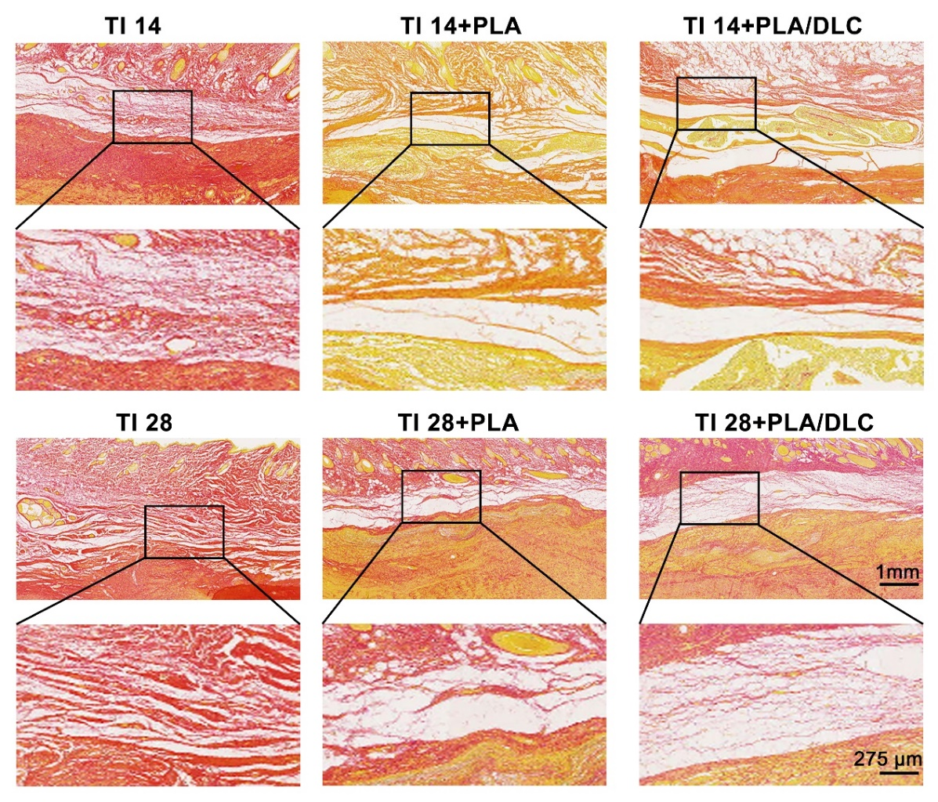
Fig. S14 The Sirius red staining and polarized light observation of peritendinous adhesion tissue after tendon injury

Fig. S15 Maximal tendon breaking strength and stiffness of repaired tendons were measured using a rheometer until the tendons were disrupted.
Table S1 Primer sequences for RT-PCR in this study
Gene | Forward Sequence (5’-3’) | Reverse Sequence (5’-3’)
Mouse Il-6 | AAGAAATGATGGATGCTACC | GAGTTTCTGTATCTCTCTGAAG
Mouse Tnf [1] | GGCACTCCCCCAAAAGATG | AGGAATGAGAAGAGGCTGAGACA
Supplementary Reference
- M. J. Charron, L. Williams, Y. Seki, X. Q. Du, B. Chaurasia, A. Saghatelian, S. A. Summers, E. B. Katz, P. M. Vuguin, S. E. Reznik. Antioxidant effects of n-acetylcysteine prevent programmed metabolic disease in mice. Diabetes. 69(8), 1650-1661 (2020). https://doi.org/10.2337/db19-1129

