Supporting Information for
TiO₂ Electron Transport Layer with p-n Homojunctions for Efficient and Stable Perovskite Solar Cells
Wenhao Zhao¹, Pengfei Guo^{1, 2, 4,}*, Jiahao Wu¹, Deyou Lin¹, Ning Jia¹, Zhiyu Fang¹, Chong Liu¹, Qian Ye¹, Jijun Zou³, Yuanyuan Zhou² and Hongqiang Wang^{1, 4,}*
¹State Key Laboratory of Solidification Processing, Center for Nano Energy Materials, School of Materials Science and Engineering, Northwestern Polytechnical University and Shaanxi Joint Laboratory of Graphene (NPU), Xi’an 710072, P. R. China
²Department of Chemical and Biological Engineering, Hong Kong University of Science and Technology, Clear Water Bay, Hong Kong SAR, P. R. China
³Key Laboratory for Green Chemical Technology of the Ministry of Education, School of Chemical Engineering and Technology, Tianjin University, Tianjin 300072, P. R. China
⁴Chongqing Innovation Center of Northwestern Polytechnical University, Northwestern Polytechnical University, Chongqing 401135, P. R. China
*Corresponding authors. E-mail: guopengfei@nwpu.edu.cn (Pengfei Guo); hongqiang.wang@nwpu.edu.cn (Hongqiang Wang)
Supplementary Figures
Fig. S1 Schematic illustration of laser process of Ti_{0.936}O₂ nanocrystals and their embedding in the ETLs
Fig. S2 SEM image of the raw Ti_{0.936}O₂ powders before laser irradiation
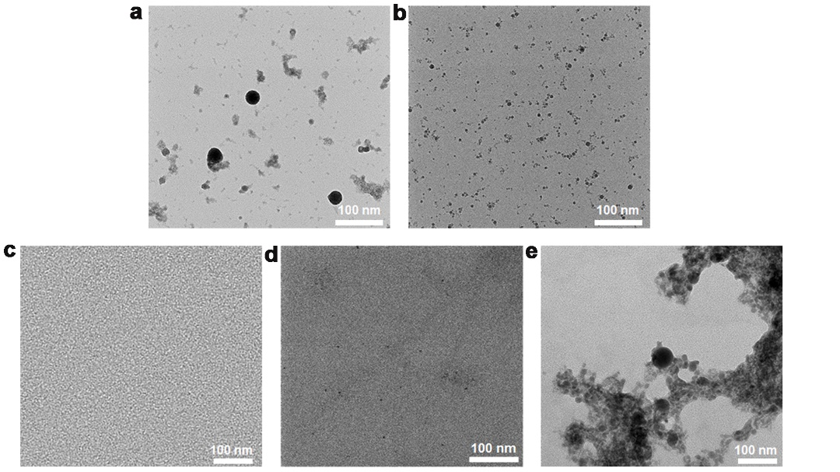
Fig. S3 TEM images of Ti_{0.936}O₂ nanoparticles with different size under various laser fluence of a 100, b 200 and c 400 mJ/pulse cm², respectively. TEM image of high concentration of Ti_{0.936}O₂ particles with d 0.05 and e 0.2 mg/ml
For optimization of laser fluence, Figure S3 shows TEM morphology and size evolution of Ti_{0.936}O₂ nanoparticles under different laser fluence. Normally, considering the employment of laser with the nanosecond pulse width, an increase in the laser fluence from 100 mJ/pulse cm² to 200 mJ/pulse cm², based on the “heat-melt-evaporation” mechanism induced by the laser in the liquid phase [S1], results in a decrease in the size of the spherical particles, as shown in Fig. S3a, b. When the laser fluence increases to 300 mJ/pulse cm², Ti_{0.936}O₂ nanocrystals with a particle size below 10 nm are obtained, as shown in Figure 1a. However, if the laser fluence is further increased to 400 mJ/pulse cm², it will be difficult to obtain Ti_{0.936}O₂ nanocrystals, which may be due to the strong photothermally induced evaporation effect under such conditions leading to the evaporation and further disappearance of Ti_{0.936}O₂ nanocrystals in liquid phase, as shown in Fig. S3c. Therefore, the laser fluence of 100~300 mJ/pulse cm² can be used to prepare different sizes of Ti_{0.936}O₂ nanoparticles, and the optimal laser fluence is 300 mJ/pulse cm².
We further explored the mechanism of the influence of target concentration on the preparation of monodisperse nanocrystals. The results shows that when the concentration of the original Ti_{0.936}O₂ particles was increased from 0.05 to 0.2 mg/ml, the laser prepared Ti_{0.936}O₂ nanoparticles would gradually change from a well-dispersed state to an agglomerated state, as shown in Fig. S3d, e. The introduction of such agglomerated Ti_{0.936}O₂ nanoparticles will keep them in the same agglomerated state in the film, which is not conducive to the preparation of smooth and flat films, and further leads to unsatisfactory interface contact and deterioration of the photoelectric performance of perovskite solar cells. Therefore, our optimal concentration of Ti_{0.936}O₂ for embedding of electron transport layer is 0.1 mg/ml.
Fig. S4 Raman spectroscopy of Ti_{0.936}O₂ with and without laser irradiation process. Raman spectroscopy of both nanoparticles and nanocrystals of Ti_{0.936}O₂ exhibits the same Raman bands at 143 cm⁻¹, 197 cm⁻¹, 397 cm⁻¹, 516 cm⁻¹, 519 cm⁻¹ (overlapping with 516 cm⁻¹) and 638 cm⁻¹. These peaks can be attributed to six Raman-active modes of anatase phase with the symmetries of E_{g}, E_{g}, B_{1g}, A_{1g}, B_{1g} and E_{g}, respectively [S2]
Fig. S5 HAADF and corresponding TEM-EDS images of different size of Ti_{0.936}O₂ nanoparticles
Fig. S6 XPS spectra of Ti_{0.936}O₂ nanocrystals. Ti 2p peaks at 458.5 eV and 464.4 eV, which are attributed to the chemical states of Ti 2p_{3/2} and Ti 2p_{1/2} of Ti⁴⁺, respectively. The O 1s peak at 529.8 eV belongs to the Ti⁴⁺-O bond, and the O 1s peak at 531.4 eV belongs to the Ti-OH bond [3], which strongly confirms that Ti and O elements exist stably in Ti_{0.936}O₂ nanocrystals, and the surface composition and chemical state of Ti_{0.936}O₂ do not change significantly after laser irradiation.
Fig. S7 Schematic illustration of embedding of Ti_{0.936}O₂ nanocrystals in the TiO₂ matrix
Fig. S8 SEM images (inset: AFM images) of a 3%-Target TiO₂ and b 9%-Target TiO₂ films
Fig. S9 Absorption spectra a of different TiO₂ films and corresponding Tauc plots b determining the optical bandgaps of TiO₂ films
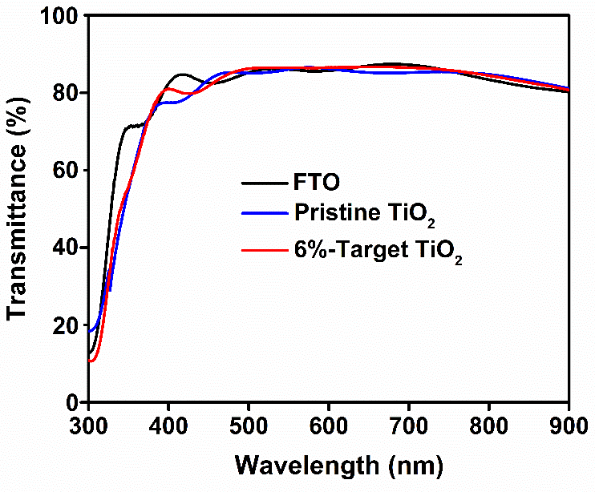
Fig. S10 Optical transmittance spectra of FTO and different TiO₂ films based on FTO
Table S1 The dark I-V plots of different devices show V_{TFL} (the onset voltage of the trap-filled limit region) kink point behavior, it could be extracted to determine the N_{t} of various ETLs. The N_{t} of different ETLs was evaluated using $N_{t}=\frac{2ε_{0}εV_{TFL}}{qL^{2}}$ formula, where${ ε}_{0}$is the vacuum permittivity, $ε$ is the relative dielectric constant, $V_{TFL}$ is the onset voltage of the trap-filled limit region, q is the elemental charge, and L is the thickness of the ETLs [S4]
ETLs | V_{TFL} (V) | N_{t} (cm⁻³)
Pristine TiO₂ | 1.87 | 6.48$×$10¹⁶
6%-Target TiO₂ | 0.40 | 1.39$×$10¹⁶
Fig. S11 Conduction properties of pristine TiO₂ and 6%-target TiO₂ films measured by a device structure of FTO/ETLs/Ag
Fig. S12 UPS spectra of different TiO₂ films
The Fermi level (E_{F}) is calculated by the equation: E_{F} = E_{cut-off} - 21.22 eV, where E_{cut-off} represents cut-off binding energy, 21.22 eV is the photon energy of excitation light. The E_{cut-off} values are extracted to be 16.68 and 17.53 eV for different TiO₂ layers. The E_{F} values were calculated to be -4.54 and -3.69 eV for the pristine TiO₂ and 6%-target TiO₂ layers, respectively. Then the valence band (E_{VB}) is calculated to be -7.42 and -7.34 eV for pristine TiO₂ and 6%-target TiO₂ layers by using the equation: E_{VB} = E_{F} - E_{F}, edge (Fermi edge). The band gap (E_{g}) values of TiO₂ are obtained from the absorption spectrum and corresponding Tauc plot, showing negligible change of E_{g} from 3.20 and 3.22 eV for different TiO₂ layers. Then the calculated conduction bands (E_{CB}) calculated by E_{g} and E_{VB} are -4.22 and -4.12 eV for different TiO₂ layers, respectively.
Fig. S13 AFM images of CsFAMA perovskite based on a the pristine TiO₂ and b 6%-target TiO₂ layers
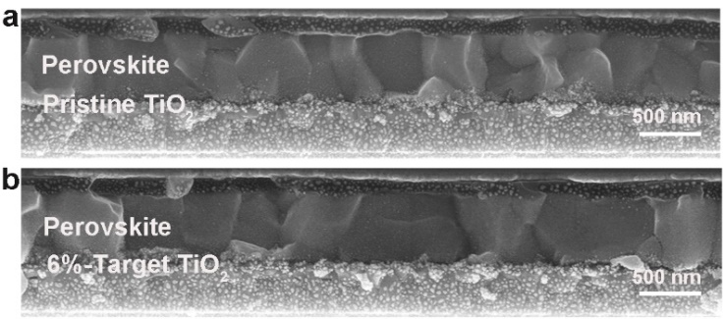
Fig. S14 Cross-sectional SEM images of different devices
Fig. S15 XRD patterns of CsFAMA perovskite upon different TiO₂ layers. the improved crystallinity results from gradual increment of intensity for (001) diffraction plane of XRD patterns
Table S2 Summaries of parameters extracted from the fitted plots of the corresponding TRPL spectra following bi-exponential rate law: f(t) = A₁exp(-t/τ₁ )+A₂exp(-t/τ₂ )+y₀, where A₁ and A₂ represent the relative amplitudes, τ₁ represents trap-assisted recombination, and τ₂ represents free carrier recombination. The τ_{ave} is calculated using τ_{ave} = $\frac{∑A_{i}τi^{2}}{∑A_{i}τi}$ formula [S4]
ETLs | A₁ | τ₁ (ns) | A₂ | τ₂ (ns) | τ_{ave} (ns)
Pristine TiO₂ | 0.40 | 7.64 | 0.60 | 135.26 | 130.63
6%-Target TiO₂ | 0.35 | 6.00 | 0.65 | 39.92 | 37.38
Note S1: AS and Mott-Schottky Analyses
Considering the limitations of the space charge-limited current (SCLC) on defect analysis, temperature dependent admittance spectroscopy (AS) along with Mott-Schottky analysis are adopted to quantitatively analyse both shallow and deep defects in PSCs. According to the previous literature [5], the defect activation energies (E_{a}) is obtained by the equation:
$$ω_{0}=βT^{2}exp(\frac{-E_{a}}{K_{b}T})$$
where $ω_{0}$is the characteristic transition angular frequency, β is a temperature dependent parameter, T is the temperature and$K_{b}$is the Boltzmann’s constant, respectively. The derivative of the capacitance spectrum can be calculated to obtain $ω_{0}$ from the peak value of the [$-ω×dC/dω$] curve. The value of$E_{a}$can be thus obtained from the slope of the plot using the Arrhenius formula [S5]:
$$\ln{\frac{ω_{0}}{T^{2}}}=\ln{β-\frac{E_{a}}{K_{b}T}}$$
the trap density (N_{t}) can be obtained according to the equation [S5]:
$N_{t}(E_{ω})=-\frac{V_{bi}}{qW}\frac{dC}{dω}\frac{ω}{k_{b}T}$ , $E_{ω}=K_{b}T\ln{\frac{βT^{2}}{ω}}$
where V_{bi} is the built-in potential, C is the capacitance, ω is the applied angular frequency, q is the elementary charge, and W is the depletion width, respectively. The values of V_{bi} and W were extracted from the Mott-Schottky [S5]:
$$\frac{A^{2}}{C^{2}}=\frac{2(V_{bi}-V)}{qεε_{0}N}$$
where A is the active area, $ε$ is the static permittivity of perovskite, $ε_{0}$ is the permittivity of free space, N is the apparent doping profile in the depleted layer, and V is the applied bias. The Mott-Schottky plot shows the intersection of a line with the bias axis for obtaining V_{bi} and the impurity doping density N is extracted from the slope of the line. Then, the depletion width $W=\sqrt{\frac{2εε_{0}V_{bi}}{qN}}$ that corresponds to the zero bias can be calculated, the distribution of trap state density can be further obtained. Fig. S16a, b show the capacitance-frequency (C-f) curves of the devices upon different ETLs, which were measured at temperatures ranging from 210 to 320 K under the dark. The defect activation energies (E_{a}) of different devices are extracted from the corresponding Arrhenius plots that depicts the relationship between the characteristic transition frequencies and temperatures (Fig. 2e), which are calculated to be 0.277 and 0.223 eV, respectively. The built-in potential (V_{bi}) and the depletion width (W) are derived from the Mott-Schottky, which were measured at a frequency of 1 kHz with bias potential from 0 to 1.2 V (Fig. S16c). The V_{bi} are determined to be 0.90 and 0.99 V for the control and the target, respectively, and the depletion widths are calculated to be 183 and 285 nm, respectively. The density distribution and energy levels of trap states of different devices are then showed in Fig. 2f.
Fig. S16 Admittance spectra of devices based on a pristine TiO₂ and b 6%-target TiO₂ ETLs were measured at gradient temperatures ranging from 210 to 320 K with a step of 15 K under the dark. c Mott-Schottky analysis at 1 kHz for obtaining the V_{bi}
Fig. S17 Dark current density-voltage plots of devices based on different TiO₂ layers
Table S3 Summaries of parameters extracted from the fitted plots of the impedance spectra of devices upon differnent ETLs using a the equivalent circuit model
ETLs | Rs  (Ω) | Rco  (Ω) | CPE1-T  (F) | CPE1-P  (F) | Rrec  (Ω) | CPE2-T  (F) | CPE2-P  (F)
Pristine TiO₂ | 15.55 | 16544 | 5.16E-09 | 0.98 | 1.05E05 | 1.45E-06 | 0.81
6%-Target TiO₂ | 7.65 | 12300 | 6.28E-09 | 0.97 | 1.64E05 | 1.27E-06 | 0.80
Fig. S18 Schematic illustration of fabrication process of perovskite devices with Ti_{0.936}O₂@TiO₂ ETLs
Table S4 The Photovoltaic parameters of champion devices with and without defected TiO₂ nanocrystals embedding under forward and reverse scanning
Scanning  direction | V_{OC}  (V) | J_{SC}  (mA/cm²) | FF  (%) | PCE  (%)
Forward control | 1.133 | 22.97 | 66.55 | 17.32
Reverse control | 1.149 | 23.16 | 74.93 | 19.94
Forward Target | 1.167 | 23.77 | 78.24 | 21.70
Reverse Target | 1.194 | 23.72 | 77.75 | 22.02
Fig. S19 Cross-sectional SEM images of control FAPbI₃ a and target FAPbI₃ b devices, respectively. Scale Bar: 1μm
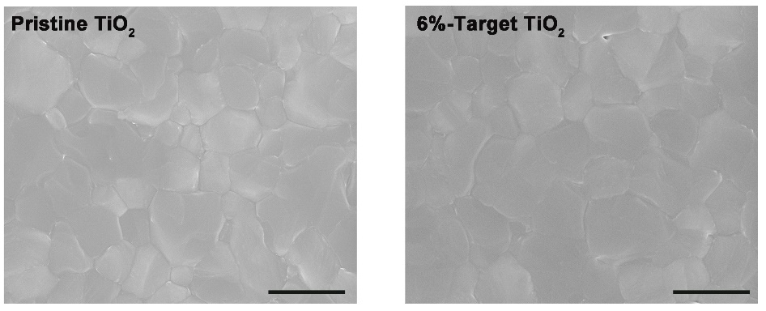
Fig. S20 SEM images of FAPbI₃ perovskite based on the pristine TiO₂ a and target TiO₂ b layers. Scale bars: 2 µm
Fig. S21 AFM images of FAPbI₃ perovskite based on a the pristine TiO₂ and b 6%-target TiO₂ layers. Scale bars: 1 µm
Fig. S22 XRD patterns of FAPbI₃ perovskite upon different TiO₂ layers
Fig. S23 PL a and TRPL b spectra of FAPbI₃ perovskite based on the pristine TiO₂ and target TiO₂ layers
Table S5 Summaries of fitting parameters for TRPL spectra with a structure of FAPbI₃/TiO₂ (with and without defected TiO₂ nanocrystals)/FTO substrates
Samples | A₁ | Ʈ₁ (ns) | A₂ | Ʈ₂ (ns) | Ʈ_{ave} (ns)
FAPbI₃ | 0.25 | 204.80 | 0.75 | 1311.17 | 1256.42
Target FAPbI₃ | 0.21 | 154.90 | 0.79 | 845.45 | 813.38
Fig. S24 The Tauc plot of FAPbI₃ film for obtaining bandgap
Fig. S25 Statistical distributions of the photovoltaic parameters of Voc, Jsc and FF for CsFAMA devices with different TiO₂ layers. The average PCE improves from 18.28% to 21.22%, as shown in Figure 3e, with Voc from 1.147 to 1.192 V, the average Jsc from 22.41 to 23.93 mA/cm², and the FF from 73.88 to 77.93%
Fig. S26 Statistical distributions of the photovoltaic parameters of Voc, Jsc and FF for FAPbI₃ devices based on different TiO₂ layers. The average PCE increases from 21.24% to 23.52%, with Voc from 1.074 to 1.125 V, the average Jsc from 25.10 to 25.86 mA/cm², and the FF from 79.23 to 81.92%
Table S6 Reported values for the efficiency of different PSCs based on TiO₂ ETLs
Type | Device  structure | Best PCE  (%) | Refs.
[BMIM]BF₄ | FTO/TiO₂/[BMIM]BF₄/MAPbI₃/PTAA/Au | 19.62 | [S6]
GQD | FTO/TiO₂@GQD/MAPbI₃/Spiro- OMeTAD/Au | 19.11 | [S7]
CuI | FTO/TiO₂@CuI/CsFAMA/Spiro-OMeTAD/Au | 19.00 | [S8]
Heparin sodium | FTO/TiO₂/heparin sodium/MAPbI₃/Spiro-OMeTAD/Au | 20.1 | [S9]
Dopamine | FTO/Dopamine-TiO₂/Cs_{0.05}FA_{0.81}MA_{0.14}PbI_{2.55}Br_{0.45}/Spiro-OMeTAD/Au | 20.93 | [S10]
Urea | ITO/TiO₂-urea/Cs_{0.05}(FA_{0.87}MA_{0.13})_{0.95}PbI_{2.55}Br_{0.45}/Spiro-OMeTAD/Au | 21.33 | [S11]
Boron | FTO/Boron-TiO₂/ MAPbI₃/Spiro- OMeTAD/Au | 20.51 | [S12]
Li₂CO₃ | FTO/Li₂CO₃-TiO₂/FAPbI₃/Spiro- OMeTAD/Au | 25.28 | [S13]
TiO_{x}N_{y} | FTO/TiO_{x}N_{y}/TiO₂/PMMA:PCBM/ Cs_{0.05}FA_{0.88}MA_{0.07}PbI_{2.56}Br_{0.44}/PMMA/P3HT:CuPC/Au | 23.28 (1cm²) | [S14]
Single-crystalline TiO₂ | FTO/Single-crystalline TiO₂/ Rb_{0.03}Cs_{0.05}MA_{0.05}FA_{0.9}PbI₃/Spiro- OMeTAD/Au | 24.05 | [S15]
Tartaric acid | FTO/tartaric acid-TiO₂/FAMAPbI₃/Spiro-OMeTAD/Au | 24.81 | [S16]
C-PCBA | FTO/TiO₂/C-PCBA/CsFAPb(IBr)₃/Spiro-OMeTAD/Au | 24.80 | [S17]
CdTe nanocrystals | FTO/TiO₂@CdTe/Cs_{0.05}(FA_{0.85}MA_{0.15})_{0.95}PbI_{2.55}Br_{0.45}/Spiro-OMeTAD/Au | 22.00 | [S4]
CdTe nanocrystals | FTO/TiO₂@CdTe/FAPbI₃/Spiro-OMeTAD/Au | 25.05 | [S4]
Ti_{0.936}O₂ | FTO/TiO₂@ Ti_{0.936}O₂/Cs_{0.05}(FA_{0.85}MA_{0.15})_{0.95}PbI_{2.55}Br_{0.45}/Spiro-OMeTAD/Au | 22.02 | Our present work
Ti_{0.936}O₂ | FTO/TiO₂@ Ti_{0.936}O₂/FAPbI₃/Spiro-OMeTAD/Au | 25.50 | Our present work
Fig. S27 UPS Fermi edge a and the cut-off energy b of CsFAMA perovskite film. The calculation of the E_{F}, E_{VB} and E_{CB} of CsFAMA-based perovskite film are -4.35, -5.70 and -4.10 eV
Fig. S28 The long-term thermal stability of CsFAMA-based devices with and without Ti_{0.936}O₂ nanocrystals embedding. The excellent thermal stability of target devices presents PCE degradation of less than 30% over 500 h in contrast with that of control devices (over 60%) after continuous thermal treatment of 85 °C. The error bars represent the standard deviation for 20 devices.
Fig. S29 Schematic illustration of the effects of embedding Ti_{0.936}O₂ nanocrystals on crystallization kinetics and light-induced stability
Fig. S30 J-V curves of the champion FAPbI₃ devices employing 6%-Target TiO₂ layers measured both in reverse scan and forward scan
Table S7 Performance parameters of champion FAPbI₃ devices employing 6%-Target TiO₂ layers measured both in reverse scan and forward scan
Scanning direction | Voc  (V) | Jsc  (mA/cm²) | FF  (%) | PCE  (%)
Reverse  6%-Target TiO₂ | 1.185 | 25.79 | 83.45 | 25.50
Forward  6%-Target TiO₂ | 1.183 | 25.68 | 82.43 | 25.04
The hysteresis index is calculated to be 0.018 according the equation below:
Hysteresis index = (PCE_{Reverse}-PCE_{Forward})/ PCE_{Reverse}
Supplementary References
- H. Yu, W. Zhao, L. Ren, H. Wang, P. Guo et al., Laser-generated supranano liquid metal as efficient electron mediator in hybrid perovskite solar cells. Adv. Mater. 32, e2001571 (2020). https://doi.org/10.1002/adma.202001571
- J. Zhang, M. Li, Z. Feng, J. Chen, C. Li UV Raman spectroscopic study on TiO₂. I. phase transformation at the surface and in the bulk. J. Phys. Chem. B 110, 927–935 (2006). https://doi.org/10.1021/jp0552473
- S. Wang, L. Pan, J.-J. Song, W. Mi, J.-J. Zou et al., Titanium-defected undoped anatase TiO₂ with p-type conductivity, room-temperature ferromagnetism, and remarkable photocatalytic performance. J. Am. Chem. Soc. 137, 2975–2983 (2015). https://doi.org/10.1021/ja512047k
- W. Zhao, P. Guo, C. Liu, N. Jia, Z. Fang et al., Laser derived electron transport layers with embedded p-n heterointerfaces enabling planar perovskite solar cells with efficiency over 25. Adv. Mater. 35, e2300403 (2023). https://doi.org/10.1002/adma.202300403
- N. Li, S. Tao, Y. Chen, X. Niu, C.K. Onwudinanti et al., Cation and anion immobilization through chemical bonding enhancement with fluorides for stable halide perovskite solar cells. Nat. Energy 4, 408–415 (2019). https://doi.org/10.1038/s41560-019-0382-6
- D. Yang, X. Zhou, R. Yang, Z. Yang, W. Yu et al., Surface optimization to eliminate hysteresis for record efficiency planar perovskite solar cells. Energy Environ. Sci. 9, 3071–3078 (2016). https://doi.org/10.1039/C6EE02139E
- J. Ryu, J.W. Lee, H. Yu, J. Yun, K. Lee et al., Size effects of a graphene quantum dot modified-blocking TiO₂ layer for efficient planar perovskite solar cells. J. Mater. Chem. A 5, 16834–16842 (2017). https://doi.org/10.1039/C7TA02242E
- M.M. Byranvand, T. Kim, S. Song, G. Kang, S.U. Ryu et al., P-type CuI islands on TiO₂ electron transport layer for a highly efficient planar-perovskite solar cell with negligible hysteresis. Adv. Energy Mater. 8, 1702235 (2018). https://doi.org/10.1002/aenm.201702235
- S. You, H. Wang, S. Bi, J. Zhou, L. Qin et al., A biopolymer heparin sodium interlayer anchoring TiO₂ and MAPbI₃ enhances trap passivation and device stability in perovskite solar cells. Adv. Mater. 30, e1706924 (2018). https://doi.org/10.1002/adma.201706924
- Y. Zhang, X. Liu, P. Li, Y. Duan, X. Hu et al., Dopamine-crosslinked TiO₂/perovskite layer for efficient and photostable perovskite solar cells under full spectral continuous illumination. Nano Energy 56, 733–740 (2019). https://doi.org/10.1016/j.nanoen.2018.11.068
- W. Hu, W. Zhou, X. Lei, P. Zhou, M. Zhang et al., Low-temperature in situ amino functionalization of TiO₂ nanoparticles sharpens electron management achieving over 21% efficient planar perovskite solar cells. Adv. Mater. 31, 1806095 (2019). https://doi.org/10.1002/adma.201806095
- X. Shi, Y. Ding, S. Zhou, B. Zhang, M. Cai et al., Enhanced interfacial binding and electron extraction using boron-doped TiO₂ for highly efficient hysteresis-free perovskite solar cells. Adv. Sci. 6, 1901213 (2019). https://doi.org/10.1002/advs.201901213
- M. Kim, I.-W. Choi, S.J. Choi, J.W. Song, S.-I. Mo et al., Enhanced electrical properties of Li-salts doped mesoporous TiO₂ in perovskite solar cells. Joule 5, 659–672 (2021). https://doi.org/10.1016/j.joule.2021.02.007
- J. Peng, F. Kremer, D. Walter, Y. Wu, Y. Ji et al., Centimetre-scale perovskite solar cells with fill factors of more than 86 per cent. Nature 601, 573–578 (2022). https://doi.org/10.1038/s41586-021-04216-5
- Y. Ding, B. Ding, H. Kanda, O.J. Usiobo, T. Gallet et al., Single-crystalline TiO₂ nanoparticles for stable and efficient perovskite modules. Nat. Nanotechnol. 17, 598–605 (2022). https://doi.org/10.1038/s41565-022-01108-1
- H. Huang, P. Cui, Y. Chen, L. Yan, X. Yue et al., 24.8%-efficient planar perovskite solar cells via ligand-engineered TiO₂ deposition. Joule 6, 2186–2202 (2022). https://doi.org/10.1016/j.joule.2022.07.004
- Z. Chen, Y. Li, Z. Liu, J. Shi, B. Yu et al., Reconfiguration toward self-assembled monolayer passivation for high-performance perovskite solar cells. Adv. Energy Mater. 13, 2202799 (2023). https://doi.org/10.1002/aenm.202202799

