Supporting Information for

Ultrafast Response and Threshold Adjustable Intelligent Thermoelectric Systems for Next-Generation Self-Powered Remote IoT Fire Warning
Zhaofu Ding¹, Gang Li¹, Yejun Wang², Chunyu Du¹, Zhenqiang Ye¹, Lirong Liang^{1,} *, Long-Cheng Tang^{2,} * and Guangming Chen^{1,} *
¹College of Materials Science and Engineering & College of Civil and Transportation Engineering, Shenzhen University, Shenzhen 518055, P. R. China
²College of Material, Chemistry and Chemical Engineering, Key Laboratory of Organosilicon Chemistry and Material Technology of MoE, Hangzhou Normal University, Hangzhou 311121, P. R. China
*Corresponding authors. E-mail: lianglirong@szu.edu.cn (Lirong Liang); lctang@hznu.edu.cn (Long-Cheng Tang); chengm@szu.edu.cn (Guangming Chen)
Supplementary Figures and Tables
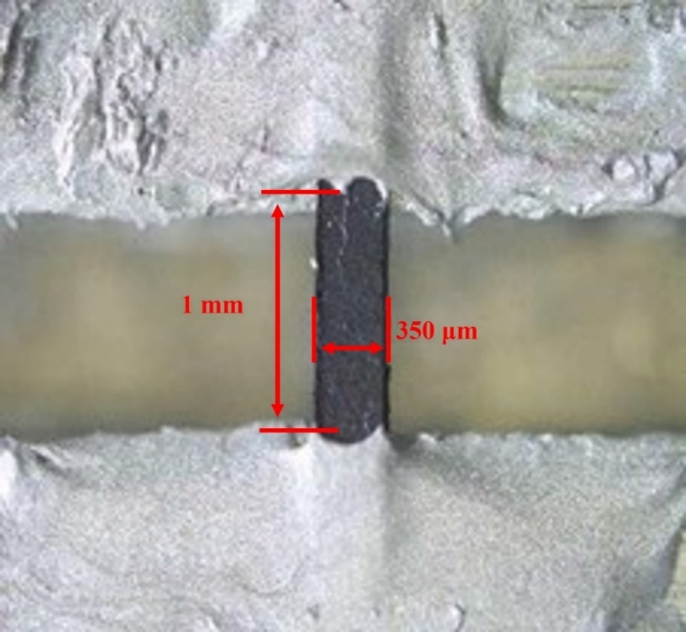
Fig. S1 Sample size diagram for thermal diffusion coefficient test
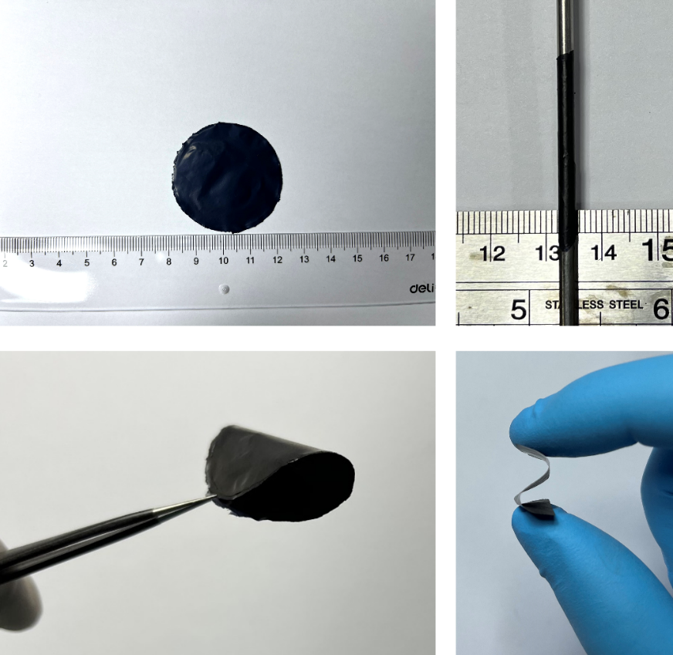
Fig. S2 High flexibility of the SWCNT/MXene composite films with the mass ratio of 10:3
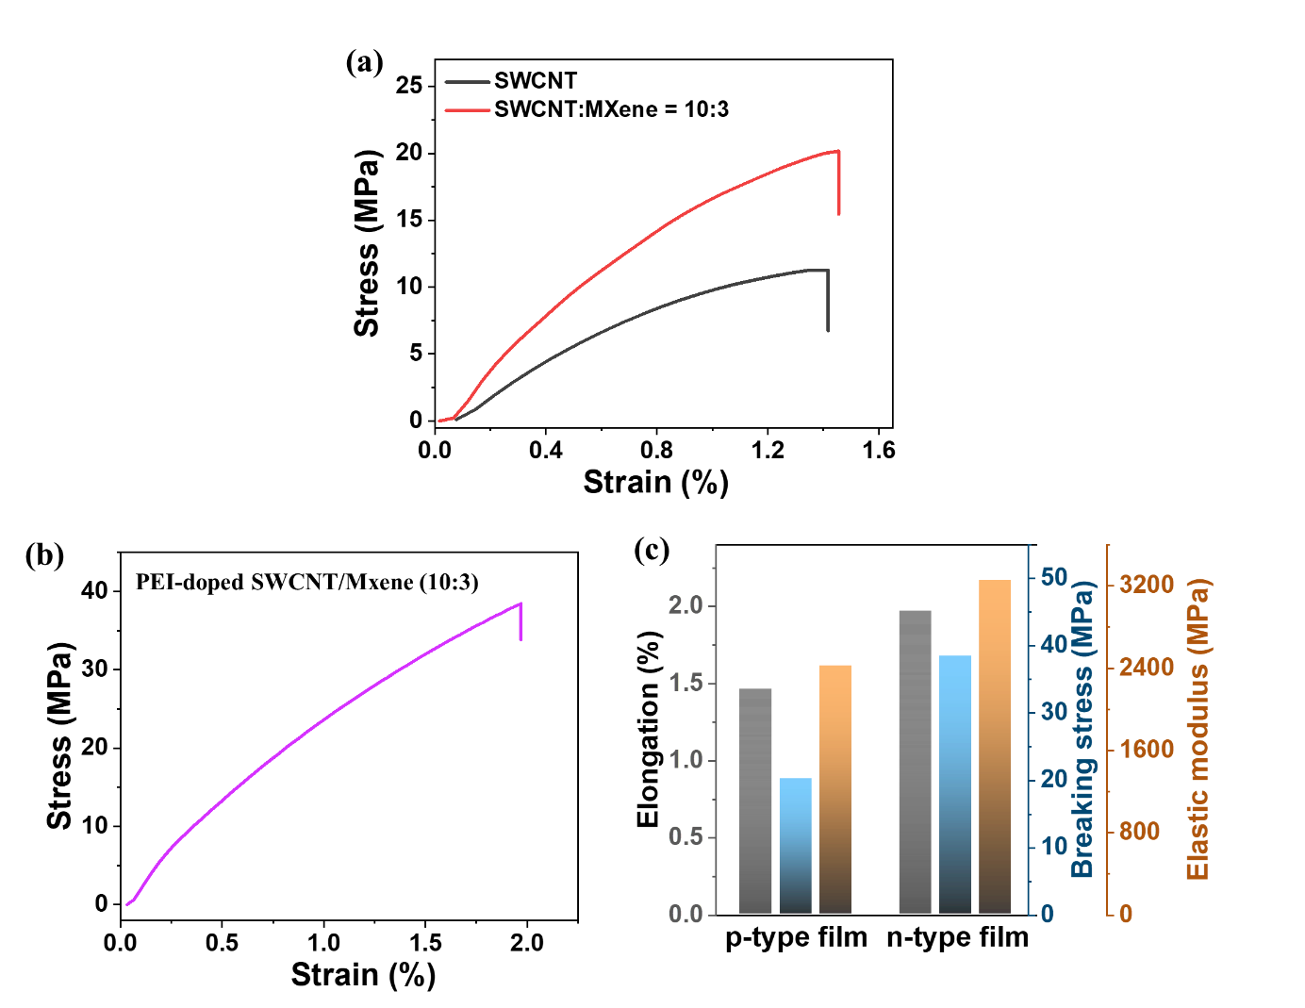
Fig. S3 (a) The stress-strain curves of the pure SWCNT film, SWCNT/MXene composite films with different mass ratio. (b) The stress-strain curve of n-type PEI-doped SWCNT/MXene composite film with SWCNT: MXene mass ratio of 10:3
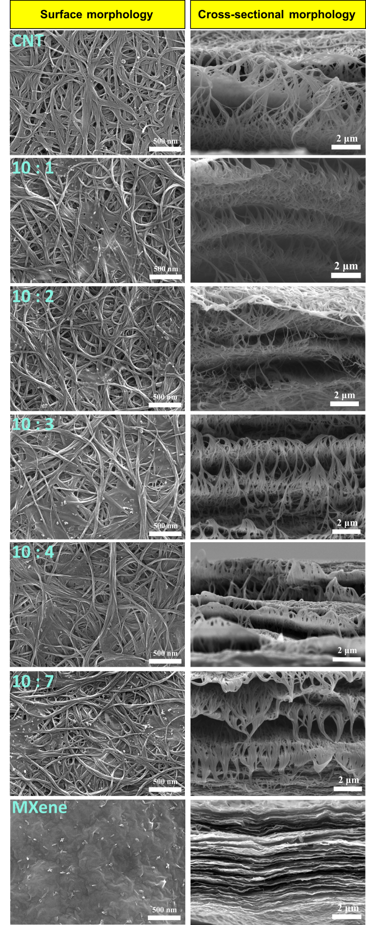
Fig. S4 Surface and cross-sectional morphologies of the SWCNT, MXene, and their composites films with different mass ratios (SWCNT: MXene 10:1 − 10:7)
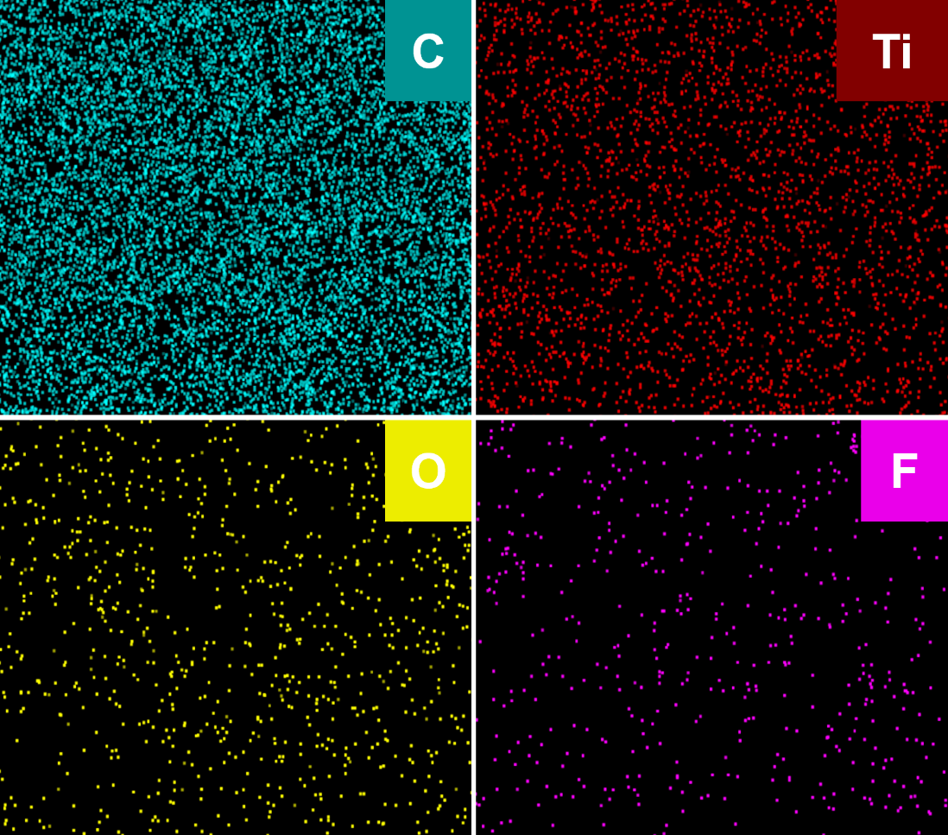
Fig. S5 Surface SEM-EDS mappings of composite film with SWCNT to MXene mass ratio of 10:3
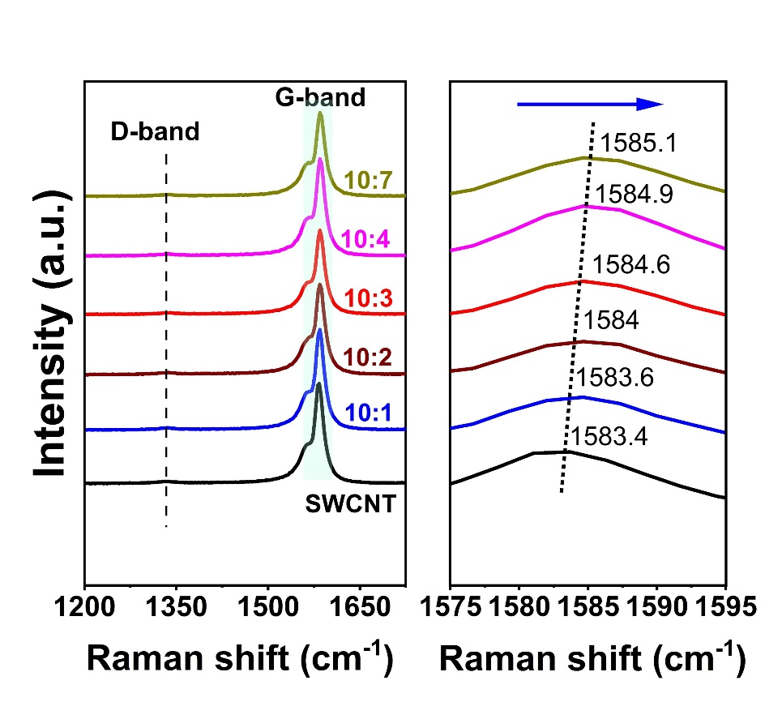
Fig. S6 Raman spectra of pristine SWCNT/MXene composite films

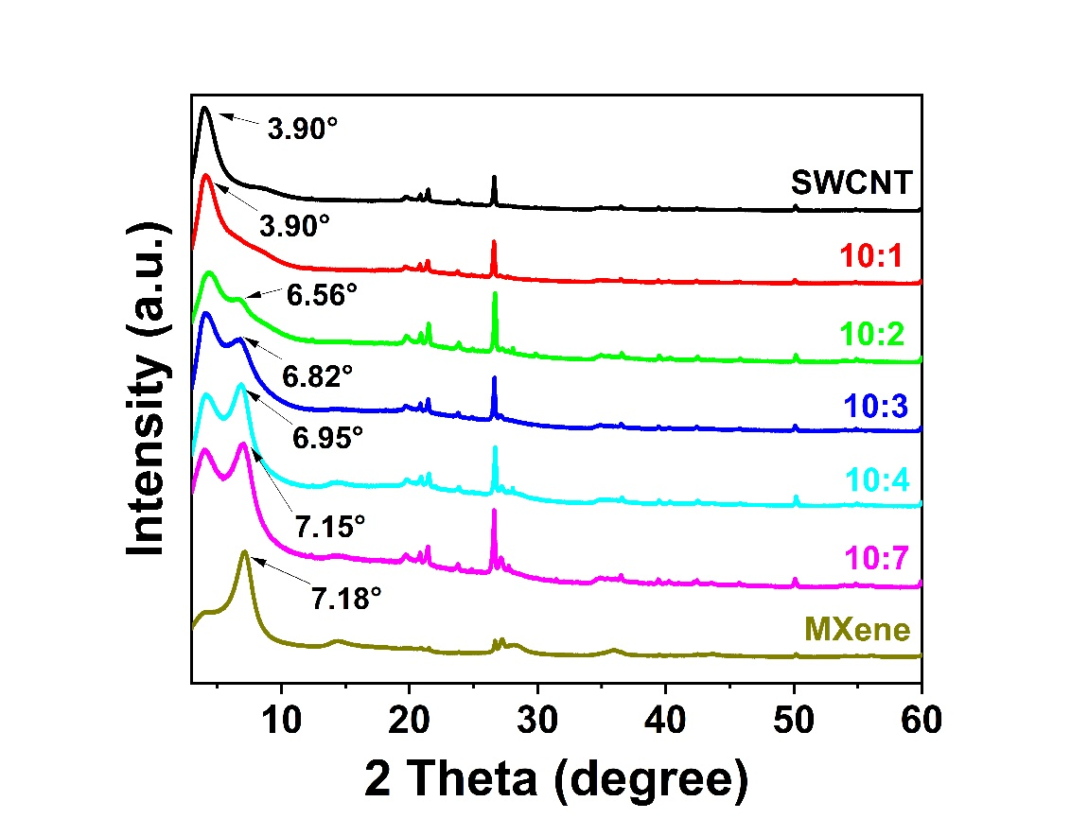
Fig. S7 XRD patterns of SWCNT, MXene, and their composite films
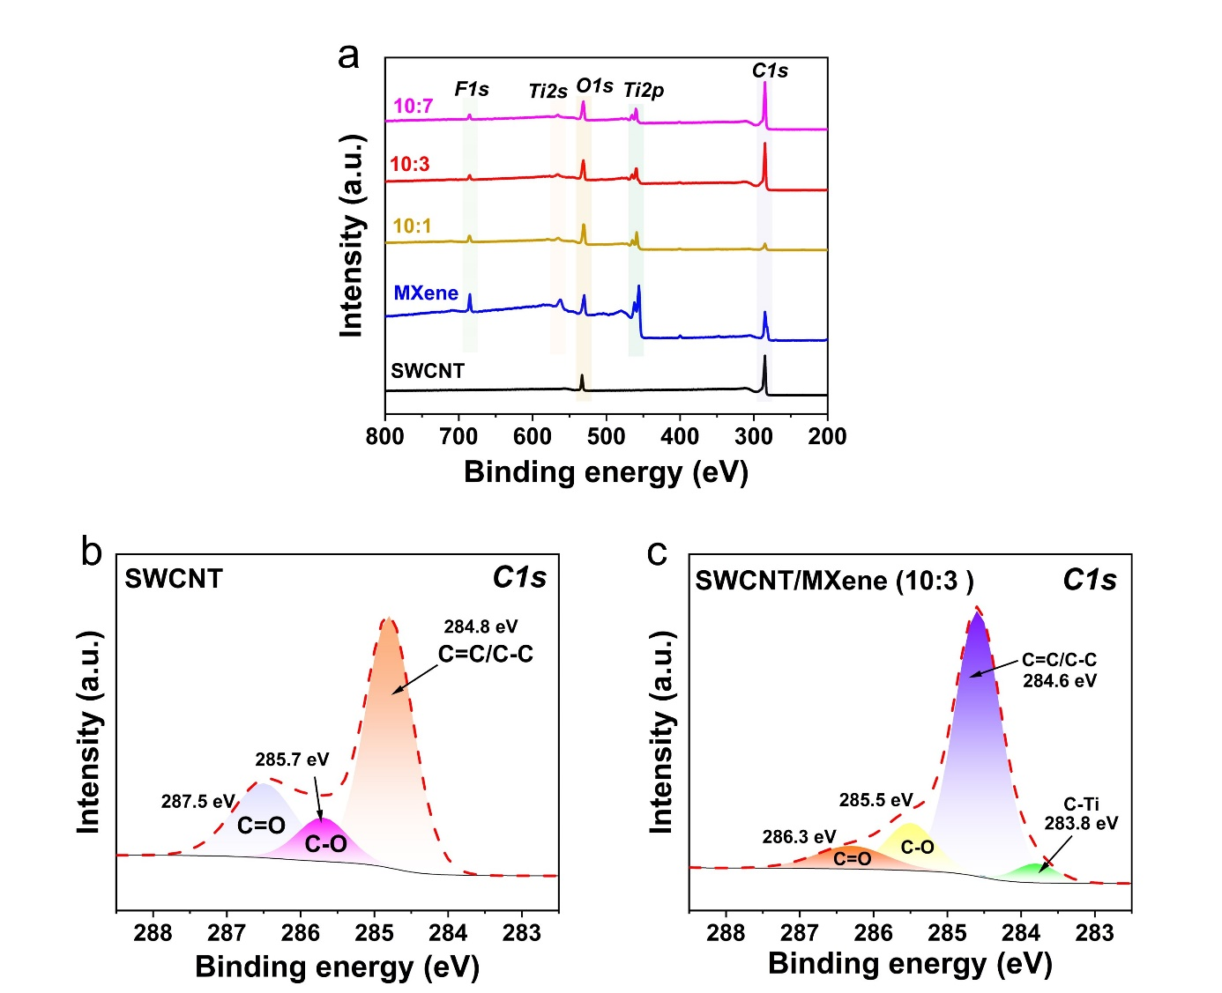
Fig. S8 (a) XPS full spectra of various samples. XPS C 1s spectra of (b) pure SWCNT and (c) SWCNT/MXene composite film
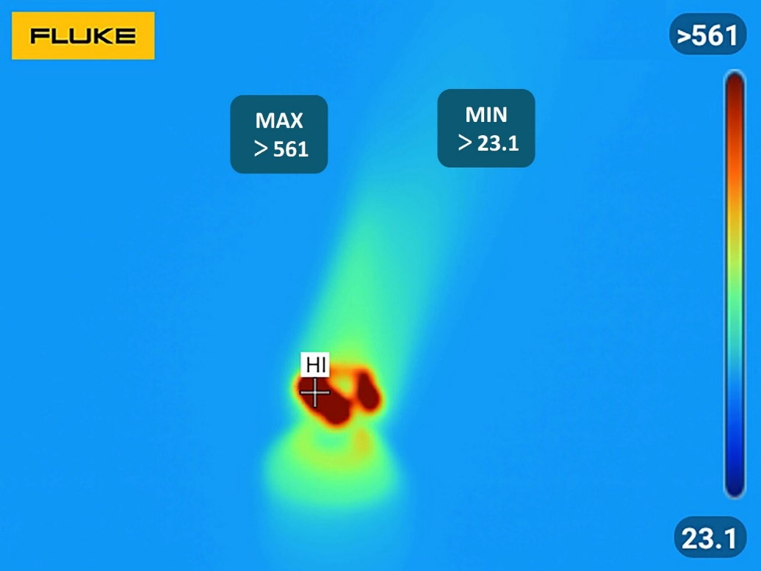
Fig. S9 Thermal imaging of Alcohol lamp used in vertical combustion test for flame-retardant coatings samples

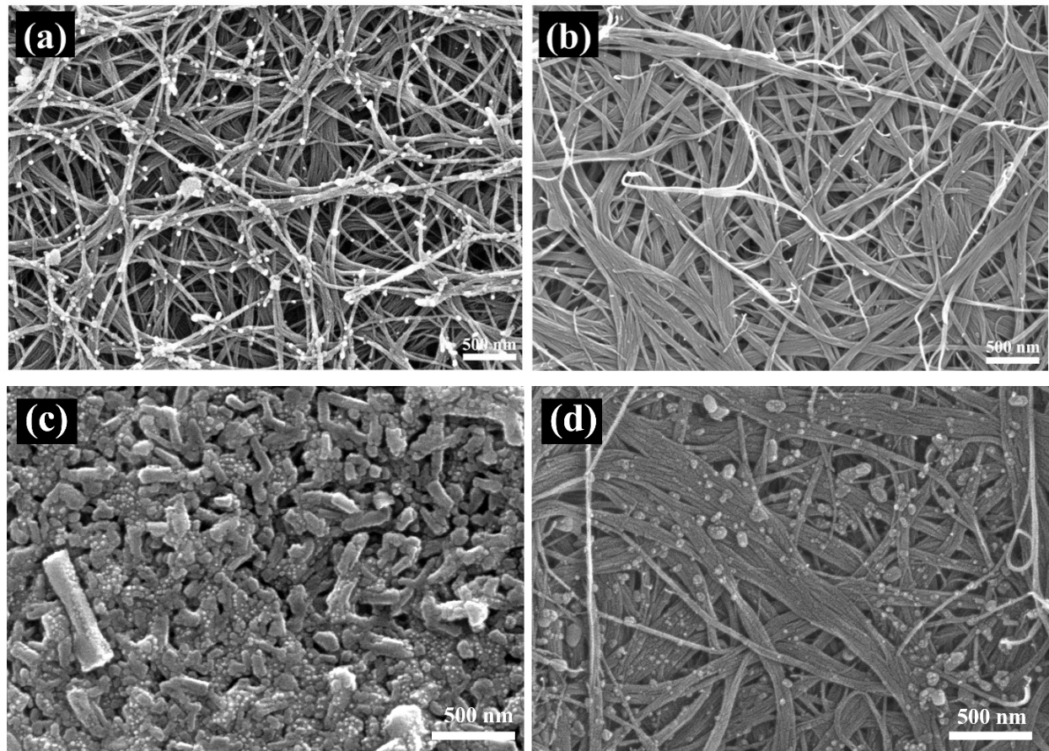
Fig. S10 The surface morphology of (a) pure SWCNT and (c) SWCNT/MXene after combustion, and the internal morphology of (b) SWCNT and (d) SWCNT/MXene after the burned surface was removed with tape

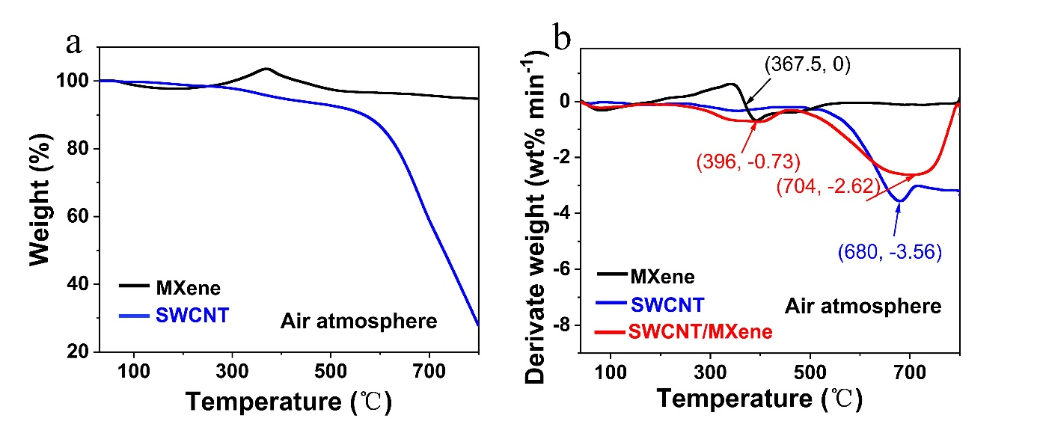Fig. S11 (a) TG curves of pure SWCNT and MXene. (b) DTG curves of pure SWCNT, MXene, and SWCNT/MXene 10:3 composite films under air atmosphere
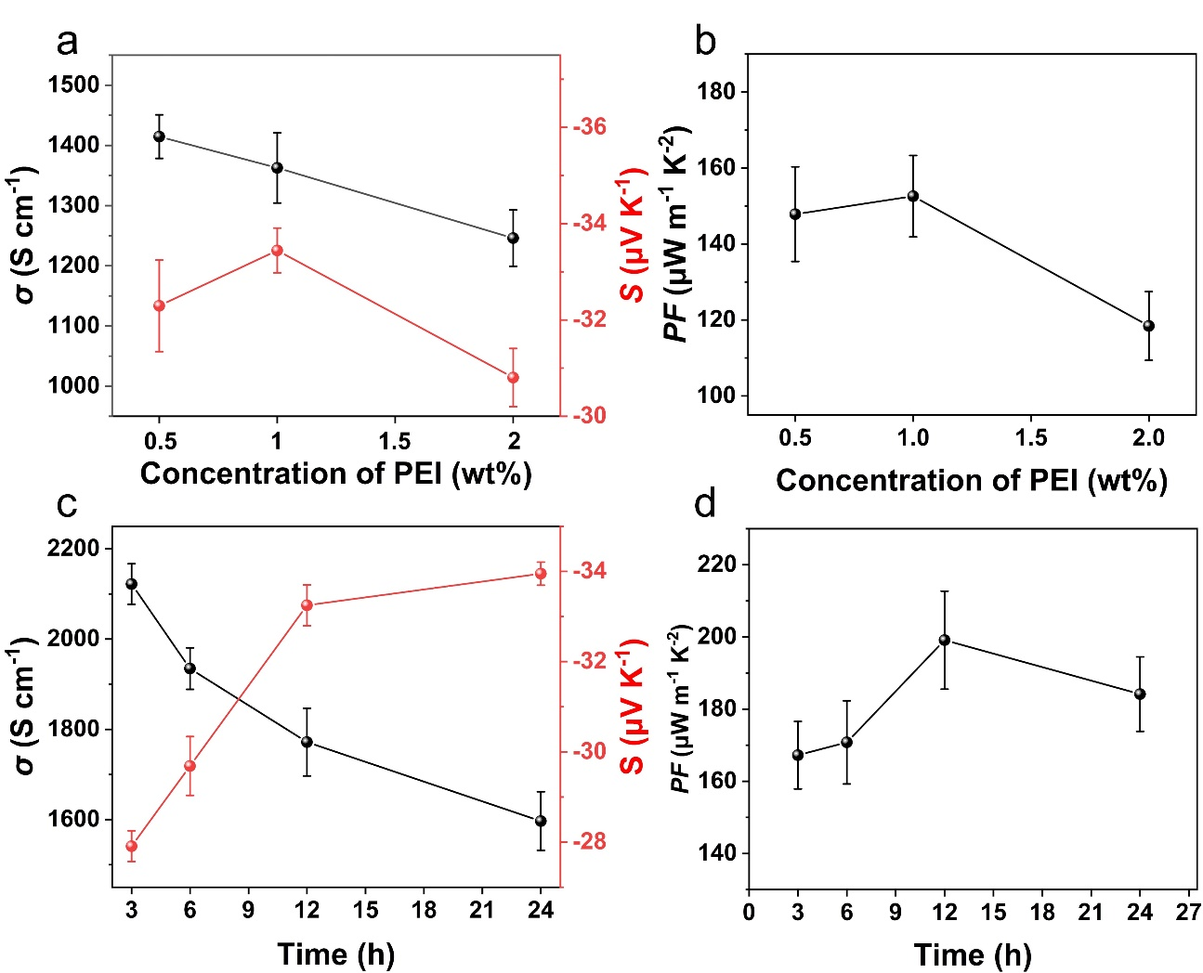
Fig. S12 The conductivity, Seebeck coefficient and their power factor of PEI doping. (a, b) doping concentration, (c, d) soaking time
We further investigated the PEI doping concentration on the effects of TE performance. Three concentrations of PEI aqueous solutions (0.5 wt%, 1 wt%, and 2 wt%) were prepared. The doping time was constant (12 h). The corresponding electrical conductivities (σ), Seebeck coefficients (S) and calculated power factors (PF) were shown in Fig. S12a and 12b. The results show that the optimal PF value is obtained when PEI concentration is 1 wt%. Besides, we also have conducted the effect of doping time (3-24 h) on TE performance. The PEI concentration is constant (1 wt%). As shown in Fig. S12c and 12d, the best PF of the film was obtained when the doping time is 12 h.
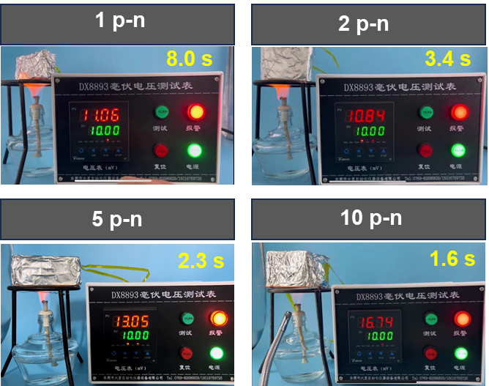
Fig. S13 Fire warning tests for thermoelectric devices with different number of p-n couples
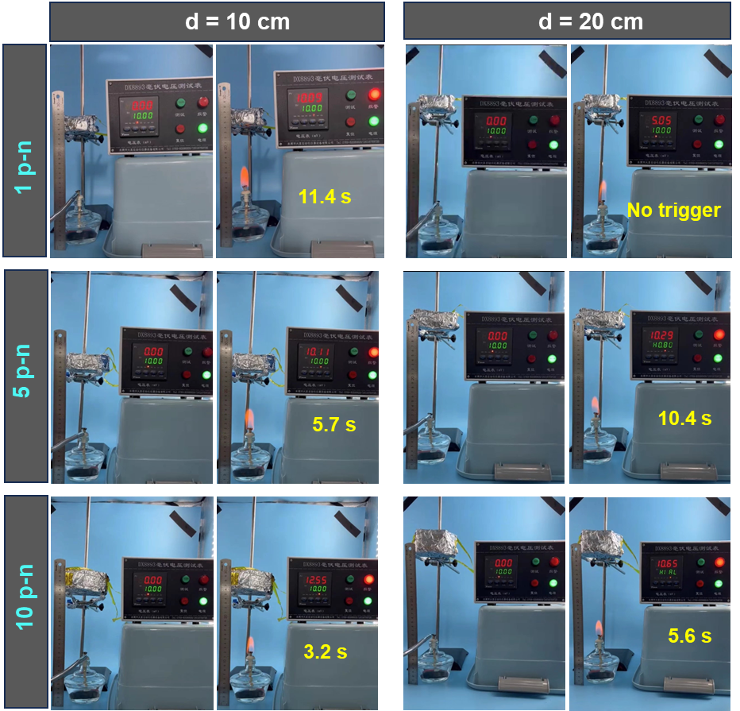
Fig. S14 Heatwaves/temperature sensing fire warning tests for thermoelectric devices with different number of p-n couples at different flame distances
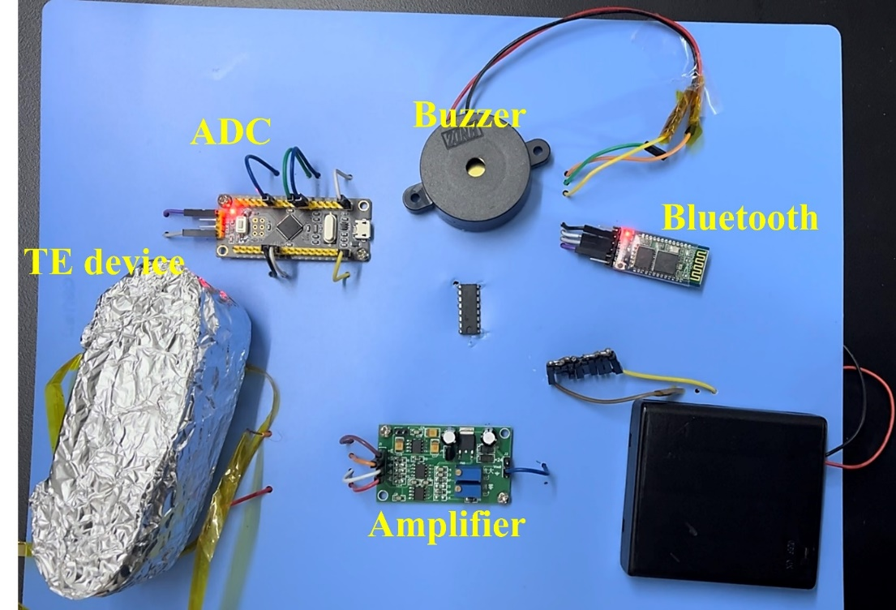
Fig. S15 The designed self-powered smart fire warning system
Table S1 Surface SEM-EDS elemental contents of SWCNT/MXene composite films
Mass ratio  SWCNT: MXene | EDS elemental mapping of SWCNT/MXene
Mass ratio  SWCNT: MXene | C | Ti | O | F
10:1 | 89.01 | 2.51 | 7.13 | 1.35
10:2 | 87.37 | 3.59 | 6.91 | 2.13
10:3 | 81.37 | 5.54 | 9.59 | 3.50
10:4 | 78.05 | 8.06 | 8.77 | 5.12
10:7 | 74.68 | 13.50 | 4.61 | 7.21
Table S2 Comparison of TE properties of CNT/MXene based systems
Component | S (μV K⁻¹) | σ (S cm⁻¹) | PF (μW m⁻¹ K⁻²) |  | Refs.
SWCNT/MXene (MXene 10 wt%) | 39.64 | 1293.76 | 203.29 | [49]
MXene/SWCNT/MXene | -32.2 | 750.9 | 77.9 | [48]
SWCNT/MXene fiber (150-300 ℃) | 20-35 | ~80-120 | 0.179 (Max) | [36]
SWCNT/MXene (10:3) | 43.4 | 1270.9 | 239.7 | This work
PEI-dopped SWCNT/MXene (10:2) | -33.7 | 1773.5 | 202.0
Table S3 Density (ρ), heat capacity (c_{p}), thermal diffusivity (α), thermal conductivity (κ), and ZT value of films
Sample | α  mm²·s⁻¹ | ρ  g·cm⁻³ | c_{p}  J·g⁻¹·K⁻¹ | k  W·m⁻¹·K⁻¹ | ZT  ×10⁻³
SWCNT | 4.19 | 0.705 | 2.75 | 8.1233625 | 7.27
p-type film | 6.08 | 0.768 | 1.65 | 7.704576 | 9.27
n-type film | 9.59 | 0.868 | 0.57 | 4.749696 | 8.94

Table S4 Comparison of fire warning performance of various different mechanisms
Mechanisms |  | System | Warning time (s) | Threshold | Repeatable? | Long-term Stability? | Refs.
Gas/smoke sensor |  | Pd/SnO₂ | ×10¹ s | 5− 200 ppm (gas concentration) | Yes | Test for 1 month | [S1]
Resistant shift |  | GO/Borate | 0.72 | Resistance reduced 10⁴ times | No | / | [S2]
 |  | Chitosan/Montmorillonite/Carbon nanotube | 0.25 | Electrical resistance 2.0 × 10⁶ Ω | No | / | [6]
 |  | GO/TA/P-CNFs paper | Less than 1 s | Resistance reduced 10⁴ times | No | / | [S3]
Chromatic change |  | Phthalonitrile | Within 20 s at 275 ℃ | Color change | No | / | [8]
 |  | POSS-metal films | / | Color change | Yes | / | [S4]
Phase/shape change |  | PU/MXene | Within 4 s | Shape change | No | / | [10]
TE | eTE | MXene/ANFs | Within 10 s | 0.1 mV | Yes | / | [31]
TE | eTE | MXene/CCS | 3.8 s | 1 mV | Yes | / | [34]
TE | eTE | MXene/AgNWs/ANFs | 1.6 s | 1 mV | Yes | / | [58]
TE | eTE | PI/MXene | 4.67 s | 1 mV | Yes | / | [33]
TE | eTE | PI/MXene/Ag2Se | 4.03 s | 1 mV | Yes | / | [32]
TE | eTE | MXene/TA/CaCl2 | Within 3 s | 4 mV | Yes | / | [11]
TE | eTE | PPy/MMT/APP | 1 s | 5 mV | Yes |  | [17]
TE | eTE | CNF/MXene | 1 s | 1 mV | Yes | / | [S5]
TE | eTE | MXene/UPC/MMT | 3.1 s | 1 mV | Yes | / | [35]
TE | eTE | SWCNT/MXene | 1.43 s | 1 mV | Yes | / | [36]
TE | eTE | SWCNT/PEDOT:PSS | 2.1 s | 1 mV | Yes |  | [13]
TE | eTE | SWCNT/MXene | ~0.1 s | 1 mV | Excellent | Test for 6 months | This work
TE | eTE | SWCNT/MXene | 0.7 s | 5 mV | Excellent | Test for 6 months | This work
TE | eTE | SWCNT/MXene | 1.6 s | 10 mV | Excellent | Test for 6 months | This work
TE | iTE | Phosphorous-containing ionic liquid | 1.1 s | 50 mV | Yes | / | [29]
TE | iTE | Ionic hydrogel | ~4 s | 100 mV | Yes | / | [30]
TE | iTE | Temperature-arousing battery | 79 s (practical tests) | / | / | / | [S6]

Video S1 Flame retardancy of the SWCNT/MXene (S/M) composite film and coating
Video S2 Representative fire warning tests with the 1th, 30th and 50th repeated warning performance
Video S3 Fire warning test with TED-10pn in fire directly, 10 cm and 20 cm fire distance, respectively
Video S4 Building fire warning tests at flame distances of 0, 10, and 20cm, respectively
Video S5 Fire hazard signals were sent through mobile devices
Supplementary References
- L. Xiao, S. Xu, G. Yu, S. Liu, Efficient hierarchical mixed Pd/SnO₂ porous architecture deposited microheater for low power ethanol gas sensor. Sens. Actuators B Chem. 255, 2002-2010 (2018). https://doi.org/10.1016/j.snb.2017.08.216
- C. F. Cao, B. Yu, J. Huang, X. L. Feng, L. Y. Lv et al., Biomimetic, mechanically strong supramolecular nano system enabling solvent resistance, reliable fire protection and ultralong Fire Warning. ACS Nano 16, 20865-20876 (2022). https://doi.org/10.1021/acsnano.2c08368
- C.-F. Cao, B. Yu, B.-F. Guo, W.-J. Hu, F.-N. Sun et al., Bio-inspired, sustainable and mechanically robust graphene oxide-based hybrid networks for efficient fire protection and warning Chem. Eng. J. 439, 134516 (2022). https://doi.org/10.1016/j.cej.2022.134516
- . Xu, L. Huang, J. Long, R. Zhang, Z. Zhong et al., Reversible thermochromic POSS-Metal Films for early warning. Compos. Sci. Technol. 217, 109083 (2022). https://doi. org/10.1016/j.compscitech.2021.109083
- H. Wang, Y. Jiang, Z. Ma, Y. Shi, Y. Zhu et al., Hyperelastic, robust, fire-safe multifunctional MXene aerogels with unprecedented electromagnetic interference shielding efficiency. Adv. Funct. Mater. 33, 2306884 (2023). https://doi.org/10.1002/adfm.202306884
- X. Li, S. Lyu, J. Jia, N. Gao, X. Wu et al., A bio-Inspired temperature-arousing battery with giant power for fire alarming. Adv. Funct. Mater. 33, 2300403 (2023). https://doi.org/10.1002/adfm.202300403

