Supporting Information for
Design of AI-Enhanced and Hardware-Supported Multimodal E-Skin for Environmental Object Recognition and Wireless Toxic Gas Alarm
Jianye Li^{1,6}, Hao Wang¹, Yibing Luo¹, Zijing Zhou¹, He Zhang⁷, Huizhi Chen^{9,10}, Kai Tao ^{2,3,}*, Chuan Liu¹, Lingxing Zeng¹¹, Fengwei Huo^{4,5}* and Jin Wu^{1,6,7,8,}*
¹State Key Laboratory of Optoelectronic Materials and Technologies and the Guangdong Province Key Laboratory of Display Material and Technology, School of Electronics and Information Technology, Sun Yat-Sen University, Guangzhou, 510275, People’s Republic of China
²Ministry of Education Key Laboratory of Micro and Nano Systems for Aerospace, School of Mechanical Engineering, Northwestern Polytechnical University, Xi'an, 710072, People’s Republic of China
³Research & Development Institute of Northwestern Polytechnical University in Shenzhen, Shenzhen, 518063, People’s Republic of China
⁴The Institute of Flexible Electronics (IFE, Future Technologies), Xiamen University, Xiamen, 361005, People’s Republic of China
⁵Key Laboratory of Flexible Electronics (KLOFE), School of Flexible Electronics (Future Technologies), Nanjing Tech University, 30 South Puzhu Road, Nanjing, 211816, People’s Republic of China
⁶State Key Laboratory of Transducer Technology, Shanghai, 200050, People’s Republic of China
⁷Guangdong Provincial Key Laboratory of Technique and Equipment for Macromolecular Advanced Manufacturing, Guangzhou, 510641, People’s Republic of China
⁸State Key Laboratory of Polymer Materials Engineering, Sichuan University, Chengdu, 610065, People’s Republic of China
⁹Guangdong Provincial Key Laboratory of Research and Development of Natural Drugs, and School of Pharmacy, Guangdong Medical University, Dongguan, 523808, People’s Republic of China
¹⁰The First Dongguan Affiliated Hospital, Guangdong Medical University, Dongguan, 523808, People’s Republic of China
¹¹Engineering Research Center of Polymer Green Recycling of Ministry of Education, College of Environment and Resources, Fujian Normal University, Fuzhou, Fujian, 350007, People’s Republic of China
*Corresponding authors. E-mail: wujin8@mail.sysu.edu.cn (Jin Wu); taokai@nwpu.edu.cn (Kai Tao); iamfwhuo@njtech.edu.cn (Fengwei Huo)
Supplementary Figures and Tables
Fig. S1 Flowchart for the fabrication of multimodal e-skin and schematic diagram showing the relative positions of different sensing modules. a Firstly, the hydrogel and the Ecoflex precursors were spin-coated on alumin um substrates and placed at room temperature for curing. After curing, the organohydrogel film was cut to the appropriate size and connected with conductive tape to construct the conductive temperature sensor. The temperature module was then placed on top of the cured Ecoflex and covered by another layer of Ecoflex through spin-coating. Two hydrogel films with suitable sizes were connected with silver wires and placed on the uncured Ecoflex layer. The entire device was kept at room temperature until the top Ecoflex layer was cured. Finally, the whole device was peeled off from the aluminum substrate to obtain a multimode e-skin. b Schematic diagram showing the relative positions of five different sensing modules
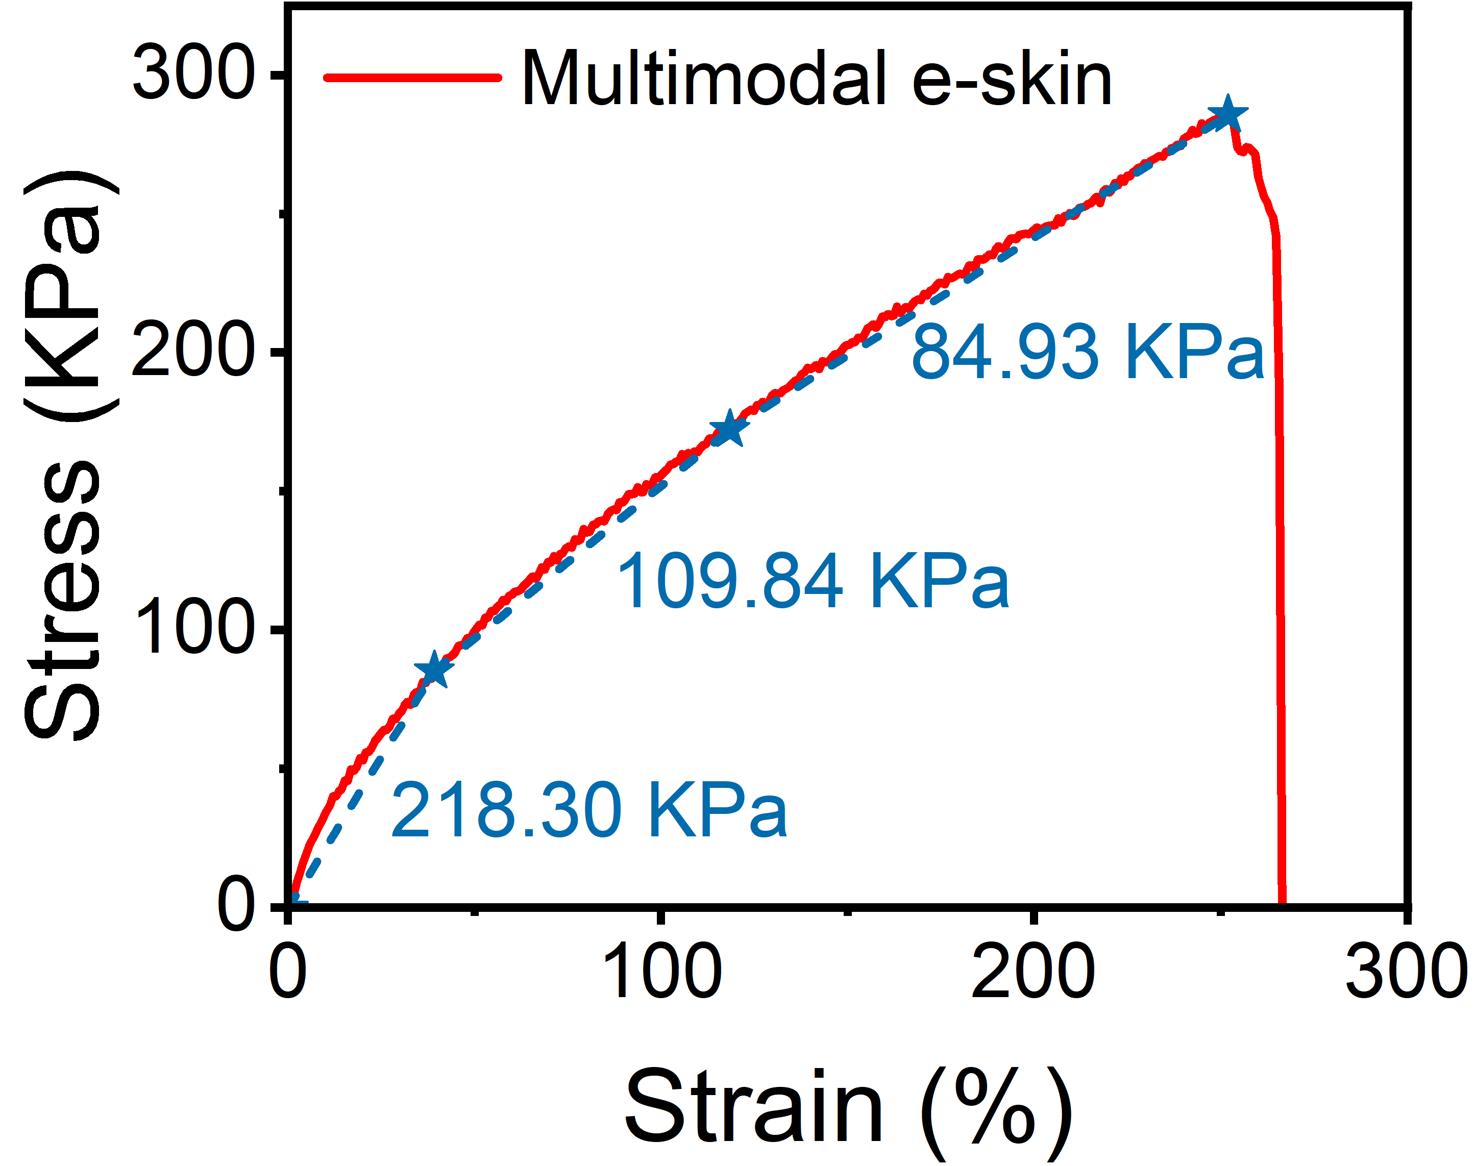
Fig. S2 Stress-strain curve of multimodal e-skin

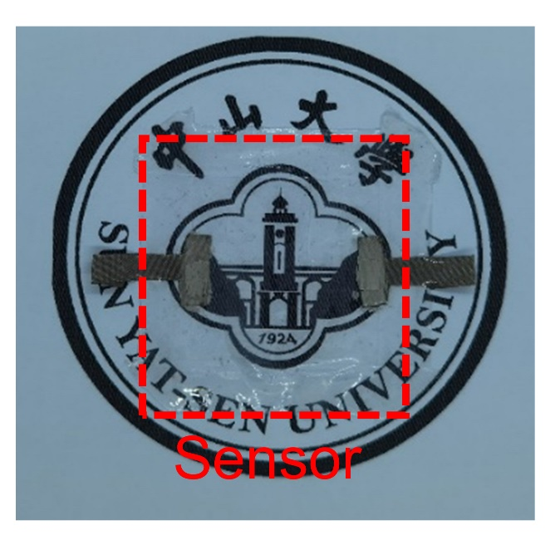
Fig. S3 University logo pattern below the multimodal e-skin is visible, demonstrating its excellent transparency

Fig. S4 At different temperatures, the sensitivity-humidity change curve and the response fitting curve of the humidity module. a Sensitivity-RH curves of the humidity module at different temperatures. b On the logarithmic scale, the humidity response is linearly related to the relative humidity
Fig. S5 Respiratory monitoring based on multimodal e-skin. a Schematic illustration of the multimodal e-skin monitoring nasal respiratory rate through detecting changes in humidity. b, c Real-time conductance and response signal recorded by the humidity module during the subject's breathing. d Flow diagram of baseline correction. e Spectral diagram of the original humidity response signal obtained by fast Fourier transform. f Real-time humidity response after baseline correction through FIR band-pass filtering.
The detailed code about the baseline correction ran on MATLAB R2022b and is presented as follows:
P2_1 = P2_2(1:N/2+1);
P2_1(2:end-1) = 2*P2_1(2:end-1);
f = Fs*(0:(N/2))/N;
subplot(4,1,1);
plot(x1,y1);
title('Original signal');
subplot(4,1,2);
plot(f,P1_1);
title('FFT of original signal');
subplot(4,1,3);
plot(x1,y2);
title('Output signal');
subplot(4,1,4);
plot(f,P2_1);
title('FFT of output signal');
N=358;
Fs=10;
x1=0:0.1:35.7;
% Data interpolation
y1=interp1(x,y,x1, 'pchip');
% Band-pass filtering
y2 = 45*filter(h',1,y1);
% Fast Fourier transform
Y1 = fft(y1);
Y2 = fft(y2);
% Plotting
P1_2 = abs(Y1/N);
P1_1 = P1_2(1:N/2+1);
P1_1(2:end-1) = 2*P1_1(2:end-1);
P2_2 = abs(Y2/N);
Fig. S6 Real-time response signals of the pressure module to different pressures at 30, 39, 42, and 48 ℃
Fig. S7 Real-time capacitance signal change of pressure module during cyclic loading-unloading test of different pressures
Fig. S8 Dynamic response signal of the proximity module when the distance varies between 1 and 15 mm

Fig. S9 Real-time response signals of the proximity module when the object gradually approaches and leaves under different temperatures

Fig. S10 Photographs of multimodal e-skin being folded and unfolded
Fig. S11 Changes of background current, response current and sensitivity of NO₂ module with humidity or temperature. a Background current (I₀) and response current (ΔI) to 2 ppm NO₂ under different relative humidity. b Response sensitivity change curve of NO₂ module under different humidity. c Background current and response current to 1.6 ppm NO₂ at different temperatures. d Response sensitivity change curve of NO₂ module at different temperatures
Fig. S12 Background noise of the NO₂ module and the 5th order polynomial fitting curve of the noise before exposure to NO₂
Fig. S13 Dynamic response of the NO₂ module to 0.8 ppm NO₂ cycling
The process of data processing and heatmap drawing: The robot hand grabbed five kinds of objects, and each kind of object was grabbed for 20 times, obtaining 100 sets of samples with 15 features. The same class of samples is summed and averaged to represent the typical response value of each kind of object. Besides, the maximum value S_{max} and minimum value S_{min} of humidity response, temperature response and pressure/proximity response in 100 samples were extracted, respectively. The 15 features of each object class are normalized according to Equation 1, and then the normalized samples are drawn into heatmaps.
$\begin{aligned}S_{i,0-1}=\frac{S_{i}-S_{min}}{S_{max}-S_{min}}\#\left(S1\right)\end{aligned}$
Fig. S14 Visual images of the response signals recorded by the e-skins when the manipulator grasps different objects. a Schematic diagram of the robot hand with multimodal e-skin integrated on each finger and the corresponding normalized signal diagram of the e-skin. The robot hand grasps five types of objects, including b bottle, c prosthesis, d heated prosthesis, e dry wood, and f wet wood, with each object grasped for 20 times. The average value of the response signals collected when grasping each kind of object is shown in normalized heatmaps
Fig. S15 Classification test confusion matrix when different modules of the e-skin are blocked. a Classification test confusion matrix when using only pressure/proximity modules, b using only humidity modules and c using the combination of pressure/proximity and temperature modules of 5 multimodal e-skins
Fig. S16 The degree of convergence of the model changes with the number of iterations. a The change curve of the loss function with the number of iterations during the DNN model training process. b The change curve of the object classification accuracy with the number of iterations during the DNN model training process
Table S1 Performance comparison of hydrogel-based multimodal e-skins
Sensing material | Stimulus | Anti-freezing | Anti-drying | Stretchable | Transparent | Self-calibration
Silk fibroin/ poly(sulfobetaine)/Ca²⁺ hydrogel [S1] | Strain, proximity, temperature | Yes | Yes | Yes | Yes | No
PDMA-C18 hydrogel [S2] | Pressure, temperature | No | Yes | Yes | Yes | No
SAA hydrogel [S3] | Strain, temperature | No | Yes | Yes | Yes | No
PMP DN ICH hydrogel [S4] | Strain, temperature | Yes | Yes | Yes | No | No
PVA/Betaine-I⁻/I₃⁻ [S5] | Strain, temperature | Yes | Yes | Yes | No | No
PVA-CNF  hydrogel[This work] | Pressure, temperature,  Humidity, NO₂,  Proximity | Yes | Yes | Yes | Yes | Yes
Table S2 The relative humidity of the surrounding environment of different salt solutions at different temperatures
Saturated salt solution | CH₃COOK | MgCl₂ | K₂CO₃ | NaBr | NaCl | K₂SO₄
25 ℃ | 22.5% | 32.8% | 43.2% | 57.6% | 75.3% | 97.3%
30 ℃ | 21.6% | 32.4% | 43.2% | 56% | 75.1% | 97%
35 ℃ | 20.9% (#) | 32.1% | 43.6% (#) | 54.6% | 74.9% | 96.7%
40 ℃ | 19.7% (*) | 31.6% | 43.4% (*) | 53.2% | 74.7% | 96.4%
45 ℃ | 19.3% (#) | 31.1% | 43.2% (#) | 52% | 74.5% | 96.1%
Note: Data marked by * is taken from Ref. [S6], data marked by # comes from Ref. [S7], and other data refer to Ref. [S8].
Table S3 The relative humidity of dry and wet gas mixtures with different flow rate ratios
Dry gas | Wet gas | Relative humidity
500 sccm | 0 sccm | 22.5%
400 sccm | 100 sccm | 33%
300 sccm | 200 sccm | 46.9%
200 sccm | 300 sccm | 60.2%
100 sccm | 400 sccm | 72.3%
0 sccm | 500 sccm | 81.4%
Table S4 Comparison in the sensing targets, wireless sensing, stretchability, environmental object recognition, humidity response, pressure, and temperature sensitivity of various e-skins
Sensing materials | Stimulus | Wireless sensing | Stretchable | Environmental object recognition | Humidity  response | Pressure sensitivity (KPa⁻¹) | Temp.  sensitivity (%/℃)
Mxene/PVDF-TrFE [S9] | Pressure | No | Yes | No | / | 0.51 | /
PEDOT: PSS/  IGZO/  AgNF/AgNW [S10] | Pressure, temperature | No | Yes | No | / | 0.00178 (Maximum) | 0.03
PU/PU@CNT [S11] | Pressure, temperature | No | No | No | / | 0.753 | 0.00284
SWCNTs/TPU [S12] | Pressure, temperature | Yes | Yes | No | / | 0.02 | 1.65
AAO/PEDOT: PSS/  CNT [S13] | Pressure | No | No | No | / | 0.67 | 1.41
GO [S14] | Pressure, humidity, temperature | No | Yes | No | 27.5 | 0.002 | /
PVA/CA/AgNPs [S15] | Strain, humidity, temperature | No | Yes | No | ~0.9 | / | 0.076
AgNWs/PDMS/  ZnS:Cu [S16] | Pressure | No | Yes | No | / | 1.28 (Maximum) | /
CB/Rgo [S17] | Strain, humidity, temperature, pressure | No | Yes | No | ~1.75 | 0.09 | 0.6
PVA-CNF  Hydrogel [This work] | Humidity, pressure, proximity, temperature, NO₂ | Yes | Yes | Yes | 238.2 | 0.57 | 9.38
The theoretical LOD of NO₂ can be calculated by the following formula [S18]:
$$\begin{aligned}LOD=\frac{{3RMS}_{Noise}}{Slope}\#\left(S2\right)\end{aligned}$$
Wherein RMS_{noise} is the root mean square derivation of the background current noise of the NO₂ module in a pure nitrogen atmosphere, and the slope is the response sensitivity to NO₂. According to the experimental results, the sensitivity of the NO₂ module in an environment of 20 °C and 33% RH is 254%/ppm. The RMS_{noise} is calculated as 0.94% based on the background noise and the 5th order polynomial fitting curve from Supplementary Figure 11. Finally, the theoretical LOD is calculated as low as 11.1 ppb.

Table S5 The 5th order polynomial fitting data used to calculate the LOD of the NO₂ module. Y_{i} is the background response recorded by the NO₂ module before exposure to NO₂, and Y is the data obtained through 5th order polynomial fitting of the original curve
Time (s) | Y_{i}-Y | (Y_{i}-Y)²
10 | 0.00144 | 2.074E-6
20 | 0.00765 | 5.852E-5
30 | -0.00213 | 4.537E-6
40 | -0.00036 | 1.296E-7
50 | -0.01723 | 2.969E-4
60 | -0.00248 | 6.150E-6
70 | 0.00666 | 4.436E-5
80 | -0.00915 | 8.372E-5
90 | -0.01296 | 1.680E-4
100 | 0.01146 | 1.313E-4
Table S6 Performance comparison of representative NO₂ sensors
Sensing material | LOD  (ppb) |  | Operating condition | Sensitivity  (%/ppm) | Stretchable | Self-calibration
[EMIM]⁺[TFSI]—TPU [S19] | 250 | Room temperature |  | 22.59%/5ppm | Yes | No
Ag/LIG [S20] | 4 | Room temperature |  | 6.66‰/ppm | Yes | No
NiCo₂O₄/WO₃ [S21] | 52 | 150 ℃ |  | 379 | No | No
CuO thin films [S22] | 300 | 200 ℃ |  | / | No | No
CuO/RGO [S23] | 50 | Room temperature |  | 246.5 | No | No
WO₃/S-rGO [S24] | 250 | Room temperature |  | 5.548 | No | No
Pb_{x}Cd_{1−x}Se QD gel [S25] | 3 | Room temperature |  | 60 | No | No
PVA-CNF  Hydrogel [This work] | 11.1 | Room temperature |  | 254 | Yes | Yes

Supplementary Movies
Movies supplementary material for this manuscript includes the following:
- Movies S1: Wireless detection of NO_{x} leakage events
Supplementary References
- Z. Lei, W. Zhu, X. Zhang, X. Wang, P. Wu. Bio-inspired ionic skin for theranostics. Adv. Funct. Mater. 31(8), 2008020 (2021). https://doi.org/10.1002/adfm.202008020
- Z. Lei, Q. Wang, P. Wu. A multifunctional skin-like sensor based on a 3D printed thermo-responsive hydrogel. Mater. Horiz. 4(4), 694-700 (2017). https://doi.org/10.1039/C7MH00262A
- H. Huang, L. Han, X. Fu, Y. Wang, Z. Yang et al., Multiple stimuli responsive and identifiable zwitterionic ionic conductive hydrogel for bionic electronic skin. Adv. Electron. Mater. 6(7), 2000239 (2020). https://doi.org/10.1002/aelm.202000239
- W. Zhao, H. Zhou, W. Li, M. Chen, M. Zhou et al., An environment-tolerant ion-conducting double-network composite hydrogel for high-performance flexible electronic devices. Nano-Micro Lett. 16(1), 99 (2024). https://doi.org/10.1007/s40820-023-01311-2
- Z. Wang, N. Li, X. Yang, Z. Zhang, H. Zhang et al., Thermogalvanic hydrogel-based e-skin for self-powered on-body dual-modal temperature and strain sensing. Microsyst. Nanoeng. 10(1), 55 (2024). https://doi.org/10.1038/s41378-024-00693-6
- C. Arai, S. Hosaka, K. Murase, Y. Sano. Measurements of the relative humidity of saturated aqueous salt solutions. J. Chem. Eng. Jpn. 9(4), 328-330 (1976). https://doi.org/10.1252/JCEJ.9.328
- M. M. Alhussaini, H. A. Hassan, N. S. Ahmedzeki. Experimental investigation of moisture sorption isotherms for mefenamic acid tablets. Iraqi J. Chem. Pet. Eng. 21(4), 11-20 (2020). https://doi.org/10.31699/IJCPE.2020.4.2
- L. Greenspan. Humidity fixed points of binary saturated aqueous solutions. J. Res. Natl. Bur. Stand. A Phys. Chem. 81(1), 89 (1977). https://doi.org/10.6028/jres.081A.011
- S. Sharma, A. Chhetry, M. Sharifuzzaman, H. Yoon, J. Y. Park. Wearable capacitive pressure sensor based on MXene composite nanofibrous scaffolds for reliable human physiological signal acquisition. ACS Appl. Mater. Interfaces 12(19), 22212-22224 (2020). https://doi.org/10.1021/acsami.0c05819
- B. W. An, S. Heo, S. Ji, F. Bien, J.-U. Park. Transparent and flexible fingerprint sensor array with multiplexed detection of tactile pressure and skin temperature. Nat. Commun. 9(1), 2458 (2018). https://doi.org/10.1038/s41467-018-04906-1
- Z. Gao, Z. Lou, W. Han, G. Shen. A self-healable bifunctional electronic skin. ACS Appl. Mater. Interfaces 12(21), 24339-24347 (2020). https://doi.org/10.1021/acsami.0c05119
- Y. Zhang, Y. Zhao, W. Zhai, G. Zheng, Y. Ji et al., Multifunctional interlocked e-skin based on elastic micropattern array facilely prepared by hot-air-gun. Chem. Eng. J. 407, 127960 (2021). https://doi.org/10.1016/j.cej.2020.127960
- B. Liang, B. Huang, J. He, R. Yang, C. Zhao et al., Direct stamping multifunctional tactile sensor for pressure and temperature sensing. Nano Res. 4(4), 1-7 (2022). https://doi.org/10.1007/s12274-021-3906-x
- D. H. Ho, Q. Sun, S. Y. Kim, J. T. Han, D. H. Kim et al., Stretchable and multimodal all graphene electronic Skin. Adv. Mater. 28(13), 2601-2608 (2016). https://doi.org/10.1002/adma.201505739
- L. Chen, X. Chang, H. Wang, J. Chen, Y. Zhu. Stretchable and transparent multimodal electronic-skin sensors in detecting strain, temperature, and humidity. Nano Energy 96, 107077 (2022). https://doi.org/10.1016/j.nanoen.2022.107077
- Q. Tang, M. Zou, L. Chang, W. Guo. A super-flexible and transparent wood film/silver nanowire electrode for optical and capacitive dual-mode sensing wood-based electronic skin. Chem. Eng. J. 430, 132152 (2022). https://doi.org/10.1016/j.cej.2021.132152
- H. Liu, H. Xiang, Y. Wang, Z. Li, L. Qian et al., A flexible multimodal sensor that detects strain, humidity, temperature, and pressure with carbon black and reduced graphene oxide hierarchical composite on paper. ACS Appl. Mater. Interfaces 11(43), 40613-40619 (2019). https://doi.org/10.1021/acsami.9b13349
- A. Shrivastava, V. B. Gupta. Methods for the determination of limit of detection and limit of quantitation of the analytical methods. Chron. Young Sci. 2(1), 21-25 (2011). https://doi.org/10.4103/2229-5186.79345
- M. L. Jin, S. Park, H. Kweon, H.-J. Koh, M. Gao et al., Scalable superior chemical sensing performance of stretchable ionotronic skin via a π-hole receptor effect. Adv. Mater. 33(13), 2007605 (2021). https://doi.org/10.1002/adma.202007605
- L. Yang, G. Zheng, Y. Cao, C. Meng, Y. Li et al., Moisture-resistant, stretchable NO_{x} gas sensors based on laser-induced graphene for environmental monitoring and breath analysis. Microsyst. Nanoeng. 8(1), 78 (2022). https://doi.org/10.1038/s41378-022-00414-x
- Y. Hu, T. Li, J. Zhang, J. Guo, W. Wang et al., High-sensitive NO₂ sensor based on p-NiCo₂O₄/n-WO₃ heterojunctions. Sens. Actuators, B 352, 130912 (2022). https://doi.org/10.1016/j.snb.2021.130912
- A. Nanda, V. Singh, R. K. Jha, J. Sinha, S. Avasthi et al., Growth-temperature dependent unpassivated oxygen bonds determine the gas sensing abilities of chemical vapor deposition-grown CuO thin films. ACS Appl. Mater. Interfaces 13(18), 21936-21943 (2021). https://doi.org/10.1021/acsami.1c01085
- H. Bai, H. Guo, J. Wang, Y. Dong, B. Liu et al., A room-temperature NO₂ gas sensor based on CuO nanoflakes modified with rGO nanosheets. Sens. Actuators, B 337, 129783 (2021). https://doi.org/10.1016/j.snb.2021.129783
- T. Wang, J. Hao, S. Zheng, Q. Sun, D. Zhang et al., Highly sensitive and rapidly responding room-temperature NO₂ gas sensors based on WO₃ nanorods/sulfonated graphene nanocomposites. Nano Res. 11(2), 791-803 (2018). https://doi.org/10.1007/s12274-017-1688-y
- X. Geng, S. Li, L. Mawella-Vithanage, T. Ma, M. Kilani et al., Atomically dispersed Pb ionic sites in PbCdSe quantum dot gels enhance room-temperature NO₂ sensing. Nat. Commun. 12(1), 4895 (2021). https://doi.org/10.1038/s41467-021-25192-4

