Supporting Information for
Injectable Nanorobot-Hydrogel Superstructure for Hemostasis and Anticancer Therapy of Spinal Metastasis
Qing Chen^{1, #}, Miao Yan^{2, 3, #}, Annan Hu^{1, #}, Bing Liang^{1, #}, Hongwei Lu¹, Lei Zhou¹, Yiqun Ma¹, Chao Jia¹, Dihan Su¹, Biao Kong^{2,} *, Wei Hong^{4,} *, Libo Jiang^{1, 5,} *, and Jian Dong^{1, 5, 6,} *
¹Department of Orthopaedic Surgery, Zhongshan Hospital, Fudan University, Shanghai 200032, P. R. China
²Department of Chemistry, Fudan University, Shanghai 200438, P. R. China
³Department of Surgery, Yong Loo Lin School of Medicine, National University of Singapore, 1E Kent Ridge Road, Singapore 119228, Singapore
⁴Department of Geriatrics and Gerontology, Huadong Hospital, Fudan University, Shanghai 200438, P. R. China
⁵State Key Laboratory of Molecular Engineering of Polymers, Fudan University, Shanghai 200438, P. R. China
⁶Department of Orthopaedic Surgery Zhongshan Hospital Wusong Branch Fudan University, Shanghai 200940, P. R. China
#Qing Chen, Miao Yan, Annan Hu and Bing Liang contributed equally to this work.
*Corresponding authors. E-mail: bkong@fudan.edu.cn (Biao Kong); drivyh@126.com (Wei Hong); jiang.libo@zs-hospital.sh.cn (Libo Jiang); dong.jian@zs-hospital.sh.cn (Jian Dong)
Supplementary Figures
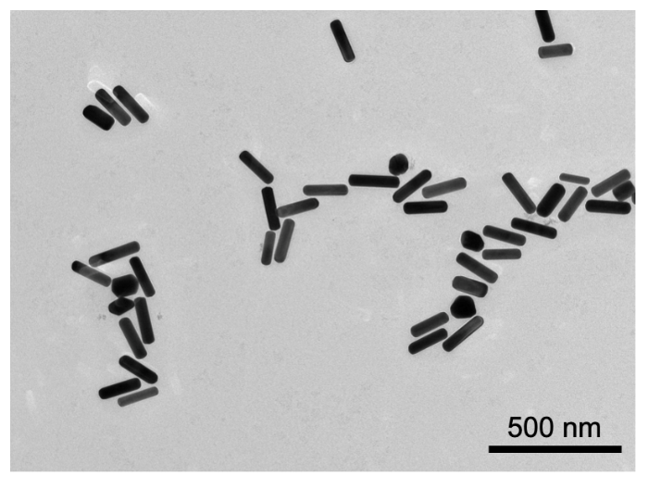
Fig. S1 TEM image of the AuNRs
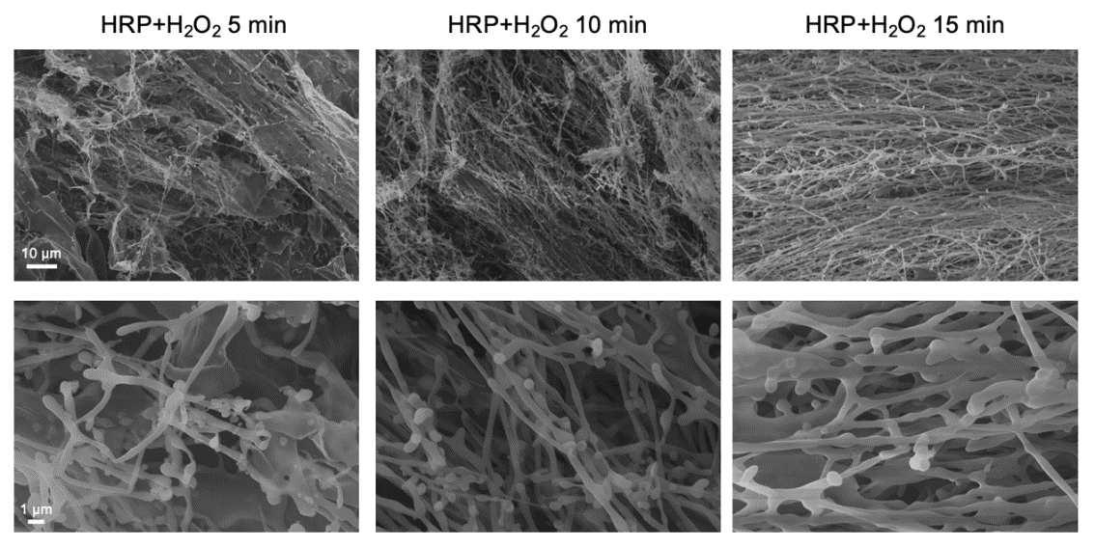
Fig. S2 SEM images of RSF (with HRP and H₂O₂) nanofibril solutions at different sonication times
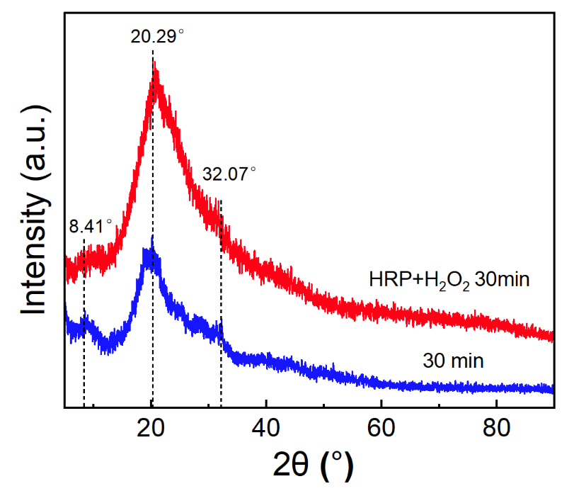
Fig. S3 XRD analysis of RSF (with or without HRP and H₂O₂) nanofibril solutions after 30 min sonication
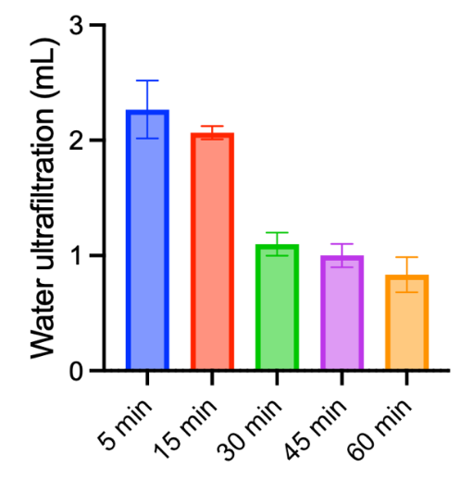
Fig. S4 Water content of RSF nanofibril solutions filtered at different ultrafiltration times
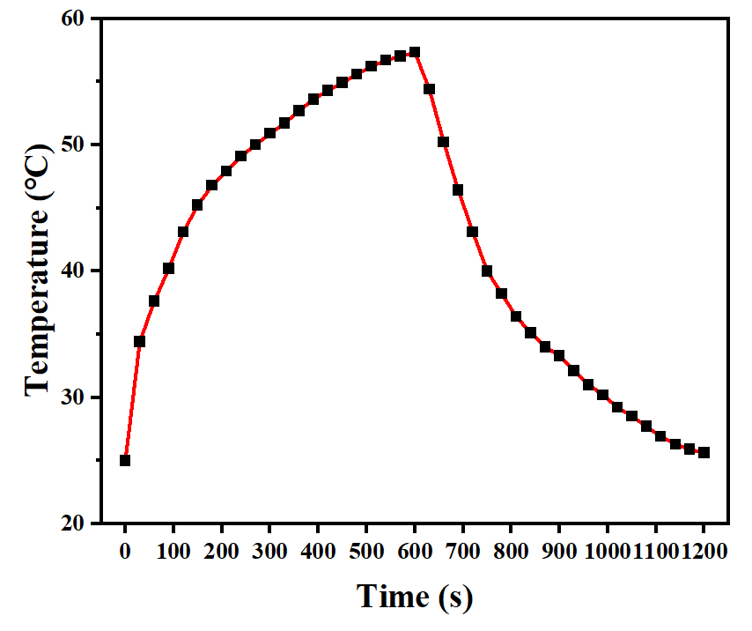
Fig. S5 Temperature changes in Nanorobot/RSF nanofibril hydrogels cooled after 10 min of irradiation with a 980 nm laser (2.0 W cm⁻²)
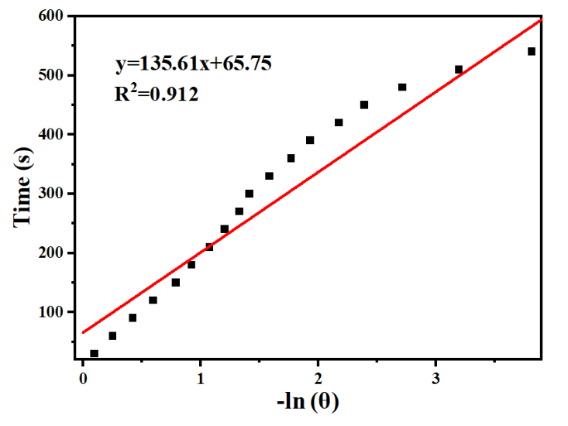
Fig. S6 Linear time data from the cooling period versus -Ln (θ)
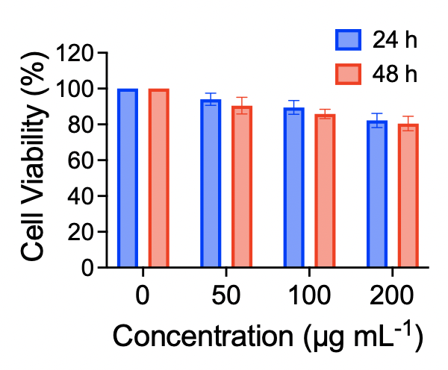
Fig. S7 CCK8 assay of normal cells (AML-12) co-cultured with AuNR-Silica NP/Thr. Data are presented as the mean ± s.d.
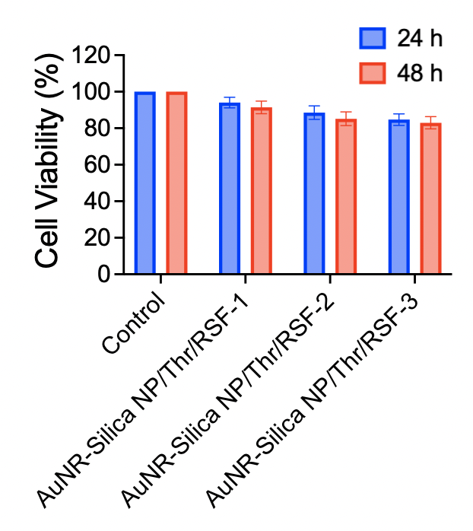
Fig. S8 CCK8 assay of normal cells (AML-12) co-cultured with AuNR-Silica NP/Thr/RSF nanofibril hydrogels (AuNR-Silica NP/Thr/RSF-1 represents AuNR-Silica NP/Thr concentration of 50 μg/mL⁻¹, AuNR-Silica NP/Thr/RSF-2 represents AuNR-Silica NP/Thr concentration of 100 μg/mL⁻¹, and AuNR-Silica NP/Thr/RSF-3 represents AuNR-Silica NP/Thr concentration of 200 μg/mL⁻¹)
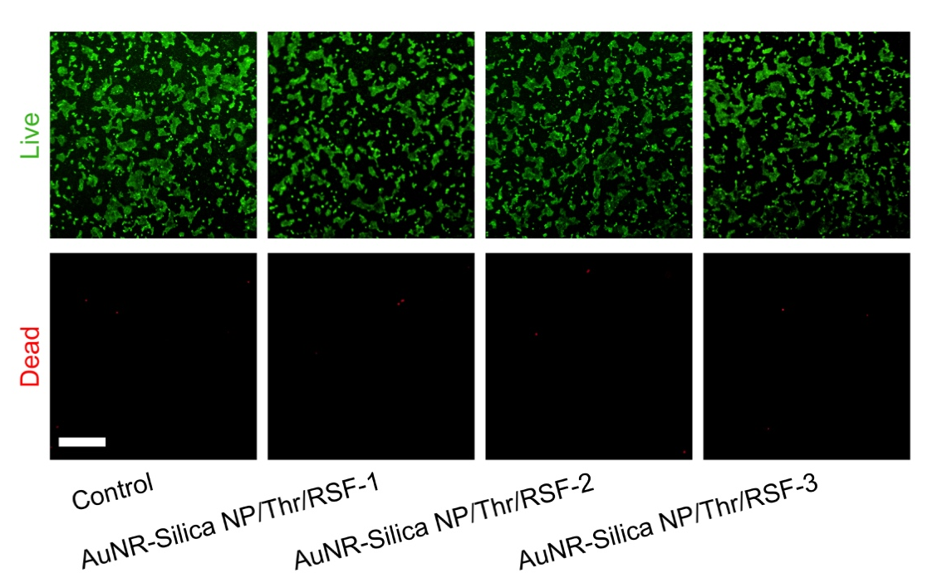
Fig. S9 Live/dead staining of AML-12 cells treated with RSF nanofibril hydrogels and AuNR-Silica NP/Thr/RSF nanofibril hydrogels (green fluorescence for live cells and red fluorescence for dead cells. AuNR-Silica NP/Thr/RSF-1 represents AuNR-Silica NP/Thr concentration of 50 μg/mL⁻¹, AuNR-Silica NP/Thr/RSF-2 represents AuNR-Silica NP/Thr concentration of 100 μg/mL⁻¹, and AuNR-Silica NP/Thr/RSF-3 represents AuNR-Silica NP/Thr concentration of 200 μg/mL⁻¹). Scale bar, 200 μm
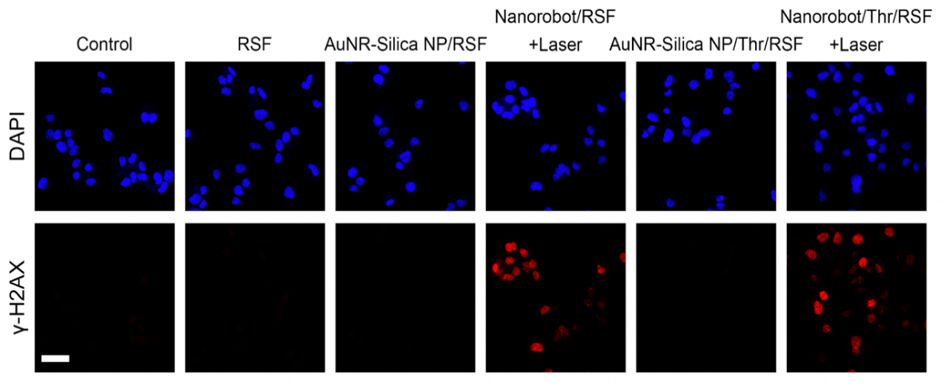
Fig. S10 γ-H2AX fluorescence images of the MHCC-97H cells with different treatments. Scale bar, 50 μm
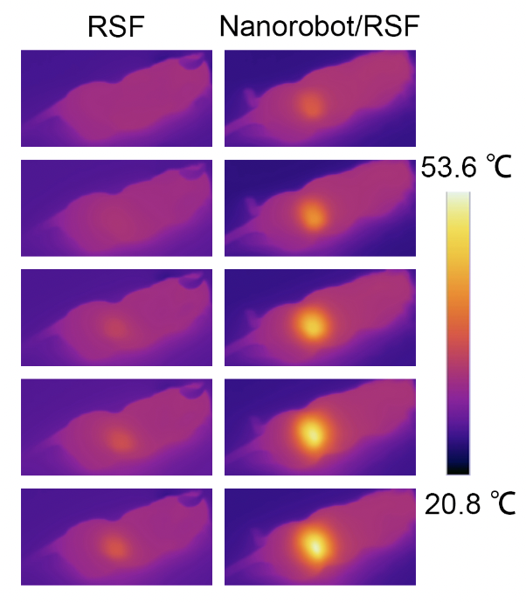
Fig. S11 Photothermal imaging of Nanorobot/RSF nanofibril hydrogels
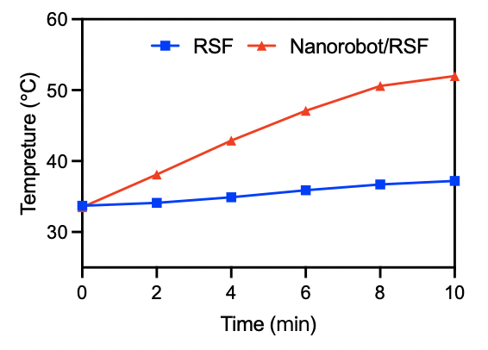
Fig. S12 Photothermal temperature curves of Nanorobot/RSF nanofibril hydrogels
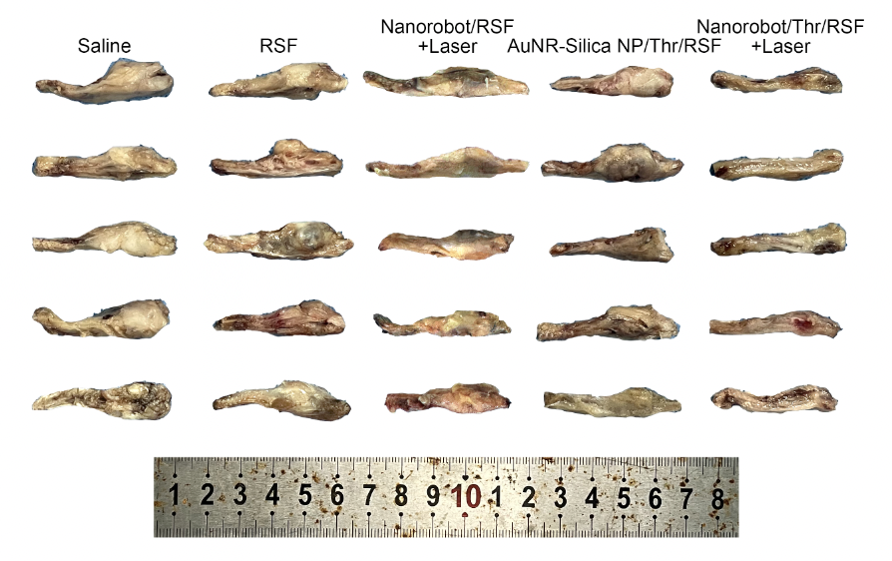
Fig. S13 Spinal tumor specimens after different treatments of HCC spinal metastasis
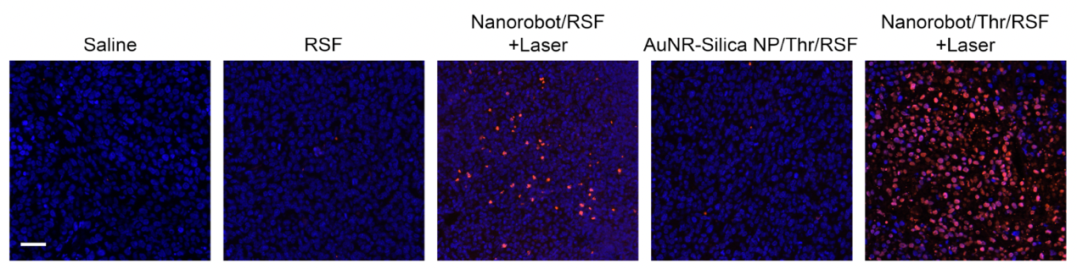
Fig. S14 TUNEL staining after different treatments of HCC spinal metastasis. Scale bar, 40 μm
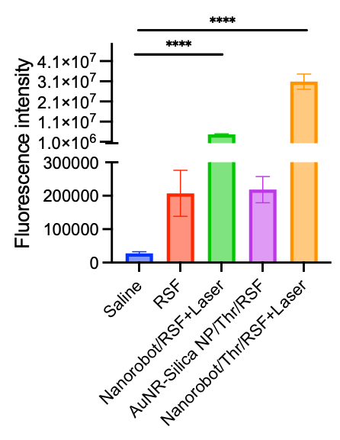
Fig. S15 Fluorescence intensity of TUNEL staining after different treatments of HCC spinal metastasis
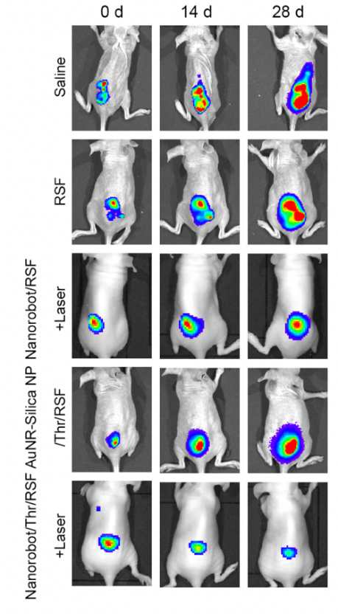
Fig. S16 In vivo imaging of renal cancer spinal metastasis in nude mice with different treatments and at different time points
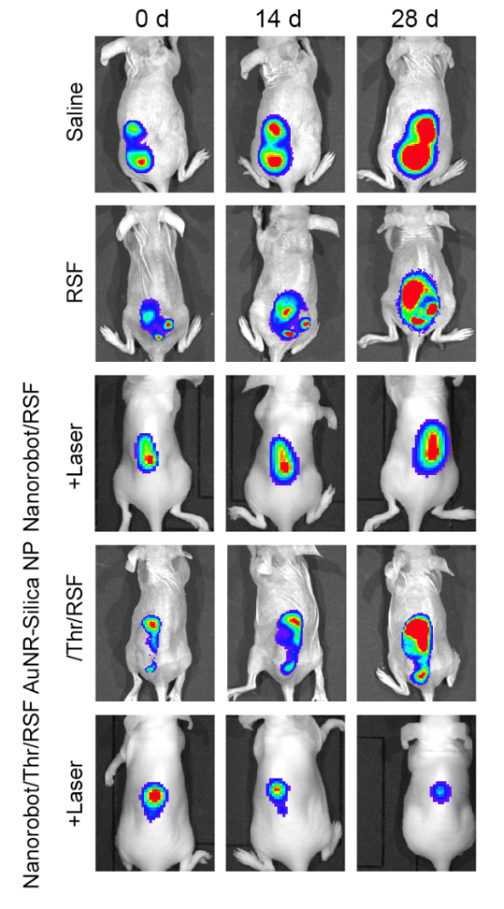
Fig. S17 In vivo imaging of thyroid cancer spinal metastasis in nude mice with different treatments at different time points
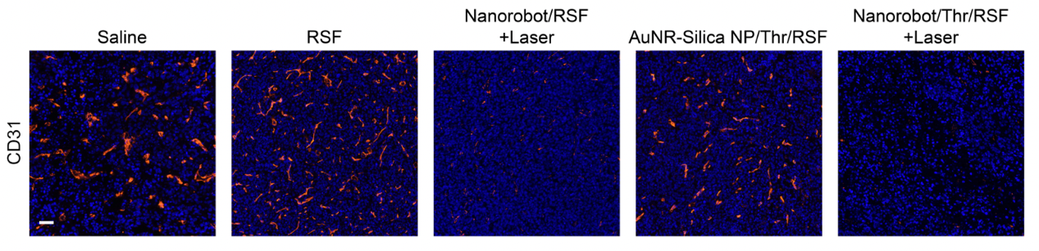
Fig. S18 CD31 fluorescent staining in postoperative recurrence of HCC spinal metastasis. Scale bar, 50 μm
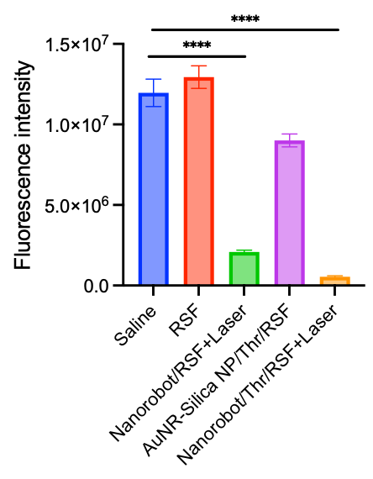
Fig. S19 CD31 fluorescence intensity in postoperative recurrence of HCC spinal metastasis
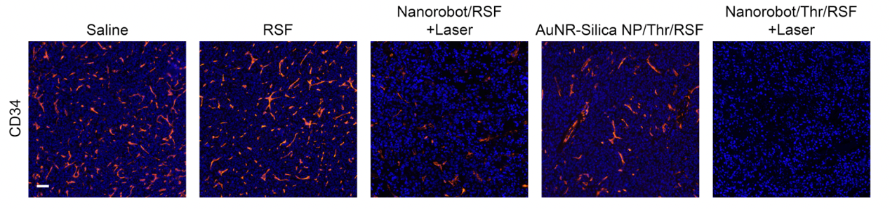
Fig. S20 CD34 fluorescent staining in postoperative recurrence of HCC spinal metastasis. Scale bar, 50 μm
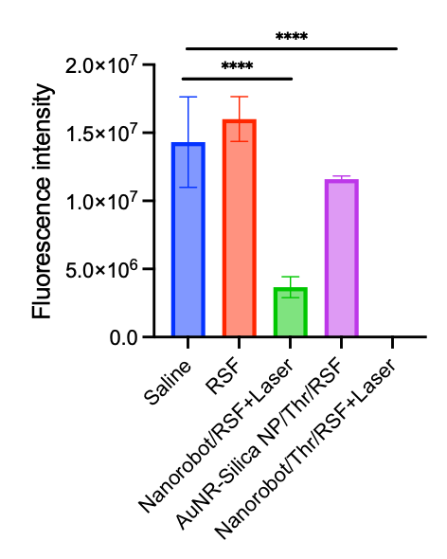
Fig. S21 CD34 fluorescence intensity in postoperative recurrence of HCC spinal metastasis
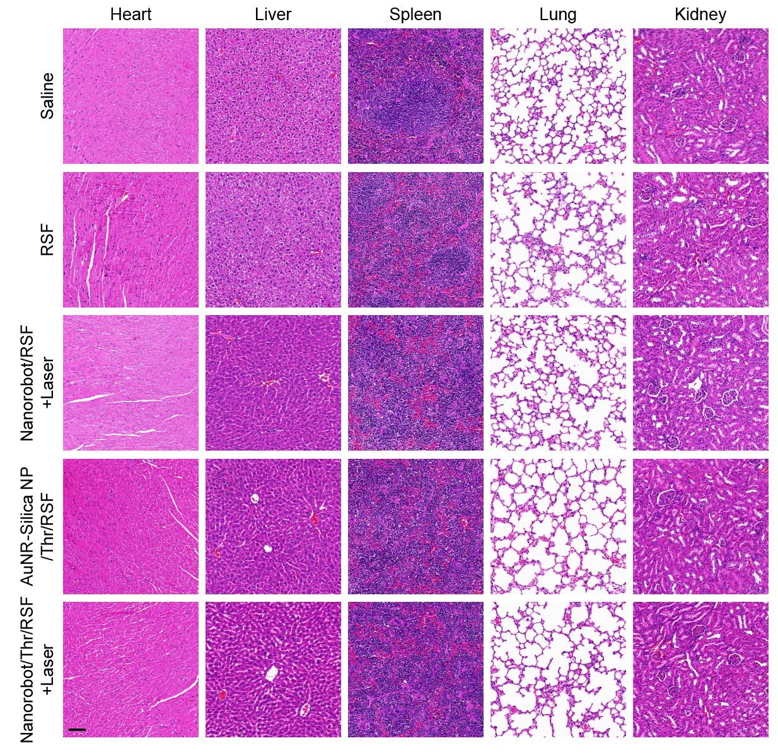
Fig. S22 H&E staining of major organs after different treatments of HCC spinal metastasis. Scale bar, 20 μm
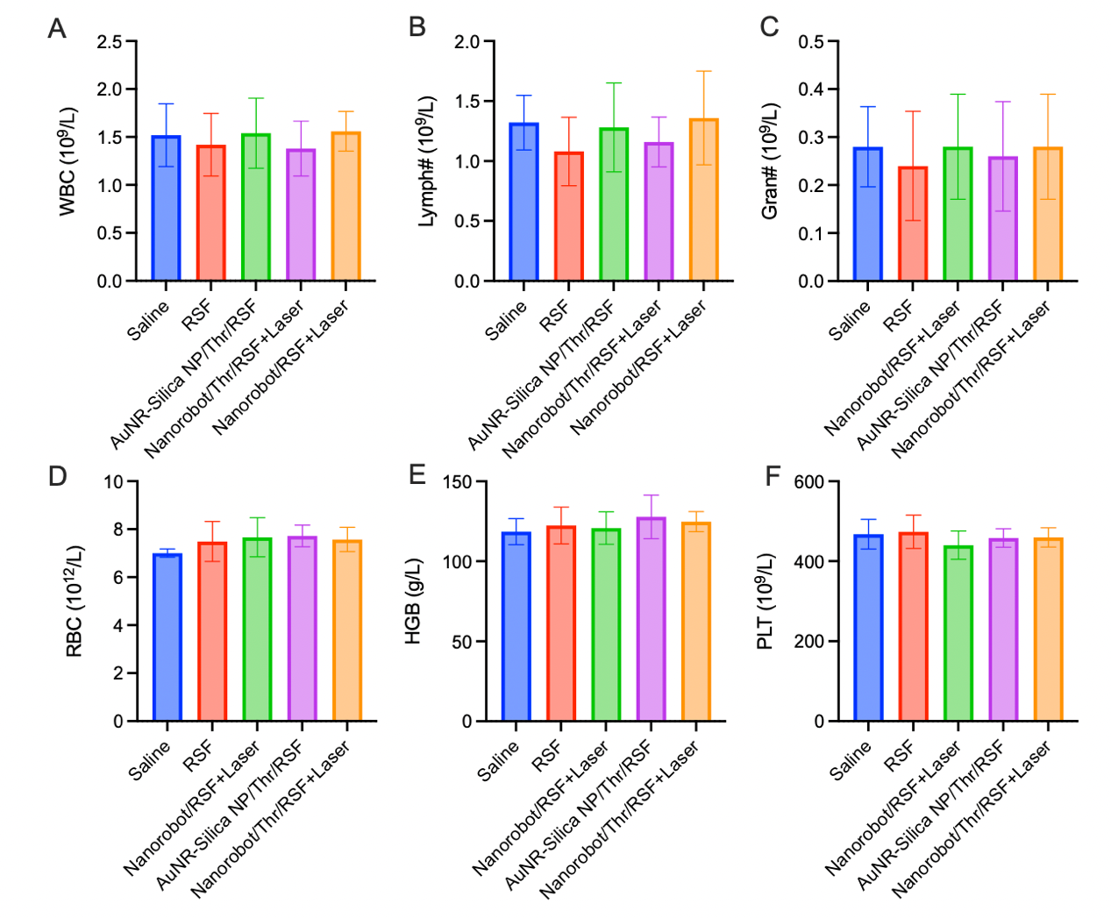
Fig. S23 Blood counts after different treatments of HCC spinal metastasis. Blood cells (WBC), lymphocytes (Lymph#), granulocytes (Gran#), red blood cells (RBC), hemoglobin (HGB), and platelets (PLT)
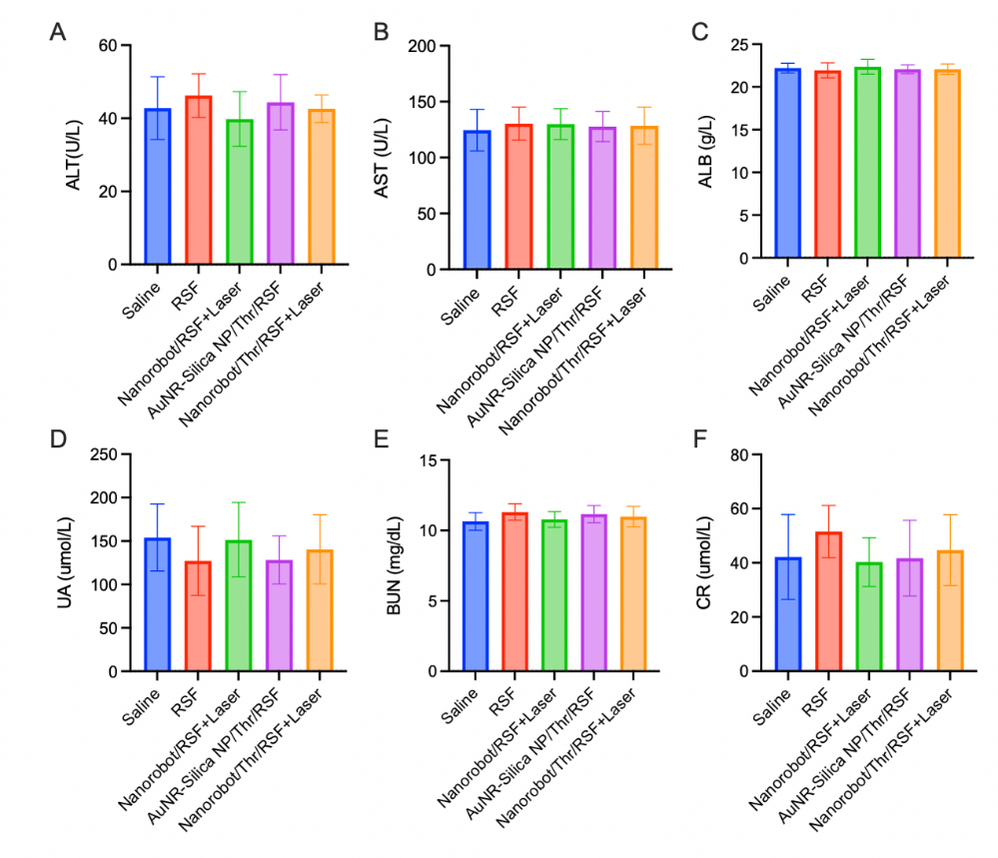
Fig. S24 Liver function and kidney function after different treatments of HCC spinal metastasis. Alt alanine aminotransferase (ALT), aspartate transaminase (AST), albumin (ALB), uric acid (UA), blood urea nitrogen (BUN), and creatinine (CR)

