Supporting Information for

Highly Sensitive Ammonia Gas Sensors at Room Temperature Based on the Catalytic Mechanism of N, C Coordinated Ni Single-Atom Active Center

Wenjing Quan^{1, 2}, Jia Shi^{1, 2}, Min Zeng^{1,} *, Wen Lv^{1, 2}, Xiyu Chen^{1, 2}, Chao Fan^{1, 2}, Yongwei Zhang^{1, 2}, Zhou Liu^{1, 2}, Xiaolu Huang^{1, 2}, Jianhua Yang^{1, 2}, Nantao Hu^{1, 2}, Tao Wang³, Zhi Yang^{1,} *

¹National Key Laboratory of Advanced Micro and Nano Manufacture Technology, Shanghai Jiao Tong University, Shanghai, 200240, China
²Department of Micro/Nano Electronics, School of Electronic Information and Electrical Engineering, Shanghai Jiao Tong University, Shanghai, 200240, China
³Shanghai Key Laboratory of Intelligent Sensing and Detection Technology, School of Mechanical and Power Engineering, East China University of Science and Technology, Shanghai, 200237, China.

*Corresponding authors. E-mail: minzeng@sjtu.edu.cn (M. Zeng) and zhiyang@sjtu.edu.cn (Z. Yang)

S1 Preparation Methods of Different Gas-Sensing Materials, MXene-Based Electrodes, and Fully Flexible Gas Sensors
S1.1 Preparation Methods of Different Gas-Sensing Materials
S1.1.1 Synthesis of ZIF-8, Ni-ZIF-8 and Ni₅₀₀-ZIF-8 Precursors
In a typical procedure, 2.19 g of MeIM (Bidepharm Co., Ltd., 98%) was dispersed in 67 mL methanol (Sinopharm Chemical Reagent Co., Ltd., ≥ 99.5%) and sonicated for 30 min, which was slowly dropped into 67 mL methanol containing 0.96 g of Zn(NO₃)₂·6H₂O (Sinopharm Chemical Reagent Co., Ltd., ≥ 99.0%) under stirring at room temperature, followed by the ZIF-8 was grown under stirring treatment for 24 h. The dispersion was centrifuged and washed at 8000 rpm for 3 min with methanol several times and dried in a freeze dryer for 12 h, thus the ZIF-8 precursor was collected. Furthermore, for the preparation of Ni-N-C and Ni-NPs/NC, we also synthesized Ni-ZIF-8 and Ni₅₀₀-ZIF-8, respectively, with different adsorbed Ni content using the same procedure, but an extra 49.43 mg of Ni(NO₃)₂·6H₂O or 500.00 mg of Ni(NO₃)₂·6H₂O was dissolved in 67 mL Zn(NO₃)₂·6H₂O/methanol mixing solution under ultrasonic mixing for 30 min to form Ni-ZIF-8 or Ni₅₀₀-ZIF-8, respectively.

S1.1.2 Synthesis of Ti₃C₂T_{x} Gas-Ssensing Material
The Ti₃C₂T_{x} gas sensing material was prepared by the liquid etching method. 1.0 g of LiF salt (Meryer Co., Ltd., 99.99%) was dispersed in 10 mL of 12.0 M HCl (Sinopharm Chemical Reagent Co., Ltd., 36%) and stirred for 30 min, then 1.0 g of Ti₃AlC₂ powder (400 mesh, purchased from 11 Technology Co., Ltd.) was slowly added to the mixture solution. After stirring at 35 °C for 24 h under a water bath, the obtained Ti₃C₂T_{x} suspension was centrifugated and washed at 8500 rpm for 5 min with DI water several times. The Ti₃C₂T_{x} precipitate was collected and dried in a freeze-dryer overnight to form the Ti₃C₂T_{x} gas sensing material.

S1.1.3 Synthesis of Ni-ZIF-8-CTAB-Ti₃C₂T_{x} Precursor
Briefly, 0.40 g of hexadecyl trimethyl ammonium bromide (CTAB, Sinopharm Chemical Reagent Co., Ltd., 99.0%) was dissolved in 20 mL methanol and sonicated for 30 min, which was added into 47 mL methanol containing 0.96 g of Zn(NO₃)₂·6H₂O and 49.43 mg of Ni(NO₃)₂·6H₂O (Sinopharm Chemical Reagent Co., Ltd., ≥ 99.0%) under stirring at room temperature to form solution A. In the meantime, 2.19 g of MeIM was dissolved into 67 mL methanol and sonicated for 30 min to form clear solution B. Then, solutions A and B were mixed under magnetic stirring. Stirring was continued after 2 h, and the 35 mL component solutions were collected to form solution C. 0.2 g of Ti₃C₂T_{x} gas sensing material was dissolved in 5 mL methanol under ultrasonic mixing for 30 min to form solution D. Then, solution D was slowly added into solution C with stirring for 24 h at room temperature. The obtained product was separated by centrifugation and washed subsequently with methanol three times and finally dried in a freeze dryer for 12 h.

S1.1.4 Synthesis of N-C, Ni NPs/N-C, Ni-N-C and Ni-N-C/Ti₃C₂T_{x} Materials
The ZIF-8, Ni₅₀₀-ZIF-8, Ni-ZIF-8, and Ni-ZIF-8-CTAB-Ti₃C₂T_{x} precursors were placed in a tube furnace and subsequently heated to 850 °C (heating rate 5 ℃/min) in a stream of argon gas for 2 h to yield the final N-C, Ni NPs/N-C, Ni-N-C, and Ni-N-C/Ti₃C₂T_{x} materials, respectively.

S1.2 Preparation Methods of Different MXene-Based Electrodes
S1.2.1 Synthesis of the Aqueous Ti₃C₂T_{x}-MXene Electrode (ME) Ink and the Hybrid Ti₃C₂T_{x}-MXene/NMP/PEDOT:PSS Electrode (MNPE) Ink
The etchant consisted of 1.6 g of LiF salt, which was dissolved in 40 mL of 9.0 M HCl and pre-stirred for 30 min. Subsequently, 1.0 g of Ti₃AlC₂ powder was gradually introduced into the etchant. The resulting mixture was stirred for 24 h in a 35 °C water bath. The as-prepared Ti₃C₂T_{x} dispersion was then subjected to centrifugation and washed with DI water at 8500 and 3500 rpm repeatedly until the pH of the supernatant reached 6, yielding the Ti₃C₂T_{x} electrode material. After decanting the supernatant, 9 mL of NMP (Meryer Co., Ltd., 99.5%) and 1 mL PEDOT:PSS (CLEVIOS PH1000, from Heraeus) was added to the Ti₃C₂T_{x} sediment, and the dispersion was sonicated for 2 h. The well-dispersed flakes were then separated from the aggregated platelets by centrifugation at a low speed (1500 rpm, 30 min). The supernatant was left overnight and then continued further collection of the supernatant. After that, the supernatant was vigorously sonicated at 400 W for 4 h to obtain the MNPE ink. Furthermore, we also synthesized the ME ink with 10 mL of DI water through the same procedure.

S1.2.2 Inkjet-Printing of ME and MNPE
The two inks were inkjet printed using a Hewlett-Packard Laserjet P1007 printer on the paper substrate. The printer was fitted with the cartridge, preparing the flexible paper-based ME by dropping the ME ink into it and continuously inkjet-printing 10 times. What’s more, the flexible MNPE was printed by alternate inkjet-printing of ME ink and MNPE hybrid ink on paper for a total of 10 times.

S1.3 Fabrication of Fully Flexible Gas Sensors
After that, 20 μL ethanol dispersion containing 10 mg of different gas sensing materials was dropped on the AuE, ME, and MNPE to fabricate a variety of gas sensors. These devices were dried at 60 °C for 12 h in a vacuum drying oven.

S1.4 Materials Characterization
The morphology of the samples was determined by SEM (Carl Zeiss Ultra Plus, Germany) and TEM (HT7000 Hitachi, Tokyo, Japan). The element compositions and structure of each sample were identified using XRD (D8 ADVANCE, Bruker, Germany) with Cu Kα diffraction (λ = 0.154056 nm). The elemental composition and bond structures of synthesized samples were analyzed using a Kratos Axis Ultra DLD (Kratos Analytical, UK) XPS system equipped with a monochromatic Al Kα source. The surface area and the pore size distribution of the samples were obtained by the N₂ isothermal adsorption/desorption at 77 K on a Micromeritics TriStar II 3020 analyzer (Micromeritics, USA). The HAADF-STEM and EDS images of dispersed Ni over the N-C framework were captured on a JEOL ARM200F (JEOL, Japan) with a 200 kV operation voltage. The XAFS spectra at the Ni K-edge were conducted at the X-ray absorption fine structure for catalysis (XAFCA) beamline at the Singapore Synchrotron Light Source (SSLS) in fluorescence mode. Ni foil and NiO served as reference materials. The EXAFS data were acquired following standard procedures based on the ATHENA module within the IFEFFIT software packages. Quantitative analysis of the samples was performed through least-squares curve fitting in the R space, employing a Fourier transform k space range from 2.4 to 10.4 Å⁻¹, with the ARTEMIS module of the IFEFFIT programs. Fourier transform infrared (FTIR) spectroscopy was performed on Nicolet 6700 FTIR spectrometers (Thermo Nicolet, Madison, WI) with a spectral range of 400 to 4000 cm⁻¹. Raman analysis was obtained by using a confocal InVia Raman microscope (England, Renishaw) with the 633 nm laser. TGA analyses of samples were conducted on an SDT-Q600 thermogravimetric analyzer (New Castle, DE, USA) at a heating rate of 5 °C min⁻¹ in Ar. The contents of Ni in the samples were obtained by the ICP-MS iCAP Q (Thermo Fisher Scientific, Waltham, USA). The rheological properties of ME, as well as MNPE inks, were studied on the rheometer (Anton Paar Physica MCR 301, Graz, Austria). The electrical conductivity of the as-printed electrodes was tested through a four-point probe technique (RTS-11, Guangzhou Four Probe Co., Ltd.). The band gap of samples was assessed via UV-vis spectroscopy (Lamda 950, PerkinElmer, USA). The hydrodynamic diameter and the zeta potential measurements of the Ti₃C₂T_{x}-based electrode inks were carried out by NanoBrook 90Plus PALS analyzer (Brookhaven, USA). The static contact angles and the surface tension of the electrode inks were evaluated using a Kruss DSA30S analyzer (Kruss, Germany). The valence band and the position of the Fermi level were investigated using UPS (Kratos Axis Ultra DLD, UK).

S2 Supplementary Figures and Tables

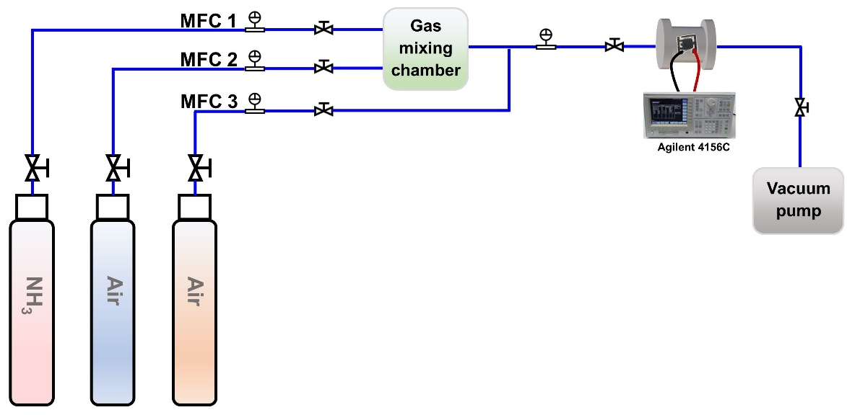
Fig. S1 Schematic diagram of the gas sensing performance test system.
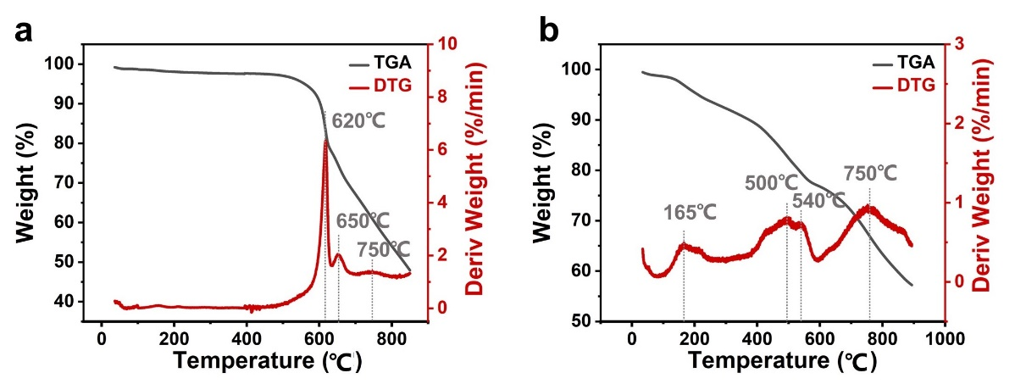
Fig. S2 The TGA–DTG of Ni-ZIF-8 and Ni-ZIF-8-CTAB-Ti₃C₂T_{x} precursor. TGA (grey) and its corresponding first-order differential curve (red) of a Ni-ZIF-8 and b Ni-ZIF-8-CTAB-Ti₃C₂T_{x} precursors under Ar.

The typical weight losses at about 500–650 °C were attributed to the organic linkers decomposition of Ni-ZIF-8 and Ni-ZIF-8-CTAB-Ti₃C₂T_{x} which were transformed into N-C skeletons. When the temperature rose to over 750 °C, the Zn species with a low boiling point were released leaving N-rich defects [S1]. It is worth noting that in contrast to Ni-ZIF-8, there was a typical weight loss at about 165 °C in Ni-ZIF-8-CTAB-Ti₃C₂T_{x} which was attributed to the carbonization of CTAB [S2].

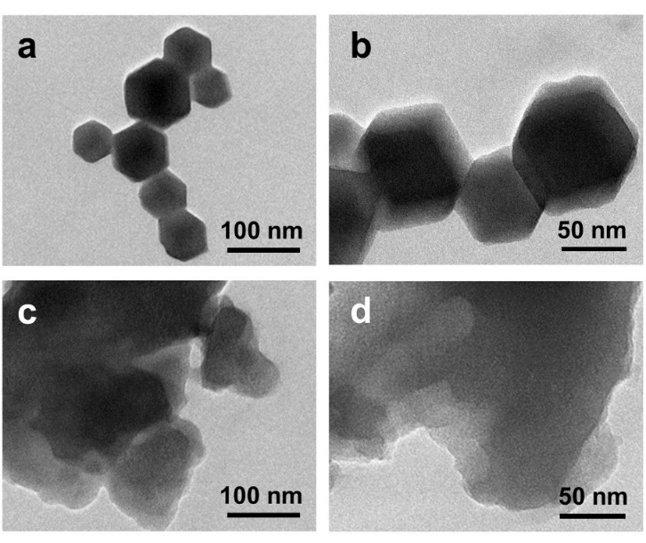
Fig. S3 The structure characterizations of ZIF-8 and N-C catalysts. a–b TEM images of the ZIF-8 material. c–d TEM images of the N-C material.

The initial ZIF-8 and Ni-ZIF-8 precursors exhibited a uniform rhombododecahedral shape and size distribution with an average size of 80 nm (Figs. S3a–b and S4a–b).
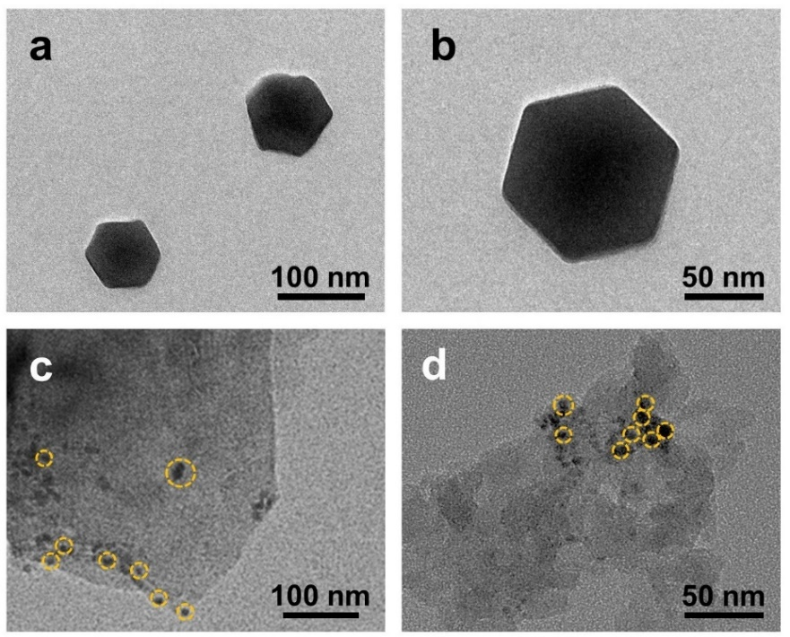
Fig. S4 The structure characterizations of Ni-ZIF-8 and Ni NPs/N-C catalysts. a–b TEM images of the Ni-ZIF-8 material. c–d TEM images of the Ni NPs/N-C material.
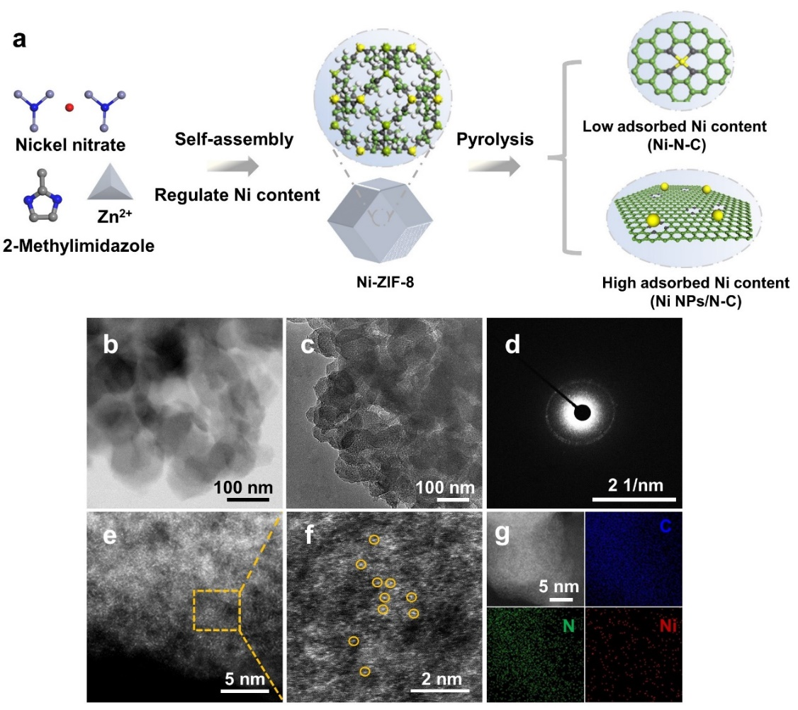
Fig. S5 The preparation process and structure characterizations of Ni-N-C. a The preparation process of Ni-N-C. b–c The HAABF-STEM and TEM images of Ni-N-C catalyst. d Corresponding selected-area electron diffraction (SAED) pattern of Ni-N-C catalyst. e–f The HAADF-STEM images of Ni-N-C catalyst. g The corresponding EDS for carbon (C), nitrogen (N), and nickel (Ni) elements of Ni-N-C catalyst.

Furthermore, by regulating the content of adsorbed Ni²⁺ and the number of anchoring sites, thus the Ni NPs/N-C and Ni-N-C formed during the pyrolysis (Figs. S4 and S5). The resulting Ni-NPs/N-C and Ni-N-C catalysts lose the protection of CTAB, and the dense and homogeneous rhombododecahedral morphology of the Ni-ZIF-8 precursor cannot be well-retained (Fig. S4c). There are significant Ni clusters on the N-C substrate surface in the sample of Ni NPs/N-C displayed in Fig. S4d. Furthermore, the Ni-N-C structure has poor crystallinity demonstrated in the SAED pattern (Fig. S5d). The HAADF-STEM images (Fig. S5e, f) and the EDS mapping results (Fig. S5g) of Ni-N-C suggest that the Ni species on the N-C surface dominantly exhibit atomic dispersion and Ni, N, and C are homogeneously dispersed on the whole structure.
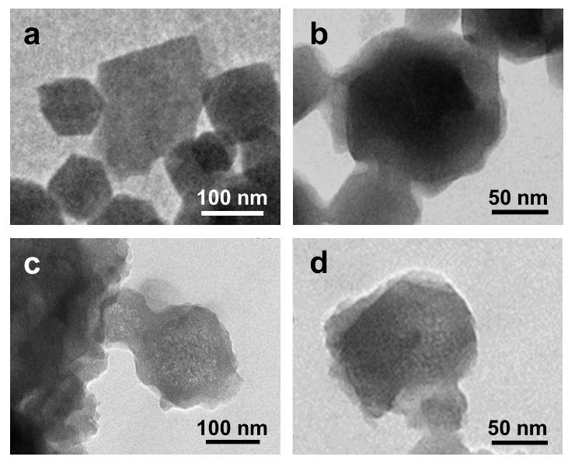
Fig. S6 The structure characterizations of Ni-ZIF-8-CTAB-Ti₃C₂T_{x} precursor and Ni-N-C/Ti₃C₂T_{x} catalyst. a–b TEM images of the Ni-ZIF-8-CTAB-Ti₃C₂T_{x} precursor. c–d TEM images of the Ni-N-C/Ti₃C₂T_{x} catalyst.

Compared to the shape of the ZIF-8 and Ni-ZIF-8 precursor, a hybrid nanostructure is observed in the Ni-ZIF-8-CTAB-Ti₃C₂T_{x} precursor (Fig. S6a and b), which consisted of the stacked 2D structure of the Ti₃C₂T_{x} membrane, a surfactant CTAB polymer and Ni-ZIF-8 structure with rhombododecahedral shape, indicating that the addition of CTAB-surfactant did not influence the crystalline structure of the Ni-ZIF-8 and Ti₃C₂T_{x}. It is worth noting that due to the capping ability of CTAB-surfactant, the particle sizes of the Ni-ZIF-8 particles in the Ni-ZIF-8-CTAB-Ti₃C₂T_{x} precursor decreased obviously.
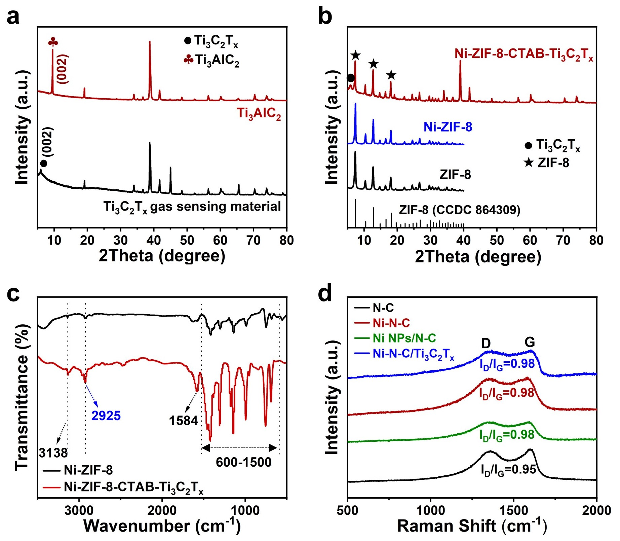
Fig. S7 The structural and Raman analysis of Ti₃C₂T_{x} gas sensing material, Ni-ZIF-8-CTAB-Ti₃C₂T_{x} precursor, N-C, Ni-N-C, Ni NPs/N-C, and Ni-N-C/Ti₃C₂T_{x} catalysts. a XRD spectra of the Ti₃AlC₂ and Ti₃C₂T_{x} gas sensing material. b XRD spectra of ZIF-8, Ni-ZIF-8, and Ni-ZIF-8-CTAB-Ti₃C₂T_{x} precursors. c The Fourier transform infrared (FTIR) spectra of Ni-ZIF-8 and Ni-ZIF-8-CTAB-Ti₃C₂T_{x} precursors. d Raman spectra of N-C, Ni-N-C, Ni NPs/N-C, and Ni-N-C/Ti₃C₂T_{x} samples.

After etching with HCl and LiF, the XRD peak of Ti₃C₂T_{x} gas sensing material corresponding to the (002) plane moved from 9.5° to 6.0° in Fig. S7a, due to the etched Al atom layers and the introduction of the surface functional group [S3], which indicated the successful synthesis of Ti₃C₂T_{x} gas sensing material. Furthermore, the XRD pattern of Ni-ZIF-8 was matched with that of ZIF-8 and observed no obvious characteristic peaks corresponding to Ni, since the content of Ni was too low to be detected (Fig. S7b). Furthermore, the absorption in Fourier Transform Infrared Spectroscopy (FTIR) at 600–1500 cm⁻¹, 1584 cm⁻¹, and 3138 cm⁻¹, which could be attributed to the vibration of the imidazole units, the stretching vibration of C=N band, and C–H bond of imidazole rings, respectively, were present in Ni-ZIF-8 and Ni-ZIF-8-CTAB-Ti₃C₂T_{x} samples (Fig. S7c) [S4]. Furthermore, the fluctuation in the intensity of the 2925 cm⁻¹ characteristic peak in the absorption in FTIR spectra assigned to the stretching vibration signals of C–H bonds of methyl in the samples showed that compared to the Ni-ZIF-8 precursor, Ni-ZIF-8-CTAB-Ti₃C₂T_{x} had distinct long-chain alkanes structure, corresponding to the CTAB surfactant [S5]. Raman spectra (Fig. S7d) indicated that all catalysts exhibited similar carbon structures with dominant D and G bands at 1350 and 1590 cm⁻¹, regardless of the Ni doping level, associated with the disordered carbons and sp² hybridized graphitic carbons, respectively. The Raman spectra of Ni-N-C, Ni-N-C/Ti₃C₂T_{x}, and Ni NPs/N-C demonstrated a relatively high I_{D}/I_{G} value of 0.98, indicating larger amounts of defects than N-C material [S6].

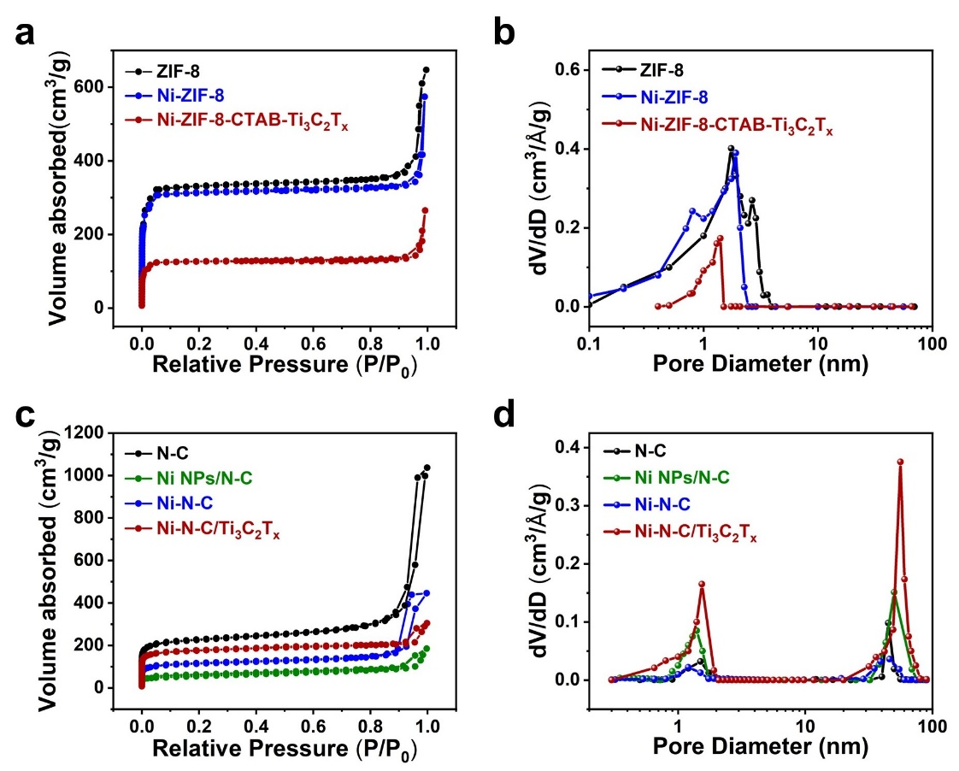
Fig. S8 The nitrogen adsorption-desorption analysis of precursors and calcined products. a N₂ adsorption-desorption curves of ZIF-8, Ni-ZIF-8, and Ni-ZIF-8-CTAB-Ti₃C₂T_{x} precursors. b The corresponding pore size distributions of ZIF-8, Ni-ZIF-8, and Ni-ZIF-8-CTAB-Ti₃C₂T_{x} precursors. c N₂ adsorption-desorption curves of N-C, Ni-N-C, Ni NPs/N-C, and Ni-N-C/Ti₃C₂T_{x} samples. d The corresponding pore size distributions of N-C, Ni-N-C, Ni NPs/N-C, and Ni-N-C/Ti₃C₂T_{x} samples.

N₂ adsorption/desorption analysis indicated that, for all precursors, the adsorption isotherm generated resembled type I isotherm, which suggested a microporous structure with a similar Brunauer-Emmett-Teller (BET) surface area of around 300–1000 m²g⁻¹ (Fig. S8a, b, and Table S2) [S7]. After pyrolysis, the surface areas of all compounds showing type IV isotherm decreased to 180–700 m²g⁻¹ with increased mesopores and macropores (Fig. S8c and d) [S8].
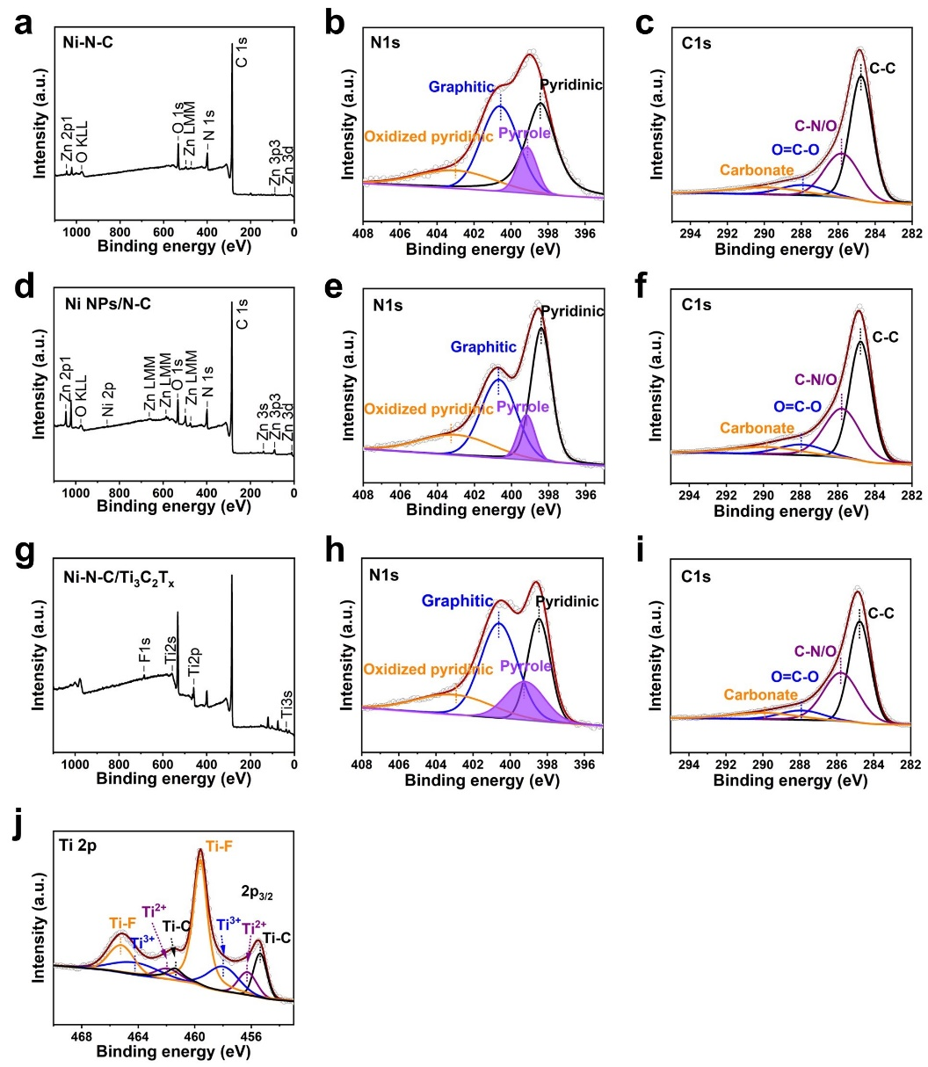
Fig. S9 The XPS analysis of Ni-N-C, Ni NPs/N-C, and Ni-N-C/Ti₃C₂T_{x} materials. XPS spectra for a survey scan, b N 1s, and c C 1s regions of Ni-N-C. XPS spectra for the d survey scan, e N 1s, and f C 1s regions of Ni NPs/N-C. XPS spectra for the g survey scan, h N 1s, i C 1s, and j Ti 2p regions of Ni-N-C/Ti₃C₂T_{x}.

The C 1s spectra of the three catalysts exhibited four main components corresponding to C-C (284.8 eV), C-N/O (285.8 eV), O=C-O (287.9 eV), and carbonate (289.7 eV) in Fig. S9c, f, and i. From the Ti 2p spectrum of Ni-N-C/Ti₃C₂T_{x} nanohybrids, the binding energies of Ti 2p_{3/2} for Ti-C, Ti²⁺, Ti³⁺, and Ti-F are 455.4, 456.3, 458.0, and 459.6 eV, respectively, in agreement with previous XPS studies (Fig. S9j) [S9].
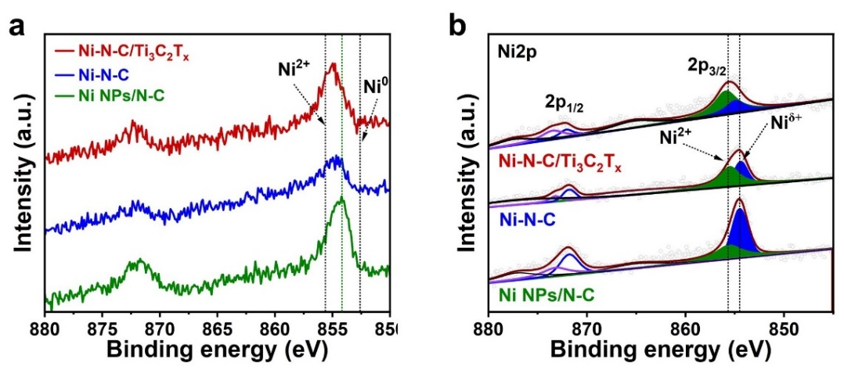
Fig. S10 The XPS analysis of Ni-N-C, Ni NPs/N-C, and Ni-N-C/Ti₃C₂T_{x} materials. a–b XPS spectra for the Ni 2p regions of Ni-N-C, Ni NPs/N-C, and Ni-N-C/Ti₃C₂T_{x} catalysis.
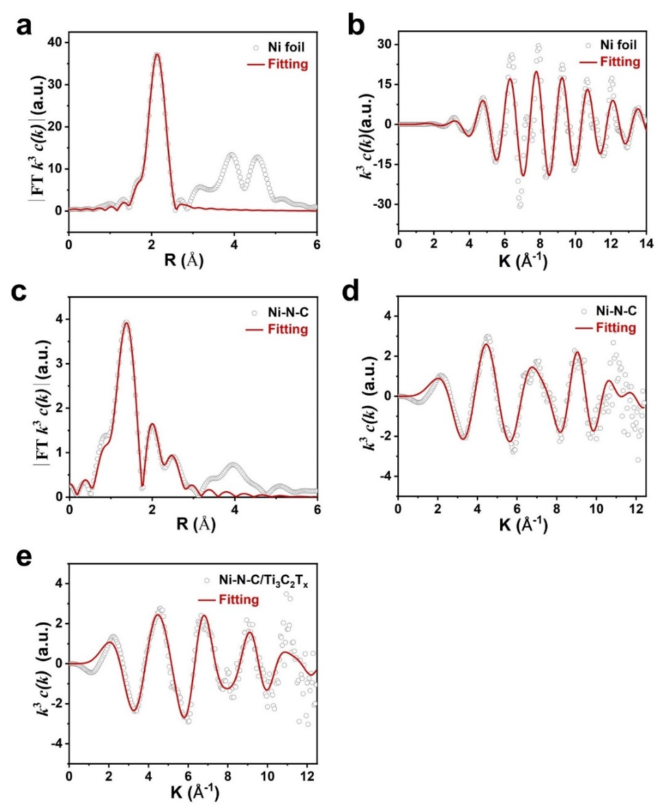
Fig. S11 The EXAFS analysis of Ni foil, Ni-N-C, and Ni-N-C/Ti₃C₂T_{x} materials. Corresponding EXAFS fitting curves for Ni foil a R-space and b K-space. Corresponding EXAFS fitting curves for Ni-N-C c R-space and d K-space. e Corresponding EXAFS fitting curves for Ni-N-C/Ti₃C₂T_{x} K-space.
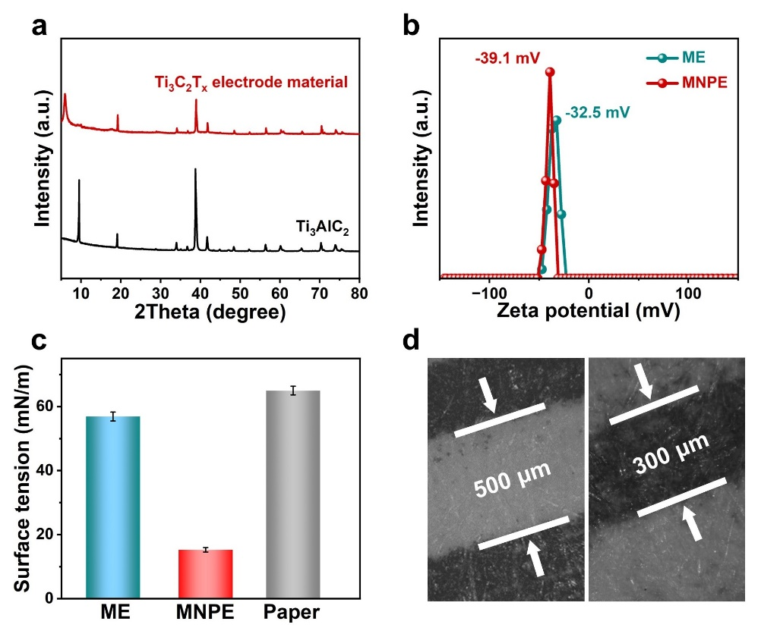
Fig. S12 The Ti₃C₂T_{x}-based inks analysis. a XRD of Ti₃AlC₂ and Ti₃C₂T_{x} electrode materials. b zeta potential of ME and MNPE inks. c The surface tension of paper substrate, ME ink, and MNPE ink. d Optical microscope images of the ME lines.

The paper substrate surface energy of 62 mN/m was higher than the surface tension of ME and MNPE inks, emphasizing the importance of substrate selection in achieving high-resolution printing of Ti₃C₂T_{x}-based inks (Fig. S12c).
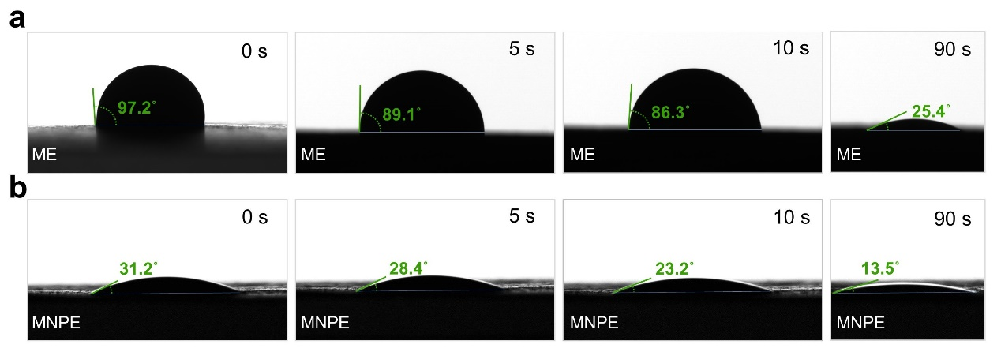
Fig. S13 The contact angles analysis of Ti₃C₂T_{x}-based inks. a Contact angles of ME ink and paper substrate. b Contact angles of MNPE ink and paper substrate.

Furthermore, the small contact angles (≪ 90°) with increasing infiltration treatment time indicated good wetting properties between the inks and paper substrate (Fig. S13).
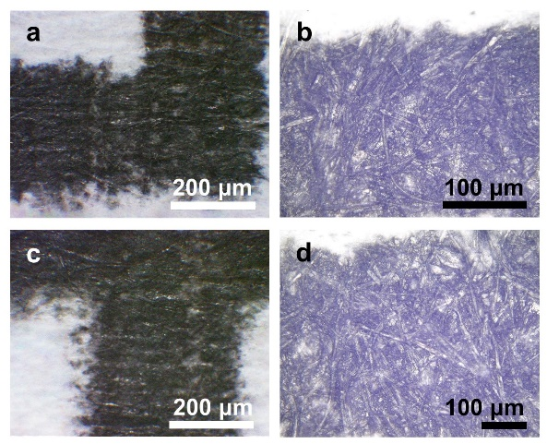
Fig. S14 The optical images of Ti₃C₂T_{x}-based electrode films. Optical microscope images of the a–b ME and c–d MNPE films.

Both Ti₃C₂T_{x}-based printed films were uniform without the coffee-ring effect (Fig. S14), demonstrating good printability of ME and MNPE inks.
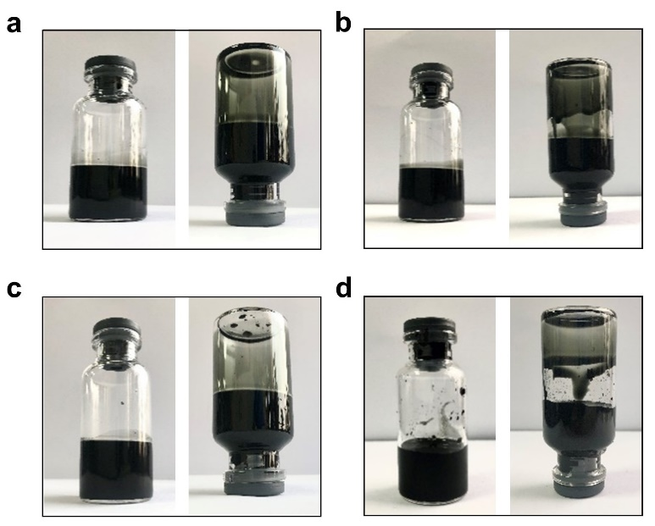
Fig. S15 The stability analysis of ME and MNPE inks. Dispersions of ME ink were monitored at time points a after ultrasound treatment and b after 10 days. Dispersions of MNPE ink were monitored at time points c after ultrasound treatment and d after 10 days.

The two Ti₃C₂T_{x}-based inks which had excellent solution processibility, appropriate viscosity, and surface energy well-matched with the substrates, had a great degree of stability that could be stable in air for 10 days, excellent conductivity, good printing adaptability, and enough versatility to design ideal patterns (Figs. S15–17).


Fig. S16 The conductivity and printing adaptability analysis of ME and MNPE films. Inkjet-printed school abbreviation SJTU (Shanghai Jiao Tong University) by a ME and b MNPE inks on paper substrate.

Two different inks were printed using an inkjet printer on paper substrates to form the “SJTU” shape and light-emitting diodes (LEDs) could be lit by both two films (Fig. S16a and b).

Fig. S17 The optical images of different patterns. Optical images of the school badges and interdigital electrodes printed by inkjet under different printing cycles.

This maskless inkjet printing technique supports a variety of pattern fabrication, paving the way for customizable geometries for gas sensors.
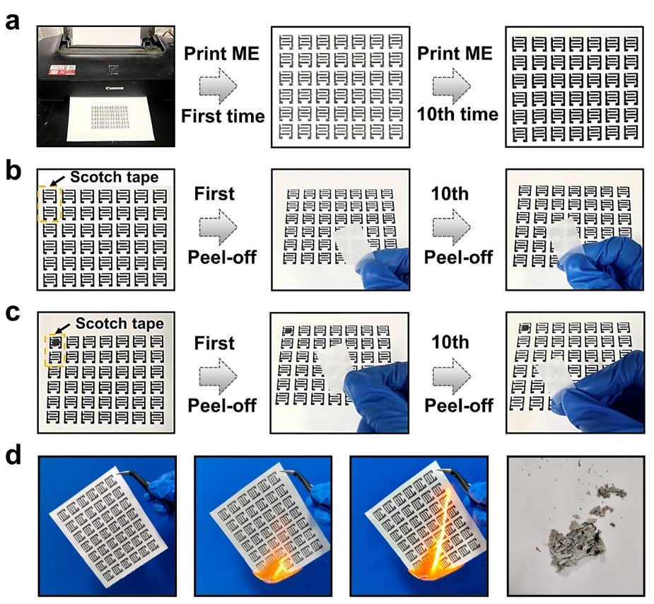
Fig. S18 The optical images of different patterns. a Optical images of paper-based ME array with the increase of printing cycles. The adhesivity of the paper-based b ME array and c integrated ME-Ni-N-C/Ti₃C₂T_{x} gas sensor tested by scotch tape. d The schematic diagram of burning the paper-based ME array.

The optical images of the paper-based ME array depicted an increase in the proportion of the surface ME ink as the printing cycles increased, finally, ME ink was evenly distributed over the paper surface (Fig. S18a). Additionally, the printed ME and ME-Ni-N-C/Ti₃C₂T_{x} gas sensor exhibited excellent structural integrity without any delamination from the substrate under sticking by cellophane tapes (Fig. S18b and c), and the combustion process proved that the flexible ME was eco-friendly (Fig. S18d).
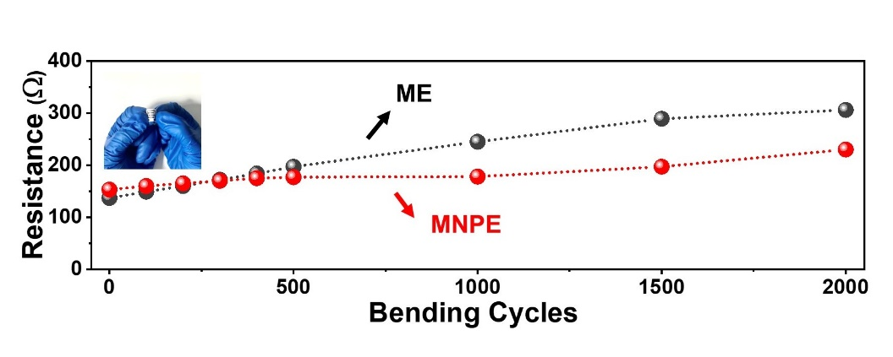
Fig. S19 The mechanical deformation analysis of ME and MNPE inks. The functional relationship between the relative change of resistance and the bending cycle of the ME and MNPE.

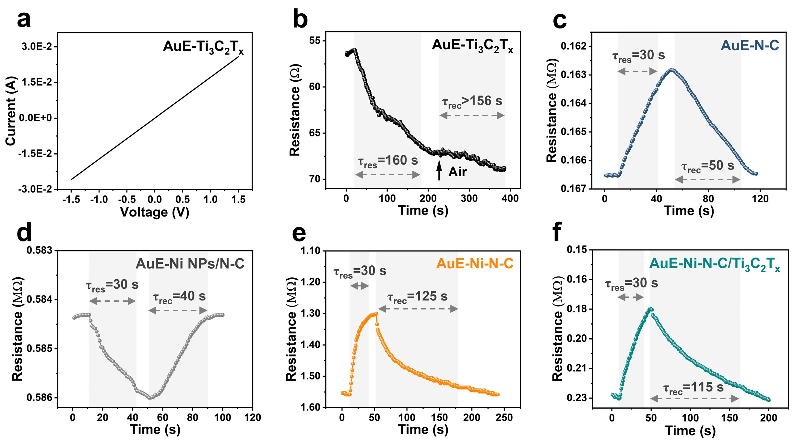
Fig. S20 Performance of different gas sensors for low-concentration NH₃ detection. a I-V curves of AuE-Ti₃C₂T_{x} sensor. b AuE-Ti₃C₂T_{x}, c AuE-N-C, d AuE-Ni NPs/N-C, e AuE-Ni-N-C, and f AuE-Ni-N-C/Ti₃C₂T_{x} sensors exposed to 5 ppm NH₃ at room temperature.

All gas sensing materials mentioned above had been constructed onto the conventional Au interdigital electrode (AuE) type gas sensors to form the AuE-N-C, AuE-Ni NPs/N-C, AuE-Ni-N-C, AuE-Ti₃C₂T_{x}, and AuE-Ni-N-C/Ti₃C₂T_{x} gas sensors for all the subsequent testing at room temperature. Although the conductivity of the AuE-Ti₃C₂T_{x} device was higher than that of the four sensors (Fig. S20a), it was to be noted that the NH₃ gas sensing curve of the AuE-Ti₃C₂T_{x} sensor cannot be restored (Fig. S20b), which was mainly due to the large stacking density of synthetic Ti₃C₂T_{x}. In addition, the slope of the I-V curve for the AuE-Ni-N-C/Ti₃C₂T_{x} sensor was enhanced in comparison with that of the AuE-Ni-N-C and AuE-Ni NPs/N-C sensors, which indicated that the conductivity of the Ni-N-C/Ti₃C₂T_{x} hybrid film was higher than that of the two sensors. Furthermore, the AuE-Ni NPs/N-C sensor was dominated by different sensing mechanisms (positive response in Fig. S20d) compared to the AuE-Ni-N-C and AuE-Ni-N-C/Ti₃C₂T_{x} sensors. The recovery rate of N-C, Ni NPs/N-C, Ni-N-C, and Ni-N-C/Ti₃C₂T_{x} sensitive materials was evaluated by fixing the response time of all sensors to 30 s. Although the surface gas diffusion rate and surface reaction rate of all sensitive materials did not reach equilibrium within 30 s, the change in the slope of all response curves indicates that the selected 30-second response time is appropriate. The recovery time of the AuE-Ni NPs/N-C sensor (40 s, Fig. S20d) to NH₃ is shorter than that of the AuE-N-C sensor (50 s, Fig. S20c), indicating that the number of surface-active sites affect the desorption rate of NH₃. Furthermore, compared to the AuE-Ni-N-C gas sensor (125 s, Fig. S20e), the AuE-Ni-N-C/Ti₃C₂T_{x} sensor exhibits a shorter recovery time for 5 ppm NH₃ (115 s, Fig. S20f). This improvement can be attributed to the high charge transfer efficiency achieved by the Ti₃C₂T_{x} conductive network, thereby decreasing the recovery time of the sensor to NH₃.
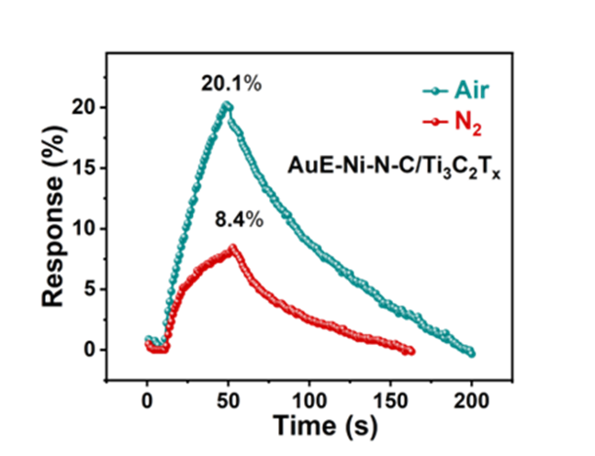
Fig. S21 The response curves of AuE-Ni-N-C/Ti₃C₂T_{x} sensor to 5 ppm NH₃ in the air and N₂.
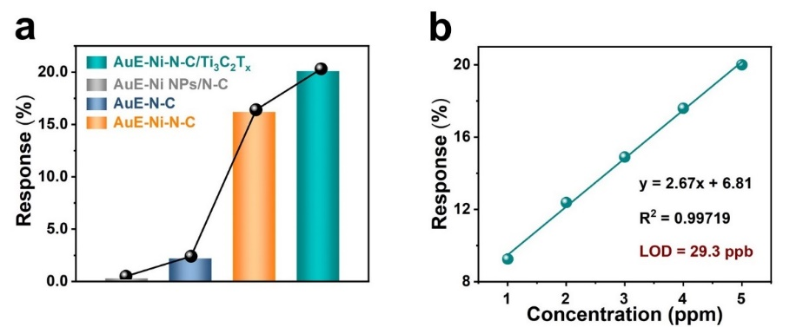
Fig. S22 Performance of different gas sensors for low-concentration NH₃ detection. a Comparison of the response of the AuE-N-C, AuE-Ni-N-C, AuE-Ni NPs/N-C, and AuE-Ni-N-C/Ti₃C₂T_{x} sensors to 5 ppm NH₃ at room temperature. b Response curves versus NH₃ concentration for AuE-Ni-N-C/Ti₃C₂T_{x} sensor.

The response of low concentration NH₃ (from 1 to 5 ppm) of the AuE-N-C, AuE-Ni-N-C, and AuE-Ni-N-C/Ti₃C₂T_{x} sensors was almost linear (Figs. S22b, S23c, and S23f).
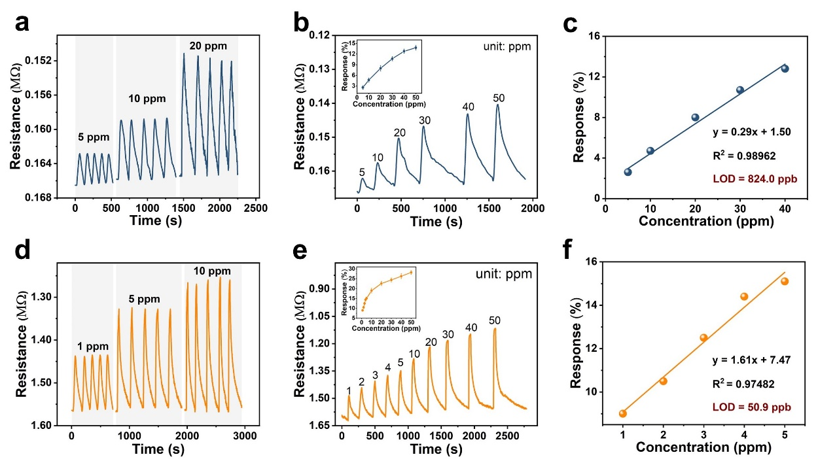
Fig. S23 Performance of AuE-N-C and AuE-Ni-N-C gas sensors for low-concentration NH₃ detection. a Repeatability of AuE-N-C sensor toward 1, 5, and 10 ppm NH₃. b The experimental real-time gas response curve of AuE-N-C sensor at different NH₃ concentrations. The inset is the responses as a function of the gas concentration to different NH₃ concentrations from 1 to 50 ppm at room temperature for AuE-N-C sensor. c Response curves versus NH₃ concentration for AuE-N-C sensor. d Repeatability of AuE-Ni-N-C sensor toward 1, 5, and 10 ppm NH₃. e The experimental real-time gas response curve of AuE-Ni-N-C sensor at different NH₃ concentrations. The inset is the responses as a function of the gas concentration to different NH₃ concentrations from 1 to 50 ppm at room temperature for AuE-Ni-N-C sensor. f Response curves versus NH₃ concentration for AuE-Ni-N-C sensor.

The repeatability of the AuE-N-C and AuE-Ni-N-C gas sensors to 1 ppm, 5 ppm, and 10 ppm NH₃ for five consecutive cycles demonstrated excellent repeatability (Fig. S23a and d). Upon cyclic exposure to NH₃ ranging from 1 to 50 ppm, the time-related dynamic response of the three gas sensors exhibited a stable response and recovery features in Fig. S23b and e. Notably, standard deviations of the measured response values for the AuE-N-C, AuE-Ni-N-C, and AuE-Ni-N-C/Ti₃C₂T_{x} gas sensors for the various NH₃ concentrations were only 1.8% at most, suggesting that N-C, Ni-N-C, and Ni-N-C/Ti₃C₂T_{x} materials provided favorable stability of gas sensing (Fig. S23b and e).
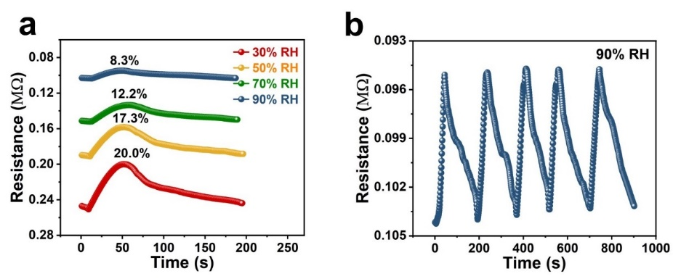
Fig. S24 Relative humidity analysis of AuE-Ni-N-C/Ti₃C₂T_{x} gas sensor for low-concentration NH₃ detection. a The resistance curve of AuE-Ni-N-C/Ti₃C₂T_{x} sensor to 5 ppm NH₃ under different RH. b Repeatability of AuE-Ni-N-C/Ti₃C₂T_{x} sensor toward 5 ppm NH₃ under 90% RH.

Prior to the introduction of NH₃ gas, the AuE-Ni-N-C/Ti₃C₂T_{x} sensor was exposed to moist air with specified RH until a steady-state baseline arrived, then 5 ppm NH₃ mixed with the specific wet air was purged into the test chamber.

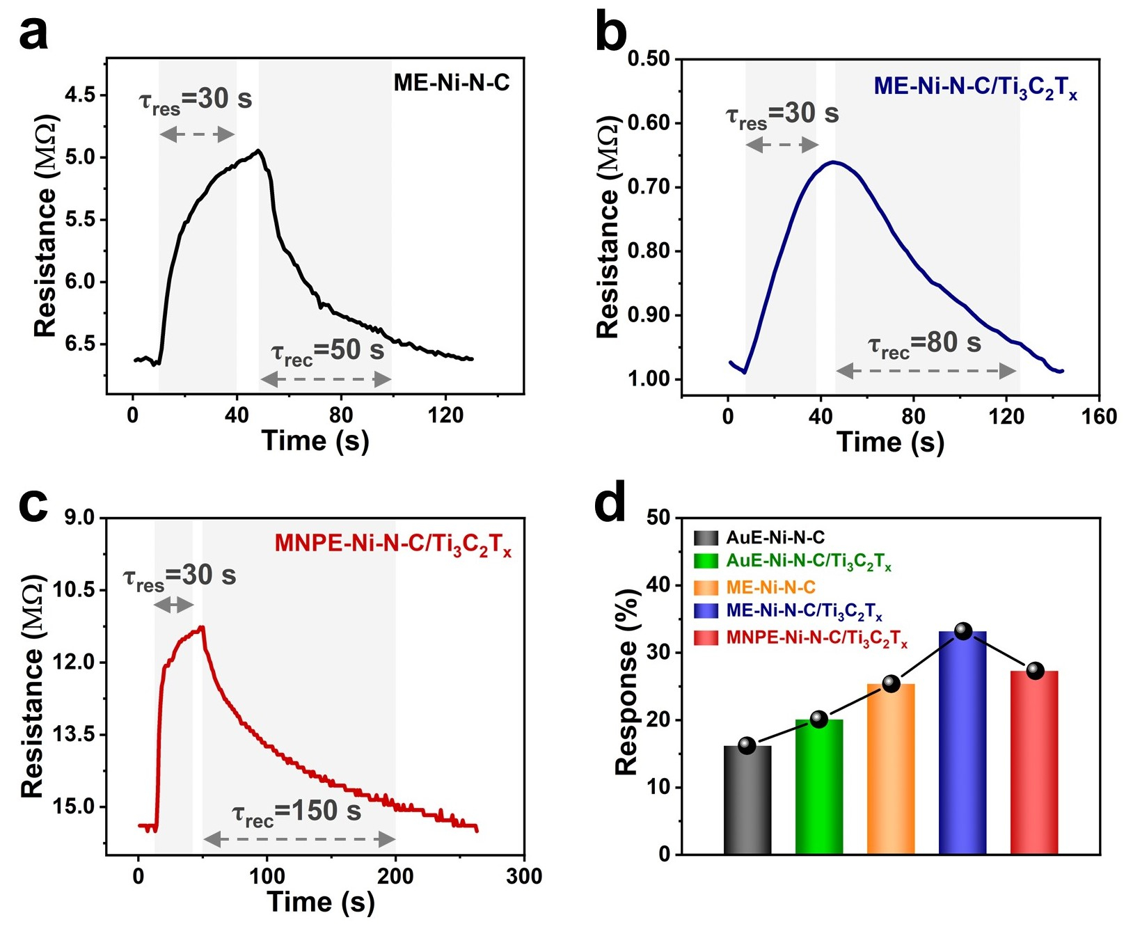
Fig. S25 Performance of different gas sensors for low-concentration NH₃ detection. a ME-Ni-N-C, b ME-Ni-N-C/Ti₃C₂T_{x}, and c MNPE-Ni-N-C/Ti₃C₂T_{x} sensors exposed to 5 ppm NH₃ at room temperature. d Comparison of the response of the AuE-Ni-N-C, AuE-Ni-N-C/Ti₃C₂T_{x}, ME-Ni-N-C, ME-Ni-N-C/Ti₃C₂T_{x}, and MNPE-Ni-N-C/Ti₃C₂T_{x} sensors to 5 ppm NH₃ at room temperature.

Furthermore, the recovery time of the ME-Ni-N-C/Ti₃C₂T_{x} sensor (80 s, Fig. S25b) to NH₃ is shorter than that of the MNPE-Ni-N-C/Ti₃C₂T_{x} sensor (150 s, Fig. S25c). This difference is due to the higher conductivity of ME, which accelerates the desorption rate of NH₃ from the surface of the sensors.

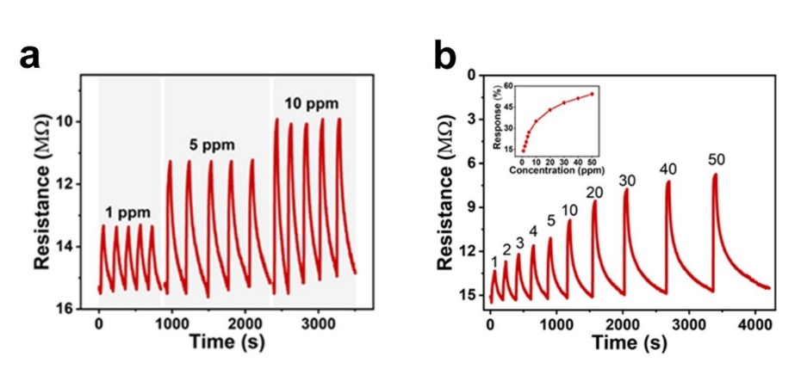
Fig. S26 Performance of MNPE-Ni-N-C/Ti₃C₂T_{x} gas sensor for low-concentration NH₃ detection. a Repeatability of MNPE-Ni-N-C/Ti₃C₂T_{x} sensor toward 1, 5, and 10 ppm NH₃. b The experimental real-time gas response curve of MNPE-Ni-N-C/Ti₃C₂T_{x} sensor at different NH₃ concentrations. The inset is the responses as a function of the gas concentration to different NH₃ concentrations from 1 to 50 ppm at room temperature for the MNPE-Ni-N-C/Ti₃C₂T_{x} sensor.

The exposure of the MNPE-Ni-N-C/Ti₃C₂T_{x}, ME-Ni-N-C/Ti₃C₂T_{x,} and ME-Ni-N-C sensors to a range of ppm NH₃ for several cycles demonstrated excellent reproductivity without major changes (Figs. S26a, S27a, and S27d). The response/recovery curves of the MNPE-Ni-N-C/Ti₃C₂T_{x}, ME-Ni-N-C/Ti₃C₂T_{x} and ME-Ni-N-C sensors to different concentrations of NH₃ from 1 to 50 ppm at room temperature were described in Figs. S26b, S27b, and S27e. It was worth noting that under the condition of ensuring that the response time was 40 s, the recovery performance of the ME-Ni-N-C/Ti₃C₂T_{x} sensor for different concentrations of NH₃ was better than that of the MNPE-Ni-N-C/Ti₃C₂T_{x} sensor, in line with the recovery time analyze in Fig. 4c.
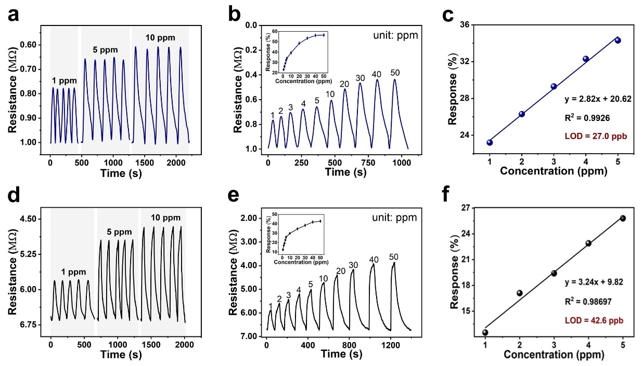
Fig. S27 Performance of ME-Ni-N-C/Ti₃C₂T_{x} and ME-Ni-N-C gas sensors for low-concentration NH₃ detection. a Repeatability of ME-Ni-N-C/Ti₃C₂T_{x} sensor toward 1, 5, and 10 ppm NH₃. b The experimental real-time gas response curve of ME-Ni-N-C/Ti₃C₂T_{x} sensor at different NH₃ concentrations. The inset is the responses as a function of the gas concentration to different NH₃ concentrations from 1 to 50 ppm at room temperature for ME-Ni-N-C/Ti₃C₂T_{x} sensor. c Response curves versus NH₃ concentration for ME-Ni-N-C/Ti₃C₂T_{x} sensor. d Repeatability of ME-Ni-N-C sensor toward 1, 5, and 10 ppm NH₃. e The experimental real-time gas response curve of ME-Ni-N-C sensor at different NH₃ concentrations. The inset is the responses as a function of the gas concentration to different NH₃ concentrations from 1 to 50 ppm at room temperature for ME-Ni-N-C sensor. f Response curves versus NH₃ concentration for ME-Ni-N-C sensor.

In addition, the theoretical LOD of the ME-Ni-N-C sensor for NH₃ was calculated to be 42.6 ppb (Fig. S27f).
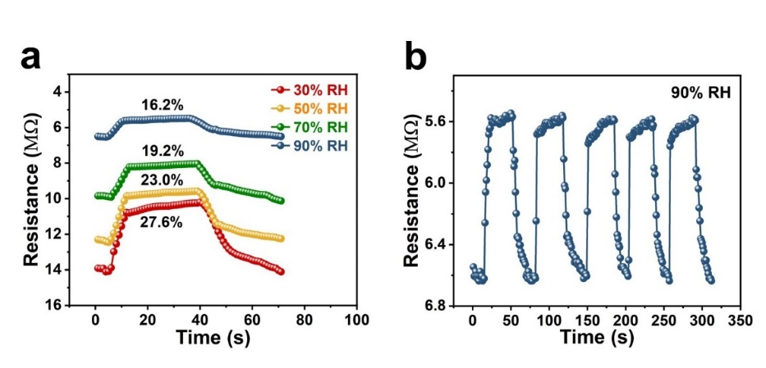
Fig. S28 Relative humidity analysis of MNPE-Ni-N-C/Ti₃C₂T_{x} gas sensor for low-concentration NH₃ detection. a The resistance curve of MNPE-Ni-N-C/Ti₃C₂T_{x} sensor to 5 ppm NH₃ under different humidity. b Repeatability of MNPE-Ni-N-C/Ti₃C₂T_{x} sensor toward 5 ppm NH₃ under 90% RH.

Interestingly, replacing metal electrodes with non-metallic electrodes also reduced the SBH between electrodes and semiconductors, significantly improving the recovery performance of the MNPE-Ni-N-C/Ti₃C₂T_{x} and ME-Ni-N-C/Ti₃C₂T_{x} sensors (less than 55 s in Figs. S28a and S29a).
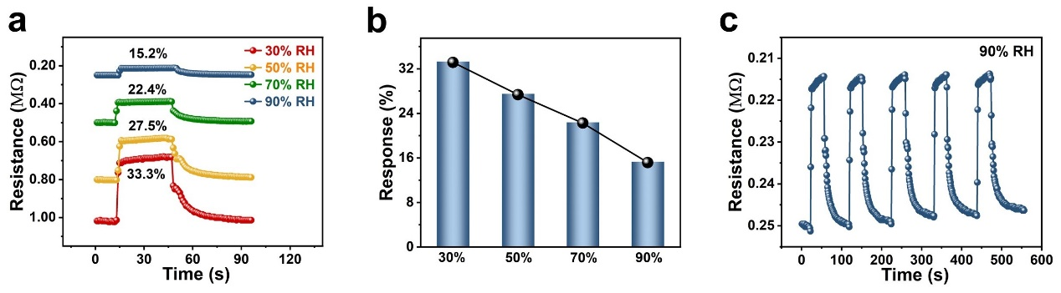
Fig. S29 Relative humidity analysis of ME-Ni-N-C/Ti₃C₂T_{x} gas sensor for low-concentration NH₃ detection. a The resistance curve of ME-Ni-N-C/Ti₃C₂T_{x} sensor to 5 ppm NH₃ under different RH. b Comparison of the response of the ME-Ni-N-C/Ti₃C₂T_{x} sensor to 5 ppm NH₃ under different RH at room temperature. c Repeatability of ME-Ni-N-C/Ti₃C₂T_{x} sensor toward 5 ppm NH₃ under 90% RH.

In addition, the response of the MNPE-Ni-N-C/Ti₃C₂T_{x} sensor decreased with increasing RH (Fig. S29b).
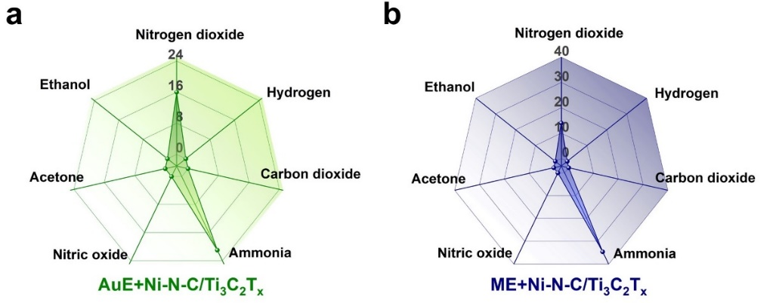
Fig. S30 Selectivity analysis of AuE-Ni-N-C/Ti₃C₂T_{x} and ME-Ni-N-C/Ti₃C₂T_{x} gas sensors. a Selectivity of AuE-Ni-N-C/Ti₃C₂T_{x} sensor to different gases (5 ppm NH₃, 50 ppm NO₂, CO₂, NO, H₂, acetone-saturated steam, and ethanol-saturated steam). b Selectivity of ME-Ni-N-C/Ti₃C₂T_{x} sensor to different gases.

The MNPE-Ni-N-C/Ti₃C₂T_{x} and ME-Ni-N-C/Ti₃C₂T_{x} sensors displayed higher sensitivity to NH₃ compared to the AuE-Ni-N-C/Ti₃C₂T_{x} sensor, due to the higher adsorption energy of the flexible MXene-based electrodes for NH₃ and the match of work function between the metal electrode and semiconductor sensing materials which allowed a fluent transfer of more charge carriers (Fig. 4f and Fig. S30).

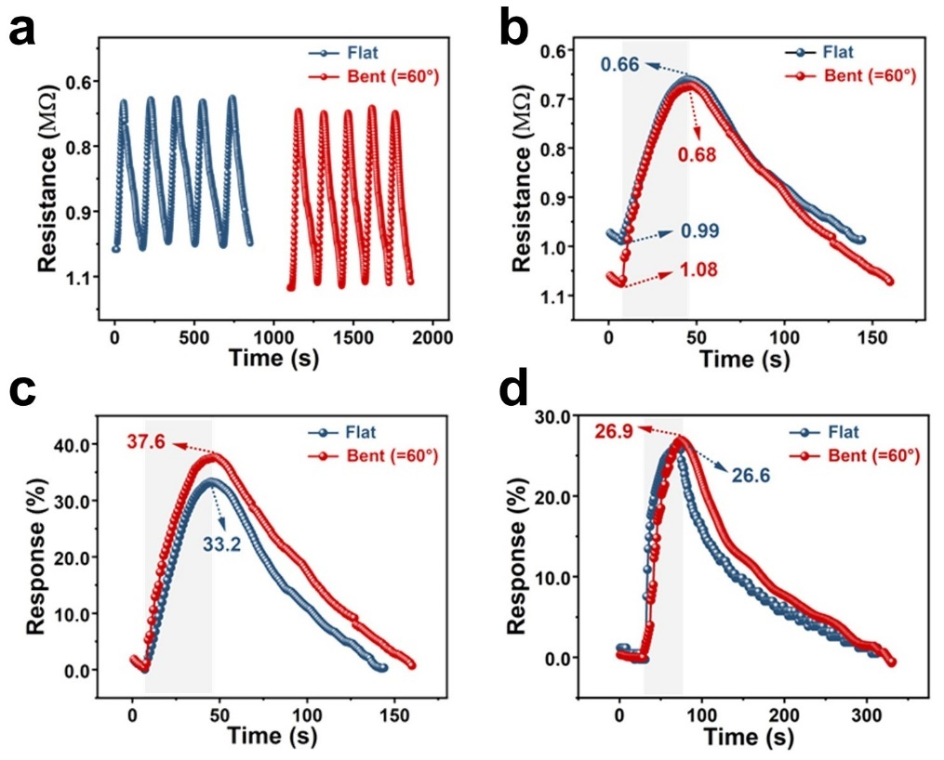
Fig. S31 Bending stability analysis of ME-Ni-N-C/Ti₃C₂T_{x} and MNPE-Ni-N-C/Ti₃C₂T_{x} gas sensors. a Repeatability of ME-Ni-N-C/Ti₃C₂T_{x} sensor toward 5 ppm NH₃ before and after bending 500 times. b Resistance and c response curves of the ME-Ni-N-C/Ti₃C₂T_{x} flexible sensor to 5 ppm NH₃ when tested under 60° bending angles. d Response curves of the MNPE-Ni-N-C/Ti₃C₂T_{x} flexible sensor to 5 ppm NH₃ when tested under 60° bending angles.

In addition, the increase in the response of the ME-Ni-N-C/Ti₃C₂T_{x} sensor may be attributed to the formation of more micro cracks and defects at the edge positions of the flexible ME and Ni-N-C/Ti₃C₂T_{x} hetero-nanojunction after bending, which can result in increased gas adsorption (Fig. S31c).

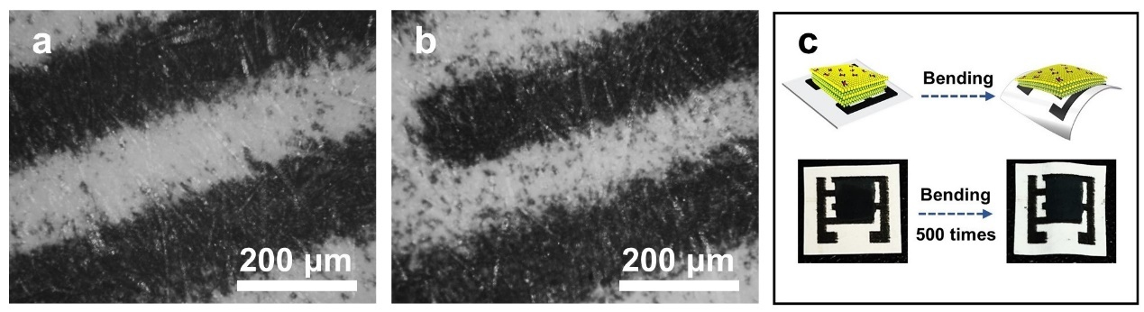
Fig. S32 Analysis of adhesion between MNPE-Ni-N-C/Ti₃C₂T_{x} sensor and paper before and after bending. a The optical image of MNPE before 500 cycles of 60° bending. b The optical image of MNPE after 500 cycles of 60° bending. c The optical photos of the MNPE-Ni-N-C/Ti₃C₂T_{x} sensor before and after bending (500 times).
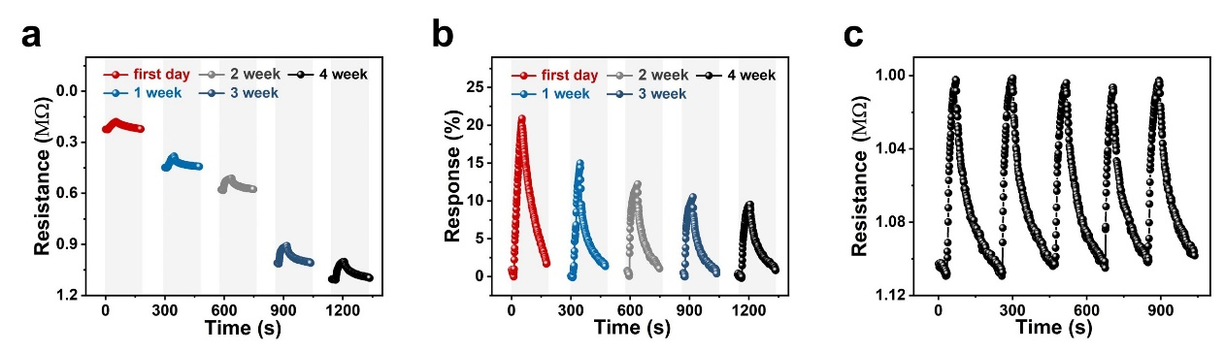
Fig. S33 Long-term stability analysis of AuE-Ni-N-C/Ti₃C₂T_{x} gas sensors. a The resistance and b response curves of AuE-Ni-N-C/Ti₃C₂T_{x} sensor to 5 ppm NH₃ at different weeks. c Repeatability of AuE-Ni-N-C/Ti₃C₂T_{x} sensor toward 5 ppm NH₃ after 4 weeks.

The repeatability of the two sensors after five consecutive cycles of exposure to 5 ppm NH₃ gas after four weeks confirmed their recoverability (Figs. S33c and S34c).

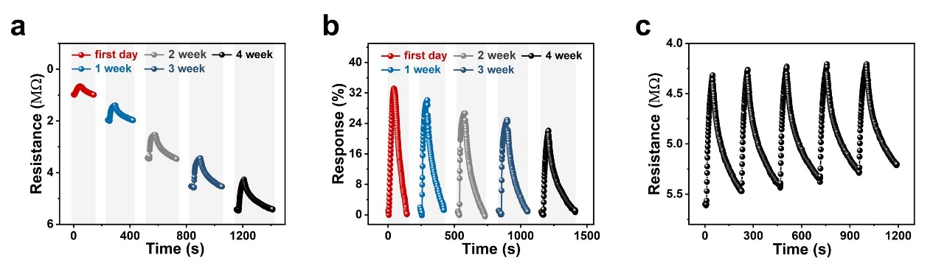
Fig. S34 Long-term stability analysis of ME-Ni-N-C/Ti₃C₂T_{x} gas sensors. a The resistance and b response curves of ME-Ni-N-C/Ti₃C₂T_{x} sensor to 5 ppm NH₃ at different weeks. c Repeatability of ME-Ni-N-C/Ti₃C₂T_{x} sensor toward 5 ppm NH₃ after 4 weeks.

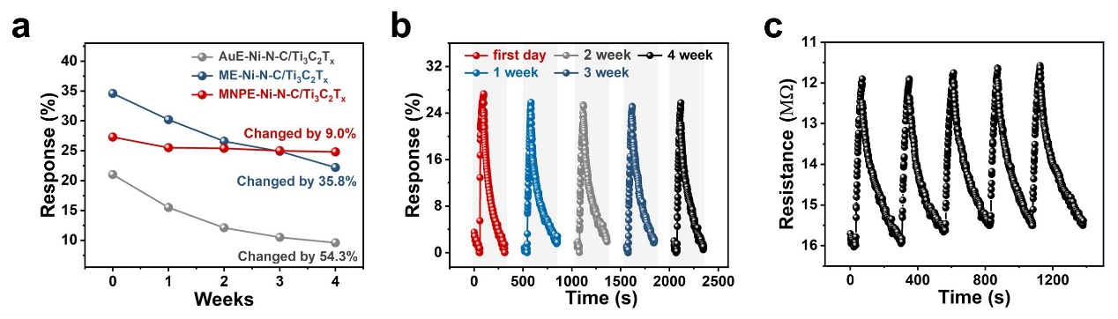
Fig. S35 Long-term stability analysis of MNPE-Ni-N-C/Ti₃C₂T_{x} gas sensors. a The changes in response of AuE-Ni-N-C/Ti₃C₂T_{x}, ME-Ni-N-C/Ti₃C₂T_{x}, and MNPE-Ni-N-C/Ti₃C₂T_{x} sensors to 5 ppm NH₃ within 4 weeks. b The response curve of MNPE-Ni-N-C/Ti₃C₂T_{x} sensor to 5 ppm NH₃ at different weeks. c Repeatability of MNPE-Ni-N-C/Ti₃C₂T_{x} sensor toward 5 ppm NH₃ after 4 weeks.

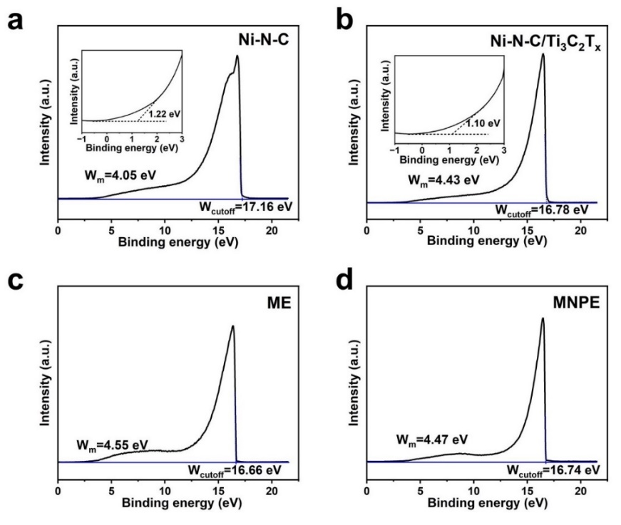
Fig. S36 Work function analysis of Ni-N-C, Ni-N-C/Ti₃C₂T_{x}, ME, and MNPE. UPS spectra of a Ni-N-C, b Ni-N-C/Ti₃C₂T_{x}, c ME, and d MNPE.

The work functions of ME and MNPE materials were demonstrated in Fig. S36c and d, with values of 4.55 and 4.47 eV, respectively. The use of a Ti₃C₂T_{x}-MXene non-metallic electrode in combination with Ni-N-C/Ti₃C₂T_{x} had positive effects on gas sensing performance compared to the AuE-Ni-N-C/Ti₃C₂T_{x} sensor. When the Ni-N-C/Ti₃C₂T_{x} gas sensing material (E_{c} = −4.16 eV, E_{v} = −5.53 eV, and work function is 4.43 eV) was in contact with an Au electrode (with a work function of 5.10 eV), the SBH hindered the efficient transport of charge carriers, resulting in only a small percentage of carriers having sufficient energy to cross the Schottky junction.
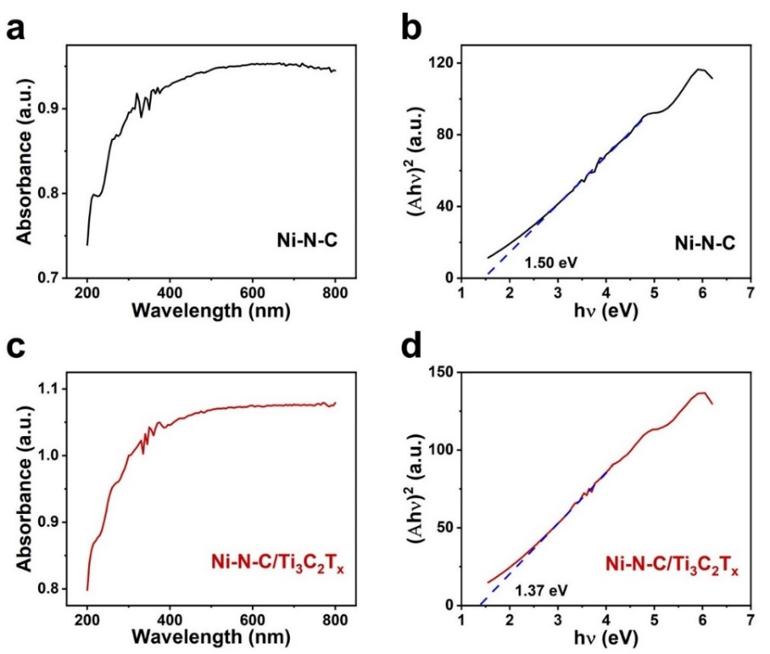
Fig. S37 Band gap analysis of Ni-N-C and Ni-N-C/Ti₃C₂T_{x} materials. a UV-vis spectra of Ni-N-C. b plot of (Ahν)² against (hν) of Ni-N-C. c UV-vis spectra of Ni-N-C/Ti₃C₂T_{x}. d plot of (Ahν)² against (hν) of Ni-N-C/Ti₃C₂T_{x}.

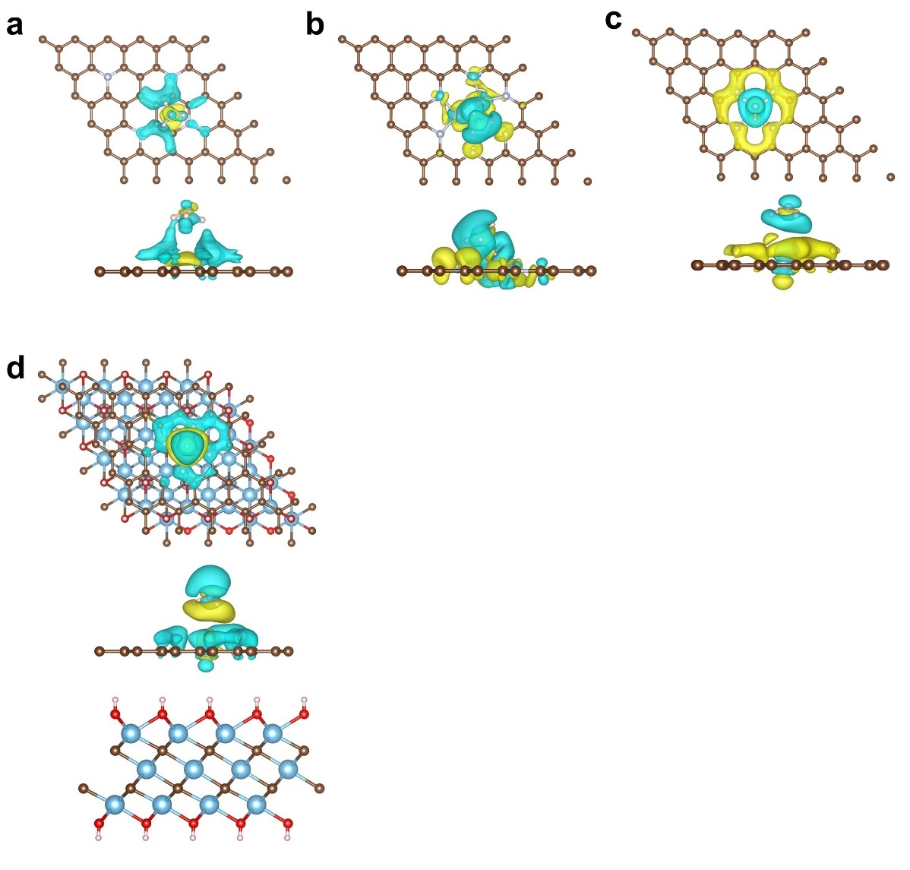
Fig. S38 Gas adsorption analysis of N-C, Ni NPs/N-C, Ni-N-C, and Ni-N-C/Ti₃C₂T_{x} materials. Top and side views of the isosurface charge density plots of NH₃ adsorbed on the a N-C, b Ni NPs/N-C, c Ni-N-C, and d Ni-N-C/Ti₃C₂T_{x}, respectively, using an isovalue of 0.0005 e Å⁻³ for NH₃. Cyan: charge depletion. Yellow: charge accumulation.
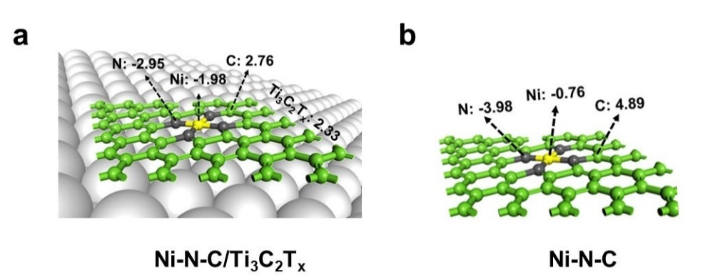
Fig. S39 Electron transfer analysis of Ni-N-C and Ni-N-C/Ti₃C₂T_{x} materials. Bader charge and charge density difference of a Ni-N-C/Ti₃C₂T_{x} and b Ni-N-C.

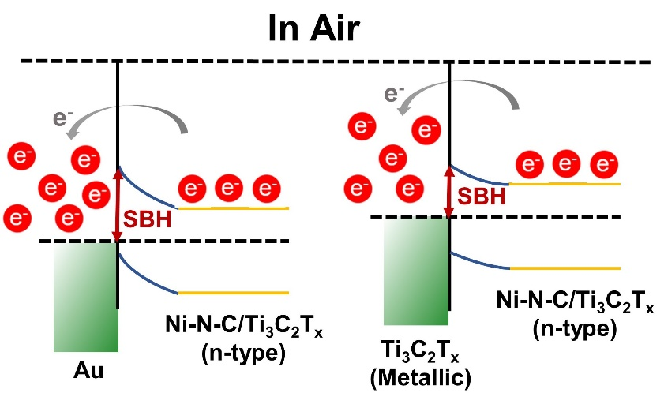
Fig. S40 SBH analysis of Au-electrode-Ni-N-C/Ti₃C₂T_{x} and Ti₃C₂T_{x}-based electrode-Ni-N-C/Ti₃C₂T_{x}. Schematic diagrams of band structure for Au-electrode-Ni-N-C/Ti₃C₂T_{x} and Ti₃C₂T_{x}-based electrode-Ni-N-C/Ti₃C₂T_{x} in the air at room temperature.
Table S1. Atomic contents (at.%) determined by ICP-OES for Ni-N-C and Ni-N-C/Ti₃C₂T_{x} catalysts.
Catalysts | Ni (at.%)
Ni-N-C | 0.10
Ni-N-C/Ti₃C₂T_{x} | 0.25

Table S2. BET surface areas (S_{BET}) and pore distribution (V_{total}) of the precursors and corresponding calcination catalysts.
Samples | S_{BET} (m²/g) | V_{total} (cm³/g)
ZIF-8 | 998.62 | 0.62
Ni-ZIF-8 | 943.18 | 0.53
Ni-ZIF-8-CTAB-Ti₃C₂T_{x} | 381.16 | 0.22
N-C | 695.79 | 0.82
Ni NPs/N-C | 180.63 | 0.15
Ni-N-C | 352.41 | 0.33
Ni-N-C/Ti₃C₂T_{x} | 535.10 | 0.52

Table S3. Structural parameters extracted from the EXAFS fitting of Ni-N-C and Ni-N-C/Ti₃C₂T_{x}.
CN, coordination numbers; R, bond distance; σ², Debye-Waller factors; ΔE₀, the inner potential correction. R factor, the goodness of fit. Ѕ₀² was set to 0.80, according to the experimental EXAFS fit of Ni foil reference by fixing CN as the known crystallographic value.
Sample | shell | CN | R(Å) | σ² | ΔE₀ | R factor
Ni foil | Ni-Ni | 12 | 2.48±0.01 | 0.0060 | −6.1±0.6 | 0.0045
Ni-N-C | Ni-N | 3.4±0.1 | 1.86±0.01 | 0.0069 | −7.9±1.1 | 0.0030
Ni-N-C | Ni-Ni | 0.8±0.1 | 2.53±0.01 | 0.0069 | −7.9±1.1 | 0.0030
Ni-N-C | Ni-Ni1 | 1.4±0.4 | 2.77±0.02 | 0.0162 | −7.9±1.1 | 0.0030
Ni-N-C/Ti₃C₂T_{x} | Ni-N | 3.8±0.2 | 1.85±0.01 | 0.0073 | −7.6±1.8 | 0.0122
Ni-N-C/Ti₃C₂T_{x} | Ni-Ni | 0.4±0.1 | 2.80±0.03 | 0.0062 | −7.6±1.8 | 0.0122
Table S4. Fluidic properties of ME and MNPE inks.
Sample | Density  (g/cm³) | Surface tension  (mN/m) | Viscosity  (cP) | Z
ME | 0.951 | 56.90 | 7.04 | 10.44
MNPE | 0.964 | 15.26 | 9.17 | 4.18
Note: The viscosity was evaluated at the sheer rate of 5 s⁻¹

The following Equation is used to calculate the Z value to describe the printability [S10]:
$$z=\frac{1}{Oh}=\frac{\sqrt{γαρ}}{η}$$
Where γ is the surface tension, ρ is the density of the fluid, α is the inkjet nozzle diameter, and η is the dynamic viscosity. Generally, the Z value of inks suitable for inkjet printing is regarded as between 1 and 14 [S11]. The Z values of ME and MNPE inks are 10.44 and 4.18, respectively, suggesting that both two inks can spray stably in the printing process.
Table S5. Resolution comparison of reported functional ink printing.
Materials | Solvent | Method | σ, S cm⁻¹ | Substrate | Post-processing | Ref.
Zn microparticles | PVP | Screen printing | 3.0×10³ | PLGA | Electrochemical sintering | [S12]
Ti₃C₂T_{x} | Water | Extrusion printing | 6.90×10³ | PET | - | [S13]
AgInGa-SIS | Toluene | Extrusion printing | 7.02×10³ | SIS | 60 °C/60 mins | [S14]
56 wt% silver nanoflakes | Water | Stencil printing | 7.38×10³ | PDMS | 80 °C/30 mins | [S15]
80 wt% silver nanoflakes | PDMS | Stencil printing | 1.51×10⁴ | Silicone | 160 °C/60 mins | [S16]
Ti₃C₂T_{x}/TFA | Ethanol | electrohydrodynamic (EHD) printing | 8.90×10³ | SiO₂/Si | 120 °C/60 mins | [S17]
Ti₃C₂T_{x} | NMP | Inkjet printing | 2.75×10² | PET | - | [S18]
Ti₃C₂T_{x} | NMP | Inkjet printing | 2.77×10³ | AlO_{x}-coated PET | 60 °C | [S19]
Ti₃C₂T_{x} | DMSO | Inkjet printing | 1.08×10³ | PET | 70 °C | [S20]
Ti₃C₂T_{x}/siloxane surfactant | Water | 3D printing | 2.45×10³ | PDMS | room temperature/72h | [S21]
Ti₃C₂T_{x} | Water | Inkjet printing | 6.38×10³ | Paper | 60 °C/10 mins | This work
Ti₃C₂T_{x} | PEDOT:  PSS/  NMP | Inkjet printing | 3.70×10³ | Paper | 60 °C/10 mins | This work

Table S6. FoM data (FoM = σc) of the different inks.
Samples | σ (S cm⁻¹) | c (mg mL⁻¹) | FoM (S cm⁻¹ mg mL⁻¹) | Ref.
rGO | 15 | 3 | 45 | [S22]
GO/PA | 64 | 25 | 1600 | [S23]
Graphene | 391 | 2.25 | 879.75 | [S24]
Graphene | 240 | 3 | 720 | [S25]
Graphene | 250 | 20 | 5000 | [S26]
PEDOT:PSS | 700 | 10 | 7000 | [S27]
PEDOT:PSS | 22 | 10 | 220 | [S28]
MXene | 1080 | 2.25 | 2430 | [S20]
p-MXene | 161 | 20 | 3220 | [S29]
MXene | 2770 | 36 | 99720 | [S19]
ME | 6380 | 14 | 89320 | This work
MNPE | 3700 | 16 | 59200 | This work

Table S7. The comparison of sensing performance of NH₃ gas sensors with different MXene-based sensing materials.
Materials | Temp. | Response | τ_{res.} (s) | τ_{rec.} (s) |  | LOD (ppb) | Ref.
Au-Ti₃C₂T_{x} MXene | RT | 16%  (100 ppm)ª | 87 | 217 | - |  | [S30]
MXene/rGO | RT | 6.77%  (50 ppm)^{b} | 25 | 25 | - |  | [S31]
TiO₂-Ti₃C₂T_{x} | RT | 3.1%  (10 ppm)ª | 33 | 277 | - |  | [S32]
Ti₃C₂ MXene | RT | 6.13%  (500 ppm)ª | 45  (25 ppm) | 94  (25 ppm) | - |  | [S33]
Ti₃C₂T_{x}-SnO₂ | RT | 75%  (500 ppm)ª | 109 | 342 | - |  | [S34]
ME-Ni-N-C/Ti₃C₂T_{x} | RT | 33.2%  (5 ppm)ª | 30 | 80 | 27.0 |  | This work
MNPE-Ni-N-C/Ti₃C₂T_{x} | RT | 27.3%  (5 ppm)ª | 30 | 150 | 12.1 |  | This work

Temp.: Work temperature, RT: Room temperature, τ_{res.}: Response time, τ_{rec.}: Recovery time, -: Not mention.
ª (ΔR/R_{a})*100%.
^{b} ΔR/R₀.

Table S8. Comparison of the response to NH₃ of three sensors under different RH conditions.
Sensors | Response to NH₃ in dry air (R_{DA}) | Response to NH₃ at 90%RH (R_{90%RH}) |  |  | (R_{DA}-R_{90%RH})/R_{DA}
AuE-Ni-N-C/Ti₃C₂T_{x} | 20.1% |  | 8.3% | 58.7%
ME-Ni-N-C/Ti₃C₂T_{x} | 33.2% |  | 15.2% | 54.2%
MNPE-Ni-N-C/Ti₃C₂T_{x} | 27.3% |  | 16.2% | 40.7%

Table S9. The quantification of different oxygen species was determined by analyzing the O 1s XPS spectra for Ni NPs/N-C, Ni-N-C, and Ni-N-C/Ti₃C₂T_{x} materials.
Materials | O₂⁻  (% Area) | O₂⁻  Position | O²⁻  (% Area) | O²⁻  Position | O₂⁻/O²⁻
Ni NPs/N-C | 27.3 | 533.6 eV | 72.7 | 531.9 eV | 0.38
Ni-N-C | 37.2 | 533.4 eV | 62.8 | 532.0 eV | 0.59
Ni-N-C/Ti₃C₂T_{x} | 72.8 | 532.6 eV | 27.2 | 531.0 eV | 2.67

Table S10. The surface adsorption energies and charge transfer on N-C (001), Ni NPs/N-C (001), Ni-N-C (001), and Ni-N-C (001)/Ti₃C₂T_{x} (001).
Substrate | E_{ad.} (eV) | Charge transfer (e)
N-C (001) | −0.59 | −0.04
Ni NPs/N-C (001) | −0.70 | −0.11
Ni-N-C (001) | −0.73 | −0.15
Ni-N-C (001)/Ti₃C₂T_{x} (001) | −0.76 | −0.16

Table S11. The surface adsorption energies and charge transfer of NH₃, NO₂, NO, acetone, ethanol, and H₂ on Ni-N-C (001)/Ti₃C₂T_{x} (001).
gas | E_{ad.} (eV) | Charge transfer (e)
NH₃ | −0.76 | −0.16
NO₂ | −0.66 | 0.12
NO | −0.22 | 0.06
Acetone | −0.19 | −0.05
Ethanol | −0.18 | −0.05
H₂ | −0.11 | −0.03

Supplementary References
[S1] C.M. Zhao, X.Y. Dai, T. Yao, W. X. Chen, X.Q. Wang et al., Ionic exchange of metal organic frameworks to access single nickel sites for efficient electroreduction of CO₂. J. Am. Chem. Soc. 139, 8078–8081 (2017).
https://doi.org/10.1021/jacs.7b02736
[S2] C.C. Cai, Y. A. Chen, P. Hu, T. Zhu, X.Y. Li et al., Regulating the interlayer spacings of hard carbon nanofibers enables enhanced pore filling sodium storage. Small 18(6), 2105303 (2022).
https://doi.org/10.1002/smll.202105303
[S3] X. Wang, H. Li, H. Li, S. Lin, W. Ding et al., 2D/2D 1T-MoS₂/Ti₃C₂ MXene heterostructure with excellent supercapacitor performance. Adv. Funct. Mater. 30(15), 0190302 (2020).
https://doi.org/10.1002/adfm.201910302
[S4] Z.W. Guo, W. Li, W.X. Li, X.J. Hou, S. Luan et al., Hierarchically porous zeolitic imidazolate framework-8 with tunable mesostructure as pickering interfacial catalyst. Microporous Mesoporous Mater. 310, 110677 (2021).
https://doi.org/10.1016/j.micromeso.2020.110677
[S5] G.C. Zheng, Z.W. Chen, K. Sentosun, I. Pérez-Juste, S. Bals et al., Shape control in ZIF-8 nanocrystals and metal nanoparticles@ZIF-8 heterostructures. Nanoscale 9(43), 16645–16651 (2017).
https://doi.org/10.1039/C7NR03739B
[S6] X.Y. Lu, L. Kuai, F. Huang, J.S. Jiang, J.K. Song et al., Single-atom catalysts-based catalytic ROS clearance for efficient psoriasis treatment and relapse prevention via restoring ESR1. Nat. Commun. 14(1), 6767 (2023).
https://doi.org/10.1038/s41467-023-42477-y
[S7] Y. Xiong, J. Dong, Z.Q. Huang, P. Xin, W. Chen et al., Single-atom Rh/N-doped carbon electrocatalyst for formic acid oxidation. Nat. Nanotechnol. 15, 390–397 (2020).
https://doi.org/10.1038/s41565-020-0665-x
[S8] X. Xie, L. Peng, H. Yang, G.I.N. Waterhouse, L. Shang et al., MIL-101-derived mesoporous carbon supporting highly exposed Fe single-atom sites as efficient oxygen reduction reaction catalysts. Adv. Mater. 33, 2101038 (2021).
https://doi.org/10.1002/adma.202101038
[S9] K. Ghosh, J. Ghosh, P.K. Giri, Accordion-like multilayered two-dimensional Ti₃C₂T_{x} MXenes for catalytic elimination of organic dyes from wastewater the fenton reaction. ACS Appl. Nano Mater. 5(11), 16451–16461 (2022).
https://doi.org/10.1021/acsanm.2c03511
[S10] G.H. Hu, J. Kang, L.W.T. Ng, X.X. Zhu, R.C.T. Howe et al., Functional inks and printing of two-dimensional materials. Chem. Soc. Rev. 47(9), 3265–3300 (2018).
https://doi.org/10.1039/C8CS00084K
[S11] L.J. Deiner, T.L. Reitz, Inkjet and aerosol jet printing of electrochemical devices for energy conversion and storage. Adv. Eng. Mater. 19(7), 1600878 (2017).
https://doi.org/10.1002/adem.201600878
[S12] Y.K. Lee, J. Kim, Y. Kim, J.W. Kwak, Y. Yoon et al., Room temperature electrochemical sintering of Zn microparticles and its use in printable conducting inks for bioresorbable electronics. Adv. Mater. 29(38), 1702665 (2017).
https://doi.org/10.1002/adma.201702665
[S13] Y.Z. Shao, L.S. Wei, X.Y. Wu, C.M. Jiang, Y. Yao et al., Room-temperature high-precision printing of flexible wireless electronics based on MXene inks. Nat. Commun. 13(1), 3223 (2022).
https://doi.org/10.1038/s41467-022-30648-2
[S14] P.A. Lopes, D.F. Fernandes, A.F. Silva, D.G. Marques, A.T. de Almeida et al., Bi-phasic Ag-in-Ga-embedded elastomer inks for digitally printed, ultra-stretchable, multi-layer electronics. ACS Appl. Mater. Interfaces 13(12), 14565–14574 (2021).
https://doi.org/10.1021/acsami.0c22206
[S15] N. Matsuhisa, M. Kaltenbrunner, T. Yokota, H. Jinno, K. Kuribara et al., Printable elastic conductors with a high conductivity for electronic textile applications. Nat. Commun. 6, 7461 (2015).
https://doi.org/10.1038/ncomms8461
[S16] Z. Li, T.R. Le, Z. Wu, Y.G. Yao, L.Y. Li et al., Rational design of a printable, highly conductive silicone-based electrically conductive adhesive for stretchable radio-frequency antennas. Adv. Funct. Mater. 25(3), 464–470 (2015).
https://doi.org/10.1002/adfm.201403275
[S17] X.W. Tang, G. Murali, H. Lee, S. Park, S. Lee et al., Engineering aggregation-resistant MXene nanosheets as highly conductive and stable inks for all-printed electronics. Adv. Funct. Mater. 31(29), 2010897 (2021).
https://doi.org/10.1002/adfm.202010897
[S18] D. Wen, X. Wang, L. Liu, C. Hu, C. Sun et al., Inkjet printing transparent and conductive MXene (Ti₃C₂T_{x}) films: a strategy for flexible energy storage devices. ACS Appl. Mater. Interfaces 13(15), 17766–17780 (2021).
https://doi.org/10.1021/acsami.1c00724
[S19] C.F. Zhang, L. McKeon, M.P. Kremer, S.H. Park, O. Ronan et al., Additive-free MXene inks and direct printing of micro-supercapacitors. Nat. Commun. 10, 1795 (2019).
https://doi.org/10.1038/s41467-019-09398-1
[S20] M. Vural, A. Pena-Francesch, J. Bars-Pomes, H. Jung, H. Gudapati et al., Inkjet printing of self-assembled 2D titanium carbide and protein electrodes for stimuli-responsive electromagnetic shielding. Adv. Funct. Mater. 28(32), 1801972 (2018).
https://doi.org/10.1002/adfm.201801972
[S21] M. Aakyiir, B. Tanner, P.L. Yap, H. Rastin, T.T. Tung et al., 3D printing interface-modified PDMS/MXene nanocomposites for stretchable conductors. J. Mater. Sci. Technol. 117, 174–182 (2022).
https://doi.org/10.1016/j.jmst.2021.11.048
[S22] V. Dua, S.P. Surwade, S. Ammu, S.R. Agnihotra, S. Jain et al., All-organic vapor sensor using inkjet-printed reduced graphene oxide. Angew. Chem. Int. Ed. 49(12), 2154–2157 (2010).
https://doi.org/10.1002/ange.200905089
[S23] Q. Liu, B.B. Zhang, Q. Xu, Y.Y. Hou, S. Seyedin et al., Development of graphene oxide/polyaniline inks for high performance flexible microsupercapacitors via extrusion printing. Adv. Funct. Mater. 28(21), 1706592 (2018).
https://doi.org/10.1002/adfm.201706592
[S24] K. Parvez, R. Worsley, A. Alieva, A. Felten, C. Casiraghi, Water-based and inkjet printable inks made by electrochemically exfoliated graphene. Carbon 149, 213–221 (2019).
https://doi.org/10.1016/j.carbon.2019.04.047
[S25] S. Majee, W. Zhao, A. Sugunan, T. Gillgren, J.A. Larsson et al., Highly conductive films by rapid photonic annealing of inkjet printable starch-graphene ink. Adv. Mater. Interfaces 9(5), 2101884 (2022).
https://doi.org/10.1002/admi.202101884
[S26] E.B. Secor, B.Y. Ahn, T.Z. Gao, J.A. Lewis, M.C. Hersam, Rapid and versatile photonic annealing of graphene inks for flexible printed electronics. Adv. Mater. 27(42), 6683–6688 (2015).
https://doi.org/10.1002/adma.201502866
[S27] U. Kraft, F. Molina-Lopez, D. Son, Z.A. Bao, B. Murmann, Ink development and printing of conducting polymers for intrinsically stretchable interconnects and circuits. Adv. Electron. Mater. 6(1), 1900681 (2020).
https://doi.org/10.1002/aelm.201900681
[S28] B. Schmatz, A.W. Lang, J.R. Reynolds, Fully printed organic electrochemical transistors from green solvents. Adv. Funct. Mater. 29(44), 1905266 (2019).
https://doi.org/10.1002/adfm.201905266
[S29] Z.M. Deng, L.L. Li, P.P. Tang, C.Y. Jiao, Z.Z. Yu et al., Controllable surface-grafted MXene inks for electromagnetic wave modulation and infrared anti-counterfeiting applications. ACS Nano 16(10), 16976–16986 (2022).
https://doi.org/10.1021/acsnano.2c07084
[S30] M.S. Nam, J.Y. Kim, A. Mirzaei, M. H. Lee, H. W. Kim et al., Au- and Pt-decorated Ti₃C₂T_{x} MXenes for preparing self-heated and flexible NH₃ gas sensors. Sensors and Actuators B: Chemical 403, 135112 (2024).
https://doi.org/10.1016/j.snb.2023.135112
[S31] S.H. Lee, W. Eom, H. Shin, R.B. Ambade, J.H. Bang et al., Room-temperature, highly durable Ti₃C₂T_{x} MXene/graphene hybrid fibers for NH₃ gas sensing. ACS Appl. Mater. Interfaces 12(9), 10434–10442 (2020).
https://doi.org/10.1021/acsami.9b21765
[S32] H.L. Tai, Z.H. Duan, Z.Z. He, X. Li, J.L. Xu et al., Enhanced ammonia response of Ti₃C₂T_{x} nanosheets supported by TiO₂ nanoparticles at room temperature. Sensors and Actuators B: Chemical 298, 126874 (2019).
https://doi.org/10.1016/j.snb.2019.126874
[S33] M. Wu, M. He, Q.K. Hu, Q.H. Wu, G. Sun et al., Ti₃C₂ MXene-based sensors with high selectivity for NH₃ detection at room temperature. ACS Sens. 4(10), 2763–2770 (2019).
https://doi.org/10.1021/acssensors.9b01308
[S34] H.M. Yu, L.H. Dai, Y.Q. Liu, Y. Zhou, P. Fan et al., Ti₃C₂T_{x} MXene-SnO₂ nanocomposite for superior room temperature ammonia gas sensor. J. Alloys Compd. 962, 171170 (2023).
https://doi.org/10.1016/j.jallcom.2023.171170

