Supporting Information for
Gradient Layered MXene/Hollow Lignin Nanospheres Architecture Design for Flexible and Stretchable Supercapacitors
Haonan Zhang,^{1, 2, ‡}, Cheng Hao^{2, ‡}, Tongtong Fu², Dian Yu³, Jane Howe³, Kaiwen Chen⁴, Ning Yan^{2,} *, Hao Ren^{1,} * and Huamin Zhai¹
¹ Jiangsu Provincial Key Lab of Sustainable Pulp and Paper Technology and Biomass Materials, NanJing Forestry University, NanJing, Jiangsu Province, 210037, P. R. China
² Department of Chemical Engineering and Applied Chemistry, University of Toronto, 200 College Street, ON M5S 3E5, Canada
³ Department of Materials Science and Engineering, University of Toronto, 184 College Street, Toronto ON M5S 3E4, Canada
⁴ College of Materials Science and Engineering, Nanjing Forestry University, 210037 Nanjing, P. R. China
‡ Haonan Zhang and Cheng Hao contributed equally to this work.
*Corresponding authors. E-mail: ning.yan@utoronto.ca (Ning Yan); renhao@njfu.edu.cn (Hao Ren)

Supplementary Figures and Tables
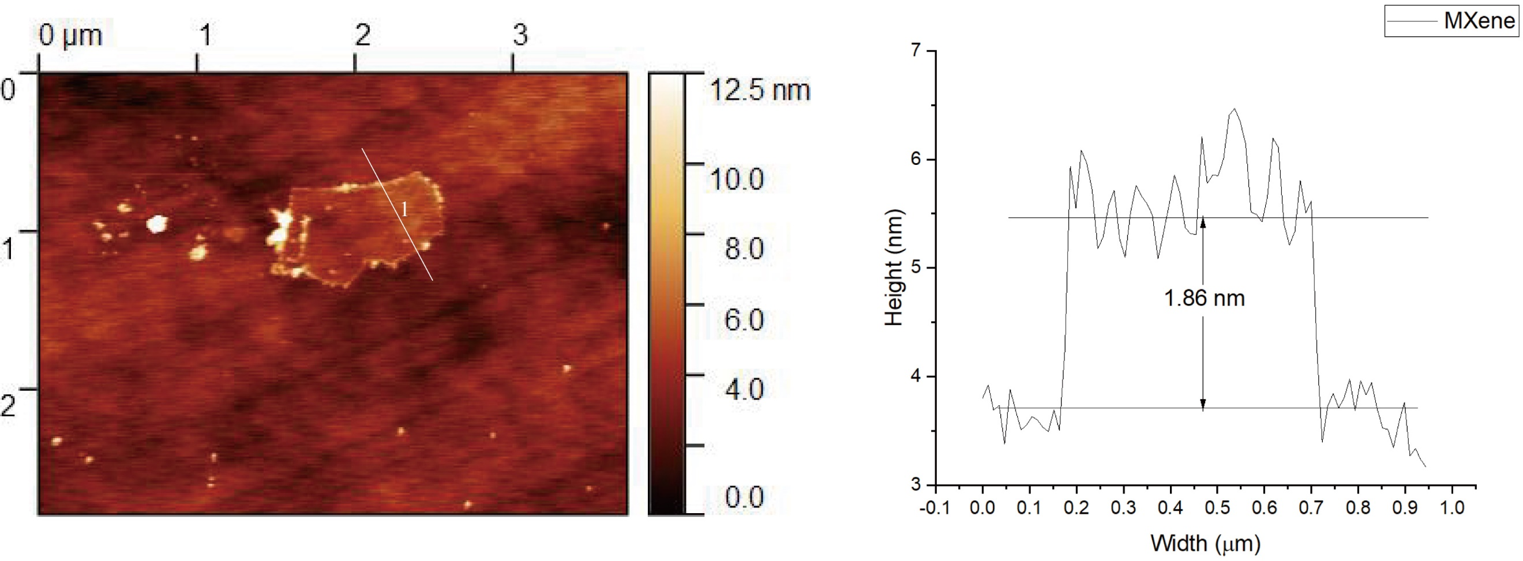
Fig. S1 AFM image of the Ti₃C₂T_{x} MXene nanosheet and thickness profile of the Ti₃C₂T_{x} MXene nanosheet measured by line scan

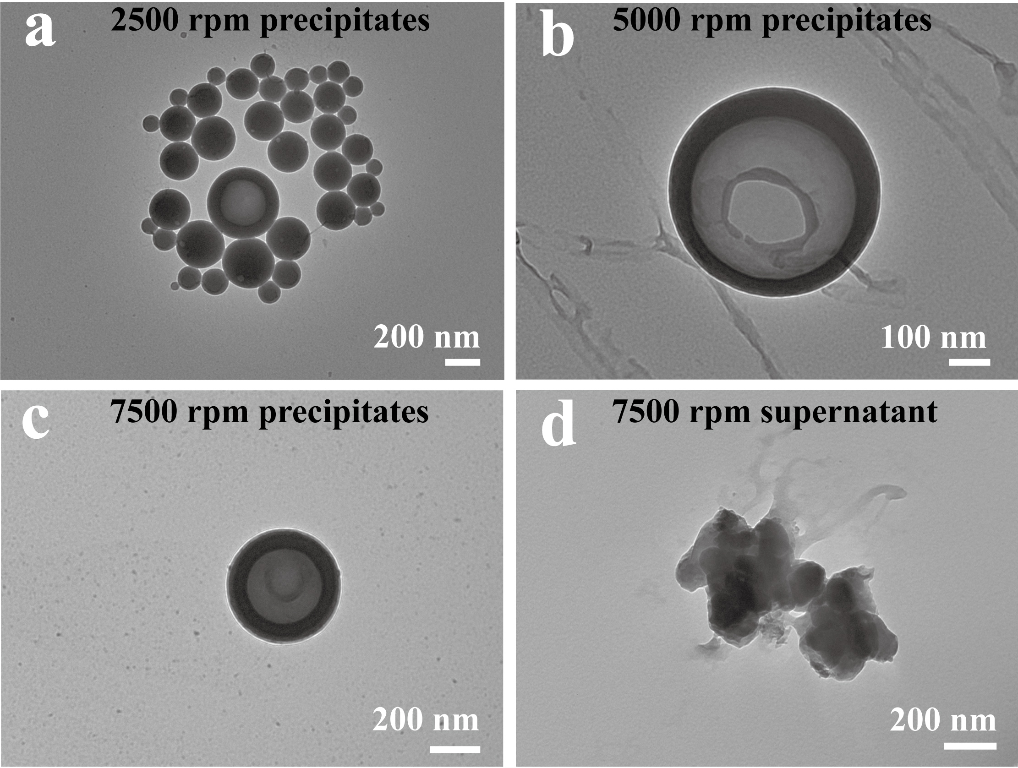
Fig. S2 HLNPs obtained by grading at different centrifugal speeds: a) 2500 rpm precipitates. b) 5000 rpm precipitates. c) 7500 rpm precipitates. d) 7500 rpm supernatant. The relative centrifugal forces (RCF) for 2500 rpm, 5000 rpm, and 7500 rpm are 629 ×g, 2516 ×g, and 5660 ×g, respectively
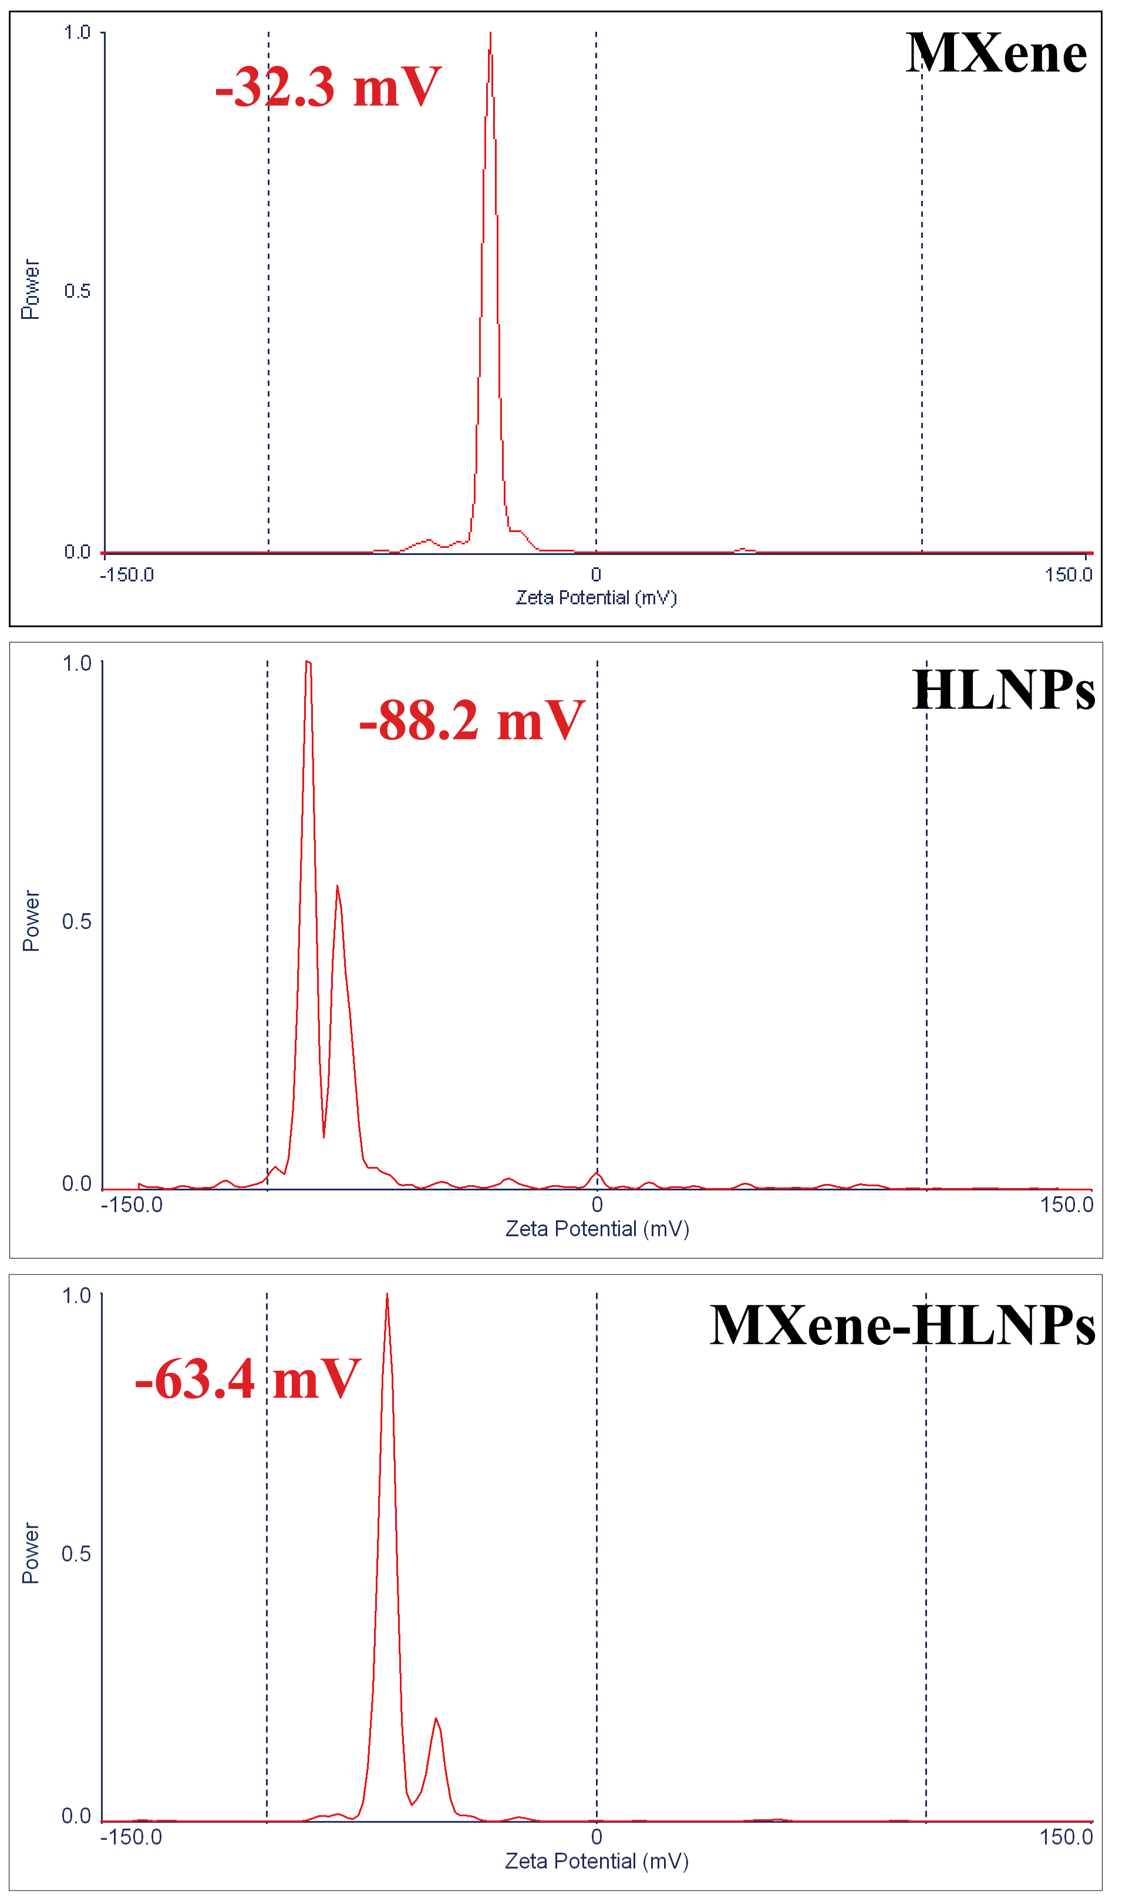
Fig. S3 Zeta potential of the deionized water dispersion of HLNPs, MXene, and MXene/HLNPs mixture
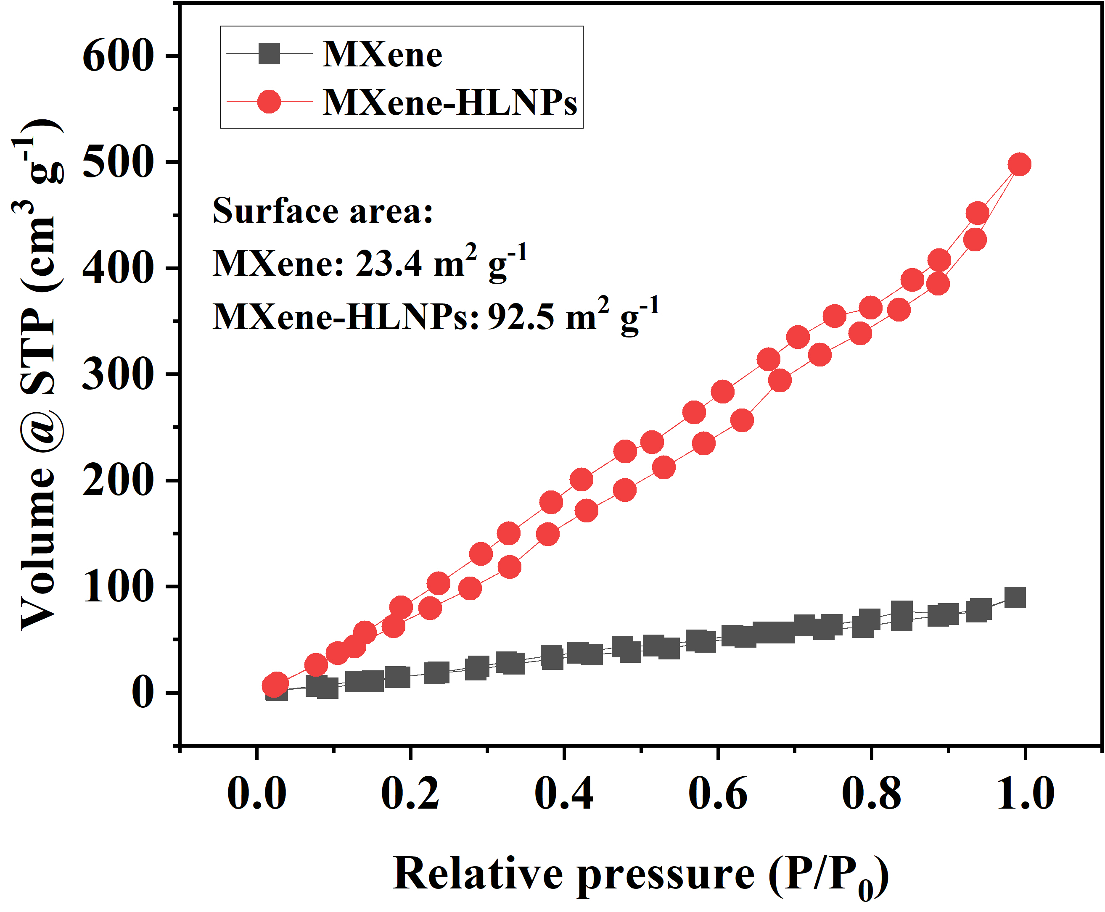
Fig. S4 Nitrogen sorption isotherms and BET specific surface area of MXene film and MXene/HLNPs film
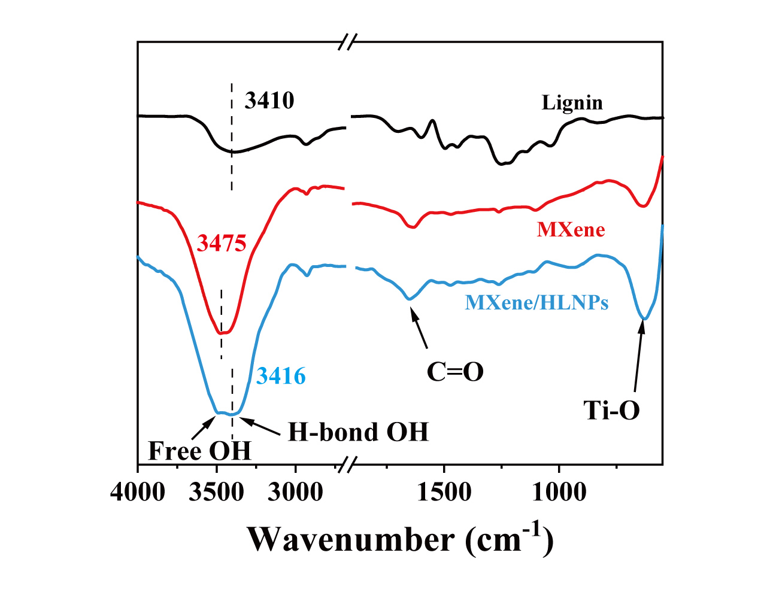
Fig. S5 FTIR spectra of lignin, MXene film, and MXene/HLNPs film
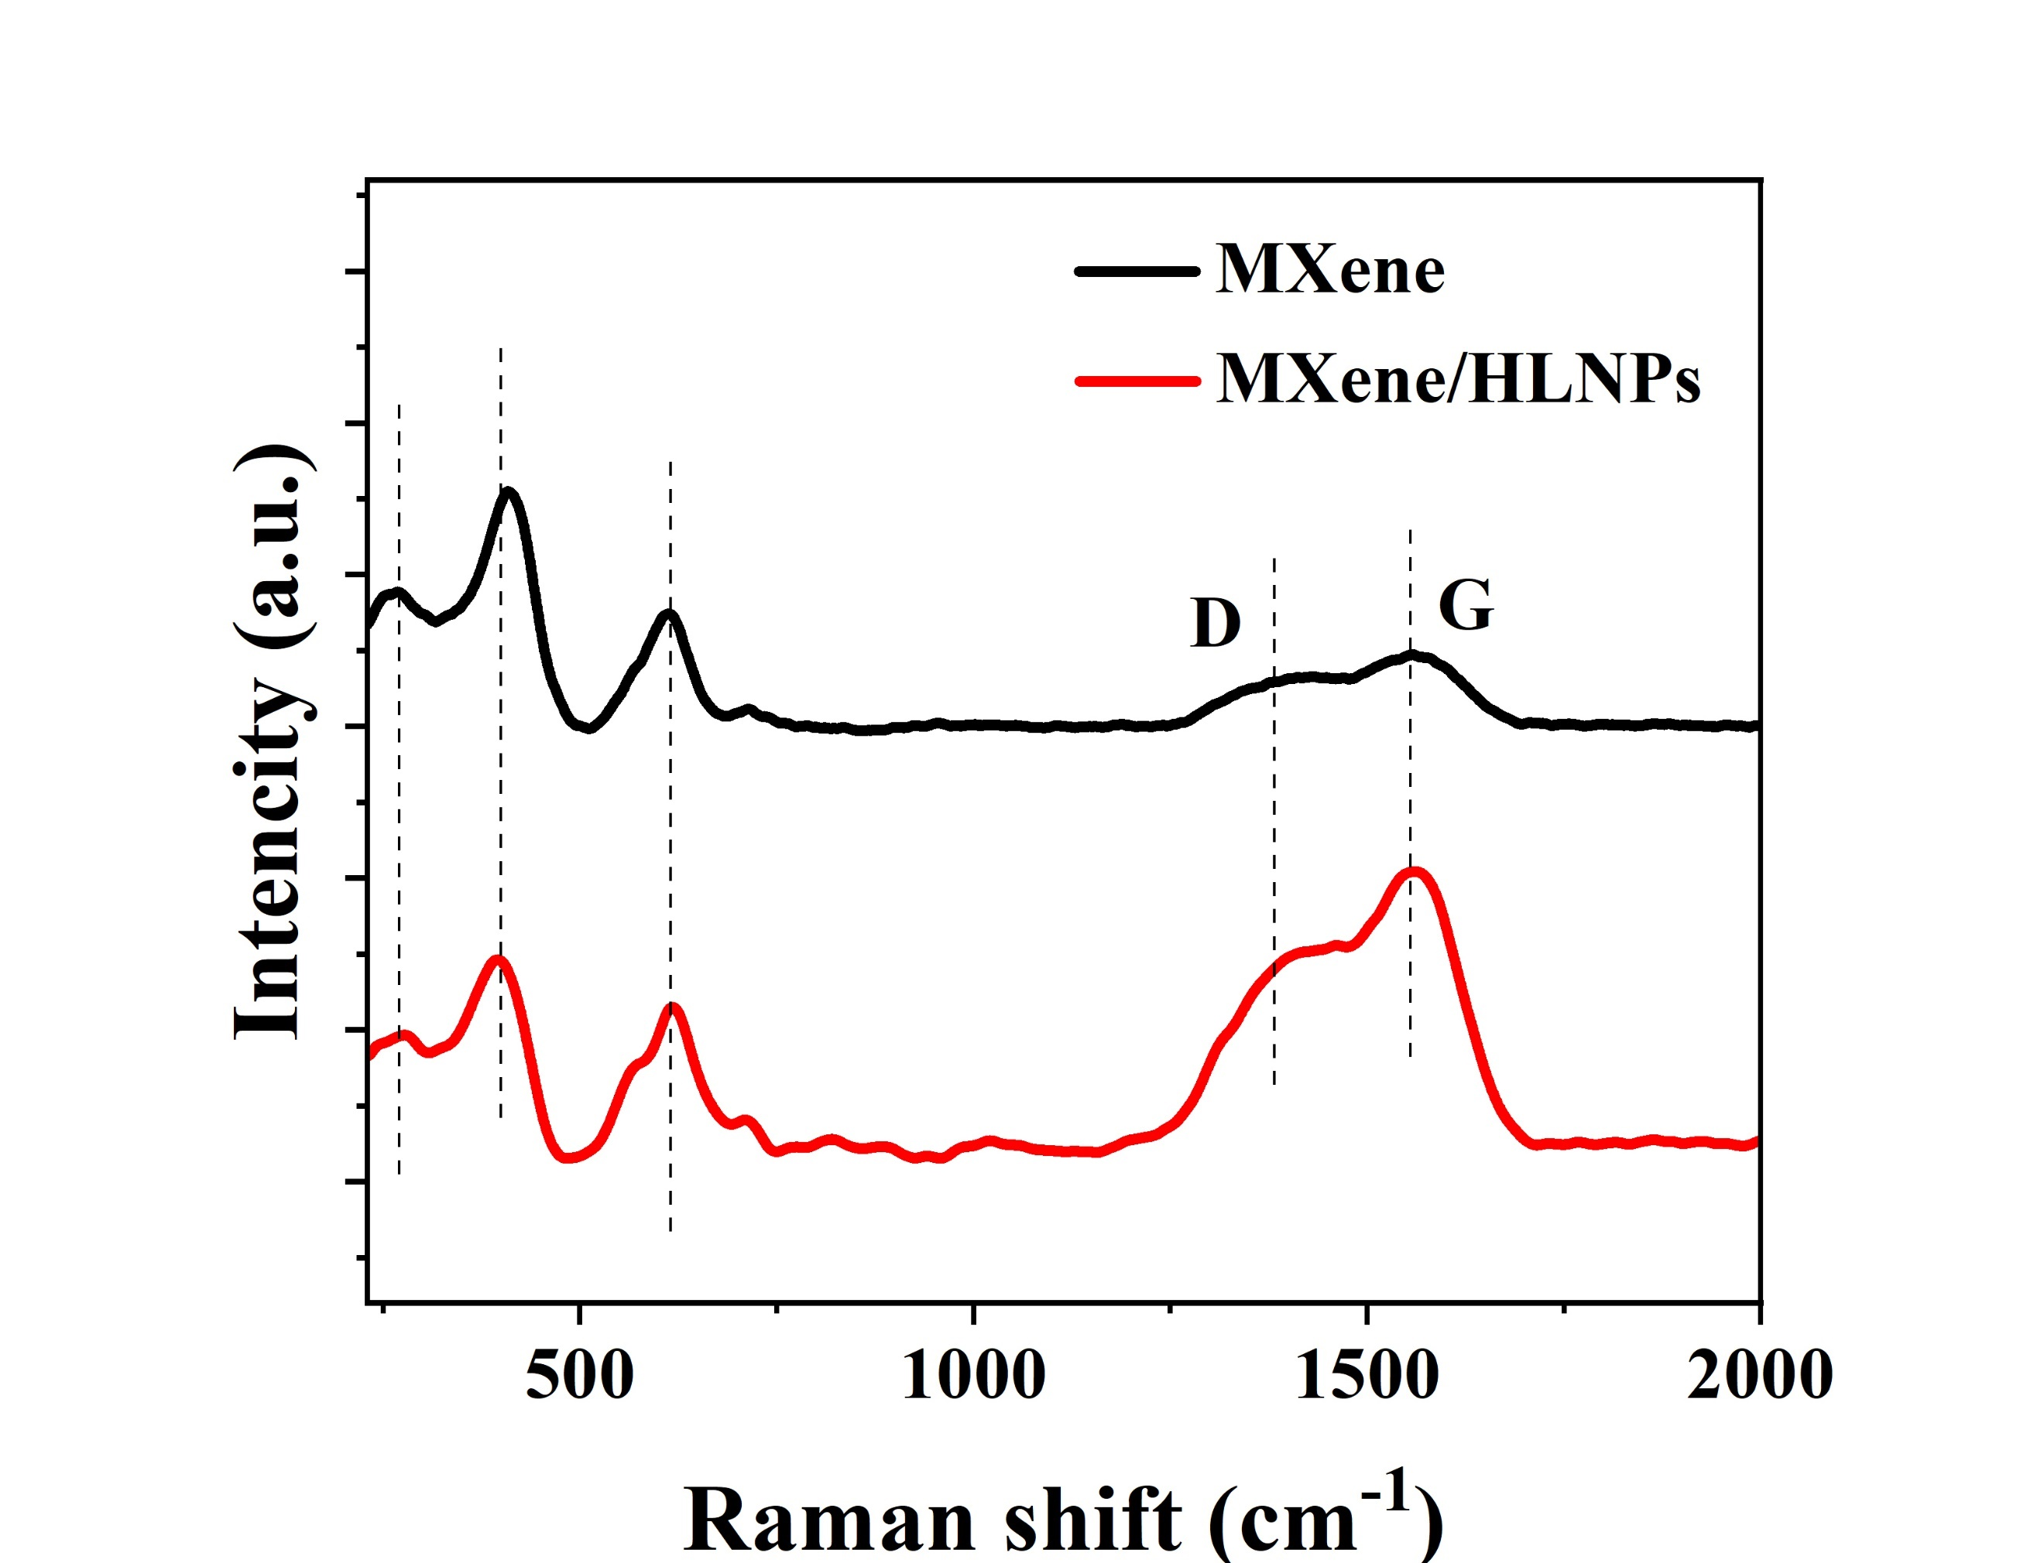
Fig. S6 Raman spectra of MXene film, and MXene/HLNPs film
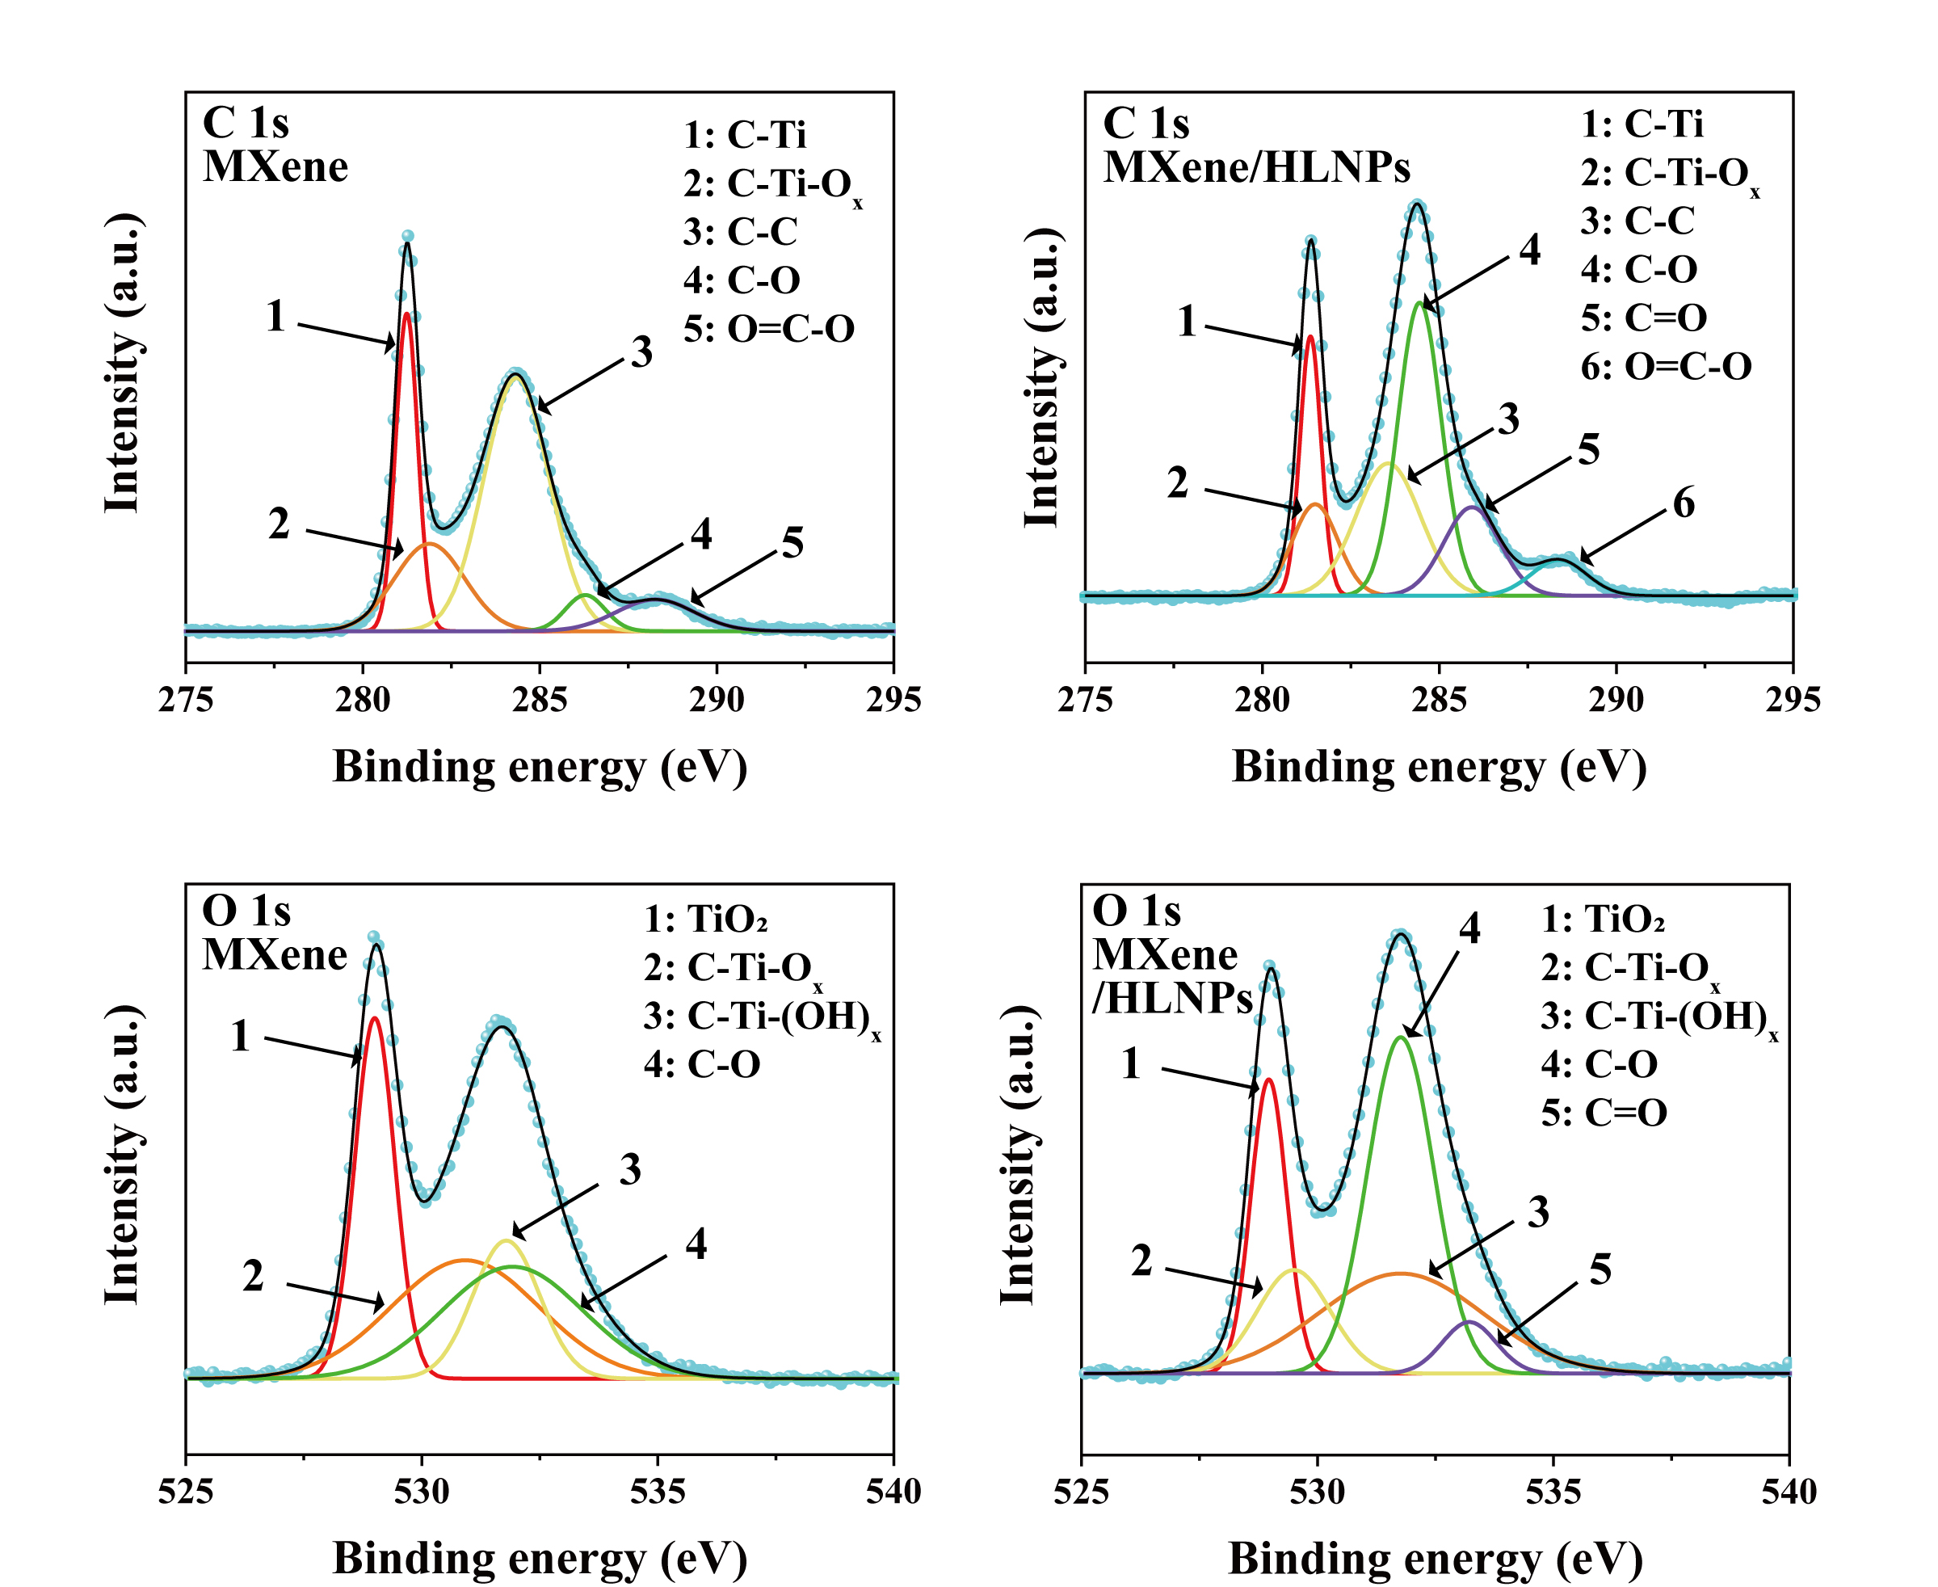
Fig. S7 XPS spectra of a) C 1s of pure MXene film, b) C 1s of MXene/HLNPs film, c) O 1s of pure MXene film, and d) O 1s of Xene/HLNPs film
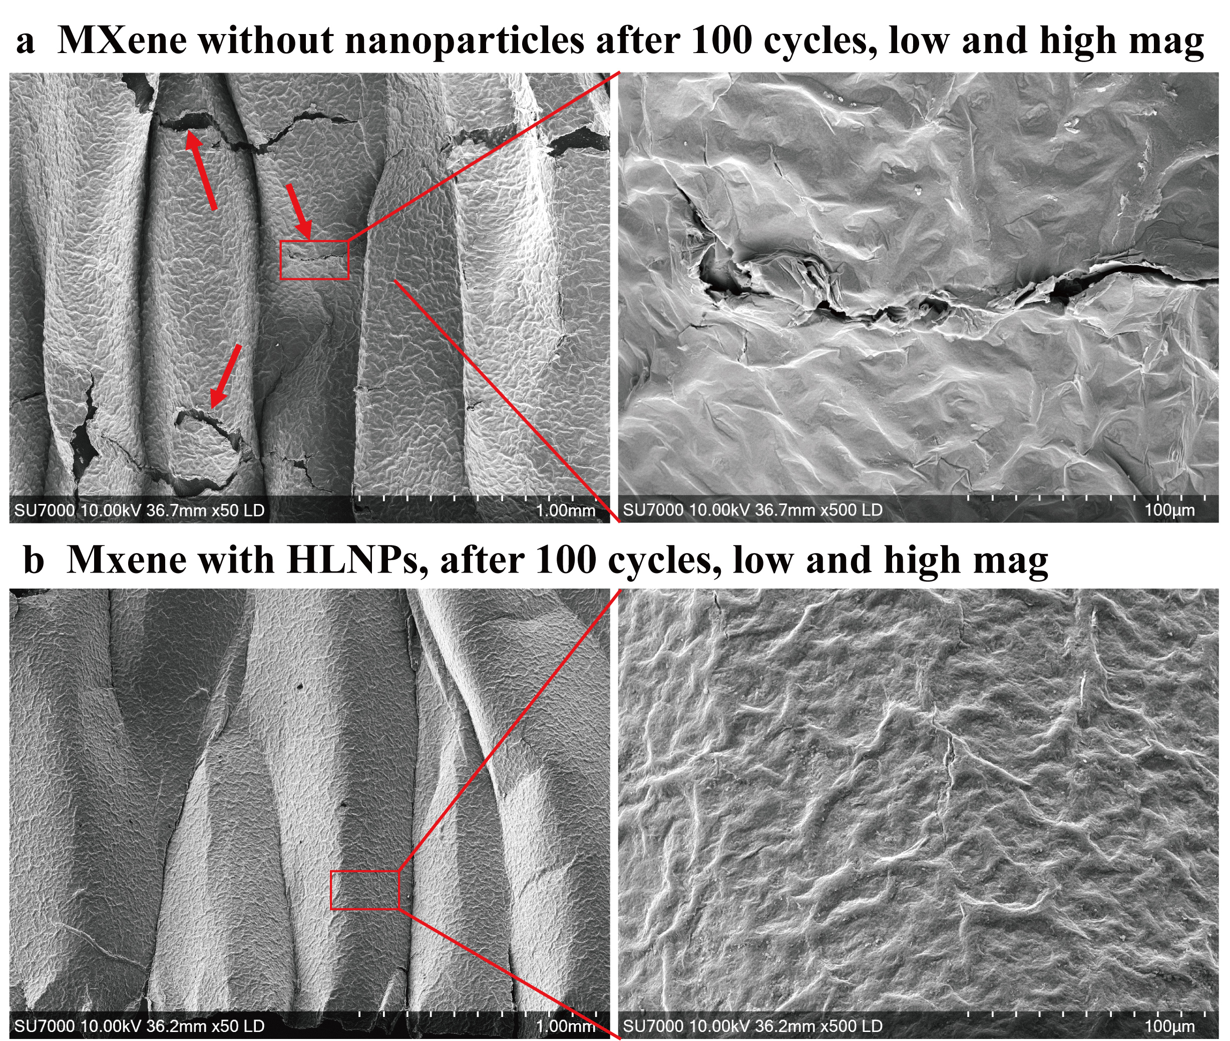
Fig. S8 MXene and MXene/HLNPs stretchable electrode after 100 times stretch-release cycle at 600%

Fig. S9 Observation of the high-density network of tiny vein-like wrinkles on top of the large-scale oriented wrinkles in HLNPs added electrodes by SEM

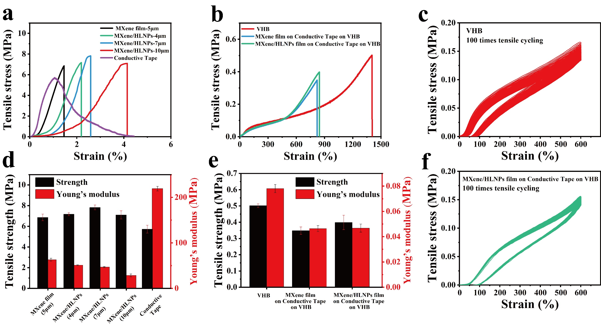
Fig. S10 a) Stress-strain curves of MXene film, MXene/HLNPs films with different thickness, and conductive tape. b) Stress-strain curves of VHB, MXene film on conductive tape on VHB and MXene/HLNPs film on conductive tape on VHB. c) Cyclic tensile test curves of VHB (100 times). d, e) tensile strength and young’s modulus of MXene film, MXene/HLNPs films with different thickness, conductive tape, VHB, MXene film on conductive tape on VHB and MXene/HLNPs film on conductive tape on VHB. f) Cyclic tensile test curves of MXene/HLNPs film on conductive tape on top of VHB (100 times)

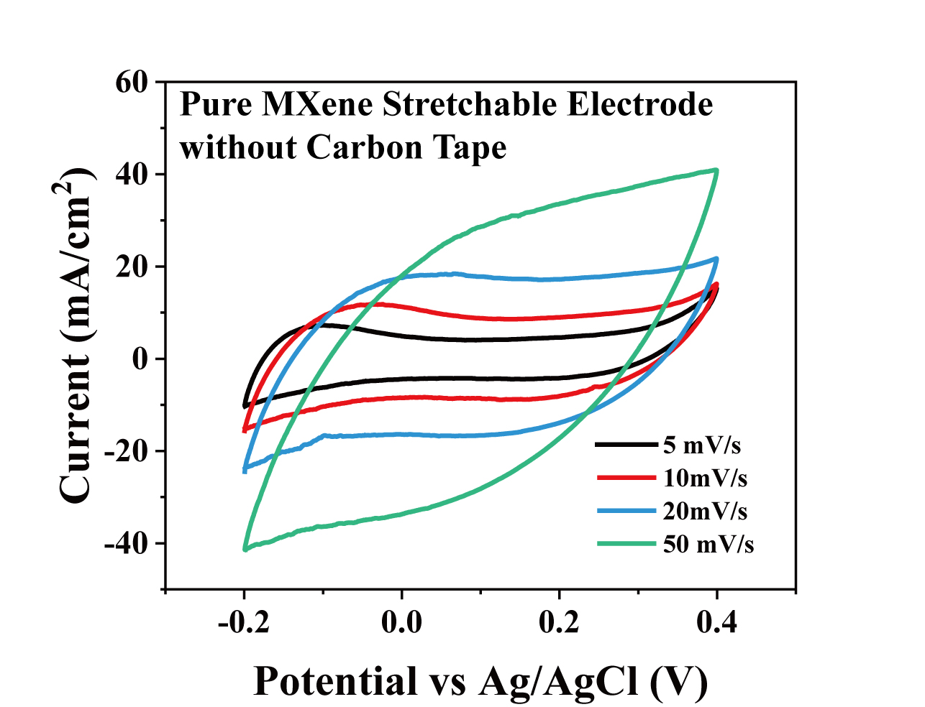
Fig. S11 CV curve of pure MXene stretchable electrode without conductive tape layer
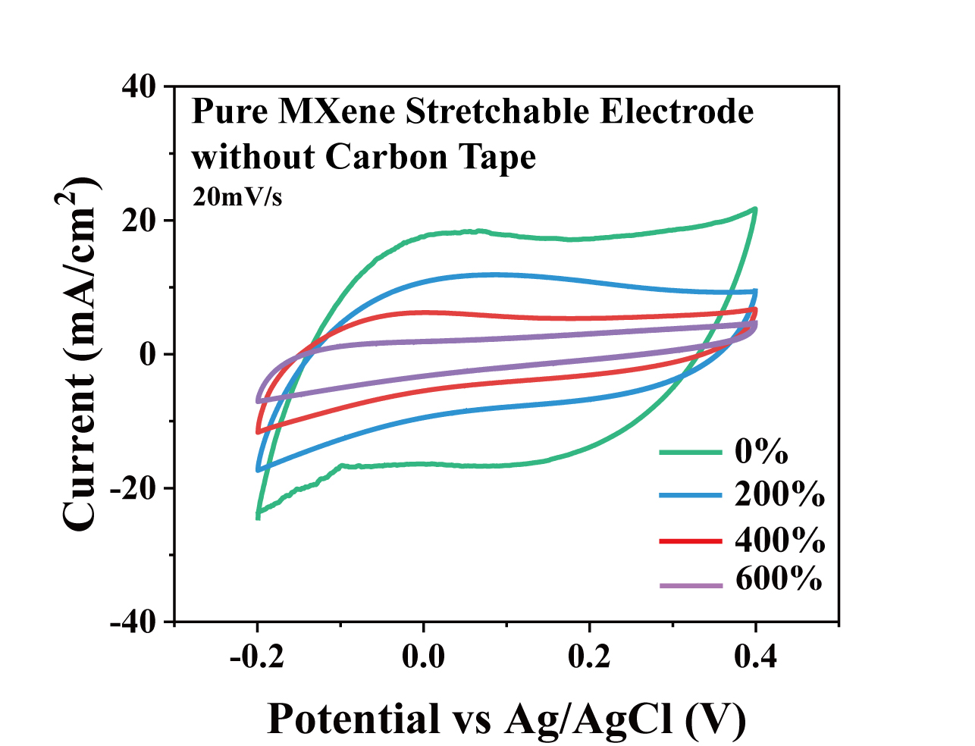
Fig. S12 CV curve of pure MXene stretchable electrode (without conductive tape layer) at strain of 0%-600%
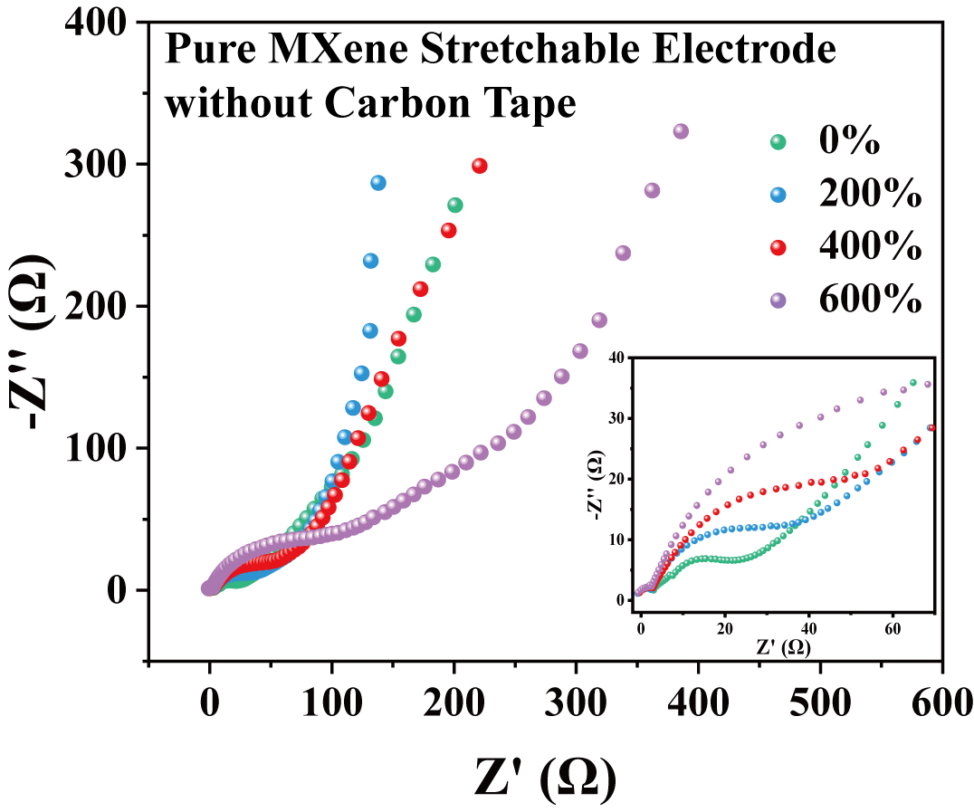
Fig. S13 EIS of pure MXene stretchable electrode (without conductive tape layer) at strain of 0%-600%
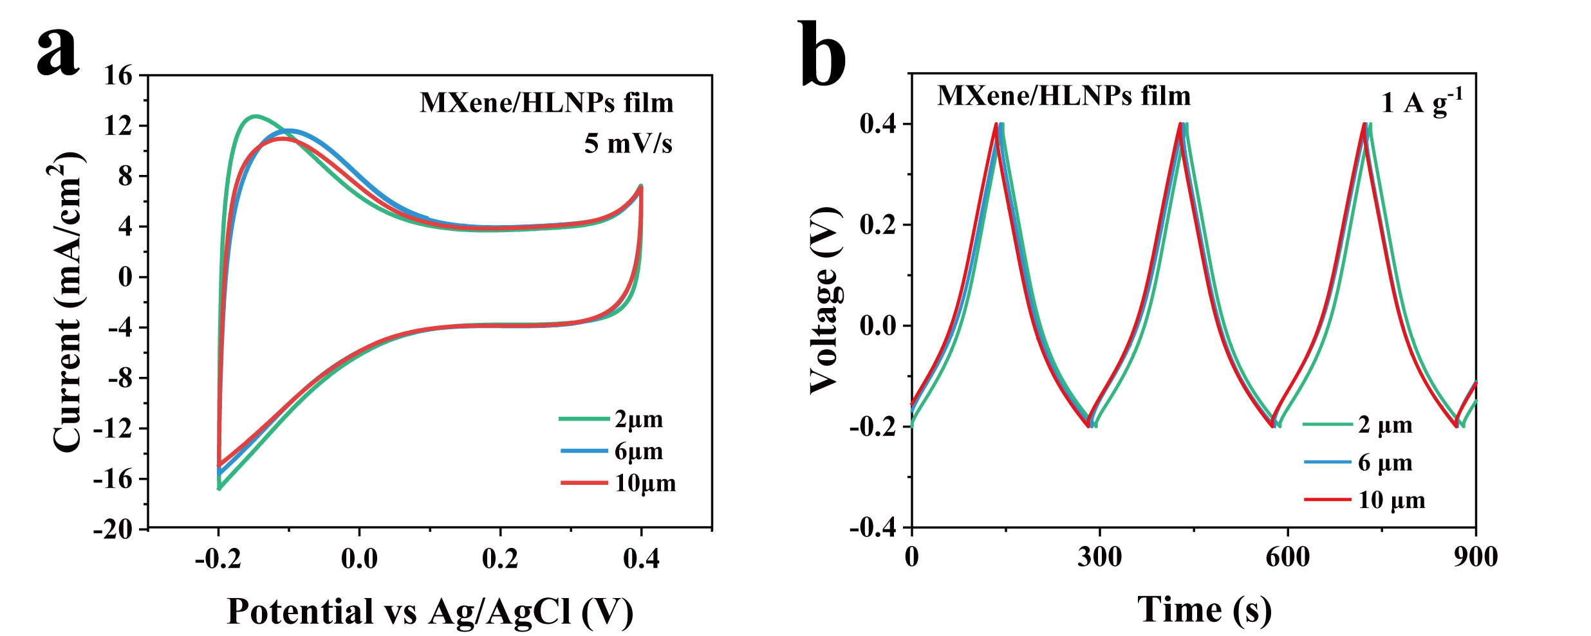
Fig. S14 a) CV curve of MXene/HLNPs stretchable electrode at different thicknesses. b) GCD curves of MXene/HLNPs stretchable electrode
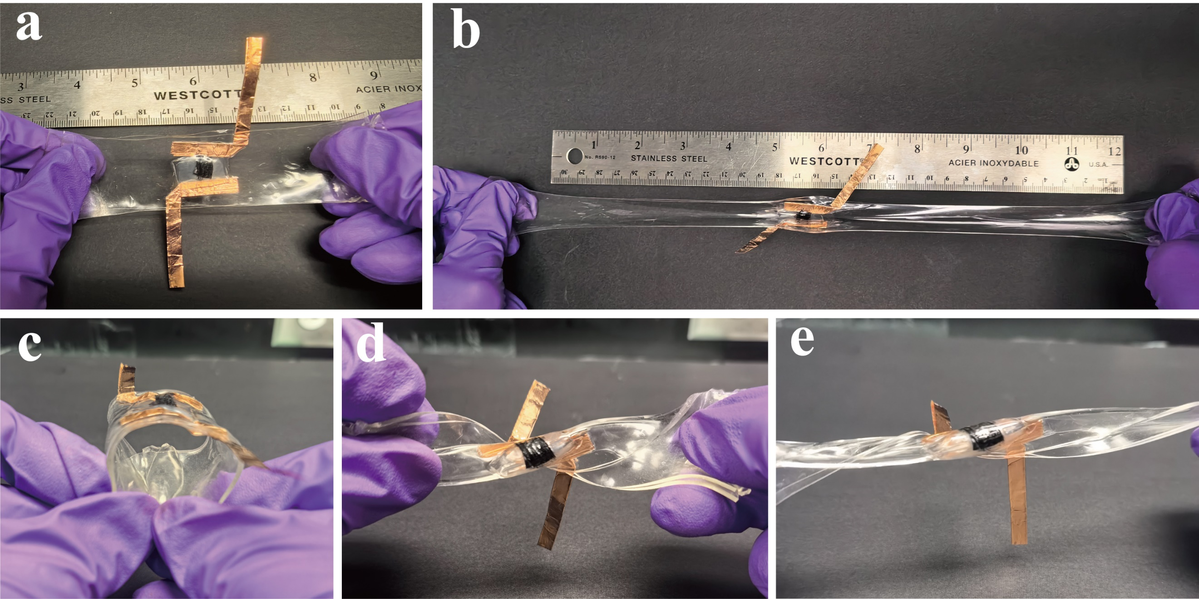
Fig. S15 Illustration of the a) stretchable all-solid-state supercapacitor and its ability to withstand b) stretching, c) bending, d) twisting and stretch under twisting state
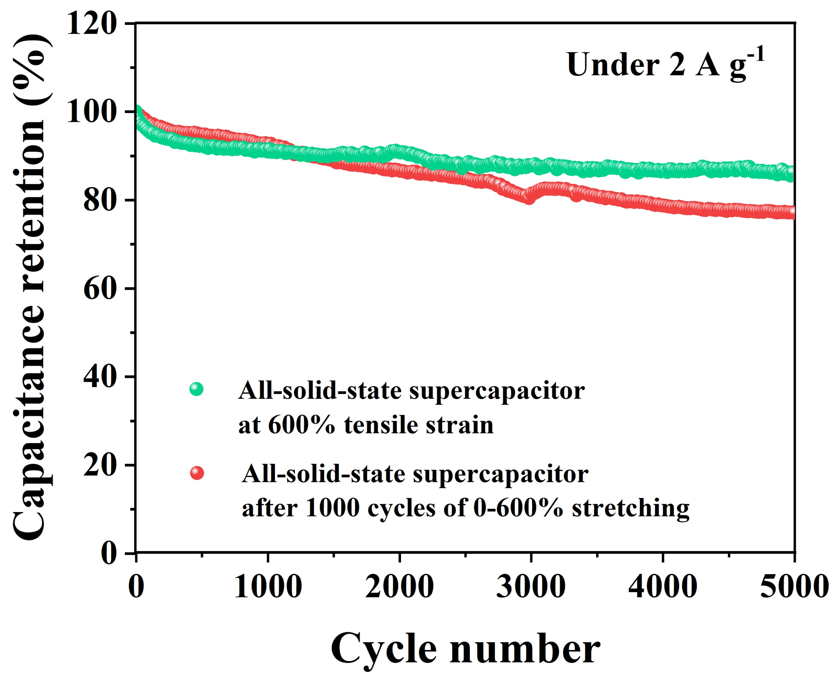
Fig. S16 Cycling stability of the stretchable all-solid-state supercapacitor at 600% tensile strain and after 1000 cycles of 0-600% stretching for 5000 cycles under 2 A g⁻¹
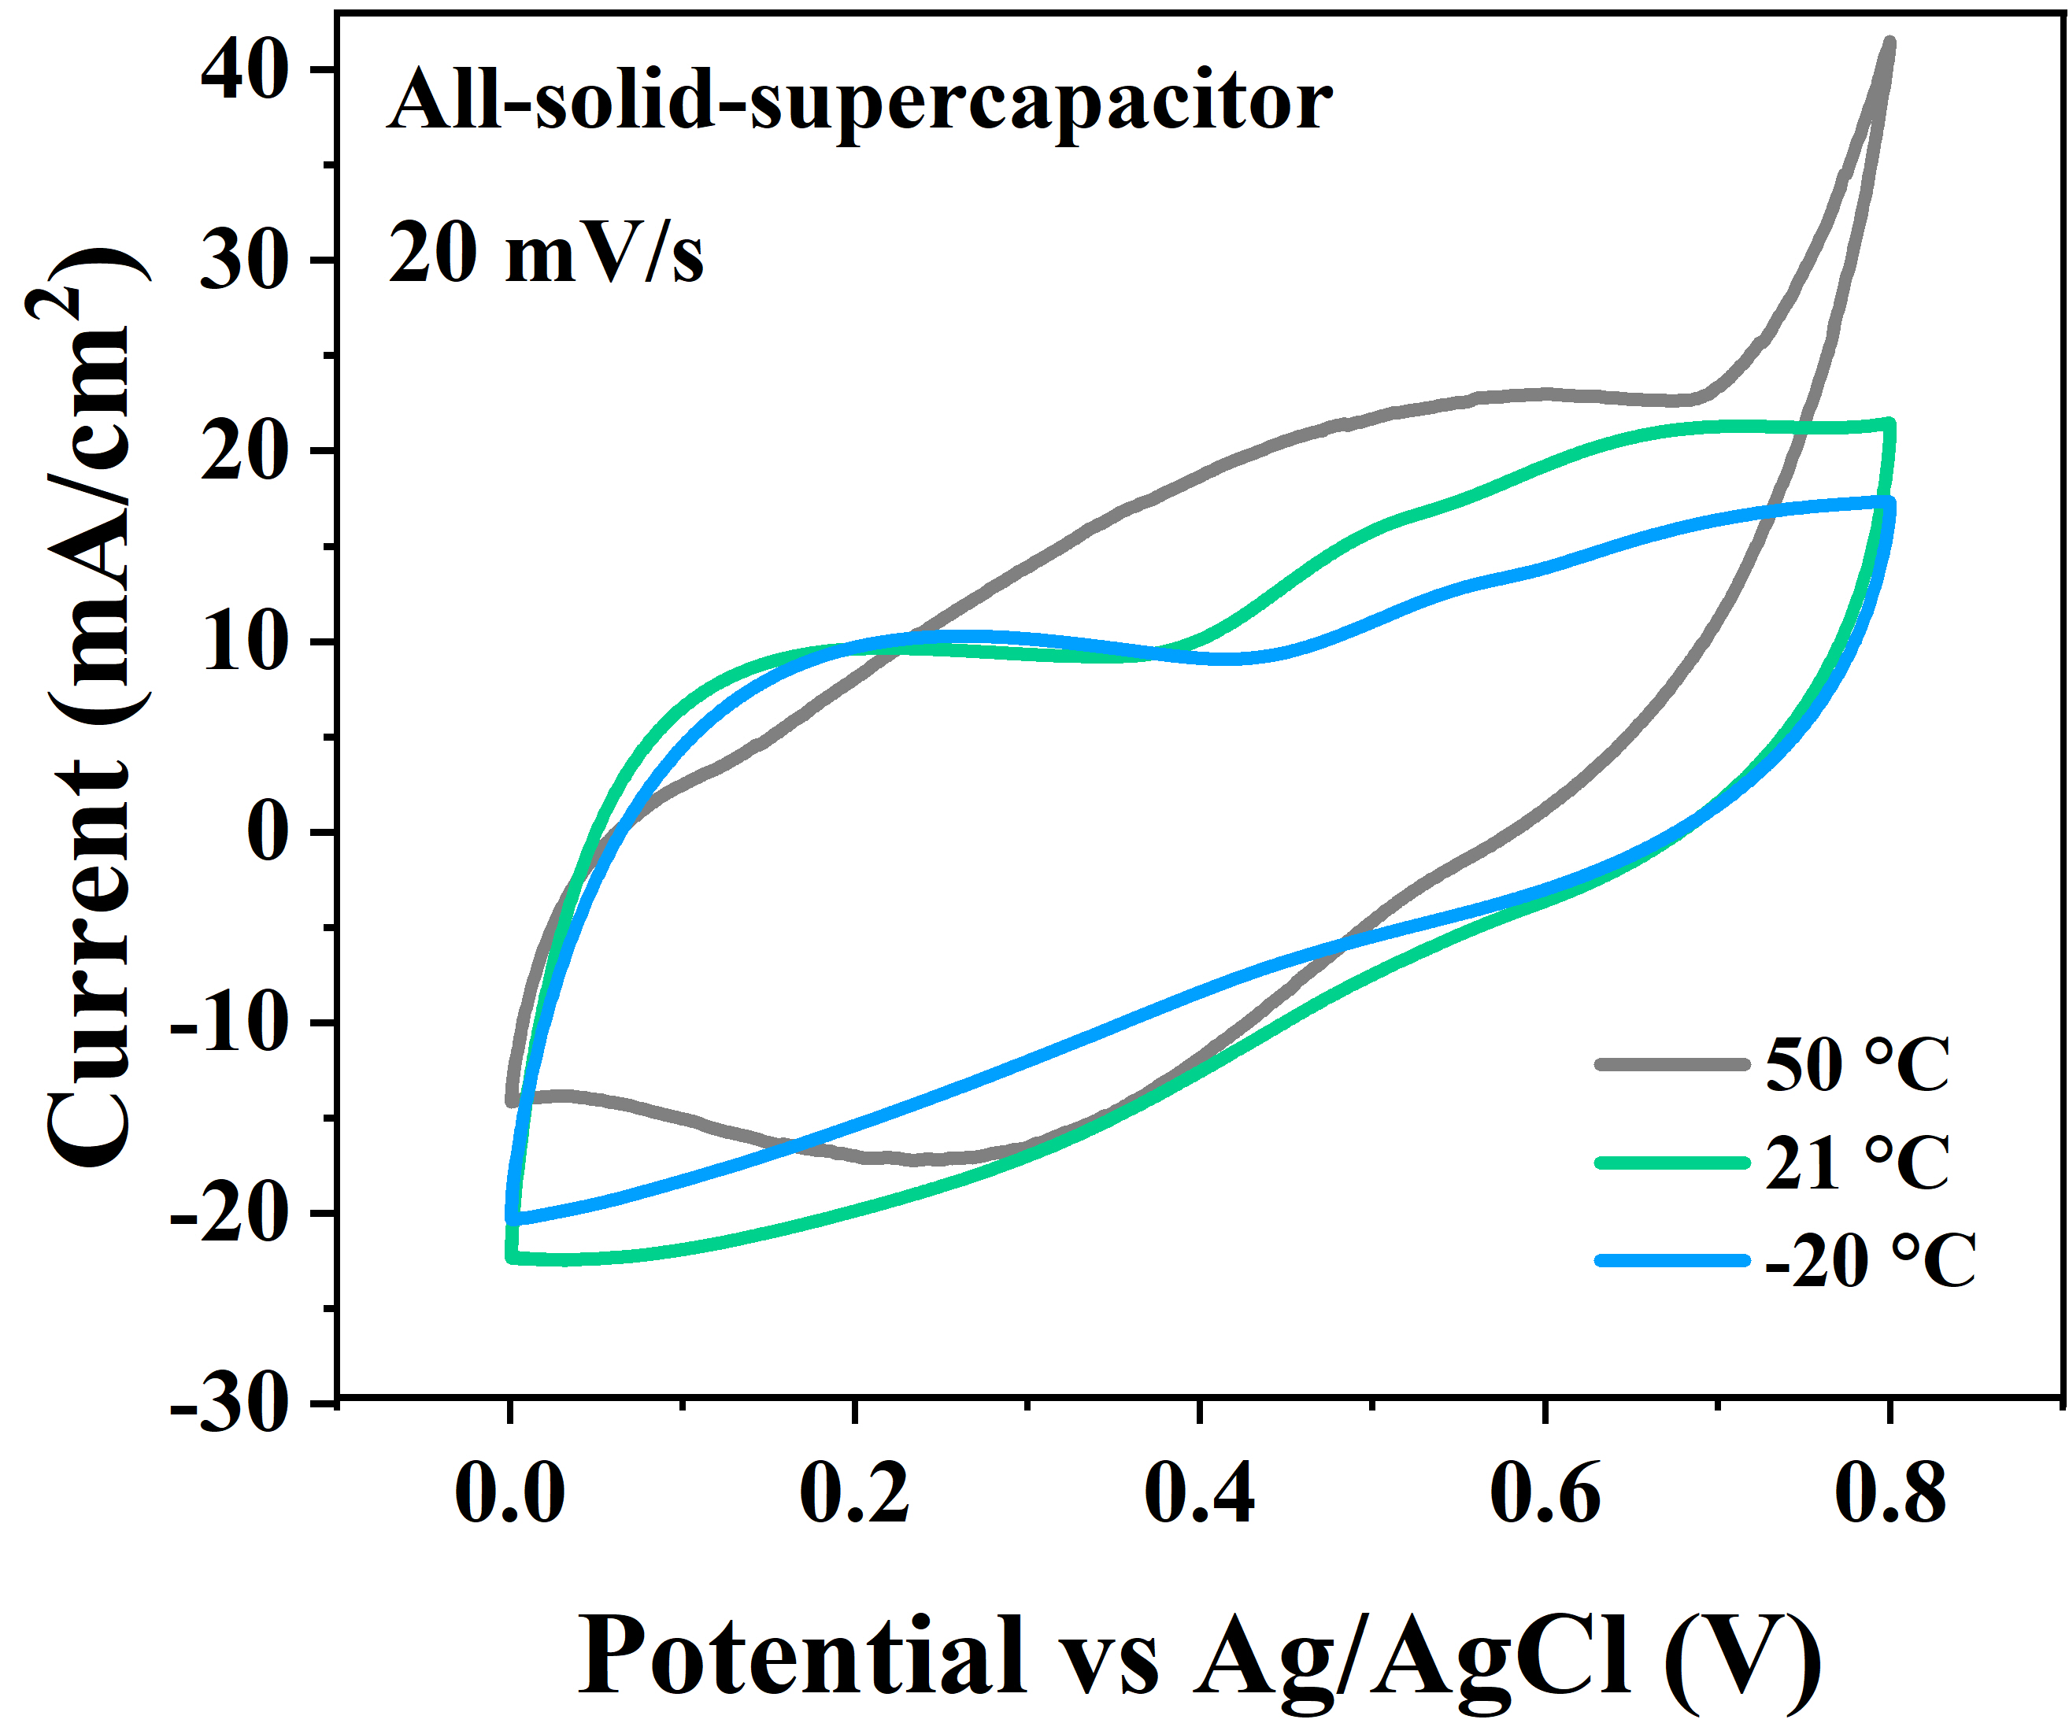
Fig. S17 CV curve of the stretchable all-solid-state supercapacitor under different temperature

Table S1 Comparison of the stretchable MXene/HLNPs electrode and all-solid-state supercapacitors with other MXene based electrodes and supercapacitors reported in literature
Electrode | Electrolyte | Stretchability | Cg (F/g) | CA  (mF/cm²) | Scan Rate | Ref.
Ti₃C₂T_{x}/HLNPs | 1 M H₂SO₄ | 600% (uniaxis) | 241 | 1273 (~10 μm) | 1 A g⁻¹ | This Work
Ti₃C₂T_{x} | 1 M H₂SO₄ | 800% (biaxis) | 64 | 470 | 2 mV s⁻¹ | [S1]
Ti₃C₂T_{x}/Au | 5 M H₃PO₄ | 800% (biaxis) |  | 185 | 2 mV s⁻¹ | [S2]
Ti₃C₂T_{x}/RGO | 1 M H₂SO₄ | 200% (uniaxis) | 115 | 35 | 1 A g⁻¹ | [S3]
Ti₃C₂T_{x}/RGO | 1 M H₂SO₄ | 800% (biaxis) | 93 | 29 | 1 A g⁻¹ | [S3]
Ti₃C₂T_{x}/RGO | 1 M H₂SO₄ | 300% (biaxis) |  | 19 | 0.1 A g⁻¹ | [S3]
Ti₃C₂T_{x}/BC | H₂SO₄ | 100% (uniaxis) |  | 111.5 (~13.3μm) | 0.75 mA cm⁻² | [S4]
AC/Ti₃C2T_{x}/CB/Alginate | 1 M Li₂SO4 | 100% (uniaxis) |  | 10.47 | 25 mV s⁻¹ | [S5]
E-MXene | 1 M ZnSO₄ | 50% (uniaxis) |  | 127.9 | 10 mV s⁻¹ | [S6]
Ti₃C₂T_{x} | 1 M H₂SO₄ | 30% (uniaxis) |  | 33.3 | 10 mV s⁻¹ | [S7]
Ti₃C₂T_{x}/PVA fiber | H₃PO₄ | 48% (uniaxis) | 119.3 | 130.9 | 0.5 mA g⁻¹ | [S8]
Ti₃C₂T_{x}/graphene | 2 M KOH |  | 154 |  | 1 A g⁻¹ | [S9]
Ti₃C₂T_{x}/RGO | 1 M MgSO₄ |  |  | 87 (~2 μm) | 2 mV s⁻¹ | [S10]
Ti₃C₂T_{x}/CNT | 1 M MgSO₄ |  |  | 78 (~2 μm) | 2 mV s⁻¹ | [S10]

Supplementary References
- S. Feng, X. Wang, M. Wang, C. Bai, S. Cao et al., Crumpled MXene electrodes for ultrastretchable and high-area-capacitance supercapacitors. Nano Lett. 21(18), 7561-7568 (2021). https://doi.org/10.1021/acs.nanolett.1c02071
- J. Wang, Y. Qi, Y. Gui, C. Wang, Y. Wu et al., Ultrastretchable E-skin based on conductive hydrogel microfibers for wearable sensors. Small 20(9), e2305951 (2024). https://doi.org/10.1002/smll.202305951
- Y. Zhou, K. Maleski, B. Anasori, J. O. Thostenson, Y. Pang et al., Ti₃C₂T_{x} MXene-reduced graphene oxide composite electrodes for stretchable supercapacitors. ACS Nano 14(3), 3576-3586 (2020). https://doi.org/10.1021/acsnano.9b10066
- S. Jiao, A. Zhou, M. Wu, H. Hu, Kirigami patterning of MXene/bacterial cellulose composite paper for all-solid-state stretchable micro-supercapacitor arrays. Adv. Sci. (Weinh) 6(12), 1900529 (2019). https://doi.org/10.1002/advs.201900529
- T.-H. Chang, T. Zhang, H. Yang, K. Li, Y. Tian et al., Controlled crumpling of two-dimensional titanium carbide (MXene) for highly stretchable, bendable, efficient supercapacitors. ACS Nano 12(8), 8048-8059 (2018). https://doi.org/10.1021/acsnano.8b02908
- S. Li, T.-H. Chang, Y. Li, M. Ding, J. Yang et al., Stretchable Ti₃C₂T_{x} MXene microsupercapacitors with high areal capacitance and quasi-solid-state multivalent neutral electrolyte. J. Mater. Chem. A 9(8), 4664-4672 (2021). https://doi.org/10.1039/D0TA10560K
- L. Weng, F. Qi, Y. Min, The Ti₃C₂T_{x} MXene coated metal mesh electrodes for stretchable supercapacitors. Mater. Lett. 278, 128235 (2020). https://doi.org/10.1016/j.matlet.2020.128235
- W. Yu, Y. Li, B. Xin, Z. Lu, MXene/PVA Fiber-based Supercapacitor with Stretchability for Wearable Energy Storage. Fibers Polym. 23(11), 2994-3001 (2022). https://doi.org/10.1007/s12221-022-4389-4
- C. Zhao, Q. Wang, H. Zhang, S. Passerini, X. Qian, Two-Dimensional Titanium Carbide/RGO Composite for High-Performance Supercapacitors. ACS Appl. Mater. Interfaces 8(24), 15661-15667 (2016). https://doi.org/10.1021/acsami.6b04767
- M.-Q. Zhao, C. E. Ren, Z. Ling, M. R. Lukatskaya, C. Zhang et al., Flexible MXene/carbon nanotube composite paper with high volumetric capacitance. Adv. Mater. 27(2), 339-345 (2015). https://doi.org/10.1002/adma.201404140

