Supporting Information for
Crystallization Modulation and Holistic Passivation Enables Efficient Two-Terminal Perovskite/CuIn(Ga)Se₂ Tandem Solar Cells
Cong Geng¹, Kuanxiang Zhang², Changhua Wang², Chung Hsien Wu², Jiwen Jiang², Fei Long³, Liyuan Han^{4,}*, Qifeng Han⁴, Yi-Bing Cheng¹, and Yong Peng^{1,}*
¹ State Key Laboratory of Advanced Technology for Materials Synthesis and Processing, Wuhan University of Technology, Wuhan 430070, P. R. China
² Triumph Photovoltaic Materials Co., Ltd. No.1001 Yannan Avenue, High-Tech Development District, Bengbu, Anhui, P. R. China
³ College of Materials Science and Engineering, Guilin University of Technology, Guilin 541004, P. R. China
⁴ State Key Laboratory of Metal Matrix Composites, Shanghai Jiao Tong University, Shanghai 200240, P. R. China
*Corresponding authors. E-mail: yongpeng@whut.edu.cn (Yong Peng); han.liyuan@sjtu.edu.cn (Liyuan Han)
Supplementary Figures and Tables
Fig. S1 5 µm × 5 µm AFM topography of surface PVK thin-film as-grown on CIGS

Fig. S2 a-d Photo-voltaic (PV) parameter statistics of the control, D-HLH-treated, LiF-treated, and 2-TEAI-treated, and 2-TEAI/LiF-treated PSCs
Fig. S3 XRD intensity evolution for (100) crystal plane at 2θ = 14.00° during the annealing process
Fig. S4 ¹³C NMR spectra of D-HLH and D-HLH/FAI
Fig. S5 XPS spectra of a Pb 4f, b I 3d, and c N 1s of the control and D-HLH-tread films
Fig. S6 PLQY of the perovskite films on a ITO/SAM/PVK stack, and b ITO/SAM/PVK/passivation layer/C₆₀ stack
The PLQY, which is directly related to the QFLS under the presumption that all PL emission results from the radiative recombination of free charges in perovskite film, can be represented by the following equation.
$$QFLS=K_{B}TIn(PLQY×{J_{G}}/{J_{0,rad})}$$
where KB, and T represent Boltzmann constant and temperature, respectively. JG is the current density under illumination, and J0,rad is the dark radiative recombination saturation current density.
The following equations can be used to calculate the in accordance with the detailed balance theory:
$$J_{0,rad}=q\int_{0}^{∞}{{EQE}_{PV}\left(E\right)∅_{BB}\left(E\right)dE}$$
$$∅_{BB}\left(E\right)=\frac{2πE^{2}}{h^{3}c^{2}}\frac{1}{\exp\left(\frac{E}{K_{B}T}\right)-1}$$
Where q, EQE_{PV}, $∅_{BB}$ , E, h, c represents elementary charge, photovoltaic external quantum efficiency, black-body radiative spectrum, photon energy, Planck constant, and light speed in vacuum, respectively.
Fig. S7 Steady-state PL spectra of the PVK films

Fig. S8 Transient PL spectra of the glass/PVK/passivation layer /C₆₀ stacks
Fig. S9 Schematic of the device layout used in the fabrication of the 2T PVK/CIGS TSCs. The final aperture area of 0.16 cm² is defined by a black shadow mask used during J-V measurements
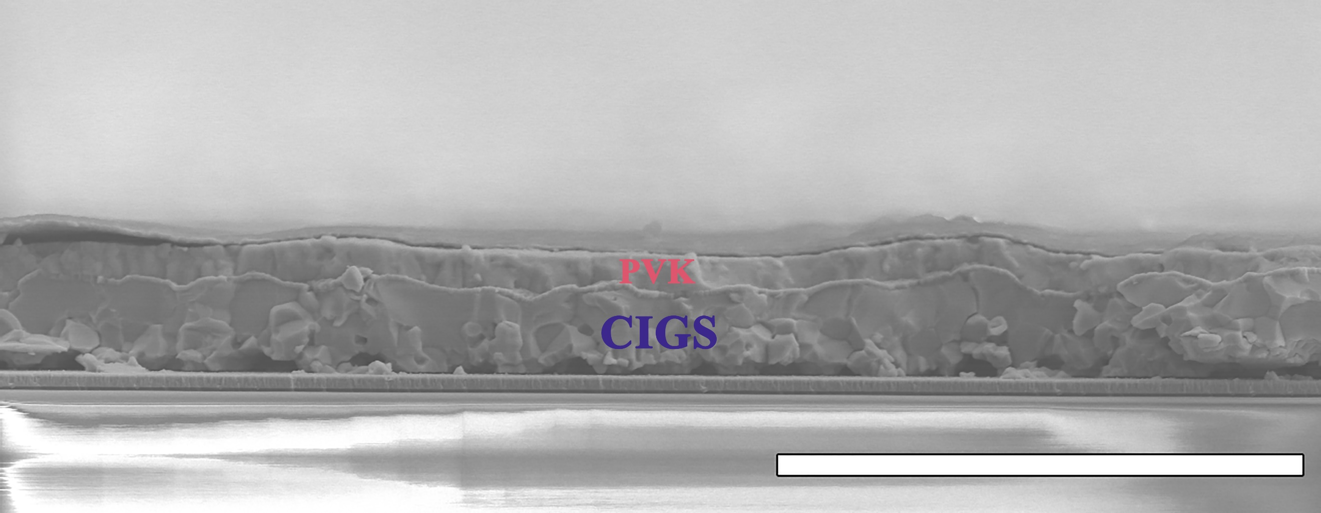
Fig. S10 Cross-section SEM images the PVK/CIGS tandem solar cells. (Scale bar: 10 μm)
Fig. S11 PV parameter statistics of PVK/CIGS tandem solar cells without NiO_{x}
Fig. S12 a-d PV parameter statistics of the control, D-HLH-treated, LiF-treated, and 2-TEAI-treated, and 2-TEAI/LiF-treated PVK/CIGS tandem solar. cells

Fig. S13 The stability of three unencapsulated tandem devices in nitrogen and air (30-50% RH) environment
Table S1 Summary of 2-T PVK/CIGS tandem solar cells
Year | Perovskite | Voc  (V) | Jsc  (mA / cm²) | FF  (%) | PCE  (%) | area  (cm²) | Refs.
2015 | MAPbIBr | 1.45 | 12.7 | 56.6 | 10.9 | 0.4 | [S1]
2017 | MAPbI₃ | 1.346 | 12.9 | 63.5 | 11.03 | 0.5 | [S2]
2018 | Cs_{0.09}FA_{0.77}MA_{0.14}Pb(I_{0.86}Br_{0.14})₃ | 1.774 | 17.3 | 73.1 | 22.43 | 0.52 | [S3]
2019 | Cs_{0.05}(MA_{0.17}FA_{0.83})_{0.95}Pb(I_{0.83}Br_{0.17})₃ | 1.58 | 18 | 76 | 21.6 | 0.78 | [S4]
2019 | Cs_{0.05}(MA_{0.17}FA_{0.83})_{0.95}Pb(I_{0.83}Br_{0.17})₃ | 1.68 | 19.17 | 71.9 | 23.26 | 1.03 | [S5]
2022 | Cs_{0.05}(MA_{0.23}FA_{0.77})Pb_{1.1}(I_{0.77}Br_{0.23})₃ | 1.77 | 18.8 | 71.2 | 24.2 | 1.04 | [S6]
2022 | Cs_{0.05}MA_{0.1}FA_{0.85}Pb(I_{0.9}Br_{0.1})₃ | 1.59 | 19.4 | 75.5 | 23.5 | 0.5 | [S7]
2024 | Cs_{0.05}(MA_{0.17}FA_{0.83})_{0.95}Pb(I_{0.83}Br_{0.17})₃ | 1.742 | 20.97 | 67.3 | 24.6 | 0.16 | This Wok
Supplementary References
- T. Todorov, T. Gershon, O. Gunawan, Y. S. Lee, C. Sturdevant et al., Monolithic perovskite-cigs tandem solar cells via in situ band gap engineering. Adv. Energy Mater. 5(23), 1500799 (2015). https://doi.org/10.1002/aenm.201500799
- Y. H. Jang, J. M. Lee, J. W. Seo, I. Kim, D.-K. Lee, Monolithic tandem solar cells comprising electrodeposited CuInSe₂ and perovskite solar cells with a nanoparticulate zno buffer layer. J. Mater. Chem. A 5(36), 19439-19446 (2017). https://doi.org/10.1039/C7TA06163C
- Q. Han, Y.-T. Hsieh, L. Meng, J.-L. Wu, P. Sun et al., High-performance perovskite/Cu(In,Ga)Se₂ monolithic tandem solar cells. Science 361(6405), 904-908 (2018). https://doi.org/10.1126/science.aat5055
- M. Jošt, T. Bertram, D. Koushik, J. A. Marquez, M. A. Verheijen et al., 21.6%-efficient monolithic perovskite/Cu(In,Ga)Se₂ tandem solar cells with thin conformal hole transport layers for integration on rough bottom cell surfaces. ACS Energy Lett. 4(2), 583-590 (2019). https://doi.org/10.1021/acsenergylett.9b00135
- A. Al-Ashouri, A. Magomedov, M. Roß, M. Jošt, M. Talaikis et al., Conformal monolayer contacts with lossless interfaces for perovskite single junction and monolithic tandem solar cells. Energy Environ. Sci. 12(11), 3356-3369 (2019). https://doi.org/10.1039/C9EE02268F
- M. Jošt, E. Köhnen, A. Al-Ashouri, T. Bertram, Š. Tomšičet al., Perovskite/cigs tandem solar cells: From certified 24.2% toward 30% and beyond. ACS Energy Lett. 7(4), 1298-1307 (2022). https://doi.org/10.1021/acsenergylett.2c00274
- M. A. Ruiz-Preciado, F. Gota, P. Fassl, I. M. Hossain, R. Singh et al., Monolithic two-terminal perovskite/cis tandem solar cells with efficiency approaching 25%. ACS Energy Lett. 7(7), 2273-2281 (2022). https://doi.org/ https://doi.org/10.1021/acsenergylett.2c00707

