Supporting Information for
Sulfolane-Based Flame-Retardant Electrolyte for High-Voltage Sodium-Ion Batteries
Xuanlong He¹, Jie Peng¹, Qingyun Lin², Meng Li³, Weibin Chen¹, Pei Liu¹, Tao Huang⁴, Zhencheng Huang¹, Yuying Liu¹, Jiaojiao Deng¹, Shenghua Ye¹, Xuming Yang¹, Xiangzhong Ren¹, Xiaoping Ouyang^{1, 5}, Jianhong Liu^{1, 6}, Biwei Xiao^{3,} *, Jiangtao Hu^{1,} *, Qianling Zhang^{1,} *
¹ Graphene Composite Research Center, College of Chemistry and Environmental Engineering, Shenzhen University, Shenzhen, 518060, P. R. China
² Center of Electron Microscopy, State Key Laboratory of Silicon and Advanced Semiconductor Materials, School of Materials Science and Engineering, Zhejiang University, Hangzhou, 310027, P. R. China
³ GRINM (Guangdong) Research Institute for Advanced Materials and Technology, Foshan, Guangdong, 528051, P. R. China
⁴ College of Energy Engineering, Zhejiang University, Hangzhou, Zhejiang 310027, P. R. China
⁵ School of Materials Science and Engineering, Xiangtan University, Xiangtan 411105, P. R. China
⁶ Shenzhen Eigen-Equation Graphene Technology Co. Ltd, Shenzhen, 518000, P. R. China
*Corresponding authors. E-mail: zhql@szu.edu.cn (Qianling Zhang); hujt@szu.edu.cn (Jiangtao Hu); xiaobiwei@grinm.com (Biwei Xiao)
Supplementary Figures
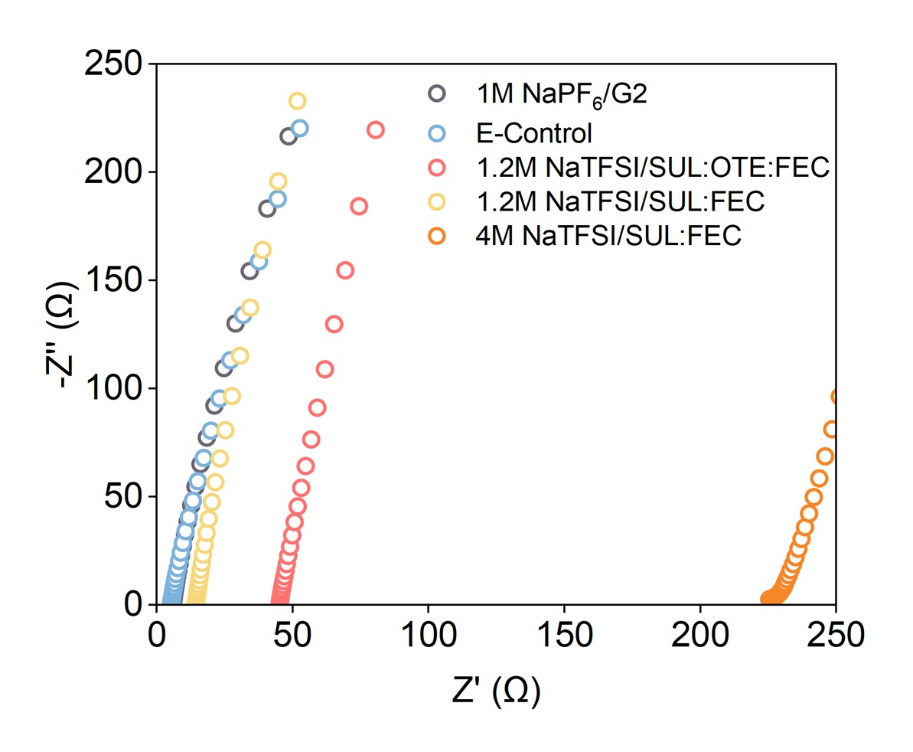
Fig. S1 Nyquist plots of symmetric stainless steel cells assembled with different electrolytes
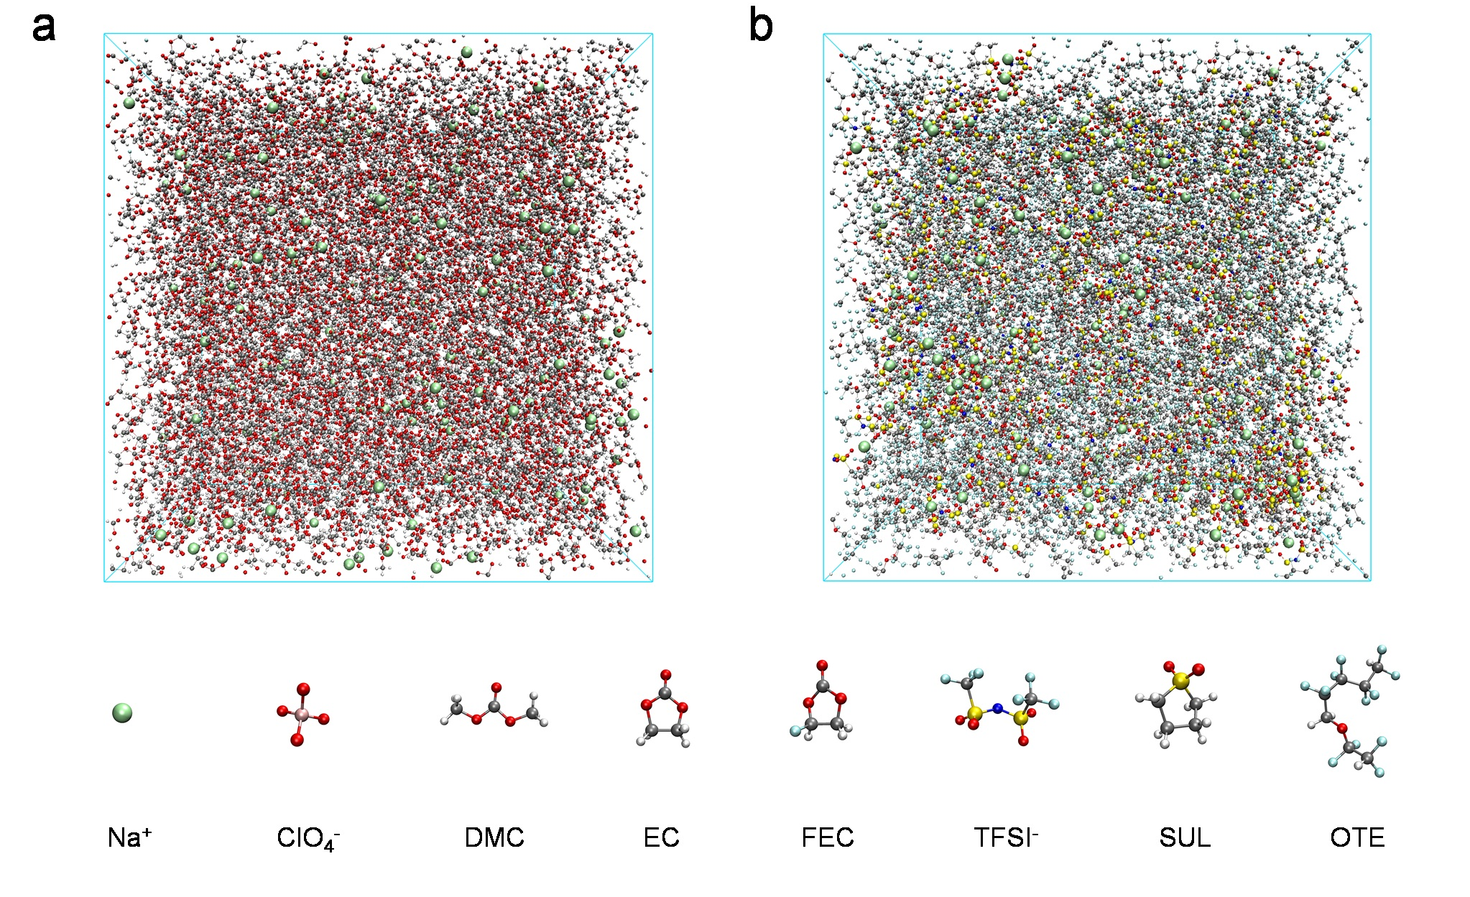
Fig. S2 Snapshots of MD simulations boxes of Na⁺ solvation sheath in (a) E-Control and (b) NaTFSI/SUL:OTE:FEC
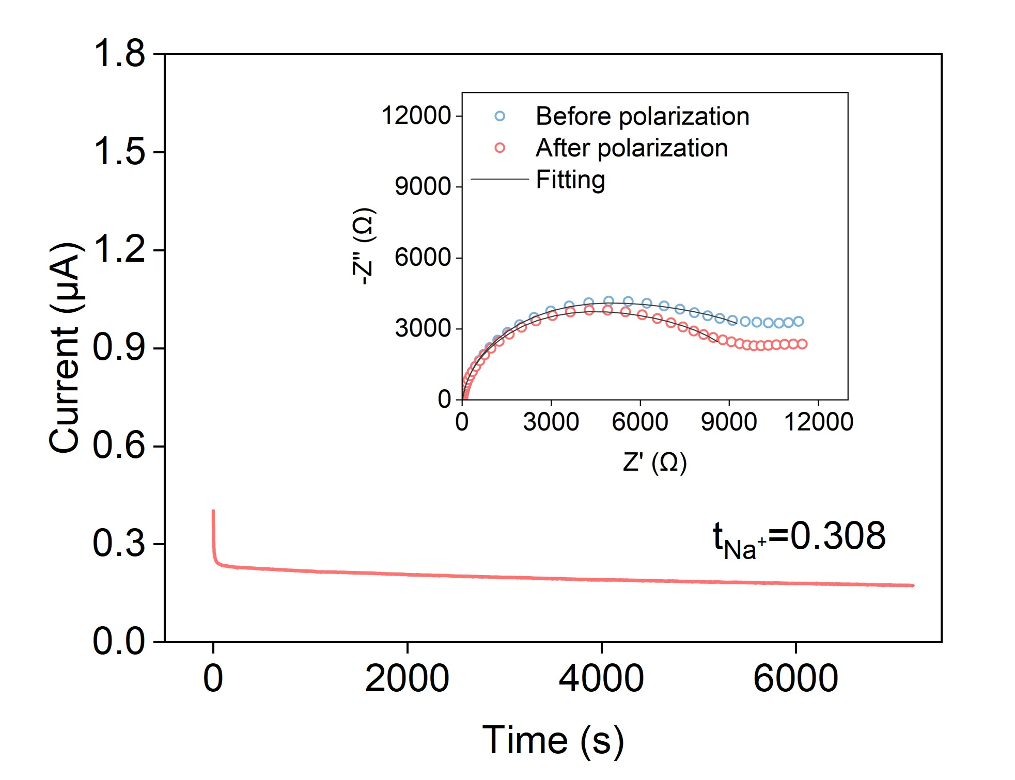
Fig. S3 Polarization curve for NaTFSI/SUL:OTE:FEC. Inset is Nyquist impedance plots before and after polarization
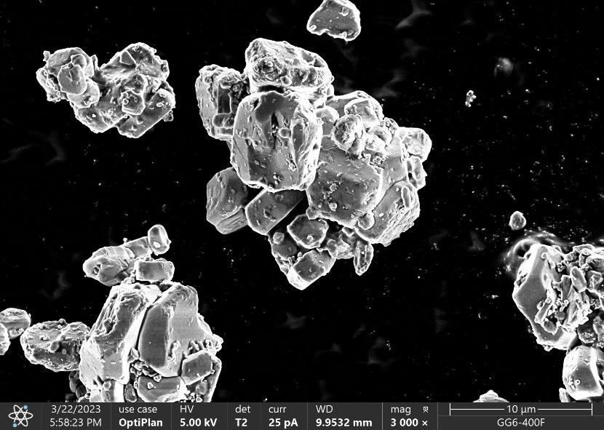
Fig. S4 SEM image of NaNi_{1/3}Mn_{1/3}Fe_{1/3}O₂
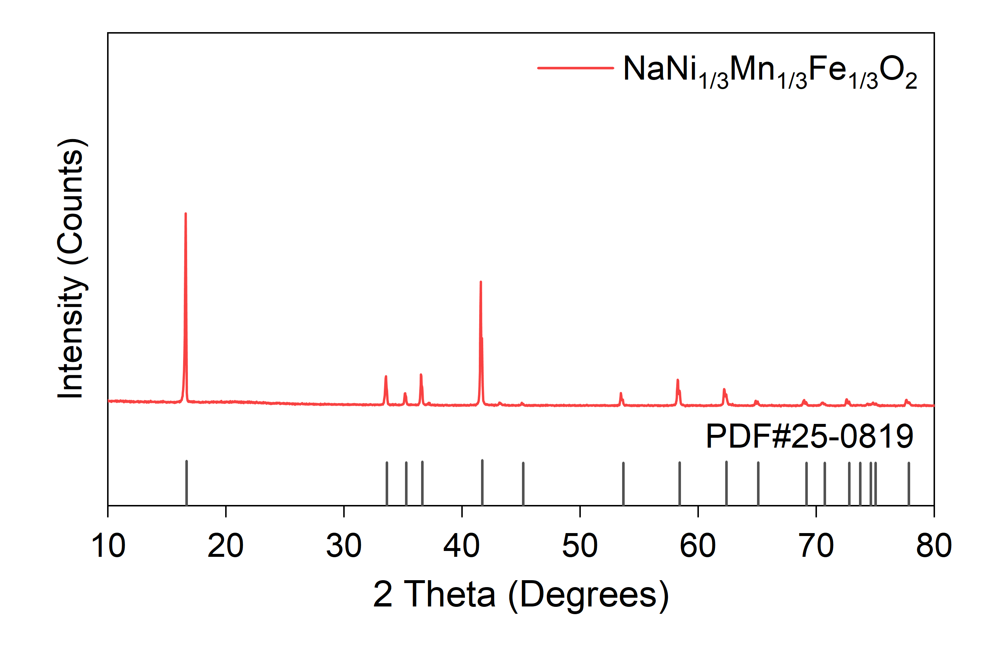
Fig. S5 XRD pattern of NaNi_{1/3}Mn_{1/3}Fe_{1/3}O₂
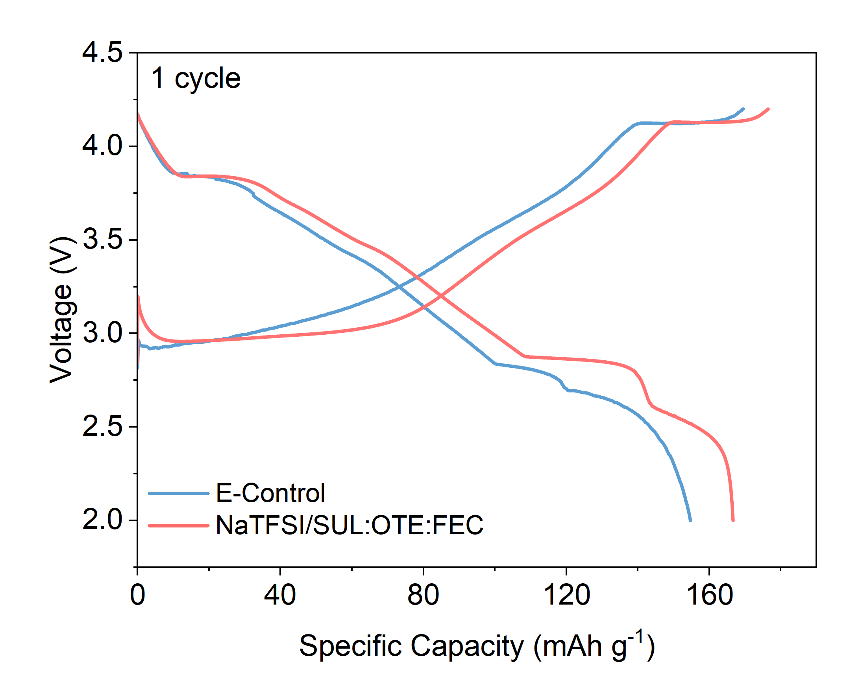
Fig. S6 Initial charge/discharge curves of NaNMF cathode in different electrolytes in the voltage range of 2–4.2 V
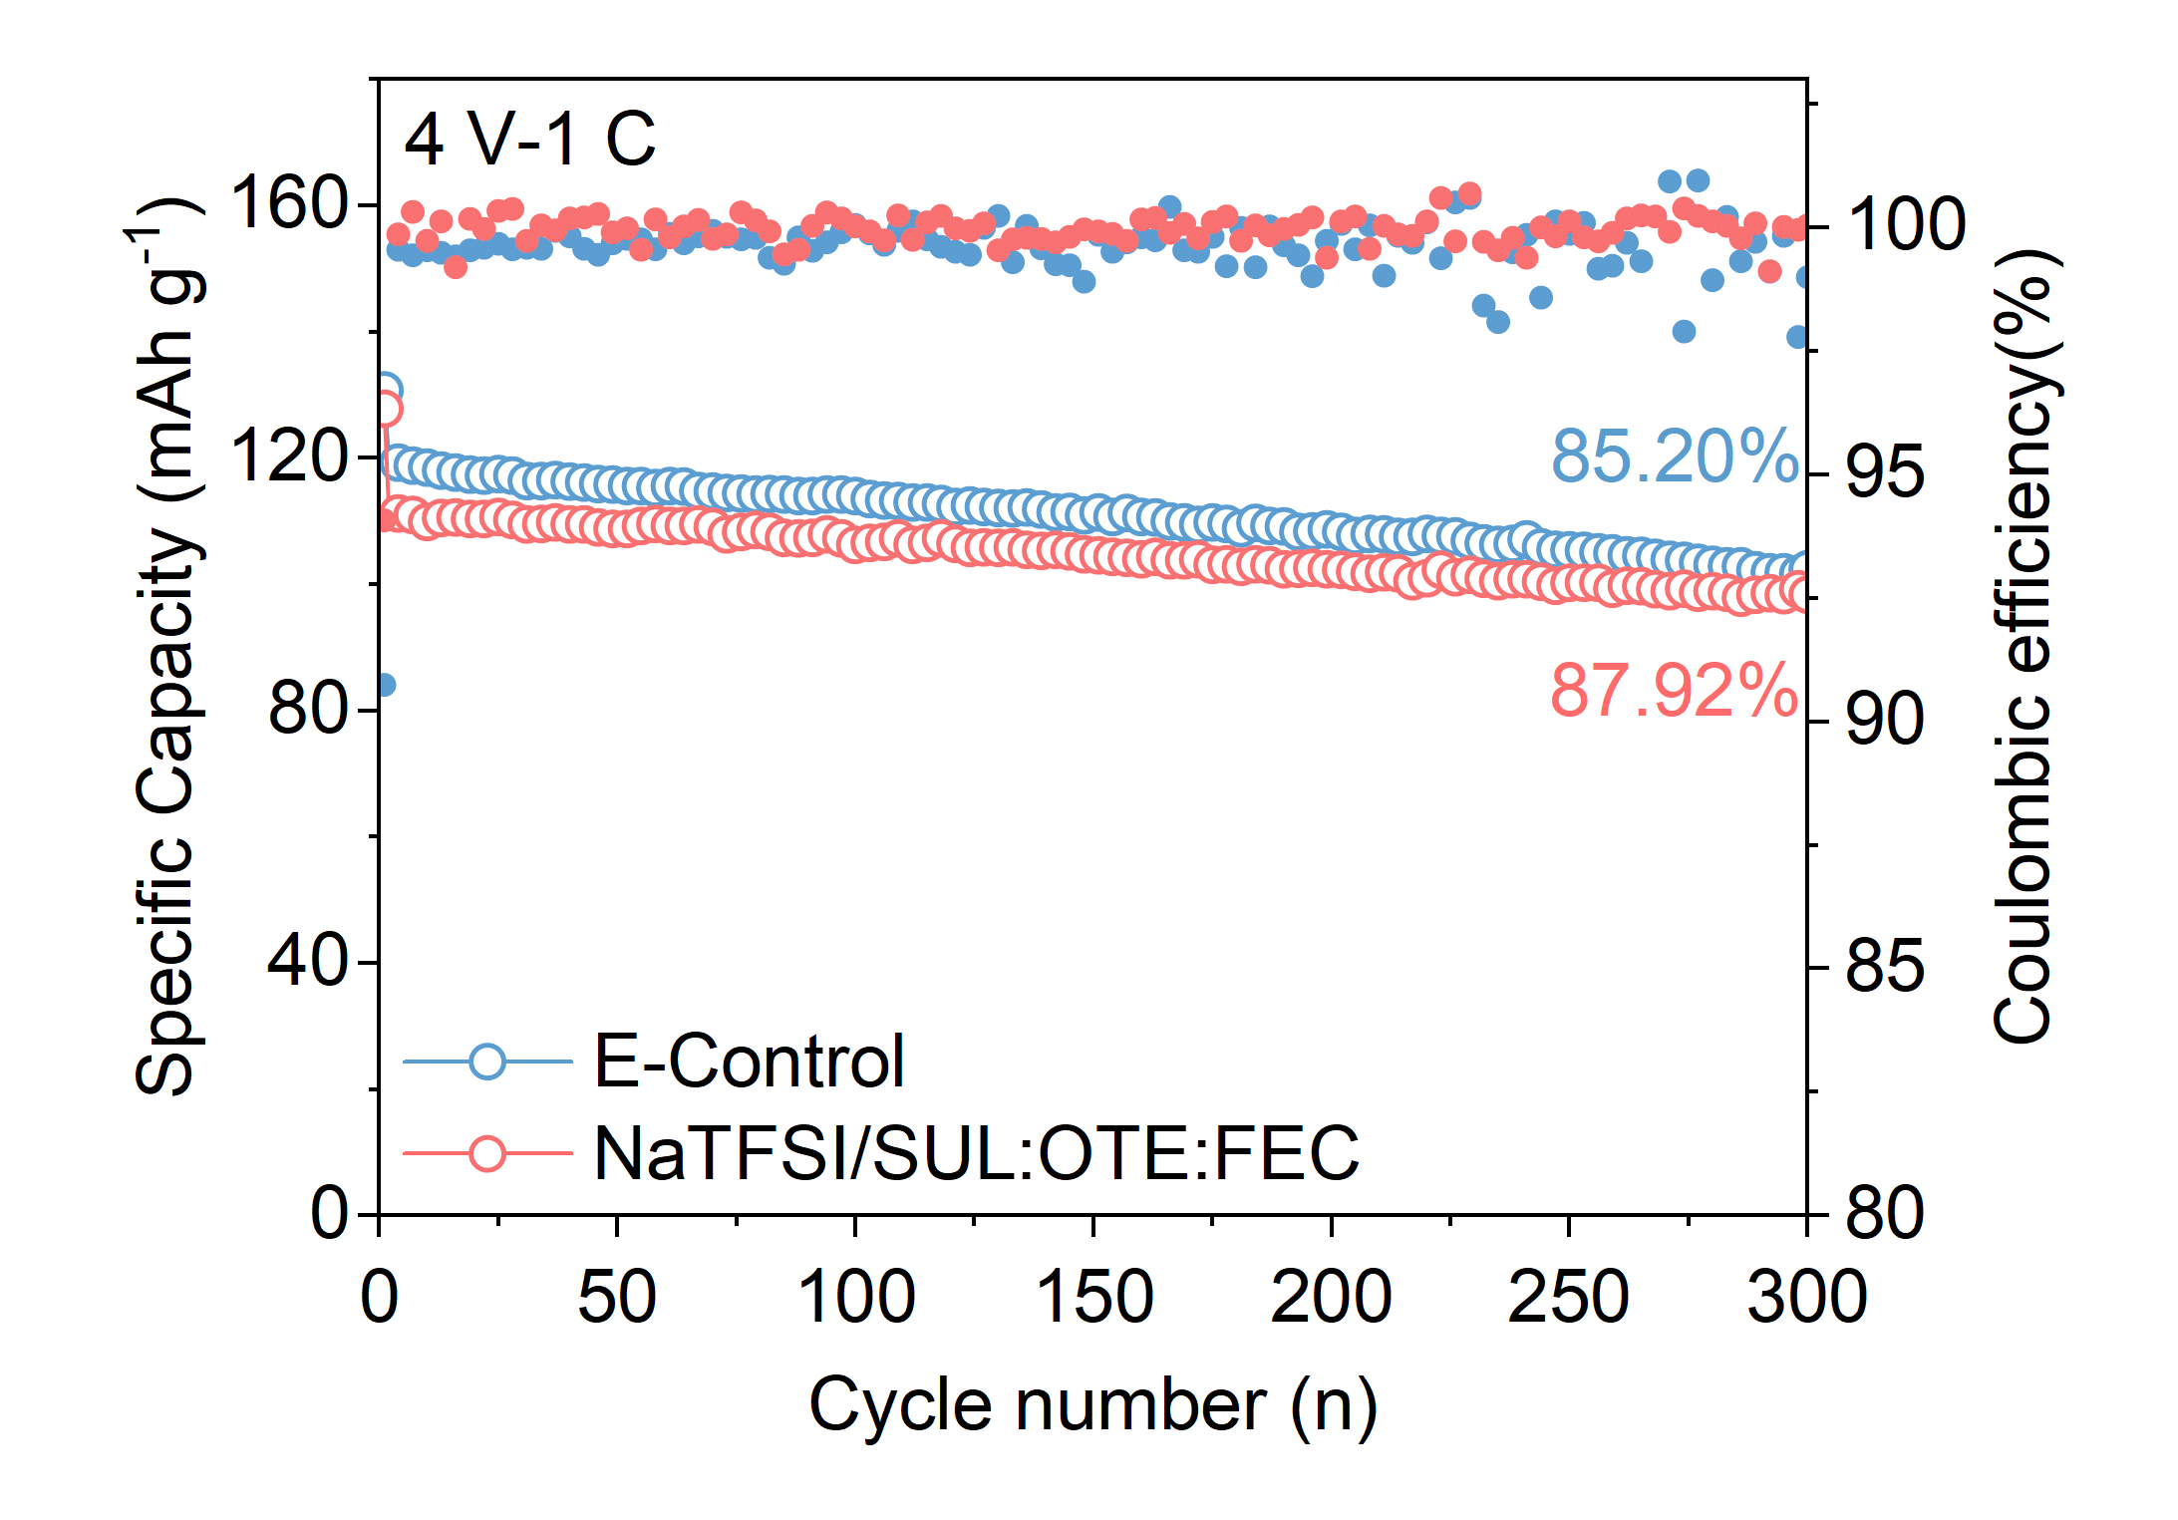
Fig. S7 Cycling performance of Na||NaNMF cells using E-Control and NaTFSI/SUL:OTE:FEC in the voltage range of 2–4 V at 1 C
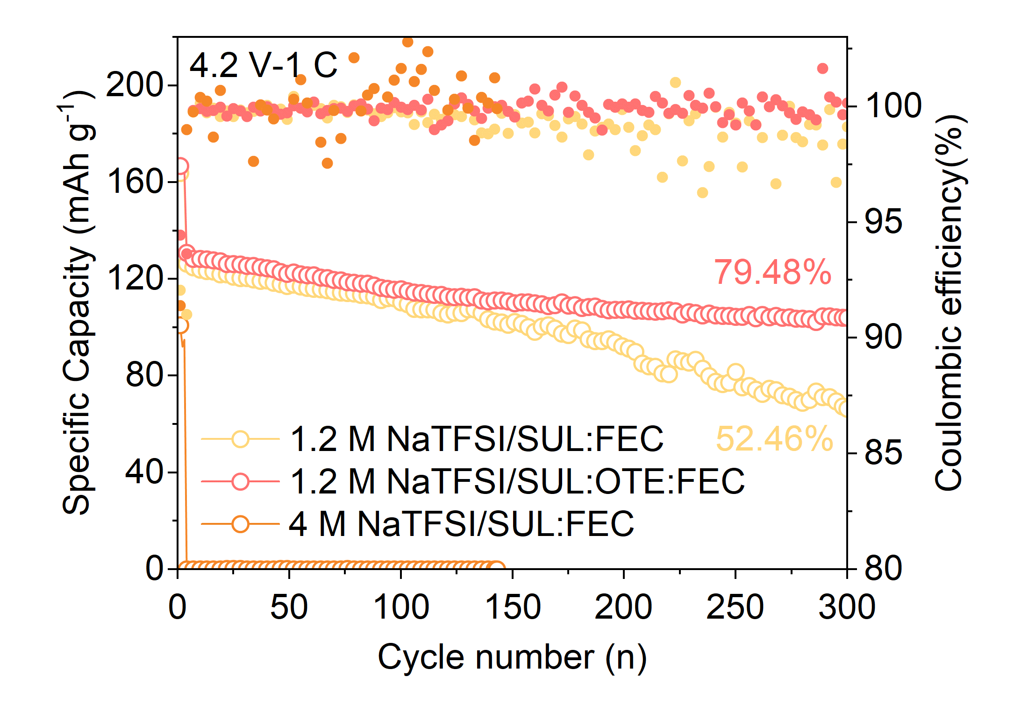
Fig. S8 Cycling performance of Na||NaNMF cells using 1.2 M NaTFSI/SUL:OTE:FEC, 1.2 M NaTFSI/SUL:FEC and 4 M NaTFSI/SUL:FEC in the voltage range of 2–4.2 V at 1 C
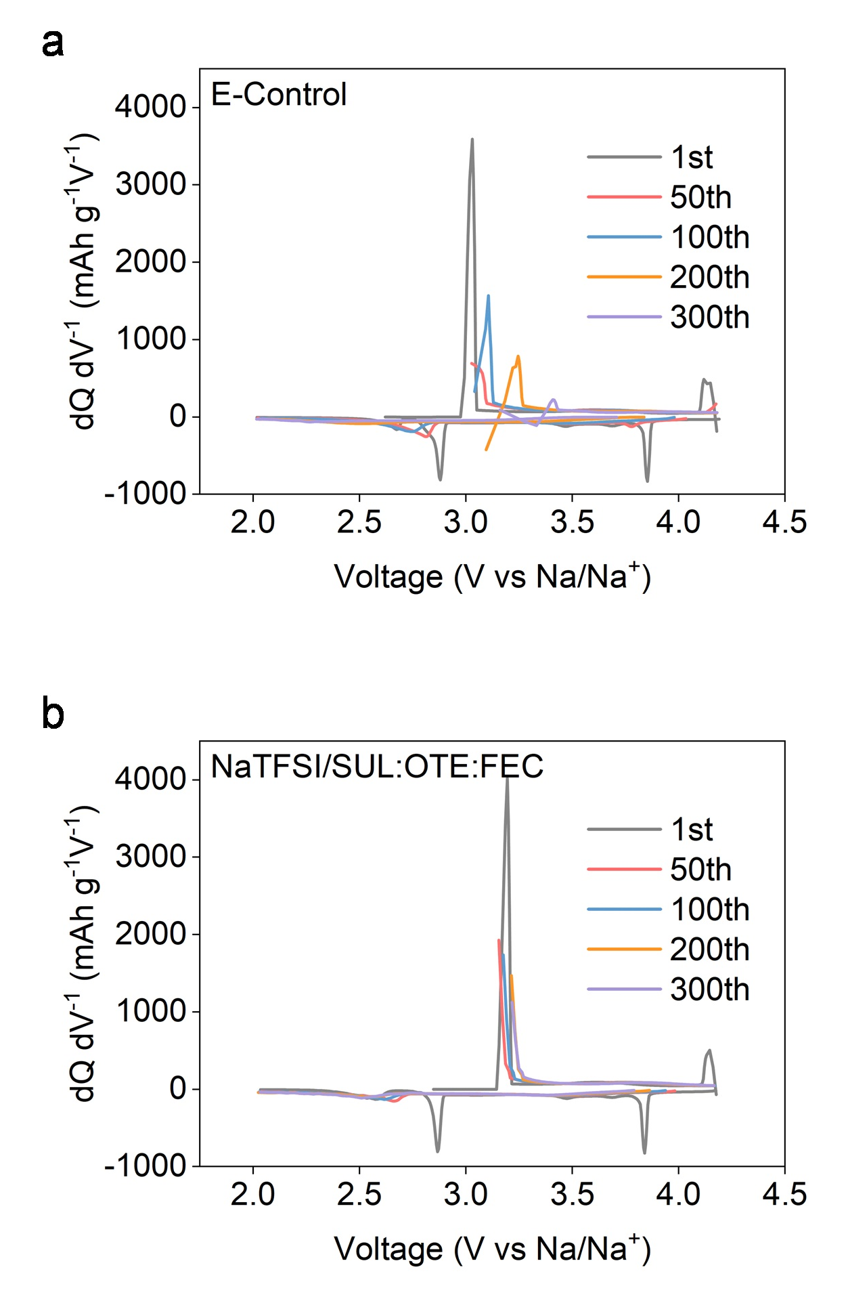
Fig. S9 The corresponding dQ/dV vs. V of Na||NaNMF cells using (a) E-Control and (b) NaTFSI/SUL:OTE:FEC in the voltage range of 2–4.2 V
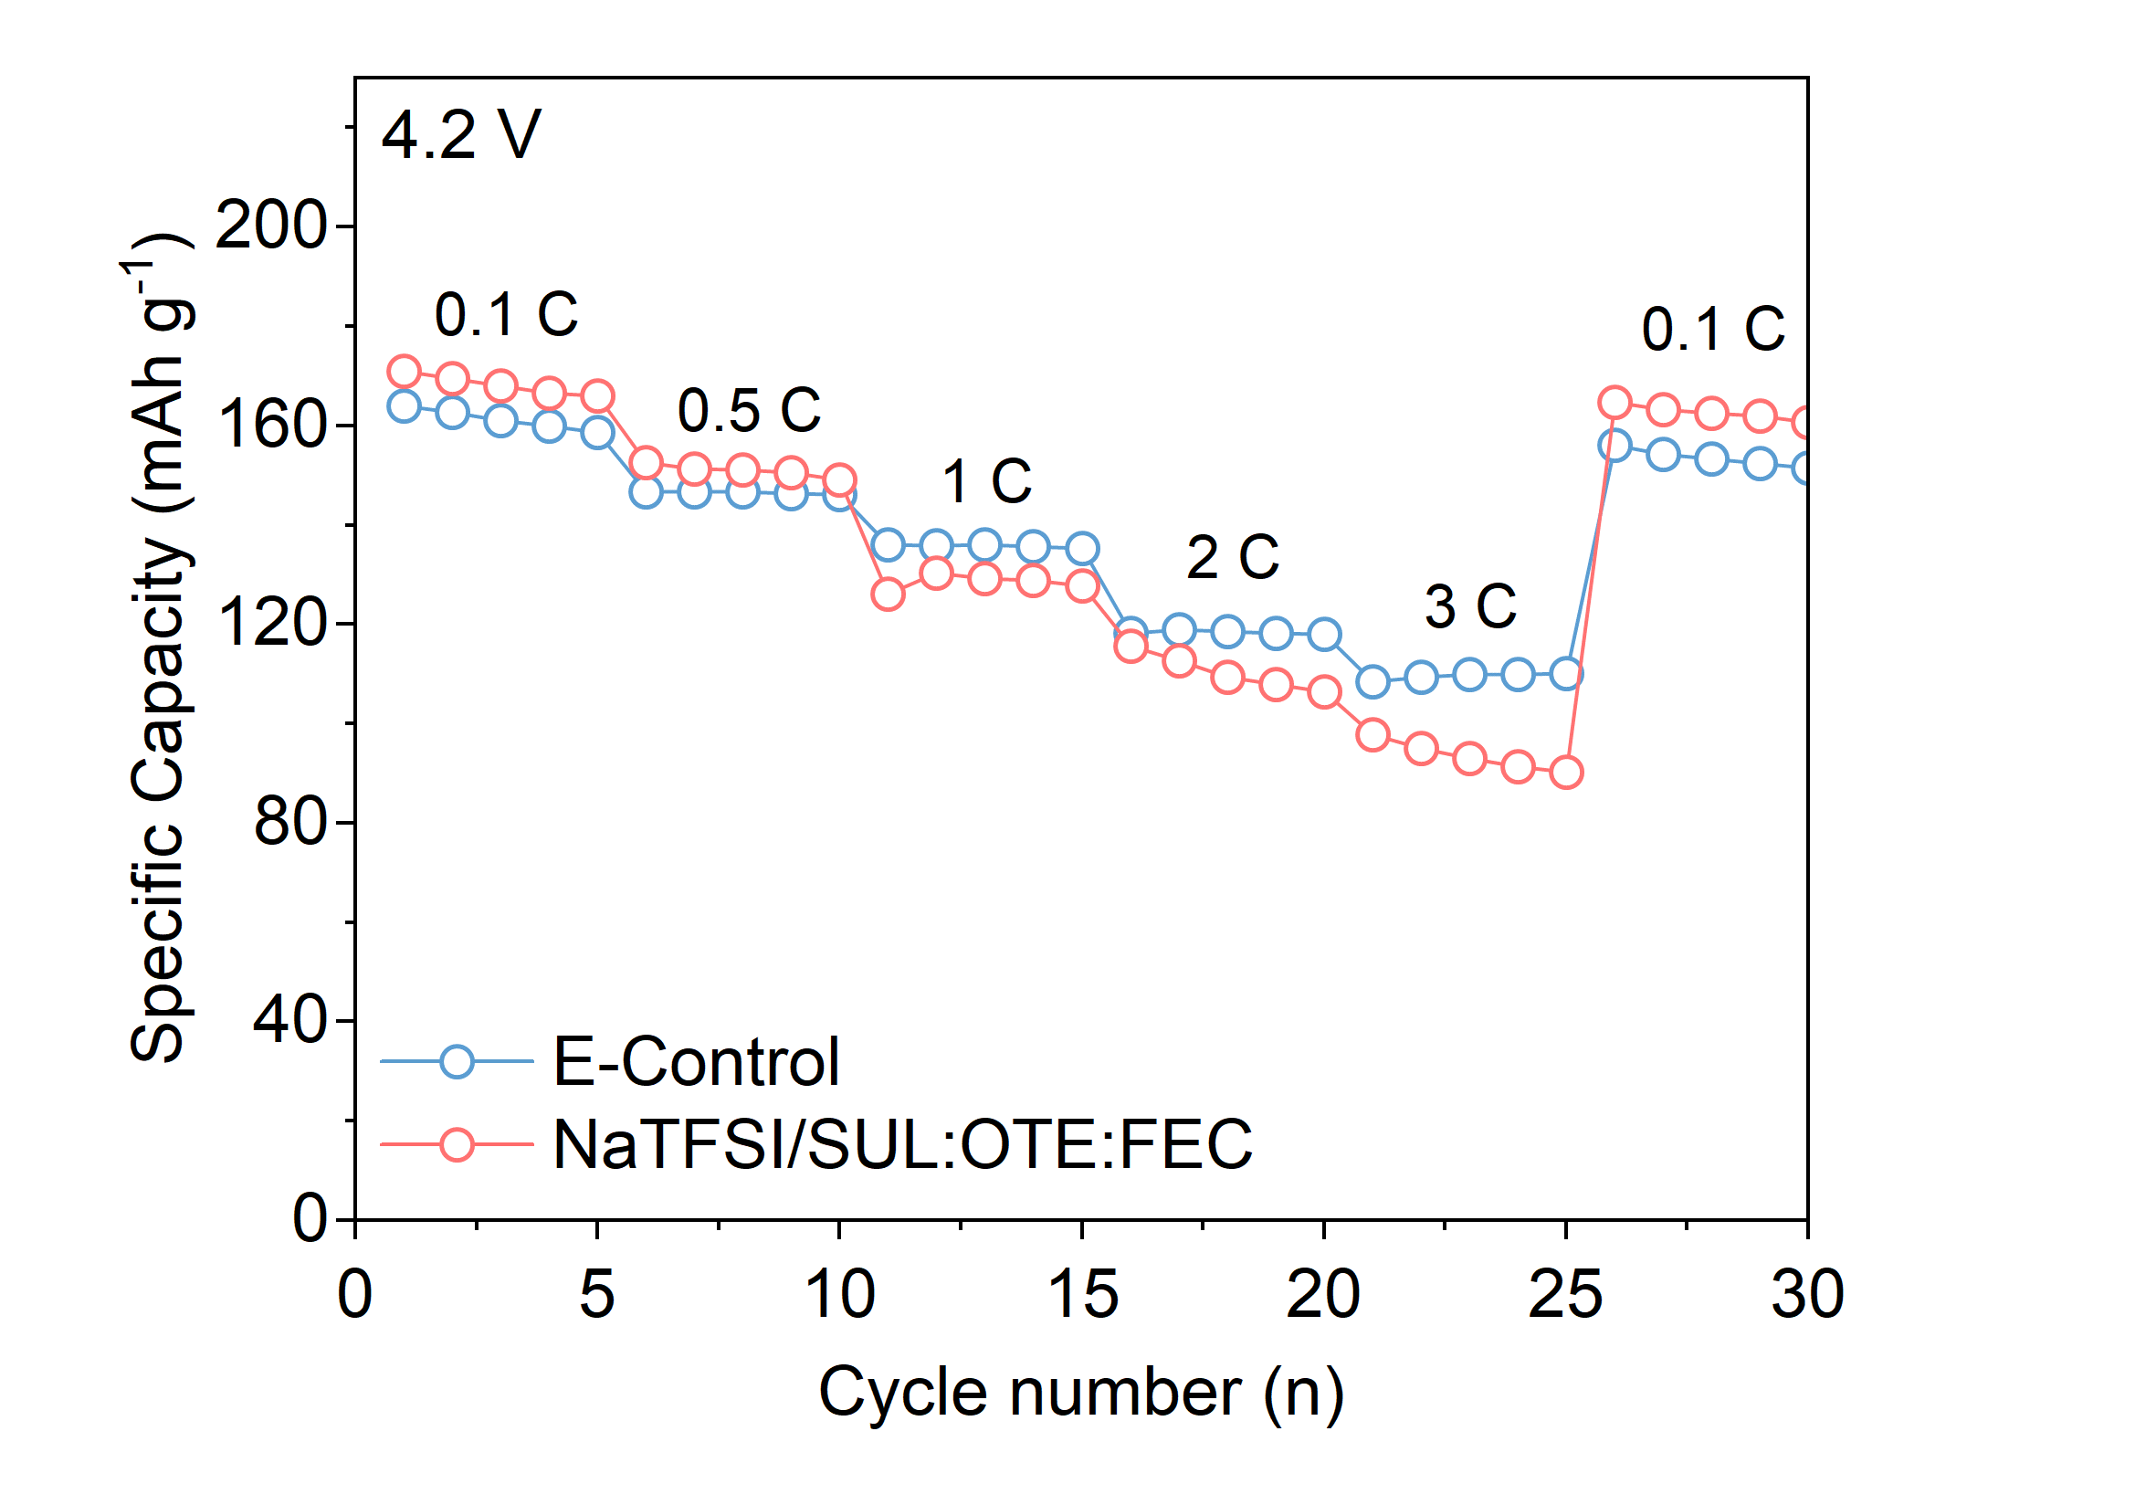
Fig. S10 Rate capability of Na||NaNMF cells using E-Control and NaTFSI/SUL:OTE:FEC in the voltage range of 2–4.2 V
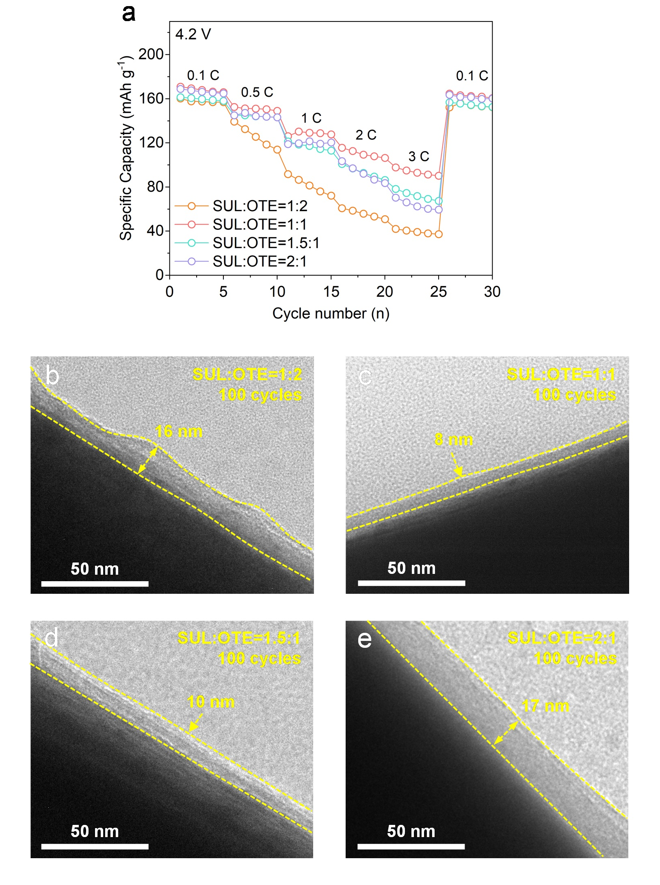
Fig. S11 (a) Rate capability of Na||NaNMF cells using electrolytes with different SUL:OTE molar ratios in the voltage range of 2–4.2 V. (b–e) TEM images of NaNMF cathode after 100 cycles in electrolytes with different SUL:OTE molar ratios
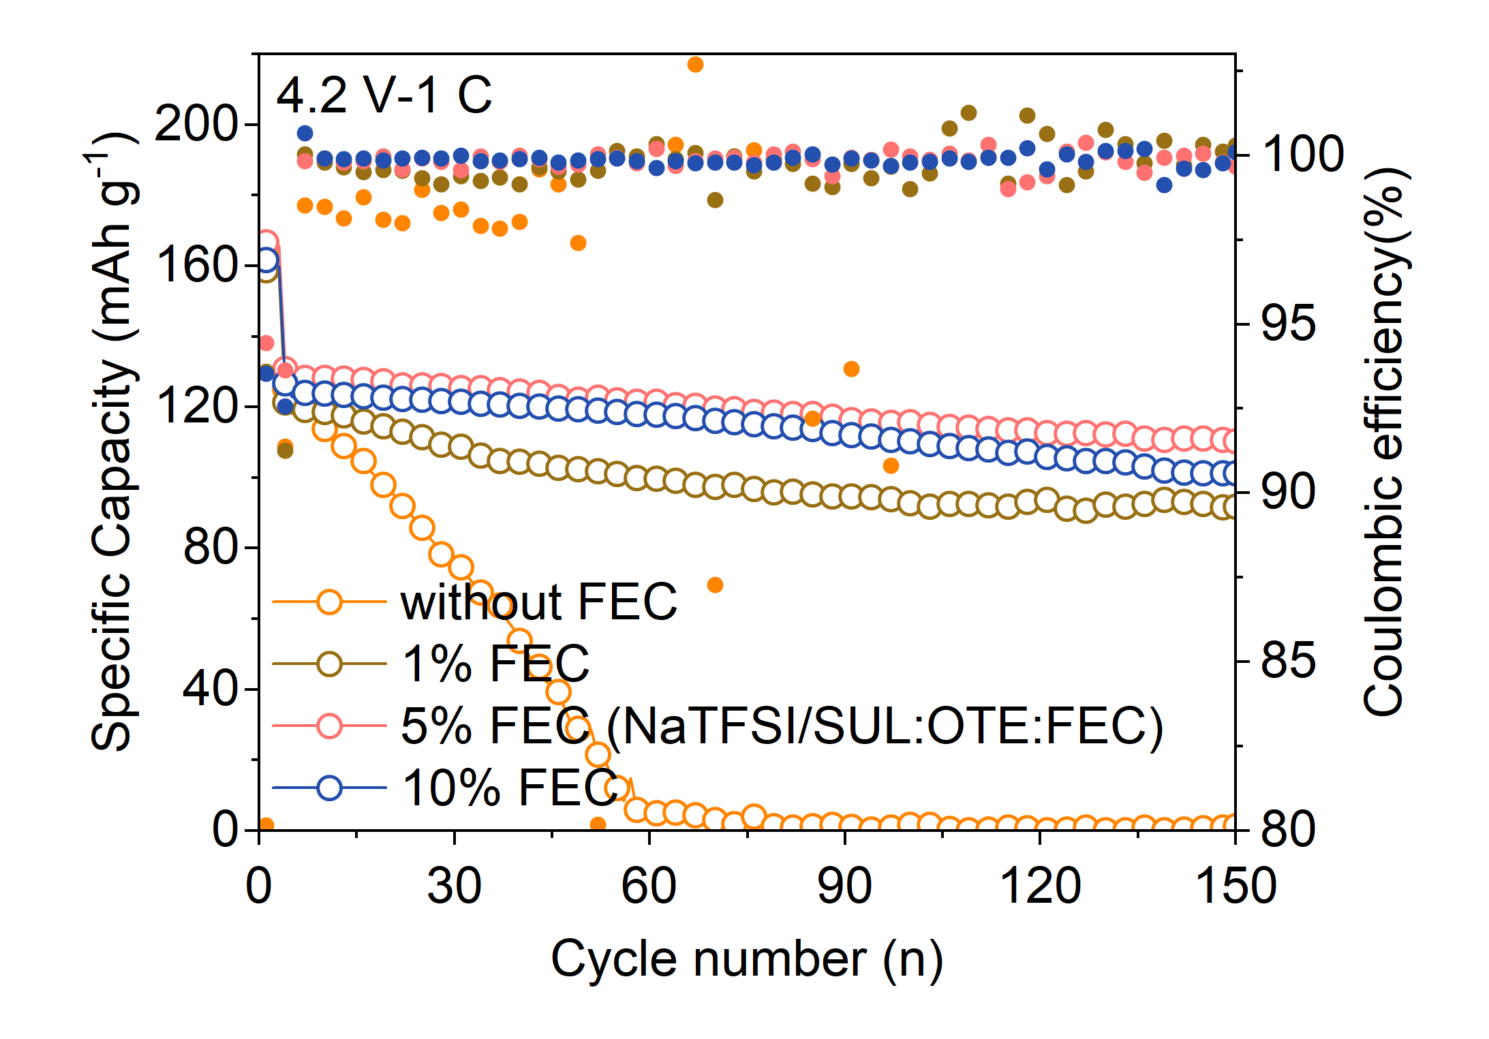
Fig. S12 Cycling performance of the Na||NaNMF cells using different electrolytes in the voltage range of 2–4.2 V at 1 C

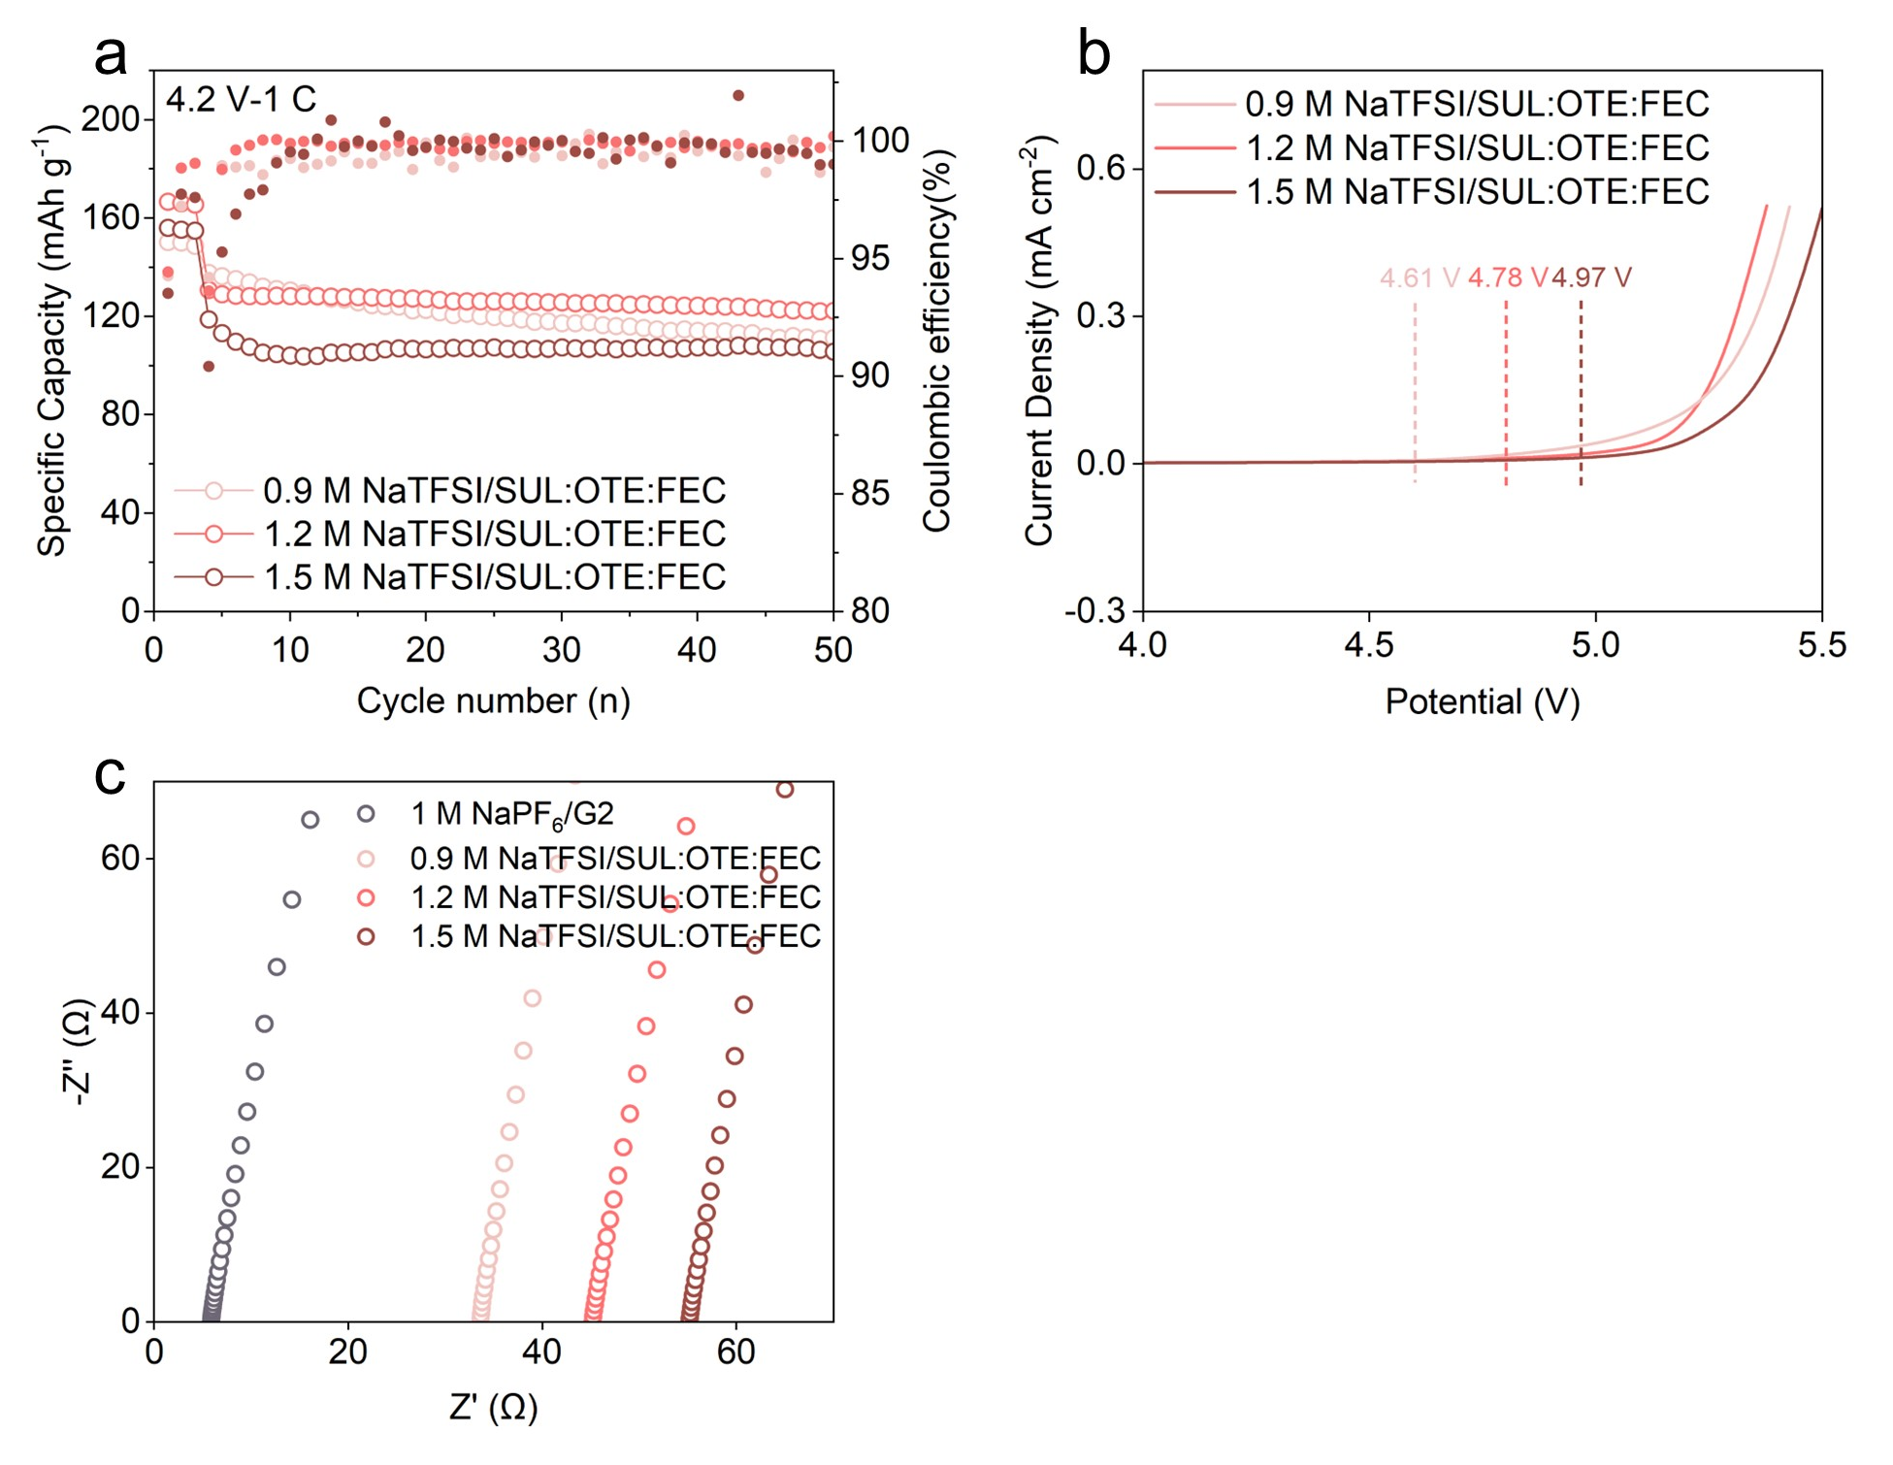
Fig. S13 (a) Cycling performance of the Na||NaNMF cells using different electrolytes in the voltage range of 2–4.2 V at 1 C. (b) LSV curves of the Na||steel half-cells with different electrolytes. (c) Nyquist plots of symmetric stainless steel cells assembled with different electrolytes
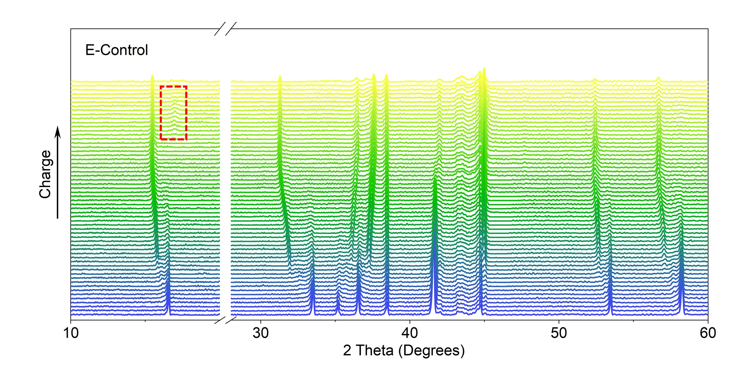
Fig. S14 In-situ XRD evolution plot of NaNMF cycled in E-Control
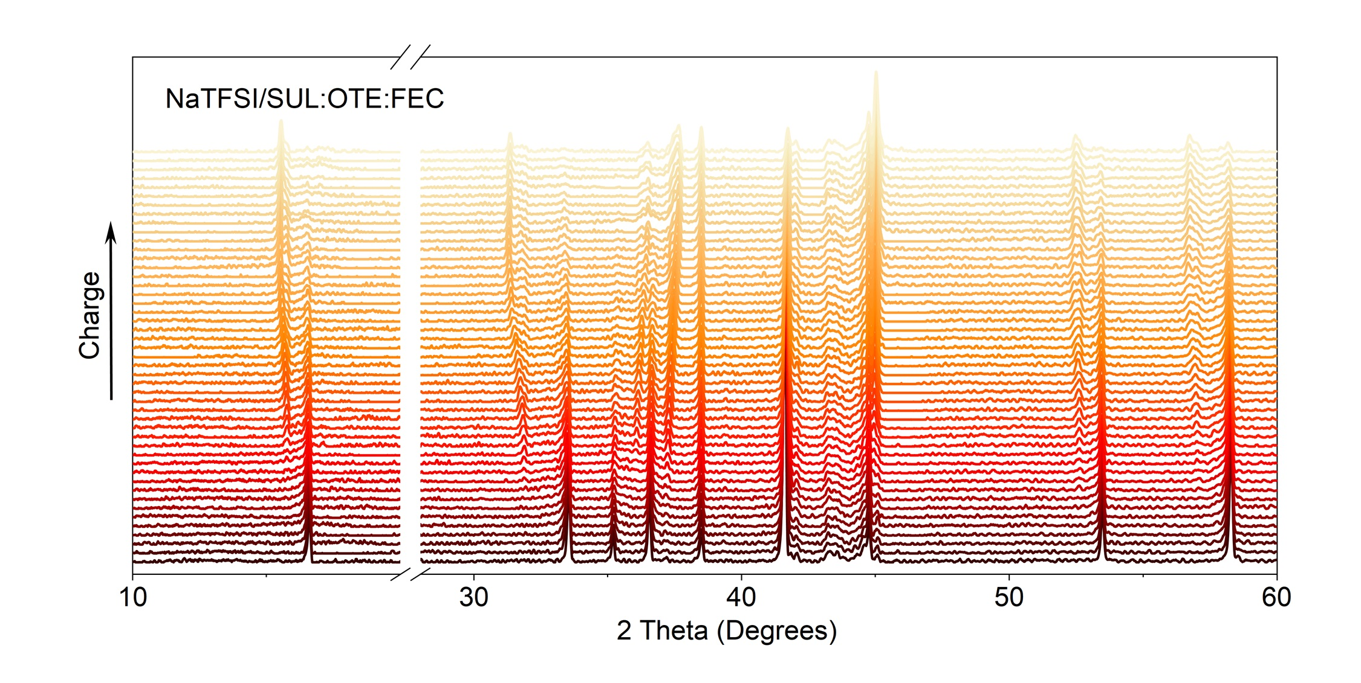
Fig. S15 In-situ XRD evolution plot of NaNMF cycled in NaTFSI/SUL:OTE:FEC
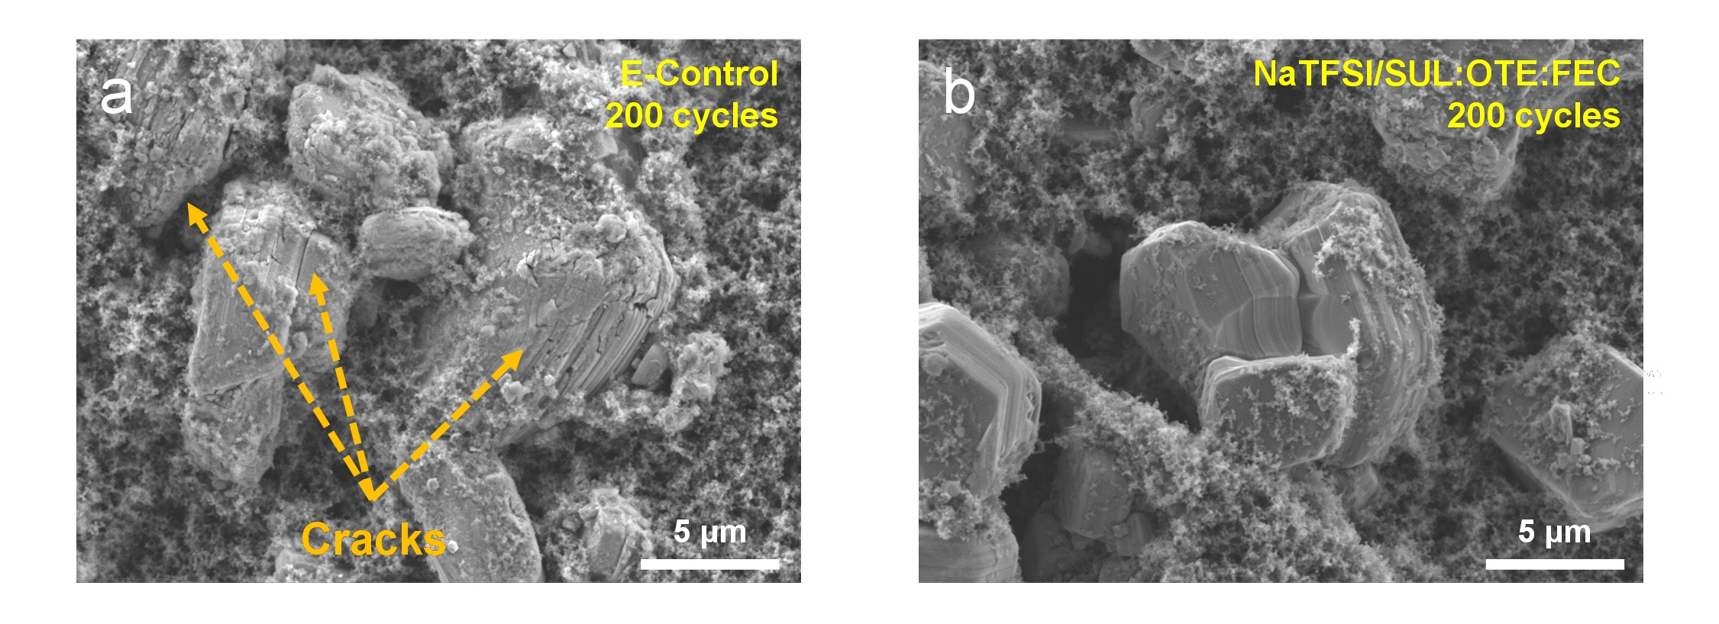
Fig. S16 SEM images of NaNMF cathode cycled in (a) E-Control and (b) NaTFSI/SUL:OTE:FEC
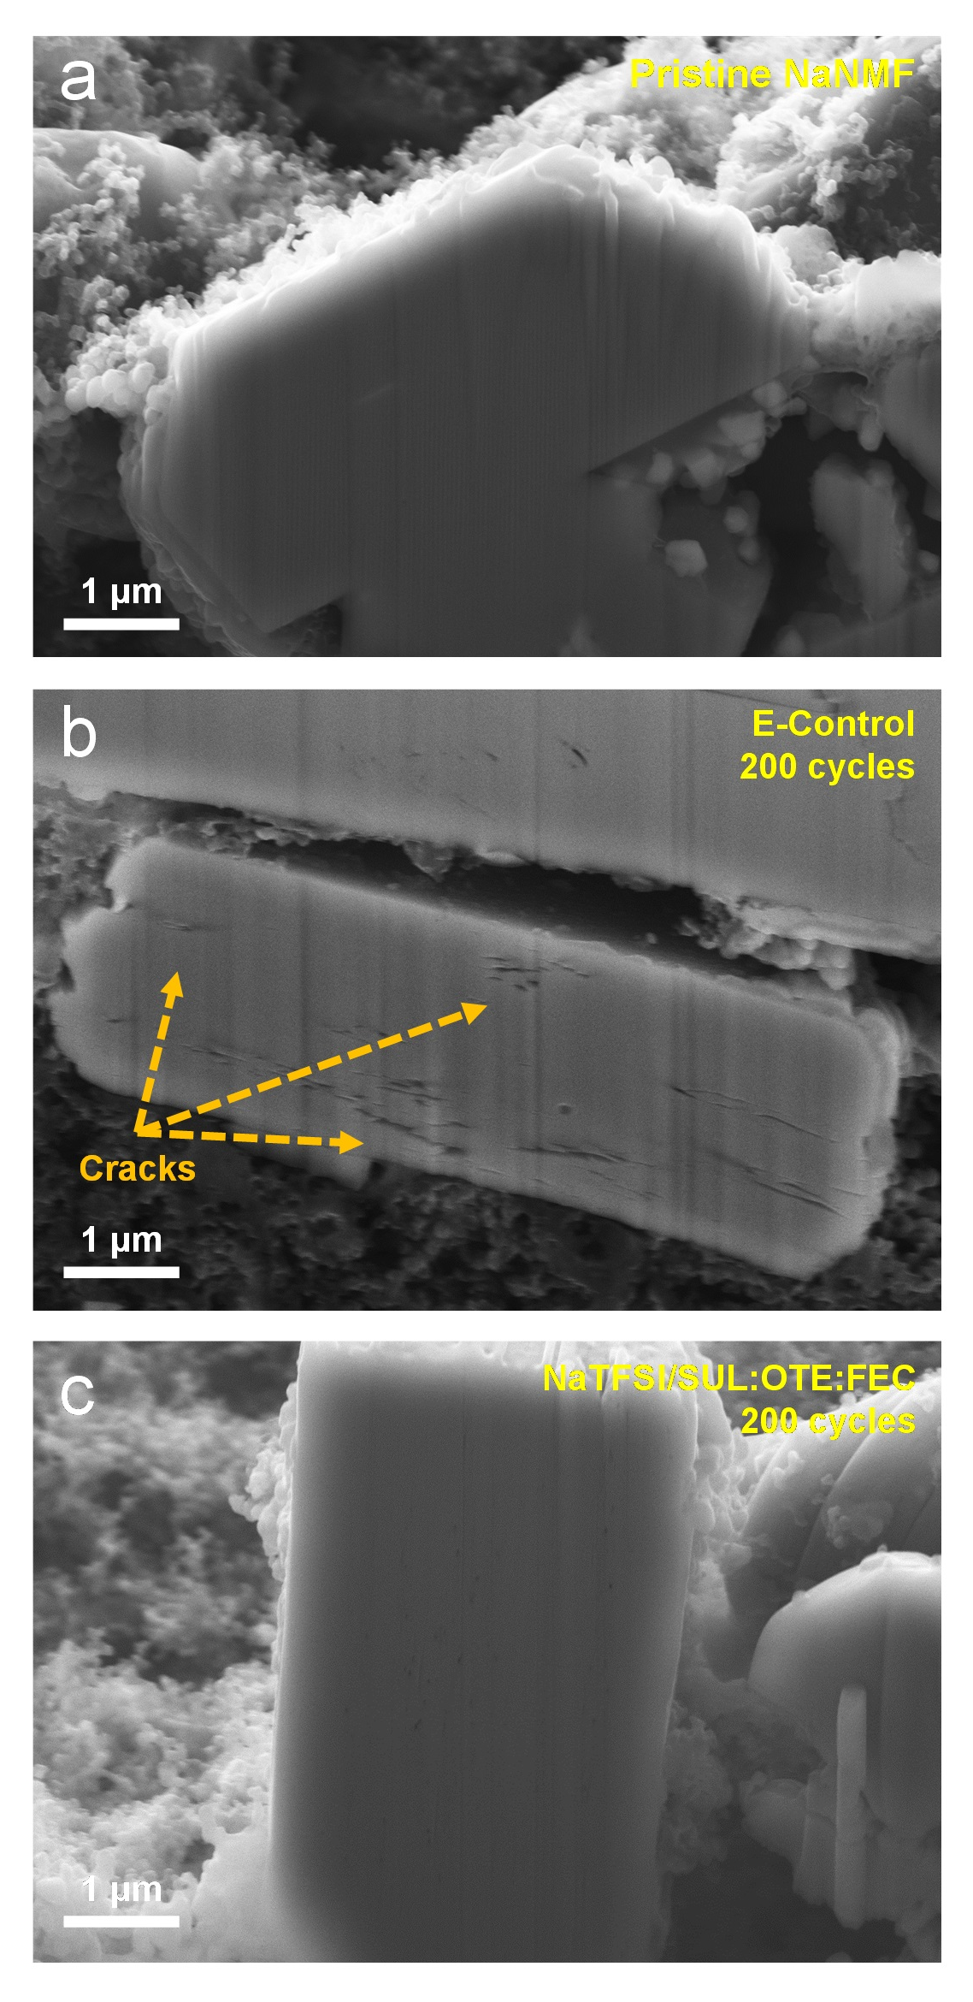
Fig. S17 Cross-section SEM images of (a) pristine NaNMF cathode and NaNMF cathode cycled in (b) E-Control and (c) NaTFSI/SUL:OTE:FEC
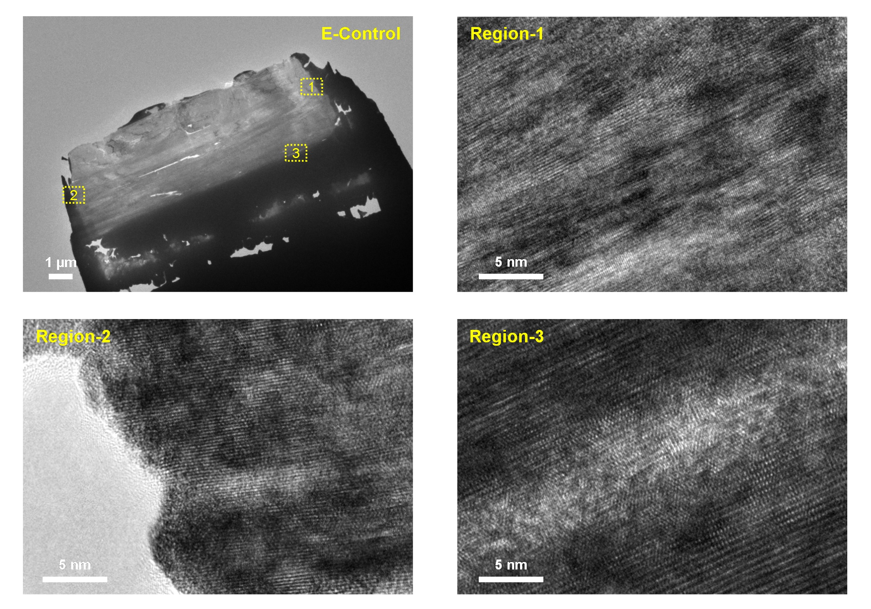
Fig. S18 HRTEM images of NaNMF cathode cycled in E-Control
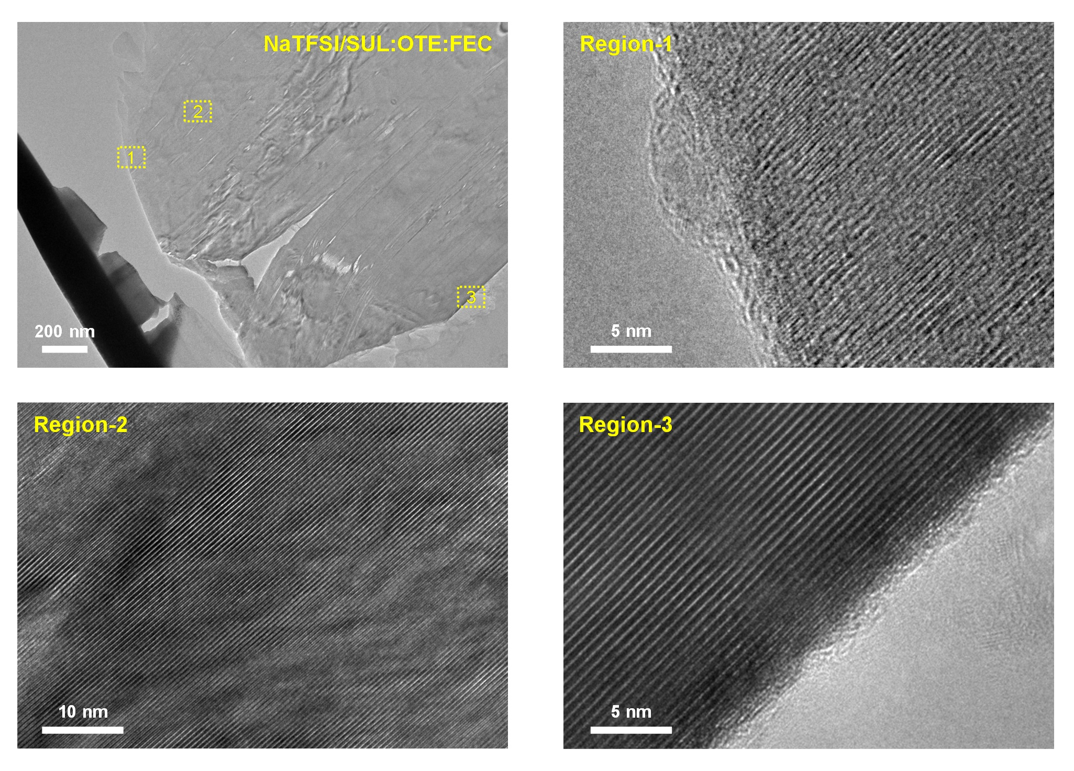
Fig. S19 HRTEM images of NaNMF cathode cycled in NaTFSI/SUL:OTE:FEC

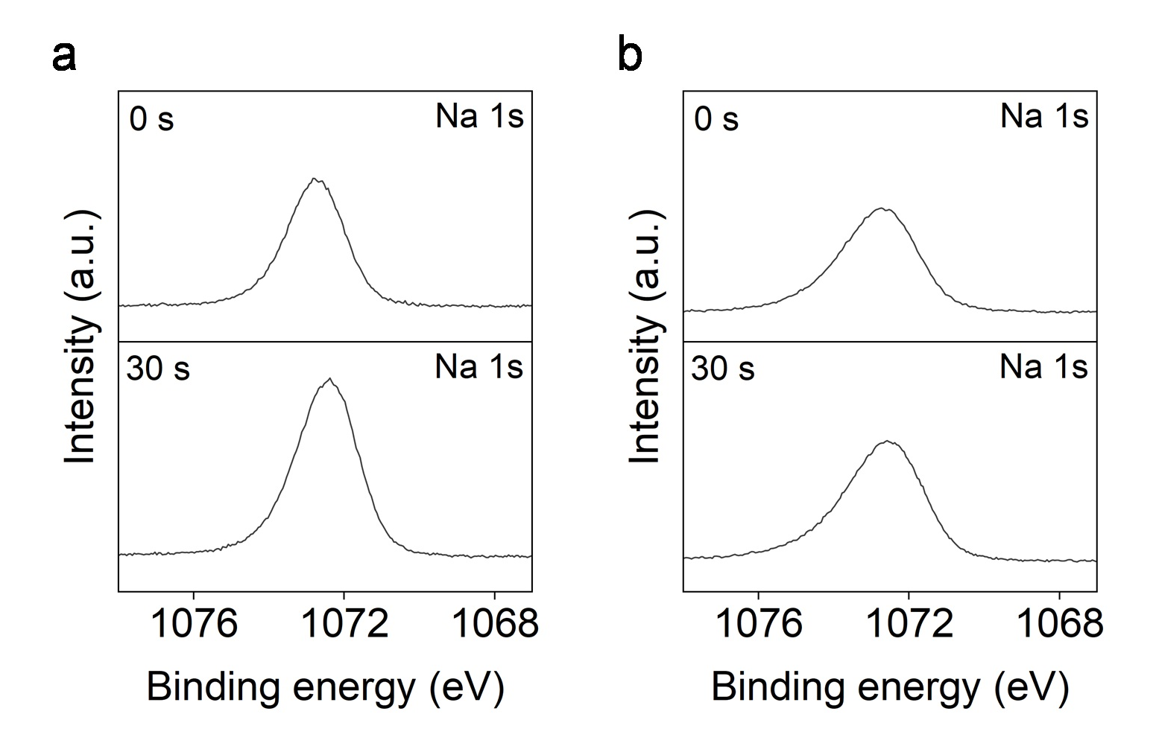
Fig. S20 Na 1s XPS spectra of the cycled NaNMF cathodes after 200 cycles in (a) E-Control and (b) NaTFSI/SUL:OTE:FEC

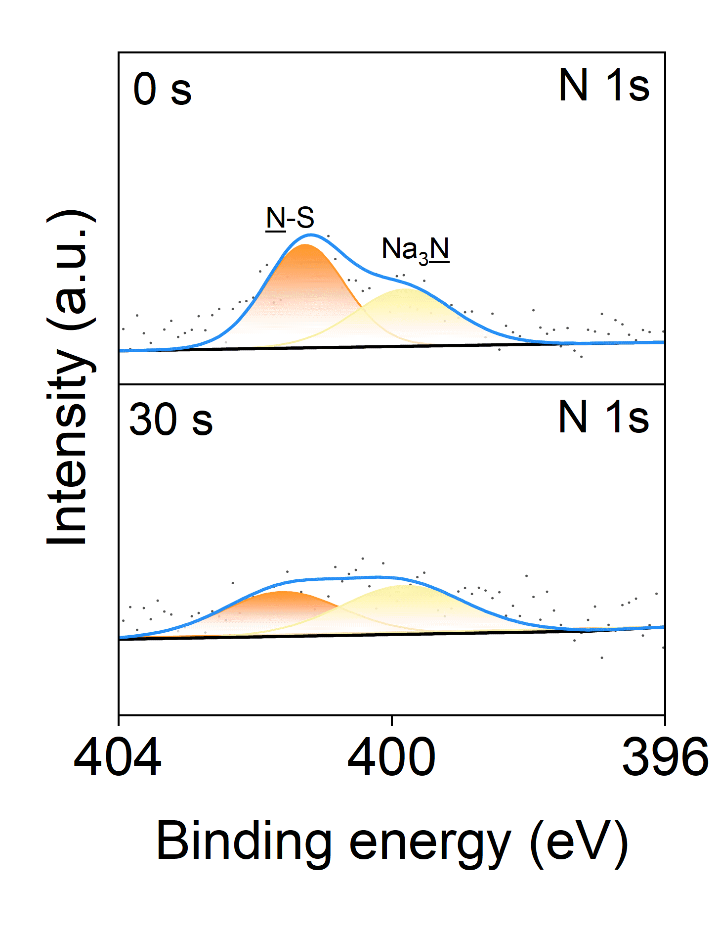
Fig. S21 N 1s XPS spectra of the cycled NaNMF cathodes after 200 cycles in NaTFSI/SUL:OTE:FEC

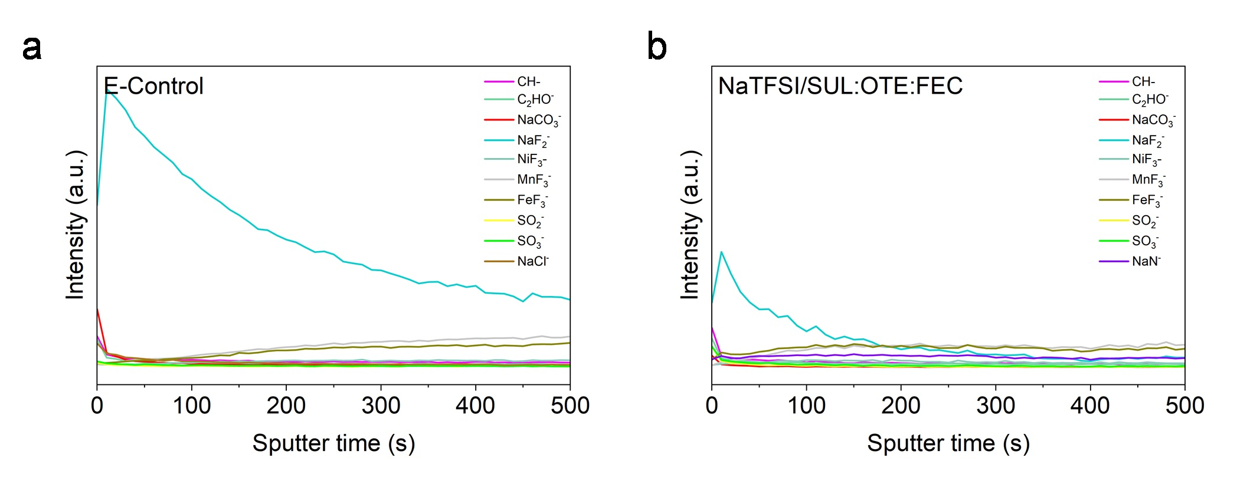
Fig. S22 TOF-SIMS depth profiles of CEIs in (a) E-Control and (b) NaTFSI/SUL:OTE:FEC
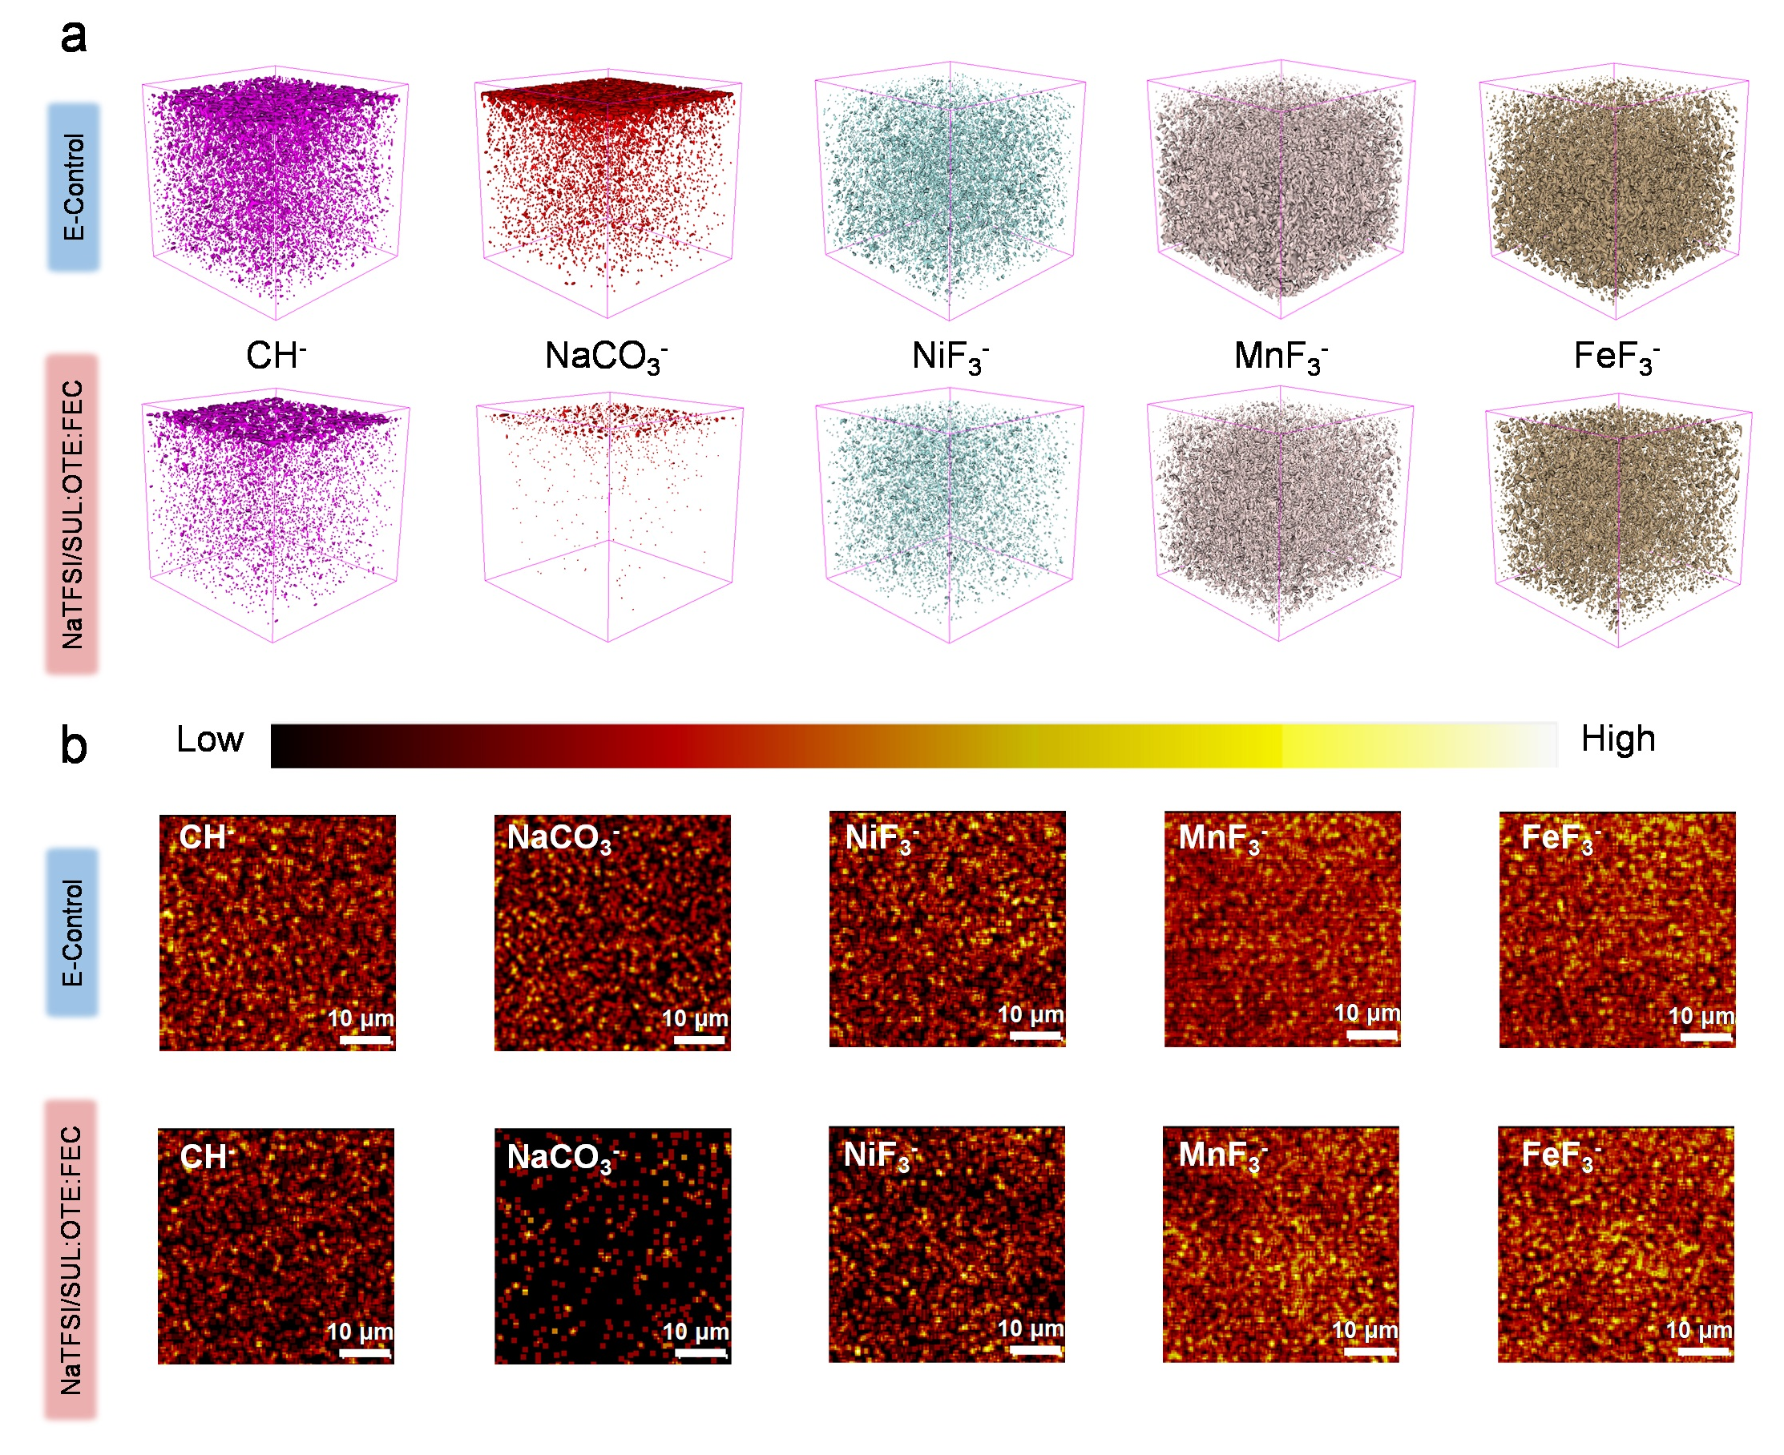
Fig. S23 (a) TOF-SIMS 3D profiling and (b) TOF-SIMS 2D surface mappings of several secondary ion fragments SO₂⁻, SO₃⁻, NaCl⁻, NaN⁻, MnF₃⁻ and FeF₃⁻ on NaNMF cathodes after being cycled with E-Control and NaTFSI/SUL:OTE:FEC
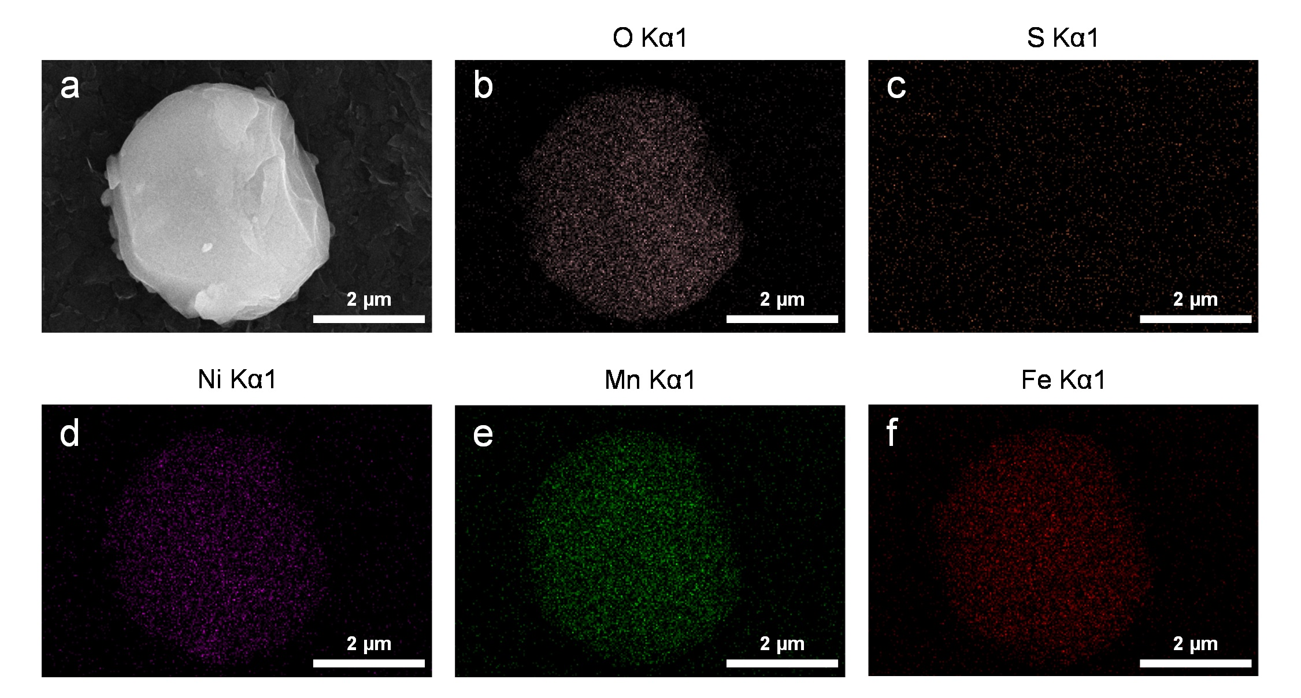
Fig. S24 SEM images of (a) pristine NaNMF particle and its corresponding EDS patterns of (b) O, (c) S, (d) Ni, (e) Mn and (f) Fe elements
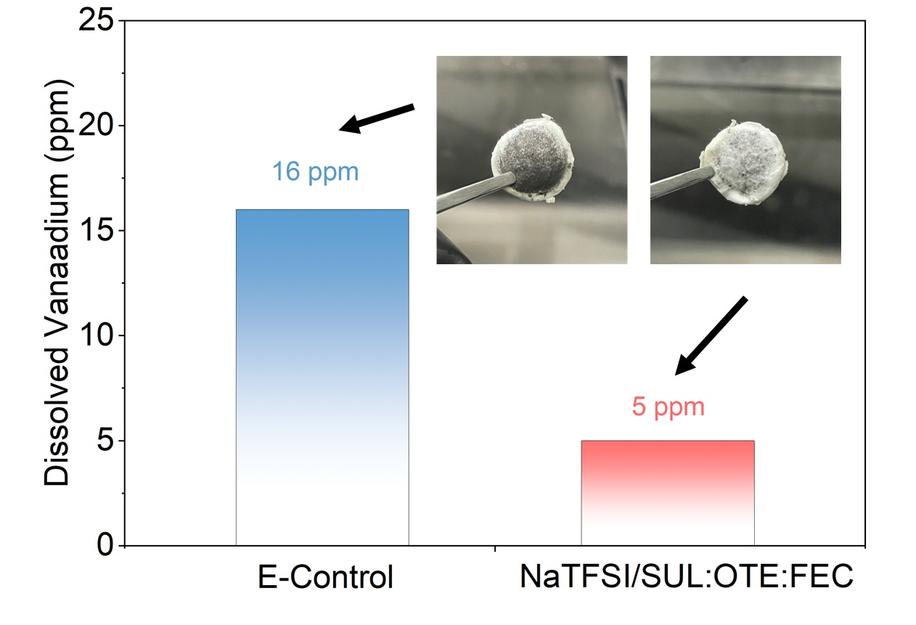
Fig. S25 Elemental analysis of dissolved nickel ions in different electrolytes after 300 cycles (inset are photos of the GF/D glass fibers)
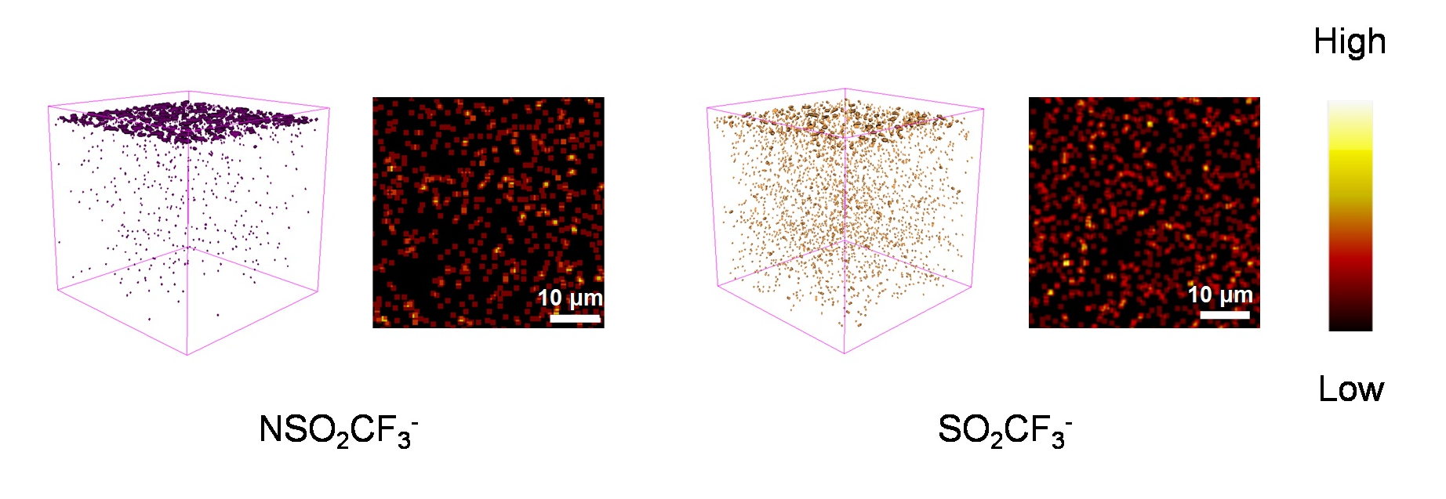
Fig. S26 TOF-SIMS 3D profiling and TOF-SIMS 2D surface mappings of several secondary ion fragments NSO₂CF₃⁻ and SO₂CF₃⁻ on NaNMF cathodes after being cycled with NaTFSI/SUL:OTE:FEC
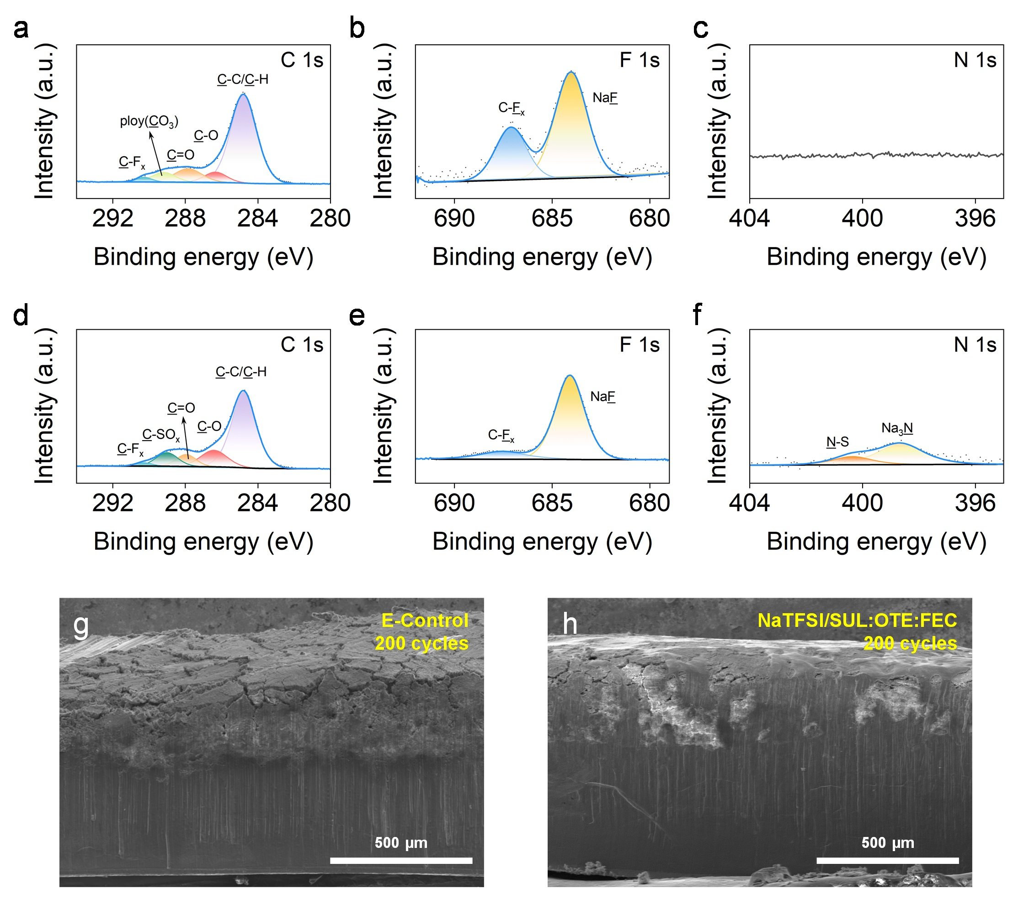
Fig. S27 XPS spectra of the cycled Cu Foil after 100 cycles in (a–c) E-Control. XPS spectra of the cycled Cu foil after 100 cycles in (d–f) NaTFSI/SUL:OTE:FEC. Cross-section SEM images of Na anode cycled in (g) E-Control and (h) NaTFSI/SUL:OTE:FEC

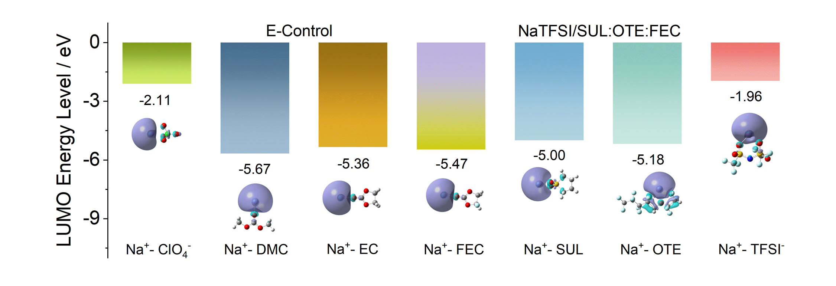
Fig. S28 Calculated LUMO energy levels of Na⁺-anion and Na⁺-solvent in E-Control and NaTFSI/SUL:OTE:FEC

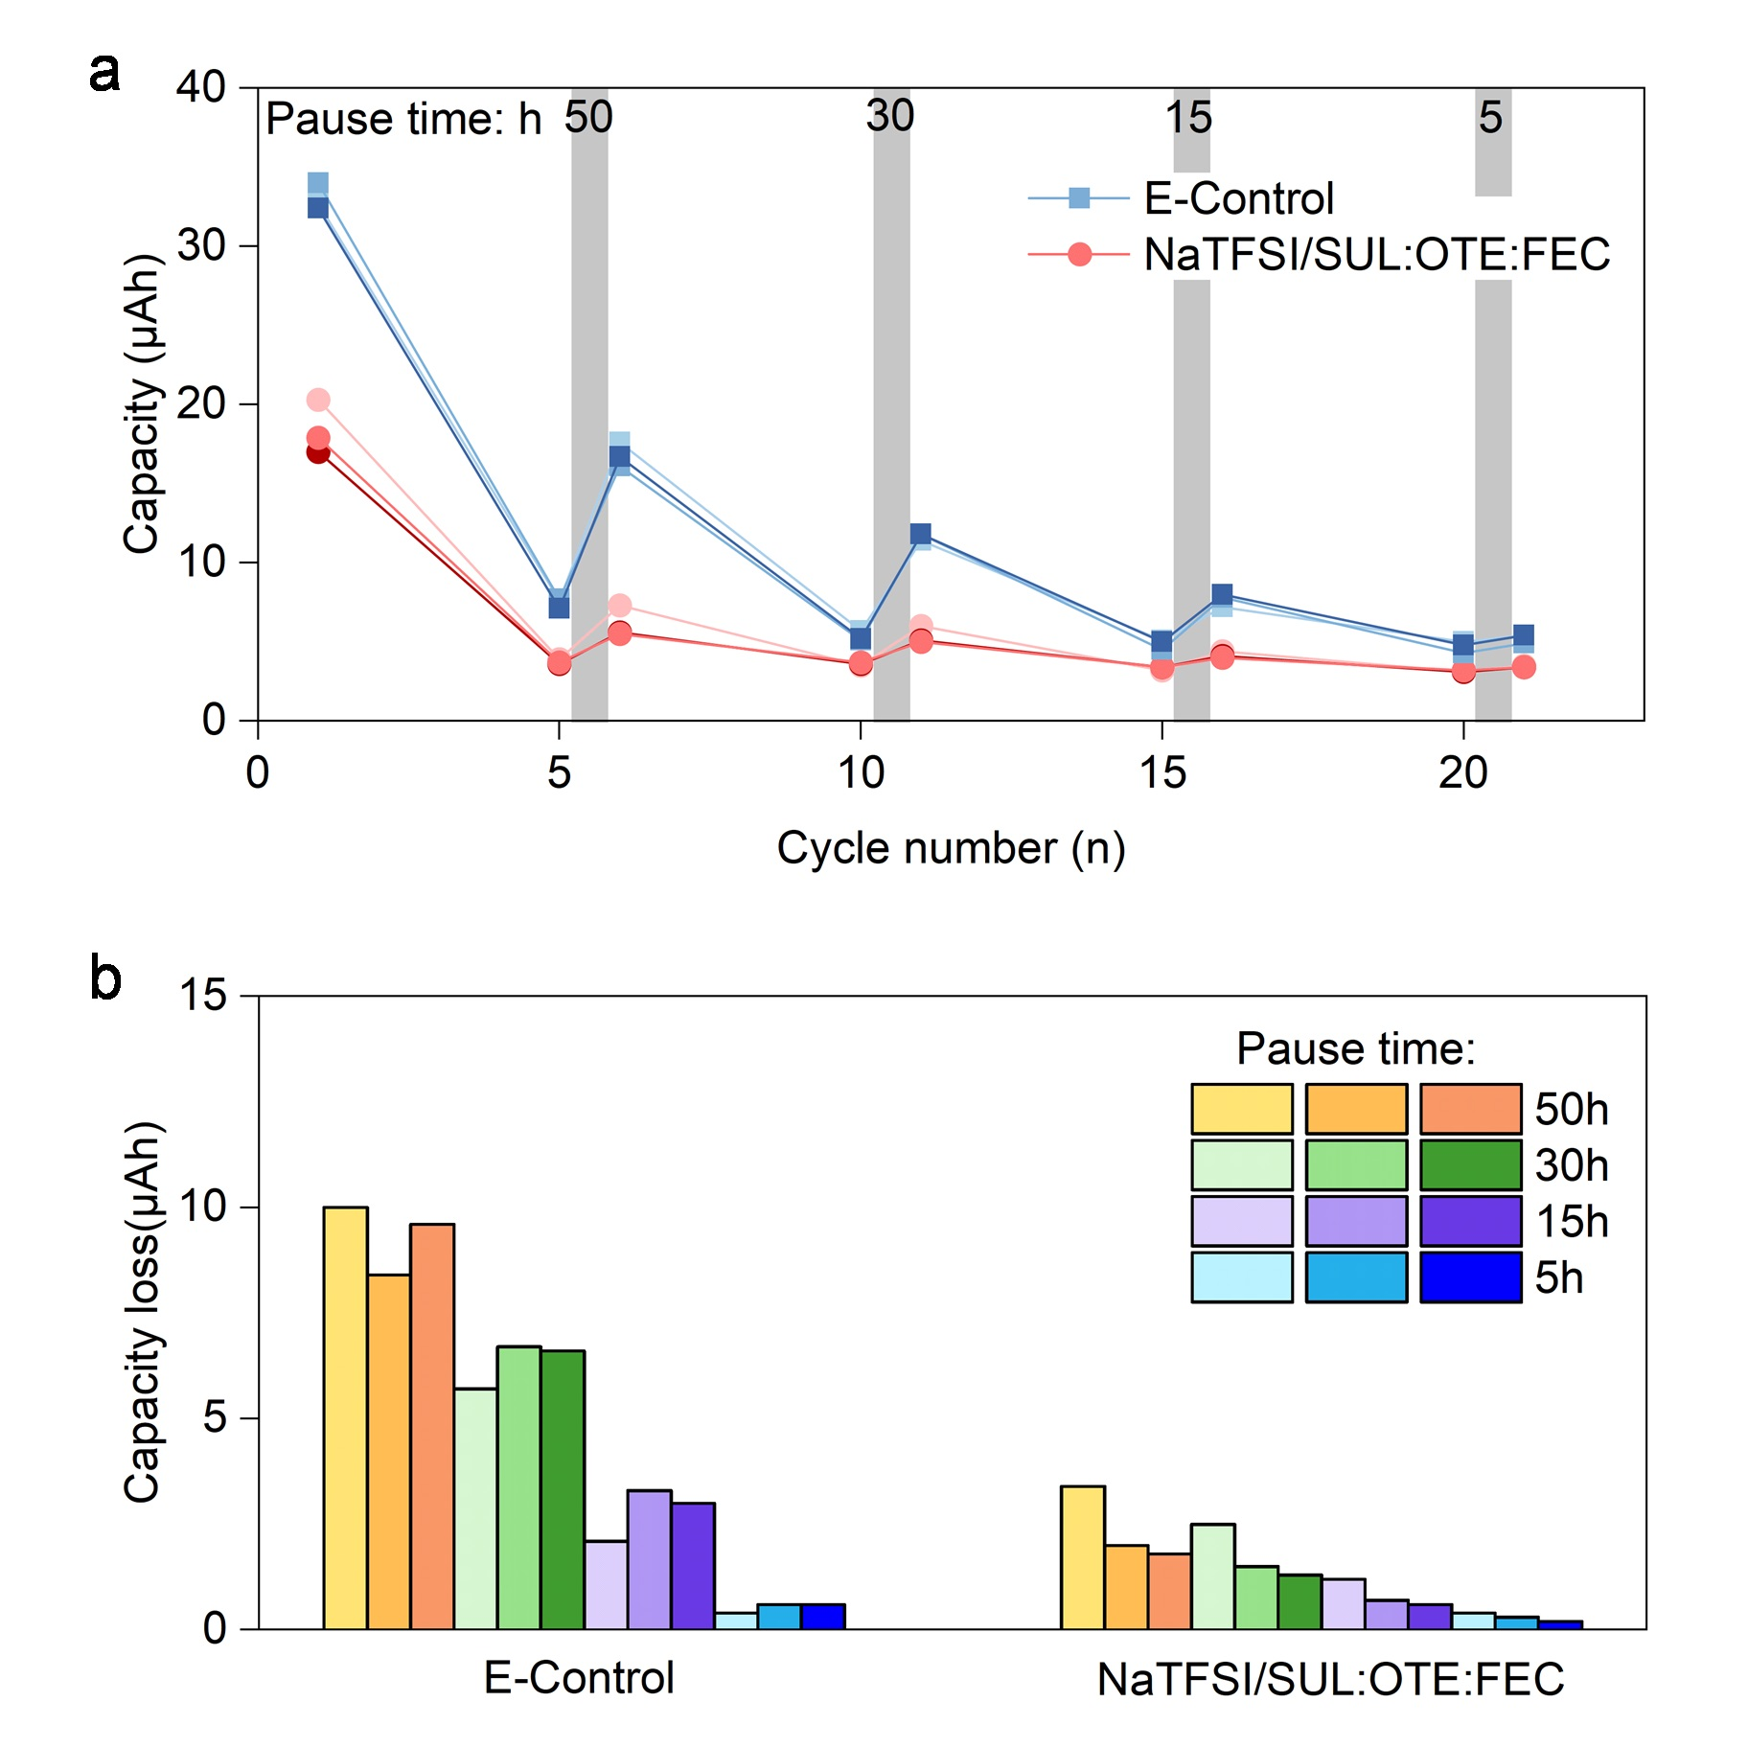
Fig. S29 (a) The capacity from the reduction reaction of electrolytes before and after each pause time as a function of cycle numbers. The grey area with arbitrary width means cell pause processes. (b) The capacity loss for different pause times in E-Control and NaTFSI/SUL:OTE:FEC
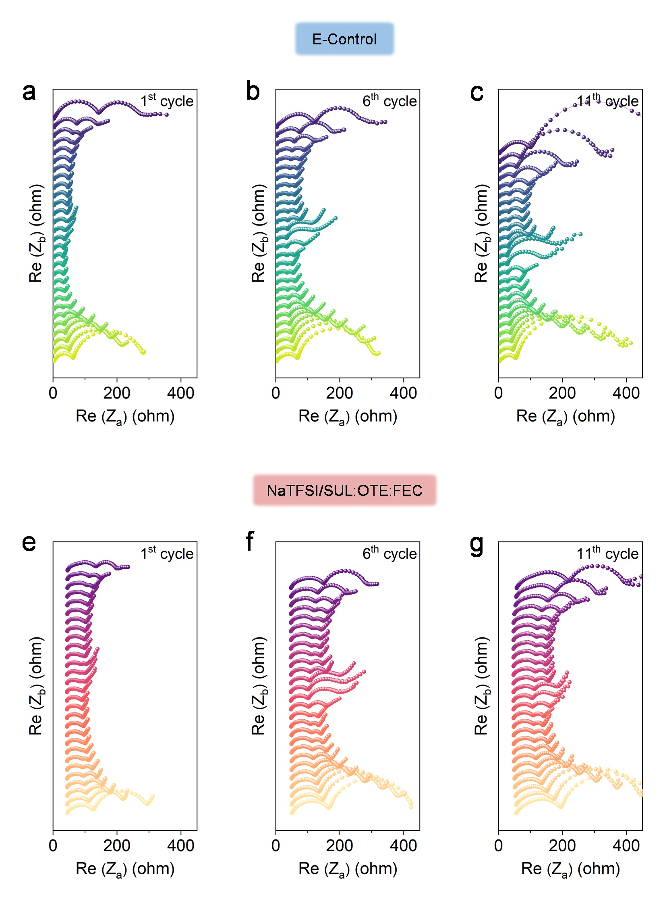
Fig. S30 In situ EIS plots of Na||NaNMF cells for the (a-c) E-Control and (d-e) NaTFSI/SUL:OTE:FEC at the 1st, 6th and 11th cycle
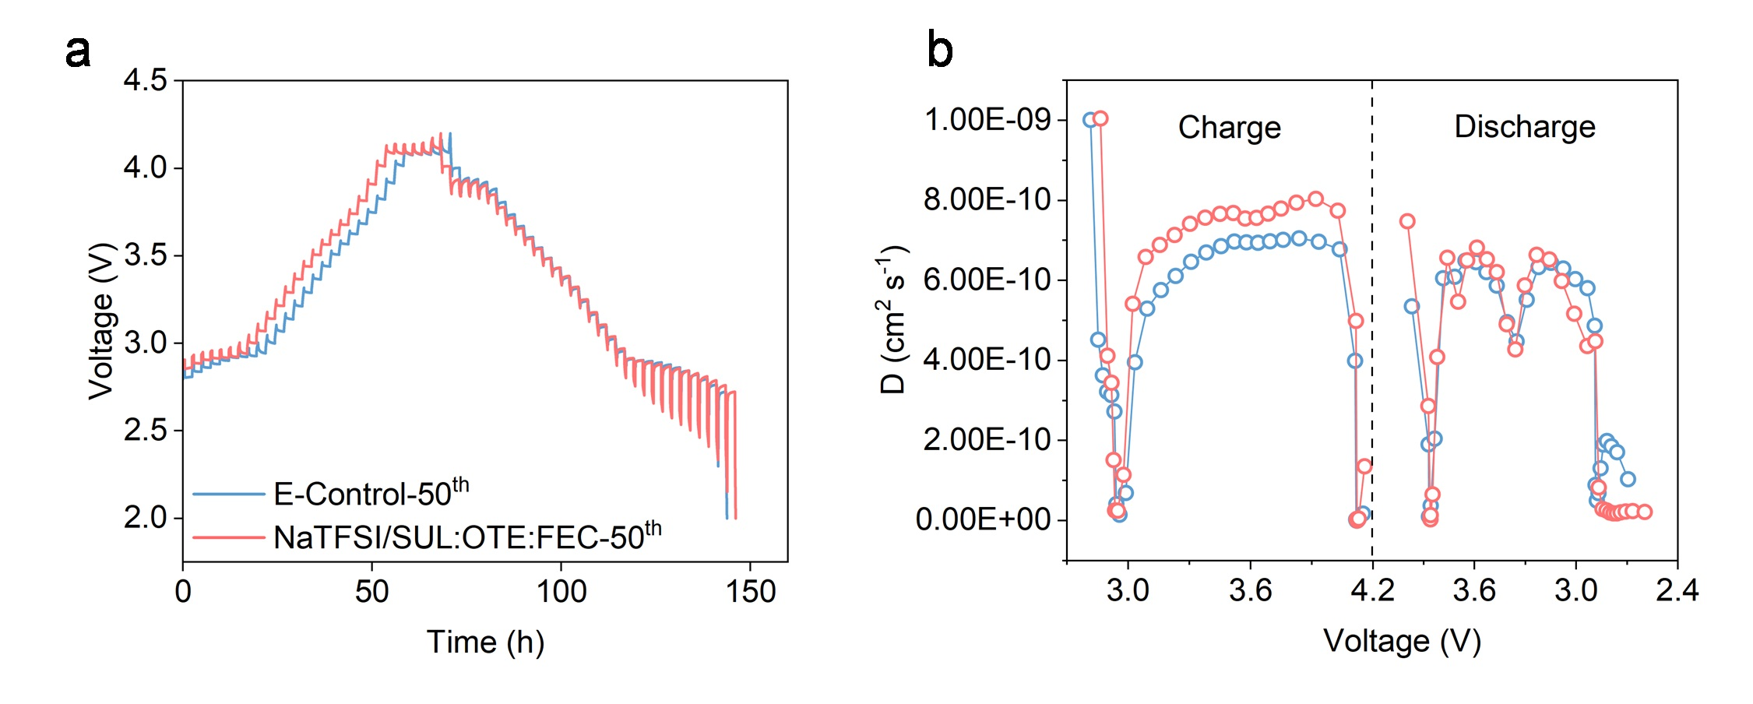
Fig. S31 (a) Charge-discharge voltage profiles of GITT technique measurements after 50 cycles and (b) corresponding D_{Na+} of NaNMF cathode in E-Control and NaTFSI/SUL:OTE:FEC

Table S1 Compositions and physicochemical properties of the electrolytes investigated in this work
Electrolyte | FEC Addition | M (mol/L) | Conductivity (mS cm⁻¹) (25 °C)
NaTFSI/SUL:OTE:FEC (SUL:OTE 1:1 molar ratio) | 5 wt.% | 1.2 | 0.97
0.9 M NaTFSI/ SUL:OTE:FEC | 5 wt.% | 0.9 | 1.30
1.5 M NaTFSI/ SUL:OTE:FEC | 5 wt.% | 1.5 | 0.76
1.2 M NaTFSI/SUL:FEC | 5 wt.% | 1.2 | 3.08
4 M NaTFSI/SUL:FEC | 5 wt.% | 4 | 0.20
E-Control (NaClO₄/DMC:EC:FEC; DMC:EC 1:1 vol. ratio) | 5 wt.% | 1 | 8.42

Table S2 Viscosity of NaTFSI/SUL:OTE:FEC and E-Control
Electrolyte | Viscosity (mPa S) (28 °C)
NaTFSI/SUL:OTE:FEC | 20.50
E-Control | 5.72

Table S3 Electrochemical performance comparison between the published literatures and this work
Electrolyte | System | Cut-off Voltage (V) | Cycle No. | Initial capacity (mAh g⁻¹)/ Capacity retention | Flammability | References
1 M NaClO₄ in TEP with 5wt.% FEC | Na||P2- Na_{2/3}Cu_{2/9}Fe_{1/9}Mn_{2/3}O₂ | 1.5–4.6 V | 200, 2 C | About 80/ 76.28% | No | [S1]
1 M NaPF₆ EMC/FEC/TTE in a 6:1:3 vol ratio | Na||P2- Na_{0.7}Li_{0.03}Mg_{0.03}Ni_{0.27}Mn_{0.6}Ti_{0.07}O₂ | 2.2–4.4 V | 200, 1 C | 129/ 87.3% | Yes | [S2]
1 M NaClO₄ in PC with 2 wt.% FEC and 2 wt.% DGA | Na||P2- Na_{0.67}Li_{0.2}Ni_{0.23}Mn_{0.67}O₂ | 2–4.3 V | 500, 0.5 C | 96.82/ 91.56% | Yes | [S3]
1 M NaClO₄ in PC with 5 vol.% FEC and 3 wt.% SA | Na||P2- Na_{0.6}Li_{0.15}Ni_{0.15}Mn_{0.55}Cu_{0.15}O₂ | 2–4.5 V | 400, 1 C | About 100/ 87.2% | Yes | [S4]
1 M NaPF₆ PC/EMC in a 1:1 vol ratio with 4 vol.% FEC and 0.5 wt.% AIBN | Na||P2/O3- Na_{0.67}Li_{0.16}Ni_{0.33}Mn_{0.67}O_{2+δ} | 1.8–4.2 V | 550, 0.5 C | 125.5/ 71.0% | - | [S5]
5 M NaFSI in DME | Na||P2- Na_{0.7}(Fe_{0.5}Mn_{0.5})O₂ | 1.5–4.3 V | 100, 0.5 C | About 110/ 82.1% | - | [S6]
1.2 M NaTFSI in SUL:OTE (1:1 molar ratio) with 5 wt.% FEC | Na||O3- NaNi_{1/3}Mn_{1/3}Fe_{1/3}O₂ | 2–4.2 V | 300, 1 C | 130.82/ 79.48% | No | This work
1.2 M NaTFSI in SUL:OTE (1:1 molar ratio) with 5 wt.% FEC | Na||O3- NaNi_{1/3}Mn_{1/3}Fe_{1/3}O₂ | 2–4.2 V | 400, 2 C | 116.39/ 81.15% | No | This work
Supplementary References
- J. Sung, N. Shaji, T. Kim, F. Jiang, M. Nanthagopal et al., The effect of nonflammable electrolyte on Cu-substituted P2-type layered cathode for high safety sodium-ion batteries. J. Power Sources 580, 233266 (2023). https://doi.org/10.1016/j.jpowsour.2023.233266
- Q. Liu, Y.-H. Feng, X. Zhu, M. Liu, L. Yu et al., Stabilizing cathode-electrolyte interphase by localized high-concentration electrolytes for high-voltage sodium-ion batteries. Nano Energy 123, 109389 (2024). https://doi.org/10.1016/j.nanoen.2024.109389
- P. Dai, C.-G. Shi, Z. Huang, X.-H. Wu, Y.-P. Deng et al., A new film-forming electrolyte additive in enhancing the interface of layered cathode and cycling life of sodium ion batteries. Energy Storage Mater. 56, 551-561 (2023). https://doi.org/10.1016/j.ensm.2023.01.046
- J. Fan, P. Dai, C. Shi, Y. Wen, C. Luo et al., Synergistic dual‐additive electrolyte for interphase modification to boost cyclability of layered cathode for sodium ion batteries. Adv. Funct. Mater. 31(17), (2021). https://doi.org/10.1002/adfm.202010500
- J. Lin, H. Peng, P. Huang, T. Naren, C. Liang et al., Electrically coupled electrolyte engineering enables high interfacial stability for high‐voltage sodium‐ion batteries. Adv. Funct. Mater. 33(48), 2307061 (2023). https://doi.org/10.1002/adfm.202307061
- J. Lee, Y. Lee, J. Lee, S. Lee, J. Choi et al., Ultraconcentrated sodium bis(fluorosulfonyl)imide-based electrolytes for high-performance sodium metal batteries. ACS Appl. Mater. Interfaces 9(4), 3723-3732 (2017). https://doi.org/10.1021/acsami.6b14878

