Supporting Information for
Ideal Bi-Based Hybrid Anode Material for Ultrafast Charging of Sodium-Ion Batteries at Extremely Low Temperatures
Jie Bai¹, Jian Hui Jia¹, Yu Wang¹, Chun Cheng Yang^{1,}*, and Qing Jiang^{1,}*
¹Key Laboratory of Automobile Materials (Jilin University), Ministry of Education, School of Materials Science and Engineering, Jilin University, Changchun 130022, P. R. China
*Corresponding authors. E-mail: ccyang@jlu.edu.cn (Chun Cheng Yang); jiangq@jlu.edu.cn (Qing Jiang)
Supplementary Figures
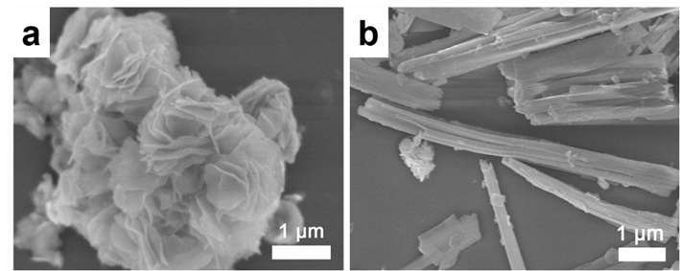
Fig. S1 SEM images of a BiOI NSs and b Bi-MOFs
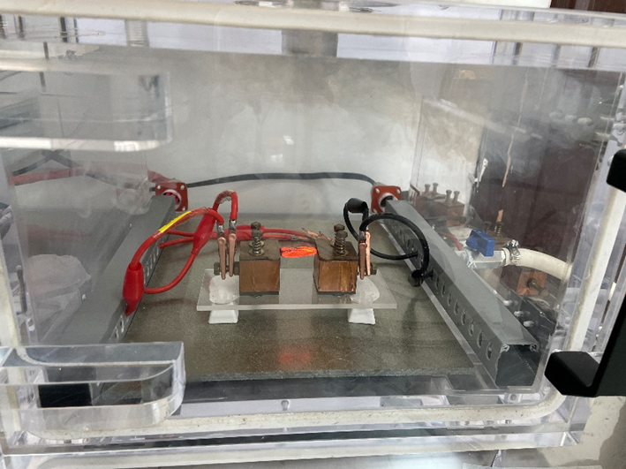
Fig. S2 Photograph of the HTS device

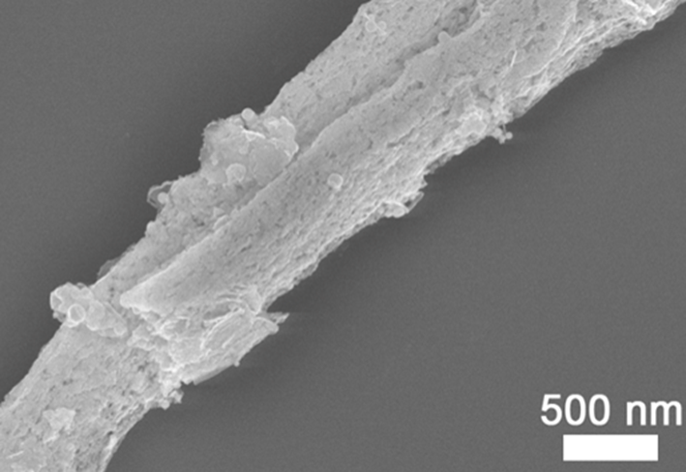
Fig. S3 SEM image of Bi/CNRs-15
Fig. S4 a Transient temperature profile and b nanoparticle size distribution of Bi/CNRs-15
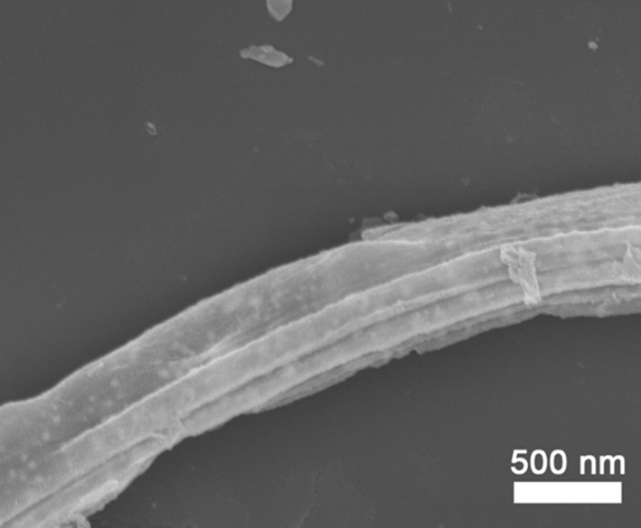
Fig. S5 SEM image of Bi/CNRs-TFA
Fig. S6 a TEM image and b nanoparticle size distribution of Bi/CNRs-TFA
Fig. S7 a The transient temperature profile, b TEM image and c size distribution of Bi/CNRs-5. d The transient temperature profile, e TEM image and f size distribution of Bi/CNRs-30
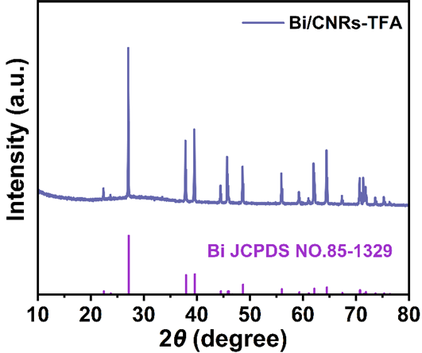
Fig. S8 XRD pattern of Bi/CNRs-TFA

Fig. S9 SAED pattern of Bi/CNRs-15
Fig. S10 BF-STEM image of Bi/CNRs-15 and corresponding elemental mappings for Bi and C elements
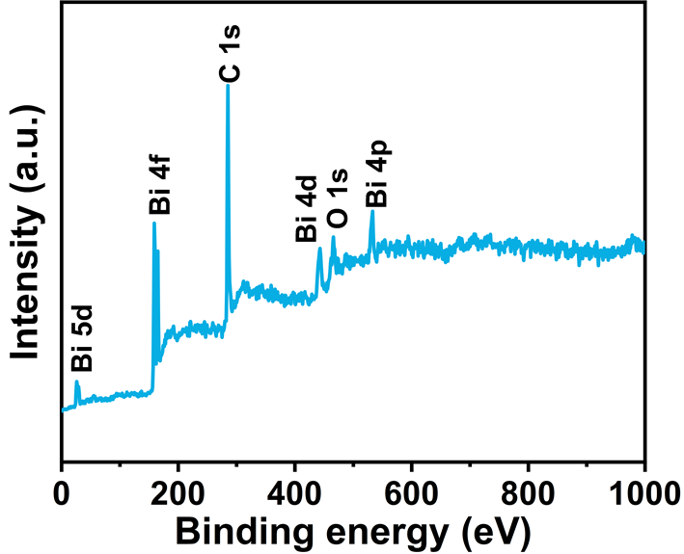
Fig. S11 XPS survey spectrum of Bi/CNRs-15
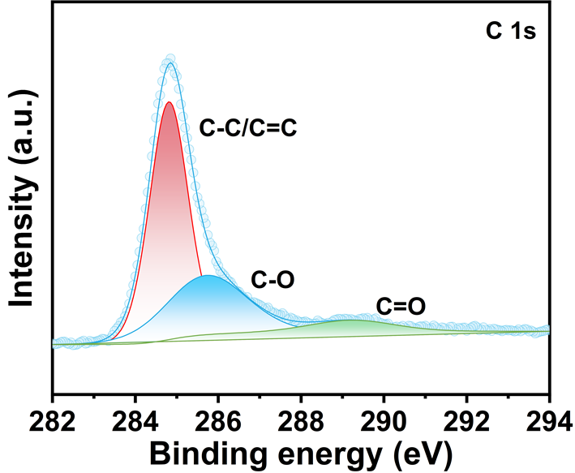
Fig. S12 C 1s spectrum of Bi/CNRs-15
Fig. S13 a Bi 4f spectrum of Bi/CNRs-15. b Bi 4f spectrum of Bi/CNRs-15 with the etching depths of 10 nm
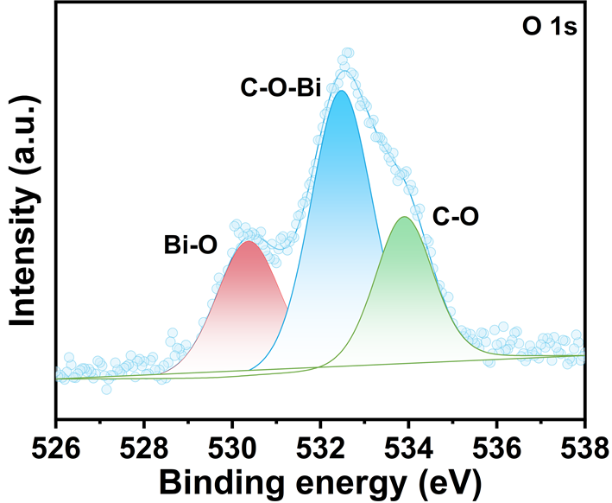
Fig. S14 O 1s spectrum of Bi/CNRs-15
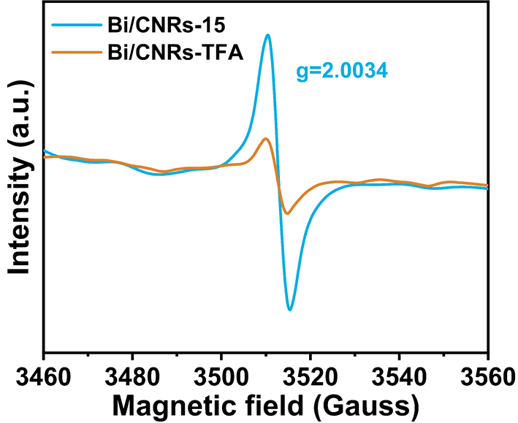
Fig. S15 EPR spectra of Bi/CNRs-15 and Bi/CNRs-TFA
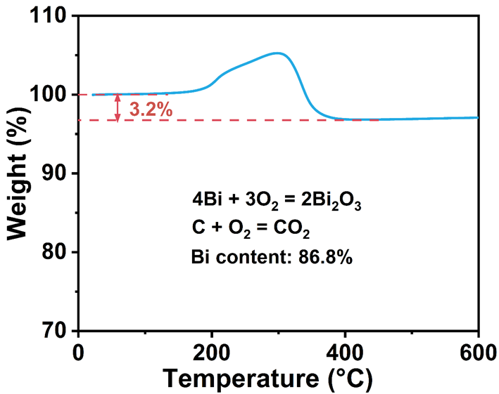
Fig. S16 TGA curve of Bi/CNRs-15
The reason for the weight percentage increase in the temperature range of 200 to 300 °C is that the rate of Bi oxidation is faster than the rate of evaporation of adsorbed water and loss of C to CO₂ gas [Ref. 50 of the text]. The content of metallic Bi in the Bi/CNRs-15 composite is calculated to be 86.8 wt% from the equation below.
Bi (wt%) =$\frac{\text{2*molecular weight of Bi}}{\text{molecular weight of }{\text{Bi}}_{\text{2}}{\text{O}}_{\text{3}}} \text{×} \frac{\text{weight of }{\text{Bi}}_{\text{2}}{\text{O}}_{\text{3}}}{\text{weight of Bi/CNRs-15}} \text{×}\text{ 100\% = }\frac{\text{2*208.98}}{\text{465.96}} \text{×} \frac{\text{1-0.032}}{\text{1}} \text{×}\text{ 100\% = 86.8\%}$

Fig. S17 a N₂ adsorption/desorption isotherms and b pore size distribution of Bi/CNRs-15. c N₂ adsorption/desorption isotherms and d pore size distribution of Bi-MOFs
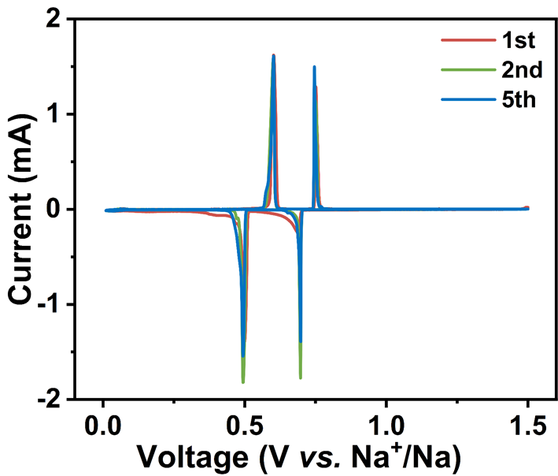
Fig. S18 CV curves of Bi/CNRs-15 at 0.1 mV s⁻¹
Two cathodic peaks at 0.49 and 0.70 V are related to the stepwise alloy reactions from Bi to NaBi and further to Na₃Bi. The sharp redox peaks and highly overlapped CV curves indicate fast kinetics and superior reversibility of Bi/CNRs-15.

Fig. S19 a Galvanostatic charge/discharge curves and b cycling performance of Bi/CNRs-15 at 1 A g⁻¹
The Bi/CNRs-15 electrode achieves the initial discharge/charge capacities of 557.7 and 430.8 mAh g⁻¹, respectively, corresponding to a high initial Coulombic efficiency (ICE) of 77.2%. The irreversible capacity in the 1st cycle is inferred to be the formation of the solid electrolyte interphase (SEI) film [S1]. The ICE values can potentially be improved according to the following strategies, such as electrolyte engineering (optimizing the formula of electrolyte and adding the electrolyte additives), binder optimization (developing multifunctional binders) and pre-sodiation (mixing the anode materials with sodium metal) [S2, S3]. Meanwhile, the discharge curves display pronounced plateaus at 0.70 and 0.50 V while plateaus at 0.60 and 0.75 V in the charge curves, which are completely in conformity with the CV curves. A reversible capacity of 393 mAh g⁻¹ can be achieved after 500 cycles with a high capacity retention of 94.2% relative to the second cycle.
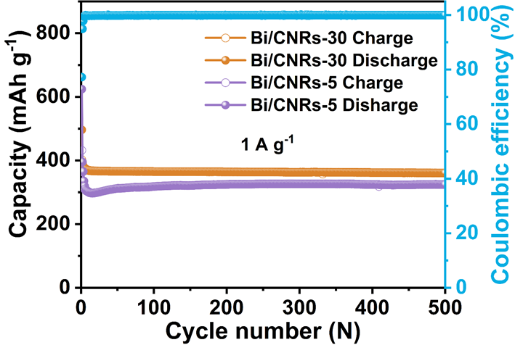
Fig. S20 Cycling performances of Bi/CNRs-5 and Bi/CNRs-30 at 1 A g⁻¹
The Bi/CNRs-5 and Bi/CNRs-30 electrodes provide lower capacities of 324.5 mAh g⁻¹/81.9% and 360.7 mAh g⁻¹/92.1%, respectively, compared with Bi/CNRs-15.

Fig. S21 a Rate performance and b charge/discharge curves at various rates of Bi/CNRs-15. c Rate performances of Bi/CNRs-5 and Bi/CNRs-30. d Comparisons of rate performance of Bi/CNRs-15 with reported Bi-based SIB anodes
Moreover, Bi/CNRs-15 also exhibits the best rate performance compared with Bi/CNRs-5 and Bi/CNRs-30. At relatively low current densities (0.2, 0.5, and 1 A g⁻¹), the average rate capacity reaches 405.6, 400.7 and 398.3 mAh g⁻¹, respectively. Even with a sharp increase in the current to 100 A g⁻¹ (only 13 s to complete full charge or discharge), the capacity of Bi/CNRs-15 displays tiny fluctuation and still remains stable at 373.4 mAh g⁻¹. Furthermore, two notable voltage plateaus still exist in the galvanostatic charge/discharge curves of Bi/CNRs-15 at 100 A g⁻¹, suggesting low polarization. It is worth noting that the Bi/CNRs-15 electrode provides ultrahigh stability even at extremely large current, showing competitive rate property compared with reported Bi-based anodes for SIBs [S1-S8].
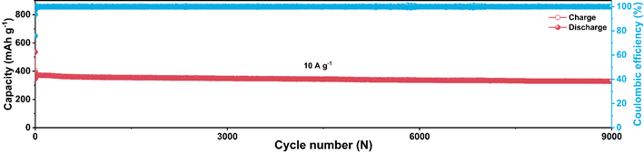
Fig. S22 Long-term cycling performance of Bi/CNRs-15 at 10 A g⁻¹
In order to further validate the sustainability of Bi/CNRs-15, the long-term cycling test at a high rate of 10 A g⁻¹ was implemented, which remains a reversible capacity of 328.4 mAh g⁻¹ after 9000 cycles with a decay rate of only 0.002% per cycle, illustrating the fast reaction kinetics and appealing cycling stability.
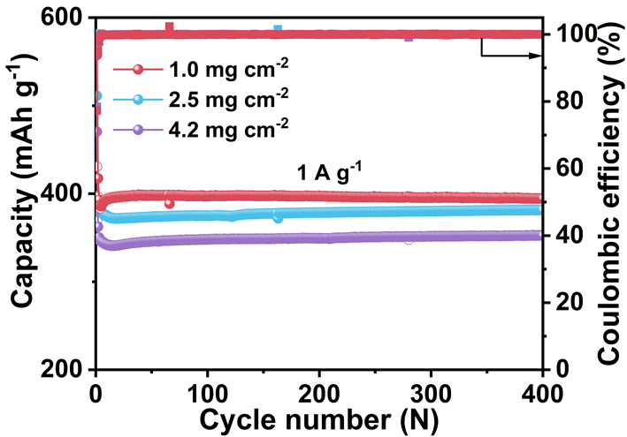
Fig. S23 Cycling performance of the Bi/CNRs-15 electrode under different mass loadings (1.0, 2.5 and 4.2 mg cm⁻²) at 1 A g⁻¹
Even under high mass loadings of 2.5 and 4.2 mg cm⁻², the Bi/CNRs-15 electrode still has high discharge capacities of 381.5 and 352.5 mAh g⁻¹ after 400 cycles under 1 A g⁻¹, respectively. Compared with the mass loading of 1.0 mg cm⁻² (394.6 mAh g⁻¹ after 400 cycles under 1 A g⁻¹), the capacities for 2.5 and 4.2 mg cm⁻² only decay 13.1 and 42.1 mAh g⁻¹, respectively. This indicates that the Bi/CNRs-15 electrode exhibits superior electrochemical performance even under high mass loadings.
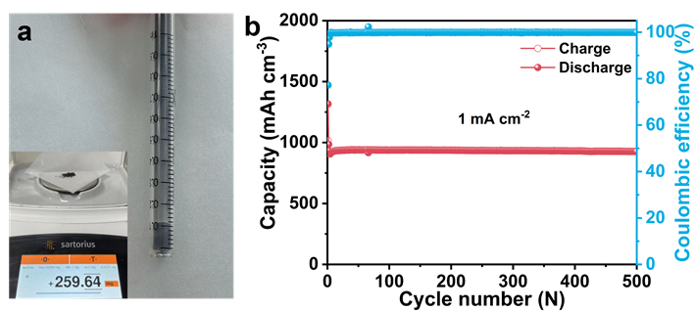
Fig. S24 a Volume of the Bi/CNRs-15 powder after 500 times vibration, and the inset shows related mass. b Cycling performance of Bi/CNRs-15 based on volumetric capacity at 1 mA cm⁻².
The average tap density of Bi/CNRs-15 is calculated to be 2.36 g cm⁻³, and the volumetric capacity of the Bi/CNRs-15 electrode remains as high as 927.5 mAh cm⁻³ at 1 mA cm⁻² after 500 cycles.
Fig. S25 a CV curves of Bi/CNRs-15 at various scan rates. b The determination of b value. c Contributions of the pseudocapacitance and diffusion at a scan rate of 1.0 mV s⁻¹. d Contribution ratios of capacitive- and diffusion-controlled capacities at different scan rates
The redox peaks hold similar shapes and peak potentials at increased scan rates, suggesting a small polarization voltage and fast reaction kinetics. The relationship of the scanning rate (v) and peak current (i) can be described as [S9]:
i = av^{b} (S1)
where both a and b are variables. Generally, the b values of 0.5 and 1.0 represent the completely diffusion-controlled process (Faradaic) and capacitive-dominated behavior, respectively. The quantitative contributions of capacitive (k₁v) and diffusion process (k₂v^{1/2}) in Bi/CNRs-15 can be calculated based on the following equation [S9]:
i(V) = k₁v + k₂v^{1/2} (S2)
The sweep-rate-dependent CV technique was employed to explore remarkable high-rate performance at room temperature. Through fitting two couples of redox peaks, the b values are 0.86, 0.59, 0.80 and 0.63 for R1, R2, O2 and O1, respectively, which demonstrates that the redox process is joint controlled by the pseudocapacitance and diffusion [8]. With increasing the scan rate, the proportion of the capacitive contribution gradually increases from 87.5% to 92.8%. This reveals that carbon vacancies induced by ultrafast HTS can facilitate Na⁺ adsorption to endow extra capacities and fast kinetics [S5, S10].

Fig. S26 a XRD pattern and b cycling performance of Na₃V₂(PO₄)₃ (NVP) at 1 A g⁻¹
Fig. S27 Electrochemical properties of the Bi/CNRs-15//NVP full cell at room temperature. a Cycling performance of Bi/CNRs-15//NVP at 1 A g⁻¹. b Rate performance of Bi/CNRs-15//NVP at various current densities. c Charge/discharge curves of Bi/CNRs-15//NVP at various current densities. d Cycling performance of Bi/CNRs-15//NVP at 5 A g⁻¹
Encouraged by the impressive half cell properties, a full cell was fabricated using Bi/CNRs-15 as an anode, and NVP as a cathode. The mass loadings of cathode and anode are about 3.9 and 1 mg cm⁻², respectively, to obtain the optimal performance of the Bi/CNRs-15//NVP full cell. The capacity of the Bi/CNRs-15 anode in the half cell at the 3th cycle is 393.1 mAh g⁻¹ (Fig. S19b) and that of the NVP cathode is 100.1 mAh g⁻¹ (Fig. S26b). The circular electrodes are discoidal pieces with a diameter of 12 mm and the corresponding area of each disk is about 1.13 cm². Hence, the negative/positive (N/P) ratio = areal capacity of anode/areal capacity of cathode = 393.1 mAh g⁻¹ × 1 mg cm⁻² × 1.13 cm²/(100.1 mAh g⁻¹ × 3.9 mg cm⁻² × 1.13 cm²) = 1.01. The full cell shows a reversible capacity of 337.8 mAh g⁻¹ (based on the mass of anode) after 100 cycles at 1 A g⁻¹. Note that the rate performance of the full cell is also impressive with the average capacities of 372.8, 367.9, 343.1, 320.1 and 308.2 mAh g⁻¹ at 0.2, 0.5, 1, 2 and 5 A g⁻¹, respectively. Moreover, the full cell achieves a high capacity of 291.2 mAh g⁻¹ after 400 cycles under a high current of 5 A g⁻¹. All these results indicate that Bi/CNRs-15 is a feasible anode for practical applications in fast charging SIBs.
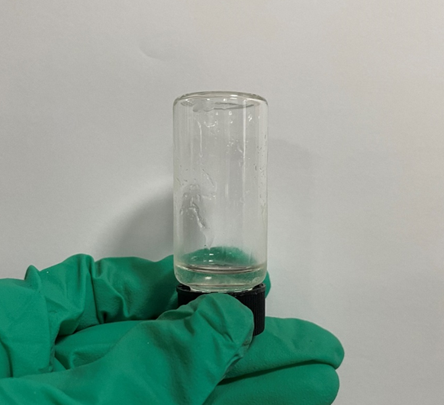
Fig. S28 Photograph of 1.0 M NaPF₆ in DME at -40 °C
Ether-based solvents are widely acknowledged for their low viscosity and freezing points, which enable the electrolyte to maintain a liquid state and display high ionic conductivity even at low temperature. For example, DME (1,2-dimethoxyethane) exhibits a low freezing point of -58 °C [Ref. 66 of the text]. Through further cryogenic storage experiments of electrolytes, we find that the electrolyte viscosity of 1 M NaPF₆ in DME increases at -40 °C (Fig. S28) compared with room temperature. A small part of electrolyte hangs upside down on the wall of the glass bottle and most remains liquid. The freezing point of the electrolyte can be reduced by lowering the electrolyte concentration and/or introducing a co-solvent with a low freezing point.
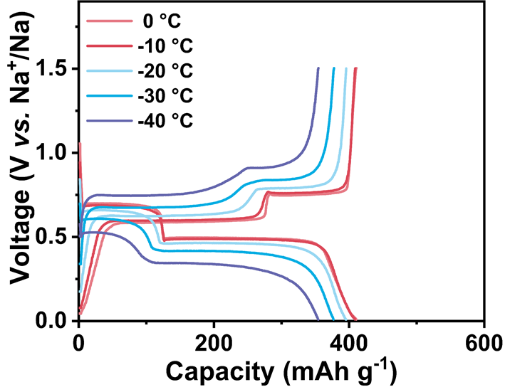
Fig. S29 Charge/discharge curves of Bi/CNRs-15 at 1 A g⁻¹ at different temperatures
Fig. S30 CV curves of Bi/CNRs-15 at 0.1 mV s⁻¹ at different temperatures
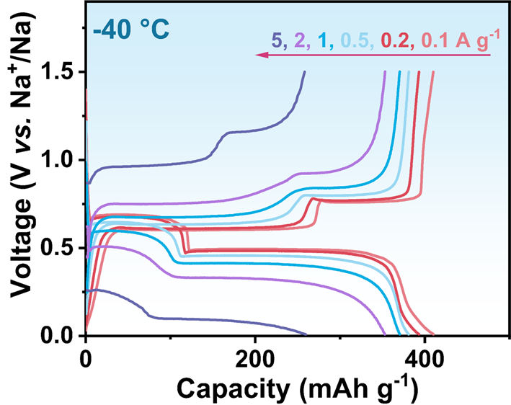
Fig. S31 Charge/discharge curves of Bi/CNRs-15 at various rates at -40 °C
Fig. S32 a Comparisons of rate performance of Bi/CNRs-15, Bi/CNRs-TFA and pure Bi at -40 °C. b Cycling performance of pure Bi at 1 A g⁻¹ at -40 °C. c The voltage-time curve of pure Bi at various current densities at -40 °C.
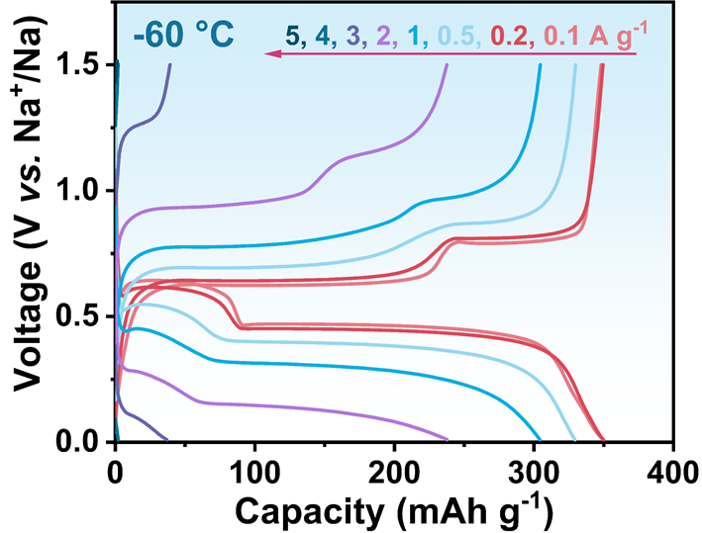
Fig. S33 Charge/discharge curves of Bi/CNRs-15 at various rates at -60 °C
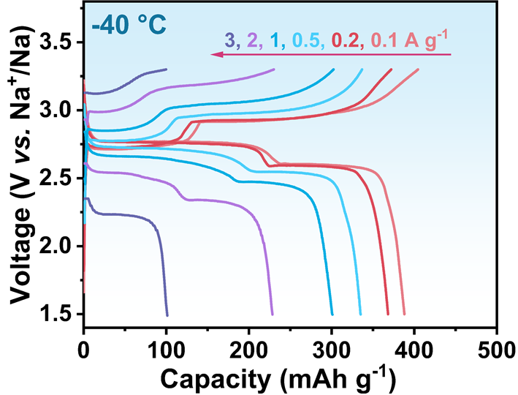
Fig. S34 Charge/discharge curves of the Bi/CNRs-15//NVP full cell at various current densities at -40 °C
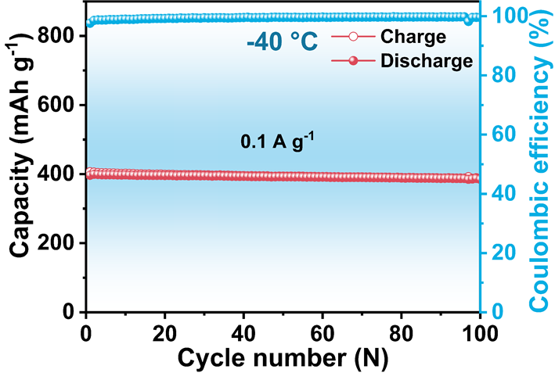
Fig. S35 Cycling performance of the Bi/CNRs-15//NVP full cell after rate tests (see Fig. 2h of the text) at 0.1 A g⁻¹ at -40 °C
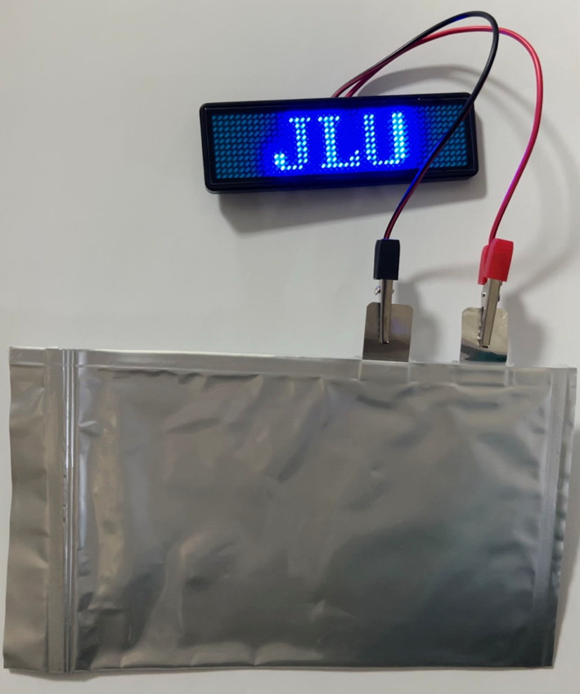
Fig. S36 Photograph of lighted LED panel by the Bi/CNRs-15//NVP pouch cell at room temperature
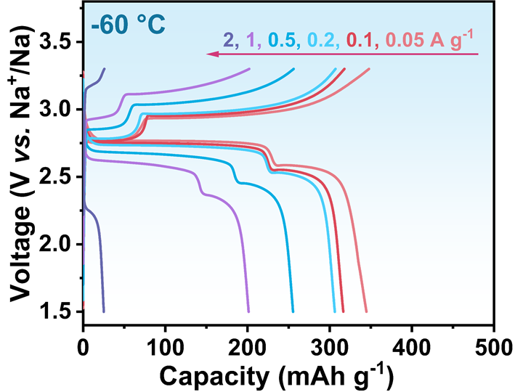
Fig. S37 Charge/discharge curves of the Bi/CNRs-15//NVP full cell at various current densities at -60 °C
Fig. S38 a-c SEM images of the Bi/CNRs-15 electrode after 1, 5 and 50 cycles, respectively
The morphology of the cycled electrode was characterized by SEM and TEM. From Fig. S38, as the cycle proceeds, the electrode gradually evolves into coral-like porous nanonetworks, which can facilitate the diffusion of Na⁺ [S1, S2].
Fig. S39 TEM image of the Bi/CNRs-15 electrode after 50 cycles
Figure S39 shows the TEM image of Bi/CNRs-15 after 50 cycles, where it can be observed that ultrasmall nanoparticles load on the porous structure.
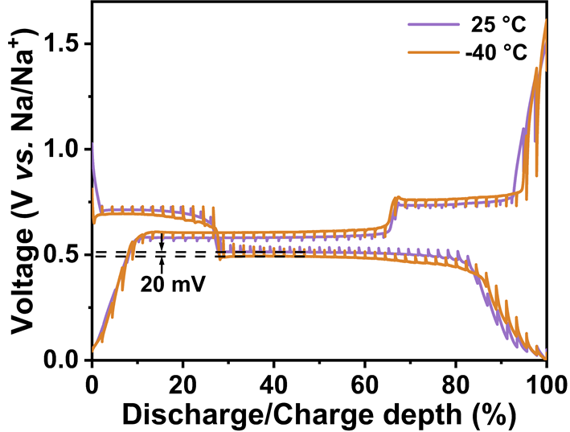
Fig. S40 Quasi-equilibrium voltage curves of Bi/CNRs-15 from GITT at 25 and -40 °C
Fig. S40 shows a small voltage polarization (20 mV) for Bi/CNRs-15 at -40 °C, validating excellent Na⁺ transport kinetics even at low temperature. The Na⁺ diffusion coefficient (D) was calculated using GITT technique to expound the electrochemical reaction kinetics. The D value was calculated from the following equation:
D = $\frac{\text{4}}{\text{ π}\text{τ} }(\frac{{\text{m}}_{\text{B} }{\text{V}}_{\text{M} }}{{\text{M}}_{\text{B}}\text{S}}$)²$(\frac{{\text{ΔΕ}}_{\text{s} }}{{\text{ΔΕ}}_{\text{τ} }}$)² (S3)
where S is the surface area of the tested electrode and τ is the time duration of the pulse, m_{B}, M_{B} and V_{M} are the weight, molar mass and molar volume of the active materials, respectively. ΔE_{s} is the steady-state potential change by the current pulse, and ΔE_{τ} is the instantaneous potential change during the constant current pulse.
Fig. S41 Na⁺ diffusion coefficients of Bi/CNRs-15 and pure Bi during the a discharging and b charging processes at 25 °C
Fig. S42 Detailed voltage response curves of the Bi/CNRs-15 and pure Bi electrodes during a single constant current pulse with respect to time
Fig. S43 a EIS plots and b corresponding R_{el} and R_{ct} values of the cycled Bi/CNR-15 electrode at room temperature

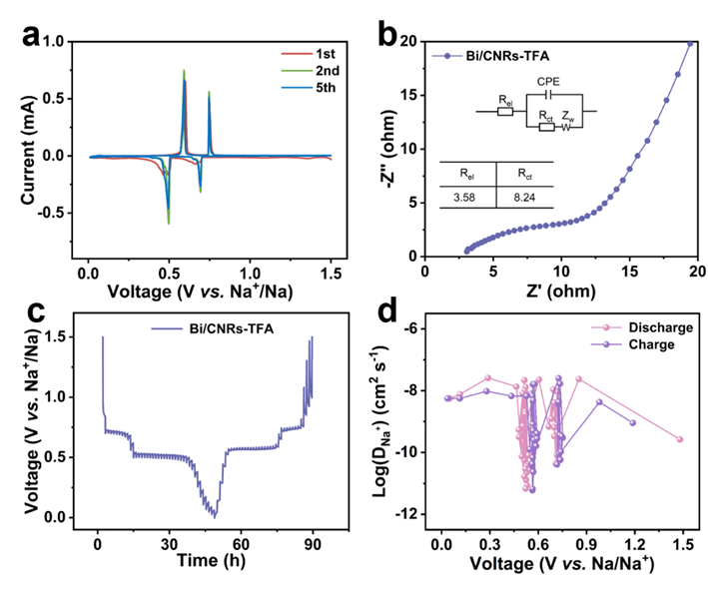
Fig. S44 a CV curves of Bi/CNRs-TFA at 0.1 mV s⁻¹. b EIS plots of Bi/CNRs-TFA, where the inset shows corresponding equivalent circuit diagram and the values of fitted R_{ct} and R_{el}. c GITT voltage profiles of the Bi/CNRs-TFA electrode. d Na⁺ diffusion coefficients of Bi/CNRs-TFA during the discharging and charging processes
Two cathodic peaks at 0.49 and 0.69 V are related to the stepwise alloy reactions from Bi to NaBi and further to Na₃Bi (Fig. S44a). On the basis of the equivalent circuit diagram in Fig. S44b, the values of R_{ct} and R_{el} are 8.2 and 3.6 Ω, respectively, which are larger than the values of Bi/CNRs-15 (R_{ct} of 5.9 Ω and R_{el} of 1.5 Ω). Furthermore, the Na⁺ diffusion kinetic of the Bi/CNRs-TFA electrode was investigated by GITT. The Na⁺ diffusion coefficients of Bi/CNRs-TFA are in ranges of 2.6 × 10⁻⁸ to 6.0 × 10⁻¹², which are smaller than those of Bi/CNRs-15 (5.8 × 10⁻⁸ to 1.6 × 10⁻¹¹).
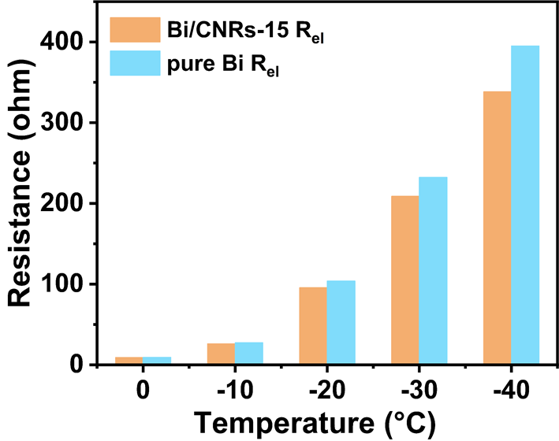
Fig. S45 Comparisons of R_{el} of the Bi/CNRs-15 and pure Bi electrodes at various temperatures
Fig. S46 Depth-profiling XPS spectra of O 1s of SEI on the a Bi/CNRs-15 and b pure Bi electrodes
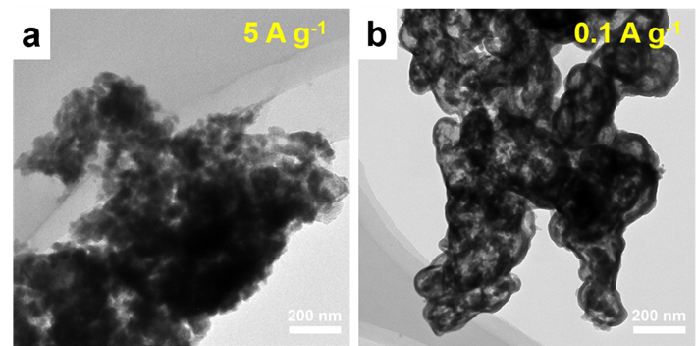
Fig. S47 a TEM image of the Bi/CNRs-15 electrode after 5 cycles at 5 A g⁻¹ at -40 °C. b TEM image of the Bi/CNRs-15 electrode after 5 cycles at 0.1 A g⁻¹ at -40 °C
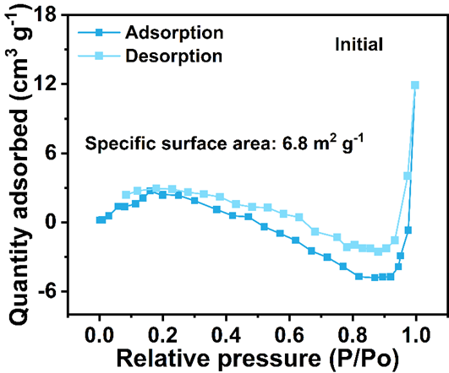
Fig. S48 N₂ adsorption/desorption isotherms of the Bi/CNRs-15 electrode before cycles
Fig. S49 EIS plots of the Bi/CNRs-15 electrodes after 5 cycles at 5/0.1 A g⁻¹ at -40 °C, where the inset shows corresponding equivalent circuit diagram and comparisons of R_{ct} and R_{el}
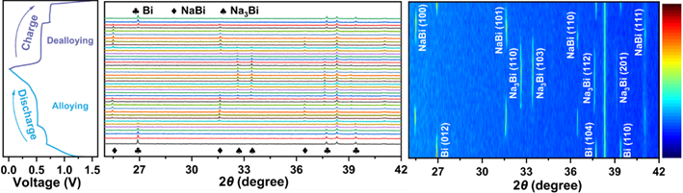
Fig. S50 In-situ XRD patterns of the Bi/CNRs-15 electrode under different discharge/charge states
The in-situ XRD measurement was conducted to probe the Na-storage reaction mechanism of Bi/CNRs-15. The corresponding charge/discharge profile (left panel), line plot (centre panel) and contour plot (right panel) are displayed in Fig. S50. In the discharging process, the diffraction peaks of Bi at 26.9°, 37.7° and 39.4° are attenuated gradually due to alloying reaction into the NaBi phase. With continuous Na⁺ insertion, the new characteristic peaks of Na₃Bi appear and gradually enhance while the peaks of NaBi weaken and eventually vanish, revealing that tetragonal NaBi has completely transformed into hexagonal Na₃Bi. During the desodiation process, the peaks of NaBi arise along with the disappearing of the Na₃Bi phase, and then all NaBi phase converts to Bi due to full charge at 1.5 V, corroborating the reversibility after alloying and dealloying reaction.

Supplementary Tables
Table S1 Crystallite sizes of Bi/CNRs-15 calculated by the Scherrer equation.
2θ (°) | β (°) | L (nm)
27.20221 | 0.20307 | 39.80275
38.00517 | 0.22482 | 36.95764
39.66177 | 0.21785 | 38.33422
The average crystallite sizes of Bi nanoparticles have been calculated by the Scherrer equation L= Kλ/(βcosθ), where L is the crystallite size, K is a constant of 0.89, λ is the wavelength of the X-rays, and β is the half-height width of the diffraction peak.
Table S2 Comparisons of low-temperature performances of various SIB anode materials
Samples | Operating temperature (°C) | Rate capability (mAh g⁻¹) | Cyclic stability  (mAh g⁻¹) | Refs.
Bi/CNRs-15 | -40  -60 | 261.4 at 5 A g⁻¹  237.9 at 2 A g⁻¹ | 241.7 (2400 cycles, 1 A g⁻¹)  334.1 (100 cycles, 0.1 A g⁻¹) | This work
CoGa₂S₄@G | -60 | 97 at 2 A g⁻¹ | 100 (1000 cycles, 1 A g⁻¹) | [S11]
hard carbon | -40  -50 | 255 at 0.1 A g⁻¹  220 at 0.1 A g⁻¹ | 243 (500 cycles, 0.1 A g⁻¹)  209 (100 cycles, 0.1 A g⁻¹) | [S12]
H-NTO | -40 | 25 at 0.3 A g⁻¹ | 55 (3000 cycles, 0.1 A g⁻¹) | [S13]
Zn-HC | -40 | 44.3 at 2 A g⁻¹ | 258 (400 cycles, 0.1 A g⁻¹) | [S14]
HCM-1300-ZBE | -40 | 295 at 0.1 A g⁻¹ | 260 (70 cycles, 0.1 A g⁻¹) | [S15]
Meso-TNOC | -40 | 59 at 1.7 A g⁻¹ | 99 (500 cycles, 0.17 A g⁻¹) | [S16]
FeSe₂/rGO | -40 | 271.7 at 1 A g⁻¹ | 216.7 (200 cycles, 1 A g⁻¹) | [S17]
Graphite | -40 | 59 at 0.3 A g⁻¹ | / | [S18]
Fe₃BO₅@C | -40 | 292 at 0.05 A g⁻¹ | 350 (20 cycles, 0.1 C) | [S19]
VS₄ | -40 | 163 at 2 A g⁻¹ | 396 (20 cycles, 0.2 A g⁻¹) | [S20]
Bi@C | -40 | 246 at 0.1 A g⁻¹ | 246 (10 cycles, 0.1 A g⁻¹) | [27 of text]
TiO₂@rGO | -40  -20 | 30 at 7 A g⁻¹  54 at 7 A g⁻¹ | 100 (1500 cycles, 1.75 A g⁻¹)  120 (1500 cycles, 1.75 A g⁻¹) | [S21]
F-CuFeS₂@RGO | -40  -20 | 200 at 2 A g⁻¹  375 at 2 A g⁻¹ | 182 (200 cycles, 2 A g⁻¹)  375 (200 cycles, 2 A g⁻¹) | [S22]
ZnSe@NCNFs | -40  -20 | /  98 at 5 A g⁻¹ | 55 (1000 cycles, 1 A g⁻¹)  123 (1000 cycles, 1 A g⁻¹) | [S23]
KTOP | -35 | 75.6 at 0.45 A g⁻¹ | 90 (550 cycles, 0.45 A g⁻¹) | [S24]
TS-MoSe₂ | -30  -10 | 308 at 0.1 A g⁻¹  410 at 0.1 A g⁻¹ | 260 (100 cycles, 0.1 A g⁻¹) 380 (100 cycles, 0.1 A g⁻¹) | [S25]
FePSe₃ | -30 | 320 at 10 A g⁻¹ | 200 (10000 cycles, 20 A g⁻¹) | [S26]
PANI/Ti₃C₂T_{x} | -30 | 120.5 at 0.1 A g⁻¹ | 100 (100 cycles, 0.1 A g⁻¹) | [S27]
MoS₂@MXene@D-TiO₂ | -30 | / | 180 (100 cycles, 0.05 A g⁻¹) | [S28]
Ti₃C₂-N_{funct} | -25 | 90 at 5 A g⁻¹ | 110 (5000 cycles, 1 A g⁻¹) | [S29]
3DSG | -25 | 84 at 2 A g⁻¹ | 250 (500 cycles, 0.1 A g⁻¹) | [S30]
defective HT-NW | -25 | 108 at 5 A g⁻¹ | 120 (4200 cycles, 1 A g⁻¹) | [S31]
c-MoS₂ | -25 | 37 at 2 A g⁻¹ | 100 (1000 cycles, 0.2 A g⁻¹) | [S32]
FeS@g-C | -25 | / | 311 (80 cycles, 0.05 A g⁻¹) | [S33]
Fe₇Se₈@C | -25 | / | 338 (80 cycles, 0.2 A g⁻¹) | [S34]
Fe_{1-x}S@NC | -25 | 159.9 at 3 A g⁻¹ | / | [S35]
hard carbon | -20 | 175 at 2 A g⁻¹ | 181 (1000 cycles, 2 A g⁻¹) | [S36]
NaV_{1.25}Ti_{0.75}O₄ | -20 | 93 at 0.2 C  1 C = 100 mA g⁻¹ | / | [S37]
Bi@3DCF | -20 | 190 at 5 A g⁻¹ | 200 (500 cycles, 1 A g⁻¹) | [S38]
NaTi₂(PO₄)₃/C foams | -20 | 95 at 20 C | 116 (500 cycles, 0.2 C) | [S39]
NaTi₂(PO₄)₃/C-CNT | -20 | 62 at 10 C  1 C = 133 mA g⁻¹ | / | [S40]
NTONb0.08 | -15 | 103 at 0.1 A g⁻¹ | 103 (200 cycles, 0.1 A g⁻¹) | [S41]
SnSe₂-SePAN | -15 | 300 at 0.5 A g⁻¹ | 300 (700 cycles, 0.5 A g⁻¹) | [S42]
Sb₂Se₃/rGO | -15 | 233 at 2 A g⁻¹ | / | [S43]
hard carbon  paper | -15 | 300 at 0.5 A g⁻¹ | 217.1 (1000 cycles, 0.5 A g⁻¹) | [S44]
CF | -10  0 | / | 270 (500 cycles, 0.2 A g⁻¹)  227 (1000 cycles, 0.5 A g⁻¹) | [S45]
ZnSe-40 | -10 | 181 at 5 A g⁻¹ | 247 (600 cycles, 1 A g⁻¹) | [S46]
ZnS/MWCNTs | -10 | 208 at 4 A g⁻¹ | 230 (400 cycles, 1 A g⁻¹) | [S47]
CoS/Cu₂S@C-NC | -5 | / | 375.2 (900 cycles, 2 A g⁻¹) | [S48]
P-NiSe@C | -5 | 343.8 at 0.2 A g⁻¹ | 313.8 (50 cycles, 0.2 A g⁻¹) | [S49]
Bi@C-NSA | 0 | 276.3 at 2 A g⁻¹ | 271.8 (200 cycles, 1 A g⁻¹) | [28 of text]
NbSSe | 0 | 85 at 3 C  1 C = 150 mAh g⁻¹ | 136 (500 cycles, 0.2 C) | [S50]
FeS_{0.5}Se_{0.5}@NC | 0 | 226.1 at 8 A g⁻¹ | 380.1 (200 cycles, 1 A g⁻¹) | [S51]
Na₂Ti₆O₁₃@C | 0 | 20 at 5 C | 43 (250 cycles, 2 C) | [S52]
SnSe@CNF | 0 | / | 267 (100 cycles, 0.1 A g⁻¹) | [S53]
Supplementary References
- Y. Z. Liang, N. Song, Z. C. Y. Zhang, W. H. Chen, J. K. Feng et al., Integrating Bi@C nanospheres in porous hard carbon frameworks for ultrafast sodium storage. Adv. Mater. 34, 2202673 (2022). https://doi.org/10.1002/adma.202202673
- X. L. Cheng, R. W. Shao, D. J. Li, H. Yang, Y. Wu et al., A self-healing volume variation three-dimensional continuous bulk porous bismuth for ultrafast sodium storage. Adv. Funct. Mater. 31, 2011264 (2021). https://doi.org/10.1002/adfm.202011264
- X. L. Qiu, X. L. Wang, Y. X. He, J. Y. Liang, K. Liang et al., Superstructured mesocrystals through multiple inherent molecular interactions for highly reversible sodium ion batteries. Sci. Adv. 7, eabh3482 (2021). https://doi.org/10.1126/sciadv.abh3482
- P. X. Xiong, P. X. Bai, A. Li, B. F. Li, M. R. Cheng et al., Bismuth nanoparticle@carbon composite anodes for ultralong cycle life and high-rate sodium-ion batteries. Adv. Mater. 31, 1904771 (2019). https://doi.org/10.1002/adma.201904771
- H. Yang, R. Xu, Y. Yao, S. F. Ye, X. F. Zhou et al., Multicore-shell Bi@N-doped carbon nanospheres for high power density and long cycle life sodium- and potassium-ion anodes. Adv. Funct. Mater. 29, 1809195 (2019). https://doi.org/10.1002/adfm.201809195
- H. Yang, L. W. Chen, F. X. He, J. Q. Zhang, Y. Z. Feng et al., Optimizing the void size of yolk-shell Bi@void@C nanospheres for high-power-density sodium-ion batteries. Nano Lett. 20, 758-767 (2020). https://doi.org/10.1021/acs.nanolett.9b04829
- X. L. Cheng, D. J. Li, Y. Wu, R. Xu, Y. Yu, Bismuth nanospheres embedded in three-dimensional (3D) porous graphene frameworks as high performance anodes for sodium- and potassium-ion batteries. J. Mater. Chem. A 7, 4913-4921 (2019). https://doi.org/10.1039/c8ta11947c
- J. Chen, X. L. Fan, X. Ji, T. Gao, S. Hou et al., Intercalation of Bi nanoparticles into graphite results in an ultra-fast and ultra-stable anode material for sodium-ion batteries. Energy Environ. Sci. 11, 1218-1225 (2018). https://doi.org/10.1039/c7ee03016a
- S. Liu, K. Niu, S. L. Chen, X. Sun, L. H. Liu et al., TiO₂ bunchy hierarchical structure with effective enhancement in sodium storage behaviors. Carbon Energy 4, 645-653 (2022). https://doi.org/10.1002/cey2.172
- H. C. Jin, S. Xin, C. H. Chuang, W. D. Li, H. Y. Wang et al., Black phosphorus composites with engineered interfaces for high-rate high-capacity lithium storage. Science 370, 192-197 (2020). https://doi.org/10.1126/science.aav5842
- F. J. Mo, Z. X. Lian, B. W. Fu, Y. Song, P. Wang et al., A novel composite strategy to build a sub-zero temperature stable anode for sodium-ion batteries. J. Mater. Chem. A 7, 9051-9058 (2019). https://doi.org/10.1039/C9TA02067E
- C. Yang, X. W. Liu, Y. Lin, L. M. Yin, J. Lu et al., Entropy-driven solvation toward low-temperature sodium-ion batteries with temperature-adaptive feature. Adv. Mater. 35, 2301817 (2023). https://doi.org/10.1002/adma.202301817
- W. J. Meng, Z. Z. Dang, D. S. Li, L. Jiang, Long-cycle-life sodium-ion battery fabrication via a unique chemical bonding interface mechanism. Adv. Mater. 35, 2301376 (2023). https://doi.org/10.1002/adma.202301376
- Z. X. Lu, J. Wang, W. L. Feng, X. P. Yin, X. C. Feng et al., Zinc single-atom-regulated hard carbons for high-rate and low-temperature sodium-ion batteries. Adv. Mater. 35, 2211461 (2023). https://doi.org/10.1002/adma.202211461
- X. P. Yin, Z. X. Lu, J. Wang, X. C. Feng, S. Roy et al., Enabling fast Na⁺ transfer kinetics in the whole-voltage-region of hard-carbon anodes for ultrahigh-rate sodium storage. Adv. Mater. 34, 2109282 (2022). https://doi.org/10.1002/adma.202109282
- H. C. Liang, L. L. Liu, N. Wang, W. Zhang, C. T. Hung et al., Unusual mesoporous titanium niobium oxides realizing sodium-ion batteries operated at -40 °C. Adv. Mater. 34, 2202873 (2022). https://doi.org/10.1002/adma.202202873
- Y. Tian, J. G. Lu, H. C. Tang, X. Wang, L. Q. Zhang et al., An ultra-stable anode material for high/low-temperature workable super-fast charging sodium-ion batteries. Chem. Eng. J. 422, 130054 (2021). https://doi.org/10.1016/j.cej.2021.130054
- J. W. Chen, Y. Peng, Y. Yin, Z. Fang, Y. J. Cao et al., A desolvation-free sodium dual-ion chemistry for high power density and extremely low temperature. Angew. Chem. Int. Ed. 60, 23858-23862 (2021). https://doi.org/10.1002/anie.202110501
- Y. J. Cao, X. L. Cao, X. L. Dong, X. Zhang, J. Xu et al., All-climate iron-based sodium-ion full cell for energy storage. Adv. Funct. Mater. 31, 2102856 (2021). https://doi.org/10.1002/adfm.202102856
- D. Yang, S. P. Zhang, P. Yu, S. L. Cheng, Z. S. Yuan et al., Structure engineering of vanadium tetrasulfides for high-capacity and high-rate sodium storage. Small 18, 2107058 (2022). https://doi.org/10.1002/smll.202107058
- D. R. Deng, X. Y. Cui, Q. H. Wu, M. S. Zheng, Q. F. Dong, In-situ synthesis TiO₂ nanosheets@rGO for ultrafast sodium ion storage at both room and low temperatures. J. Alloy. Compound. 835, 155413 (2020). https://doi.org/10.1016/j.jallcom.2020.155413
- G. Sun, H. Z. Lin, R. Y. Tian, Z. X. Wei, X. Q. Wang et al., Rational design and synthesis of nanosheets self-assembled hierarchical flower-ball-like CuFeS₂ for boosted wide temperature sodium-ion batteries. Nano Res. 16, 9407-9415 (2023). https://doi.org/10.1007/s12274-023-5614-1
- X. W. Wang, W. M. Zhao, W. Zhang, K. W. Wong, J. W. Wu et al., Ultrafine ZnSe encapsulated in nitrogen-doped porous carbon nanofibers for superior Na-ion batteries with a long lifespan and low-temperature performance. ACS Sustainable Chem. Eng. 9, 11705-11713 (2021). https://doi.org/10.1021/acssuschemeng.1c02447
- Y. R. Qi, J. Li, W. Zhong, S. J. Bao, M. W. Xu, KTiOPO₄: A long-life, high-rate and low-temperature-workable host for Na/K-ion batteries. Chem. Eng. J. 417, 128159 (2021). https://doi.org/10.1016/j.cej.2020.128159
- M. X. Jiang, Y. J. Hu, B. G. Mao, Y. X. Wang, Z. Yang et al., Strain-regulated Gibbs free energy enables reversible redox chemistry of chalcogenides for sodium ion batteries. Nat. Commun. 13, 5588 (2022). https://doi.org/10.1038/s41467-022-33329-2
- S. H. Yuan, W. Q. Zhao, Z. H. Zeng, Y. Dong, F. Jiang et al., Triggering highly conductive FePSe₃ with Cu-based coordination towards all-climate ultrafast sodium ion storage. J. Mater. Chem. A 10, 22645-22661 (2022). https://doi.org/10.1039/D2TA04174J
- X. Wang, J. Wang, J. W. Qin, X. Xie, R. Yang et al., Surface charge engineering for covalently assembling three-dimensional MXene network for all-climate sodium ion batteries. ACS Appl. Mater. Interfaces 12, 39181-39194 (2020). https://doi.org/10.1021/acsami.0c10605
- H. W. Zhang, J. J. Song, J. Y. Li, J. N. Feng, Y. Y. Ma et al., Interlayer-expanded MoS₂ nanoflowers vertically aligned on MXene@dual-phased TiO₂ as high-performance anode for sodium-ion batteries. ACS Appl. Mater. Interfaces 14, 16300-16309 (2022). https://doi.org/10.1021/acsami.2c02080
- Y. Xia, L. F. Que, F. D. Yu, L. Deng, Z. J. Liang et al., Tailoring nitrogen terminals on MXene enables fast charging and stable cycling Na-ion batteries at low temperature. Nano-Micro Lett. 14, 143 (2022). https://doi.org/10.1007/s40820-022-00885-7
- Y. Y. Wang, B. H. Hou, J. Z. Guo, Q. L. Ning, W. L. Pang et al., An ultralong lifespan and low-temperature workable sodium-ion full battery for stationary energy storage. Adv. Energy Mater. 8, 1703252 (2018). https://doi.org/10.1002/aenm.201703252
- M. Y. Sun, F. D. Yu, Y. Xia, L. Deng, Y. S. Jiang et al., Trigger Na⁺-solvent co-intercalation to achieve high-performance sodium-ion batteries at subzero temperature. Chem. Eng. J. 430, 132750 (2022). https://doi.org/10.1016/j.cej.2021.132750
- J. Lin, Y. H. Shi, Y. F. Li, X. L. Wu, J. P. Zhang et al., Confined MoS₂ growth in a unique composite matrix for ultra-stable and high-rate lithium/sodium-ion anodes. Chem. Eng. J. 428, 131103 (2022). https://doi.org/10.1016/j.cej.2021.131103
- H. H. Fan, H. H. Li, J. Z. Guo, Y. P. Zheng, K. C. Huang et al., Target construction of ultrathin graphitic carbon encapsulated FeS hierarchical microspheres featuring superior low-temperature lithium/sodium storage properties. J. Mater. Chem. A 6, 7997-8005 (2018). https://doi.org/10.1039/c8ta01392f
- H. H. Fan, H. H. Li, Z. W. Wang, W. L. Li, J. Z. Guo et al., Tailoring coral-like Fe₇Se₈@C for superior low-temperature Li/Na-ion half/full batteries: synthesis, structure, and DFT studies. ACS Appl. Mater. Interfaces 11, 47886-47893 (2019). https://doi.org/10.1021/acsami.9b15765
- H. H. Fan, B. W. Qin, Z. W. Wang, H. H. Li, J. Z. Guo et al., Pseudocapacitive sodium storage of Fe_{1-x}S@N-doped carbon for low-temperature operation. Sci. China Mater. 63, 505-515 (2020). https://doi.org/10.1007/s40843-019-1220-2
- Z. Tang, H. Wang, P. F. Wu, S. Y. Zhou, Y. C. Huang et al., Electrode-electrolyte interfacial chemistry modulation for ultra-high rate sodium-ion batteries. Angew. Chem. Int. Ed. 61, e202200475 (2022). https://doi.org/10.1002/anie.202200475
- Q. Li, K. Z. Jiang, X. Li, Y. Qiao, X. Y. Zhang et al., A high-crystalline NaV_{1.25}Ti_{0.75}O₄ anode for wide-temperature sodium-ion battery. Adv. Energy Mater. 8, 1801162 (2018). https://doi.org/10.1002/aenm.201801162
- B. Wang, H. Yang, Y. Feng, S. Zeng, L. Tan et al., Boosting low-temperature sodium/potassium storage performance of Bi via novel electrochemical milling process. Mater. Today Energy 20, 100627 (2021). https://doi.org/10.1016/j.mtener.2020.100627
- X. H. Rui, X. H. Zhang, S. T. Xu, H. T. Tan, Y. Jiang et al., A low-temperature sodium-ion full battery: superb kinetics and cycling stability. Adv. Funct. Mater. 31, 2009458 (2021). https://doi.org/10.1002/adfm.202009458
- L. Wang, B. Wang, G. J. Liu, T. F. Liu, T. T. Gao et al., Carbon nanotube decorated NaTi₂(PO₄)₃/C nanocomposite for a high-rate and low-temperature sodium-ion battery anode. RSC Adv. 6, 70277-70283 (2016). https://doi.org/10.1039/C6RA11042H
- C. Y. Hu, Y. Li, D. Wang, C. J. Wu, F. Chen et al., Improving low-temperature performance and stability of Na₂Ti₆O₁₃ anodes by the Ti-O spring effect through Nb-doping. Angew. Chem. Int. Ed. 62, e202312310 (2023). https://doi.org/10.1002/anie.202312310
- Y. Y. Wang, F. Y. Xiao, X. Chen, P. X. Xiong, C. Y. Lin et al., Extraordinarily stable and wide-temperature range sodium/potassium-ion batteries based on 1D SnSe₂-SePAN composite nanofibers. InfoMat 5, e12467 (2023). https://doi.org/10.1002/inf2.12467
- L. L. Hu, J. Pan, P. Zhao, G. J. Shi, B. F. Wang et al., A new method of synthesis of Sb₂Se₃/rGO as a high-rate and low-temperature anode for sodium-ion batteries. Mater. Adv. 3, 3554-3561 (2022). https://doi.org/10.1039/D2MA00170E
- B. H. Hou, Y. Y. Wang, Q. L. Ning, W. H. Li, X. T. Xi et al., Self-supporting, flexible, additive-free, and scalable hard carbon paper self-interwoven by 1D microbelts: superb room/low-temperature sodium storage and working mechanism. Adv. Mater. 31, 1903125 (2019). https://doi.org/10.1002/adma.201903125
- L. Tao, P. Sittisomwong, B. Y. Ma, A. Y. Hu, D. W. Xia et al., Tailoring solid-electrolyte interphase and solvation structure for subzero temperature, fast-charging, and long-cycle-life sodium-ion batteries. Energy Storage Mater. 55, 826-835 (2023). https://doi.org/10.1016/j.ensm.2022.12.042
- Y. M. Zhou, X. H. Sun, A. R. Fan, Y. P. Shang, K. Z. Xiong et al., ZnSe nanoparticles combined with uniform 3D interconnected MWCNTs conductive network as high-rate and freeze-resistant anode materials for sodium-ion batteries. Appl. Surf. Sci. 538, 148194 (2021). https://doi.org/10.1016/j.apsusc.2020.148194
- A. R. Fan, T. Y. Hou, X. H. Sun, D. L. Xie, X. Li et al., One-pot hydrothermal synthesis of ZnS nanospheres anchored on 3D conductive MWCNTs networks as high-rate and cold-resistant anode materials for sodium-ion batteries. ChemElectroChem 7, 1904-1913 (2020). https://doi.org/10.1002/celc.202000204
- X. F. Huang, K. H. Tao, T. L. Han, J. J. Li, H. G. Zhang et al., Long-cycling-life sodium-ion battery using binary metal sulfide hybrid nanocages as anode. Small 19, 2302706 (2023). https://doi.org/10.1002/smll.202302706
- C. Q. Su, Q. Ru, S. K. Cheng, Y. Q. Gao, F. M. Chen et al., 3D pollen-scaffolded NiSe composite encapsulated by MOF-derived carbon shell as a high-low temperature anode for Na-ion storage. Compos. Part B Eng. 179, 107538 (2019). https://doi.org/10.1016/j.compositesb.2019.107538
- L. F. Zhou, X. W. Gao, T. Du, H. Gong, L. Y. Liu et al., Two-dimensional NbSSe as anode material for low-temperature sodium-ion batteries. Chem. Eng. J. 435, 134838 (2022). https://doi.org/10.1016/j.cej.2022.134838
- Y. F. Wang, Y. Liu, Q. M. Li, Z. Q. Li, A. Xu et al., New dual-anions FeS_{0.5}Se_{0.5}@NC porous nanorods as advanced electrode materials for wide-temperature sodium-ion half/full batteries. Appl. Surf. Sci. 620, 156836 (2023). https://doi.org/10.1016/j.apsusc.2023.156836
- Q. S. Lai, J. J. Mu, Z. M. Liu, L. K. Zhao, X. W. Gao et al., Tunnel-type Na₂Ti₆O₁₃@Carbon nanowires as anode materials for low-temperature sodium-ion batteries. Batteries Supercaps 6, e202200549 (2023). https://doi.org/10.1002/batt.202200549
- X. Q. Zhou, S. S. Ding, H. C. He, Z. Huang, M. Q. Cai et al., Encapsulated SnSe in carbon nanofibers as anode of sodium ion batteries with improved properties. Ionics 26, 3937-3946 (2020). https://doi.org/10.1007/s11581-019-03382-x

