Supporting Information for
Unlocking Novel Functionality: Pseudocapacitive Sensing in MXene-Based Flexible Supercapacitors
Eunji Kim^{1,2}, Seongbeen Kim¹, Hyeong Min Jin^{3,4}, Gyungtae Kim², Hwi-Heon Ha², Yunhui Choi², Kyoungha Min², Su-Ho Cho², Hee Han², Chi Won Ahn², Jaewoo Roh⁶, Il-Kwon Oh⁶, Jinwoo Lee^{1,}*, Yonghee Lee^{2,5}*
¹Department of Chemical and Biomolecular Engineering, Korea Advanced Institute of Science and Technology (KAIST), 291 Daehak-Ro, Yuseong-Gu, Daejeon, 34141 Republic of Korea
²National Nano Fab Center (NNFC), 291 Daehak-Ro, Yuseong-Gu, Daejeon 34141, Republic of Korea
³Department of Organic Materials Engineering, Chungnam National University, 99 Daehak-ro, Yuseong-gu, Daejeon 34134, Republic of Korea
⁴Department of Materials Science and Engineering, Chungnam National University, 99 Daehak-ro, Yuseong-gu, Daejeon 34134, Republic of Korea
⁵Department of Nano & Advanced Materials Science and Engineering, Kyungpook National University, 2559, Gyeongsang-daero, Sangju-si, Gyeongsangbuk-do, 37224, Republic of Korea
⁶Department of Mechanical Engineering, Korea Advanced Institute of Science and Technology (KAIST), 291 Daehak-Ro, Yuseong-Gu, Daejeon, 34141 Republic of Korea
*Corresponding authors. E-mail: jwlee1@kaist.ac.kr (Jinwoo Lee); yhlee@knu.ac.kr (Yonghee Lee)
Supplementary Figures and Tables
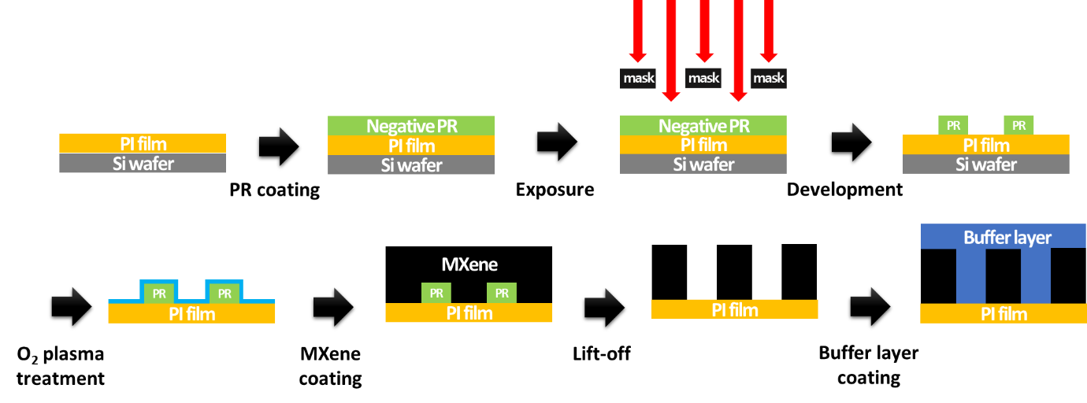
Fig. S1 Fabrication process of flexible MXene MSCs: 1) photoresist coating (negative PR: L300, width: 50 µm, spacing: 50 µm, length: 3.95 mm, # of finger: 60 ea, thickness: 3.5 µm), 2) exposure (exposure time: 4~15s), 3) development, 4) O₂ plasma treatment (100W, 20sccm, 1min), 4) MXene coating (10-15 mg ml⁻¹ of MXene solution, spin coating: 1000-1500rpm, 5min), 5) lift-off using by acetone (sonication), 6) buffer layer coating (10 wt% PVA in water, spin coating: 1000rpm, 1min)

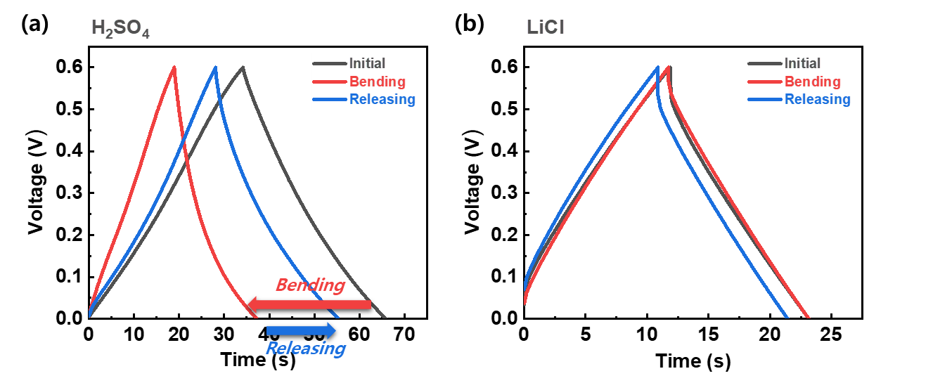
Fig. S2 Electrochemical sensing test of flexible MXene MSCs by GCD (galvanostatic charge-discharge) on a) PVA/H₂SO₄ and b) PVA/LiCl electrolyte

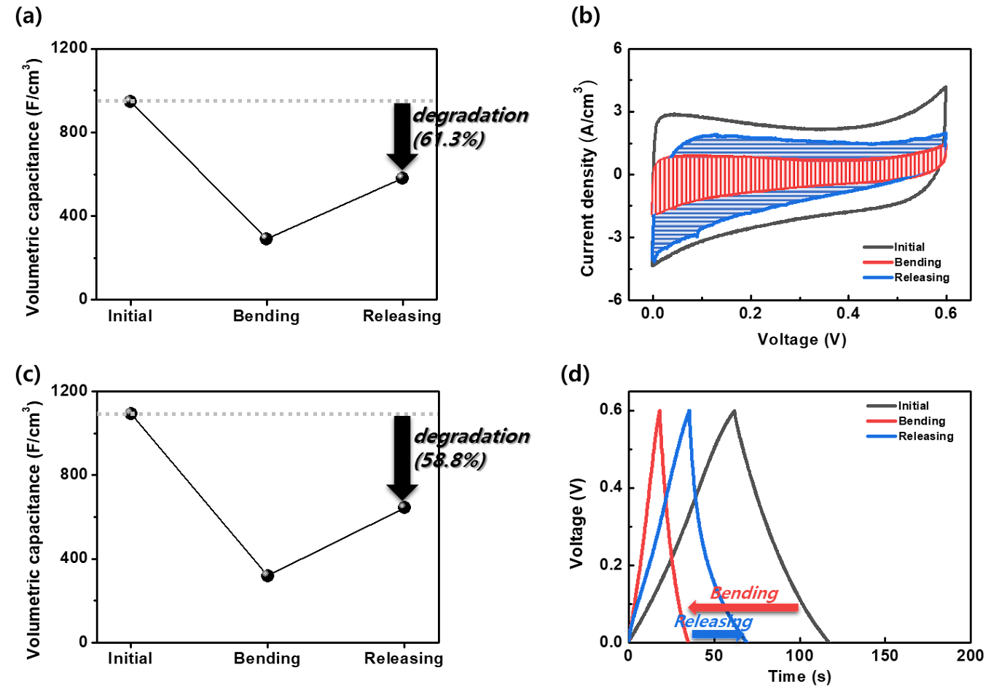
Fig. S3. Electrochemical sensing test without buffer layer. a) change in capacitance calculated by b) CV curves, and c) change in capacitance calculated by d) GCD plot

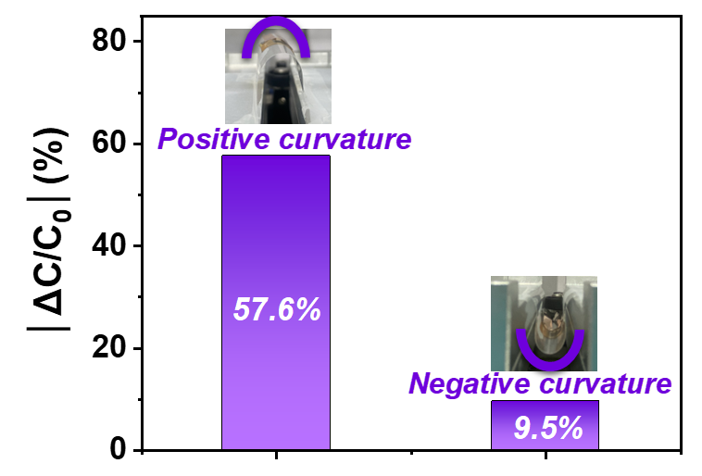
Fig. S4 Electrochemical sensing test depending on the curvature direction of positive (tensile strain) and negative (compressive strain)

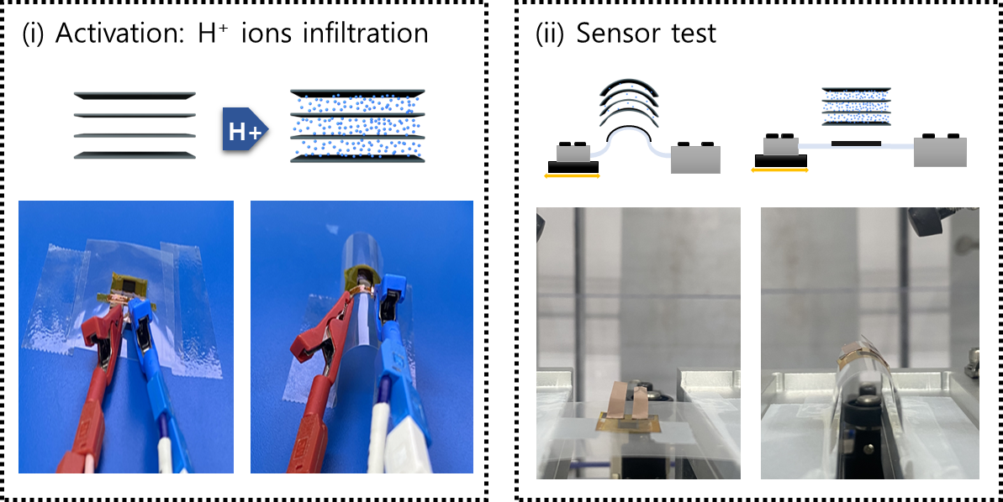
Fig. S5 Process of (i) Activation (H+ ions infiltration) and (ii) mechanical sensing test in practical

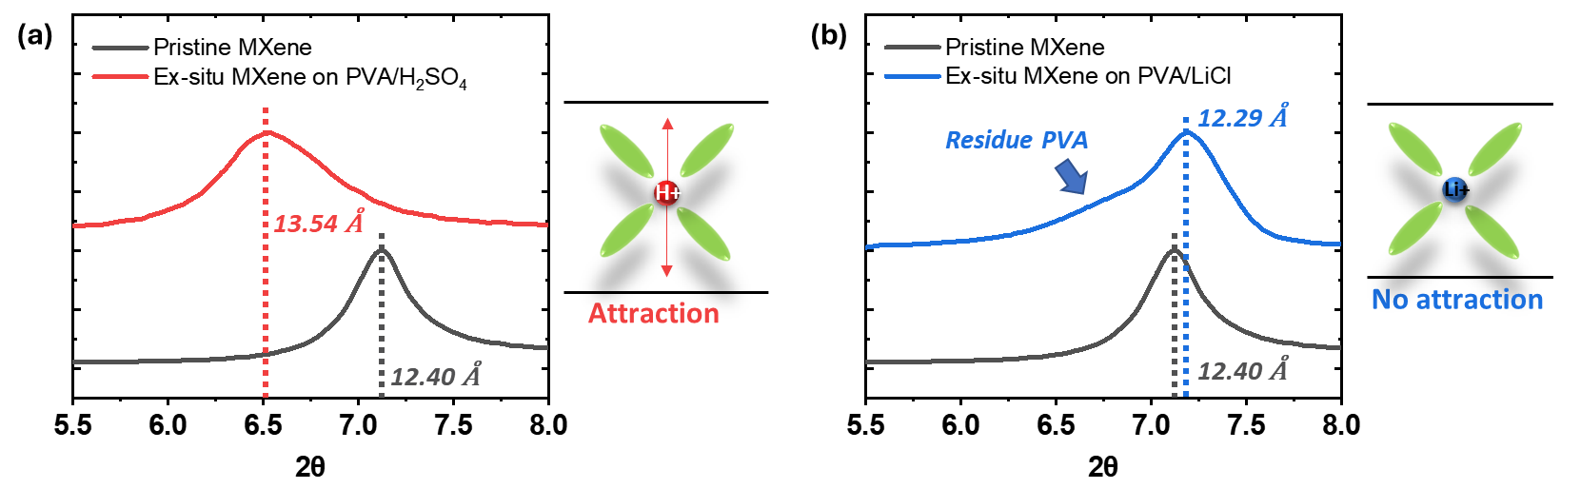
Fig. S6 Ex-situ XRD of MXene films on a) PVA/H₂SO₄ electrolyte (d-spacing : pristine (12.40 Å) and PVA/H₂SO₄ (13.54 Å)) and b) PVA/LiCl electrolyte (d-spacing : pristine (12.40 Å) and PVA/H₂SO₄ (12.29 Å)
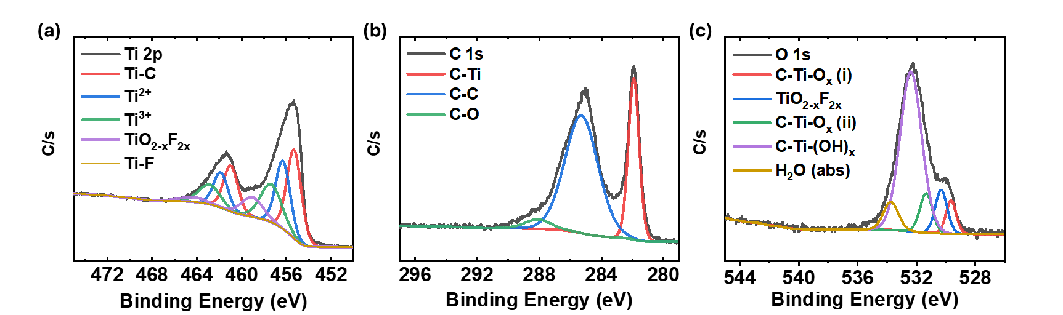

Fig. S7 Ex-situ XPS spectra of MXene supercapacitors on PVA/H₂SO₄ electrolyte after 100 cycles charge/discharge. a) Ti 2p, b) C 1s, and c) O 1s, respectively
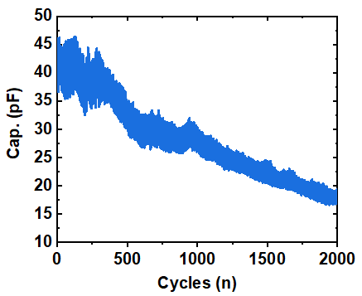
Fig. S8 Mechanical sensing test of MXene-EDLC
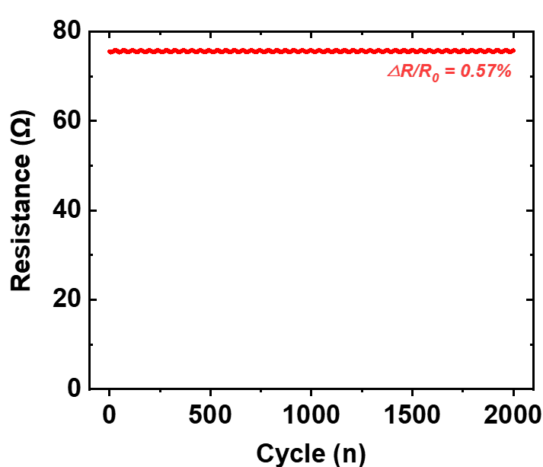
Fig. S9 The change of resistance of MXene during bending and releasing up to 2,000 cycles
Table S1 Comparison of capacitive-type strain sensors

 | Material | Sensor type | Linearity | Sensitivity | Strain (ε) (%) | Stability | Response time (ms) | Refs.
Pseudocapacitor-cap | MXene/PVA/H₂SO₄ | Capacitive  (interdigitated) | Near one-linear | GF 1,200 | ~1% | up to 2,000 | ~500 ms | Our work
Dielectric-cap | Au film/Parylene/Prestretched elastomer | Capacitive  (sandwich) | One-linear | GF 3.05 | 20%  upto 110% | 1,000 | NA | [S1]
 | AgNW/PDMS | Capacitive  (interdigitated) | One-linear | GF -2 | upto 30% | 1,000 | NA | [S2]
 | CNTs–Dragon-skin elastomer | Capacitive  (sandwich) | One-linear | GF 0.97 | 1%  upto 300% | 2,000 | ~100 ms | [S3]
 | CNTs–silicone elastomer | Capacitive  (sandwich+pattern) | One-linear | GF 0.99 | 100% | 3,000 | NA | [S4]
 | AgNWs–Ecoflex | Capacitive  (sandwich) | One-linear | GF 0.7 | upto 50% | 100 | ~40 ms | [S5]
 | AgNWs-PDMS | Capacitive  (sandwich) | One-linear | GF 1.01 | 40% | NA(4) | NA | [S6]
 | EGaIn/Acrylic elastomer/  Polysil/silicone elastomer | Capacitive  (interdigitated) | One-linear | GF 1.61 | 80% | 10,000 | NA | [S7]
 | Graphene/PDMS | Capacitive  (sandwich) | One-linear | GF 0.97 | 80% | 1,000 | 180 ms | [S8]
 | CNTs/PDMS | Capacitive  (interdigitated) | One-linear | GF 0.637 | 100% | 1,500 | 60 ms | [S9]
 | MXene/VHB/PVA hydrogel | Capacitive  (sandwich) | One-linear | GF 0.4 | 200% | 10,000 | 190 ms | [S10]
 | Ecoflex-CB | Capacitive  (sandwich) | non-linear | GF 0.83-0.98 | 50-500% | 10,100 | NA | [S11]
 | SWCNT-SB/Ecoflex | Capacitive  (sandwich) | non-linear | GF -0.64-1.13 | 0-100% | 10 | 80ms | [S12]
 | PA 6.6/elastane yarn | Capacitive  (interdigitated) | One-linear | GF -0.68 | 230% | 100 | 66ms | [S13]
 | SSPU/Galinstan | Capacitive  (sandwich) | One-linear | GF 1.003 | 200% | NA | 32ms | [S14]
 | Parylene C-SU-8 | Capacitive  (sandwich) | One-linear | GF -0.25 | 100% | 100 | 22ms | [S15]
 | Chitosan/Cu NWs | Capacitive  (sandwich) |  | GF 2.9 | 70% | 1,000 | NA | [S16]
EDL-cap | Ag NFs/Ionic Hydrogels | Capacitive  (sandwich) | Two-linear | GF 3  GF165 | 10%  1,000% | 300 | 320 ms | [S16]
 | PDA–PAA–Cr3+ hydrogel | Capacitive  (sandwich) | Non-linear | GF33.4 | 500% | NA (10) | NA | [S17]
 | Poly(NaSS-Co-DMC) | Capacitive  (sandwich) | Two-linear | GF 2.9 | 0-350% | 1,000 | 250ms | [S18]

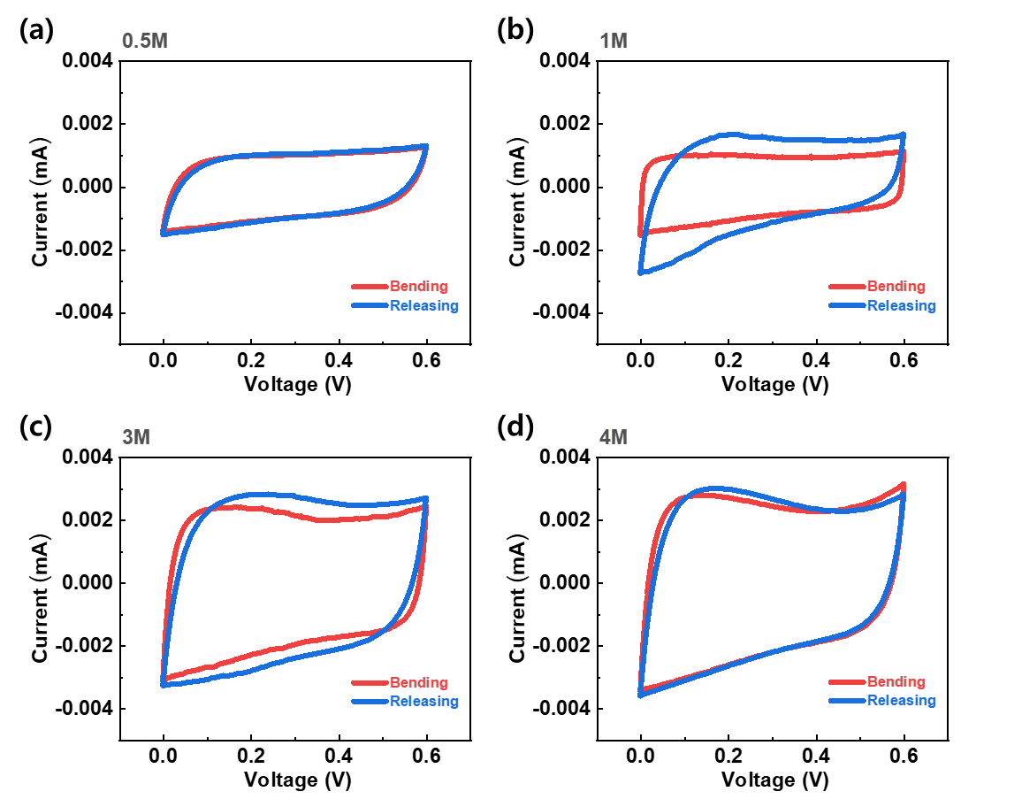
Fig. S10 a–d) CV curves depending on varying molar concentration of PVA/H₂SO₄ electrolyte (0.5M – 4M) on bending and releasing
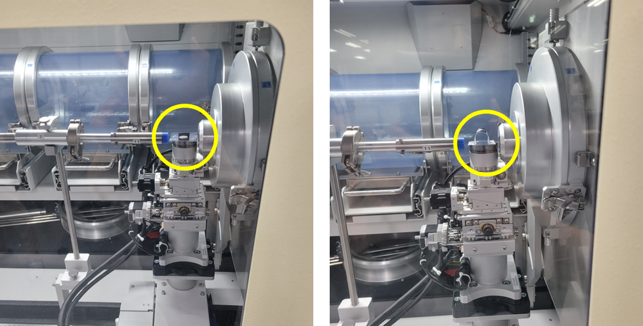
Fig. S11 GIWAXS analysis set up of MXene films in flat and bent

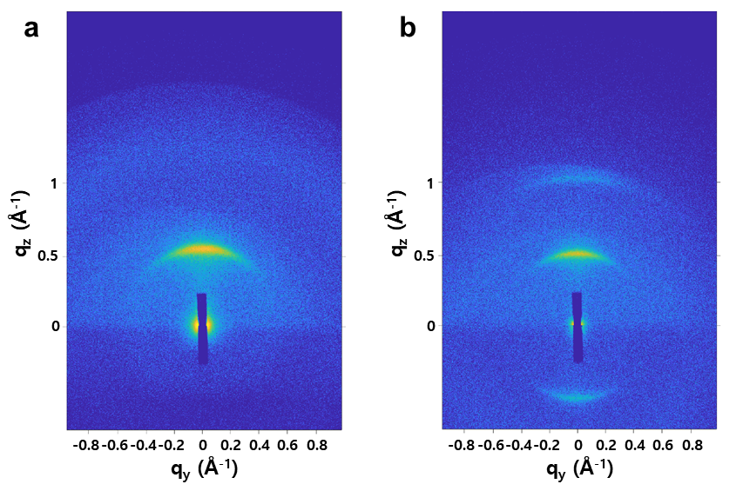
Fig. S12 2D GIWAXS pattern of MXene film in a) flat and b) bending geometry

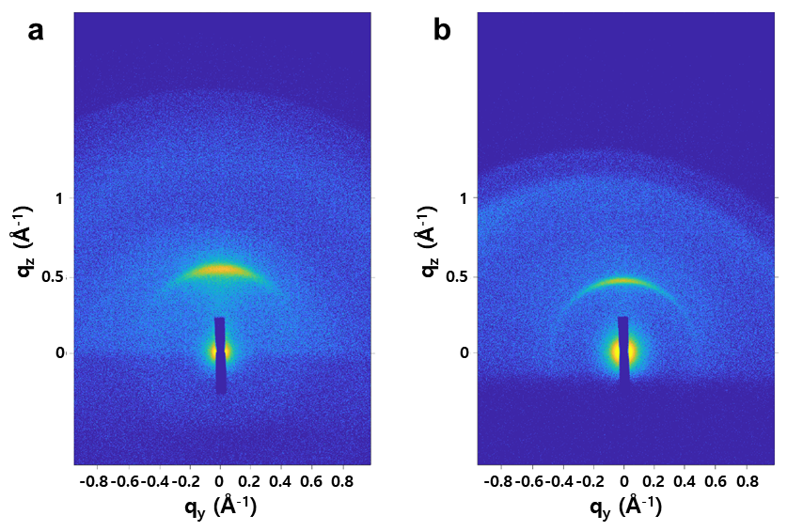
Fig. S13 2D GIWAXS pattern of a) MXene and b) MXene/PVA film under compression strain

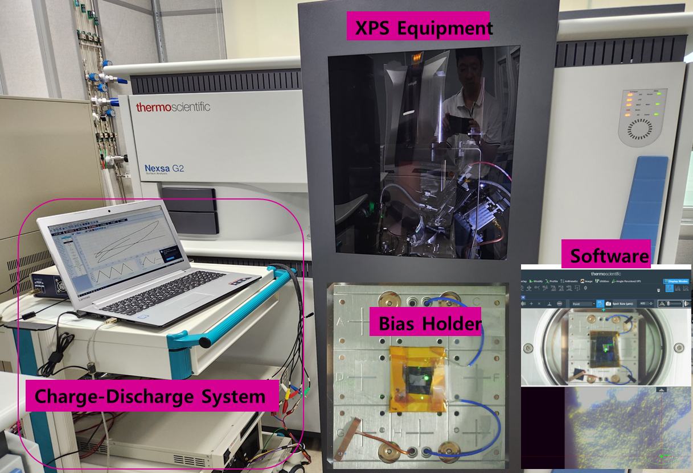
Fig. S14 Operando XPS experiment set-up environment (XPS equipment connected with charge-discharge system)

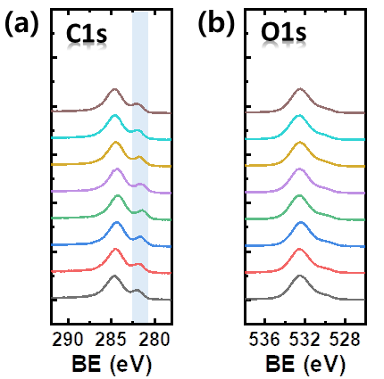
Fig. S15 Operando XPS spectra at a) C 1s and b) O 1s of MXene SCs

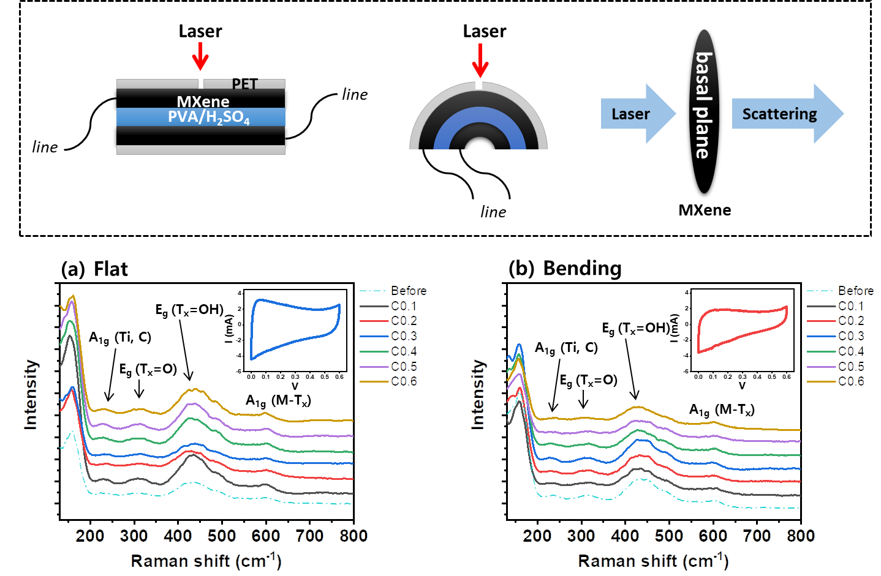
Fig. S16 Operando Raman spectra of a) MXene SC in flat state and b) in bent state
Supplementary References
- R. Nur, N. Matsuhisa, Z. Jiang, M. O. G. Nayeem, T. Yokota et al., A highly sensitive capacitive-type strain sensor using wrinkled ultrathin gold films. Nano Lett. 18(9), 5610-5617 (2018). https://doi.org/10.1021/acs.nanolett.8b02088
- S.-R. Kim, J.-H. Kim, J.-W. Park, Wearable and transparent capacitive strain sensor with high sensitivity based on patterned Ag nanowire networks. ACS Appl. Mater. Inter. 9(31), 26407-26416 (2017). https://doi.org/10.1021/acsami.7b06474
- L. Cai, L. Song, P. Luan, Q. Zhang, N. Zhang et al., Super-stretchable, transparent carbon nanotube-based capacitive strain sensors for human motion detection. Sci. Rep. 3(1), 3048 (2013). https://doi.org/10.1038/srep03048
- D. J. Cohen, D. Mitra, K. Peterson, M. M. Maharbiz, A highly elastic, capacitive strain gauge based on percolating nanotube networks. Nano Lett. 12(4), 1821-1825 (2012). https://doi.org/10.1021/nl204052z
- S. Yao, Y. Zhu, Wearable multifunctional sensors using printed stretchable conductors made of silver nanowires. Nanoscale 6(4), 2345-2352 (2014). https://doi.org/10.1039/C3NR05496A
- P. Goel, J. P. Singh, Fabrication of silver nanorods embedded in pdms film and its application for strain sensing. J. Phys. D: Appl. Phys. 48(44), 445303 (2014). https://doi.org/10.1088/0022-3727/48/44/445303
- J. Shintake, T. Nagai, K. Ogishima, Sensitivity improvement of highly stretchable capacitive strain sensors by hierarchical auxetic structures. Front. Robot. AI. 6((2019).
- C. Deng, L. Lan, P. He, C. Ding, B. Chen et al., High-performance capacitive strain sensors with highly stretchable vertical graphene electrodes. J. Mater. Chem. C 8(16), 5541-5546 (2020). https://doi.org/10.1039/D0TC00491J
- X. Wang, Y. Deng, P. Jiang, X. Chen, H. Yu, Low-hysteresis, pressure-insensitive, and transparent capacitive strain sensor for human activity monitoring. Microsyst. Nanoeng. 8(1), 113 (2022). https://doi.org/10.1038/s41378-022-00450-7
- J. Zhang, L. Wan, Y. Gao, X. Fang, T. Lu et al., Highly stretchable and self-healable mxene/polyvinyl alcohol hydrogel electrode for wearable capacitive electronic skin. Adv. Electron. Mater. 5(7), 1900285 (2019). https://doi.org/10.1002/aelm.201900285
- J. Shintake, Y. Piskarev, S. H. Jeong, D. Floreano, Ultrastretchable strain sensors using carbon black-filled elastomer composites and comparison of capacitive versus resistive sensors. Adv. Mater. Technol. 3(3), 1700284 (2018). https://doi.org/https://doi.org/10.1002/admt.201700284
- K. Okada, T. Horii, Y. Yamaguchi, K. Son, N. Hosoya et al., Ultraconformable capacitive strain sensor utilizing network structure of single-walled carbon nanotubes for wireless body sensing. ACS Appl. Mater. Inter. 16(8), 10427-10438 (2024). https://doi.org/10.1021/acsami.3c19320
- A. F. Yilmaz, I. A. K. Ahmed, C. Gumus, K. Ozlem, M. S. Cetin et al., Highly stretchable textile knitted interdigital sensor for wearable technology applications. Adv. Sens. Res. 3(2), 2300121 (2024). https://doi.org/10.1002/adsr.202300121
- F. Sun, L. Liu, T. Liu, X. Wang, Q. Qi et al., Vascular smooth muscle-inspired architecture enables soft yet tough self-healing materials for durable capacitive strain-sensor. Nat. Comm. 14(1), 130 (2023). https://doi.org/10.1038/s41467-023-35810-y
- X. Huang, L. Liu, Y. H. Lin, R. Feng, Y. Shen et al., High-stretchability and low-hysteresis strain sensors using origami-inspired 3D mesostructures. Sci. Adv. 9(34), eadh9799 https://doi.org/10.1126/sciadv.adh9799
- H. Xu, Y. Lv, D. Qiu, Y. Zhou, H. Zeng et al., An ultra-stretchable, highly sensitive and biocompatible capacitive strain sensor from an ionic nanocomposite for on-skin monitoring. Nanoscale 11(4), 1570-1578 (2019). https://doi.org/10.1039/C8NR08589G
- V. K. Rao, N. Shauloff, X. Sui, H. D. Wagner, R. Jelinek, Polydiacetylene hydrogel self-healing capacitive strain sensor. J. Mater. Chem. C 8(18), 6034-6041 (2020). https://doi.org/10.1039/D0TC00576B
- H. Zheng, H. Zhou, Z. Wang, S. Zhang, H. Zhang, Ionically conductive and self-healing polyampholyte hydrogels for wearable resistive strain sensors and capacitive pressure sensors. ACS Appl. Polymer Mater. 5(9), 7581-7589 (2023). https://doi.org/10.1021/acsapm.3c01497

