Supporting Information for
Hierarchical Polyimide Nonwoven Fabric with Ultralow-Reflectivity Electromagnetic Interference Shielding and High-Temperature Resistant Infrared Stealth Performance
Xinwei Tang¹, Yezi Lu¹, Shuangshuang Li¹, Mingyang Zhu¹, Zixuan Wang¹, Yan Li², Zaiyin Hu³, Penglun Zheng⁴, Zicheng Wang^{1,}* and Tianxi Liu^{1,}*
¹ The Key Laboratory of Synthetic and Biological Colloids, Ministry of Education, School of Chemical and Material Engineering, International Joint Research Laboratory for Nano Energy Composites, Jiangnan University, Wuxi, Jiangsu 214122, P. R. China
² Jiangsu Ferrotec Semiconductor Technology Co., Ltd. Yancheng, Jiangsu 214000, P. R. China
³ Guizhou Aerospace Wujiang Electro-mechanical Equipment Co., Ltd. 563000, No. 20-5, Dalian Road Aerospace Industrial Park, Huichuan District, Zunyi City, Guizhou Province, P. R. China
⁴ Civil Aircraft Fire Science and Safety Engineering Key Laboratory of Sichuan Province, College of Civil Aviation Safety Engineering, Civil Aviation Flight University of China, Guanghan 618307, P. R. China.
*Corresponding authors. E-mail: wangzc@jiangnan.edu.cn (Zicheng Wang); txliu@jiangnan.edu.cn (Tianxi Liu)
Supplementary Figures
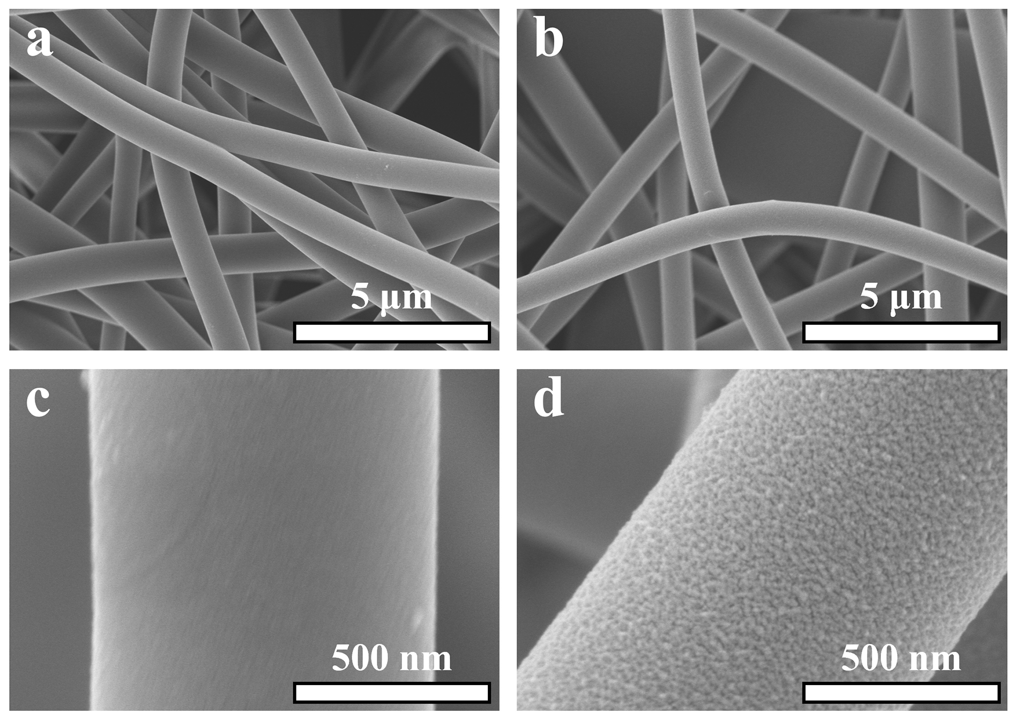
Fig. S1 SEM images of (a, c) PI, and (b, d) PI-NaOH fiber

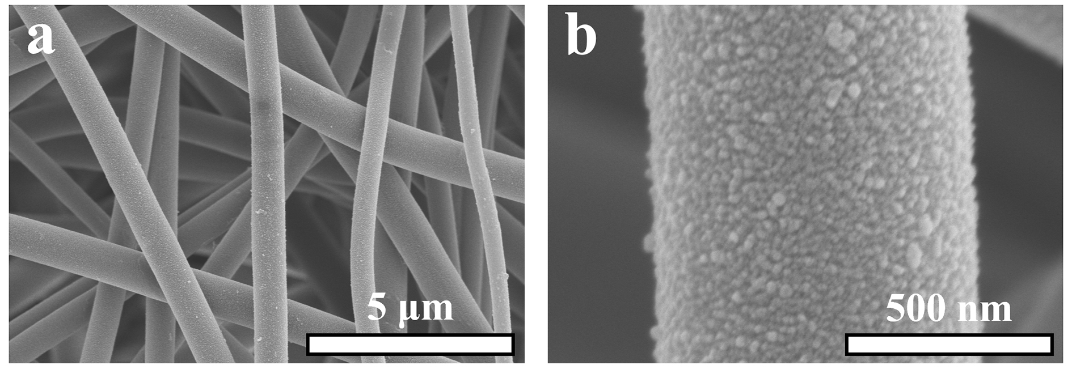
Fig. S2 (a, b) SEM images of PI fiber after activation
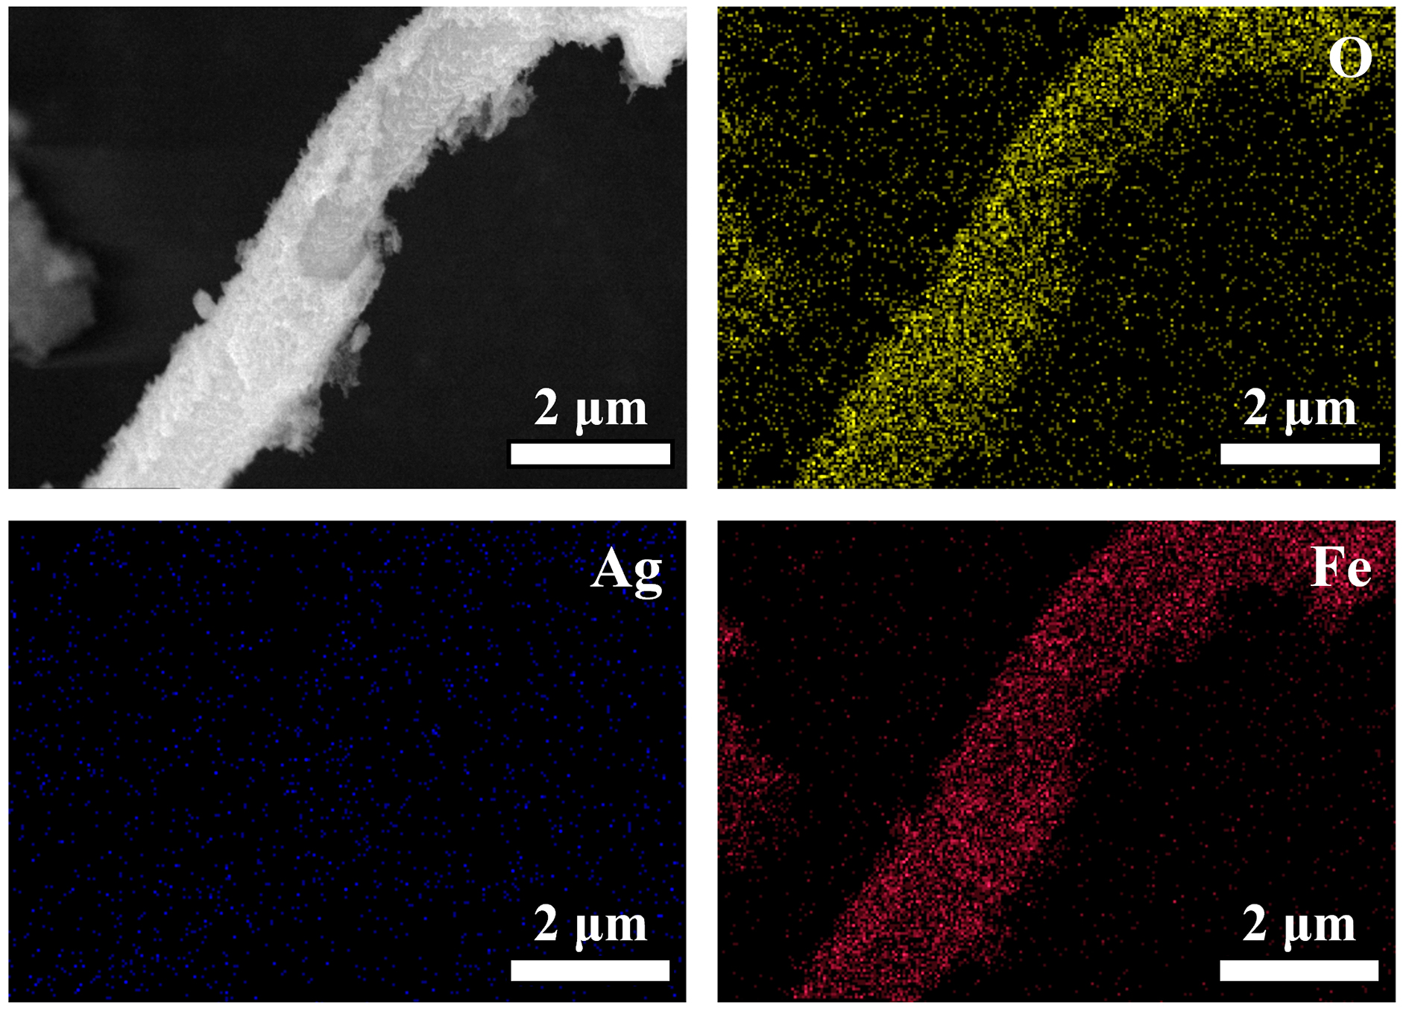
Fig. S3 EDS mapping images of PFA₀ fiber

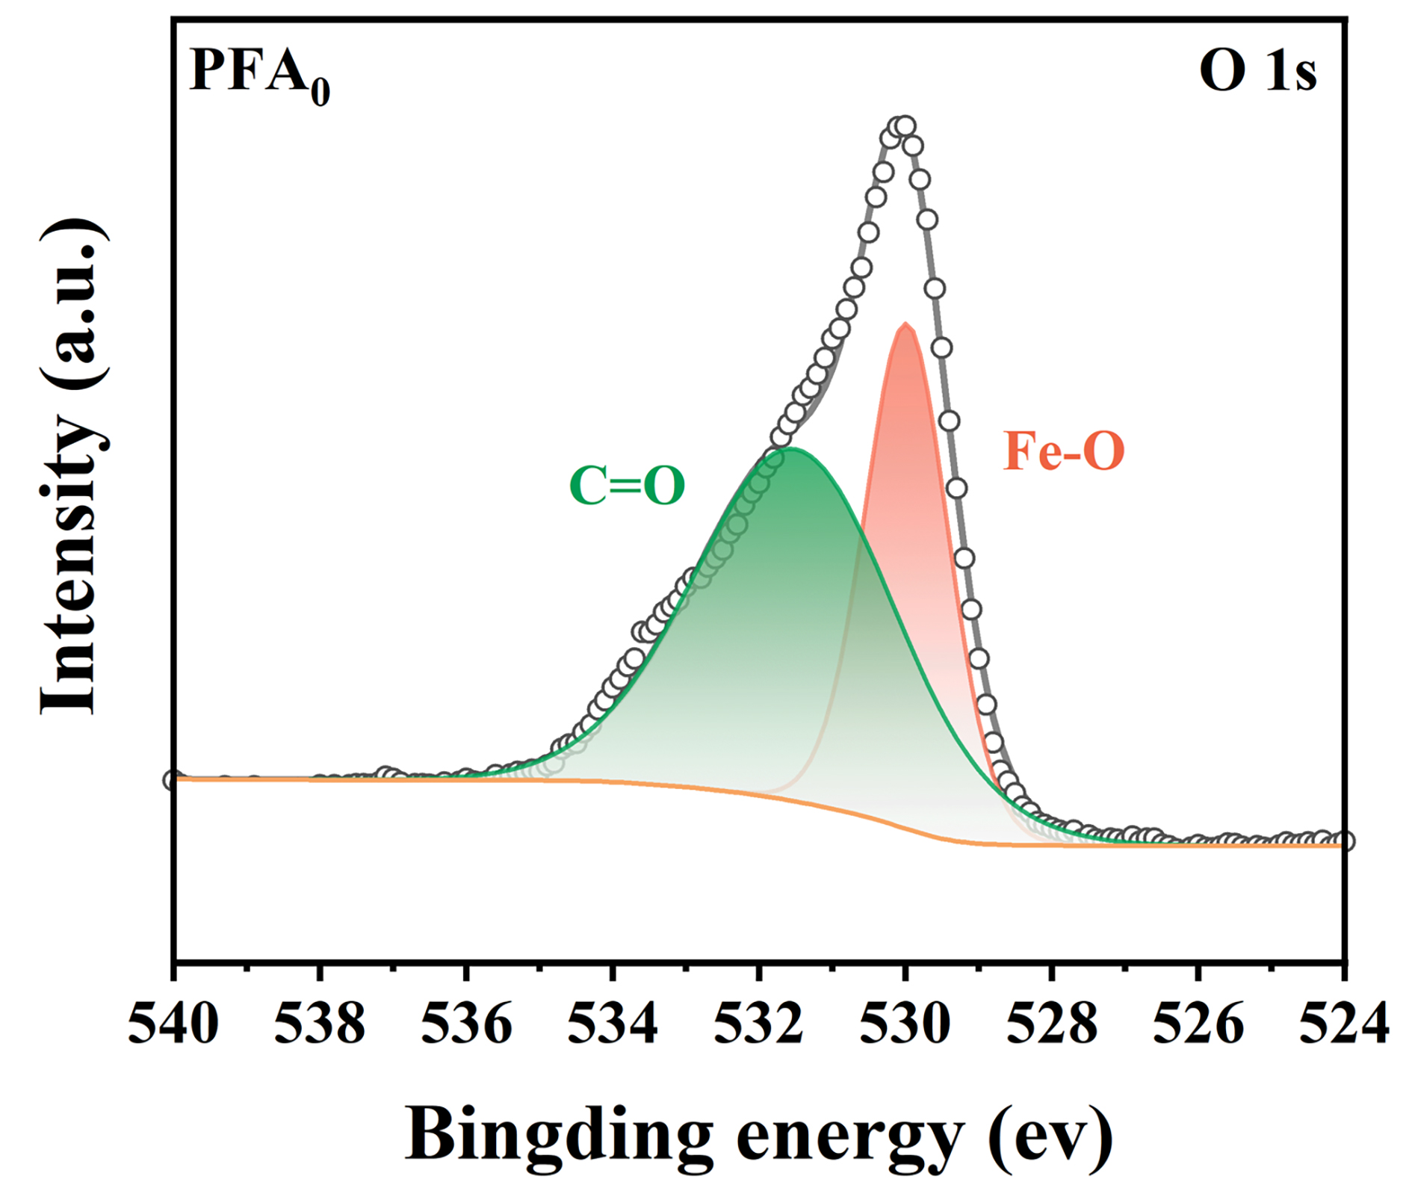
Fig. S4 High resolution XPS spectra of O 1s for PFA₀ nonwoven fabric

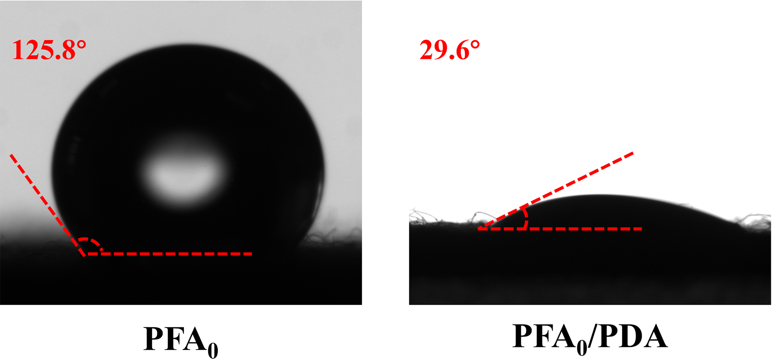
Fig. S5 Water contact angles of PFA₀ and PFA₀/PDA nonwoven fabrics

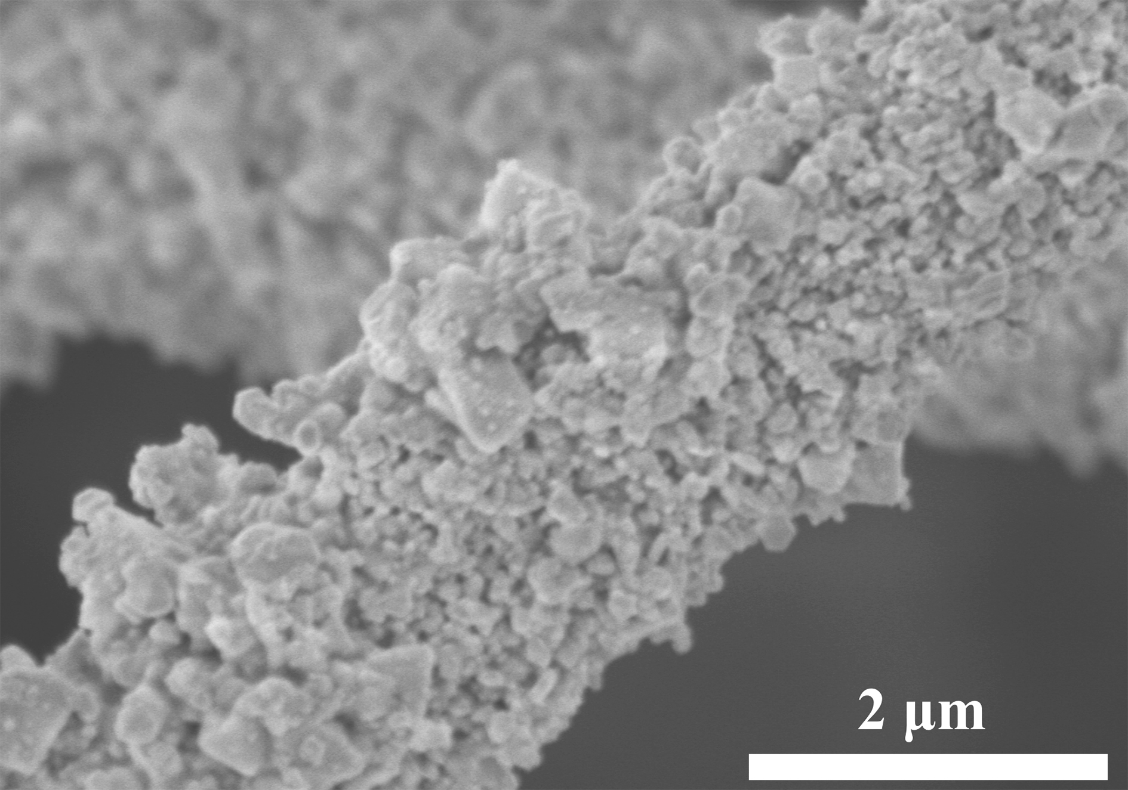
Fig. S6 SEM images of PFA₁ nonwoven fabric

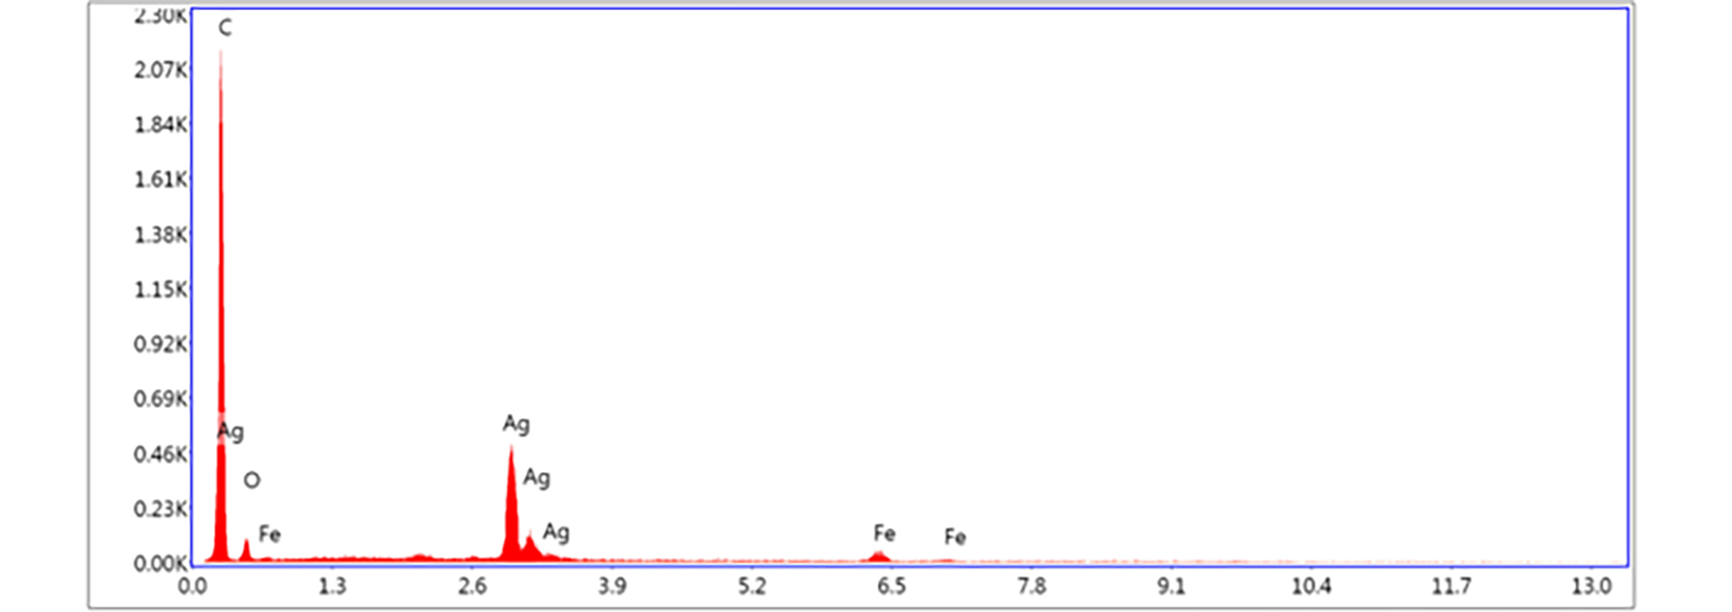
Fig. S7 EDS spectra of PFA₁ nonwoven fabric

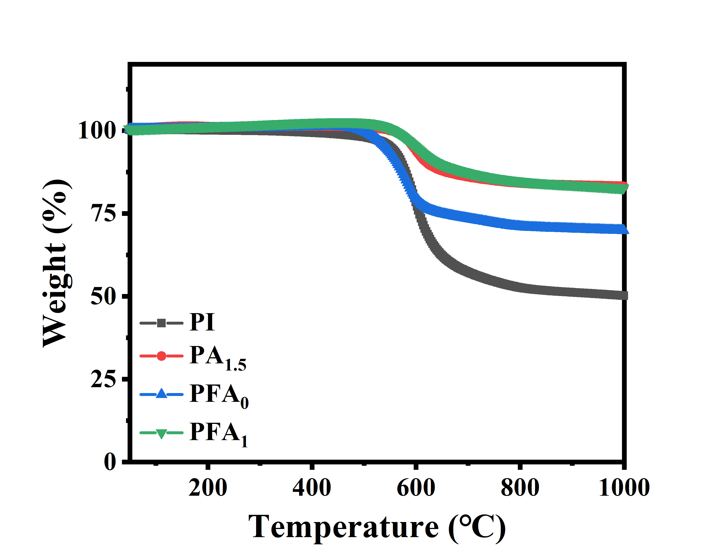
Fig. S8 TGA curves of PI, PA_{1.5}, PFA₀ and PFA₁ nonwoven fabrics

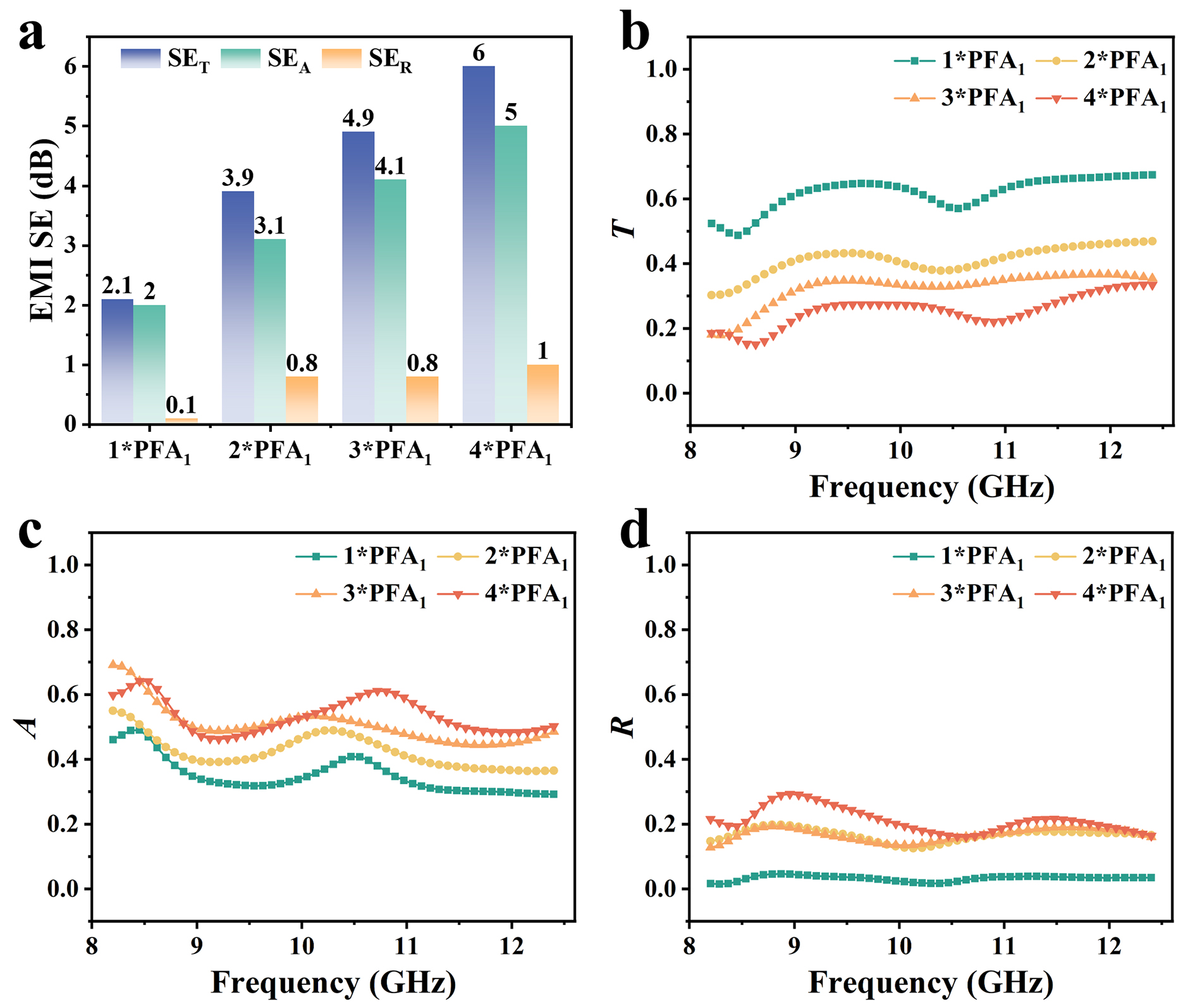
Fig. S9 (a) EMI SE, (b) T, (c) A and (d) R of N*PFA₁
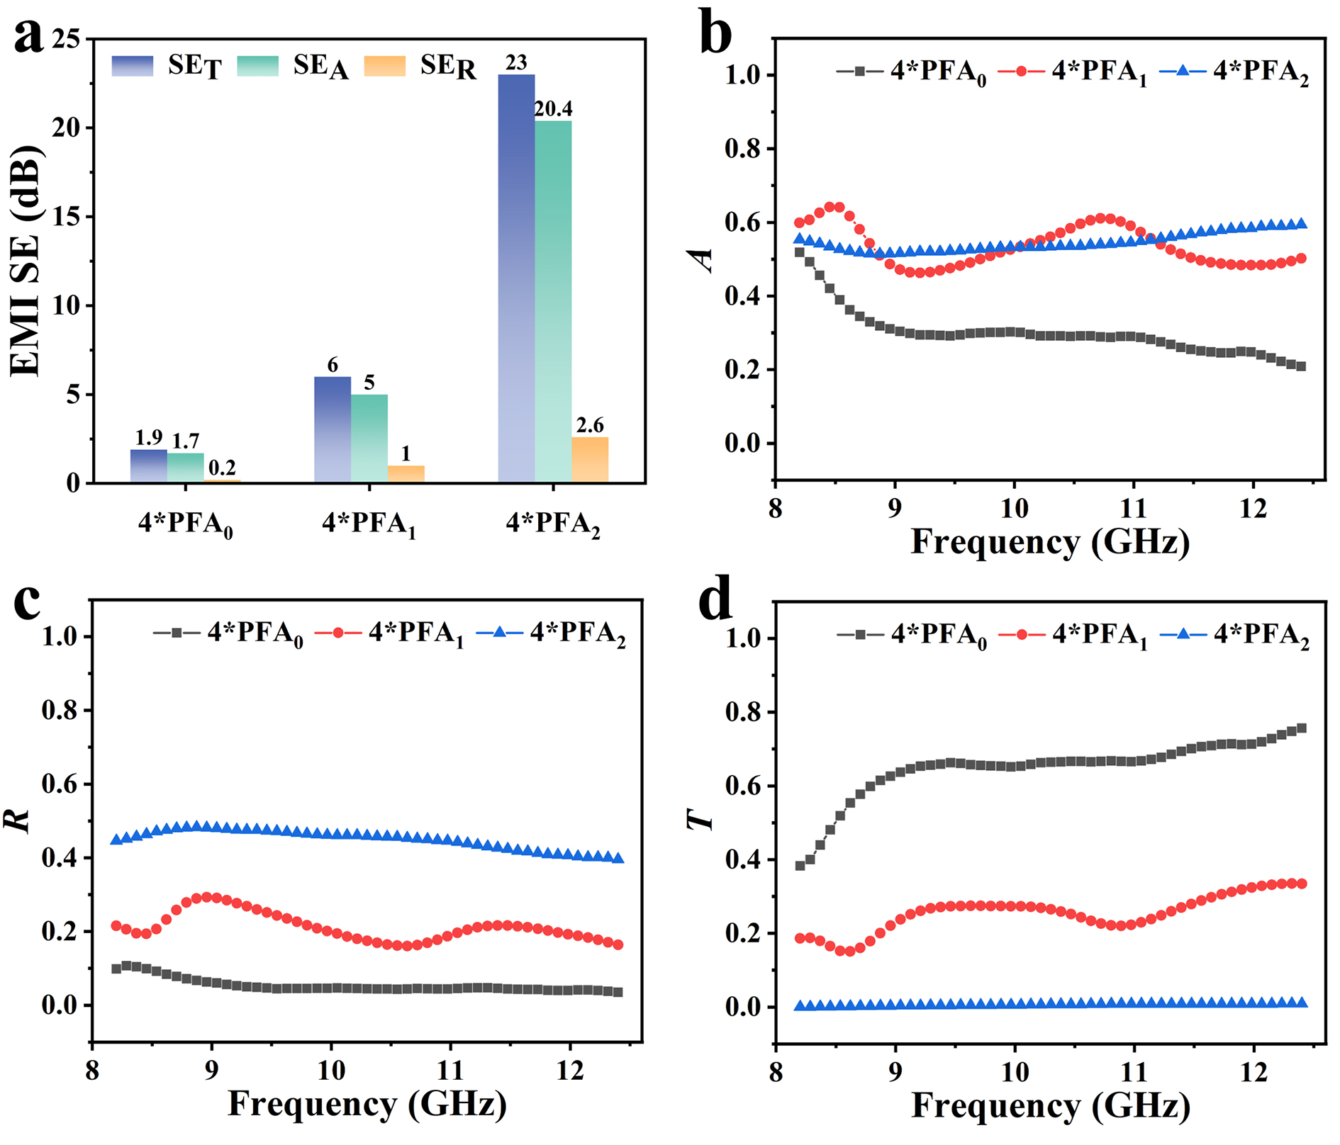
Fig. S10 (a) EMI SE, (b) A, (c) R and (d) T of 4*PFA_{x}

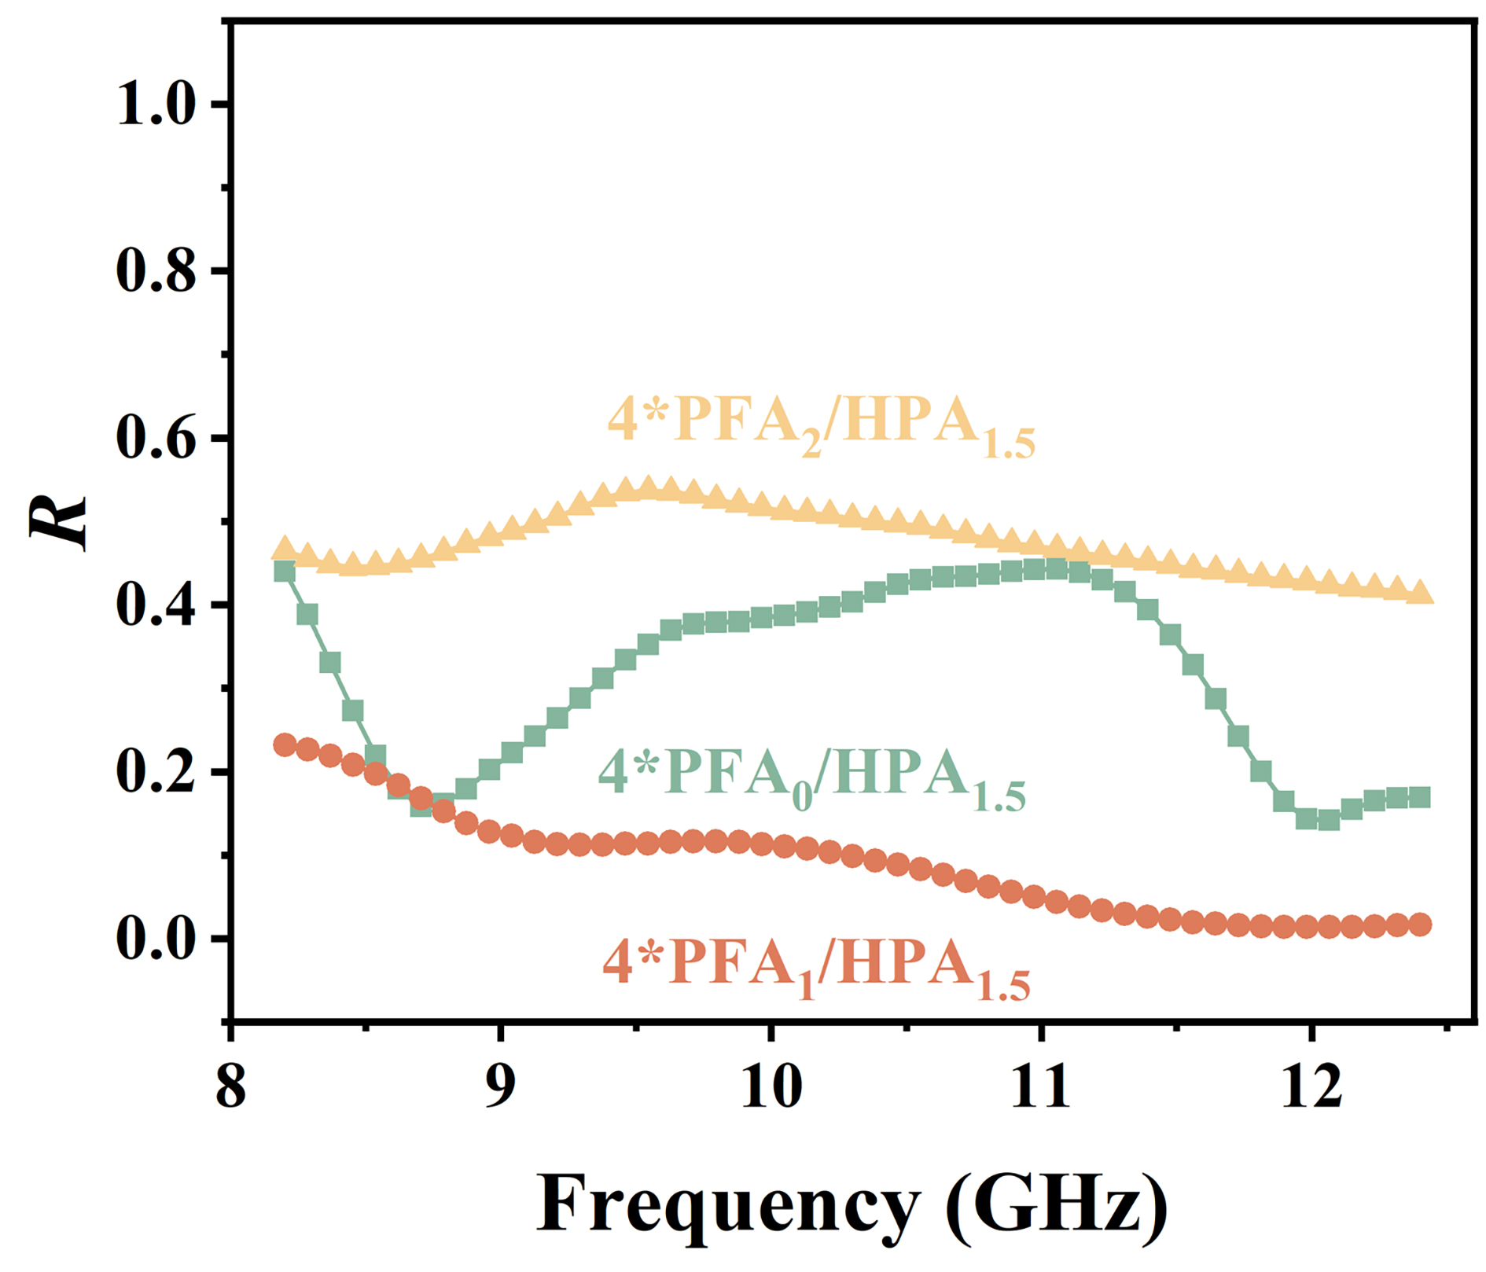
Fig. S11 R of 4*PFA_{x}/PA_{1.5}

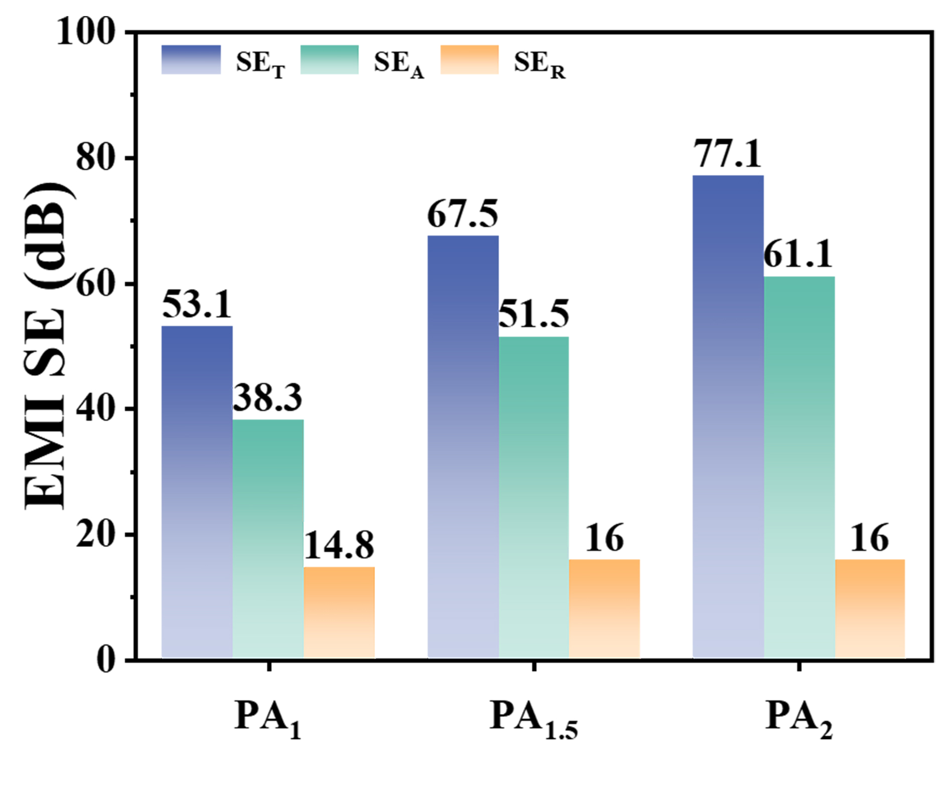
Fig. S12 EMI SE of PA_{y}

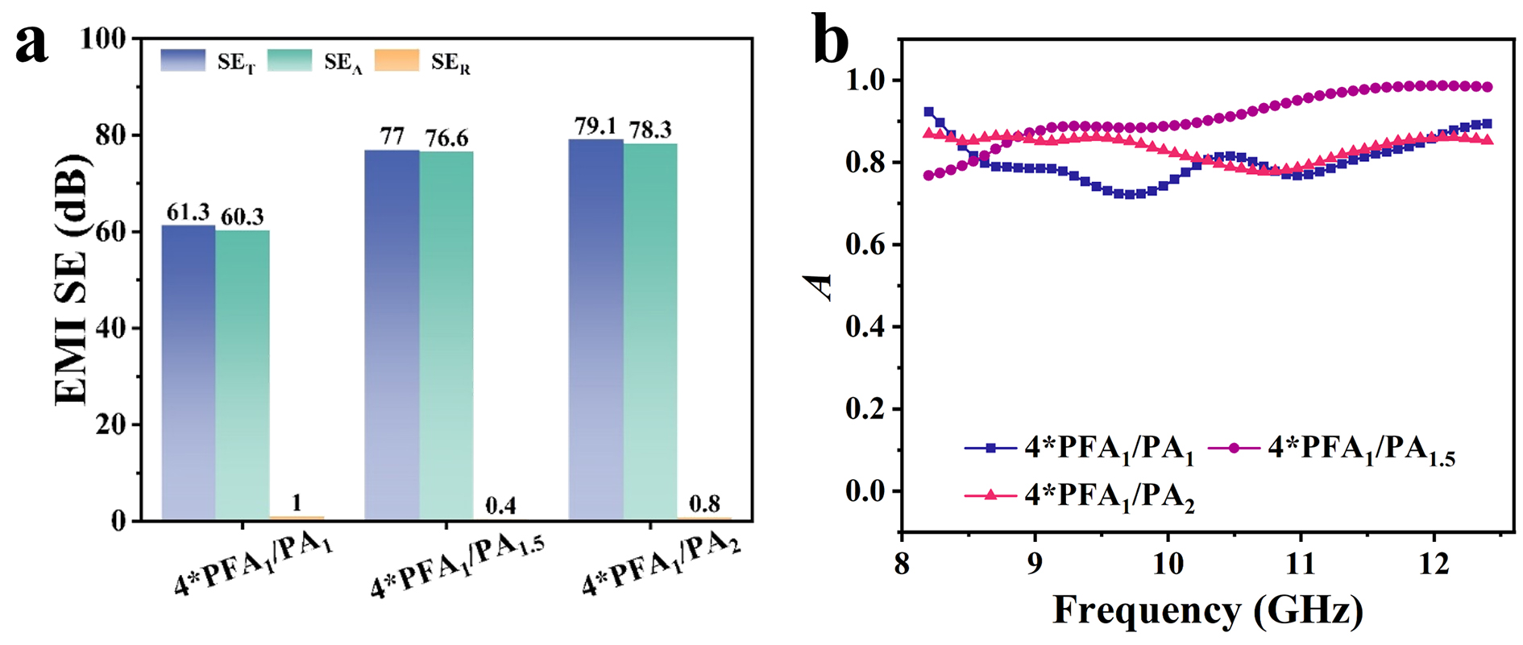
Fig. S13 (a) EMI SE and (b) A of 4*PFA₁/PA_{y}

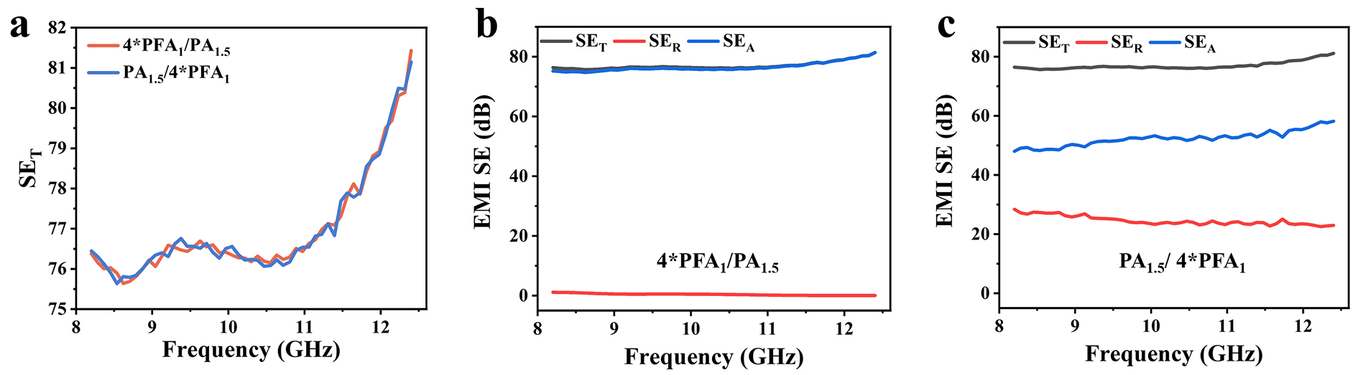
Fig. S14 (a) SE_{T} curves of 4*PFA₁/PA_{1.5} and PA_{1.5}/4*PFA₁ nonwoven fabrics; EMI SE curves of (b) 4*PFA₁/PA_{1.5} and (c) PA_{1.5}/4*PFA₁ nonwoven fabrics

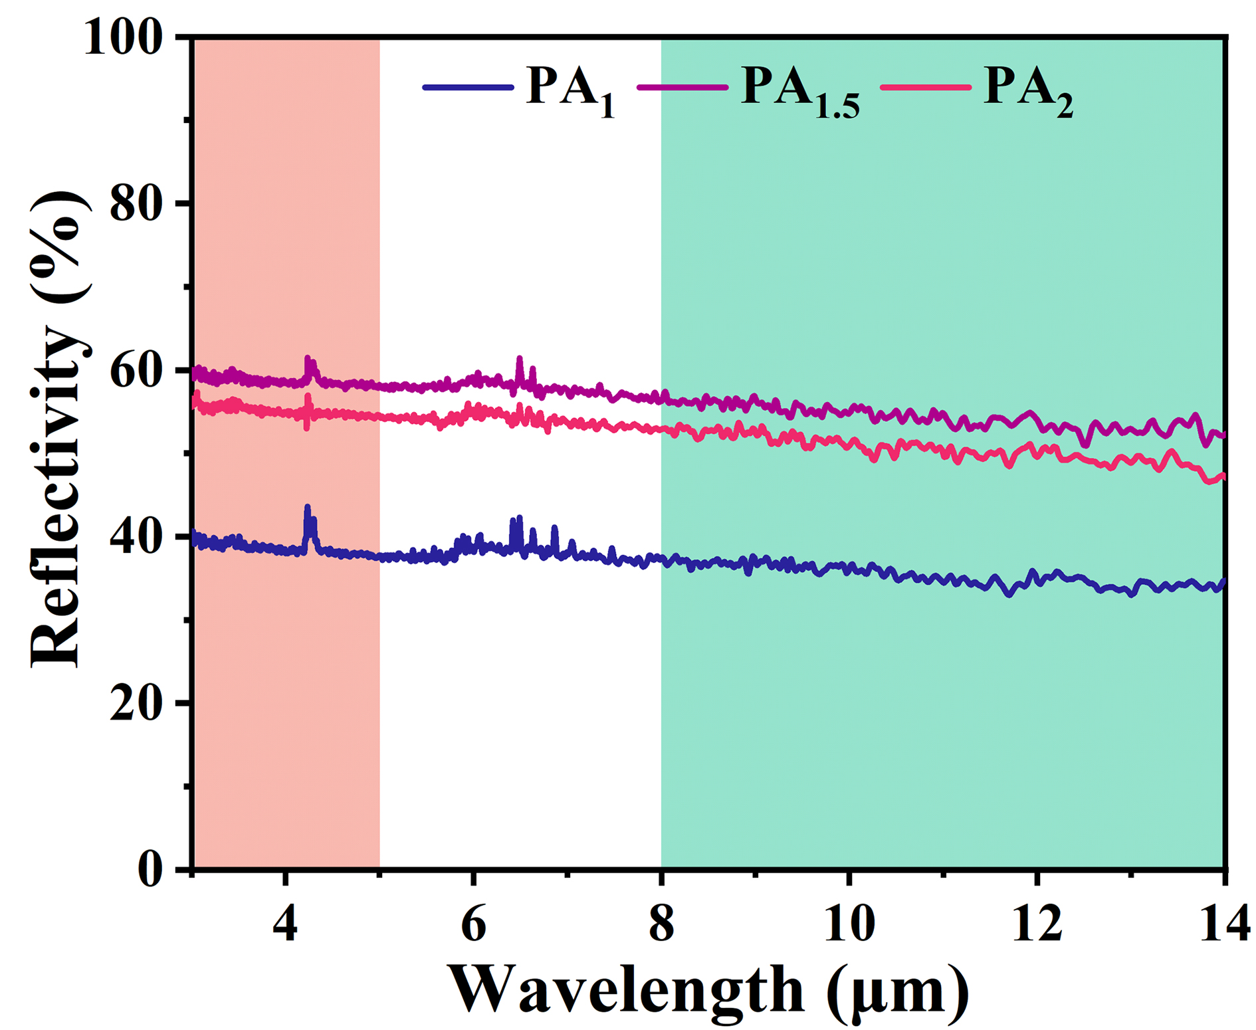
Fig. S15 IR-reflectivity curves of PA_{y}
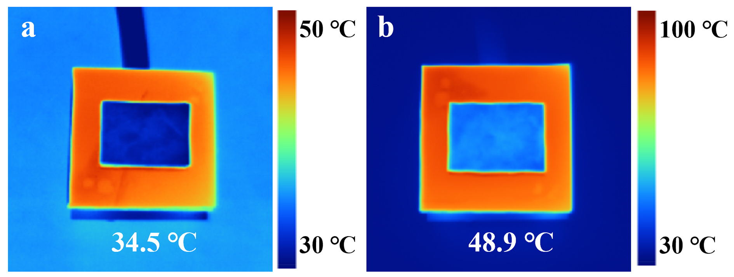
Fig. S16 IR photograph of 4*PFA₁/PA_{1.5} at (a) 50 °C and (b) 100 °C
Table S1 Comparison for EMI shielding performances of polymer-based materials in X-band
Samples | Density  (g cm⁻³) | Thickness (mm) | SE_{T}  (dB) | SE_{R}  (dB) | A | R | Refs.
Ni/TPU/CIP | / | 0.5 | 48 | 2.3 | 0.6 | 0.4 | [3]
NR/EPMS/CNT | 0.5 | 2 | 44.2 | 2.5 | 0.57 | 0.43 | [51]
CS-MWCNTs | 0.01 | 4.9 | 64 | 5.4 | 0.28 | 0.72 | [52]
PEBA/CNS | / | 15 | 33 | 0.32 | 0.929 | 0.071 | [53]
A4U6C4 | 1.53 | 3.64 | 78.6 | 0.27 | 0.94 | 0.06 | [54]
CrO₂@G-LM | 0.5 | 3.64 | 63.8 | 0.27 | 0.88 | 0.12 | [55]
MXene/PEDOT:PSS | 0.01 | 5 | 52 | 3 | 0.65 | 0.35 | [56]
SiO₂/CNTs/PI-AgNWs/CNF | 0.06 | 10 | 110 | 0.023 | 0.995 | 0.005 | [57]
CoFe₂O₄@MXene/CNTAgNWs/CNF | 1.64 | 0.1 | 87.8 | 5.6 | 0.28 | 0.72 | [58]
PCPES/Cu | 0.29 | 0.3 | 59.7 | 9.7 | 0.27 | 0.73 | [30]
4*PFA₁/PA_{1.5} | 0.17 | 2.46 | 77 | 0.4 | 0.91 | 0.09 | This work

