Supporting Information for
2D Undulated Metal Hydrogen-Bonded Organic Frameworks with Self-Adaption Interlayered Sites for Highly Efficient C–C Coupling in the Electrocatalytic CO₂ Reduction
Jianning Lv¹, Wenrui Li¹, Shuai Li^{1, 4}, Shuo Xu¹, Zunhang Lv¹, Zhejiaji Zhu¹, Lu Dai¹, Bo Wang^{1, 2} and Pengfei Li^{1, 3,} *
¹ Key Laboratory of Cluster Science Ministry of Education, Beijing Key Laboratory of Photoelectronic/Electrophotonic, School of Chemistry and Chemical Engineering, Beijing Institute of Technology, No. 5, South Street, Zhongguancun, Haidian District, Beijing 100081, P. R. China
² Advanced Technology Research Institute (Ji’nan), Beijing Institute of Technology, Ji’nan, Shandong 250300, P. R. China
³ Advanced Research Institute of Multidisciplinary Science, Beijing Institute of Technology (Zhuhai), No.6, Jinfeng Road, Tangjiawan, Zhuhai 519088, P. R. China
⁴ Petrochina Petrochemical Research Institute, No.7, Kunlun Street, Changping District, Beijing 102206, P. R. China
*Corresponding author. E-mail: lipengfei@bit.edu.cn (Pengfei Li)
S1 Experimental Details
S1.1 Materials synthesis
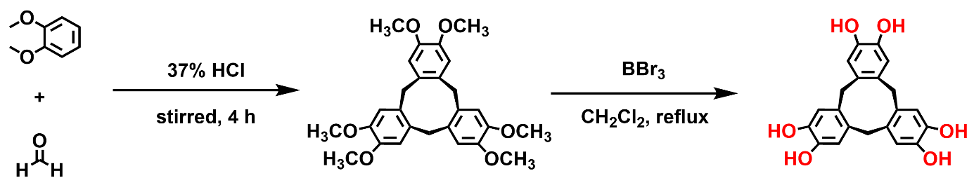
Scheme S1 The synthetic route toward hexahydroxyl cyclotricatechylene
S1.1.1 The synthesis of hexamethoxy cyclotriveratrylene (HMCC)
According to the previous literature [S1], aqueous HCl (37%, 54 mL) was placed in a 250 mL three-neck flask and cooled to 0 ºC by using an ice water bath. The aqueous formaldehyde (38%, 40 mL) was added carefully into the above solvent under stirring. Then, veratrole (9.2 mL) was added portion-wise to a stirred mixture, and the resultant mixture was stirred for 30 min at 0 ºC. Next, the reaction temperature was adjusted from 0 ºC to room temperature and stirred for 4 h. The white product was filtered, and washed with deionized water several times until the filtrate was neutral. The resulting powder was purified by recrystallization in toluene, then dried at 100 ºC under a vacuum for 12 h to obtain white crystals of HMCC in 92% yield. ¹H NMR (400 MHz, CDCl₃) δ (ppm): 3.84 (18H, s), 3.58 (3H, d, J = 13.8 Hz), 4.80 (3H, d, J = 13.73 Hz), 6.83 (6H, s). ¹³C NMR (100 MHz, CDCl₃) δ (ppm): 147.75, 131.79, 113.15, 56.05, 36.54.
S1.1.2 The synthesis of hexahydroxyl cyclotricatechylene (HHCC)
According to the previous literature [S2], in a three-neck 100 mL round bottom flask, a solution of HMCC (2.52 g, 5 mmol) in dry DCM was cooled to 0 °C under an Ar atmosphere. To this stirred solution, BBr₃ (3.3 mL, 35 mmol) was added. The solution was removed from the cooling bath and the purple-colored reaction mixture was brought to room temperature and stirred for a further 15 min. Then it was refluxed for 12 h. After this time, the reaction mixture was slowly cooled to 0 °C by an ice water bath. It was then quenched by the slow addition of ice-cold water (50 mL). The resulting slurry was filtered and the residue was washed with water (200 mL) and acetonitrile (10 mL). The crude wet solid was recrystallized from ethanol to obtain brown crystals of HHCC in 87% yield. ¹H NMR (400 MHz, DMSO-d₆) δ (ppm): 8.52 (6H, s), 6.65 (6H, s), 4.49 (3H, d, J = 13.4 Hz), 3.21 (3H, d, J = 13.6 Hz). ¹³C NMR (100 MHz, DMSO-d₆) δ (ppm): 143.91, 131.23, 117.15, 35.49.
S1.1.3 The general synthetical procedure for 2D-Cu-HOF and 2D-Ni-HOF
Metal salt (0.0324 mmol) and HHCC (0.0217 mmol) were dissolved in a mixed solvent in a 4 mL glass vial. The vial was sonicated for 30 minutes. Then a base was added to the above solution. The vial was capped and heated in an isothermal oven. When the vial was cooled to room temperature, the mixture was centrifugated, and the deposit was washed with H₂O (10 mL × 5) and acetone (10 mL × 3), successively. Finally, the obtained solid was dried at 60 ºC under a vacuum for 12 h.
S1.1.4 The optimization of bases
All the synthetical conditions are the same as the general synthetical procedure, except that 1.5 mL of H₂O/MeOH (v/v = 2:1) was added as the mixed solvent and 500 µL TEA, 500 µL NH₃·H₂O (25 wt%), 200 µL TBAH (1 M), 200 µL EDA, or 200 µL of 6 M NaOH was added as the base, respectively.
S1.1.5 The optimization of solvent combinations
All the synthetical conditions are the same as the general synthetical procedure, except that 1.5 mL of H₂O/MeOH, H₂O/1,4-dioxane, H₂O/DMSO, H₂O/DMAc, or H₂O/DMF (v/v = 2:1) was added as the mixed solvent and 50 µL of NH₃·H₂O (25 wt%) was added as the base.
S1.1.6 The optimization of the amount of base
All the synthetical conditions are the same as the general synthetical procedure, except that 1.5 mL of H₂O/MeOH (v/v = 2:1) was added as the mixed solvent and 50, 200, or 500 µL of NH₃·H₂O (25 wt%) was added as the base, respectively.
S1.1.7 The optimization of solvent ratios
All the synthetical conditions are the same as the general synthetical procedure, except that 1.5 mL of H₂O/MeOH (v/v = 1.5:0.5, 1.6:0.4, 1.7:0.3, 1.8:0.2, or 1.9:0.1) was added as the mixed solvent and 50 µL of NH₃·H₂O (25 wt%) was added as the base.
S1.1.8 The optimization of temperature and reaction time
All the synthetical conditions are the same as the general synthetical procedure, except that 60, 80, or 100 ºC as the reaction temperature and 3, 5, 7, or 10 days as the reaction time.
S1.2 Characterization
¹H NMR and ¹³C NMR spectra were measured on a Bruker ARX-400 NMR spectrometer with tetramethylsilane (TMS) as the internal standard. Powder X-ray diffraction (PXRD) was recorded on a Rigaku MiniFlex 600 diffractometer using a Cu Kα X-ray source with 40 kV voltage and 15 mA current. Fourier transform infrared (FT-IR) spectra were performed on Bruker ALPHA spectrometer in the range of 400-4000 cm⁻¹. The content of Cu was measured by inductively coupled plasma-optical emission spectroscopy (ICP-OES). The elemental analysis (EA) was performed on an Elementar UNICUBE. Thermogravimetric analysis (TGA) was conducted on a NETZSCH Proteus STA 449F5 analyzer at a heating rate of 10 ºC/min in the temperature range of 35-800 ºC under an N₂ atmosphere. Scanning electron microscopy (SEM) images were obtained from a JEOL model JSM-7500F scanning electron microscope. Transmission electron microscopy (TEM) images were collected on JEOL model JM-2100 microscope. X-ray photoelectron spectroscopy (XPS) was performed by using Thermo scientific ESCALAB 250Xi with Al Kα radiation. Electron paramagnetic resonance spectroscopy (EPR) was conducted on a Bruker EMX plus with a sweep width of 1500 G and a center field of 3500 G. The X-ray absorption spectra (XAS) were collected at the Singapore Synchrotron Light Source (SSLS) center, where a pair of channel-cut Si (111) crystals was used in the monochromator. The electronic beam energy of 700 MeV with an average electron current of below 200 mA. The continuous rotation electron diffraction was collected using the JEM-2100 Plus transmission electron microscope produced by NEC Corporation. The microscope operated at an acceleration voltage of 200 kV, with a wavelength of 0.0025079 nm, and was outfitted with a MerelinEM high-speed direct electron camera. The experiments were conducted utilizing a Fischione 2550 refrigerated transmission rod at an ambient temperature of 77 K.
S1.2.1 The measurement of N₂ and CO₂ adsorption isotherms
The gas adsorption measurements were performed on a Quantachrome Instrument Autosorb-iQ with N₂ at 77 K and CO₂ at 273 K and 298 K, respectively. The sample was immersed in anhydrous acetone (10 mL) for 2 days, during which the solvent was decanted and replaced with fresh solvent 3 times per day. Then the product was separated by centrifugation and dried at 60 ºC under vacuum for 12 h. Before gas adsorption measurement, the product was evacuated at 120 °C for 12 h under a vacuum. The Brunauer–Emmett–Teller (BET) surface area was evaluated in the relative pressure range from 0.05 to 0.40. The pore size distribution was determined by non-local density functional theory.
S1.2.2 The measurement of electrical conductivity
40 mg of sample was placed into a standard die with a diameter of 10 mm and was pressed at pressures of 1, 2, and 3 MPa for 30 s to form the pellet, respectively. Electrical conductivity measurements were performed at 298 K and a relative humidity of 45%. The electrical conductivity was obtained by an ST2742B resistivity meter with a four-point probe.
S1.2.3 XAFS data processing
The acquired EXAFS data were processed according to the standard procedures using the Athena and Artemis software packages.[S3] The EXAFS spectra were obtained by subtracting the post-edge background from the overall absorption and then normalizing concerning the edge-jump step. Subsequently, the χ(k) data were Fourier transformed to real space to separate the EXAFS contributions from different coordination shells. To obtain the quantitative structural parameters around central atoms, least-squares curve parameter fitting was performed using the ARTEMIS.
S1.3 CO₂RR performance evaluation
The electrocatalytic reduction of CO₂ was conducted in an H-type cell with two compartments separated by a Nafion-117 membrane and tested by an electrochemical workstation (CHI 760E). Each compartment contained CO₂-saturated KHCO₃ electrolyte (0.1 M, 30 mL). The linear sweep voltammograms and electrolysis were performed in a three-electrode system using Pt foil as the counter electrode and Ag/AgCl electrode as the reference electrode. The working electrode was prepared as follows: 2 mg of catalyst and 20 μL of 5 wt% Nafion were dispersed in a mixed solution of isopropanol (0.15 mL) and H₂O (0.05 mL). The mixed ink was sonicated for 10 min. Then 5 μL of the catalyst ink was dropped onto a glassy carbon (GC) disk with a diameter of 5 mm to form the working electrode. All gas phase products were detected by gas chromatography (GC, Shimadzu) with TCD and FID detectors. All liquid products were detected by ¹H NMR spectroscopy with water signal suppression. 0.5 mL of electrolyte was mixed with 0.1 mL of D₂O and dimethyl sulfoxide solution (DMSO, 0.25 mmol/L), wherein DMSO was used as an internal standard. Before electrolysis, pure CO₂ gas or Ar gas was bubbled into a 0.1 M KHCO₃ aqueous solution with stirring for 30 min to obtain CO₂ or Ar-saturated KHCO₃ electrolyte. During the whole electrochemical test, CO₂ was kept purging in the electrolyte. The Faradaic efficiency of the different products was calculated by the equation:
$$FE = \frac{α × n ×F}{i ×t}$$
(Where α is the number of electrons transferred, n is the total amount of the gas product (in moles), F is the Faraday constant, i is current, t is the running time)
The turnover frequency (TOF) was calculated by the equation:
$$TOF = \frac{i × FE}{N × F × n_{tot}}$$
Where i is the current, FE is the Faradaic efficiency for the product, N is the number of electrons in the half-reaction (N = 12 for the CO₂ to C₂H₄ and C₂H₅OH conversion), F is the Faraday constant, and n_{tot} is the total moles of catalyst used in the electrolysis.
S1.4 DFT computational details
All the calculations are performed in the framework of the density functional theory with the projector augmented plane-wave method, as implemented in the Vienna ab initio simulation package. [S4, S5] The generalized gradient approximation proposed by Perdew-Burke-Ernzerhof (PBE) is selected for the exchange-correlation potential. [S6] The cut-off energy for the plane wave is set to 450 eV. The energy criterion is set to 10⁻⁵ eV in the iterative solution of the Kohn-Sham equation. All the structures are relaxed until the residual forces on the atoms have declined to less than 0.02 eV/Å. To avoid interlaminar interactions, a vacuum spacing of 20 Å is applied perpendicular to the slab.

S2 Figures and Tables

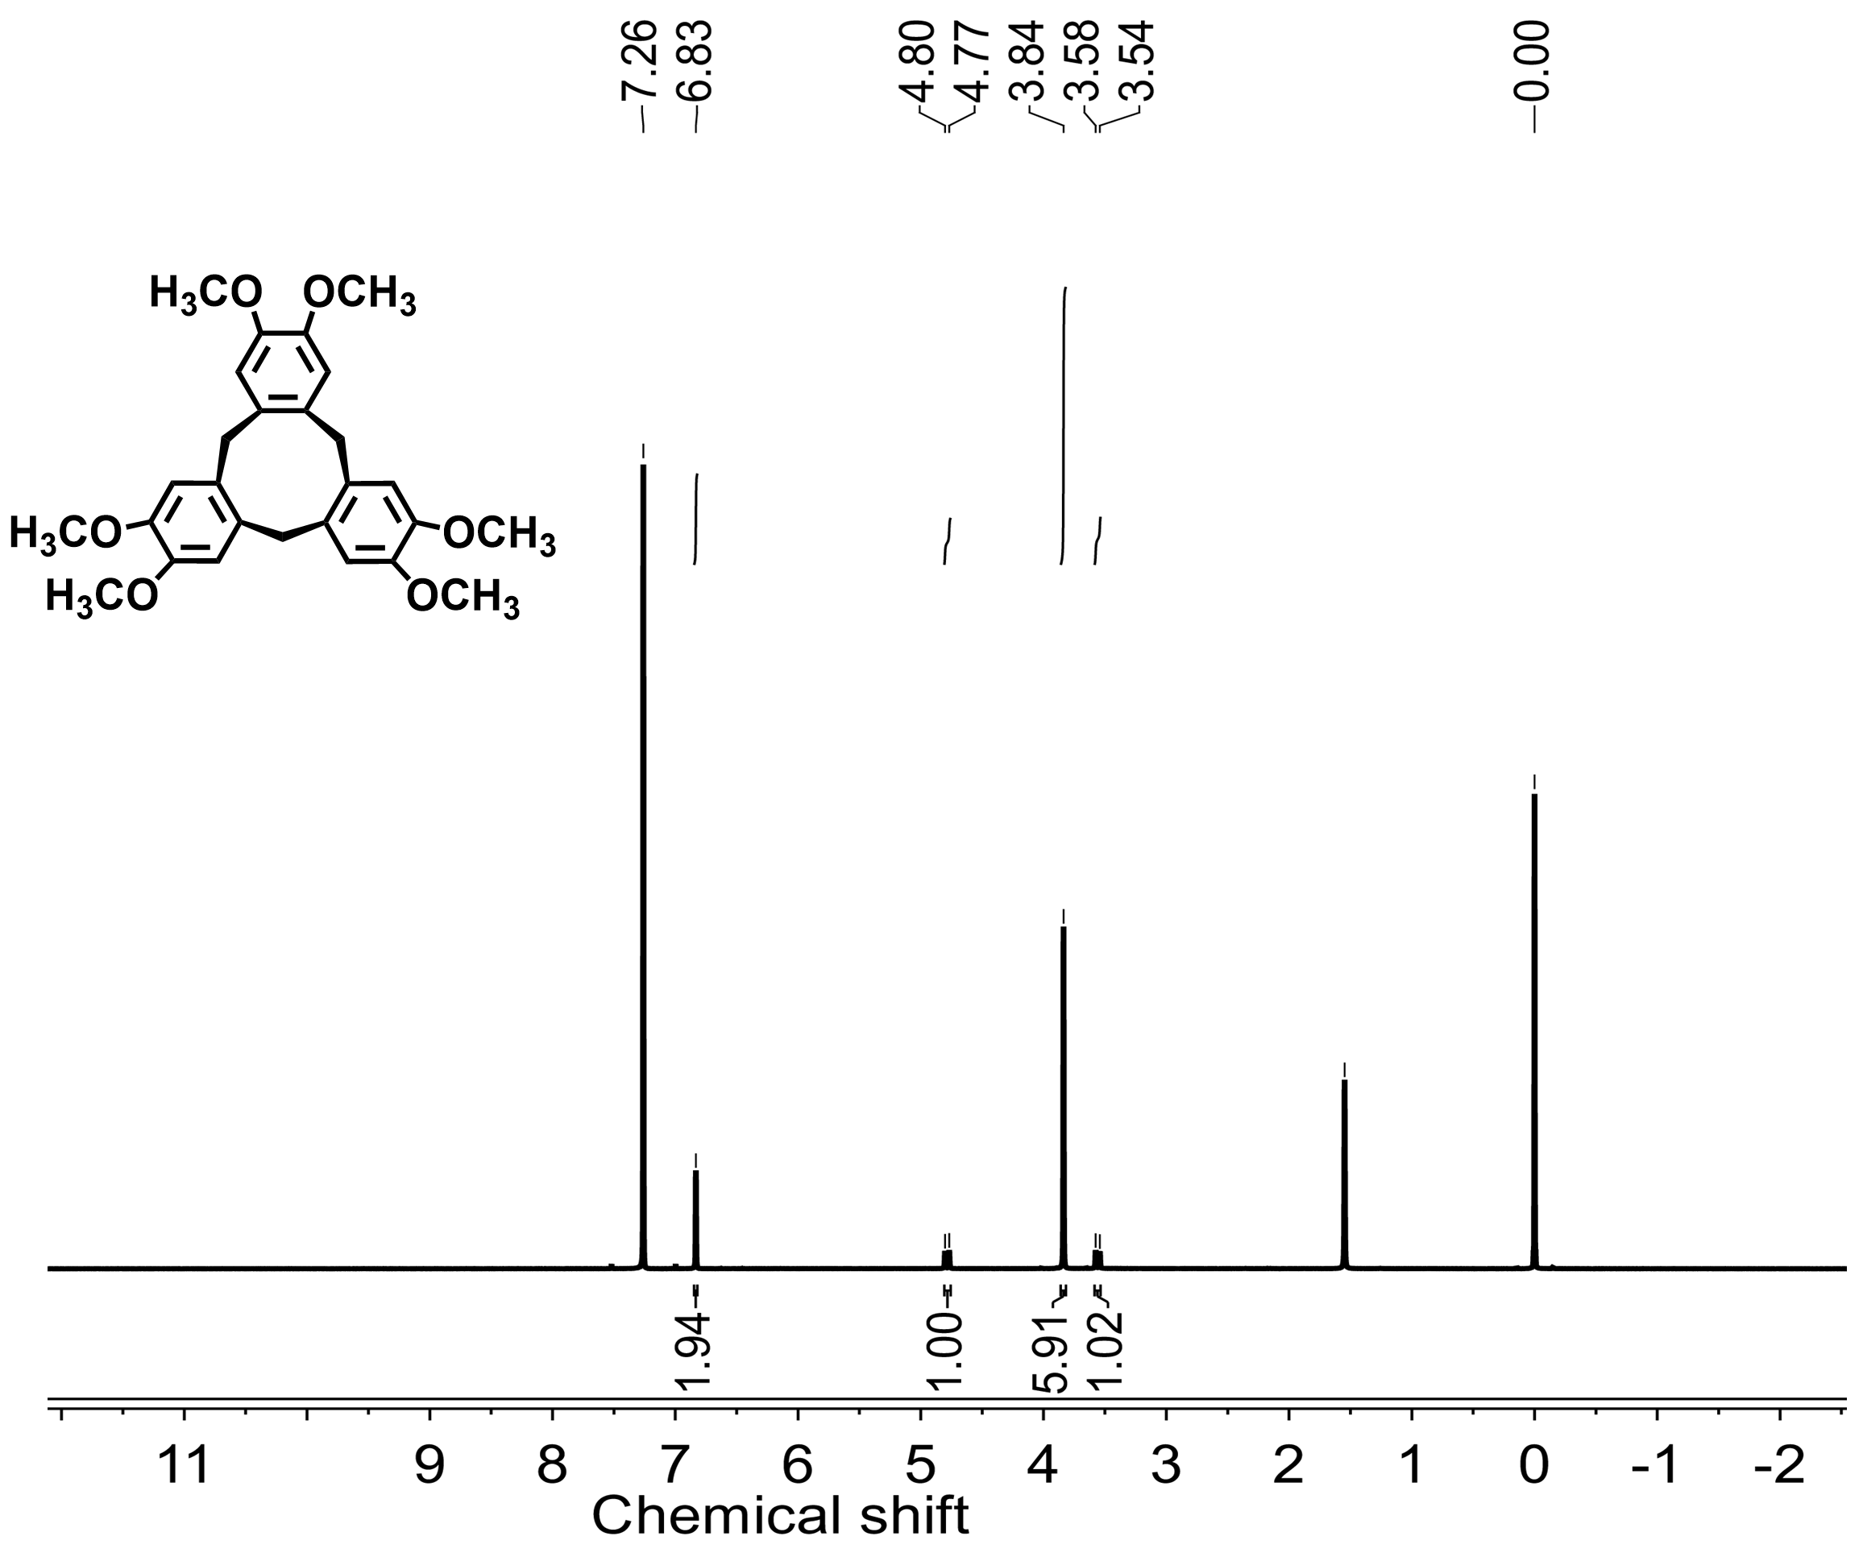
Fig. S1 ¹H NMR spectrum of HMCC (CDCl₃, 400 MHz)

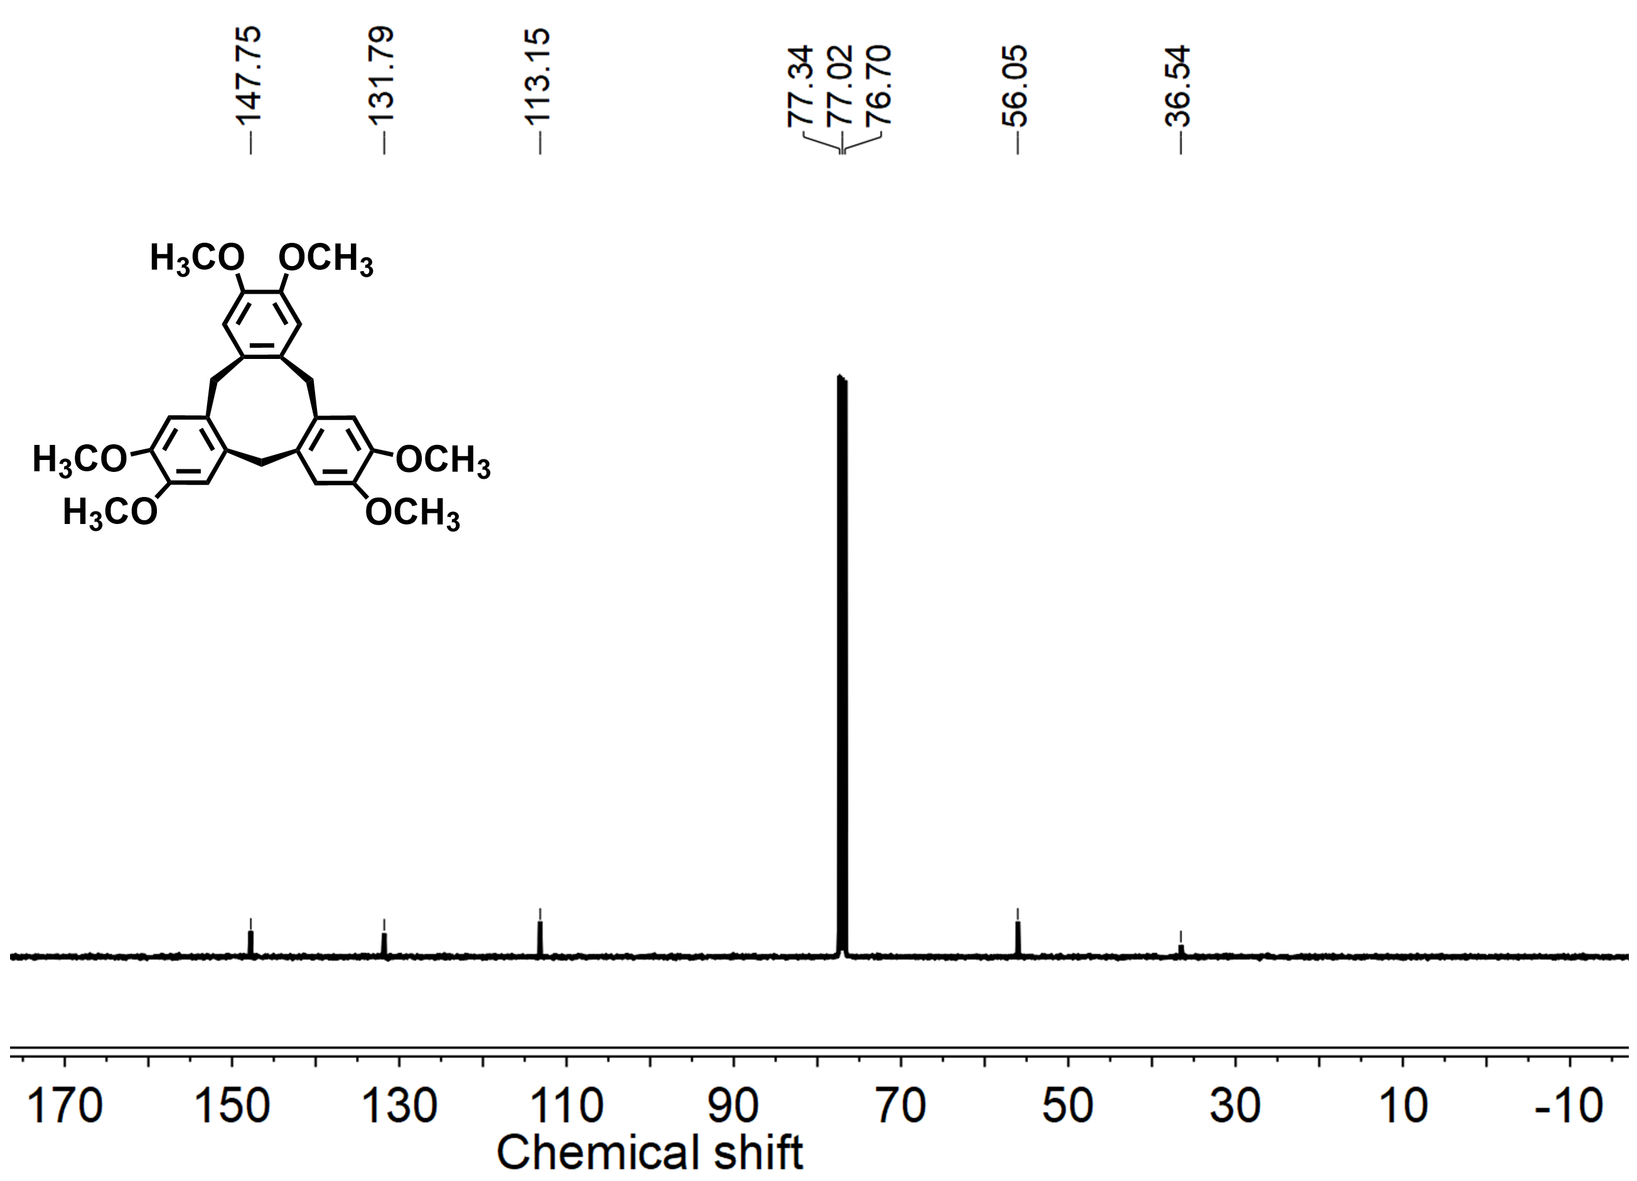
Fig. S2 ¹³C NMR spectrum of HMCC (CDCl₃, 400 MHz)

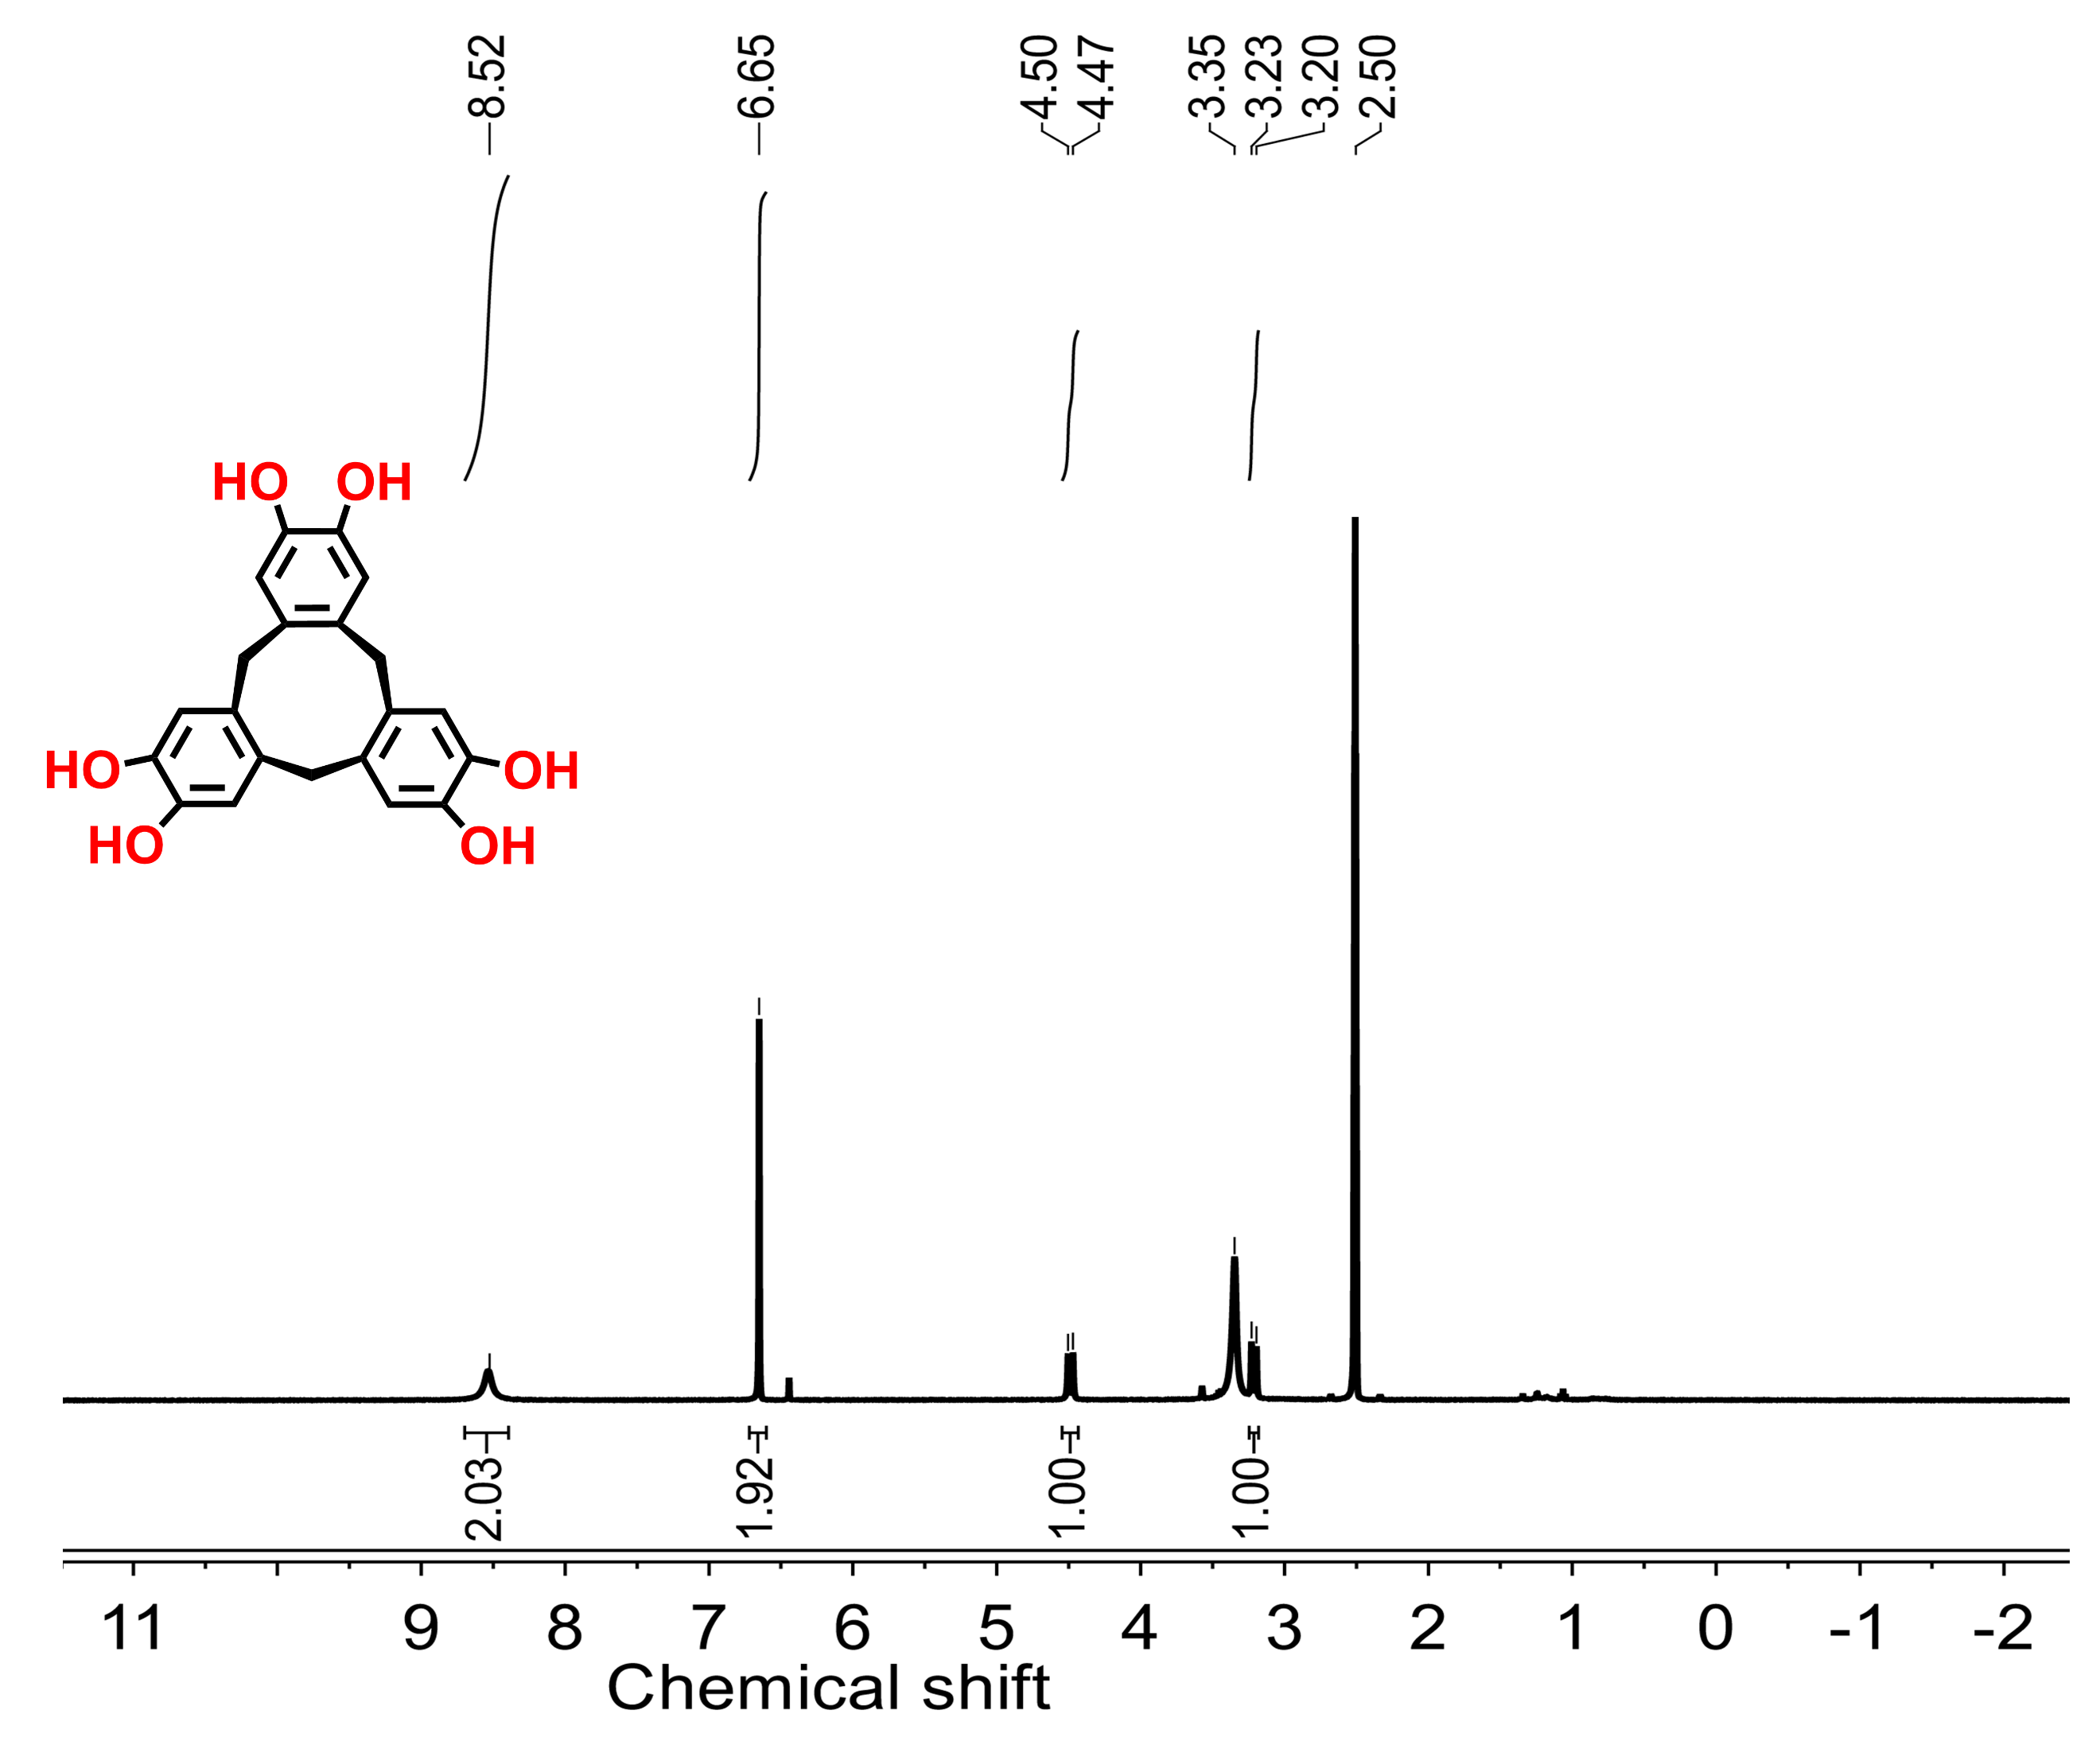
Fig. S3 ¹H NMR spectrum of HHCC (DMSO-d₆, 400 MHz)

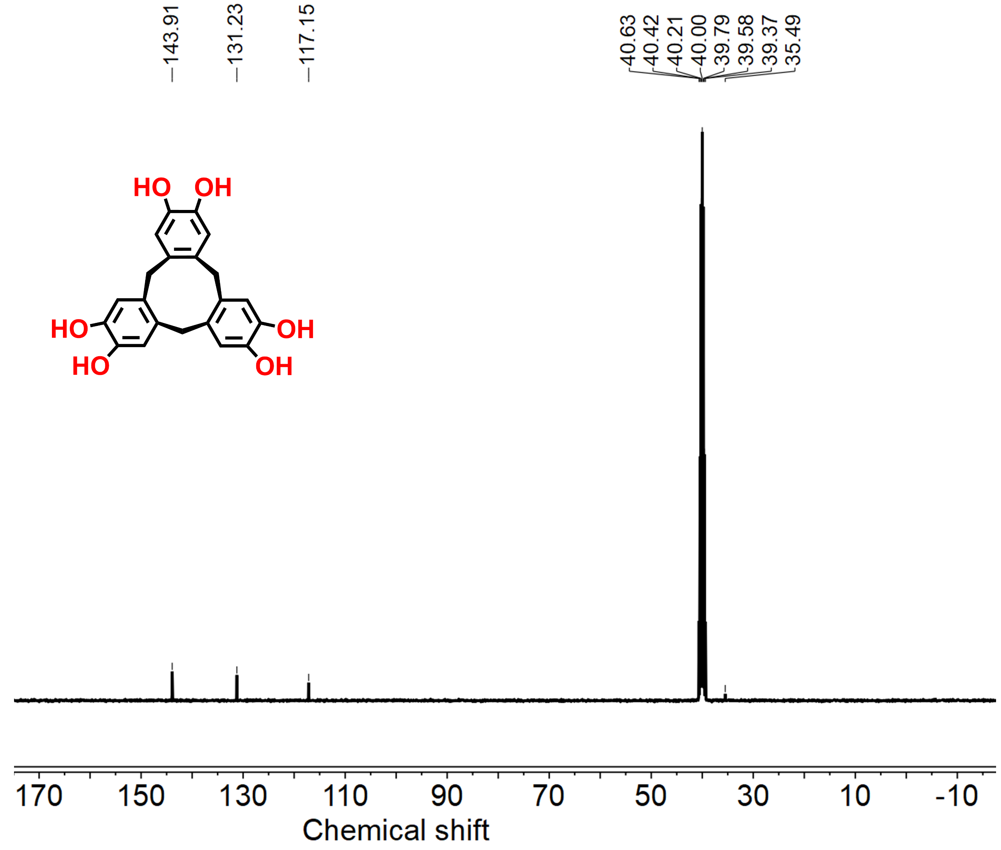
Fig. S4 ¹³C NMR spectrum of HHCC (DMSO-d₆, 400 MHz)

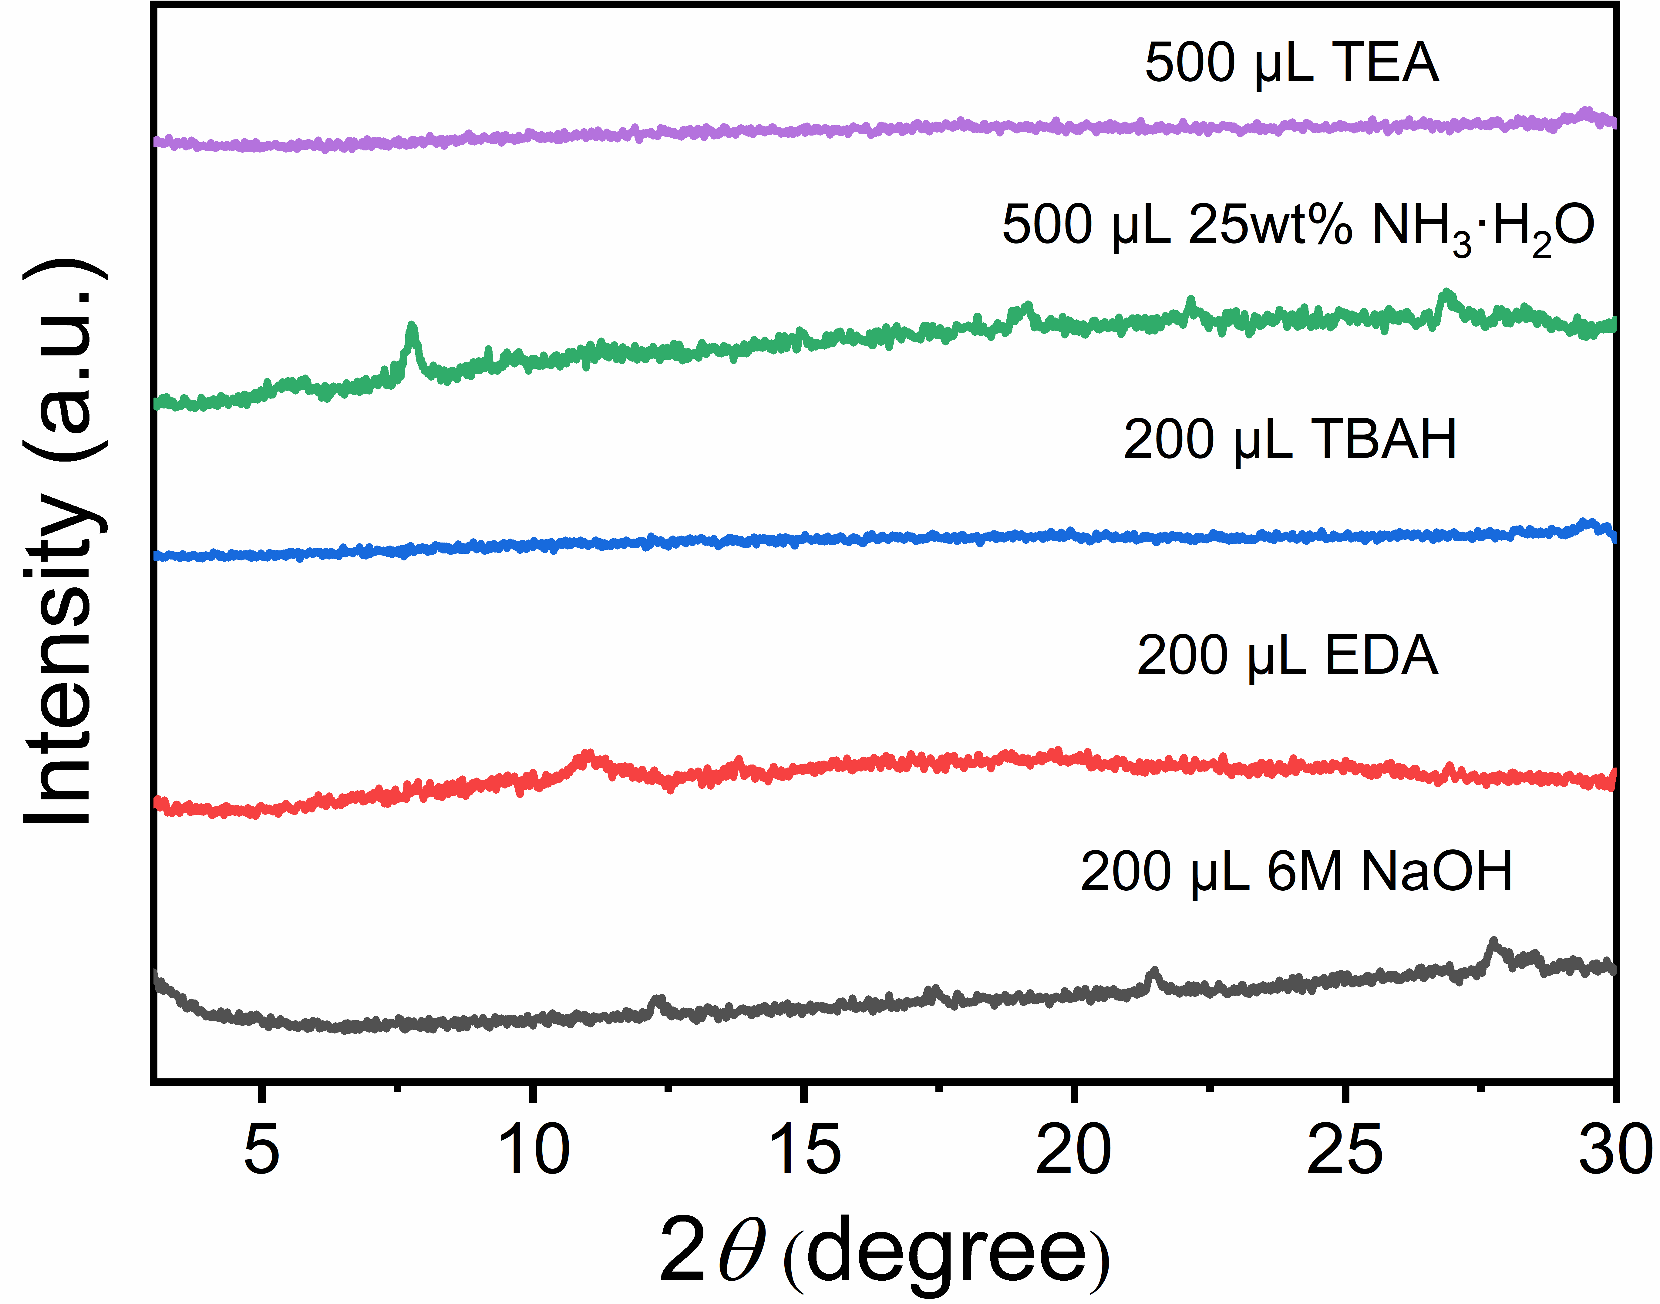
Fig. S5 PXRD patterns of 2D-Cu-HOF synthesized in H₂O/MeOH with the addition of different bases

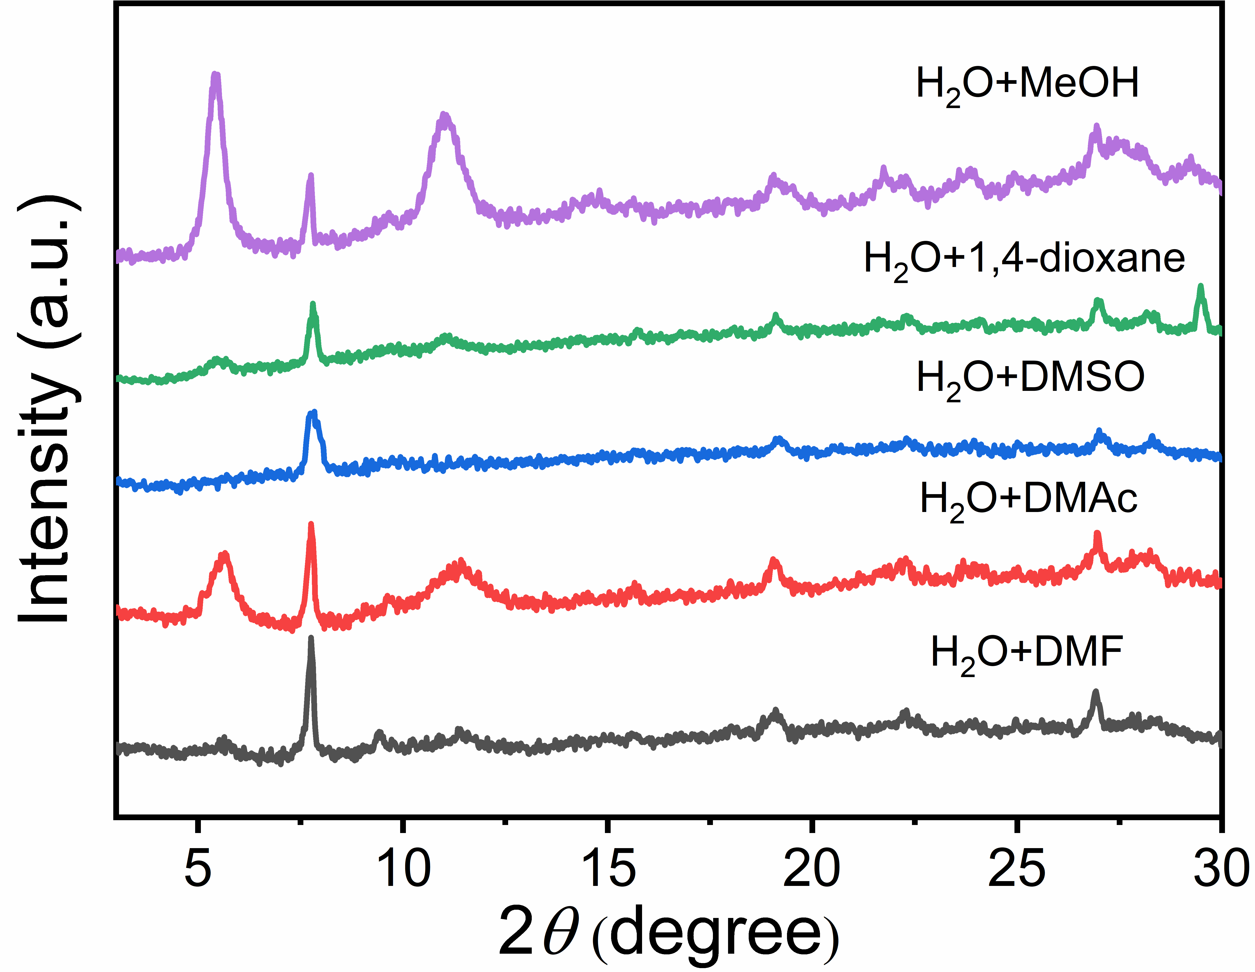
Fig. S6 PXRD patterns of 2D-Cu-HOF synthesized with different solvents
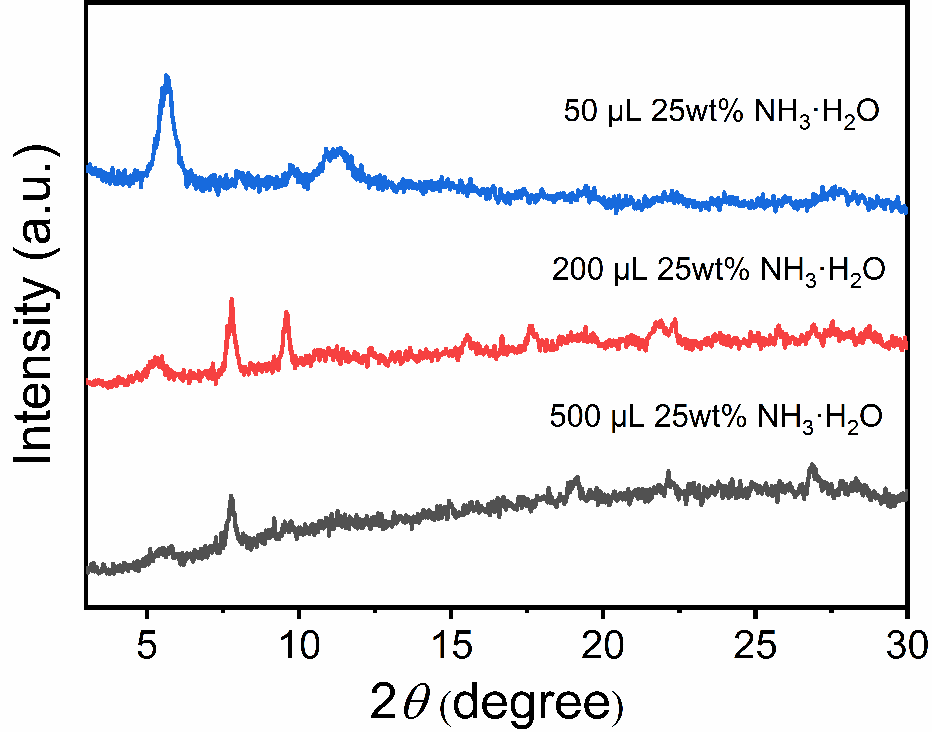
Fig. S7 PXRD patterns of 2D-Cu-HOF synthesized in H₂O/MeOH with the addition of different amounts of 25 wt% NH₃·H₂O

Fig. S8 PXRD patterns of 2D-Cu-HOF synthesized with different ratios of H₂O/MeOH

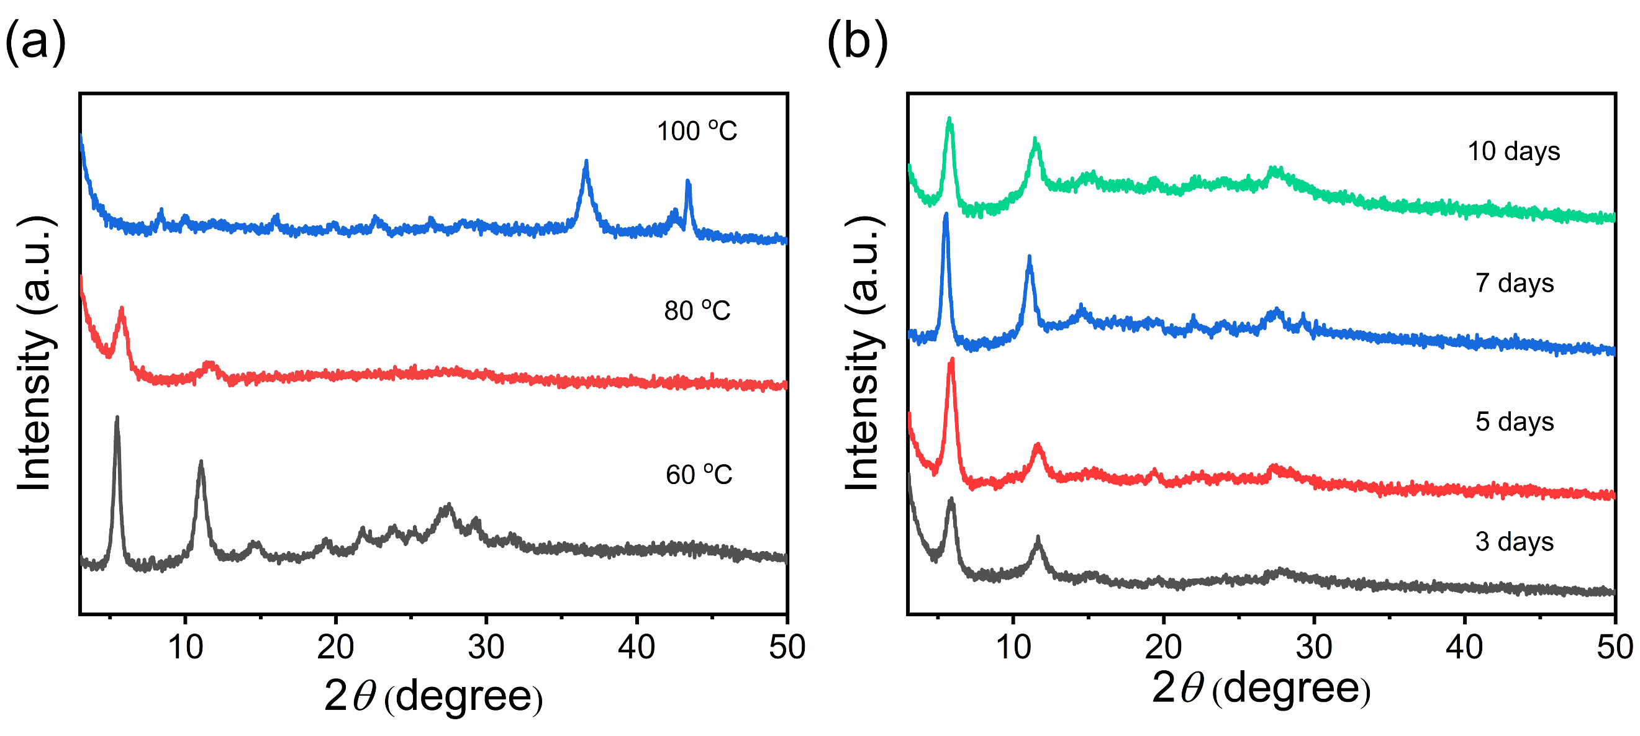
Fig. S9 PXRD patterns of 2D-Cu-HOF synthesized with different reaction temperature (a) and time (b)

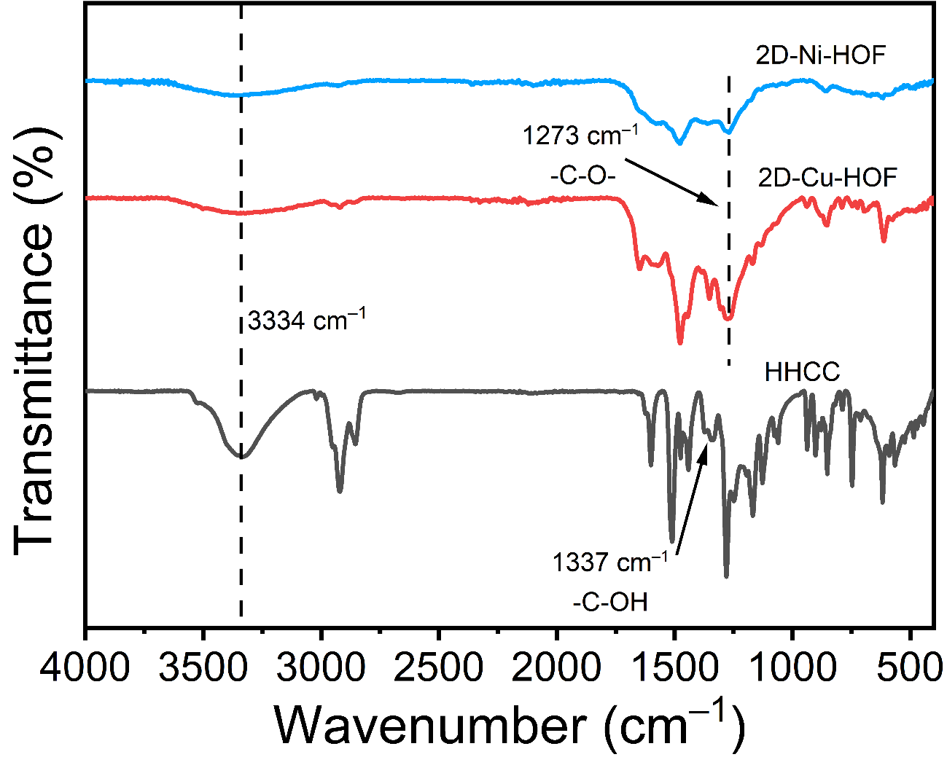
Fig. S10 FT-IR spectra of HHCC (black), 2D-Cu-HOF (red) and 2D-Ni-HOF (blue)

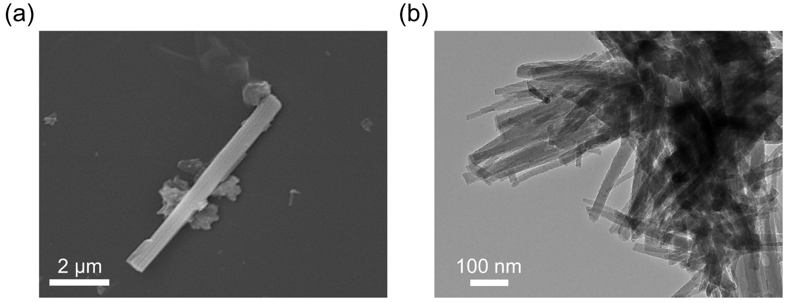
Fig. S11 SEM (a) and TEM (b) images of 2D-Cu-HOF

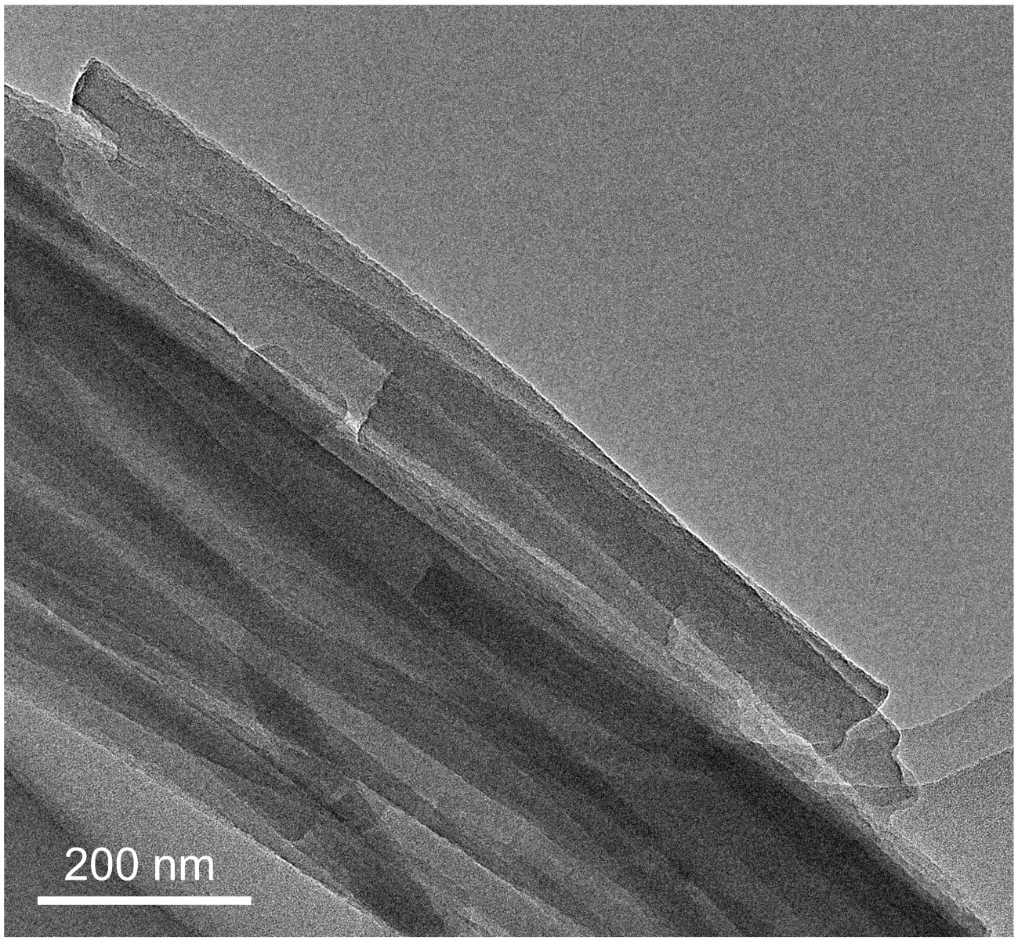
Fig. S12 TEM image of 2D-Ni-HOF

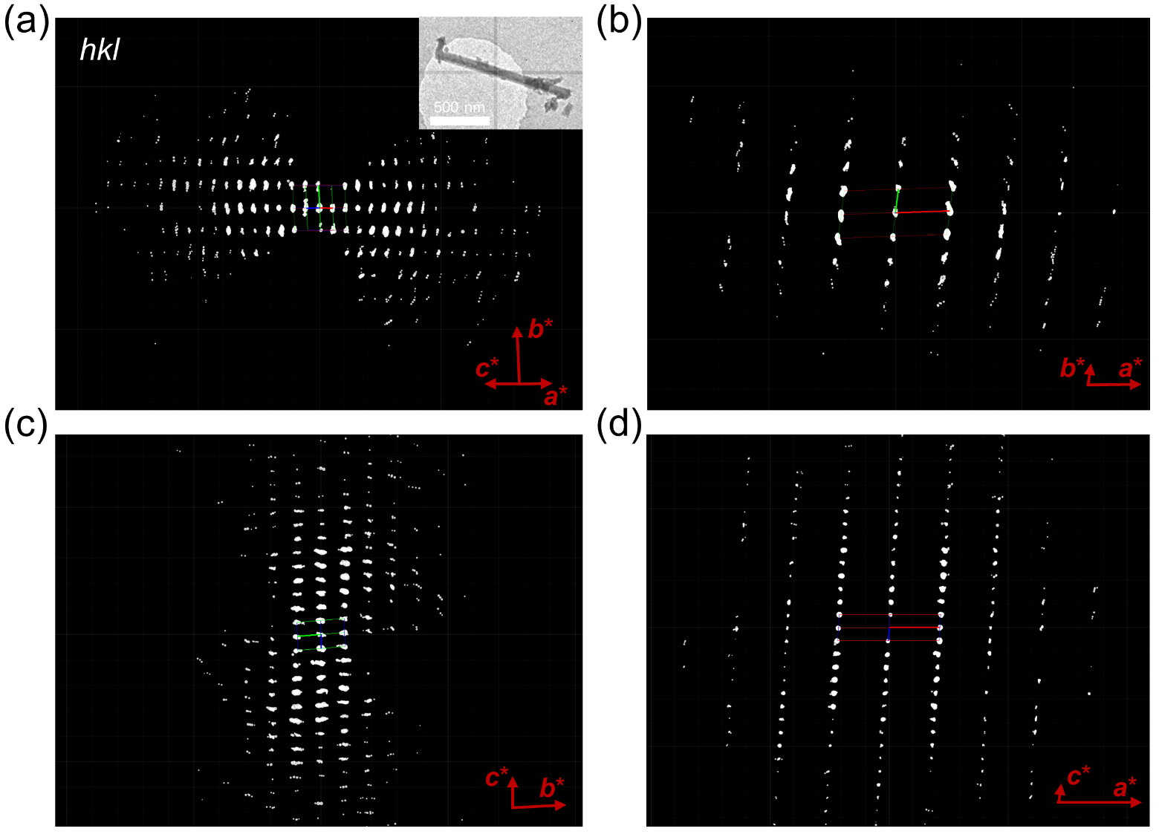
Fig. S13 3D cRED data for 2D-Cu-HOF. (a) Overview of the 3D reciprocal lattice, (b) hk0 slice cut from the 3D reciprocal lattice, (c) 0kl slice cut from the 3D reciprocal lattice, (d) h0l slice cut from the 3D reciprocal lattice

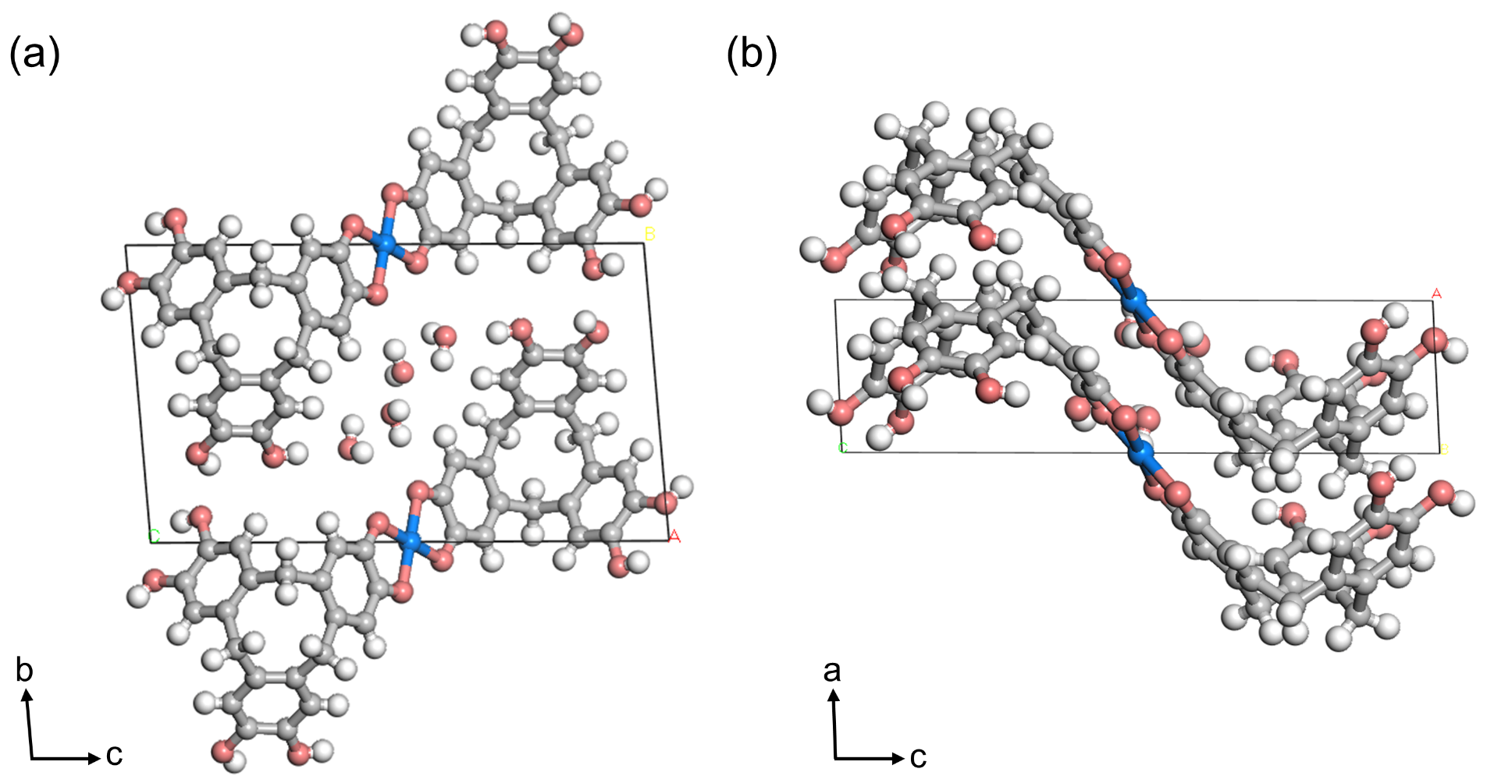
Fig. S14 Structural model of 2D-Cu-HOF single crystal along the (a) a-axis and (b) b-axis direction

Fig. S15 PXRD patterns of 2D-Cu-HOF and 2D-Ni-HOF

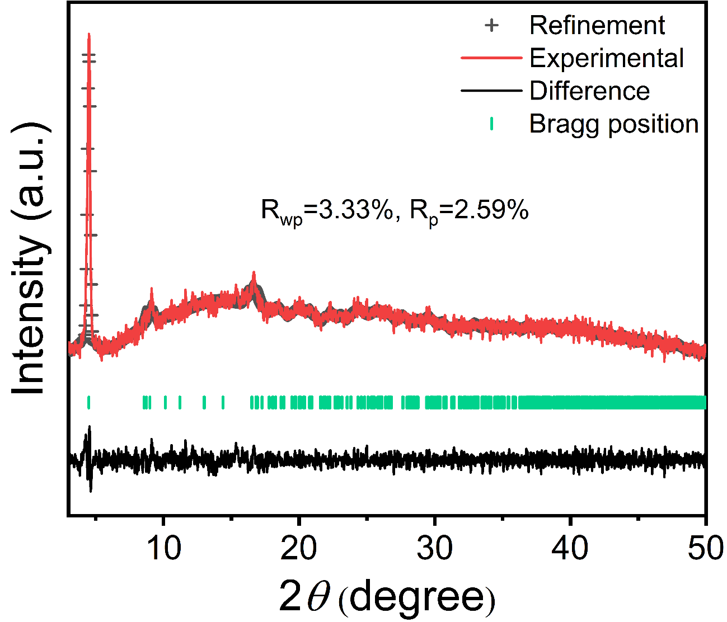
Fig. S16 Experimental and Pawley refined PXRD patterns of 2D-Ni-HOF

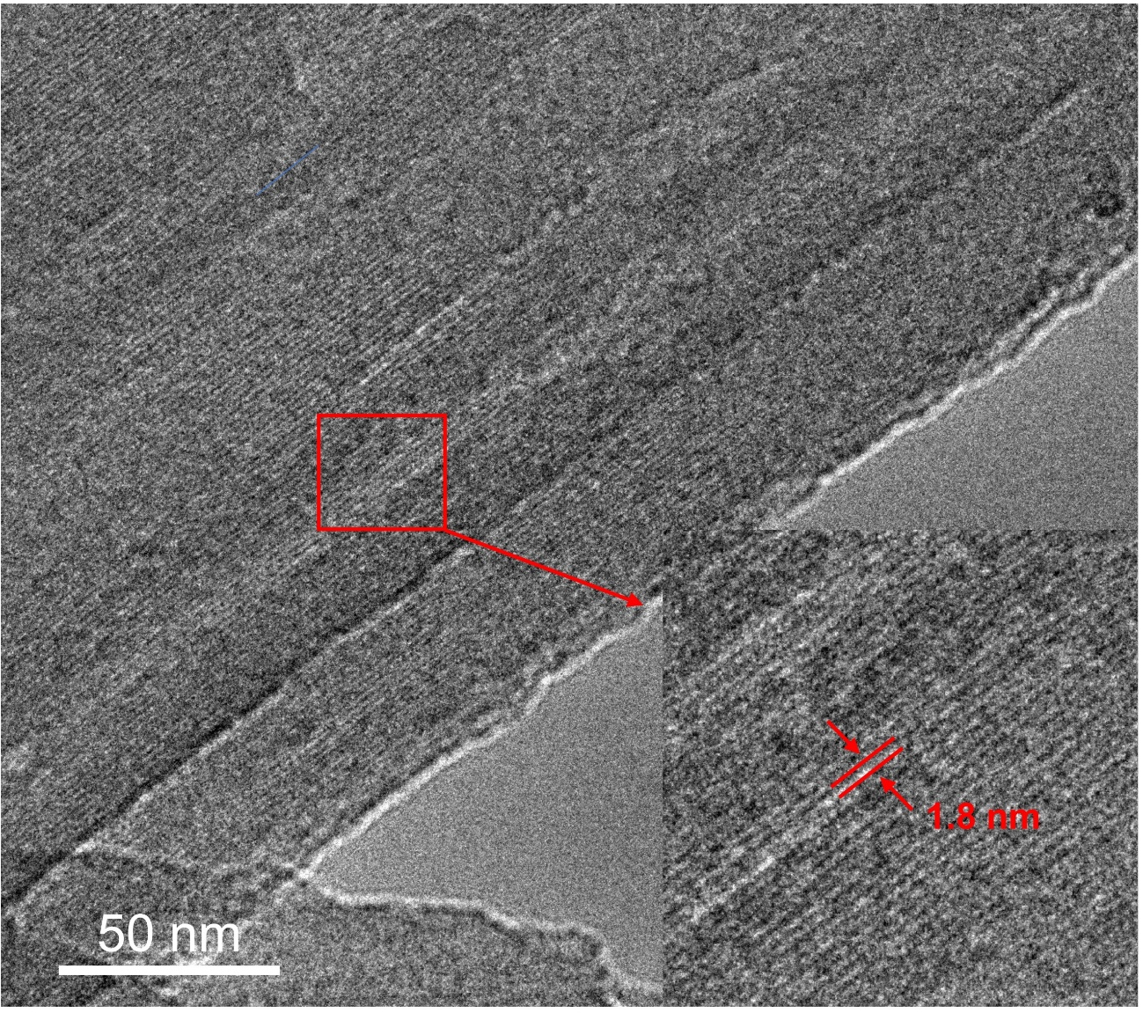
Fig. S17 HR-TEM image of 2D-Ni-HOF

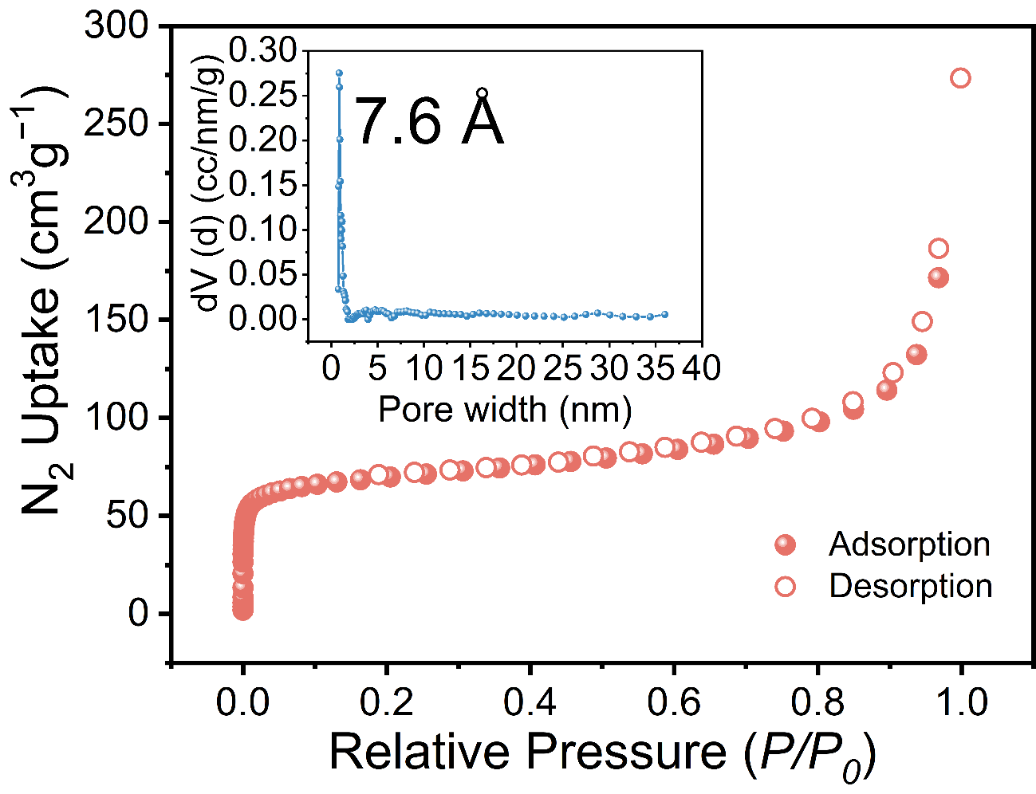
Fig. S18 N₂ sorption isotherm of 2D-Cu-HOF at 77 K, insert: the pore width distribution

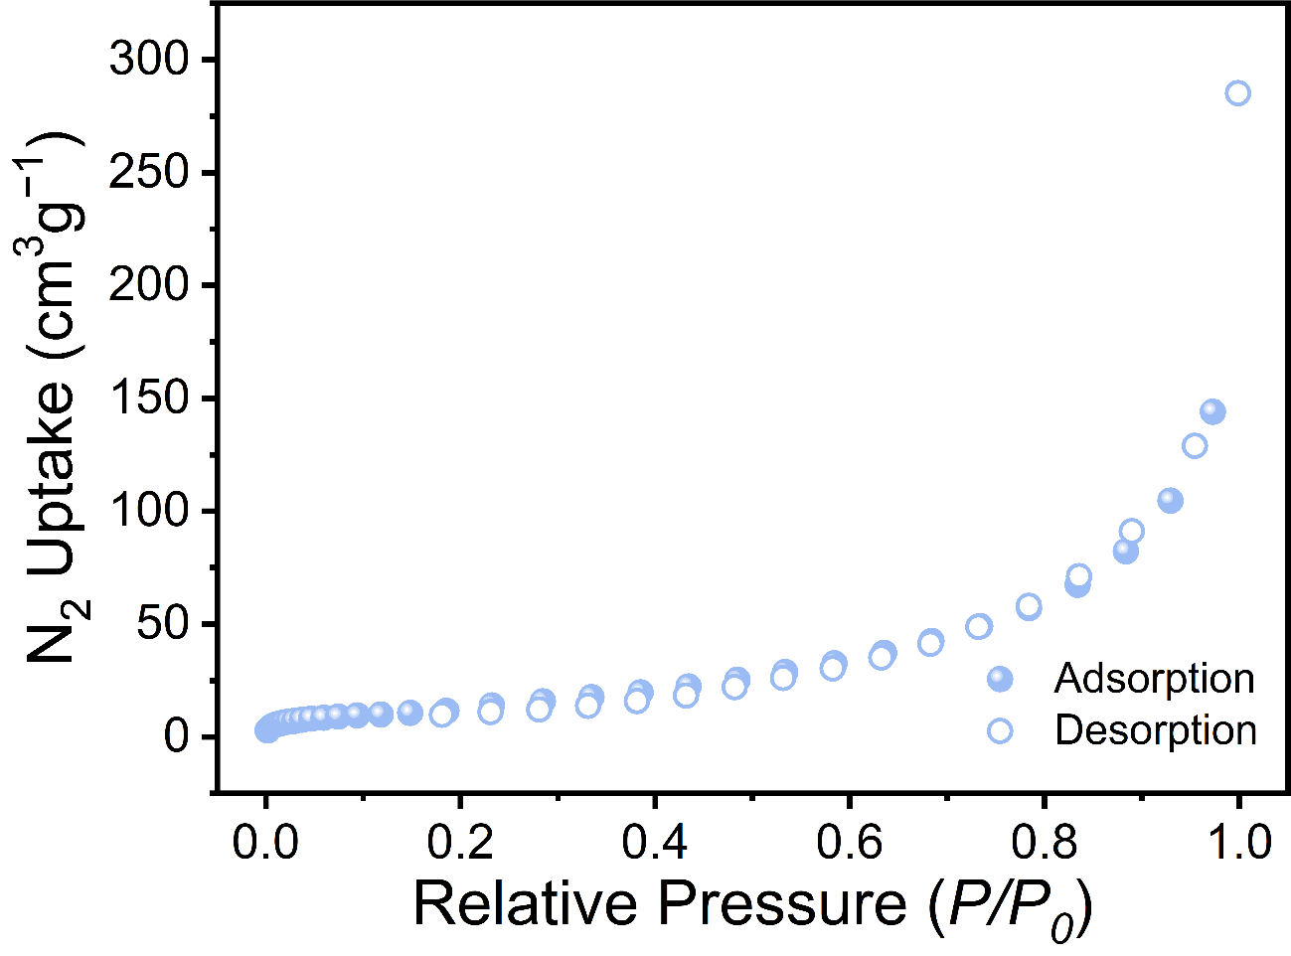
Fig. S19 N₂ sorption isotherm of 2D-Ni-HOF at 77 K

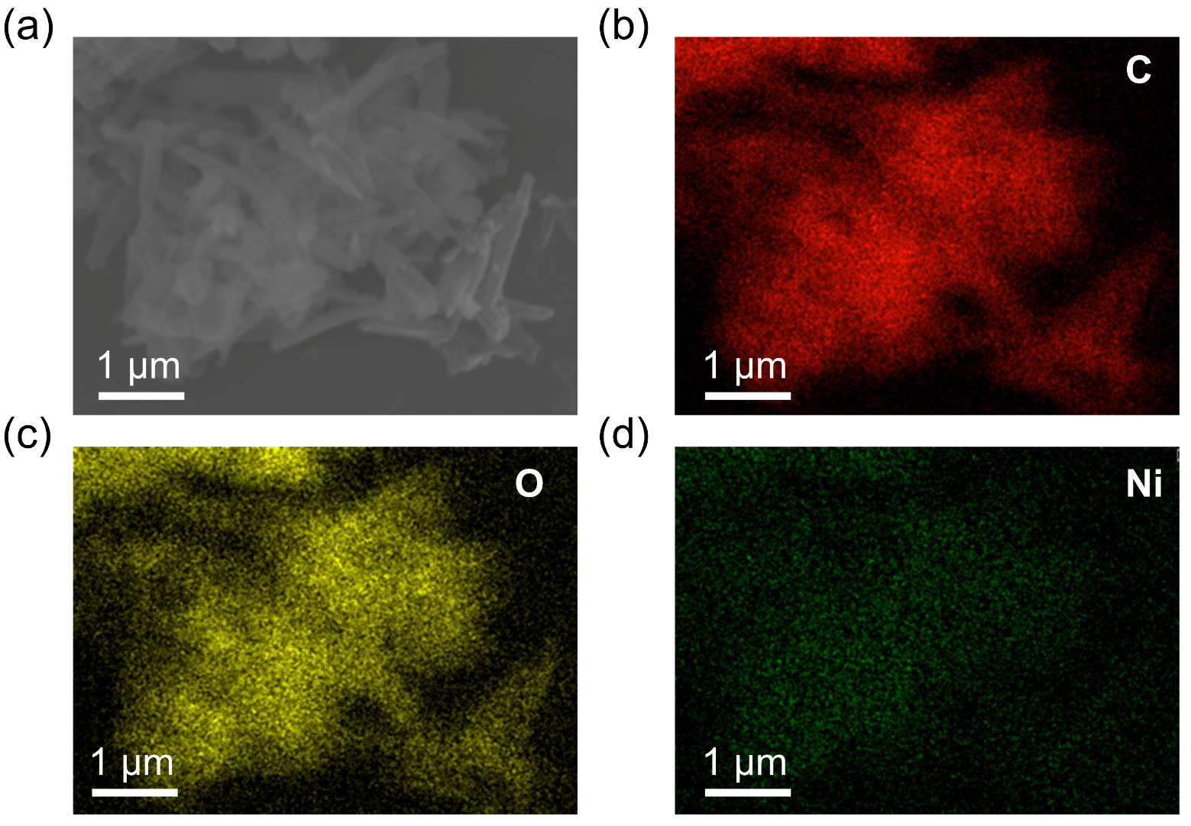
Fig. S20 EDS elemental mapping of 2D-Ni-HOF

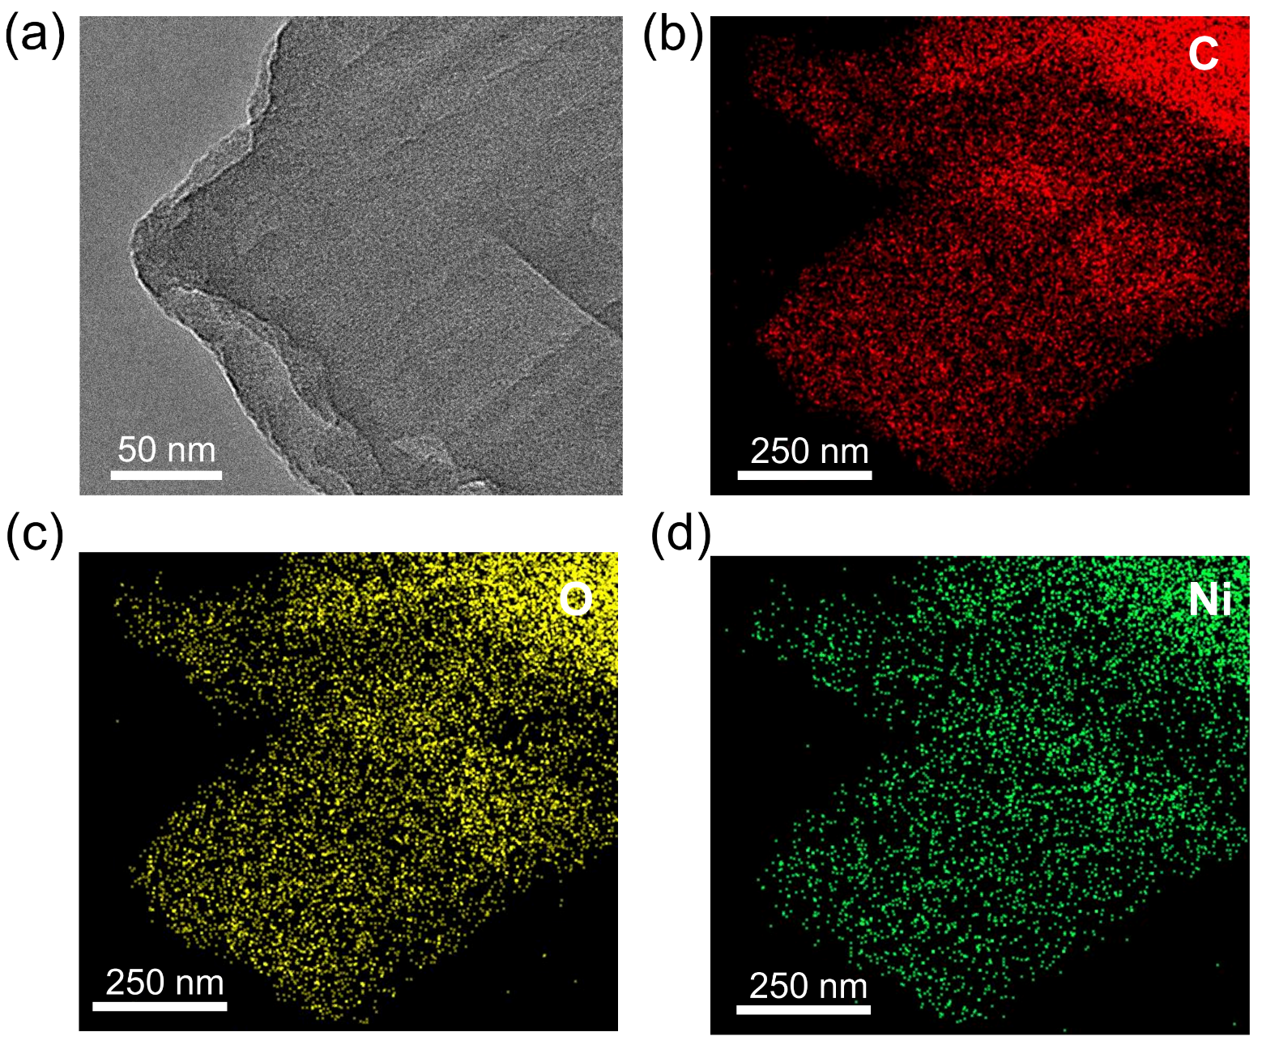
Fig. S21 TEM elemental mapping of 2D-Ni-HOF

Fig. S22 XPS survey spectra of (a) 2D-Cu-HOF and (b) 2D-Ni-HOF

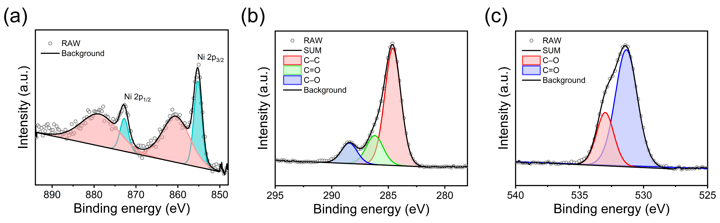
Fig. S23 High-resolution XPS (a) Ni 2p, (b) C 1s, and (c) O 1s spectra of 2D-Ni-HOF

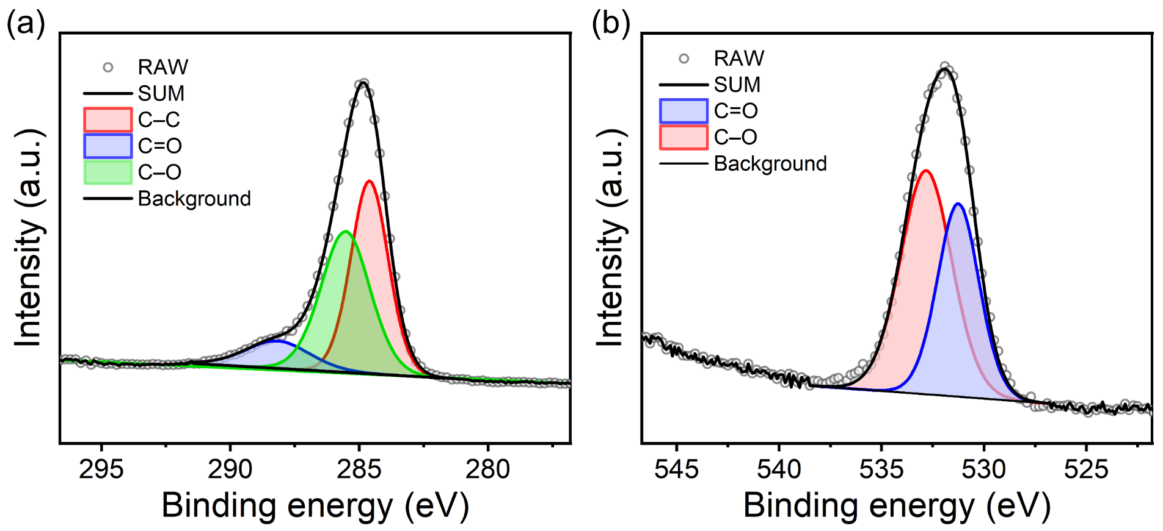
Fig. S24 High-resolution XPS (a) C 1s and (b) O 1s spectra of 2D-Cu-HOF

Fig. S25 EPR spectra of (a) 2D-Cu-HOF and (b) 2D-Ni-HOF

Fig. S26 Ni K-edge XANES spectra of 2D-Ni-HOF
Fig. S27 Ni K-edge EXAFS fitting of 2D-Ni-HOF
Fig. S28 Ni K-edge wavelet transform of 2D-Ni-HOF

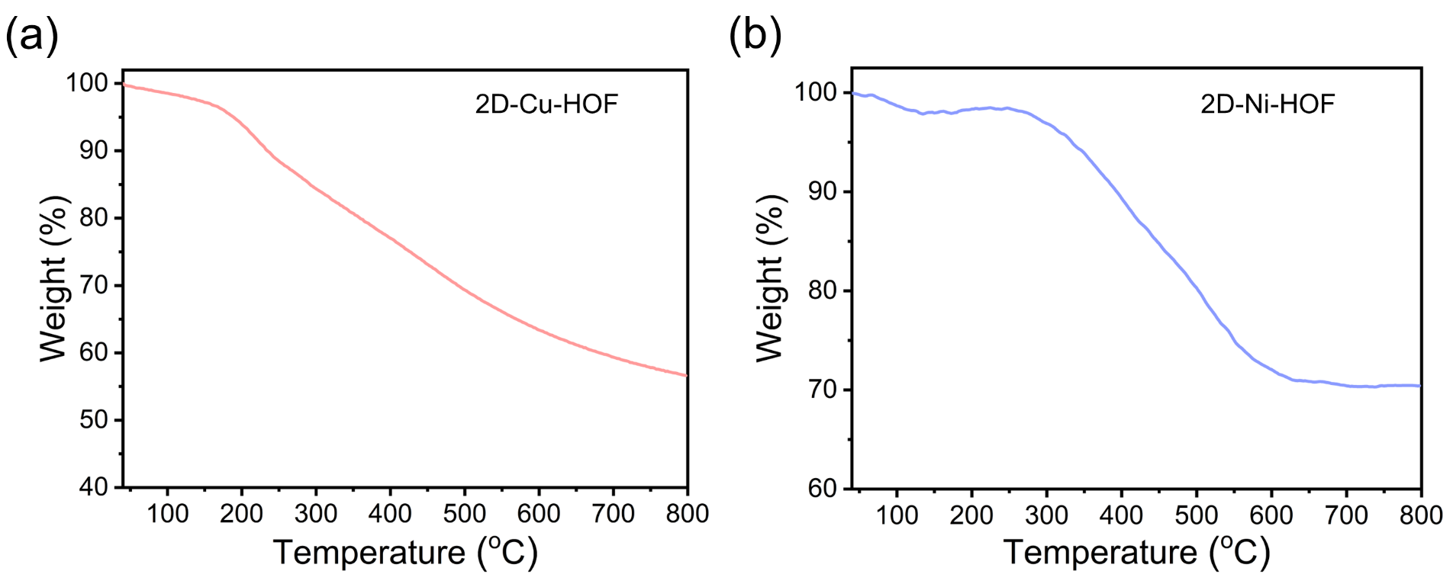
Fig. S29 TGA curves of (a) 2D-Cu-HOF and (b) 2D-Ni-HOF under N₂ atmosphere

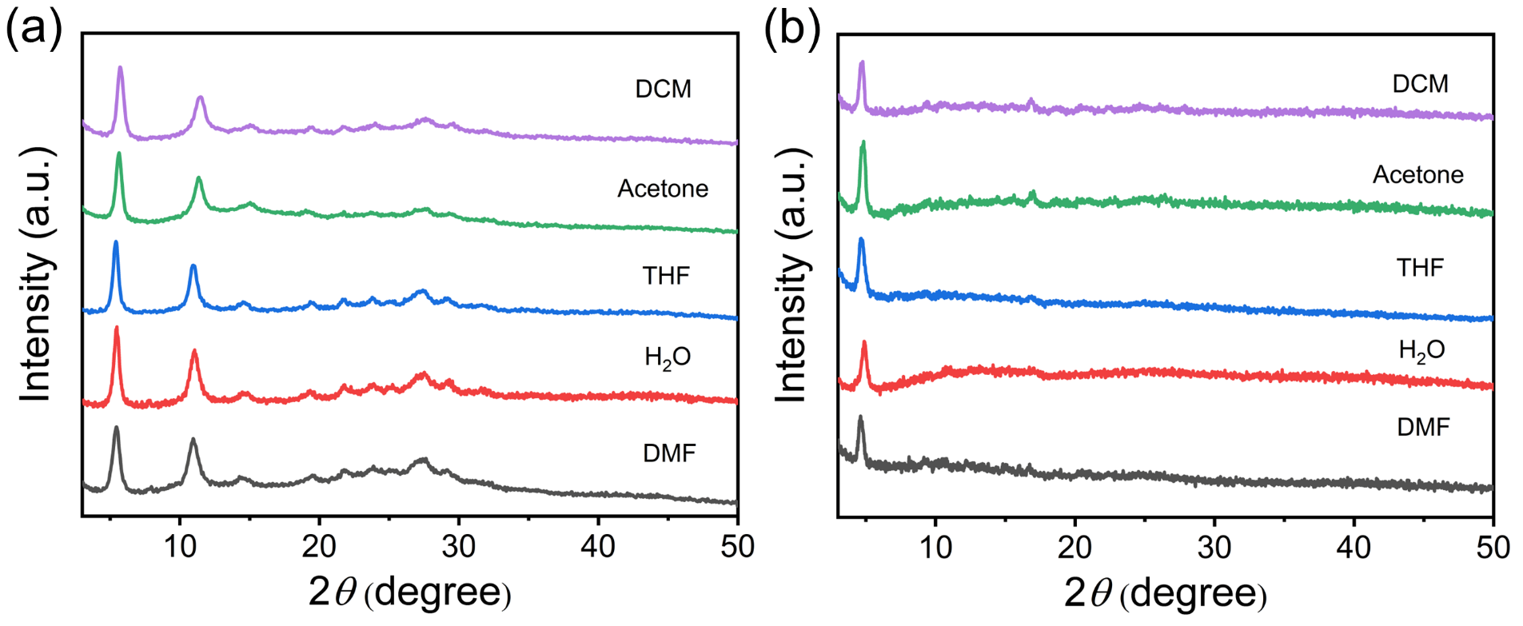
Fig. S30 Comparison of PXRD patterns of (a) 2D-Cu-HOF and (b) 2D-Ni-HOF after immersing in different solvents for three days
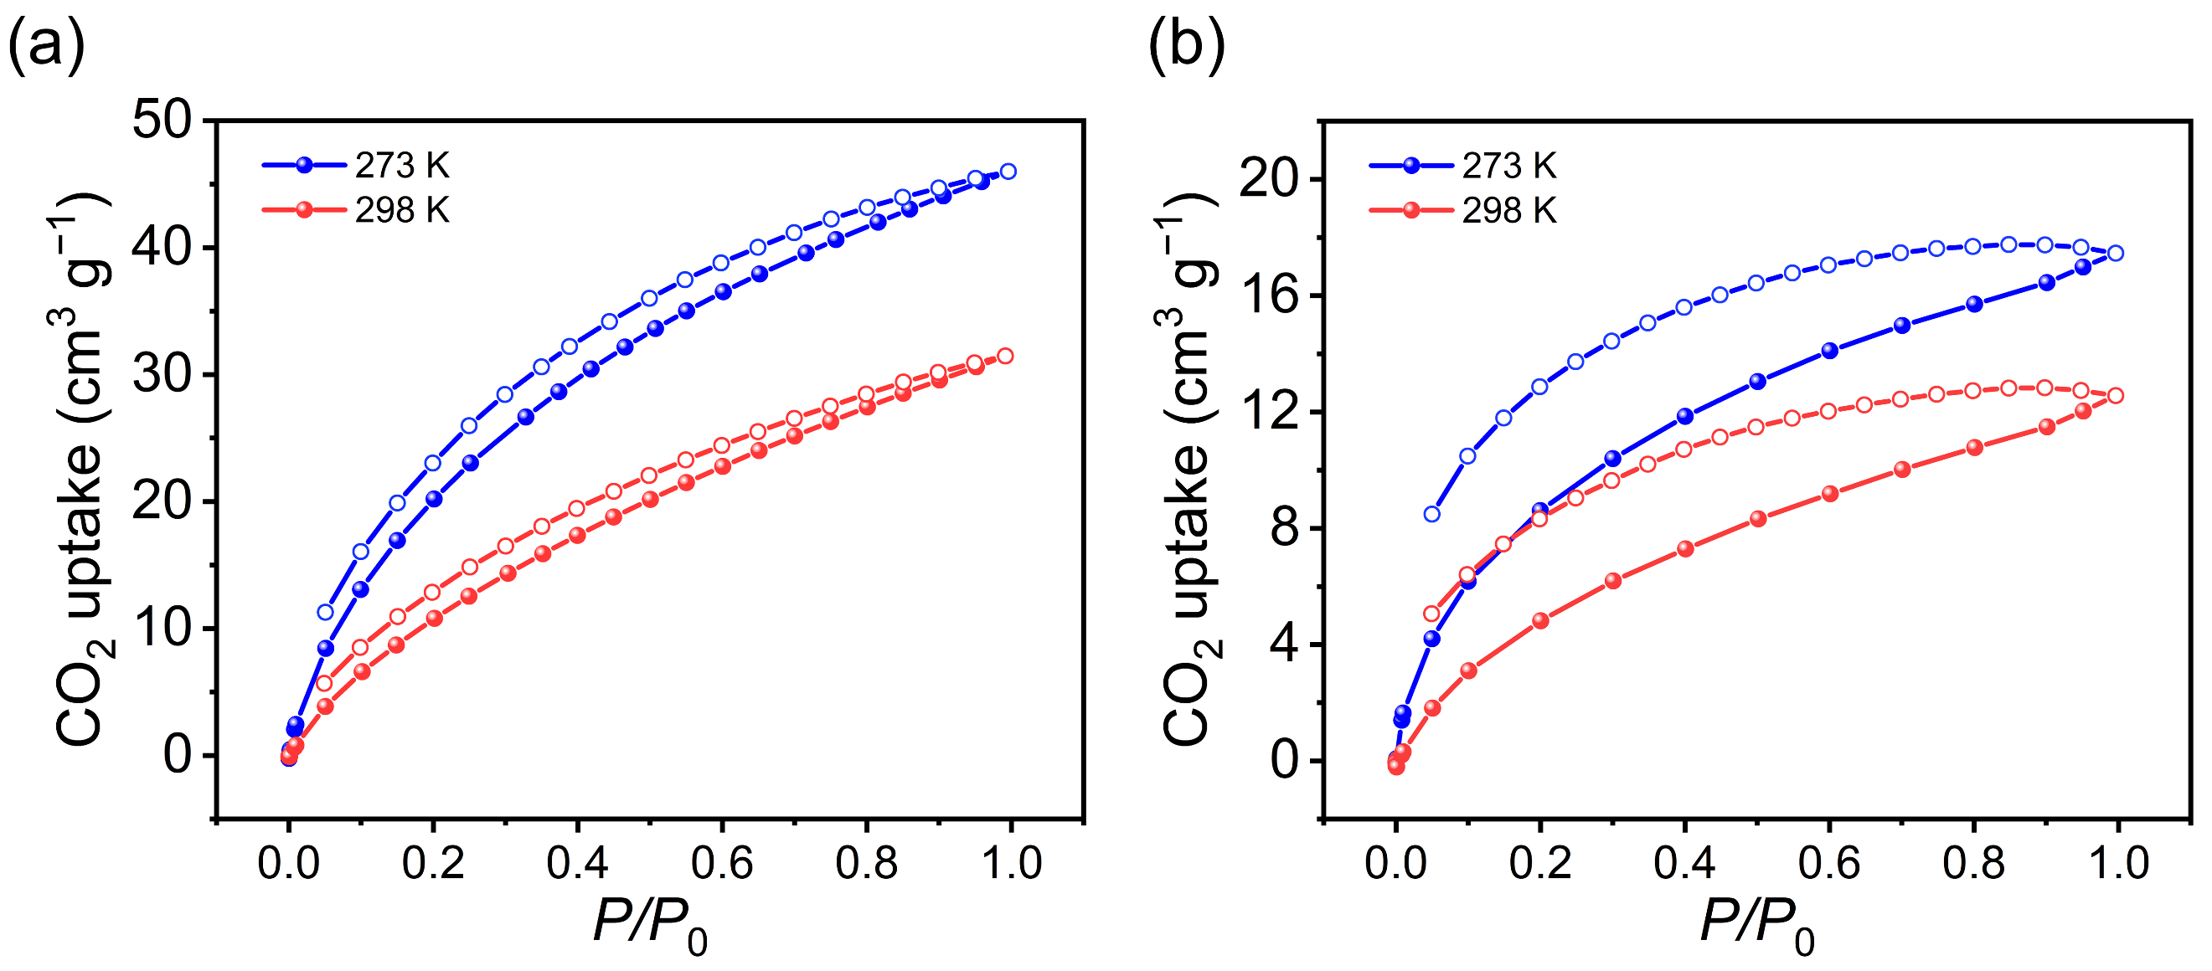
Fig. S31 CO₂ adsorption isotherms of (a) 2D-Cu-HOF and (b) 2D-Ni-HOF at 273 K (blue) and 298 K (red)
Fig. S32 Q_{st} of (a) 2D-Cu-HOF and (b) 2D-Ni-HOF calculated from the CO₂ adsorption isotherms by the Clausius–Clapeyron approach
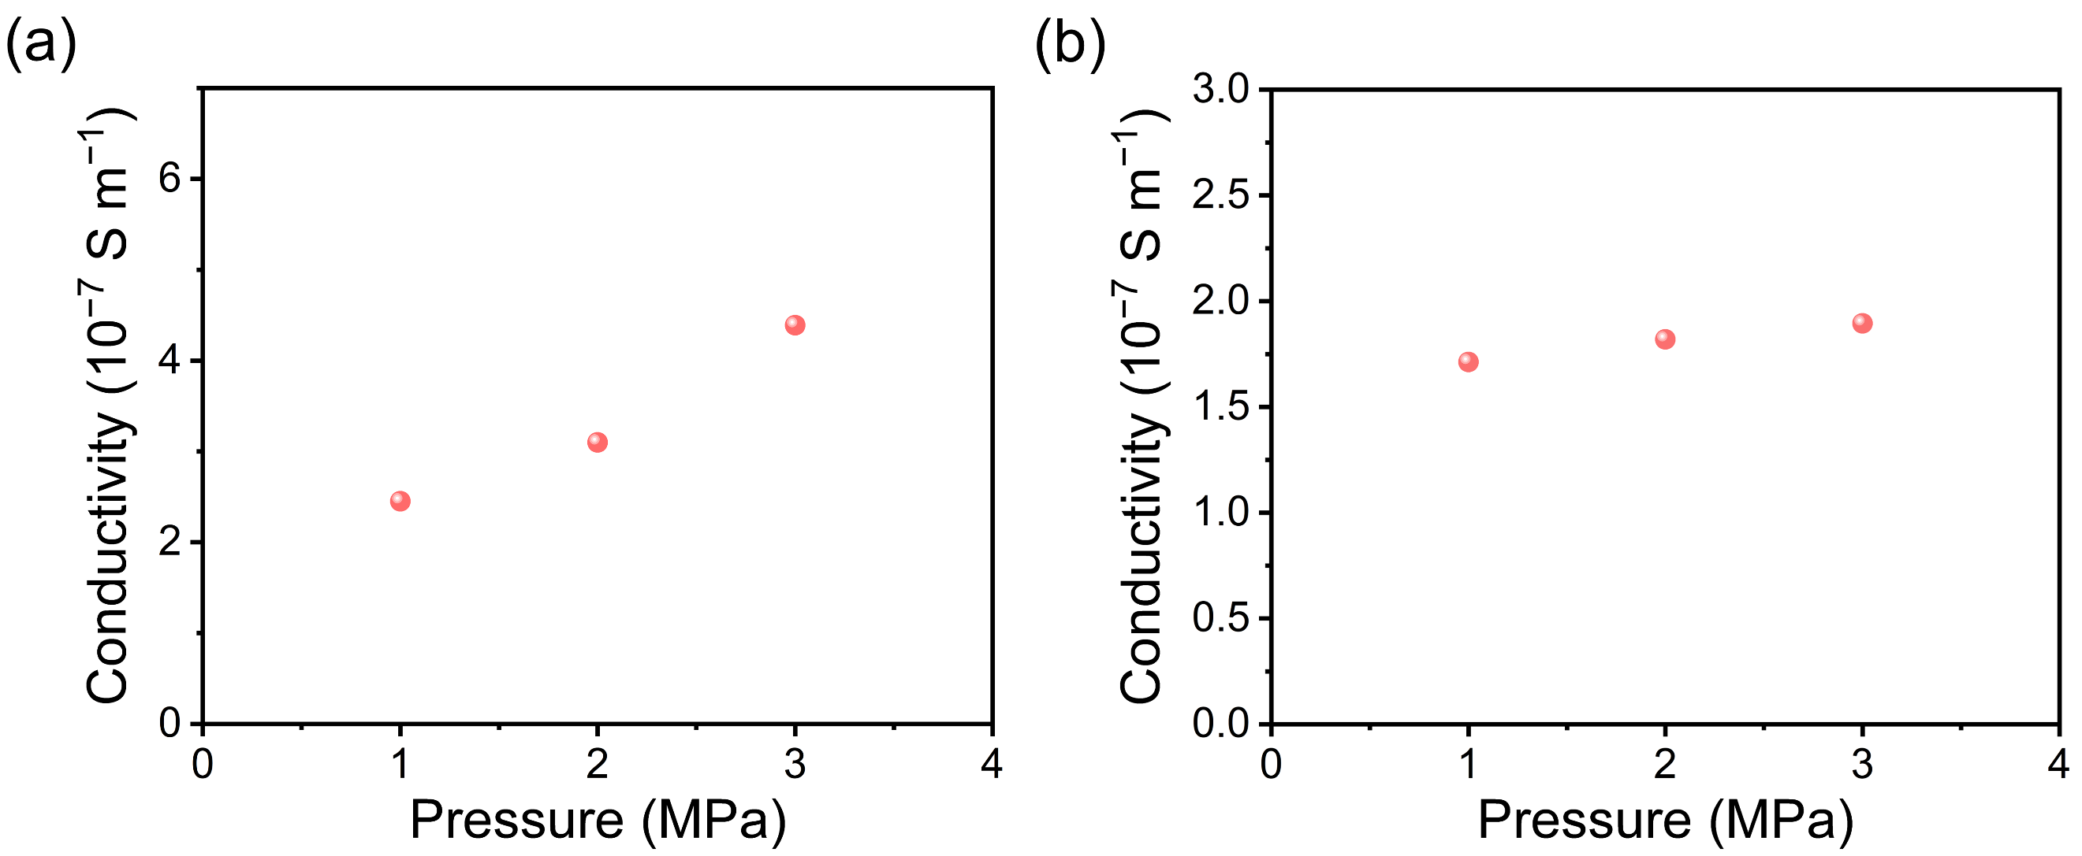
Fig. S33 The conductivity of (a) 2D-Cu-HOF pellet and (b) 2D-Ni-HOF pellet under different pressed pressure at room temperature
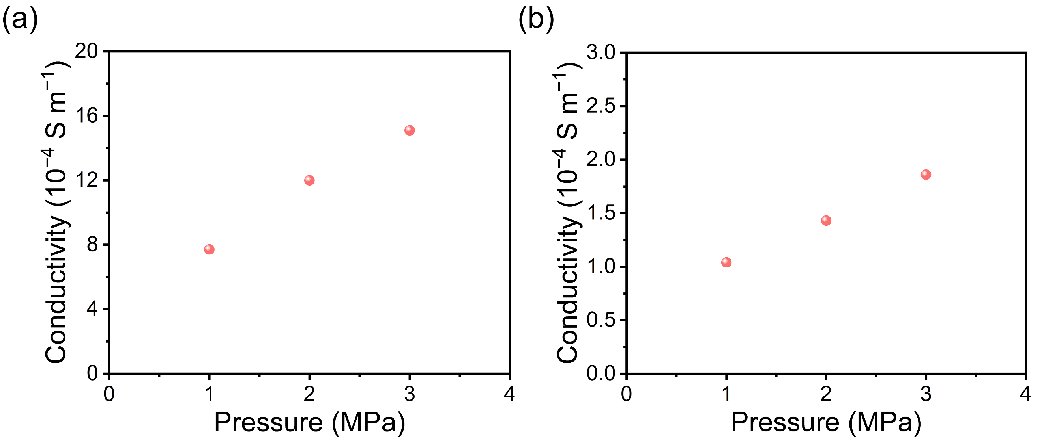
Fig. S34 The conductivity of iodine-doped (a) 2D-Cu-HOF pellet and (b) 2D-Ni-HOF pellet under different pressed pressure at room temperature
Fig. S35 Chronoamperometry of the 2D-Cu-HOF
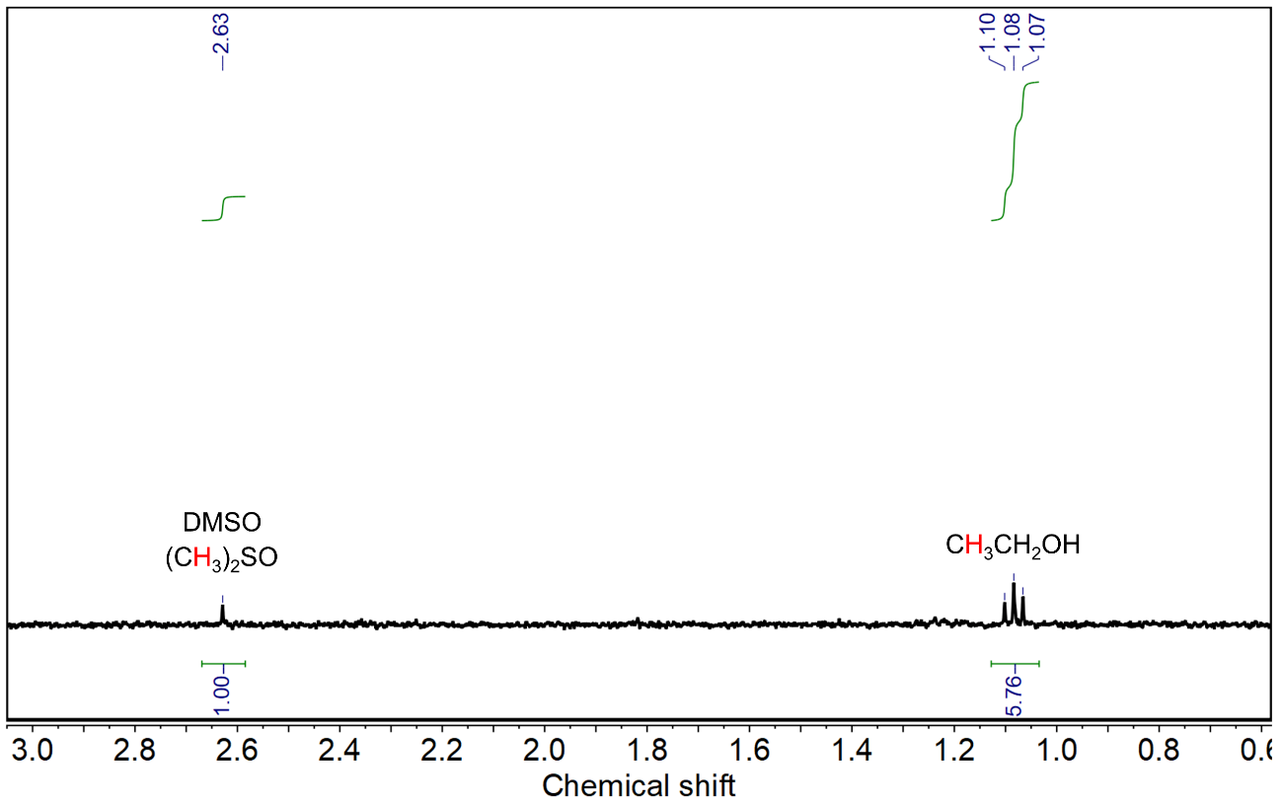
Fig. S36 ¹H NMR spectrum of the liquid phase products as catalyzed by 2D-Cu-HOF, wherein DMSO was used as an internal standard under H₂O signal suppression
Fig. S37 Mass spectrum of the CO₂RR electrolysis products with 2D-Cu-HOF by using ¹³C labeling CO₂
Fig. S38 Chronoamperometry of the 2D-Ni-HOF
Fig. S39 PXRD pattern of Cu₃(HHTP)₂
Fig. S40 SEM image of Cu₃(HHTP)₂

Fig. S41 FT-IR spectra of pyrocatechol and copper catecholate (CuO₄)

Fig. S42 EDS elemental mapping of CuO₄@PPy

Fig. S43 Chronoamperometry of the Cu₃(HHTP)₂

Fig. S44 Chronoamperometry of the CuO₄@PPy

Fig. S45 FE of different CO₂RR products of Cu₃(HHTP)₂ at various potentials

Fig. S46 FE of different CO₂RR products of CuO₄@PPy at various potentials

Fig. S47 ECSAs of 2D-Cu-HOF, 2D-Ni-HOF, Cu₃(HHTP)₂, and CuO₄@PPy

Fig. S48 Tafel slopes of 2D-Cu-HOF, 2D-Ni-HOF, Cu₃(HHTP)₂, and CuO₄@PPy

Fig. S49 TOFs of C₂ products for 2D-Cu-HOF, 2D-Ni-HOF, Cu₃(HHTP)₂, and CuO₄@PPy at the optimal reaction potential

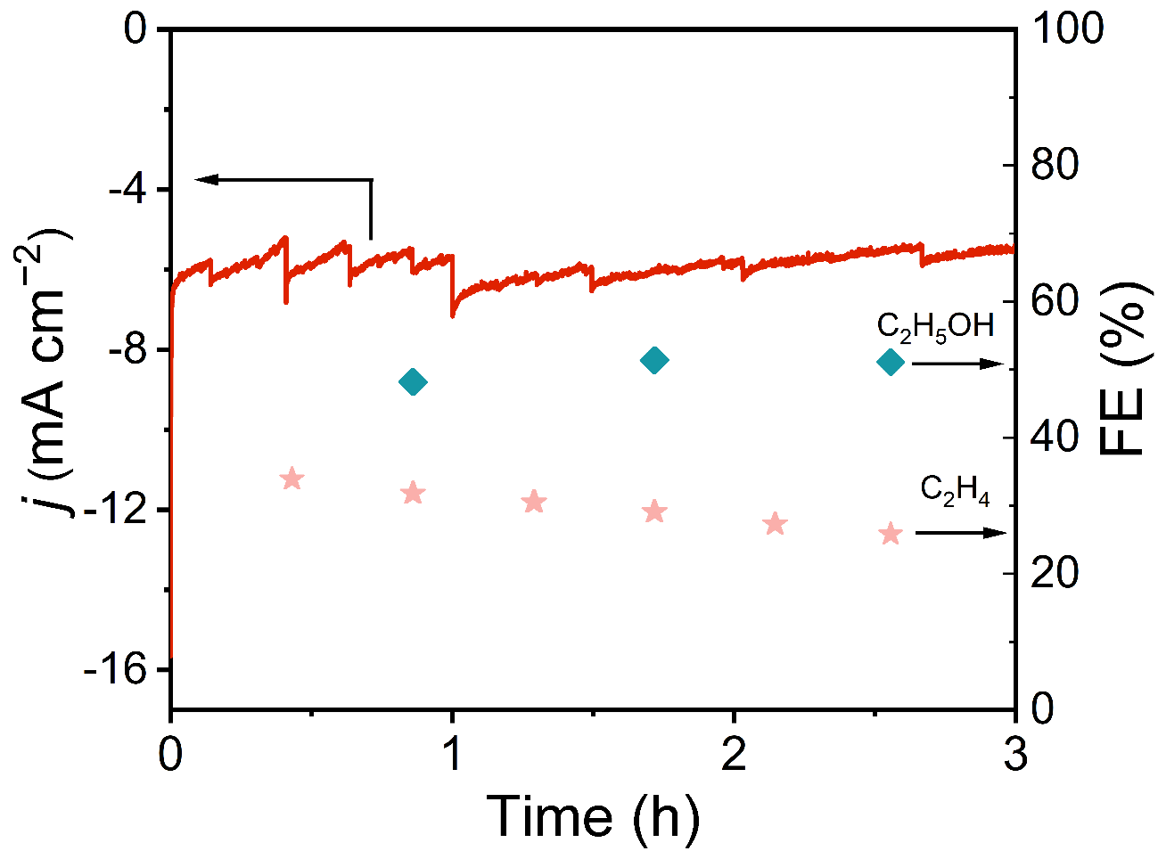
Fig. S50 FE(C₂H₅OH), FE(C₂H₄), and current density of 2D-Cu-HOF at −1.2 V vs. RHE for 3 hours

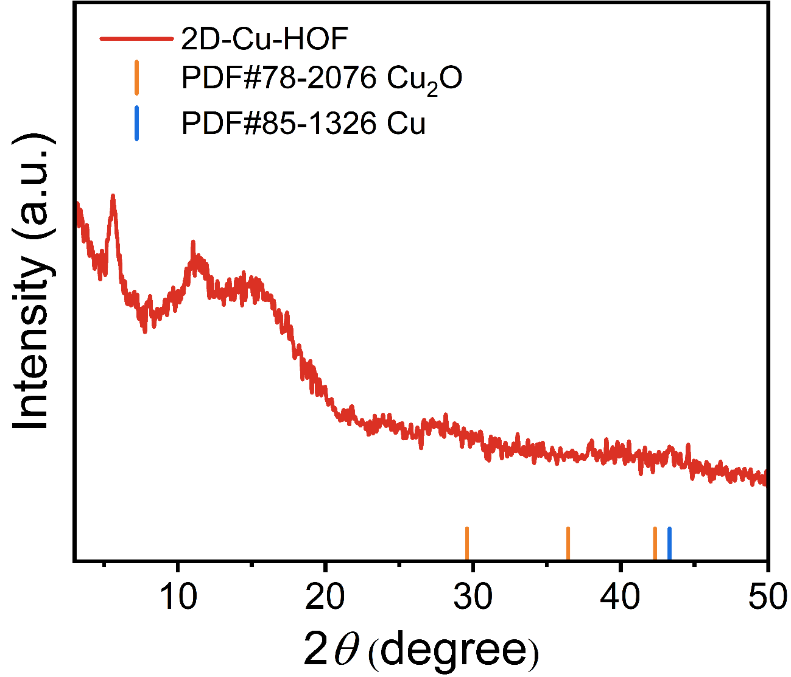
Fig. S51 PXRD pattern of 2D-Cu-HOF after CO₂RR

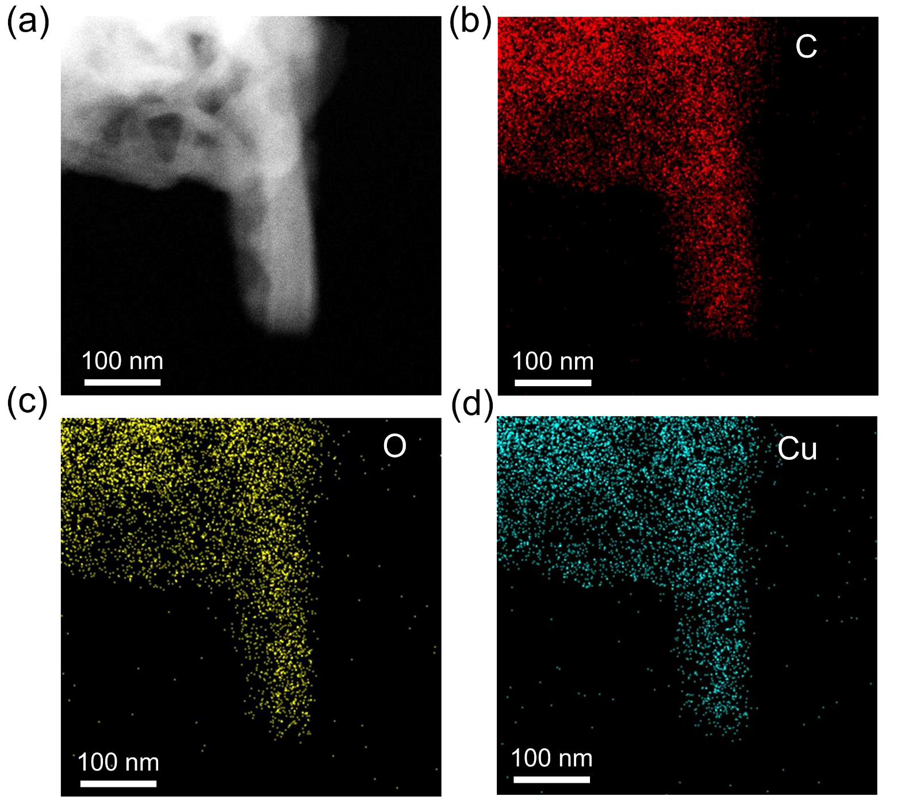
Fig. S52 TEM elemental mapping of 2D-Cu-HOF after CO₂RR
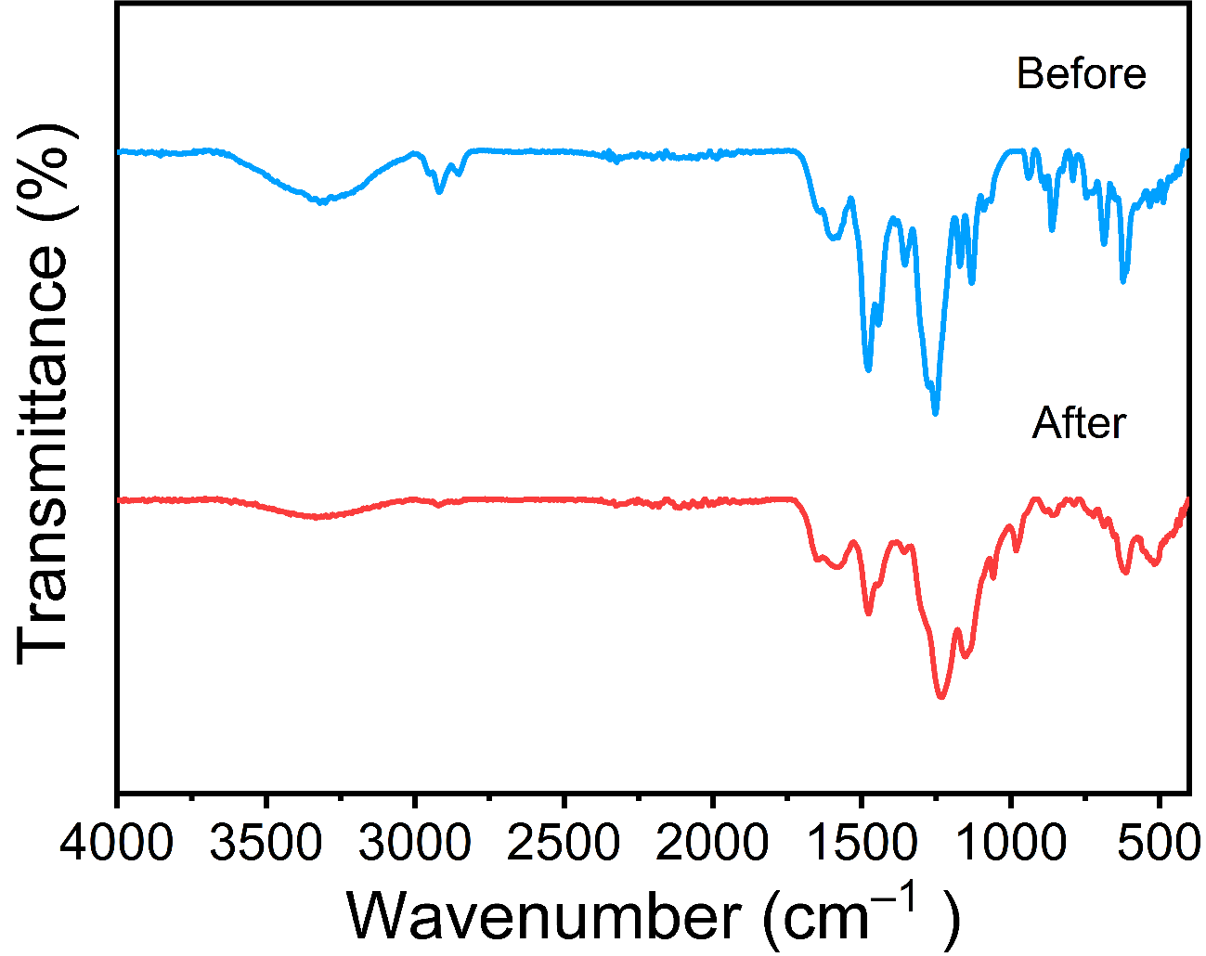
Fig. S53 FT-IR spectra of 2D-Cu-HOF before (red) and after (blue) CO₂RR
Fig. S54 High-resolution XPS C 1s (a), O 1s (b) and Cu 2p (c) spectra of 2D-Cu-HOF after CO₂RR
Fig. S55 Operando ATR-FTIR spectra of 2D-Cu-HOF in CO₂-saturated 0.1 M KHCO₃ electrolyte at the potential from 0 to −1.8 V vs. RHE (from bottom to top)
Fig. S56 The absorbance of *OCCHO of 2D-Cu-HOF in the operando ATR-FTIR spectra at the potential from 0 to −1.8 V vs. RHE
Fig. S57 The intermediate structures at the surface of 2D-Cu-HOF involved in the *COCOH pathway, *COCHO pathway, and C₁ pathway as calculated by DFT. The asterisk (*) represents chemisorbed species
Table S1 cRED data collection and crystallographic details of 2D-Cu-HOF
Chemical formula | C₄₂H₄₀CuO₁₆
Formula weight | 864.31
Temperature | 77 K
Crystal system | triclinic
Space group | P-1
a | 4.7100 Å
b | 10.640 Å
c | 18.230 Å
α | 84.900°
β | 86.500°
γ | 80.900°
Volume | 897.5 Å³
Radiation | Electron (λ = 0.002508 nm)

Table S2 The atomic sites of 2D-Cu-HOF
2D-Cu-HOF
Atom | x/a | y/b | z/c | Atom | x/a | y/b | z/c
Cu1 | 0.1000 | 0.0000 | 0.5000 | C16 | 0.3372 | 0.2314 | 0.0739
O2 | 0.7406 | 0.1253 | 0.0007 | C17 | 0.1574 | 0.2279 | 0.1363
O3 | 0.7297 | -0.063 | 0.4418 | C18 | 0.3835 | 0.2692 | 0.4002
O4 | 0.7737 | 0.1667 | 0.4761 | O19 | 0.5942 | 0.7105 | 0.2512
C5 | 0.5520 | 0.0262 | 0.4105 | C20 | 0.3456 | 0.0156 | 0.3581
C6 | 0.5575 | 0.1308 | 0.0611 | C21 | -0.0034 | 0.3712 | 0.3151
O7 | 0.7964 | -0.0862 | 0.1008 | C22 | -0.053 | 0.3530 | 0.1493
C8 | 0.0042 | 0.1060 | 0.2575 | C23 | 0.4337 | 0.6248 | 0.2320
C9 | 0.5768 | 0.1550 | 0.4316 | C24 | 0.1021 | 0.4510 | 0.1823
C10 | 0.1838 | 0.1199 | 0.1875 | C25 | 0.3928 | 0.6215 | 0.1562
C11 | 0.1930 | 0.2495 | 0.3460 | C26 | 0.2288 | 0.5362 | 0.1305
C12 | 0.1780 | 0.1264 | 0.3238 | C27 | 0.2960 | 0.5418 | 0.2827
O13 | 0.5236 | 0.7004 | 0.1051 | C28 | 0.1368 | 0.4517 | 0.2573
C14 | 0.4041 | 0.0127 | 0.1737 | O29 | 0.7100 | 0.6885 | 0.3979
C15 | 0.5903 | 0.0232 | 0.1114 | O30 | 0.7790 | 0.4314 | 0.5132
Table S3 The deconvolution of high-resolution XPS spectrum for 2D-Cu-HOF (FWHM: full width at half maxima)
Peak identification | Position (eV) | FWHM | Area (%)
Cu 2p_{3/2} | 934.3 | 3.59 | 44.43
Cu 2p_{1/2} | 954.3 | 4.19 | 22.75
Cu(II) satellite | 941.8 | 5.40 | 16.81
Cu(II) satellite | 944.3 | 2.80 | 5.50
Cu(II) satellite | 962.5 | 4.01 | 10.52
Table S4 The deconvolution of high-resolution XPS spectrum for 2D-Ni-HOF (FWHM: full width at half maxima)
Peak identification | Position (eV) | FWHM | Area (%)
Ni 2p_{3/2} | 855.2 | 2.26 | 20.20
Ni 2p_{1/2} | 872.8 | 2.38 | 8.09
Ni(II) satellite | 860.5 | 7.73 | 36.99
Ni(II) satellite | 878.7 | 10.5 | 34.72
Table S5 EXAFS fitting parameters for 2D-Cu-HOF
Sample | Bond | CN | r (Å) | σ² | ΔE₀ | R factor
2D-Cu-HOF | Cu–O | 4 | 1.93±0.03 | 0.007 | 3.55 | 0.0083
2D-Cu-HOF | Cu–C | 4 | 2.52±0.14 | 0.00059 | 0.56 | 0.0083
CN: coordination numbers; r: bond distance; σ²: Debye-Waller factors; ΔE₀: the inner potential correction. R factor: goodness of fit. Ѕ₀² was set to 0.85; Data ranges: 3 ≤ k ≤ 12.3 Å⁻¹, 1.0 ≤ R ≤ 3.0 Å.
Table S6 EXAFS fitting parameters for 2D-Ni-HOF
Sample | Bond | CN | r (Å) | σ² | ΔE₀ | R factor
2D-Ni-HOF | Ni–O | 3.84 | 2.04±0.07 | 0.009 | -4.43 | 0.008
CN: coordination numbers; R: bond distance; σ²: Debye-Waller factors; ΔE₀: the inner potential correction. R factor: goodness of fit. Ѕ₀² was set to 0.87; Data ranges: 3 ≤ k ≤ 12.3 Å⁻¹, 1.0 ≤ R ≤ 2.5 Å.
Table S7 Comparison of the CO₂RR products and selectivity with other reported Cu-based frameworks
Catalysts | Products | Selectivity (%) | Potential  (V vs. RHE) | Refs.
2D-Cu-HOF | C₂₊ | 82.1 | −1.2V | This work
Cu-MMT | C₂₊ | 73.75 | −1.15 | Nano Lett. 2024, 24, 1553.
def-Cu-HHTP-TFPN-1 | C₂H₄ | 54 | −1.2 | J. Mater. Chem. A, 2024, 12, 24549.
MIL-53(Cu) | C₂₊ | 55.5 | −1.19 | J. Am. Chem. Soc. 2023, 145, 21442.
2D-vc-MOF(Cu) | CH₄ | 65 | −1.4 | Angew. Chem. Int. Ed. 2023, 62, e202217958.
Ag@BIF-104NSs(Cu) | C₂H₄ | 21.43 | −1.2 | Adv. Energy Mater. 2023, 13, 2300088.
KB@Cu₃(HITP)₂ | C₂H₄ | 70 | −1.37 | Nat. Commun. 2021, 12, 6823.
HATNA-Cu-MOF | CH₄ | 78 | −1.5 | Angew. Chem. Int. Ed. 2021, 60, 14473.
Cu-THQ | CO | 91 | −0.45 | Adv. Mater. 2021, 33, 2004393.
PcCu-Cu-O | C₂H₄ | 50 | −1.2 | J. Am. Chem. Soc. 2021, 143, 7242.
Note. The above Faradaic selectivity is measured in H-cells.
Table S8 Comparison of the CO₂RR products and selectivity with other reported Ni-based frameworks
Catalysts | Products | Selectivity (%) | Potential  (V vs. RHE) | Refs.
2D-Ni-HOF | C₂H₅OH | 35.6 | −1.3 | This work
NiPc-Salen(Co)₂-COF | CO | 97.2 | −1.0 | Angew. Chem. Int. Ed. 2024, 63, e202319472.
Ni SAC-1000 | CO | 98.2 | −0.8 | J. Mater. Chem. A 2024, 12, 11090.
Ni₅₀/Zn₅₀ | CO/HCO₂H | 69/10 | −0.6 | ACS Appl. Mater. Interfaces 2024, 16, 34010.
Ni_{0.1}Zn_{0.9}/ZIF-8 | CO | 34.7 | −1.2 | Adv. Mater. 2023, 35, 2208224.
Ni/HNC | CO | 97.2 | −0.7 | Nano Res. 2023, 16, 8970.
MWCNT-Por-COF-Ni | CO | 56.4 | −0.6 | Appl. Catal., B 2022, 303, 120897.
TPPDA-NiPor-COF | CO | 76 | −0.9 | Inorg. Chem. Front. 2022, 9, 3217.
NiPc-COF | CO | 99.1 | −0.9 | Small 2020, 16, 2005254.
Ni-Pc-Cu-O | CO | 56 | −0.74 | J. Am. Chem. Soc. 2020, 142, 21656.
Note. The above Faradaic selectivity is measured in H-cells.
Table S9 Elemental content of Cu in Cu₃(HHTP)₂ and CuO₄@PPy (Cu was analyzed by ICP-MS)
Cu (wt.%) | Cu₃(HHTP)₂ | CuO₄@PPy
Calcd. | 23.18 | 11.36
Found | 23.10 | 12.05
Table S10 Elemental analysis of copper catecholate (CuO₄)
 | C (wt.%) | H (wt.%)
Calcd. | 51.52 | 2.88
Found | 50.74 | 2.71
Table S11 The deconvolution of high-resolution XPS spectrum for 2D-Cu-HOF after CO₂RR (FWHM: full width at half maxima)
Peak identification | Position (eV) | FWHM | Area (%)
Cu 2p_{3/2} | 934.0 | 3.65 | 42.98
Cu 2p_{1/2} | 954.0 | 4.65 | 22.18
Cu(II) satellite | 941.0 | 6.70 | 20.55
Cu(II) satellite | 944.2 | 2.06 | 4.26
Cu(II) satellite | 962.6 | 3.65 | 10.03

Supplementary References
- P.T. Lee, J.E. Thomson, A. Karina, C. Salter, C. Johnston et al., Selective electrochemical determination of cysteine with a cyclotricatechylene modified carbon electrode. Analyst 140, 236-242 (2015). https://doi.org/10.1039/C4AN01835D
- G.T. Illa, S. Hazra, P. Satha, C.S. Purohit, Hydrogen-bonded molecular capsules: probing the role of water molecules in capsule formation in modified cyclotricatechylene. CrystEngComm 19, 4759-4765 (2017). https://doi.org/10.1039/C7CE01075C
- B. Ravel, M. Newville, ATHENA, ARTEMIS, HEPHAESTUS: Data analysis for X-ray absorption spectroscopy using IFEFFIT. J. Synchrotron Radiat. 12, 537-541 (2005). https://doi.org/10.1107/S0909049505012719
- G. Kresse, D. Joubert, From ultrasoft pseudopotentials to the projector augmented-wave method. Phys. Rev. B 59, 1758-1775 (1999). https://doi.org/10.1103/PhysRevB.59.1758
- G. Kresse, J. Furthmüller, Efficiency of ab-initio total energy calculations for metals and semiconductors using a plane-wave basis set. Comput. Mater. Sci. 6, 15-50 (1996). https://doi.org/10.1016/0927-0256(96)00008-0
- J.P. Perdew, K. Burke, M. Ernzerhof, Generalized gradient approximation made simple. Phys. Rev. Lett. 77, 3865-3868 (1996). https://doi.org/10.1103/PhysRevLett.77.3865

