Supporting information

In-situ Partial-cyclized Polymerized Acrylonitrile-coated NCM811 Cathode for High-temperature ≥100 ℃ Stable Solid-state Lithium Metal Batteries

Jiayi Zheng^{1,+},Haolong Jiang^{1,+}, Xieyu Xu^{2,+},Jie Zhao¹, Xia Ma¹, Weiwei Sun¹, Shuangke Liu¹, Yufang Chen¹, ShiZhao Xiong³, Hui Wang¹, Kai Xie¹, Yu Han^{1,}*, Chunman Zheng^{1,}*, Maoyi Yi^{1,}*, Qingpeng Guo^{1,}*

1 College of Aerospace Science and Engineering, National University of Defense Technology, Changsha, Hunan 410073, China
2 State Key Laboratory for Mechanical Behavior of Materials, Xi'an Jiaotong University, Xi'an, Shanxi 710049, China
3 Faculty of Materials Science and Engineering, Kunming University of Science and Technology, Kunming, 650093 China
+ These authors contributed equally.
*Corresponding author. E-mail:
yumihan1981@sina.com (Y. Han)
zhengchunman@nudt.edu.cn (C. Zheng)
yimaoyi_1993@163.com (M. Yi)
qingpeng.guo@nudt.edu.cn (Q. Guo)

Supporting Tables and Figures
Table S1 Rietveld refinement parameters of XRD patterns for In-cPAN-260@NCM811 before and after cycling
Sample | a (Å) | c (Å) | Volume (Å) | I₍₀₀₃₎/I₍₁₀₄₎
Before cycling | 2.8709 | 14.1958 | 101.33 | 2.29
After cycling | 2.8737 | 14.2385 | 101.83 | 2.25

Fig. S1 XRD pattern of PAN and In-situ PAN.

Fig. S2 Arrhenius plot of ionic conductivity versus temperature for PAN electrolytes.

Fig. S3 Optical photographs of cPAN formed at different sintering temperatures.

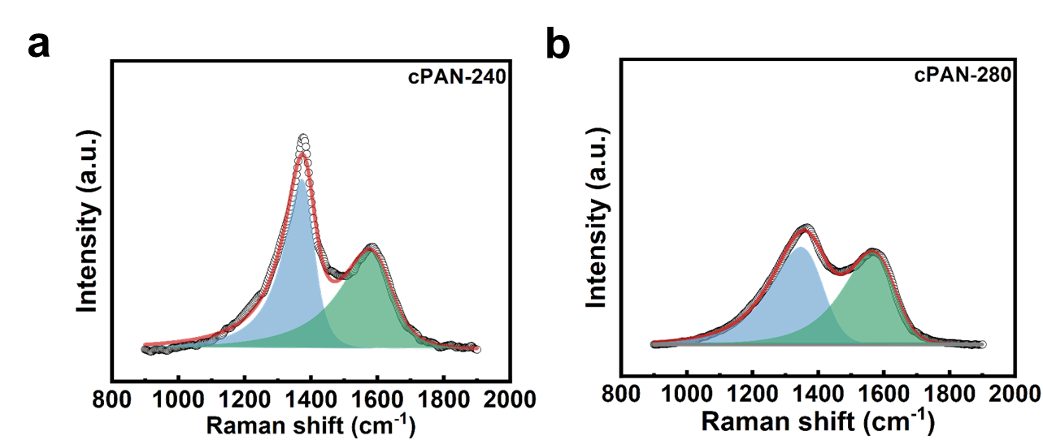
Fig. S4 Raman spectra of cPAN-240 and cPAN-280.

Fig. S5 XPS spectra of cPAN-240 and cPAN-280.

Fig. S6 XRD pattern of NCM811 and In-cPAN@NCM811.

Fig. S7 TEM images of (a) pristine NCM811 and (b) PAN@NCM811[1], (c)-(d) AFM images of pristine NCM811. (e)-(f) In-cPAN-260@NCM811.

Fig. S8 FTIR pattern of NCM811 and In-cPAN-260@NCM.

Fig. S9 Raman spectra of cPAN-260, NCM811 and In-cPAN-260@NCM811.

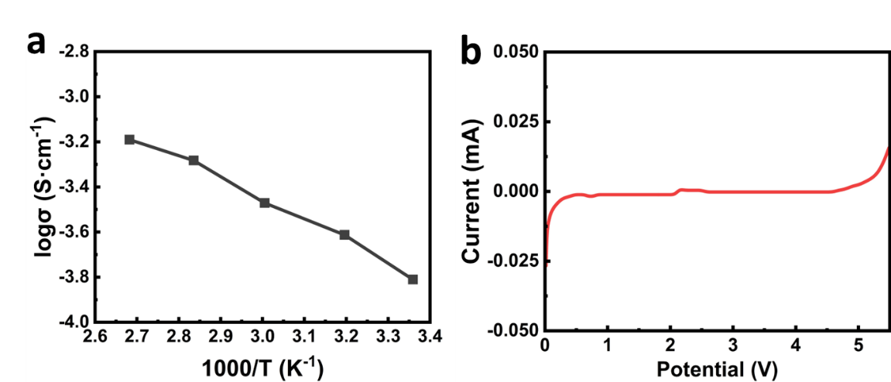
Fig. S10 a Arrhenius plot of ionic conductivity versus temperature for PVDF-HFP-based electrolyte. b LSV curves of PVDF-HFP-based electrolyte.

Fig. S11 Long cycling of PVDF-HFP-based electrolyte in symmetric cells at 0.05 mA·cm⁻² and 0.05 mAh·cm⁻².

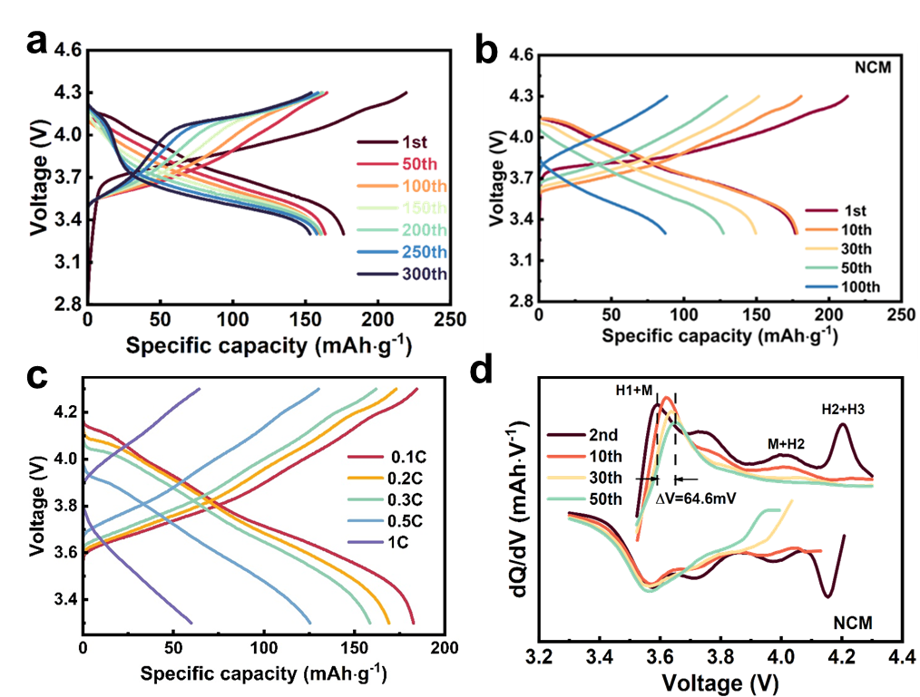
Fig. S12 a Charge and discharge curves of In-cPAN-260 @NCM811. b Charge and discharge curves of NCM811. c Charge and discharge curves of NCM811 at different current density. d The dQ/dV curves of NCM811.

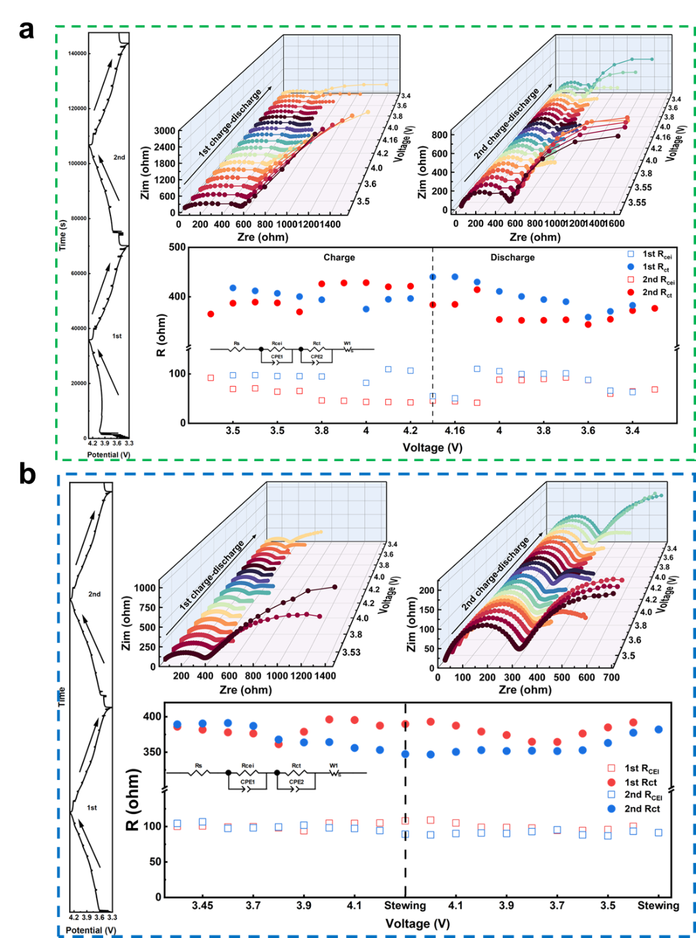
Fig. S13 In situ impedance spectra of a NCM811 and b In-cPAN-260@NCM811.

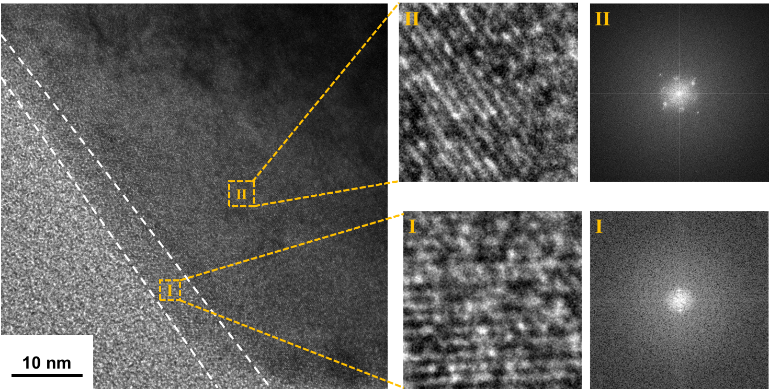
Fig. S14 TEM images of NCM811 cathode in NCM811/SCPE/Li batteries after 50 cycles.

Fig. S15 XRD Rietveld refinement patterns of In-cPAN-260@NCM811 before and after cycling.

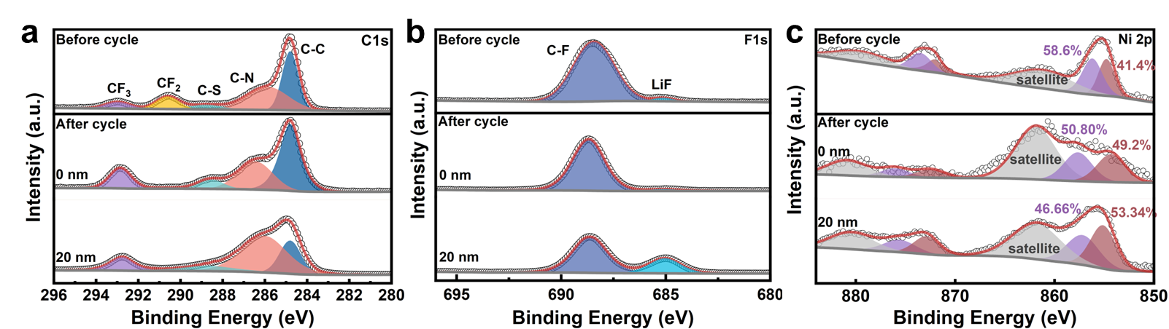
Fig. S16 XPS spectra of NCM811 cathode before and after cycling: (a) C1s; (b) F1s; (c) Ni2p.

Fig. S17 Visualization of cracks inside the NCM811 secondary of a NCM811 and b In-cPAN-260@NCM811 at different cycles.Visualization of damage inside the c NCM811 and d In-cPAN-260@NCM811 at different cycles.

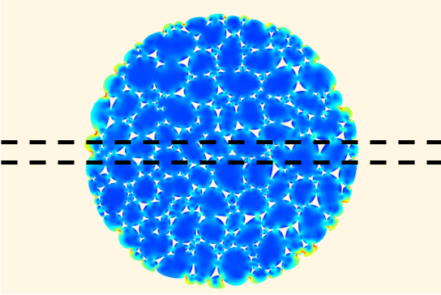
Fig. S18 Distribution of von Mises stress along the X-axis at Y=5 μm after different cycles, the slide width is 1.0 μm

Supporting References
[1] H. Jiang; X. Xu; Q. Guo; H. Wang; J. Zheng et al., Electro-chemo-mechanical design of polymer matrix in composited LiNi_{0.8}Co_{0.1}Mn_{0.1}O₂ cathode endows solid-state batteries with superior performance. J. Energy Chem. 78, 277 (2023). http://doi.org./10.1016/j.jechem.2022.11.059

