Supporting Information for
Highly Active Oxygen Evolution Integrating with Highly Selective CO₂-to-CO Reduction
Chaowei Wang^{1,2}, Laihong Geng³, and Yingpu Bi^{1,}*
¹State Key Laboratory for Oxo Synthesis and Selective Oxidation, National Engineering Research Center for Fine Petrochemical Intermediates, Lanzhou Institute of Chemical Physics, Chinese Academy of Sciences, Lanzhou 730000, P. R. China
²University of Chinese Academy of Sciences, Beijing 100049, P. R. China
³Gansu Research Institute of Chemical Industry Co., Ltd, Lanzhou 730000, P. R. China
*Corresponding author. E-mail: yingpubi@licp.cas.cn (Yingpu Bi)
S1 Experimental Section
S1.1 Materials
Bismuth nitrate pentahydrate (Bi(NO₃)₃·5H₂O, 99%), potassium iodide (KI, 99%), quinhydrone, vanadium acetylacetone oxygen (VO(acac)₂), nitric acid (HNO₃), ethanol, iron chloride hexahydrate (FeCl₃·6H₂O, 99%), nickel chloride hexahydrate (NiCl₂·6H₂O, 98%), sodium hydroxide (NaOH, 96%), sodium sulfite (Na₂SO₃), boric acid (H₃BO₃), potassium hydroxide (KOH, 99%), zinc nitrate (Zn(NO₃)₂·6H₂O, 99%), cobaltous nitrate hexahydrate (Co(NO₃)₂·6H₂O, 99%), potassium bicarbonate (KHCO₃, 99.5%) were purchased from Sinopharm Chemical Reagent Co., Ltd. 2-Methylimidazole (C₄H₆N₂) and Cobalt phthalocyanine were bought from Shanghai Aladdin Biochemical Technology Co., Ltd. Deionized water (18.25 MΩ) was used in all reactions. All reagents were analytical grade and used without further purification. Fluorine doped Tin Oxide coated glasses (FTO) as substrates were obtained from Zhuhai Kaivo Electronic Components Co., Ltd. China. FTO was washed by ultrasonic cleaning with acetone, ethanol, isopropanol and deionized water, successively before use.
S1.2 Preparation of BiVO₄-Ov and BiVO₄-Ov/NiFe photoanodes
The BiVO₄ photoanodes were treated by Ar plasma with a medium power (10.5 W) under 300 Pa for 2 min to obtain BiVO₄-Ov. BiVO₄-Ov/NiFe photoanodes were prepared by the above impregnation method excepted for BiVO₄ was replaced with BiVO₄-Ov.
S1.3 Preparation of Co NPs-NC
4 mmol Co(NO₃)₂·6H₂O was dissolved in 40 mL deionized water, then 8 mmol NaBH₄ was added into the solution and stirred for 12 h. Co NPs were obtained by centrifugation, washed with deionized and dried at 60 ℃ under vacuum. The 60 mg as-prepared NC was dispersed in 60 mL deionized water with ultrasonication for 30 min. Then 12 mg Co NPs were added to the suspension and followed by ultrasonication for 30 min, then stirred for 24 h at room temperature. The precipitate was centrifuged and washed by deionized water, followed by dried at 60 ℃ under vacuum to yield Co NPs-NC.
S1.4 Preparation of Co-NC
A solution of Zn(NO₃)₂·6H₂O (1.67 g) and Co(NO₃)₂·6H₂O (0.041 g) dissolved in 42 mL of methanol was mixed with 2-methylimidazole methanol solution (1.84 g/21 mL) and stirred vigorously for 1 h, then kept still for 24 h at room temperature. The solid (Co-MOF) was collected by centrifugation, washed with methanol for three times and dried at 60 ℃ under vacuum. The Co-MOF samples were calcined at 1000 ℃ in a tube furnace under Ar flow for 2 h with the ramping rate of 2 ℃/min to obtain Co-NC.
S1.5 Performance evaluation of PEC CO₂ reduction with two-electrode system
In a typical artificial photosynthetic system, the cells consisting of the anode cell, cathode cell, and a proton exchange membrane (Nafion 115). The electrolyte was 0.5 M K₃BO₃ for anode and CO₂-saturated 0.5M KHCO₃ for cathode. And the prepared BiVO₄/NiFe-Ov and CoPc-NC were used as the working electrode (photoanode) and counter electrode (cathode), respectively. In addition, the BiVO₄/NiFe-Ov photoanode was connected with a working electrode, and the CoPc-NC cathode was connected with a counter electrode and reference electrode. And the working electrode was placed under simulated sunlight irradiation (100 mW/cm²) with different cell voltage, while the cathodic cell was placed in dark condition. Before the reaction, the cathode cell was saturated by bubbling with CO₂ gas for 30 min. During the reaction, the gas composition of the cathode cell was analyzed by Shimadzu GC-2014C gas chromatography.
S1.6 Faradaic efficiency
$$FE \left(\%\right)=\frac{m×n×F}{I×t}×100$$
FE is the Faradaic efficiency; m is the mole amount of the product, mol; n is the number of electrons transferred in the reaction; I is the current density in the system, A; t is the reaction time, s; F is the Faradaic constant, 96485.3 C/mol.
S1.7 Solar energy conversion efficiency
The total reaction equation of the artificial photosynthetic cells:
$$xCO_{2} \left(g\right)+yH_{2}O \left(l\right)=xCO \left(g\right)+yH_{2} \left(g\right)+ \frac{x+y}{2}O_{2} (g)$$
The Gibbs free energy of the whole reaction:
$$∆_{r}G^{θ}=x∆_{f}G_{m}^{θ}\left(CO\left(g\right)\right)+y∆_{f}G_{m}^{θ}\left(H_{2}\left(g\right)\right)+\frac{x+y}{2}∆_{f}G_{m}^{θ}\left(O_{2}\left(g\right)\right)-x∆_{f}G_{m}^{θ}\left(CO_{2}\left(g\right)\right)-y∆_{f}G_{m}^{θ}\left(H_{2}O\left(l\right)\right)=257.2x+237.1y$$
Solar-to-CO conversion efficiency (STC):
$$STC \left(\%\right)= \frac{257.2x}{P_{Irradiate}×t_{Irradiate}} ×100=\frac{257.2×62.2}{100×3600}×100=4.44\%$$
Solar-to-H₂ conversion efficiency (STH):
$$STH \left(\%\right)= \frac{237.1y}{P_{Irradiate}×t_{Irradiate}} ×100=\frac{237.1×14.7}{100×3600}×100=0.97\%$$
P_{Irradiate} is the total power of the irradiation light, mW. t_{Irradiate} is the time of irradiation, s. x and y are the production of CO and H₂, respectively, μmol.
Solar-to-fuel conversion efficiency (STF):
$$STF (\%)=STC+STH=4.44\%+0.97\%=5.41\%$$
S2 Supplementary Figures and Discussions
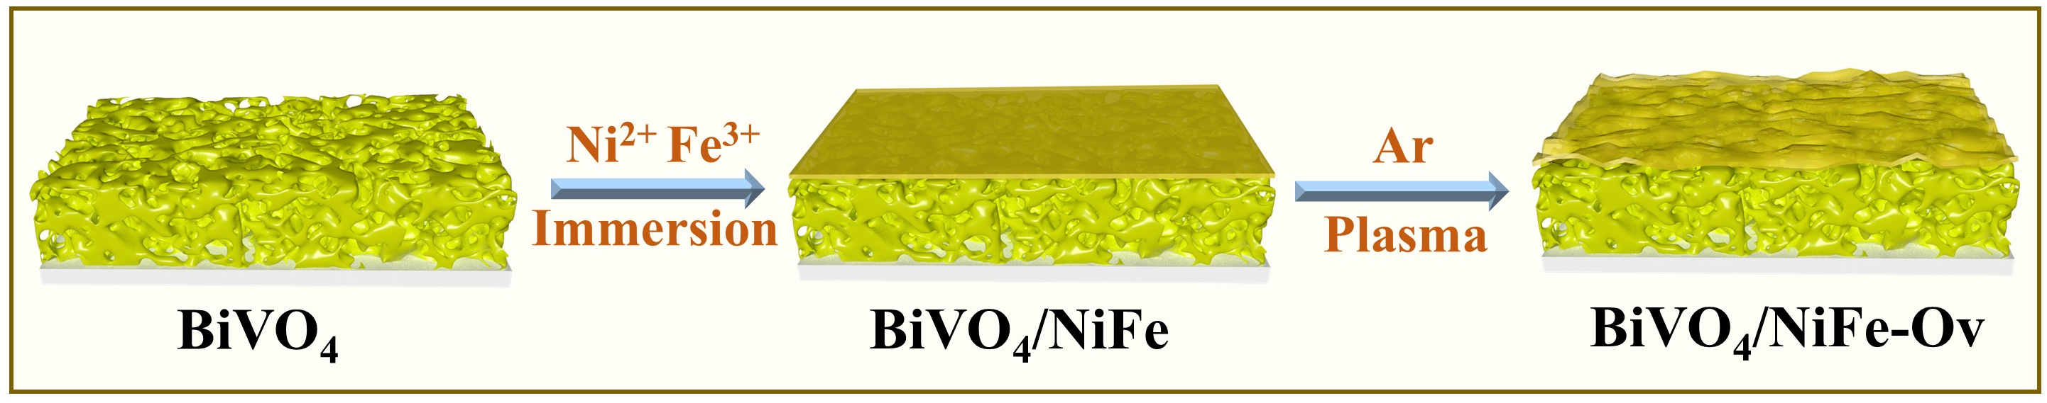
Scheme S1 Diagram of the preparation process of BiVO₄/NiFe-Ov photoanodes

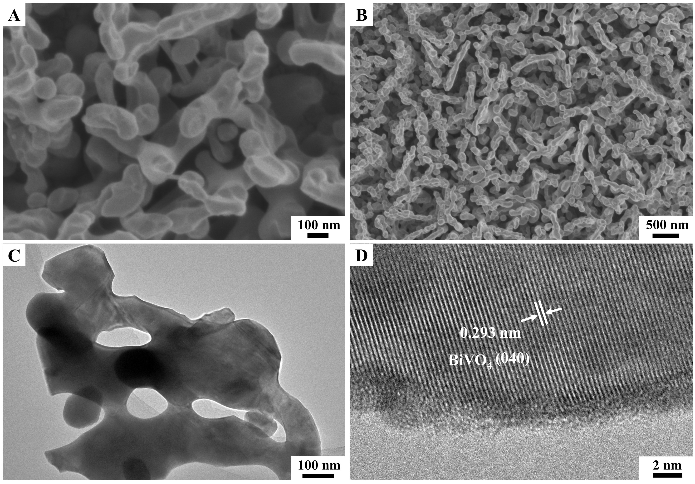
Fig. S1 (A, B) SEM images of and (C, D)TEM images of BiVO₄ photoanodes

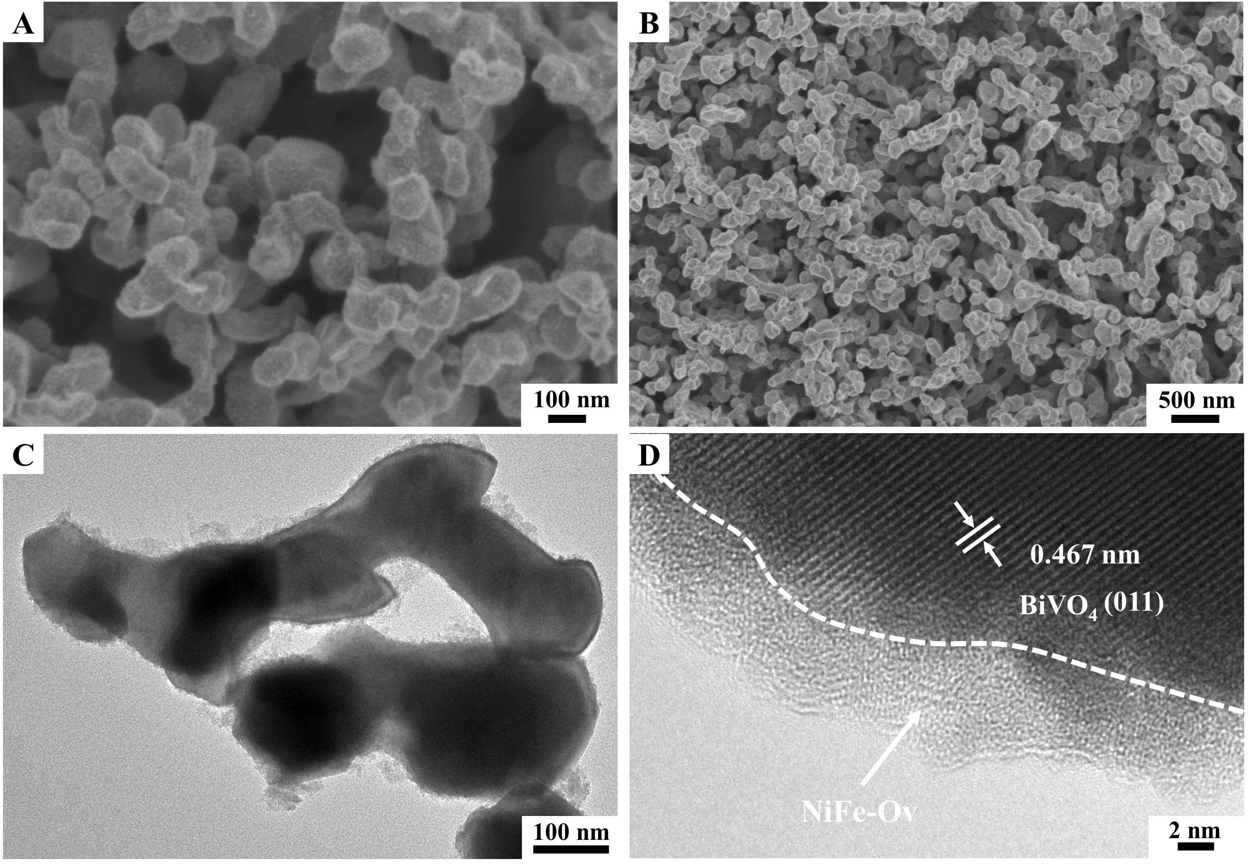
Fig. S2 (A, B) SEM images of and (C, D)TEM images of BiVO₄/NiFe-Ov photoanodes
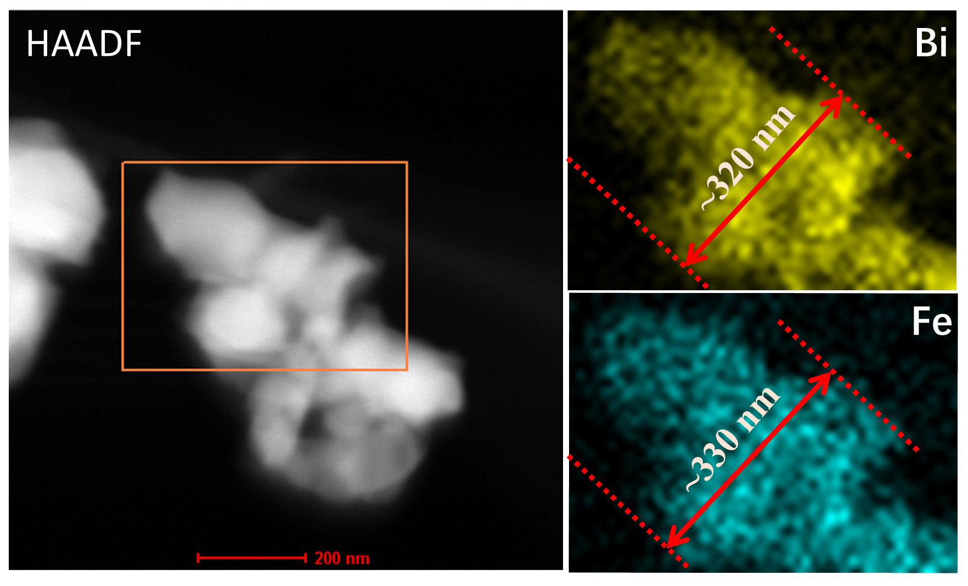
Fig. S3 EDS mapping analysis of BiVO₄/NiFe-Ov photoanodes
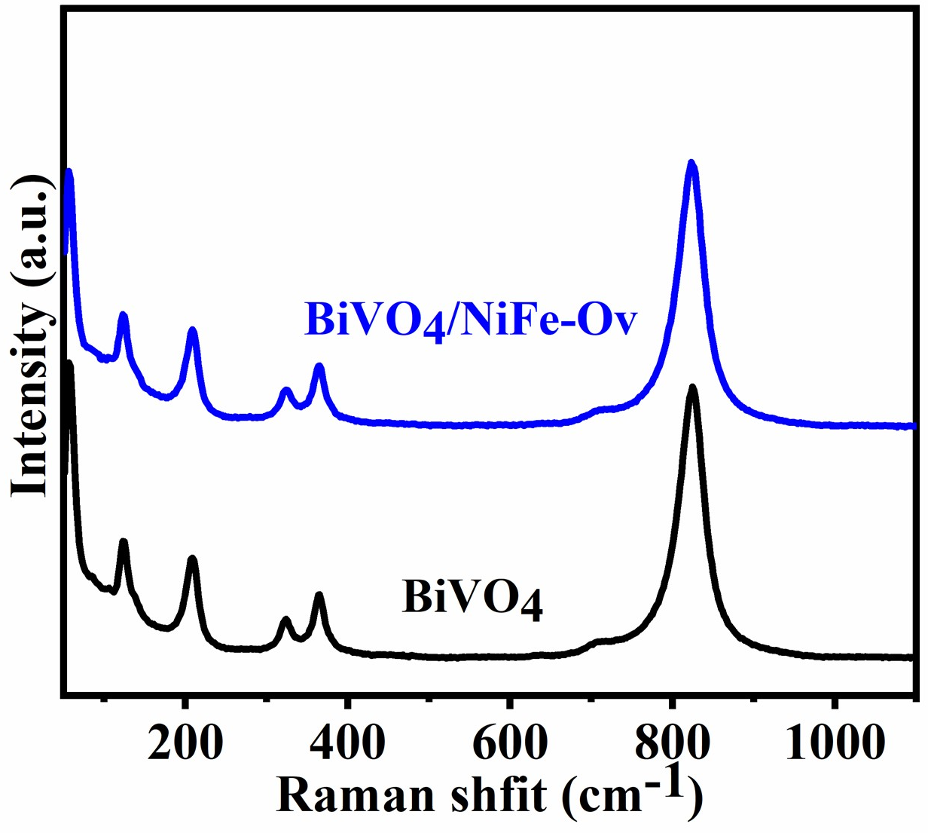
Fig. S4 Raman spectra of BiVO₄ and BiVO₄/NiFe-Ov photoanodes
Additional discussion
Raman spectra was performed to explore the local structures under the green (532 nm) laser. It was found that the typical vibrational bands of BiVO₄ located at 210, 324, 366, and 826 cm⁻¹ were observed for BiVO₄, which could be assigned to the vibration of VO₄³⁻ (324 and 366 cm⁻¹) and V-O (826 cm⁻¹) [S1], and no bands of NiFeOOH was observed for BiVO₄/NiFe-Ov. This result confirms the amorphous structure and ultrathin thickness of NiFe-Ov.
Fig. S5 The calculated photocurrent density curves by integrating IPCE curves with the standard AM1.5 G spectrum
Additional discussion
The estimated photocurrent densities (J_{c}) were calculated by integrating the IPCE values with the standard solar spectrum (ASTMG-173-03) using the following equation:
$$J_{c}=\int_{350}^{600}{\frac{λ×IPCE\left(λ\right)×E\left(λ\right)}{1240}}d(λ)$$
Specifically, λ and E(λ) represent the light wavelength (nm) and the corresponding solar power density (mW cm⁻² nm⁻¹), respectively. According to the above equation, the calculated photocurrent densities for BiVO₄ and BiVO₄/NiFe-Ov photoanodes were 1.49 and 6.48 mA cm⁻² at 1.23 V_{RHE}, respectively, which are both close to the measured values (1.55 and 6.51 mA cm⁻² for BiVO₄ and BiVO₄/NiFe-Ov, Fig. 2a).
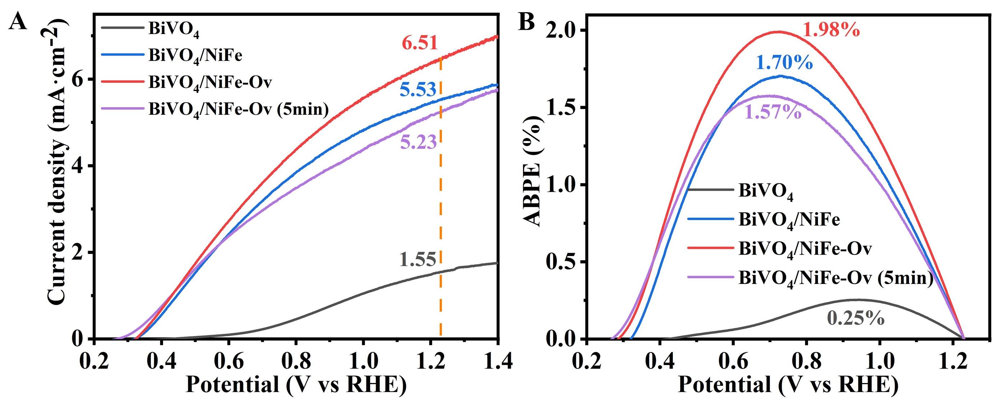
Fig. S6 LSV (A) and ABPE (B) curves for BiVO₄, BiVO₄/NiFe, BiVO₄/NiFe-Ov, and BiVO₄/NiFe-Ov (5min) photoanodes measured in 0.5 M K₃BO₃ electrolyte
Additional discussion
Figure S6 shows the infuence of Ar-plasma treatment time on PEC water oxidation performance of BiVO₄/NiFe photoanodes. At 1.23 V_{RHE}, the BiVO₄/NiFe-Ov (2 min) possesses a higher photocurrent density of 6.51 mA·cm⁻¹ than BiVO₄/NiFe (0 min, 5.53 mA·cm⁻¹) and BiVO₄/NiFe-Ov (5 min, 5.23 mA·cm⁻¹) photoanodes, respectively. In addition, the BiVO₄/NiFe-Ov also exihibits a highest ABPE value of 1.98% at 0.72 V_{RHE}. This results indicate the Ar-plasma treatment time on NiFeOOH catalyst play a crucial roles in PEC activity of BiVO₄/NiFe photoanodes.
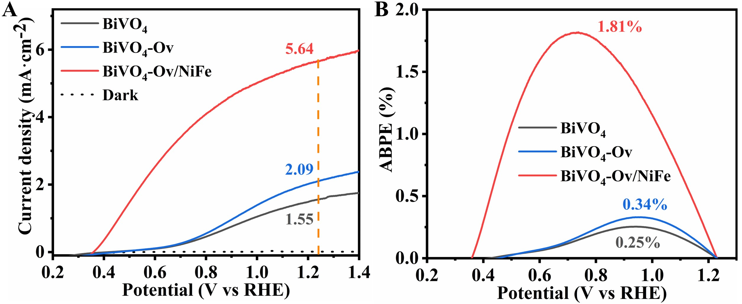
Fig. S7 LSV (A) and ABPE (B) curves for BiVO₄, BiVO₄-Ov, and BiVO₄-Ov/NiFe photoanodes measured in 0.5 M K₃BO₃ electrolyte
Additional discussion
The effects of Ar-plasma treatment on the PEC performances of pristine BiVO₄ have also been studied. The photocurrent density of BiVO₄-Ov (2.09 mA cm⁻¹) is slightly higher than that of pristine BiVO₄ (1.55 mA cm⁻¹), while the photocurrent of BiVO₄-Ov/NiFe (5.64 mA cm⁻¹) is nearly consistent with BiVO₄/NiFe (5.53 mA cm⁻¹) but obviously lower than BiVO₄/NiFe-Ov (6.51 mA cm⁻¹). These results clearly indicate the improvement of PEC activity for BiVO₄/NiFe-Ov should be mainly attributed to the oxygen vacancy formation on NiFe catalyst nanolayers instead of BiVO₄.
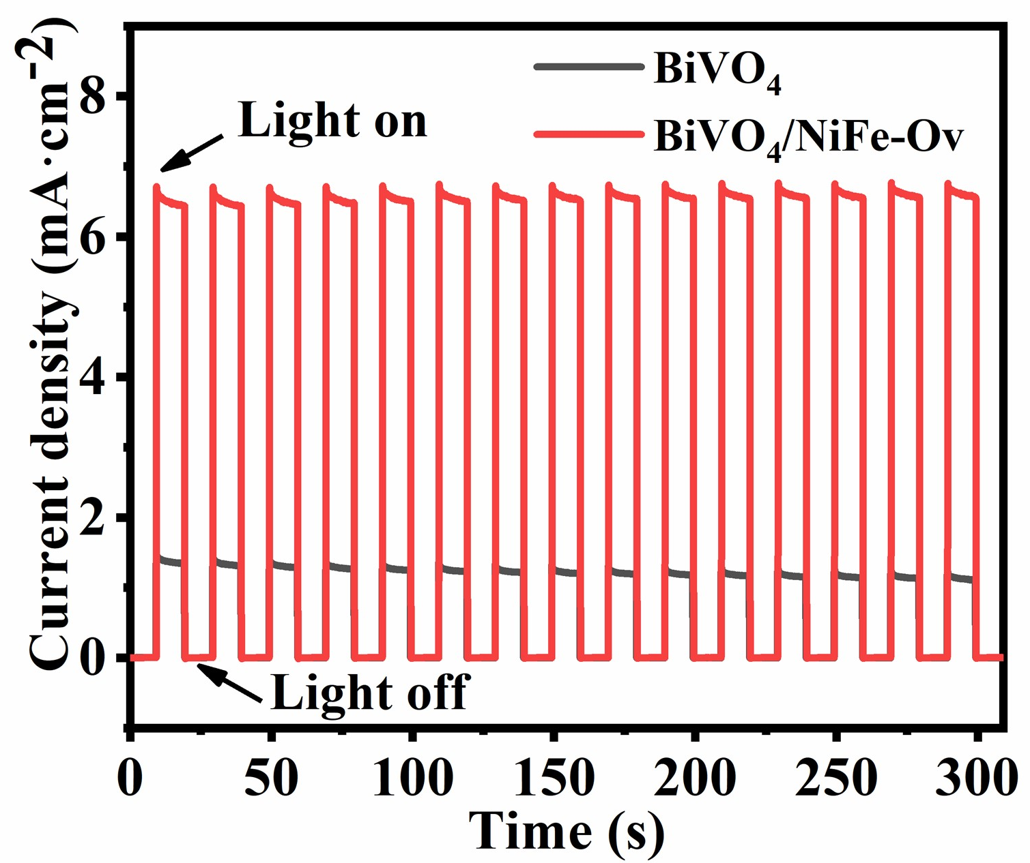
Fig. S8 The chopped irradiation i-t curve of BiVO₄ and BiVO₄/NiFe-Ov photoanodes
Additional discussion
The chopped irradiation i-t curve exhibits the low charge recombination of BiVO₄/NiFe-Ov compared with BiVO₄ photoanodes.

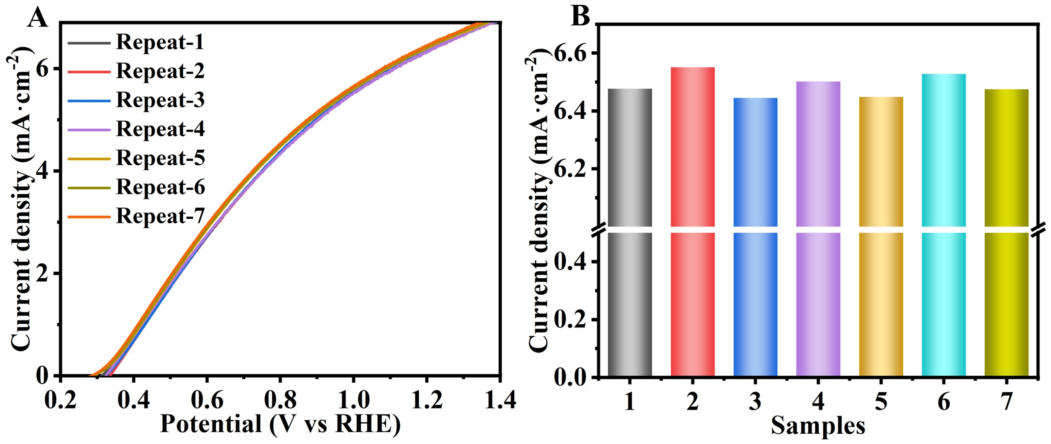
Fig. S9 (A) Reproducibility of the LSV curves of the BiVO₄/NiFe-Ov photoanodes, and (B) the statistics of the corresponding photocurrent at 1.23 V_{RHE}
Additional discussion
The LSV curves for seven prepared BiVO₄/NiFe-Ov photoanodes under the same conditions have been measured (Fig. S9A), and their current densities at 1.23 V_{RHE} have been summarized in Fig. S9B. Obviously, the obtained average current density of 6.51 mA cm⁻² at 1.23 V_{RHE}, suggesting the relatively high repeatability of BiVO₄/NiFe-Ov photoanodes.
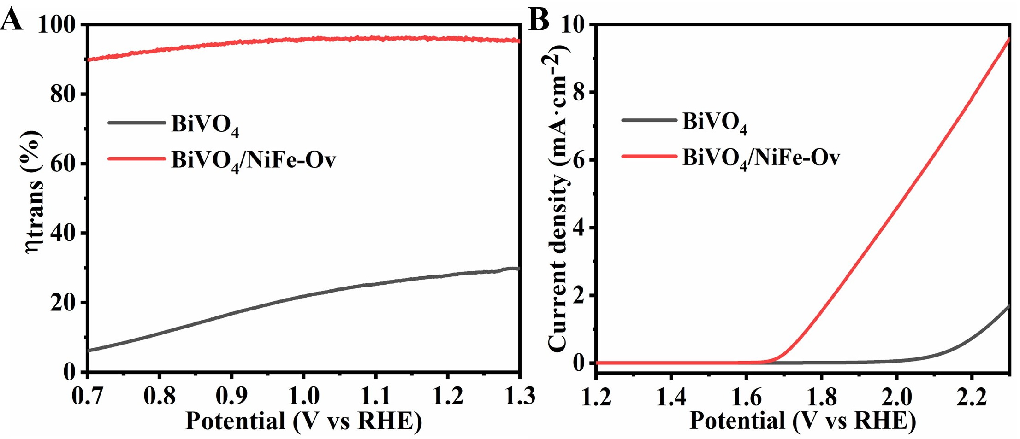
Fig. S10 (A) The charge transfer efficiencies (η_{trans}) and (B) LSV curves in the dark of BiVO₄ and BiVO₄/NiFe-Ov photoanodes
Additional discussion
As shown in Fig. S10A, the interfacial charge separation efficiencies (η_{trans}) are important for PEC water oxidation, which was explored by using 0.2 M Na₂SO₃ as a hole scavenger. According to the equation of J_{water}/J_{sulfite} from the LSV curves, a much higher charge separation efficiency have been obtained on the BiVO₄/NiFe-Ov compared with that of the BiVO₄ photoanodes, indicating the crucial roles of the NiFe-Ov catalyst for promoting the interfacial charge separation and hole transport. Moreover, the electrochemical OER properties under darkness have also been investigated and shown in Fig. S10B. Obviously, BiVO₄/NiFe-Ov exhibits a lower overpotential and higher water oxidation current density compared with BiVO₄, further demonstrating the outstanding OER performance of the BiVO₄/NiFe-Ov photoanodes.
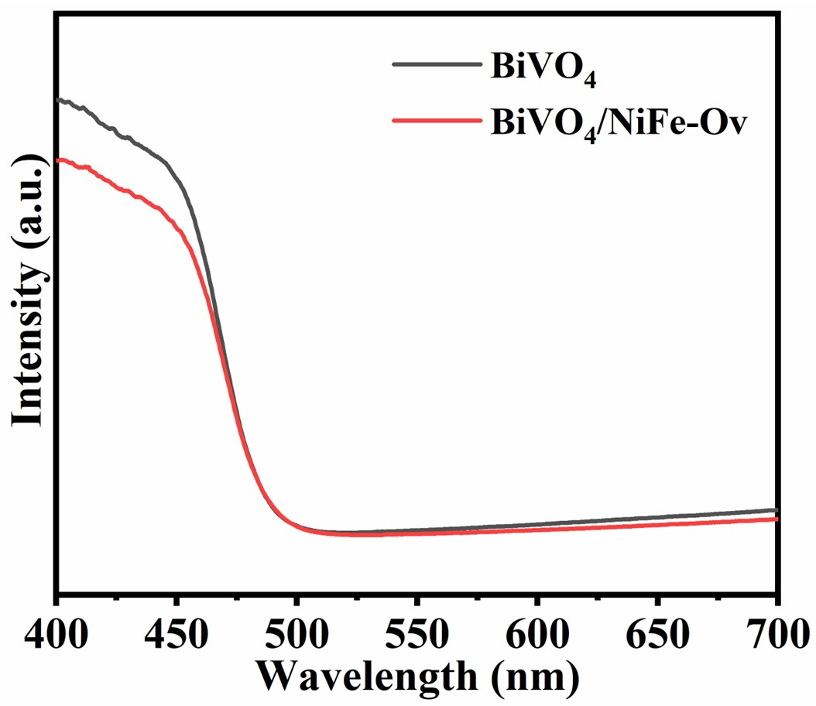
Fig. S11 UV-vis diffuse reflectance spectra of BiVO₄ and BiVO₄/NiFe-Ov photoanodes
Additional discussion
Figure S11 shows the UV-vis diffuse reflectance spectra of the BiVO₄ and BiVO₄/NiFe-Ov photoanodes, and no obvious change for the absorption band-edge could be observed, varifing that the decoration of NiFe-Ov catalyst has no evident effect on the optical absorption properties of BiVO₄ photoanodes.
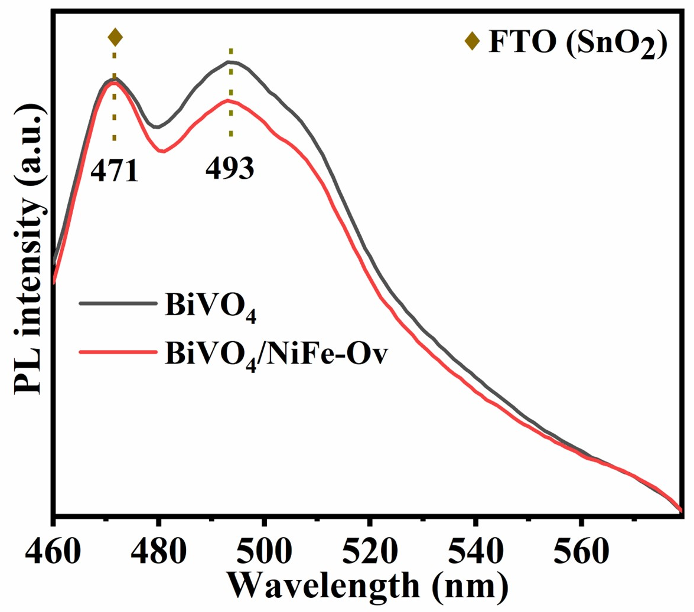
Fig. S12 Photoluminescence spectra of BiVO₄ and BiVO₄/NiFe-Ov photoanodes
Additional discussion
As shown in Fig. S12, to further explore the charge separation capability, the Photoluminescence spectras (PL) of the BiVO₄ and BiVO₄/NiFe-Ov photoanodes were measured under laser excitation of 355 nm. Obviously, two PL peaks at 471 and 493 nm have been detected, which assigned to FTO (SnO₂) substrate and the radiative recombination of hole in O 2p band and electron in V 3d band for BiVO₄, respectively [S2, S3]. A much weaker PL peak intensity has been obtained on BiVO₄/NiFe-Ov compared with that of the BiVO₄ photoanodes, demonstrating the relatively low electron-hole recombination after decorating NiFe-Ov catalyst on BiVO₄. Therefore, BiVO₄/NiFe-Ov photoanodes possess more efficient capability of charge separation.
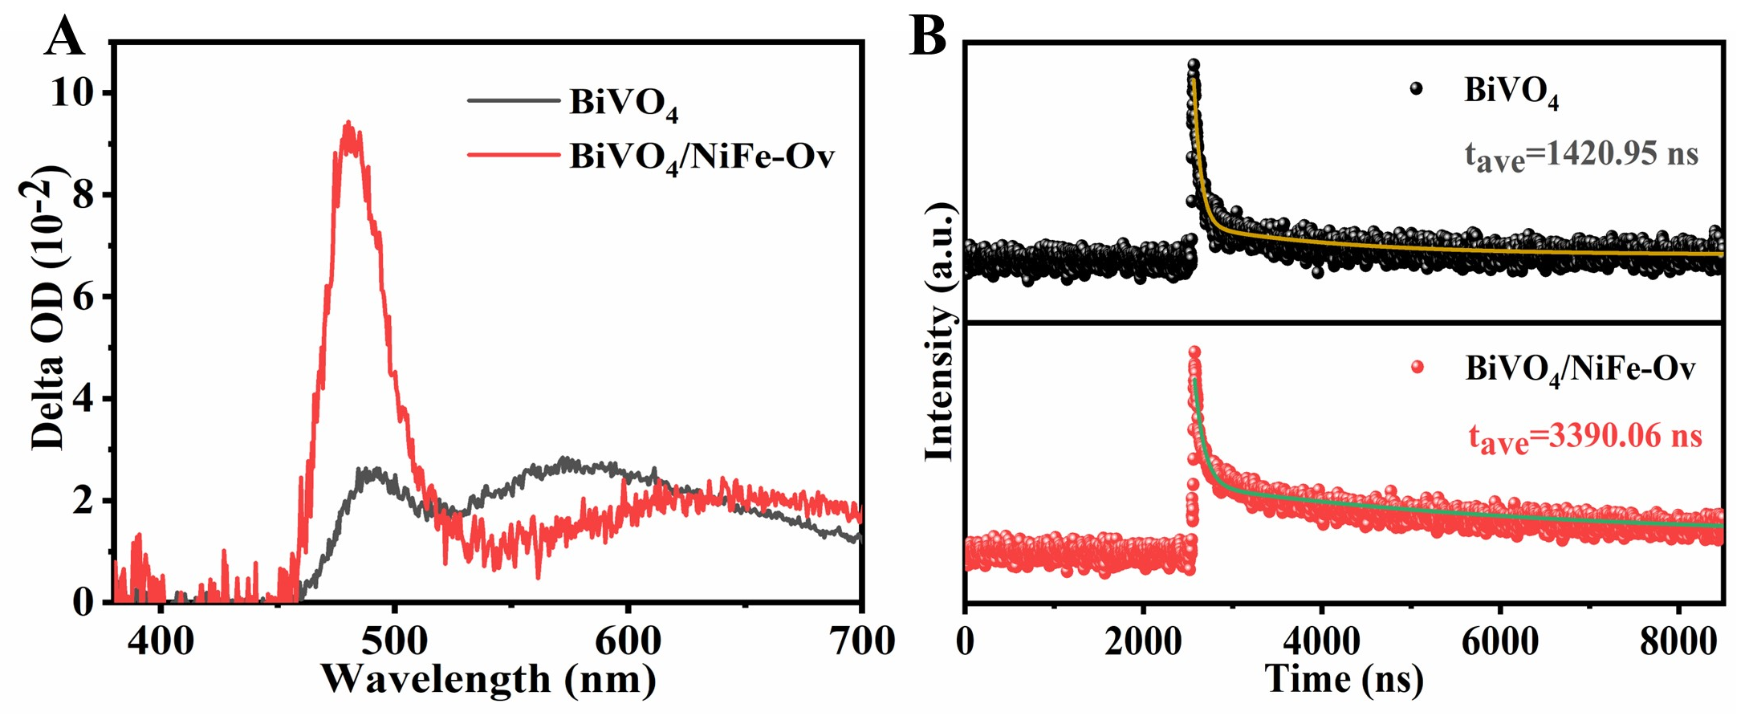
Fig. S13 (A) Transient absorption (TA) spectra and (B) time-resolved TA curves of BiVO₄ and BiVO₄/NiFe-Ov photoanodes
Additional discussion
The energy relaxation process and charge transfer behavior under excited states have been evaluated by the time-resolved transient absorption spectra (TR-TAS). Fig. S13A shows that the BiVO₄/NiFe-Ov photoanodes exhibit a higher peak intensity than BiVO₄, indicating that the photo-induced absorption processes have been significantly improved after the decoration of the NiFe-Ov catalysts. As shown in Fig. S13B and Table S2, the BiVO₄/NiFe-Ov photoanodes possess a longer carrier lifetime compared with BiVO₄ photoanodes. Based on the above analysis, it can be concluded that the NiFe-Ov catalysts exhibit a preferable capability for promoting charge separation and extending the carrier lifetimes.
Fig. S14 The spectra of SPECM surface tip currents of the BiVO₄ photoanode with and without NiFe-Ov catalysts under light irradiation
Additional discussion
To further investigate the surface photoactive properties, scanning photoelectrochemical microscopy (SPECM) has been conducted. As shown in Fig. S14, a relatively low photocurrent was obtained under light illumination on the pristine BiVO₄ regions, while the photocurrent drastically improved on the BiVO₄/NiFe-Ov regions. This result clearly indicates that BiVO₄/NiFe-Ov possesses the higher water oxidation capability than BiVO₄, which is line with their PEC water oxidation activities.
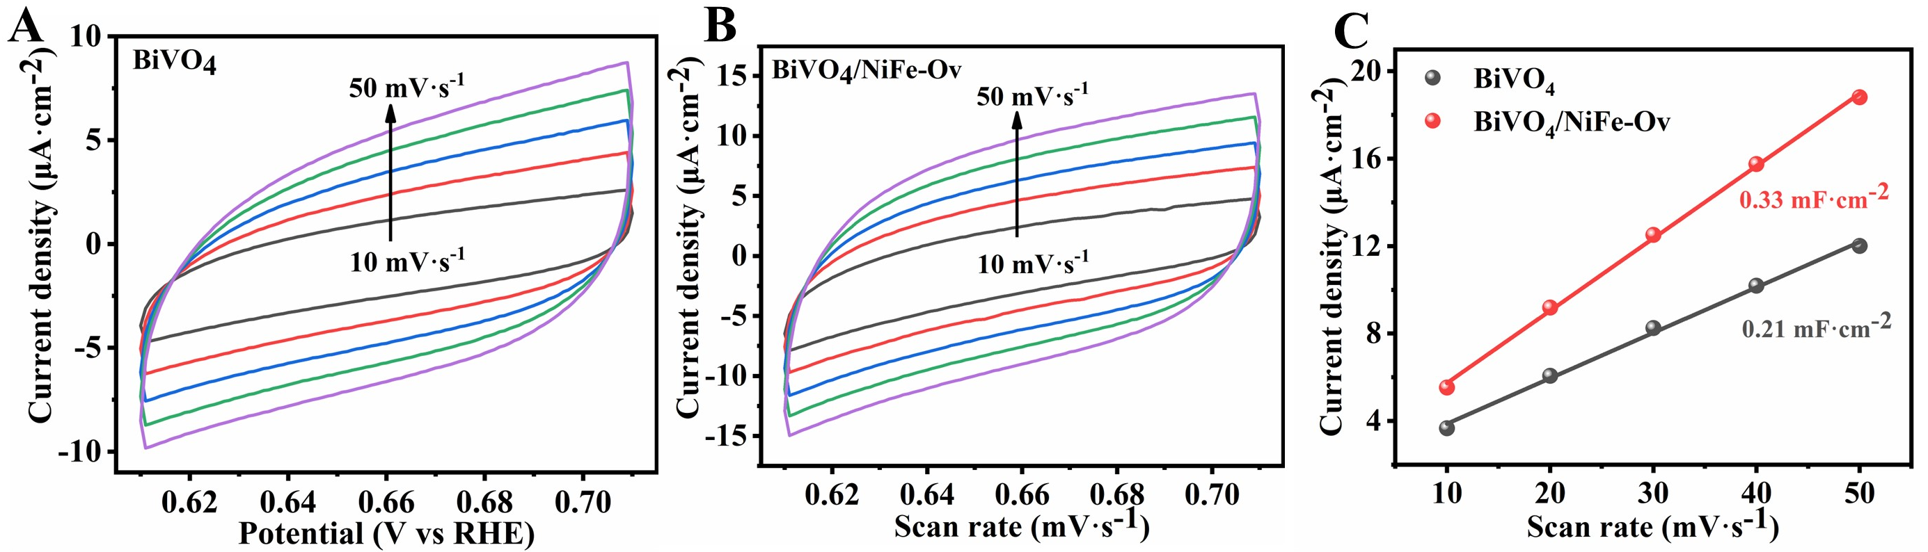
Fig. S15 The cyclic voltammetry curves of (A) BiVO₄, and (B) BiVO₄/NiFe-Ov with the scan rates from 0.01 to 0.05 V/s, and (C) the electrochemical double layer capacitance of BiVO₄ and BiVO₄/NiFe-Ov
Additional discussion
To explore the electrochemical active surface area, cyclic voltammetry curves have been performed at 0.66 V_{RHE} in 0.5 M K₃BO₃ under dark conditions. As shown in Fig. S15, the electrochemical double layer capacitance (C_{dl}) of BiVO₄ and BiVO₄/NiFe-Ov have been achieved to 0.21 and 0.33 mF·cm⁻², respecyively. This result confirms the significantly increases the surface active sites of BiVO₄ photoanodes after the decoration of NiFe-Ov catalyst.
Fig. S16 Room-temperature EPR spectra of BiVO₄ and BiVO₄/NiFe-Ov
Additional discussion
The oxygen vacancies were further investigated by electron paramagnetic resonance (EPR) spectroscopy (Fig. S16). Compared with BiVO₄ photoanodes, BiVO₄/NiFe-Ov exhibits a significantly enhanced EPR signal at g = 2.003, indicating that more oxygen vacancies should be formed in NiFe-Ov catalysts.
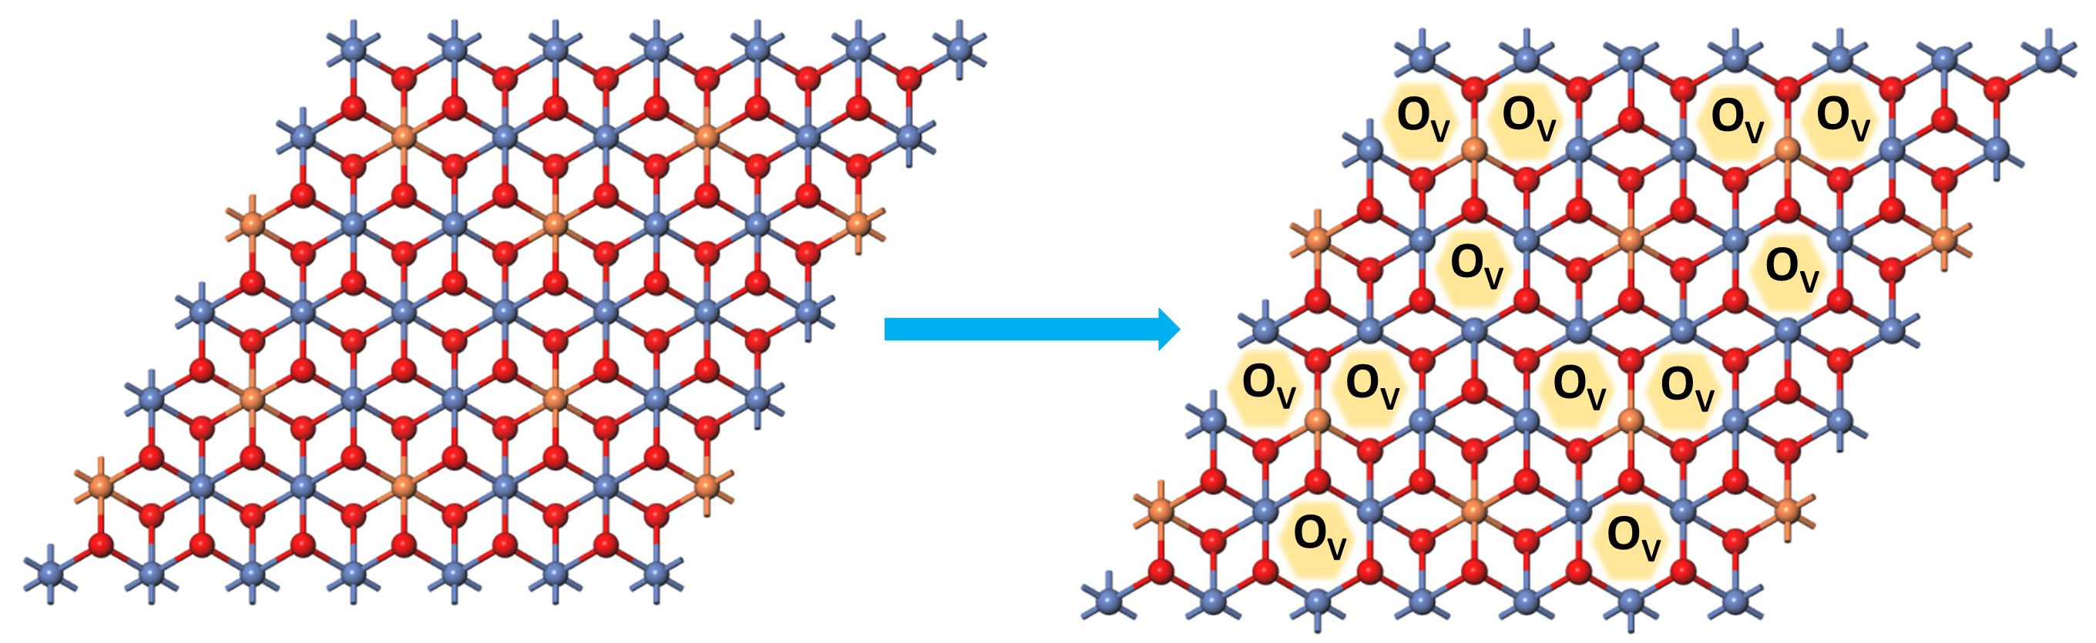
Scheme S2 Diagram of NiFeOOH and NiFe-Ov, Ni (blue), Fe (orange), O (red)
Additional discussion
According to the XPS O 1s spectra and EPR result (Fig. 1F and Fig. S16), the BiVO₄/NiFe-Ov photoanodes possess the abundant oxygen vacancies. Additionally, as shown in Scheme. S2, the coordination number of NiFe catalyst could be reduced in the presence of oxygen vacancies

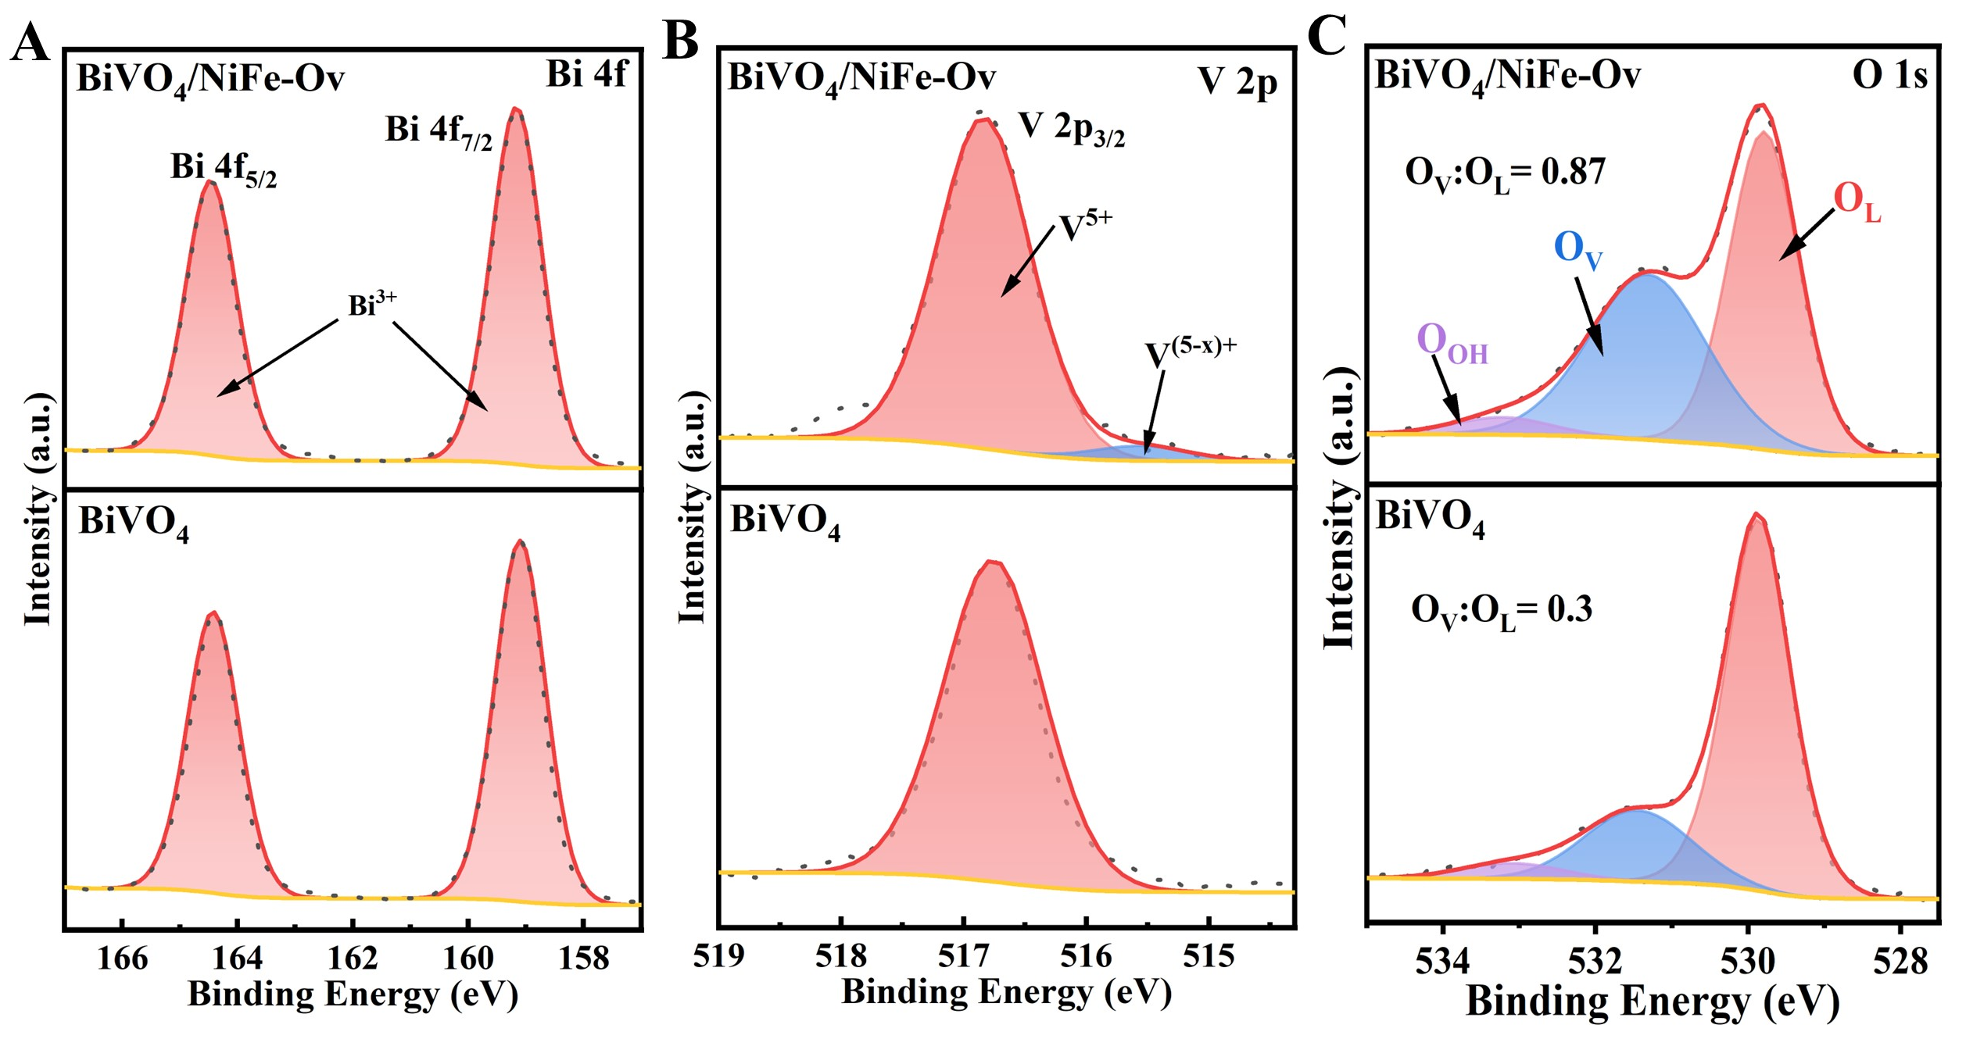
Fig. S17 XPS high-resolution (A) Bi 4f, (B) V 2p and (C) O 1s spectra of BiVO₄ and BiVO₄/NiFe-Ov photoanodes
Additional discussion
The chemical states and electronic structures of the BiVO₄/NiFe-Ov photoanodes were investigated by high-resolution X-ray photoelectron spectroscopy (XPS). The evidently changes of Bi 4f, V 2p, and O 1s peaks were observed for BiVO₄/NiFe-Ov photoanodes compared to BiVO₄ (Fig. S17). Specifically, for BiVO₄/NiFe-Ov, the peak at binding energy of 159.1 and 164.3 eV for Bi 4f spectra, attributed to the Bi³⁺ species, while a shoulder peak at 515.5 eV for V 2p spectra, assinged to the low-valence V^{(5-x)+} species caused by the injection of eletrons from electron-rich NiFe-Ov to BiVO₄. In addition, the peaks of O 1s spectra at 529.8, 531.2, and 532.4 eV could be assinged to the lattice oxygens (O_{L}), oxygen vacancies (O_{V}), hydroxyl oxygens (O_{OH}), respectively. Apparently, the intensity of Ov peak has remarkedly increased for BiVO₄/NiFe-Ov photoanodes, indicating the nature of the BiVO₄/NiFe-Ov photoanodes with abundant oxygen vacancies.
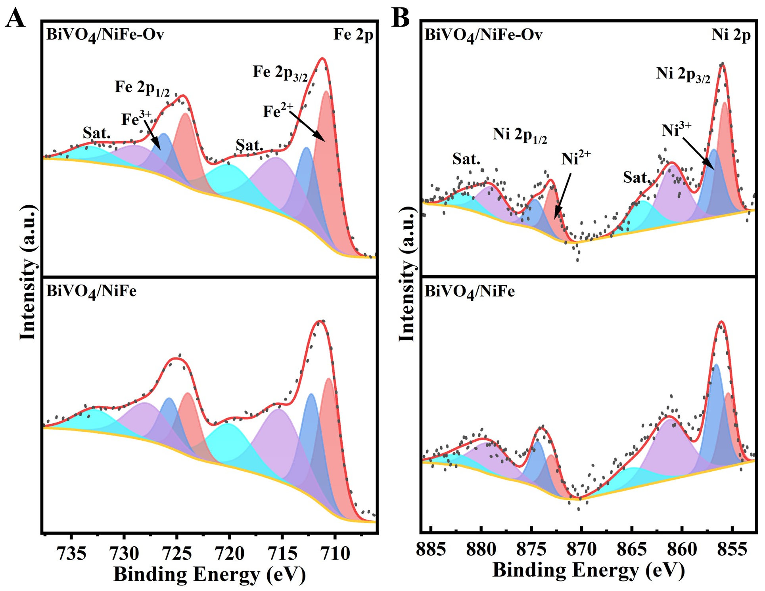
Fig. S18 XPS high-resolution (A) Fe 2p and (B) Ni 2p spectra of BiVO₄/NiFe and BiVO₄/NiFe-Ov photoanodes

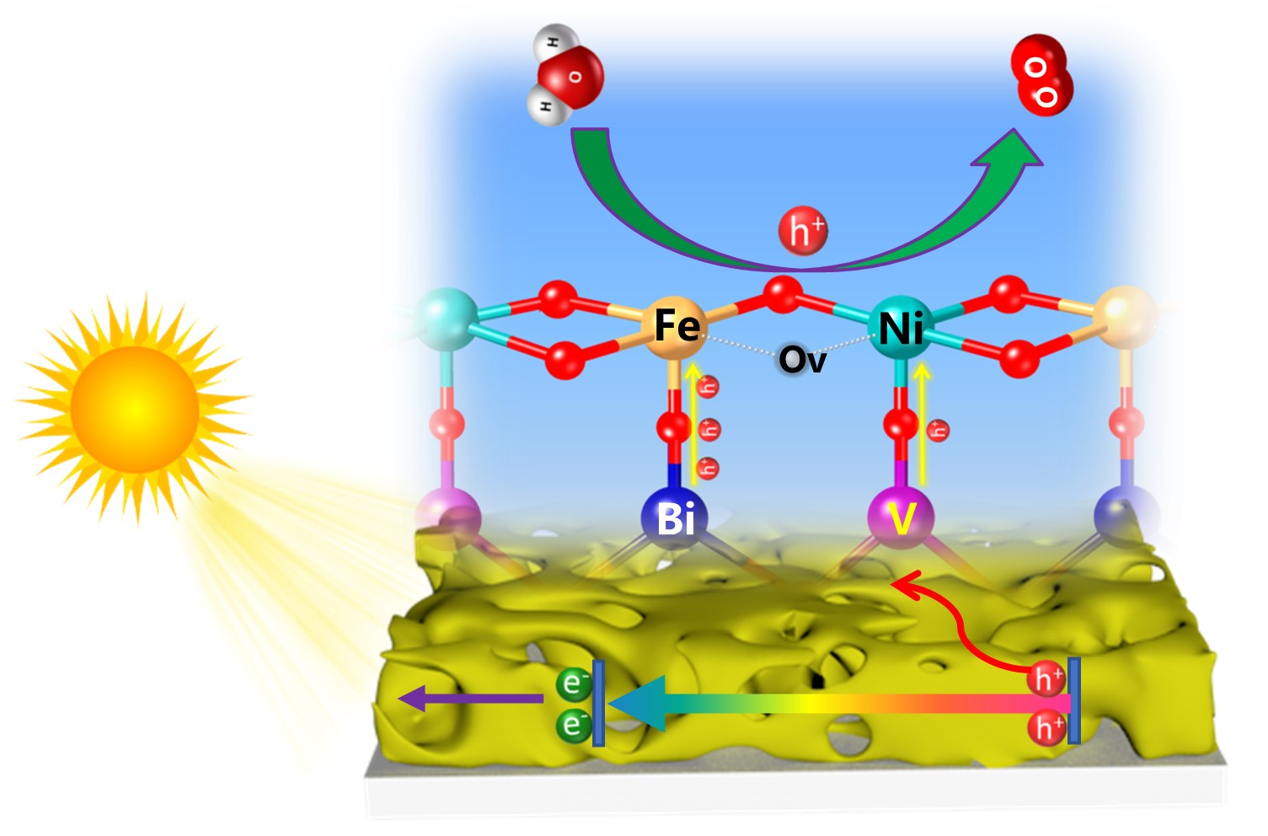
Scheme S3 Diagram of the PEC water oxidation process on BiVO₄/NiFe-Ov photoanodes
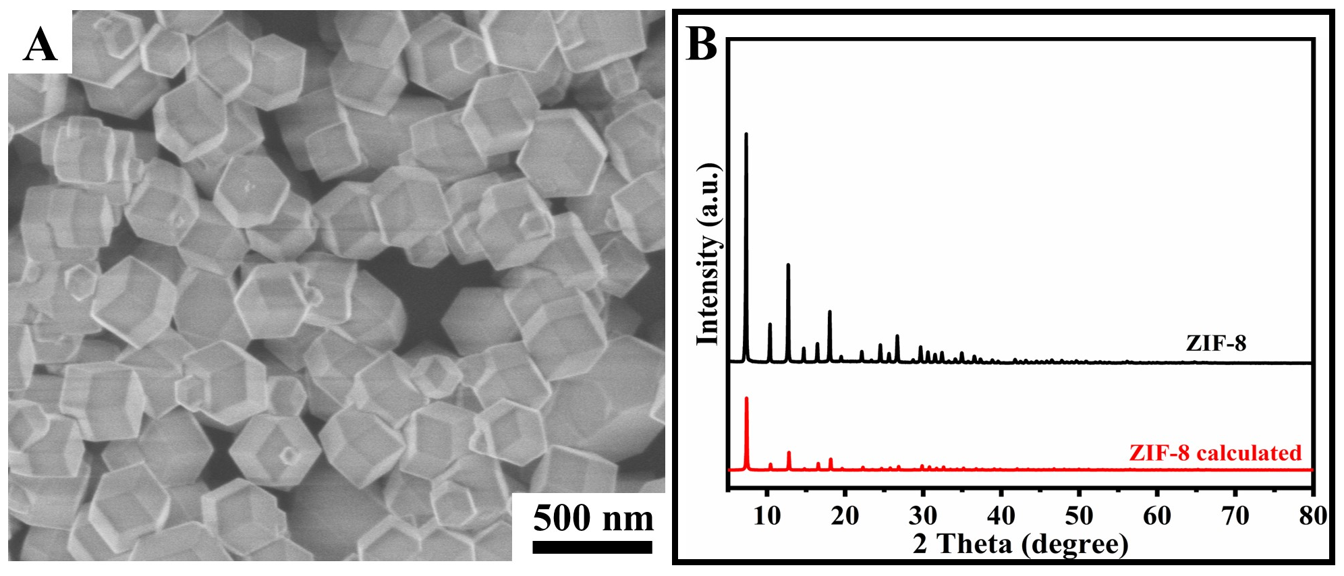
Fig. S19 (A) SEM image and (B) XRD pattern of prepared ZIF-8
Additional discussion
As a precursor of N-C substrate, ZIF-8 was prepared by a simple stirring process at room trmperature. As shown in Fig. S19A, ZIF-8 exhibits an uniform rhombic dodecahedron morphology with an average size of ~250 nm. And the XRD characterize diffraction patterns of prepared ZIF-8 have been consistent with the standard ZIF-8 calculated by the cif data.

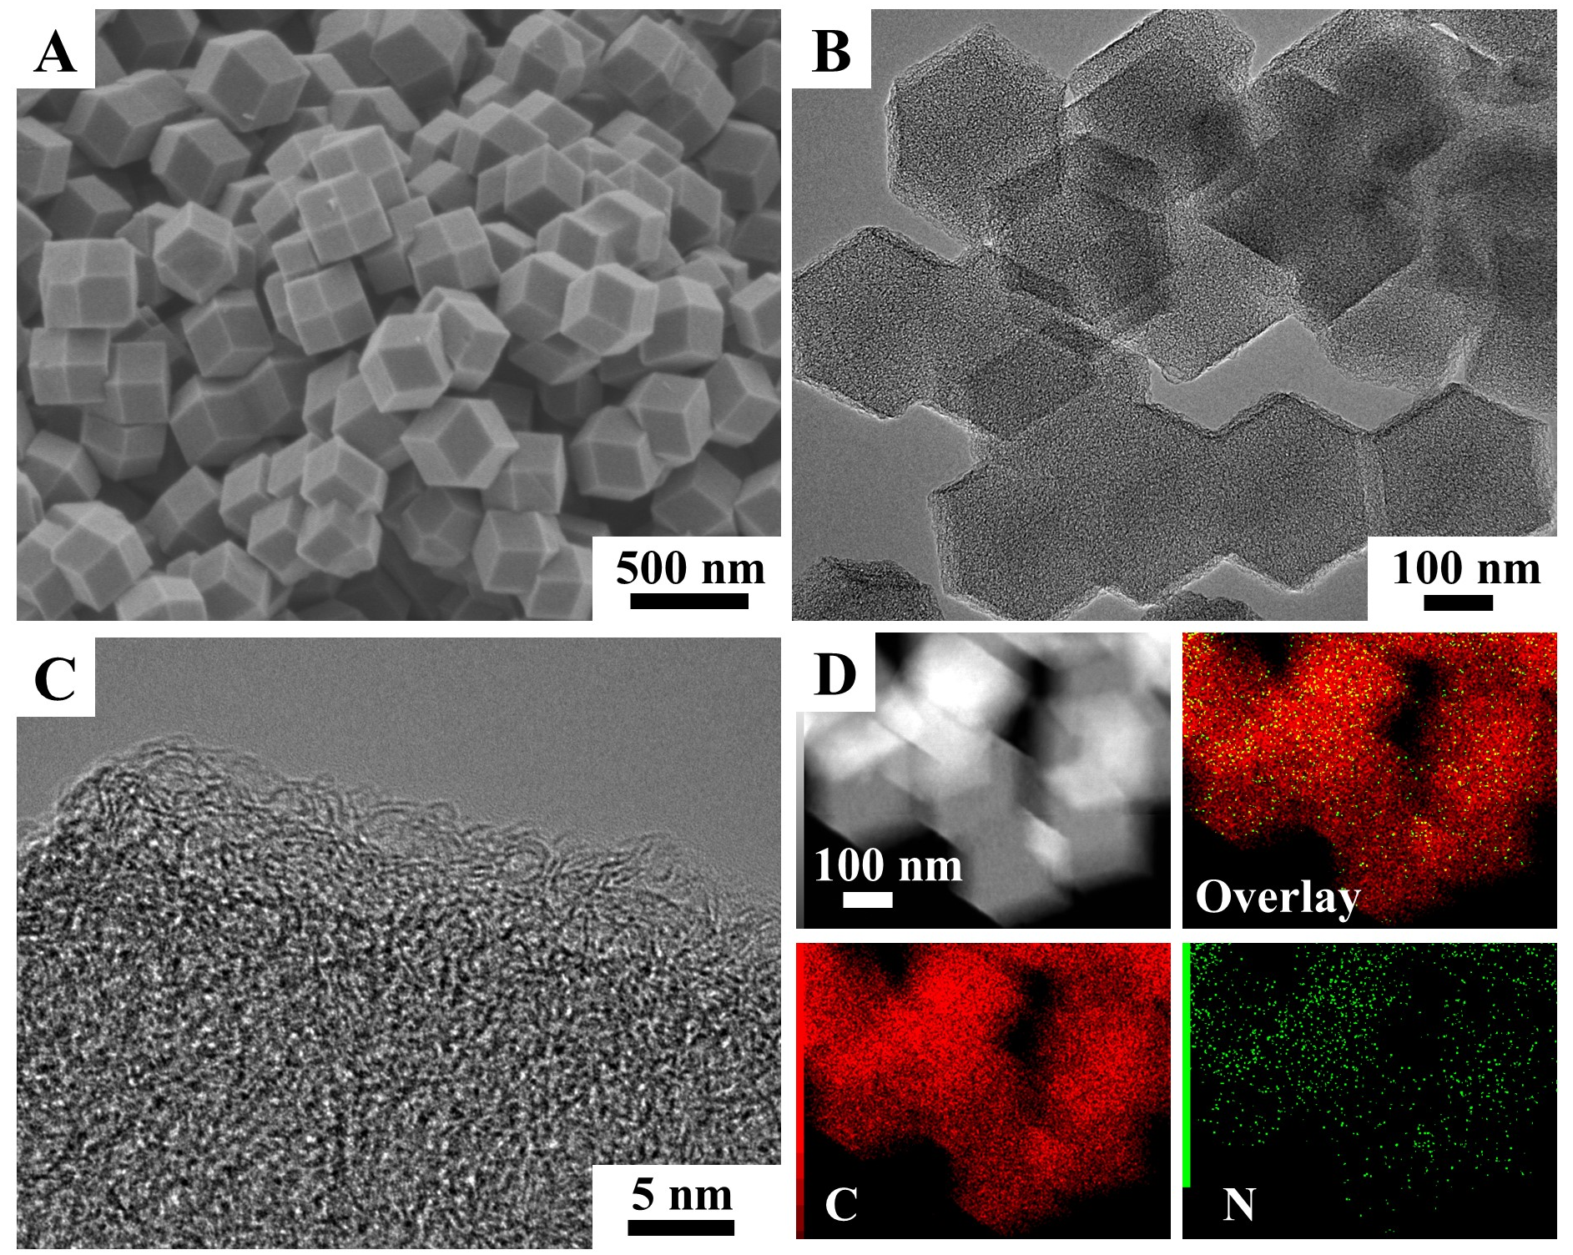
Fig. S20 (A) SEM, (B) TEM, (C) HR-TEM, and (D) EDS Mapping images of NC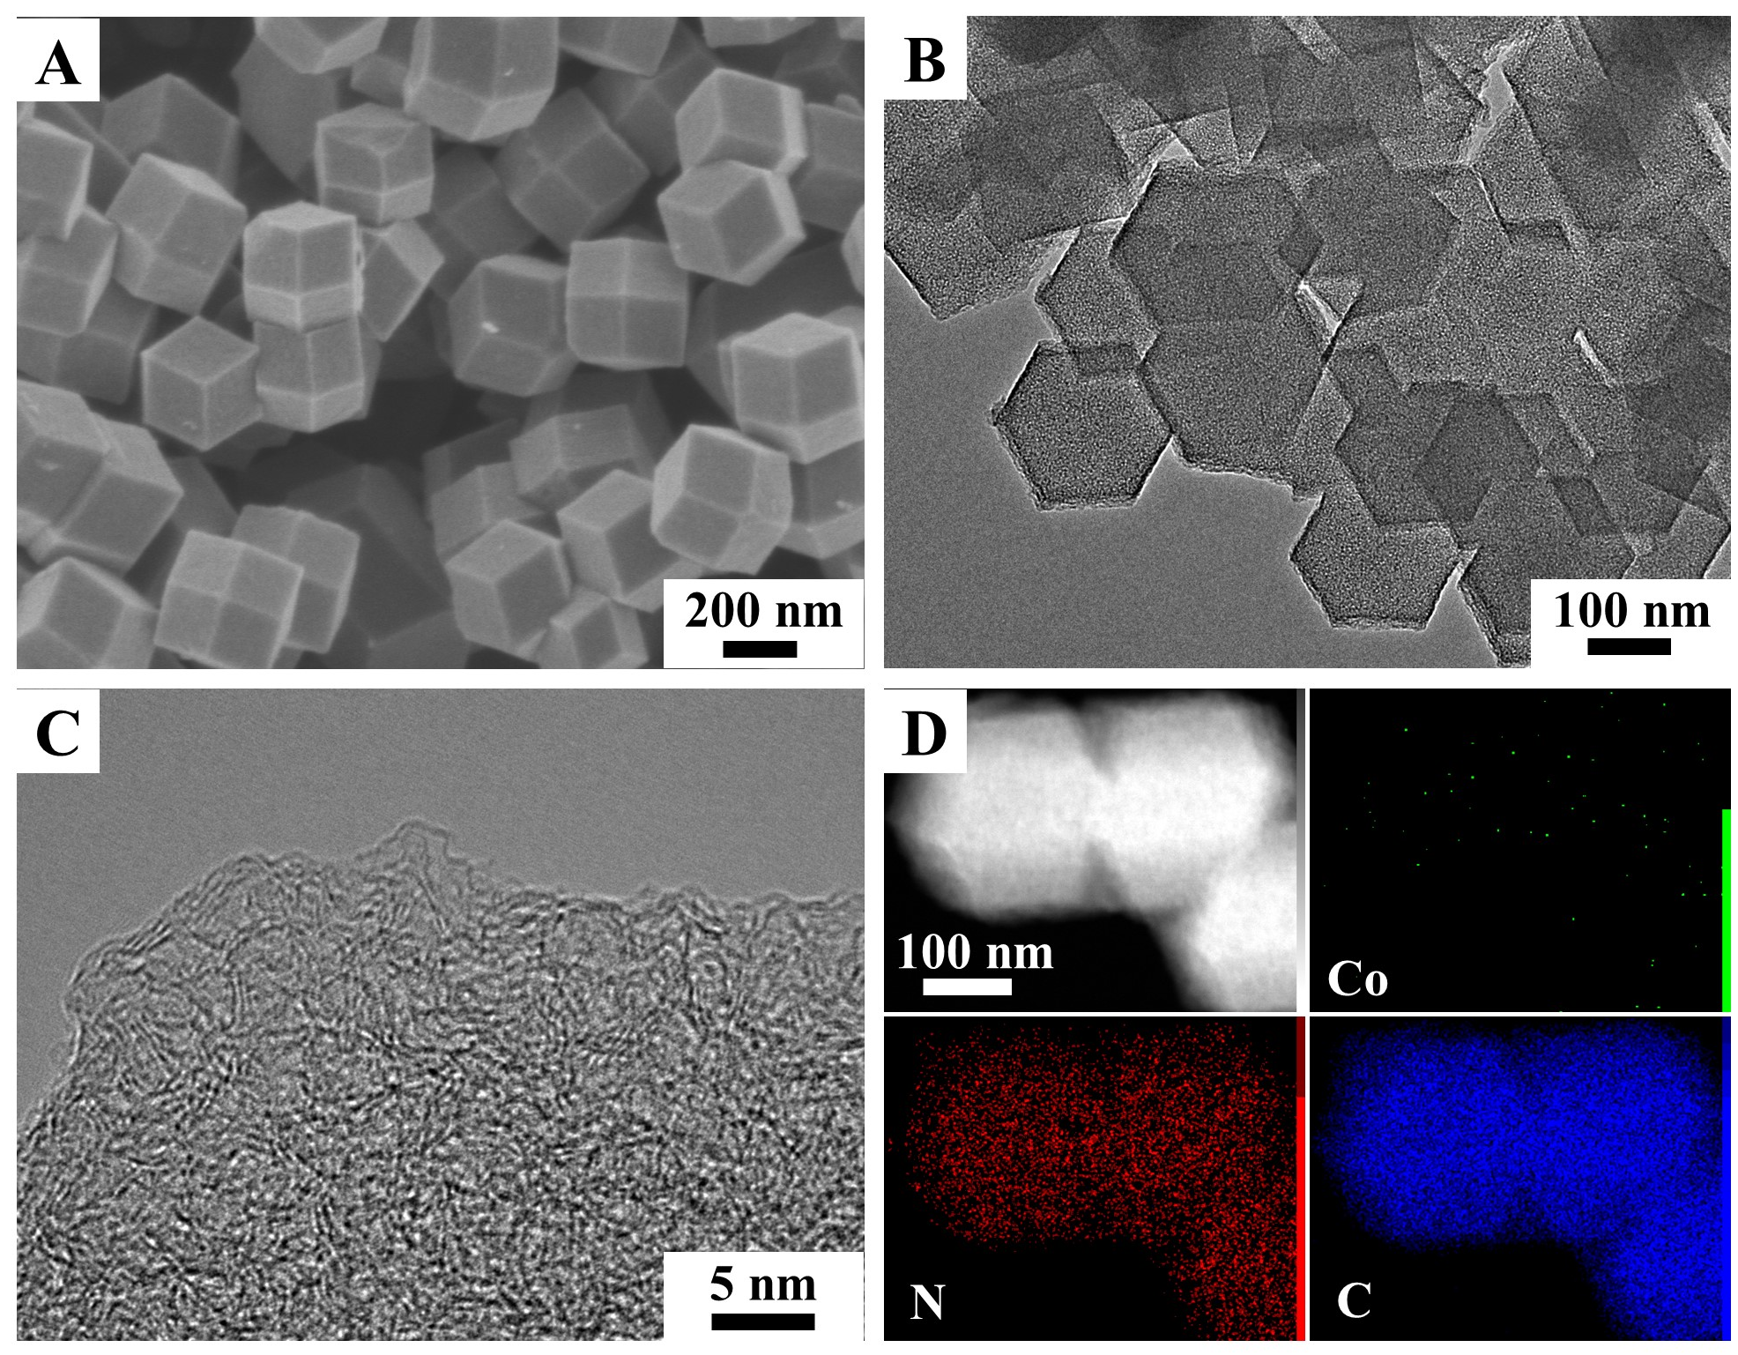
Fig. S21 (A) SEM, (B) TEM, (C) HR-TEM, and (D) EDS Mapping images of CoPc-NC
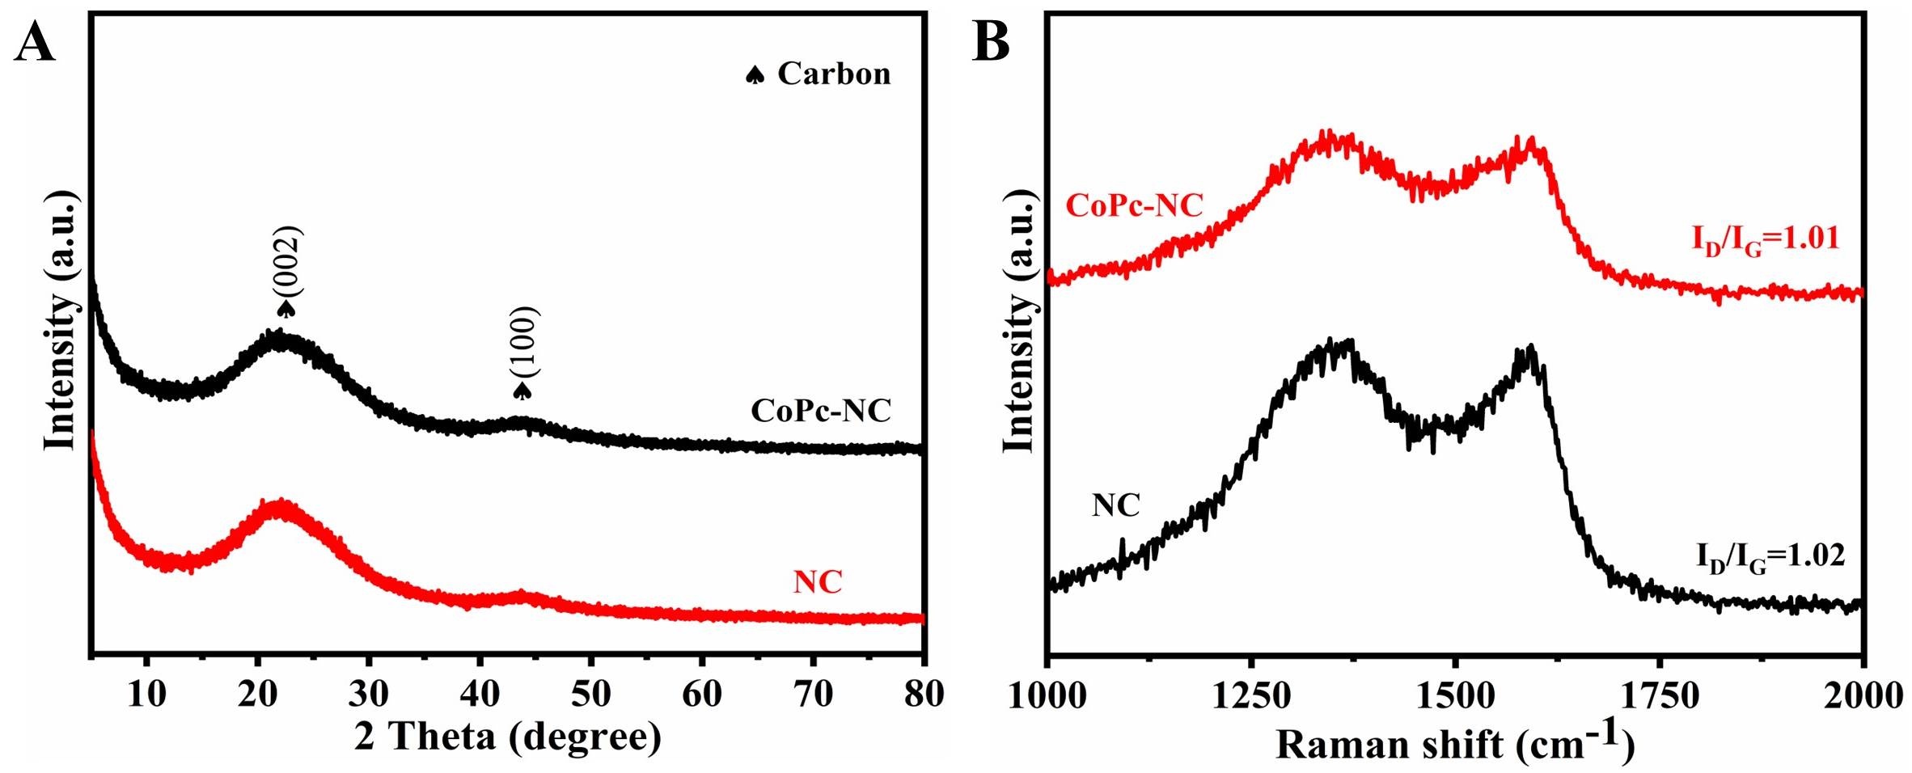
Fig. S22 (A) XRD pattern and (B) Raman spectra of NC and CoPc-NC
Additional discussion
As shown in Fig. S22A, two broad peaks at 23° and 44° could be correspond to the (002) and (100) planes of graphitic carbon, respectively [S4]. No diffraction peaks of CoPc are observed, indicating no aggreation of CoPc on NC substrate. In Raman spectra (Fig. S22B), the peak at 1330 cm⁻¹ is assigned to the D-band, which is commonly releated to the structural defects and disorder of carbon. While the G-band (1590 cm⁻¹) usually reveals the existence of graphite structure in carbon materials. The near I_{D}/I_{G} ratios for NC and CoPc-NC demonstrate the similar graphitized structure.

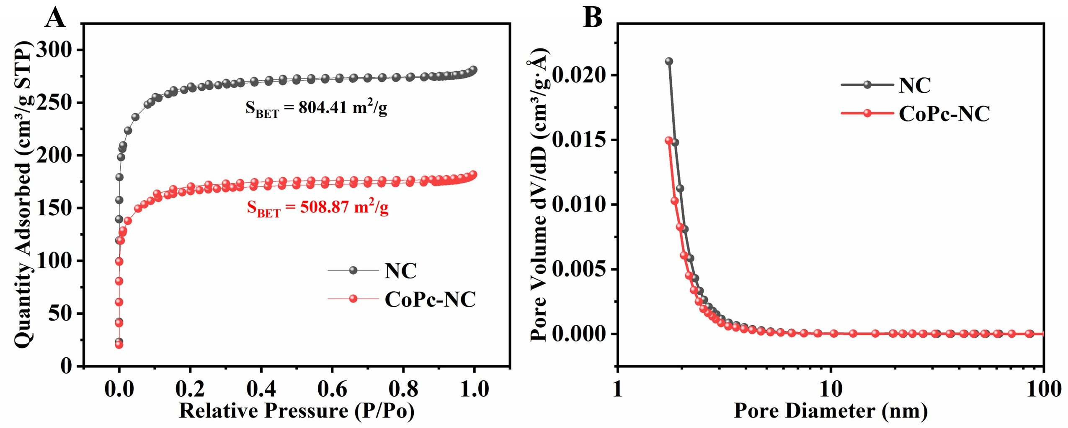
Fig. S23 (A) N₂ adsorption-desorption isotherm and (B) Pore size distribution of NC and CoPc-NC
Additional discussion
The textures of NC and CoPc-NC have been evaluated by N₂ adsorption-desorption isotherm measurement. As shown in Fig. S23A, the Brunauer-Emmett-Teller (BET) surface areas of NC and CoPc-NC are 804.41 m²/g and 508.87 m²/g, respectively. The decrease of surface area for CoPc-NC compared to NC could be attributed to the incorporation of CoPc species into the channels of NC substrates. Additionally, the pore size distribution plots of NC and CoPc-NC indicate a narrow distribution centered at about 2 nm (Fig. S23B).

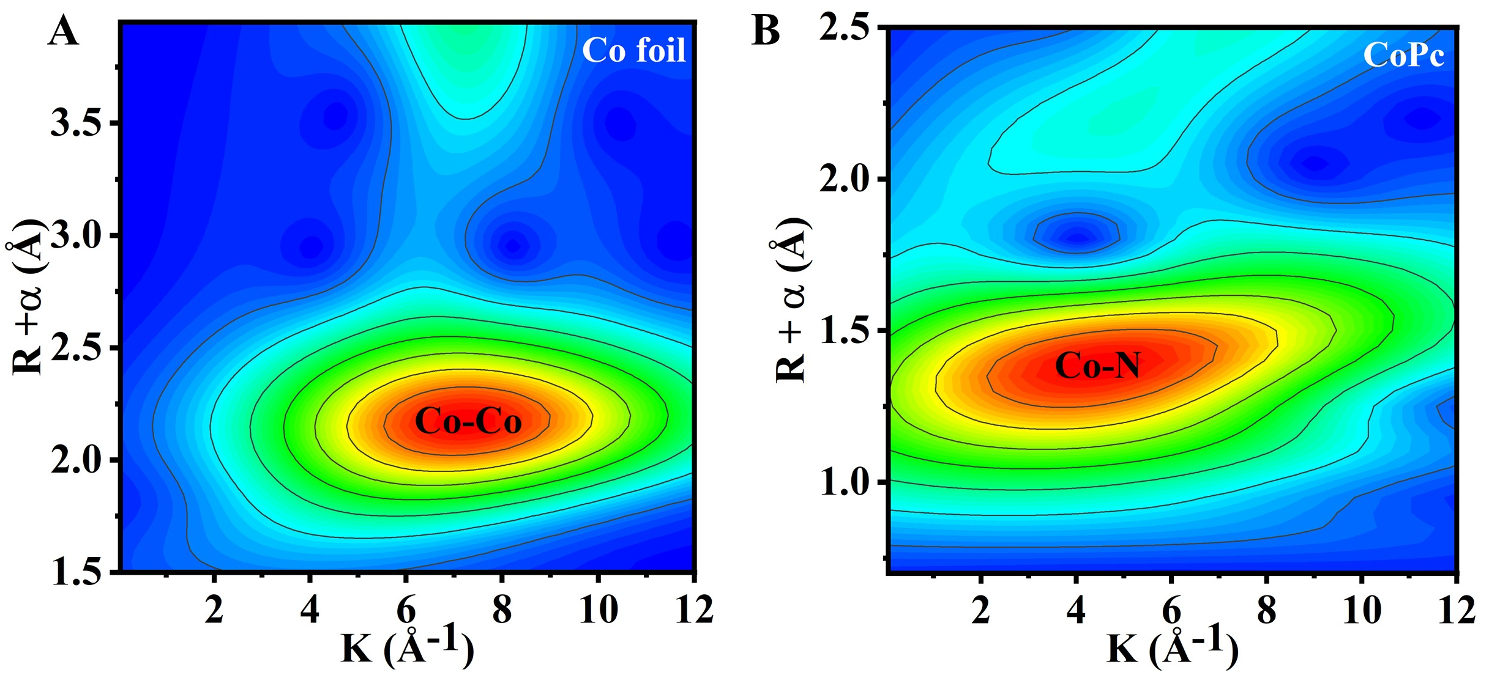
Fig. S24 Fourier transformation of EXAFS analysis of (A) Co foil and (B) CoPc
Additional discussion
For comparion, the Fourier transformation of EXAFS analysis of Co foil and CoPc have shown in Fig. S24. The maximum intensity of WT contour plots for Co-Co bonds and Co-N bonds is located at 7.2 Å⁻¹ and 4.3 Å⁻¹, respectively.

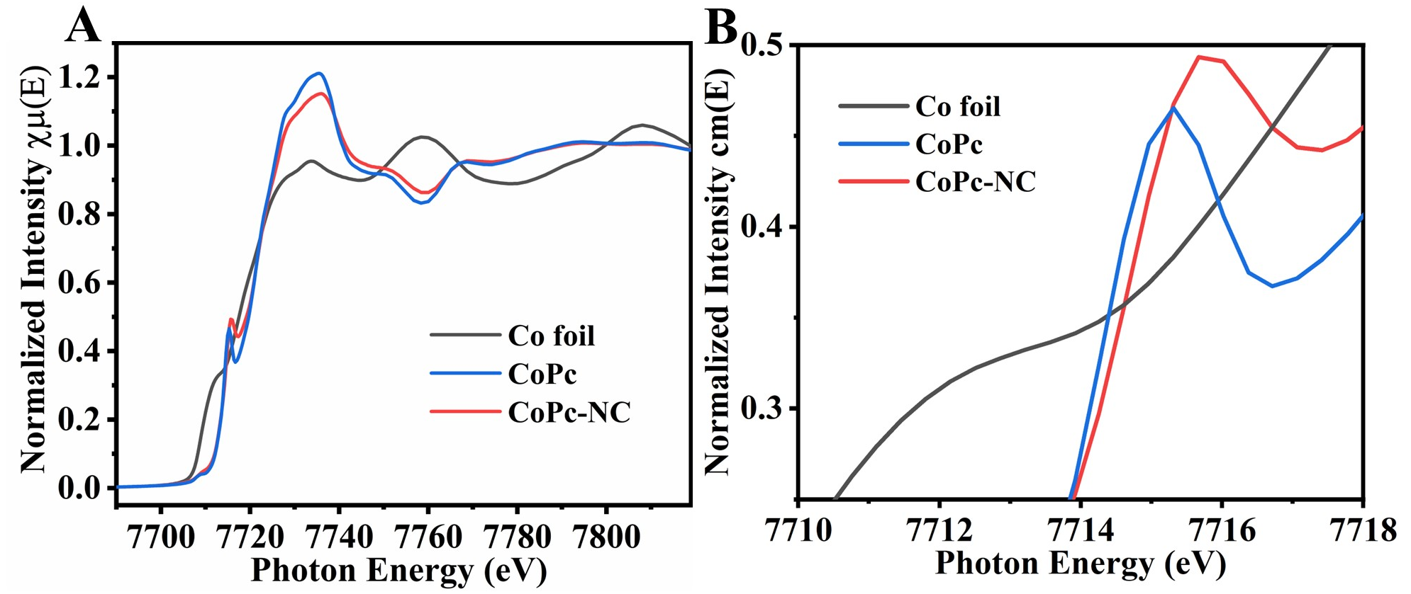
Fig. S25 Co K-edge XANES spectra of CoPc-NC, CoPc, and Co foil

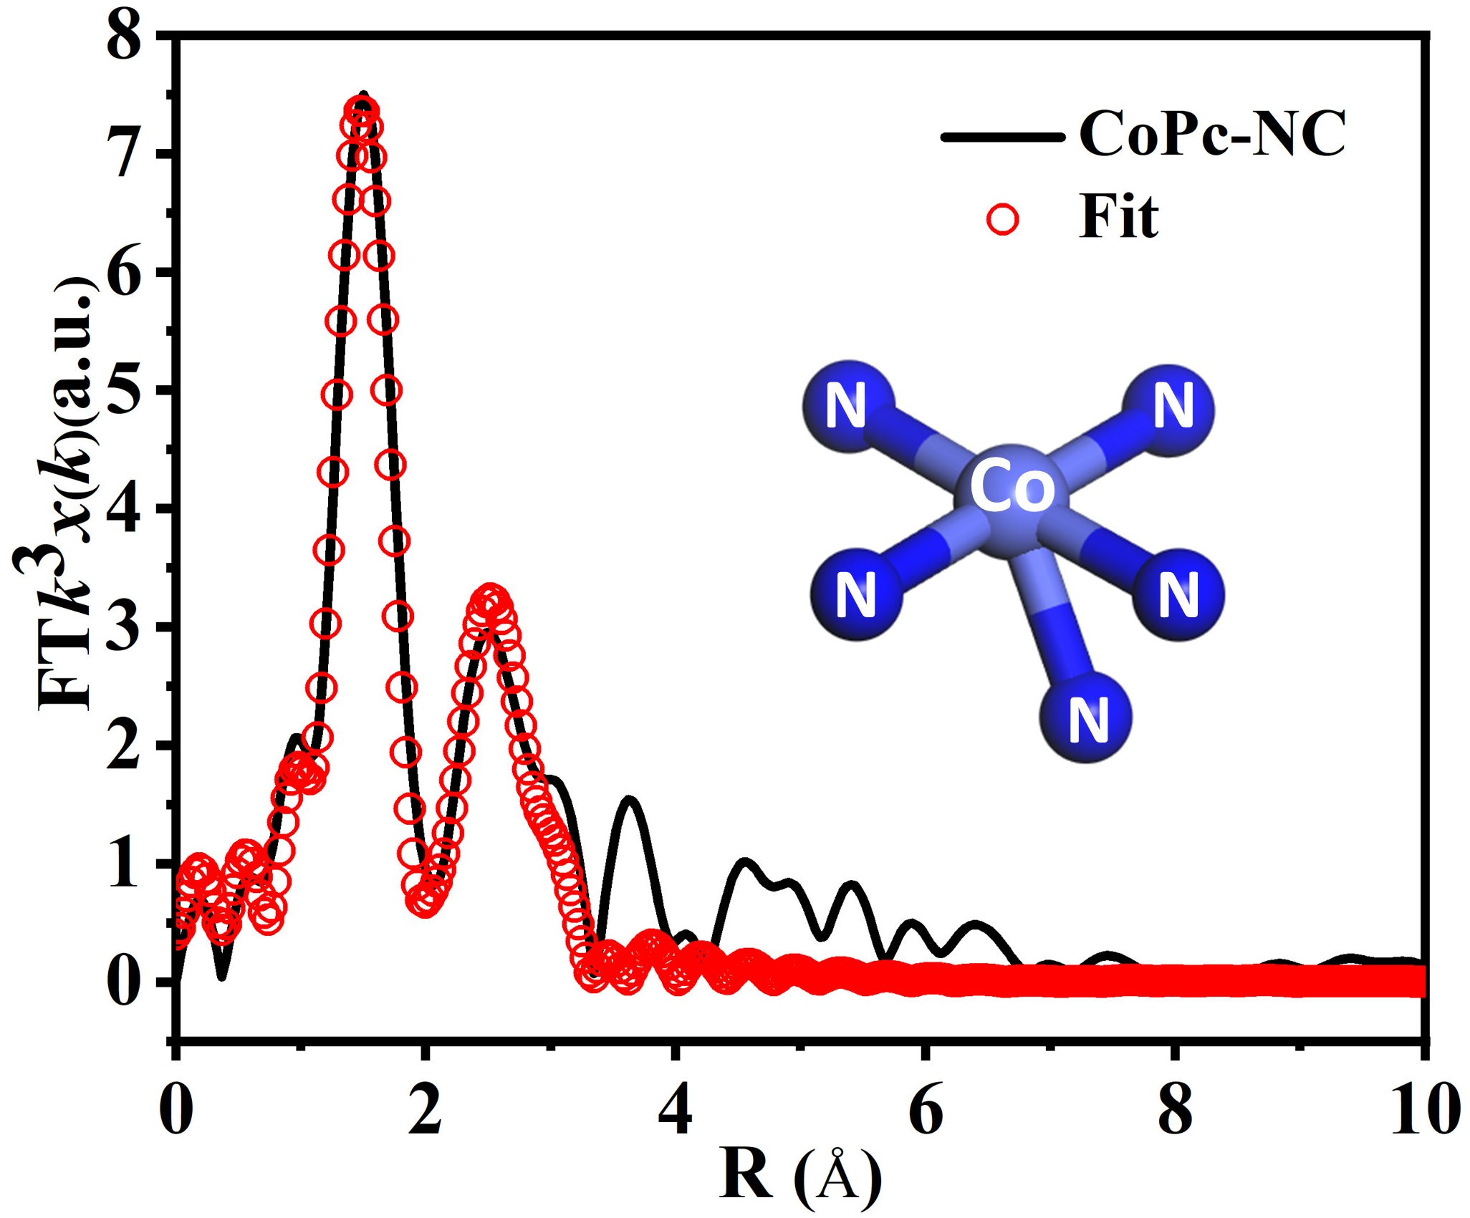
Fig. S26 FT-EXAFS fitting curve and (inset) corresponding structure model of CoPc-NC
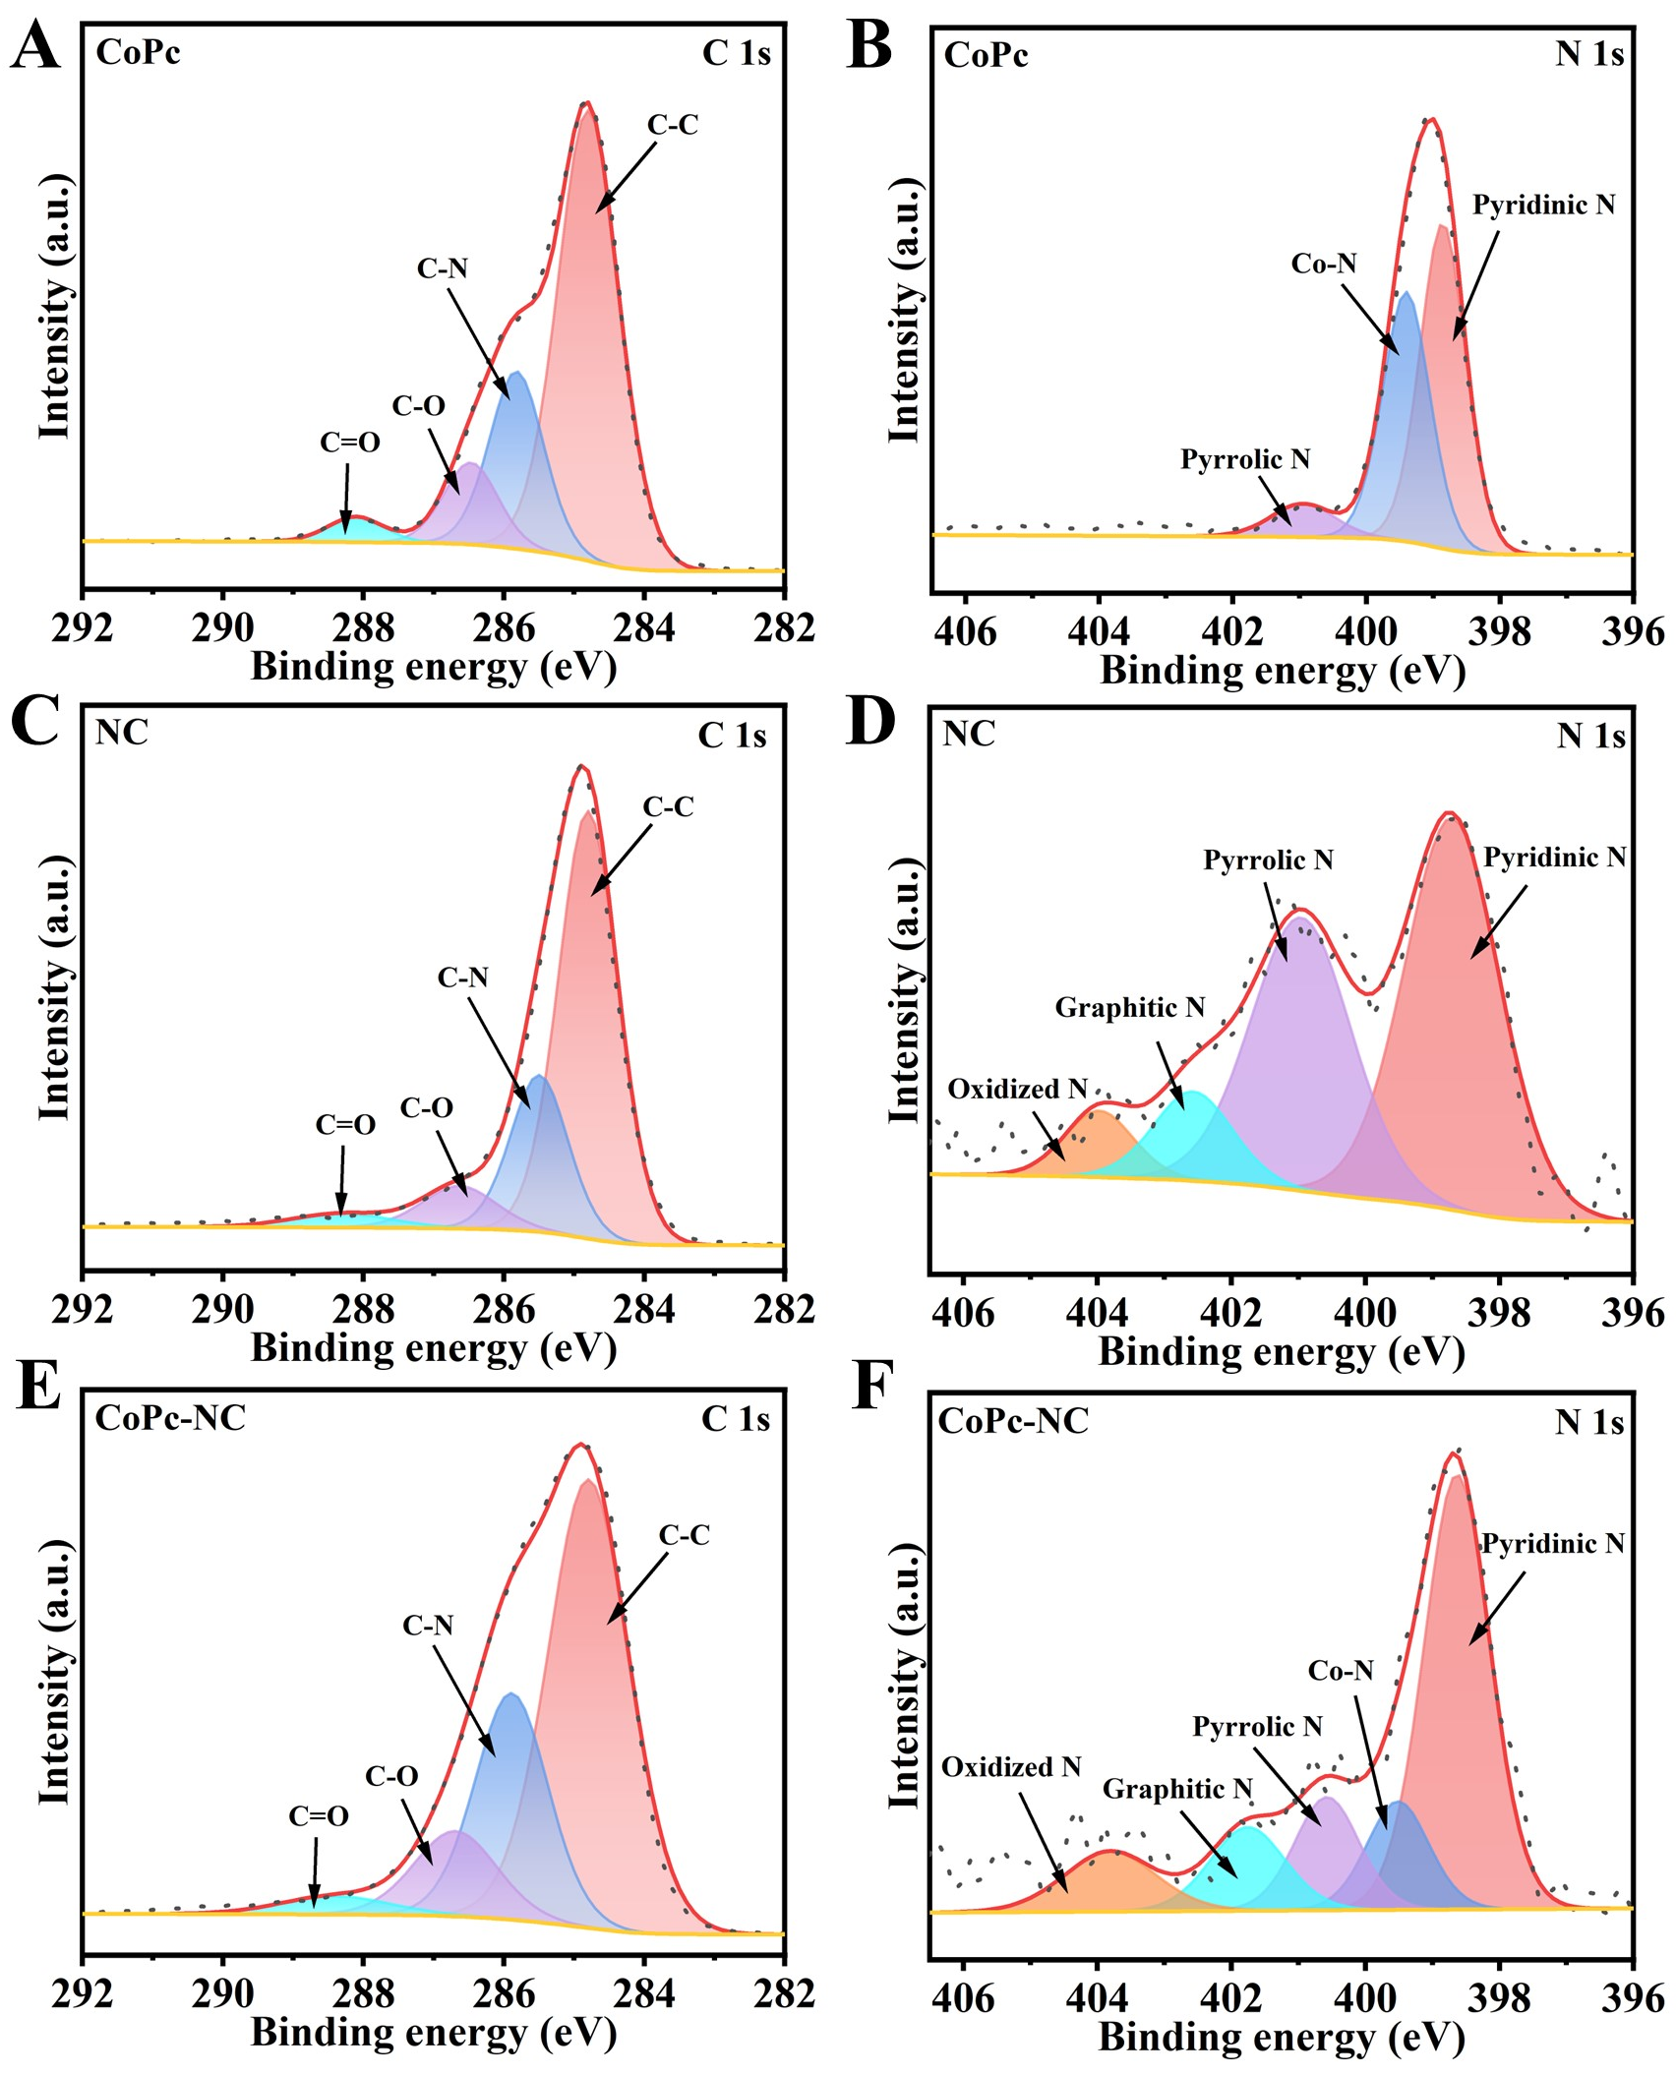
Fig. S27 XPS high-resolution (A, C, and E) C 1s and (B, D, and F) N 1s spectra of CoPc, NC, and CoPc-NC, respectively
Additional discussion
As shown in Fig. S27, the XPS high-resolution C 1s spectra of CoPc, NC, and CoPc-NC could be divided into four peaks at 284.8, 285.7, 286.5, and 288.3 eV, which are related to C-C, C-N, C-O, and C=O, respectively. The N 1s spectra of CoPc, NC, and CoPc-NC display that N mainly existed as pyridinic N (398.6 eV), Co-N (399.2 eV), pyrrolic N (400.7 eV), graphitic N (401.9 eV), and oxided N (403.8 eV). Note that the peak intensity of pyrrolic N for CoPc-NC has evently decreased compared to NC, this may be caused by the coordination of pyrrolic N in NC substrate with Co single atom. And the strong coordination ability of Co atom with pyrrolic N is higher than that of other N species was reported by Li et al. [S5].

Fig. S28 XPS high-resolution Co 2p spectra of CoPc and CoPc-NC
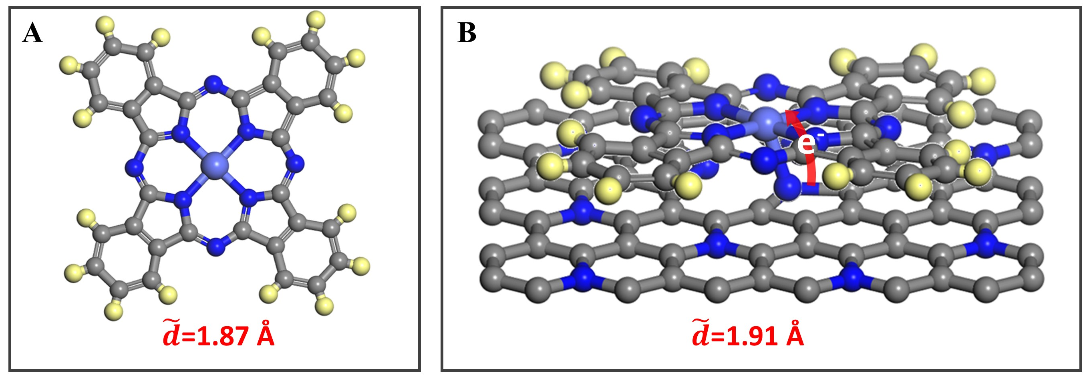
Fig. S29 Diagram of (A) CoPc and (B) CoPc-NC, Co (wathet), N (blue), C (gray), H (yellow)
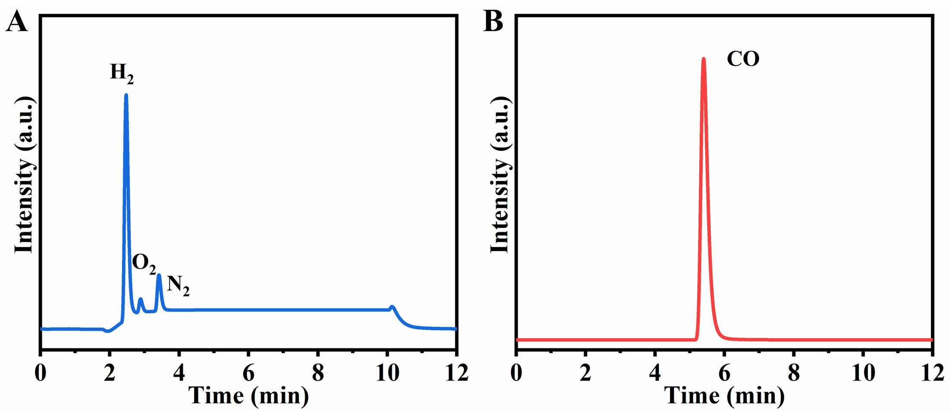
Fig. S30 The gas chromatogram of gases produced by the cathode during PEC CO₂RR at 1.23 V_{RHE}
Additional discussion
The gas products in the cathode cell of the PEC CO₂RR system was analyzed by a gas chromatograph (GC). A certain amount of gas was injected into the GC and was automatically entered two separate chromatographic columns for analysis. The columns equipped with TCD detector provide the accurate quantification of H₂ (Fig. S30A), while the columns equipped with nickel reformers and FID detectors provide the accurate quantification of carbonaceous products (Fig. S30B).
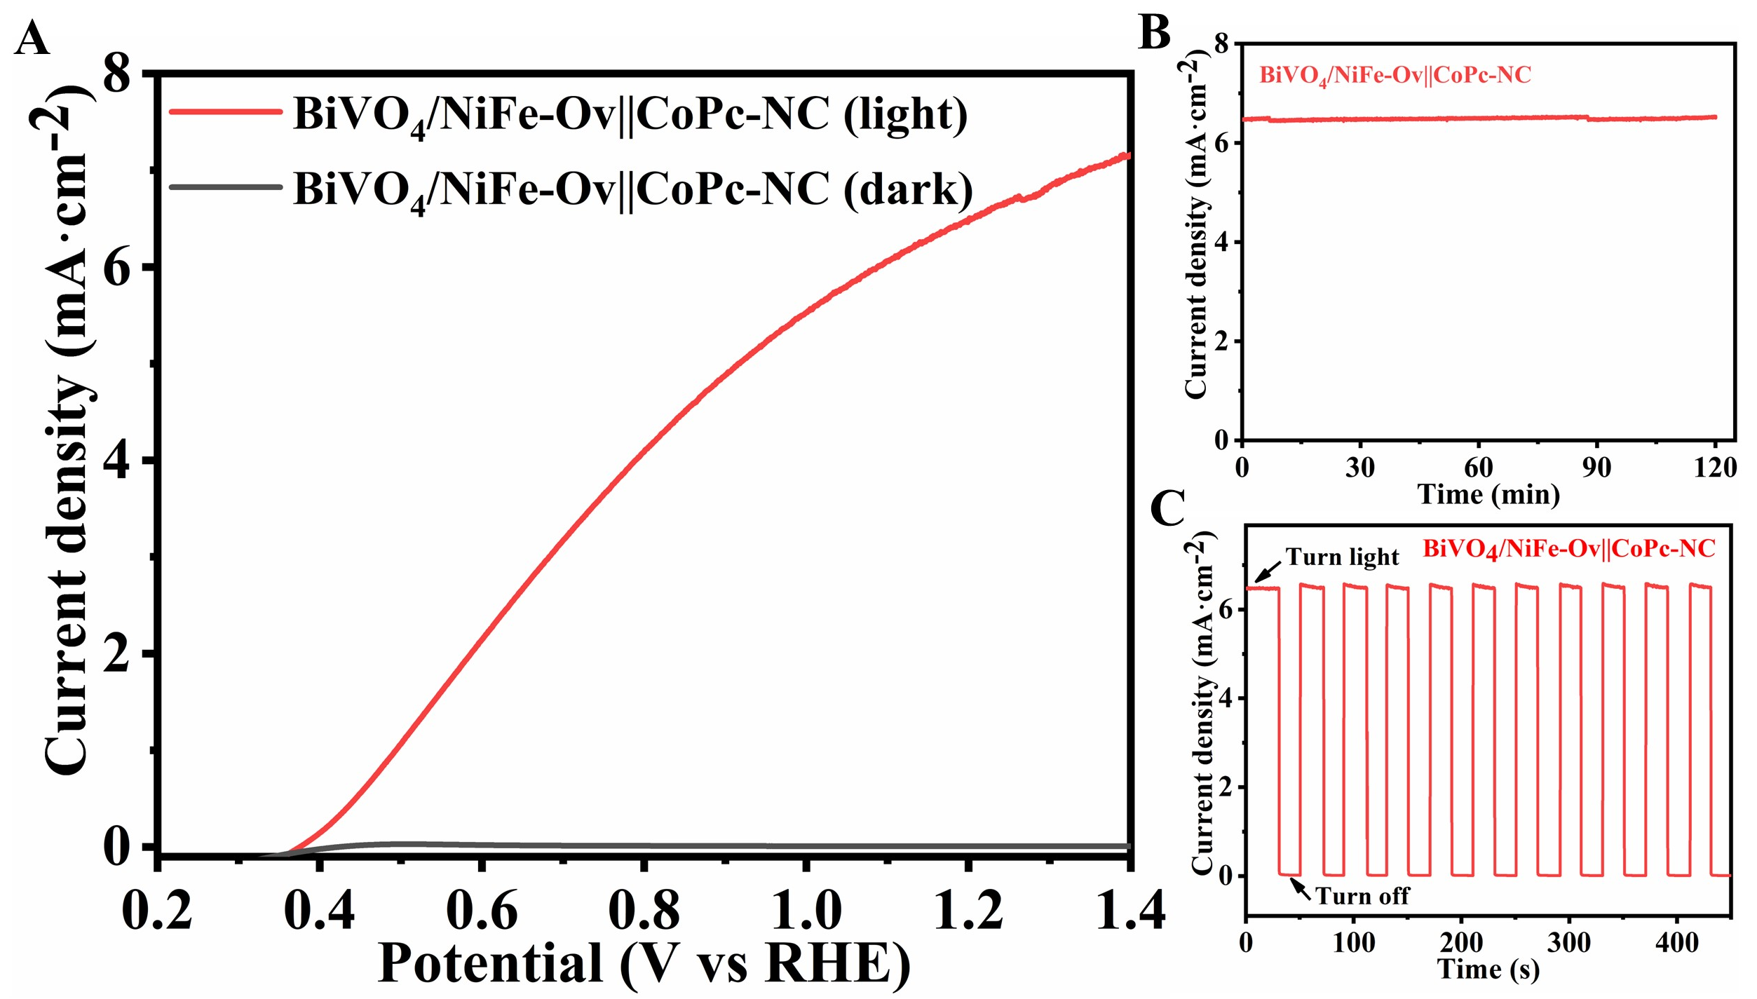
Fig. S31 (A) LSV of BiVO₄/NiFe-Ov‖CoPc-NC tandems for PEC CO₂RR under illumination and dark; (B) I-t of BiVO₄/NiFe-Ov‖CoPc-NC tandems for PEC CO₂RR at 1.23 V_{RHE}; (C) I-t curves of chopped irradiation on BiVO₄/NiFe-Ov‖CoPc-NC tandems for PEC CO₂RR at 1.23 V_{RHE}

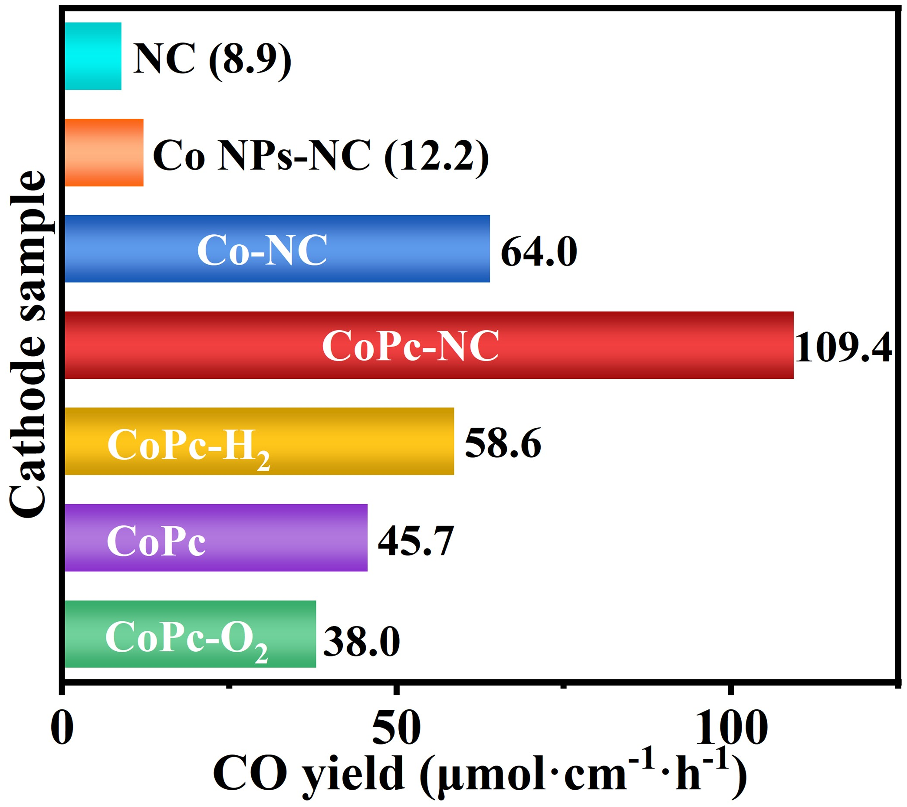
Fig. S32 CO yield by integrating BiVO₄/NiFe-Ov photoanode with different cathodes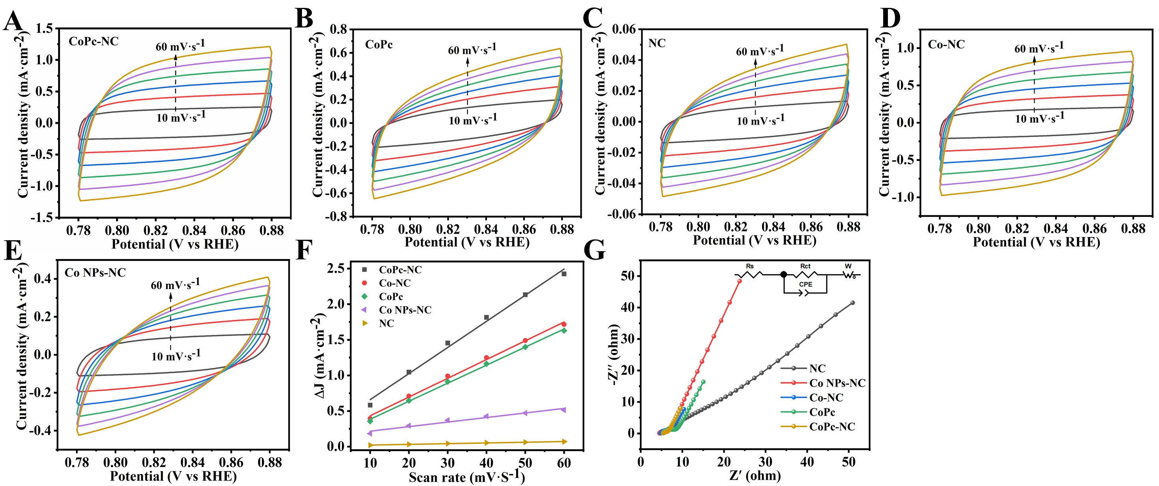
Fig. S33 (A-E) CV curves, (F) the electrochemical double layer capacitance (C_{dl}), and (G) the electrochemical impedance spectroscopy (EIS) plots of the CoPc-NC, CoPc, NC, Co-NC, and Co NPs-NC
Additional discussion
To explore the electrochemical active surface area, cyclic voltammetry curves have been performed at 0.83 V_{RHE} in 0.5 M KHCO₃ under dark conditions. As shown in Fig. S33F, the electrochemical double layer capacitance (C_{dl}) of CoPc-NC, CoPc, NC, Co-NC, and Co NPs-NC have been achieved to 21.7, 14.2, 0.7, 18.1, and 4.9 mF·cm⁻², respecyively. Moreover, the electrochemical impedance spectroscopy (EIS) has been explored and shown in Fig. S33G, according to the Nyquist plots and the fitting results, the calculated resistance values of CoPc-NC, CoPc, NC, Co-NC, and Co NPs-NC are 4.5, 5.2, 5.5, 5.0, and 5.4 Ω, respectively.
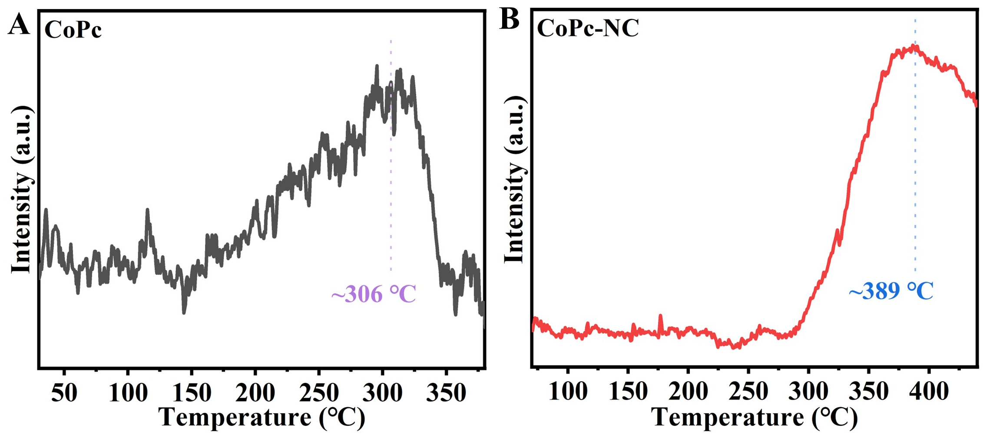
Fig. S34 CO₂-TPD curves of CO₂ gas for (A) CoPc and (B) CoPc-NC
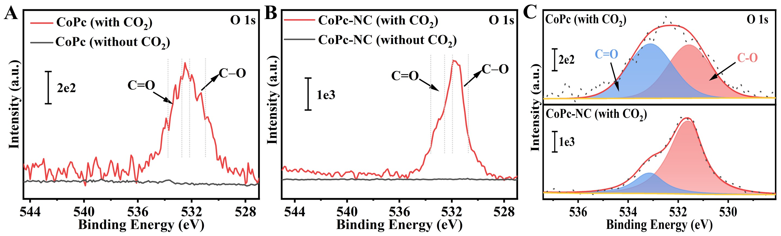
Fig. S35 XPS high-resolution O 1s spectra of (A) CoPc and (B) CoPc-NC of before and after CO₂ adsorption, and (C) O1s spectra comparion of CoPc and CoPc-NC after CO₂ adsorption
Additional discussion
As shown in Fig. S35A and B, the CO₂ adsorption capacity of CoPc-NC could be ~5 times that of pristine CoPc, which attributed to the high surface area of CoPc-NC and the excellent electronic regulation capabality between CoPc molecule and NC substrate.
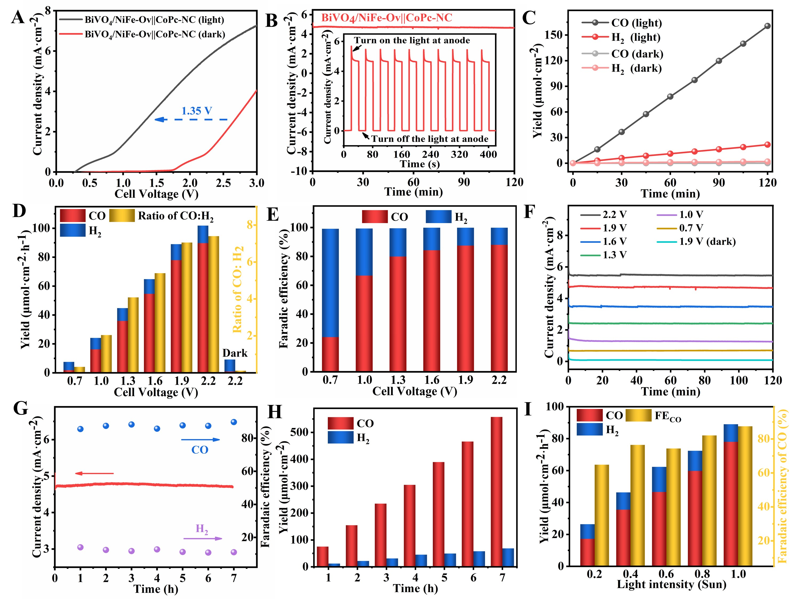
Fig. S36 (A) LSV curves of BiVO₄/NiFe-Ov‖CoPc-NC PEC CO₂ reduction system under illumination and dark; (B) I-t curve of BiVO₄/NiFe-Ov‖CoPc-NC PEC CO₂ reduction system at 1.9 V; (C) CO/H₂ yields of BiVO₄/NiFe-Ov‖CoPc-NC PEC CO₂ reduction system at 1.9 V; (D) CO/H₂ yields and ratio of BiVO₄/NiFe-Ov‖CoPc-NC PEC CO₂ reduction system at different cell voltage; (E) Faradaic efficiency of CO and H₂ over BiVO₄/NiFe-Ov‖CoPc-NC PEC CO₂ reduction system at different cell voltage; (F) I-t curve of BiVO₄/NiFe-Ov‖CoPc-NC PEC CO₂ reduction system at different cell voltage; (G) The stability experiment and (H) CO/H₂ evolution amounts of BiVO₄/NiFe-Ov‖CoPc-NC PEC CO₂ reduction system during 7h test; (I) CO/H₂ yields and FE_{CO} of BiVO₄/NiFe-Ov‖CoPc-NC PEC CO₂ reduction system under different light intensity at 1.9 V
Additional discussion
For the possibility of practical application in future, the performances of artificial photosynthetic CO₂ reduction cells constructed by BiVO₄/NiFe-Ov photoanode coupled CoPc-NC cathode have been conducted in a two-electrode system (Fig. S36). As shown in Fig. S36A, the required voltage for the PEC CO₂ reduction system under illumination at photoanode could be lower by 1.35 V than that of the darkness, indicating that this PEC cell droved by BiVO₄/NiFe-Ov photoanode is crucial for generating CO fuels at a low voltage. Besides, the amounts of CO and H₂ produced by CoPc-NC cathode surface are 160.6 and 21.7 μmol·cm⁻² after 2 h irradiation, respectively (Fig. S36C). In Fig. S36D, not only does the faradic efficiency of CO increase with enhancing cell voltage, but also that is greater than 80% at a wide cell voltage range of 1.3-2.2 V. During 7 h irradiation, an average CO faradic efficiency of 87.9% has been obtained on the PEC CO₂ reduction system, as well as the amounts of CO and H₂ exhibit a linear increasement (Fig. S36H), indicating its excellent selectivity and stability. Furthermore, the influences of light intensity on the activity of CO₂ reduction have been investigated, which should be highly important for the practical applications (Fig. S36I). The CO faradaic efficiency of 64.9% has even been achieved for the PEC CO₂ reduction system under the light intensity of 0.2 sun. This result suggests the PEC CO₂ reduction system could be operated for CO production under sunny and cloudy weather.
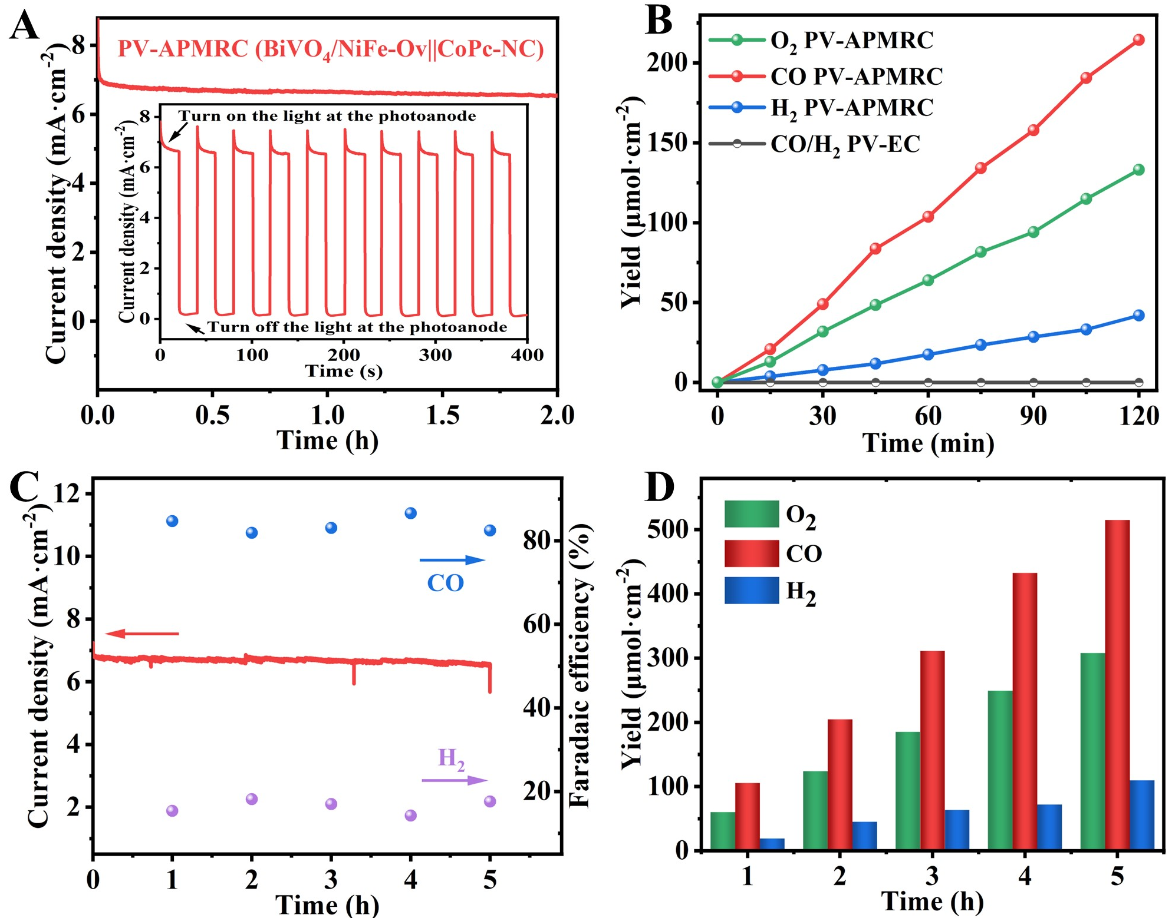
Fig. S37 (A) I-t curve of BiVO₄/NiFe-Ov‖CoPc-NC PV-APMRC; (B) O₂, CO, and H₂ yields of BiVO₄/NiFe-Ov‖CoPc-NC PV-APMRC; (C) The stability experiment and (D) O₂, CO, and H₂ evolution amounts of BiVO₄/NiFe-Ov‖CoPc-NC PV-APMRC
Additional discussion
For the possibility of practical application on Mars in future, replace the CO₂ gas in the above PV-PEC CO₂ reduction system with a simulated Mars atmosphere (95.51% CO₂, 2.71% N₂, 1.58% Ar, 0.132% O₂, 0.0699% CO), noted as PV-APMRC system. When a commercial PV cell with an output voltage of 2 V was applied to assemble with the APMRC, the photocurrent density could be reached to 6.7 mA·cm⁻² under light intensity of 2 sun (Fig. S37A). However, the photocurrent density of PV-APMRC system was rapidly dropped to near zero, and no gas was detected (Fig. S37A inset), confirming that the PV-APMRC system for oxygen and syngas production is driven by BiVO₄/NiFe-Ov photoanode rather than solar cell. In Fig. S37B, the amounts of O₂, CO and H₂ reached 63.8, 103.6 and 17.5 μmol·cm⁻² after 1 h irradiation, respectively, exhibiting the appropriate stoichiometric ratio of ~2:1 (CO+H₂/O₂). As shown in Fig. S37C, the faradaic efficiency of CO and H₂ could be constant during the 5h irradiation, suggesting the excellent stability of the PV-APMRC system. After 5h irradiation, the amounts of O₂, CO and H₂ could be reached up to 9.9, 14.4, and 0.22 mg·cm⁻², respectively (Fig. S37D).
S3 Supplemental Tables and Discussions
Table S1 Fitting results of the Nyquist plots of BiVO₄ and BiVO₄/NiFe-Ov photoanodes
 | Rct (Ω) | CPE (F·cm⁻²)
BiVO₄ | 665.1 | 3.8×10⁻⁴
BiVO₄/NiFe-Ov | 76.1 | 4.2×10⁻⁴
Table S2 Fitting parameters of transient absorption kinetics of BiVO₄ and BiVO₄/NiFe-Ov photoanodes
 | τ₁ (ns) | τ₂ (ns) | τ_{ave} (ns)
BiVO₄ | 1747.56 (80.39%) | 83.28 (19.61%) | 1420.95
BiVO₄/NiFe-Ov | 3585.65 (94.38%) | 105.34 (5.62%) | 3390.06
Table S3 ICP-OES results of Ni and Fe content in BiVO₄/NiFe-Ov photoanodes
Element | Volume (mL) | Concentration (mg/L) | Calculated content (wt%)
Ni | 1 | 0.0925 | 0.093
Fe | 1 | 0.9222 | 0.922
Additional discussion
The loading amounts of Ni and Fe in BiVO₄/NiFe-Ov photoanodes have been analyzed by an inductively coupled plasma optical emission spectroscopy (ICP-OES, Agilent 700). As shown in Table S3, the loading amounts of Ni and Fe in BiVO₄/NiFe-Ov were calculated to be 0.093 wt%, and 0.92 wt%, respectively, and the ratio of Ni and Fe was calculated to be about 0.1.

Table S4 ICP-MS results of leaking content for BiVO₄/NiFe-Ov photoanodes after the stability test
Element | Volume (mL) | Concentration (mg/L) | Calculated amount (μmol/L)
Ni | 1 | 0.001 | 0.00002
Fe | 1 | 0.0193 | 0.00035
Additional discussion
The leaking amounts of BiVO₄/NiFe-Ov photoanodes after the stability test have been analyzed by an inductively coupled plasma mass spectroscopy (ICP-MS, Agilent 7800). The contents of Ni, and Fe after the PEC stability test were calculated to be 0.00002, and 0.00035 µmol/L, respectively, indicating no evident dissolution of Ni and Fe during the stability test (Table S4).
Table S5 EXAFS fitting parameters at the Co K-edge for CoPc-NC sample
 | Shell | CNª | R(Å)^{b} | σ²×10³(Å²)^{c} | ΔE₀ (eV)^{d} | R factor
CoPc-NC | Co-N | 4.7±0.3 | 1.91±0.01 | 3.5 | 7.7±1.8 | 0.0086
ªCN: coordination numbers; ^{b}R: bond distance; ^{c}σ²: Debye-Waller factors; ^{d} ΔE₀: the inner potential correction. R factor: goodness of fit.
Additional discussion
The obtained XAFS data was processed in Athena (version 0.9.26) for background, pre-edge line and post-edge line calibrations. Then Fourier transformed fitting was carried out in Artemis (version 0.9.26). The k³ weighting, k-range of 3-14 Å⁻¹ and R range of 1-3 Å were used for the fitting of Co foil; k-range of 3-11 Å⁻¹ and R range of 1-3 Å were used for the fitting of samples. The four parameters, coordination number, bond length, Debye-Waller factor and E₀ shift (CN, R, σ², ΔE₀) were fitted without anyone was fixed, the σ² was set. For Wavelet Transform analysis, the χ(k) exported from Athena was imported into the Hama Fortran code. The parameters were listed as follow: R range, 1-4 Å, k range, 0-12 Å⁻¹ for samples; k weight, 3; and Morlet function with κ=10, σ=1 was used as the mother wavelet to provide the overall distribution.
Table S6 XPS analysis results of CoPc, NC, and CoPc-NC samples (unit: at%)
 | C | N | Co
CoPc | 83.59 | 14.87 | 1.55
NC | 96.38 | 3.63 | -
CoPc-NC | 96.23 | 3.52 | 0.17
Table S7 XPS analysis results of different N species in CoPc, NC, and CoPc-NC samples (unit: at%)
 | Pyridinic N | Co-N | Pyrrolic N | Graphitic N | Oxidized N | Ratio of Co-N/Co
CoPc | 7.64 | 6.13 | 1.10 | - | - | 3.96
NC | 1.77 | - | 1.31 | 0.22 | 0.33 | -
CoPc-NC | 1.25 | 0.91 | 0.50 | 0.32 | 0.54 | 5.35
Additional discussion
The XPS has been used to investigate the chemical composition and electron structure. The different N species and content of CoPc, NC, and CoPc-NC samples could be analyzed and shown in Table S6 and Table S7, the ratio of Co-N to Co is close to 5. This result further confirms that the coordination detail of Co single atom in CoPc-NC should be Co-N₅, which is agreement with the X-ray absorption structure spectroscopy result.
Table S8 ICP-OES measurement results of Co content in CoPc-NC sample
Elements wavelength (nm) | Concentration (mg/L) | RSD (%) | Calculated content (wt%)
Co 228.615 | 1.12655 | 6.9 | 2.25310
Co 231.406 | 1.07329 | 8.1 | 2.14658
Co 236.379 | 1.14333 | 7.0 | 2.28666
Co 237.863 | 1.13440 | 7.1 | 2.26880
Co 238.345 | 1.11102 | 9.7 | 2.22204
Additional discussion
The loading amounts of cobalt in CoPc-NC sample have been analyzed by an inductively coupled plasma optical emission spectroscopy (ICP-OES, Agilent 725-ES). As shown in Table S8, the average content of cobalt in CoPc-NC was calculated to be 2.24 wt%.
Table S9 Summary of recent significant progress in BiVO₄-based photoanodes
Photoanodes | Photocurrent (mA·cm⁻² 1.23 V_{RHE}) | Year | Refs.
BiVO₄/FeOOH/NiOOH | 4.5 | 2014 | [S6]
WO₃/BiVO₄/CoPi | 6.72 | 2015 | [S7]
Mo:BiVO₄/Fe(Ni)OOH | 5.82 | 2016 | [S8]
Ni:FeOOH/WO₃/BiVO₄ | 4.5 | 2016 | [S9]
NiOOH/FeOOH/CQD/BiVO₄ | 5.99 | 2017 | [S10]
FeCoO_{x}/BiVO₄ | 4.82 | 2018 | [S11]
Mo:BiVO₄@TANF | 5.1 | 2018 | [S12]
BiVO₄/TiO_{2-x} | 6.12 | 2019 | [S13]
NiFeO_{x}/BiVO₄ | 5.54 | 2020 | [S14]
BiVO₄/Fe_{x}Ni_{1-x}OOH | 5.8 | 2020 | [S15]
Ov-BiVO₄@NiFe-MOFs | 5.3 | 2021 | [S16]
BiVO₄/N:NiFeO_{x} | 6.4 | 2021 | [S17]
BiVO₄/Bi/NiFeOOH | 4.7 | 2022 | [S18]
BiVO₄/NiFePO_{x} | 6.73 | 2022 | [S19]
NiOOH/Co₃O₄/BiVO₄ | 6.4 | 2023 | [S20]
NiFe/CA/Fe-BiVO₄ | 6.2 | 2024 | [S21]
BiVO₄/NiFe-Ov | 6.51 | This work
Table S10 The performance of photoanode-driven PEC CO₂ reduction
Photoanode | Cathode | Products and FEª/% | Yield/μmol cm⁻² h⁻¹ | Refs.
TiO₂ NR | Cu₂O | CH₄ (54.63)  CO (30.03)  CH₃OH (2.79) | 3.4  7.5  0.2 | [S22]
WO₃ | Sn/SnO_{x} | CO (17.5)  HCOOH (26.8) | 12.9  19.8 | [S23]
WO₃ | Cu | CH₄ (67)  C₂H₄ (2.7) | 2.8  0.1 | [S24]
CNTs/ZnO/Co₃O₄ | Pd-Cu | CO (75) | 5.6 | [S25]
Si-Ni | Ag | CO (90) | - | [S26]
Si-Ni | Ag^{b} | CO (70) | - | [S27]
Fe₂O₃/Co-C₃N₄ | Ag-Pd | CO (51.4) | 42.1 | [S28]
RuO_{x}-Al₂O₃-Fe₂O₃ | Ni-SNG | CO (90) | 26.5 | [S29]
Co-Ci/BiVO₄/WO₃ | Cu | CO (1.4)  C₂H₄ (3.7)  CH₄ (46.8) | 0.24  0.11  2.03 | [S30]
Co-Pi/BiVO₄ | Au | CO (90) | - | [S31]
NiFe-BiVO₄ | AgO_{x}/Ag | CO (66.9) | 84.7 | [S32]
BiVO₄/NiFe-Ov | CoPc-NC | CO (90.6) | 109.4 | This work
a: The faradaic efficiency of products. b: Nanoporous Ag.
Table S11 Comparisons of solar energy conversion efficiency for unbiased-PEC CO₂ reduction
(Photo)anode | (Photo)cathode | PV | η (STF) | η (STC) | Refs.
Si-Ni foam | Cu-Zn | Si | 4.3% | 0.8% | [S33]
Si-Ni | Ag | Si | --- | 2.42% | [S26]
Pt | Cu-Sn | DDSCª | 0.97% | 0.79% | [S34]
Pt | CuFeO₂/CuO | Si | 1.2% | 1% | [S35]
BiVO₄/TiCo | CoMTPP@CNT | Perovskite | 0.633% | 0.053% | [S36]
Co-Ci | Au/CdTe/ZnTe | Perovskite | 0.43% | 0.35% | [S37]
BiVO₄/Co | CoMTPP@CNT | Perovskite | 0.08% | 0.02% | [S38]
BiVO₄ | Cu₉₆In₄ | Perovskite | 0.25% | 0.19% | [S39]
Mo:BiVO₄/Co-Pi | CuAg/GDE | CuInSe | 2% | 0.56% | [S40]
BiVO₄/NiFe-Ov | CoPc-NC | Si | 5.41% | 4.44% | This work
a: dye-sensitized solar cell.
Supplementary References
- Y. Wang, D. Chen, J. Zhang, M.-S. Balogun, P. Wang et al., Charge relays via dual carbon-actions on nanostructured BiVO₄ for high performance photoelectrochemical water splitting. Adv. Funct. Mater. 32, 2112738 (2022). https://doi.org/10.1002/adfm.202112738
- A. Kudo, K. Omori, H. Kato, A novel aqueous process for preparation of crystal form-controlled and highly crystalline BiVO₄ powder from layered vanadates at room temperature and its photocatalytic and photophysical properties. J. Am. Chem. Soc. 121, 11459-11467 (1999). https://doi.org/10.1021/ja992541y
- S. Gu, W. Li, F. Wang, S. Wang, H. Zhou et al., Synthesis of buckhorn-like BiVO₄ with a shell of CeO_{x} nanodots: Effect of heterojunction structure on the enhancement of photocatalytic activity. Appl. Catal. B-Environ. 170, 186-194 (2015). https://doi.org/10.1016/j.apcatb.2015.01.044
- J. Gao, Y. Hu, Y. Wang, X. Lin, K. Hu et al., MOF structure engineering to synthesize Co-N-C catalyst with richer accessible active sites for enhanced oxygen reduction. Small 17, 2104684 (2021). https://doi.org/10.1002/smll.202104684
- Y. Pan, R. Lin, Y. Chen, S. Liu, W. Zhu et al., Design of single-atom Co-N₅ catalytic site: a robust electrocatalyst for CO₂ reduction with nearly 100% CO selectivity and remarkable stability. J. Am. Chem. Soc. 140, 4218 (2018). https://doi.org/10.1021/jacs.8b00814
- T. W. Kim, K.-S. Choi, Nanoporous BiVO₄ photoanodes with dual-layer oxygen evolution catalysts for solar water splitting. Science 343, 990 (2014). https://doi.org/10.1126/science.1246913
- Y. Pihosh, I. Turkevych, K. Mawatari, J. Uemura, Y. Kazoe et al., Photocatalytic generation of hydrogen by core-shell WO₃/BiVO₄ nanorods with ultimate water splitting efficiency. Sci. Rep. 5, 11141 (2015). https://doi.org/10.1038/srep11141
- Y. Qiu, W. Liu, W. Chen, W. Chen, G. Zhou et al., Efficient solar-driven water splitting by nanocone BiVO₄-perovskite tandem cells. Sci. Adv. 2, e1501764 (2016). https://doi.org/10.1126/sciadv.1501764
- L. Cai, Ji. Zhao, H. Li, J. Park, I.S. Cho et al., One-step hydrothermal deposition of Ni:FeOOH onto photoanodes for enhanced water oxidation. ACS Energy Lett. 1, 624-632 (2016). https://doi.org/10.1021/acsenergylett.6b00303
- K.-H.Ye, Z. Wang, J. Gu, S. Xiao, Y. Yuan et al., Carbon quantum dots as a visible light sensitizer to significantly increase the solar water splitting performance of bismuth vanadate photoanodes. Energy Environ. Sci. 10, 772-779 (2017). https://doi.org/10.1039/C6EE03442J
- S. Wang, T. He, J.-H. Yun, Y. Hu, M. Xiao et al., New iron-cobalt oxide catalysts promoting BiVO₄ films for photoelectrochemical water splitting. Adv. Funct. Mater. 28, 1802685 (2018). https://doi.org/10.1002/adfm.201802685
- Y. Shi, Y. Yu, Y. Yu, Y. Huang, B. Zhao et al., Boosting photoelectrochemical water oxidation activity and stability of Mo-doped BiVO₄ through the uniform assembly coating of NiFe-phenolic networks. ACS Energy Lett. 3, 1648-1654 (2018). https://doi.org/10.1021/acsenergylett.8b00855
- Z. Tian, P. Zhang, P. Qin, D. Sun, S. Zhang et al., Novel black BiVO₄/TiO_{2−x} photoanode with enhanced photon absorption and charge separation for efficient and stable solar water splitting. Adv. Energy Mater. 9, 1901287 (2019). https://doi.org/10.1002/aenm.201901287
- S. Wang, T. He, P. Chen, A. Du, K. Ostrikov, W. Huang et al., In situ formation of oxygen vacancies achieving near-complete charge separation in planar BiVO₄ photoanodes. Adv. Mater. 32, 2001385 (2020). https://doi.org/10.1002/adma.202001385
- B. Zhang, X. Huang, Y. Zhang, G. Lu, L. Chou et al., Unveiling the activity and stability origin of BiVO₄ photoanodes with FeNi oxyhydroxides for oxygen evolution. Angew. Chem. Int. Ed. 59, 18990-18995 (2020). https://doi.org/10.1002/anie.202008198
- J.-B. Pan, B.-H. Wang, J.-B. Wang, H.-Z. Ding, W. Zhou et al., Activity and stability boosting of an oxygen-vacancy-rich BiVO₄ photoanode by NiFe-MOFs thin layer for water oxidation. Angew. Chem. Int. Ed. 60, 1433-1440 (2021). https://doi.org/10.1002/anie.202012550
- B. Zhang, S. Yu, Y. Dai, X. Huang, L. Chou et al., Nitrogen-incorporation activates NiFeO_{x} catalysts for efficiently boosting oxygen evolution activity and stability of BiVO₄ photoanodes. Nat. Commun. 12, 6969 (2021). https://doi.org/10.1038/s41467-021-27299-0
- J. Cui, M. Daboczi, M. Regue, Y.-C. Chin, K. Pagano et al., 2D bismuthene as a functional interlayer between BiVO₄ and NiFeOOH for enhanced oxygen-evolution photoanodes. Adv. Funct. Mater. 32, 2207136 (2022). https://doi.org/10.1002/adfm.202207136
- Z. Zhang, X. Huang, B. Zhang, Y. Bi, High-performance and stable BiVO₄ photoanodes for solar water splitting via phosphorus–oxygen bonded FeNi catalysts. Energy Environ. Sci. 15, 2867 (2022). https://doi.org/10.1039/D2EE00936F
- Y. Zhang, L. Xu, B. Liu, X. Wang, T. Wang et al., Engineering BiVO₄ and oxygen evolution cocatalyst interfaces with rapid hole extraction for photoelectrochemical water splitting. ACS Catal. 13, 5938-5948 (2023). https://doi.org/10.1021/acscatal.3c00444
- X. Li, J. Wu, C. Dong, Y. Kou, C. Hu et al., Boosting photoelectrocatalytic oxygen evolution activity of BiVO₄ photoanodes via caffeic acid bridged to NiFeOOH. Appl. Catal. B-Environ. Energy 353, 124096 (2024). https://doi.org/10.1016/j.apcatb.2024.124096
- X. Chang, T. Wang, P. Zhang, Y. Wei, J. Zhao et al., Stable aqueous photoelectrochemical CO₂ reduction by a Cu₂O dark cathode with improved selectivity for carbonaceous products. Angew. Chem. Int. Ed. 55, 8840-8845 (2016). https://doi.org/10.1002/anie.201602973
- G. Magesh, E.S. Kim, H.J. Kang, M. Banu, J.Y. Kim et al., A versatile photoanode-driven photoelectrochemical system for conversion of CO₂ to fuels with high faradaic efficiencies at low bias potentials. J. Mater. Chem. A 2, 2044 (2014). https://doi.org/10.1039/C3TA14408A
- W. Liu, Y. Yang, F. Zhan, D. Li, Y. Li et al., Ultrafast fabrication of nanostructure WO₃ photoanodes by hybrid microwave annealing with enhanced photoelectrochemical and photoelectrocatalytic activities. Int. J. Hydrogen Energy 43, 8770-8778 (2018). https://doi.org/10.1016/j.ijhydene.2018.03.082
- M. Li, P. Li, K. Chang, H. Liu, X. Hai et al., Design of a photoelectrochemical device for the selective conversion of aqueous CO₂ to CO: using mesoporous palladium-copper bimetallic cathode and hierarchical ZnO-based nanowire array photoanode. Chem. Commun. 52, 8235-8238 (2016). https://doi.org/10.1039/C6CC03960J
- B. Liu, T. Wang, S. Wang, G. Zhang, D. Zhong et al., Back-illuminated photoelectrochemical flow cell for efficient CO₂ reduction. Nat. Commun. 13, 7111 (2022). https://doi.org/10.1038/s41467-022-34926-x
- Y. Zhang, W. Luc, G.S. Hutchings, F. Jiao, Photoelectrochemical carbon dioxide reduction using a nanoporous Ag cathode. ACS Appl. Mater. Interfaces 8, 24652-24658 (2016). https://doi.org/10.1021/acsami.6b09095
- B. Zhao, X. Huang, Y. Ding, Y. Bi, Bias-free solar-driven syngas production: a Fe₂O₃ photoanode featuring single-atom cobalt integrated with a silver-palladium cathode. Angew. Chem. Int. Ed. 62, e202213067 (2023). https://doi.org/10.1002/anie.202213067
- H. Zhang, P. Zhang, J. Zhao, Y. Liu, Y. Huang et al., The hole-tunneling heterojunction of hematite-based photoanodes accelerates photosynthetic reaction. Angew. Chem. Int. Edit. 60, 16009-16018 (2022). https://doi.org/10.1002/anie.202102983
- J.H. Kim, G. Magesh, H.J. Kang, M. Banu, J.H. Kim et al., Carbonate-coordinated cobalt co-catalyzed BiVO₄/WO₃ composite photoanode tailored for CO₂ reduction to fuels. Nano Energy 15, 153-163 (2015). https://doi.org/10.1016/j.nanoen.2015.04.022
- L.-X. Liu, J. Fu, L.-P. Jiang, J.-R. Zhang, W. Zhu et al., Highly Efficient photoelectrochemical reduction of CO₂ at low applied voltage using 3D Co-Pi/BiVO₄/SnO₂ nanosheet array photoanodes. ACS Appl. Mater. Interfaces 11, 26024-26031 (2019). https://doi.org/10.1021/acsami.9b08144
- Z. Zhang, X. Huang, Y. Bi, High-efficiency and stable syngas production by coupling NiFe-BiVO₄ photoanodes with AgO_{x}/Ag cathodes. Appl. Catal. B-Environ. Energy 349, 123894 (2024). https://doi.org/10.1016/j.apcatb.2024.123894
- F. Urbain, P. Tang, N.M. Carretero, T. Andreu, L.G. Gerling et al., A prototype reactor for highly selective solar-driven CO₂ reduction to synthesis gas using nanosized earth-abundant catalysts and silicon photovoltaics. Energy Environ. Sci. 10, 2256 (2017). https://doi.org/10.1039/C7EE01747B
- A. Sacco, R. Speranza, U. Savino, J. Zeng, M.A. Farkhondehfal et al., An integrated device for the solar-driven electrochemical conversion of CO₂ to CO. ACS Sustainable Chem. Eng. 8, 7563-7568 (2020). https://doi.org/10.1021/acssuschemeng.0c02088
- U. Kang, S.K. Chio, D.J. Ham, S.M. Ji, W. Choi et al., Photosynthesis of formate from CO₂ and water at 1% energy efficiency via copper iron oxide catalysis. Energy Environ. Sci. 8, 2638-2643 (2015). https://doi.org/10.1039/C5EE01410G
- V. Andrei, G.M. Ucoski, C. Pornrungroj, C. Uswachoke, Q. Wang et al., Floating perovskite-BiVO₄ devices for scalable solar fuel production. Nature 608, 518-522 (2022). https://doi.org/10.1038/s41586-022-04978-6
- Y.J. Jang, I. Jeong, J. Lee, J. Lee, M.J. Ko et al., Unbiased sunlight-driven artificial photosynthesis of carbon monoxide from CO₂ using a ZnTe-based photocathode and a perovskite solar cell in tandem. ACS Nano 10, 6980-6987 (2016). https://doi.org/10.1021/acsnano.6b02965
- . Andrei, B. Reuillard, E. Reisner, Bias-free solar syngas production by integrating a molecular cobalt catalyst with perovskite-BiVO₄ tandems. Nat. Mater. 19, 189 (2020). https://doi.org/10.1038/s41563-019-0501-6
- M. Rahaman, V. Andrei, C. Pornrungroj, D. Wright, J.J. Baumberg et al., Selective CO production from aqueous CO₂ using a Cu₉₆In₄ catalyst and its integration into a bias-free solar perovskite-BiVO₄ tandem device. Energy Environ. Sci. 13, 3536 (2020). https://doi.org/10.1039/D0EE01279C
- Q. Jia, S. Tanabe, I. Waki, Direct gas-phase CO₂ reduction for solar methane generation using a gas diffusion electrode with a BiVO₄:Mo and a Cu-In-Se photoanode. Chem. Lett. 47, 436 (2018). https://doi.org/10.1246/cl.171094

