Supporting Information for
Manipulating Interfacial Stability via Preferential Absorption for Highly Stable and Safe 4.6 V LiCoO₂ Cathode
Long Chen^{1#}, Xin He^{2#}, Yiqing Chen¹, Youmin Hou¹*, Yujie Zhang², Kangli Wang²*, Xinping Ai³, Yuliang Cao³, and Zhongxue Chen¹*
¹ Key Laboratory of Hydraulic Machinery Transients, Ministry of Education, School of Power and Mechanical Engineering, Wuhan University, Wuhan 430072, P. R. China
² State Key Laboratory of Advanced Electromagnetic Technology, School of Electrical and Electronic Engineering, Huazhong University of Science and Technology, 430074, Wuhan, P. R. China
³ Hubei Key Laboratory of Electrochemical Power Sources, College of Chemistry and Molecular Sciences, Wuhan University, Wuhan 430072, P. R. China
# Long Chen and Xin He contributes equally to this work.
*Corresponding authors. E-mail: houyoumin@whu.edu.cn (Youmin Hou); zxchen_pmc@whu.edu.cn (Zhongxue Chen); klwang@hust.edu.cn (Kangli Wang)
Supplementary Figures and Tables
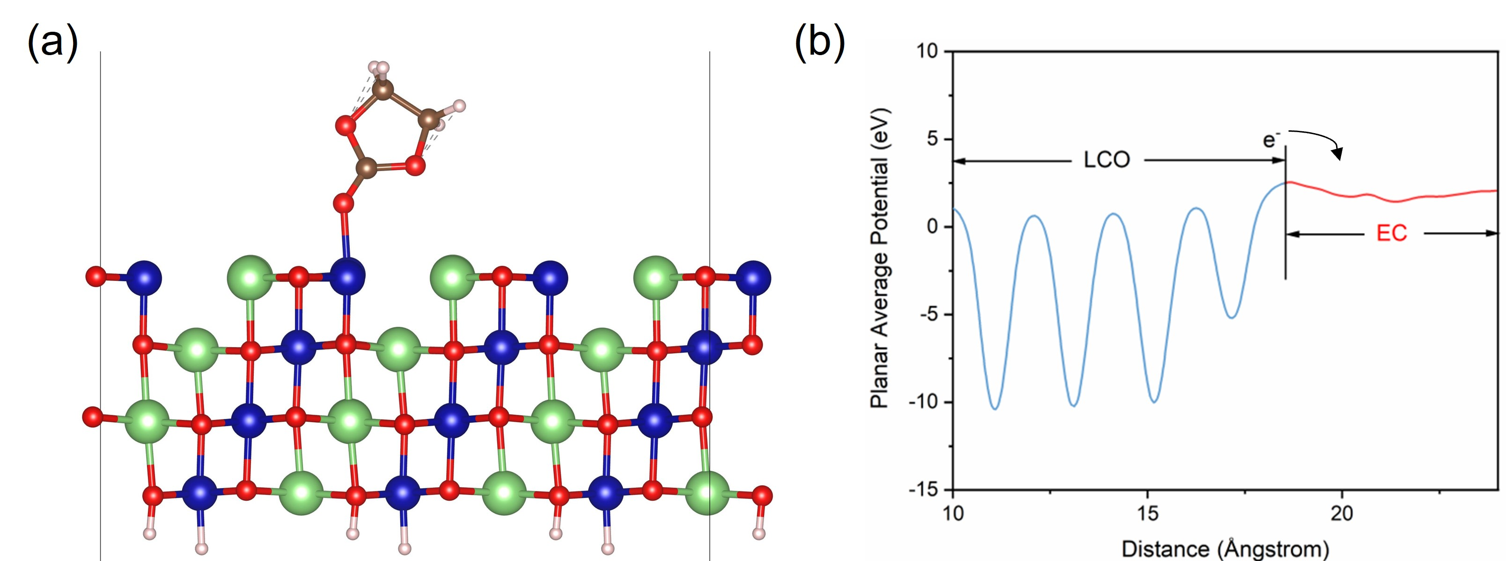
Fig. S1 (a) Absorption model of EC-LCO; (b) Planar average total potential energy along the Z direction

Fig. S2 HOMO energy levels of ten typical flame-retardant solvents
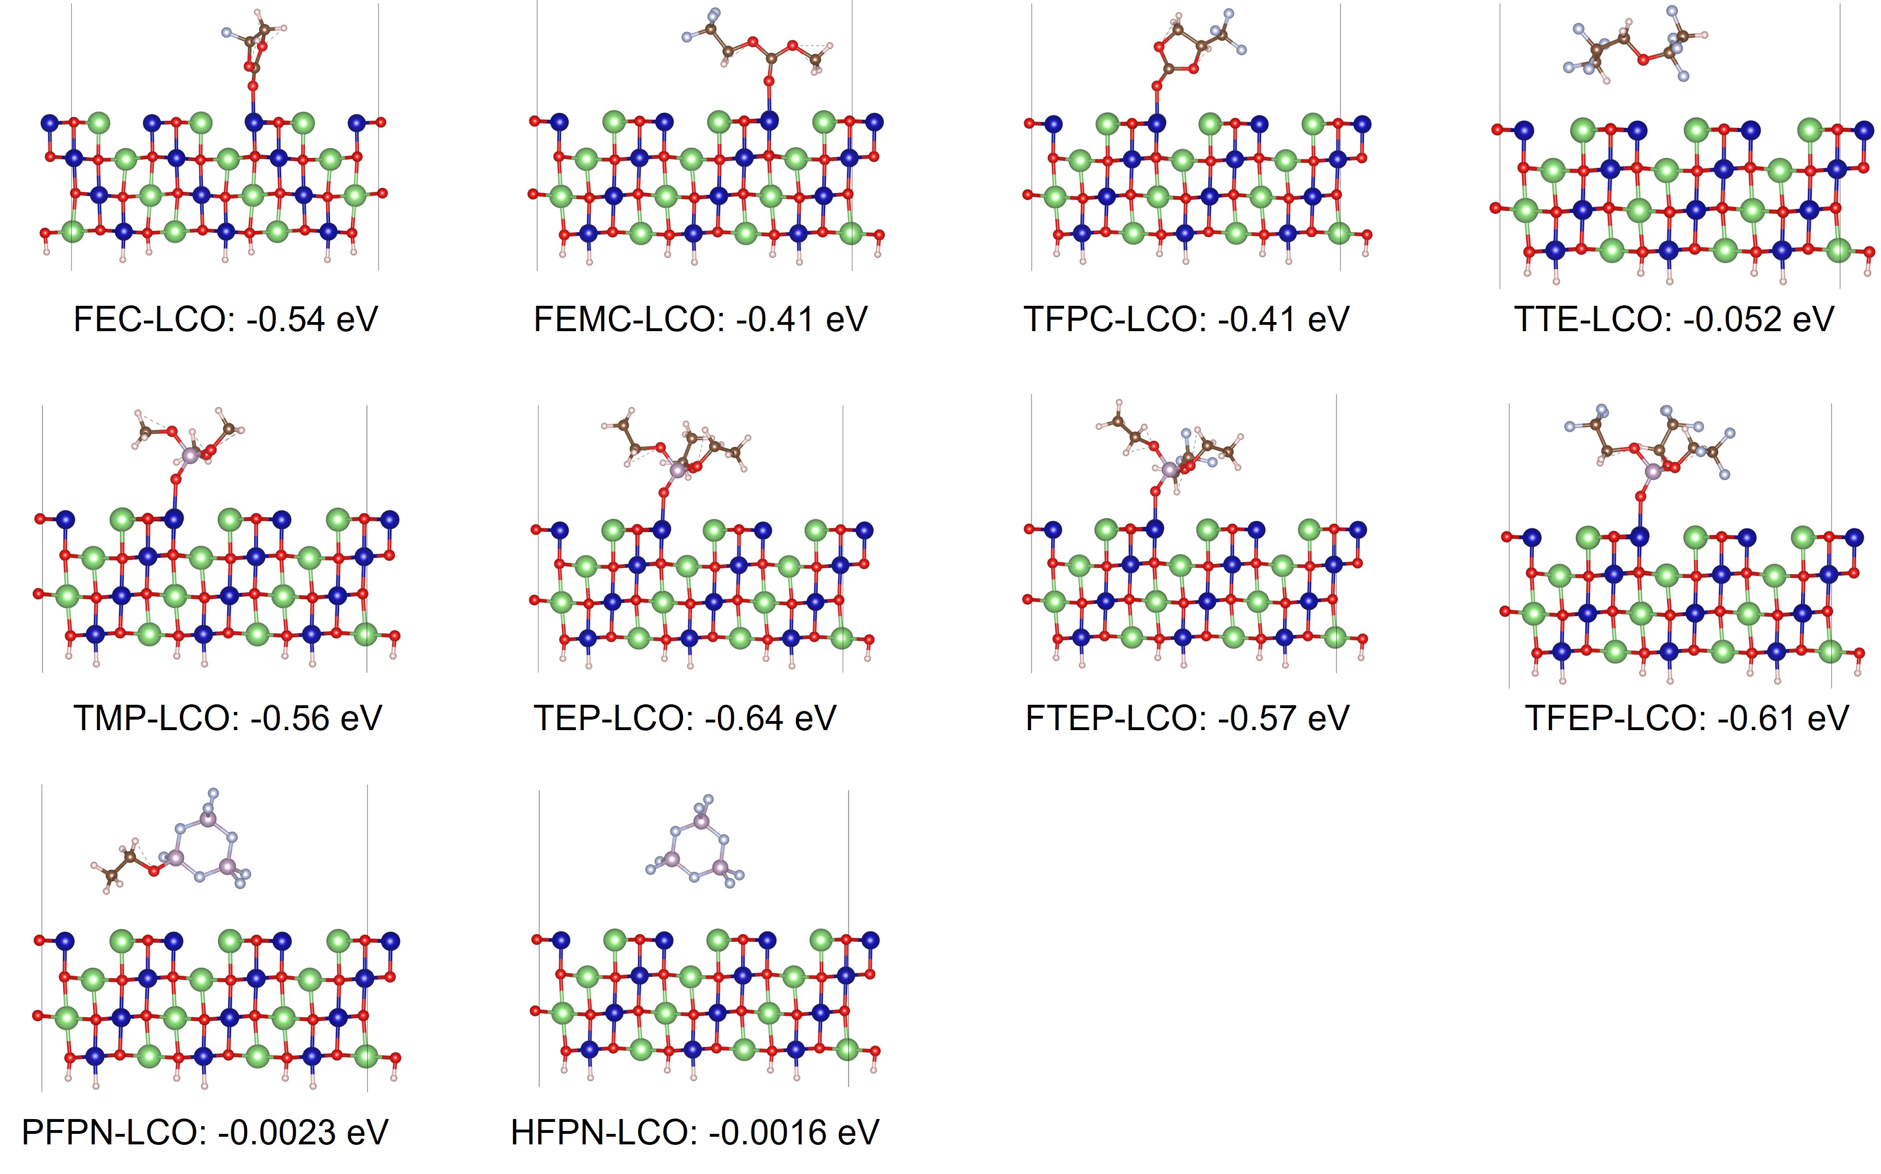
Fig. S3 The absorption energies and models of ten typical flame-retardant solvents on LCO surface
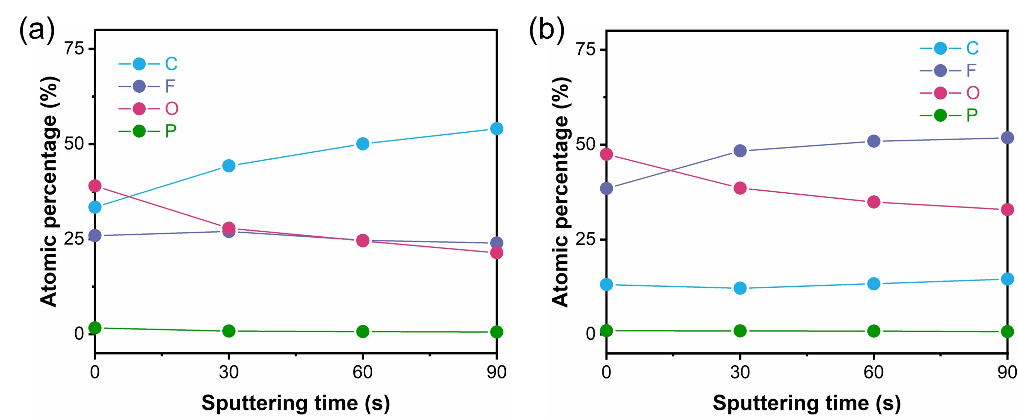
Fig. S4 Atomic percentage changes of CEI films formed on LCO electrode surface after 20 cycles in (a) EE and (b) TFE electrolytes with different etching time
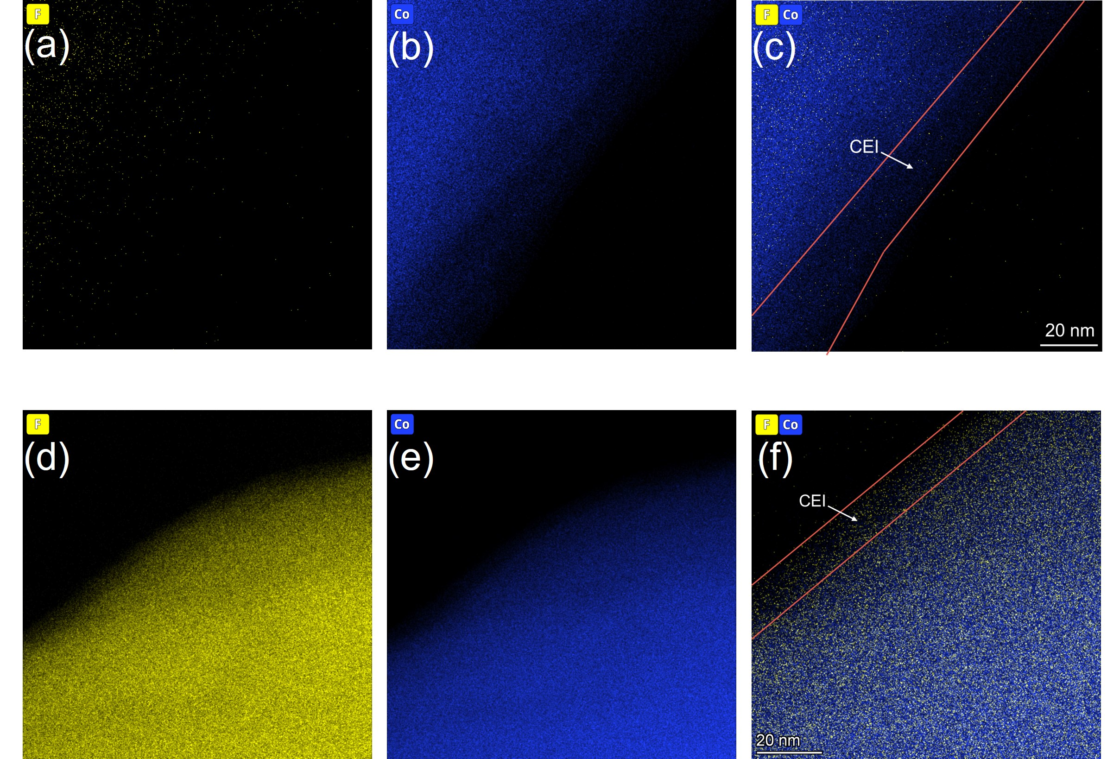
Fig. S5 The STEM-EDS results of LCO after cycling in (a-c) EE and (d-e) TFE. Note: Co element (in blue) and F element (in yellow)

Fig. S6 (a) Equivalent circuit; EIS results of Li/LCO half cells with (b) EE electrolyte and (c) TFE electrolyte after different cycles

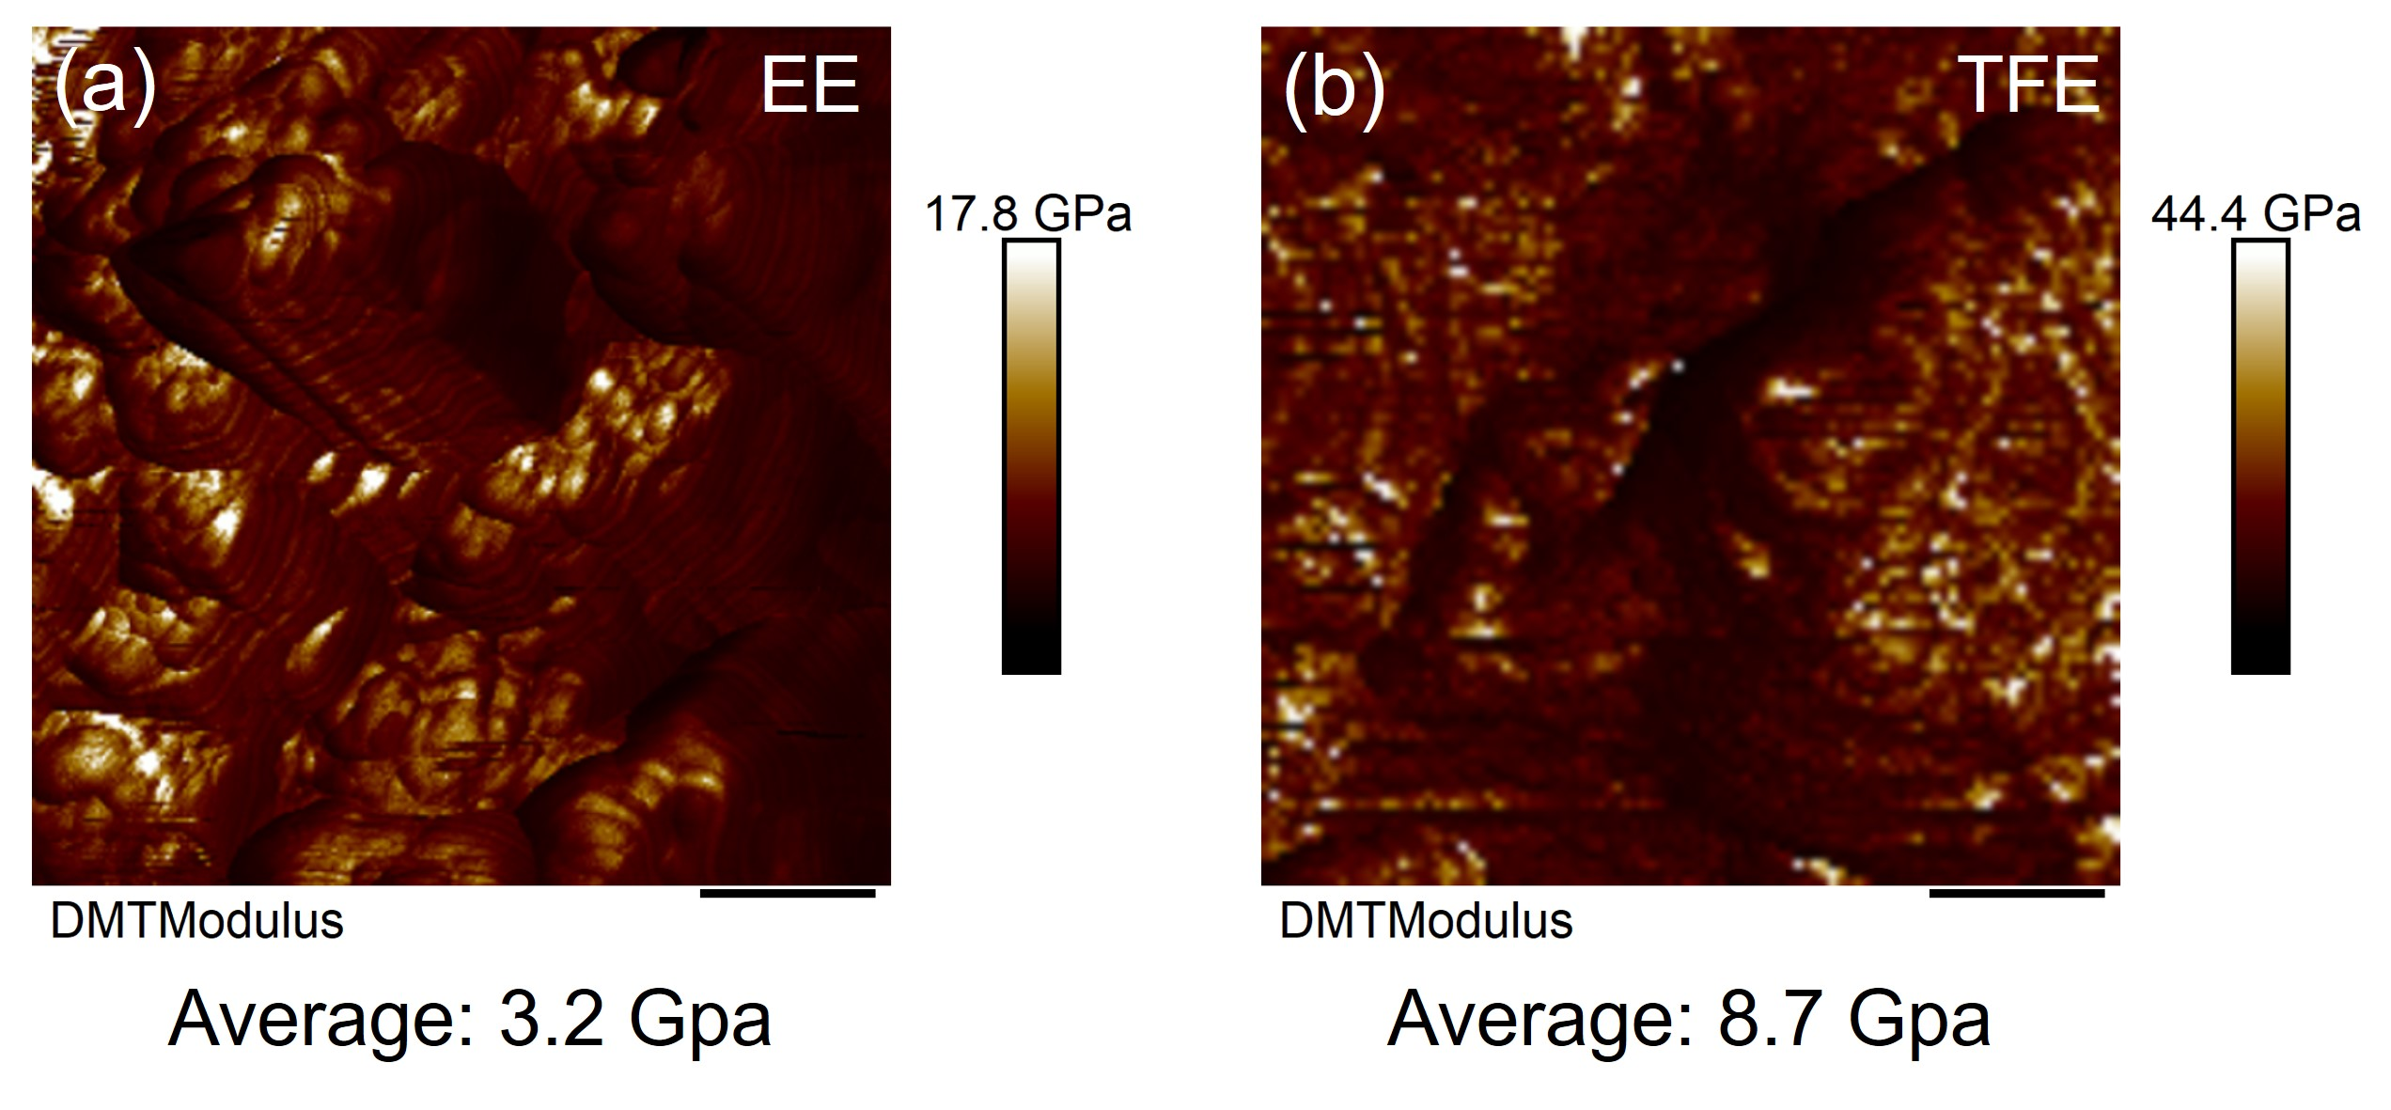
Fig. S7 The Young’s modulus of CEI film formed in (a) EE and (b) TFE electrolytes
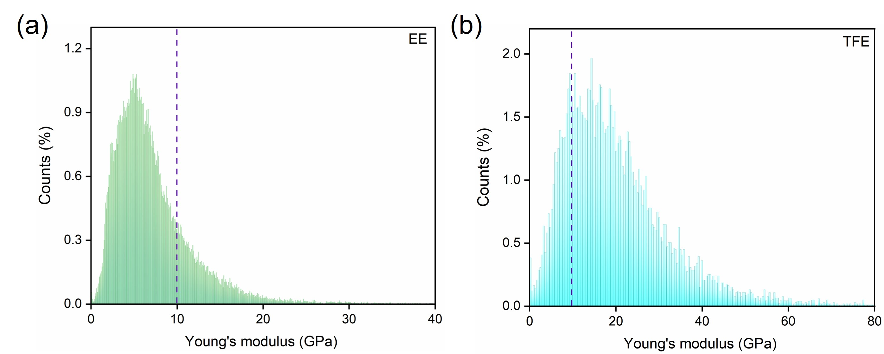
Fig. S8 The Young’s modulus of CEI film formed in (a) EE and (b) TFE electrolytes
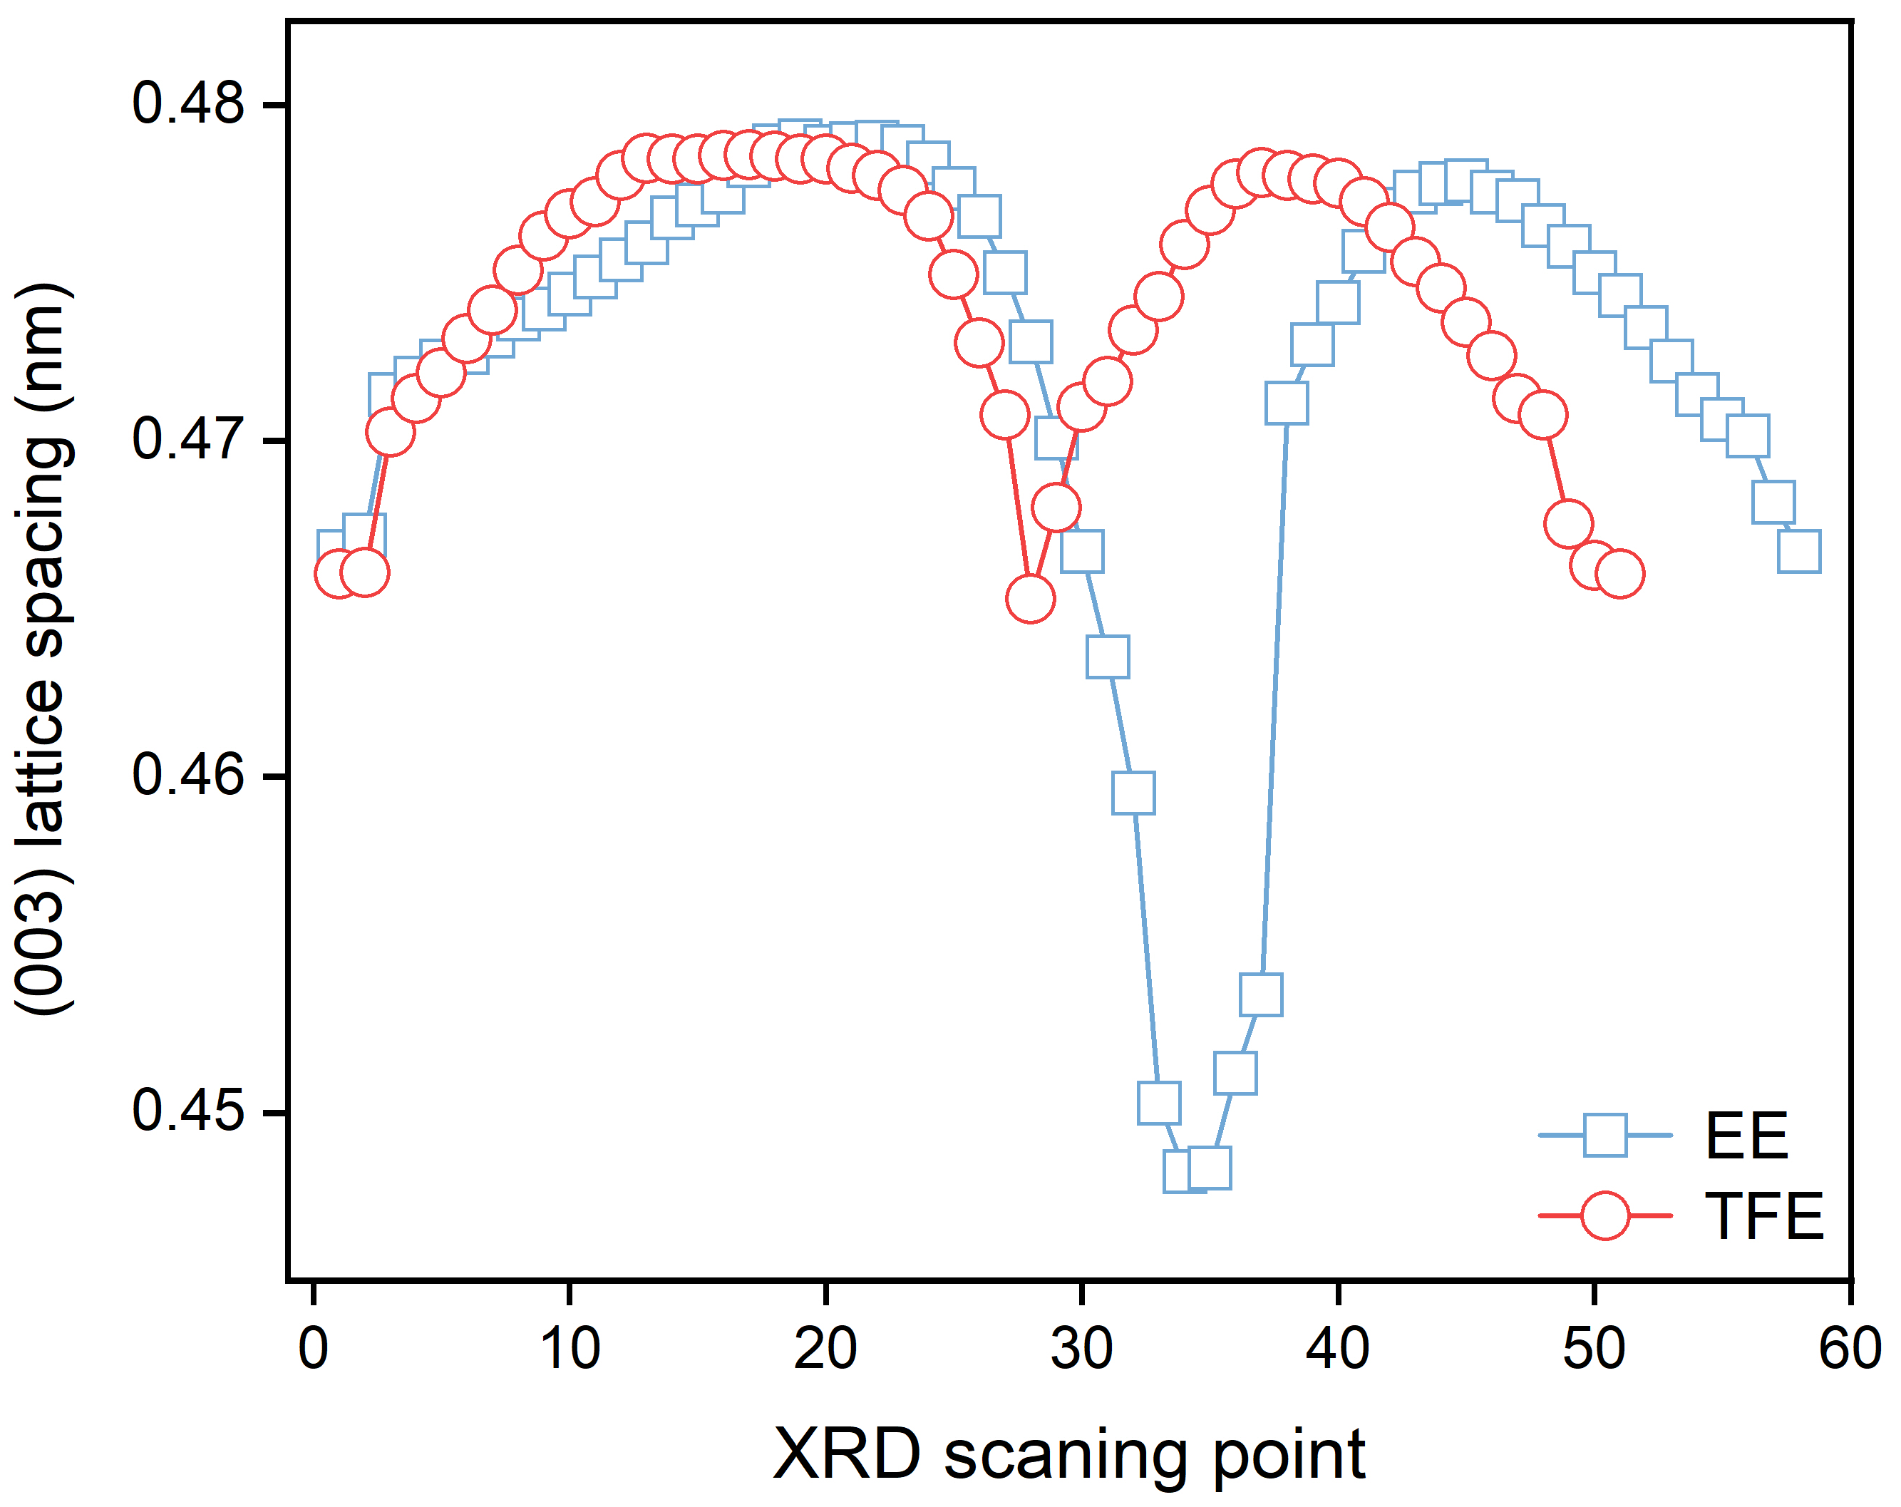
Fig. S9 The (003) peak lattice spacing of LCO during cycling with different electrolytes
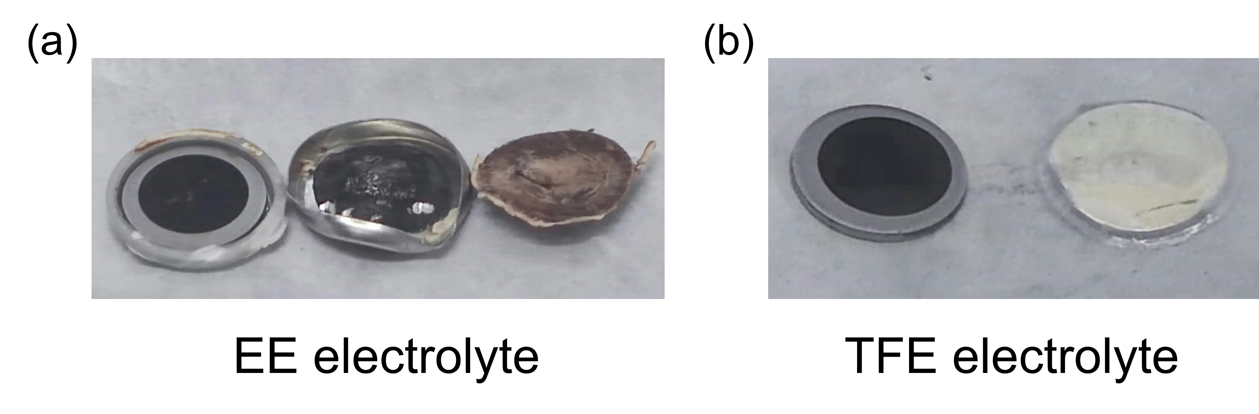
Fig. S10 Optical photographs of Li electrodes cycling in (a) EE and (b) TFE electrolytes after 20 cycles

Fig. S11 The contents of (a) Co and (b) Li ions in different electrolytes after 20 cycles

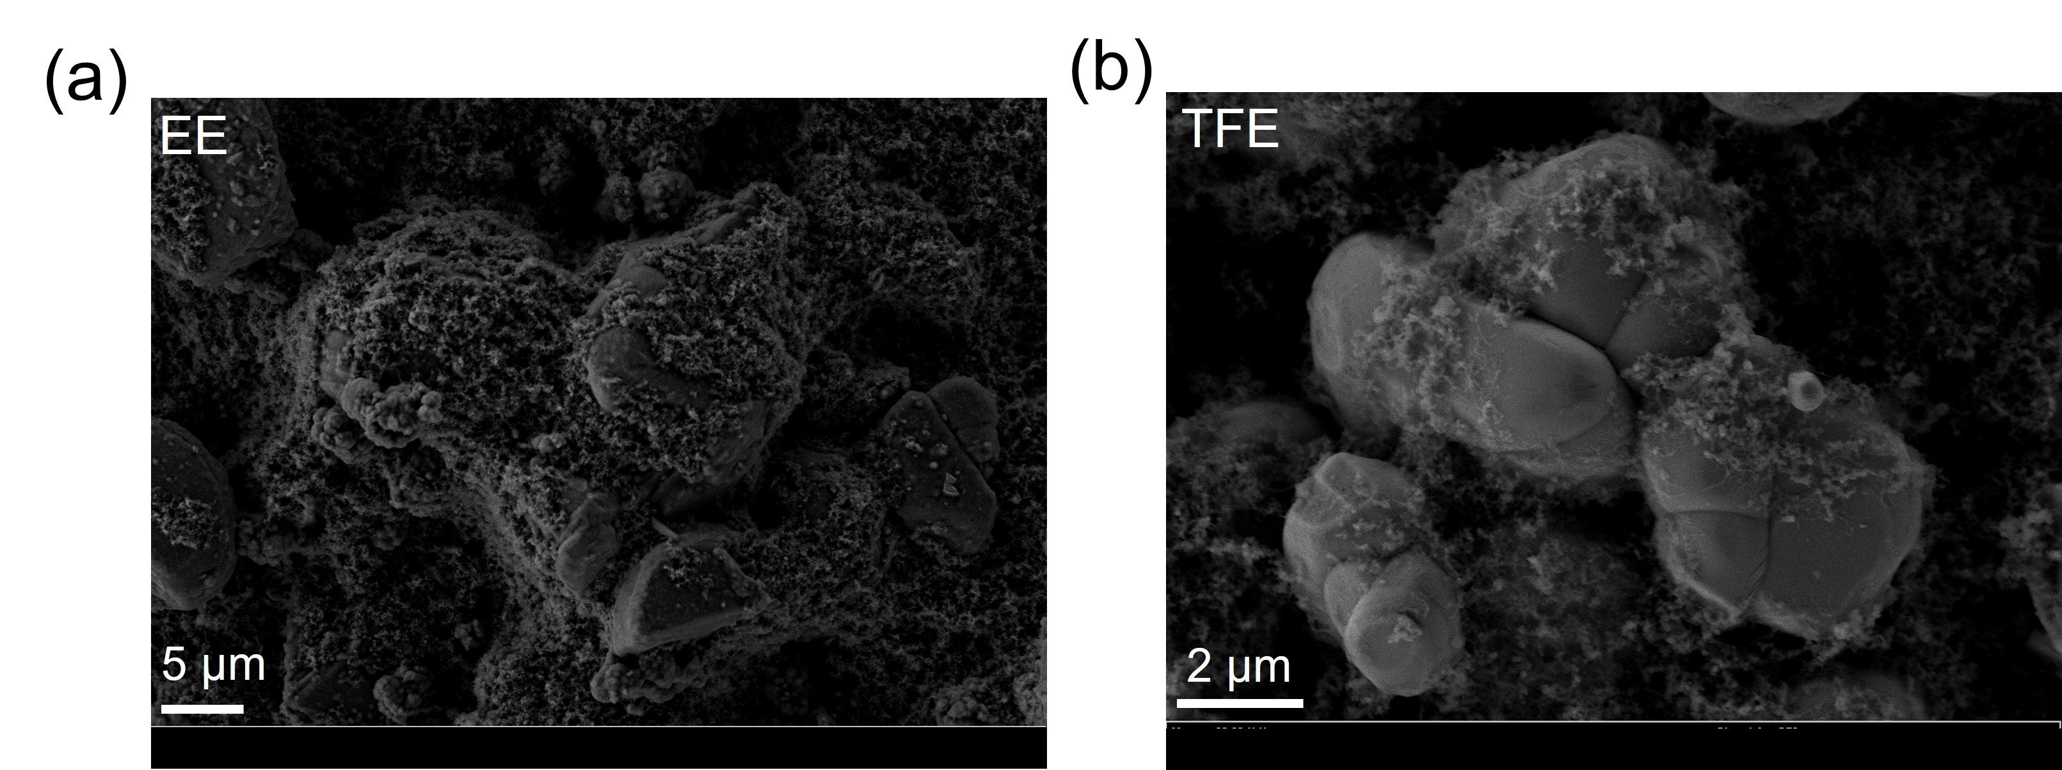
Fig. S12 SEM images of LCO cathodes cycling in (a) EE and (b) TFE electrolyte after 20 cycles
Fig. S13 Linear sweep voltammetry results of Li||Al half cells with different electrolytes and the scan rate is 10 mV s⁻¹
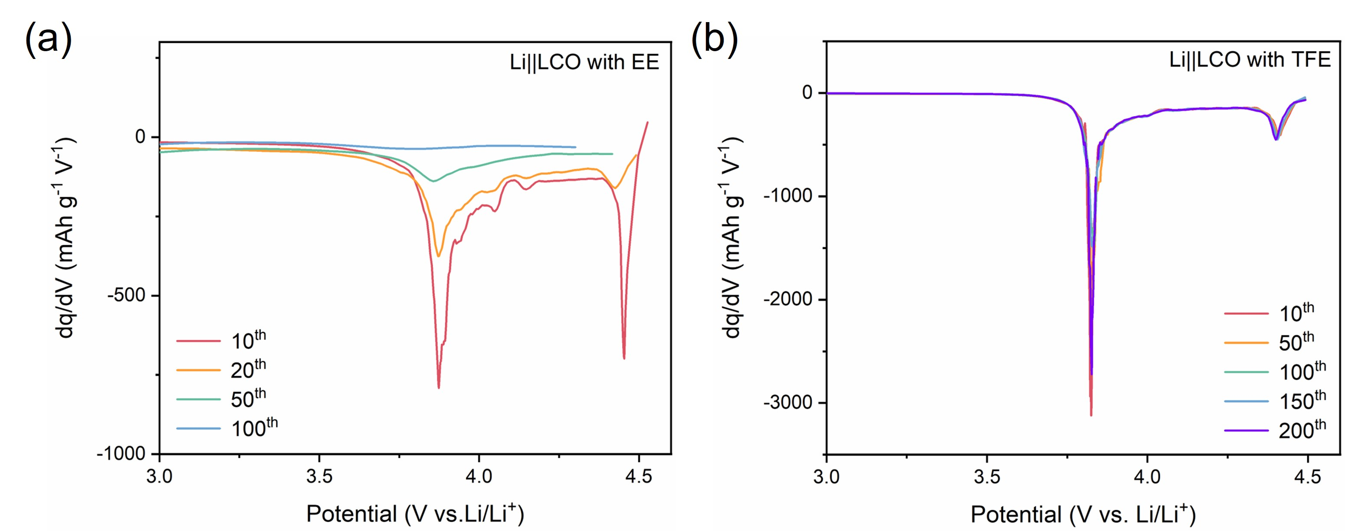
Fig. S14 dQ/dV curves of Li||LCO cells after different cycles with (a) EE and (b) TFE electrolyte in a voltage range of 3–4.6 V
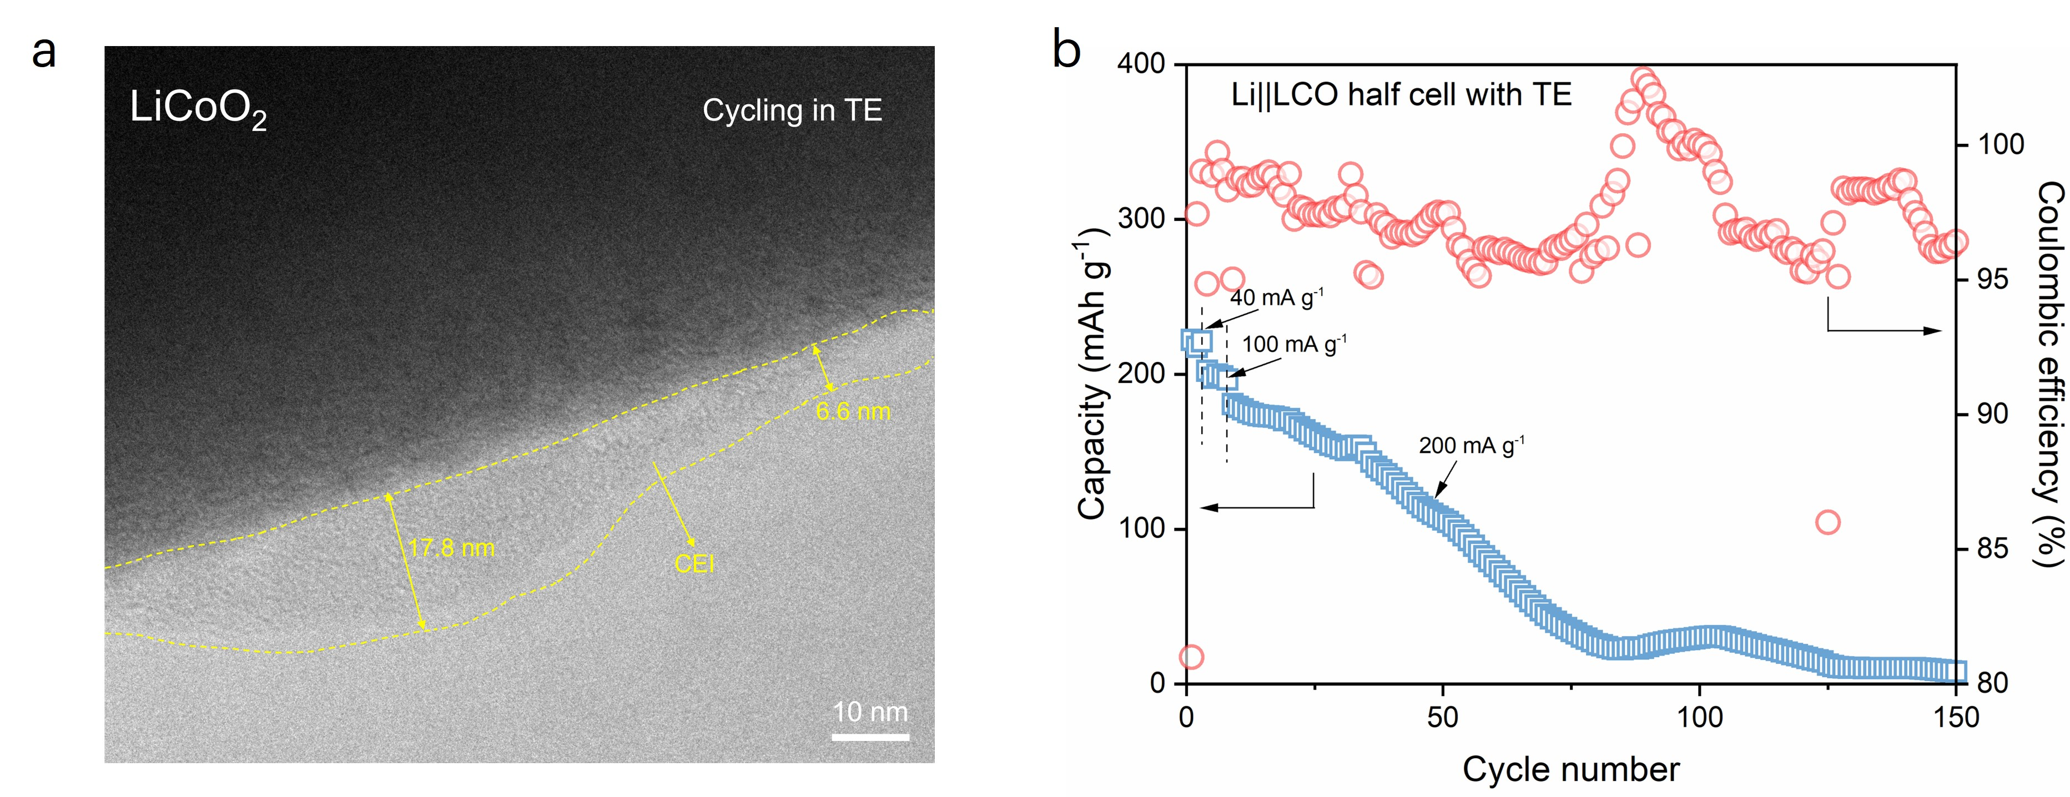
Fig. S15 (a) HR-TEM images of CEI film formed on LCO with TE electrolyte. (b) Cycling performance and Coulombic efficiency of Li||LCO half-cell with TE electrolyte under a voltage range from 3.0-4.6 V
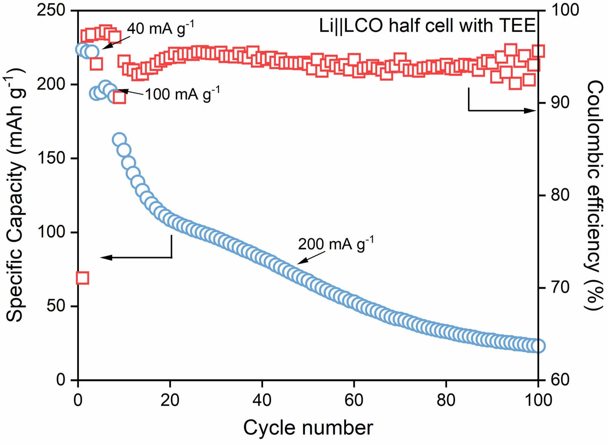
Fig. S16 Cycling performance and Coulombic efficiency of Li||LCO half-cell with TEE electrolyte (the specific current density is 40 mA g⁻¹ for the first three cycles, 100 mA g⁻¹ for the following five cycles, and 200 mA g⁻¹ for the subsequent cycles)

Fig. S17 (a) HR-TEM images of CEI film formed on LCO with TE electrolyte. (b) Cycling performance and Coulombic efficiency of Li||LCO half-cell with TE electrolyte under a voltage range from 3.0-4.6 V

Fig. S18 GITT curves of Li||LCO half cells with TFE (above) and EE (below) electrolytes

Fig. S19 The ionic conductivity of different electrolytes from -60 ℃ to 80 ℃

Fig. S20 TG results of EE and TFE electrolytes from room temperature to 250 ℃, the temperature rising rate was 10 ℃ min⁻¹

Fig. S21 (a) First charge and discharge curve of Gr anodes in TFE electrolyte under a current density of 25 mAh g⁻¹; (b) Cycling performance and Coulombic efficiency of Li/Gr half cells with TFE electrolyte. The specific current density is 25 mAh g⁻¹ in the first three cycles and 100 mA g⁻¹ in the subsequent cycles. The voltage range is 0.01–2.0 V (vs. Li/Li⁺).

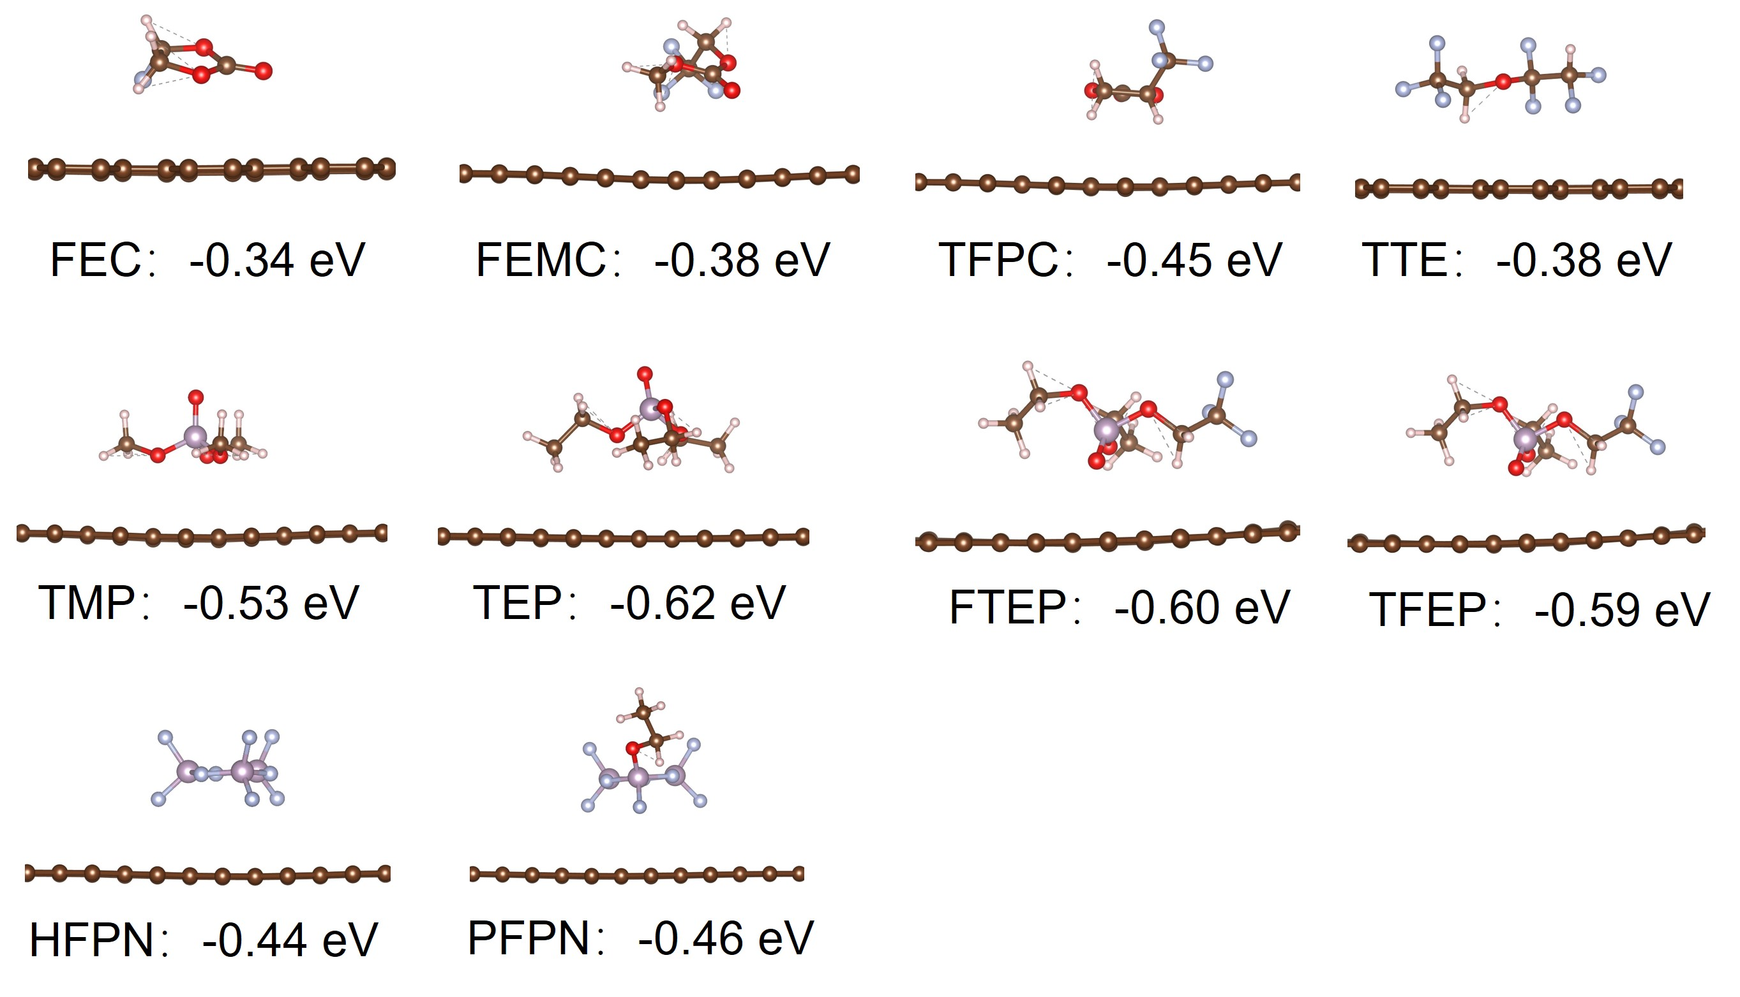
Fig. S22 The absorption energies and models of ten typical flame-retardant solvents on graphite surface
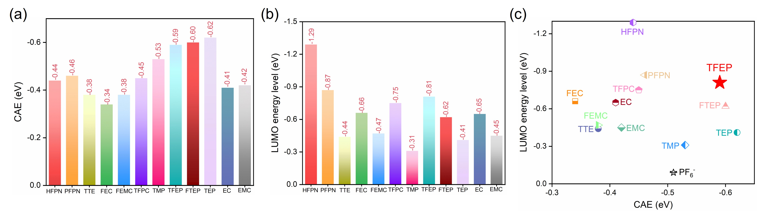
Fig. S23 (a-b) CAE and LUMO energy level of different solvents; (c) Two-dimensional diagrams for solvent screening
Fig. S24 Discharge curves of 0.7 Ah Gr||LCO pouch cells with (a) EE and (b) TFE electrolyte at different current rates
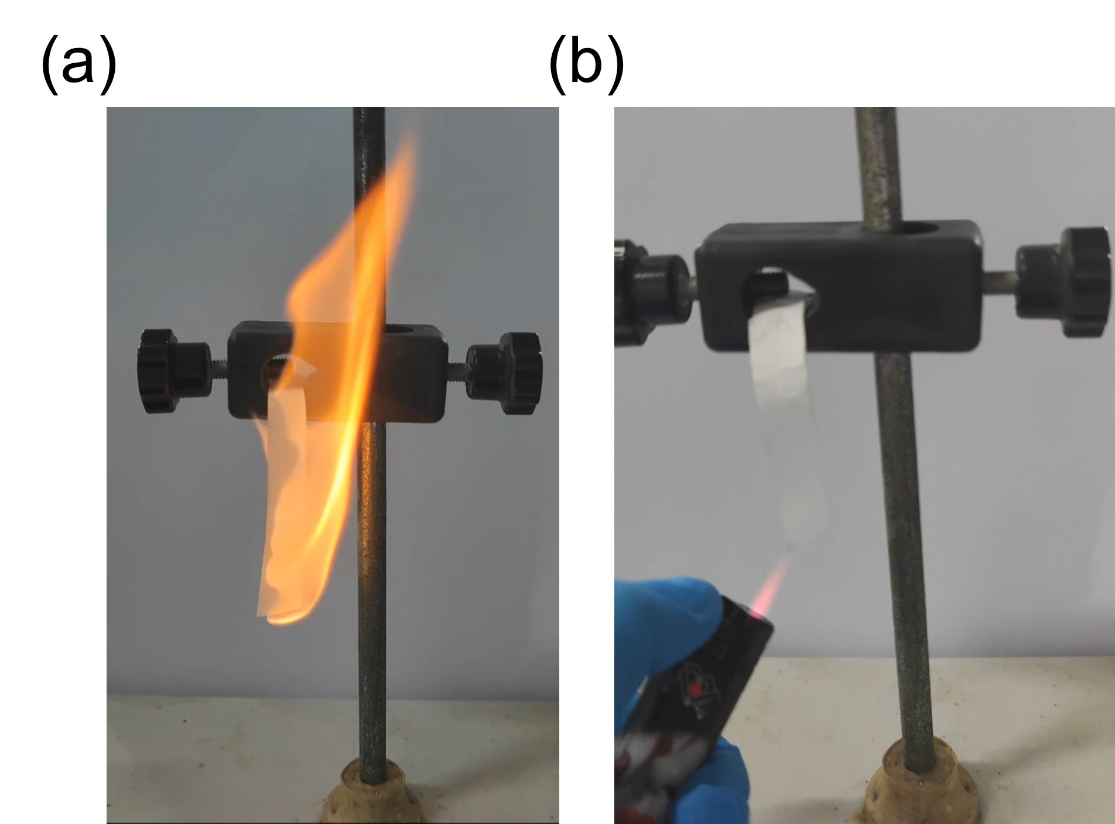
Fig. S25 Flame tests of (a) EE and (b) TFE electrolytes

Fig. S26 Cycling performance and Coulombic efficiencies of 3.6 Ah Gr||LCO pouch cells with EE and TFE electrolytes under a current of 0.5 C (1C= 3600 mA)

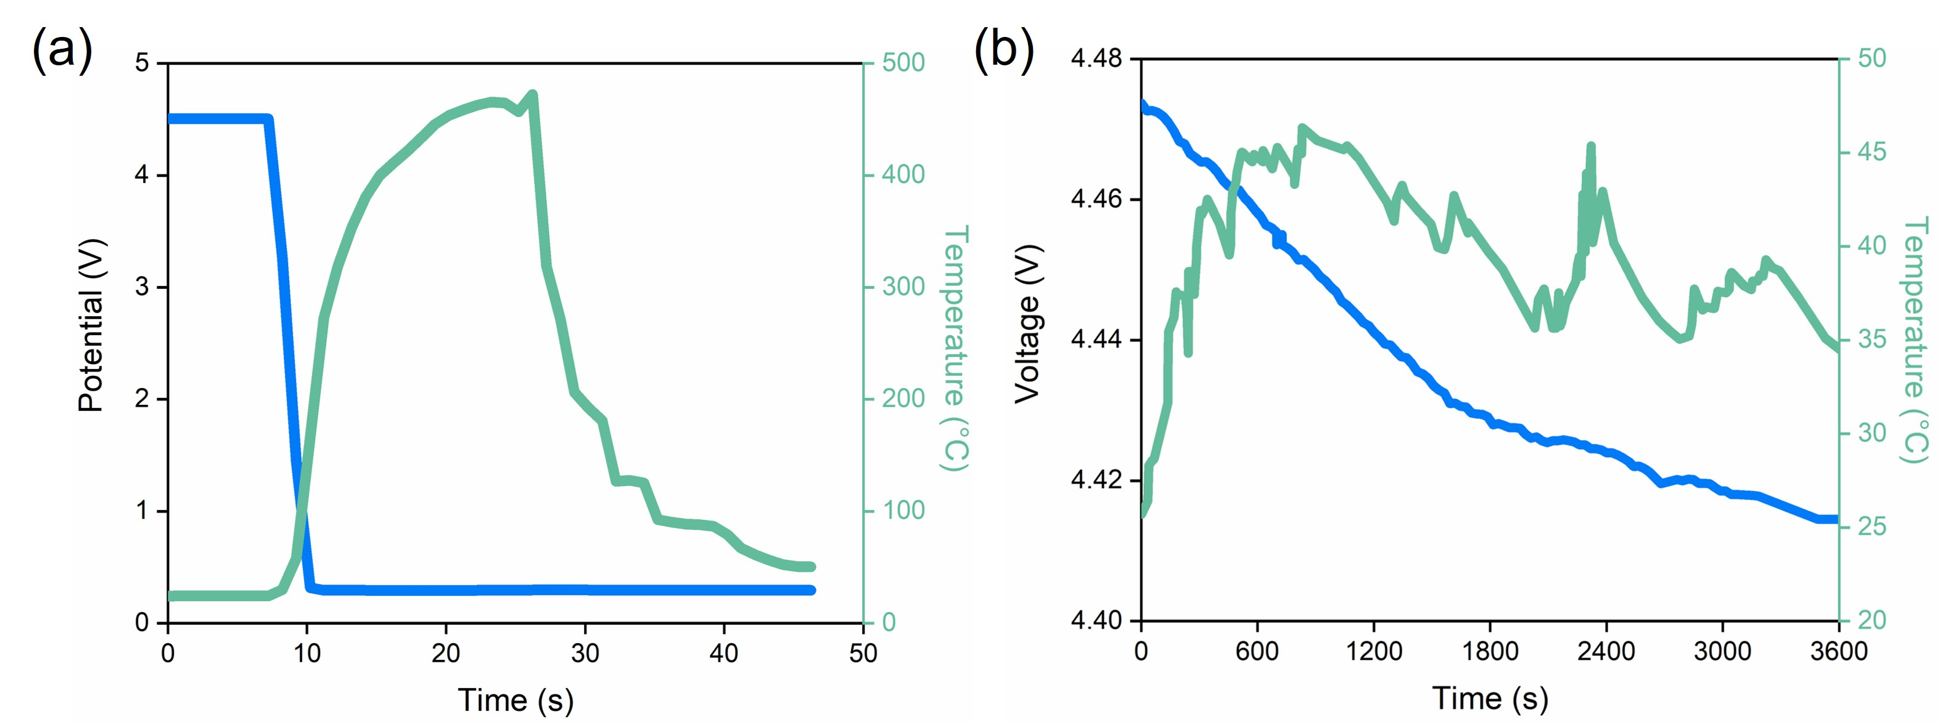
Fig. S27 Time-voltage/temperature curves of Gr||LCO pouch cells during nail penetration using (a) EE electrolyte and (b) TFE electrolyte

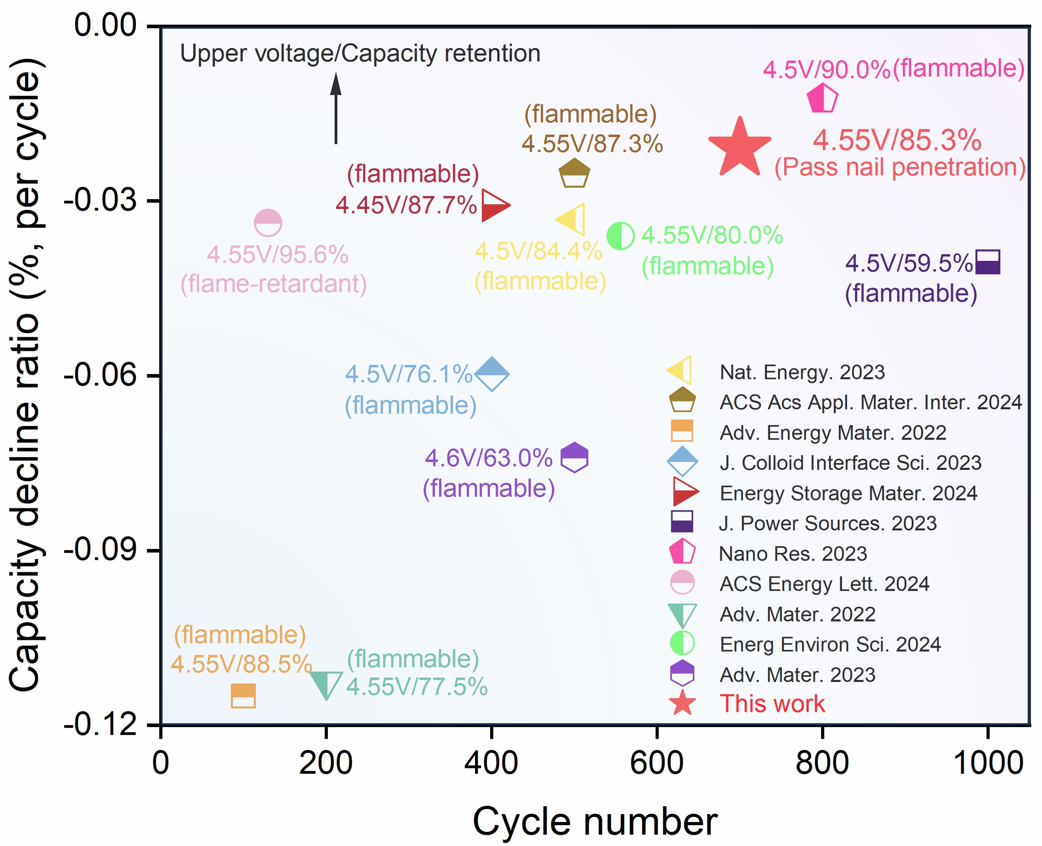
Fig. S28 Comparison of electrochemical performance of recently reported high-voltage LCO cathodes

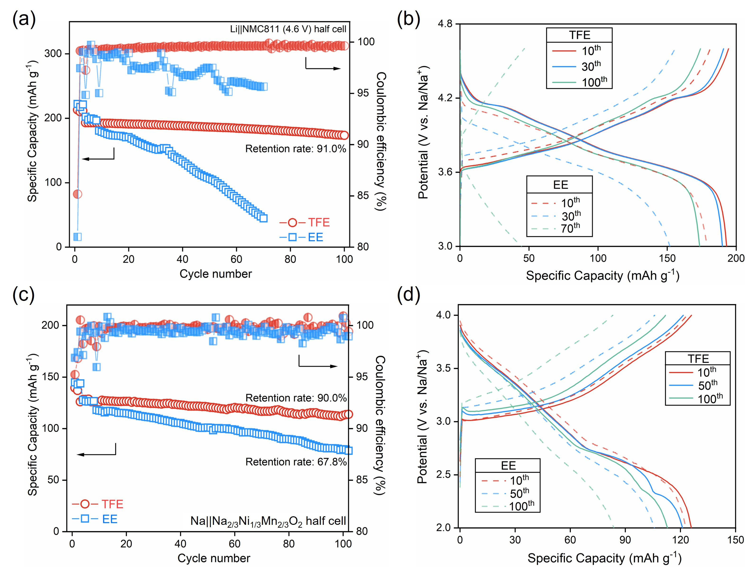
Fig. S29 (a-b) Cycling performance and charge-discharge curves of Li||NMC811 half-cells with TFE and EE electrolyte in a voltage range of 3.0-4.6 V; (c-d) Cycling performance and charge-discharge curves of Na||Na_{2/3}Ni_{1/3}Mn_{2/3}O₂ half-cells with NaPF₆-TFEP/EMC and NaPF₆-EC/EMC in a voltage range of 2.0-4.0 V

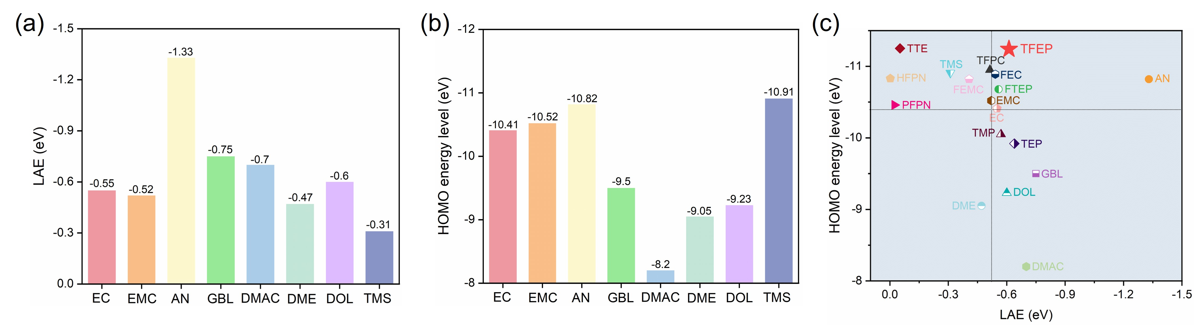
Fig. S30 (a-b) LAE and HOMO of different solvents; (c) Two-dimensional diagrams for solvent screening, where x axis is LAE and y axis is HOMO

Table S1 The physical properties of selected solvents
 | Viscosity (mPa·s) | Density (cm³ g⁻¹) | Melting point (℃) | Flash point (℃)
Hexafluorocyclotriphosphazene  (HFPN) | / | 2.24 | 25-30 | 60.9
Ethoxy(pentafluoro)cyclotriphosphazene (PFPN) | / | 2.08 | -34 | 85
2,2,3,3-Tetrafluoro-1-(1,1,2,2-tetrafluoroethoxy)propane (TTE) | 0.25 | 1.53 | -94.3 | 27.5
Methyl 2,2,2-trifluoroethyl carbonate (FEMC) | 0.54 | 1.31 | -44.2 | 65
3,3,3-Trifluoropropylene carbonate (TFPC) | 3.0 | 1.55 | / | >120
Fluoroethylene carbonate (FEC) | 1.9 | 1.45 | 18 | >102
Trimethyl phosphate (TMP) | 1.2 | 1.21 | -46 | 107
Triethyl phosphate (TEP) | 1.6 | 1.07 | -56.5 | 117
2,2,2-Trifluoroethyl phosphate (FTEP) | / | / | / | >120
Tris(2,2,2-trifluoroethyl) phosphate (TFEP) | 3.1 | 1.56 | -22 | >130
Ethylene carbonate (EC) | 1.9 | 1.32 | 36.5 | 152
Ethyl methyl carbonate (EMC) | 0.65 | 1.0 | -55 | 23
Acetonitrile (AN) | 0.34 | 0.79 | -45 | 2
Gamma-butyrolactone (GBL) | 1.5 | 1.13 | -43.5 | 98
Dimethylacetamide (DMAC) | 0.92 | 0.94 | -20 | 70
Dimethoxyethane (DME) | 0.32 | 0.87 | -58 | -2
1,3-Dioxacyclopentane (DOL) | 0.57 | 1.01 | -95 | 1
Tetramethylene sulfone (TMS) | 10.29 | 1.26 | 27.5 | 166
Table S2 The fitted EIS parameters of the LCO cathode at different cycles in EE and TFE electrolytes
 | R_{CEI} (Ω) | R_{ct} (Ω)
EE (pristine) | / | 164.9
EE (1st cycle) | 203.5 | 224.3
EE (50th cycle) | 527.8 | 418.4
TFE (pristine) | / | 206.8
TFE (1st cycle) | 49.8 | 61.7
TFE (50th cycle) | 53.4 | 63.0

