Supporting Information for
Catalysis-Induced Highly-Stable Interface on Porous Silicon for High-Rate Lithium-Ion Batteries
Zhuobin Han^{1,†}, Phornphimon Maitarad^{1,8,†}, Nuttapon Yodsin², Baogang Zhao¹, Haoyu Ma¹, Kexin Liu¹, Yongfeng Hu³, Siriporn Jungsuttiwong⁴, Yumei Wang⁵, Li Lu⁵, Liyi Shi^{1,7}, Shuai Yuan¹, Yongyao Xia^{6,}* and Yingying Lv^{1,}*
¹ Research Centre of Nanoscience and Nanotechnology, Shanghai University, Shanghai 200444, People’s Republic of China
² Department of Chemistry, Faculty of Science, Silpakorn University, Nakhon Pathom 73000, The Kingdom of Thailand
³ Sinopec Shanghai Research Institute of Petrochemical Technology Co., Ltd., Shanghai 201208, People’s Republic of China
⁴ Department of Chemistry and Center of Excellence for Innovation in Chemistry Faculty of Science, Ubon Ratchathani University, Ubon Ratchathani 34190, The Kingdom of Thailand
⁵ National University of Singapore (Chongqing) Research Institute, Chongqing 401123, People’s Republic of China
⁶ Department of Chemistry, Fudan University, Shanghai 200433, People’s Republic of China
⁷ Emerging Industries Institute Shanghai University, Jiaxing, Zhejiang 314006, People’s Republic of China
⁸Program in Bioinformatics and Computational Biology, Graduate School, Chulalongkorn University, Bangkok 10330, The Kingdom of Thailand
† Zhuobin Han and Phornphimon Maitarad contributed equally to this work.
*Corresponding authors. E-mail: yyinglv@shu.edu.cn (Yingying Lv); yyxia@fudan.edu.cn (Yongyao Xia)
Supplementary Figures and Tables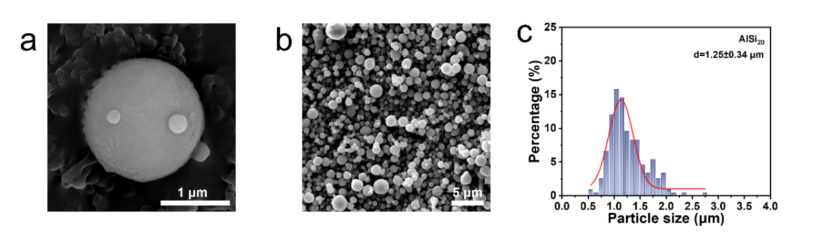
Fig. S1 (a, b) SEM images of pristine AlSi₂₀ alloy; (b) The particle size distribution of pristine AlSi₂₀ alloy
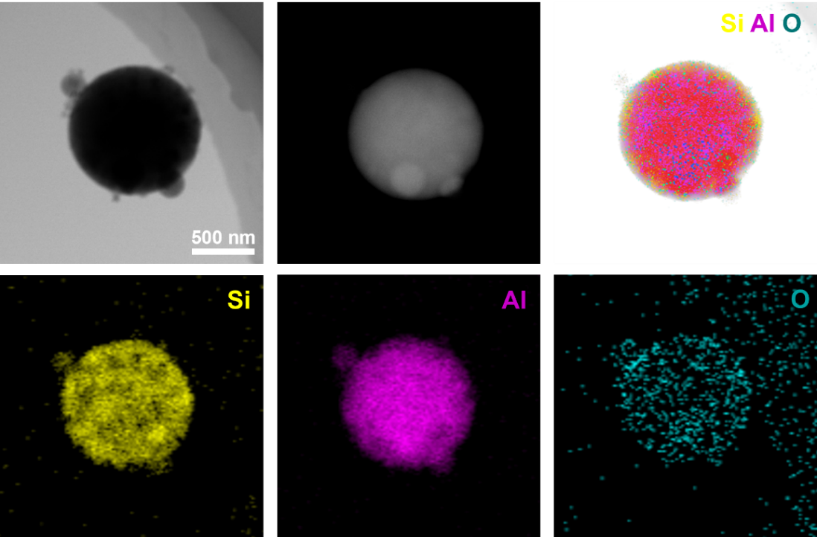
Fig. S2 TEM and elemental mapping images of AlSi₂₀ alloy

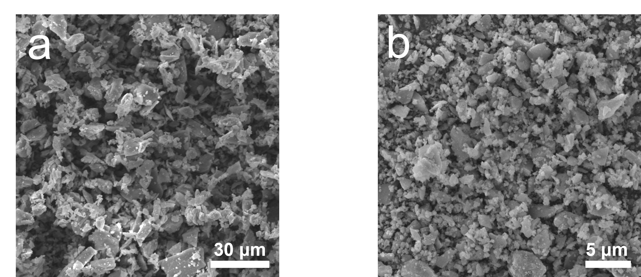
Fig. S3 SEM images of commercial Si

Fig. S4 Elemental mapping images of p-Si@ATO

Fig. S5 Nitrogen sorption/desorption isotherms and the corresponding pore size distribution of p-Si. SSA: 98.5 m² g⁻¹

Fig. S6 Nitrogen sorption/desorption isotherms of commercial Si. SSA: 10.1 m² g⁻¹
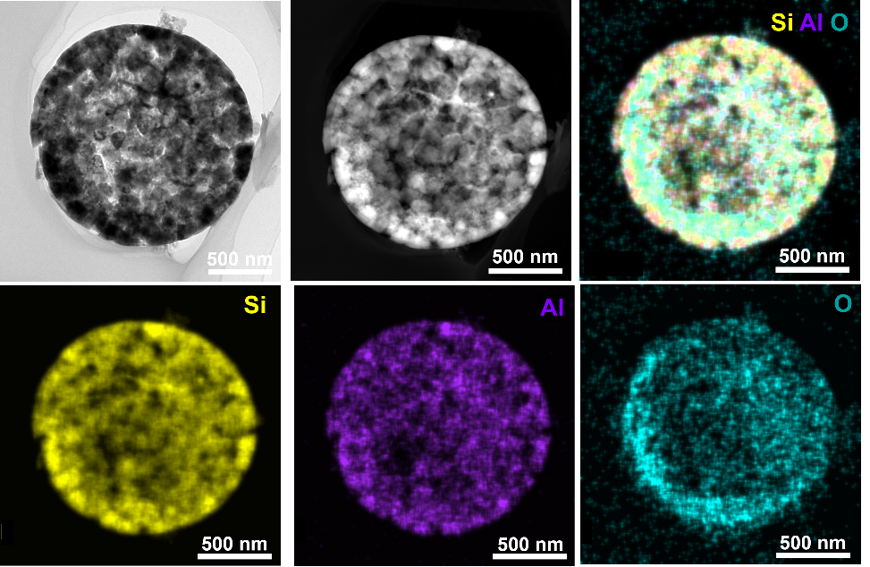
Fig. S7 TEM and elemental mapping images of p-Si obtained from acid etching of pristine AlSi₂₀ alloy

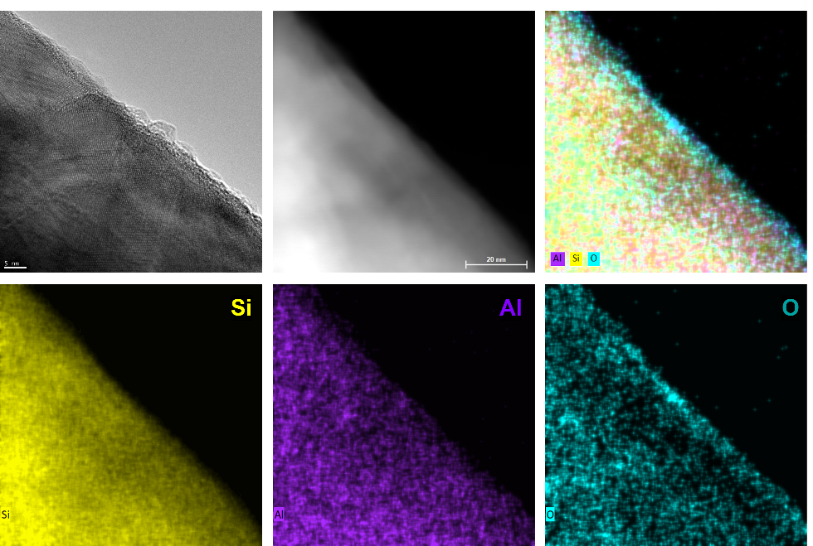
Fig. S8 HRTEM and elemental mapping images of surface oxide layer on the p-Si

Fig. S9 The Al 2p and Si 2p XPS of AlSi₂₀ alloy (a, b), p-Si@ATO (c, d) and p-Si (e, f)

Fig. S10 The Si 2p XPS of commercial Si

Fig. S11 EPR spectroscopy of p-Si@ATO, p-Si, commercial Si and commercial Si with TiO_{x}
Commercial Si with TiO_{x}: commercial Si replaces AlSi₂₀ alloy for hydrolysis of TBOT under the alkaline conditions provided by TMAOH. The results indicate the presence of only oxygen vacancies, and no Ti³⁺ signal was detected in the absence of Al.

Fig. S12 Comparison of performance of p-Si@ATO with different TBOT mass at 2 A g⁻¹

Fig. S13 (a) Cycling performance of different FEC concentrations at 2 A g⁻¹ after 2 cycles at 0.2 A g⁻¹; (b) Galvanostatic first cycle charge/discharge voltage profiles at 0.2 A g⁻¹
Fig. S14 Galvanostatic first cycle charge/discharge voltage profiles of p-Si@ATO, p-Si and commercial Si at 0.2 A g⁻¹

Fig. S15 Cycling performance of p-Si@ATO, p-Si and commercial Si at 25 °C

Fig. S16 Cycling performance of p-Si@ATO, p-Si and commercial Si at 50 °C

Fig. S17 Cycling performance of p-Si@ATO electrode with a load of 1.8 mg cm⁻² at 25 ℃
The high loading anode of 1.8 mg cm⁻² (without additional conductive agent is added) displays an area capacity of approximately 3.2 mAh cm⁻² at 0.2 A g⁻¹, and can withstand high current density cycles.

Fig. S18 Capacity-voltage curves of p-Si@ATO||LFP pouch-cell at first cycle

Fig. S19 (a) Cycling performance of p-Si@ATO||LFP and p-Si||LFP coin-type full-cell; (b) Capacity-voltage curves of first cycle at 0.2 C
The coin-type full-cell has an N/P ratio of approximately 1.05, with a voltage range of 2.5–3.9 V and 1 C =160 mAh g⁻¹. The negative electrode is pre-cycled 5 times at 0.2 A g⁻¹ before being assembled into the full-cell.

Fig. S20 Cycling performance of coin-type full-cell p-Si@ATO/Gr||LFP at 25 ℃
The p-Si@ATO/Gr electrode slurry was fabricated by mixing 76.5 wt% graphite, 8.5 wt% p-Si@ATO powder, 10 wt% polyacrylic acid, and 5 wt% acetylene black in N-methyl-2-pyrrolidone. The initial Coulombic efficiency is 94.3% at 0.2 C.

Fig. S21 EIS after 1 cycle measured at 100% SOC

Fig. S22 (a) EIS of Li-Li symmetric cells and (b) the corresponding DRT

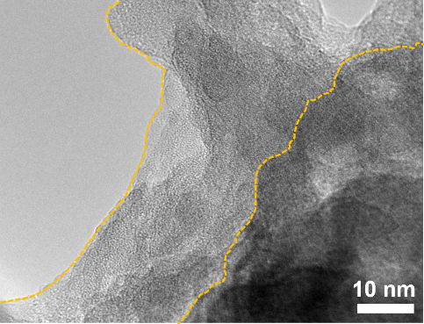
Fig. S23 HRTEM images of p-Si electrodes after 100 cycles

Fig. S24 F at% of LiF in F 1s XPS at different voltages

Fig. S25 Raman spectroscopy of p-Si@ATO powder and p-Si@ATO electrode before cycle
Fig. S26 F at% of LiF in F 1s XPS after 1, 50 and 100 cycles
Fig. S27 ToF-SIMS results of the Si electrode after 100 cycles: depth profiles of various species
The ions composition and distribution of the anode surface and depth sputtering area (70×70 μm²) were characterized by Time-of-Flight secondary ion mass spectrometry (ToF-SIMS, ToF-SIMS 5 ION-ToF GmbH, Germany). ToF-SIMS was equipped with a 30 keV Bi³⁺ primary ion gun and a 1 keV Cs⁺ sputter gun, and an electron flood gun was used for charge neutralization. The silicon-based electrodes were tested after 100 cycles and subsequently washed repeatedly with DMC.

Fig. S28 PDOS without FEC on SiO₂, Al₂O₃ and ATO surfaces

Table S1 Content of elements in p-Si@ATO
Element | EDS Mapping (wt%) | ICP (wt%)
Si | 46.2 | 85.11
Al | 35.3 | 5.58
Ti | 0.14 | 0.32

Table S2 Content of elements after the etching process with alkaline solution
Element | After TMAOH etching (wt%)
Si | 46.16
Al | 35.28
Ti | 0.14

Table S3 Comparison of the electrochemical characteristics for Si-base anode materials at high temperture
Anode material | Electrolytes | Specific capacity (temperature) | Capacity retention | References
p-Si@ATO | 1 M LiPF₆ in EC/DEC (1:1) + 15% FEC | 2423 mAh g⁻¹ at 0.2 A g⁻¹,  270 mAh g⁻¹ at 25 A g⁻¹ (50 ℃) | 80.0% after 500 cycles at 2 A g⁻¹ | This work
Microsized Si | 2 M LiFSI in Pyr₁₄FSI | ~3500 mAh g⁻¹ at 0.4 A g⁻¹ (80 ℃) | 85%  after 100 cycles at 4 A g⁻¹ | [S1]
Si@GCA13 | 1 M LiPF₆ in EC/DEC  (1:1) + 10% FEC and 1%VC | 2302 mAh g⁻¹ at 0.8 A g⁻¹ after 55 cycles (60 ℃) | \ | [S2]
MFG/PNSi@C | 1 M LiPF₆ in EC/DC/DMC (1:1:1) | 851 mAh g⁻¹ at 0.4 A g⁻¹ (50 ℃) | \ | [S3]
Si@C@Al₂O₃ | 1 M LiPF₆ in EC/EMC  (3:7) + 5% FEC | 1276 mAh g⁻¹ at 8 A g⁻¹ (80 ℃) | \ | [S4]
3D-Si@SiOx/C | 1 M LiPF₆ in EC/EMC  (1:2) + 2% FEC | 1746 mAh g⁻¹ at 0.2 A g⁻¹ (60 ℃) | 79.4% after 70 cycles at 0.2 A g⁻¹ | [S5]
Si@BaTiO_{x}-600@C | 1.3 M LiPF₆ in EC/DEC  (3:7) + 10% FEC | 2021 mAh g⁻¹ at 1 C (60 °C) | 64% after 600 cycles at 1 C | [S6]
Si-C@Al₂O₃ | 1 M LiPF₆ in EC/DMC  (1:1) + 10% FEC | 668.6 mAh g⁻¹ at 0.5 A g⁻¹ (60 °C) | 80.4% after 100 cycles at 0.5 A g⁻¹ | [S7]
Si@PAA-B-HPR | 1 M LiPF₆  in EC/DEC (1:1) + 5% FEC and 0.5% VC | 2106 mAh g⁻¹ at 1.4 A g⁻¹ (55 °C) | 50.14% after 500 cycles at 1.4 A g⁻¹ | [S8]
Si@C-5CNTs | 1 M LiPF₆ in EC/DMC (1:1) | 819 mAh g⁻¹ at 2 A g⁻¹ (40 °C) | 83.6% after 100 cycles at 0.1 A g⁻¹ | [S9]

Supplementary References
- Q. Liu, T. Meng, L. Yu, S. Guo, Y. Hu et al., Interface engineering to boost thermal safety of microsized silicon anodes in lithium-ion batteries. Small Methods. 6, 2200380 (2022). https://doi.org/10.1002/smtd.202200380
- Y. Tong, S. Jin, H. Xu, J. Li, Z. Kong et al., An energy dissipative binder for self-tuning silicon anodes in lithium-ion batteries. Adv Sci 10, 2205443 (2023). https://doi.org/10.1002/advs.202205443
- H. Chen, X. Hou, F. Chen, S. Wang, B. Wu et al., Milled flake graphite/plasma nano-silicon@carbon composite with void sandwich structure for high performance as lithium ion battery anode at high temperature. Carbon. 130, 433-440 (2018). https://doi.org/10.1016/j.carbon.2018.01.021
- L. Fu, A. Xu, Y. Song, J. Ju, H. Sun et al., Pinecone-like silicon@carbon microspheres covered by Al₂O₃ nano-petals for lithium-ion battery anode under high temperature. Electrochim Acta. 387, 138461 (2021). https://doi.org/10.1016/j.electacta.2021.138461
- J. Lee, J. Moon, S. A. Han, J. Kim, V. Malgras et al., Everlasting living and breathing gyroid 3D network in Si@SiO_{x}/C nanoarchitecture for lithium ion battery. ACS Nano. 13, 9607-9619 (2019). https://doi.org/10.1021/acsnano.9b04725
- H. Park, S. Choi, S.-J. Lee, Y.-G. Cho, G. Hwang et al., Design of an ultra-durable silicon-based battery anode material with exceptional high-temperature cycling stability. Nano Energy. 26, 192-199 (2016). https://doi.org/10.1016/j.nanoen.2016.05.030
- C. Zhang, F. Ji, D. Li, T. Bai, H. Zhang et al., Interface engineering enables wide-temperature Li-ion storage in commercial silicon-based anodes. Small. 2310633 (2024). https://doi.org/10.1002/smll.202310633
- Z. H. Xie, M. Z. Rong, M. Q. Zhang, Dynamically cross-linked polymeric binder-made durable silicon anode of a wide operating temperature Li-ion battery. ACS Appl Mater Interfaces. 13, 28737-28748 (2021). https://doi.org/10.1021/acsami.1c01472
- M. Zhang, L. Zhao, D. Sun, Y. Sun, C. Xu et al., S doped CNTs scaffolded Si@C spheres anode toward splendid high-temperature performance in lithium-ion battery. Appl Surf Sci. 626, 157254 (2023). https://doi.org/10.1016/j.apsusc.2023.157254

