Supporting Information for
Water-Restrained Hydrogel Electrolytes with Repulsion-Driven Cationic Express Pathways for Durable Zinc Ion Batteries
Dewu Lin¹, Yushuang Lin², Ruihong Pan¹, Jiapei Li¹, Anquan Zhu¹, Tian Zhang¹, Kai Liu¹, Dongyu Feng¹, Kunlun Liu¹, Yin Zhou¹, Chengkai Yang^{2,}*, Guo Hong^{1,3,}*, and Wenjun Zhang^{1,}*
¹ Department of Materials Science and Engineering & Center of Super-Diamond and Advanced Films (COSDAF), City University of Hong Kong, Hong Kong 999077, P. R. China
² College of Materials Science and Engineering, Fuzhou University, Fujian 350108, P. R. China
³ The Shenzhen Research Institute, City University of Hong Kong, Shenzhen 518057, P. R. China
*Corresponding authors. E-mail: chengkai_yang@fzu.edu.cn (Chengkai Yang); guohong@cityu.edu.hk (Guo Hong); apwjzh@cityu.edu.hk (Wenjun Zhang)
S1 Experimental Section
S1. 1 Materials
Zn foil (10~100 μm, Canrd New Energy Technology). ZnSO₄·7H₂O (≥99.5%); Acrylamide (≥99.9%); (3-Acrylamidopropyl) trimethyl ammonium chloride solution (75 wt.% in H₂O); N, N’-methylenebisacrylamide (≥99.5%); Potassium persulfate (≥99.5%). Mn(Ac)₂·4H₂O (≥99.9%); N₂H₄·H₂O (50% wt.% in H₂O); NaClO (6-14% active chlorine basis); V₂O₅ (≥99.0%); Zinc acetate (≥99.0%) are purchased from Sigma-Aldrich.
S1.2 Preparation of cathode materials
The δ-MnO₂ cathode material was prepared using a previously reported method. Typically, 4 mmol Mn(Ac)₂·4H₂O was dissolved into 40 mL DI water, followed by adding 3 mL N₂H₄·H₂O (50%). The resulted solution was transferred into a Teflon-lined stainless-steel autoclave and heated at 180 ℃ for 12 hours. Afterward, a white solid was obtained after washing the product with DI water and ethanol and dried at 60 ℃ overnight. Subsequently, 0.2 g obtained white powder was dissolved into 50 mL DI water, followed by adding 10 mL of NaClO (>10%) solution. The mixture was stirred for 24 h, resulting in the formation of δ-MnO₂. The black δ-MnO₂ sample was finally collected by filtration and washed with DI water.
Zn_{0.25}V₂O₅ cathode material was synthesized by the hydrothermal method as well. Typically, 4 mmol V₂O₅ and 2.6 mmol zinc acetate were dispersed in 100 ml mixed solvent (DI : acetone : 10%HNO₃ = 92:6:2 in volume). The resulted solution was transferred into a Teflon-lined stainless-steel autoclave and heated at 180 ℃ for 24 hours. The dark blue product was available after thorough washing and drying.
The cathode slurry for full cell was prepared by mixing δ-MnO₂ (or Zn_{0.25}V₂O₅), Super P (10 wt%), and PVDF binder (10 wt%) in N-methyl-2-pyrrolidone (NMP) to form a homogeneous slurry. Then, the slurry was uniformly coated on carbon cloth using a doctor blade and dried in an oven at 60 °C for 12 h. The areal δ-MnO₂ (or Zn_{0.25}V₂O₅) loading was controlled around 1.0~1.5 mg cm^{–2}.
S1.3 Electrochemical Measurements
All the symmetric and asymmetric batteries were assembled in CR2032 coin-type cells for testing. The full cell components used were as follows: a polished Zn foil (20 μm in thickness, 12 mm in diameter) as anode, a slice of hydrogel (0.5 mm in thickness and 13 mm in diameter) as electrolyte, and carbon cloth supported cathode material. In the case of punch cell, area of Zn anode, hydrogel electrolyte and cathode material (~6.5 mg·cm⁻²) were expanded to 4×4 cm² with other parameters unchanged.
Galvanostatic charge/discharge profiles were recorded using a NEWARE battery-testing instrument. Other electrochemical examinations, including chronoamperometry (CA) tests with an applied voltage of 100 mV, electrochemical impedance spectroscopy (EIS) over a frequency range from 100 kHz to 100 mHz, corrosion current measurements, chronopotentiometry (CP) tests with a current density of 0.5 mA·cm⁻², linear sweep voltammetry (LSV) with a scan rate of 1 mV·s⁻¹, and cyclic voltammetry tests (CV) were implemented using ModuLab XM test system (AMETEK Inc.). The Zn²⁺ transference number (t${\text{Zn}}^{\text{2+}}$) was determined using the Bruce-Vincent method. All symmetric cells were subjected to a 30-minute rest before the examination of t${\text{Zn}}^{\text{2+}}$to allow the stabilization of the hydrogel/electrode interface.
The ionic conductivity of hydrogel electrolyte was determined at 25 ℃ by measuring the EIS using two stainless steel electrodes and calculated according to the following equation:
σ = L/(R×S)
where R is the resistance based on EIS measurement, L is the thickness of hydrogel (0.5 mm), and S is contact area (1.13 cm²) between electrode and hydrogel. Importantly, to avoid deformation of hydrogel under the pressure of fixture, two pieces of 0.5-mm thick rubber were placed between electrodes as a support.
S2 Theoretical Calculation and Simulation
The electrostatic potential (ESP) distributions of the AM and APTMA monomers were evaluated using Density Functional Theory (DFT) with the Gaussian 16 software package. The Becke, three-parameter, Lee-Yang-Parr (B3LYP) exchange-correlation functional was employed in conjunction with the 6-311+G(d,p) basis set. The DFT calculations in this study were conducted using the CP2K¹ software package (version 7.1). The minimal energy structures studied in this paper were obtained by optimizing with the DZVP-MOLOPT-SR-GTH² basis set, PBE^{3,4} functional, and Grimme’s D3(BJ) dispersion correction.⁵ Electronic energy calculations were also performed under this configuration. Through cp2k, the adsorption energy was computed to investigate the adsorption characteristics of AM and APTMA on Zn. The definition of adsorption energy is as follows:
△E_{adb}=E_{AB}-E_{A}-E_{B}
The term E_{AB} represents the overall energy of AM and APTMA on Zn. E_{A} represents the overall energy of AM and APTMA, while E_{B} represents the energy of Zn.
S3 Supplementary Figures and Tables
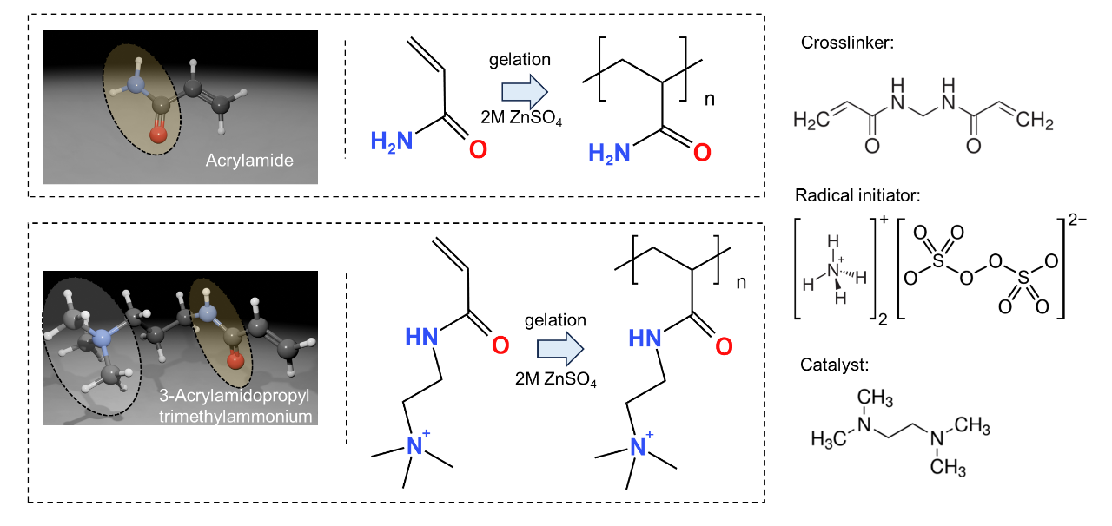
Fig. S1 Synthesis procedure of PAM and PAPTMA hydrogels
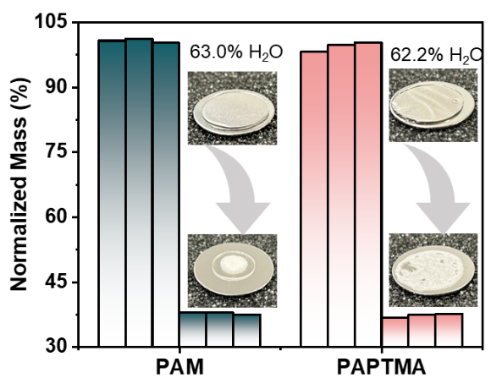
Fig. S2 Normalized mass of PAM and PAPTMA hydrogels before and after completely drying process. Insets are corresponding optical images
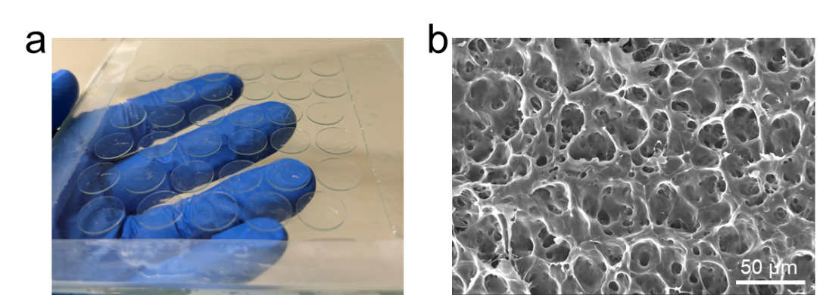
Fig. S3 a) Optical and b) SEM image of PAPTMA cationic hydrogel
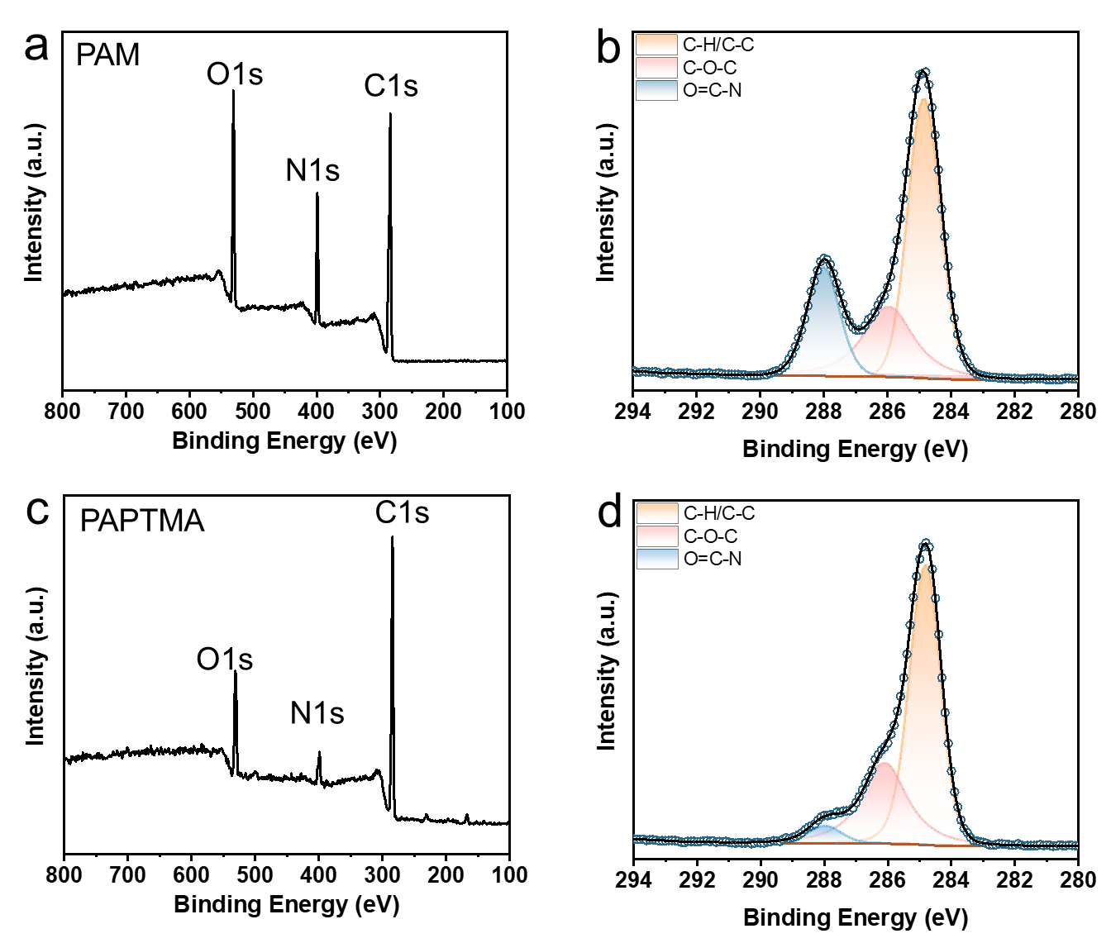
Fig. S4 XPS characterization of PAM and PAPTMA. a, c) Survey and b, d) O1s XPS profiles of a, b) PAM and c, d) PAPTMA hydrogel
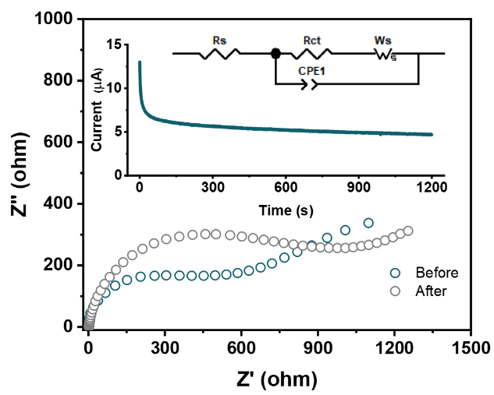
Fig. S5 EIS profiles of Zn/PAM/Zn symmetric cell. The insets show the CA curve before and after polarization with a constant voltage of 10 mV and equivalent circuits. All the cells for transference number test were rested for 0.5 h after assembly. Fitted results are listed in Table S2
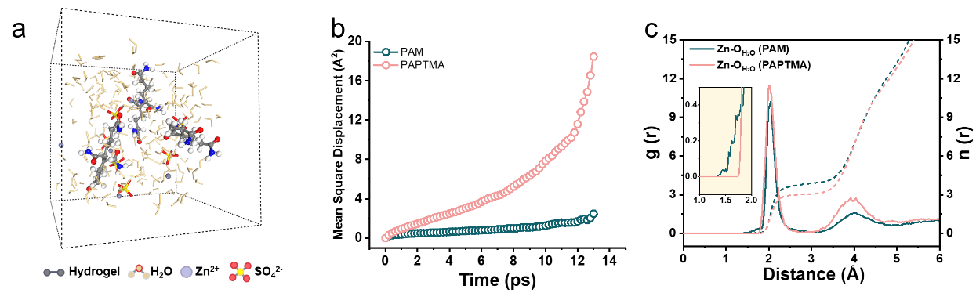
Fig. S6 AIMD simulation of hydrogels. a) Molecular configuration of PAM. b) Mean square displacement of Zn²⁺ in PAM and PAPTMA hydrogels. c) Radial distribution functions for Zn-O (H₂O) collected in PAM and PAPTMA
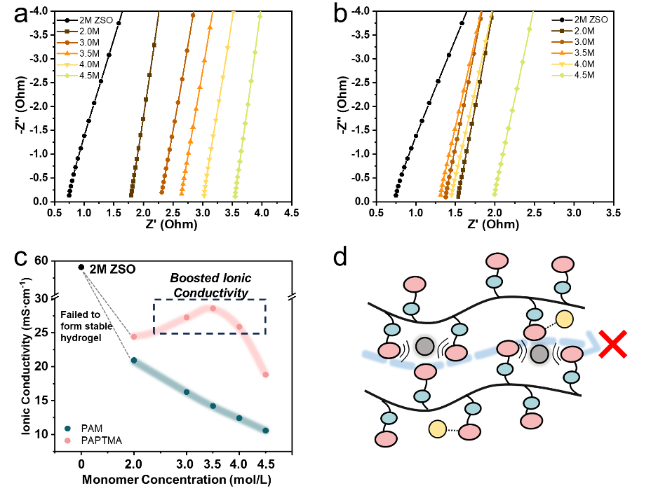
Fig. S7 Characterization of ionic conductivity. a, b) EIS profiles of PAM (a) and PAPTMA (b) hydrogels with increasing monomer concentration. c) Summary of corresponding ionic conductivity using various concentration of monomers. d) Schematic illustration shows the impeded transport of Zn²⁺ in dense PAPTMA hydrogel
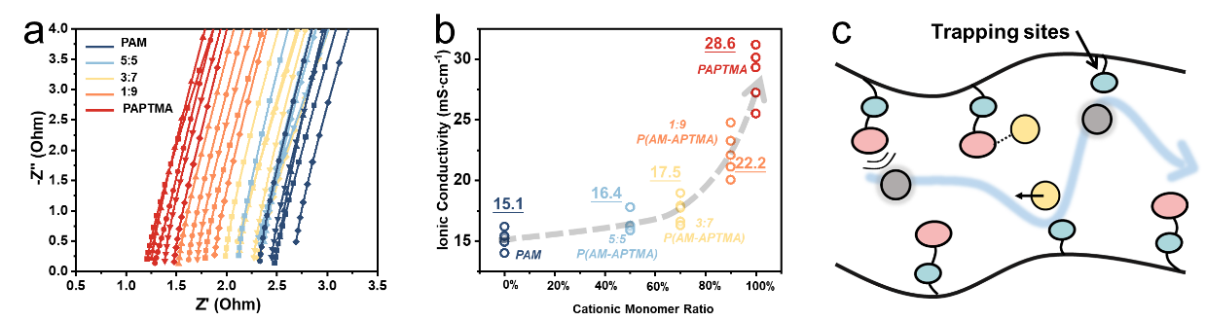
Fig. S8 Ionic conductivity of AM-APTMA copolymer hydrogels. a) EIS profiles and b) corresponding ionic conductivity of AM-APTMA with various monomer ratio. c) Schematic illustration shows the “trapping site role of AM blocks in the copolymer chain
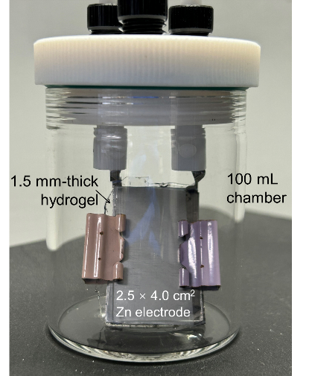
Fig. S9 Equipment for the measurement of H₂ evolution using different hydrogel and symmetric Zn electrodes. Applied current: 50 mA

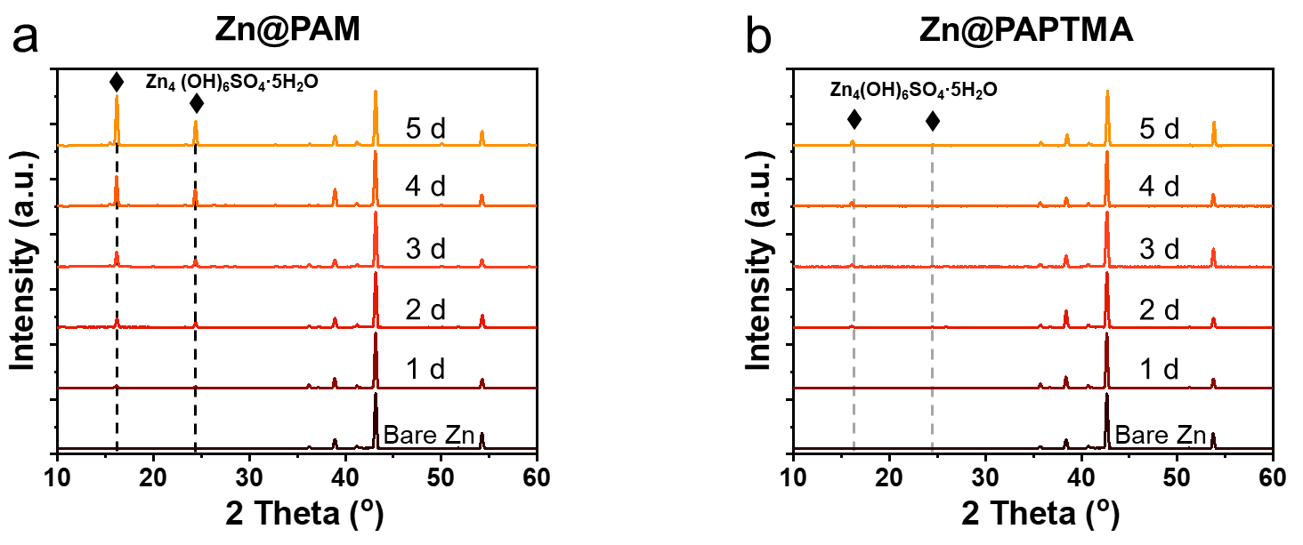
Fig. S10 XRD profiles of Zn foils covered by PAM (a) and PAPTMA (b) for increasing duration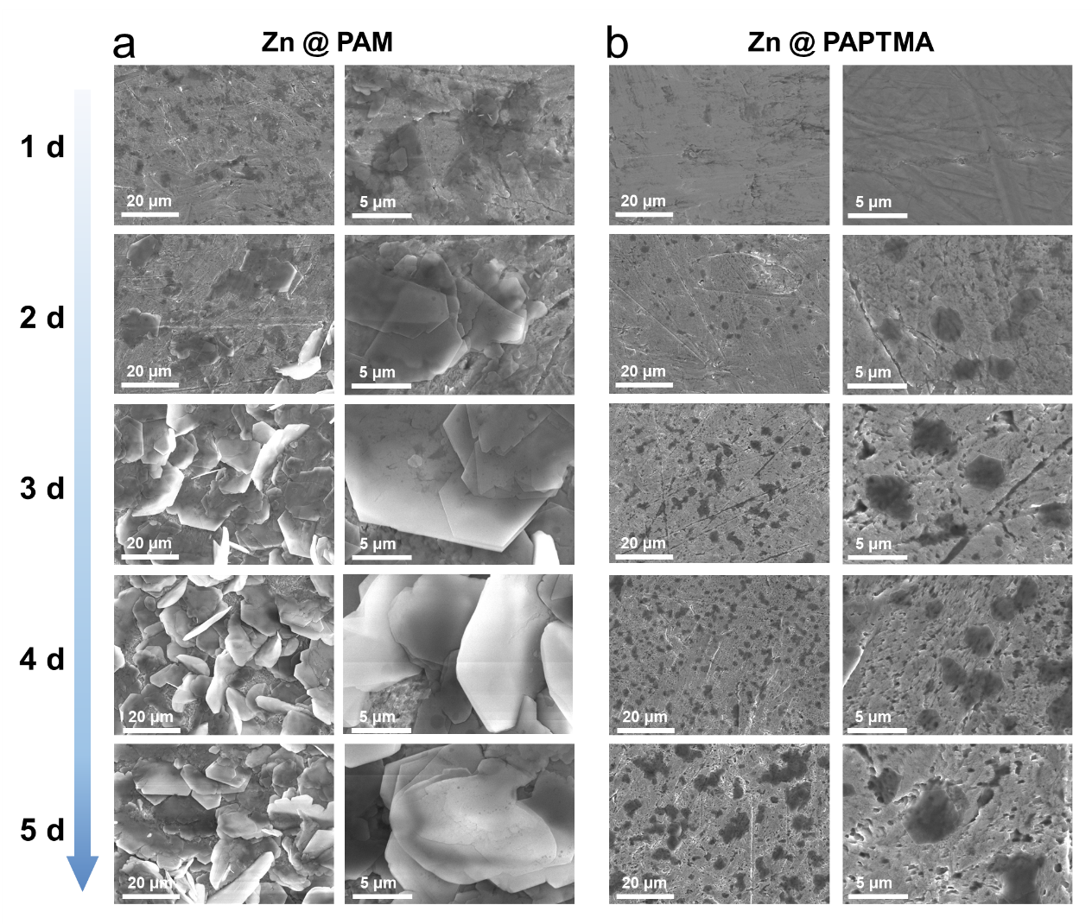
Fig. S11. Top-view SEM images of the Zn electrode covered by PAM (a) and PAPTMA (b) for increasing duration

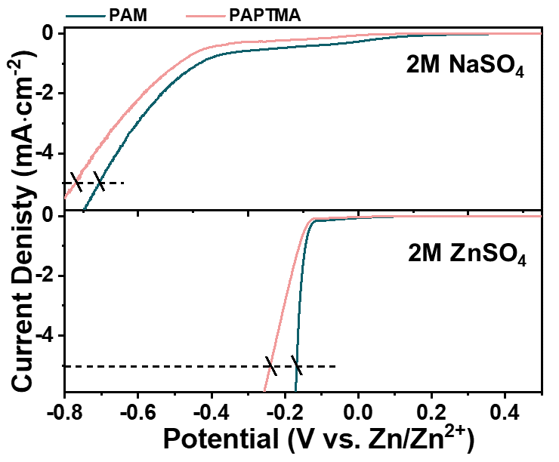
Fig. S12 LSV curves of hydrogels using NaSO₄ (a) and ZnSO₄ (b) as electrolyte
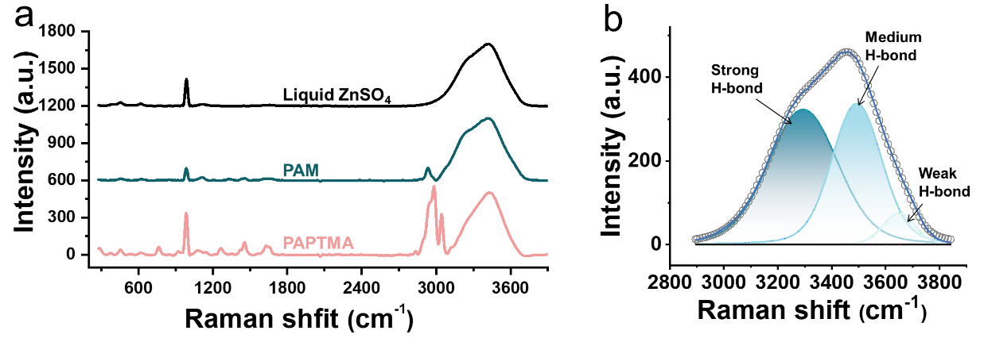
Fig. S13 Raman characterization. a) Comparison of Raman spectra of hydrogels and liquid ZnSO₄ electrolyte. b) Raman spectrum of O-H vibration in liquid ZnSO₄ electrolyte

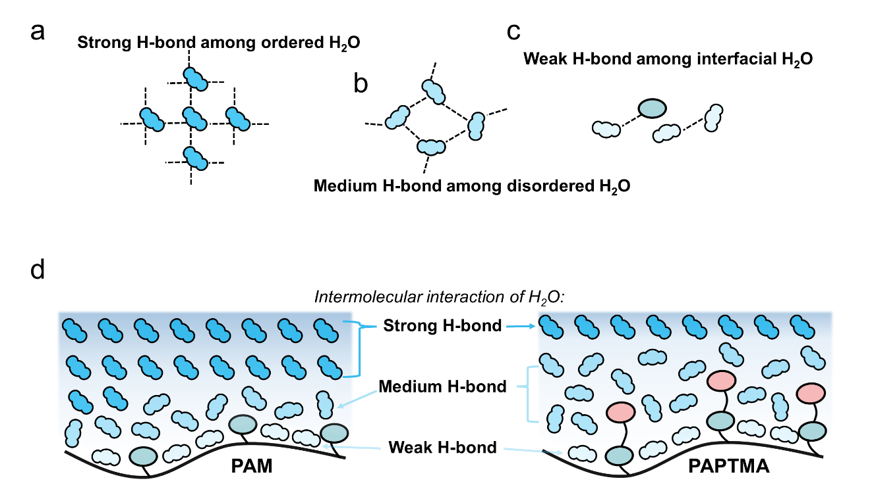
Fig. S14 Schematic illustrations of three types of hydrogen bond in the hydrogel. a) Strong H-bond. b) Medium H-bond and c) Weak H-bond. d) Spatial distribution of H-bonds in the hydrogels

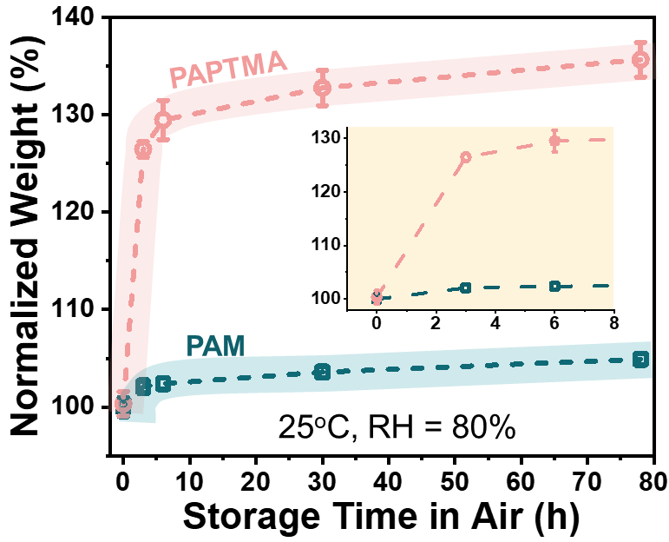
Fig. S15 Water adsorption of dried hydrogels in ambient air
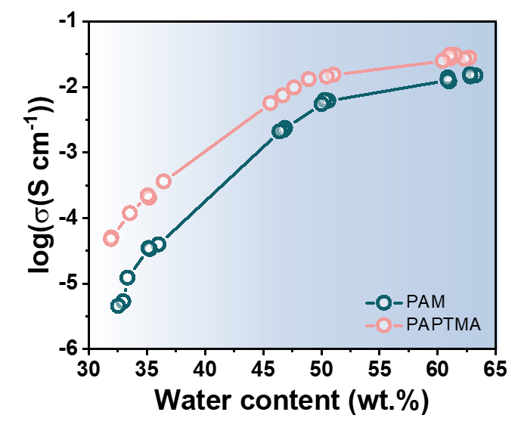
Fig. S16 Ionic conductivity of hydrogels at reduced water content

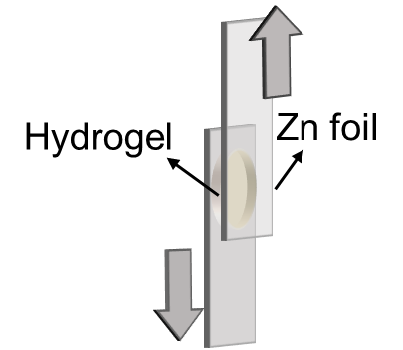
Fig. S17 Adhesion characterization of hydrogels using lap-shear method. The thickness and diameter of cylinder-shape hydrogel was 1.5 mm and 13 mm, respectively

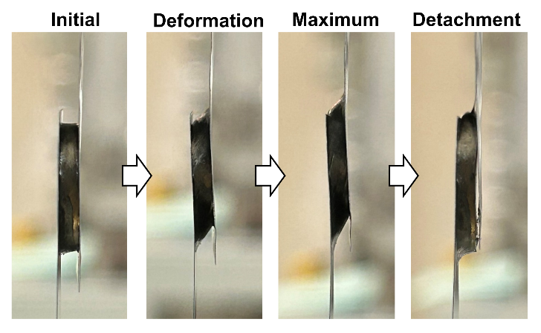
Fig. S18 Optical images of lap-shear test of PAM hydrogel
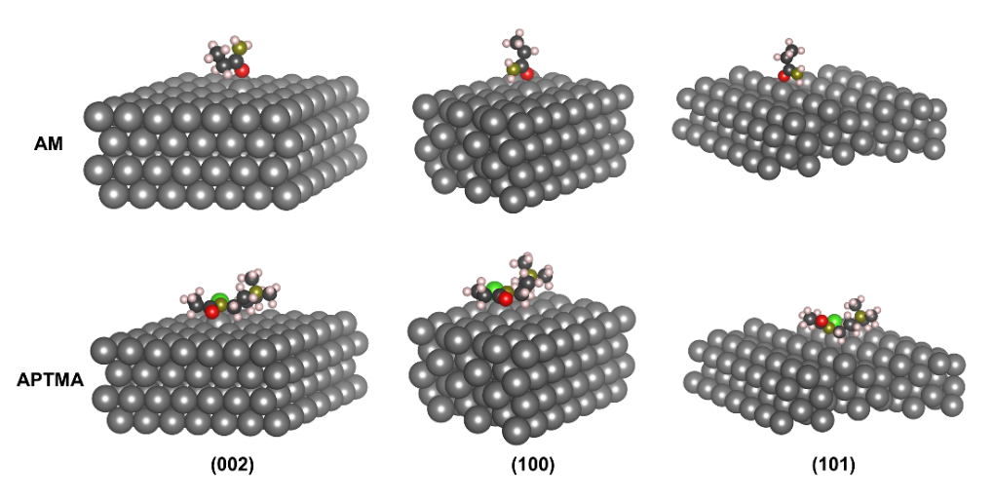
Fig. S19 Optimized adsorption structures of AM and APTMA monomers on different Zn crystal planes
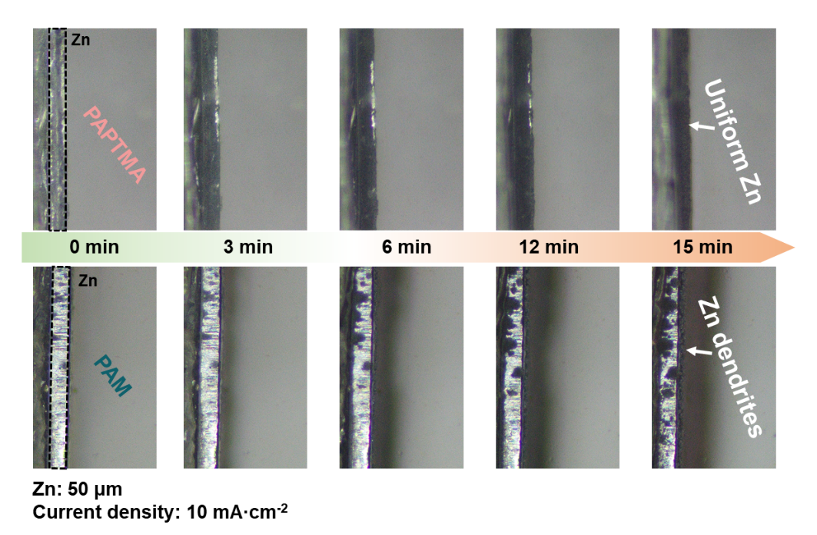
Fig. S20 In situ optical microscopy of the Zn plating process using PAPTMA and PAM hydrogels
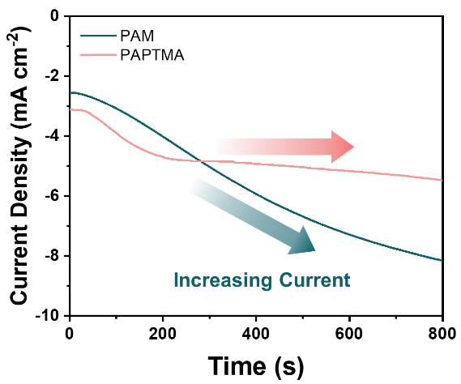
Fig. S21 Chronopotentiometry characterization of Zn|Gel|Zn symmetric cells at an applied voltage of 100 mV
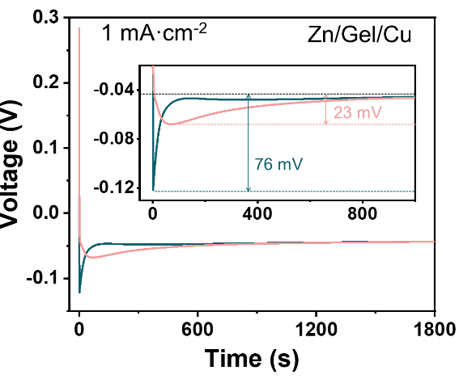
Fig. S22 Characterization of nucleation overpotential of Zn|Gel|Cu asymmetric cells at a current density of 1 mA∙cm⁻²

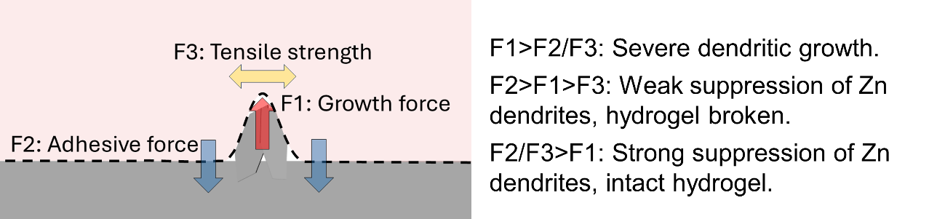
Fig. S23 Mechanical suppression of Zn dendritic growth
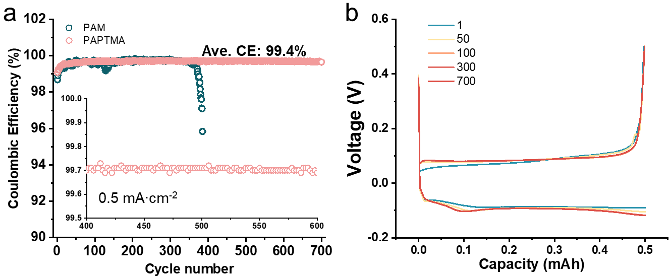
Fig. S24 Electrochemical characterization of Zn|Gel|Cn asymmetric cells. a) Coulombic efficiency. b) Voltage profiles
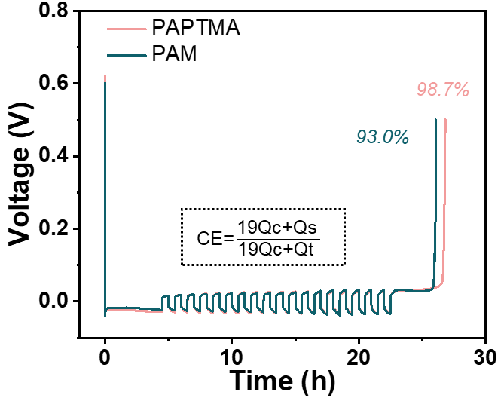
Fig. S25 Determination of coulombic efficiency using Adams’s method

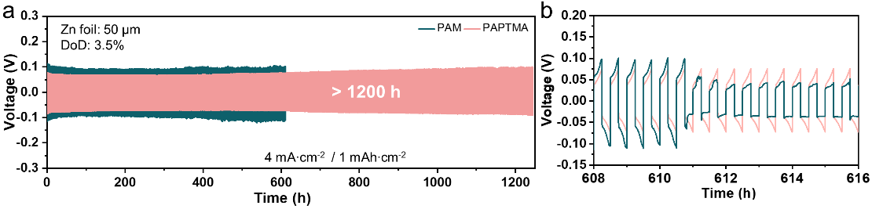
Fig. S26 Long-term cycling performance of symmetric cells at 4 mA∙cm⁻². PAM symmetric cell failed at 611 h
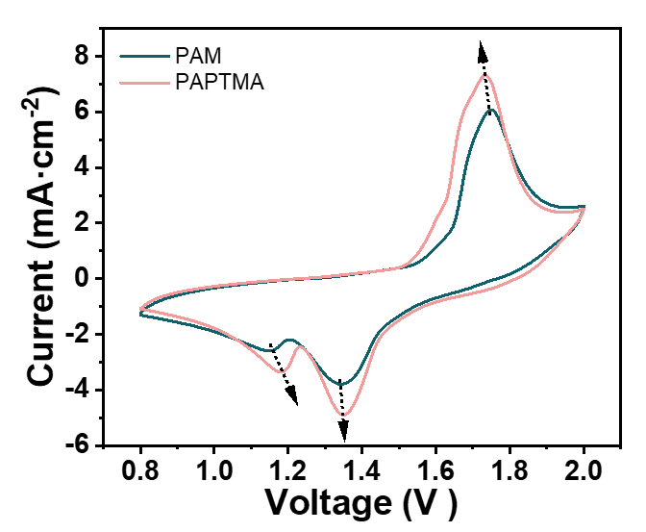
Fig. S27 CV profiles of Zn|Gel|MnO₂ cells

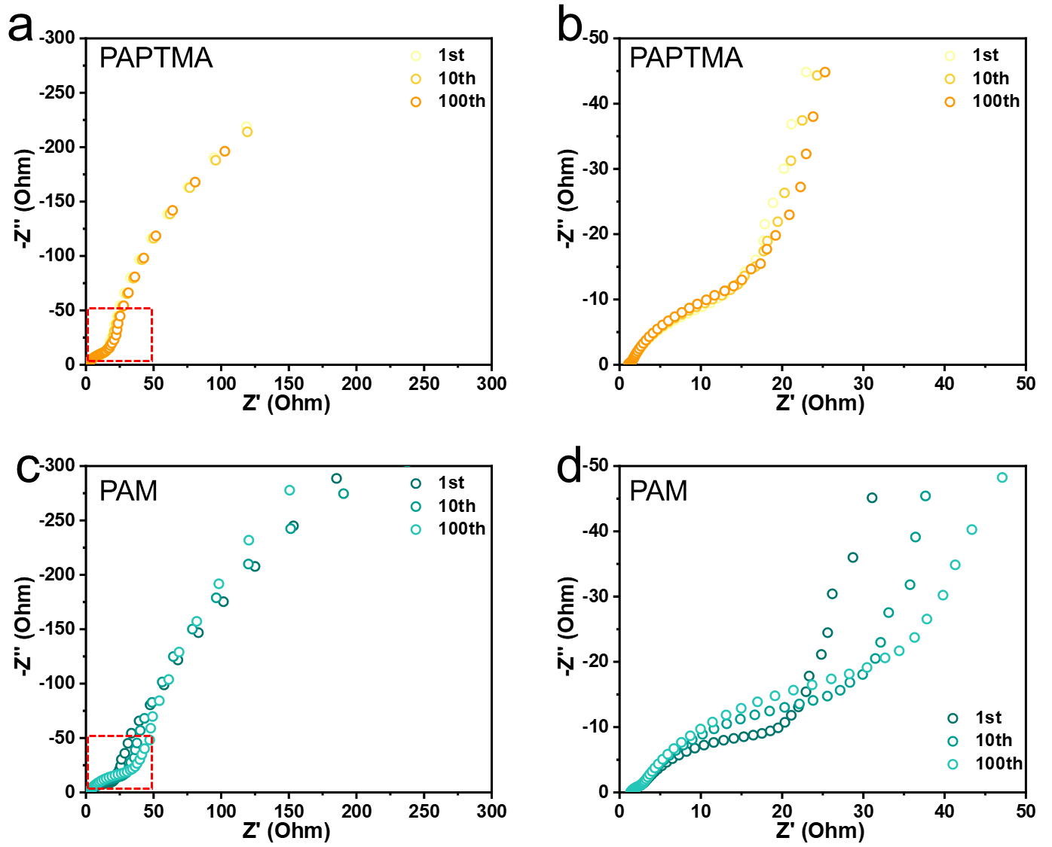
Fig. S28 Ex situ EIS profiles of full cells using (a, b) PAPTMA and (c, d) PAM

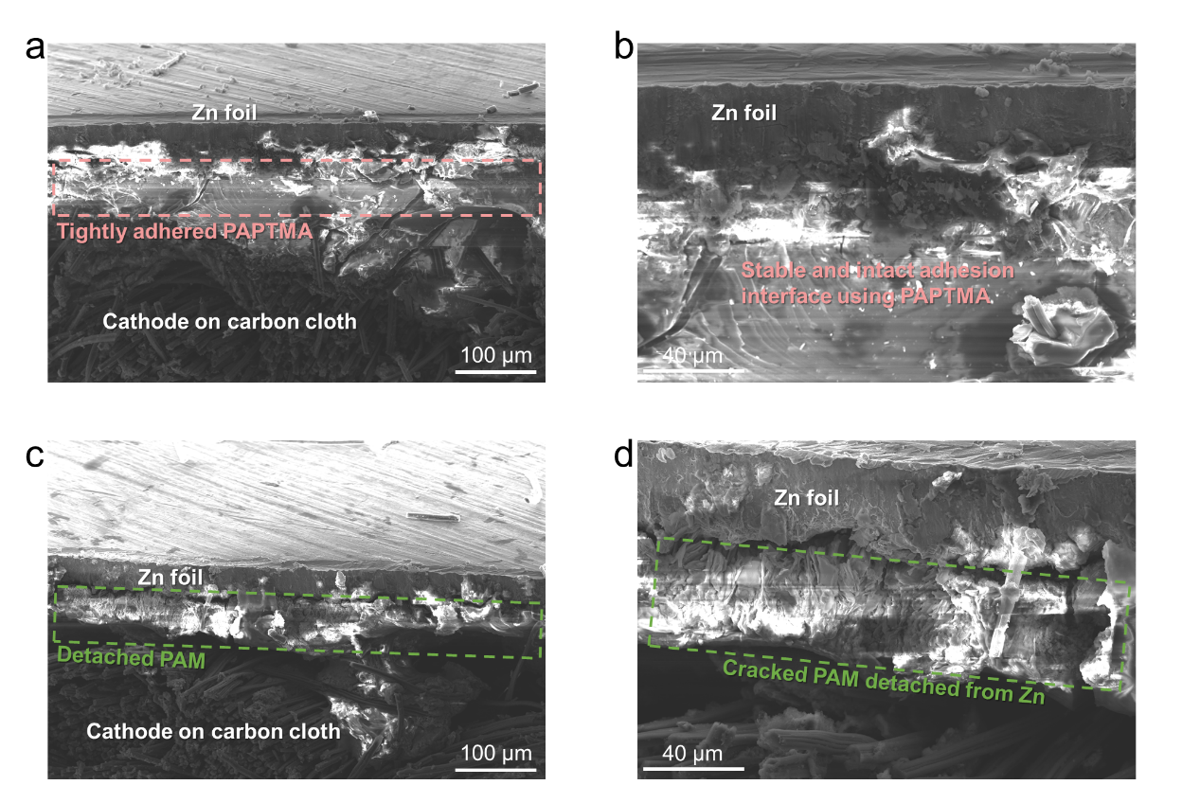
Fig. S29 Cross sectional SEM images of (a, b) PAPTMA and (c, d) PAM after 100 cycles in full cells
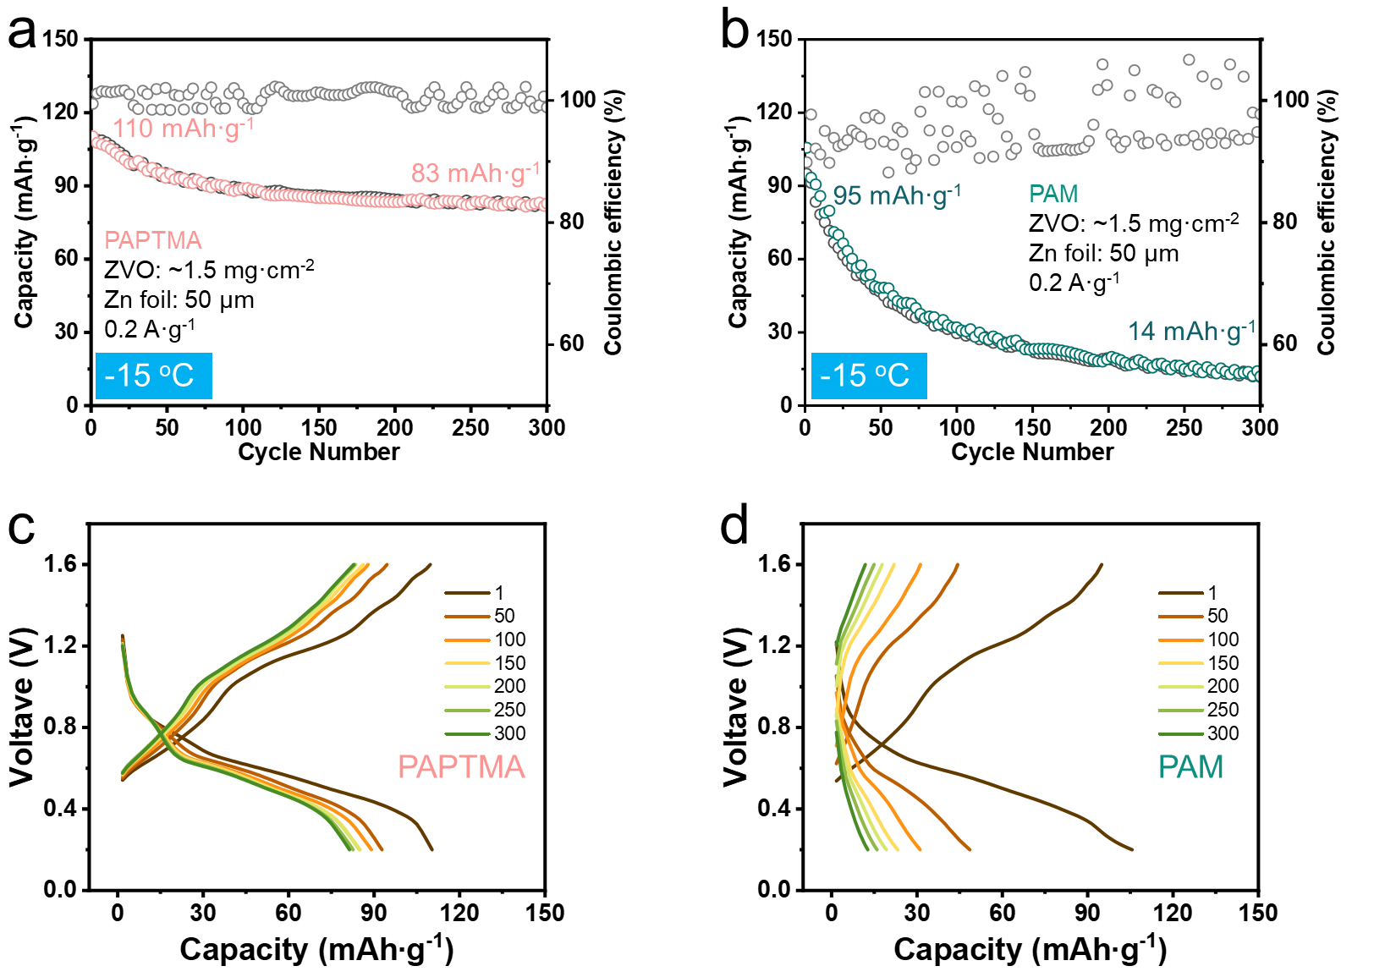
Fig. S30 Full cell performance using PAPTMA (a, c) and PAM (b, d) at -15 ℃

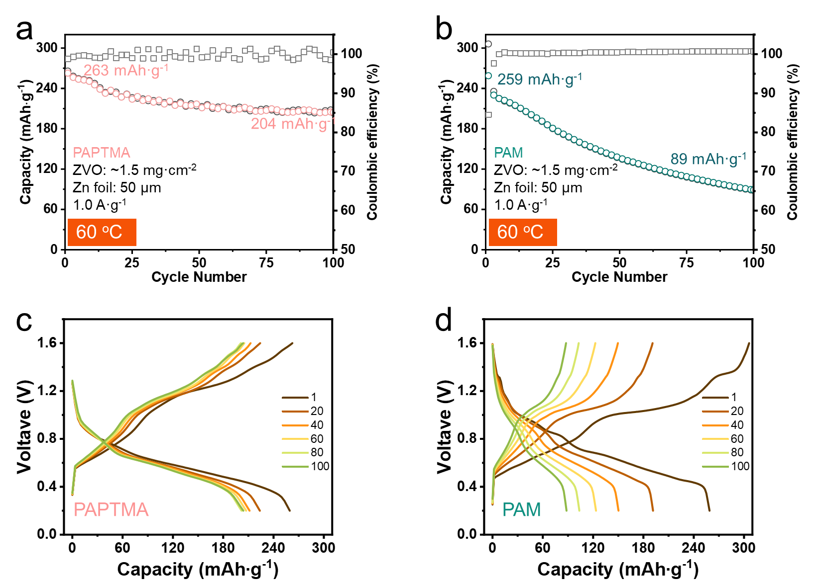
Fig. S31 Full cell performance using PAPTMA (a, c) and PAM (b, d) at 60 ℃
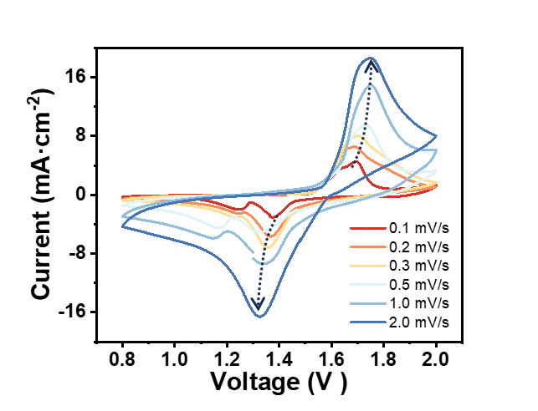
Fig. S32 CV curves of pouch batteries based on PAPTMA hydrogel electrolytes with increasing scan rate
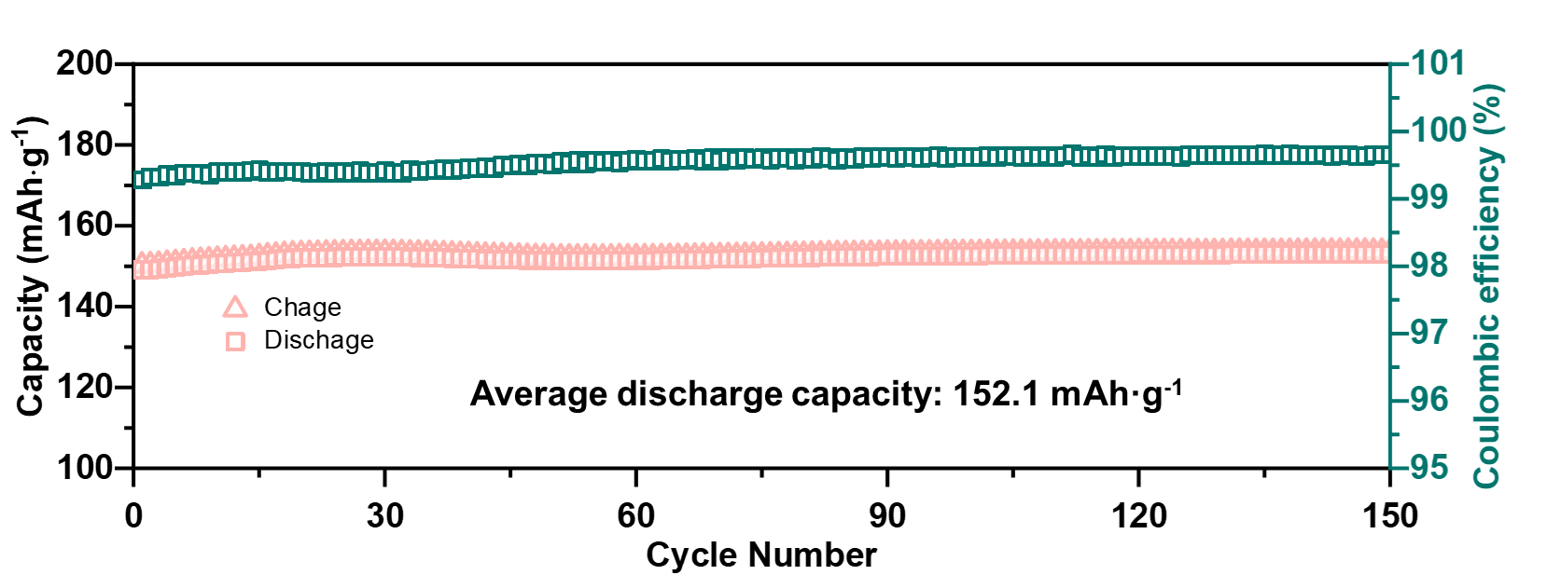
Fig. S33 Cycling performance of pouch batteries under 0.5 A·g⁻¹
Table S1 The amount of each substance for the preparation of hydrogel electrolytes.
 | PAPTMA  (3.5 M) | APTMA:AM =9:1 | APTMA:AM=7:3 | APTMA:AM=5:5 | PAM  (3.5 M) | PAPTMA  (2.0 M) | PAPTMA  (3.0 M) | PAPTMA  (4.0 M) | PAPTMA  (4.5 M)
APTMA  (75% w/w) (g) | 3.87 | 3.48 | 2.61 | 1.93 | \ | 2.21 | 3.29 | 4.42 | 4.98
AM (g) | \ | 0.1 | 0.3 | 0.5 | 1 | \ | \ | \ | \
H₂O (mL) | 3.03 | 3.13 | 3.35 | 3.52 | 4.00 | 3.45 | 3.18 | 2.89 | 2.76
ZnSO₄·7H₂O (g) | 2.30 | 2.30 | 2.30 | 2.30 | 2.30 | 2.30 | 2.30 | 2.30 | 2.30
MBA (mg) | 20 | 20 | 20 | 20 | 20 | 11.4 | 17.1 | 22.9 | 25.7
APS  (5% w/v) (μL) | 100 | 100 | 100 | 100 | 100 | 57 | 86 | 114 | 129
TEMED (μL) | 10 | 10 | 10 | 10 | 10 | 5.7 | 8.6 | 11.4 | 12.9
Note: Monomer concentration is set according to the volume of water.
Table S2 Calculation details of Zn²⁺ transference number
 | PAM | PAPTMA
∆V (mV) | 10 | 10
I₀ (μA) | 13.0 | 12.7
I_{s} (μA) | 4.7 | 9.0
R₀ (Ω) | 316 | 243
R_{s} (Ω) | 843 | 418
t${\text{Zn}}^{\text{2+}}$ | 0.36 | 0.79
Table S3 Comparison of hydrogel performance with reported works
Material | Current density  (mA cm⁻²) | Areal  capacity (mAh cm⁻²) | Cycle life | Ionic conductivity (mS cm⁻¹) | t${\text{Zn}}^{\text{2+}}$ | References
P(AM-co-SBMA) | 2 | 2 | 400 | 32.9 | 0.84 | Adv. Energy Mater. 2022, 12, 2202219
Hyaluronic Acid | 1 | 1 | 5500 | 47.7 | 0.73 | Nat Commun. 2023, 14, 6526
Cellulose-CMC | 40 | 8 | 440 | 26 | 0.39 | Adv. Funct. Mater. 2023, 33, 2302098
TCOF-S-PAM | 1 | 0.5 | 1100 | 27.2 | 0.89 | Angew. Chem. Int. Ed. 2023, 62, e202312020.
CD-PEO/PAM | 1 | 1 | 160 | 22.4 | 0.92 | Adv. Mater. 2023, 35, 2301996
PSX | 0.1 | 0.1 | 2000 | 18.9 | 0.80 | Energy Storage Mater. 2022, 51, 588.
CCH | 1 | 1 | 5000 | 9.7 | 0.81 | Adv. Mater. 2024, 36, e2313610.
SFPAM-Zr | 0.5 | 0.5 | 2500 | 22.9 | 0.71 | Energy Environ. Sci., 2023,16, 4561-4571
R-ZSO | 2 | 2 | 1500 | 30.3 | 0.59 | Angew. Chem. Int. Ed. 2024, 63, e202318928
Kevlar H | 1 | 1 | 3500 | 9.9 | 0.69 | ACS Energy Lett. 2023, 8, 4, 1959
Zinc Alginate | 2 | 0.25 | 2200 | 0.54 | 0.82 | Adv. Funct. Mater. 2023, 33, 2300952
CSAM | 1 | 1 | 700 | 25.2 | 0.76 | Adv. Mater. 2022, 34, 2110140
OR-PUU/PAM | 1 | 1 | 2000 | 26.9 | 0.78 | Adv. Mater. 2024, 36, 2311082
C-PVA/PAN | 1 | 1 | 3400 | 17.4 | 0.64 | Energy Environ. Sci., 2024, 10.1039/d4ee01993h
Electropolymerized hydrogel | 1 | 1 | 6060 | 10.6 | 0.77 | Angew. Chem. Int. Ed. 2024, 21, e202400230
PAPTMA | 1  4  8 | 1  1  1 | 6070  1240  500 | 28.7 | 0.79 | This work
Supplementary References
- T.D. Kühne, M. Iannuzzi, M. Del Ben, V.V. Rybkin, P. Seewald et al., CP2K: an electronic structure and molecular dynamics software package - quickstep: efficient and accurate electronic structure calculations. J. Chem. Phys. 152(19), 194103 (2020). https://doi.org/10.1063/5.0007045
- J. VandeVondele, J. Hutter, Gaussian basis sets for accurate calculations on molecular systems in gas and condensed phases. J. Chem. Phys. 127(11), 114105 (2007). https://doi.org/10.1063/1.2770708
- J.P. Perdew, K. Burke, M. Ernzerhof, Generalized gradient approximation made simple. Phys. Rev. Lett. 77(18), 3865–3868 (1996). https://doi.org/10.1103/physrevlett.77.3865
- S. Grimme, J. Antony, S. Ehrlich, H. Krieg, A consistent and accurate ab initio parametrization of density functional dispersion correction (DFT-D) for the 94 elements H-Pu. J. Chem. Phys. 132(15), 154104 (2010). https://doi.org/10.1063/1.3382344

