Supporting Information for
Joule Heating-Driven sp²-C Domains Modulation in Biomass Carbon for High-performance Bifunctional Oxygen Electrocatalysis
Jiawei He^{1#}, Yuying Zhao^{3#}, Yang Li⁴, Qixin Yuan¹, Yuhan Wu¹, Kui Wang³, Kang Sun³, Jingjie Wu⁴, Jianchun, Jiang³, Baohua Zhang⁵, Liang Wang²*, Mengmeng Fan^{1,3}*
¹ Jiangsu Co-Innovation Center of Efficient Processing and Utilization of Forest Resources, International Innovation Center for Forest Chemicals and Materials, College of Chemical Engineering, Nanjing Forestry University, Nanjing 210037, P. R. China
² Institute of Nanochemistry and Nanobiology, School of Environmental and Chemical Engineering, Shanghai University, Shanghai 200444, P. R. China
³ Key Lab of Biomass Energy and Material, Jiangsu Province; Jiangsu Co-Innovation Center of Efficient Processing and Utilization of Forest Resources, Institute of Chemical Industry of Forest Products, Chinese Academy of Forestry, Nanjing 210042, P. R. China
⁴ Department of Chemical and Environmental Engineering, University of Cincinnati, Cincinnati, OH 45221, USA
⁵ Department of Chemical Engineering, School of Environmental and Chemical Engineering, Shanghai University, Shanghai 200444, P. R. China
#Jiawei He and Yuying Zhao contributed equally to this work.
*Corresponding authors. E-mail: wangl@shu.edu.cn (Liang Wang); fanmengmeng370@163.com (Mengmeng Fan)
Supplementary Figures and Tables
Fig. S1 N₂ adsorption–desorption isothermal curves (a) and pore size distribution (b) of coconut shell-derived activated carbon (AC)
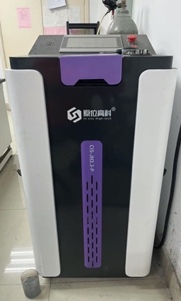
Fig. S2 Joule heating equipment and the heating curves for N-C_{D} sample

Fig. S3 HR-TEM images of pure C (a), pure C_{D} (b), N-C (c) and N-C_{D}’ (d)
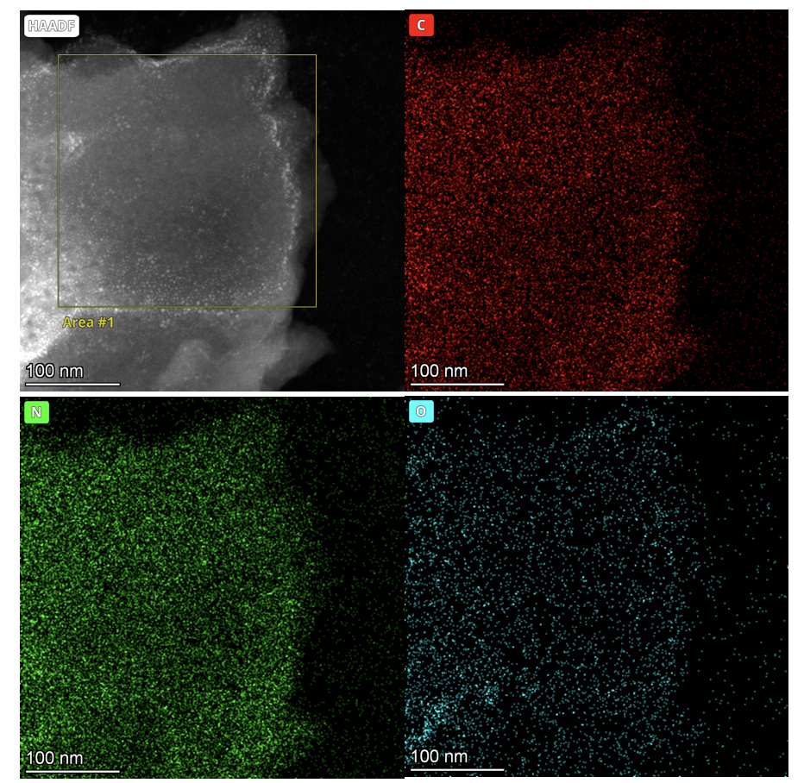
Fig. S4 High-angle annular dark-field scanning transmission electron microscopy (HAADF-STEM) image and the corresponding EDS mapping images of N-C_{D}
Fig. S5 Pore size distribution of different samples
Fig. S6 High-resolution N 1s spectra of N-C
Fig. S7 LSV curve of N-C_{D} before and after adding 10 mM KSCN into O₂-saturated 0.1 M KOH solution
Fig. S8 LSV curves without iR compensation in O₂ saturated 0.1 m KOH at the scan rate of 10 mV s⁻¹ at 1600 rpm with RDE for N-C_{D} and N-C_{D}’
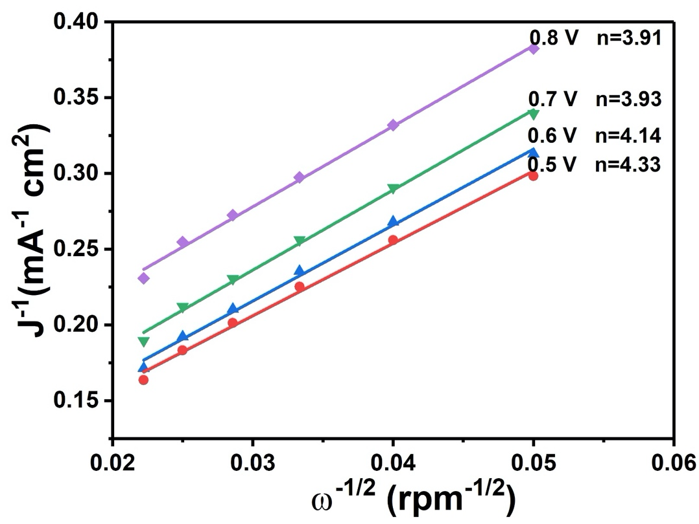
Fig. S9 K-L plots and electron transfer numbers for N-C_{D}
Fig. S10 LSV curve (solid line) of N-C_{D} measured using a Rotating Ring-Disk Electrodes (RRDE) and the corresponding H₂O₂ current (dashed line) on the ring electrode were obtained in O₂ saturated 0.1 M KOH at the speed of 1600 rpm with a fixed potential of 1.2 V vs. RHE

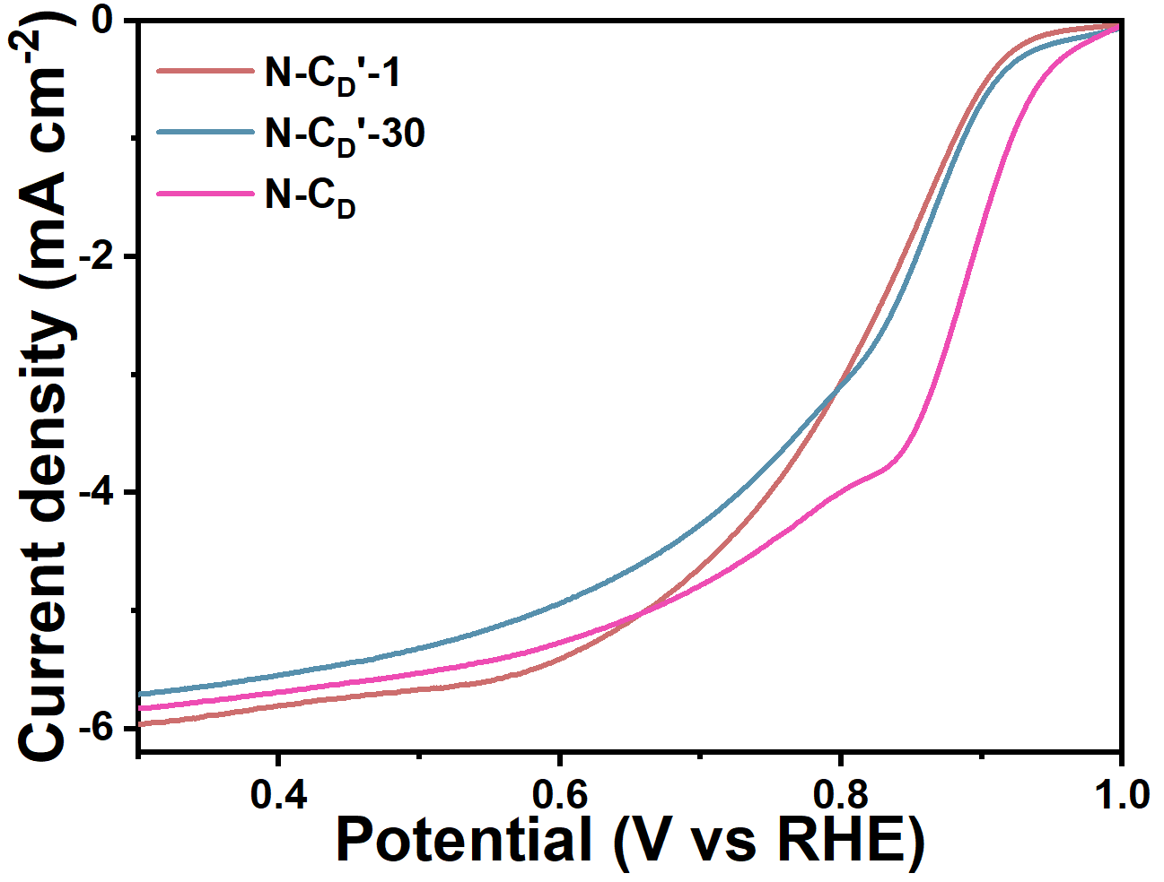
Fig. S11 LSV curves of catalysts annealed in secondary tube furnaces

Fig. S12 The anti-methanol toxicity test of N-C_{D} and Pt/C 20% adding 2 mL methanol at 30min in 0.1 M KOH
Fig. S13 (a-e) CV curves obtained in a potential window of 0.95-1.15 V vs RHE at different scan rates in Ar saturated 0.1 M KOH for pure C (a), pure C_{D} (b), N-C (c), N-C_{D}’ (d) and N-CD (e). (f) The charging current density plots with different scan rates for the samples
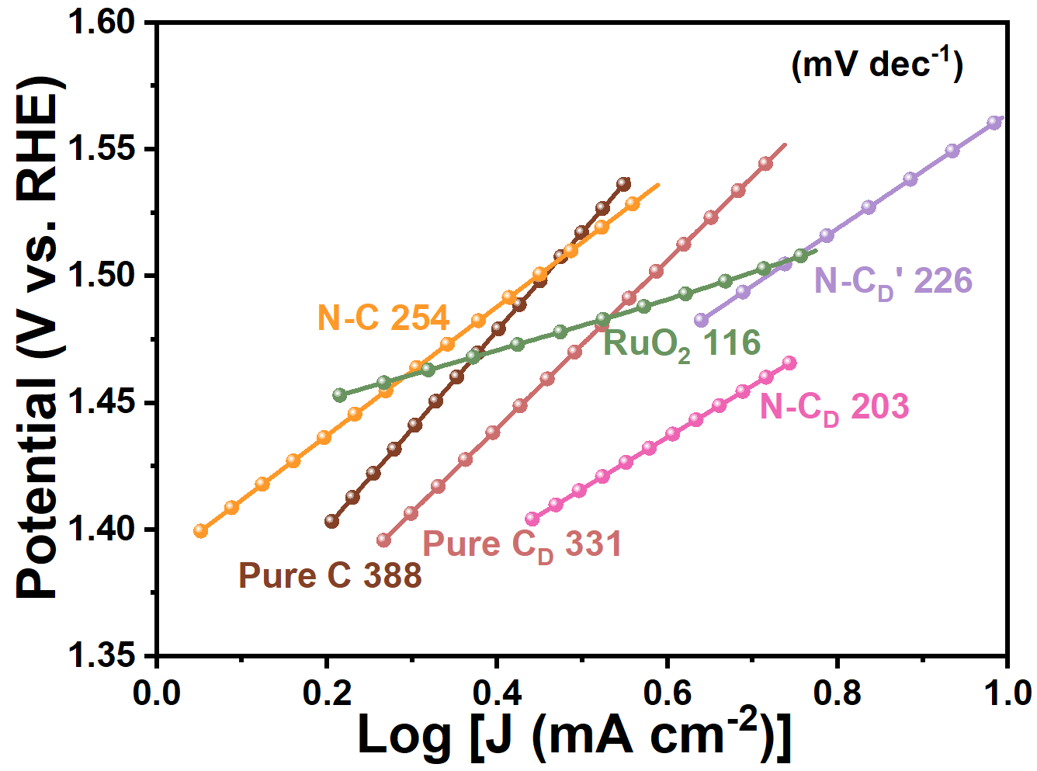
Fig. S14 OER Tafel plots of the catalysts
Fig. S15 HR-TEM images of N-C_{D} under different joule heating time from 1 s to 10 s
Fig. S16 HR-TEM of other biomass-based ACs with Joule heating
Fig. S17 N₂ adsorption–desorption isothermal curves and pore size distribution of biomass-based ACs before and after Joule heating

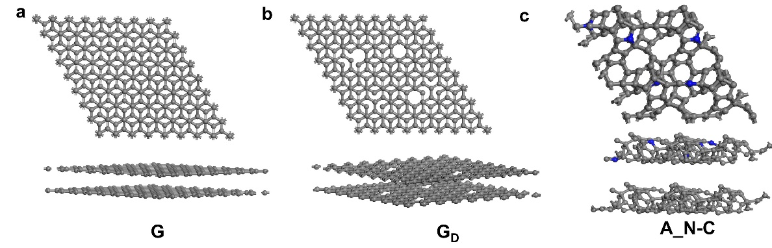
Fig. S18 DFT calculation model of (a) G, (b) G_{D}, (c) A_N-C
Fig. S19 Gibbs free energy of the ORR intermediates on A_N-C at 1.23 V
Fig. S20 Gibbs free energy of the ORR intermediates on different catalysts at 0 V

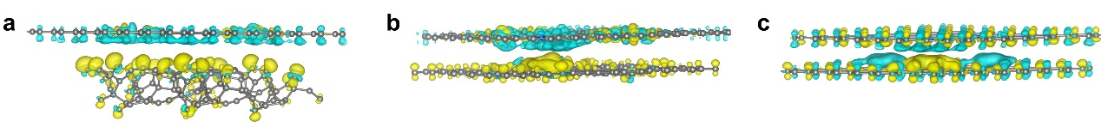
Fig. S21 (a-c) The charge density difference mappings of N-C_{A} (a), N-C_{L} (b), N-C_{G} (c). Yellow: charge accumulation, cyan: charge depletion
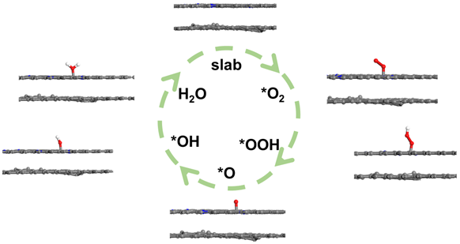
Fig. S22 The optimized adsorption configurations of ORR intermediates (*, *OOH, *O, and *OH) on N-C_{L}

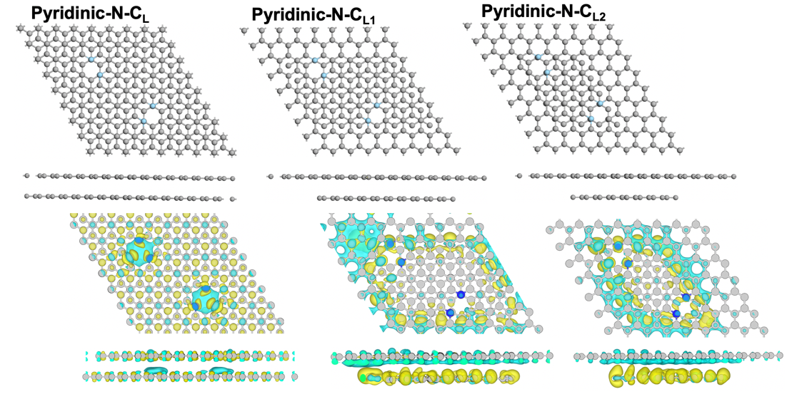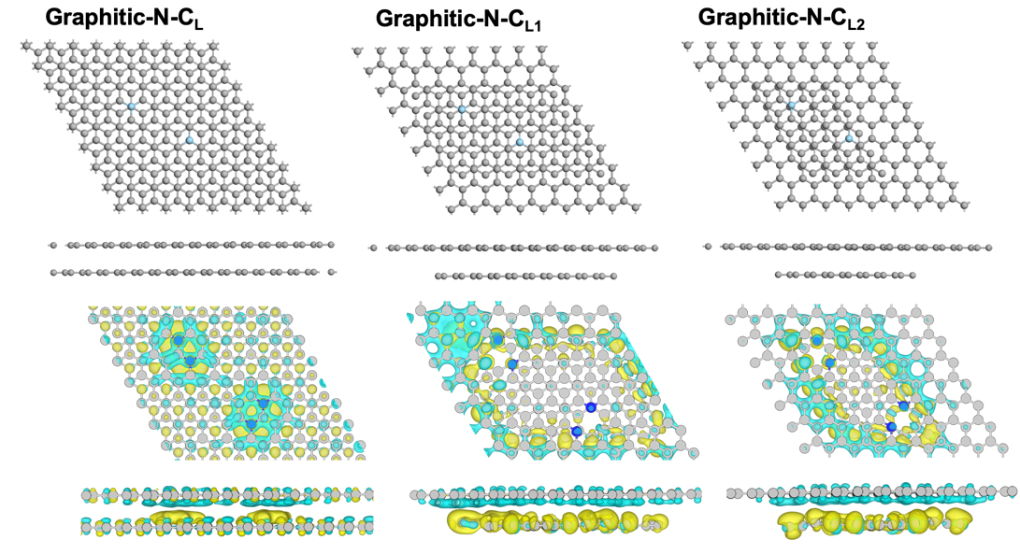
Fig. S23 The pyridinic N and graphitic N models effect by different size sp²-C domains (sp²-C size order: C_{L}>C_{L1}>C_{L2})
Fig. S24 The calculated density of states (DOS) of pyridinic N and graphitic N models

Fig. S25 Gibbs free energy of the ORR intermediates on pyridinic-N-C_{L} and graphitic-N-C_{L}
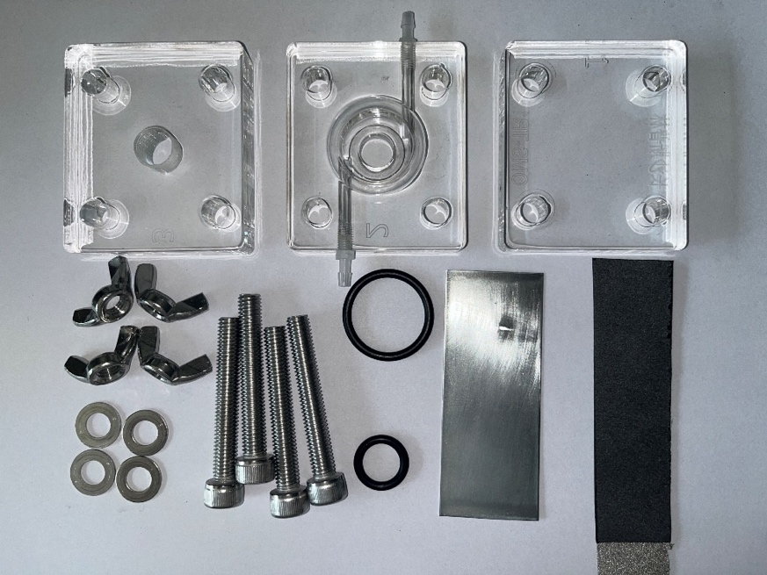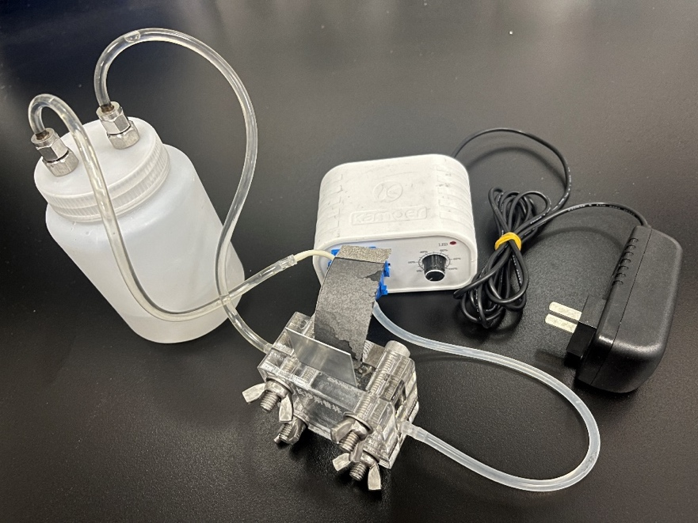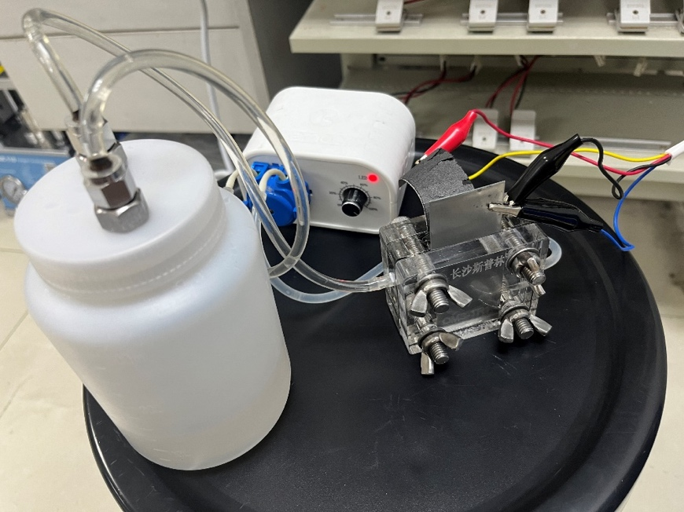
Fig. S26 Assembled ZAB device

Table S1 Elemental content of C, N, and O in different catalysts measured by XPS
Catalysts | C (at%) | N (at%) | O (at%)
Pure C | 97.88 | / | 2.12
Pure C_{D} | 96.94 | / | 3.06
N-C | 95.94 | 0.89 | 3.17
N-C_{D}’ | 92.26 | 1.94 | 5.8
N-C_{D} | 93.03 | 2.35 | 4.62

Table S2 The C, N, O contents of N-C_{D}’ treated with a tube furnace
Catalysts | C (at%) | N (at%) | O (at%)
N-C_{D} | 93.03 | 2.35 | 4.62
N-C_{D}’-1 | 93.19 | 2.22 | 4.58
N-C_{D}’-30 | 93.74 | 2.38 | 3.89
Table S3 The comparison with the reported metal-free bifunctional electrocatalysts
samples | E_{ORRonest}  (V) | E_{ORR1/2}  (V) | E_{OER}(V)  (j=10 mA cm⁻²) | ΔE(V)  (E_{j=10}-E_{ORR1/2}) | Refs.
N-C_{D} | 0.98 | 0.884 | 1.525 | 0.64 | This work
20%Pt/C+RuO₂ | 0.96 | 0.882 | 1.54 | 0.66 | This work
2D-PPCN | 0.92 | 0.85 | 1.595 | 0.75 | [S1]
1100-CNS | 0.99 | 0.85 | 1.69 | 0.84 | [S2]
B, N-Carbon | 0.98 | 0.84 | 1.57 | 0.73 | [S3]
DG | 0.91 | 0.76 | 1.57 | 0.81 | [S4]
GH-BGQD | / | 0.87 | 1.6 | 0.73 | [S5]
N-GRW | 0.92 | 0.84 | 1.66 | 0.82 | [S6]
NKCNPs | 0.81 | 0.79 | 1.71 | 0.92 | [S7]
NPCS-900 | 0.91 | 0.83 | 1.64 | 0.81 | [S8]
S, S’-CNT | / | 0.78 | 1.58 | 0.8 | [S9]
TTF-F | 0.86 | 0.77 | / | / | [S10]
SNGL-20 | 0.86 | 0.68 | / | / | [S11]
PG | 0.92 | 0.54 | / | / | [S12]
NCNF-1000 | 0.97 | 0.82 | / | / | [S13]
NCS-800 | 0.86 | 0.7 | / | / | [S14]
MCN-1000-5 | 0.95 | 0.82 | / | / | [S15]
G-CBP-A | 0.68 | 0.64 | / | / | [S16]

Table S4 The comparison of the performance of assembled Zn-air battery with the reported bifunctional electrocatalysts
samples | current density(mA cm⁻²) | Time(h) | Refs.
N-C_{D} | 5 | over 1200 | This work
C111-900 | 5 | 200 | [S17]
HEO/CoNC | 5 | 140 | [S18]
HHPC | 10 | 388 | [S19]
N-CNSP | 5 | 150 | [S20]
NFS-CNF | 10 | 60 | [S21]
N-GDY-900 | 5 | 300 | [S22]
NPCTC | 5 | 30 | [S23]
PSNC-0.8 | 10 | 320 | [S24]
PyN-GDY | 2 | 150 | [S25]
SNC | 5 | 500 | [S26]
SD-Fe-N/C | 10 | 300 | [S27]
WN- Ni@pDC-750–0.02 | 5 | 400 | [S28]
NPC-950 | 20 | 85 | [S29]
Suppplementary References
- W. Lei, Y.-P. Deng, G. Li, Z. P. Cano, X. Wang et al., Two-dimensional phosphorus-doped carbon nanosheets with tunable porosity for oxygen reactions in zinc-air batteries. ACS Catal. 8, 2464-2472 (2018). https://doi.org/10.1021/acscatal.7b02739
- Z. Pei, H. Li, Y. Huang, Q. Xue, Y. Huang et al., Texturing in situ: N,S-enriched hierarchically porous carbon as a highly active reversible oxygen electrocatalyst. Energy Environ. Sci. 10, 742-749 (2017). https://doi.org/10.1039/c6ee03265f
- T. Sun, J. Wang, C. Qiu, X. Ling, B. Tian et al., B, N codoped and defect-rich nanocarbon material as a metal-free bifunctional electrocatalyst for oxygen reduction and evolution reactions. Adv. Sci. 5, 1800036 (2018). https://doi.org/10.1002/advs.201800036
- Y. Jia, L. Zhang, A. Du, G. Gao, J. Chen et al., Defect graphene as a trifunctional catalyst for electrochemical reactions. Adv. Mater. 28, 9532-9538 (2016). https://doi.org/10.1002/adma.201602912
- T.V. Tam, S.G. Kang, M.H. Kim, S.G. Lee, S.H. Hur et al., Novel graphene hydrogel/b‐doped graphene quantum dots composites as trifunctional electrocatalysts for Zn-air batteries and overall water splitting. Adv. Energy Mater. 9, 1900945 (2019). https://doi.org/10.1002/aenm.201900945
- H.B. Yang, J. Miao, S.F. Hung, J. Chen, H.B. Tao et al., Identification of catalytic sites for oxygen reduction and oxygen evolution in N-doped graphene materials: Development of highly efficient metal-free bifunctional electrocatalyst. Sci. Adv. 2, e1501122 (2016). https://doi.org/10.1126/sciadv.1501122
- Q. Wang, Y. Lei, Y. Zhu, H. Wang, J. Feng et al., Edge defect engineering of nitrogen-doped carbon for oxygen electrocatalysts in Zn-air batteries. ACS Appl. Mater. Interf. 10, 29448-29456 (2018). https://doi.org/10.1021/acsami.8b07863
- S. Chen, L. Zhao, J. Ma, Y. Wang, L. Dai et al., Edge-doping modulation of N, P-codoped porous carbon spheres for high-performance rechargeable Zn-air batteries. Nano Energy 60, 536-544 (2019). https://doi.org/10.1016/j.nanoen.2019.03.084
- A. M. El‐Sawy, I. M. Mosa, D. Su, C. J. Guild, S. Khalid et al., Controlling the active sites of sulfur‐doped carbon nanotube-graphene nanolobes for highly efficient oxygen evolution and reduction catalysis. Adv. Energy Mater. 6, 1501966 (2015). https://doi.org/10.1002/aenm.201501966
- L. Hao, S. Zhang, R. Liu, J. Ning, G. Zhang et al., Bottom-up construction of triazine-based frameworks as metal-free electrocatalysts for oxygen reduction reaction. Adv. Mater. 27, 3190-3195 (2015). https://doi.org/10.1002/adma.201500863
- J. Xu, G. Dong, C. Jin, M. Huang, L. Guan, Sulfur and nitrogen co-doped, few-layered graphene oxide as a highly efficient electrocatalyst for the oxygen-reduction reaction. ChemSusChem 6, 493-499 (2013). https://doi.org/10.1002/cssc.201200564
- C. Zhang, N. Mahmood, H. Yin, F. Liu, Y. Hou, Synthesis of phosphorus-doped graphene and its multifunctional applications for oxygen reduction reaction and lithium ion batteries. Adv. Mater. 25, 4932-4937 (2013). https://doi.org/10.1002/adma.201301870
- Q. Liu, Y. Wang, L. Dai, J. Yao, Scalable fabrication of nanoporous carbon fiber films as bifunctional catalytic electrodes for flexible Zn-air batteries. Adv. Mater. 28, 3000-3006 (2016). https://doi.org/10.1002/adma.201506112
- P. Chen, L.-K. Wang, G. Wang, M.-R. Gao, J. Ge et al., Nitrogen-doped nanoporous carbon nanosheets derived from plant biomass: an efficient catalyst for oxygen reduction reaction. Energy Environ. Sci. 7, 4095-4103 (2014). https://doi.org/10.1039/c4ee02531h
- H. Jiang, J. Gu, X. Zheng, M. Liu, X. Qiu et al., Defect-rich and ultrathin N doped carbon nanosheets as advanced trifunctional metal-free electrocatalysts for the ORR, OER and HER. Energy Environ. Sci. 12, 322-333 (2019). https://doi.org/10.1039/c8ee03276a
- Y. Zhang, X. Zhuang, Y. Su, F. Zhang, X. Feng, Polyaniline nanosheet derived B/N co-doped carbon nanosheets as efficient metal-free catalysts for oxygen reduction reaction. J. Mater. Chem. A 2, 7742-7746 (2014). https://doi.org/10.1039/c4ta00814f
- Y. Zhou, J. Wu, Z. Wang, H. Huang, Y. Liu et al., A biomass derived porous carbon materials with adjustable interfacial electron transmission dynamics as highly-efficient air cathode for Zn-Air battery. Mater. Res. Bull. 153, 111908 (2022). https://doi.org/10.1016/j.materresbull.2022.111908
- T. Yu, H. Xu, Z. Jin, Y. Zhang, H.-J. Qiu, Noble metal-free high-entropy oxide/Co-N-C bifunctional electrocatalyst enables highly reversible and durable Zn-air batteries. Appl. Surf. Sci. 610, 155624 (2023). https://doi.org/10.1016/j.apsusc.2022.155624
- X. Xiao, X. Li, Z. Wang, G. Yan, H. Guo et al., Robust template-activator cooperated pyrolysis enabling hierarchically porous honeycombed defective carbon as highly-efficient metal-free bifunctional electrocatalyst for Zn-air batteries. Appl. Catal. B Environ. 265, 118603 (2020). https://doi.org/10.1016/j.apcatb.2020.118603
- L. Zong, W. Wu, S. Liu, H. Yin, Y. Chen et al., Metal-free, active nitrogen-enriched, efficient bifunctional oxygen electrocatalyst for ultrastable zinc-air batteries. Energy Storage Mater. 27, 514-521 (2020). https://doi.org/10.1016/j.ensm.2019.12.013
- H. Li, T. A. Ha, S. Jiang, C. Pozo-Gonzalo, X. Wang et al., N, F and S doped carbon nanofibers generated from electrospun polymerized ionic liquids for metal-free bifunctional oxygen electrocatalysis. Electrochim. Acta 377, 138089 (2021). https://doi.org/10.1016/j.electacta.2021.138089
- T. Lu, X. Hu, J. He, R. Li, J. Gao et al., Aqueous/solid state Zn-air batteries based on N doped graphdiyne as efficient metal-free bifunctional catalyst. Nano Energy 85, 106024 (2021). https://doi.org/10.1016/j.nanoen.2021.106024
- Y. Li, Z. Yan, Q. Wang, H. Ye, M. Li et al., Ultrathin, highly branched carbon nanotube cluster with outstanding oxygen electrocatalytic performance. Electrochim. Acta 282, 224-232 (2018). https://doi.org/10.1016/j.electacta.2018.06.058
- X. Xiao, H. Zhao, L.-F. Li, B.-L. Qu, Y.-L. Wu et al., Ion exchange coupled biomineral self-sacrificial template synthesis of N-enriched porous carbon as robust electrocatalyst for rechargeable Zn-air battery. Rare Metals 42, 1186-1194 (2023). https://doi.org/10.1007/s12598-022-02190-z
- Q. Lv, N. Wang, W. Si, Z. Hou, X. Li et al., Pyridinic nitrogen exclusively doped carbon materials as efficient oxygen reduction electrocatalysts for Zn-air batteries. Appl. Catal. B Environ. 261, 118234 (2020). https://doi.org/10.1016/j.apcatb.2019.118234
- Y. Guo, S. Yao, L. Gao, A. Chen, M. Jiao et al., Boosting bifunctional electrocatalytic activity in S and N co-doped carbon nanosheets for high-efficiency Zn-air batteries. J. Mater. Chem. A 8, 4386-4395 (2020). https://doi.org/10.1039/c9ta12762c
- J.-C. Li, Y. Meng, H. Zhong, L. Zhang, S. Ding et al., Supramolecular complex derived carbon nanotubes decorated with iron single atoms and nanoclusters as efficient bifunctional oxygen electrocatalysts for rechargeable Zn-air batteries. Carbon 205, 302-309 (2023). https://doi.org/10.1016/j.carbon.2023.01.024
- Y. Du, W. Chen, Z. Zhong, S. Wang, L. Zhou et al., Bifunctional oxygen electrocatalysts with WN@Ni nanostructures implanted on N-doped carbon nanorods for rechargeable Zn-Air batteries. J. Alloy Compd. 960, 170789 (2023). https://doi.org/10.1016/j.jallcom.2023.170789
- Z. Li, S. Ji, H. Liu, C. Xu, C. Guo et al., Constructing asymmetrical coordination microenvironment with phosphorus‐incorporated nitrogen‐doped carbon to boost bifunctional oxygen electrocatalytic activity. Adv. Funct. Mater. 34, 2314444 (2024). https://doi.org/10.1002/adfm.202314444

