Supporting Information for
Single-Point Linkage Engineering in Conjugated Phthalocyanine-Based Covalent Organic Frameworks for Electrochemical CO₂ Reduction
Wenchang Chen¹, Yi Zhang¹, Mingyu Yang¹, Chao Yang¹*, Zheng Meng¹*
¹Department of Chemistry, University of Science and Technology of China, Hefei, Anhui 230026, P.R. China
*Corresponding authors. E-mail: zhengmeng@ustc.edu.cn (Zheng Meng); chao_yang@ustc.edu.cn (Chao Yang)

S1 Materials
All the starting materials were purchased from commercial source and used without further purification, including 1,2-dibromo-4,5-difluorobenzene, N,N-dimethylacetamide (DMAc), poly(methylhydrosiloxane) (PMHS), 1,1’-ferrocenediyl-bis(diphenylphosphine) (DPPF), tris(dibenzylideneacetone)dipalladium(0) (Pd₂(dba)₃), zinc cyanide (Zn(CN)₂), magnesium sulfate (MgSO₄), nickel(II) chloride (NiCl₂), ethylene glycol, 2,5-dihydroxy-1,4-benzoquinone, hydrochloric acid (36 wt%), triethylamine (Et₃N), 1,8-diazabicyclo[5.4.0]undec-7-ene (DBU), 4-dimethylaminopyridine (DMAP), tin, tetrahydrofuran (THF), sodium hydride, N,N-dimethylformamide (DMF), benzyl mercaptan, 1,2,4,5-tetrafluorobenzene, sodium, 1,2,4,5-tetraaminobenzene hydrochloride (TAB), dichloromethane (DCM), ethyl acetate (EtOAc), methanol, ethyl alcohol, and N-methylpyrrolidone (NMP), 1,3,5-trimethylbenzene (mesitylene), petroleum ether (PE), and acetone.

S2 Instruments of materials characterization
Nuclear magnetic resonance (NMR) experiments were recorded on a Bruker AVAVCE III HD400. Powder X-ray diffraction (PXRD) measurements were conducted with a Rigaku sixth generation multifunctional rotating-anode X-ray diffractometer. Scanning electron microscopy (SEM) images were obtained using a ZEISS GeminiSEM 450. Transmission electron microscopy (TEM) was carried out on a JEOL JEM-F200. Fourier transform infrared (FTIR) spectra were obtained using attenuated total reflectance infrared spectroscopy (ATR-IR) by Bruker Tensorll. Thermal gravimetric analysis (TGA) was performed using a NETZSCH TG 209F1 Libra. Elemental analysis, including C, H, N and S was performed on an Elementar Vario EL cube using a combustion method by automatic analyzers. The metal contents were analyzed by Thermo Fisher iCAP 7400 inductively coupled plasma atomic emission spectrometer (ICP-AES). X-ray photoelectron spectroscopy (XPS) experiments of each element in this NiPc COF series before and after electrocatalysis were recorded on Thermo Scientific ESCALAB 250Xi and Thermo NEXSA G2 X-ray Photoelectron Spectrometer. Electron paramagnetic resonance (EPR) spectra were obtained using a JEOL JES-FA 200 (150 K, 9.08 GHz, X-band) with a microwave power of 2 mW from 187.3 to 487.3 mT. Ultraviolet–visible–near infrared (UV–Vis–NIR) spectra between 200 and 2500 nm were acquired using a Shimadzu SolidSpec-3700DUV spectrophotometer. CO₂ adsorption measurements were performed on a Micromeritics ASAP 2460BSD-PM2 physisorption analyzer at 298 K. Electrochemical measurements were conducted on a CH Instruments CHI 660E electrochemical analyzer. The electrochemical test was performed using a three-electrode setup in an H-shape glass cell separated by a SELEMION anion exchange membrane (Nafion115, Dupont). The gaseous products were determined and quantified by Shimadzu GC-2014 gas chromatography with a thermal conductivity detector and a flame ionization detector. In-situ FTIR in electrocatalytic CO₂RR was conducted on Bruker Tensorll, using a customized sealed PTFE electrochemical cell with a gold electrode as the working electrode, Ag/AgCl electrode as reference electrode, platinum wire as the counter electrode, and Nafion 212 membrane as separate at room temperature.

S3 Synthesis of NiPc-based COFs

S3.1 Synthesis of NiPc-F
Scheme S1 Synthesis of (2,3,9,10,16,17,23,24-octafluorophthalocyanine) nickel (II) (compound 3)

S3.2 Synthesis of 4,5-difluoro-1,2-dicyanobenzene (compound 2)
4,5-difluoro-1,2-dicyanobenzene (2) was synthesized from 1 according to literature methods [S1]. A 250 mL two-neck round-bottom flask was charged with 5.44 g (20.0 mmol) of 1 in DMAc (40 mL) and PMHS (400 mg, 2.00 mol%) at room temperature. The reaction mixture was heated to 100 ℃, followed by Pd₂(dba)₃ (400 mg, 2.00 mol%) and DPPF (300 mg, 2.70 mol%). Afterwards, Zn(CN)₂ (3.52 g, 30.0 mmol) was added in 4 portions within 3 hours. The reaction mixture was heated for another 2 hours and then cooled down to room temperature, diluted with EtOAc and filtered. Filtrate was washed with H₂O, dried with MgSO₄, and concentrated in vacuum. The crude product was purified by column chromatography using PE/DCM (v/v=1/1) as an eluent to give a pale-yellow powder, which was dried in vacuum. (2.00 g, yield 61%). ¹H NMR (400 MHz, CDCl₃): δ = 7.68 (t, J_{F-H} = 8.0 Hz, 2H).

Fig. S1 ¹H NMR (400 M, 298 K, DMSO-d₆) spectrum of 2

S3.3 Synthesis of (2,3,9,10,16,17,23,24-octafluorophthalocyanine) nickel (II) (compound 3)
A mixture of 2 (1.64 g, 10.0 mmol), anhydrous NiCl₂ (0.37 g, 2.86 mmol), and ethylene glycol (13 mL) was heated and stirred at 180 °C for 4 h under N₂. After cooling to room temperature, the reaction mixture was treated with ethanol to precipitate the dark green product and then filtered. The precipitate was intensively washed with ethanol and acetone. Yield: 55%. Element analysis and ICP-AES for C₃₃H₁₁F₈N₈Ni (C, 54.3%; H, 1.5%; F, 20.8%; N, 15.4%; Ni, 8.0%), found: C, 53.1%; H, 1.9%; N, 15.5%; Ni, 12.5%.

S3.4 Synthesis of 1,2,4,5-tetrahydroxybenzene (THB, compound 5)
Scheme S2 Synthesis of THB (compound 5)
THB (5) was synthesized from 4 according to literature methods [S2]. To a mixture of 32.2 g (230 mmol) of 4 in 700 mL of 36% hydrochloric acid, 32.8 g (276 mmol) of granular tin was slowly added. This mixture was slowly heated to reflux for 1 h, during which time the reaction mixture remained black. The solution was filtered through a coarse glass frit and allowed to cool slowly to room temperature and then cooled to 0 °C. The large colorless crystals of 5 were collected by filtration and dried in vacuum affording 24.4 g (75%) of a brown solid, which was recrystallized from THF into a white crystalline solid (20.3 g, 62%). ¹H NMR (400 MHz, DMSO-d₆): δ = 8.02 (br, 2H), 6.21 (s, 1H).

Fig. S2 ¹H NMR (400 M, 298 K, DMSO-d₆) spectrum of 5

S3.5 Synthesis of 1,2,4,5-tetrathiolbenzene (TTB, compound 8)

Scheme S3 Synthesis of TTB (compound 8)

S3.6 Synthesis of 1,2,4,5-tetrakis(benzylthio)benzene (compound 7)
To a suspension of sodium hydride (3.52 g, 88.0 mmol) in dry DMF (20 ml), benzyl mercaptan (10.4 mL) was added under N₂ while keeping the temperature between 10 and 15 °C. The mixture was brought to room temperature and 6 (1.1 mL, 10.0 mmol) was then added in small portions. The reaction mixture was left overnight under N₂ while stirring. The product was collected by filtration and purified by column chromatography (silica gel, DCM/PE = 1/1 as an eluent). The last fraction was collected and then dried in vacuum. Finally, white product was collected for 2.77 g in 49% yield. ¹H NMR (400 MHz, DMSO-d₆): δ = 4.07 (s, 4H), 7.03 (s, 1H), 7.28 (m, 10H).

Fig. S3 ¹H NMR (400 M, 298 K, DMSO-d₆) spectrum of 7

S3.7 Synthesis of TTB (compound 8)
To 50 mL of anhydrous liquid ammonia at −78 °C, solid sodium (1.38 g, 60 mmol) was added in 10 portions (sodium stored in oil was rinsed by hexane and cut before use). A dark-blue color appeared as the sodium dissolved. Then, 7 (1.13 g, 2.0 mmol) was added under nitrogen atmosphere. The solution was stirred for 4 hours at −78 °C. Methanol (10 mL, degassed by bubbling nitrogen) was then added cautiously via a syringe to the flask until the blue color disappeared. The flask was warmed to room temperature over 2 hours. Subsequently, the yellow solid was then washed by DCM (degassed by bubbling nitrogen) and dispersed in 100 mL of deionized water (degassed by bubbling nitrogen). Then 10 mL of HCl (5%, degassed by N₂) was then dropwise added into the above aqueous layer until yellow precipitate formed. The mixture was centrifuged at 8000 rpm/min for 10 min and the liquid was then decanted. The yellow solid was then washed by water (degassed by nitrogen, 3×100 mL) and acetone (degassed by nitrogen, 3×100 mL). The pale-yellow precipitate was then dried under vacuum for 24 hours. 371 mg (1.80 mmol) of yellow product was collected in 90% yield. The product was stored under vacuum. ¹H NMR (400 MHz, CDCl₃): δ = 3.99 (s, 2H), δ = 7.41 (s, 1H).

Fig. S4 ¹H NMR (400 M, 298 K, DMSO-d₆) spectrum of 8

S3.8 Synthesis of NiPc-based COFs
Synthesis of NiPc-TAB. NiPcF₈ (28.56 mg, 0.04 mmol) and 1,2,4,5-tetraaminobenzene hydrochloride (TAB) (22.72 mg, 0.08 mmol) were added into the mixed solvent of 1.5 mL mesitylene and 1.5 mL NMP in a 16 mL Pyrex tube measuring o.d. × i.d. = 10 × 8 mm². The mixture was sonicated for 5 min to form a homogeneous suspension. Then, 100 μL DBU was added into the mixture. After three freeze-pump-thaw cycles, the Pyrex tube was sealed and heated in an oven at 180 °C for 5 days. The dark-blue precipitate was collected by centrifugation and rinsed with acetone, DCM, and THF in a Soxhlet extractor for 1 week. The resulting COF was obtained as dark-blue powder in a yield of 33%.
Synthesis of NiPc-THB. NiPcF₈ (28.56 mg, 0.04 mmol) and 1,2,4,5-tetrahydroxybenzene (THB) (11.37 mg, 0.08 mmol) were added into the mixed solvent of 1.5 mL mesitylene and 1.5 mL NMP in a 16 mL Pyrex tube measuring o.d. × i.d. = 10 × 8 mm². The mixture was sonicated for 5 min to form a homogeneous suspension. Then 100 mg DMAP was added into the mixture. After three freeze-pump-thaw cycles, the Pyrex tube was sealed and heated in an oven at 180 °C for 3 days. The dark-blue precipitate was collected by centrifugation and rinsed with acetone, dichloromethane, and THF in a Soxhlet extractor for 1 week. The resulting COF was obtained as dark-blue powder in a yield of 75%.
Synthesis of NiPc-TTB. NiPcF₈ (28.56 mg, 0.04 mmol) and 1,2,4,5-tetrathiolbenzene (TTB) (16.48 mg, 0.08 mmol) were added into the mixed solvent of 1.5 mL mesitylene and 1.5 mL NMP in a 16 mL Pyrex tube measuring o.d. × i.d. = 10 × 8 mm². The mixture was sonicated for 5 min to form a homogeneous suspension. Then 100 μL Et₃N was added into the mixture. After three freeze-pump-thaw cycles, the Pyrex tube was sealed and heated in an oven at 180 °C for 5 days. The dark-blue precipitate was collected by centrifugation and rinsed with acetone, DCM, and THF in a Soxhlet extractor for 1 week. The resulting COF was obtained as dark-blue powder in a yield of 45%.

S4 Elemental analysis
Elemental analyses, including C, H, S, N were performed by Elementar vario EL cube using a combustion method by automatic analyzers. The metal content was analyzed by Optima 7300 DV inductively coupled plasma atomic emission spectrometer (ICP-AES). After NiPc-TXB (X= O, NH, S) COFs were synthesized as described in section 1.4, it was further performed three solvent thermal activations using ethanol and water separately. Finally, these materials were dried in vacuum desiccator equipped with an oil pump for 24 h under 50 °C in preparation for elemental analysis. Elemental analyses, including C and H, were performed by Elementar vario EL cube using a combustion method by automatic analyzers.
Table S1 Elemental analysis of NiPc-based COFs
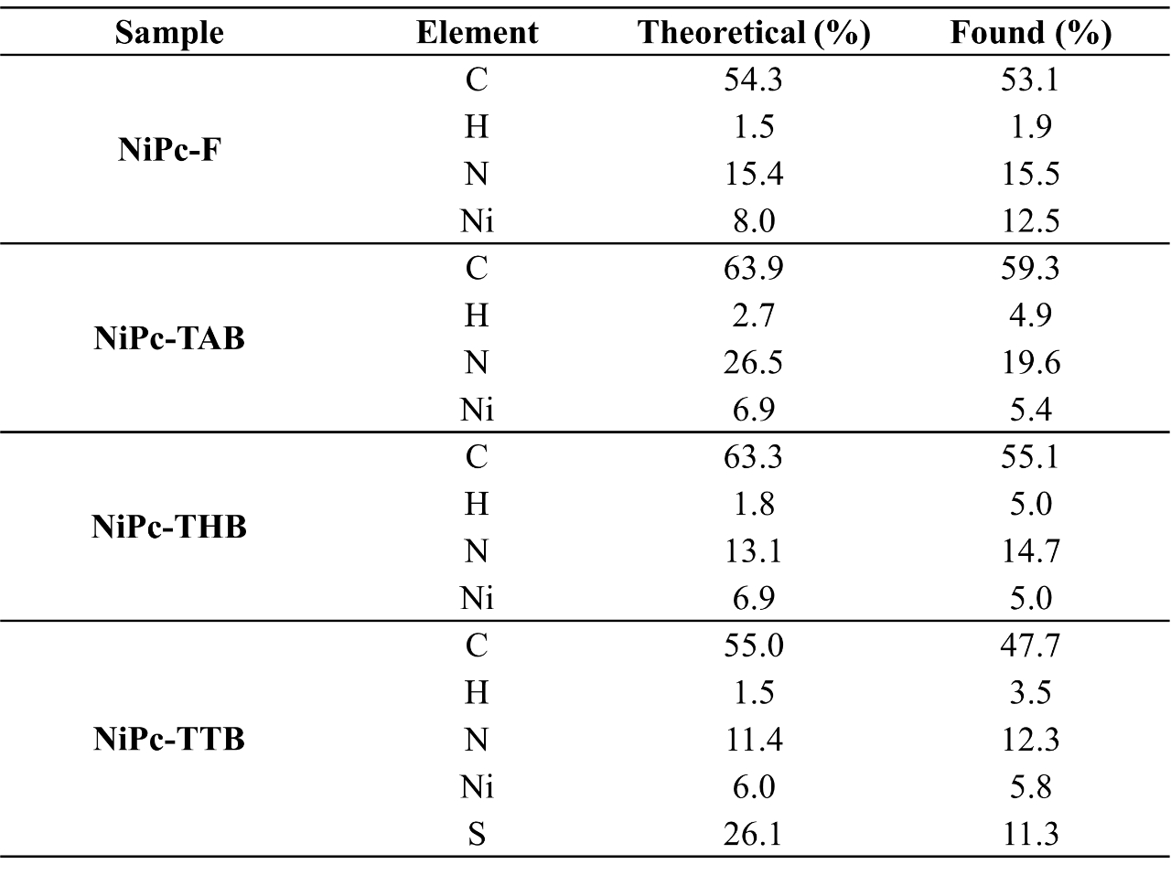

S5 Structural analysis
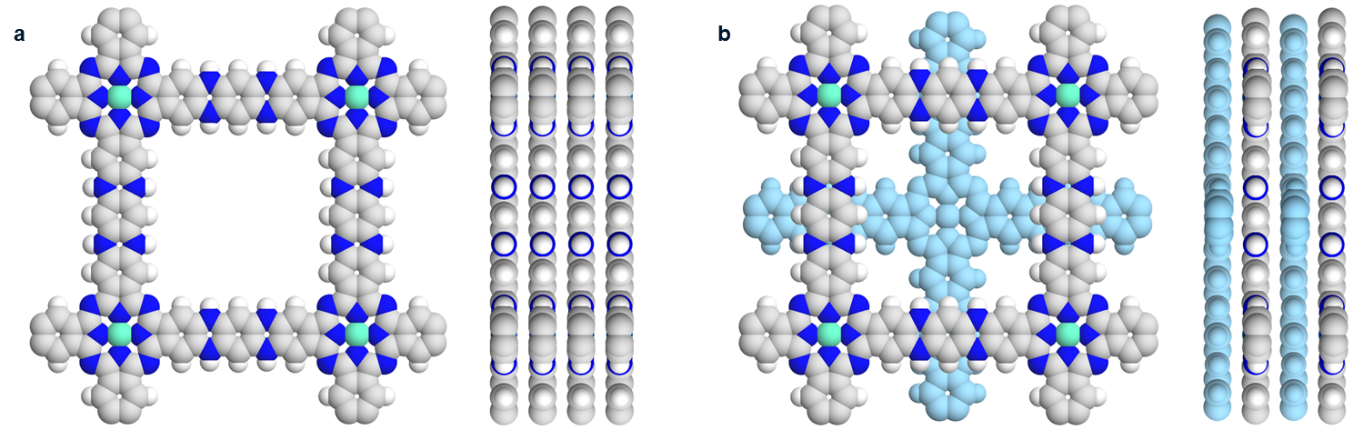
Fig. S5 a AA stacking and b AB stacking views from z and x axes of modeled COF crystal structures with eclipsed and staggered packing mode for NiPc-TAB

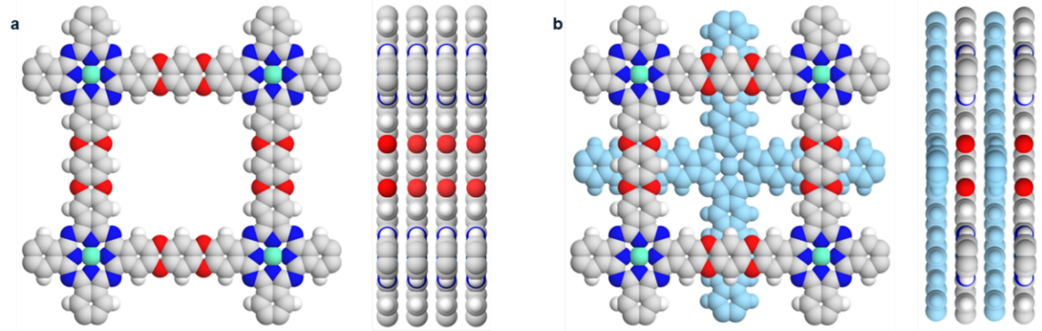
Fig. S6 a AA stacking and b AB stacking views from z and x axes of modeled crystal structures with eclipsed and staggered packing mode for NiPc-THB
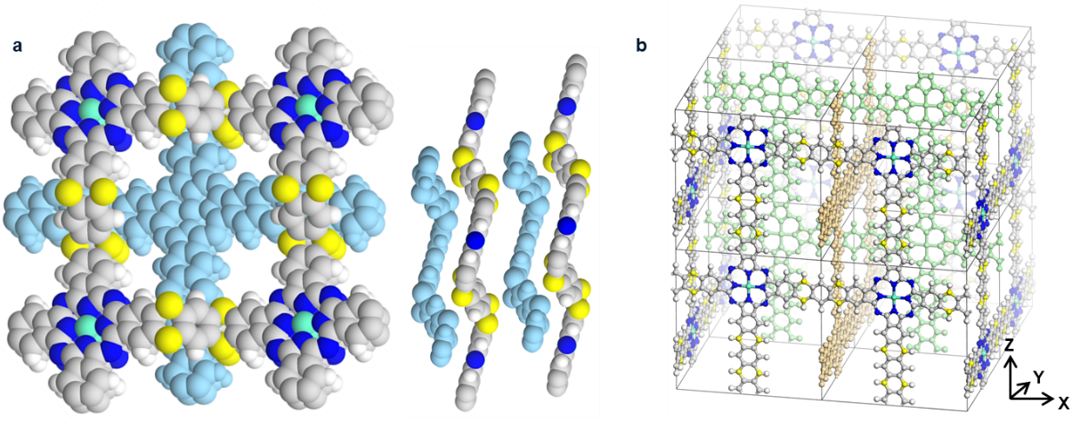
Fig. S7 a AB stacking views from z and x axes of modeled COF crystal structures with staggered packing mode and b three-dimentional modeled COF crystal structures with structural interpretation viewing from x, y, and z axes for NiPc-TTB
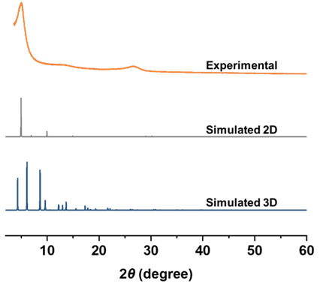
Fig. S8 The comparison of simulated 2D AA stacking structure model and 3D interpretation mode patterns with the experimental profile of NiPc-TTB
The geometry optimization with cell parameters was performed using the CASTEP module in Materials Studio with Perdew−Burke−Ernzerhof (PBE) generalized gradient approximation (GGA). The convergence tolerance was set at 2×10⁻⁵ eV/atom and the max force was set to 0.05 eV A⁻¹. Calculation of the simulated powder diffraction pattern was performed by Materials Studio Reflex Plus Module. The optimized crystal structure of NiPc-TAB and NiPc-THB are shown in Figs. 5 and 6 with lattice parameters a = b = 20.70 Å, c = 3.33 Å in P4/MMM space group. Lattice parameters of NiPc-TTB shows lattice parameters of a = 28.44, b = 28.64 Å, c = 3.81 Å, α = γ = 90°, β =76.72° in C2/M space. Modeling of the staggered structures was performed in a similar manner but with the space group I4/mmm for NiPc-TTB (Fig. S7).
Table S2 The full width at half maxima (FWHM) and grain size calculated by Debye-Scherrer equation of three NiPc COFs
Parameter  COF | Full width at half maxima (FWHM) | Grain size (nm)
NiPc-TAB | 0.03301 | 4.16
NiPc-THB | 0.03118 | 4.40
NiPc-TTB | 0.03936 | 3.49

S6 SEM and TEM images
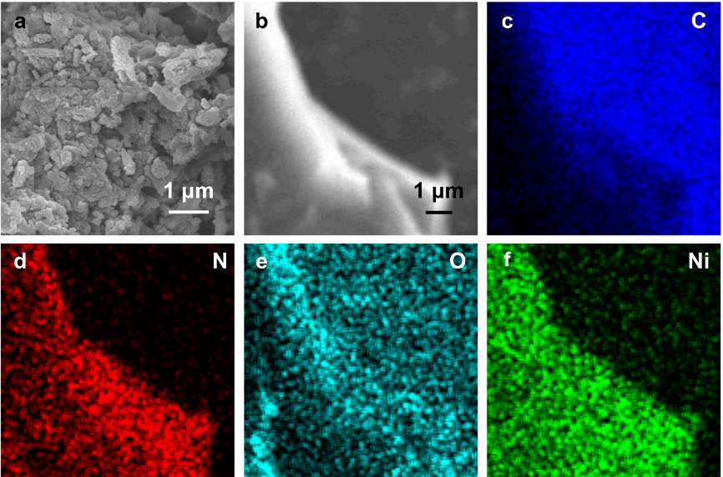
Fig. S9 a SEM image of NiPc-THB. b SEM image and c-f corresponding elemental mappings of the C, N, O, and Ni elements for NiPc-THB, respectively

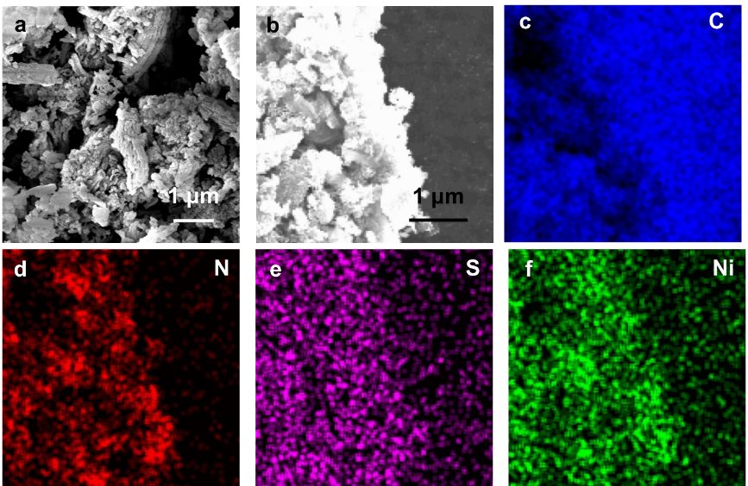
Fig. S10 a SEM image of NiPc-TTB. b SEM image and c-f corresponding elemental mappings of the C, N, S, and Ni elements for NiPc-TTB, respectively
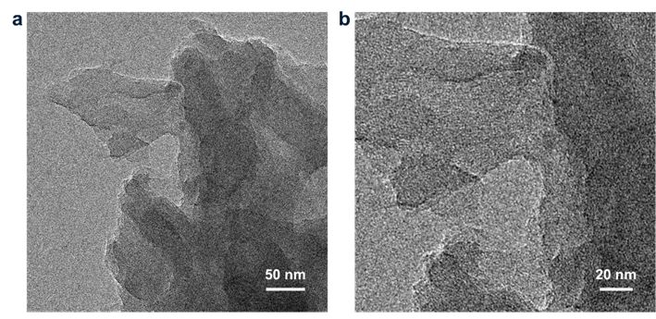
Fig. S11 TEM images of NiPc-TAB at different magnifications
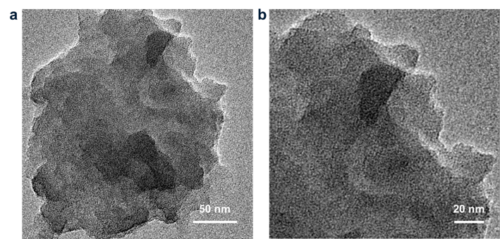
Fig. S12 TEM images of NiPc-THB at different magnifications

S7 ATR-IR spectra
Fourier transform infrared spectra were obtained using an attenuated total reflectance infrared spectroscopy (ATR-IR) by Bruker Tensorll. NiPc-F and NiPc-based COFs were used after they were further dried in vacuum desiccator equipped with an oil pump for 24 h under 50 °C after synthesis. The sample is positioned directly between the ATR accessory's ZnSe crystal and the ejector pin for testing. Each sample was collected 64 times from 4000 to 550 cm⁻¹.
Table S3 The assignment of peaks in ATR-IR spectra of NiPc-F ligand and NiPc-based COFs
Material | Bond and vibration type | Wavenumber (cm⁻¹)
NiPc-F | ν_{C-N} | 747
NiPc-F | Ni-N | 883
NiPc-F | ν_{C=N–C=C} | 1093
NiPc-F | ν_{C-N} | 1346
NiPc-F | ν_{C=N–C=C} | 1410
NiPc-F | ν_{C=N–C=C} | 1613
NiPc-TAB | ν_{C-N} | 747
NiPc-TAB | Ni-N | 867
NiPc-TAB | ν_{C-N} | 1340
NiPc-TAB | ν_{C=N–C=C} | 1094
NiPc-TAB | ν_{C=N–C=C} | 1419
NiPc-TAB | ν_{C=N–C=C} | 1623
NiPc-TAB | ν_{-NH-} | 3327
NiPc-THB | ν_{C-N} | 744
NiPc-THB | Ni-N | 863
NiPc-THB | ν_{C=N–C=C} | 1094
NiPc-THB | ν_{C-O-C} | 1281
NiPc-THB | ν_{C-N} | 1347
NiPc-THB | ν_{C=N–C=C} | 1411
NiPc-THB | ν_{C=N–C=C} | 1619
NiPc-TTB | ν_{C-S-C} | 704
NiPc-TTB | ν_{C-N} | 749
NiPc-TTB | Ni-N | 871
NiPc-TTB | ν_{C-N} | 1352
NiPc-TTB | ν_{C=N–C=C} | 1074
NiPc-TTB | ν_{C=N–C=C} | 1405
NiPc-TTB | ν_{C=N–C=C} | 1611

S8 TGA curves
Thermal gravimetric analysis (TGA) was performed using a NETZSCH TG 209F1 Libra with a 5 °C/min ramp from 30 ℃ to 800 ℃ under N₂. Thermogravimetric analysis showed excellent thermal stability of NiPc-TTB with only a total 10% of mass loss upon heating to 400 °C. NiPc-THB and NiPc-TAB COFs show an early onset of the decomposition at around 400 °C, a total 20% around of mass loss. The higher weight loss observed in NiPc-THB and NiPc-TAB COFs could be attributed to the presence of water or guest molecules in the materials. These results indicate the thermal stability of the materials under the studied temperature range.

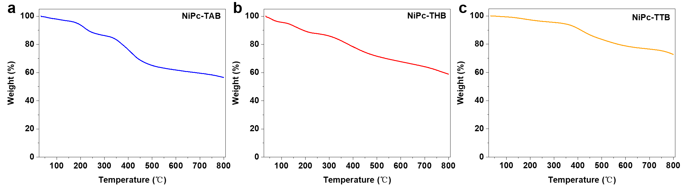
Fig. S13 TGA curves of a NiPc-TAB, b NiPc-THB, and c NiPc-TTB
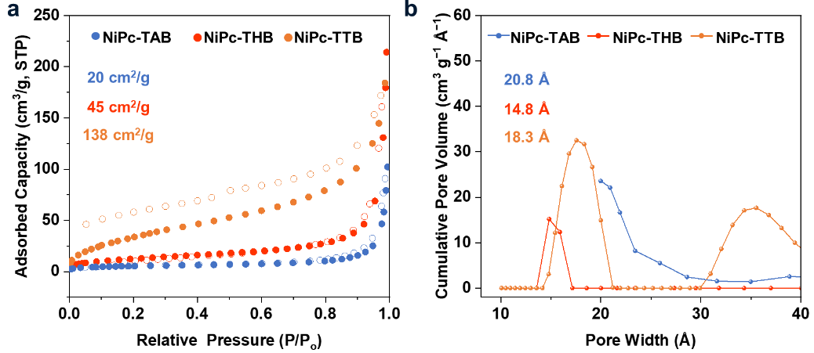
Fig. S14 N₂ sorption isotherms at 77 K and caculated pore size distribution for NiPc COFs

S9 XPS spectra
X-ray photoelectron spectroscopy (XPS) experiments of each element in this NiPc COF series before and after electrocatalysis were recorded on Thermo Scientific ESCALAB 250Xi and Thermo NEXSA G2 X-ray Photoelectron Spectrometer under ultrahigh vacuum (base pressure 10⁻⁷ Torr) with a pass energy of 40 eV. The measurement chamber was equipped with an excitation source of monochromatized Al (K_{α}) X-ray source (hν = 1486.6 eV). Both survey and high-resolution spectra were obtained using a beam diameter of 400 μm. Survey spectra were obtained from 0~1100 eV to obtain elemental surface composition. Before tests, COFs samples were treated by an activation procedure in which the COFs were successively soaked into water for 3 days and ethanol for another 3 days at 50 °C, during which the solvent was changed with corresponding fresh solvent every 12 h. The COFs were further dried by an oil pump for 24 h. About 4~6 mg of each COF was mounted onto copper tape by lightly pressing. High resolution spectra were then obtained at energy regions specific to elements observed in the survey spectrum (C 1s, N 1s, O 1s, S 2p, Ni 2p).

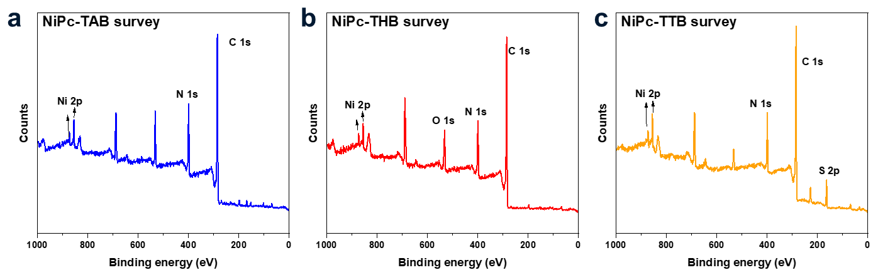
Fig. S15 XPS survey spectra of a NiPc-TAB, b NiPc-THB, and c NiPc-TTB before electrocatalysis

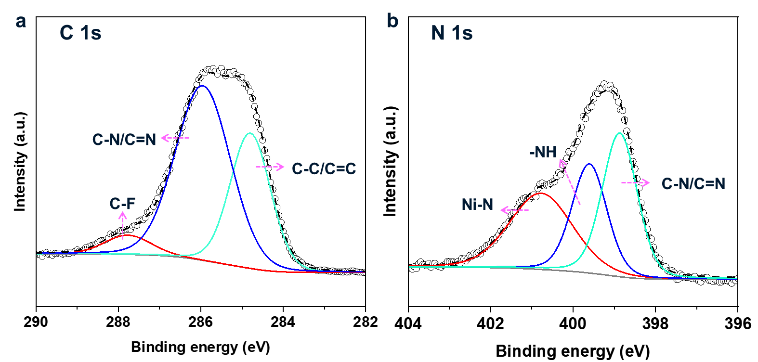
Fig. S16 Deconvoluted XPS spectra of a C 1s and b N 1s for NiPc-TAB

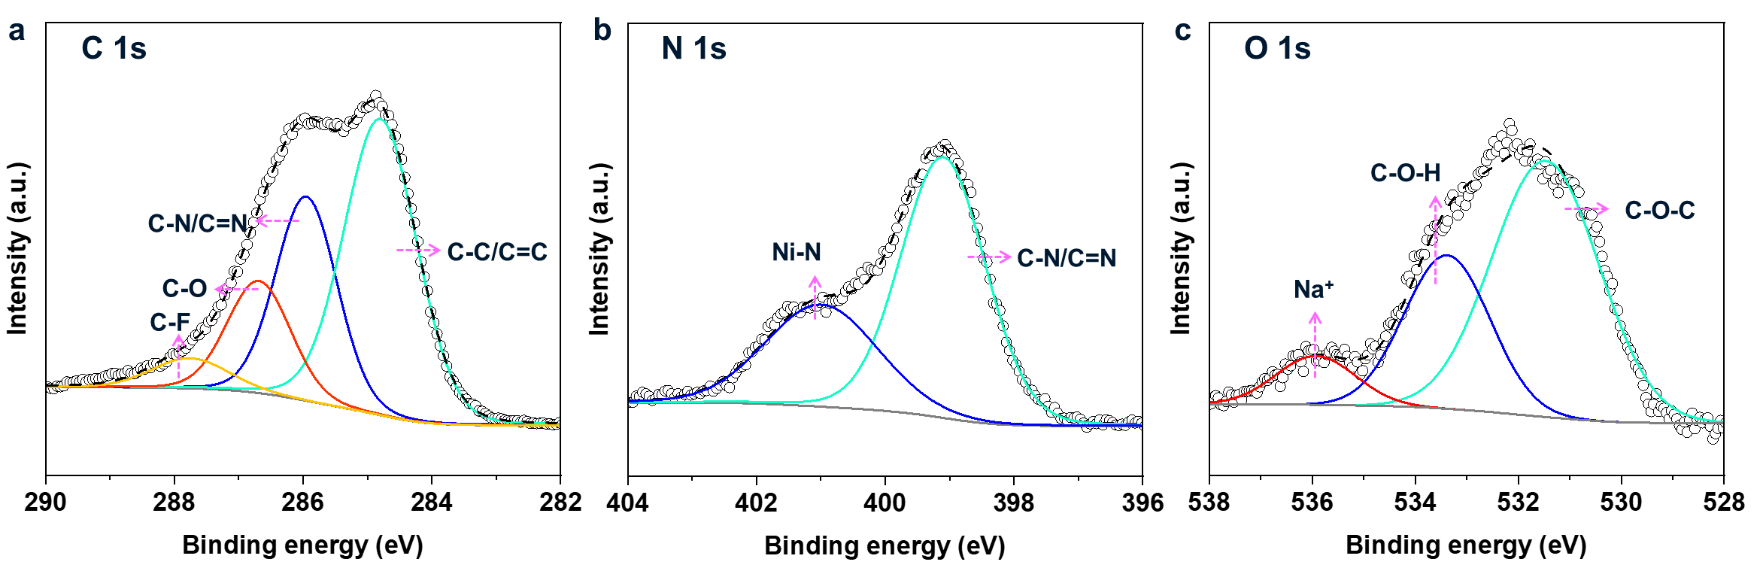
Fig. S17 Deconvoluted XPS spectra of a C 1s, b N 1s, and c O 1s for NiPc-THB
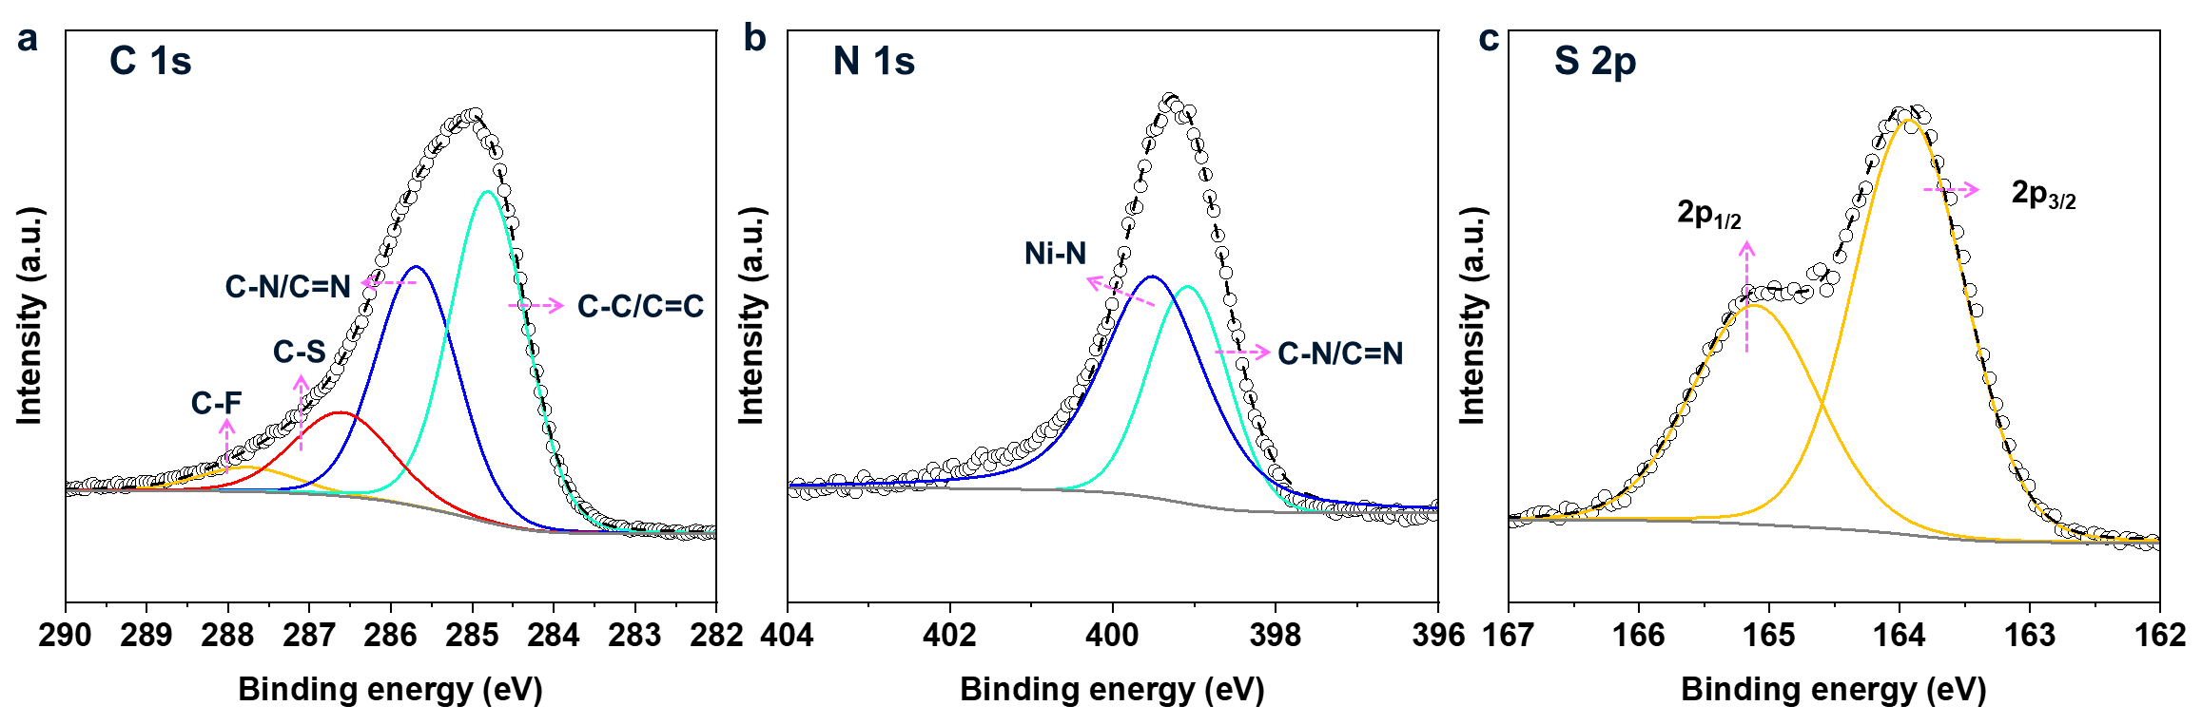
Fig. S18 Deconvoluted XPS spectra of a C 1s, b N 1s, and c S 2p for NiPc-TTB
In NiPc-TAB (Fig. S16), the high-resolution spectrum of N 1s can be deconvoluted into three peaks with binding energies of 398.87, 399.60, and 400.78 eV ascribed to C=N, N-H and Ni-N [S3] in nickel phthalocyanine ligand (Fig. S16b) [S4]. In NiPc-THB (Fig. S17), the high-resolution spectrum of N 1s can be deconvoluted into two peaks with binding energies of 399.10 eV and 400.99 eV ascribed to C=N and Ni-N (Fig. S17b). High-resolution scan of O 1s region showed two peaks with binding energies at 531.47 and 533.38 eV ascribed to C-O-C and C-O-H (Fig. S17c) [S5, S6]. In NiPc-TTB (Fig. S18), the high-resolution spectrum of N 1s can be deconvoluted into two peaks with binding energies of 399.07 and 399.50 eV ascribed to C=N and Ni-N (Fig. S18b). High-resolution scan of S 2p region showed two peaks with binding energies at 163.84 eV and 165.00 eV, which can be ascribed to the formation of C-S-C (Fig. S18c).

S10 UV−Vis−NIR spectra
UV–Vis–NIR spectra between 200 and 2500 nm were acquired using a Shimadzu SolidSpec-3700DUV spectrophotometer at a low scan rate with a step size of 1 nm under ambient conditions. Before measuring the samples, blank baseline and zero background corrections were obtained.

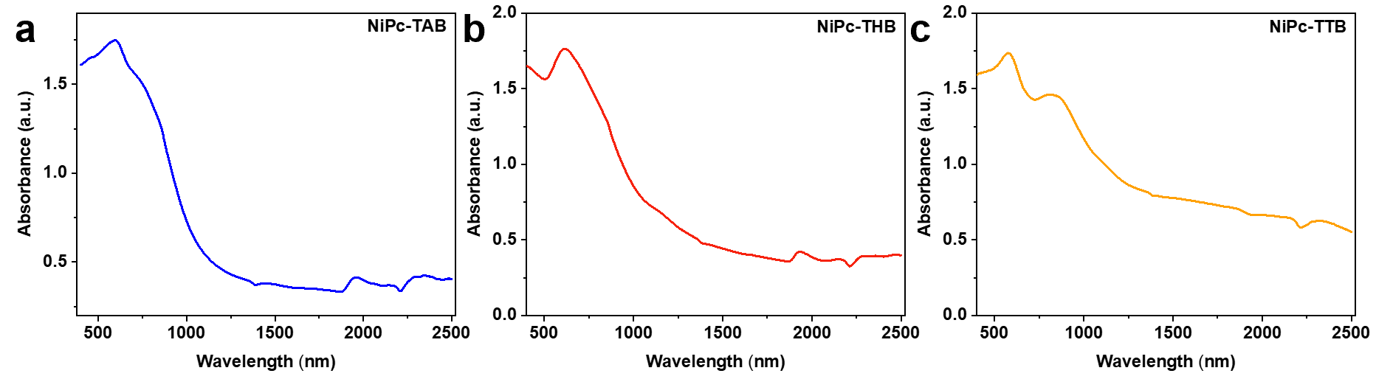
Fig. S19 UV−Vis−NIR spectra of a NiPc-TAB, b NiPc-THB, and c NiPc-TTB
The Tauc method, originally developed for estimating the band gap energy of amorphous semiconductors using optical absorption spectra [S7, S8], relies on the assumption that the energy-dependent absorption coefficient α can be expressed by the following Eq. (S1):
(S1)
In the Tauc equation, which relates the absorption coefficient to the energy of incident photons, h represents the Planck constant, ν is the frequency of the photons, E_{g} is the optical band gap energy, and B is a constant. The value of the factor γ depends on the nature of the electron transition, with γ being 1/2 for direct transitions and 2 for indirect transitions in the band gap [S9-S10].
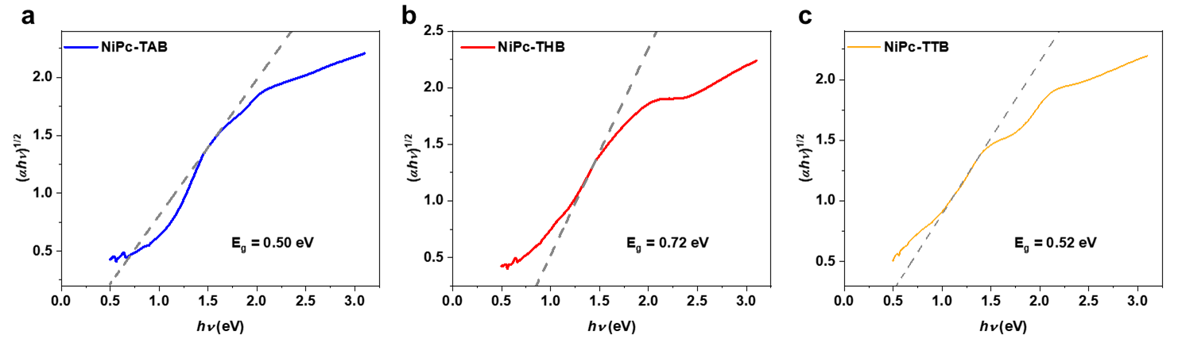
Fig. S20 Normalized Tauc plots of a NiPc-TAB, b NiPc-THB, and c NiPc-TTB from the UV−Vis−NIR spectra

S11 Conductivity test
To make a pressed pellet, ~50 mg of the COF sample was put into a 6 mm inner-diameter split sleeve pressing die and pressed for 5 min under a pressure of approximately 1000 psi. A two-contact probe method was employed to collect bulk conductivity measurements of the COFs pellet. We calculated the bulk conductivity measurements (S/cm) using Eq. S2. Herein, L (0.15 cm) is the distance of between the probes, which equals the thickness of the pellet, A is the basal area of the pellet, V (1 volts) is the voltage of cross the probes, I (A) is current, which is measured by electrochemical analyzer.
$σ=\frac{I}{V}$(S2)

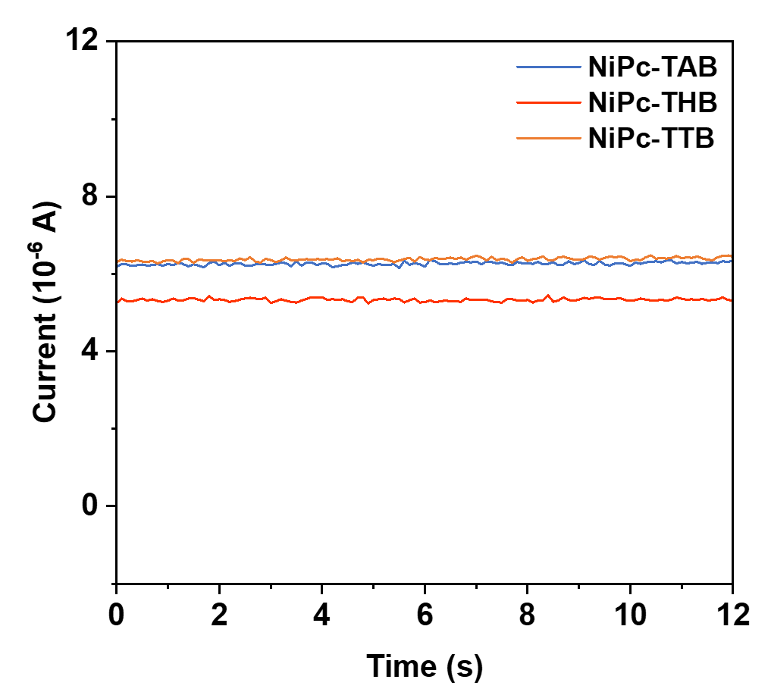
Fig. S21 Two probe conductivity test of three NiPc COFs

S12 Electrochemical test
The pH of the KHCO₃ solution (0.5 M) was measured after gently flushing the solution with N₂ (pH = 7.2) and CO₂ (pH = 6.8), respectively.
The overpotential η is the difference between the actual electrode reduction potential and the thermodynamic potential, defined by Eq. (S3):
$η=\left|E-E^{ϴ}\left({{CO}_{2}}/{CO}\right)\right|$(S3)
In the equation, E is the applied potential (vs. RHE), and E^{ϴ}(CO₂/CO) is the standard electrode for CO₂ to CO conversion which is −0.106 V (vs. RHE).
Working electrode. Carbon fiber paper (CFP) (HCP020P, Toray) was used as the substrate. COF inks were prepared by dispersing 4 mg of COFs and 4 mg of carbon black (Macklin, C915132, cabot vulcan xc-72R, 10-20 nm ) in a mixture of 40 μL of a Nafion 117 solution (D520 Dupont, 5 wt%) and 400 μL EtOH with the assistance of sonication for 30 min. 200 μL ink was pipetted onto CFP with a mass loading of 1.5~2 mg cm⁻², which was further dried at room temperature for using.
Counter electrode. A platinum electrode was used as a counter electrode for all the electrochemical tests.
Reference electrode. A Ag/AgCl electrode was used as the reference electrode. All potentials were measured against Ag/AgCl electrode and converted to the potential of reversible hydrogen electrode (RHE) by using Eq. (S4):
E_{RHE} = 0.197V + 0.0591×pH (S4)
The reference electrode was stored under a saturated KCl solution in MiliQ water before and after using.
Liner sweep voltammetry (LSV). Before testing, the electrolyte solution in the working compartment was supplied with N₂ or CO₂ for 15 minutes. The scan rate was ranging from 50 mV s⁻¹. The applied potential was ranging from −0.2 V to −1.3V (vs. RHE).
Electrochemical impedance spectroscopy (EIS). EIS was carried out at 100 mV alternating current voltage amplitude in a frequency range from 0.01 Hz to 100 kHz under a biased voltage of −0.8 V (vs. RHE). The setup was the same as that of the CV and chronopotentiometry.
Cyclic voltammetry (CV). Before testing, the electrolyte solution in the working compartment was supplied with CO₂ for 15 minutes. The scan rate was ranging from 10 to 100 mV s⁻¹.
Electrochemical active surface area (ECSA). ECSA was estimated by measuring the capacitive current related to double-layer capacitance from the scan-rate dependence of CVs under the potential windows of 0.2 V ~ 0.4 V (vs. RHE). The capacitance was obtained by plotting the ∆j = (j_{a} − j_{c}) at 0.3 V (j_{c} and j_{a} are the cathodic and anodic current densities, respectively) against the scan rate. The slope (∆j/2)/(scan rate) is thus the layer capacitance.
Chronopotentiometry. The electrolyte solution in the working compartment was purged for 10 minutes with CO₂ before testing. The applied potential was ranging from −0.5 V to −1.0 V (vs. RHE).
Product quantification. Gas products of CO₂ electrocatalysis were detected by the gas chromatograph. Argon was used as the carrier gas. A flame ionization detector with a methanizer was used to quantify the concentration of carbon monoxide (CO). Hydrogen (H₂) product was analyzed with a thermal conductivity detector. The peak areas were converted to gas concentration based on calibration curves.
The corresponding faradaic efficiency (FE) was calculated by Eq. (S5):
$j_{co}=j_{product}×FE×100\%$ (S5)
where the j_{product} and j_{total} are partial current density for a given gas product (CO or H₂) and total current density, respectively.
The cathodic energy efficiency towards CO products was calculated as a descriptor of economic viability analysis by plotting each potential and current density as the horizontal coordinates, respectively, using Eq. (S6) [S11]:
${EE}_{1/2}$= $\frac{E_{CO_{2 }}^{0}- E_{OER}^{0}}{E_{co_{2}R}^{applied}-E_{OER}^{0}}$ × FE_{CO} × 100% (S6)

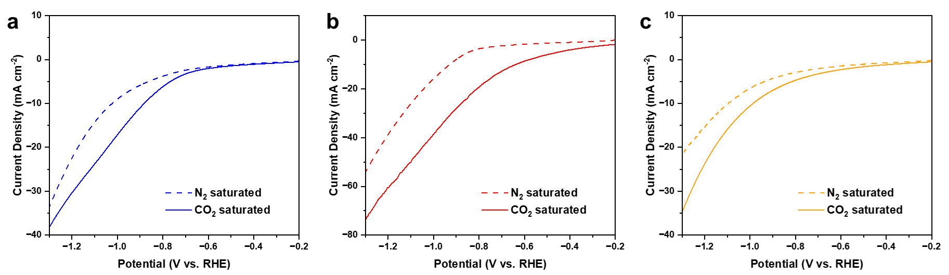
Fig. S22 LSV curves for a NiPc-TAB, b NiPc-THB, and c NiPc-TTB in a CO₂-saturated (solid line, pH = 6.8) and N₂-saturated (dashed line, pH = 7.2) KHCO₃ solution
NiPc-TAB
NiPc-THB
NiPc-TTB
Fig. S23 ¹H NMR spectra for electrolytes after electrolysis at all potentials. From top to bottom: NiPc-TAB, NiPc-THB, and NiPc-TTB

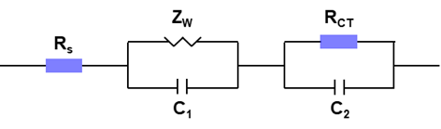
Fig. S24 Equivalent circuit used for fitting the data. In the circuit, R_{S} shows the combination of the resistance of electrodes and electrolyte. A diffusion element Z_{W} represents the diffusion of CO₂ in the electrolyte. C₁ is the capacitance value of working electrode-electrolyte interface. C₂ and R_{CT} are the capacitance and charge transfer resistance values of the counter electrode-electrolyte interface, respectively. Z_{W} and R_{CT} are in parallel with the capacitive elements C₁ and C₂

Table S4 The resistance and capacitance values for the fitting equivalent circuit for three NiPc COFs
Values  COFs | R_{S} (Ω) | R_{CT1} (Ω) | Z_{WR}  (Ω) | Z_{WT}  (Ω) | Z_{WP}  (Ω) | C₁ (F) | C₂ (F)
NiPc-TAB | 3.479 | 12.64 | 8.79 | 1.498 | 0.3596 | 1.8683 × 10⁻⁴ | 8.4099 × 10⁻³
NiPc-THB | 2.777 | 2.32 | 5.379 | 0.90725 | 0.30256 | 1.3223 × 10⁻³ | 7.9944 × 10⁻³
NiPc-TTB | 2.9891 | 32.57 | 12.83 | 0.21591 | 0.54327 | 2.1442 × 10⁻³ | 1.5267 × 10⁻³

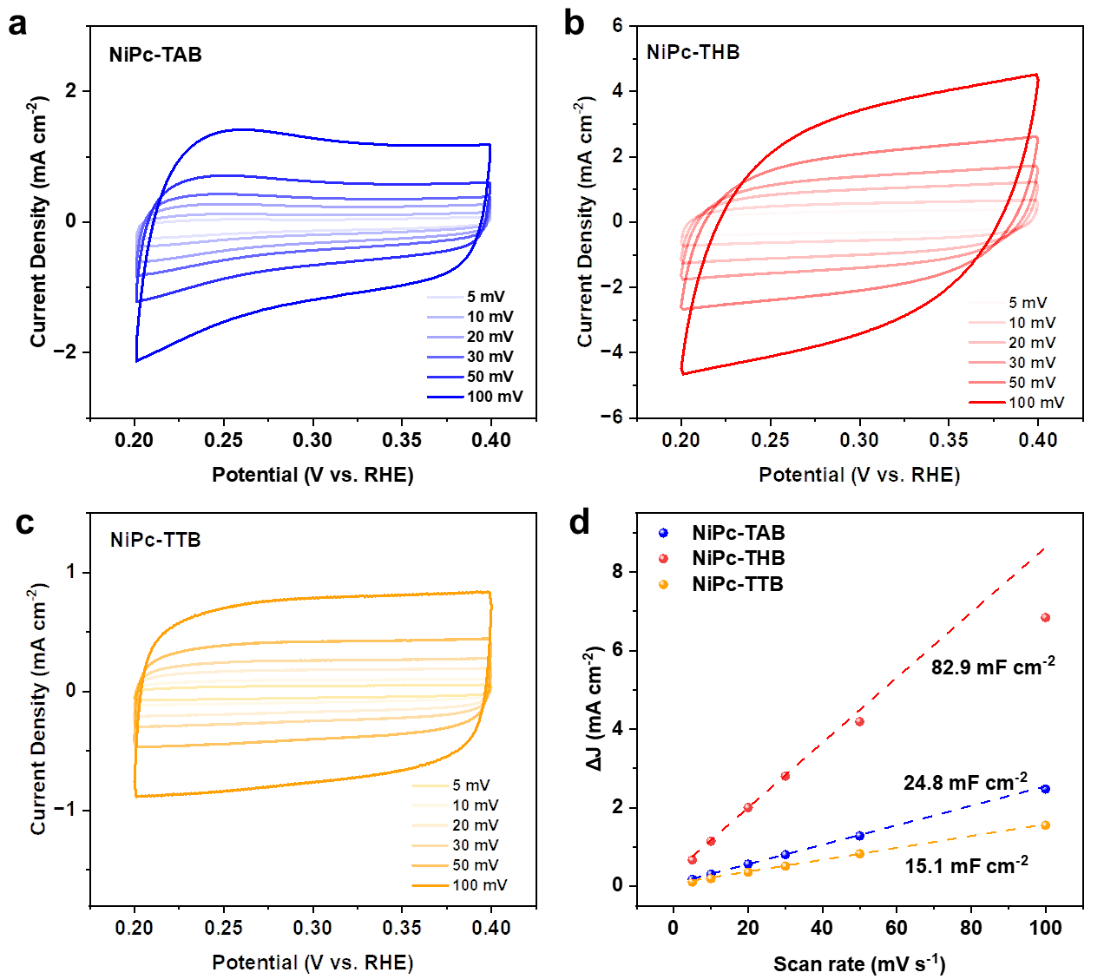
Fig. S25 CV curves of a NiPc-TAB, b NiPc-THB, and c NiPc-TTB at different scan rates. d Capacitive current density against the scan rate of NiPc-based COFs
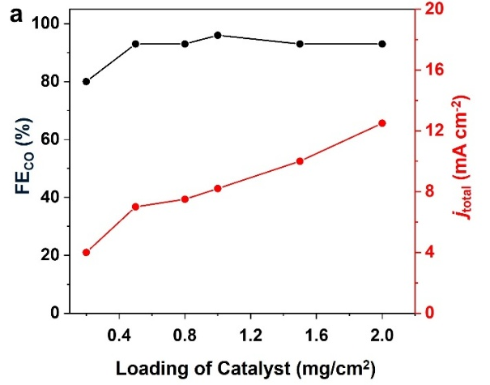
Fig. S26 The Faradaic efficiency for the electrocatalytic CO₂RR of NiPc-TAB under different loadings in an H-cell at −0.8 V (vs. RHE). Increasing the loadings of catalyst over 0.5 mg cm⁻² resulted in no obvious change of CO selectivity while giving an increased current density which might be due to the increased available catalytic sites with more catalyst

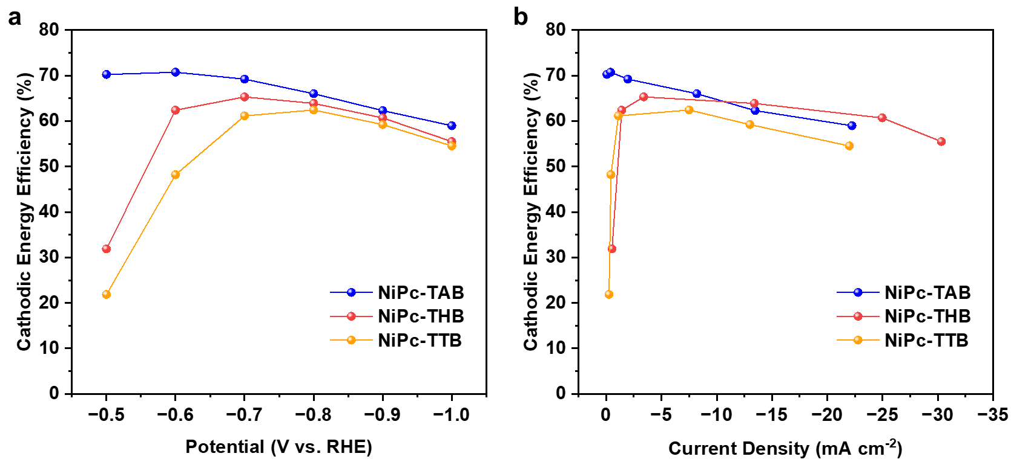
Fig. S27 Comparison of cathodic energy efficiency over NiPc-TAB, NiPc-THB, and NiPc-TTB at a each potential and b current density, respectively
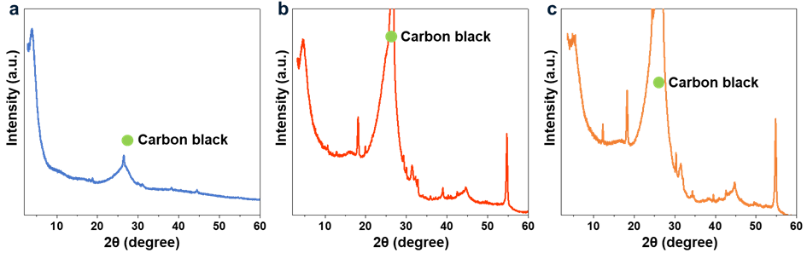
Fig. S28 PXRD patterns of a NiPc-TAB, b NiPc-THB, and c NiPc-TTB sample after electrocatalytic CO₂RR. The presence of additives in COF catalysts and the irregular residual guests, such as KHCO₃, Nafion in the pores, may lead to weakened peak intensities in PXRD compared with pristine COFs
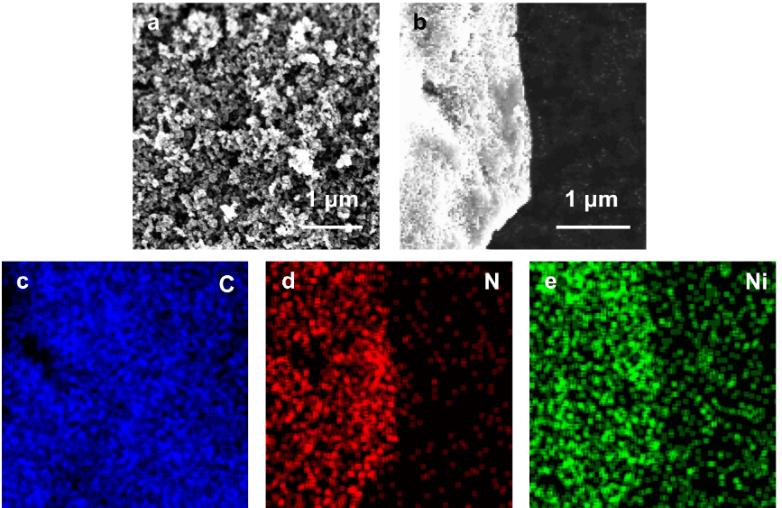
Fig. S29 a SEM images of NiPc-TAB. b SEM images and c-f corresponding elemental mappings of the C, N, and Ni elements, respectively, for NiPc-TAB after electrocatalytic CO₂RR
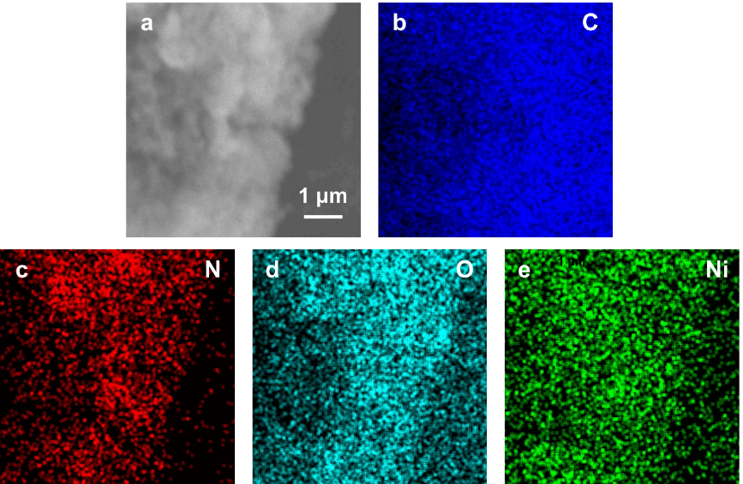
Fig. S30 a SEM images and b-d corresponding elemental mapping of the C, N, O, and Ni elements, respectively, for NiPc-THB after electrocatalytic CO₂RR
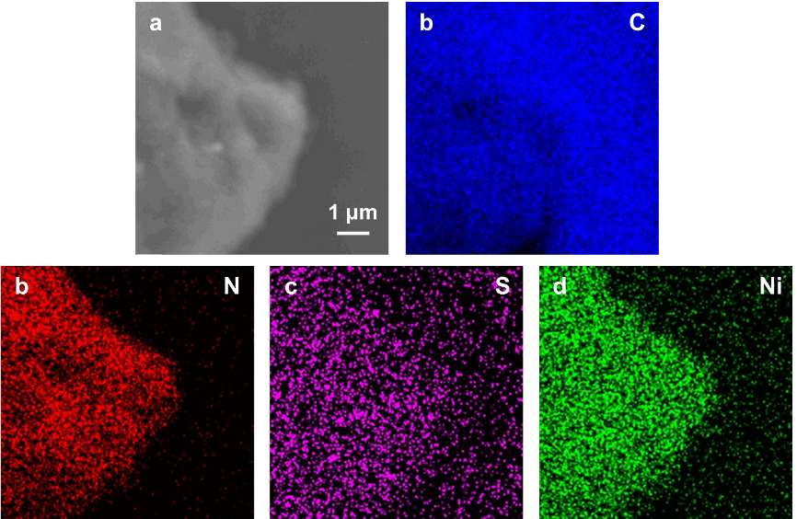
Fig. S31 a SEM images and b-d corresponding elemental mapping of the C, N, S, and Ni, respectively, for NiPc-TTB after electrocatalytic CO₂RR
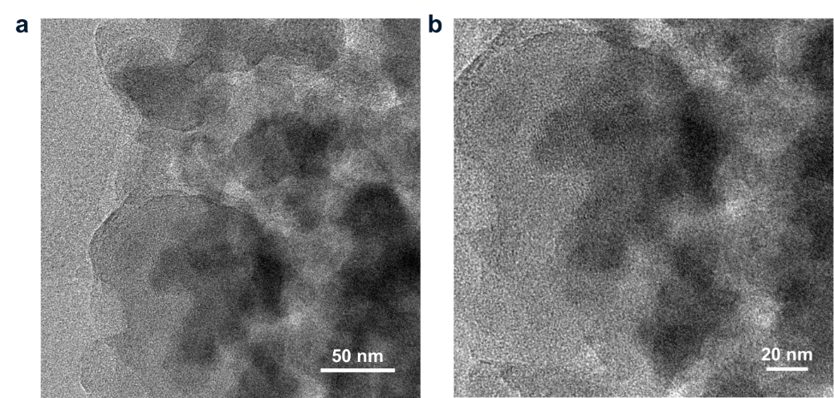
Fig. S32 TEM images of NiPc-TAB at different magnifications after electrocatalytic CO₂RR

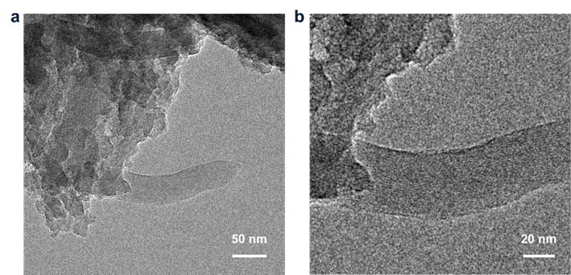
Fig. S33 TEM images of NiPc-THB at different magnifications after electrocatalytic CO₂RR

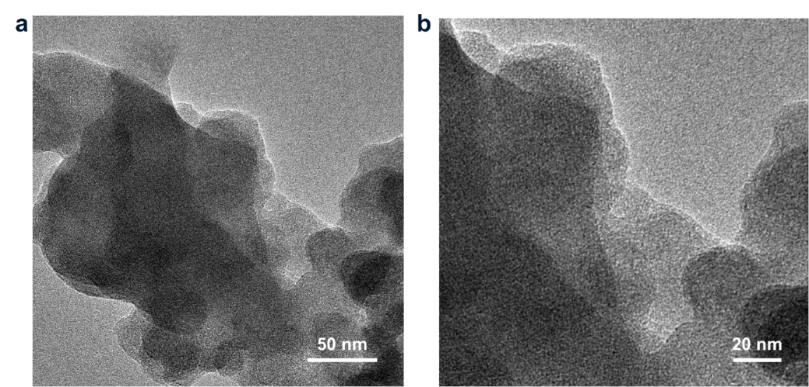
Fig. S34 TEM images of NiPc-TTB at different magnifications after electrocatalytic CO₂RR

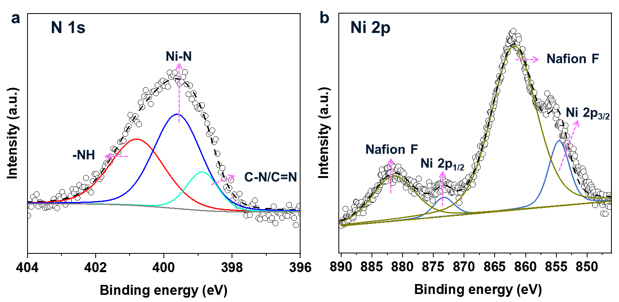
Fig. S35 Deconvoluted XPS spectra of a N 1s and b Ni 2p for NiPc-TAB after electrocatalytic CO₂RR

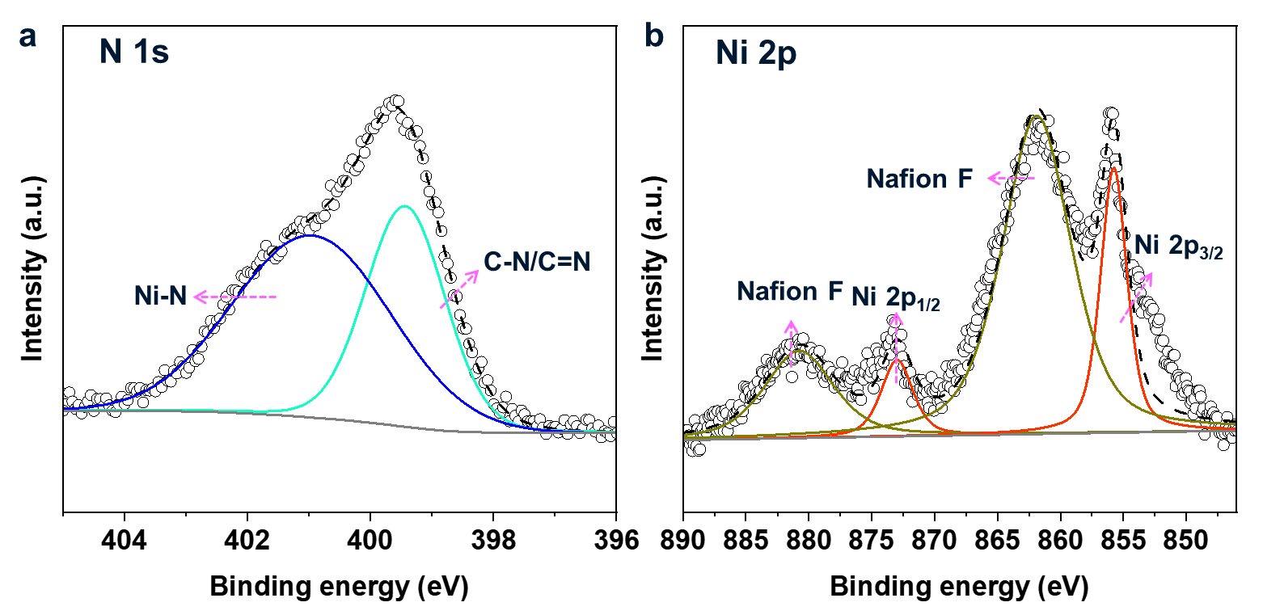
Fig. S36 Deconvoluted XPS spectra of a N 1s and b Ni 2p for NiPc-THB after electrocatalytic CO₂RR

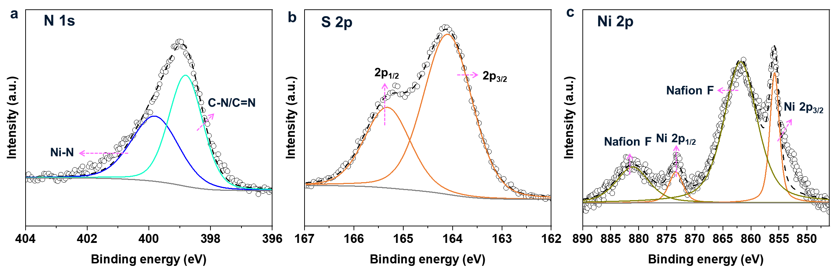
Fig. S37 Deconvoluted XPS spectra of a N 1s, b S 2p, and c Ni 2p for NiPc-TTB after electrocatalytic CO₂RR

S13 Performance comparison
We have summarized the performance matrix of the catalytic electrochemical conversion of CO₂ to CO by the utilization of several important classes of the materials, including reticular materials, molecular metallophthalocyanine (MPc), metalloporphyrin (MPy), and the composites bases on molecular MPc and MPy. The corresponding data are listed in Table S5.
Table S5 Comparison of the electrochemical reduction of CO₂ to CO catalyzed by MPc based COFs used in this work with reticular materials and other related materials
Type of catalysts | Electrocatalyst | E  (V vs. RHE) | FE_{CO}  (%) | j  (mA cm⁻²) | Cathodic EE (%) | Tafel slopes (mV dec⁻¹ ) | Ref.
MPc and MPy based reticular materials | NiPc-TAB | −0.80 | 99.90 | −8.2 | 65.94 | 134.8 | this work
MPc and MPy based reticular materials | NiPc-THB | −0.80 | 93.00 | −13.4 | 61.39 | 190.7 | this work
MPc and MPy based reticular materials | NiPc-TTB | −0.8 | 90 | −7.5 | 59.41 | 176.3 | this work
MPc and MPy based reticular materials | NiPc-TFPN COF | −0.9 | 99.80 | −14.1 | 62.78 | 209.9 | [S12]
MPc and MPy based reticular materials | NiPc-NH-TFPN-NH₂ | −0.8 | 99.6 | −24.33 | 65.75 | 103 | [S13]
MPc and MPy based reticular materials | CoPc-DSDSCOF | −0.9 | 96.5 | −26 | 60.71 | 242 | [S14]
MPc and MPy based reticular materials | TFPc-PBBA-COF | −0.9 | 97 | −25 | 61.02 | 226.2 | [S15]
MPc and MPy based reticular materials | CoPc-PI-COF-1 | −0.7 | 93 | −9.4 | 64.57 | 95 | [S16]
MPc and MPy based reticular materials | CoPc-PDQ-COF/CB | −0.66 | 96 | −22.2 | 68.06 | 112 | [S17]
MPc and MPy based reticular materials | CoPc-2H₂Por COF | −0.55 | 95 | <−6 | 71.52 | 123 | [S18]
MPc and MPy based reticular materials | COF-367-Co | −0.67 | 90 | −3.3 | 63.47 | over 470 | [S19]
MPc and MPy based reticular materials | MOF-1992 | −0.63 | 80 | −16.5 | 57.63 | N/A | [S20]
MPc and MPy based reticular materials | CuPcF₈-CoNPc-COF | −0.62 | 97 | −16.5 | 70.26 | 104 | [S21]
MPc and MPy based reticular materials | NiPcF₈-NiPc-COF | −0.87 | 93 | N/A | 59.34 | N/A | [S21]
MPc and MPy based reticular materials | TTF-Por(Co)-COF | −0.7 | 95 | −6.88 | 65.96 | N/A | [S22]
MPc and MPy based reticular materials | pCoNiPc | −0.8 | 94 | −16 | 62.05 | ~118 | [S23]
MPc and MPy based reticular materials | Al₂(OH)₂TCPP-Co | −0.70 | 90 | −1.0 | 62.49 | 165 | [S24]
MPc and MPy based reticular materials | NiPc-NiO₄ | −0.84 | 98.4 | −34.5 | 63.70 | N/A | [S25]
MPc and MPy based reticular materials | Re-SURMOF | −1.60 | 93 | −2.5 | 44.04 | N/A | [S26]
MPc and MPy based reticular materials | MOF-545(Fe)/CB | −0.60 | 91 | −1.2 | 66.63 | 188 | [S27]
MPc and MPy based reticular materials | Fe-PB | −0.63 | 85.00 | 0.20 | 61.24 | 165 | [S28]
MPc and MPy based reticular materials | PcCu-O₈-Zn/CNT (1:0.5) | −0.70 | 88.00 | −4.0 | 61.10 | 125 | [S29]
MPc and MPy based reticular materials | Co-TTCOF | −0.70 | 91.30 | −1.84 | 63.39 | 237 | [S30]
Molecular MPc and MPy | FTDHPP | −0.58 | 94.00 | −0.31 | 69.59 | N/A | [S31]
Molecular MPc and MPy | Cobalt protoporphyrin | −0.80 | 37.40 | −0.33 | 24.69 | N/A | [S32]
Molecular MPc and MPy | CoFPc | −0.80 | 93.00 | −4.2 | 61.39 | 270 | [S33]
Molecular MPc and MPy | Cu(II)-5,10,15,20-tetrakis-(2,6-dihydroxyphenyl)porphyrin | −0.98 | 10.00 | <−2 | 6.06 | N/A | [S34]
Molecular MPc and MPy | Zinc(II) 5,10,15,20-tetramesitylporphyrin | −1.94 | 95.00 | −2.1 | 40.16 | N/A | [S35]
Molecular MPc and MPy | CoPc | −0.80 | 99.00 | −8 | 65.35 | ~121 | [S36]
MPc and MPy based composite | Co chlorin/CNTs | −1.10 | 64.00 | N/A | 36.81 | N/A | [S37]
MPc and MPy based composite | CoPc/poly-4-vinylpyridine | −0.73 | 89.00 | −2 | 60.85 | N/A | [S38]
MPc and MPy based composite | CAT_{Pyr}/CNT | −0.59 | 93.00 | −0.24 | 68.47 | N/A | [S39]
MPc and MPy based composite | CoPc/CNT | −0.63 | 92.00 | −10 | 66.28 | N/A | [S40]
MPc and MPy based composite | CoPPc/CNT | −0.61 | 80.00 | −20 | 58.26 | 121 | [S36]
MPc and MPy based composite | Co-TPP/CNT | −0.50 | 83.00 | −0.59 | 64.29 | 255 | [S41]
MPc and MPy based composite | Protoporphyrin IX cobalt chloride CoPP@CNT | −0.65 | 98.30 | −21 | 70.06 | 118 | [S42]
MPc and MPy based composite | CoPc/CNT | −0.78 | 95.00 | −11 | 63.33 | N/A | [S43]
MPc and MPy based composite | CoPc-NH₂/CNT | −0.78 | 95.00 | −12.5 | 63.33 | N/A | [S43]
MPc and MPy based composite | CoPc@carbon powder | −0.68 | 93.00 | −18.1 | 65.25 | N/A | [S44]
MPc and MPy based composite | CoCoPcP/CNTs | −0.44 | 94.00 | −8.1 | 75.43 | 123 | [S45]

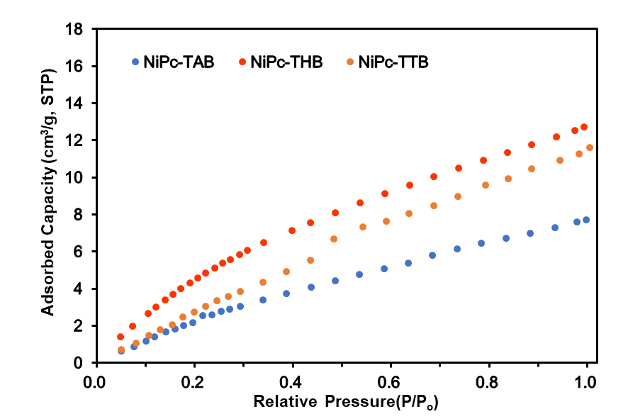
Fig. S38 CO₂ sorption isotherms of NiPc-based COFs

S14 Computational study of electronic properties
For the computation of electronic properties including band structures and density of states (DOS), the functional GGA with PBE was employed with energy cutoffs set at 435.4 eV, 571.4 eV, and 435.4 eV for NiPc-TAB, NiPc-THB, and NiPc-TTB, respectively. The Brillouin zones are sampled using a 2 × 2 × 4 k-point mesh in the Monkhorst-Pack scheme.

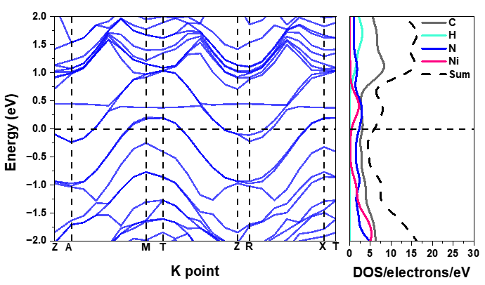
Fig. S39 Calculated electronic band structure (left) and DOS (right) for NiPc-TAB

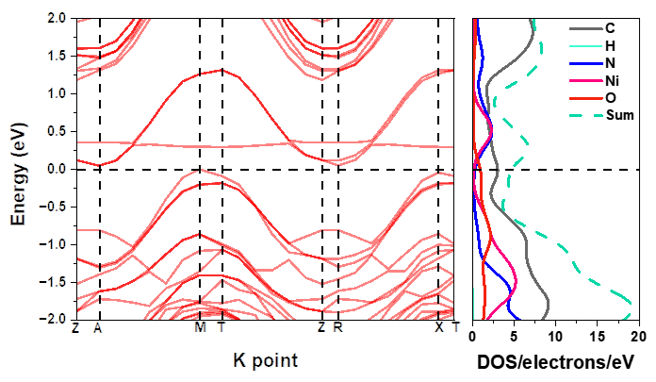
Fig. S40 Calculated electronic band structure (left) and DOS (right) for NiPc-THB
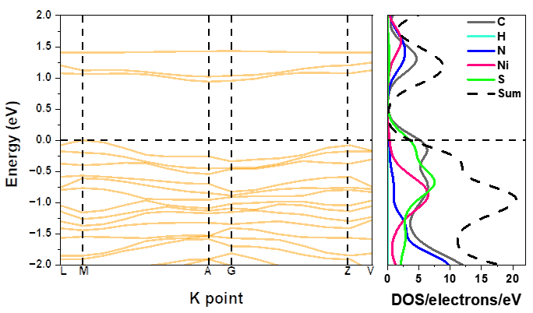
Fig. S41 Calculated electronic band structure (left) and DOS (right) for NiPc-TTB
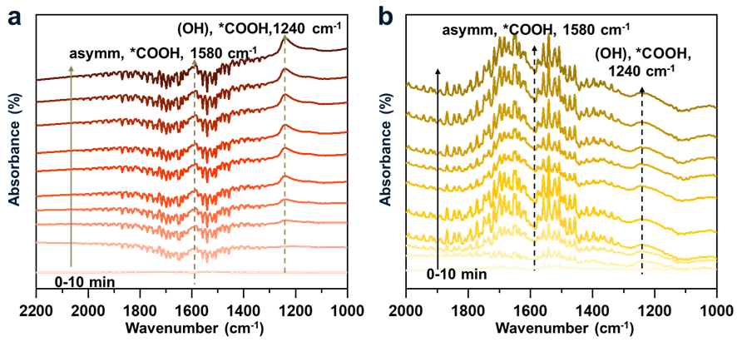
Fig. S42 In-situ FTIR spectra of a NiPc-THB and b NiPc-TTB collected at −0.80 V (vs. RHE) under CO₂-saturated 0.5 M KHCO₃ electrolyte

S15 Computational investigation of catalytic mechanism
Computational details. Electrocatalytic CO₂RR reduction is a proton-coupled electron transfer process.
CO₂(g) + 2H⁺ (aq) + 2e⁻(aq) → CO(g) + H₂O (S6)
In the calculation, following four steps are considered in electrocatalytic carbon dioxide
reduction:
M + CO₂ + 2H⁺ + 2e⁻ → [M-CO₂] + 2H⁺+ 2e⁻ (S7)
[M-CO₂] + 2H⁺ + 2e⁻→ [M-COOH] + 2H⁺+ 2e⁻ (S8)
[M-COOH] + H⁺ + e⁻ → [M-CO] + H₂O (S9)
[M-CO] + H₂O → M + CO + H₂O (S10)
Electronic calculations were performed to optimize the geometry and calculate the Gibbs free energy of all intermediates involved in the reactions using density functional theory (DFT) in the Dmol3 module of Materials Studio.
$G=H-TS=E_{DFT}+E_{ZPE}+\int_{0}^{298.15}{C_{p}dT-TS}$ (S11)
$μ\left(H^{+}\right) + μ\left(e^{-}\right)=\frac{1}{2}μ\left[H_{2}\left(g\right)\right]$(S12)
In eq S10, T is the system temperature (298.15 K), E_{DFT} is the electron energy calculated by DFT above, E_{ZPE} is the zero-point energy, which is a combination of vibrational, translational, and rotational energy at absolute zero, C_{p} is the heat capacity, and S is entropy. E_{ZPE}, C_{p}, and S are calculated using the harmonic approximation of the frequency analysis in the Dmol3 module.

 | [Ni-CO₂] |  | [Ni-COOH] |  | [Ni-CO]
NiPc-TAB | 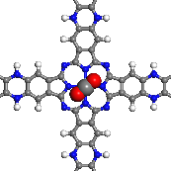 | 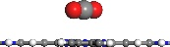 | 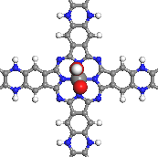 | 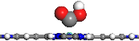 | 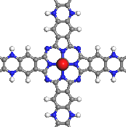 | 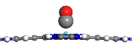
NiPc-THB | 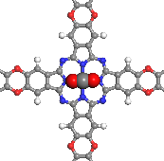 | 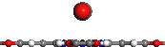 | 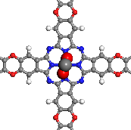 | 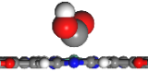 | 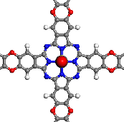 | 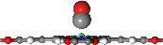
NiPc-TTB | 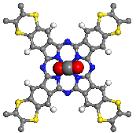 | 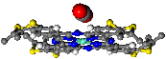 | 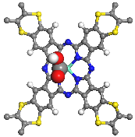 | 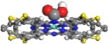 | 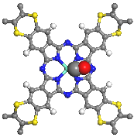 | 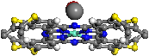
Fig. S43 Optimization of the ground state structure of NiPc-TAB, NiPc-THB, and NiPc-TTB monolayer by CO₂ adsorption, COOH, and CO adsorbed on the NiPc-TAB, NiPc-THB, and NiPc-TTB monolayer. Using the Dmol3 module in Materials Studio, the GGA-PBE exchange correlation function and DND base set were used to optimize the structure
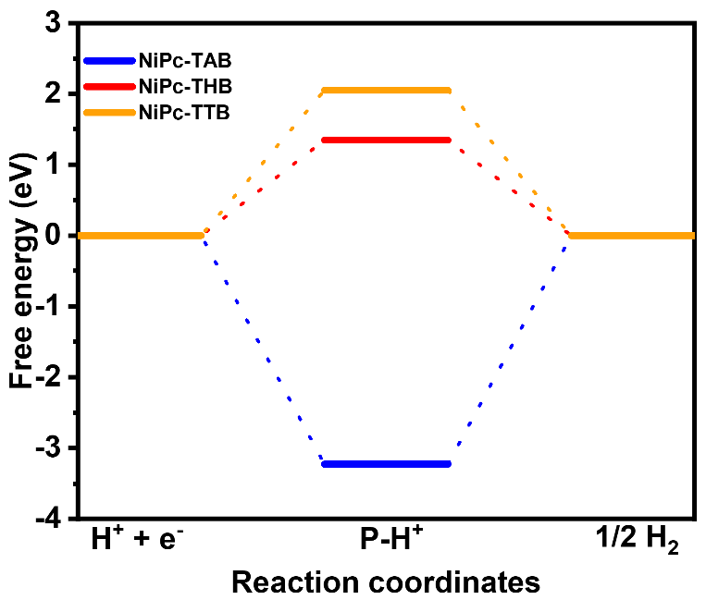
Fig. S44 Free energy diagrams of HER for NiPc-based COFs
Table S6 Calculated electronic energies (E_{DFT}), zero-point vibrational energies (E_{ZPE}), entropies (TS), thermal corrections ($\int{C_{p}dT}$), and free energies (G) associated with NiPc-TAB catalyzed process
 | E_{DFT}  (Ha) | E_{ZPE}  (kcal mol⁻¹) | -TS  (cal mol⁻¹) | $$\int{C_{p}dT}$$  (J mol⁻¹) | E_{ZPE}-TS  (kcal mol⁻¹) | G  (Ha)
H₂(g) | -1.1612253 | 8.306 | -9703.88805 | 2073.63325 | -1.398 | -1.163453188
CO₂(g) | -188.3997745 | 8.859 | -15776.3091 | 2790.38585 | -6.918 | -188.3942622
NiPc-TAB | -2733.246748 | 378.512 | 45161.07865 | 51881.0815 | 333.351 | -2732.643542
[Ni-COO⁻] | -2921.647876 | 388.68 | 56266.56985 | 55310.70095 | 332.414 | -2921.118133
[Ni-COOH] | -2922.200738 | 394.55 | -50873.9308 | 55819.643 | 343.676 | -2921.653047
[Ni-CO] | -2846.431761 | 383.355 | -46740.3792 | 53450.84125 | 336.615 | -2845.895323
[CO] | -113.1844156 | 4.869 | -14113.8247 | 2077.87704 | -9.244 | -113.1991471
[H₂O] | -76.3586153 | 14.897 | -13894.3863 | 2388.1815 | 1.003 | -76.35701689
[H*] | -2733.7801389 | 382.268 | -45373.95775 | 52650.3085 | 336.894 | -2733.243256
Table S7 Calculated electronic energies (E_{DFT}), zero-point vibrational energies (E_{ZPE}), entropies (TS), thermal corrections ($\int{C_{p}dT}$), and free energies (G) associated with Pc-THB catalyzed process
 | E_{DFT}  (Ha) | E_{ZPE}  (kcal mol⁻¹) | -TS  (cal mol⁻¹) | $$\int{C_{p}dT}$$  (J mol⁻¹) | E_{ZPE}-TS  (kcal mol⁻¹) | G  (Ha)
H₂(g) | -1.1612253 | 8.306 | -9703.88805 | 2073.63325 | -1.398 | -1.163453188
CO₂(g) | -188.3997745 | 8.859 | -15776.3091 | 2790.38585 | -6.918 | -188.3942622
NiPc-THB | -2891.8934661 | 310.833 | -44153.33165 | 50989.31485 | 266.68 | -2891.468485
[Ni-COO⁻] | -3080.2940434 | 319.318 | -48877.81655 | 53453.82275 | 270.44 | -3079.86307
[Ni-COOH] | -3080.8442696 | 327.219 | -50324.1422 | 54969.3192 | 276.894 | -3080.403011
[Ni-CO] | -3005.0800678 | 316.768 | -52020.91385 | 53899.25885 | 264.747 | -3004.658167
[CO] | -113.1844156 | 4.869 | -14113.8247 | 2077.87704 | -9.244 | -113.1991471
[H₂O] | -76.3586153 | 14.897 | -13894.3863 | 2388.1815 | 1.003 | -76.35701689
[H*] | -2892.4299444 | 315.263 | -45914.20555 | 52032.24355 | 269.348 | -2892.000705
Table S8 Calculated electronic energies (E_{DFT}), zero-point vibrational energies (E_{ZPE}), entropies (TS), thermal corrections ($\int{C_{p}dT}$), and free energies (G) associated with NiPc-TTB catalyzed process
 | E_{DFT}  (Ha) | E_{ZPE}  (kcal mol⁻¹) | -TS  (cal mol⁻¹) | $$\int{C_{p}dT}$$  (J mol⁻¹) | E_{ZPE}-TS  (kcal mol⁻¹) | G  (Ha)
H₂(g) | -1.1612253 | 8.306 | -9703.88805 | 2073.63325 | -1.398 | -1.163453188
CO₂ | -188.3997745 | 8.859 | -15776.3091 | 2790.38585 | -6.918 | -188.3942622
NiPc-TTB | -10949.7974501 | 617.842 | -105760.9606 | 108472.6349 | 512.081 | -10948.9814
[Ni-COO⁻] | -11138.1976087 | 626.61 | -113079.3505 | 111584.1283 | 513.531 | -11137.37925
[Ni-COOH] | -11138.7474524 | 632.777 | -112614.5347 | 112822.0471 | 520.162 | -11137.91852
[Ni-CO] | -11062.9849335 | 623.72 | -111433.2644 | 111337.5582 | 512.286 | -11062.16855
[CO] | -113.1844156 | 4.869 | -14113.8247 | 2077.87704 | -9.244 | -113.1991471
[H₂O] | -76.3586153 | 14.897 | -13894.3863 | 2388.1815 | 1.003 | -76.35701689
[H*] | -10950.3079205 | 621.852 | -107176.28 | 109505.43 | 514.676 | -10949.48772

Supplementary references
- Z. Iqbal, A. Lyubimtsev, M. Hanack, Synthesis of phthalonitriles using a palladium catalyst. Synlett 2287-2290 (2008). https://doi.org/10.1055/s-2008-1078269
- S. Aldridge, R.J. Calder, M.H. Cunningham, K.M.A. Malik, J.W. Steed, Convenient syntheses, spectroscopic and structural characterisation of bi-functional boranes. J. Organomet. Chem. 614-615, 188-194 (2000). https://doi.org/10.1016/S0022-328X(00)00305-3
- H. Yuan, W. Gao, W. Xinhao, J. Ye, F. Ma, et al., Surface engineering of Pt aerogels by metal phthalocyanine to enhance the electrocatalytic property for oxygen reduction reaction. Mater. Today Energy 37, 101379 (2023). https://doi.org/10.1016/j.mtener.2023.101379
- H. Jia, Y. Yao, J. Zhao, Y. Gao, Z. Luo, et al., A novel two-dimensional nickel phthalocyanine-based metal–organic framework for highly efficient water oxidation catalysis. J. Mater. Chem. A 6, 1188-1195 (2018). http://dx.doi.org/10.1039/C7TA07978H
- W. Qi, W. Liu, B. Zhang, X. Gu, X. Guo, et al., Oxidative dehydrogenation on nanocarbon: identification and quantification of active sites by chemical titration. Angew. Chem. Int. Ed. 52, 14224-14228 (2013). https://doi.org/10.1002/anie.201306825
- S. Wu, G. Wen, R. Schlogl, D.S. Su, Carbon nanotubes oxidized by a green method as efficient metal-free catalysts for nitroarene reduction. Phys. Chem. Chem. Phys. 17, 1567-1571 (2015). 10.1039/c4cp04658g
- J. Tauc, R. Grigorovici, A. Vancu, Optical properties and electronic structure of amorphous germanium. Phys. Status. Solidi. B 15, 627-637 (1966). https://doi.org/10.1002/pssb.19660150224
- J. Tauc, R. Grigorovici, A. Vancu, Optical properties and electronic structure of amorphous germanium. Phys. Status. Solidi. B 15, 627-637 (1966). https://doi.org/10.1002/pssb.19660150224
- 9. T. Chen, J.-H. Dou, L. Yang, C. Sun, N.J. Libretto et al., Continuous electrical conductivity variation in M₃(hexaiminotriphenylene)₂ (M = Co, Ni, Cu) MOF alloys. J. Am. Chem. Soc. 142, 12367-12373 (2020). https://doi.org/10.1021/jacs.0c04458
- A. Mähringer, A.C. Jakowetz, J.M. Rotter, B.J. Bohn, J.K. Stolarczyk et al., Oriented thin films of electroactive triphenylene catecholate-based two-dimensional metal–organic frameworks. ACS Nano 13, 6711-6719 (2019). https://doi.org/10.1021/acsnano.9b01137
- L. Chen, J. Chen, W. Fu, J. Chen, D. Wang et al., Energy-efficient CO(₂) conversion to multicarbon products at high rates on CuGa bimetallic catalyst. Nat. Commun. 15, 7053 (2024). https://doi.org/10.1038/s41467-024-51466-8
- M. Lu, M. Zhang, C.-G. Liu, J. Liu, L.-J. Shang et al., Stable dioxin-linked metallophthalocyanine covalent organic frameworks (COFs) as photo-coupled electrocatalysts for CO₂ reduction. Angew. Chem. Int. Ed. 60, 4864-4871 (2021). https://doi.org/10.1002/anie.202011722
- T. Xie, S. Chen, Y. Yue, T. Sheng, N. Huang et al., Biomimetic phthalocyanine-based covalent organic frameworks with tunable pendant groups for electrocatalytic CO₂ reduction. Angew. Chem. Int. Ed. 63, e202411188 (2024). https://doi.org/10.1002/anie.202411188
- X. Yang, X. Li, M. Liu, S. Yang, Q. Niu et al., Modulating electrochemical CO₂ reduction performance via sulfur-containing linkages engineering in metallophthalocyanine based covalent organic frameworks. ACS Mater. Lett. 5, 1611-1618 (2023). https://doi.org/10.1021/acsmaterialslett.3c00168
- X. Yang, X. Li, M. Liu, S. Yang, Q. Xu et al., Quantitative construction of boronic-ester linkages in covalent organic frameworks for the carbon dioxide reduction. Angew. Chem. Int. Ed. 63, e202317785 (2024). https://doi.org/10.1002/anie.202317785
- B. Han, X. Ding, B. Yu, H. Wu, W. Zhou et al., Two-dimensional covalent organic frameworks with cobalt(II)-phthalocyanine sites for efficient electrocatalytic carbon dioxide reduction. J. Am. Chem. Soc. 143, 7104-7113 (2021). https://doi.org/10.1021/jacs.1c02145
- N. Huang, K.H. Lee, Y. Yue, X. Xu, S. Irle et al., A stable and conductive metallophthalocyanine framework for electrocatalytic carbon dioxide reduction in Water. Angew. Chem. Int. Ed. 59, 16587-16593 (2020). https://doi.org/10.1002/anie.202005274
- J. Yuan, S. Chen, Y. Zhang, R. Li, J. Zhang et al., Structural regulation of coupled phthalocyanine‐porphyrin covalent organic frameworks to highly active and selective electrocatalytic CO₂ reduction. Adv. Mater. 34, (2022). http://doi.org/10.1002/adma.202203139
- S. Lin, C.S. Diercks, Y.-B. Zhang, N. Kornienko, E.M. Nichols et al., Covalent organic frameworks comprising cobalt porphyrins for catalytic CO₂ reduction in water. Science 349, 1208-1213 (2015). https://doi.org/10.1126/science.aac8343
- R. Matheu, E. Gutierrez-Puebla, M.Á. Monge, C.S. Diercks, J. Kang et al., Three-Dimensional Phthalocyanine Metal-Catecholates for High Electrochemical Carbon Dioxide Reduction. J. Am. Chem. Soc. 141, 17081-17085 (2019). https://doi.org/10.1021/jacs.9b09298
- Y. Yue, P. Cai, K. Xu, H. Li, H. Chen et al., Stable bimetallic polyphthalocyanine covalent organic frameworks as superior electrocatalysts. J. Am. Chem. Soc. 143, 18052-18060 (2021). https://doi.org/10.1021/jacs.1c06238
- Q. Wu, R.-K. Xie, M.-J. Mao, G.-L. Chai, J.-D. Yi et al., Integration of strong electron transporter tetrathiafulvalene into metalloporphyrin-based covalent organic framework for highly efficient electroreduction of CO₂. ACS Energy Letters 5, 1005-1012 (2020). https://doi.org/10.1021/acsenergylett.9b02756
- Y. Zhang, X. Zhang, L. Jiao, Z. Meng, H.-L. Jiang, Conductive covalent organic frameworks of polymetallophthalocyanines as a tunable platform for electrocatalysis. J. Am. Chem. Soc. 145, 24230-24239 (2023). https://doi.org/10.1021/jacs.3c08594
- N. Kornienko, Y. Zhao, C.S. Kley, C. Zhu, D. Kim et al., Metal–Organic Frameworks for Electrocatalytic Reduction of Carbon Dioxide. J. Am. Chem. Soc. 137, 14129-14135 (2015). https://doi.org/10.1021/jacs.5b08212
- J.-D. Yi, D.-H. Si, R. Xie, Q. Yin, M.-D. Zhang et al., Conductive two-dimensional phthalocyanine-based metal–organic framework nanosheets for efficient electroreduction of CO₂. Angew. Chem. Int. Ed. 60, 17108-17114 (2021). https://doi.org/10.1002/anie.202104564
- L. Ye, J. Liu, Y. Gao, C. Gong, M. Addicoat et al., Highly oriented MOF thin film-based electrocatalytic device for the reduction of CO₂ to CO exhibiting high faradaic efficiency. J. Mater. Chem. A 4, 15320-15326 (2016). http://dx.doi.org/10.1039/C6TA04801C
- B.-X. Dong, S.-L. Qian, F.-Y. Bu, Y.-C. Wu, L.-G. Feng et al., Electrochemical reduction of CO₂ to CO by a heterogeneous catalyst of Fe–porphyrin-based metal–organic framework. ACS Appl. Energy Mater. 1, 4662-4669 (2018). https://doi.org/10.1021/acsaem.8b00797
- P.T. Smith, B.P. Benke, Z. Cao, Y. Kim, E.M. Nichols et al., Iron porphyrins embedded into a supramolecular porous organic cage for electrochemical CO₂ reduction in water. Angew. Chem. Int. Ed. 57, 9684-9688 (2018). https://doi.org/10.1002/anie.201803873
- H. Zhong, M. Ghorbani-Asl, K.H. Ly, J. Zhang, J. Ge et al., Synergistic electroreduction of carbon dioxide to carbon monoxide on bimetallic layered conjugated metal-organic frameworks. Nat. Commun. 11, 1409 (2020). https://doi.org/10.1038/s41467-020-15141-y
- H.-J. Zhu, M. Lu, Y.-R. Wang, S.-J. Yao, M. Zhang et al., Efficient electron transmission in covalent organic framework nanosheets for highly active electrocatalytic carbon dioxide reduction. Nat. Commun. 11, 497 (2020). https://doi.org/10.1038/s41467-019-14237-4
- C. Costentin, S. Drouet, M. Robert, J.-M. Savéant, A local proton source enhances CO₂ electroreduction to CO by a molecular Fe catalyst. Science 338, 90-94 (2012). https://doi.org/10.1126/science.1224581
- J. Shen, R. Kortlever, R. Kas, Y.Y. Birdja, O. Diaz-Morales et al., Electrocatalytic reduction of carbon dioxide to carbon monoxide and methane at an immobilized cobalt protoporphyrin. Nat. Commun. 6, 8177 (2015). https://doi.org/10.1038/ncomms9177
- N. Morlanés, K. Takanabe, V. Rodionov, Simultaneous reduction of CO₂ and splitting of H₂O by a single immobilized cobalt phthalocyanine electrocatalyst. ACS Catal. 6, 3092-3095 (2016). https://doi.org/10.1021/acscatal.6b00543
- Z. Weng, J. Jiang, Y. Wu, Z. Wu, X. Guo et al., Electrochemical CO₂ reduction to hydrocarbons on a heterogeneous molecular Cu catalyst in aqueous solution. J. Am. Chem. Soc. 138, 8076-8079 (2016). https://doi.org/10.1021/jacs.6b04746
- Y. Wu, J. Jiang, Z. Weng, M. Wang, D.L.J. Broere et al., Electroreduction of CO₂ catalyzed by a heterogenized Zn–porphyrin complex with a redox-innocent metal center. ACS Cent. Sci. 3, 847-852 (2017). https://doi.org/10.1021/acscentsci.7b00160
- N. Han, Y. Wang, L. Ma, J. Wen, J. Li et al., Supported cobalt polyphthalocyanine for high-performance electrocatalytic CO₂ reduction. Chem 3, 652-664 (2017). http://doi.org/10.1016/j.chempr.2017.08.002
- S. Aoi, K. Mase, K. Ohkubo, S. Fukuzumi, Selective electrochemical reduction of CO₂ to CO with a cobalt chlorin complex adsorbed on multi-walled carbon nanotubes in water. Chem. Commun. 51, 10226-10228 (2015). http://dx.doi.org/10.1039/C5CC03340C
- W.W. Kramer, C.C.L. McCrory, Polymer coordination promotes selective CO₂ reduction by cobalt phthalocyanine. Chem. Sci. 7, 2506-2515 (2016). http://dx.doi.org/10.1039/C5SC04015A
- A. Maurin, M. Robert, Noncovalent immobilization of a molecular iron-based electrocatalyst on carbon electrodes for selective, efficient CO₂-to-CO conversion in water. J. Am. Chem. Soc. 138, 2492-2495 (2016). https://doi.org/10.1021/jacs.5b12652
- X. Zhang, Z. Wu, X. Zhang, L. Li, Y. Li et al., Highly selective and active CO₂ reduction electrocatalysts based on cobalt phthalocyanine/carbon nanotube hybrid structures. Nat. Commun. 8, 14675 (2017). https://doi.org/10.1038/ncomms14675
- X.-M. Hu, M.H. Rønne, S.U. Pedersen, T. Skrydstrup, K. Daasbjerg, Enhanced catalytic activity of cobalt porphyrin in CO₂ electroreduction upon immobilization on carbon materials. Angew. Chem. Int. Ed. 56, 6468-6472 (2017). https://doi.org/10.1002/anie.201701104
- M. Zhu, J. Chen, L. Huang, R. Ye, J. Xu et al., Covalently grafting cobalt porphyrin onto carbon nanotubes for efficient CO₂ electroreduction. Angew. Chem. Int. Ed. 58, 6595-6599 (2019). https://doi.org/10.1002/anie.201900499
- Y. Wu, Z. Jiang, X. Lu, Y. Liang, H. Wang, Domino electroreduction of CO₂ to methanol on a molecular catalyst. Nature 575, 639-642 (2019). https://doi.org/10.1038/s41586-019-1760-8
- M. Wang, K. Torbensen, D. Salvatore, S. Ren, D. Joulié et al., CO₂ electrochemical catalytic reduction with a highly active cobalt phthalocyanine. Nat. Commun. 10, 3602 (2019). https://doi.org/10.1038/s41467-019-11542-w
- T. Wang, L. Xu, Z. Chen, L. Guo, Y. Zhang et al., Central site regulation of cobalt porphyrin conjugated polymer to give highly active and selective CO₂ reduction to CO in aqueous solution. Appl. Catal. B-Environ. 291, 120128 (2021). https://doi.org/10.1016/j.apcatb.2021.120128

