Supporting Information for
Machine Learning Tailored Anodes for Efficient Hydrogen Energy Generation in Proton-Conducting Solid Oxide Electrolysis Cells
Fangyuan Zheng^{1#}, Baoyin Yuan^{2#}, Youfeng Cai¹, Huanxin Xiang¹, Chunmei Tang¹*, Ling Meng¹, Lei Du¹, Xiting Zhang¹, Yoshitaka Aoki³, Ning Wang¹*, Siyu Ye¹*
¹ Huangpu Hydrogen Energy Innovation Center, School of Chemistry and Chemical Engineering, Guangzhou University, Guangzhou 510006, P. R. China
² School of Mathematics and Information Science, Guangzhou University, Guangzhou 510006, P. R. China
³ Faculty of Engineering, Hokkaido University, N13W8, Kita-ku, Sapporo, 060-8628, Japan
# Fangyuan Zheng and Baoyin Yuan contributed equally to this work.
*Corresponding authors. E-mail: siyu.ye@gzhu.edu.cn (Siyu Ye); ningwang@gzhu.edu.cn (Ning Wang); tangchunmei554@gzhu.edu.cn (Chunmei Tang)
Supplementary Figures and Tables
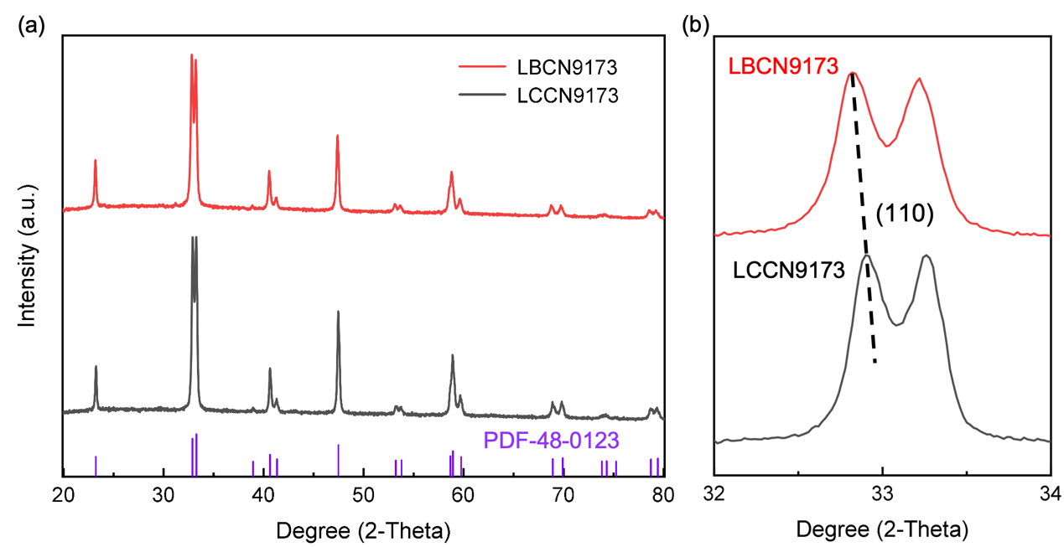
Fig. S1 (a) X-ray diffraction patterns and (b) the enlarged (110) peak for LBCN9173 and LCCN9173 oxides

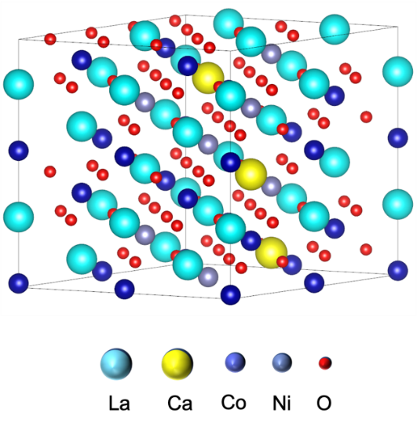
Fig. S2 Phase structure of LCCN9173 oxide
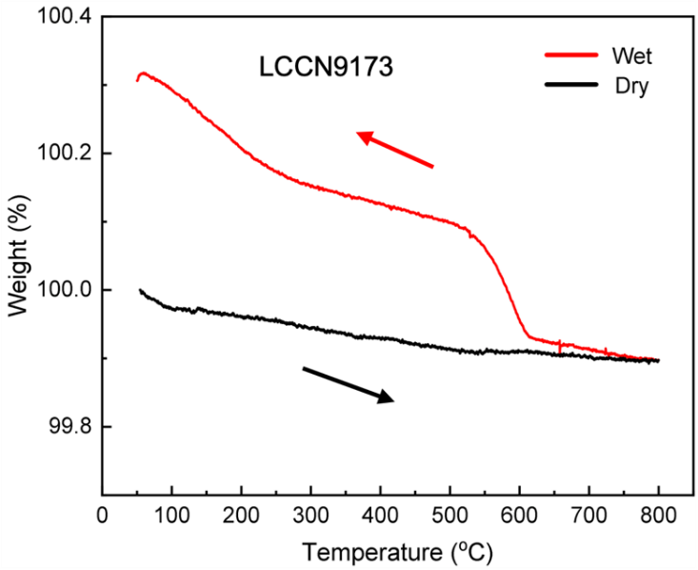
Fig. S3 TG curves of LCCN9173 oxide under dry and wet air (p_{H2O} =0.02 atm) at 50-800 °C
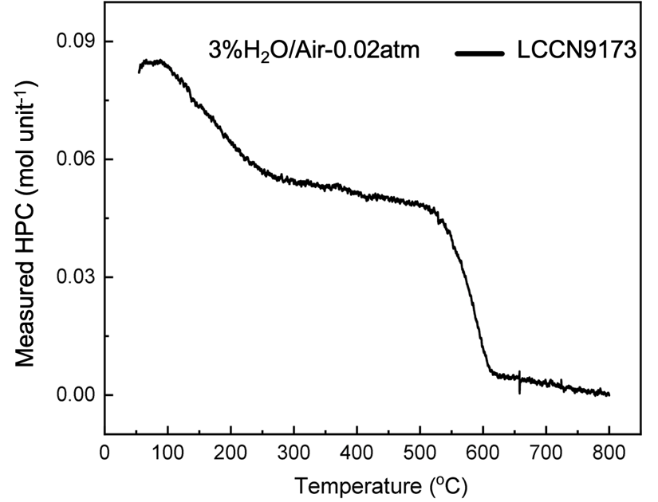
Fig. S4 Measured hydrated proton concentration (HPCs) of LCCN9173 oxide at 50-800 °C
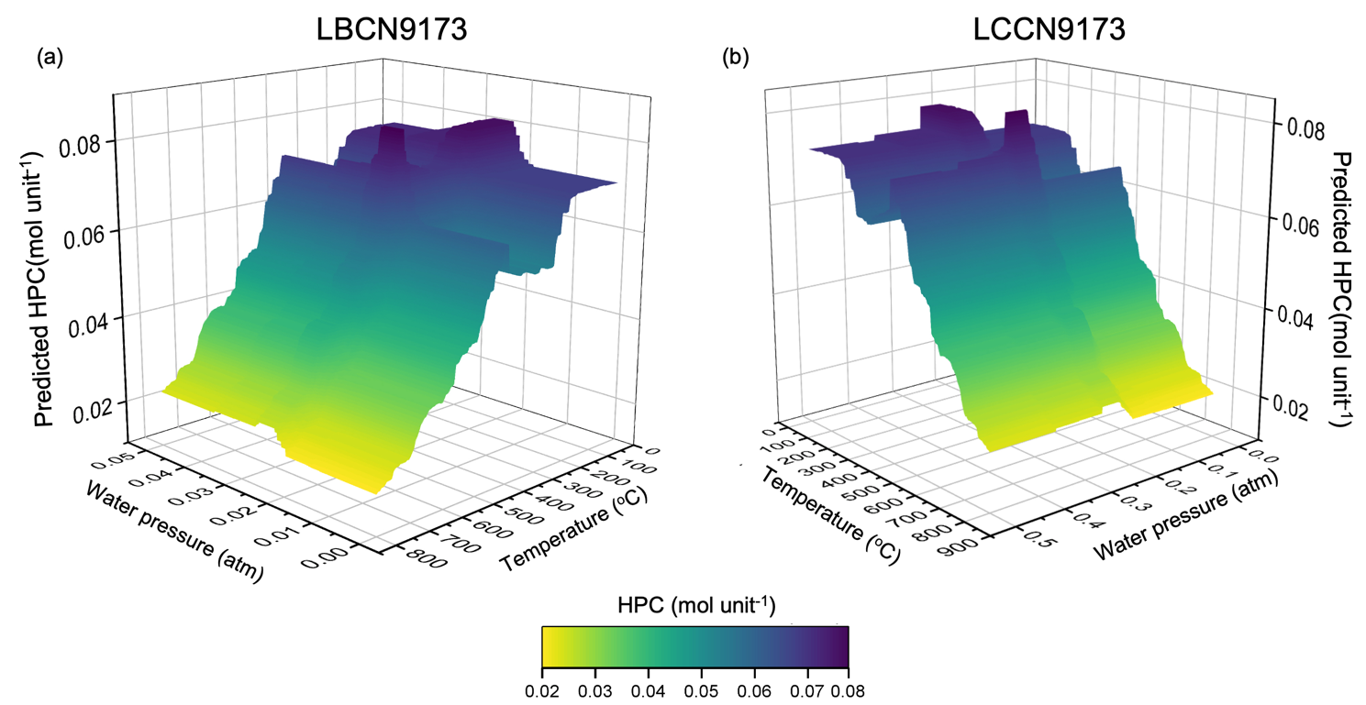
Fig. S5 Predicted HPCs as functions of p_{H2O} (0-0.05 atm) and temperatures (50-800 °C)

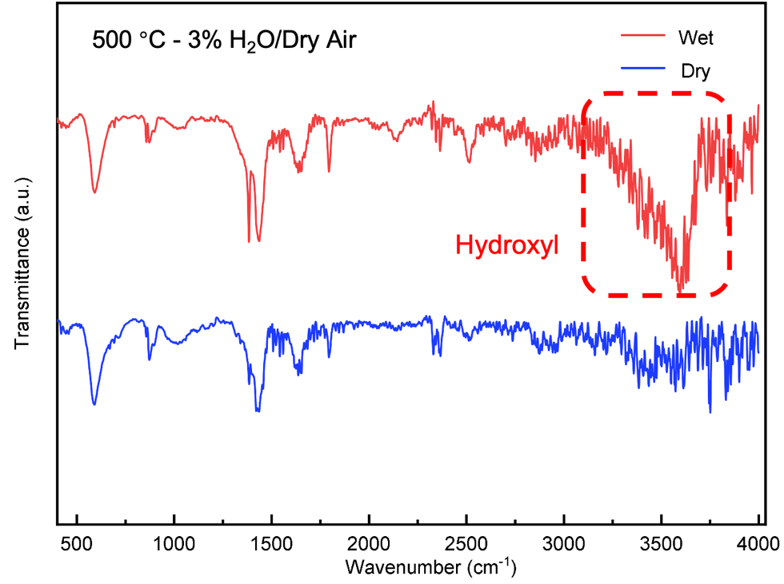
Fig. S6 Fourier Transform Infrared Spectrometer (FT-IR) profiles for hydrated and dehydrated LBCN9173 samples

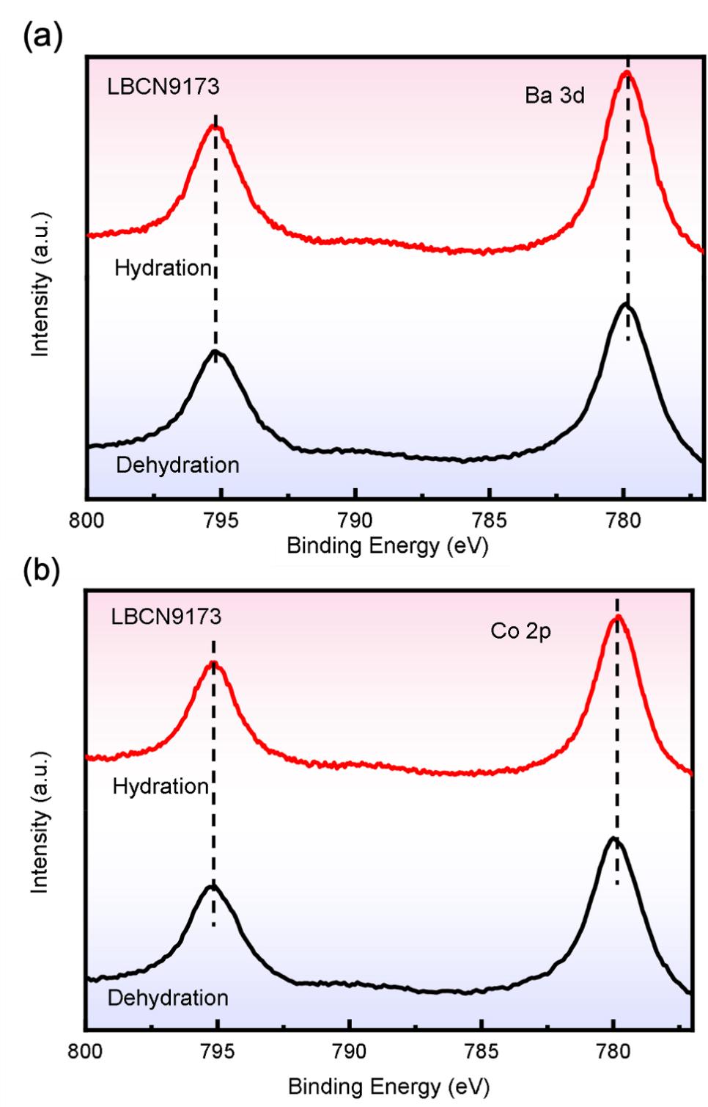
Fig. S7 X-ray Photoelectron Spectroscopy (XPS) spectra of (a) Ba 3d and (b) Co 2p for hydrated and dehydrated LBCN9173 samples
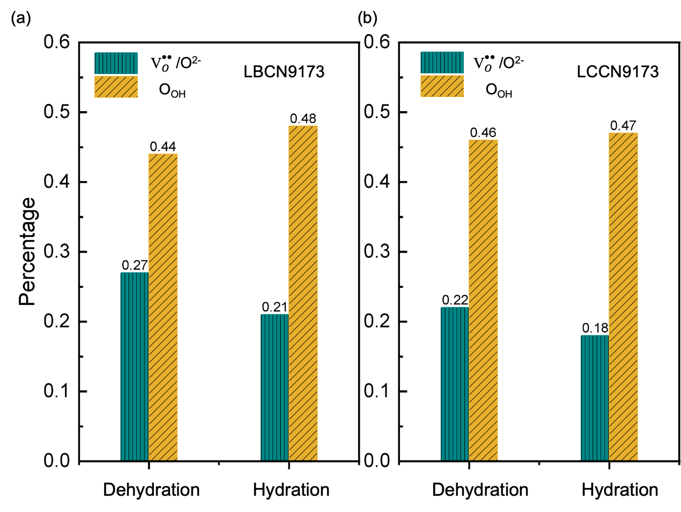
Fig. S8 Percentage of the ${\text{V}}_{\text{O}}^{\text{••}}$/O²⁻ and O_{OH} contents for hydrated and dehydrated (a) LBCN9173 and (b) LCCN9173 oxides

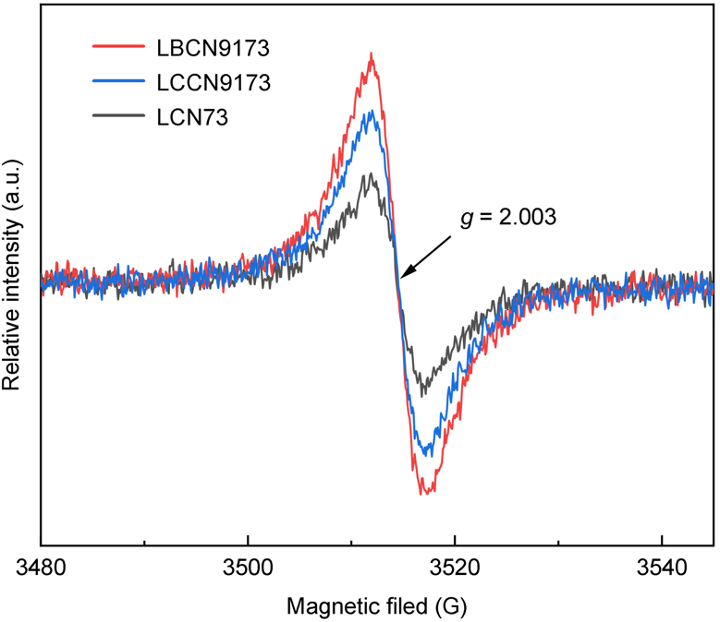
Fig. S9 EPR spectra of LCN73, LBCN9173, and LCCN9173 oxides
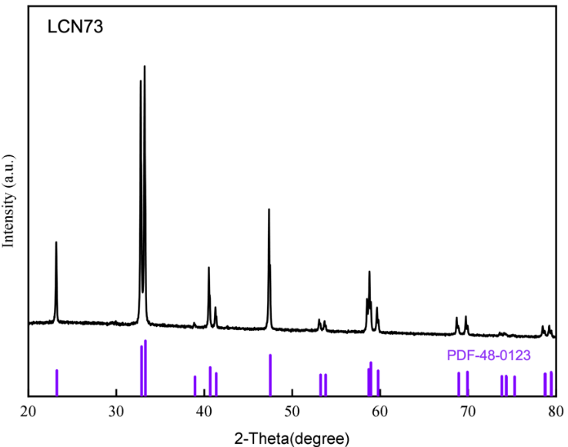
Fig. S10 XRD pattern of LCN73 oxide
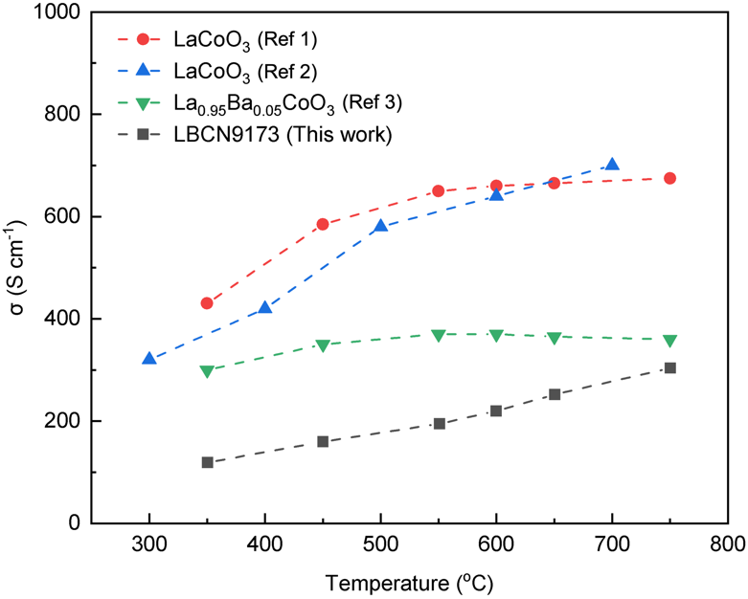
Fig. S11 Electrical conductivity of LBCN9173 and other reported oxides (LaCoO₃ and La_{0.95}Ba_{0.05}CoO₃) [S1-S3]
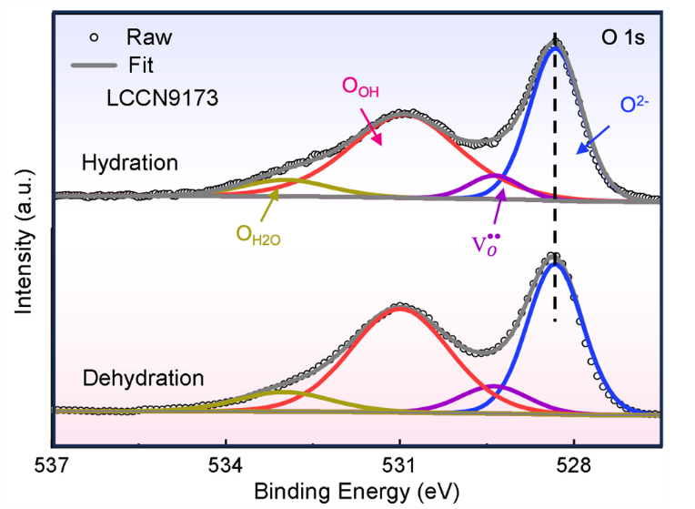
Fig. S12 XPS spectra of O 1s for hydrated and dehydrated LCCN9173 samples
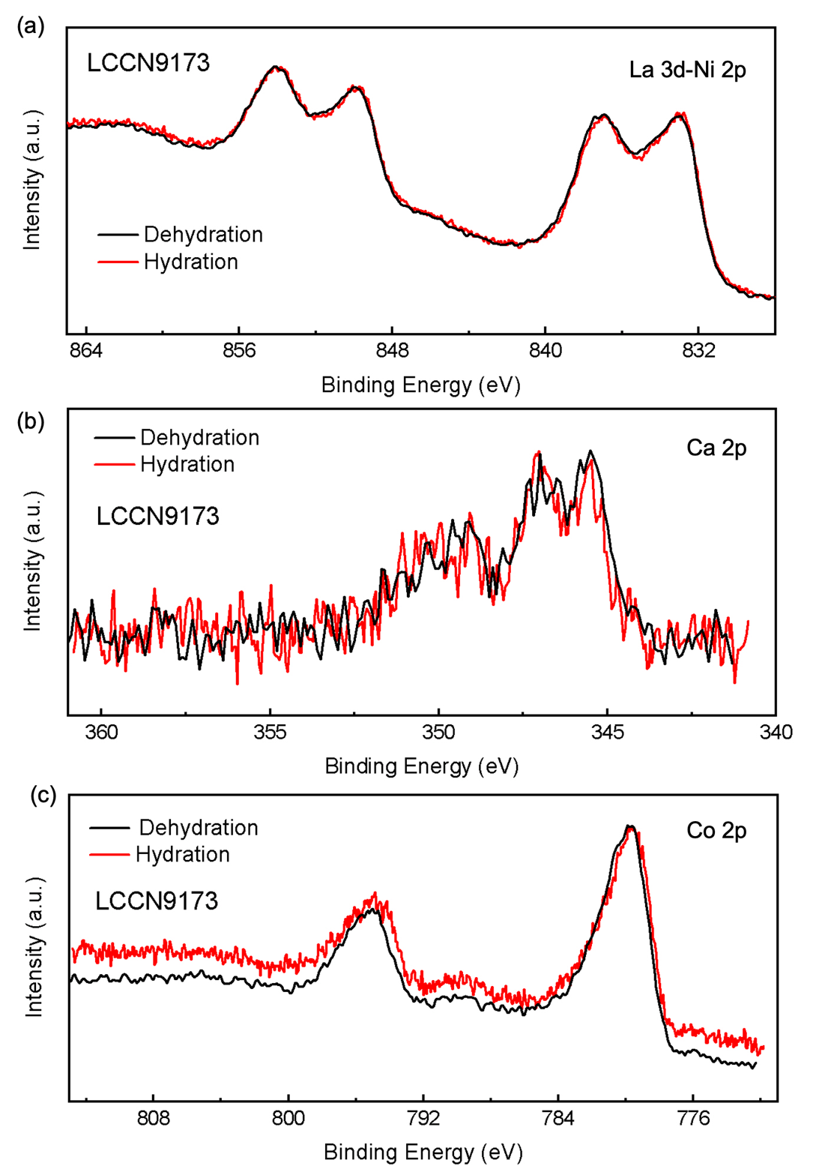
Fig. S13 XPS spectra of (a) La 3d-Ni 2p, (b) Ca 2p, (c) Co 2p for hydrated and dehydrated LCCN9173 samples
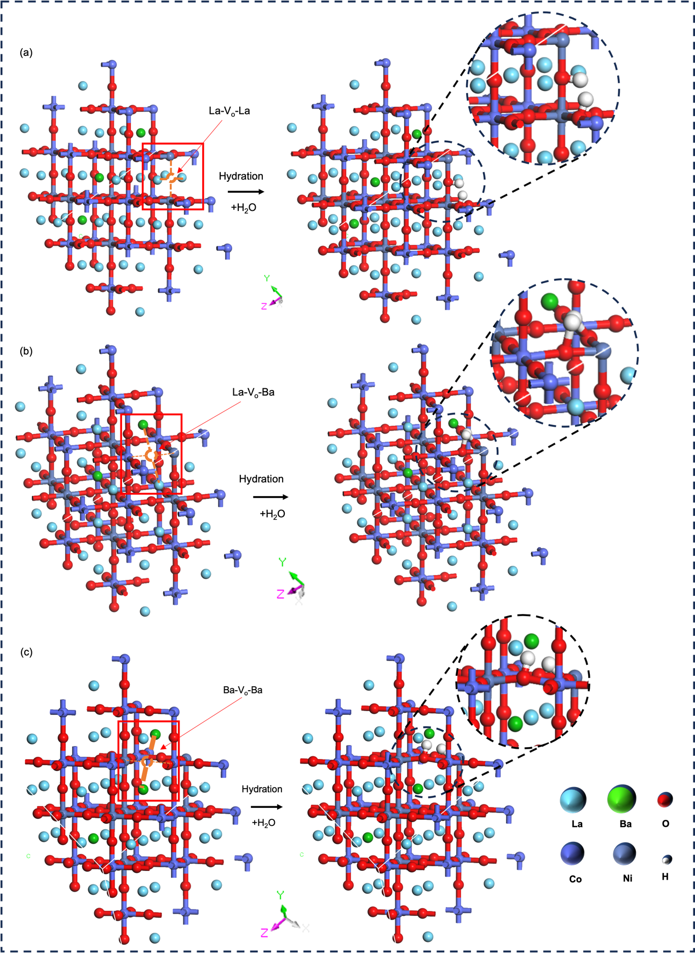
Fig. S14 Illustration of hydration reaction for LBCN9173 oxides with ${\text{V}}_{\text{O}}^{\text{••}}$ located between (a) La-La, (b) La-Ba, (c) Ba-Ba cations
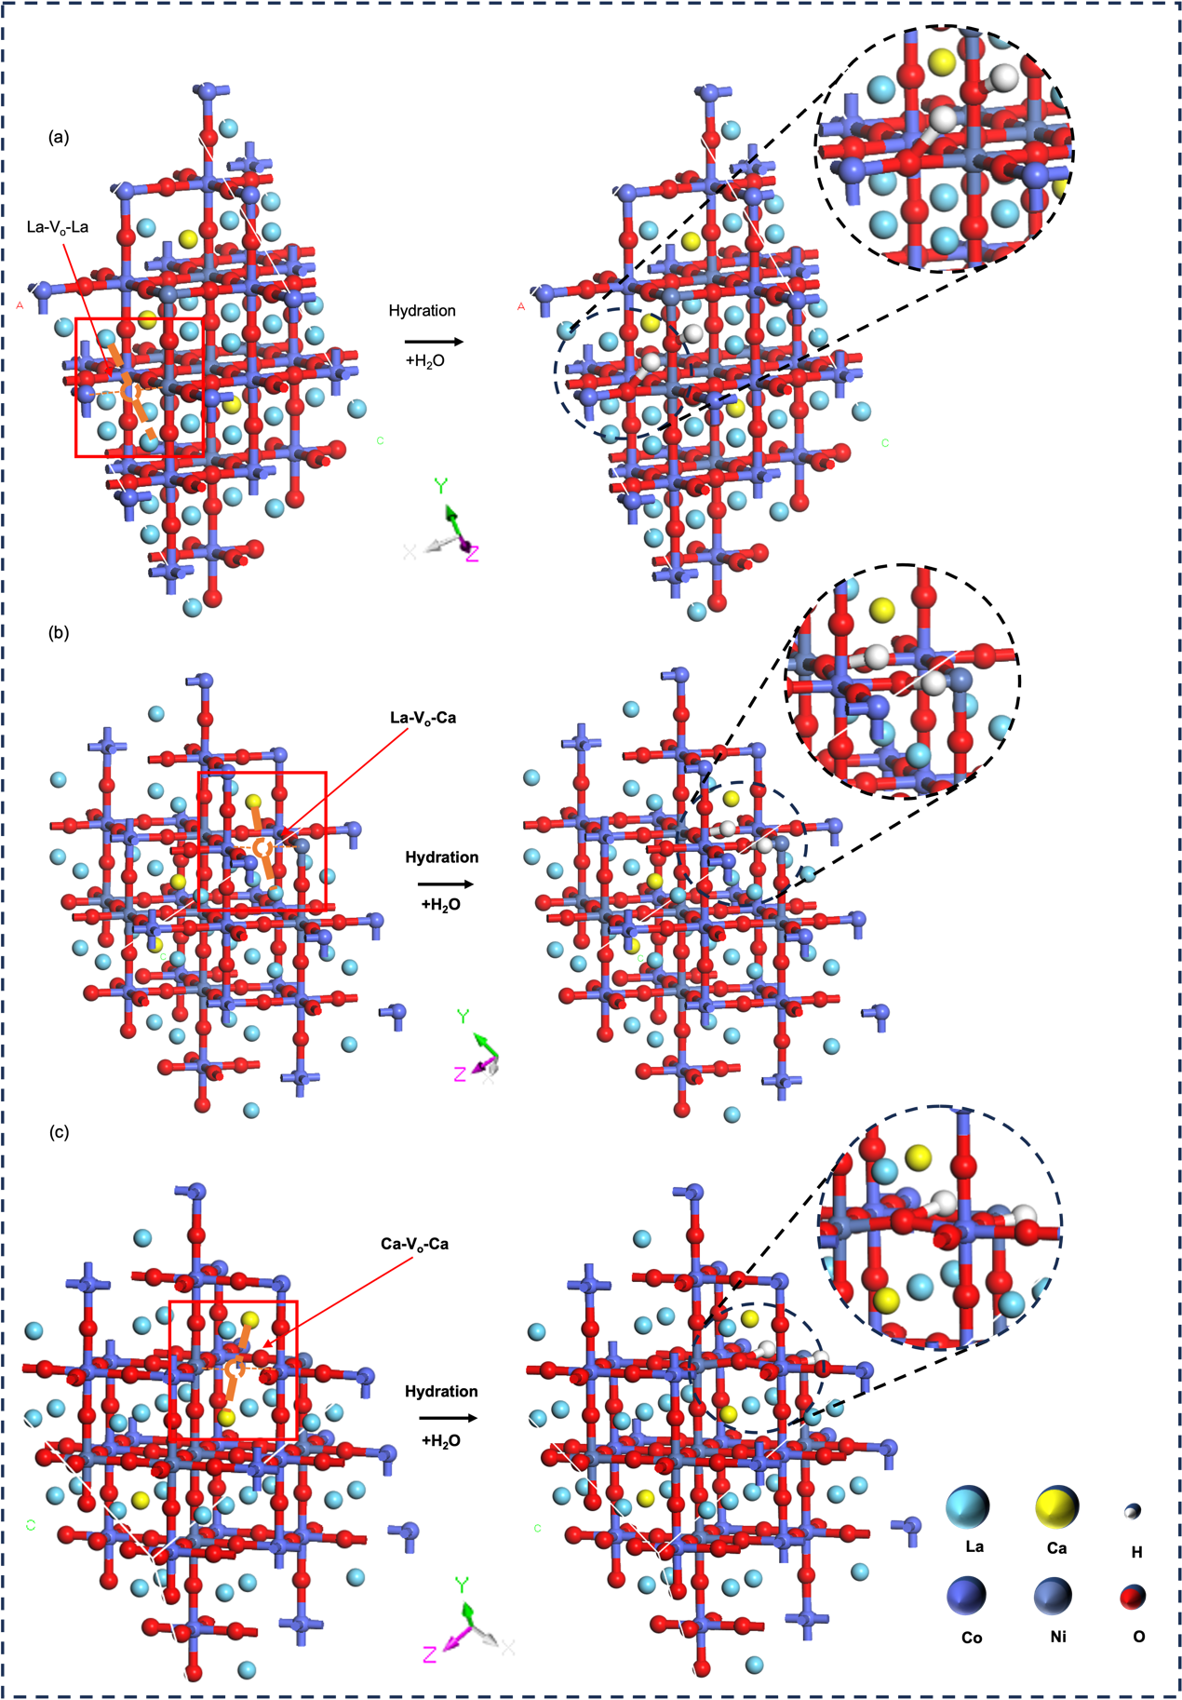
Fig. S15 Illustration of hydration reaction for LCCN9173 with ${\text{V}}_{\text{O}}^{\text{••}}$ located between (a) La-La, (b) La-Ca, (c) Ca-Ca cations
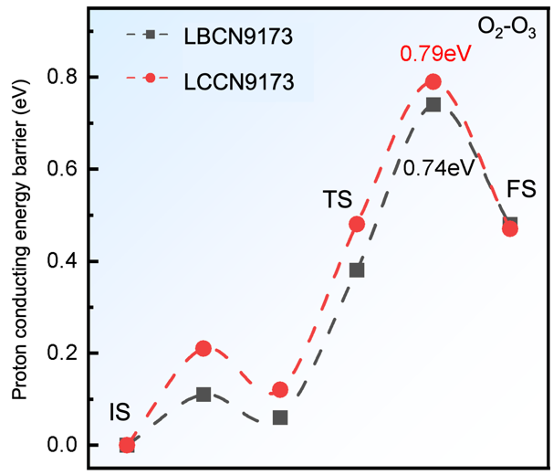
Fig. S16 Proton conducting energy barriers from O2 to O3 site in LBCN9173 and LCCN9173 oxides
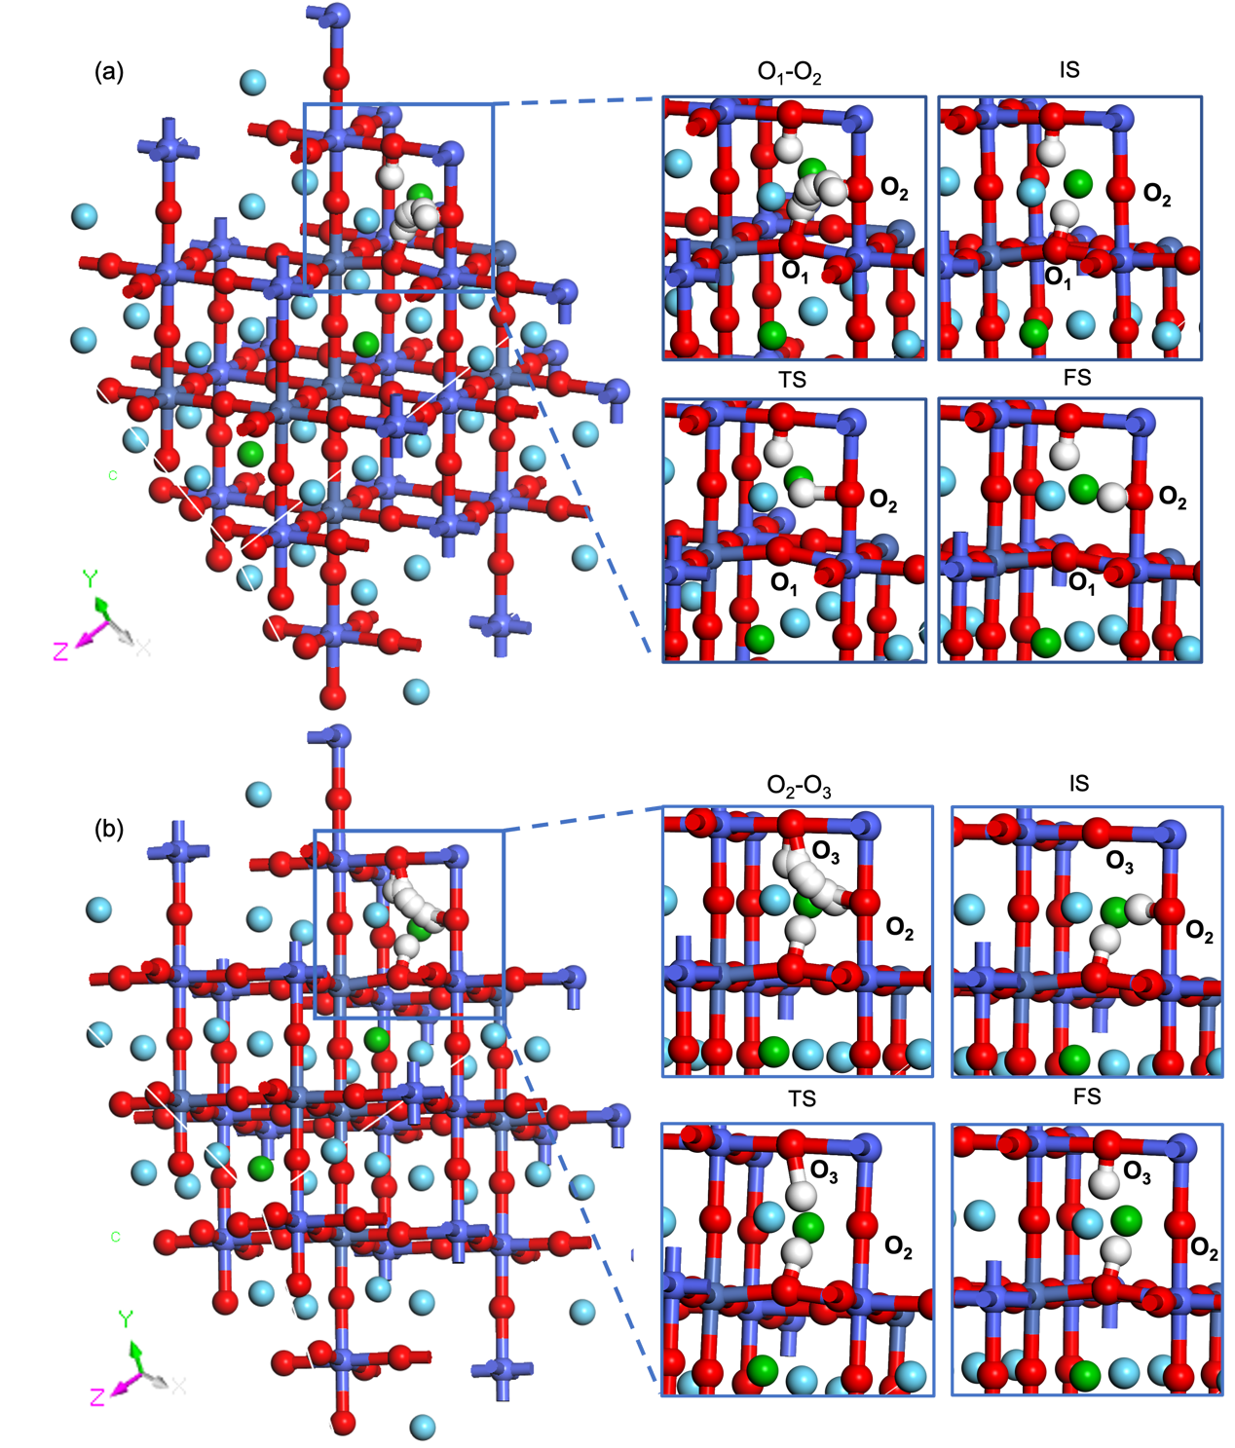
Fig. S17 Proton conducting path for LBCN9173 oxide during proton transferring from (a) O1 to O2 and (b) O2 to O3 site
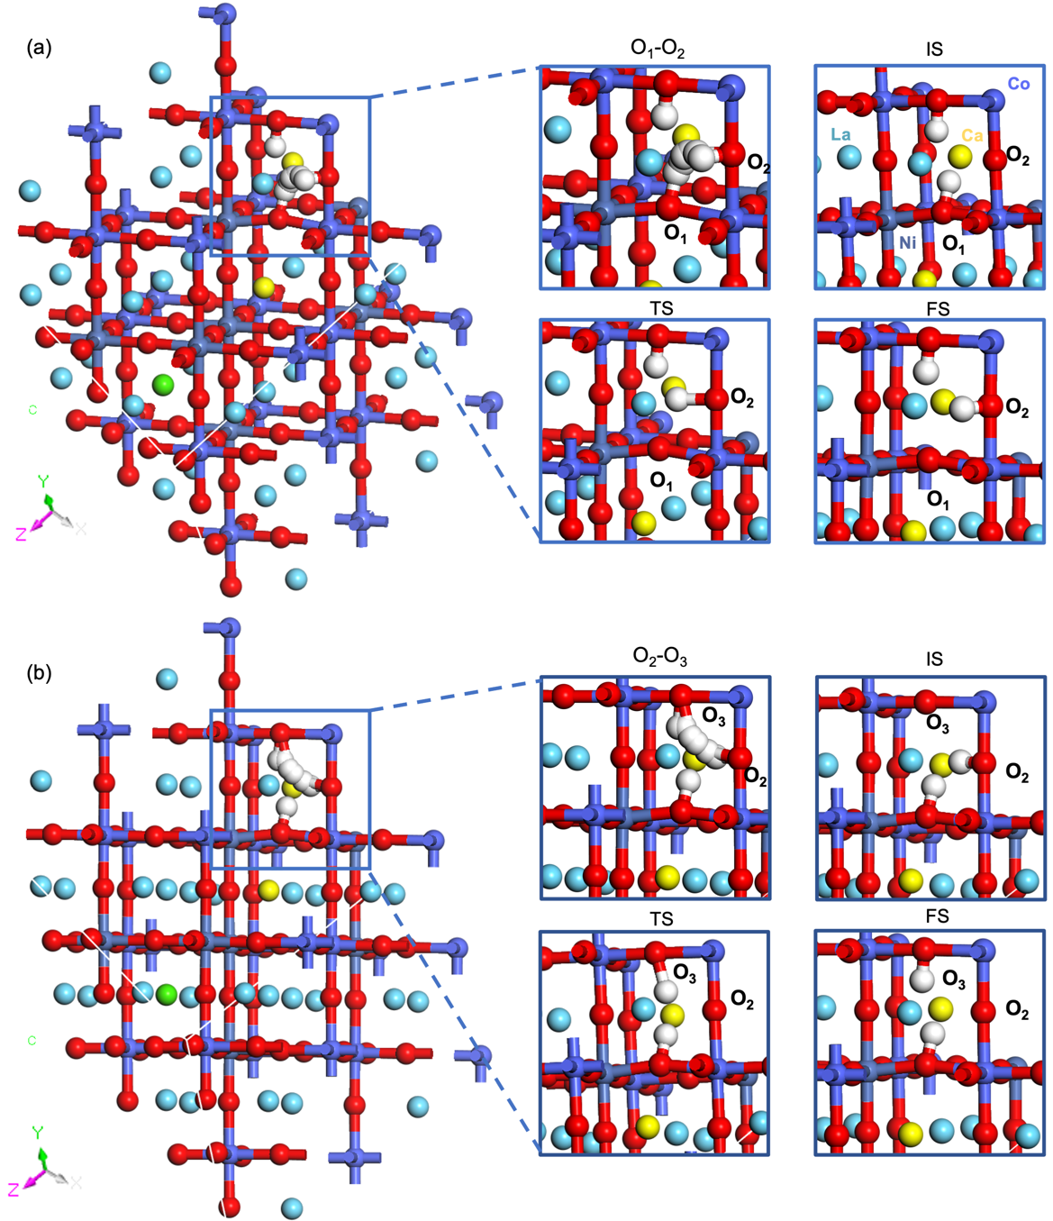
Fig. S18 Proton conducting path for LCCN9173 oxide during proton transferring from (a) O1 to O2 and (b) O2 to O3 site
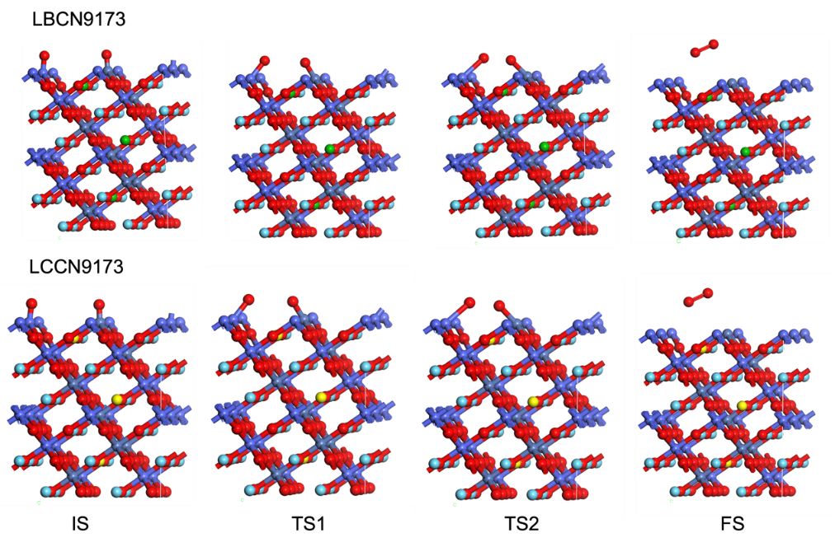
Fig. S19 OER reaction states (initial state (IS), transition state (TS), and final state (FS)) at Co-Ni sites on (001) surface of LBCN9173 and LCCN9173 oxides
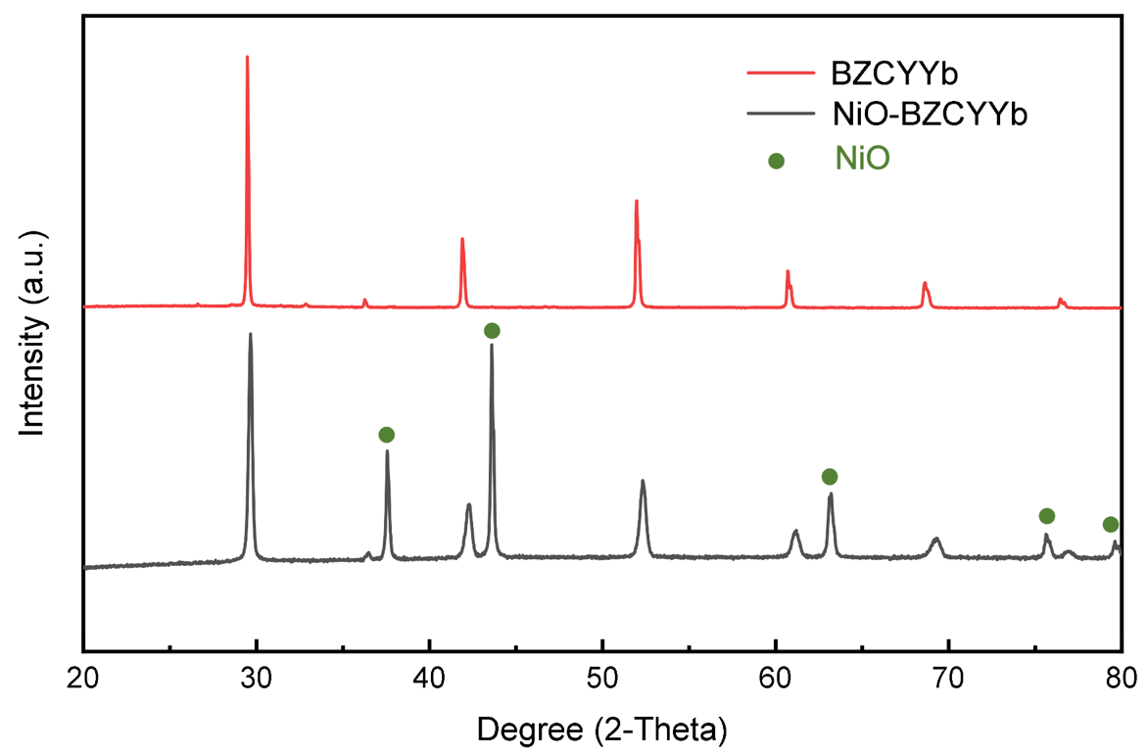
Fig. S20 XRD patterns of a dense BZCYYb4411 electrolyte and NiO-BZCYYb4411 composite cathode

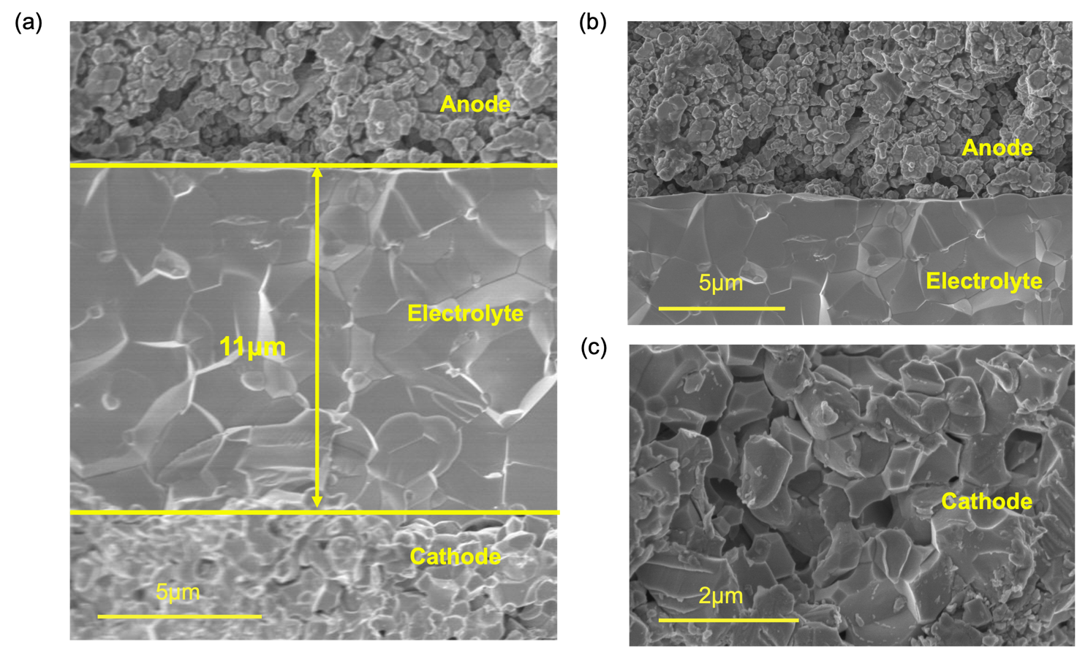
Fig. S21 SEM images of P-SOEC with LBCN9173 anode: (a) cross-section, (b) magnified image near the interface between anode and electrolyte, and (c) cathode
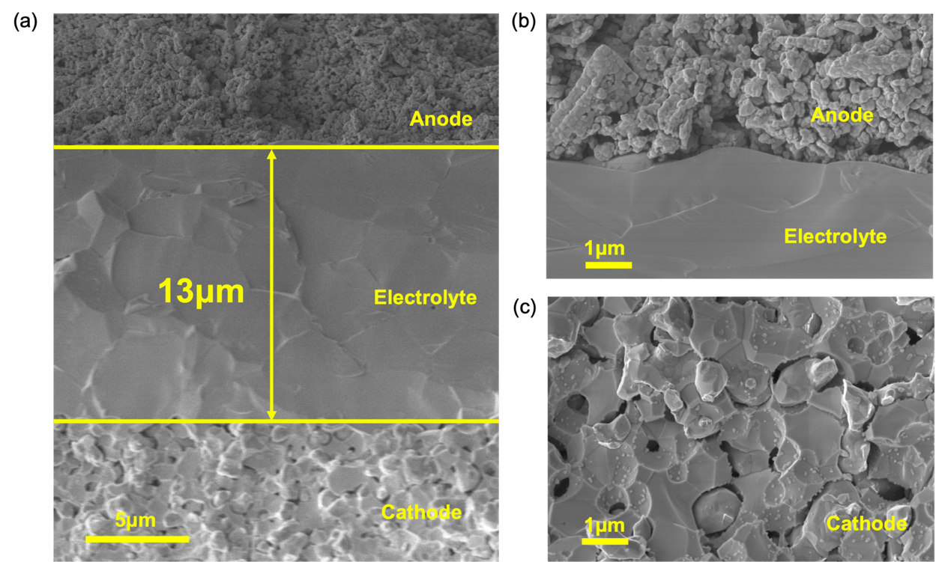
Fig. S22 SEM images of P-SOECs with LCCN9173 as the anode: (a) cross-section, (b) magnified image near the interface between anode and electrolyte, and (c) cathode

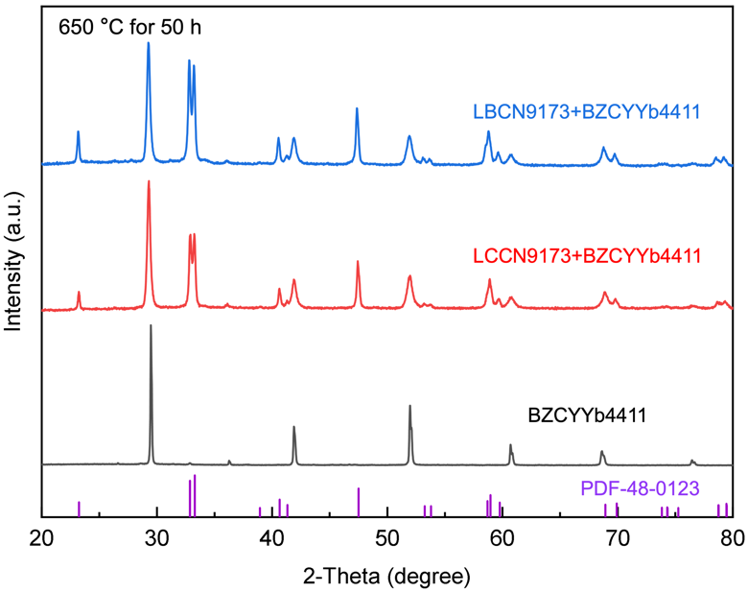
Fig. S23 XRD patterns of LBCN9173/LCCN9173+BZCYYb4411 composite oxides (with a mass ratio 1:1) after exposing to air for 50 h at 650 °C and raw BZCYYb4411 oxide
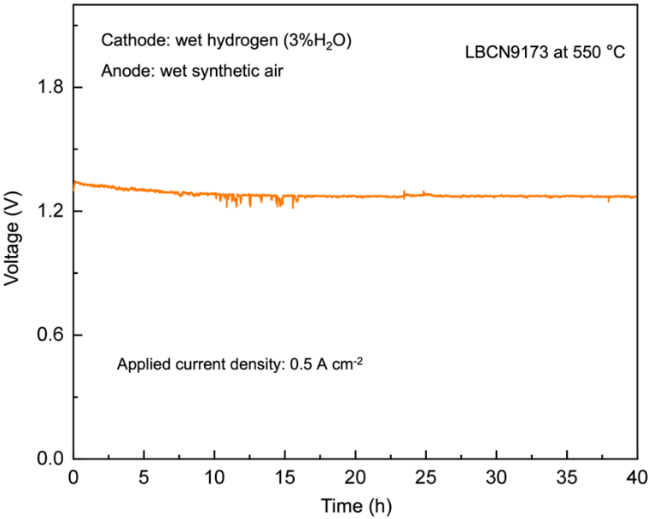
Fig. S24 The stability testing of P-SOEC with LBCN9173 anode under wet synthetic air at a current density of 0.5 A cm⁻² and 550 °C
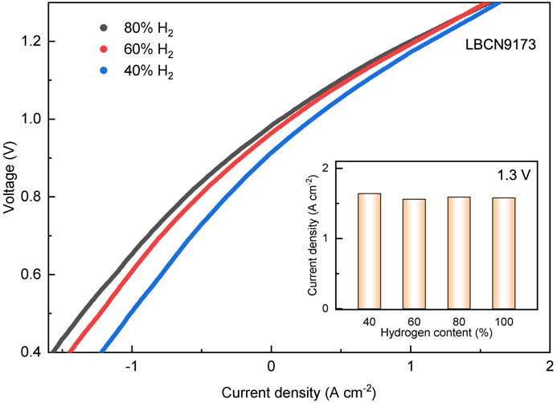
Fig. S25 I-V curves of P-SOEC with LBCN9173 anode under 40%, 60%, and 80% hydrogen content, respectively, at 600 °C
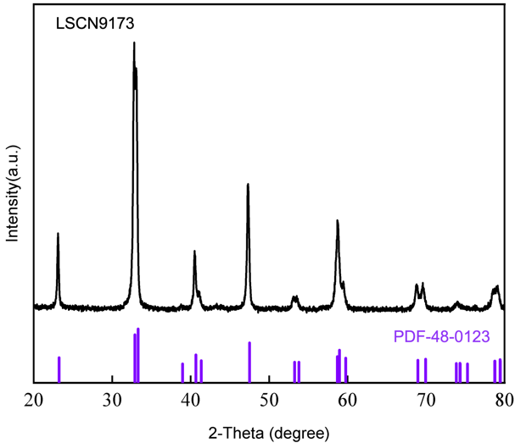
Fig. S26 XRD pattern of LSCN9173 oxide
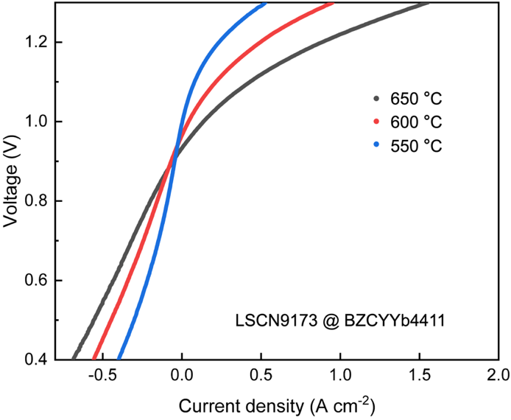
Fig. S27 I-V curves of P-SOEC with LSCN9173 anode at 550-650 °C

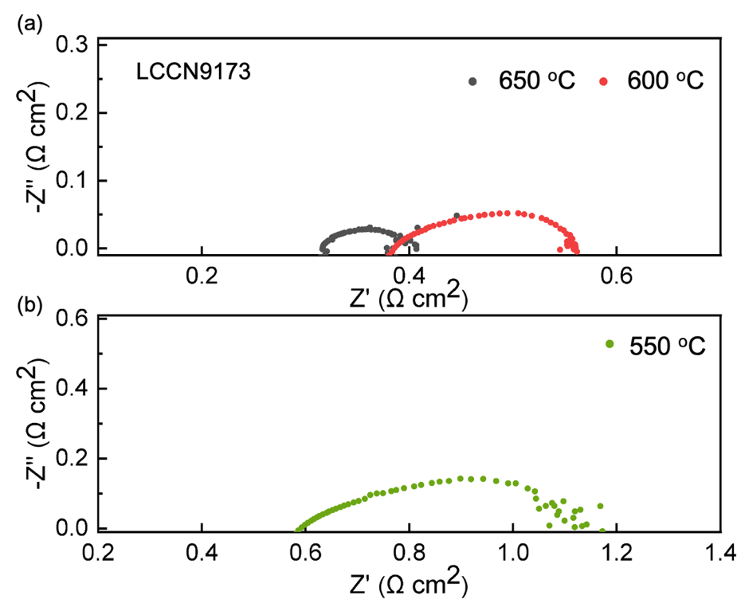
Fig. S28 EIS of P-SOEC with LCCN9173 anode measured at (a) 650 °C, 600 °C and (b) 550 °C

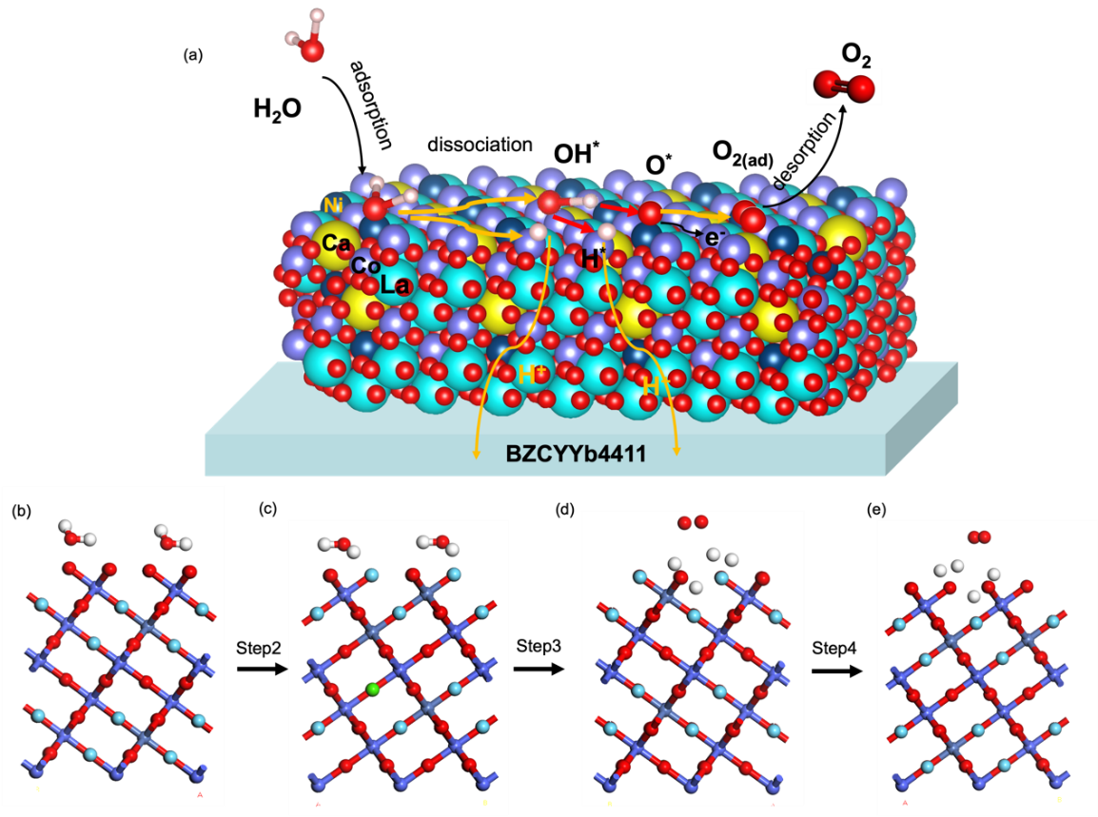
Fig. S29 Schematic WOR reaction mechanism on (001) surface of LCCN9173 oxide
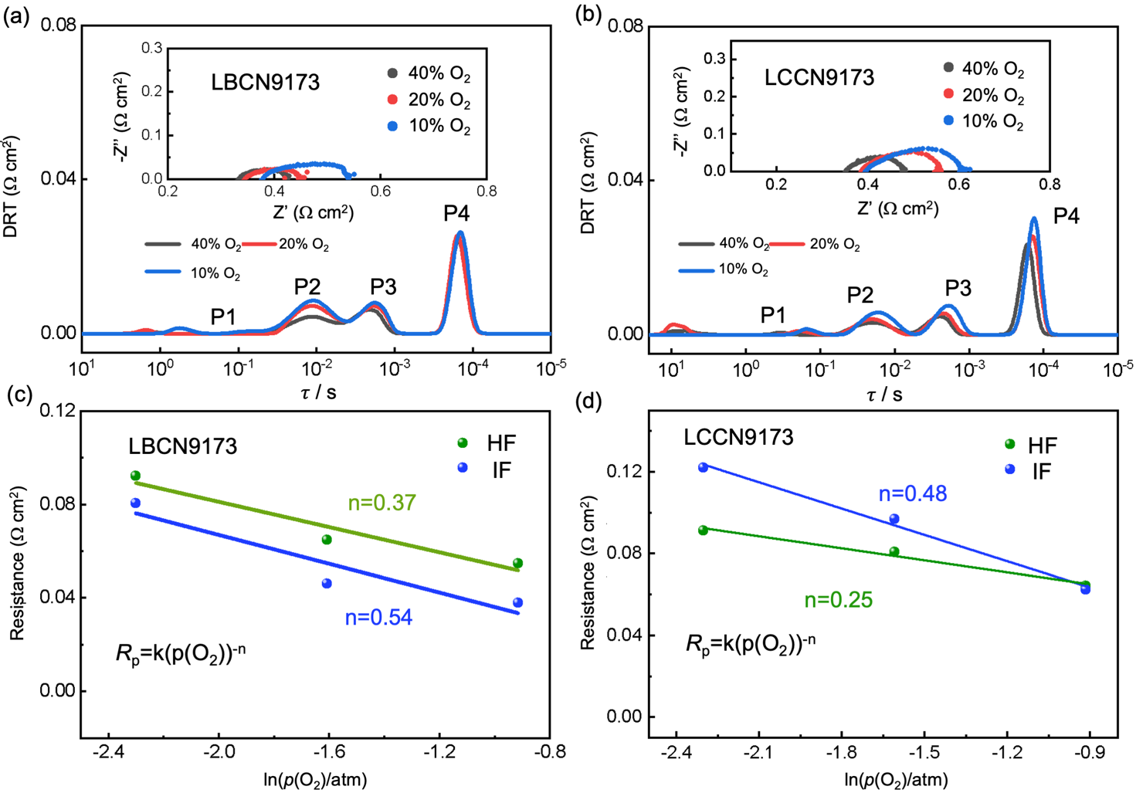
Fig. S30 DRT plots and EIS of (a) LBCN9173 and (b) LCCN9173 cell as a function of p_{O2} (p_{O2}=10%, 20%, 40%) at 600 °C. Plots of R_{HF} and R_{IF} dependences p_{O2} for (c) LBCN9173 and (d) LCCN9173 cell
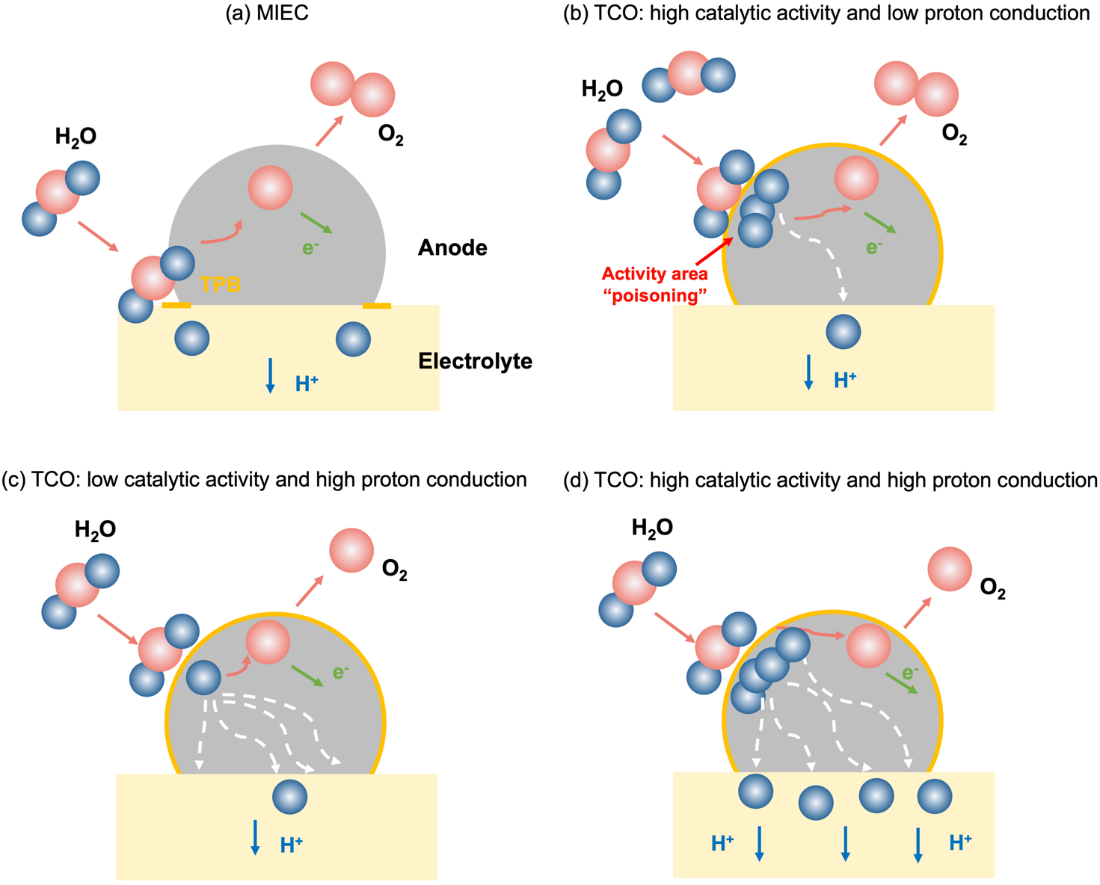
Fig. S31 Schematic diagram of the anodic reaction
Table S1 XRD Refinement results of LBCN9173 and LCCN9173 oxides
Composition | a(Å) | b(Å) | c(Å) | R_{p} (%) | R_{wp} (%) | R_{exp} (%) | Space group
LBCN9173 | 5.4547 | 5.4547 | 13.13578 | 2.76 | 3.66 | 0.85 | $$\text{R}\overline{\text{3}}\text{c}$$
LCCN9173 | 5.4476 | 5.4476 | 13.12905 | 3.87 | 4.88 | 1.01 | $$\text{R}\overline{\text{3}}\text{c}$$
Table S2 XPS of O 1s spectra fitting results for dehydrated and hydrated LBCN9173 and LCCN9173 samples
Samples |  | Dehydrated  LBCN9173 |  | Hydrated  LBCN9173 |  | Dehydrated  LCCN9173 |  | Hydrated  LCCN9173
 |  | Position (eV) | Area percentage (%) | Position (eV) | Area percentage (%) | Position (eV) | Area percentage (%) | Position (eV) | Area percentage (%)
O1s | O²⁻ | 528.70 | 36.33  9.85  44.04  9.78 | 528.38 | 35.87  7.56  47.60  8.96 | 528.33 | 37.47  8.25  46.17  8.11 | 528.33 | 39.82  7.14  47.01  6.02
O1s | $${\text{V}}_{\text{O}}^{\text{••}}$$ | 529.66 | 36.33  9.85  44.04  9.78 | 529.40 | 35.87  7.56  47.60  8.96 | 529.38 | 37.47  8.25  46.17  8.11 | 529.38 | 39.82  7.14  47.01  6.02
O1s | O_{OH} | 531.09 | 36.33  9.85  44.04  9.78 | 530.98 | 35.87  7.56  47.60  8.96 | 530.90 | 37.47  8.25  46.17  8.11 | 530.93 | 39.82  7.14  47.01  6.02
O1s | O_{H2O} | 532.85 | 36.33  9.85  44.04  9.78 | 532.90 | 35.87  7.56  47.60  8.96 | 532.99 | 37.47  8.25  46.17  8.11 | 532.98 | 39.82  7.14  47.01  6.02
Table S3 Energies for dehydrated and hydrated LBCN9173 and LCCN9173 oxides with oxygen vacancy at different sites
LBCN9173 | E_{dehyd} (eV) | E_{perfect}  (eV) | 1/2E_{O2}  (eV) | ΔE_{FE}  (eV) | E_{hyd}  (eV) | E_{H2O}  (eV) | ΔE_{hydration}  (eV)
La-${\text{V}}_{\text{O}}^{\text{••}}$-La | -250.91 | -253.30 | -0.1668 | 2.23 | -266.04 | -13.49 | -1.64
La-${\text{V}}_{\text{O}}^{\text{••}}$-Ba | -251.16 | -253.30 | -0.1568 | 1.99 | -266.72 | -13.49 | -2.06
Ba-${\text{V}}_{\text{O}}^{\text{••}}$-Ba | -251.47 | -253.30 | -0.1568 | 1.67 | -267.27 | -13.49 | -2.30
LCCN9173 | E_{dehyd} (eV) | E_{perfect} (eV) | 1/2E_{O2} (eV) | ΔE_{FE} (eV) | E_{hyd}  (eV) | E_{H2O}  (eV) | ΔE_{hydration}  (eV)
La-${\text{V}}_{\text{O}}^{\text{••}}$-La | -841.49 | -844.30 | -0.168 | 2.64 | -855.05 | -13.49 | -0.06
La-${\text{V}}_{\text{O}}^{\text{••}}$-Ca | -841.62 | -844.30 | -0.168 | 2.52 | -855.33 | -13.49 | -0.22
Ca-${\text{V}}_{\text{O}}^{\text{••}}$-Ca | -842.01 | -844.30 | -0.187 | 2.10 | -856.52 | -13.49 | -1.02
Table S4 Proton conducting energy barrier values at different steps
O1-O2/steps | LBCN9173 | LCCN9173 | O2-O3/steps | LBCN9173 | LCCN9173
1 | 0.14 | 0.19 | 1 | 0.11 | 0.21
2 | 0.02 | 0.12 | 2 | 0.06 | 0.12
3 | 0.22 | 0.35 | 3 | 0.38 | 0.48
4 | 0.43 | 0.57 | 4 | 0.74 | 0.79
5 | 0.18 | 0.43 | 5 | 0.48 | 0.47
Table S5 TEC values of this work, Co-base and Co-free oxides
Anode composition | TEC (10⁻⁶ K⁻¹) | Refs
La_{0.6}Sr_{0.4}Co_{0.2}Fe_{0.8}O_{3-δ} | 21.4 | [S4]
Ba_{0.5}Sr_{0.5}Co_{0.8}Fe_{0.2}O_{3-δ} | 19.7 | [S5]
BaCo_{0.4}Fe_{0.4}Zr_{0.1}Y_{0.1}O_{3-δ} | 20.4 | [S6]
PrNi_{0.5}Co_{0.5}O_{3-δ} | 19.2 | [S7]
La_{0.6}Sr_{0.4}Fe_{0.8}Ni_{0.2}O_{3-δ} | 13.7 | [S8]
Pr_{0.5}Sr_{0.5}Fe_{0.8}Cu_{0.2}O_{3-δ} | 16.4 | [S9]
La_{0.4}Ca_{0.6}Fe_{0.8}Cr_{0.2}O_{3-δ} | 13.2 | [S10]
La_{0.9}Ca_{0.1}Co_{0.7}Ni_{0.3}O_{3-δ} | 15.1 | This work
La_{0.9}Ba_{0.1}Co_{0.7}Ni_{0.3}O_{3-δ} | 15.4 | This work

Table S6 Comparison of current densities at 600 °C and 1.3V for P-SOECs with high-performance anodes
Time | Materials |  | Inlet gas composition |  | I  (A cm^{–2})
Time | Anode | Electrolyte | Anode | Fuel electrode | I  (A cm^{–2})
2020[S11] | PNC55 (3D) | BZCYYb4411 | Air (10% H₂O) | 10% H₂/Ar | 1.17
2020[S12] | PBCC95 | BZCYYb4411 | Air (20% H₂O) | 100% H₂(3% H₂O) | 0.72
2021[S13] | SCFN | BZCYYb1711 | Air | 100% H₂ | 0.36
2022[S14] | BCFZYM | BZCYYb1711 | Air (10% H₂O) | 100% H₂(3% H₂O) | 1.24
2022[S15] | BSCFP | BZCYYb1711 | Air (10% H₂O) | 100% H₂ | 1
2022[S16] | PBCFN | BZCYYb1711 | Air (3% H₂O) | 100% H₂(3% H₂O) | 1.04
2022[S17] | LCCN7382 | BZCYYb4411 | Air (3% H₂O) | 100% H₂(3% H₂O) | 0.88
2023[S18] | LCN91 | BZCYYb4411 | Air (3% H₂O) | 100% H₂(3% H₂O) | 0.84
2023[S19] | BCFNbS | BZCYYb1711 | Air (3% H₂O) | 100% H₂(3% H₂O) | 0.91
2023[S20] | BSCFE | BZCYYb1711 | Air (5% H₂O) | 100% H₂(3% H₂O) | 0.98
2023[S21] | BCFZYN | BZCYYb1711 | Air (5% H₂O) | 100% H₂(3% H₂O) | 1.2
2024[S22] | SFN | BZCYYb1711 | Air (3% H₂O) | 100% H₂ | 0.8
2024[S23] | PSCN | BZCYYb1711 | Air | 100% H₂(3% H₂O) | 1.25
2024[S24] | BCFZYNF | BZCYYb1711 | Air (3% H₂O) | 100% H₂ | 1.1
2025[S25] | BSCsCFZr | BZCYYb1711 | Air (3% H₂O) | 97% H₂(3% H₂O) | 1.23
2025[S26] | LCCFN‐Cr | BZCYYb6211 | Air (3% H₂O) | 97% H₂(3% H₂O) | 1.18
2025[S27] | BLFZN0.1 | BZCYYb1711 | Air (3% H₂O) | 97% H₂(3% H₂O) | 0.67
This work | LSCN9173 | BZCYYb4411 | Air (3% H₂O) | 97% H₂(3% H₂O) | 0.95
This work | LCCN9173 | BZCYYb4411 | Air (3% H₂O) | 97% H₂(3% H₂O) | 1.01
This work | LBCN9173 | BZCYYb4411 | Air (3% H₂O) | 97% H₂(3% H₂O) | 1.58
PNC=PrNi_{0.5}Co_{0.5}O_{3-δ} [S11], PBCC95=(PrBa_{0.8}Ca_{0.2})_{0.95}Co₂O_{6−δ} [S12], SCFN= Sr_{0.9}Ce_{0.1}Fe_{0.8}Ni_{0.2}O_{3-δ} [S13], BCFZYM=Ba(Co_{0.4}Fe_{0.4}Zr_{0.1}Y_{0.1})_{0.95}Mg_{0.05}O_{3-δ} [S11], BSCFP= Ba_{0.5}Sr_{0.5}(Co_{0.8}Fe_{0.2})_{0.95}P_{0.05}O_{3-δ} [S15], PBCFN=PrBaCo_{1.6}Fe_{0.2}Nb_{0.2}O_{5+δ} [S16], LCCN7382=La_{0.7}Ca_{0.3}Co_{0.8}Ni_{0.2}O_{3-δ}[S17], LCN91= LaCo_{0.9}Ni_{0.1}O_{3-δ} [S18], BCFNS= BaCo_{0.4}Fe_{0.4}Nb_{0.1}Sc_{0.1}O_{3-δ} [S19], BSCFE= Ba_{0.5}Sr_{0.5}(Co_{0.8}Fe_{0.2})_{0.9}Er_{0.1}O_{3-δ} [S20], BCFZYN= Ba_{0.95}(Co_{0.4}Fe_{0.4}Zr_{0.1}Y_{0.1})_{0.95}Ni_{0.05}O_{3-δ} [S21], SFN= Sr_{2.8}Fe_{1.8}Nb_{0.2}O_{7-δ} [S22], PSCN= PrSrCo_{1.8}Nb_{0.2}O_{6-δ} [S23], BCFZYNF= Ba(Co_{0.4}Fe_{0.4}Zr_{0.1}Y_{0.1})_{0.95}Ni_{0.05}F_{0.1}O_{2.9-δ} [S24], BSCsCFZr= Ba_{0.4}Sr_{0.5}Cs_{0.1}Co_{0.7}Fe_{0.2}Zr_{0.1}O_{3−δ} [S25], BLFZN0.1= Ba_{0.95}La_{0.05}(Fe_{0.8}Zn_{0.2})_{0.9}Ni_{0.1}O_{3-δ} [S27], LCCFN‐Cr= La(Co_{0.2}Cu_{0.2}Fe_{0.2}Ni_{0.2}Cr_{0.2})O_{3-δ} [S26], BZCYYb1711= BaZr_{0.1}Ce_{0.7}Y_{0.1}Yb_{0.1}O_{3-δ}.

Table S7 R_{HF,} R_{IF}, R_{LF} values and ratios for LBCN9173 and LCCN9173 at 550 and 600 °C
Reaction steps | R (Peaks) | Reaction equations | Resistance from DRT peak (Ω cm²)
Reaction steps | R (Peaks) | Reaction equations | 550 °C |  | 600 °C | 550 °C | 600 °C
step1: | R_{IF}  (P2-P3) | $${\text{2H}}_{\text{2}}\text{O }\text{⟶} {{\text{2H}}_{\text{2}}\text{O}}^{\text{*}}$$  (H₂O adsorption) | LCCN9173 |  |  | LBCN9173
step2: | R_{IF}  (P2-P3) | $${{\text{2H}}_{\text{2}}\text{O}}^{\text{*}} \text{⟶} {\text{2OH}}^{\text{*}}\text{+2}{\text{H}}^{\text{*}}$$  (H₂O* dissociation) | 0.364 | 0.094 |  | 0.213 | 0.039
step3: | R_{IF}  (P2-P3) | $${\text{2OH}}^{\text{*}}\text{⟶}\text{ 2}{\text{O}}^{\text{*}}\text{+}{\text{2H}}^{\text{*}}$$  (OH* dissociation)
step4: | R_{IF}  (P2-P3) | $${\text{2O}}^{\text{*}}\text{- 4}{\text{e}}^{\text{-}}\text{⟶}{{\text{ O}}_{\text{2}}}^{\text{*}}$$  (O₂ formation)
step5: | R_{LF}  (P1) | $${{\text{O}}_{\text{2}}}^{\text{*}} \text{⟶} {\text{O}}_{\text{2}}$$  (O₂ desorption) | 0.028 | 0.003 |  | 0.022 | 0.007
step6: | R_{HF}  (P4) | $${\text{OH}}_{\text{O anode}}^{\text{•}}\text{⟶} {\text{OH}}_{\text{O electrolyte}}^{\text{•}}$$  (Charge transfer) | 0.148 | 0.078 |  | 0.158 | 0.055

Supplementary References
- W. Zhou, Z. Shao, R. Ran, P. Zeng, H. Gu et al., Ba_{0.5}Sr_{0.5}Co_{0.8}Fe_{0.2}O_{3−δ}+LaCoO₃ composite cathode for Sm_{0.2}Ce_{0.8}O_{1.9}-electrolyte based intermediate-temperature solid-oxide fuel cells. J. Power Sources 168, 330-337 (2007). https://doi.org/10.1016/j.jpowsour.2007.03.041
- A.N. Petrov, O.F. Kononchuk, A.V. Andreev, V.A. Cherepanov, P. Kofstad, Crystal structure, electrical and magnetic properties of La_{1-x}Sr_{x}CoO_{3-y}. Solid State Ionics 80, 189-199 (1995). https://doi.org/10.1016/0167-2738(95)00114-L
- R. Kun, S. Populoh, L. Karvonen, J. Gumbert, A. Weidenkaff et al., Structural and thermoelectric characterization of Ba substituted LaCoO₃ perovskite-type materials obtained by polymerized gel combustion method. J. Alloys Compd. 579, 147-155 (2013). https://doi.org/10.1016/j.jallcom.2013.05.019
- G.C. Kostogloudis, C. Ftikos, Properties of A-site-deficient La_{0.6}Sr_{0.4}Co_{0.2}Fe_{0.8}O_{3−δ}-based perovskite oxides. Solid State Ionics 126, 143-151 (1999). https://doi.org/10.1016/S0167-2738(99)00230-1
- S. Li, Z. Lü, B. Wei, X. Huang, J. Miao et al., A study of (Ba_{0.5}Sr_{0.5})_{1−x}Sm_{x}Co_{0.8}Fe_{0.2}O_{3−δ} as a cathode material for IT-SOFCs. J. Alloys Compd. 426, 408-414 (2006). https://doi.org/10.1016/j.jallcom.2006.02.040
- M. Liang, F. He, C. Zhou, Y. Chen, R. Ran et al., Nickel-doped BaCo_{0.4}Fe_{0.4}Zr_{0.1}Y_{0.1}O_{3-δ} as a new high-performance cathode for both oxygen-ion and proton conducting fuel cells. Chem. Eng. J. 420, 127717 (2021). https://doi.org/10.1016/j.cej.2020.127717
- Z.Y. Zhu, M.Y. Zhou, K. Tan, Z.D. Fan, D. Cao et al., High performance and stability enabled by tuning the component thermal expansion coefficients of a proton-conducting solid oxide cell operating at high steam concentration. ACS Appl. Mater. Interfaces 15, 14457-14469 (2023). https://doi.org/10.1021/acsami.3c00728
- S.P. Simner, J.F. Bonnett, N.L. Canfield, K.D. Meinhardt, V.L. Sprenkle et al., Optimized lanthanum ferrite-based cathodes for anode-supported SOFCs. Electrochem. Solid St 5, A173-A175 (2002). https://doi.org/10.1149/1.1483156
- S. Pang, W. Wang, T. Chen, X. Shen, Y. Wang et al., Systematic evaluation of cobalt-free Ln_{0.5}Sr_{0.5}Fe_{0.8}Cu_{0.2}O_{3−δ} (Ln = La, Pr, and Nd) as cathode materials for intermediate-temperature solid oxide fuel cells. J. Power Sources 326, 176-181 (2016). https://doi.org/10.1016/j.jpowsour.2016.06.134
- J. Xiao, Q. Xu, M. Chen, K. Zhao, B.H. Kim, Improved overall properties in La_{1-x}Ca_{x}Fe_{0.8}Cr_{0.2}O_{3-δ} as cathode for intermediate temperature solid oxide fuel cells. Ionics 21, 2805-2814 (2015). https://doi.org/10.1007/s11581-015-1468-1
- H. Ding, W. Wu, C. Jiang, Y. Ding, W. Bian et al., Self-sustainable protonic ceramic electrochemical cells using a triple conducting electrode for hydrogen and power production. Nat. Commun. 11, 1907 (2020). https://doi.org/10.1038/s41467-020-15677-z
- W. Tang, H. Ding, W. Bian, W. Wu, W. Li et al., Understanding of A-site deficiency in layered perovskites: promotion of dual reaction kinetics for water oxidation and oxygen reduction in protonic ceramic electrochemical cells. J. Mater. Chem. A 8, 14600-14608 (2020). https://doi.org/10.1039/d0ta05137c
- Y. Song, J. Liu, Y. Wang, D. Guan, A. Seong et al., Nanocomposites: a new opportunity for developing highly active and durable bifunctional air electrodes for reversible protonic ceramic cells. Adv. Energy Mater. 11, 2101899 (2021). https://doi.org/10.1002/aenm.202101899
- M. Liang, Y. Song, D. Liu, L. Xu, M. Xu et al., Magnesium tuned triple conductivity and bifunctionality of BaCo_{0.4}Fe_{0.4}Zr_{0.1}Y_{0.1}O_{3-δ} perovskite towards reversible protonic ceramic electrochemical cells. Appl. Catal. B Environ. 318, 121868 (2022). https://doi.org/10.1016/j.apcatb.2022.121868
- Z. Liu, D. Cheng, Y. Zhu, M. Liang, M. Yang et al., Robust bifunctional phosphorus-doped perovskite oxygen electrode for reversible proton ceramic electrochemical cells. Chem. Eng. J. 450, 137787 (2022). https://doi.org/10.1016/j.cej.2022.137787
- K. Xu, H. Zhang, Y. Xu, F. He, Y. Zhou et al., An efficient steam‐induced heterostructured air electrode for protonic ceramic electrochemical cells. Adv. Funct. Mater. 32, 2110998 (2022). https://doi.org/10.1002/adfm.202110998
- N. Wang, B. Yuan, C. Tang, L. Du, R. Zhu et al., Machine‐learning‐accelerated development of efficient mixed protonic–electronic conducting oxides as the air electrodes for protonic ceramic cells. Adv. Mater. 34, 2203446 (2022). https://doi.org/10.1002/adma.202203446
- N. Wang, B. Yuan, F. Zheng, S. Mo, X. Zhang et al., Machine‐learning assisted screening proton conducting Co/Fe based oxide for the air electrode of protonic solid oxide cell. Adv. Funct. Mater. 34, 2309855 (2023). https://doi.org/10.1002/adfm.202309855
- C. Lu, R. Ren, Z. Zhu, G. Pan, G. Wang et al., BaCo_{0.4}Fe_{0.4}Nb_{0.1}Sc_{0.1}O_{3-δ} perovskite oxide with super hydration capacity for a high-activity proton ceramic electrolytic cell oxygen electrode. Chem. Eng. J. 472, 144878 (2023). https://doi.org/10.1016/j.cej.2023.144878
- Z. Liu, Y. Lin, H. Nie, D. Liu, Y. Li et al., Highly active nanocomposite air electrode with fast proton diffusion channels via Er doping‐induced phase separation for reversible proton ceramic electrochemical cells. Adv. Funct. Mater. 34, 2311140 (2024). https://doi.org/10.1002/adfm.202311140
- M. Liang, Y. Wang, Y. Song, D. Guan, J. Wu et al., High-temperature water oxidation activity of a perovskite-based nanocomposite towards application as air electrode in reversible protonic ceramic cells. Appl. Catal. B Environ. 331, 122682 (2023). https://doi.org/10.1016/j.apcatb.2023.122682
- N. Yu, I.T. Bello, X. Chen, T. Liu, Z. Li et al., Rational design of ruddlesden–popper perovskite ferrites as air electrode for highly active and durable reversible protonic ceramic cells. Nano-Micro Lett. 16, 177 (2024). https://doi.org/10.1007/s40820-024-01397-2
- L.Z. Kang Zhu, N. Shi, B. Qiu, X. Hu, D. Huan et al., A superior catalytic air electrode with temperature-induced exsolution toward protonic ceramic cells. ACS Nano 18, 5141-5151 (2024). https://doi.org/10.1021/acsnano.3c12609
- X. Chen, N. Yu, Y. Song, T. Liu, H. Xu et al., Synergistic bulk and surface engineering for expeditious and durable reversible protonic ceramic electrochemical cells air electrode. Adv. Mater. 36, 2403998 (2024). https://doi.org/10.1002/adma.202403998
- Y. Zhang, Y. Wang, Z. Liu, Z. Wang, Y. Wang et al., Constructing robust and efficient ceramic cells air electrodes through collaborative optimization bulk and surface phases. Adv. Funct. Mater. 2422531 (2025). https://doi.org/10.1002/adfm.202422531
- X. Zhang, C. Tang, Y. Yang, F. Zheng, Q. Su et al., Novel high-entropy air electrodes enhancing electrochemical performances of reversible protonic ceramic cells. Adv. Funct. Mater. 2421083 (2025). https://doi.org/10.1002/adfm.202421083
- X. Yu, L. Ge, Y. Mi, B. Wu, Z. Yu et al., Superior active and durable air electrode for protonic ceramic cells by metal-oxide bond engineering. Small 21, 2408607 (2025). https://doi.org/10.1002/smll.202408607

