Supporting Information for
Se-Regulated MnS Porous Nanocubes Encapsulated in Carbon Nanofibers as High-Performance Anode for Sodium-Ion Batteries
Puwu Liang^{1,2}, Duo Pan¹, Xiang Hu^{1,}* , Ke R. Yang⁵, Yangjie Liu¹, Zijing Huo^{1,2}, Zheng Bo³, Lihong Xu¹, Junhua Xu^{4,}*, Zhenhai Wen^{1,}*
¹ State Key Laboratory of Structural Chemistry, and Fujian Provincial Key Laboratory of Materials and Techniques toward Hydrogen Energy, Fujian Institute of Research on the Structure of Matter, Chinese Academy of Sciences, Fuzhou 350002, P. R. China
² College of Chemistry, Fuzhou University, Fuzhou 350002, P. R. China
³ State Key Laboratory of Clean Energy Utilization, Zhejiang University, Hangzhou 310027, P. R. China
⁴ Geological Survey of Finland, P.O. Box 96, FI-02151, Espoo, Finland
⁵ Key Laboratory of Advanced Energy Materials Chemistry (Ministry of Education), Nankai University, Tianjin 300071, P. R. China
* Corresponding authors. E-mail: huxiang@fjirsm.ac.cn (Xiang Hu); junhua.xu@gtk.fi (Junhua Xu); wen@fjirsm.ac.cn (Zhenhai Wen)
S1 Calculation of the b Value and Capacitive Contribution
In cyclic voltammetry (CV) studies, the b-value is an important parameter used to describe the electrochemical kinetics process of electrode reactions. The magnitude of the b-value can help distinguish the dominant charge storage mechanism in the electrode reaction process, whether it is a capacitance-controlled process or a diffusion-controlled process. Generally speaking, the b-value ranges from 0.5 to 1. When b = 0.5, the reaction is mainly diffusion-controlled, conforming to the Randles-Sevcik equation for semi-infinite linear diffusion; when b=1, the reaction is mainly capacitance-controlled, such as the surface capacitance process. According to the formula [S1]:
$\text{i}\text{=a }{\text{v}}^{\text{b}}$ (S1)
Where i is the peak current, v is the scan rate, a is a constant related to the electrode material and the reaction system, and the b-value is obtained by performing logarithmic transformation on i and b
Taking the logarithm of both sides of the formula gives
$\text{log}{\text{(i)=b}\text{log}\left(\text{v}\right)\text{+}\text{log}{\text{(a)}}}$ (S2)
By measuring the peak current i of the cyclic voltammetry curve at different scan rates v, and then performing linear fitting with log(v) as the abscissa and log(i) as the ordinate, the slope of the straight line is the b-value.
The ratios of Na⁺ capacitive contribution can be further quantitatively distinguished by separating the current response (i) at a specific potential (V) according to the following equations [S2]:
$\text{i}\left(\text{V}\right)\text{=}{\text{k}}_{\text{1}}\text{+}{\text{k}}_{\text{2}}{\text{v}}_{\text{2}}^{\text{1}}$ (S3)
$\frac{\text{i}\left(\text{V}\right)}{{\text{v}}_{\text{2}}^{\text{1}}}\text{=}\frac{{\text{k}}_{\text{1}}}{{\text{v}}_{\text{2}}^{\text{1}}}\text{+}{\text{k}}_{\text{2}}$ (S4)
where both k₁ and k₂ are constant values obtained from the slope and intercept of the i(V)/v^{1/2}versus v^{1/2} plot, respectively. And k₁v and k₂v^{1/2} represent the capacitive contribution and ionic diffusion, respectively.
S2 Galvanostatic intermittent titration (GITT) measurement
According to the GITT theory, during the relaxation stage, the sodium ion diffusion coefficient (D_{Na+}) can be calculated by the simplified Fick’s second law with the following formula [S3]:
$\text{D=}\frac{\text{4}}{\text{πτ}}{\text{(}\frac{{\text{m}}_{\text{B}}{\text{V}}_{\text{M}}}{{\text{M}}_{\text{B}}\text{S}}\text{)}}^{\text{2}}{\text{(}\frac{\text{∆}{\text{E}}_{\text{S}}}{{\text{∆E}}_{\text{τ}}}\text{)}}^{\text{2}}$ (S5)
Where $\text{τ}$ is the relaxation time, ${\text{V}}_{\text{M}}$ is the molar volume of the sodium ion active material in the electrode material, $S$ is the contact area between the electrode and the electrolyte, $\text{∆}{\text{E}}_{\text{S}}$ is the change in potential during the small current pulse stage, and $∆E_{τ}$ is the change in potential during the relaxation stage. ${\text{m}}_{\text{B}}$ is the the electrode active mass, ${\text{M}}_{\text{B}}$ (g mol⁻¹) and ${\text{V}}_{\text{M}}$ (cm³ mol⁻¹) are the molecular weight and molar volume of electrode material.
S3 DFT parameters
All the calculations are implemented by PWSCF codes contained in the Quantum ESPRESSO distribution [S4]. Spin-polarized DFT calculations were performed with periodic super-cells under the generalized gradient approximation (GGA) using the Perdew-Burke-Ernzerhof (PBE) functional for exchange-correlation and the ultrasoft pseudopotentials for nuclei and core electrons. The Kohn-Sham orbitals were expanded in a plane-wave basis set with a kinetic energy cutoff of 30 Ry and the charge-density cutoff of 300 Ry. The Fermi-surface effects has been treated by the smearing technique of Methfessel and Paxton, using a smearing parameter of 0.02 Ry. To further enhance accuracy, the dispersion correction was consistently incorporated across all calculations, employing the semiempirical zero damping D3 method advanced by Grimme [S5].
The Brillouin-zones were sampled with a k-point mesh of 1×1×1. The calculation model of MnS_{0.5}Se_{0.5} and MnS was constructed with 3×3 lateral periodicity. MnSe in the calculation model were constructed with 1×1 lateral periodicity. (100) surface was chosen for MnS_{0.5}Se_{0.5}, MnS and MnSe to represent the exposed surfaces.
The diffusion barrier for Na atom was determined by nudged elastic band (NEB). The vacuum layer was ∼ 15 Å to remove the interaction of adjacent atomic slabs in the z direction.
S4 Details for adsorption energies calculation and charge density difference
The adsorption energy ΔEa can be calculated by the following equation:
$\text{∆}{\text{E}}_{\text{a}}\text{=}{\text{E}}_{\text{tot}}\text{-}{\text{E}}_{{\text{N}}_{\text{a}}}\text{-}{\text{E}}_{\text{str}}$ (S6)
where ${\text{E}}_{\text{tot}}$ is the total energy of compound obtained from DFT calculations, ${\text{E}}_{\text{tot}}$ is the energy of Na atoms and ${\text{E}}_{\text{str}}$ is the energy of each structure. Electron density difference was calculated by subtracting the charge densities of Na atom and each configuration from the corresponding compounds.
The charge density difference can be used to analyze the bonding process or the charge transfer before and after structural relaxation. The charge density difference of system can be calculated by the following equation:
$\text{∆ρ=}{\text{ρ}}_{\text{AB}}\text{-}{\text{ρ}}_{\text{A}}\text{-}{\text{ρ}}_{\text{B}}$ (S7)
Where ${\text{ρ}}_{\text{AB}}$ is the composition, ${\text{ρ}}_{\text{A}}$ is base and ${\text{ρ}}_{\text{B}}$ is absorabte. In calculation of thelatter two quantities, the atomic positions are fixed as those they have in the AB system.
S5 Supplementary Figures and Tables
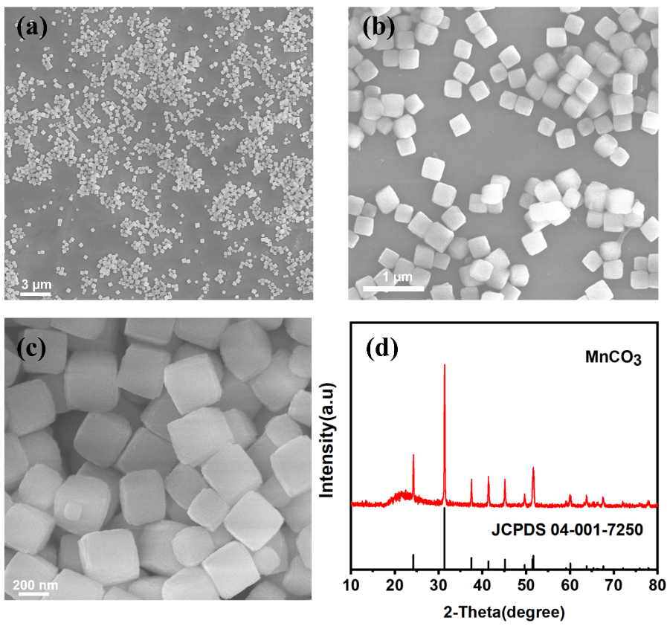
Fig. S1 (a-c) SEM images, (d) XRD pattern of MnCO₃ nanocubes
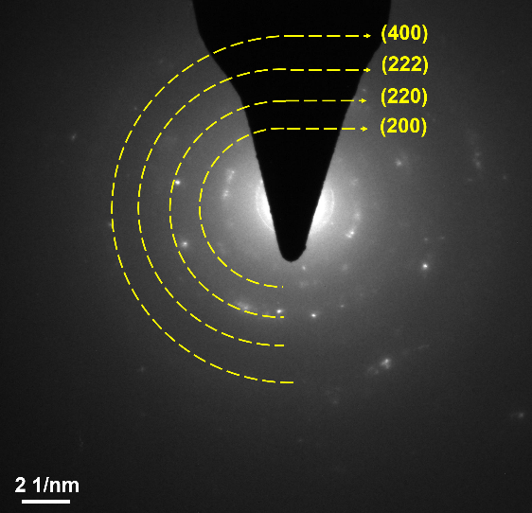

Fig. S2 The selected area electron diﬀraction (SAED) pattern of MnS0.5Se0.5@N-CNF

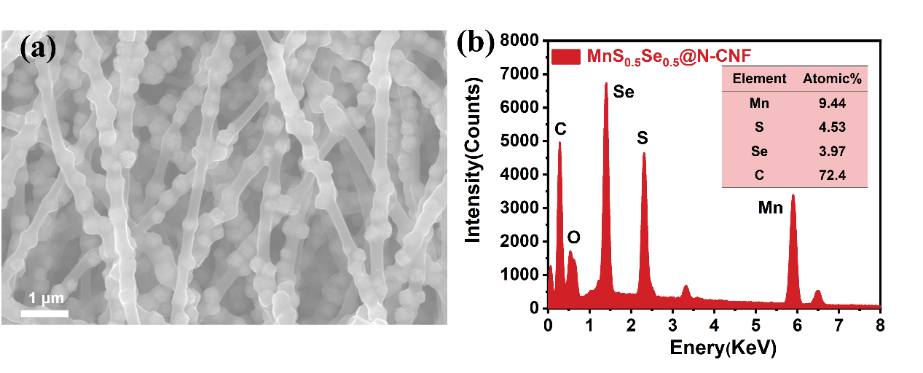
Fig. S3 (a) SEM image, (b) the corresponding EDX spectrum and table (inset) illustrating the element content conta of MnS_{0.5}Se_{0.5}@N-CNF
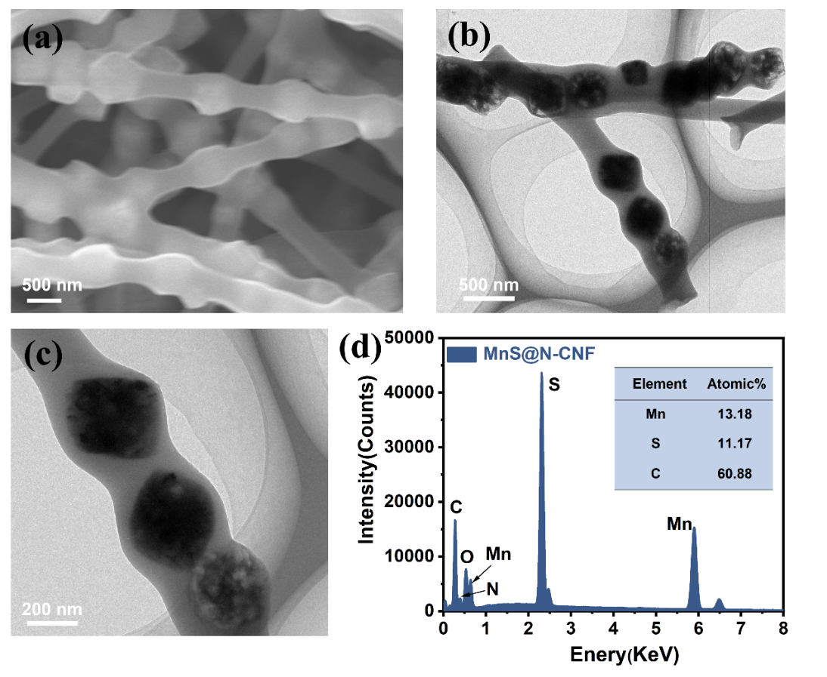
Fig. S4 (a) SEM image, (b, c) TEM images, (d) the corresponding EDX spectrum and
table (inset) illustrating the element content conta of MnS@N-CNF
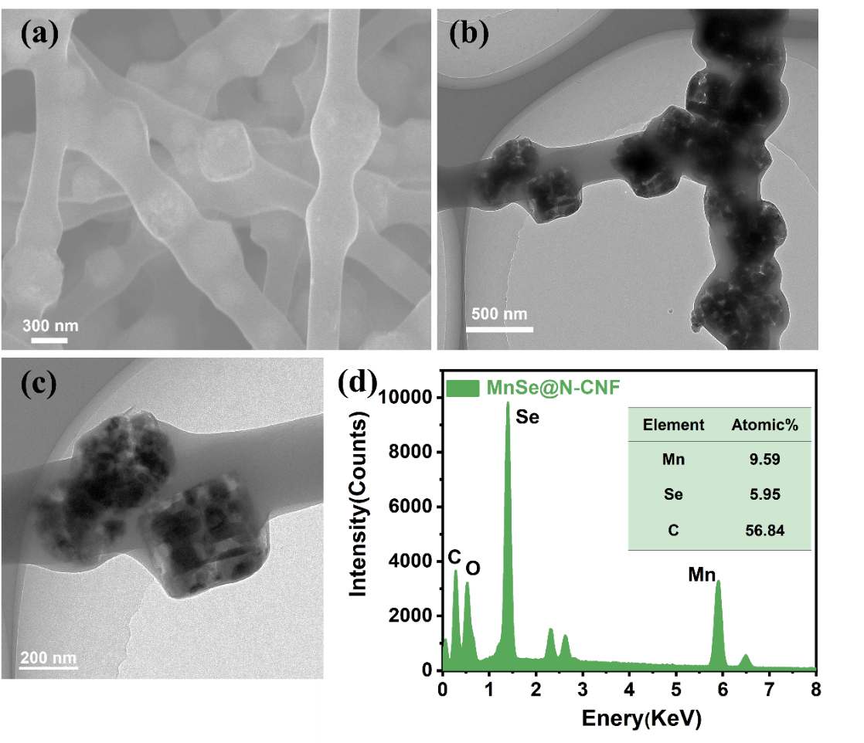
Fig. S5 (a) SEM image, (b, c) TEM images, (d) the corresponding EDX spectrum and
table (inset) illustrating the element content conta of MnSe@N-CNF
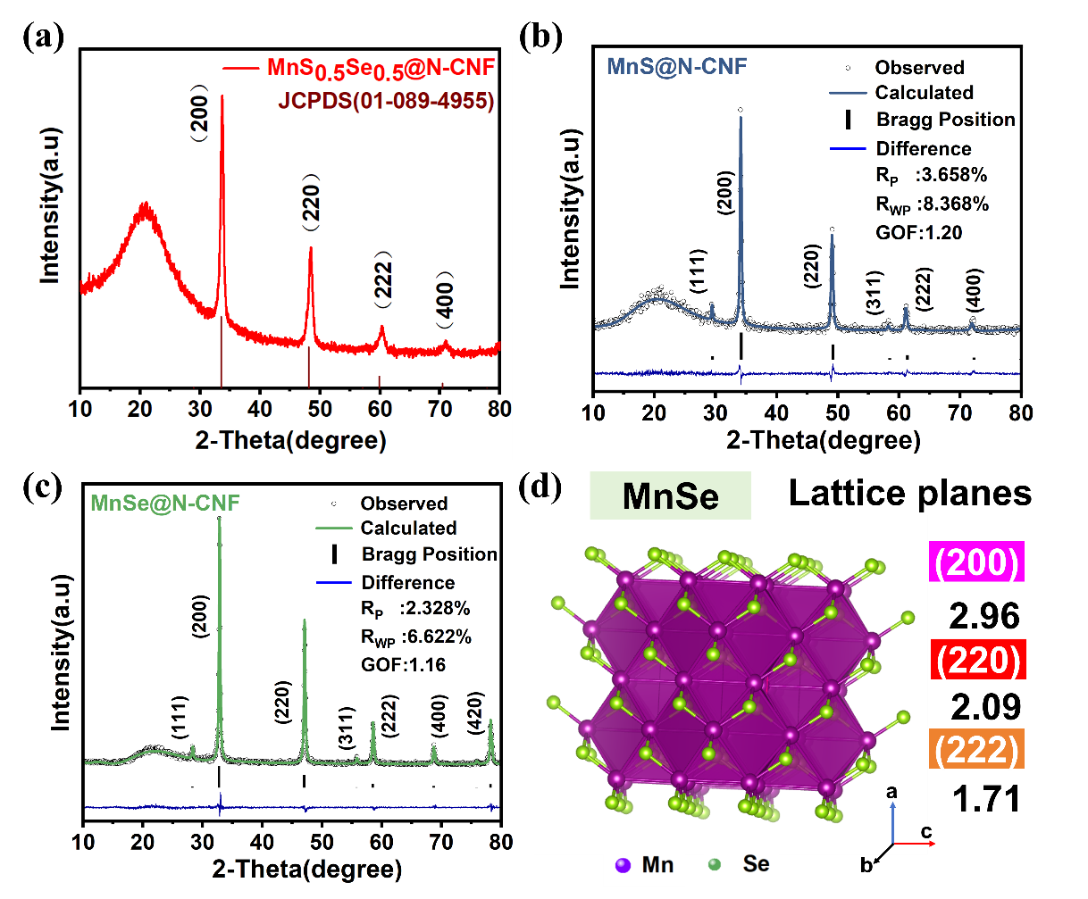
Fig. S6 (a) XRD patterns of the MnS_{0.5}Se_{0.5}@N-CNF, (b, c) Rietveld-refined XRD result of the MnS@N-CNF and MnSe@N-CNF. (d) Crystal structures of MnSe@N-CNF
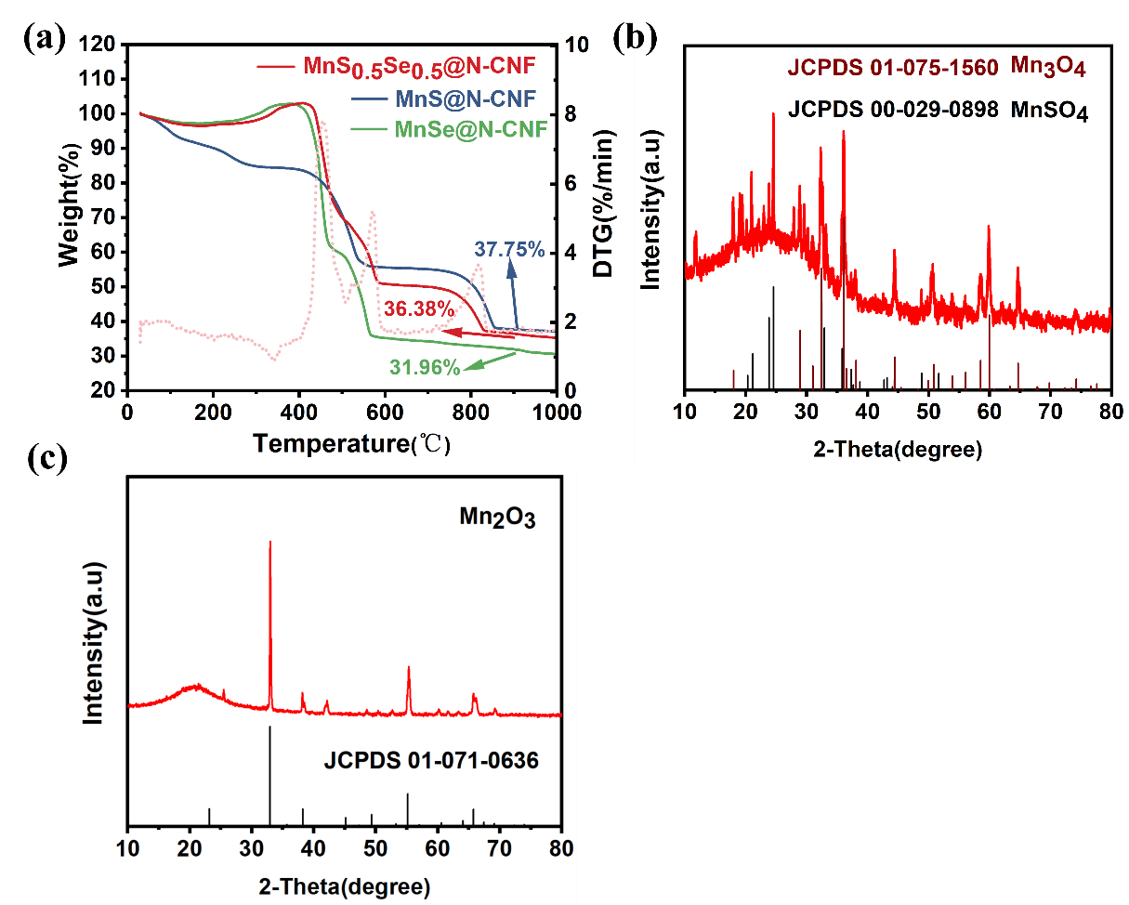
Fig. S7 (a) TGA curves, (b, c) XRD pattern of the residual material after TGA test at 600 ℃ and 900 ℃ of MnS_{0.5}Se_{0.5}@N-CNF composite
TGA analysis:
The weight percentage of carbon nanofiber (N-CNF) in the MnS_{0.5}Se_{0.5}@N-CNF composites was analyzed using thermogravimetric analysis (TGA). As depicted in Fig. S7, a minor weight loss below 300 °C was attributed to the evaporation of absorbed water on the surface of the samples. The weight gain observed between 300 and 500 °C was due to the formation of manganese sulfate (MnSO₄) and manganese oxide (Mn₃O₄). The following rapid mass loss occurring between 450 to 600 °C signified the complete combustion of N-CNF in the composite, while the second weight reduction between 700 and 900 °C corresponded to the transformation of MnSO₄ and Mn₃O₄ into Mn₂O₃. The exothermic peak in the differential thermogravimetry curve (red line in Fig. S7a) aligns with the weight loss curve, indicating chemical reactions and phase transitions. Note that SeO₂, SO₂ and CO₂ would be evaporated completely after the TGA measurement. The total reaction can be simply written as:
$$\text{C+}{\text{O}}_{\text{2}}\text{→C}{\text{O}}_{\text{2}}$$
$$\text{4Mn}{\text{S}}_{\text{0.5}}{\text{Se}}_{\text{0.5}}\text{+9}{\text{O}}_{\text{2}}\text{→}\text{MnS}{\text{O}}_{\text{4}}\text{+}{\text{Mn}}_{\text{3}}{\text{O}}_{\text{4}}\text{+3S}{\text{O}}_{\text{2}}\text{+2Se}{\text{O}}_{\text{2}}$$
$$\text{MnS}{\text{O}}_{\text{4}}\text{+}{\text{Mn}}_{\text{3}}{\text{O}}_{\text{4}}\text{→}{\text{2Mn}}_{\text{2}}{\text{O}}_{\text{3}}\text{+S}{\text{O}}_{\text{2}}$$
Therefore, the MnS_{0.5}Se_{0.5}@N-CNF composite can be calculated according to the following equation:
$$\text{M}\text{n}\text{S}\text{0.5}\text{Se}\text{0.5}\left(\text{wt\%}\right)\text{=}\frac{\text{molecular weight of Mn}\text{S}\text{0.5}\text{Se}\text{0.5}}{\text{molecular weight of }{\text{Mn}}_{\text{2}}{\text{O}}_{\text{3}}}\text{×}\frac{\text{final weight of }{\text{Mn}}_{\text{2}}{\text{O}}_{\text{3}}}{\text{initial weight of Mn}\text{S}\text{0.5}\text{Se}\text{0.5}}\text{×100\%}$$
Based on the final residual weight, which was verified by the XRD pattern (Fig. S7b-c), the mass content of MnS_{0.5}Se_{0.5} in MnS_{0.5}Se_{0.5}@N-CNF composite is calculated as about 88.9 %, and the corresponding weight percentage of N-CNF in the sample is estimated to be 11.1 %. Given the theoretical capacity of carbon at 372 mAh g⁻¹, the capacity contribution from carbon matrix (N-CNF) in the MnS_{0.5}Se_{0.5}@N-CNF composite is only 41.3 mAh g⁻¹, which can be negligible.
From the TGA curves (Fig. S7a), the weight loss observed before 200 °C can be attributed to the evaporation of moisture adsorbed on the surface of the MnS@N-CNF and MnSe@N-CNF samples. Subsequently, a stepwise weight loss occurs in the range from 400 to 900 °C, indicative of carbon burnout and the oxidation of MnS and MnSe into Mn₂O₃, SeO₂, SO₂ and CO₂, respectively. It is worth noting that SeO₂, SO₂ and CO₂ would evaporate completely following the TGA measurement. The total reaction can be simply written as:
$$\text{C+}{\text{O}}_{\text{2}}\text{→C}{\text{O}}_{\text{2}}$$
$$\text{2MnS+}\frac{\text{7}}{\text{2}}{\text{O}}_{\text{2}}\text{→}{\text{Mn}}_{\text{2}}{\text{O}}_{\text{3}}\text{+2S}{\text{O}}_{\text{2}}$$
$$\text{2MnSe+}\frac{\text{7}}{\text{2}}{\text{O}}_{\text{2}}\text{→}{\text{Mn}}_{\text{2}}{\text{O}}_{\text{3}}\text{+2Se}{\text{O}}_{\text{2}}$$
Therefore, the MnS@N-CNF and MnSe@N-CNF composite can be calculated according to the following equation:
$$\text{M}\text{n}\text{S} \left(\text{wt}\text{\%}\right)\text{=}\frac{\text{molecular weight of Mn}\text{S}}{\text{molecular weight of }{\text{Mn}}_{\text{2}}{\text{O}}_{\text{3}}}\text{×}\frac{\text{final weight of }{\text{Mn}}_{\text{2}}{\text{O}}_{\text{3}}}{\text{initial weight of MnS}}\text{×100\%}$$
$$\text{M}\text{n}\text{S}\text{e} \left(\text{wt}\text{\%}\right)\text{=}\frac{\text{molecular weight of Mn}\text{Se}}{\text{molecular weight of }{\text{Mn}}_{\text{2}}{\text{O}}_{\text{3}}}\text{×}\frac{\text{final weight of }{\text{Mn}}_{\text{2}}{\text{O}}_{\text{3}}}{\text{initial weight of MnS}\text{e}}\text{×100\%}$$
Based on the TGA result, the mass content of MnS in MnS@N-CNF composite is calculated as about 68.5%, and the corresponding weight percentage of N-CNF in the sample is estimated to be 31.5%. The mass content of MnSe in MnSe@N-CNF composite is calculated as about 57.7%, and the corresponding weight percentage of N-CNF in the sample is estimated to be 42.3%.
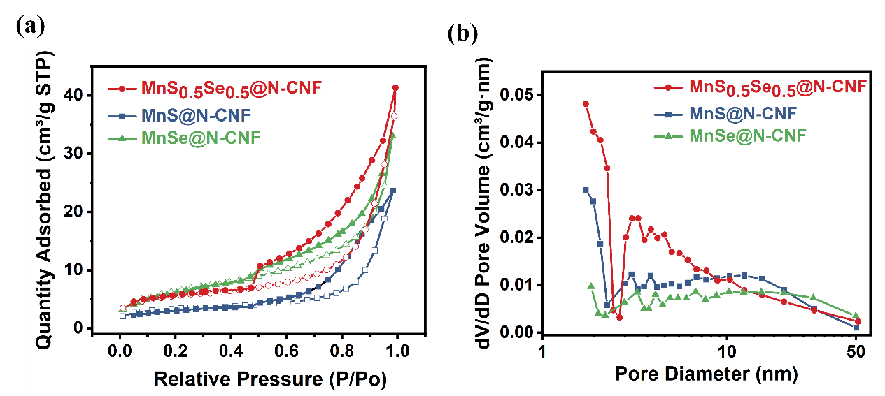
Fig. S8 (a) Nitrogen adsorption-desorption isothermal and (b) pore size distributions curves of MnS_{0.5}Se_{0.5}@N-CNF, MnS@N-CNF and MnSe@N-CNF
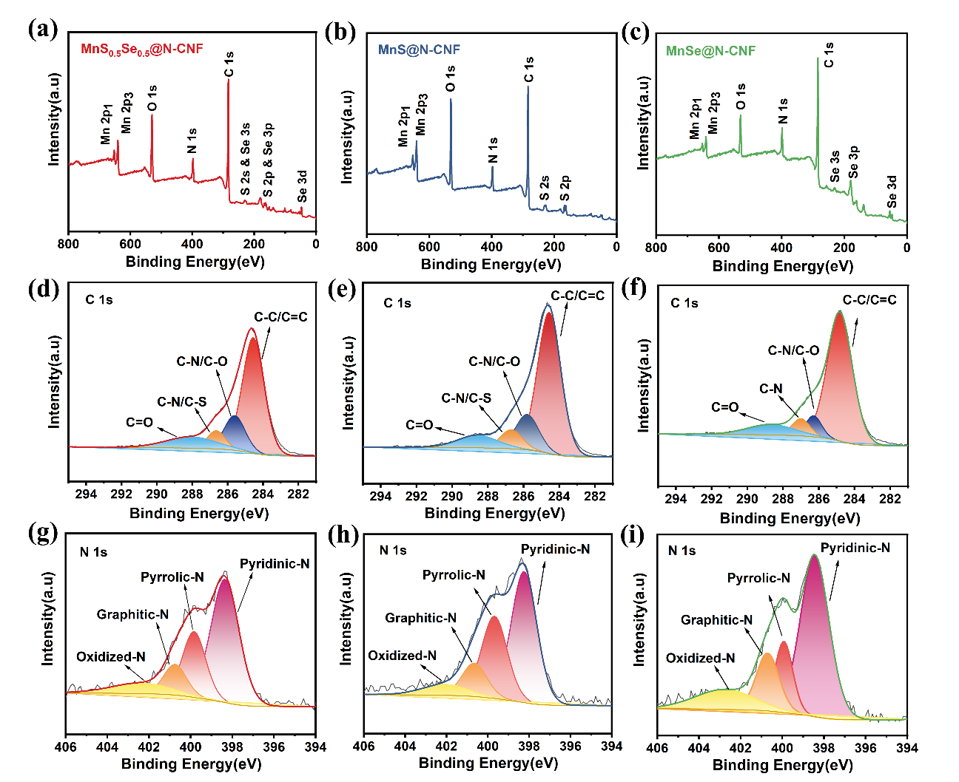
Fig. S9 The survey XPS spectrum of (a) MnS_{0.5}Se_{0.5}@N-CNF, (b) MnS@N-CNF and (c) MnSe@N-CNF. The high-resolution C 1s spectra of (d) MnS_{0.5}Se_{0.5}@N-CNF, (e) MnS@N-CNF and (f) MnSe@N-CNF. The high-resolution N 1s spectra of (g) MnS_{0.5}Se_{0.5}@N-CNF, (h) MnS@N-CNF and (i) MnSe@N-CNF
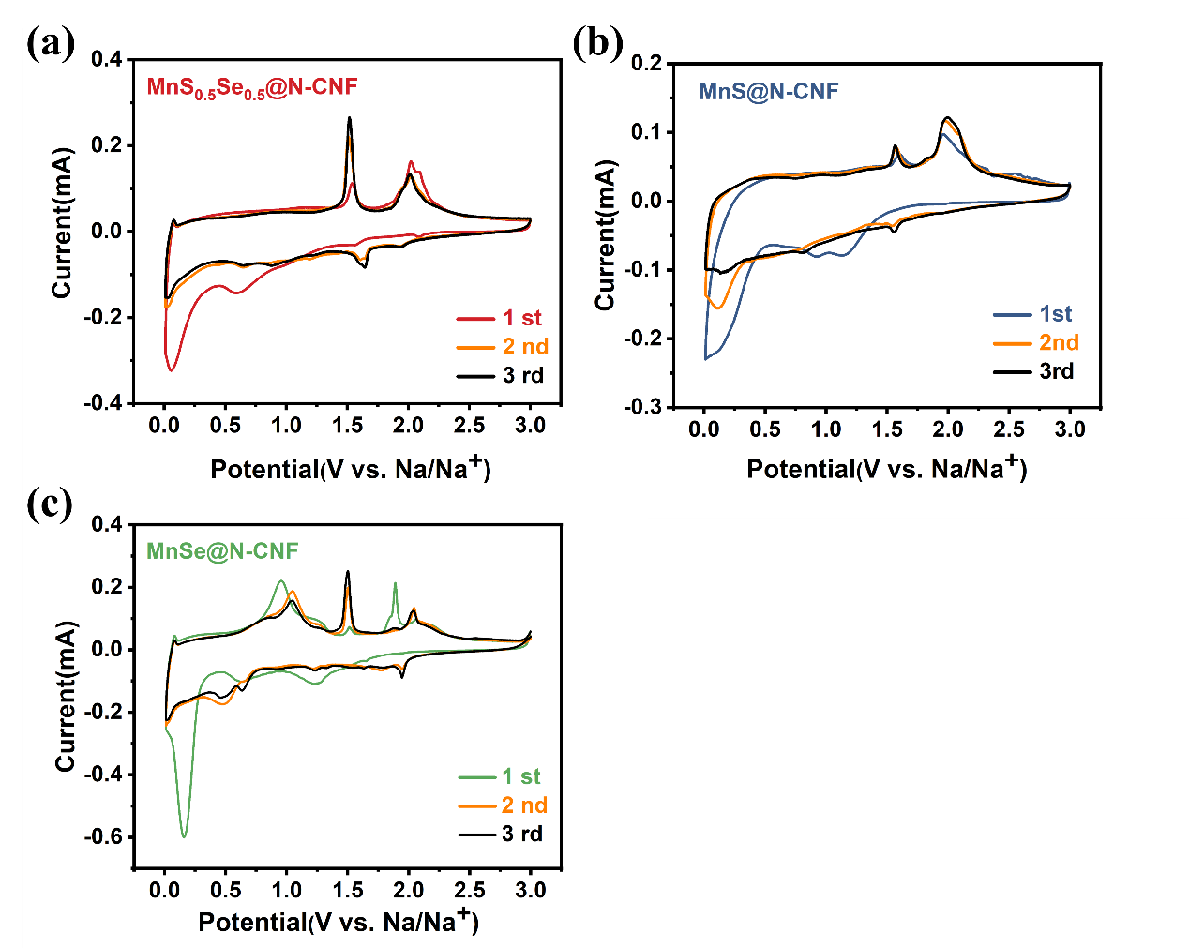
Fig. S10 CV curves of the (a) MnS_{0.5}Se_{0.5}@N-CNF, (b) MnS@N-CNF and (c) MnSe@N-CNF electrodes for the first cycles at a scan rate of 0.1 mV s⁻¹

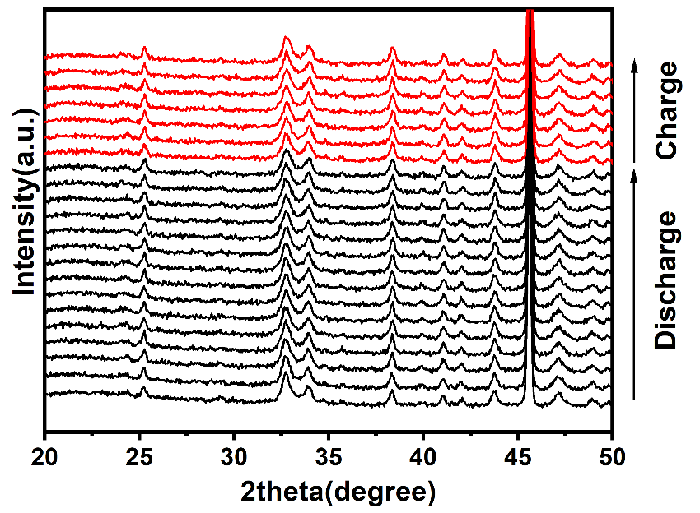
Fig. S11 In-situ XRD patterns of MnS_{0.5}Se_{0.5}@N-CNF electrode during the initial cycle

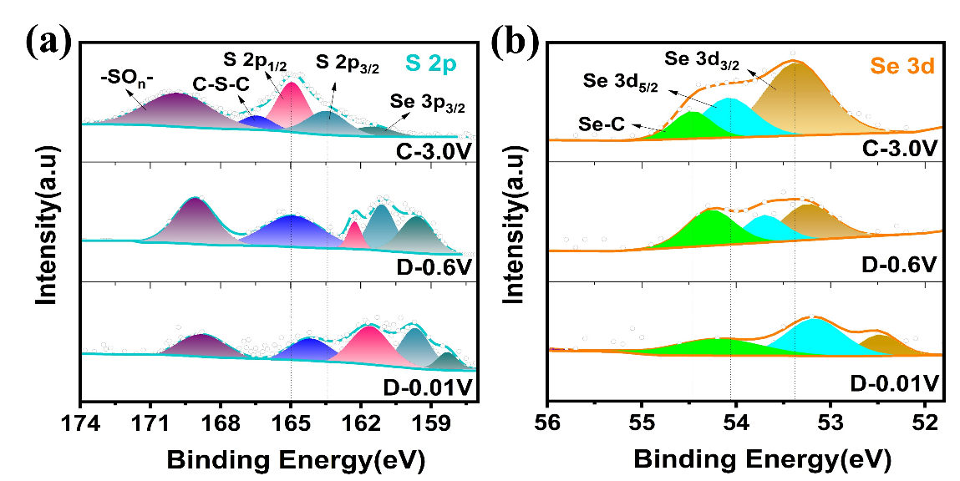
Fig. S12 The high-resolution spectrum of (a) S 2p and (b) Se 3d at different potentials for the MnS_{0.5}Se_{0.5}@N-CNF electrode during the initial cycle

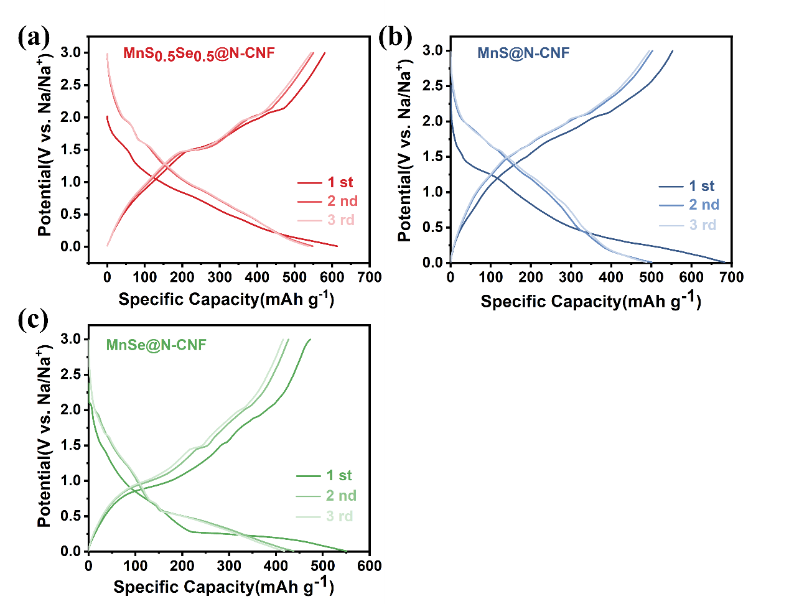
Fig. S13 Galvanostatic charge/discharge voltage profiles of the (a) MnS_{0.5}Se_{0.5}@N-CNF, (b) MnS@N-CNF and (c) MnSe@N-CNF electrodes for the first three cycles at a current density of 0.1A g⁻¹

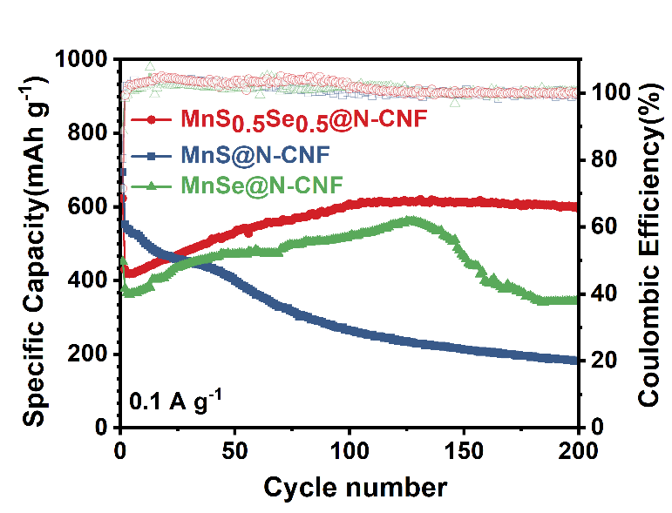
Fig. S14 Cycling stability of MnS_{0.5}Se_{0.5}@N-CNF, MnS@N-CNF and MnSe@N-CNF at 0.1 A g⁻¹

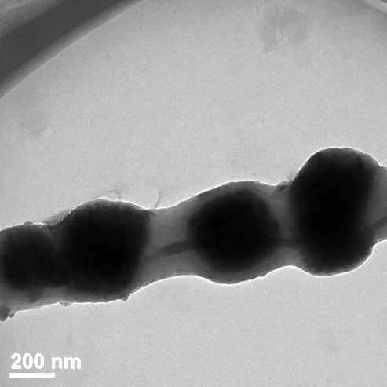
Fig. S15 The TEM image of the electrode sheets of the MnS_{0.5}Se_{0.5}@N-CNF sample after 200 cycles of charge and discharge at 0.1 A g⁻¹

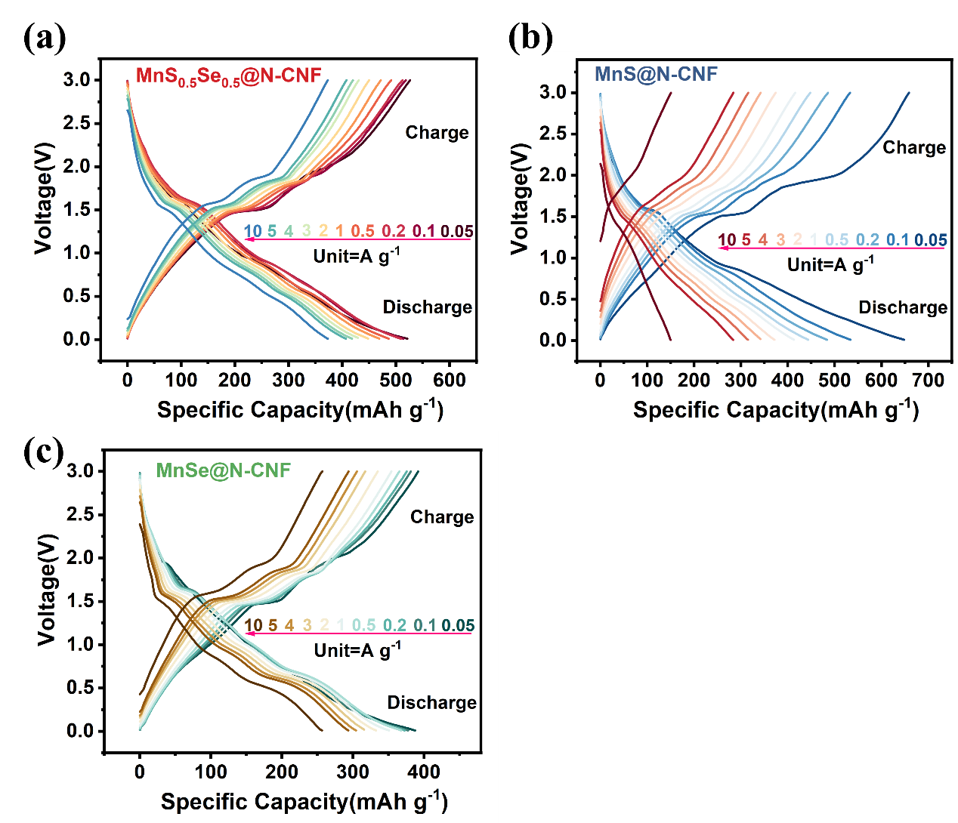
Fig. S16 Charge-discharge proﬁles of the (a) MnS_{0.5}Se_{0.5}@N-CNF, (b) MnS@N-CNF and (c) MnSe@N-CNF electrodes for SIBs at various current densities

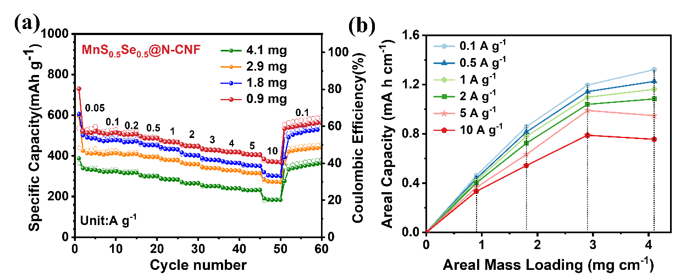
Fig. S17 (a) Comparison of the rate performance between 0.05 A g⁻¹ and 10 A g⁻¹ for MnS_{0.5}Se_{0.5}@N-CNF electrodes under different mass loadings (0.9, 1.8, 2.9 and 4.1 mg cm⁻²). (b) The correlation of areal capacity with mass loading at various rates for the MnS_{0.5}Se_{0.5}@N-CNF electrode
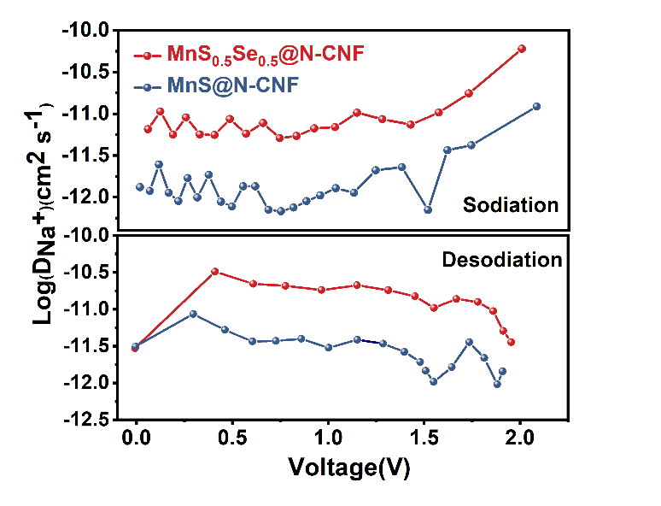
Fig. S18 Na⁺ diffusion coefficients of the MnS_{0.5}Se_{0.5}@N-CNF and MnS@N-CNF and at 0.05 A g⁻¹ after the 3rd cycles during the sodiation and desodiation process

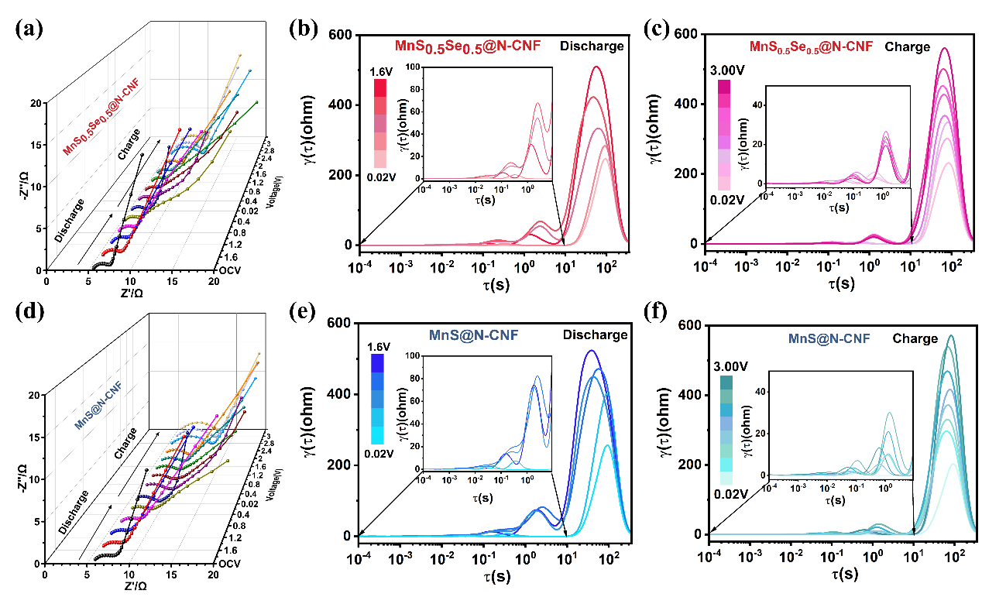
Fig. S19 (a) In situ EIS proﬁles of the MnS_{0.5}Se_{0.5}@N-CNF and (d) MnS@N-CNF electrodes recorded during the initial cycle at a current rate of 50 mA g⁻¹. (b, c) DRT calculated from EIS measurements of MnS_{0.5}Se_{0.5}@N-CNF at different potentials. (e, f) DRT calculated from EIS measurements of MnS@N-CNF at different potentials

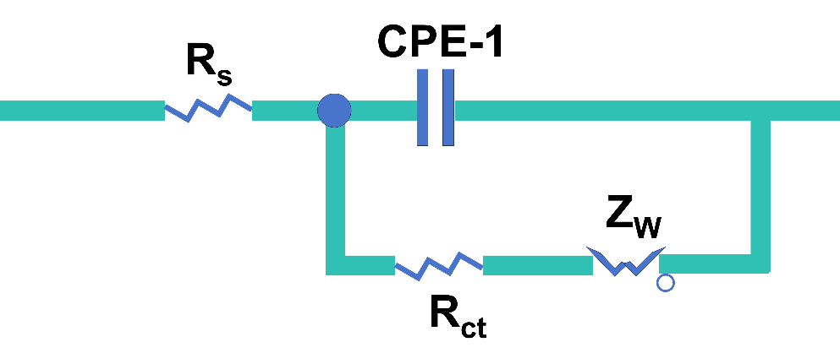
Fig. S20 Equivalent circuits of Electrochemical impedance spectra (EIS)

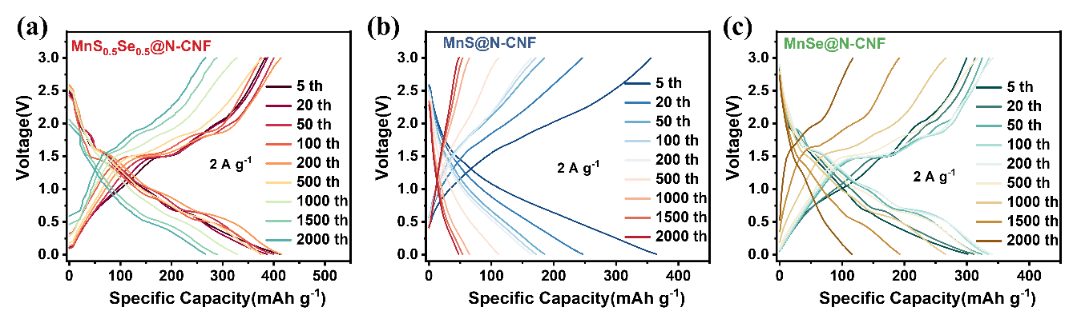
Fig. S21 The charge-discharge profile of different cycles including the 2000th cycle for (a) MnS_{0.5}Se_{0.5}@N-CNF, (b) MnS@N-CNF and (c) MnSe@N-CNF electrodes

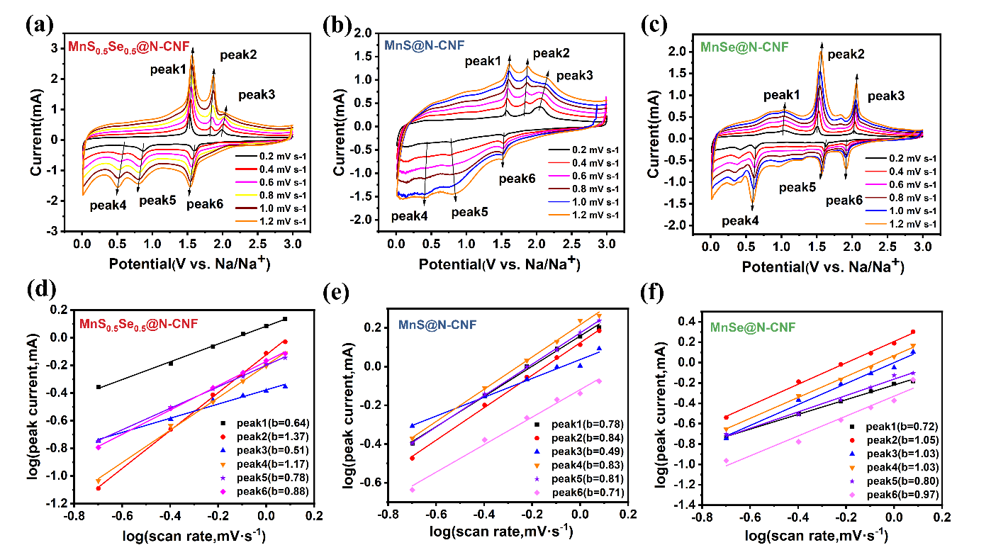
Fig. S22 CV curves at various scan rates from 0.2 to 1.2 mV s⁻¹ and linear relationships between logarithm currents and logarithm sweep rate for (a, d) MnS_{0.5}Se_{0.5}@N-CNF, (b, e) MnS@N-CNF and (c, f) MnSe@N-CNF electrodes
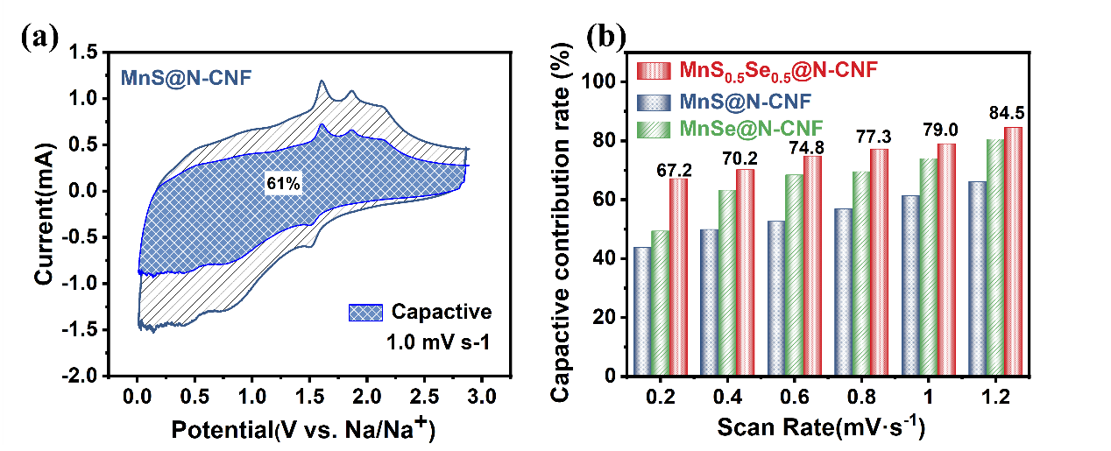
Fig. S23 (a) Capacitive contribution at 1.0 mV s⁻¹ of the MnS@N-CNF electrode. (b) Calculated capacitive contributions at different sweep rate for the MnS_{0.5}Se_{0.5}@N-CNF, MnS@N-CNF and MnSe@N-CNF electrodes

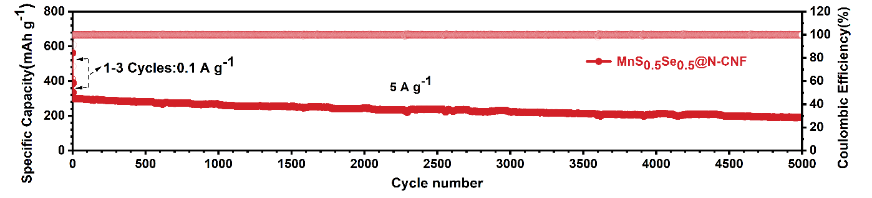
Fig. S24 Long cycling performance at 5 A g⁻¹ of the MnS_{0.5}Se_{0.5}@N-CNF electrodes

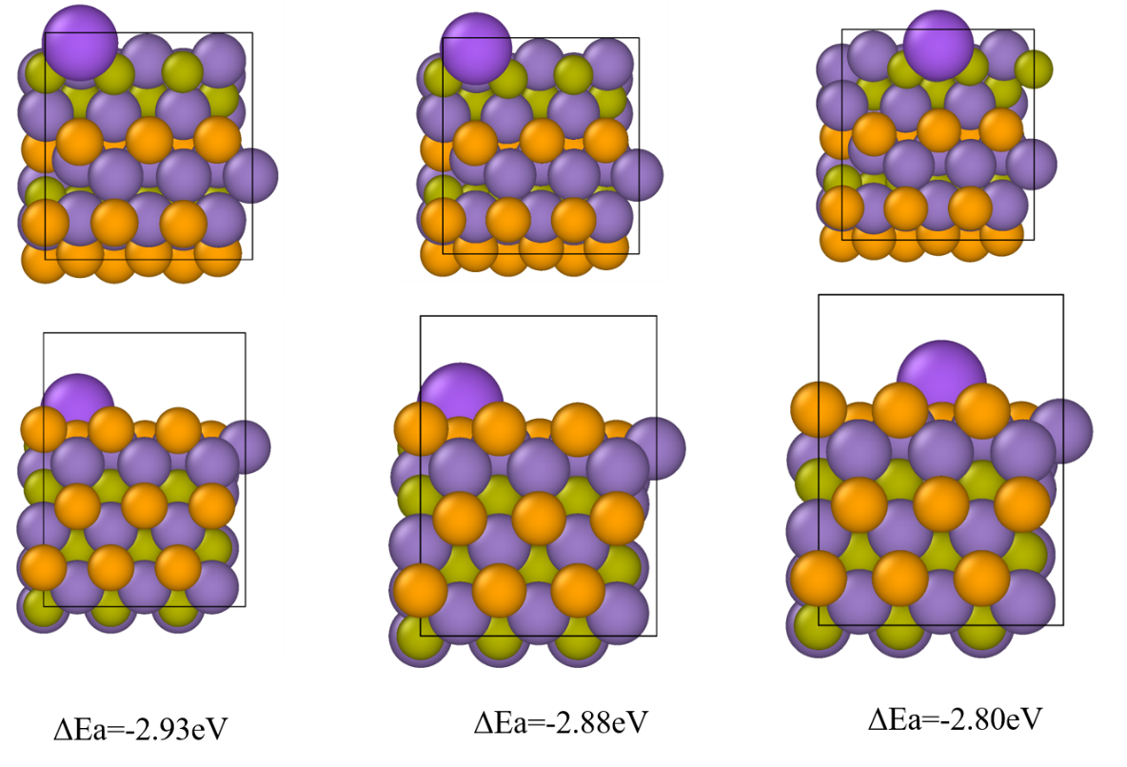
Fig. S25 Top and side view of the simulations for one Na ion adsorbed on the MnS_{0.5}Se_{0.5} as well as corresponding ΔEa

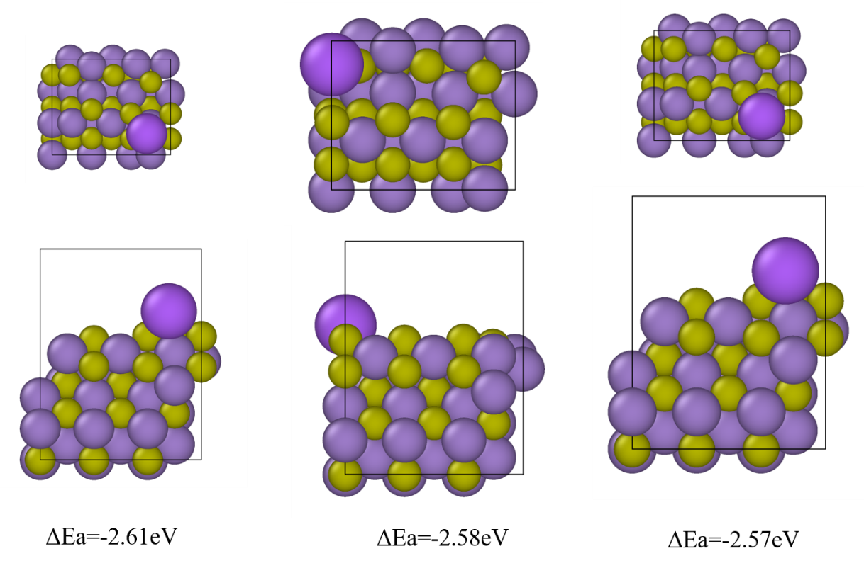
Fig. S26 Top and side view of the simulations for one Na ion adsorbed on the MnS as well as corresponding ΔEa

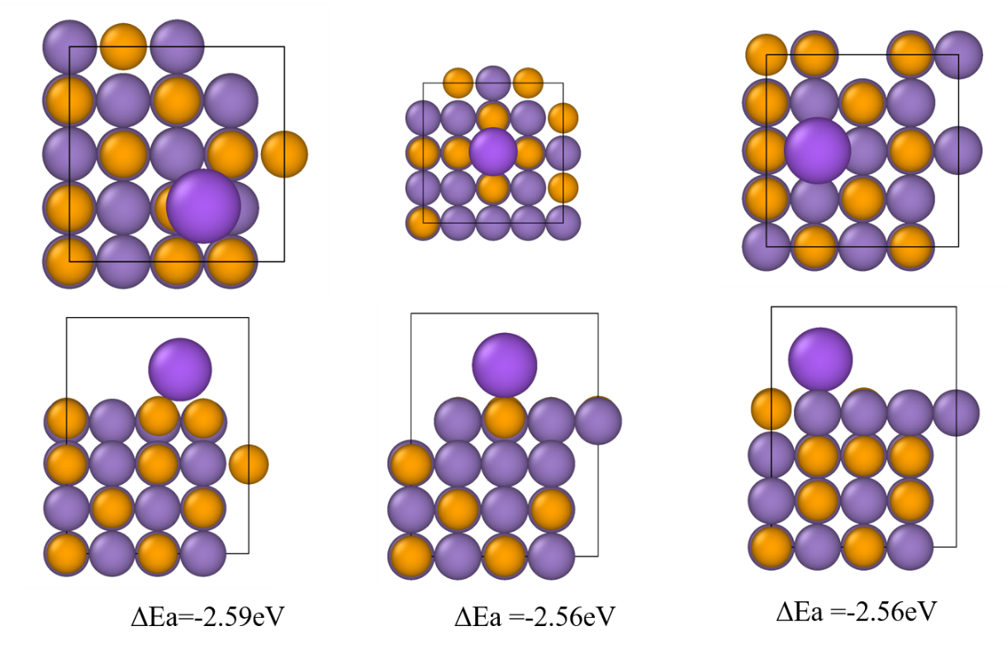
Fig. S27 Top and side view of the simulations for one Na ion adsorbed on the MnSe as well as corresponding ΔEa

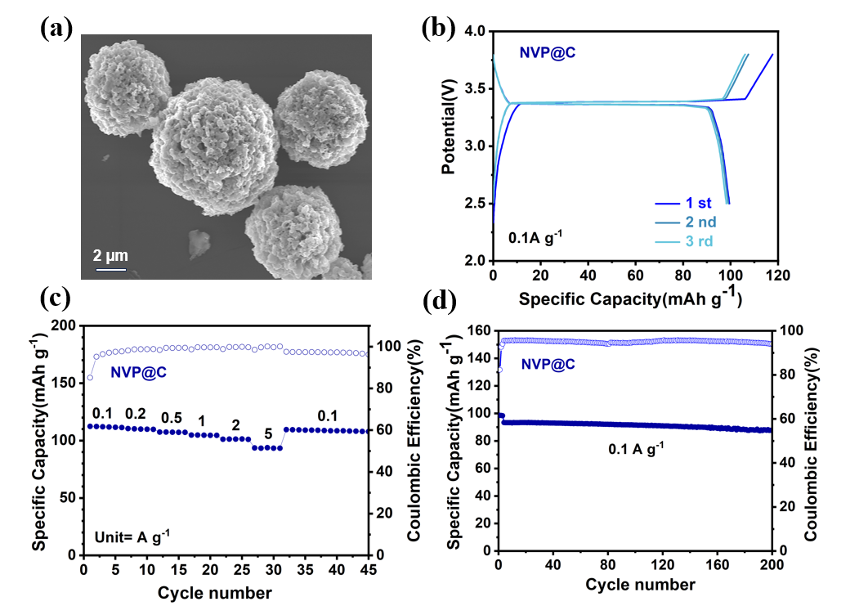
Fig. S28 (a) SEM images, (b) discharge-charge curves first three cycles, (c) rate capability at different current densities and (d) cycling performance at 0.1 A g⁻¹ of the Na₃V₂(PO₄)₃@C

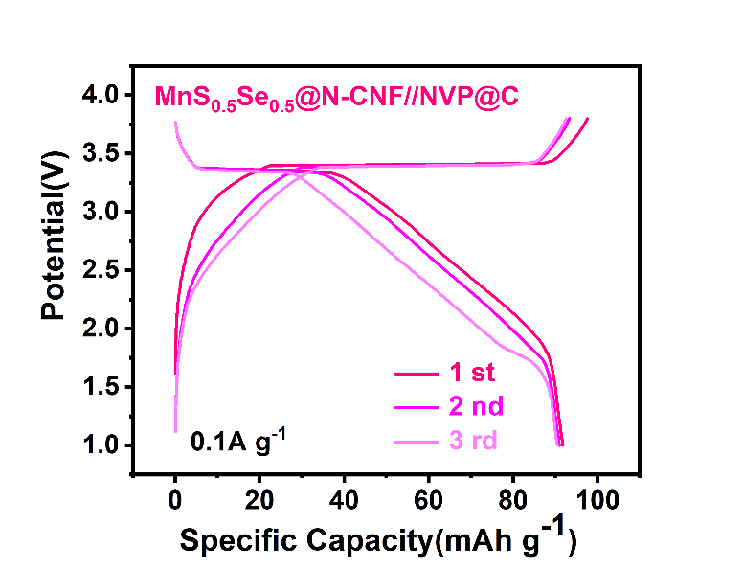
Fig. S29 The charge/discharge curves across the ﬁrst three cycles of the full battery
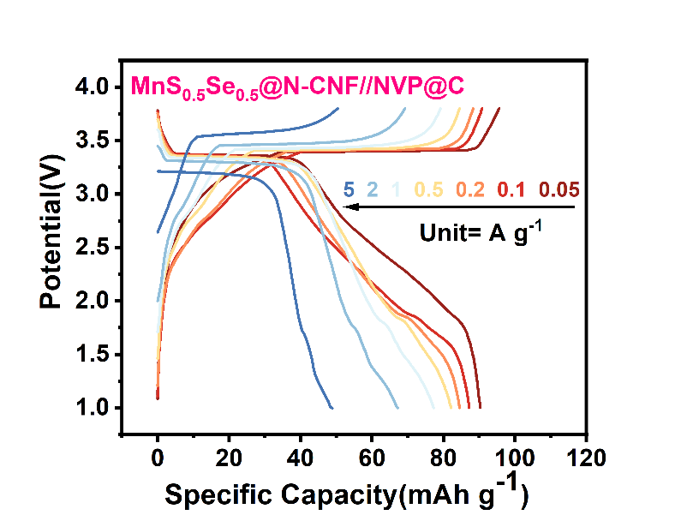
Fig. S30 Discharging-charging profiles at different rates of the full battery
Table S1 Comparison of the high-rate performance and long cycling stability between MnS_{0.5}Se_{0.5}@N-CNF and other Mn-based anode materials reported in recent literature
Materials | Capacity/Current density | Cycle Life | Rate capability | References
MnS_{0.5}Se_{0.5}@N-CNF | 446.8 mAh/g  (2 A/g) | 2000 cycles | 370.5 mAh/g  (10 A/g) | This  work
MnS@NSC | 290.0 mAh/g  (2 A/g) | 2000 cycles | 205.6 mAh/g  (10 A/g) | [S6]
MnS-RT | 258.6 mAh/g  (5 A/g) | 1000 cycles | 169.8 mAh/g  (10 A/g) | [S7]
MnS/CNTs | 225.0 mAh/g  (0.5 A/g) | 200 cycles | 170.0 mAh/g  (1 A/g) | [S8]
MnS/NSCTs | 411.6 mAh/g  (1 A/g) | 1400 cycles | 319.8 mAh/g  (10 A/g) | [S9]
MnS@N,P-LPC_{2/1} | 392.5 mAh/g  (1.6 A/g) | 1500 cycles | 392.5 mAh/g  (1.6 A/g) | [S10]
MnSe@C | 267.0 mAh/g  (0.5 A/g) | 1000 cycles | 209.0 mAh/g  (2 A/g) | [S11]
MnSe-NC | 237.0 mAh/g  (2 A/g) | 2000 cycles | 237.0 mAh/g  (2 A/g) | [S12]
δ-α-MnSe | 137.8 mAh/g  (1 A/g) | 1000 cycles | 81.1 mAh/g  (5 A/g) | [S13]
MnSe@PPyC/rGO | 346.0 mAh/g  (0.2 A/g) | 197 cycles | 294.4 mAh/g  (2 A/g) | [S14]

Supplementary References
[S1] C. Lu, Z. Li, Z. Xia, H. Ci, J. Cai et al., Confining MOF-derived SnSe nanoplatelets in nitrogen-doped graphene cages via direct CVD for durable sodium ion storage. Nano Res. 12(12), 3051-3058 (2019). http://10.1007/s12274-019-2551-0
[S2] X. Ren, J. Wang, D. Zhu, Q. Li, W. Tian et al., Sn-C bonding riveted SnSe nanoplates vertically grown on nitrogen-doped carbon nanobelts for high-performance sodium-ion battery anodes. Nano Energy 54, 322-330 (2018). http://10.1016/j.nanoen.2018.10.019
[S3] W. Wang, P. Li, H. Zheng, Q. Liu, F. Lv et al., Ultrathin layered SnSe nanoplates for low voltage, high-rate, and long-life alkali-ion batteries. Small 13(46), 1702228 (2017). http://10.1002/smll.201702228
[S4] P. Giannozzi, S. Baroni, N. Bonini, M. Calandra, R. Car et al., QUANTUM ESPRESSO: a modular and open-source software project for quantum simulations of materials. J. Phys. Condens. Matter 21(39), 395502 (2009). http://10.1088/0953-8984/21/39/395502
[S5] S. Grimme, J. Antony, S. Ehrlich and H. Krieg, A consistent and accurate ab initio parametrization of density functional dispersion correction (DFT-D) for the 94 elements H-Pu. J. Chem. Phys. 132(15), 154104 (2010). http://10.1063/1.3382344
[S6] S. Li, J. Chen, J. Xiong, X. Gong, J. Ciou et al., Encapsulation of MnS Nanocrystals into N, S-Co-doped Carbon as Anode Material for Full Cell Sodium-Ion Capacitors. Nano-Micro Lett. 12(1), 34 (2020). http://10.1007/s40820-020-0367-9
[S7] K. Chen, G. Li, Z. Hu, Y. Wang, D. Lan et al., Construction of γ-MnS/α-MnS hetero-phase junction for high-performance sodium-ion batteries. Chem. Eng. J. 435, 135149 (2022). http://10.1016/j.cej.2022.135149
[S8] N. Zhang, X. Li, T. Hou, J. Guo, A. Fan et al., MnS hollow microspheres combined with carbon nanotubes for enhanced performance sodium-ion battery anode. Chin. Chem. Lett. 31(5), 1221-1225 (2020). http://10.1016/j.cclet.2019.09.050
[S9] G. Li, K. Chen, Y. Wang, Z. Wang, X. Chen et al., Cream roll-inspired advanced MnS/C composite for sodium-ion batteries: encapsulating MnS cream into hollow N,S-co-doped carbon rolls. Nanoscale 12(15), 8493-8501 (2020). http://10.1039/d0nr00626b
[S10]D. Lan, Y. Zhao, Y. Liu, N. Zhu and J. Cui, Self-assembled nano-MnS@N,P dual-doped lignite based carbon as high-performance sodium-ion batteries anode. J. Energy Storage 90, 111827 (2024). http://10.1016/j.est.2024.111827
[S11]J. S. Park, A. Lee, G. D. Park and Y. C. Kang, Synthesis of MnSe@C yolk‐shell nanospheres via a water vapor‐assisted strategy for use as anode in sodium‐ion batteries. Int. J. Energy Res. 46(3), 2500-2511 (2021). http://10.1002/er.7323
[S12]L. Hu, L. He, X. Wang, C. Shang and G. Zhou, MnSe embedded in carbon nanofibers as advanced anode material for sodium ion batteries. Nanotechnology. 31(33), 335402 (2020). http://10.1088/1361-6528/ab8e78
[S13]S. Chong, T. Li, S. Qiao, Y. C. Yang, Z. Liu et al., Boosting manganese selenide anode for superior sodium-ion storage via triggering α→β phase transition. ACS Nano 18(4), 3801-3813 (2024). http://10.1021/acsnano.3c12215
[S14]N.-J. Song, Y. Wang, C. Ma, Q. Zhang, Y. Zhao et al., Cage-like MnSe@PPyC/rGO as superior dual anode materials in Li/Na-ions storage. J. Alloys Compd. 927, 167002 (2022). http://10.1016/j.jallcom.2022.167002

