Supporting Information for
A Strongly Coupled Cluster Heterostructure with Pt-N-Mo Bonding for Durable and Efficient H₂ Evolution in Anion-Exchange Membrane Water Electrolyzers
Wenbo Zhou ^{1, 2, †}, Yichao Huang^{1,†,*}, Hanqing Cai¹, Tao Wang¹, Haitao Li¹, Chao Zhang², Lianming Zhao^{1, *}, Lulu Chen¹, Meihong Liao⁴, Zhiqing Tang¹, Kai Chen³, Jing Gu⁶, Wenpei Gao^{2, *}, Zhuangjun Fan^{1, 5, *}, Zhenhai Wen^{3, *}
¹ State Key Laboratory of Chemical Safety, Shandong Key Laboratory of Intelligent Energy Materials, School of Materials Science and Engineering, China University of Petroleum (East China), Qingdao 266580, P. R. China
² State Key Laboratory of Metal Matrix Composites, School of Materials Science and Engineering, Future Material Innovation Center, Zhangjiang Institute for Advanced Study, Shanghai Jiao Tong University, Shanghai 200240, P. R. China
³ Fujian Institute of Research on the Structure of Matter, Chinese Academy of Science, Institute of Materials, Fuzhou 350002, P. R. China
⁴ School of Mechanical and Electronic Engineering, Qingdao Binhai University, Qingdao 266555, P. R. China
⁵ Institute of Energy, Hefei Comprehensive National Science Center, Hefei 230051, P. R. China
⁶ Department of Chemistry and Biochemistry, San Diego State University, 5500 Campanile Drive, San Diego, California 92182-1030, USA
† Wenbo Zhou and Yichao Huang contributed equally to this work.
* Corresponding authors. E-mails: yichaoh@upc.edu.cn (Yichao Huang); Lmzhao@upc.edu.cn (Lianming Zhao); gaowenpei@sjtu.edu.cn (Wenpei Gao); fanzhj666@163.com (Zhuangjun Fan); wen@fjirsm.ac.cn (Zhenhai Wen)
Supplementary Figures and Tables
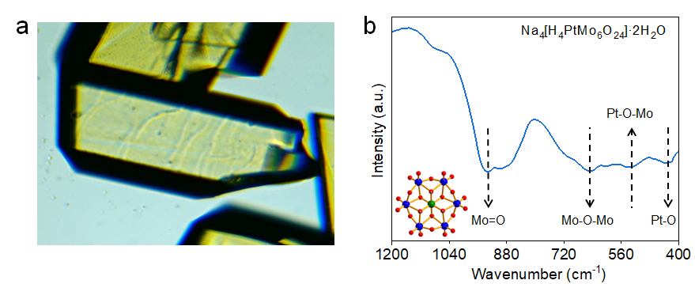
Fig. S1 a) Crystallographic morphology and b) Fourier transform infrared spectroscopy (FT-IR) of Na₄[H₄PtMo₆O₂₄]·2H₂O (PtMo6), the peaks of Mo=O (933 cm⁻¹), Mo-O-Mo (661 cm⁻¹), Pt-O-Mo (518 cm⁻¹) and Pt-O (424 cm⁻¹) verify the successful synthesis of PtMo6 compound (the inset is the structure diagram of PtMo6) [S1]
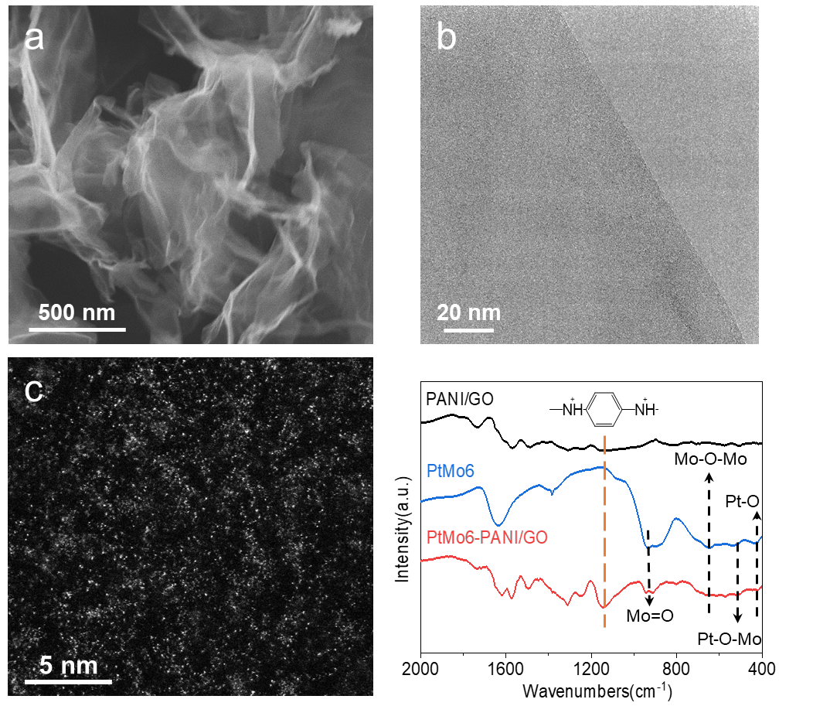
Fig. S2 a) SEM, b) TEM, and c) HAADF-STEM spectra of PtMo6-PANI/GO precursor. The results confirm the PtMo6 POMs cluster is uniformly dispersed on the PANI/GO matrix without significant agglomeration. d) Fourier transform infrared (FT-IR) spectra of PtMo6-PANI/GO, PANI/GO, and PtMo6 [S1]
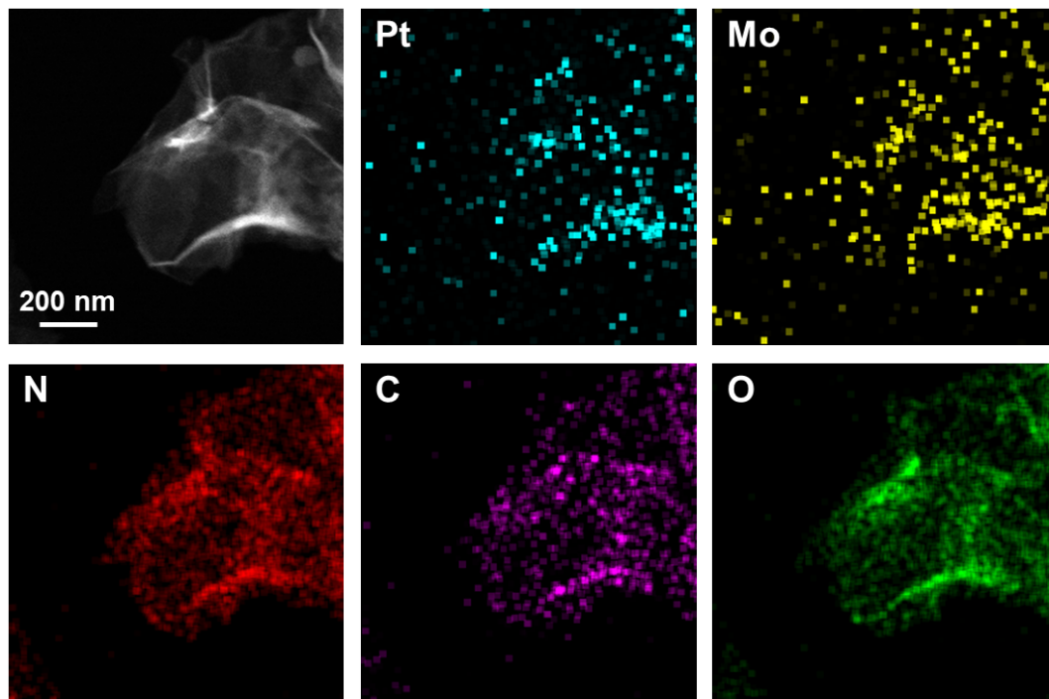
Fig. S3 The energy dispersive X-ray spectroscopy (EDS) mapping of Pt (cyan), Mo (yellow), N (red), C (purple) and O (green) in the PtMo6-PANI/GO nanosheet. The EDS mapping images show the homogeneous dispersion of Pt and Mo in the PtMo6-PANI/GO nanosheets, further confirming the successful combination of PtMo6 POMs cluster and PANI/GO substrate.
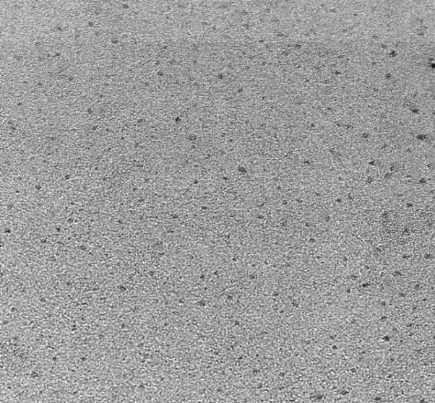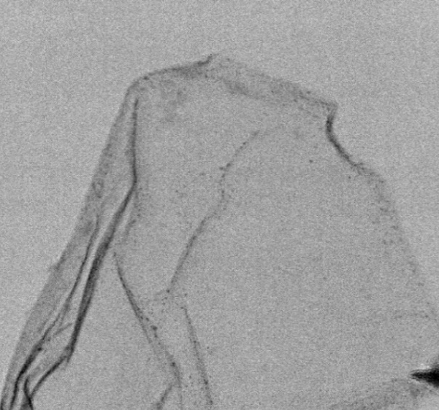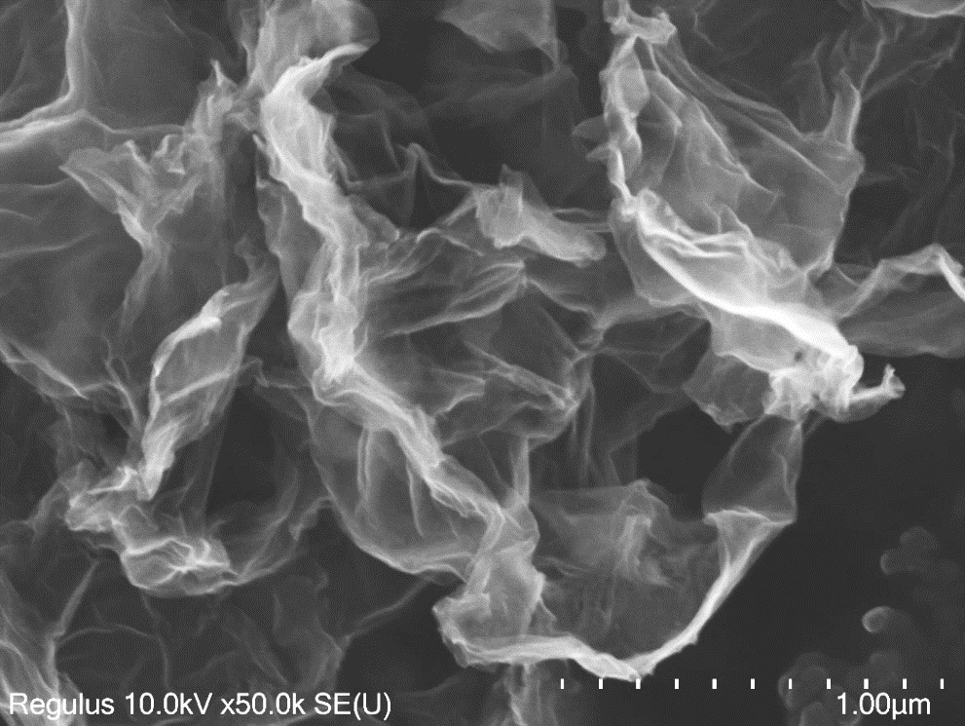
20 nm
100 nm
500 nm
50 nm
a
b
c
d
Fig. S4 a) The SEM, b) TEM and c) HRTEM (the inset is particle size distribution) and d) HAADF-STEM images of Pt/Mo₂N-NrGO, demonstrating that the quantum dots with an average size of 2.0 nm are uniformly loaded on the NrGO surface. It is noteworthy that achieving high-density dispersion of such small-size nanoparticles is remarkably surprising.

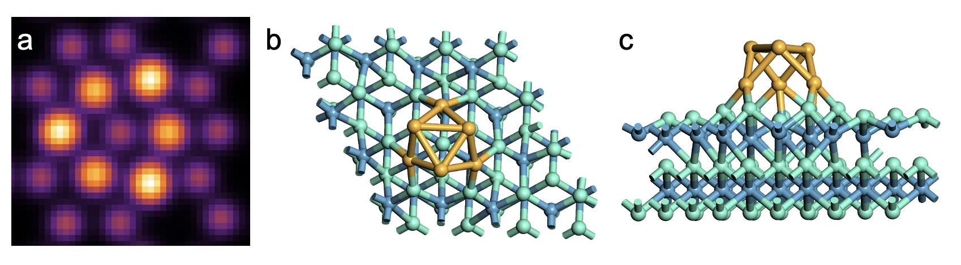
Fig. S5 a) The HAADF simulation used Dr. probe and b~c) atomic model of the DFT-derived structure of Pt/Mo₂N, including top view and side view

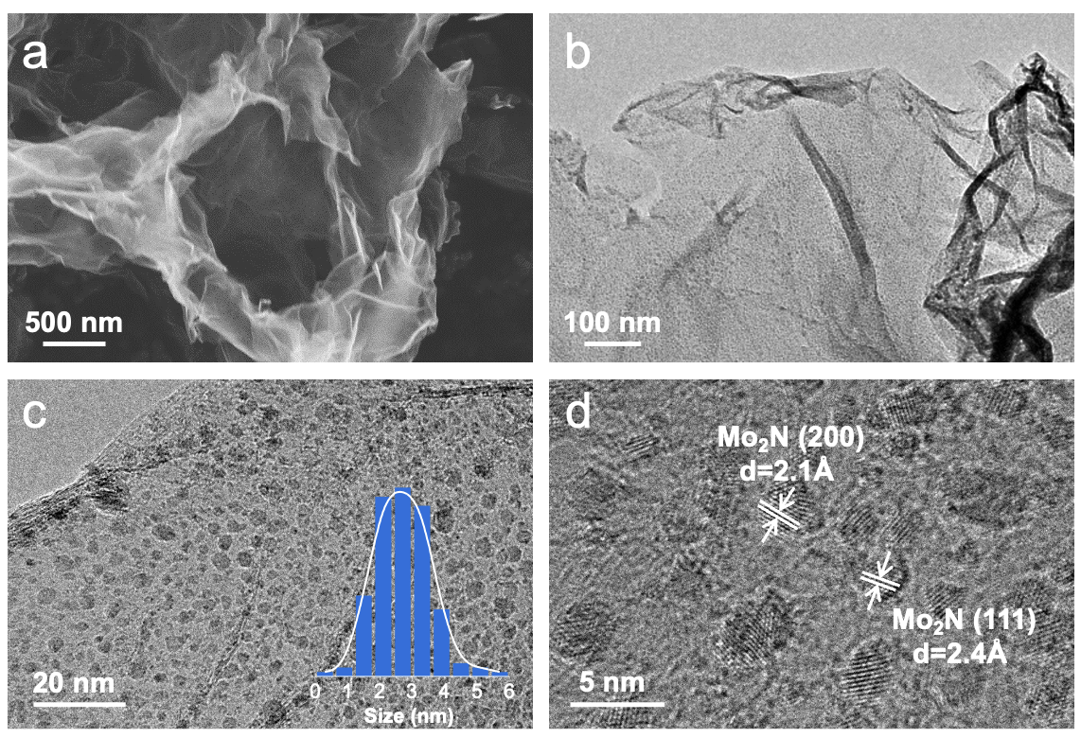
Fig. S6 a) SEM, b~c) TEM (the inset image is particle size distribution) and d) HRTEM images of Mo₂N-NrGO. The hexagonal Mo₂N quantum dots with an average size of 2.72 nm, exposed (111) and (200) crystalline surface, are loaded at NrGO nanosheets

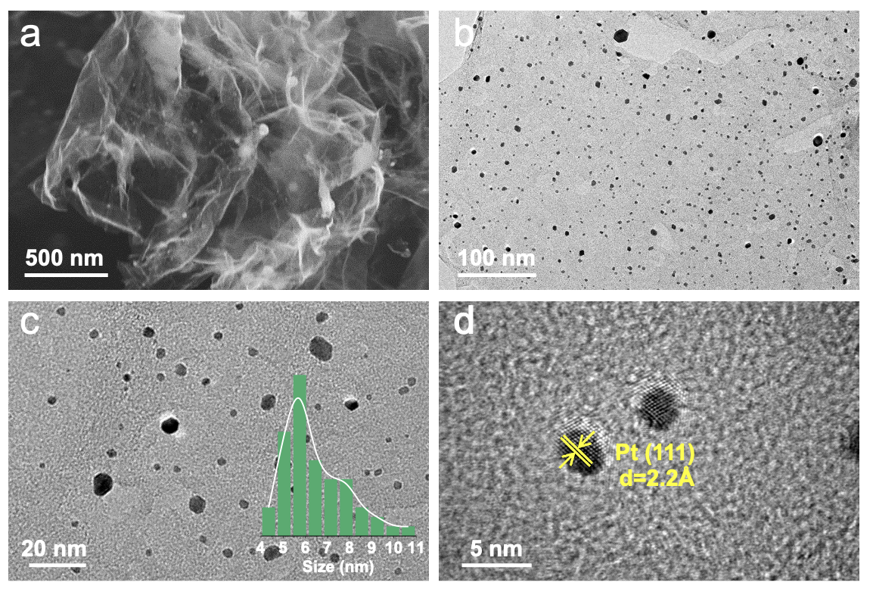
Fig. S7 a) SEM, b~c) TEM (the inset image is particle size distribution) and d) HRTEM images of Pt-NrGO. Without Mo₂N support, the Pt atoms undergo an Ostwald ripening process, resulting in severe agglomeration and sintering into Pt nanoparticles with an average size of 5.75 nm that expose the (111) crystalline surface

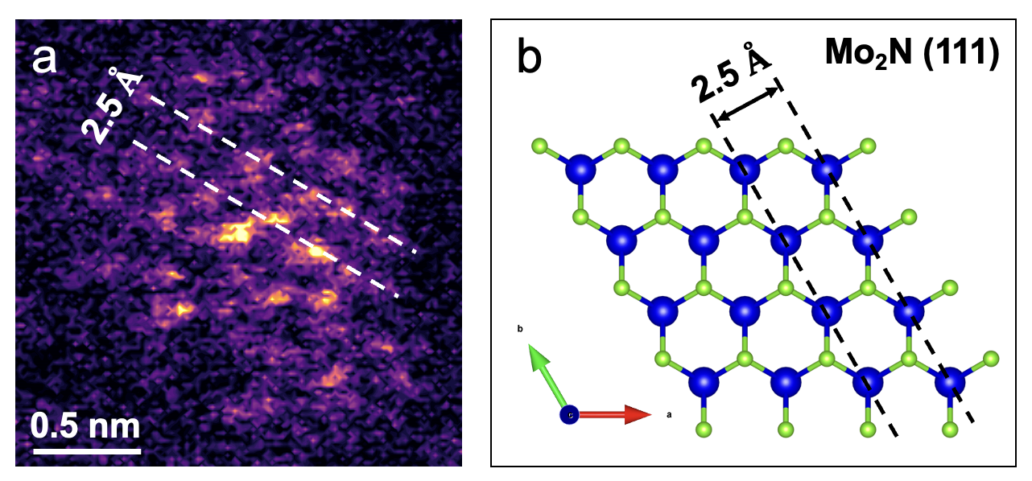
Fig. S8 a) The HAADF-STEM image of Pt/Mo₂N-NrGO, where the bright spots in the center represent Pt atoms and the surrounding darker spots represent Mo atoms due to the different contrast of Pt and Mo. The crystal plane spacing of Mo₂N is 0.25 nm, which is consistent with that of the b) crystal model of Mo₂N (111)

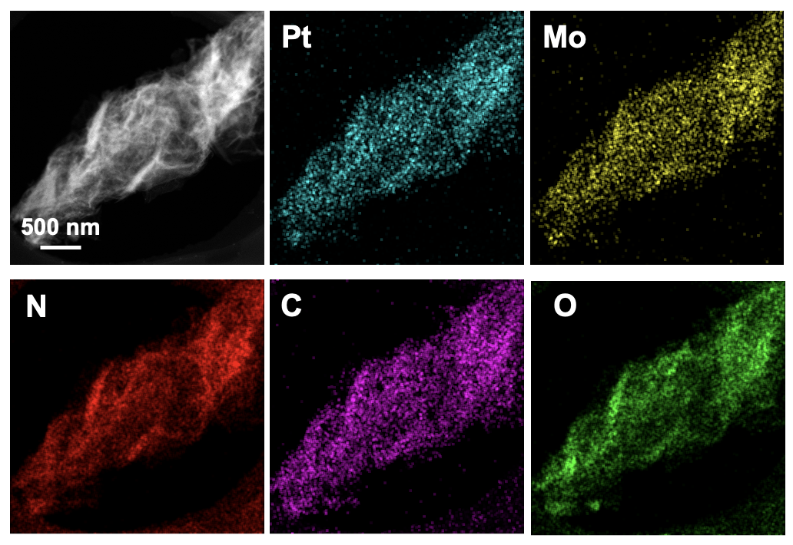
Fig. S9 STEM-EDS element mapping of Pt (cyan), Mo (yellow), N (red), C (purple) and O (green) in the Pt/Mo₂N-NrGO under scale bar of 500 nm

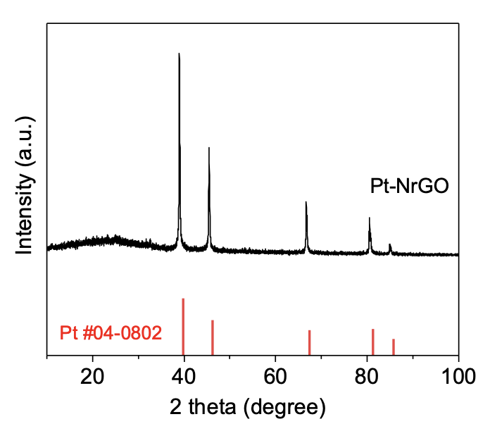
Fig. S10 XRD pattern of Pt-NrGO with sharp peaks of Pt
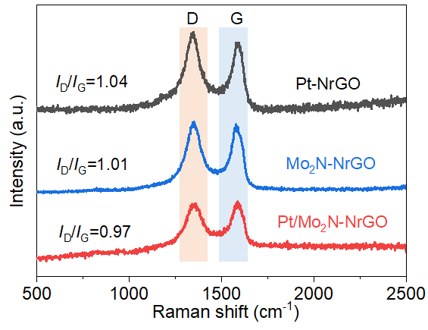
Fig. S11 Raman spectroscopy of Pt/Mo₂N-NrGO, Pt-NrGO and Mo₂N-NrGO where the D band (1350 cm⁻¹) and G band (1580 cm⁻¹) provide the evidence of defects and crystallinity of graphene structure, respectively
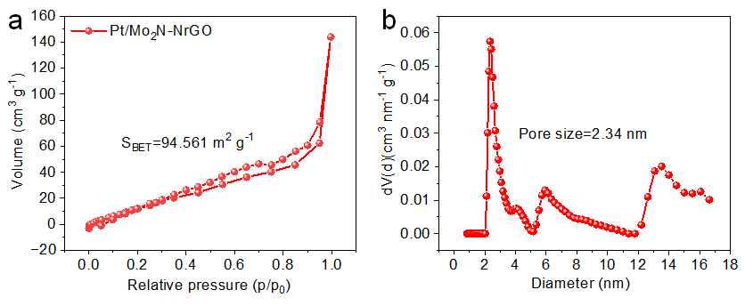
Fig. S12 a) The N₂ adsorption-desorption isotherm of Pt/Mo₂N-NrGO measured by the Brunauer-Emmett-Teller (BET) method. b) Hole size distribution of Pt/Mo₂N-NrGO used the Barrett-Joyner-Hallender method. The specific surface area and average pore size of Pt/Mo₂N rGO are 94.56 m₂·g⁻¹ and 2.34 nm
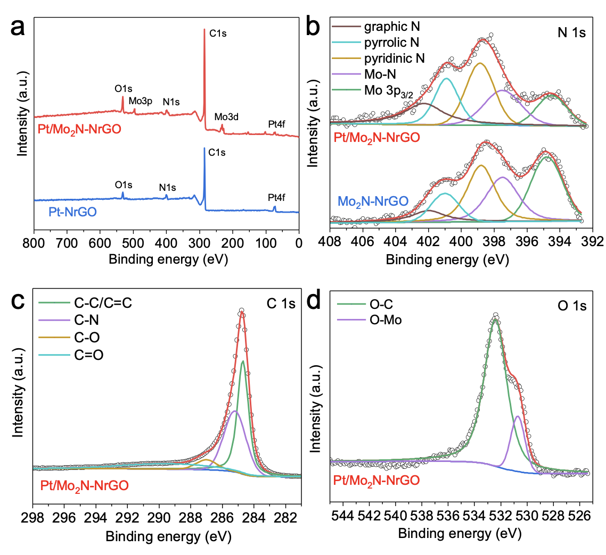
Fig. S13 a) The XPS survey spectrum of Pt/Mo₂N-NrGO and Pt-NrGO. b) High-resolution XPS signals of N 1s for Pt/Mo₂N-NrGO and Pt-NrGO. c~d) High-resolution XPS signals of C 1s and O 1s for Pt/Mo₂N-NrGO
With regard to N 1s (Fig. S11b), the four peaks at 397.48 eV, 398.88 eV, 400.88 eV and 402.38 eV are derived from N-Mo, pyridinic-N, pyrrolic-N and graphic-N, respectively. The main peak of the C 1s spectrum is located at 284.68 eV in Fig. S11c, demonstrating the existence of the NrGO matrix. The O 1s spectrum is deconstructed into two peaks at 532.48 eV and 530.68 eV, assigned to O-C and O-Mo, respectively (Fig. S11d).

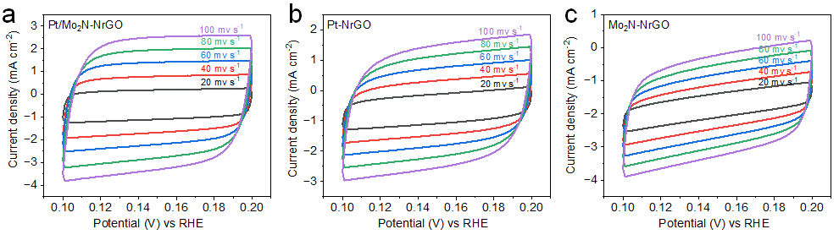
Fig. S14 CVs of a) Pt/Mo₂N-NrGO, b) Pt-NrGO and c) Mo₂N-NrGO with different rates from 20 to 100 mV s⁻¹

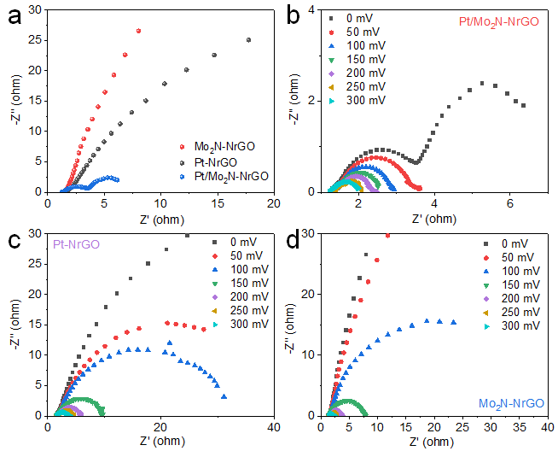
Fig. S15 a) EIS spectra of Pt/Mo₂N-NrGO, Pt-NrGO and Mo₂N-NrGO at open circuit voltage. The Nyquist plots of b) Pt/Mo₂N-NrGO, c) Pt-NrGO and d) Mo₂N-NrGO at different overpotentials of 0, 50, 100, 150, 200, 250 and 300 Mv

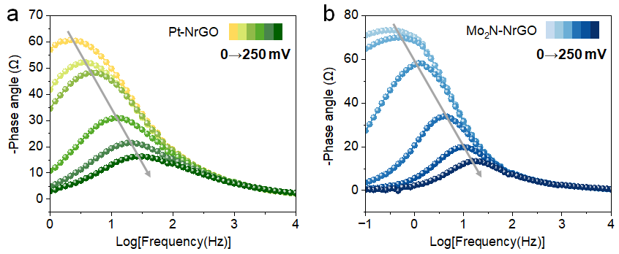
Fig. S16 Bode phase plot of a) Pt-NrGO and b) Mo₂N-NrGO with increasing overpotentials from 0 mV to 250 mV
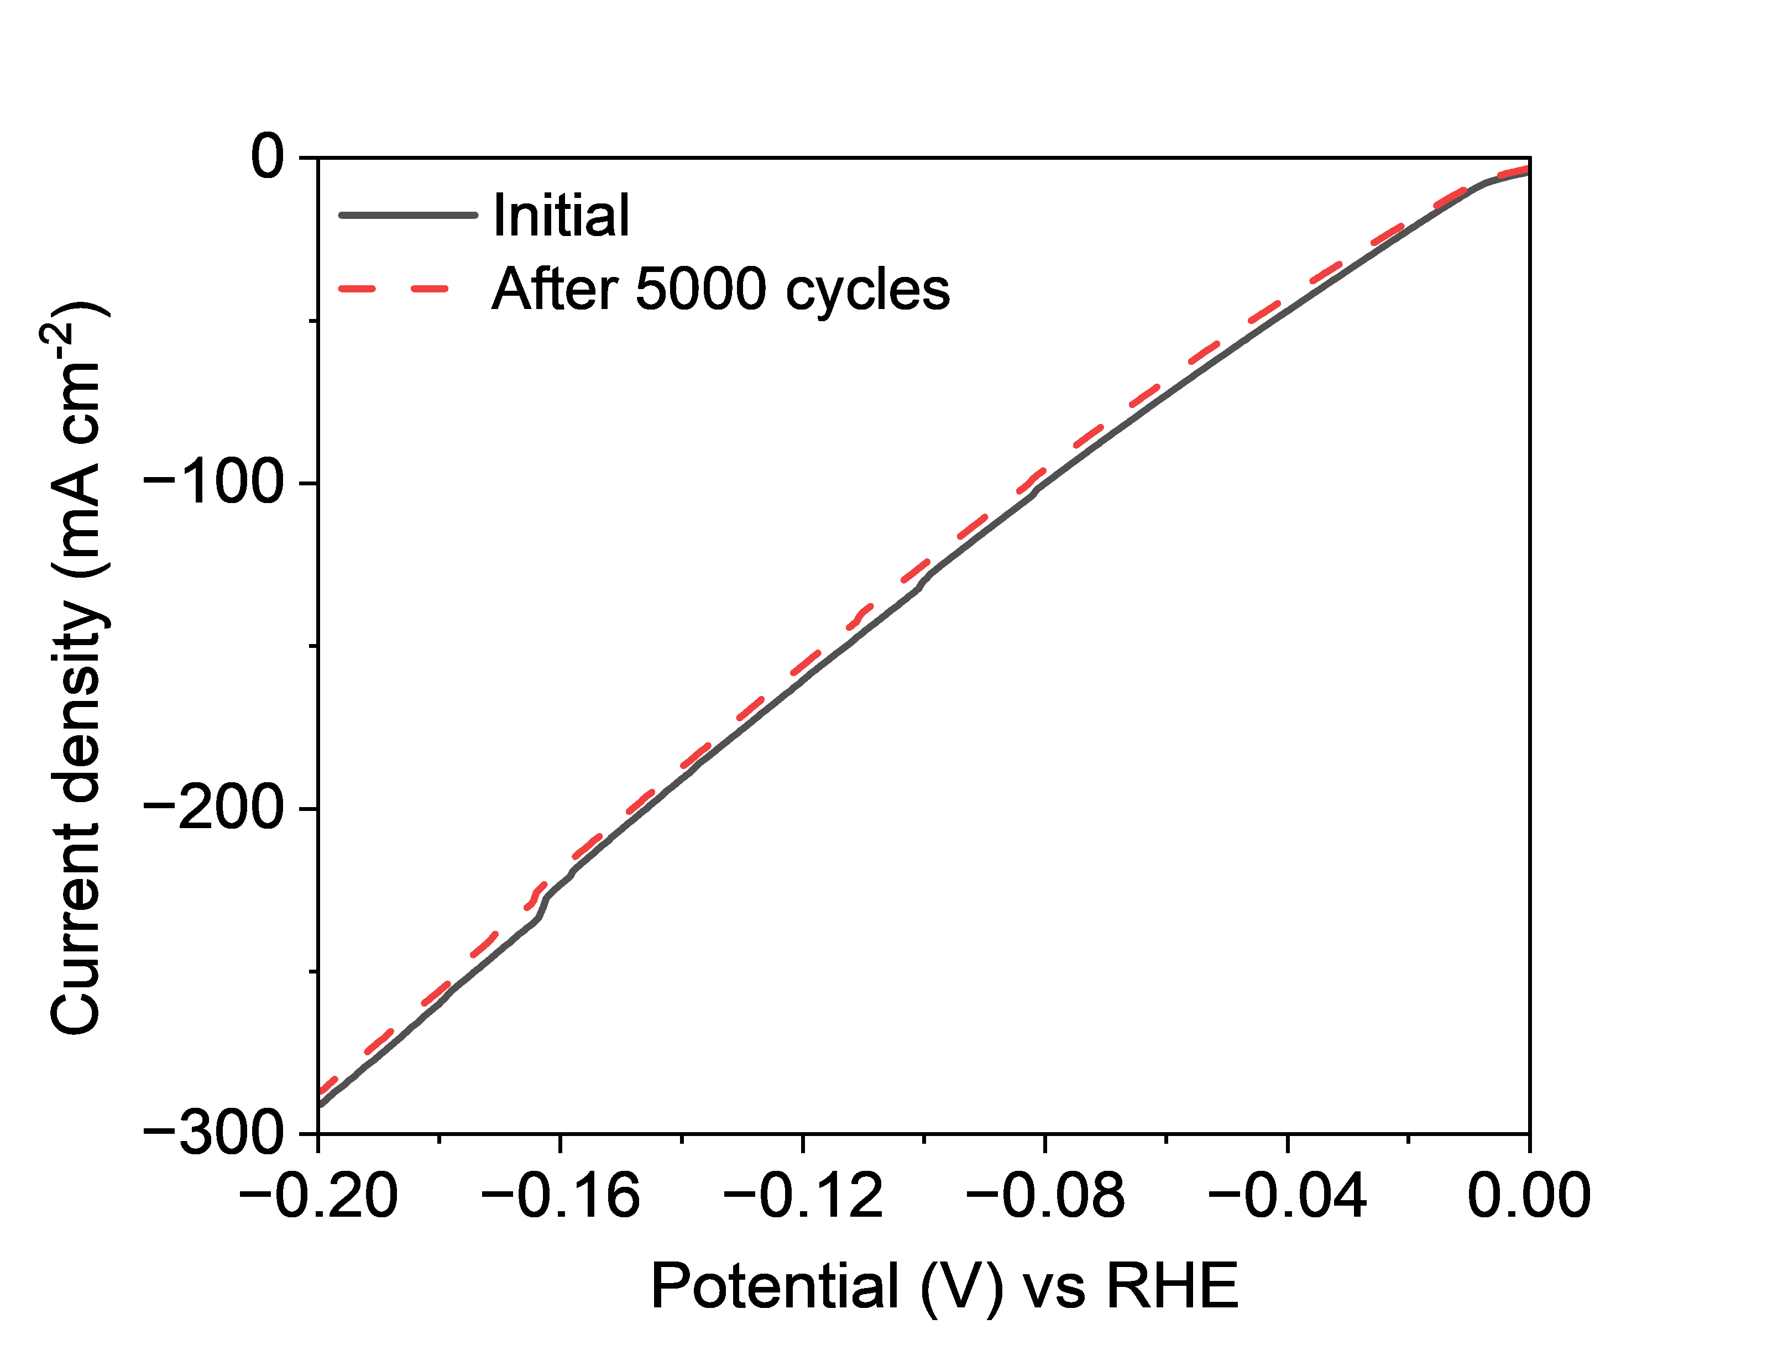
Fig. S17 The polarization curves of Pt/Mo₂N-NrGO after 5000 CV cycles from 0.0 V to -0.5 V (RHE) in 1.0 M KOH with a scan rate of 5 mV s⁻¹
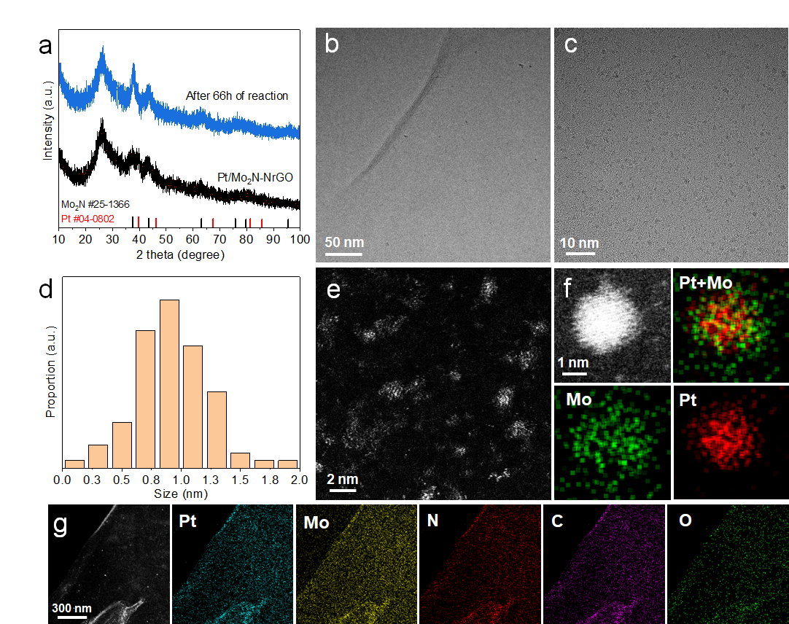
Fig. S18 The phase, morphology, and atomic distribution of Pt/Mo₂N-NrGO after stability test at 230 mA·cm⁻², for 66 h in 1 M KOH. a) XRD pattern obverses the characteristic peaks of Mo₂N without obvious peaks of Pt, indicating that the Pt/Mo₂N-NrGO have excellent phase structure stability. b) TEM and c) HRTEM show the Pt/Mo₂N quantum dots with d) an average size of 0.94 nm uniformly anchored on the NrGO matrix without aggregation. e) The HAADF-STEM image is consistent with Fig. 2a in the article. f) The magnified HAADF-STEM image and STEM-EDS mappings of a single nanocluster indicate that Pt atoms are anchored on the Mo₂N. g) The STEM-EDS mappings of Pt (cyan), Mo (yellow), N (red), C (purple), and O (green) show the uniform distribution of Pt/Mo₂N quantum dots.
The excellent stability of our Pt/Mo₂N-NrGO co-catalyst can be ascribed to the intimate contact between Pt atoms and Mo₂N clusters through strong metal-support interaction, as well as the strong combination of Pt/Mo₂N clusters to NrGO by metal-nitrogen/carbon chemical bonding.
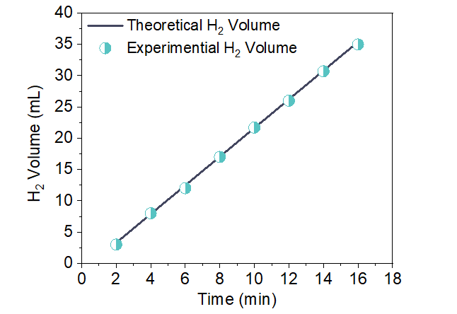
Fig. S19 The Faradaic efficient testing of Pt/Mo₂N-NrGO. The amount of H₂ was theoretically calculated (100%) and experimentally measured (99.87%) versus time on the electrocatalyst in mA·cm⁻²
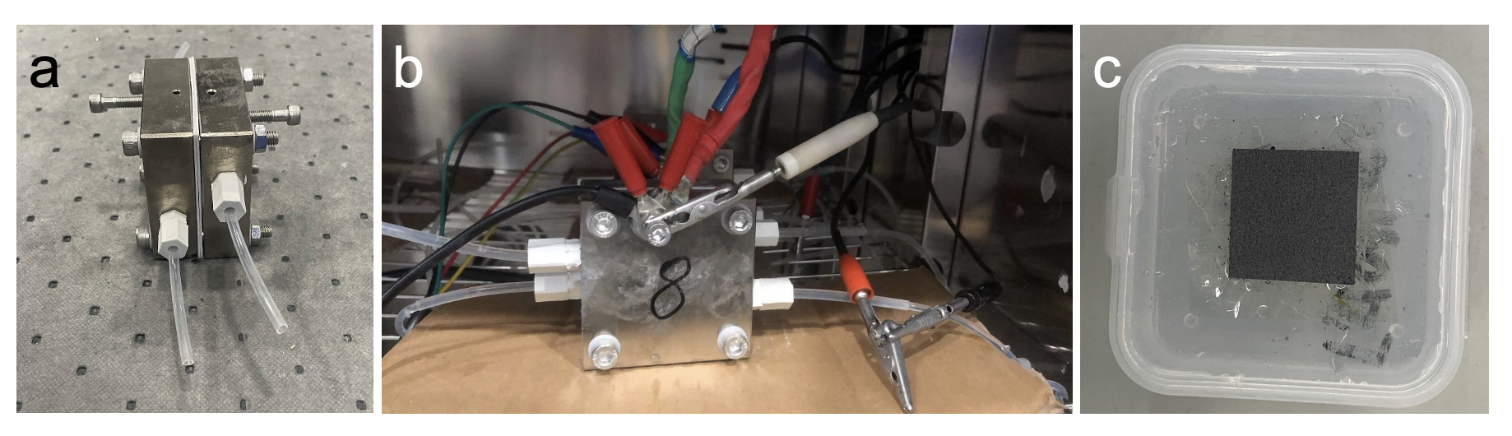
Fig. S20 a) and b) Image of our AEMWE electrolyzer. c) The image of the AEM membrane electrode
Technology-economy analysis:
A TEA analysis was conducted to estimate the CAPEX, OPEX and the resulting LOCH when scaling up our lab-scale product to 1MW industrialization, considering various operating conductions. The all calculations were conducted under the assumption of complete performance retention from the lab-scale tests to plant-scale, as well as the linear relationship between manufacturing costs per single and plant scale. The CAPEX of a generic 1 MW-scale AEMWE system was estimated based on the unitary cost of the diaphragm/electrode package (DEP), considering cost of raw materials of electrodes and the associate manufacture, providing by IRENA reports. The annual CAPEX was subsequently derived by factoring in the depreciation of the total CAPEX through a capital recovery factor (CRF). Besides, the OPEX-related calculations have been performed by the current density and associate voltage collected from our single AEMWE cell. In addition, we also estimated other operational expenses including process water consumption, labor costs, maintenance expenditures and miscellaneous ancillary charges, except for the electrical energy supplied to the electrolyzer. The production of H₂ of ideal AEMWE single cell per year was calculated using the Faraday’s law:
Annual H₂ production = $\frac{I×t×FE×MM(H2)}{n×F}$ (S1)
where I was the total current output of the plant per year, t was the time, FE was the Faradaic Efficiency, MM_{H2} was the molecular mass of H₂ (g·mol⁻¹), n was the number of electrons transferred during the generation of H₂ molecule and F was the Faradaic constant.
Finally, the LCOH of annual H₂ production was calculated as:
LCOH ($·kg_{H2}⁻¹) = $\frac{Annual CAPEX+Annual OPEX}{Annual H2 production}$ (S2)
where detailed CAPEX, OPEX and Annual H₂ production analysis was available in the section of technology-economy analysis of supporting information.
Details see the followings:
When scaling our single-cell device to an initial 1 MW-scale plant, we roughly estimate the LCOH of an AEMWE electrolyzer based on the average CAPEX, as published by IRENA (shown in the following Figure) [S2], and basic OPEX such as water and electricity supplied to the electrolyzer and other ancillary costs.
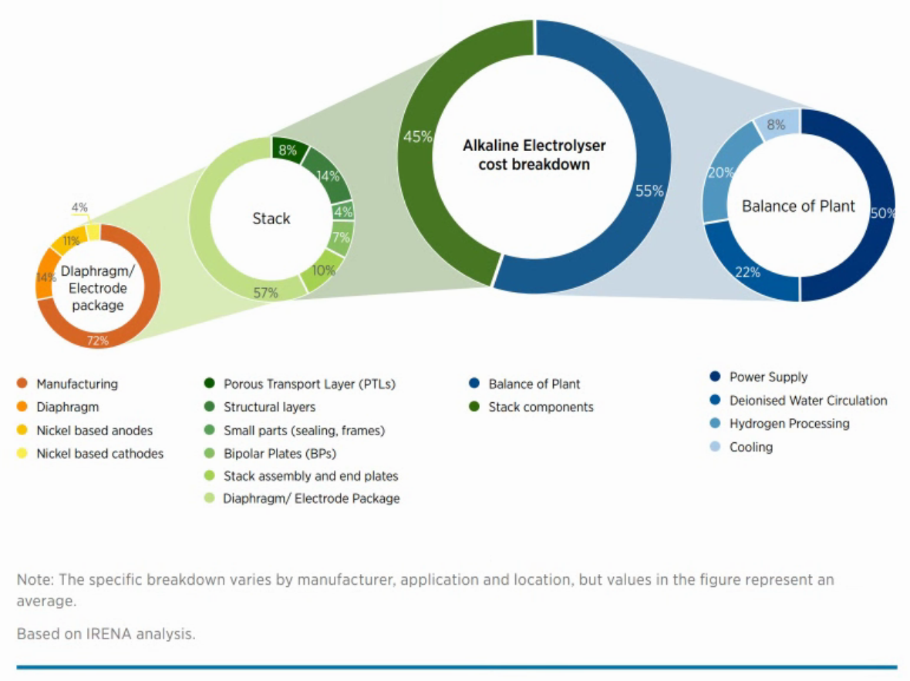
1. The unitary cost ($ per 1 cm²) of a diaphragm/electrode package (DEP) includes the cost of the cathode, anode, and diaphragm as follows (the catalyst load is 1.5 mg·cm⁻² and the area of the cathode and anode is 4 cm²):
The cost of raw materials of cathode:
 | Platinum¹ | Molybdenum² | Graphene Oxide³ | Carbon paper⁴
Loading (ug·cm⁻²) | 45.0 | 324.0 | 1113.0 | -
Cost ($) | 0.01224 | 0.00024 | 0.00385 | 0.0132
1 https://www.leyan.com/12325-31-4.html (cost of Na₂Pt(OH)₆ is 0.068 $·mg⁻¹)
2 http://www.macklin.cn/products/A915090 (cost of H₂₄Mo₇N₆O₂₄·4H₂O is 0.000178 $·mg⁻¹)
3 https://www.aladdin-e.com/zh_cn/g139805.html
4 https://m.tb.cn/h.5vI20LicJbcSvdN tk=QSTCWmHsnxt
The cost of raw materials of synthetic routes:
 |  | Volume (uL) | Mass (mg) | Cost ($)
Synthesis of PtMo6 | HNO₃¹ | 30.0 |  | 0.00019
Synthesis of PtMo6-PANI-GO | Aniline² | 3.25 |  | 0.00164
Synthesis of PtMo6-PANI-GO | H₂O₂³ | 2.77 |  | 0.00025
Synthesis of PtMo6-PANI-GO | HCl⁴ | 0.67 |  | 0.00032
Synthesis of Pt@Mo₂N-NrGO | Urea⁵ |  | 3.3 | 0.00005
1 https://www.reagent.com.cn/goodsDetail/Nitric-acid/%E7%A1%9D%E9%85%B8/d17ba41c5d3d469a94d684b93cfd372e
2 https://www.energy-chemical.com/front/search_goodsbyclass.htm keyword=%E8%8B%AF%E8%83%BA
3 https://www.reagent.com.cn/goodsDetail/Hydrogen-peroxide-30%25-aqueous-solution/%E8%BF%87%E6%B0%A7%E5%8C%96%E6%B0%A230%25/e9b7901600624cba9e2d3f9413b0b40b
4 https://www.reagent.com.cn/goodsDetail/Hydrochloric-acid/%E7%9B%90%E9%85%B8/f3048cdd35044454869c9b959f0b98de
5 https://www.aladdin-e.com/zh_cn/u111897.html
Cost of cathode, anode and diaphragm per 1 cm²:
 | Cathode¹ | Anode² | Diaphragm³
Cost ($) | 0.00799 | 0.02 | 0.038
1 Cost of cathode = cost of raw materials of cathode + cost of raw materials of synthetic routes
2 NiFe LDH is from Adv. Funct. Mater. 2024, 34, 2310762
3 https://doi.org/10.1021/jacs.3c06726
2. Standard CAPEX of single AEMWE cell: The average cost per 1 MW stack components is estimated as 270 $·kW⁻¹ from previous literature [S3]. Therefore, the CAPEX of an ideal 1 MW AEMWE system is 600000 $ calculated as following:
CAPEX of ideal 1 MW AEMWE = $\frac{270}{45}×$100$×$1000
Therefore, the cost breakdown from IRENA is showing following:
 |  | Proportion (%) | Actual cost ($·MW⁻¹) |  | Proportion in stack components/BOP (%) | Actual cost ($·MW⁻¹) |  | Proportion in DEP (%) | Actual cost ($·MW⁻¹)
 | Stack components | 45 | 270000 | PTLs | 8 | 21600
 | Stack components | 45 | 270000 | Structural layers | 14 | 37800
 | Stack components | 45 | 270000 | Small parts | 4 | 10800
 | Stack components | 45 | 270000 | BPs | 7 | 18900
 | Stack components | 45 | 270000 | Stack assembly and end plates | 10 | 27000
 | Stack components | 45 | 270000 | DEP | 57 | 153900 | Cell manufacturing | 72 | 110808
 |  |  |  |  |  |  | Diaphragm | 14 | 21546
 |  |  |  |  |  |  | Anode | 11 | 16929
 |  |  |  |  |  |  | Cathode | 4 | 6156
 | BOP | 55 | 330000 | Power supply | 50 | 165000
 | BOP | 55 | 330000 | DI circulation | 22 | 72600
 | BOP | 55 | 330000 | H2 processing | 20 | 66000
 | BOP | 55 | 330000 | Cooling | 8 | 26400
The basic parameter of 1 MW AEMWE cell:
Cell voltage | 1.8 V
Current density | 1 A·cm⁻²
Electrode area | 700 cm⁻²
Cell power | 1.8 W·cm⁻²
Cell power | 1260 W
Cells per stack | 200 units
Stacks in the system | 5 units
Gross system power | 1.26 MW
Stack (cell) efficiency | 82 % at Higher heating value¹
Stack power | 1.03 MW
1 Higher heating value (HHV) is from IRENA.
3. The cost breakdown of our cell stacks:
Electrode area | 700 cm⁻²
Cost of cathodel | 5.6 $·cm⁻¹
Cost of anode | 14 $·cm⁻¹
Cost of diaphragm | 26.6 $·cm⁻¹
Our DEP is calculated as following:
 |  | Proportion in stack components/BOP (%) |  | Actual cost ($·MW⁻¹) |  |  |  | Proportion in DEP (%) |  | Actual cost ($·MW⁻¹)
 | DEP |  | 58.2 |  | 157006 |  | Cell manufacturing |  | 70.576 |  | 110.808
 |  |  |  |  |  |  | Diaphragm |  | 16.942 |  | 26.600
 |  |  |  |  |  |  | Anode |  | 8.917 |  | 14.000
 |  |  |  |  |  |  | Cathode |  | 3.565 |  | 5.598
4. The capital recovery factor (CRF) has been estimated according to the equation:
CRF = $\frac{i × {\left(1+i\right)}^{n}}{{\left(1+i\right)}^{n}-1}$ = 0.061
where i is the discount rate (set it as 4.5%) and n is the AEMWE plant lifetime (set is as 30 years).
5. CAPEX and OPEX calculated: The CAPEX is calculated based electrochemical data on the Higher Heating Value (HHV = 141.7 kJ·g_{H2}⁻¹) and Lower Heating Value (LHV = 120.0 kJ·g_{H2}⁻¹).
The electrochemical data are shown as following:
operative conditions | Current density (mA cm⁻²) | Cell voltage (V) | Single cell power (W) | Desired system net power (MW) | Energy Efficiency (%, HHV) | Required system gross power (MW) | Cells required to meet the ideal 1 MW-scale, HHV (net system power) | Overall electricity fed to the AEL, HHV (A) | Energy Efficiency (%, LHV) | Required system gross power LHV (MW) | Cells required to meet the ideal 1 MW-scale, LHV (net system power) | Overall electricity fed to the AEL, LHV (A)
1 | 118.025 | 1.4599 | 120.6132883 | 1 | 99.4022222 | 0.986171682 | 8176.310388 | 675506.3234 | 85.87344154 | 1.164504394 | 9654.859849 | 797660.3836
2 | 180.525 | 1.4799 | 187.0112633 | 1 | 99.0318293 | 0.999681808 | 5345.570051 | 675506.3234 | 84.71291121 | 1.180457602 | 6312.227302 | 797660.3836
3 | 245.475 | 1.4999 | 257.7315668 | 1 | 98.69798267 | 1.013191935 | 3931.190685 | 675506.3234 | 83.58333042 | 1.196410809 | 4642.081001 | 797660.3836
4 | 319.425 | 1.52 | 339.8682 | 1 | 97.39283172 | 1.026769612 | 3021.081736 | 675506.3234 | 82.47805086 | 1.212443783 | 3567.394016 | 797660.3836
5 | 394.925 | 1.54 | 425.72915 | 1 | 96.12798975 | 1.040279738 | 2443.524805 | 675506.3234 | 81.40690734 | 1.228396991 | 2885.39554 | 797660.3836
6 | 472.675 | 1.5599 | 516.1280128 | 1 | 94.90166306 | 1.053722314 | 2041.591016 | 675506.3234 | 80.36838086 | 1.244270432 | 2410.778725 | 797660.3836
7 | 560.725 | 1.5799 | 620.1225993 | 1 | 93.70030015 | 1.06723244 | 1721.002334 | 675506.3234 | 79.35099519 | 1.26022364 | 2032.216922 | 797660.3836
8 | 641.525 | 1.5999 | 718.4630933 | 1 | 92.52897319 | 1.080742567 | 1504.242288 | 675506.3234 | 78.35904575 | 1.276176848 | 1776.259434 | 797660.3836
9 | 738.575 | 1.6199 | 837.4923498 | 1 | 91.38656967 | 1.094252693 | 1306.582315 | 675506.3234 | 77.39159041 | 1.292130055 | 1542.855951 | 797660.3836
10 | 828.3 | 1.6399 | 950.830419 | 1 | 90.27203135 | 1.10776282 | 1165.047728 | 675506.3234 | 76.44773297 | 1.308083263 | 1375.727193 | 797660.3836
11 | 1027.825 | 1.6799 | 1208.650252 | 1 | 88.12256933 | 1.134783073 | 938.8845703 | 675506.3234 | 74.6274405 | 1.339989678 | 1108.666197 | 797660.3836
12 | 1132.875 | 1.6999 | 1348.041949 | 1 | 87.08577223 | 1.148293199 | 851.8230462 | 675506.3234 | 73.74941897 | 1.355942886 | 1005.861047 | 797660.3836
13 | 1343.3 | 1.7399 | 1636.045369 | 1 | 85.08368539 | 1.175313452 | 718.3868335 | 675506.3234 | 72.05393258 | 1.387849301 | 848.2951193 | 797660.3836
14 | 1458.175 | 1.7599 | 1796.369528 | 1 | 84.11677039 | 1.188823579 | 661.7923318 | 675506.3234 | 71.23509137 | 1.403802509 | 781.4664452 | 797660.3836
15 | 1687.2 | 1.7999 | 2125.753896 | 1 | 82.24740497 | 1.215843832 | 571.9588866 | 675506.3234 | 69.65200139 | 1.435708924 | 675.3881186 | 797660.3836
16 | 1794.925 | 1.8199 | 2286.608805 | 1 | 81.34353767 | 1.229353958 | 537.6319531 | 675506.3234 | 68.88655272 | 1.451662132 | 634.8537313 | 797660.3836
17 | 2032.475 | 1.8599 | 2646.140177 | 1 | 79.59412023 | 1.256374211 | 474.7950324 | 675506.3234 | 67.40504183 | 1.483568547 | 560.6538008 | 797660.3836
18 | 2179.1 | 1.8799 | 2867.543063 | 1 | 78.74732923 | 1.269884337 | 442.8475212 | 675506.3234 | 66.68792877 | 1.499521755 | 522.9291146 | 797660.3836
19 | 2403.3 | 1.9199 | 3229.866969 | 1 | 77.10667442 | 1.29690459 | 401.5349867 | 675506.3234 | 65.29852456 | 1.53142817 | 474.1458968 | 797660.3836
20 | 2592.225 | 1.94 | 3520.24155 | 1 | 76.30778568 | 1.310482267 | 372.2705527 | 675506.3234 | 64.62197799 | 1.547461144 | 439.5894777 | 797660.3836
21 | 2742.15 | 1.96 | 3762.2298 | 1 | 75.5291348 | 1.323992394 | 351.9169387 | 675506.3234 | 63.96257005 | 1.563414352 | 415.5552518 | 797660.3836
22 | 2832.6 | 1.9799 | 3925.785318 | 1 | 74.76999051 | 1.33743497 | 340.6795995 | 675506.3234 | 63.31968145 | 1.579287793 | 402.2858271 | 797660.3836
23 | 3031.175 | 1.9999 | 4243.432818 | 1 | 74.02225322 | 1.350945096 | 318.3613726 | 675506.3234 | 62.68645297 | 1.595241001 | 375.9317208 | 797660.3836
Total CAPEX is calculated as the function:
Total CAPEX = $\frac{i × {\left(1+i\right)}^{n}}{{\left(1+i\right)}^{n}-1}$ = 0.061=Single cell CAPEX of DEP $×$ Cells required to meet the ideal 1MW-scale + ideal actual cost of stack components except for DEP + BOP
The total and annual CAPEX on HHV and LHV are calculated as following:
Operative conditions | Total CAPEX of HHV ($) | Annual CAPEX of HHV ($ year⁻¹) | Total CAPEX of LHV ($) | Annual CAPEX of LHV ($ year⁻¹)
1 | 1729827.269 | 106196.765 | 1961967.95 | 120448.2396
2 | 1285384.924 | 78911.76372 | 1437155.614 | 88229.20057
3 | 1063319.313 | 65278.81324 | 1174933.139 | 72130.95822
4 | 920427.028 | 56506.43538 | 1006201.166 | 61772.24203
5 | 829747.3024 | 50939.46712 | 899123.523 | 55198.58034
6 | 766641.4099 | 47065.29901 | 824605.9815 | 50623.8335
7 | 716307.162 | 43975.20187 | 765169.6238 | 46974.94379
8 | 682274.601 | 41885.89044 | 724982.8414 | 44507.81521
9 | 651240.8603 | 39980.68122 | 688337.1659 | 42258.08066
10 | 629019.1246 | 38616.45458 | 662096.9996 | 40647.15636
11 | 593510.2215 | 36436.50823 | 620166.9032 | 38073.00305
12 | 579841.0667 | 35597.33773 | 604025.9096 | 37082.08255
13 | 558890.8218 | 34311.16987 | 579287.1621 | 35563.33267
14 | 550005.1629 | 33765.66556 | 568794.6799 | 34919.18299
15 | 535900.8007 | 32899.777 | 552139.7788 | 33896.71292
16 | 530511.2767 | 32568.90581 | 545775.6493 | 33506.00919
17 | 520645.5225 | 31963.23194 | 534125.8379 | 32790.80929
18 | 515629.5814 | 31655.29557 | 528202.8474 | 32427.18777
19 | 509143.2784 | 31257.09142 | 520543.6045 | 31956.97503
20 | 504548.5957 | 30975.01676 | 515118.0501 | 31623.89187
21 | 501352.9624 | 30778.83191 | 511344.5398 | 31392.23026
22 | 499588.6362 | 30670.5172 | 509261.1646 | 31264.32864
23 | 496084.5475 | 30455.39579 | 505123.4199 | 31010.30611
The OPEX includes the main operating expenses i.e., the electricity fed to the AEMWE, the process water consumed, labor, maintenance and ancillary costs, is calculated according to the following equations:
OPEX_{electricity}:
I_{total} = i $×$ A_{single cell} $×$ n_{cells per stack} $×$ n_{stacks per system}
P_{gross} = I_{total} $×$ E_{cell} $×$ t_{annual AEMWE operation}
OPEX_{electricity} = P_{gross} $×$ Celectricity
where I and i indicate the current and current density, A stands for area, E for voltage, P for power, t for time and C for cost, respectively.
OPEX_{H2O}:
m_{H2O consumed per year} = m _{produced H2 per year} $×$ m_{H2O consumption per kg}
OPEX_{H2O} = m_{H2O consumed per year} $×$ C_{H2O}
where m indicates mass.
The other costs of labor (0.3% of total CAPEX), maintenance (2.5% of total CAPEX) and other ancillary (1% of total CAPEX) are calculated as percentages of the total CAPEX of the whole system. Therefore, the OPEX is calculated as following:
HHV |  |  |  |  |  | LHV
Annual electricity cost ($ year-1) | Labour ($ year-1) | Water-related expenses ($ year-1) | Maintainance ($ year-1) | Other ancillary costs ($ year-1) | Annual OPEX ($ year-1) | Annual electricity cost ($ year-1) | Labour ($ year-1) | Wate-related expenses ($ year-1) | Maintainance ($ year-1) | Other ancillary costs ($ year-1) | Annual OPEX ($ year-1)
165676.8425 | 5189.481807 | 2987.720536 | 43245.68172 | 17298.27269 | 400074.8418 | 195636.7382 | 5885.90385 | 3528 | 49049.19875 | 19619.6795 | 469356.2585
167946.5438 | 3856.154772 | 2987.720536 | 32134.6231 | 12853.84924 | 387725.4352 | 198316.8771 | 4311.466843 | 3528 | 35928.89036 | 14371.55614 | 454773.6675
170216.245 | 3189.95794 | 2987.720536 | 26582.98283 | 10633.19313 | 383826.3444 | 200997.016 | 3524.799417 | 3528 | 29373.32848 | 11749.33139 | 450169.4912
172497.2948 | 2761.281084 | 2987.720536 | 23010.6757 | 9204.27028 | 382958.5371 | 203690.5556 | 3018.603497 | 3528 | 25155.02914 | 10062.01166 | 449144.7554
174766.996 | 2489.241907 | 2987.720536 | 20743.68256 | 8297.473024 | 384052.11 | 206370.6944 | 2697.370569 | 3528 | 22478.08807 | 8991.23523 | 450436.0828
177025.3487 | 2299.92423 | 2987.720536 | 19166.03525 | 7666.414099 | 386170.7916 | 209037.4326 | 2473.817945 | 3528 | 20615.14954 | 8246.059815 | 452937.8926
179295.05 | 2148.921486 | 2987.720536 | 17907.67905 | 7163.07162 | 388797.4927 | 211717.5715 | 2295.508871 | 3528 | 19129.2406 | 7651.696238 | 456039.5888
181564.7512 | 2046.823803 | 2987.720536 | 17056.86503 | 6822.74601 | 392043.6578 | 214397.7104 | 2174.948524 | 3528 | 18124.57103 | 7249.828414 | 459872.7688
183834.4525 | 1953.722581 | 2987.720536 | 16281.02151 | 6512.408603 | 395403.7782 | 217077.8493 | 2065.011498 | 3528 | 17208.42915 | 6883.371659 | 463840.5109
186104.1537 | 1887.057374 | 2987.720536 | 15725.47812 | 6290.191246 | 399098.7547 | 219757.9882 | 1986.290999 | 3528 | 16552.42499 | 6620.969996 | 468203.6624
190643.5562 | 1780.530665 | 2987.720536 | 14837.75554 | 5935.102215 | 406828.2214 | 225118.266 | 1860.50071 | 3528 | 15504.17258 | 6201.669032 | 477330.8743
192913.2575 | 1739.5232 | 2987.720536 | 14496.02667 | 5798.410667 | 410848.196 | 227798.4049 | 1812.077729 | 3528 | 15100.64774 | 6040.259096 | 482077.7943
197452.66 | 1676.672465 | 2987.720536 | 13972.27054 | 5588.908218 | 419130.8917 | 233158.6826 | 1737.861486 | 3528 | 14482.17905 | 5792.871621 | 491858.2774
199722.3612 | 1650.015489 | 2987.720536 | 13750.12907 | 5500.051629 | 423332.6391 | 235838.8215 | 1706.38404 | 3528 | 14219.867 | 5687.946799 | 496819.8409
204261.7637 | 1607.702402 | 2987.720536 | 13397.52002 | 5359.008007 | 431875.4784 | 241199.0993 | 1656.419336 | 3528 | 13803.49447 | 5521.397788 | 506907.5102
206531.4649 | 1591.53383 | 2987.720536 | 13262.78192 | 5305.112767 | 436210.079 | 243879.2382 | 1637.326948 | 3528 | 13644.39123 | 5457.756493 | 512025.9511
211070.8674 | 1561.936568 | 2987.720536 | 13016.13806 | 5206.455225 | 444913.9853 | 249239.516 | 1602.377514 | 3528 | 13353.14595 | 5341.258379 | 522303.8138
213340.5687 | 1546.888744 | 2987.720536 | 12890.73954 | 5156.295814 | 449262.782 | 251919.6549 | 1584.608542 | 3528 | 13205.07119 | 5282.028474 | 527439.0179
217879.9712 | 1527.429835 | 2987.720536 | 12728.58196 | 5091.432784 | 458095.1075 | 257279.9326 | 1561.630814 | 3528 | 13013.59011 | 5205.436045 | 537868.5223
220161.0209 | 1513.645787 | 2987.720536 | 12613.71489 | 5045.485957 | 462482.609 | 259973.4722 | 1545.35415 | 3528 | 12877.95125 | 5151.180501 | 543049.4303
222430.7222 | 1504.058887 | 2987.720536 | 12533.82406 | 5013.529624 | 466900.5775 | 262653.6111 | 1534.033619 | 3528 | 12783.61349 | 5113.445398 | 548266.3147
224689.0749 | 1498.765909 | 2987.720536 | 12489.71591 | 4995.886362 | 471350.2386 | 265320.3493 | 1527.783494 | 3528 | 12731.52911 | 5092.611646 | 553520.6229
226958.7762 | 1488.253643 | 2987.720536 | 12402.11369 | 4960.845475 | 475756.4857 | 268000.4882 | 1515.37026 | 3528 | 12628.0855 | 5051.234199 | 558723.6663
6. Annual H₂ productivity-1 MW net power is estimated by following function:
Annual H₂ productivity = $\frac{Total current × t}{n × F}$ $×$ $\frac{FEH2× MH2}{100}$ ÷ 1000
where t stands for time (1 year=30240000s), n for mole of electrons of H₂, F for Faraday constant, FE for Faraday efficiency, M_{H2} for molar mass of H₂, as following.
Operative conditions | Total current of HHV (A) | Total current of LHV (A) | Annual H₂ production of HHV (kg· year⁻¹) | Annual H₂ production of LHV (kg· year⁻¹)
1 | 675506.3234 | 797660.3836 | 213408.6097 | 252000
2 | 675506.3234 | 797660.3836 | 213408.6097 | 252000
3 | 675506.3234 | 797660.3836 | 213408.6097 | 252000
4 | 675506.3234 | 797660.3836 | 213408.6097 | 252000
5 | 675506.3234 | 797660.3836 | 213408.6097 | 252000
6 | 675506.3234 | 797660.3836 | 213408.6097 | 252000
7 | 675506.3234 | 797660.3836 | 213408.6097 | 252000
8 | 675506.3234 | 797660.3836 | 213408.6097 | 252000
9 | 675506.3234 | 797660.3836 | 213408.6097 | 252000
10 | 675506.3234 | 797660.3836 | 213408.6097 | 252000
11 | 675506.3234 | 797660.3836 | 213408.6097 | 252000
12 | 675506.3234 | 797660.3836 | 213408.6097 | 252000
13 | 675506.3234 | 797660.3836 | 213408.6097 | 252000
14 | 675506.3234 | 797660.3836 | 213408.6097 | 252000
15 | 675506.3234 | 797660.3836 | 213408.6097 | 252000
16 | 675506.3234 | 797660.3836 | 213408.6097 | 252000
17 | 675506.3234 | 797660.3836 | 213408.6097 | 252000
18 | 675506.3234 | 797660.3836 | 213408.6097 | 252000
19 | 675506.3234 | 797660.3836 | 213408.6097 | 252000
20 | 675506.3234 | 797660.3836 | 213408.6097 | 252000
21 | 675506.3234 | 797660.3836 | 213408.6097 | 252000
22 | 675506.3234 | 797660.3836 | 213408.6097 | 252000
23 | 675506.3234 | 797660.3836 | 213408.6097 | 252000
7. The levelized cost of H₂ production (LCOH) is calculated as following equation:
LCOH ($·kg_{H2}⁻¹) = $\frac{Annual CAPEX+Annual OPEX}{Annual H2 production}$
and the results are represented as following:
Operative conditions | Current density (mA cm-2) | LCOH of HHV ($·kg_{H2}⁻¹) | LCOH of LHV ($·kg_{H2}⁻¹)
1 | 118.025 | 2.372311067 | 2.34049404
2 | 180.525 | 2.186590314 | 2.154773286
3 | 245.475 | 2.104437859 | 2.072620831
4 | 319.425 | 2.05926543 | 2.027448403
5 | 394.925 | 2.038303786 | 2.006486758
6 | 472.675 | 2.030077845 | 1.998260818
7 | 560.725 | 2.027906442 | 1.996089415
8 | 641.525 | 2.033327281 | 2.001510254
9 | 738.575 | 2.040144772 | 2.008327744
10 | 828.3 | 2.051066308 | 2.019249281
11 | 1027.825 | 2.077070509 | 2.045253481
12 | 1132.875 | 2.091975269 | 2.060158241
13 | 1343.3 | 2.124759925 | 2.092942897
14 | 1458.175 | 2.141892519 | 2.110075492
15 | 1687.2 | 2.177865532 | 2.146048504
16 | 1794.925 | 2.196626394 | 2.164809366
17 | 2032.475 | 2.234573468 | 2.202756441
18 | 2179.1 | 2.25350832 | 2.221691292
19 | 2403.3 | 2.293029318 | 2.261212291
20 | 2592.225 | 2.312266719 | 2.280449691
21 | 2742.15 | 2.332049349 | 2.300232321
22 | 2832.6 | 2.352392232 | 2.320575204
23 | 3031.175 | 2.372031204 | 2.340214176

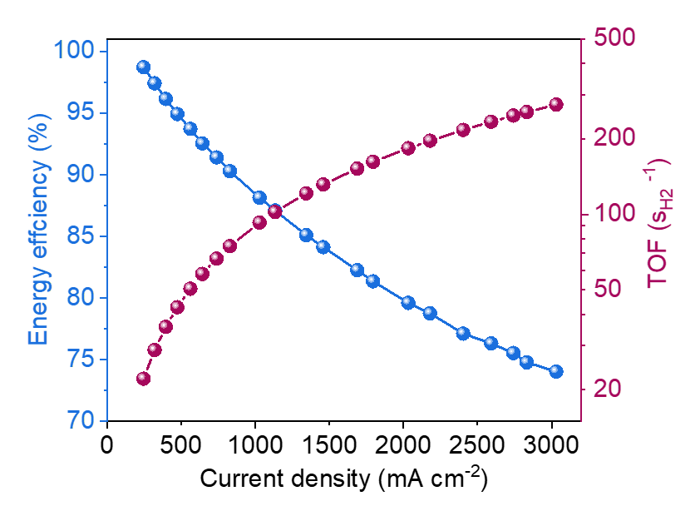
Fig. S21 H₂ energy efficiency and TOF values of Pt/Mo₂N-NrGO||NiFe LDH

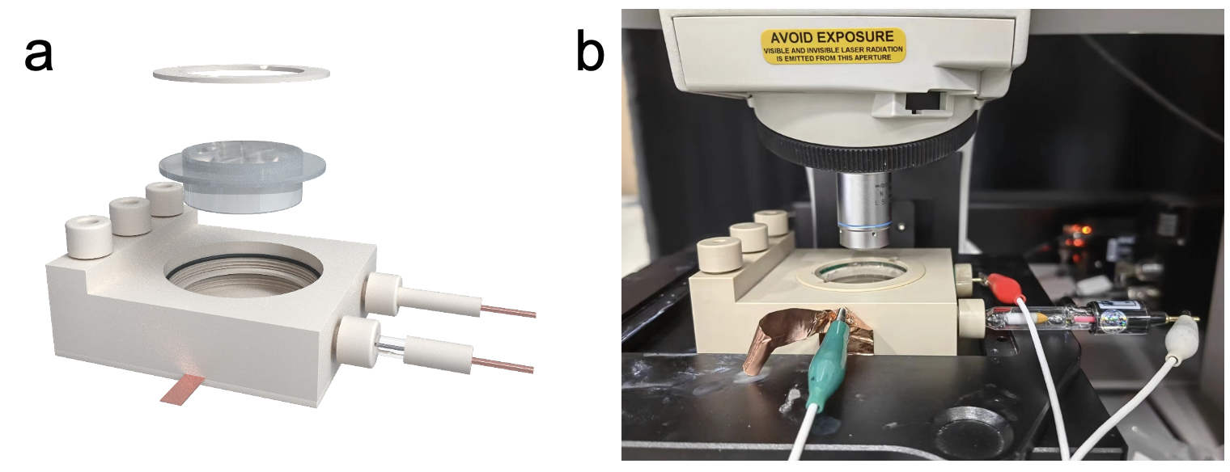
Fig. S22 a) The scheme and b) image of in-situ Raman spectroscopy measurement. Pt wire and Hg/HgO are used as counter electrode and (CE) reference electrode, respectively

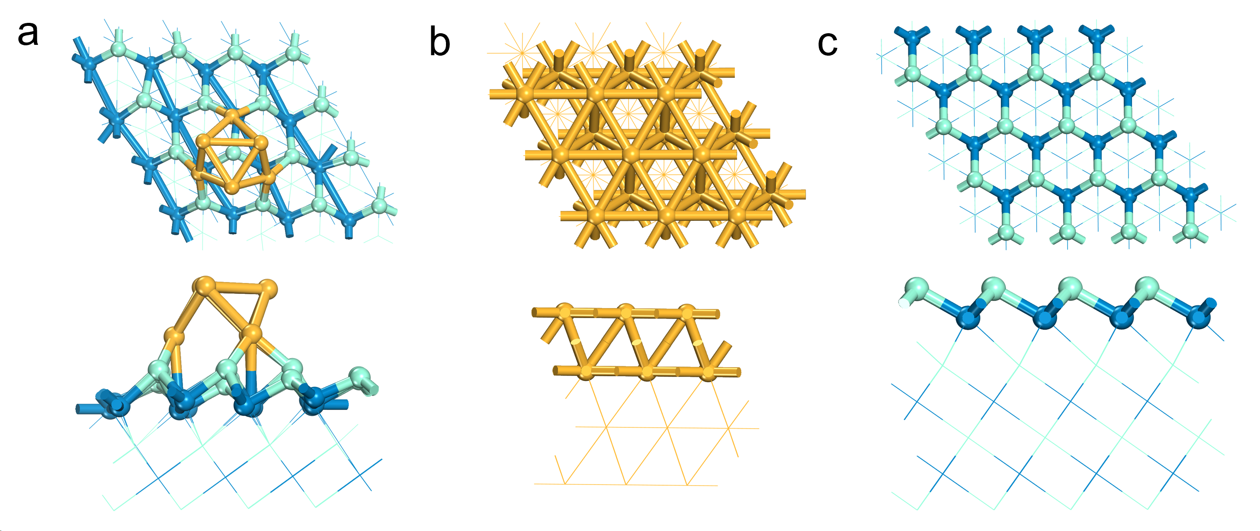
Fig. S23 The optimized models of a) Pt/Mo₂N, b) Pt and c) Mo₂N by DFT relaxation. The blue is Mo atom, the yellow is Pt atom and the green is N atom

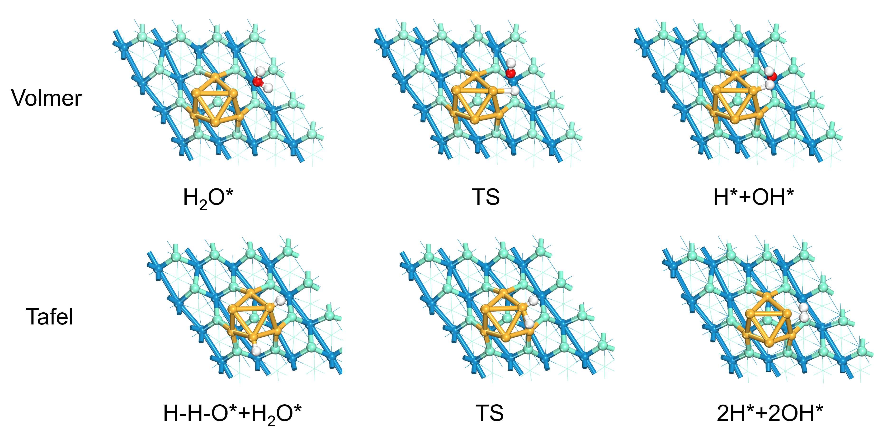
Fig. S24 Elementary processes of the Volmer and the Tafel mechanism for the HER on Pt/Mo₂N. The blue, yellow, green, red, and white balls represent the Mo, Pt, N, O, and H atoms, respectively

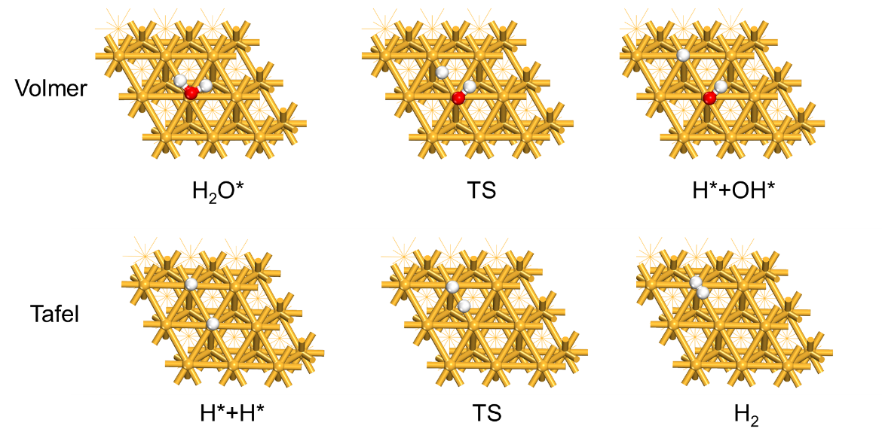
Fig. S25 Elementary processes of the Volmer and the Tafel mechanism for the HER on Pt. The yellow, red, and white balls represent the Pt, O, and H atoms, respectively

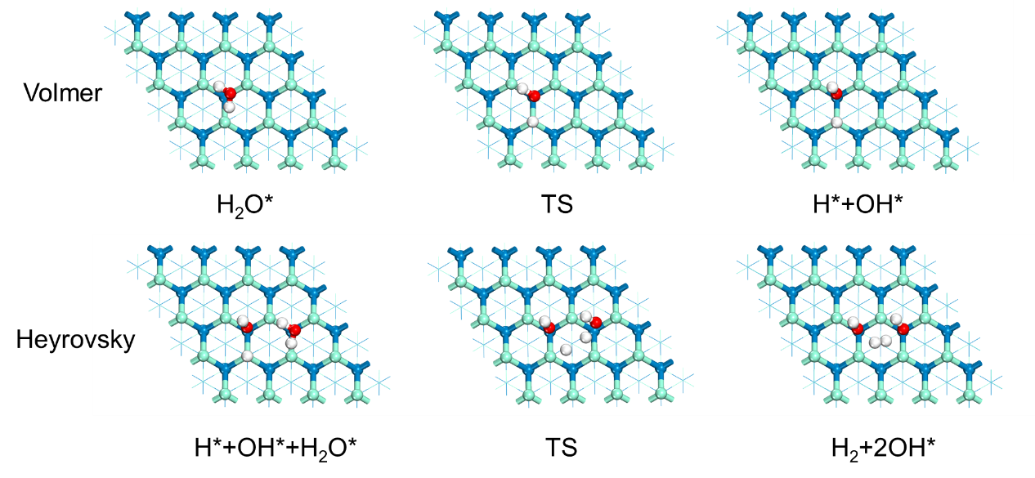
Fig. S26 Elementary processes of the Volmer and the Tafel mechanism for the HER on Mo₂N. The blue, green, red, and white balls represent the Mo, N, O, and H atoms, respectively
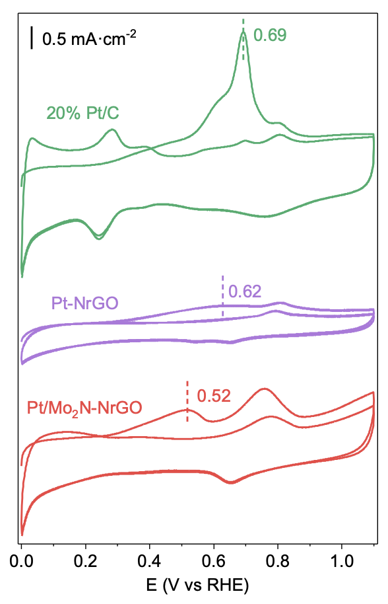
Fig. S27 The CO stripping voltammetry measurements of commercial Pt/C, Pt-NrGO and Pt/Mo₂N-NrGO. The dashed lines represent the CO oxidation potentials of above three samples
Table S1 Summary of elemental analysis of Pt/Mo₂N-NrGO co-catalysis
Catalysts | Pt content (wt%) | Mo content (wt%)
Pt/Mo₂N-NrGO | 3.394 | 14.923
Notes: Data are determined by ICP-AES elemental analysis.
Table S2 Summary of FWHM, lattice parameters and crystallite sizes of Pt/Mo₂N-NrGO
 | Peak positions/ 2 theta | FWHM/2 theta | Lattice parameters | Crystallite sizes/nm
Mo₂N of Pt/Mo₂N-NrGO | 37.30 | 3.76 | (111) | 2.1
Mo₂N of Pt/Mo₂N-NrGO | 42.76 | 3.26 | (200) | 2.5
Mo₂N of Pt/Mo₂N-NrGO | 62.55 | 3.15 | (220) | 2.9
Pt of Pt/Mo₂N-NrGO | 39.75 | 2.90 | (111) | 2.8
Pt of Pt/Mo₂N-NrGO | 46.16 | 2.56 | (200) | 3.3
Pt of Pt/Mo₂N-NrGO | 67.31 | 2.50 | (220) | 3.8
Mo₂N-NrGO | 37.57 | 2.41 | (111) | 3.4
Mo₂N-NrGO | 42.83 | 2.22 | (200) | 3.8
Mo₂N-NrGO | 61.92 | 2.09 | (220) | 4.4
Table S3 Area of XPS results
Catalysts | Pt⁴⁺:Pt⁰ | MoOx:Mo-N
Pt/Mo₂N-NrGO | 1.16 | 0.59
Pt-NrGO | 0.50 | -
Mo₂N-NrGO | - | 0.65
Notes: Data are from Fig. 3b, c.
Table S4 Summary of the HER activity of Pt/Mo₂N-NrGO, Pt-NrGO, Mo₂N-NrGO and 20% Pt/C on CP in 1.0 M KOH
Catalysts | η _{onset} (mV) | η ₁₀  (mV) | η ₁₀₀  (mV) | Tafel slope (mV dec⁻¹) | R_{s} ^{a)}  (Ω) | R_{p} ^{a)}  (Ω) | R_{ct} ^{a)}  (Ω) | W_{d} ^{a)} (Ω cm⁻²) | C_{dl} ^{b)}  (mF cm⁻²)
Pt/Mo₂N-NrGO | ~0 | 11 | 102.2 | 31 | 1.25 | 4.32 | 2.53 | 1.25 | 28.39
Pt/Mo₂N-NrGO after 5000 CV cycles | ~0 | 12 | 129.5 | 33
20%Pt/C | ~0 | 18 | 133 | 39 | - | - | - | - | -
Pt-NrGO | ~0 | 32 | 170 | 44 | 14.35 | 107.7 | 86.4 | 1.79 | 19.23
Mo₂N-NrGO | 15 | 180 | - | 178 | 1.53 | 350.9 | 230.9 | 2.17 | 14.58
Notes: EIS Data are measured at η = 0 mV vs. RHE. Notes: Rs, Rp, Rct and W_{d} represent the electrolyte, electrode porosity, charge transfer resistance and Warburg impedance, respectively.
Table S5 Comparison of HER performance for Pt/Mo₂N-NrGO and the performance of AEMWE cell (Pt/Mo₂N-NrGO || NiFe LDH) with other Pt-based electrocatalysts in 1.0 M KOH
Catalyst | Tafel slope (mV dec⁻¹) | η₁₀^{a)}  (mV) | TOF at 0.1 V (s⁻¹) | AEMWE Cell | Cell voltage at 1A cm⁻² (V) | AEMWE stability | References
AlO@Mo₂N-NrGO | 31.0 | 11.0 | 6.3 | Pt/Mo₂N-NrGO || NiFe LDH | 1.87 | 95.24%@500h at 1.5 A·cm⁻² | This work
Pt/CoV-LDHs | 37 | 37.0 | 1.3 | - | - | - | [S4]
Pt-AD-NiOOH | 57.0 | 13.0 | - | - | - | - | [S5]
Pt–Ru/RuO₂ | 50.7 | 18.0 | - | Pt–Ru/RuO₂// NiFe LDH | 1.90 | - | [S6]
Pt–Ni₄Mo/CNT | 37.4 | 18.6 | 6.24 | - | - | - | [S7]
Pt/CeOx/C | 50 | 19 | - | - | - | - | [S8]
1%Pt-NiCoP@Mxene | 38.6 | 26.5 | 3.6 | 1%Pt-NiCoP@Mxene || NiFeLDH | 1.95 | 96%@500h at 0.5 A·cm⁻² | [S9]
Pt₁/CeOx | 34 | 37 | - | - | - | - | [S10]
2D-Pt/LDH | 32.2 | 25 | - | - | - | - | [S11]
Pt@CoS | 32.0 | 28 | 0.131 | - | - | - | [S12]
Pt/MgO | 39 | 39 | - | - | - | - | [S13]
Pt-AC/Cr−N−C | 32 | 19 | 4.1 | Pt-AC/Cr−N−C || NiFeLDH | 1.9 | 9 mV@100h at 0.5 A·cm⁻² | [S14]
Pt1.5Rh1.5Tm | 33.8 | 20 | - | - | - | - | [S15]
Pt-a/c-CoN | 33.6 | 19 | - | - | - | - | [S16]
HEA-PdPtRhIrCu | 37 | 15 | 3.16 |  |  |  | [S17]
Pt_{SA}–Mn3O4 | 54 | 24 |  |  |  |  | [S18]
CC@MoS2/Pt1,n | 40.8 | 35.6 | 1.27 |  |  |  | [S19]
PtRu NCs/BP | 43 | 22 |  |  |  |  | [S20]
Pt–C core-shell@h-MoS2/GNF | 32 | 30 | - | Pt–C core-shell@h-MoS2/GNF || NiCo2O4 | 2.08 | 14h at 0.1 A·cm⁻² | [S21]
Pt@Co-NPC-800 | 42.72 | 34 |  | Pt@Co-NPC-800 || NiCo2O4 | 2.2 | 20 h at 0.3 A·cm⁻² | [S22]
Pd44Pt30Ir26ASNSs/C | 36.1 | 17 |  | Pd44Pt30Ir26ASNSs/C || Pd44Pt30Ir26ASNSs/C | 1.8 V (400 mA cm⁻²) | 40 h at 0.5 A·cm⁻² | [S23]
Turing PtNiNb | 30 | 27.2 | 27.5 | Turing PtNiNb || PtIr | 1.98 | 500 h at 1 A·cm⁻² | [S24]
Cl-Pt/LDH | 75.6 | 25.2 | 30.3 | Cl-Pt/LDH || Ir/C | 1.99 | 32 mV@20h at 1 A·cm⁻² | [S25]
aPt/pNi-NOMC | 40 | 65 | - | aPt/pNi-NOMC || Co3O4 | 1.9 | 200 h at 0.5 A·cm⁻² | [S26]
Supplementary References
- F.-Y. Yu, Z.-L. Lang, Y.-J. Zhou, K. Feng, H.-Q. Tan et al., Revealing hydrogen evolution performance of single-atom platinum electrocatalyst with polyoxometalate molecular models. ACS Energy Lett. 6(11), 4055–4062 (2021). https://doi.org/10.1021/acsenergylett.1c01911
- E. Taibi, H. Blanco, R. Miranda, M. Carmo. Hydrogen cost reduction: Scaling up electrolysers to meet the 1.5 oc climate goal. (IRENA; Abu Dhabi, 2020).
- B. Lee, H.-S. Cho, H. Kim, D. Lim, W. Cho et al., Integrative techno-economic and environmental assessment for green H₂ production by alkaline water electrolysis based on experimental data. J. Environ. Chem. Eng. 9(6), 106349 (2021). https://doi.org/10.1016/j.jece.2021.106349
- X. Li, Y. Yan, Y. Yao, Y. Liu, Three-in-one tandem catalysis for alkaline hydrogen evolution reaction on Pt/CoV-LDHs. Chem. Eng. J. 489, 151237 (2024). https://doi.org/10.1016/j.cej.2024.151237
- Z. Lin, Z. Wang, J. Gong, T. Jin, S. Shen et al., Reversed spillover effect activated by Pt atom dimers boosts alkaline hydrogen evolution reaction. Adv. Funct. Mater. 33(45), 2307510 (2023). https://doi.org/10.1002/adfm.202307510
- Y. Zhu, M. Klingenhof, C. Gao, T. Koketsu, G. Weiser et al., Facilitating alkaline hydrogen evolution reaction on the hetero-interfaced Ru/RuO₂ through Pt single atoms doping. Nat. Commun. 15(1), 1447 (2024). https://doi.org/10.1038/s41467-024-45654-9
- J. Liu, Z. Wang, X. Wu, D. Zhang, Y. Zhang et al., Pt doping and strong metal–support interaction as a strategy for NiMo-based electrocatalysts to boost the hydrogen evolution reaction in alkaline solution. J. Mater. Chem. A 10(29), 15395–15401 (2022). https://doi.org/10.1039/D2TA03934F
- S.-W. Yu, S. Kwon, Y. Chen, Z. Xie, X. Lu et al., Construction of a Pt-CeOx interface for the electrocatalytic hydrogen evolution reaction. Adv. Funct. Mater. 34(38), 2402966 (2024). https://doi.org/10.1002/adfm.202402966
- H.-J. Niu, C. Huang, T. Sun, Z. Fang, X. Ke et al., Enhancing Ni/co activity by neighboring Pt atoms in NiCoP/MXene electrocatalyst for alkaline hydrogen evolution. Angew. Chem. Int. Ed 63(20), e202401819 (2024). https://doi.org/10.1002/anie.202401819
- V. Dao, G. Di Liberto, S. Yadav, P. Uthirakumar, K. Chen et al., Pt single atoms supported on defect ceria as an active and stable dual-site catalyst for alkaline hydrogen evolution. Nano Lett. 24(4), 1261–1267 (2024). https://doi.org/10.1021/acs.nanolett.3c04237
- Y.R. Hong, S. Dutta, S.W. Jang, O.F. Ngome Okello, H. Im et al., Crystal facet-manipulated 2D Pt nanodendrites to achieve an intimate heterointerface for hydrogen evolution reactions. J. Am. Chem. Soc. 144(20), 9033–9043 (2022). https://doi.org/10.1021/jacs.2c01589
- A. Mosallanezhad, C. Wei, P. Ahmadian Koudakan, Y. Fang, S. Niu et al., Interfacial synergies between single-atomic Pt and CoS for enhancing hydrogen evolution reaction catalysis. Appl. Catal. B Environ. 315, 121534 (2022). https://doi.org/10.1016/j.apcatb.2022.121534
- H. Tan, B. Tang, Y. Lu, Q. Ji, L. Lv et al., Engineering a local acid-like environment in alkaline medium for efficient hydrogen evolution reaction. Nat. Commun. 13(1), 2024 (2022). https://doi.org/10.1038/s41467-022-29710-w
- L. Zeng, Z. Zhao, Q. Huang, C. Zhou, W. Chen et al., Single-atom Cr-N₄ sites with high oxophilicity interfaced with Pt atomic clusters for practical alkaline hydrogen evolution catalysis. J. Am. Chem. Soc. 145(39), 21432–21441 (2023). https://doi.org/10.1021/jacs.3c06863
- Q. Li, B. Zhang, C. Sun, X. Sun, Z. Li et al., Enhanced alkaline hydrogen evolution reaction via electronic structure regulation: activating PtRh with rare earth Tm alloying. Small 20(32), 2400662 (2024). https://doi.org/10.1002/smll.202400662
- Y. Li, X. Zhang, L. Liu, H. Sheng, C. Li et al., Ultra-low Pt doping and Pt-Ni pair sites in amorphous/crystalline interfacial electrocatalyst enable efficient alkaline hydrogen evolution. Small 19(23), e2300368 (2023). https://doi.org/10.1002/smll.202300368
- Q. Mao, X. Mu, K. Deng, H. Yu, Z. Wang et al., Multisite synergism-induced electron regulation of high-entropy alloy metallene for boosting alkaline hydrogen evolution reaction. Adv. Funct. Mater. 33(42), 2304963 (2023). https://doi.org/10.1002/adfm.202304963
- J. Wei, K. Xiao, Y. Chen, X.-P. Guo, B. Huang et al., In situ precise anchoring of Pt single atoms in spinel Mn₃O₄ for a highly efficient hydrogen evolution reaction. Energy Environ. Sci. 15(11), 4592–4600 (2022). https://doi.org/10.1039/D2EE02151J
- X. Wang, X. Zhang, Y. Xu, H. Song, X. Min et al., Heterojunction Mo-based binary and ternary nitride catalysts with Pt-like activity for the hydrogen evolution reaction. Chem. Eng. J. 470, 144370 (2023). https://doi.org/10.1016/j.cej.2023.144370
- Y. Li, W. Pei, J. He, K. Liu, W. Qi et al., Hybrids of PtRu nanoclusters and black phosphorus nanosheets for highly efficient alkaline hydrogen evolution reaction. ACS Catal. 9(12), 10870–10875 (2019). https://doi.org/10.1021/acscatal.9b03506
- S. Ramakrishnan, S. Vijayapradeep, S.C. Selvaraj, J. Huang, S.C. Karthikeyan et al., An efficient cathode electrocatalyst for anion exchange membrane water electrolyzer. Carbon 220, 118816 (2024). https://doi.org/10.1016/j.carbon.2024.118816
- M.R. Subramaniam, S. Ramakrishnan, S. Sidra, S.C. Karthikeyan, S. Vijayapradeep et al., Carbon core–shell Pt nanoparticle embedded porphyrin Co-MOF derived N-doped porous carbon for the alkaline AEM water electrolyzer application. J. Mater. Chem. A 12(10), 5967–5979 (2024). https://doi.org/10.1039/D3TA06745A
- Z. Lyu, X. Zhang, X. Liao, K. Liu, H. Huang et al., Two-dimensionally assembled Pd–Pt–Ir supernanosheets with subnanometer interlayer spacings toward high-efficiency and durable water splitting. ACS Catal. 12(9), 5305–5315 (2022). https://doi.org/10.1021/acscatal.2c00859
- J. Gu, L. Li, Y. Xie, B. Chen, F. Tian et al., Turing structuring with multiple nanotwins to engineer efficient and stable catalysts for hydrogen evolution reaction. Nat. Commun. 14(1), 5389 (2023). https://doi.org/10.1038/s41467-023-40972-w
- T. Zhang, J. Jin, J. Chen, Y. Fang, X. Han et al., Pinpointing the axial ligand effect on platinum single-atom-catalyst towards efficient alkaline hydrogen evolution reaction. Nat. Commun. 13(1), 6875 (2022). https://doi.org/10.1038/s41467-022-34619-5
- W.-G. Lim, H.N. Truong, J.-Y. Jeong, D. Kim, L.S. Oh et al., Toward feasible single atom-based hydrogen evolution electrocatalysts via artificial ensemble sites for anion exchange membrane water electrolyzer. Appl. Catal. B Environ. 343, 123568 (2024). https://doi.org/10.1016/j.apcatb.2023.123568

