Supporting Information for
Multifunctional Asymmetric Bilayer Aerogels for Highly Efficient Electromagnetic Interference Shielding with Ultrahigh Electromagnetic Wave Absorption
Cheng-Zhang Qi^{1, 2}, Peng Min¹ *, Xinfeng Zhou¹, Meng Jin¹, Xia Sun¹, Jianjun Wu³, Yanjun Liu³, Hao-Bin Zhang¹ *, Zhong-Zhen Yu² *
¹ State Key Laboratory of Organic-Inorganic Composites, Beijing University of Chemical Technology, Beijing 100029, China
² Center for Nanomaterials and Nanocomposites, College of Materials Science and Engineering, Beijing University of Chemical Technology, Beijing 100029, China
³ Ningxiamogong Technology Co., Ltd, Yongning 750100, China
*E-mails: pmin@buct.edu.cn (Peng Min); zhanghaobin@buct.edu.cn (Hao-Bin Zhang); yuzz@mail.buct.edu.cn (Zhong-Zhen Yu)
Supplementary Figures and Tables
Fig. S1 a SEM image of Ti₃AlC₂ MAX phase. b SEM image of etching phase Ti₃C₂T_{x}. c SEM image of Ti₃C₂T_{x}. d Preparation of MXene Ti₃C₂T_{x}. e XRD patterns of Ti₃AlC₂ and Ti₃C₂T_{x}.
Fig. S2 DLS size distribution diagrams of a MXene dispersion, and b GO dispersion.

Fig. S3 FTIR spectra of ODA, GO, MXene, and aerogels.

Fig. S4 Digital photos of contracting a pendent drop of an aqueous MXene suspension (10 mg mL⁻¹) in the ODA/toluene solution (10 mg mL⁻¹).
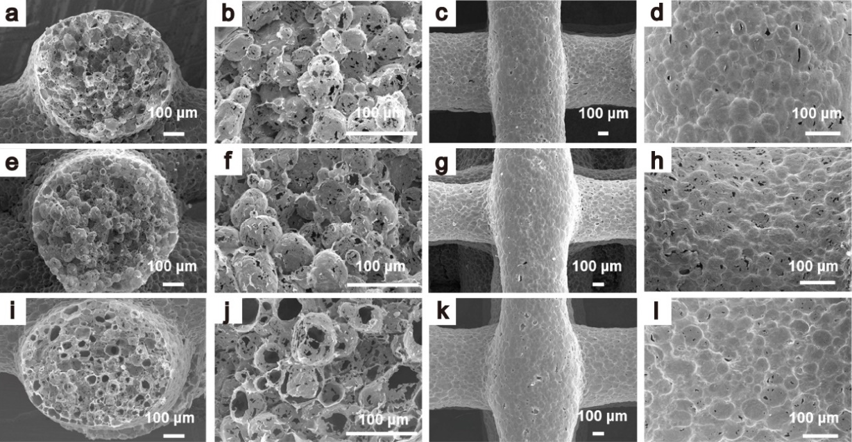
Fig. S5 SEM images of a-d M2G1 aerogel, e-h M1G1 aerogel, and i-l M1G2 aerogel.
Fig. S6 Pore sizes of MXene aerogel, and M1G2 aerogel.
Fig. S7 Conductivities of a MXene aerogel, b MG2 aerogel, c MG1 aerogel, d MG0.5 aerogel, and e MG0.3 aerogel. f Thicknesses of aerogels with different printed layers.

Fig. S8 Plots of a real permittivity, b imaginary permittivity, c tangent loss, and d impedance matching of MXene, M2G1, M1G1, M1G2, and M1G3 aerogels.

Fig. S9 Plots of average absorption coefficient (A) and reflection coefficient (R) of MG8L-MXene8L aerogels with different GO contents in the X-band.
Fig. S10 Plots of a A and R, and b EMI SE of M1G2-MXene4L aerogels with different thicknesses of MG layers. Plots of c A and R, and d EMI SE of M1G2-MXene8L aerogels with different thicknesses of MG layers.
Fig. S11 Average A and R values of copper foil and aluminum foil in the X-band, and average A and R values of M1G2 8L-MXene6L-Cu and M1G2 8L-MXene6L-Al in the X-band.
Fig. S12 a Plots of SE_{R}, SE_{A,} and SE_{T} of MXene-Al and MG-Al in the X-band. b Plots of A and R of MXene-Al and MG-Al in the X-band.
Fig. S13 a Schematic diagram of electromagnetic wave incident direction of MXene6L-M1G2 8L-Al aerogel. Plots of b A and R, and c average EMI SE of MXene6L-M1G2 8L-Al in the X-band.

Fig. S14 Simulation curves of A and R of M1G2-MXene with different thickness of M1G2 layer in 8.2-40 GHz band. Simulation curves of A and R of a M1G2 4L-MXene6L, b M1G2 6L-MXene6L, c M1G2 8L-MXene6L, and d M1G2 10L-MXene6L.

Fig. S15 A and R values of MG-MXene aerogels in different bands.

Fig. S16 a Simulated electric field distribution and b cross-section at the dotted line for M1G2-MXene dense structure. Simulation curves of R and A of c M1G2 dense layer, d MXene dense layer, and e M1G2-MXene dense structure.

Fig. S17 Electric field simulation distributions of a straight pore structure and b spherical pore structure.

Fig. S18 Simulated electric field distributions of a straight pore structure and b spherical pore structure.

Fig. S19 a Simulated electric field distribution of a₂ the vertical dashed plane of MG-MXene straight pore structure. b Simulated electric field distribution of b₂ the vertical dashed plane of MG-MXene spherical pore structure.

Fig. S20 a Simulated electric field distribution of a₃ the vertical dashed plane of MG-MXene straight pore structure. b Simulated electric field distribution of b₃ the vertical dashed plane of MG-MXene spherical pore structure.
Fig. S21 a Simulated electric field distribution for a₄ the vertical dashed plane of MG-MXene straight pore structure. b Simulated electric field distribution for b₄ the vertical dashed plane of MG-MXene spherical pore structure.
Fig. S22 Plots of a A and R, and b EMI SE of the M1G2-MXene aerogel prepared by random freezing. Plots of c A and R, and d Plots of EMI SE of the M1G2-MXene aerogel prepared by directional-freezing.
Fig. S23 Solar-thermal energy conversion curves of the MG-MXene aerogel at different solar light power densities.

Fig. S24 Top surface temperatures of the MG-MXene aerogel placing on a heating platform of 80 and 100 °C.

Table S1 Compositions of 3D printing aerogels.
Samples | Components, Concentration (mg mL⁻¹), and Ratios
MXene | MXene (15 mg mL⁻¹), 1
M2G1 | MXene (15 mg mL⁻¹)/GO (7.5 mg mL⁻¹), 2/1
M1G1 | MXene (15 mg mL⁻¹)/GO (7.5 mg mL⁻¹), 1/1
M1G2 | MXene (15 mg mL⁻¹)/GO (7.5 mg mL⁻¹), 1/2
M1G3 | MXene (15 mg mL⁻¹)/GO (7.5 mg mL⁻¹), 1/3

Table S2 Comparison of EMI shielding performances of 3D printing aerogels
Samples | Density  (mg cm⁻³) | Thickness  (mm) | EMI SE  (dB) | A | Band | Refs.
M1G2 8L-MXene6L | 11.83 | 5.6 | 23.2 | 0.95 | X-band | This work
M1G2 8L-MXene6L | 11.83 | 5.6 | 43.7 | 0.95 | Ka-band | This work
M1G2 6L-MXene6L | 11.60 | 4.8 | 24.9 | 0.95 | Ku-band | This work
M1G2 4L-MXene6L | 11.76 | 4.0 | 32.1 | 0.92 | K-band | This work
M1G2 3-MXene2 | 10.00 | 5.0 | 18.4 | 0.95 | X-band | This work
M1G2 8L-MXene6L-Cu | / | 5.6 | 100.7 | 0.95 | X-band | This work
M1G2 8L-MXene6L-Al | / | 5.6 | 106.1 | 0.95 | X-band | This work
MXene/CNT/PI aerogel | 152.00 | 5 | 68.2 | 0.77 | X-band | [S1]
PLA/Ag | 262.00 | 1.5 | 110 | 0.79 | X-band | [S2]
rGO@Fe₃O₄/T-ZnO /Ag/WPU | / | 0.5 | 87.2 | 0.61 | X-band | [S3]
PI/graphene aerogel | 83.96 | 2.5 | 28.8 | 0.63 | X-band | [S4]
NG@Fe₃O₄  /PEDOT:PSS | ~100.00 | 5.0 | 54.0 | 0.59 | 12.4 GHz | [S5]
M6-FC2 | 10.00 | 2 | 32.5 | 0.69 | X-band | [S6]
CNT/RGO foam | 57.20 | 2 | 31.2 | 0.26 | X-band | [S7]
AgNW/PDMS aerogel | 6.20 | 2 | 70.5 | 0.02 | X-band | [S8]
G@Fe₃O₄/PEI aerogel | 433.73 | 2.5 | 18.2 | 0.89 | X-band | [S9]
References
[S1] T. Xue, Y. Yang, D. Yu, Q. Wali, Z. Wang et al., 3D printed integrated gradient-conductive MXene/CNT/polyimide aerogel frames for electromagnetic interference shielding with ultra-low reflection. Nano-Micro Lett. 15, 45 (2023). https://doi.org/10.1007/s40820-023-01017-5
[S2] Y.-N. Gao, Y. Wang, T.-N. Yue, B. Zhao, R. Che et al., Superstructure silver micro-tube composites for ultrahigh electromagnetic wave shielding. Chem. Eng. J. 430, 132949 (2022). https://doi.org/10.1016/j.cej.2021.132949
[S3] Y. Xu, Y. Yang, D. X. Yan, H. Duan, G. Zhao, Y. Liu, Gradient structure design of flexible waterborne polyurethane conductive films for ultraefficient electromagnetic shielding with low reflection characteristic. ACS Appl. Mater. Interfaces 10, 19143-19152 (2018). https://doi.org/10.1021/acsami.8b05129
[S4] Z. Yu, T. Dai, S. Yuan, H. Zou, P. Liu, Electromagnetic interference shielding performance of anisotropic polyimide/graphene composite aerogels. ACS Appl. Mater. Interfaces 12, 30990-31001 (2020). https://doi.org/10.1021/acsami.0c07122
[S5] X.-X. Wang, J.-C. Shu, W.-Q. Cao, M. Zhang, J. Yuan et al., Eco-mimetic nanoarchitecture for green emi shielding. Chem. Eng. J. 369, 1068-1077 (2019). https://doi.org/10.1016/j.cej.2019.03.164
[S6] Z. Ma, Z. Deng, X. Zhou, L. Li, C. Jiao et al., Multifunctional and magnetic mxene composite aerogels for electromagnetic interference shielding with low reflectivity. Carbon 213, 118260 (2023). https://doi.org/10.1016/j.carbon.2023.118260
[S7] L. Kong, X. Yin, H. Xu, X. Yuan, T. Wang et al., Powerful absorbing and lightweight electromagnetic shielding CNTs/RGO composite. Carbon 145, 61-66 (2019). https://doi.org/10.1016/j.carbon.2019.01.009
[S8] Z. Zeng, T. Wu, D. Han, Q. Ren, G. Siqueira et al., Ultralight, flexible, and biomimetic nanocellulose/silver nanowire aerogels for electromagnetic interference shielding. ACS Nano 14, 2927-2938 (2020). https://doi.org/10.1021/acsnano.9b07452
[S9] B. Shen, W. Zhai, M. Tao, J. Ling, W. Zheng, Lightweight, multifunctional polyetherimide/graphene@Fe₃O₄ composite foams for shielding of electromagnetic pollution. ACS Appl. Mater. Interfaces 5, 11383-11391 (2013). https://doi.org/10.1021/am4036527

