Supporting Information for
Hydrolysis-Engineered Robust Porous Micron Silicon Anode for High-Energy Lithium-Ion Batteries
Mili Liu¹, Jiangwen Liu¹, Yunqi Jia¹, Chen Li¹, Anwei Zhang³, Renzong Hu¹, Jun Liu¹, Chengyun Wang³, Longtao Ma¹*, Liuzhang Ouyang^{1,2}*
¹ School of Materials Science and Engineering, Guangdong Provincial Key Laboratory of Advanced Energy Storage Materials, South China University of Technology, Guangzhou 510641, P. R. China
² Guangdong Engineering Technology Research Center of Advanced Energy Storage Materials, Guangzhou 510641, P. R. China
³ GAC Automotive Research & Development Center, Guangzhou 511434, P. R. China
*Corresponding authors. E-mail: longtaoma@scut.edu.cn (Longtao Ma); meouyang@scut.edu.cn (Liuzhang Ouyang)
Supplementary Figures and Tables
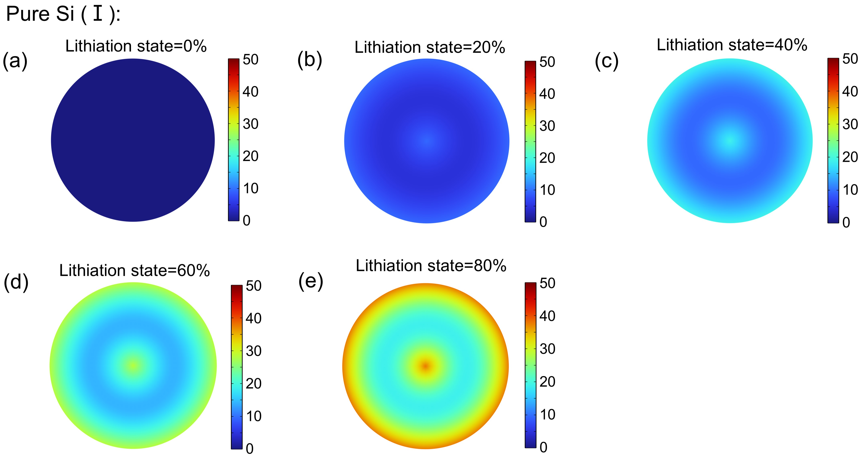
Fig. S1 Chemo-mechanical model of stress distribution for pure Si (Ⅰ) within various lithiation state

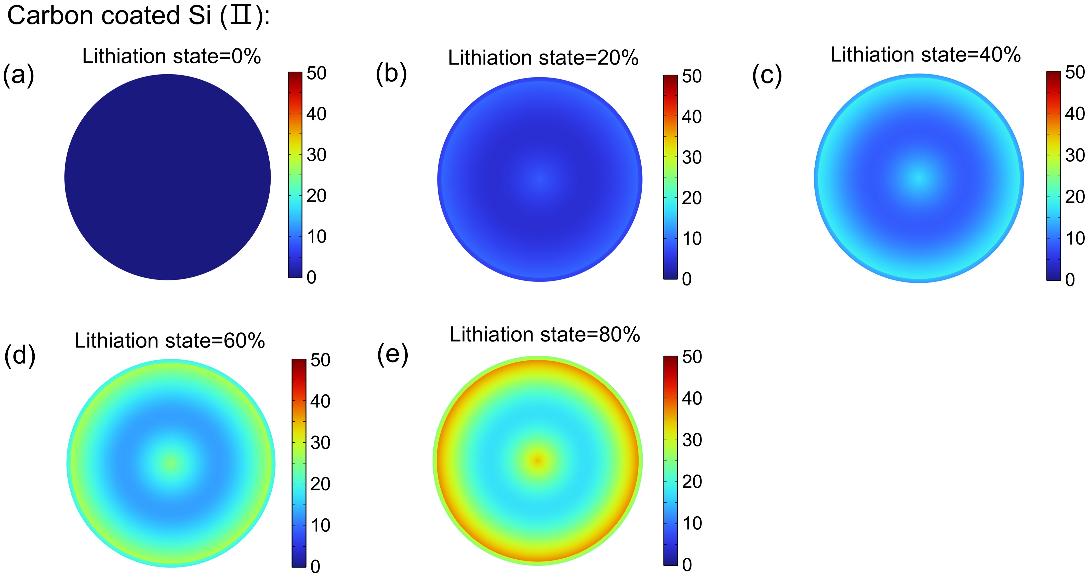

Fig. S2 Chemo-mechanical model of stress distribution for carbon-coated Si (Ⅱ) within various lithiation state

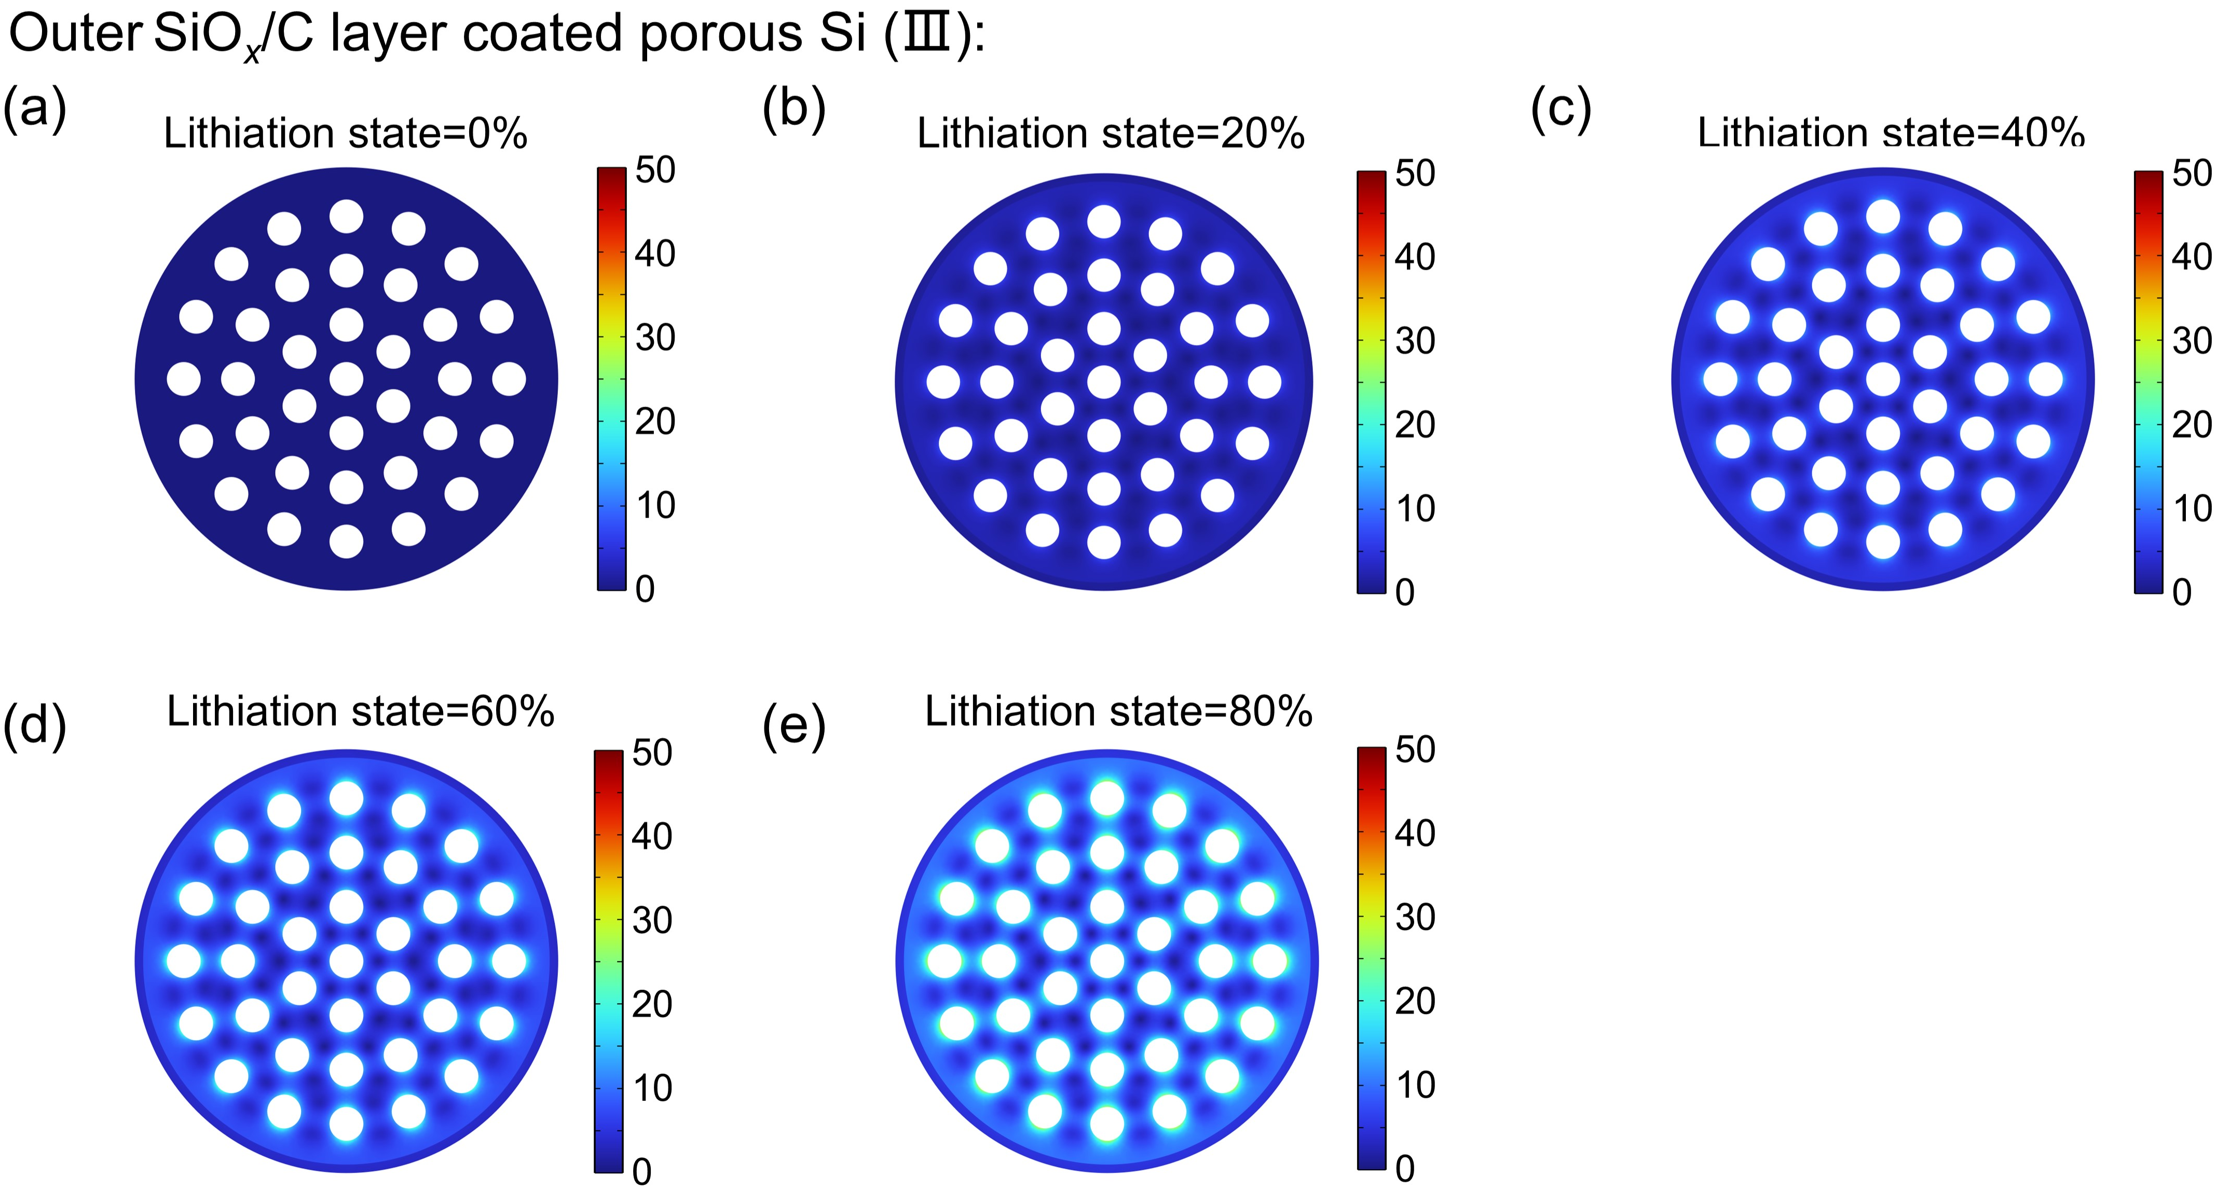
Fig. S3 Chemo-mechanical model of stress distribution for outer SiO_{x}/C layer coated porous Si (Ⅲ) within various lithiation state

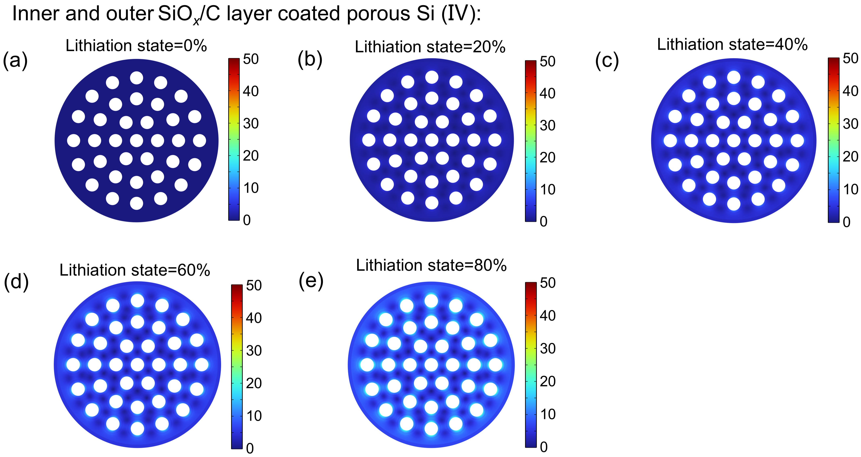
Fig. S4 Chemo-mechanical model of stress distribution for both inner and outer SiO_{x}/C layer coated porous Si (Ⅳ) within various lithiation state
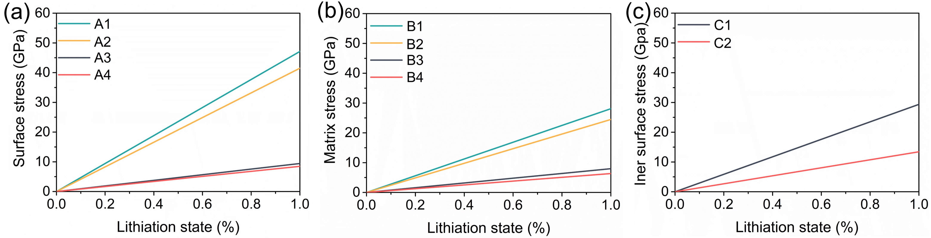
Fig. S5 (a) Surface stress and (b) Si matrix stress distribution for various materials upon lithiation. (c) Inner pore surface stress distribution of outer SiO_{x}/C layer coated porous Si (Ⅲ, C1) and both inner and outer SiO_{x}/C layer coated porous Si (Ⅳ, C2) upon lithiation
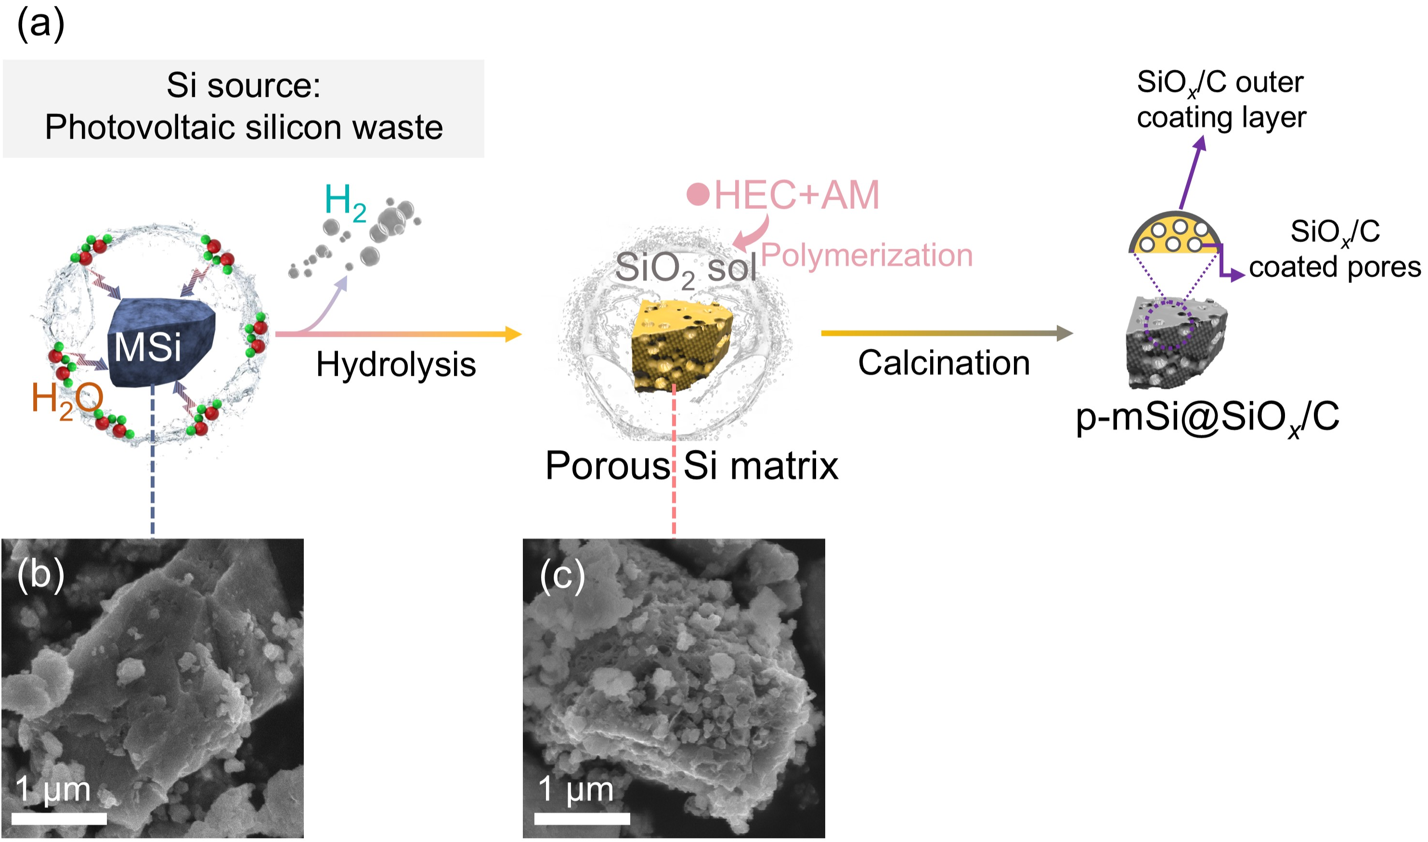
Fig. S6 (a) Schematic illustration of the preparation process for the p-mSi@SiO_{x}/C. SEM images of (b) MSi and (c) the obtained porous Si matrix from the hydrolysis of MSi within 1 h

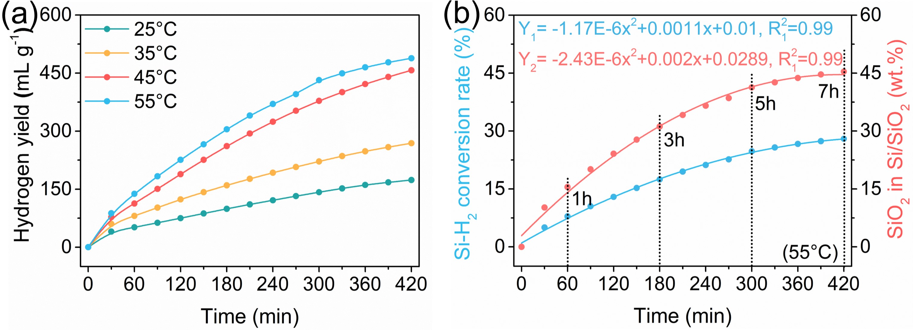
Fig. S7 (a) Hydrogen evolution performance of MSi at different temperatures. (b) The Si-H₂ conversion rate curve of MSi, and the corresponding SiO₂ content in Si/SiO₂ mixture
Note S1:
As shown in Fig. S7a, the hydrogen evolution performance of MSi is positively correlated with reaction temperature. In our specific case of 55℃, it not only can enhance the hydrogen evolution kinetics, but also be compatible for facilitating the subsequent hybrid polymerization process between the hydrolysis-obtained SiO₂ sol and the organics of HEC and AM. Moreover, based on the hydrolysis equation of $\text{Si+}{\text{2H}}_{\text{2}}\text{O →Si}{\text{O}}_{\text{2}}\text{+2}{\text{H}}_{\text{2}}$, the Si-H₂ conversion rate and corresponding SiO₂ content in the mixture can be calculated and fitted against the reaction time (Fig. S7b), indicating the SiO₂ content in the subsequent SiO_{x}/C layer can be well-controlled through adjusting the hydrolysis reaction, further balancing the electrochemical capacity and cyclic stability.
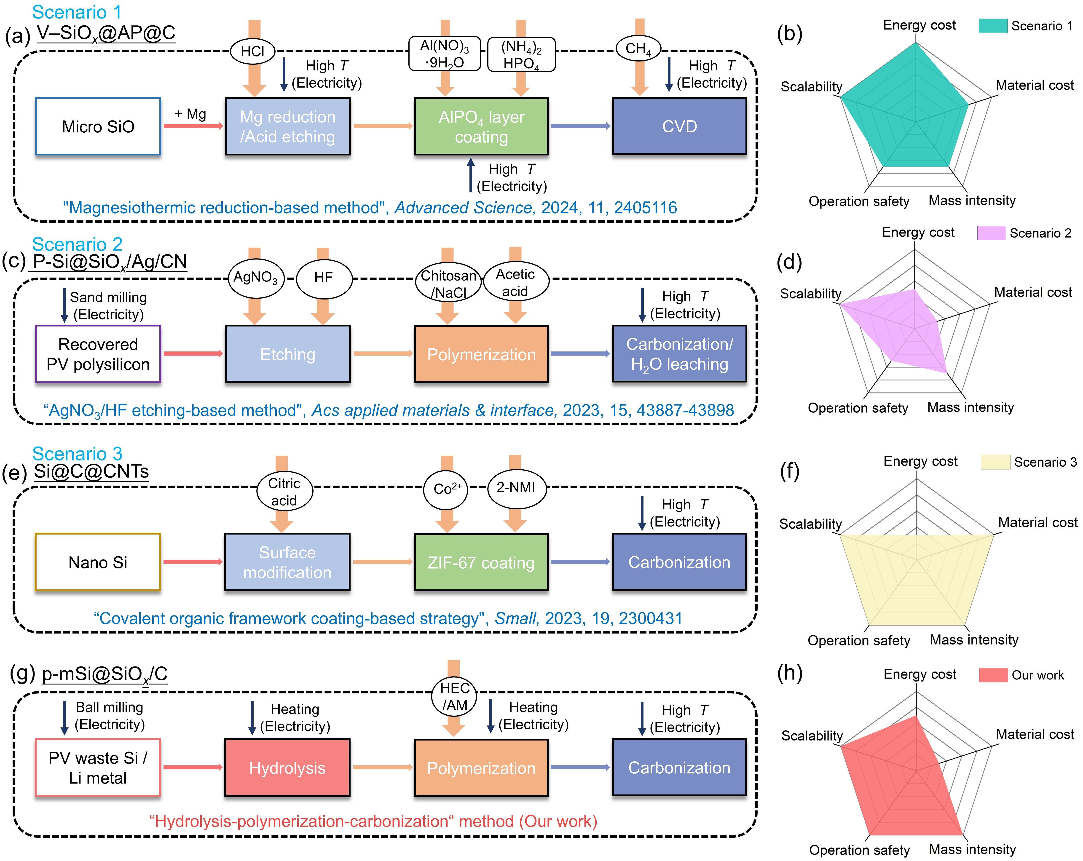
Fig. S8 Flow diagrams and comprehensive analysis of four scenarios for advanced Si anode preparation, namely, (a, b) the magnesiothemic reduction-based method (scenario 1), (c, d) the AgNO₃/HF etching-based method (scenario 2), (e, f) covalent organic framework coating strategy (scenario 3) and (g, h) our developed “hydrolysis-polymerization-carbonization” method
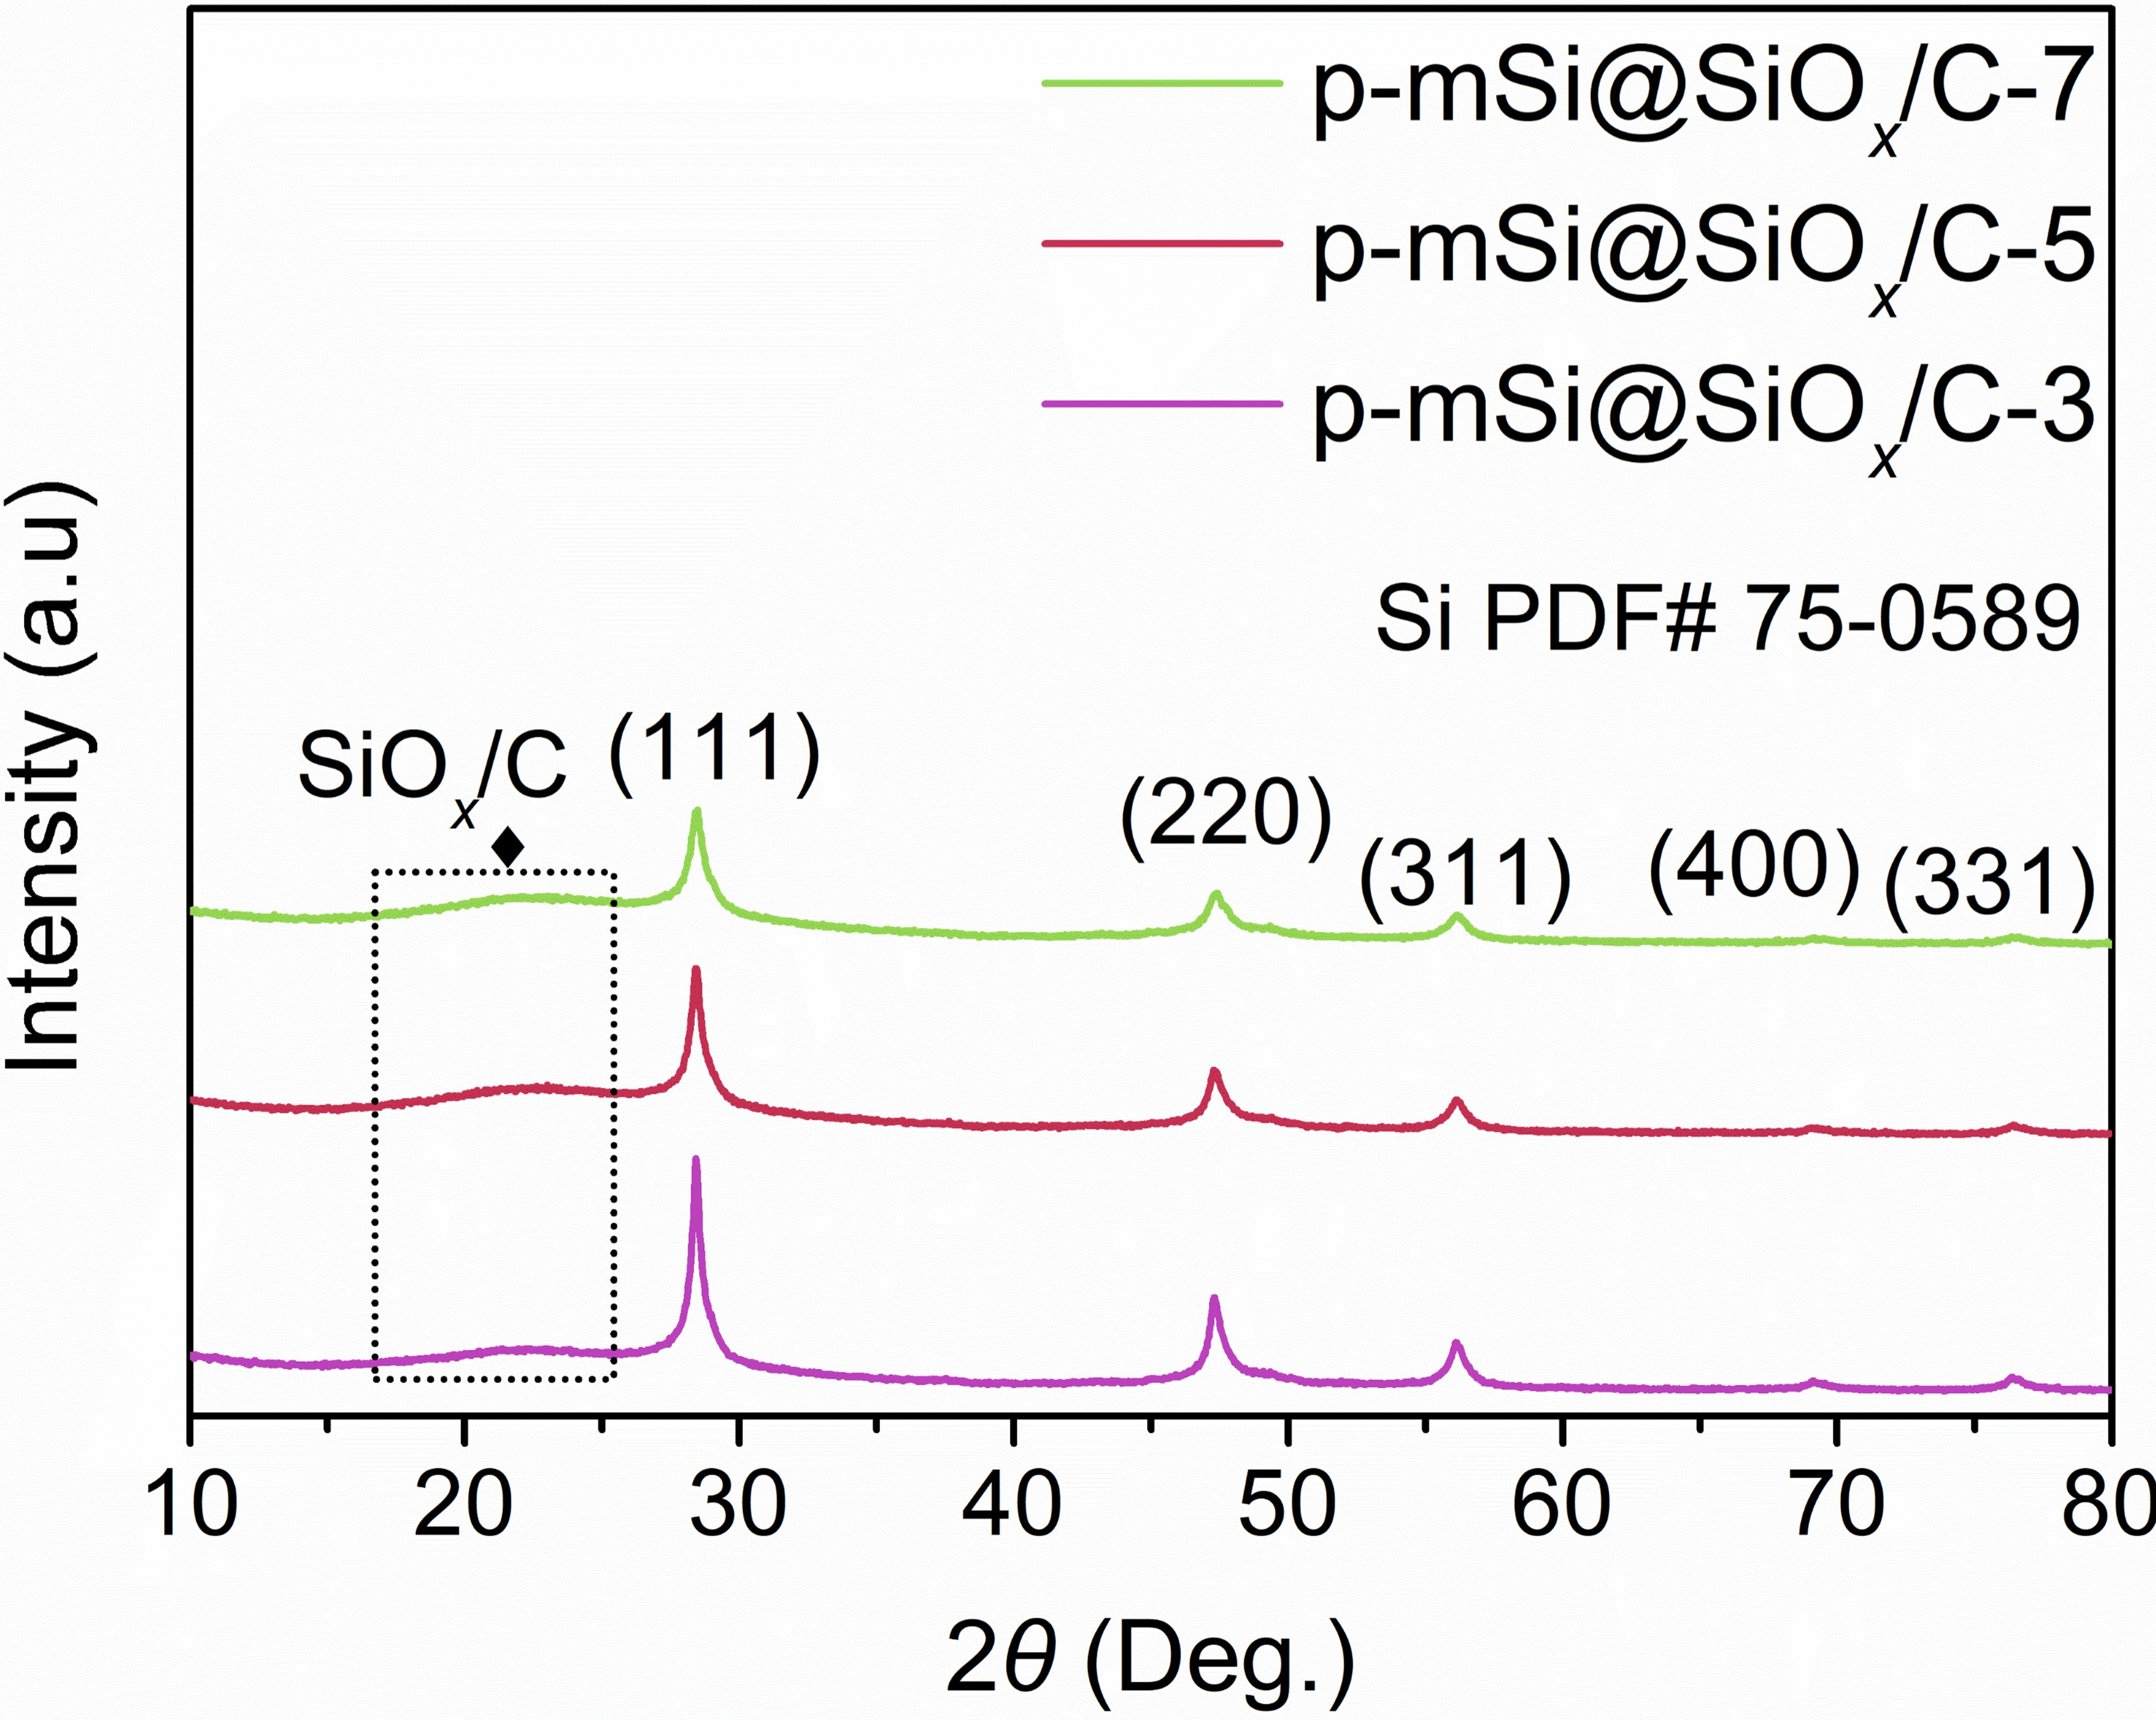
Fig. S9 XRD patterns of p-mSi@SiO_{x}/C-3, p-mSi@SiO_{x}/C-5, p-mSi@SiO_{x}/C-7

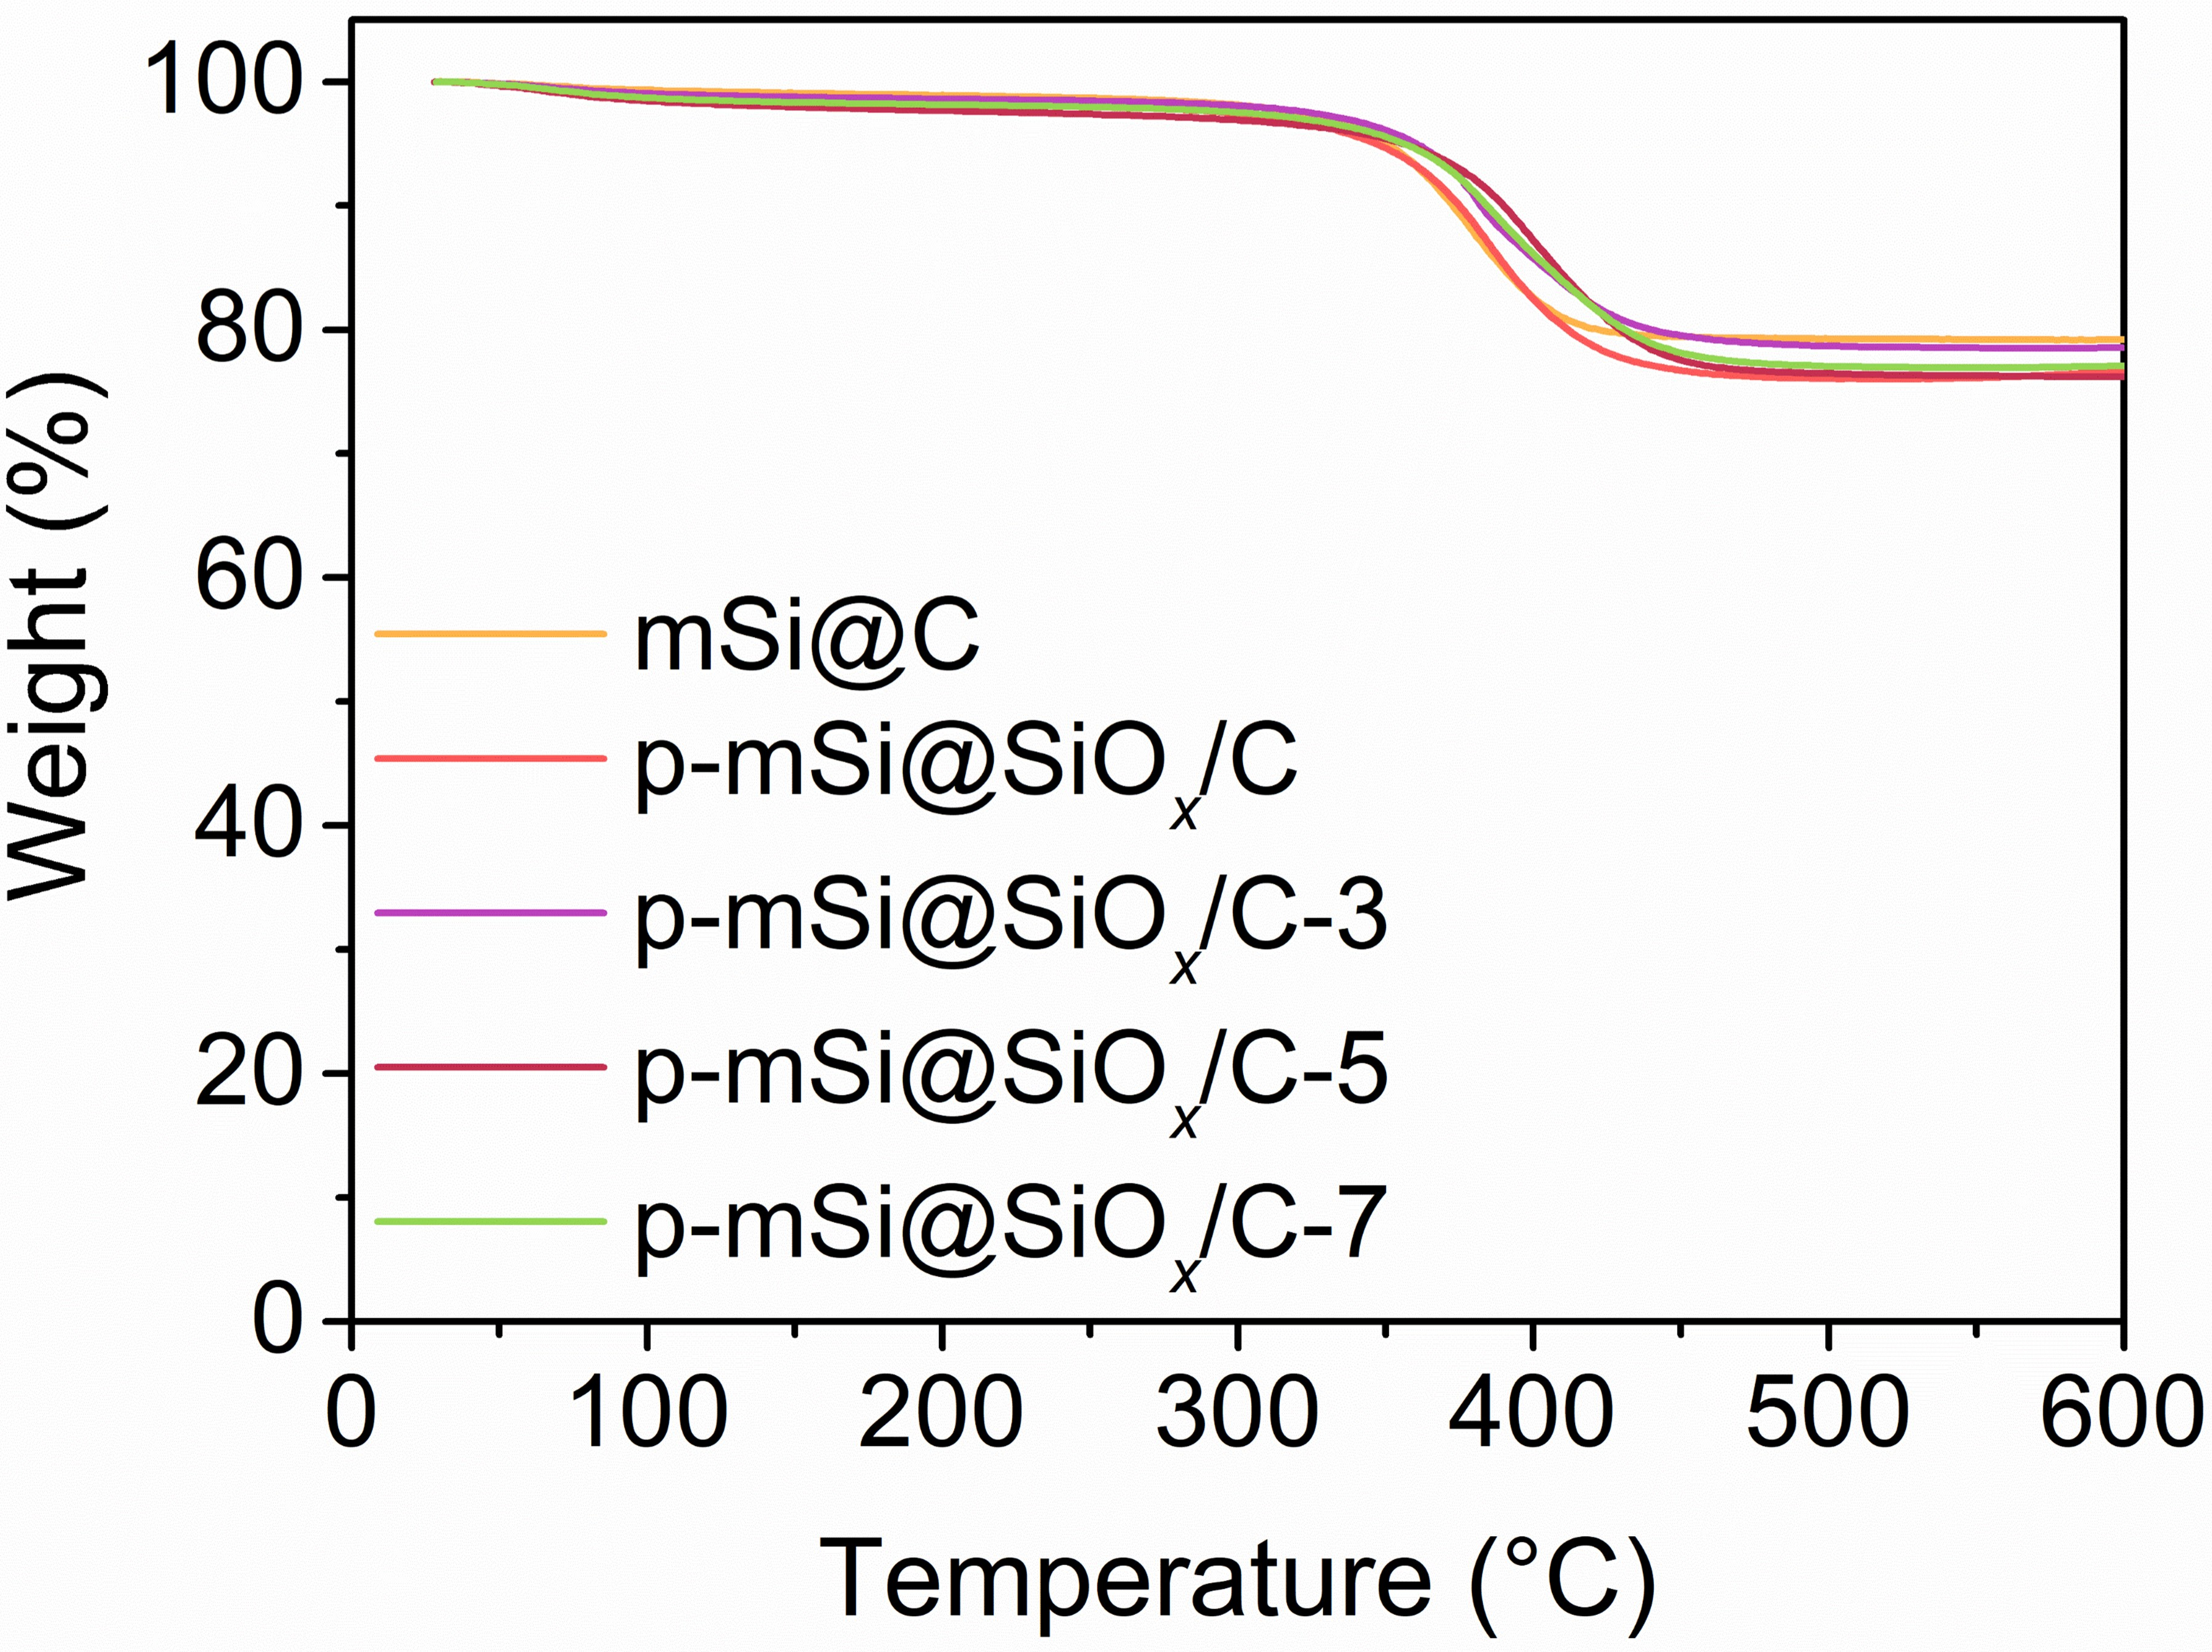
Fig. S10 TG curves of mSi@C, p-mSi@SiO_{x}/C, p-mSi@SiO_{x}/C-3, p-mSi@SiO_{x}/C-5, p-mSi@SiO_{x}/C-7

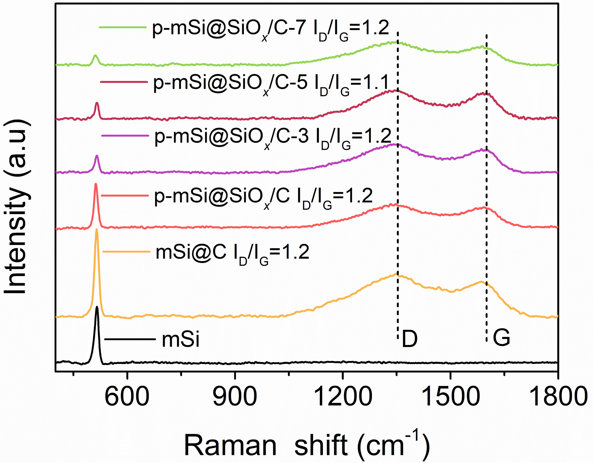
Fig. S11 Raman spectra of mSi, mSi@C, p-mSi@SiO_{x}/C, p-mSi@SiO_{x}/C-3, p-mSi@SiO_{x}/C-5, p-mSi@SiO_{x}/C-7

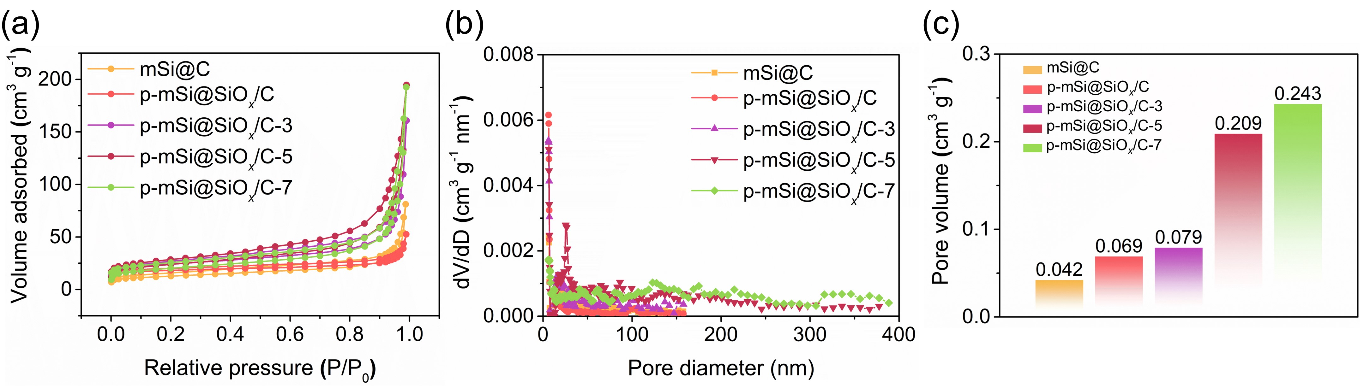
Fig. S12 (a) Nitrogen sorption isotherms curves, (b) pore size distribution and (c) pore volume of mSi@C, p-mSi@SiO_{x}/C, p-mSi@SiO_{x}/C-3, p-mSi@SiO_{x}/C-5 and p-mSi@SiO_{x}/C-7
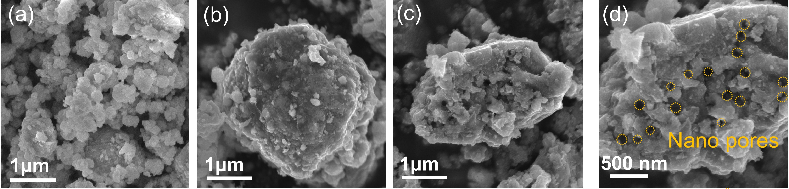
Fig. S13 SEM images of (a) mSi, (b) mSi@C and (c, d) p-mSi@SiO_{x}/C
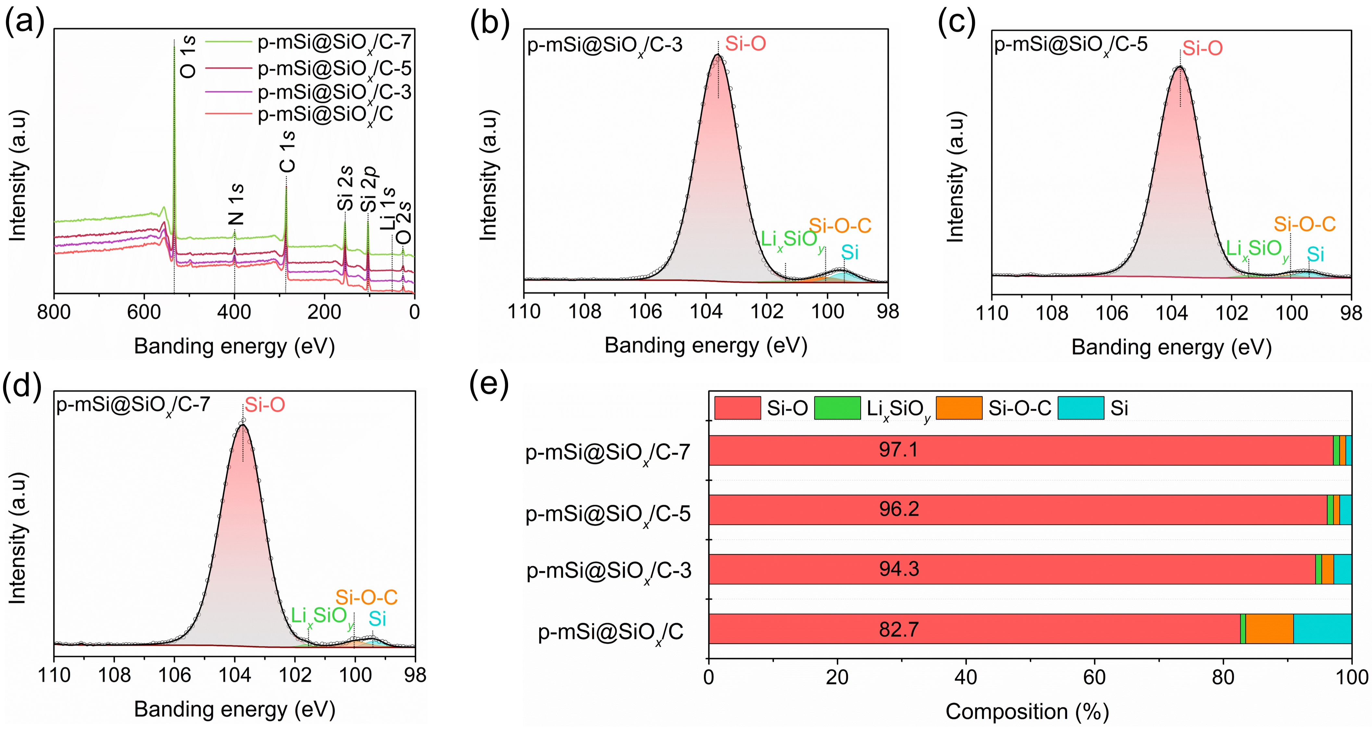
Fig. S14 (a) XPS survey spectra of p-mSi@SiO_{x}/C, p-mSi@SiO_{x}/C-3, p-mSi@SiO_{x}/C-5, p-mSi@SiO_{x}/C-7. High resolution Si 2p spectra of (b) p-mSi@SiO_{x}/C-3, (c) p-mSi@SiO_{x}/C-5 and (d) p-mSi@SiO_{x}/C-7. (e) The surface composition analysis of Si 2p spectra for p-mSi@SiO_{x}/C, p-mSi@SiO_{x}/C-3, p-mSi@SiO_{x}/C-5, p-mSi@SiO_{x}/C-7
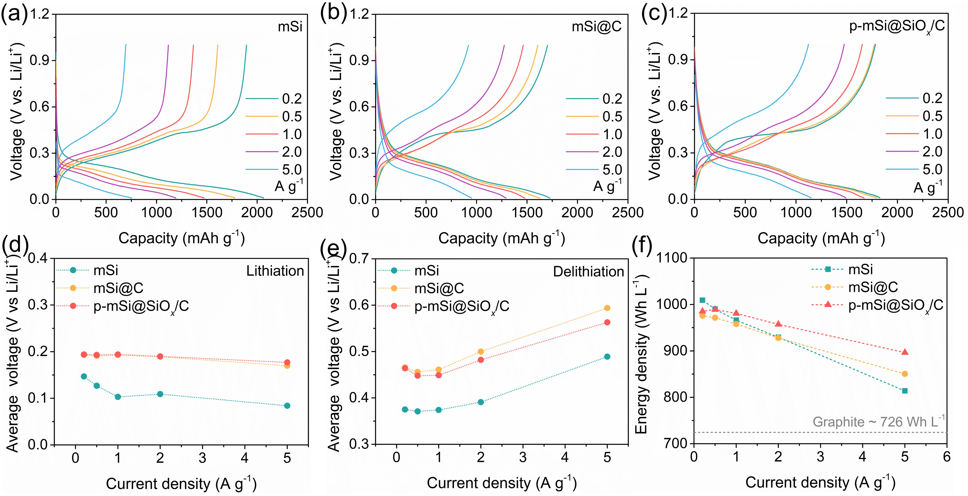
Fig. S15 Discharge-charge profiles of (a) mSi, (b) mSi@C and (c) p-mSi@SiO_{x}/C at various current densities. (d, e) Average lithiation/delithiation voltages and (f) energy densities of mSi, mSi@C and p-mSi@SiO_{x}/C at various current densities
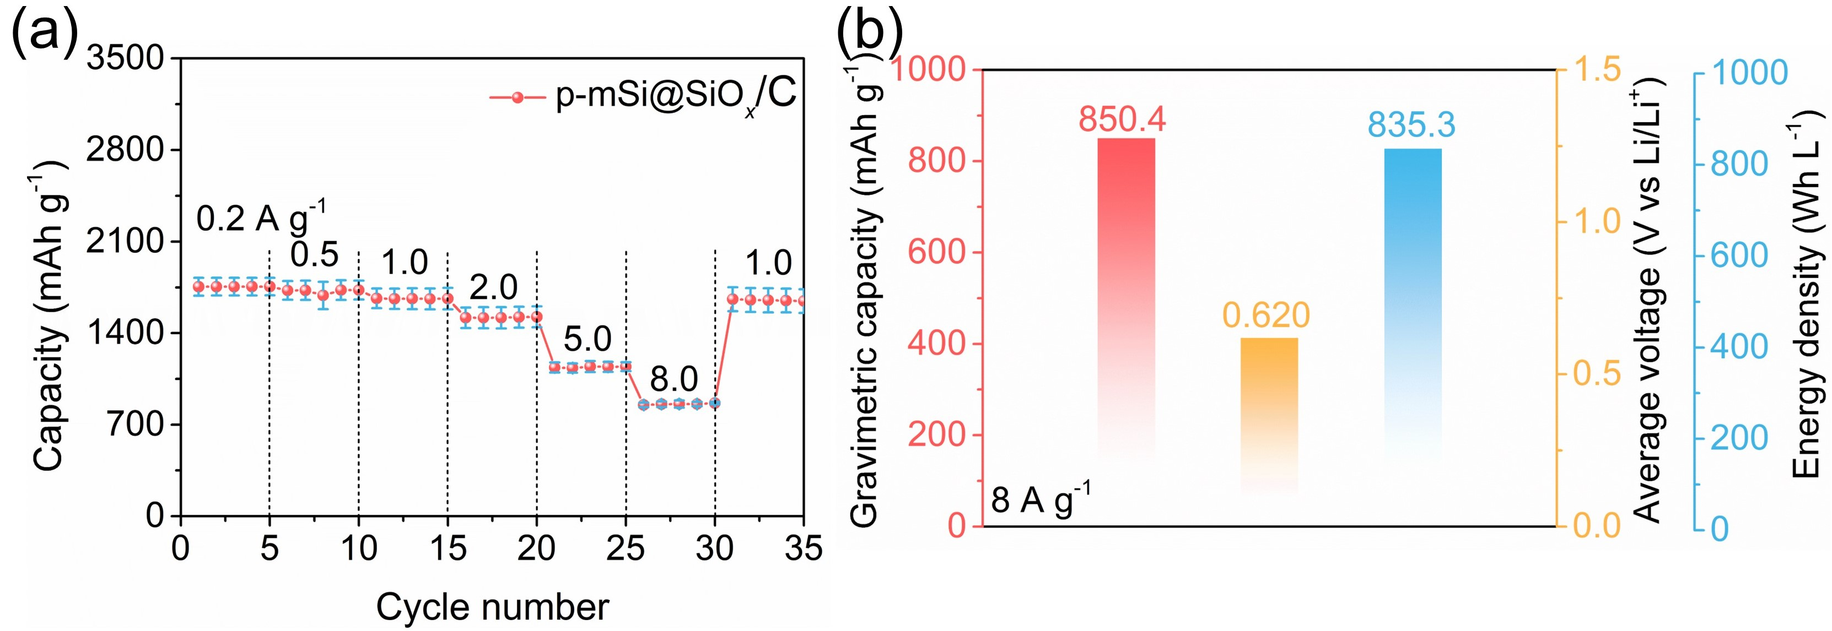
Fig. S16 (a) Rate performance of p-mSi@SiO_{x}/C at 0.2-8 A g⁻¹. (b) Reversible gravimetric capacity, average lithiation voltage and stack cell energy density of p-mSi@SiO_{x}/C at 8 A g⁻¹

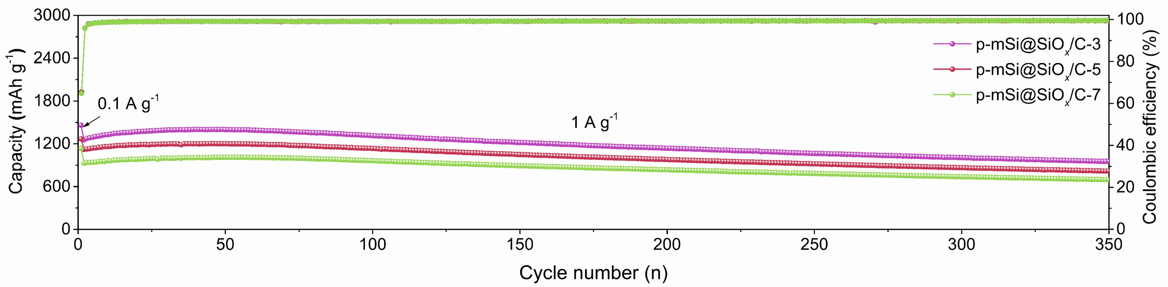
Fig. S17 Cyclic performance of p-mSi@SiO_{x}/C-3, p-mSi@SiO_{x}/C-5 and p-mSi@SiO_{x}/C-7 at 1 A g⁻¹.
Note S2:
As shown in Fig. S17, the reversible capacities and retention rates of the p-mSi@SiO_{x}/C-3, p-mSi@SiO_{x}/C-5 and p-mSi@SiO_{x}/C-7 after 350 cycles at 1A g⁻¹ are 1070.2 mAh g⁻¹/63.0%, 951.5 mAh g⁻¹/67.9%, 818.1 mAh g⁻¹/68.1% and 696.3 mAh g⁻¹/68.9%, respectively.

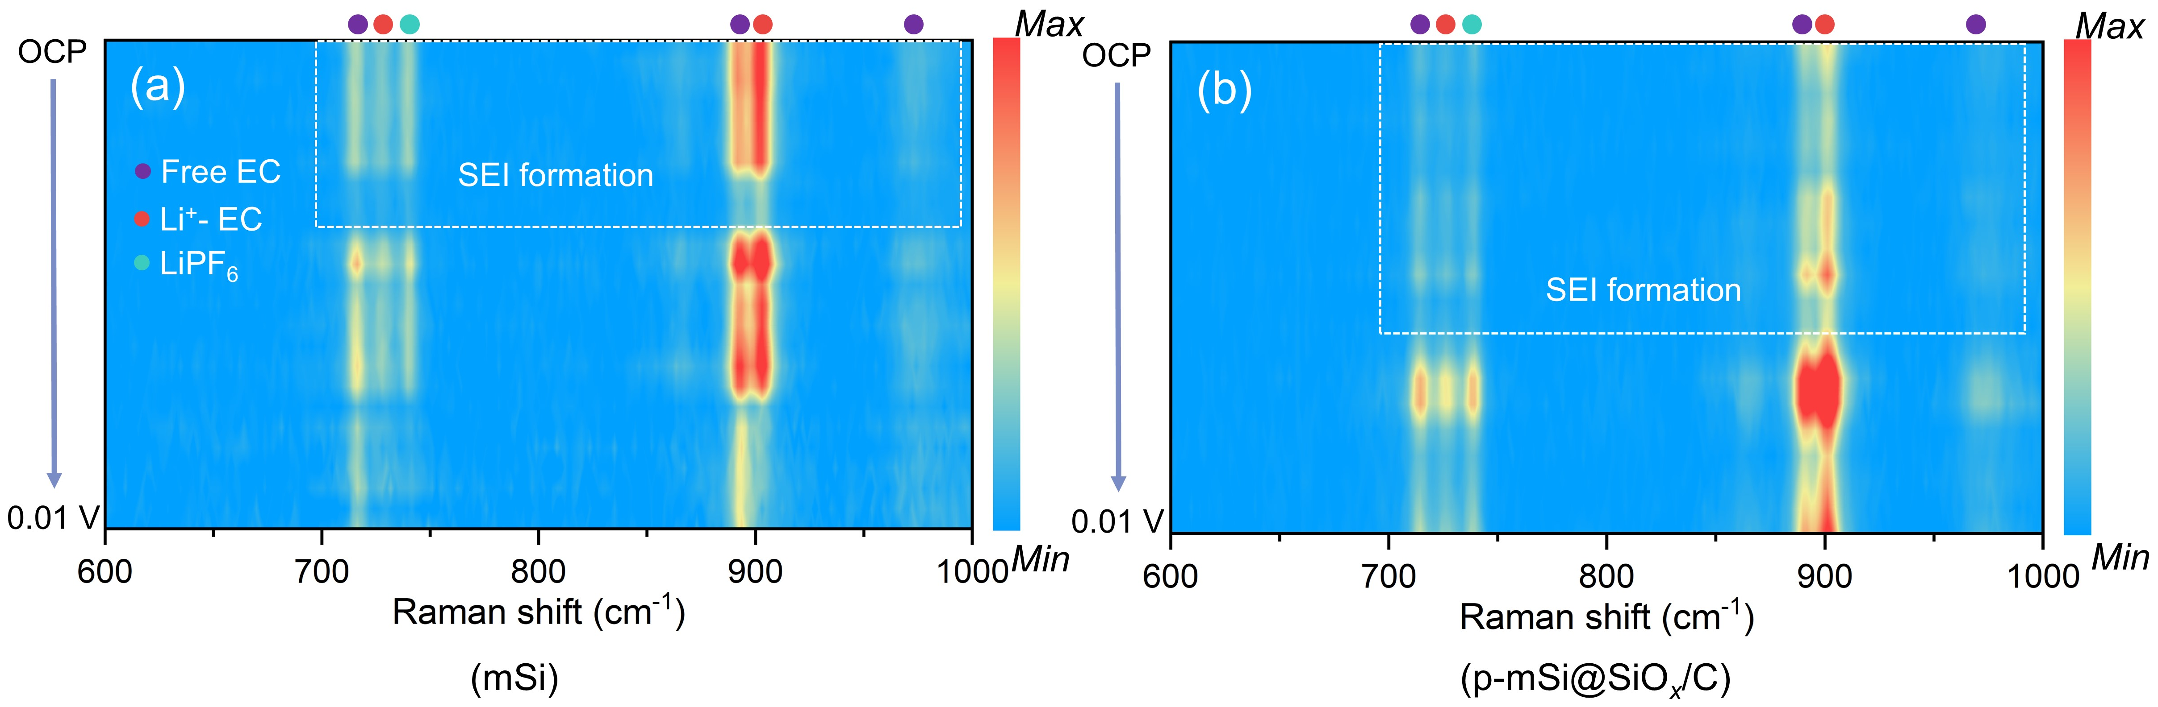
Fig. S18 In situ Raman tests of (a) mSi and (b) p-mSi@SiO_{x}/C electrodes during the first lithiation process
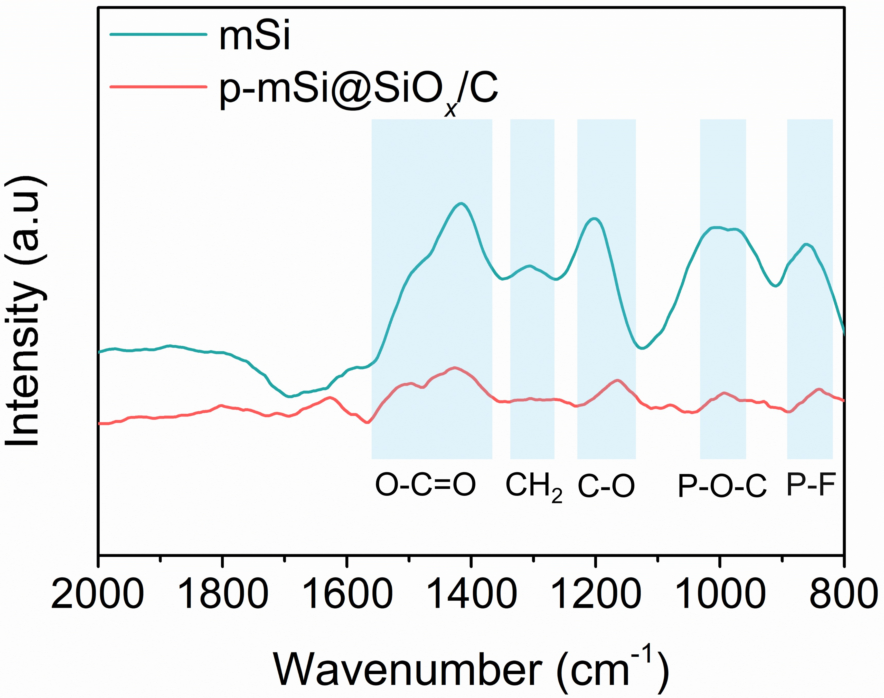
Fig. S19 FTIR spectra of lithiated mSi and p-mSi@SiO_{x}/C electrodes

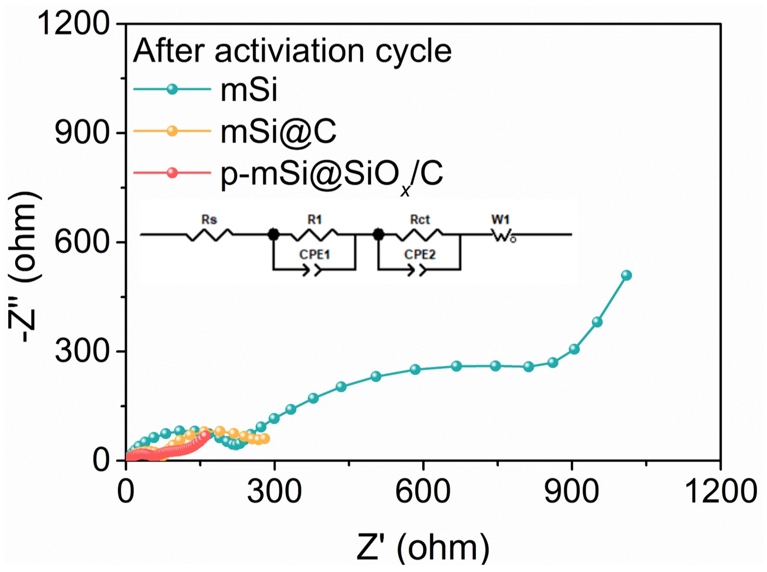
Fig. S20 Nyquist plots of mSi, mSi@C and p-mSi@SiO_{x}/C after the activation cycle. The inset is Fitting model of Nyquist plots

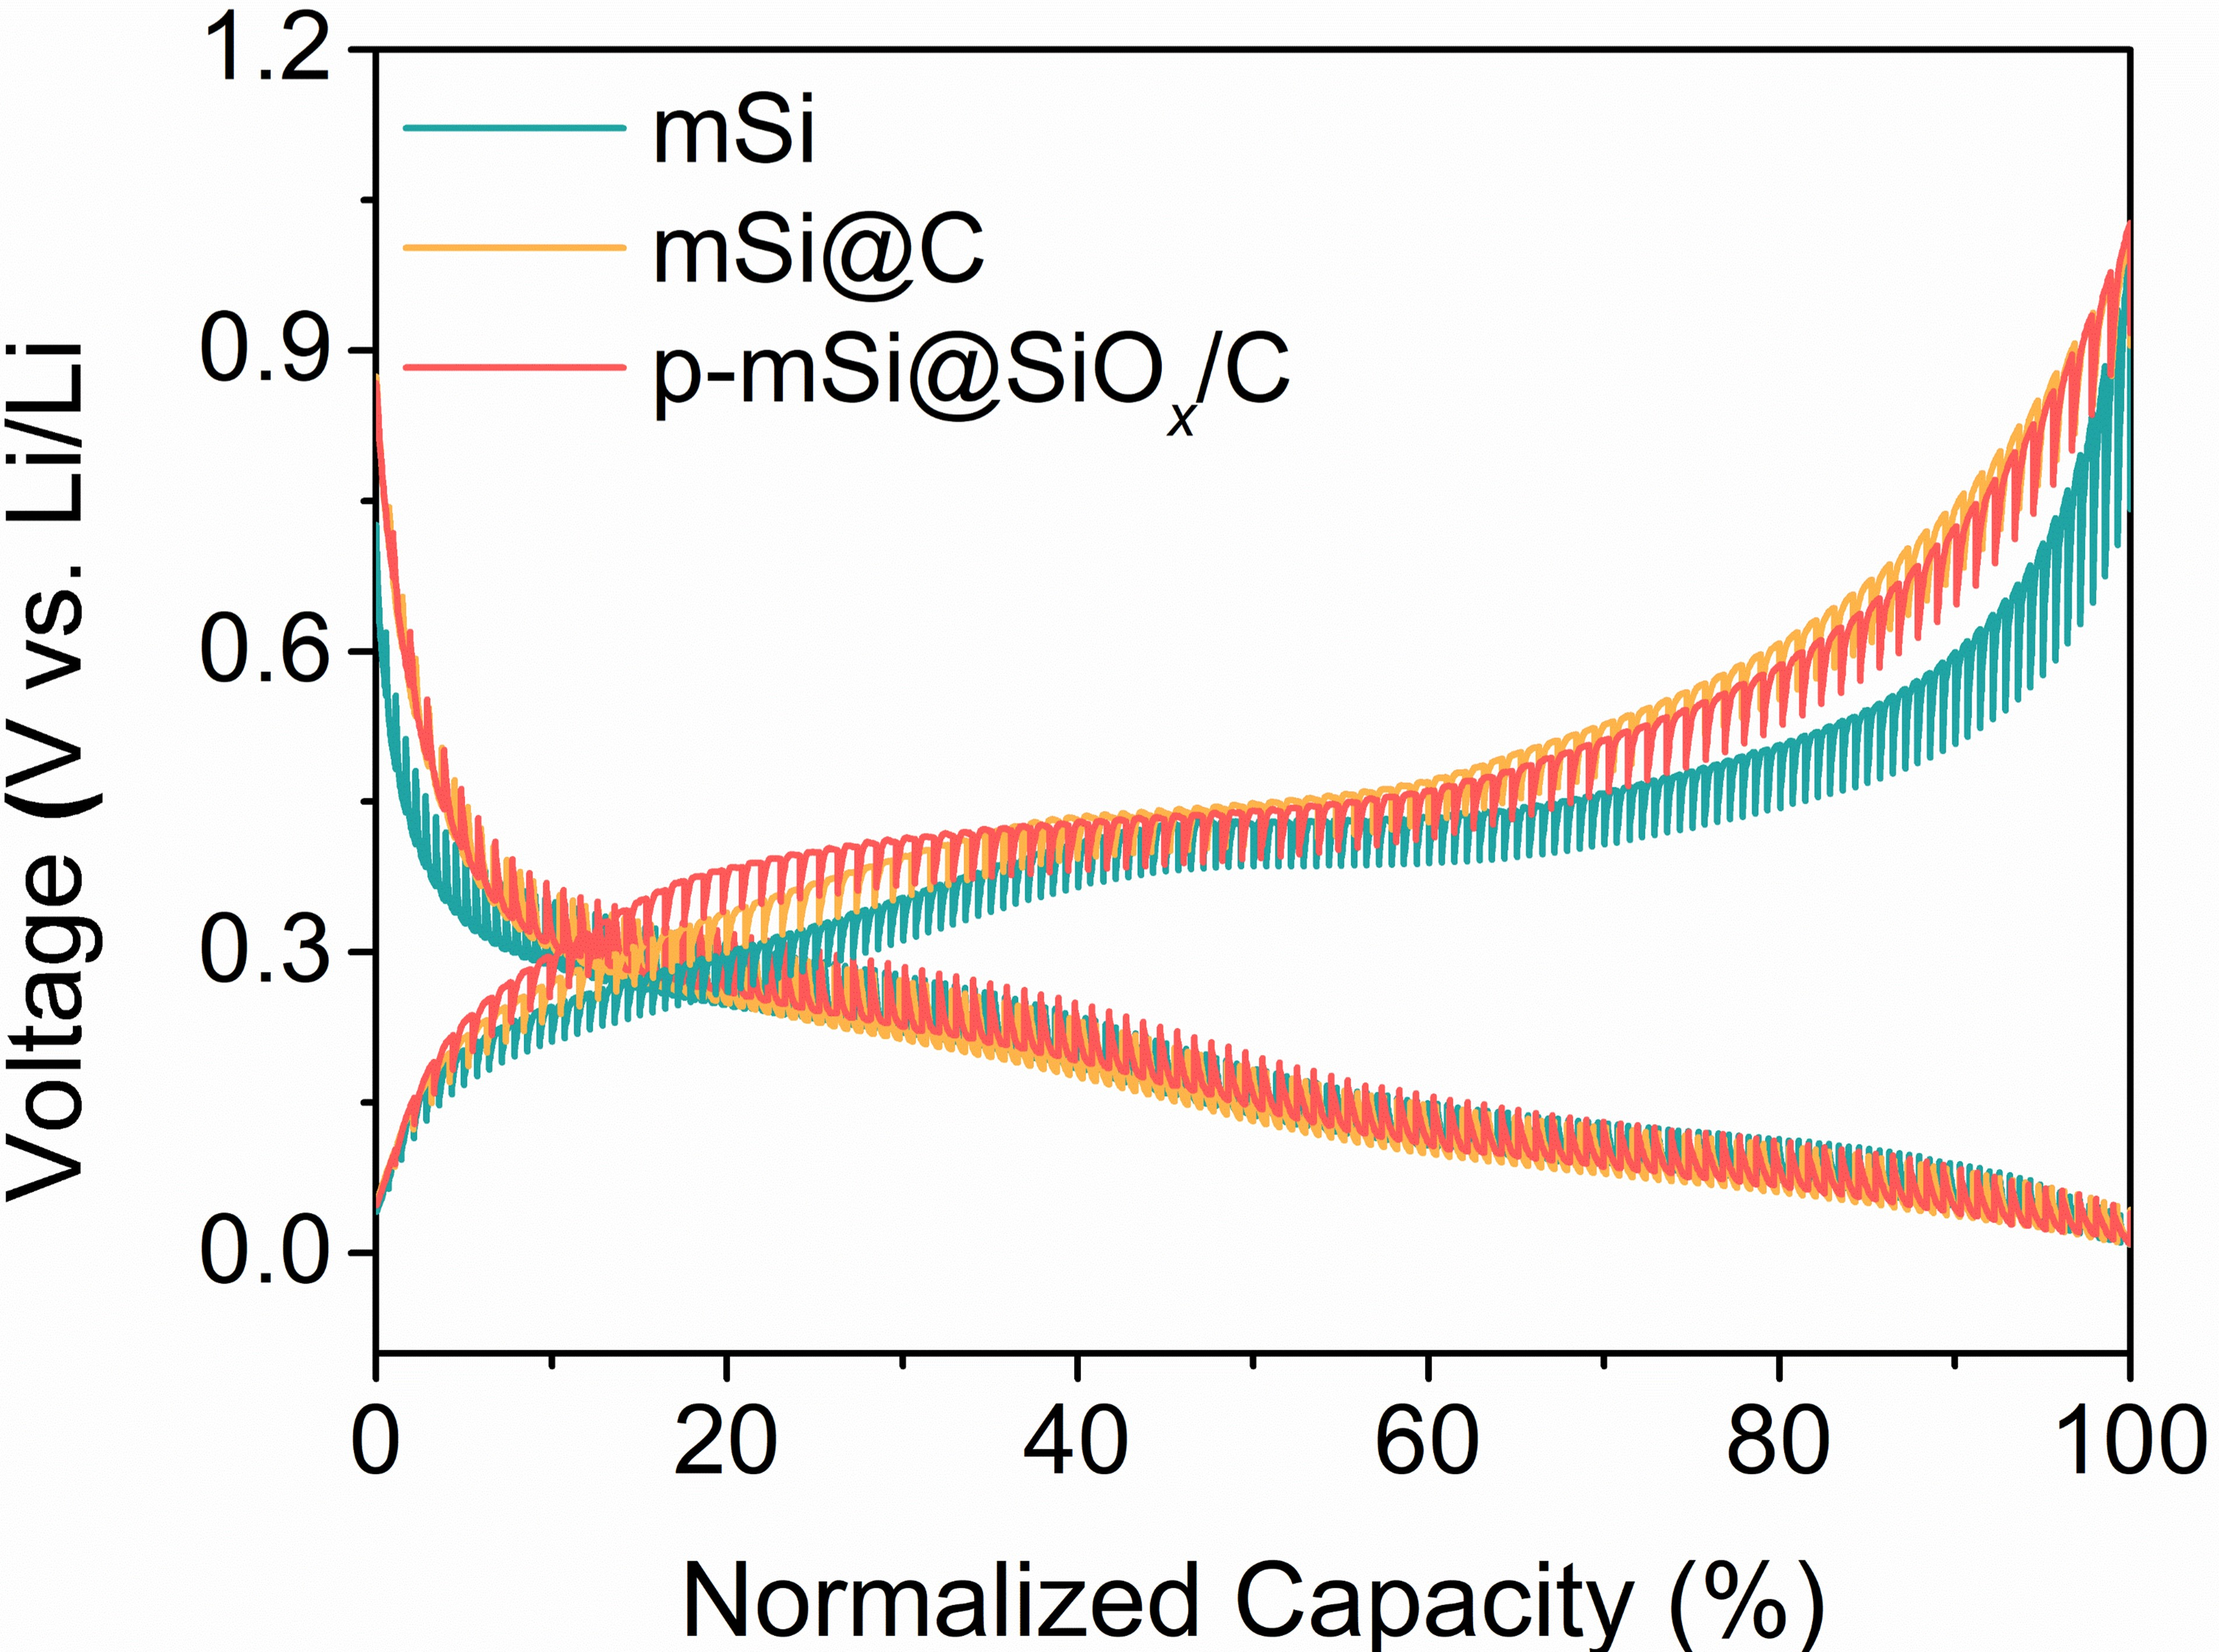
Fig. S21 GITT curves of lithiation and delithiation process for the mSi, mSi@C and p-mSi@SiO_{x}/C

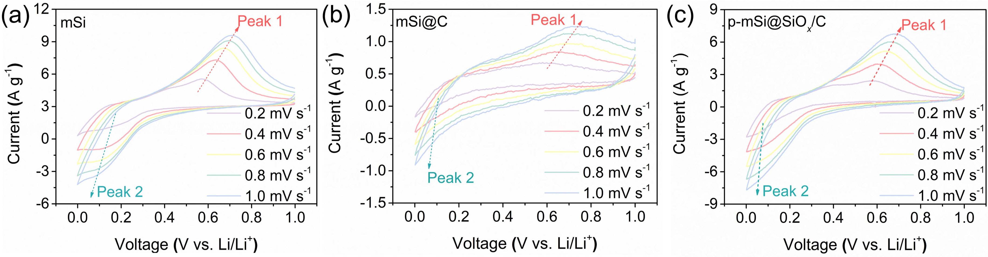
Fig. S22 CV curves of (a) mSi, (b) mSi@C and (c) p-mSi@SiO_{x}/C conducted with 0.2~1.0 mV s⁻¹

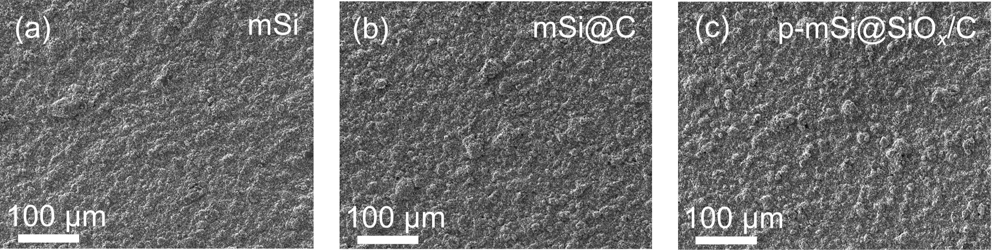
Fig. S23 Surface SEM images of pristine (a) mSi, (b) mSi@C and (c) p-mSi@SiO_{x}/C electrodes

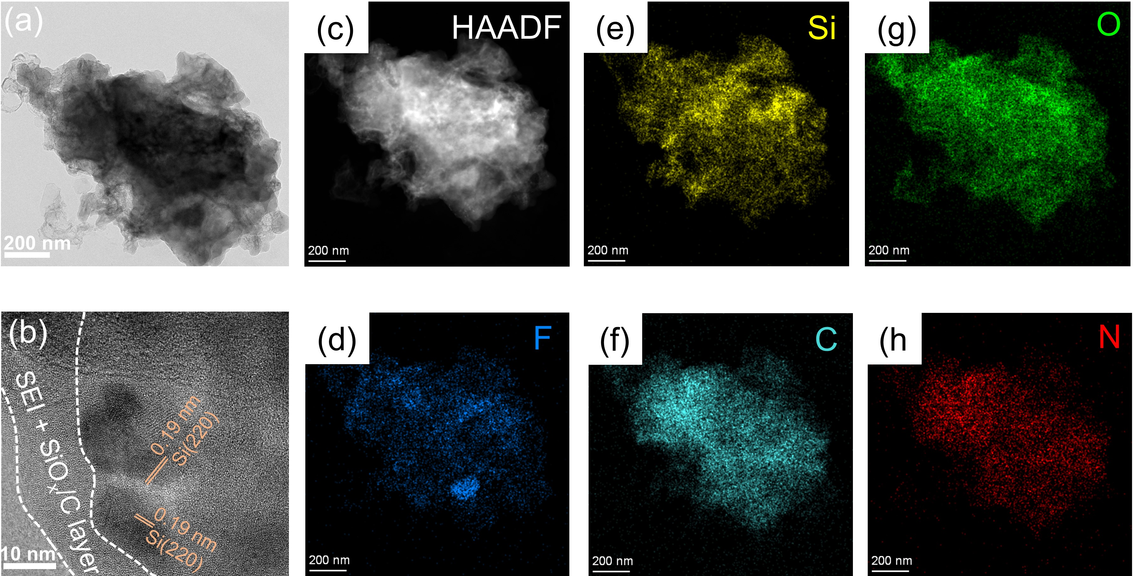
Fig. S24 (a, b) TEM images and (c-h) EDS mapping of cycled p-mSi@SiO_{x}/C

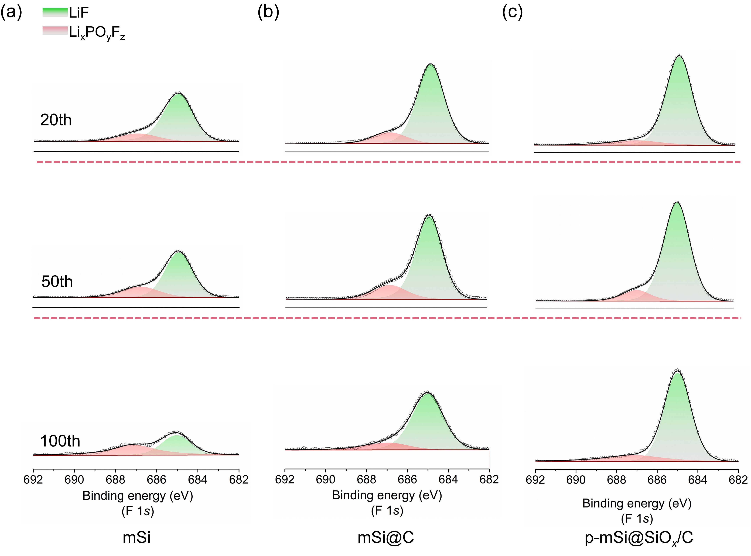
Fig. S25 High resolution F 1s XPS spectra of (a) mSi, (b) mSi@C and (c) p-mSi@SiO_{x}/C electrodes after 20th, 50th and 100th cycle
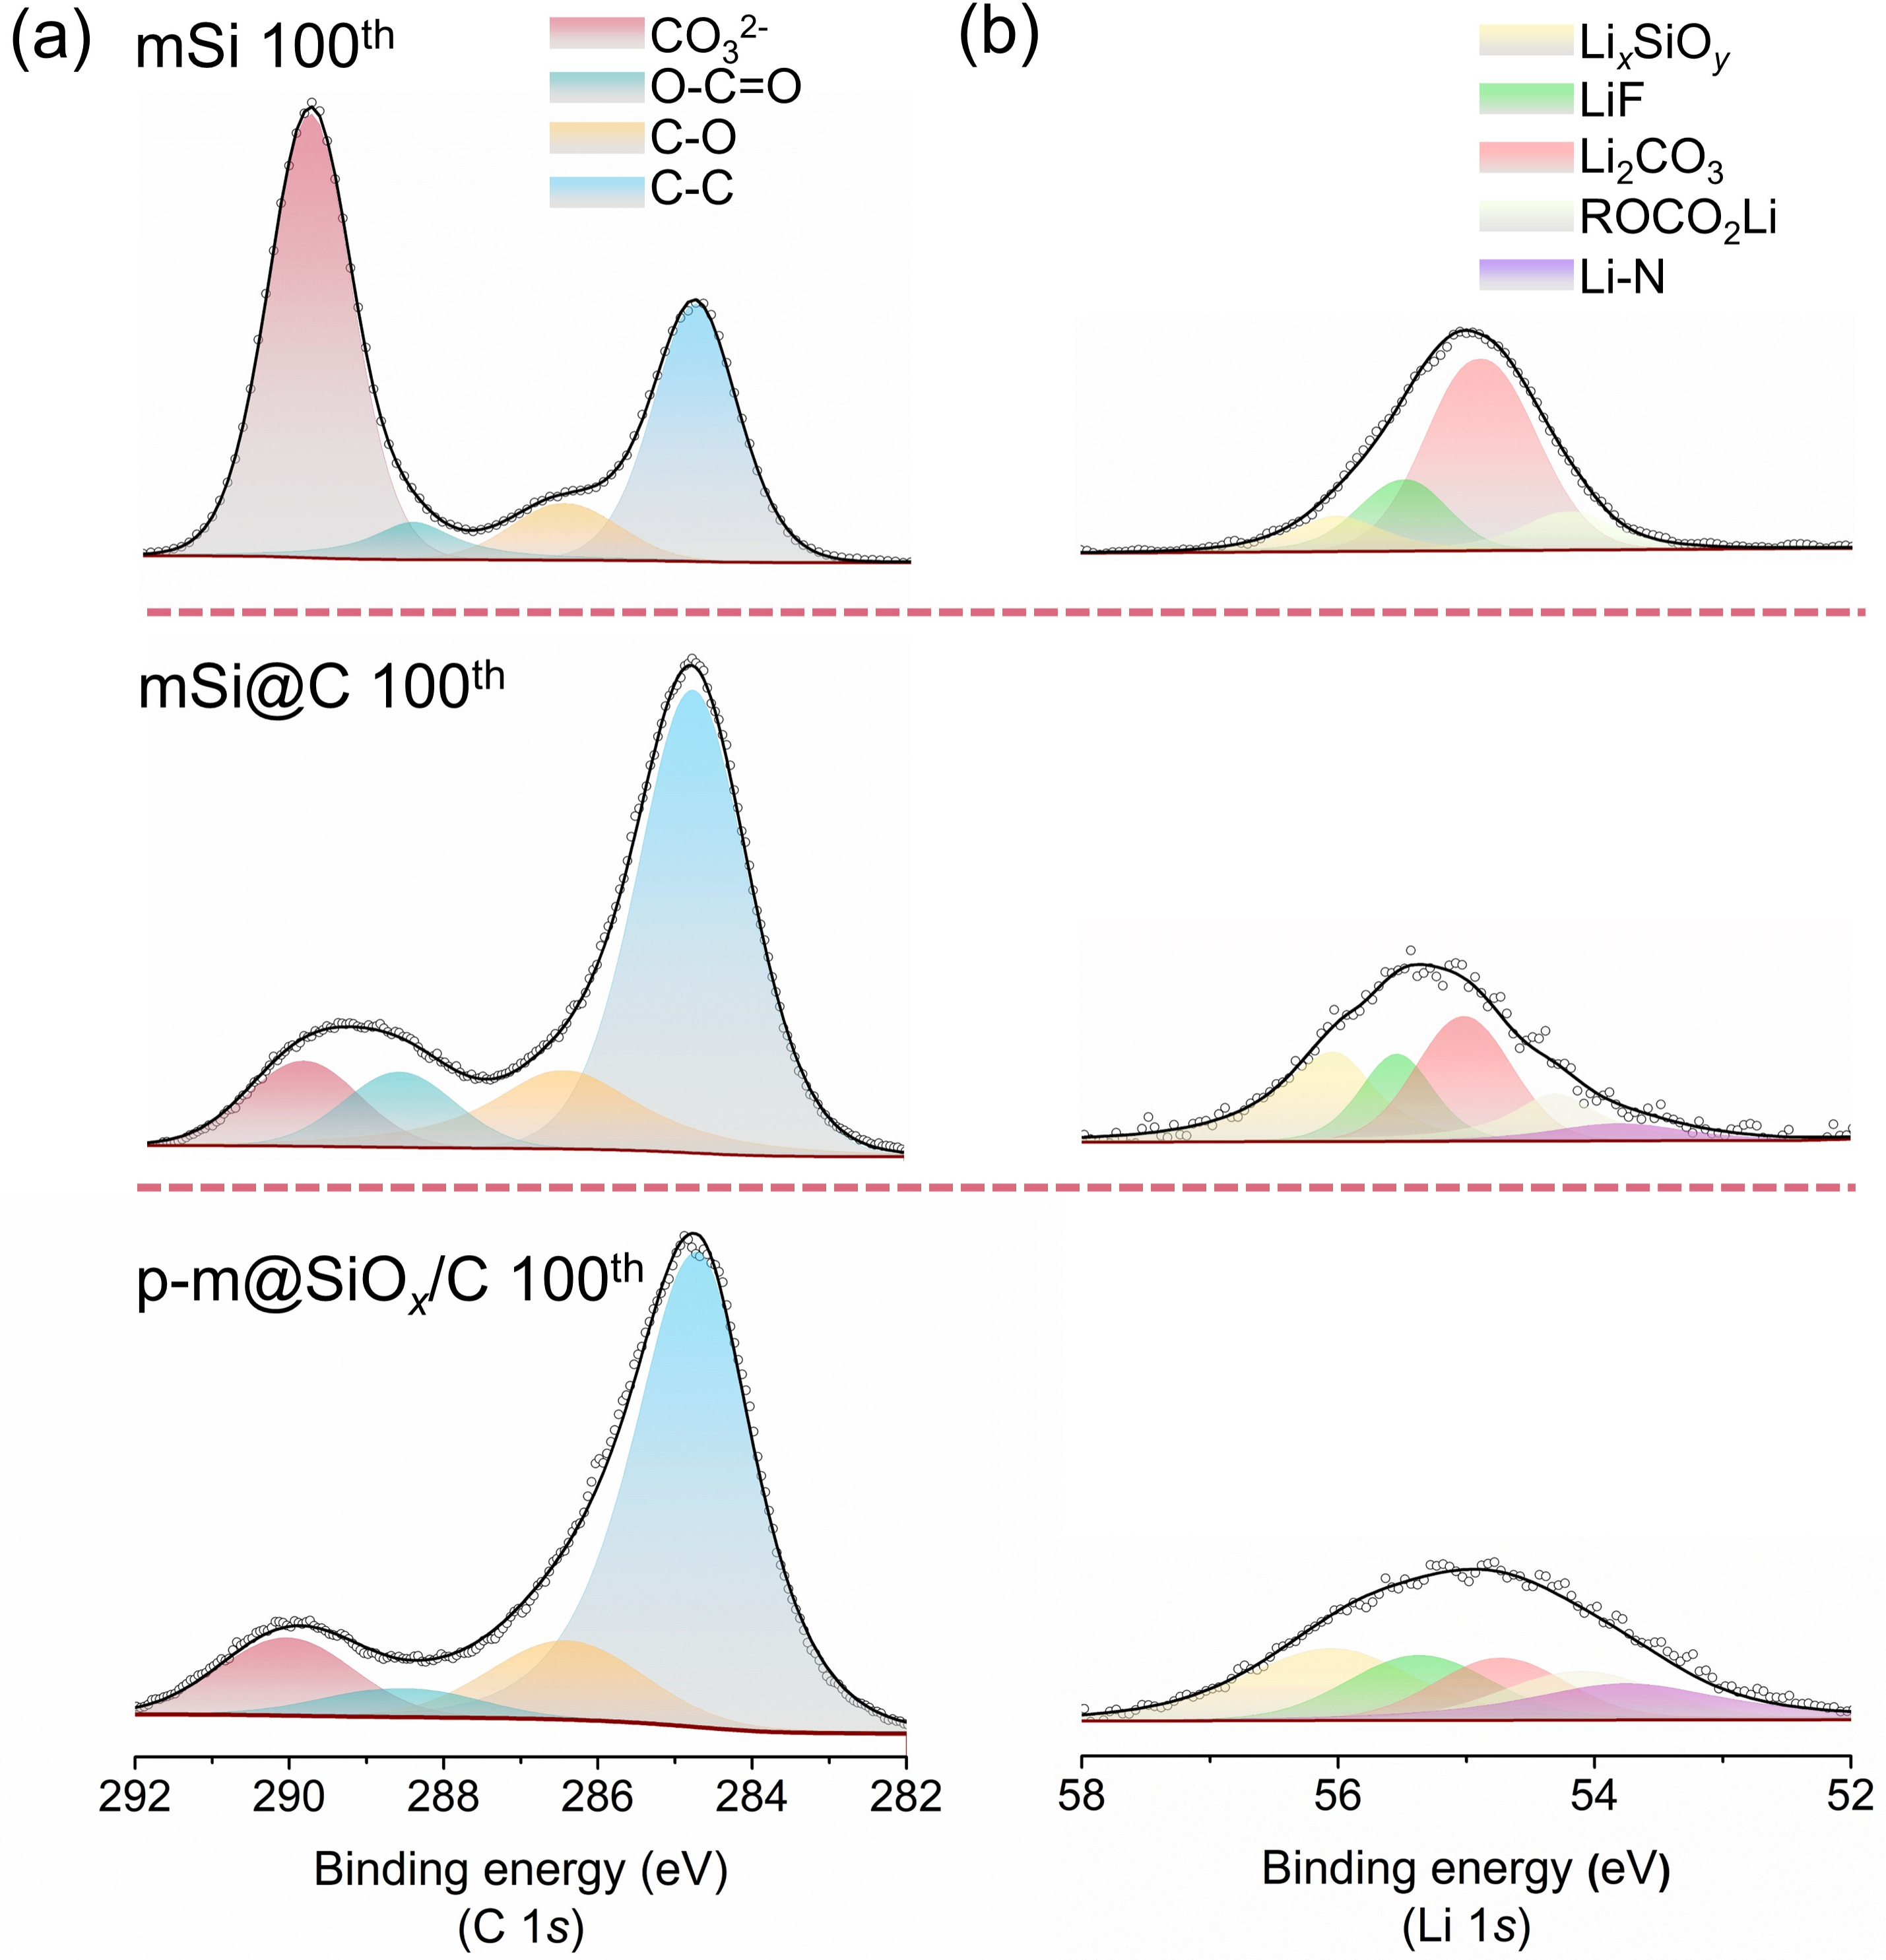
Fig. S26 High resolution XPS spectra of (a) C 1s, and (b) Li 1s for the cycled mSi, mSi@C and p-mSi@SiO_{x}/C electrodes, respectively
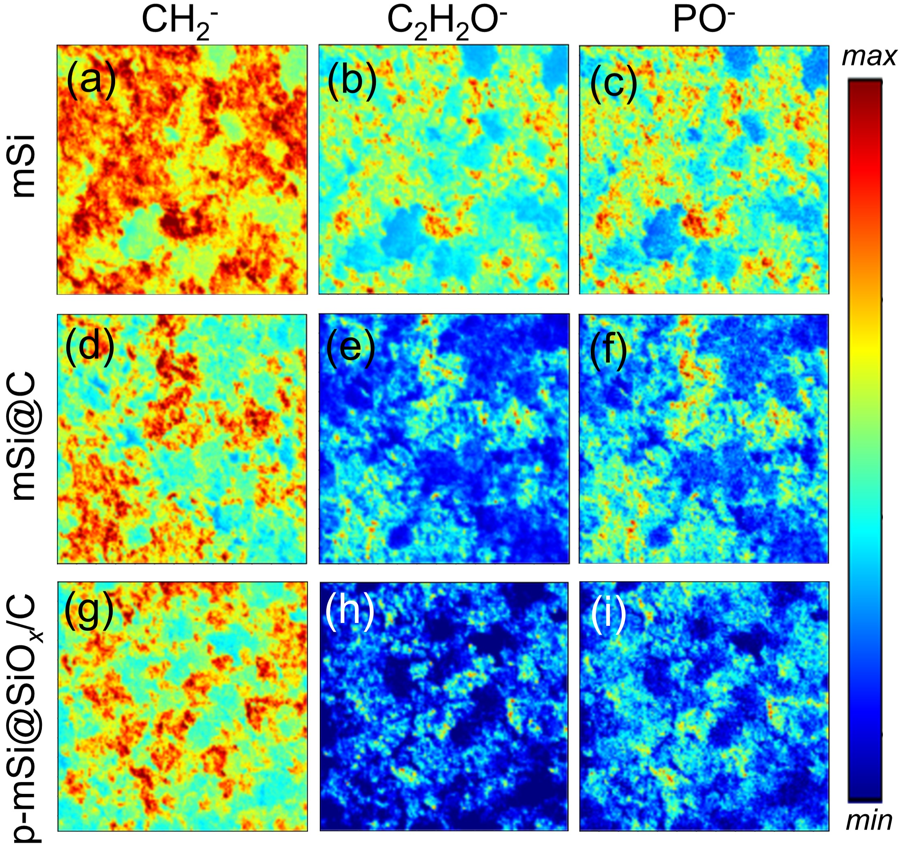
Fig. S27 Surface TOF-SIMS mapping images of (a, d, g) CH₂⁻, (b, e, h) C₂H₂O⁻ and (c, f, i) PO⁻ signals for the cycled mSi, mSi@C and p-mSi@SiO_{x}/C electrodes
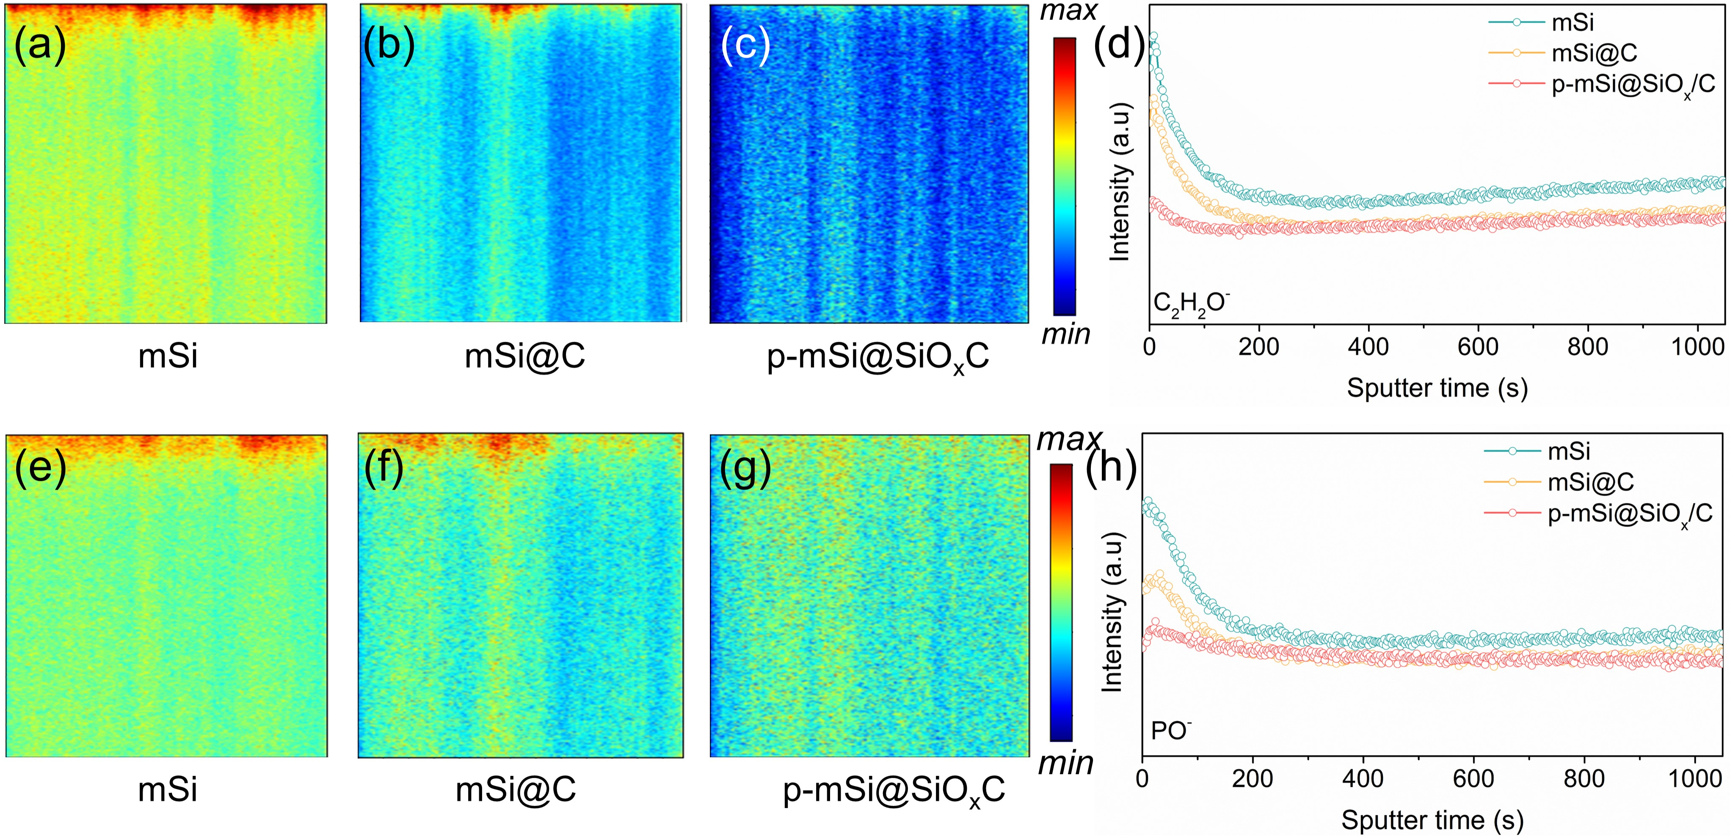
Fig. S28 In-depth TOF-SIMS mapping images and analysis curves of (a-d) C₂H₂O⁻ and (e-h) PO⁻ signals for the cycled mSi, mSi@C and p-mSi@SiO_{x}/C electrodes
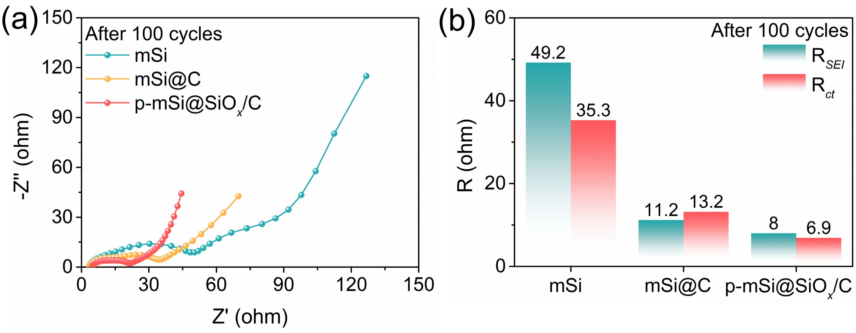
Fig. S29. Nyquist plots and corresponding fitted R_{SEI}/R_{ct} values for of mSi, mSi@C and p-mSi@SiO_{x}/C after 100 cycles
Table S1 The dosage of HEC and AM for the different as-prepared samples
Materials | HEC (g) | AM (g)
mSi@C | 0.029 | 0.174
p-mSi@SiO_{x}/C | 0.04 | 0.24
p-mSi@SiO_{x}/C-3 | 0.044 | 0.266
p-mSi@SiO_{x}/C-5 | 0.046 | 0.276
p-mSi@SiO_{x}/C-7 | 0.048 | 0.289
Table S2 The production cost of single preparation flow based on the 50 g MSi input
Energy cost |  |  | Material cost |  |  | Total cost ($)
Treatments | electricity consumption (kWh) | Cost ($) | Material (g) | Amount (g) | Cost ($) | Total cost ($)
Ball milling | 27.06 | 2.71 | PV Si waste | 50 | 0.27 | 3.44
Ball milling | 27.06 | 2.71 | Li metal | 0.4 | 0.03 | 3.44
Heating | 3.2 | 0.32 | HEC | 10 | 0.03 | 3.44
Heating | 3.2 | 0.32 | AM | 60 | 0.08 | 3.44
a. Electricity, high voltage {CN} | market group for | $ 0.1/kWh
b. PV Si waste | unknown market price, replaced by the PV Si {CN} | $5.49/kg
c. Li metal, industrial grade, {CN} | market for | $79.63/kg
d. HEC, industrial grade, {CN} | market for | $3.43/kg
e. AM, industrial grade, {CN} | market for | $1.28/kg
Note S3:
In our work, the used planetary ball milling process can handle a maximum of 50 g MSi per batch, yielding approximately 70 g of p-mSi@SiO_{x}/C materials. This throughput poses a challenge for industrial-scale production requiring kilogram-to-hundred-kilogram outputs. Moreover, we have estimated the cost per production batch based on the input of 50 g MSi (yielding about 70 g product). As shown in Table S2, the total cost is about $3.43, suggesting a production cost of $0.05 per 1 g p-mSi@SiO_{x}/C, which is comparable to the price of commercial Si/C anode. Meantime, it can be observed that the energy consumption of ball milling accounts for more than 78% of total expenses. Therefore, developing more advanced ball milling equipment with enhanced energy efficiency and scaled throughput is of great significance to improve the industrial-scale production potential and economic viability of our developed technology.

Table S3 Electrochemical characteristics and the calculated energy density of mSi, mSi@C and p-mSi@SiO_{x}/C at various current densities
Samples | Current (A g⁻¹) | Average voltage (V) |  | Reversible capacity |  | U_{R}  (Wh L⁻¹)
Samples | Current (A g⁻¹) | Lithiation | Delithiation | Gravimetric (mAh g⁻¹) | Volumetric (Ah L⁻¹) | U_{R}  (Wh L⁻¹)
mSi | 0.2 | 0.147 | 0.375 | 1894.4 | 2706.3 | 1009.3
mSi | 0.5 | 0.127 | 0.371 | 1609.2 | 2298.9 | 990.0
mSi | 1 | 0.103 | 0.374 | 1366.6 | 1952.3 | 966.2
mSi | 2 | 0.109 | 0.391 | 1117.24 | 1596.1 | 929.5
mSi | 5 | 0.084 | 0.489 | 697.0 | 995.7 | 813.9
mSi@C | 0.2 | 0.193 | 0.466 | 1702.7 | 2541.3 | 975.9
mSi@C | 0.5 | 0.191 | 0.456 | 1607 | 2398.5 | 971.6
mSi@C | 1 | 0.193 | 0.461 | 1462.5 | 2182.8 | 958.0
mSi@C | 2 | 0.189 | 0.500 | 1274.9 | 1902.8 | 927.9
mSi@C | 5 | 0.17 | 0.594 | 920.4 | 1373.7 | 850.6
p-mSi@SiO_{x}/C | 0.2 | 0.194 | 0.464 | 1783.6 | 2744.0 | 985.4
p-mSi@SiO_{x}/C | 0.5 | 0.193 | 0.448 | 1772.3 | 2726.6 | 989.3
p-mSi@SiO_{x}/C | 1 | 0.194 | 0.449 | 1653.1 | 2543.2 | 980.8
p-mSi@SiO_{x}/C | 2 | 0.190 | 0.482 | 1474.6 | 2268.6 | 957.2
p-mSi@SiO_{x}/C | 5 | 0.177 | 0.563 | 1123.0 | 1727.7 | 896.4
Table S4 Comparison of p-mSi@SiO_{x}/C with the previous micro-Si based anode
No. | Materials | Current density (A g⁻¹) | Cycle number | Capacity (mAh g⁻¹) | Refs.
1 | Si-NHC@CNFs | 1 | 100 | 928.4 | [S1]
2 | p-Si@SiO_{x}/Ag/CN | 1 | 50 | 830.6 | [S2]
3 | Si/AC@GC-700 | 1 | 200 | 956 | [S3]
4 | SiFe | 0.5 | 200 | 803 | [S4]
5 | p-SiO_{x}@0.3TiO₂@C | 0.7 | 500 | 805.9 | [S5]
6 | SiO@LCO | 0.2 | 300 | 588.2 | [S6]
7 | μHGC+nHGC | 0.8 | 500 | 804 | [S7]
8 | Si/SiO_{x}-ZnO-C | 0.5 | 200 | 633 | [S8]
9 | Si/C-650@C-600 | 1 | 300 | 846 | [S9]
10 | Si@SiO_{x}/WCGCs | 0.1 | 100 | 869.88 | [S10]
11 | Si/Ag/C | 1 | 300 | 706 | [S11]
12 | μP-Si@CNT@C | 0.5 | 200 | 1000 | [S12]
13 | DE-0.5 | 1 | 200 | 444 | [S13]
14 | pSi/MXene | 1 | 500 | 555 | [S14]
15 | DP-Si-1.0 | 1 | 300 | 587.2 | [S15]
16 | PoHC/Si@C | 1.5 | 200 | 550 | [S16]
17 | Si/CoMo@NCP | 1 | 400 | 745 | [S17]
18 | M-Si@SiO_{x}@C | 1.2 | 200 | 886 | [S18]
19 | Si@8Z | 1 | 650 | 818.5 | [S19]
20 | D-Si@RF-CTP | 0.5 | 60 | 900.8 | [S20]
21 | Si@C@CNTs | 0.5 | 500 | 968 | [S21]
22 | SHT-3@PC@SnS₂ | 1 | 200 | 1125.3 | [S22]
23 | DP Si/SiO_{x}@Li–C | 0.1 | 100 | 809.8 | [S23]
24 | PSi/TiN@NC | 0.5 | 300 | 923.6 | [S24]
25 | V–SiO_{x}@AP@C | 1 | 200 | 761.5 | [S25]
 | p-mSi@SiO_{x}/C | 1 | 500 | 901.1 | This work
Supplementary References
- D.-C. Jia, Y.-Y. Feng, C.-L. Zhang, J.-J. Li, B.-W. Zhang et al., Freestanding carbon fiber-confined yolk-shelled silicon-based anode for promoted lithium storage applications. Rare Met. 42(11), 3718–3728 (2023). https://doi.org/10.1007/s12598-023-02380-3
- Y. Li, G. Chen, H. Yang, X. Geng, Z. Luo et al., Three-dimensional porous Si@SiOx/Ag/CN anode derived from deposition silicon waste toward high-performance Li-ion batteries. ACS Appl. Mater. Interfaces 15(37), 43887–43898 (2023). https://doi.org/10.1021/acsami.3c09561
- S.H. Yang, J.K. Kim, D.-S. Jung, Y.C. Kang, Facile fabrication of Si-embedded amorphous carbon@graphitic carbon composite microspheres via spray drying as high-performance lithium-ion battery anodes. Appl. Surf. Sci. 606, 154799 (2022). https://doi.org/10.1016/j.apsusc.2022.154799
- M. Li, J. Qiu, S. Zhang, P. Zhao, Z. Jin et al., Micrometer-sized ferrosilicon composites wrapped with multi-layered carbon nanosheets as industrialized anodes for high energy lithium-ion batteries. J. Energy Chem. 50, 286–295 (2020). https://doi.org/10.1016/j.jechem.2020.03.077
- F. Dou, Y. Weng, G. Chen, L. Shi, H. Liu et al., Volume expansion restriction effects of thick TiO₂/C hybrid coatings on micro-sized SiO_{x} anode materials. Chem. Eng. J. 387, 124106 (2020). https://doi.org/10.1016/j.cej.2020.124106
- Y. Qian, Y. Liang, W. Zhang, B. Xi, N. Lin, Thermal polymerization of ion-modified carbon dots into multi-functional LiF-carbon interface for stabilizing SiO anode. Energy Storage Mater. 63, 102996 (2023). https://doi.org/10.1016/j.ensm.2023.102996
- Q. Shi, Y. Cheng, J. Wang, J. Zhou, H.Q. Ta et al., Strain regulating and kinetics accelerating of micro-sized silicon anodes via dual-size hollow graphitic carbons conductive additives. Small 19(4), 2205284 (2023). https://doi.org/10.1002/smll.202205284
- Y. Li, G. Chen, H. Wu, H. Ding, C. zhang et al., Constructing triple-protected Si/SiOx@ZnO@C anode derived from volatile silicon waste for enhanced lithium storage capacity. Appl. Surf. Sci. 634, 157651 (2023). https://doi.org/10.1016/j.apsusc.2023.157651
- J. Wan, H. Dong, Z. Zhao, H. Wang, H. Xie et al., Lowering oxygen content on the surface of Si/C composite anode material of lithium-ion batteries with calcium carbide. J. Energy Storage 70, 107913 (2023). https://doi.org/10.1016/j.est.2023.107913
- S.-F. Liu, C.-H. Kuo, C.-C. Lin, H.-Y. Lin, C.-Z. Lu et al., Biowaste-derived Si@SiOx/C anodes for sustainable lithium-ion batteries. Electrochim. Acta 403, 139580 (2022). https://doi.org/10.1016/j.electacta.2021.139580
- Y. Li, G. Chen, W. Liu, C. zhang, L. Huang et al., Construction of porous Si/Ag@C anode for lithium-ion battery by recycling volatile deposition waste derived from refining silicon. Waste Manag. 156, 22–32 (2023). https://doi.org/10.1016/j.wasman.2022.11.022
- L. Sun, Y. Liu, L. Wang, Z. Chen, Z. Jin, Stabilizing porous micro-sized silicon anodes via construction of tough composite interface networks for high-energy-density lithium-ion batteries. Nano Res. 17(11), 9737–9745 (2024). https://doi.org/10.1007/s12274-024-6937-2
- H. Ruan, S. Guo, L. Zhang, Y. Liu, L. Li et al., Boosting lithium storage performance of diatomite derived Si/SiOx micronplates via rationally regulating the composition, morphology and crystalline structure. Ceram. Int. 48(12), 17510–17517 (2022). https://doi.org/10.1016/j.ceramint.2022.03.015
- Z. Zhang, H. Ying, P. Huang, S. Zhang, Z. Zhang et al., Porous Si decorated on MXene as free-standing anodes for lithium-ion batteries with enhanced diffusion properties and mechanical stability. Chem. Eng. J. 451, 138785 (2023). https://doi.org/10.1016/j.cej.2022.138785
- P. Duan, R. Zhang, Z. Wu, Z. Yang, H. Li et al., Design and construction of porous silicon materials as stable anodes for lithium-ion batteries. Ind. Eng. Chem. Res. 62(18), 6995–7006 (2023). https://doi.org/10.1021/acs.iecr.3c00084
- S. Yi, Z. Yan, X. Li, Z. Wang, P. Ning et al., Design of phosphorus-doped porous hard carbon/Si anode with enhanced Li-ion kinetics for high-energy and high-power Li-ion batteries. Chem. Eng. J. 473, 145161 (2023). https://doi.org/10.1016/j.cej.2023.145161
- H. Ruan, L. Zhang, S. Li, K. Wang, W. Huang et al., Carbon polyhedra encapsulated Si derived from Co-Mo bimetal MOFs as anode materials for lithium-ion batteries. J. Mater. Sci. Technol. 159, 91–98 (2023). https://doi.org/10.1016/j.jmst.2023.03.009
- T. Meng, B. Li, C. Liu, Q. Wang, D. Shu et al., Molecular cooking: Amino acids trap silicon in carbon matrix to boost lithium-ion storage. Energy Storage Mater. 46, 344–351 (2022). https://doi.org/10.1016/j.ensm.2022.01.005
- D. Zhang, R. Yang, J. Zhou, W. Liu, H. Qin et al., Uniform Li-ion diffusion and robust solid electrolyte interface construction for kilogram-scale Si@ZIF powder as the anode in Li-ion batteries. Energy Storage Mater. 63, 102976 (2023). https://doi.org/10.1016/j.ensm.2023.102976
- H. Li, Z. Chen, Z. Kang, W. Liu, Y. Chen, High-density crack-resistant Si-C microparticles for lithium ion batteries. Energy Storage Mater. 56, 40–49 (2023). https://doi.org/10.1016/j.ensm.2022.12.045
- X. Fan, T. Cai, S. Wang, Z. Yang, W. Zhang, Carbon nanotube-reinforced dual carbon stress-buffering for highly stable silicon anode material in lithium-ion battery. Small 19(30), 2300431 (2023). https://doi.org/10.1002/smll.202300431
- X. Du, Y. Huang, Z. Zhou, C. Chen, Constructing yolk@multi-shell free-standing anodes with porous carbon tube and SnS₂ nanosheets for Si-based lithium-ion batteries. J. Mater. Sci. Technol. 220, 23–29 (2025). https://doi.org/10.1016/j.jmst.2024.09.018
- Y. Zhu, H. Zhang, X. Zeng, T. Han, M. Qi et al., Engineering a dual-porous Li-rich carbon-coated Si/SiOx nanosphere as a high-performance Li-ion battery anode. Chem. Commun. 61(17), 3564–3567 (2025). https://doi.org/10.1039/D4CC06590E
- Y. Li, L. Pang, Y. Li, Z. Li, P. Xiao, Dramatic enhancement enabled by introducing TiN into bread-like porous Si-carbon anodes for high-performance and safe lithium storage. ACS Appl. Mater. Interfaces. (2024). https://doi.org/10.1021/acsami.4c11332
- J. Luan, H. Yuan, J. Liu, N. Zhao, W. Hu et al., Amorphous AlPO₄ layer coating vacuum thermal reduced SiO_{x} with fine silicon grains to enhance the anode stability. Adv. Sci. 11(36), 2405116 (2024). https://doi.org/10.1002/advs.202405116

