Supporting Information for
Designing Metal Phosphide Solid-Electrolyte Interphase for Stable Lithium Metal Batteries through Electrified Interface Optimization and Synergistic Conversion
Jung Been Park^{1#}, Changhoon Choi^{2#}, Min Sang Kim¹, Hyeongbeom Kang¹, Eunji Kwon³, Seungho Yu^{3,4}, and Dong-Wan Kim¹*
School of Civil, Environmental, and Architectural Engineering, Korea University, Seoul 02841, South Korea
Department of Materials Science and Engineering, SungShin Women’s University, Seoul, 01133, South Korea
Energy Storage Research Center, Korea Institute of Science and Technology, 5, Hwarang-ro 14-gil, Seongbuk-gu, Seoul 02792, Republic of Korea
⁴ Division of Energy & Environment Technology, KIST School, Korea University of Science and Technology, Seoul 02792, Republic of Korea
# Jung Been Park and Changhoon Choi contributed equally to this work.
*Corresponding author. E-mail: dwkim1@korea.ac.kr (Dong-Wan Kim)
Supplementary Figures and Tables

Fig. S1 XRD pattern of SnCo(OH)₆
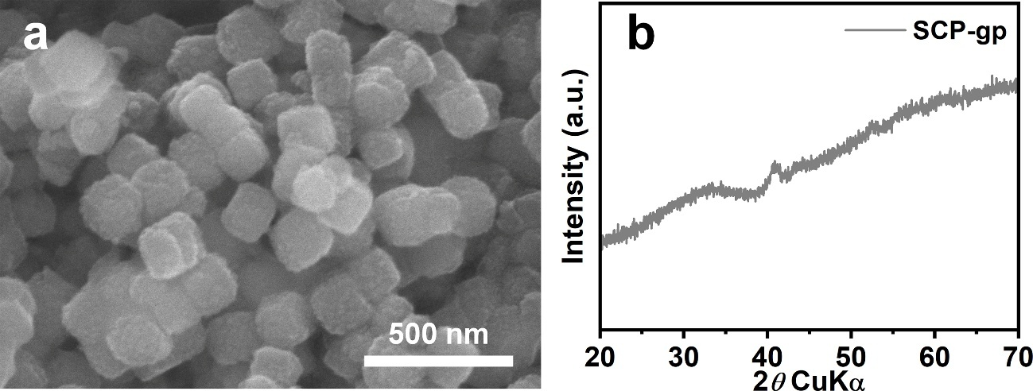

Fig. S2 a SEM image and b XRD pattern of SCP-gp

Fig. S3 EDS spectra of a SCP-gp and b SCP-ss
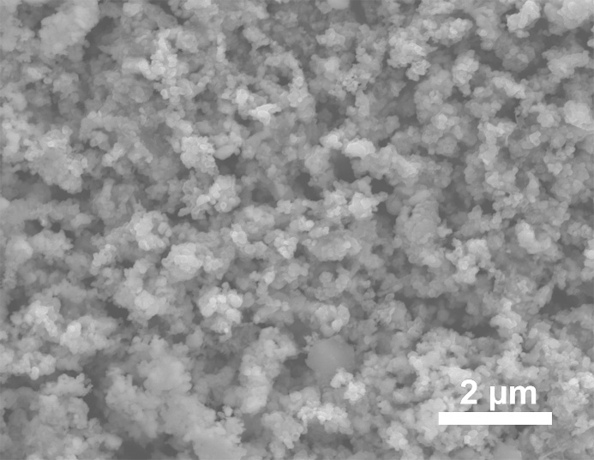

Fig. S4 Low-magnified SEM image of SCP-ss
Fig. S5 a BET surface area and b BJH pore size distribution of SnCo(OH)₆, SCP-gp, and SCP-ss

Fig. S6 ICP-OES measurements of the contents Sn, Co, and P in the SCP
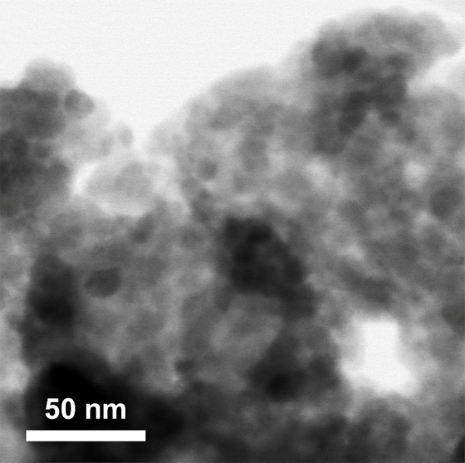

Fig. S7 High-magnified TEM image corresponding to Fig. 1d.

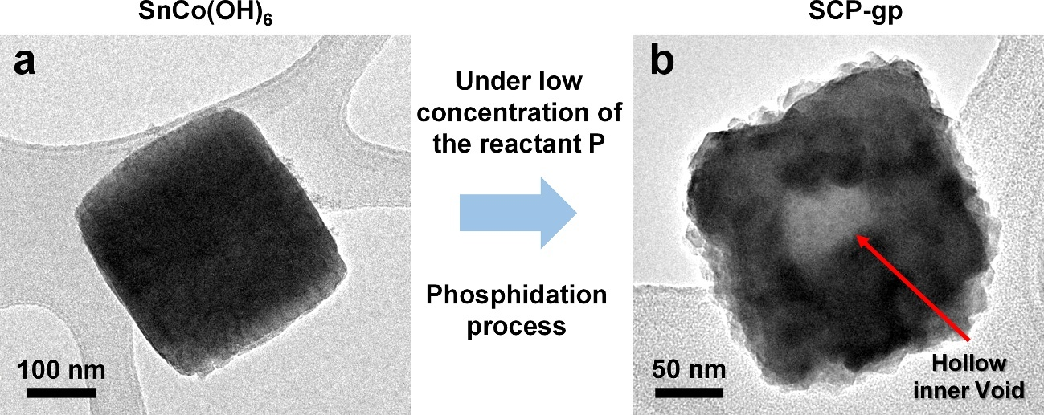
Fig. S8 TEM images of a SnCo(OH)₆ and b SCP-gp
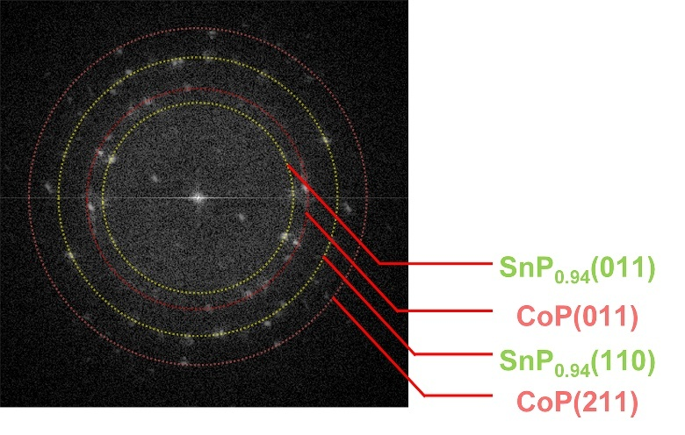

Fig. S9 FFT pattern corresponding to Fig. 1g

Fig. S10 High resolution XPS spectra of SCP-gp. a Co 2p, b Sn 3d, and c P 2p

Fig. S11 SEM images of a CoP and b SnP_{0.94} and corresponding to XRD patterns of c CoP and d SnP_{0.94}
Fig. S12 UPS spectra of a CoP and b SnP_{0.94}. XPS valence band spectra of c CoP and d SnP_{0.94}. e UV-vis absorption spectra of CoP and SnP_{0.94} and f corresponding to Tauc plot
<Note>
The work function (ϕ_{Wf}) is defined as the minimum energy required to remove an electron from the solid surface to a vacuum level (E_{vac}–E_{F}). Thus, the ϕ_{Wf} of materials can determine E_{F}. By integrating the difference between E_{VBM} and E_{F} with the E_{g} (conduction band minimum energy level (E_{c}) – valence band maximum energy level (E_{v})) and ϕ_{Wf}, we can determine the position of E_{F} within the band gap for each material.

Fig. S13 Voltage-time profiles of BLi, SnP_{0.94}@Li, CoP@Li, and SCP@Li at a current density of 0.5 mA cm^{–2}
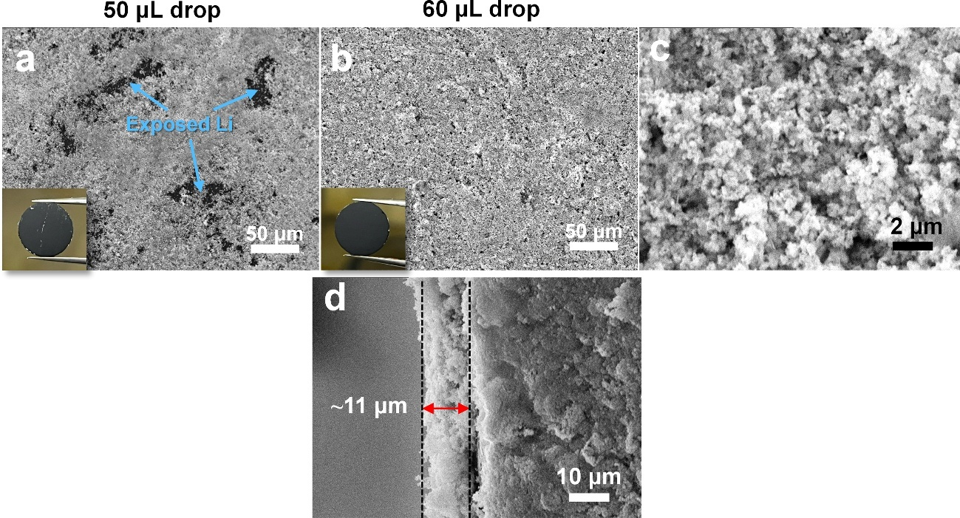
Fig. S14 SEM and digital images of SCP@Li after drop casting using a 50 uL volume and b 60 uL volume. c high magnified SEM images corresponding to Fig. 14b. d Cross-sectional SEM image of optimized SCP@Li.
<Note>
Due to the complex interactions between the solvent, particles, and substrate that influence layer quality, exposure of Li metal in localized areas was unavoidable during drop casting at a 50 µL volume. Therefore, to ensure a stable and uniform coating on the entire Li surface, we optimized drop casting for those conditions (SCP: 20 mg, solvent (toluene): 1 mL, drop volume: 60 μL, Li foil: 15 Pi).
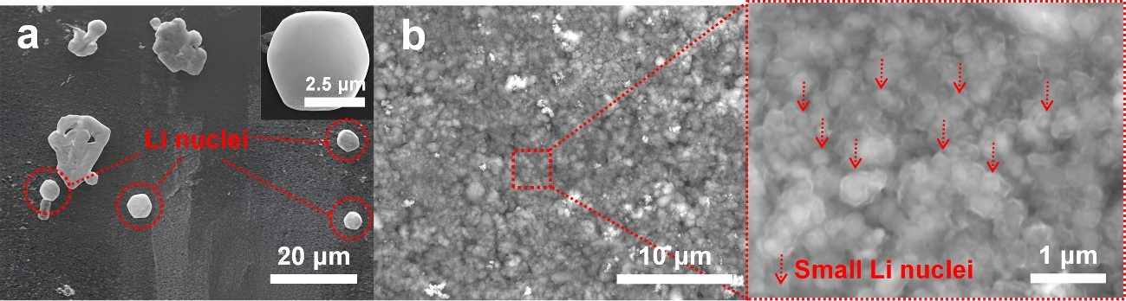
Fig. S15 SEM images of a BLi and b SCP@Li after Li deposition of 0.05 mAh cm^{–2}

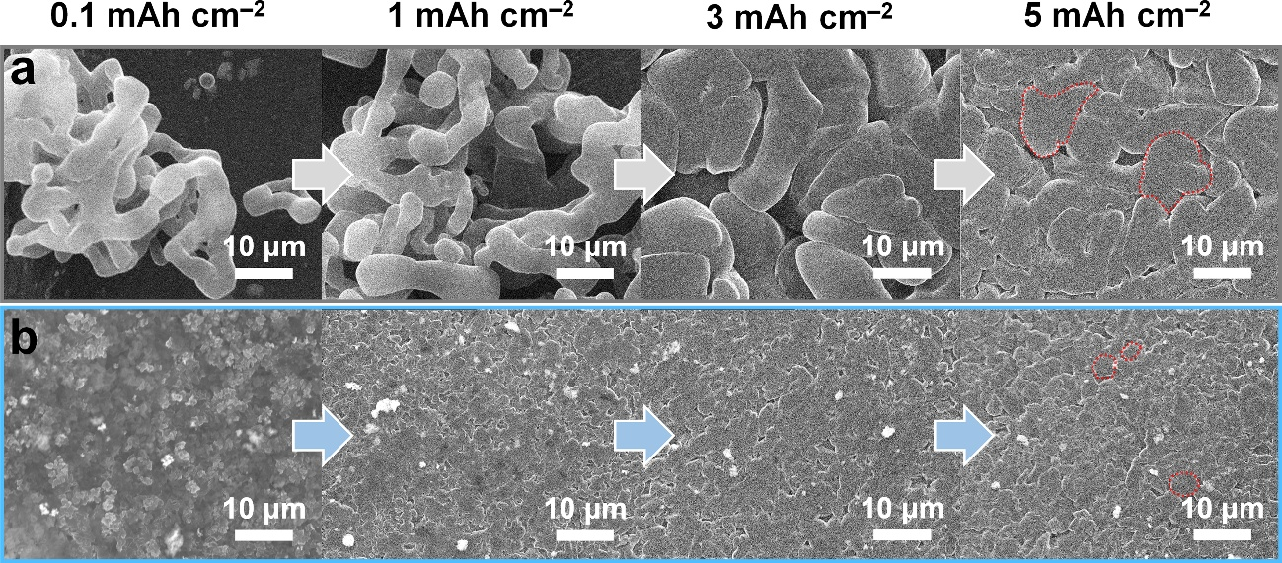
Fig. S16 The enlarged ex-situ SEM images of a BLi and b SCP@Li corresponding to Fig. 3a, b
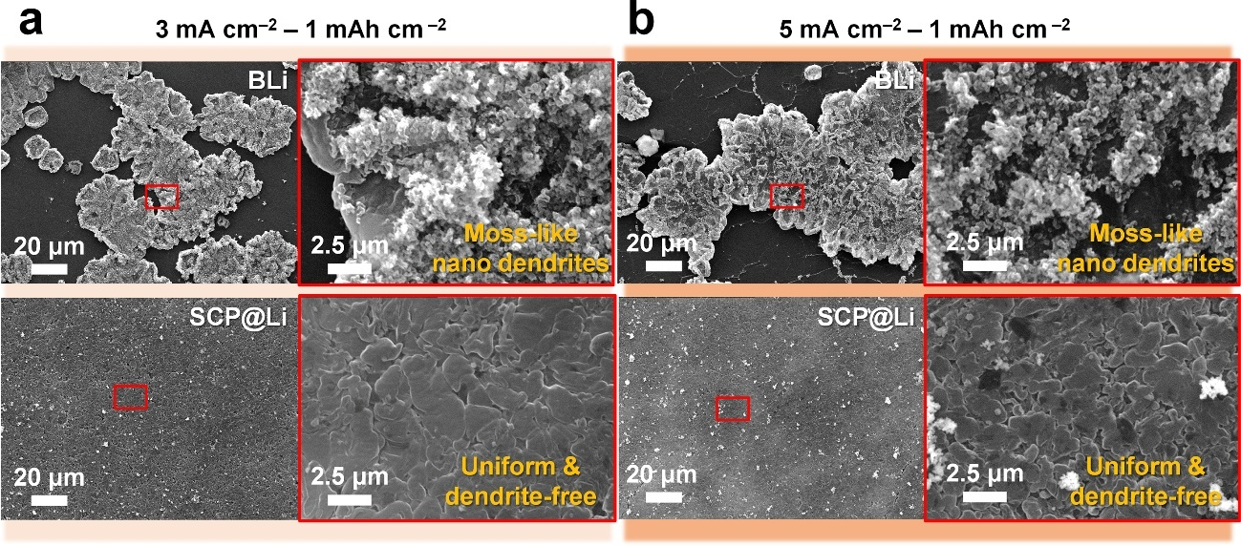

Fig. S17 Ex-situ SEM images of BLi and SCP@Li after Li deposition. (a) A current density of 3 mA cm^{–2} under an areal capacity of 1 mAh cm^{–2}. (b) A current density of 5 mA cm^{–2} under an areal capacity of 1 mAh cm^{–2}
Fig. S18 Galvanostatic profiles of BLi and SCP@Li at a current density of 3 mA cm^{–2}

Fig. S19 BSE and EDS elemental mapping images of SCP modulation layer after Li deposition of 5 mAh cm^{–2}

Fig. S20 Constant current polarization test for BLi and SCP@Li at a current density of 5 mA cm^{–2}
Fig. S21 Current-time transients obtained at a potential of –100 mV
<Note>
B.R. Scharifker’s theory follows the Equation S1 below.
$I = zFc{\left(\frac{D}{πt}\right)}^{\frac{1}{2}}\left(1-exp\left\{-N_{0}πkD\left[t-\frac{1-e^{-At}}{A}\right]\right\}\right)$ (S1-1)
$k = {\left(\frac{8πcM}{ρ}\right)}^{\frac{1}{2}}$ (S1-2)
where $I$ is the current density, $zF$, $D$, and $c$ denote the molar charge of the electro-plating species, diffusion coefficient, and bulk concentration of the electrolyte, respectively. $M$ and $ρ$ are the molecular mass and the density of deposit, respectively. $A$ and $N_{0}$ represent the nucleation rate constant and quantity of active sites on the electrode, respectively. The large number of active sites and low nucleation barrier in SCP@Li compared with BLi results in an increased overall current density, as depicted in Fig. S21.

Fig. S22 The current density vectors on a BLi and b SCP@Li at initial step (0 s) obtained by numerical simulation

Fig. S23 The stepwise growth of Li nuclei on a BLi and b SCP@Li

Fig. S24 CV curves of a BLi and b SCP@Li symmetric cells at the 1st, 5th, and 10th cycle

Fig. S25 CV curve of SCP@Li symmetric cell in the two potential windows (a –0.5 to +0.5 V and b –0.2 to +0.2 V) at a scan rate of 0.2 mV s^{–1}
<Note>
As shown in Fig. S25a, after the first cycle (SCP conversion reaction), Li-Sn alloy/dealloy peaks in SCP@Li is clearly reversible around ~0.15 V. However, when the SCP did not undergo electrochemical lithiation reaction in the first cycle (Fig. 25b), Li-Sn alloy/dealloy peaks are not clearly observed. Based on the results of CV tests, if most of the SCP initially undergoes electrochemical lithiation, leading to sufficient Li-Sn alloy formation, the Li-Sn alloy/dealloy reaction would occur prominently and reversibly during subsequent Li plating/stripping. However, when the potential for SCP electrochemical lithiation is not reached during continuous Li plating/stripping, the Li-Sn alloy/dealloy reaction does not appear prominently.

Fig. S26 CV curves of a BLi and b SCP@Li asymmetric cells

Fig. S27 Nyquist plots of a blank cell and b cell with SCP layer at different temperatures. c The activation energies for Li⁺ conduction

Fig. S28 a Nyquist plots of BLi and SCP@Li symmetric cell at different temperatures.

Fig. S29 Voltage-time profiles of SnP_{0.94}@Li symmetric cell

Fig. S30 The equivalent circuit model for Nyquist plots of BLi and SCP@Li symmetric cells corresponding to Fig. 4e
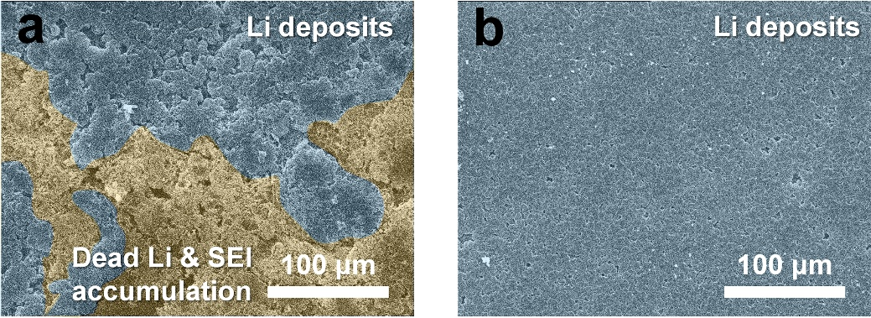
Fig. S31 Low magnification SEM images of a Li-deposited BLi and b Li-deposited SCP@Li after 50 cycles at a current density of 1 mA cm^{–2} with an areal capacity of 1 mAh cm^{–2}
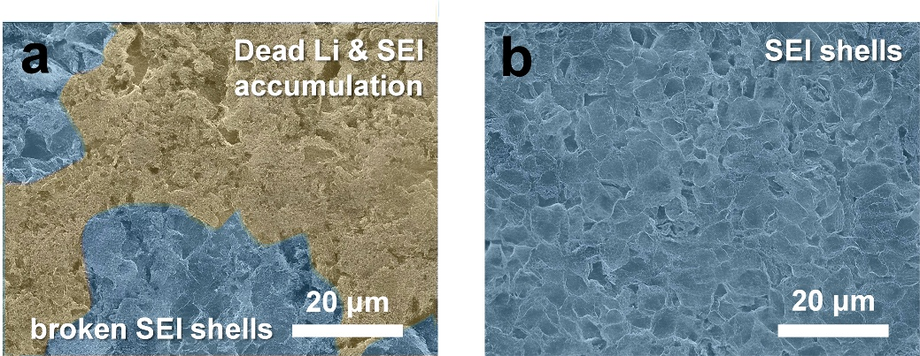
Fig. S32 Low magnification SEM images of a Li-stripped BLi and b Li-stripped SCP@Li after 50 cycles at a current density of 1 mA cm^{–2} with an areal capacity of 1 mAh cm^{–2}
Fig. S33 XRD patterns of SCP and SCP@Li before and after cycling

Fig. S34 High resolution XPS spectra of pristine SCP@Li before Ar⁺ etching. a Co 2p, b Sn 3d, and c P 2p. P 2p XPS spectra of d SCP@Li and e SCP@Li with thinner layer after Ar⁺ etching. f Li 1s XPS spectra of SCP@Li and SCP@Li with thinner layer after Ar⁺ etching

Fig. S35 Depth-profiled XPS spectra of SEI layer on BLi after cycling

Fig. S36 C 1s XPS spectra of a cycled BLi and b SCP@Li at different Ar⁺ sputtering times

Fig. S37 Atomic proportions of SEIs on SCP@Li and BLi calculated from depth-profiled XPS spectra (5 min)

Fig. S38 Galvanostatic profiles of NCM811//SCP@Li and NCM811//BLi cells at various C-rates. a 0.2 C, b 0.5 C, c 1.0 C, d 2.0 C, e 3.0 C, and f 5.0 C

Table S1 Energy positions of ${\text{ϕ}}_{\text{Wf}}$, E_{VBM}, and E_{g} of CoP and SnP_{0.94}
Energy  levels  Samples | $${\text{ϕ}}_{\text{Wf}}$$ | E_{VBM} | E_{g}
CoP | 4.2 eV | 0.25 eV | 1.25 eV
SnP_{0.94} | 3.17 eV | 1.16 eV | 1.45 eV
Table S2 Comparison of electrochemical resistances in BLi and SCP symmetric cells before/after cycling (R_{int} = R_{SEI} + R_{ct})
Resistances  Samples | R_{SEI} | R_{ct} | R_{int}
BLi before cycling | 12.3 Ω | 295.1 Ω | 307.4 Ω
BLi after cycling | 5.1 Ω | 48.6 Ω | 53.7 Ω
SCP@Li before cycling | 1.1 Ω | 1.9 Ω | 3.0 Ω
SCP@Li after cycling | 0.54 Ω | 1.0 Ω | 1.54 Ω
Table S3 Comparison of the performance of symmetric cells using previously reported surface-modified Li metal anodes and SCP@Li
Composition | Current density (mA cm^{–2}) | Areal capacity (mAh cm^{–2}) | Over  potential  (mV) | Cycle  (No.) | References
SnP_{0.94}/CoP | 1 | 1 | 14.5 | 600 | This work
SnP_{0.94}/CoP | 5 | 1 | 68 | 750 | This work
BF₃-doped MXene | 1 | 1 | 33.3 | 500 | [S1]
Ag@C₃N₄ | 1 | 1 | 28 | 700 | [S2]
Ag@C | 1 | 1 | 13 | 500 | [S3]
Zn₃Si₄O₁₀(OH)₂ | 1 | 1 | 30 | 425 | [S4]
Zn₃Si₄O₁₀(OH)₂ | 2 | 1 | 50 | 750 | [S4]
MoS₂@C | 0.5 | 1 | 15 | 250 | [S5]
MoS₂@C | 1 | 1 | 22 | 375 | [S5]
Montmorillonite | 0.5 | 0.5 | 10 | 500 | [S6]
Montmorillonite | 3 | 3 | 80 | 35 | [S6]
Ag@CuO | 1 | 1 | 25 | 525 | [S7]
SbCl₃ | 1 | 1 | 20 | 200 | [S8]
LiF-Li₃N | 0.5 | 0.5 | 50 | 500 | [S9]
Cetyltrimethylammonium bromide | 0.5 | 1 | 50 | 325 | [S10]

Table S4 Comparison of specific capacities of LFP//BLi and LFP//SCP@Li cells at different C-rates
C-rate  Cells | 0.2 C | 0.5 C | 1.0 C | 2.0 C | 3.0 C | 5.0 C | 10 C | 0.5 C  (recover)
LFP//BLi | 151.0 | 140.8 | 127.2 | 105.2 | 88.3 | 65.9 | 36.9 | 136.7
LFP//SCP@Li | 157.2 | 150.5 | 140.9 | 125.9 | 113.6 | 95.6 | 68.5 | 148.6
Supplementary References
- M. Shang, O.G. Shovon, F.E.Y. Wong, J. Niu, A BF₃-Doped MXene dual-layer interphase for a reliable lithium-metal anode. Adv. Mater. 35(8), 2210111 (2023). https://doi.org/10.1002/adma.202210111
- H. Lim, M. Choi, H. Kang, W. Choi, Accelerating lithium deposition kinetics via lithiophilic Ag-decorated graphitic carbon nitride spheres for stable lithium metal anode. Energy Environ. Mater. 8(2), e12830 (2025). https://doi.org/10.1002/eem2.12830
- Y. Fang, S.L. Zhang, Z.-P. Wu, D. Luan, X.W.D. Lou, A highly stable lithium metal anode enabled by Ag nanoparticle–embedded nitrogen-doped carbon macroporous fibers. Sci. Adv. 7(21), eabg3626 (2021). https://doi.org/10.1126/sciadv.abg3626
- H.-J. Liu, C.-Y. Yang, M.-C. Han, C.-Y. Yu, X. Li et al., In-situ constructing a heterogeneous layer on lithium metal anodes for dendrite-free lithium deposition and high Li-ion flux. Angew. Chem. 135(11), e202217458 (2023). https://doi.org/10.1002/ange.202217458
- L. Yu, Q. Su, B. Li, L. Huang, G. Du et al., Pre-lithiated Edge-enriched MoS2 nanoplates embedded into carbon nanofibers as protective layers to stabilize Li metal anodes. Chem. Eng. J. 2022, 429, 132479. https://doi.org/10.1016/j.cej.2021.132479
- Y. Nan, S. Li, C. Han, H. Yan, Y. Ma et al., Interlamellar lithium-ion conductor reformed interface for high performance lithium metal anode. Adv. Funct. Mater. 31(25), 2102336 (2021). https://doi.org/10.1002/adfm.202102336
- M. Gao, Q. Dong, M. Yao, X. Wang, J. Li et al., Dual-gradient engineering of urchin-like silver@copper oxide heterostructures for highly stable lithium metal anodes. Adv. Funct. Mater. 34(28), 2401442 (2024). https://doi.org/10.1002/adfm.202401442
- B.C. Min, J.B. Park, C. Choi, D.-W. Kim, Dynamic construction of a composite solid electrolyte interphase for dendrite-free lithium metal batteries via lithium-antimony self-alloying. Adv. Compos. Hybrid Mater. 8, 4 (2025). https://doi.org/10.1007/s42114-024-01070-7
- K. Zeng, Q. Liu, H. Ma, G. Zhao, Q. An, In situ co-growth LiF-Li₃N rich dual-protective layers enable high interface stability for solid-state lithium-metal batteries. Energy Storage Mater. 70, 103564 (2024). https://doi.org/10.1016/j.ensm.2024.103564
- Z. Sun, J. Yang, H. Xu, C. Jiang, Y. Niu et al., Enabling an inorganic-rich interface via cationic surfactant for high-performance lithium metal batteries. Nano-Micro Lett. 16(1), 141 (2024). https://doi.org/10.1007/s40820-024-01364-x

