Nanosized Anatase TiO₂ with Exposed (001) Facet for High-Capacity Mg²⁺ Ion Storage in Magnesium Ion Batteries
Rong Li^{1,2}, Liuyan Xia^{1,2}, Jili Yue^{1,2,}*, Junhan Wu^{1,2}, Xuxi Teng^{1,2}, Jun Chen³, Guangsheng Huang^{1,2,}*, Jingfeng Wang ^{1,2}, Fusheng Pan^{1,2,}*
¹ National Engineering Research Center for Magnesium Alloys, National Innovation Center for Industry-Education Integration of Energy Storage Technology, College of Materials Science and Engineering, Chongqing University, Chongqing 400044, P. R. China
² Chongqing Institute of New Energy Storage Materials and Equipment, Chongqing 401135, P. R. China
³ Department of Materials, University of Oxford, Oxford, OX1 3PH, United Kingdom
*Corresponding authors. E-mail: jili.yue@cqu.edu.cn (Jili Yue); gshuang@cqu.edu.cn (Guangsheng Huang); fspan@cqu.edu.cn (Fusheng Pan)
S1 Electrochemical analytical method
The galvanostatic intermittent titration technique (GITT) is performed at 50 mA/g for 5 min, followed by a relaxation period of 30 min. The value of the D_{Mg}²⁺ can be obtained based on the simplified Fick's second law by the following equation [S1, S2]:

$$\begin{aligned}D = \frac{4}{\left(πτ\right)}\left(\frac{m_{B}V_{M}}{M_{B}S}\right)\left(\frac{ΔE_{s}}{ΔE_{t}}\right) \#(S1\end{aligned})$$
where τ is the time of current pulse. V_{M}, m_{B}, and M_{B} represent molar volume, the mass, and molar mass of materials, respectively. S is the contact area of electrode/electrolyte. $ΔE_{s}$and $ΔE_{t}$ are the steady-state potential change by the current pulse and potential change during the constant current.
The b-values of the contribution of capacitance-controlled and diffusion capacities can be obtained according to Eqs. S2 and S3. The quantifiable proportion of the pseudocapacitive/diffusion control contribution is based on Eq. S4 [S3].
$$\begin{aligned} i=av^{b}\#(S\end{aligned}2)$$
where 𝑎 and 𝑏 both are constants, 𝑖 is the peak current value (A), 𝑣 is the different scan rate (mV/s).
The electrochemical reaction type can also be summarized via the relationship among scan rate (v) and peak current (i) in CV curves under different scan rates, which follows the equation of [S1, S3, S4]:
$$\begin{aligned}\log\left(i\right)= b\log\left(v\right)+\log\left(a\right) \#(S3)\end{aligned}$$

where the b value is used to distinguish electrochemical reaction behaviors. When the b value is close to 0.5, electrochemical reactions are dominated by diffusion-controlled process; when the b value is approaching to 1.0, capacitive process become the dominant factor in electrochemical reactions.
To further confirm the capacitive contribution of the current response (i) at a certain voltage (V), the corresponding pseudocapacitance and diffusion-controlled behaviors in the CV results were measured and calculated by the following Eq. S2 [S1, S4]:

i(V) = k₁v + k₂v¹ᐟ² (S4)
where 𝑖 is the peak current value (A), 𝑣 is the different scan rate (mV/s), V is the specified voltage (V), and 𝑘₁ and 𝑘₂ are adjustable parameters.
S2 Supplementary Figures and Tables
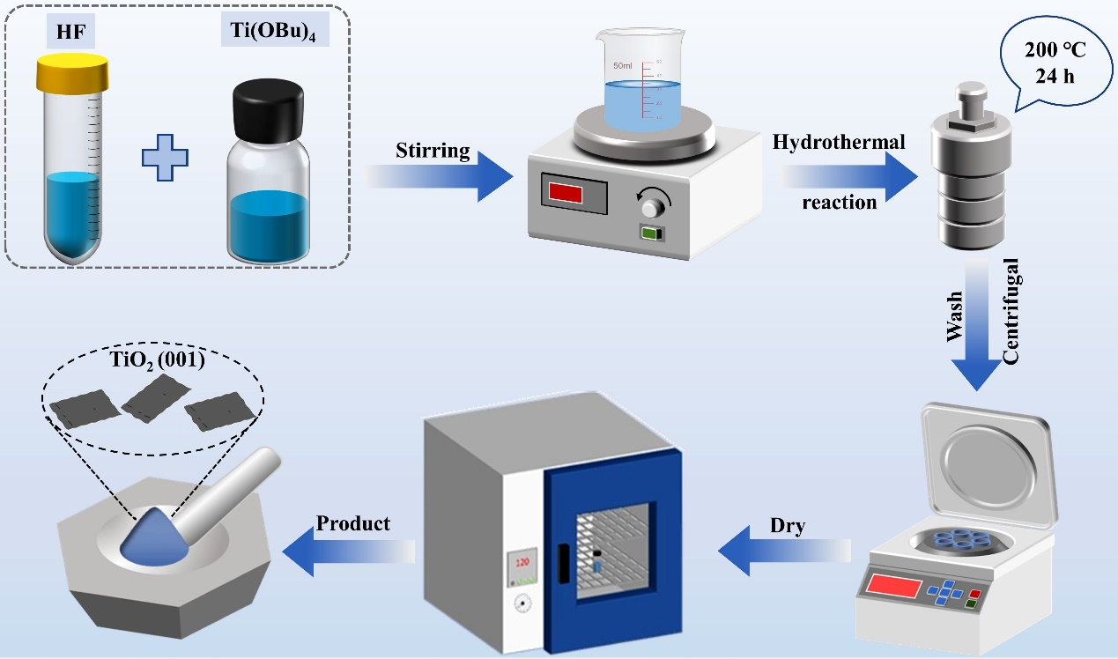

Fig. S1 Schematic illustration of the synthesis process of TiO₂ (001) facet materials

Fig. S2 XRD patterns of TiO₂ (001) facets and TiO₂ (100) facets

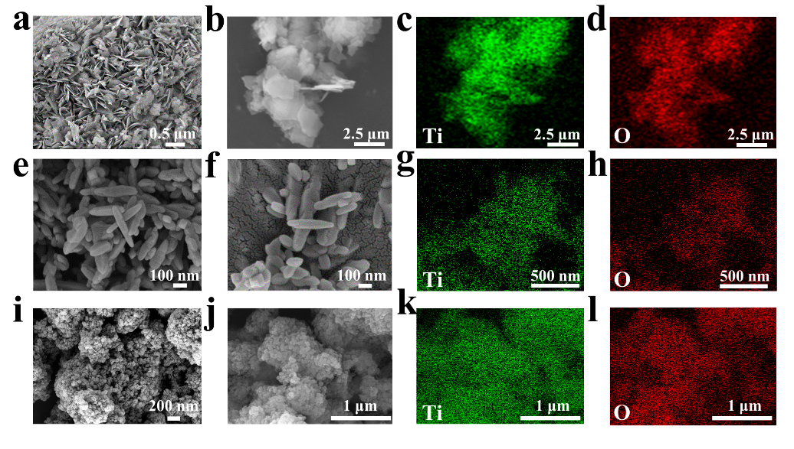
Fig. S3 SEM and Elemental mapping images of a-d TiO₂ (001) facets, e-h TiO₂ (100) facets and i-l anatase TiO₂
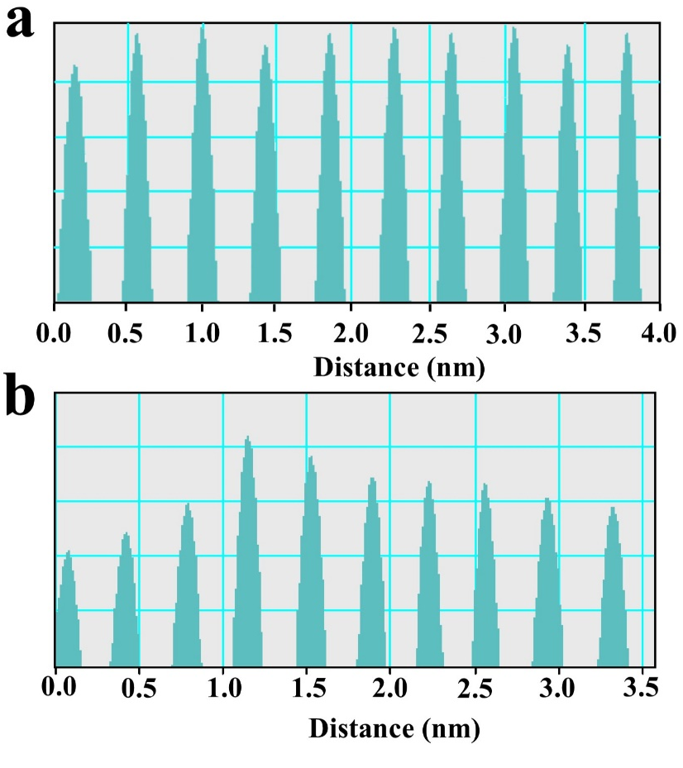
Fig. S4 Brightness profiles along the dotted lines in a TiO₂ (001) facets and b TiO₂ (100) facets

Fig. S5 N₂ adsorption-desorption isotherm curves and Pore-size distribution curves of a TiO₂ (001) facets and b TiO₂ (100) facets
Fig. S6 a The UV−visible absorption spectrum of the TiO₂ samples. b-d Their corresponding plots of transformed Kubelka−Munk function versus the energy of photon

Fig. S7 Color comparison of the synthesized sample TiO₂ (001) facets (left) and TiO₂ (100) facets (right)

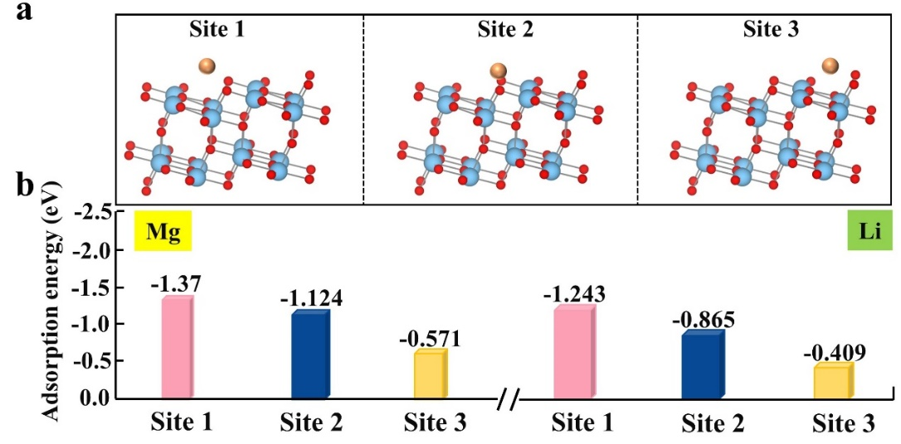
Fig. S8 a Schematic illustration of Mg²⁺ and Li⁺ adsorption sites on the TiO₂ (101) facet, with different adsorption sites labeled as Site 1, Site 2, and Site 3. b Adsorption energies of Mg²⁺ and Li⁺ at different adsorption sites on the TiO₂ (101) facet
Fig. S9 a Diffusion energy barrier and b diffusion paths the Mg²⁺ at TiO₂ (001) facets and (100) facets
Fig. S10 a Diffusion energy barrier and b diffusion paths the Li⁺ at TiO₂ (001) facets and (100) facets
Fig. S11 Diffusion paths the Mg²⁺ and Li⁺ at TiO₂ (001) facets and (100) facets in anatase TiO₂

Fig. S12 Voltage profiles of of TiO₂ (001) facets, TiO₂ (100) facets and anatase TiO₂ at 50 mA/g in Li salt electrolyte

Fig. S13 a Voltage profiles of the TiO₂ (001) facets in MLIBs at 50 mA/g and b 1000 mA/g
Fig. S14 a Charge-discharge curves of anatase TiO₂, TiO₂ (001) facets, and TiO₂ (100) facets at current density of 50 mA/g in MIBs. b Rate performance of anatase TiO₂, TiO₂ (001) facets and (100) facets in MIBs. c Cycling performances of the TiO₂ (001) facets at 50 mA/g in MIBs. d Charge and discharge curves of the TiO₂ (001) facets at current densities ranging from 20 mA/g to 1000 mA/g in MIBs. e Cycling performances of the TiO₂ (001) facets at 500 mA/g in MIBs

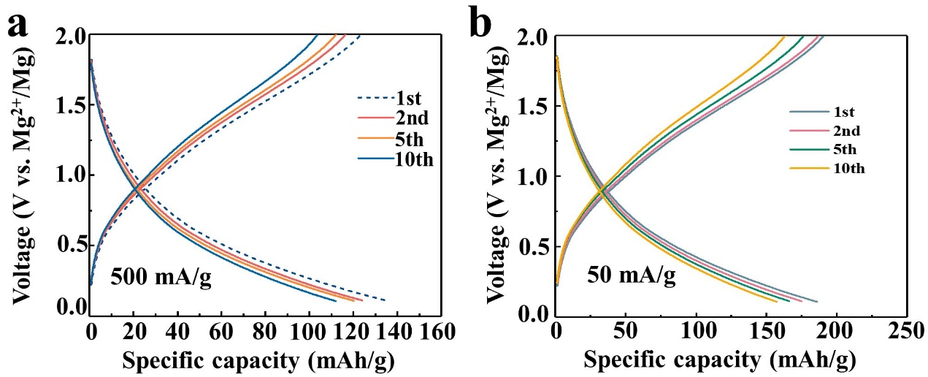
Fig. S15 a Voltage profiles of the TiO₂ (001) facets in MIBs at 500 mA/g and b 50 mA/g

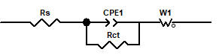
Fig. S16 The equivalent circuits employed to analyze the EIS curves for the three materials after 20 cycles in the Mg-Li dual-salt electrolyte
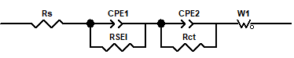
Fig. S17 The equivalent circuits employed to analyze the EIS curves for the three materials after 20 cycles in the Mg salt electrolyte
Fig. S18 a Nyquist plots of anatase TiO₂, TiO₂ (001) facets and (100) facets in MIBs. b GITT profiles of the discharge process of anatase TiO₂, TiO₂ (001) facets and (100) facets in MIBs. c The diffusion coefficients of ions as a function of the state of discharge process in MIBs
Fig. S19 CV curves of a TiO₂ (001) facets and b TiO₂ (100) facets and c anatase TiO₂ at 0.01 mV/s in MLIBs
Fig. S20 CV curves of TiO₂ (001) facets, TiO₂ (100) facets and anatase TiO₂ at 0.01 mV/s in MLIBs
Fig. S21 CV curves of a TiO₂ (001) facets and b TiO₂ (100) facets and c anatase TiO₂ at 0.01 mV/s in MIBs

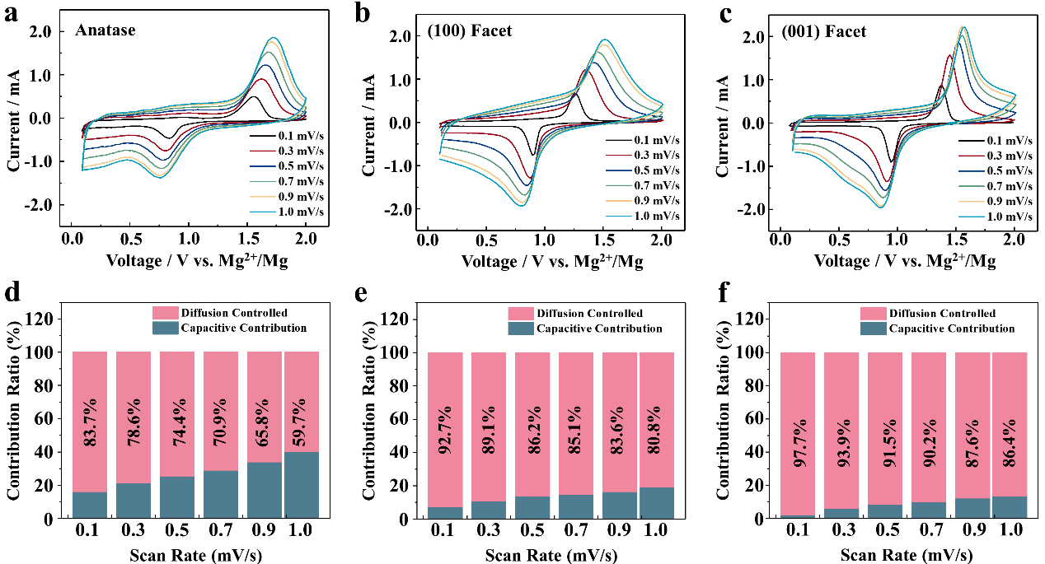
Fig. S22 a-c CV curves of anatase TiO₂, TiO₂ (001) facet and (100) facet at different scan rates in MLIBs. d-f The diffusion and capacitive contributions of anatase TiO₂, TiO₂ (001) facet and (100) facet at different scan rates in MLIBs
Fig. S23 Ex situ XRD of TiO₂ (001) facets comparing the a Mg-Li system and the reference b Mg system
Fig. S24 a Ex situ XRD of TiO₂ (100) facets and b anatase TiO₂ comparing the at first discharge and charge states in MLIBs
Fig. 25 The GCD curves of TiO₂ (001) material in pure Mg salt, pure Li salt and Mg-Li dual-salt electrolyte
Fig. S26 a, b The TEM and Elemental mapping after 30 cycles of discharging and charging of TiO₂ (001) facet
Fig. S27 The TEM and Elemental mapping after the 350 cycles of discharging and charging of TiO₂ (001) facet

Fig. S28 a SEM image, b SEM mapping and c EDS of Mg anode. d-e XPS spectra of Mg anode
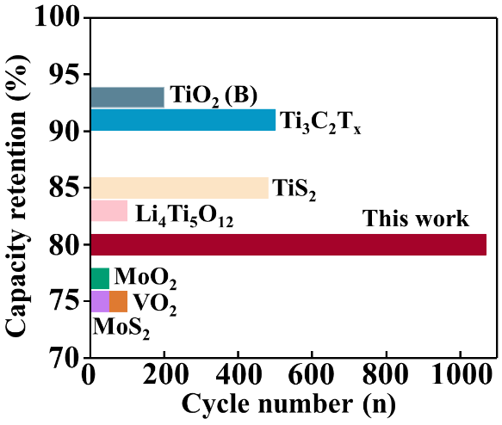
Fig. 29 The reversible capacity and cycling performance comparisons of TiO₂ (001) and other typical electrode materials used for MLIBs reported
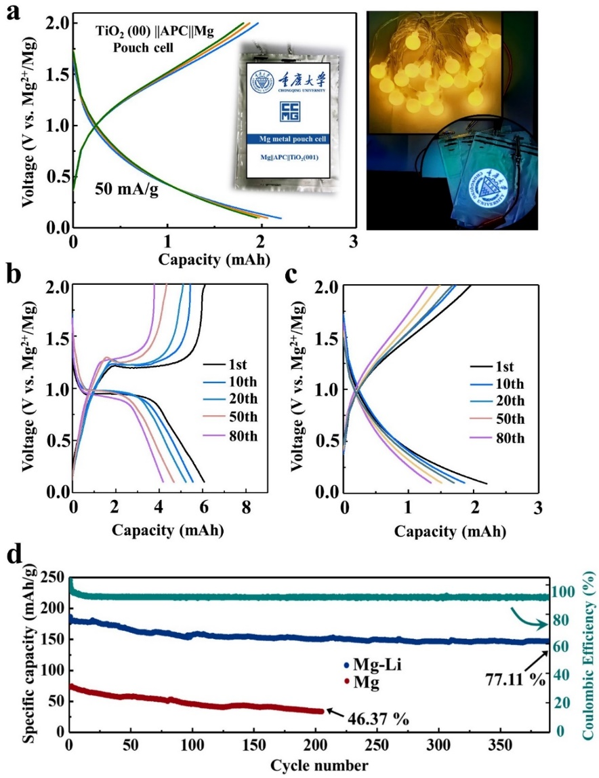
Fig. S30a Charge/discharge profiles of the Mg||APC|| TiO₂ (001) facet pouch cell at 50 mA/g, and the 20 LEDs lightened by two Mg||APC|| TiO₂ (001) facet pouch cells connected in series. b Voltage profiles of the Mg||APC+LiCl|| TiO₂ (001) facet pouch cell in MLIBs at 50 mA/g. c Voltage profiles of the Mg||APC|| TiO₂ (001) facet pouch cell in MIBs at 50 mA/g. d Cycling performances of the TiO₂ (001) facets at 50 mA/g in MIBs and MLIBs
Table S1 The fitted parameters of the EIS results cycled in Mg-Li dual-salt electrolyte for three materials
Electrode material | R_{ct} (Ω)
Anatase TiO₂ | 766.3
(100) facet | 603.2
(001) facet | 425.8
Table S2 The fitted parameters of the EIS results cycled in Mg salt electrolyte for three materials
Electrode material | R_{ct} (Ω) | R_{SEI} (Ω)
Anatase TiO₂ | 2003.5 | 251.19
(100) facet | 1432.6 | 202.47
(001) facet | 1069.3 | 182.03
Supplementary References
- X. Yu, G. Zhao, C. Liu, C. Wu, H. Huang, J. He, N. Zhang, A MoS₂ and Graphene Alternately Stacking Van Der Waals Heterostructure for Li⁺ /Mg²⁺ Co‐Intercalation. Adv Funct Mater. 31, (42), 2103214 (2021). https://doi.org/10.1002/adfm.202103214
- F. Liu, Y. Liu, X. Zhao, K. Liu, H. Yin, L.-Z. Fan, Prelithiated V₂C MXene: A High‐Performance Electrode for Hybrid Magnesium/Lithium‐Ion Batteries by Ion Cointercalation. Small 16, 1906076 (2020). https://doi.org/ 10.1002/smll.201906076
- D. Wu, F. Wang, H. Yang, Y. Xu, Y. Zhuang, J. Zeng, Y. Yang, J. Zhao, Realizing Rapid Electrochemical Kinetics of Mg²⁺ in Ti-Nb Oxides through a Li⁺ Intercalation Activated Strategy toward Extremely Fast Charge/Discharge Dual-Ion Batteries. Energy Storage Mater. 52, 94–103 (2022). https://doi.org/10.1016/j.ensm.2022.07.042
- J. Tian, D. Cao, X. Zhou, J. Hu, M. Huang, C. Li, High-Capacity Mg–Organic Batteries Based on Nanostructured Rhodizonate Salts Activated by Mg–Li Dual-Salt Electrolyte. ACS Nano 12, 3424–3435 (2018). https://doi.org/10.1021/acsnano.7b09177

